Introduction to pHYSIOLOGY

  - Nazreen Akhtar - 2128933

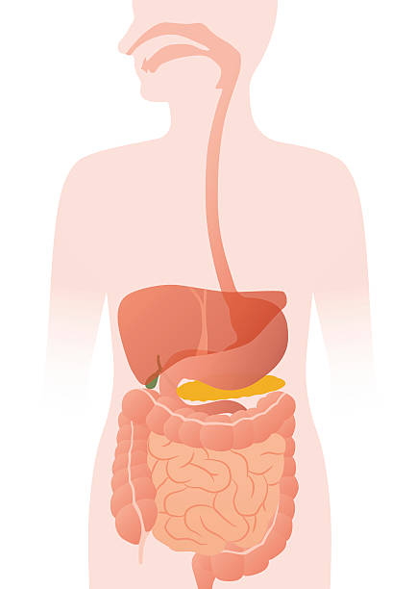
Gillian Weaver
Assessment 1 – Individual Academic Poster Presentation - (BMHP5003)
Introduction to Physiology

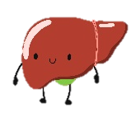



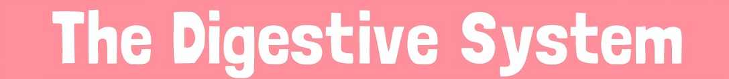
Individual Academic Poster
OESPHAGUS:
An Oesophagus is a muscular tube that passes down the food from the mouth. Th muscles in the Oesophagus moves the food down which allows the body to sallow the food even if a person is upside down.
LARGE INTESTINE:
Left over water and dead cells are sent to the large Intestine. The Large Intestine contains two sections which are the colon and rectum. The colon reabsorbs water from food and the rectum stores faeces until they are ready to be passed.

PANCREAS:
The Pancreas function is to create juices that will be transported to the small intestine. The Pancreas breaks down carbohydrates, fats, and protein with the help of the bile.

GALLBLADDER:
The Gallbladder is a small pouch that is located under the liver, it stores bile produced by the liver.

LIVER:
The liver helps the body produce bile. Bile supports the digestive system with fats and oils. It sends them to the small intestine via the gallbladder.

MOUTH:
The mouth is where the food enters the body, it starts to breakdown by saliva alongside biting and chewing. The mouth softens the food with the tongue which then changes its shape to swallow the food (C, Professional)

FUNCTION
The Digestive System is responsible for breaking down food that can be absorbed by the body, its main function is to extract energy and nutrients while eliminating waste products. The process begins in the mouth, travels to the stomach, and then enters the small intestine where the absorption takes place. Furthermore, the large intestine absorbs water from undigested food before it is eliminated as waste. Without this system working efficiently, our bodies would not receive essential nutrients needed for growth and maintenance (H. Direct).

In health and social care understanding the functioning of the digestive system is crucial in providing appropriate care and support to individuals. The Digestive System is an important component of the human body that contains 4 stages:
- Intake food
- Mechanical and chemicals degradation of food
- Absorb nutrients.
- Removal of indigestible food
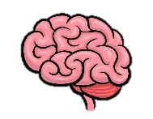

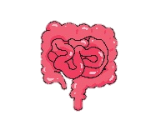

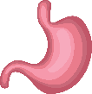
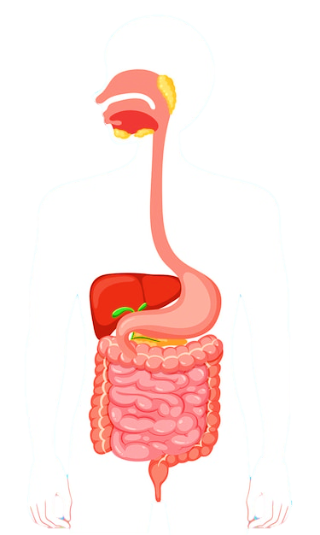
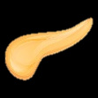
Did you know:
A small intine is only small because of how narrow it is… its actually 4 times as tall as you stretched out!

ANUS:
The last part of the digestive system is the anus where the faeces leave the alimentary canal.

SMALL INTESTINE:
After the food being dissolved in the stomach its then passed to the small intestine where it leaves. When the food is in the middle of the small intestine, all of the chyme are been broken down by the fluids provided by the lover and pancreas. Near the end of the transportation process the food enters the blood stream by entering the small holes in the walls of the small intestines.
STOMACH:
The Stomachs role is to pound down the food further through muscular contractions. Th Stomach wall releases enzymes and acids which dissolves the food into smaller chunks and separates the proteins. Whilst this process is taking place the organs liver, gallbladder and the pancreas get together to create juices to help the food digest.
Potential Issues Associated with the Digestive System
Diabetes
The potential issue associated with the Digestive System; I will be describing is Diabetes. Diabetes is a medical condition that is characterised by high blood sugar levels which can result in the body's inability to produce or use insulin. Insulin is a hormone produced by the pancreas that regulates blood sugar levels and allows cells to use glucose for energy (NHS, Choices).
There are two main types of Diabetes Type 1 and Type 2. Type 1 diabetes appears when the immune system accidentally attacks the insulin-producing cells in the pancreas which is a part of the digestive system. This type of diabetes develops in childhood or adolescence (NHS, Choices). On the other hand, Type 2 diabetes occurs when the body becomes resistant to insulin meaning it fails to produce enough insulin to meet the body’s needs. Obesity, sedentary habits, and poor dietary choices are among lifestyle variables that are frequently linked to this kind of diabetes (NHS, Choices).
Diabetes can have a negative impact on the Digestive System as it can affect the absorption of nutrients in the small intestine. High blood sugar levels can damage blood vessels and their ability to transport the nutrients needed to carry out the process of digesting food. This can lead to malabsorption of essential vitamins and minerals necessary for overall health. Another effect that diabetes can have on the digestive system is that can damage the body's nerves which is known as diabetic neuropathy. This can lead to gastroparesis; this is a condition that impacts the stomach. Specifically, it slows down the organ's ability to empty its content into the small intestine. Furthermore, this can lead to individuals containing symptoms that involve nausea, bloating, vomiting and heartburn (D, Digestion).
The first recommendation that can manage these health issues affecting the digestive system, is maintaining a healthy diet. Regulating blood sugar levels and having proper digestion can be achieved through consuming a balanced meal plan that includes high fibre like vegetables, fruits, and whole grains. Another advice that can improve the effects of diabetes on the digestive system is regular exercise. Exercise helps people manage their weight and improves digestion by promoting bowel motions and easing gastroparesis symptoms (Emma, W). Finally, the proper medication can play an important role in alleviating digestive issues caused by diabetes. People should take their prescribed medications and consult with their healthcare professionals regularly to adjust dosages.
In conclusion, Diabetes is a potential health issue associated with the Digestive system and can primarily affect the blood sugar regulations throughout the body and the organs in the body that are needed in order to carry out the food digestion process. Additionally, it can cause disturbance in liver function and impaired insulin production due to pancreatic damage. Understanding these health issues is a crucial aspect of managing diabetes and maintaining good health. By implementing the provided advice of exercising and keeping a healthy diet with the correct medication into their lives individuals can alleviate discomfort and improve their lives

References
- Digestive system (2023) healthdirect. Available at: https://www.healthdirect.gov.au/digestive-system (Accessed: 05 October 2023).
- professional, C.C. medical (2023) Digestive system: Function, Organs & Anatomy, Cleveland Clinic. Available at: https://my.clevelandclinic.org/health/body/7041-digestive-system (Accessed: 08 October 2023).
- (2023) NHS choices. Available at: https://www.nhs.uk/conditions/diabetes/ (Accessed: 08 October 2023).
- Diabetes and digestion (2022) Centers for Disease Control and Prevention. Available at: https://www.cdc.gov/diabetes/library/features/diabetes-digestion.html#:~:text=Nausea%2C%20heartburn%2C%20or%20bloating%20can,common%20known%20cause%20of%20gastroparesis. (Accessed: 08 October 2023).
- EmmaW (2023) Weight loss and diabetes, Diabetes UK. Available at: https://www.diabetes.org.uk/guide-to-diabetes/enjoy-food/eating-with-diabetes/whats-your-healthy-weight/lose-weight (Accessed: 08 October 2023).

