

Developing An Educational Game for Teaching Social Situations and Skills to Younger Players
by
Charlie Keirl

Supervisor:
Prof. Nik Whitehead PhD, MSc, BSc (Hons), PGCE(PCET), MRi.

Project submitted as part of the requirements for the award of
BSc (Hons) Applied Computing

May 2025

Declaration
I, Charlie Keirl, declare that I am the sole author of this Project; that all references cited have been consulted; that I have conducted all work of which this is a record, and that the finished work lies within the prescribed word limits.
This work has not previously been accepted as part of any other degree submission.
Date : 13/05/2025

Form of Consent
I, Charlie Keirl, hereby consent that my Project, submitted in candidature for the BSc (Hons) Applied Computing degree, if successful, may be made available for inter-library loan or photocopying (subject to the law of copyright), and that the title and abstract may be made available to outside organisations.
Date : 13/05/2025

Abstract
This project explores the development of Social Shuffle, a card-based educational video game designed to help children aged 6-9 practise social-emotional skills such as empathy, emotional regulation and decision-making. The aim was to create an engaging, age-appropriate tool that supports social-emotional learning through interactive scenarios and reflective feedback. The project’s objectives included research social-emotional learning principles, designing accessible gameplay for young users and evaluating the game’s clarity, usability and educational impact.
The project followed an iterative development methodology, beginning with a paper prototype to test gameplay structure and core learning objectives. The game was built in Unity using Scriptable Objects to manage scenario data and feedback, replacing earlier hard-coded approaches for greater flexibility. Key features include drag-and-drop card responses, feedback-driven scoring and gameplay modifiers to simulate real-life social pressure. Accessibility for neurodivergent users was prioritised through visual clarity, simplified UI and inclusive language. Evaluation was carried out via structured playtesting with adult participants simulating the target age group. Feedback was collected through a Google Form combining Likert-scale and open-ended questions.
Findings indicated high levels of clarity, engagement and perceived educational value. Participants reported that the interface was intuitive, the content age-appropriate and the feedback system effective in reinforcing empathetic thinking. Modifiers were largely understood, though some users suggested clearer instructions or visual cues. While testing with adults provided useful insights, limitations were acknowledged in the absence of child participants.
The final product is a functional, accessible educational game that aligns closely with established social-emotional learning frameworks. It demonstrates how thoughtful game design can support emotional learning in young children. Future development should focus on refining tutorial guidance, expanding the variety of social scenarios and conducting further testing with children and educational professionals to validate learning outcomes and classroom sustainability.

Contents
Declaration 2
Form of Consent 2
Abstract 3
1. Introduction 6
2. Literature Review 7
2.1 Social Skills Development in Children 7
2.1.1 Importance of Social Skills in Early Childhood 7
2.1.2 Influence of Gender and Environment on Social Development 7
2.1.3 Neurodivergence and Social Skill Development 8
2.1.3.1 ADHD and ASD Challenges 8
2.2 Education and Video Games 9
2.2.1 Examples of Teaching within Non-Educational Video games 10
2.2.2 Engagement and Retention Benefits 11
2.2.3 Studies on Educational Specific Video Games 11
2.3 Market Gap for Social-Emotional Learning Games 13
2.3.1 The Focus on Social-Emotional Learning 13
2.3.2 Comparison with STEM-Focused Games 14
2.3.3 Opportunity for Innovation 15
2.4 Game Design and Development 16
2.4.1 Scenario-Based Learning Approach 16
2.4.2 User-Centric Interface Design 16
2.4.3 Age-Appropriate Content and Mechanics 17
2.4.4 Feedback and Rewards Systems 18
2.4.5 Development Tools and Methodology 19
2.5 Evaluation and Playtesting 20
2.5.1 Metrics for Success: Engagement and Learning Outcomes 20
2.5.2 Ethical Considerations in Testing 20
2.5.3 Parental Consent in Testing 21
2.6 Challenges and Solutions 21
2.6.1 Accessibility for Young Players 21
2.6.2 Developmental Appropriateness of Game Content 22
2.6.3 Balancing Fun and Educational Goals 22
2.7 Potential Impact of the Game 22
2.7.1 Complementing Traditional Teaching Methods 22
2.7.2 Supporting Families and Shaping the Future of SEL Games 23
3. Research Methodology 24
3.1 Research Approach 24
3.2 Literature Review 24
3.3 Development Methodology 24
3.4 Evaluation and Playtesting Strategy 24
3.5 Ethical Considerations 25
4. Project Design and Implementation 26
4.1 Concept and Aim of the Game 26
4.2 Early Game Designs 27
4.3 Game Mechanics and Flow 28
4.4 Software Development and Tools 29
4.5 Accessibility and Age Appropriateness 30
4.6 Database Design 31
4.7 Modifiers and Progressive Challenge 32
4.8 Audio and User Feedback Systems 33
4.9 Development Overview and Progress Reflection 33
5. Evaluation 35
5.1 Playtesting Approach 35
5.2 Feedback and Findings 37
5.3 Reflection on User Impact 38
6. Conclusions and Recommendations 39
6.1 Final Summary 39
7. Personal Reflection 40
References 41
Appendix 46
Full Developmental Timeline 46
Social Shuffle Playtesting Document 48

1. Introduction
The development of social skills during childhood is a fundamental part of a child’s emotional, academic and interpersonal growth. For many children, particularly those who are neurodivergent or living in environments with fewer developmental supports, acquiring these skills can be challenging. Traditional educational approaches, while valuable, can sometimes fall short in providing engaging, tailored experiences that address the wide range of needs and abilities present in today’s classrooms.
Social-emotional Learning (SEL) provides a structured framework for developing empathy, emotional regulation, decision-making and relationship skills in young learners [19]. However, the methods used to deliver SEL content must be both developmentally appropriate and engaging, especially for children who may struggle with traditional teaching styles and methods [5] [6]. Educational video games have emerged as a promising solution, offering interactive environments where players can learn through exploration, feedback and choice [12] [17].
When designed with care, video games can support emotional learning by combining player agency, structured challenges and reflective feedback. Interactivity and immersion have been shown to enhance motivation and understanding in children, particularly when the experience is tailored to their developmental stage and accessibility needs [11] [18].
This paper presents the research, design and evaluation of Social Shuffle, a card-based educational video game developed to help children aged 6-9 practise empathy, emotional recognition and social decision-making. Grounded in theories of game-based learning, developmental psychology and inclusive design, the project demonstrates how purposeful mechanics and thoughtful UI can create a meaningful and playful SEL experience.
The aim of this project is to develop an accessible and engaging educational video game that supports children aged 6-9 (previously 3-6 but more on that in chapter 3.5) in developing social-emotional skills through interactive scenarios and reflective gameplay.
To achieve this, the following objectives were established:
- To analyse key social-emotional skills relevant to early childhood development and evaluate the need for SEL-focused games within the current educational landscape.
- To design and implement a card-based game that integrates empathy-based scenarios and encourages players to make reflective choices.
- To create a user interface and game mechanics tailored to cognitive and emotional abilities of children aged 6-9, ensuring accessibility for both neurotypical and neurodivergent users.
- To evaluate the game’s clarity, usability and educational value through playtesting with adult participants simulating the target age group.

2. Literature Review
Social skills are critical for children’s development, enabling them to form relationships, communicate effectively and succeed academically. Factors such as gender, environment and neurodivergence, including Autism Spectrum Disorder (ASD) [63] and Attention Deficit Hyperactivity Disorder (ADHD) [62], significantly influence how these skills are acquired, often creating unique challenges and disparities.
This literature review explores the importance of social skills in early childhood and highlights innovative tools like Socially Assistive Robots (SAR) and educational video games that can enhance these abilities. While SAR has demonstrated success in fostering social development for neurodivergent children, video games present a scalable and engaging alternative for teaching social-emotional learning. By identifying gaps in the market for such games, this review emphasises the potential for video games to complement traditional methods and bridge disparities in social skill development.

2.1 Social Skills Development in Children

2.1.1 Importance of Social Skills in Early Childhood
Learning social skills at a young age is vital for children to be able to understand and apply these skills in different social situations. Without any of that learning, a child’s social skills are going to be severely underdeveloped which could then lead to problems in their future with forming relationships, effective communication and emotional regulation. Strong social abilities also come hand-in-hand with the support of cognitive growth and academic success as these skills can include problem-solving, teamwork and even classroom engagement for those in school.

2.1.2 Influence of Gender and Environment on Social Development
A study by Rashid [1] examining social skills among children within Primary School Education revealed significant differences in how they responded to a 69-item questionnaire assessing areas such as criticism, respect, problem-solving, rights and responsibilities and tolerance for differences. The findings showed gender disparities, with boys scoring higher in accepting criticism and rights and responsibilities, whereas girls outperformed in tolerating differences. Urban and rural disparities were also present, as students from urban schools scored higher in accepting criticism, respect, problem-solving and tolerance.
These results suggest that environmental and cultural factors significantly influence social skill development. According to Bronfenbrenner's [2] Ecological Systems Theory, a child's development is influenced by multiple environmental systems, ranging from immediate settings like family and school to broader societal and cultural contexts. This shows that there is indeed a link between the environmental and cultural factors and how they influence social skill development.
Urban students may benefit from more diverse and structured environments, leading to higher scores in critical social situations. Rural students may also face fewer opportunities for exposure to diverse perspectives and structured social learning. This study highlights a critical gap in the education system's approach to teaching social skills, as disparities based on gender and geography suggest unequal access to resources and teaching methods that promote social development. Tailored educational interventions (such as educational video games) are essential to bridge these gaps and to ensure equal opportunities for all children to develop the social skills necessary for thriving in diverse environments.

2.1.3 Neurodivergence and Social Skill Development
Neurodivergence refers to natural variations in brain function and cognition, including conditions like ASD and ADHD. ADHD, characterised by inattention, hyperactivity and impulsivity, affects around 5% of children globally and was first recognised in the early 20th century [3]. ASD, marked by challenges in social interaction and communication, affects approximately 1 in 54 children and was first described by Leo Kanner in 1943 [4]. Both conditions are more commonly diagnosed in boys, though girls often present differently—girls with ADHD may show less hyperactivity and those with ASD often mask their challenges. Diagnosis involves behavioural assessments, questionnaires and input from caregivers and educators, highlighting the need for gender-sensitive approaches.
Neurodivergence is also a huge factor when it comes the development of social skills in younger children. Neurodivergences such as ADHD and ASD are types of diagnosis’ that can severely affect how those children understand, process and develop social situations and skills,

2.1.3.1 ADHD and ASD Challenges
ASD significantly affects a child's development, particularly in areas of social interaction, communication and behaviour. These challenges often impede children from forming meaningful relationships, interpreting social cues and participating fully in group activities, which are critical for cognitive and emotional growth. For instance, difficulties in joint attention—where a child shares focus with another person on an object or activity—hinder their ability to engage in collaborative learning or understand social contexts. Furthermore, repetitive behaviours and restricted interests can limit opportunities for broader exploration and interaction, resulting in developmental delays.
The Matson Evaluation of Social Skills for Youngsters-II (MESSY-II) [64] is a questionnaire-based tool designed to assess the social behaviours and adaptive skills of children. It evaluates key areas such as initiating interactions, responding to social cues and managing social relationships. The tool is widely used to identify deficits in social functioning among children with developmental disorders such ASD and ADHD, as well as to compare these groups with neurotypical peers. The MESSY-II provides both qualitative and quantitative data, enabling researchers and clinicians to better understand the specific social skill challenges faced by different groups of children and to design targeted interventions accordingly.
Using the MESSY-II on Iranian children with intellectual disabilities, Cervantes [5] highlighted distinct social skill challenges in ASD and ADHD. 80% of children with ASD (ages 6-9) showed significant social deficits, compared to 45% of those with ADHD and 15% of neurotypical peers. ASD children struggled with initiating interactions, responding to social cues and maintaining engagement, while ADHD children, despite 60% demonstrating social knowledge, had difficulty applying these skills consistently due to impulsivity. Over 75% of ASD children scored below the norm in recognising social cues. These findings highlight the need for tailored interventions, focusing on foundational skill-building for ASD and self-regulation for ADHD.
O’Keeffe [6] shows that children with ASD can benefit greatly from interventions that focus on enhancing social skills, such as recognising emotions, maintaining eye contact and understanding perspectives. Socially Assistive Robots (SAR) have emerged as a promising tool in this area, providing consistent, engaging and adaptive interactions. Unlike traditional methods that often require significant resources and trained personnel, SARs offer a scalable approach to delivering personalised support.
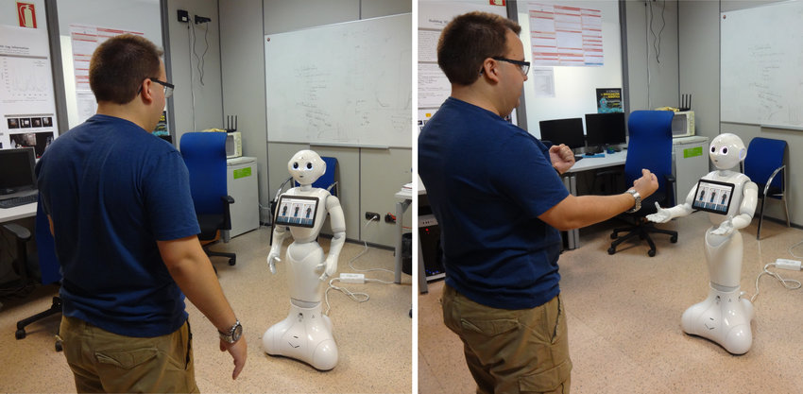
Figure 1: Socially Assistive Robot interacting with a user.
One study investigated the use of a socially assistive robot (SAR) to improve social skills in children with ASD. Over a one-month period, 12 children aged 6 to 12 participated in daily 30-minute sessions at home. The sessions involved storytelling and interactive games targeting key social skills such as emotional understanding, joint attention and perspective-taking. The robot adapted the difficulty of tasks based on each child’s abilities, providing a personalised and engaging experience.[7]
The results showed significant improvements in social-emotional skills among participants. A total of 86% of children reached the highest level in emotional understanding games and 67% succeeded in sequencing tasks. Additional behavioural gains were observed, including better joint attention, improved eye contact, increased communication initiation and greater responsiveness to social cues, demonstrating the overall effectiveness of the intervention.
By providing accessible, adaptive and engaging interventions, SAR offers a scalable solution to complement traditional therapy and foster meaningful developmental gains. As video games are also interactive and engaging, video games should also be able to do the same job.

2.2 Education and Video Games
Since the 1980s, video games have been a significant part of popular culture, transitioning from being purely a form of entertainment to becoming multifaceted tools that can engage players in learning experiences, enhance cognitive skills and provide innovative methods for teaching complex concepts. Their interactive nature and ability to simulate real-world scenarios make them increasingly valuable in educational contexts, offering unique opportunities to captivate learners of all ages. Whether these games are directly educational or not, they can hold a lot of learning opportunities for those that play them, even for those no longer in the educational system.

2.2.1 Examples of Teaching within Non-Educational Video games
Video games come in various forms, with some designed specifically for education and others incorporating elements that teach skills indirectly. The study by Shute [8] demonstrates that video games can significantly enhance cognitive skills such as problem-solving, spatial abilities and persistence. Participants played Portal 2 and Lumosity for eight hours, with Portal 2 outperforming Lumosity. These findings highlight the potential for entertainment games to effectively support education and skill development.
Skill | Portal 2 Improvement (%) | Lumosity Improvement (%)
Problem-solving | 20 | 10
Spatial Skills | 15 | 5
Persistence | 12 | 4
Table 1: Skills being improved by playing video games from Shute’s paper [8].
Barr's study [9] investigated the potential of commercial video games to enhance graduate attributes such as communication, adaptability and resourcefulness. Over eight weeks, students played games including Portal 2, Civilization V, Team Fortress 2, Borderlands 2 and Lara Croft and the Guardian of Light. Results showed significant improvements in the intervention group compared to the control, with games that encouraged collaboration and strategic thinking, such as Portal 2 and Team Fortress 2, being particularly effective. The study concludes that video games can be valuable tools for developing graduate-level skills, though limitations such as reliance on self-reported data and the controlled study environment were acknowledged.
Skill | Intervention Group (+) | Control Group (-)
Communicative Ability | 4.94 | -2.8
Adaptability | 11.31 | -8.25
Resourcefulness | 9.69 | 0.25
Table 2: Graduate skill improvements from Barr's study [9].
Shin and Kim's study [10] highlights how video games within the metaverse can enhance soft skills like communication, teamwork and creativity. Games such as Overcooked and Minecraft promote collaboration, problem-solving and resourcefulness, while multiplayer games like World of Warcraft encourage socialising and teamwork. This research demonstrates that video games, even non-educational ones, can be effective tools for skill development. By combining entertainment with immersive learning, video games in the metaverse offer an innovative and scalable way to teach essential life skills.
From the above research, it is clear that non-educational video games can effectively teach and enhance a wide range of skills. These games achieve this by incorporating elements of collaboration, strategic thinking and problem-solving within engaging gameplay. Together, these studies provide compelling evidence that entertainment video games, although not explicitly designed for education, can effectively teach valuable skills transferable to real-world contexts.

2.2.2 Engagement and Retention Benefits
Engagement and retention are critical factors in both gaming and educational contexts. Video games are designed to captivate players' attention and encourage prolonged interaction, offering valuable insights for educational strategies. Engagement benefits include intrinsic motivation, as games provide immediate feedback, clear goals and a sense of achievement, fostering greater commitment to tasks [11]. Active participation is another benefit, requiring decision-making and problem-solving, which enhances cognitive engagement and critical thinking skills. Retention benefits include repetition and practice, as games reinforce learning through repeated tasks, aiding in memory retention [12]. Adaptive challenges, where games adjust difficulty levels based on player performance, ensure sustained engagement and learning retention.
Bauckhage [13] highlights the importance of achievement and social connections in retaining players. It shows how incorporating elements of achievement and social interaction into educational contexts can significantly enhance student engagement and retention.

2.2.3 Studies on Educational Specific Video Games
There are also educational video games that are purposefully designed to teach specific concepts, skills and lessons, offering an engaging way to enhance children’s learning and development. These games blend education with interactivity, making complex topics more accessible while fostering cognitive and problem-solving abilities.
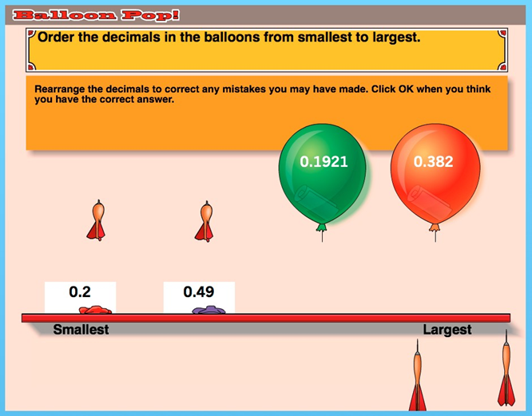
Figure 2: A student playing the "Balloon Pop!" mini-game within the game Decimal Point [14]
The study by McLaren [14] examines the effectiveness of the educational game Decimal Point in improving middle school students' understanding of decimal mathematics. Conducted with 153 participants, the study compared a game-based approach to a traditional non-game instructional method. Students in the game group showed higher performance on both immediate and delayed post-tests, indicating the game's effectiveness in fostering learning retention. Additionally, the game group reported greater enjoyment and made fewer errors during the intervention. The results also highlighted that students with low prior knowledge benefited significantly more from the game-based approach than their higher knowledge counterparts, underscoring the potential of games to support targeted educational needs.
Outcome | Game Group Improvement (Effect Size)
Immediate Post-Test Score | 0.65
Delayed Post-Test Score | 0.59
Low Prior Knowledge Gains | Significant Improvement
Table 3: Learning gains in the game group, with higher post-test scores [14].
Baig and Alotaibi [15] investigated the impact of curriculum-based video games on mathematics performance among 789 female students in Saudi Arabia. Participants, divided into experimental and control groups, were taught using either video games aligned with the curriculum or traditional methods. Results showed that the experimental group outperformed the control group across Grades 4 to 6, with significant gains in post-test scores. The findings highlighted the potential of video games to enhance learning through immediate feedback, motivation and active engagement. Teachers also reported increased student alertness and interaction during lessons when using video games.
Metric | Control Group (Mean ± SD) | Experimental Group (Mean ± SD) | p-Value
4th Grade Post-Test Scores | 23.73 ± 2.34 | 24.56 ± 2.24 | 0.003
5th Grade Post-Test Scores | 24.17 ± 2.77 | 25.34 ± 2.36 | < 0.001
6th Grade Post-Test Scores | 23.61 ± 2.31 | 24.92 ± 2.63 | < 0.001
Table 4: Curriculum-based video games improved post-test scores across Grades 4 to 6.
While the study acknowledged the importance of traditional teaching methods, it emphasised the value of integrating educational video games as a complementary tool. This approach aligns teaching methods with the preferences and needs of modern learners, demonstrating the effectiveness of video games in improving academic performance and student engagement.
Mayer [16] explores how video games can enhance educational outcomes through three research types. Value-added research identifies features like spoken text and conversational language that improve learning. Cognitive consequences research shows games like first-person shooters and puzzle games enhance skills such as attention and spatial reasoning. Media comparison research finds games often outperform traditional teaching methods in subjects like science, mathematics and second-language learning. The paper concludes that video games hold considerable potential in education when designed with evidence-based principles. While more research is needed to optimise their application, this study provides strong evidence that video games can effectively support skill development and educational outcomes, particularly in engaging and interactive contexts.
Feature/Game Type | Cognitive/Skill Improvement | Experiments Observed | Effect Size
Spoken text in games | Enhanced learning outcomes | 9/9 | 1.4
Conversational language | Improved retention | 8/8 | 1.5
Pre-game information | Better conceptual understanding | 7/7 | 0.8
First-person shooter games | Perceptual attention improvement | 17/18 | 1.2
Spatial puzzle games (e.g., Tetris) | Two-dimensional mental rotation | 6/6 | 0.8
Table 5: Video games enhance learning, retention and cognitive skills across multiple research studies.
These studies show that educational video games enhance learning and cognitive skills. McLaren’s research on Decimal Point improved decimal understanding, especially for students with low prior knowledge. Baig and Alotaibi found curriculum-based games boosted math performance and classroom engagement. Mayer’s study highlights how video games improve retention, attention and spatial reasoning, often surpassing traditional teaching. Key features like spoken text and conversational language contribute to learning gains, reinforcing the potential of well-designed games as effective educational tools. Together, these findings underline that video games, when thoughtfully designed, can be powerful educational tools fostering engagement, retention and skill development across diverse contexts.

2.3 Market Gap for Social-Emotional Learning Games
When it comes to educational video games, most people will think of the typical STEM (Science, Technology, Engineering and Mathematics) based learning and educational games. Because of this, there is a bit of a gap in the market for games that focus on social-emotional learning.
While STEM-focused games help children develop logical thinking and problem-solving skills, they often neglect the development of essential social and emotional competencies such as empathy, communication and conflict resolution. Social-emotional learning games have the potential to address these gaps by providing interactive and engaging experiences that teach children how to navigate social situations, regulate emotions and build meaningful relationships [17]. Asadzadeh [18] highlights the effectiveness of educational games in engaging young learners but notes that many existing games prioritise cognitive and academic skills over emotional and social development. This further reinforces the gap in the market for SEL-focused games.

2.3.1 The Focus on Social-Emotional Learning
Social-emotional learning plays a crucial role in a child's development by fostering essential skills such as self-awareness, self-management, social awareness, relationship-building and responsible decision-making [19].
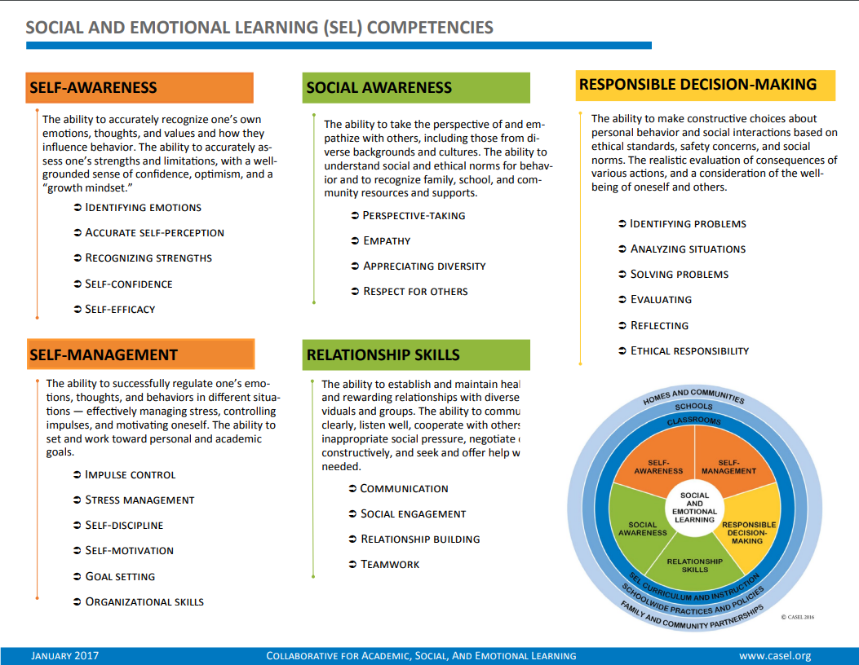
Figure 3: Social and Emotional Learning (SEL) Competencies [19]
The CASEL framework [19] outlines five core SEL competencies that support both personal growth and academic success: self-awareness, social awareness, self-management, relationship skills and responsible decision-making (Figure 3).
These skills not only support personal growth but also enhance academic performance and long-term success. According to the Social-Emotional Learning User Guide, SEL promotes a growth mindset, resilience and a sense of belonging, which are vital for emotional well-being and positive social interactions [20].
The SEL Toolkit outlines various strategies for integrating SEL into educational settings, helping children build emotional intelligence and improve their ability to navigate social situations [21]. Research presented in Evidence for Social and Emotional Learning in Schools [22] highlights the effectiveness of SEL programs, demonstrating their positive impact on student well-being, behaviour and academic success. Despite these benefits, many educational games still focus primarily on STEM subjects, leaving a gap in the market for interactive, engaging tools that support SEL. Addressing this gap through game-based learning can provide children with an immersive way to develop these crucial life skills in a safe and engaging environment.

2.3.2 Comparison with STEM-Focused Games
Educational video games have traditionally focused on STEM subjects, with a strong emphasis on problem-solving, logic and technical skills. Studies show that digital game-based learning can significantly enhance STEM education by increasing engagement and motivation in subjects like math and science [23]. Examples of popular STEM-focused games include Minecraft: Education Edition [65], which teaches coding and engineering concepts, Kerbal Space Program [66], which introduces physics and aerospace engineering and Code.org [67] games, which help young learners develop programming skills in an interactive way [24].
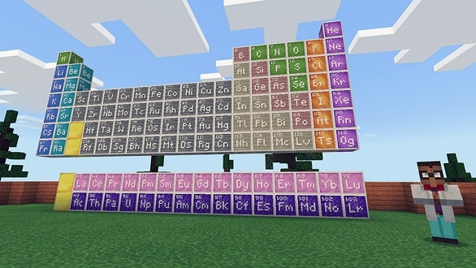
Figure 4: Teaching chemistry in Minecraft: Education Edition [25]
While STEM games have proven highly effective in engaging children and enhancing cognitive abilities, they often lack elements that promote social-emotional learning. SEL-focused games are designed to develop skills like empathy, communication, emotional regulation and conflict resolution, which are equally critical for a child's overall growth. Unlike STEM games, which focus on solving technical challenges, SEL games emphasize navigating social situations, making ethical decisions and fostering collaboration. Hromek [26] suggests that games designed with SEL in mind provide structured opportunities for children to practice these skills in interactive and engaging ways, reinforcing learning through role-playing and cooperative play.
According to García-Gil [27], video games can play a significant role in fostering social skills such as cooperation and communication, especially in online multiplayer settings where players must work together to achieve common objectives. The study also highlights that video games provide an interactive space for children to experience and manage emotions in real-time, helping them build emotional intelligence and improve their ability to handle interpersonal conflicts. While concerns around video game overuse exist, the research suggests that when designed with clear social-emotional objectives, games can become valuable tools for improving children's social interactions and well-being.

2.3.3 Opportunity for Innovation
The integration of SEL in video games presents a significant opportunity for innovation in educational game design. While traditional educational games have primarily focused on STEM subjects, SEL-focused games remain underdeveloped despite growing recognition of their importance in child development. And because of this, there is room for innovation into the game’s industry for creating a game that helps support the building of these SEL skills.
Traditional educational games rarely focus on soft skills such as teamwork, resilience and emotional regulation, yet these are essential for social and professional success. Alloza [28] highlights the potential of commercial video games in training these skills, using facial expression recognition and real-time feedback to help players improve emotional control and decision-making. By integrating adaptive soft-skills training, future SEL games can provide real-time emotional insights, guiding players through complex social situations that mirror real-world interactions.
Innovative SEL games can blend entertainment with structured learning by embedding real-world social situations into gameplay. Multiplayer cooperative games, for example, encourage collaboration, negotiation and perspective-taking, reinforcing SEL skills through shared experiences [29]. Research suggests that video games provide safe practice spaces for developing SEL competencies, allowing children to experiment with different responses and reflect on outcomes. By combining interactive storytelling, role-playing mechanics and adaptive feedback, SEL games can create engaging and meaningful learning experiences.

2.4 Game Design and Development
Designing an educational game requires a balance between engagement and learning, ensuring that players remain immersed while also developing key skills. For SEL games, this involves crafting interactive experiences that reinforce empathy, communication and emotional regulation in a way that feels natural and rewarding. Effective game design incorporates scenario-based learning, user-centric interfaces and age-appropriate mechanics to make the experience both accessible and meaningful. This section explores the key components of game design and development that contribute to creating impactful SEL-focused educational games.

2.4.1 Scenario-Based Learning Approach
Scenario-based learning (SBL) immerses learners in realistic social situations, requiring them to apply knowledge and skills to navigate challenges. In SEL, SBL allows learners to practice empathy, communication and problem-solving in safe environments [30]. In SEL-focused games, SBL creates interactive narratives where players assume roles and navigate real-life social interactions, helping them experiment with different responses and understand social dynamics and emotional regulation [31]. Multiplayer games can foster collaboration, decision-making and perspective-taking, encouraging team-based problem-solving [32].
Scenario cards further enhance SBL by presenting specific social situations, prompting learners to consider various perspectives and develop emotional intelligence [33]. Programs like Quest Atlantis [34] demonstrate SBL’s potential in game-based learning, immersing children in narrative-driven inquiry tasks that foster social responsibility and emotional development.
By integrating interactive role-play and real-world social challenges, SBL in SEL games provides a powerful tool for fostering social skills, helping children navigate social interactions in an engaging and meaningful way.

2.4.2 User-Centric Interface Design
User-Centric Interface Design is essential for designing an educational game, especially those that would focus on SEL. A clear and intuitive layout will help the players (children) navigate and play the game with ease, thus reducing negative emotional responses like frustration and confusion. This in turn allows them to focus on the content the game provides, rather than diverting their focus on the mechanics of the game. Ensuring the game is simple, consistent and accessible using features such as large text, buttons and even visual cues makes the games more inclusive for the younger players as well as those that require the extra bit of help to play the game [35]
For SEL games specifically, interfaces should also support the emotional learning. Features such as expressive characters, tones of voice and clear, reflective prompts can help guide those players into making those important decisions and recognising those emotions [36]. According to Norman’s [37] theory of affordances and signifiers, well-designed interfaces communicate possible actions clearly, helping those users feel confident and in control.

2.4.3 Age-Appropriate Content and Mechanics
Designing a game for a younger audience, especially an educational game, requires some tailoring compared to a game made for adults, specifically in challenge and accessibility. Age-appropriate content ensures that games scenarios, vocabulary and emotional cues align with the developmental stage of the target audience. For younger players, complex game mechanics, instructions and topics can hinder learning and engagement and therefore remove the purpose of an educational video game. Even for non-educational games, keeping the content aligned with the target audience will ensure that their engagement with the product will be focused [35].
Game mechanics also need to be tailored to the target audience. Aspects like controls, error systems and difficulty all need to be considered how they could affect the player’s experience when playing a game. A game such as Elden Ring [68] is designed to be very challenging and would not be suitable for a younger audience due to its complex mechanics, high difficulty level and lack of guided feedback, which could lead to frustration rather than engagement or learning. According to Malone [38], intrinsic motivation is enhanced when children feel competent and in control, making those mentioned design challenges crucial for the user’s engagement.
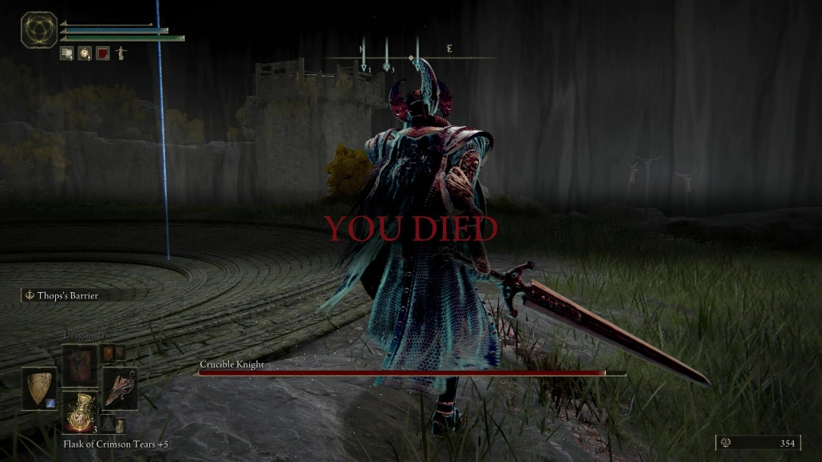
Figure 5: The death screen from the video game Elden Ring, known for its challenging gameplay and minimal guidance [43].
Cervantes [5] investigated the social skill profiles of children aged 6–9, particularly in those with ASD and ADHD, and found notable differences in adaptive and maladaptive behaviours across the groups. Their findings highlight that this age range is developmentally suitable for assessing and shaping social-emotional competencies, as children are capable of engaging with structured, scenario-based tasks and beginning to demonstrate more consistent social understanding. Although the study does not focus exclusively on neurotypical children, it provides a useful benchmark to work from, supporting the idea that educational tools, such as games centred on empathy and decision-making, can be effectively introduced from age six upwards.
In SEL games, it is especially important that those emotional scenarios reflect real-life situations that the user might experience themselves, such as making friends or sharing. Having this relatable content not only aids comprehension but also increases the likelihood of emotional transfer beyond the game environment [39].

2.4.4 Feedback and Rewards Systems
Feedback and reward systems are a crucial component in all video games, not just in educational ones. Feedback provides information about a player’s actions and decisions within a game. For younger players, clear and immediate feedback and help reinforce skills and correct decisions and can help to gentle correct those mistakes without any discouragement [40].
In SEL games, feedback and include verbal prompts, animations or expressions from characters that mirror those real-life social responses. These cues can help children connect their choices to emotional outcomes, thus prompting empathy and emotional awareness [41]. Adaptive feedback systems that adjust responses based on player’s behaviour can also support deeper learning and encourage experimentation [42].
Reward systems can vary between points, badges, achievements and even in-game progression and can motivate continued play and reinforce those learning goals. However, it is important that those reward systems don’t take away from the SEL game’s goals, making the game about the rewards and not the learning. It should support the learning by providing the celebration of improvement and emotional insight rather than superficial achievements [38]. A good, balanced system between the two can sustain the engagement of those young players.
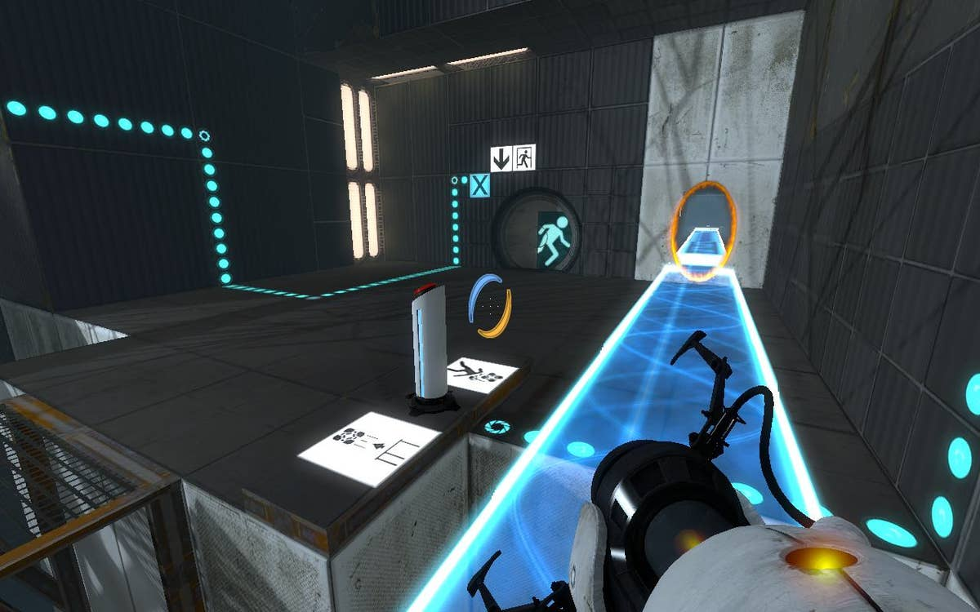
Figure 6: A screenshot from the game Portal 2 [45]
An example would be Portal 2 [69] which has a strong reward system that supports its core focus on logical thinking and problem-solving. Progress and story unfold through clever dialogue and satisfying puzzles, rewarding player intelligence without relying on arbitrary points or unlocks [44].

2.4.5 Development Tools and Methodology
Developing an educational game, particularly one that focuses on SEL, requires careful planning and the selection of appropriate tools and methods. A clear development methodology ensures that educational objectives and user experience remain aligned throughout the design process [46].
A commonly used approach is iterative development which involves prototyping, testing and refining the game in cycles. This method allows for continuous user feedback and improvements, which is especially important when designing games for children as usability and engagement can vary between the different age groups [47].
Game engines such as Unity [70] and Unreal Engine [71] offer flexible development environments with support for 2D and 3D graphics, animation and audio, all aspects that are key for creating an immersive, educational experience [48]. These engines also support plugins and assets that can speed up development without compromising customisation.
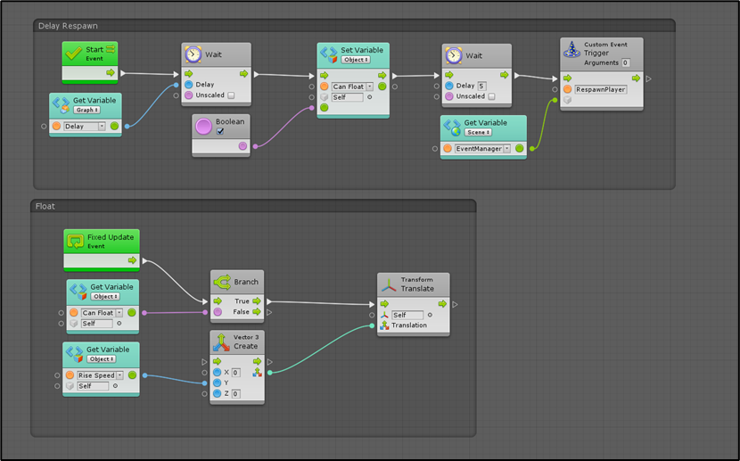
Figure 7: Example of a visual scripting setup using Bolt in Unity [56].
Visual scripting tools, such as Unity’s Bolt or Unreal’s Blueprints, allow designers with limited programming experience to implement game logic, which is useful for smaller teams or education-focused developers [49]. Paired with user-centric design and regular testing, these tools help maintain a focus on accessibility, age-appropriateness and emotional engagement.

2.5 Evaluation and Playtesting
Evaluating and playtesting an educational game is crucial to ensuring that it meets both its engagement and learning objectives. For a game focused on social-emotional learning, testing must assess not only usability and enjoyment but also whether the game effectively fosters skills such as empathy, communication and emotional regulation.

2.5.1 Metrics for Success: Engagement and Learning Outcomes
Measuring the success of an educational video game usually involves evaluating player engagement and the and the achievement of learning outcomes. Engagement can be measured through metrics such as time spent playing, number of completed sessions, number of voluntary sessions and even player-reported enjoyment [50].
For SEL games, learning outcomes should be focused on observable improvements in social skills, emotional regulation and decision making. Testing the user’s skills both before and after playing the game is a solid assessment method to evaluate whether or not the game has fostered the desired skills [51].

2.5.2 Ethical Considerations in Testing
When testing educational games with children, ethical considerations are critical. It is important to design testing environments that are non-judgemental and supportive to minimise any potential pressure and anxiety. Developers must ensure that participants' safety, privacy and emotional well-being are prioritised at every stage of testing. Any data collected from the tests must be anonymised to protect the participant’s identities [52].

2.5.3 Parental Consent in Testing
Obtaining parental consent is a fundamental requirement when conducting playtesting with children. Parents or legal guardians must be fully informed about the purpose of the study, the type of data being collected and their child's right to withdraw at any time without consequence [53]. Clear and accessible information sheets and consent forms should be provided to ensure transparency and build trust.

2.6 Challenges and Solutions
Creating an educational SEL game for young children involves a range of challenges. Developers must balance engagement with educational outcomes [54], accessibility [55] and maintain developmental appropriateness to support effective learning [51].

2.6.1 Accessibility for Young Players
Accessibility has always been an ever-evolving factor within the games industry. In recent years, developers and hardware manufacturers have taken significant steps to make gaming more inclusive for players with physical, cognitive and sensory differences. One major milestone is the Xbox Adaptive Controller [57], developed by Microsoft, which allows players with limited mobility to customise their input setup using external switches and devices. Many games now also feature colourblind modes, custom controls, text-to-speech and high contrast visuals. Titles like The Last of Us Part II [58] have set new standards by offering extensive accessibility options for players with visual, auditory and motor impairments, reflecting the industry’s growing focus on inclusive design.
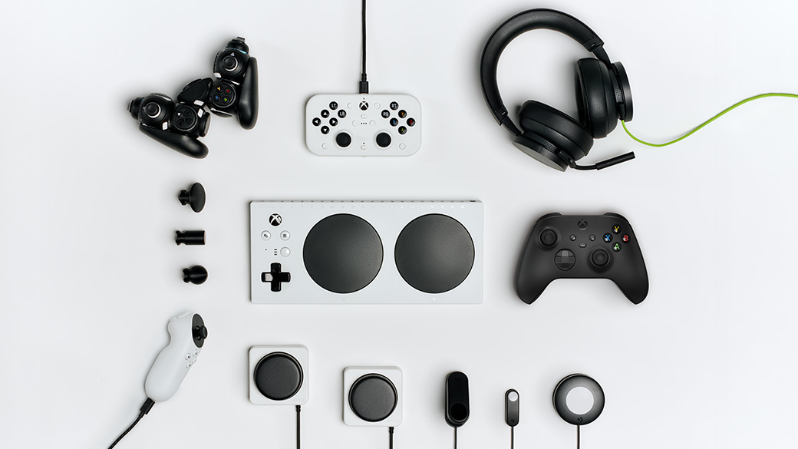
Figure 8: The Xbox Adaptive Controller and a range of compatible accessibility peripherals [57].
Accessibility is a critical factor when designing educational games for children. Young players come with diverse abilities, learning styles and developmental needs and failing to accommodate these differences can exclude significant portions of the intended audience. Accessibility in games involves more than just technical options. It includes visual design, control simplicity, audio support and inclusive content [55].

2.6.2 Developmental Appropriateness of Game Content
Educational games must match the cognitive, emotional and social stages of their target audience to remain effective. If content is too complex or abstract, younger players can become overwhelmed, reducing both engagement and learning outcomes [51]. Language should be simple and relatable, with scenarios based on familiar experiences like making friends or sharing. The game’s difficulty must also be balanced, too easy risks boredom, while too hard risks frustration [51].
In SEL games specifically, it is important to introduce emotional scenarios gradually and ensure that emotional cues (such as facial expressions or tone of voice) are easily recognisable to younger players [51]. Designing content with the developmental stage in mind enhances both the educational value and the overall gaming experience.

2.6.3 Balancing Fun and Educational Goals
One of the greatest difficulties when creating an educational game is finding that balance between making the game fun for the player and ensuring it delivers the desired educational content. If a game feels too much like a traditional lesson, younger players may disengage quickly. However, if the game focuses on the gameplay and not the educational teachings, the desired learning outcomes could be lost [54].
Successful educational games need to integrate the learning elements seamlessly into the gameplay. It should feel like a natural part of the player’s progression rather than an interruption. Mechanics such as problem-solving, decision-making and reflection can be intertwined with the game’s challenges and storylines, allowing the player to learn through active participation [51].
Playtesting with the target audience is crucial to finding and maintaining that balance. Observing how those players interact with the different elements of the game, whether it be the gameplay or educational aspects, can provide insight into whether the learning components are engaging enough or require adjustment.

2.7 Potential Impact of the Game
A well-designed educational game that supports SEL has the potential to make a meaningful impact on children’s development. By combining interactive storytelling, relatable scenarios and decision-based gameplay, such games can help children build empathy, self-awareness and interpersonal skills in a way that feels engaging and natural [17].
Unlike traditional teaching methods, video games offer immersive environments where players can explore emotions, make choices and witness the consequences in a safe and controlled space. This interactivity not only reinforces understanding but can also lead to long-term behavioural change [26]. SEL games also provide an inclusive platform for children with different learning styles or neurodivergent conditions, who may struggle with more rigid classroom approaches.

2.7.1 Complementing Traditional Teaching Methods
Educational video games, especially those focused on SEL, can effectively complement traditional teaching methods. While classroom lessons often rely on structured instruction, games provide interactive environments where children can practise empathy, emotional regulation and decision-making in safe, simulated scenarios [17]. Through repetition and immediate feedback, games can help reinforce lessons in a way that feels engaging and personal [59].
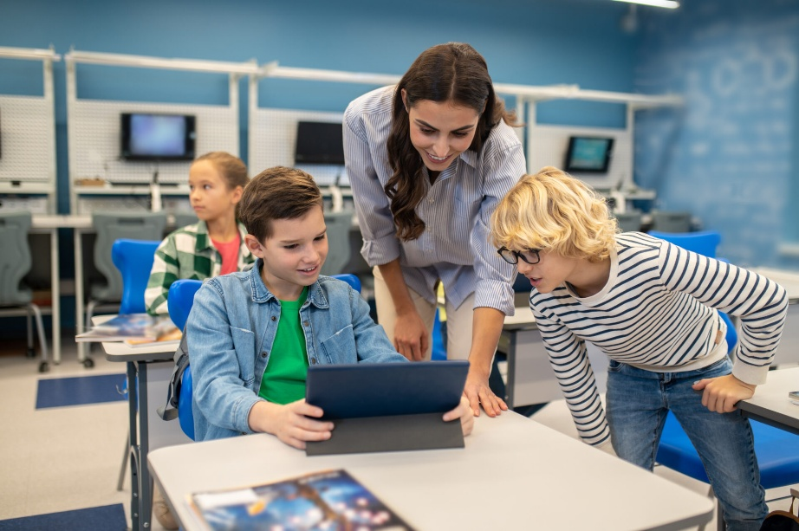
Figure 9: A teacher guiding students through a digital learning game [60].
Rather than replacing teachers, SEL games can extend learning beyond the classroom and offer alternative routes for understanding. They also provide insight into how children make choices and respond emotionally, helping educators better support individual needs. When thoughtfully integrated, educational games can diversify the learning experience and enhance traditional methods with active, play-based learning [26].

2.7.2 Supporting Families and Shaping the Future of SEL Games
Social-emotional learning games have the potential not only to support classroom learning but also to engage families in meaningful ways. When parents and children play together, games can open up opportunities for conversations about emotions, relationships and decision-making. Co-play experiences can reinforce the lessons embedded within the game, helping children apply these skills in real-world contexts [26].
By involving families, SEL games can extend their influence beyond schools, creating a more consistent learning environment across home and educational settings. Parents can gain insights into their child’s emotional development while fostering communication and empathy through shared experiences [17].
As interest in SEL-focused games grows, it is also driving innovation within the gaming industry. Developers are exploring new ways to blend education with entertainment, including adaptive feedback systems, scenario-based storytelling and collaborative play models that encourage both social and emotional skill-building [59]. Family engagement provides valuable feedback, highlighting the importance of inclusivity, accessibility and emotional resonance in future game development. Through supporting families and inspiring innovation, SEL games have the potential to redefine how emotional intelligence and social skills are taught, making learning a collaborative and evolving experience.

3. Research Methodology
This chapter outlines the research strategy used to inform the design, development and evaluation of Social Shuffle. A mixed-method approach was employed, incorporating literature-based inquiry, qualitive user feedback and iterative design principles. The methodology was designed to ensure that the game aligned with developmental theories, frameworks and the needs of the target audience.

3.1 Research Approach
A qualitive research approach was adopted to explore how children develop social-emotional skills and how these can be supported through interactive gameplay. The approach involved synthesising insights from educational psychology, child development, user interface design and serious game development. This allowed for a theory-informed process that addressed both learning outcomes and accessibility.
The research drew heavily on secondary sources, including peer-reviewed journals, educational toolkits and SEL frameworks such as CASEL [19], as well as supporting research from Lieberman [17] and Asadzadeh [18] which explore the benefits and application of game-based learning in early childhood contexts.

3.2 Literature Review
An extensive literature review was conducted to provide a foundation for the game’s learning objectives and structure. Key areas explored included:
- Social skill development in children [1] [5].
- Neurodivergence and accessibility in game design [5] [6] [55].
- SEL frameworks [19] [20] [22].
- Engagement and motivation in educational games [11] [12] [59].
This review helped identify a gap in the market for educational games that prioritise emotional learning over academic or STEM content [18] [27]. It also reinforced the importance of scenario-based learning [30] [32] and how it can be implemented in interactive digital environments [33] [34].

3.3 Development Methodology
An iterative development methodology was used, consistent with standard best practise in game design [46] [47]. Initial testing was conducted using a physical paper prototype. Once core mechanics were validated, the game was then implemented in Unity. Scriptable Objects were used as a modular data management system, replacing earlier hard-coded implementations to improve scalability, maintainability and testing flexibility.
This shift to a data-driven architecture also aligns with recommendations from Fullerton [46] and Squire [59] who advocate for flexible, user-centred development practices in educational media.

3.4 Evaluation and Playtesting Strategy
To evaluate the game, user testing was conducted with adult participants simulating the mindset of a player aged 6-9. Direct testing with children was not feasible due to ethical and time constraints, a limitation acknowledged by Flewitt [52]. Participants were briefed on the typical emotional and cognitive characteristics of the target age group and completed a structured feedback form after playtesting.
The form combined quantitative Likert-scale questions with open-ended responses, capturing both usability data and participant reflection. This method enabled the combination of quantitative data and open-ended feedback, providing a well-rounded perspective, an approach commonly recommended for evaluating educational games in their early development stages [51].

3.5 Ethical Considerations
No identifiable personal data was collected during testing. All participants provided informed consent after being briefed on the nature and purpose of the project. By asking adults to simulate younger users, the project avoided the need for direct parental consent, in line with ethical recommendations for minimal-risk studies [53]. All feedback data was anonymised and stored securely.

4. Project Design and Implementation
For this project, a game was designed and developed called Social Shuffle, a card-based educational video game to be used as a tool in teaching children social skills. The development of this game was guided by the goal of creating an engaging, age-appropriate game that teaches children social-emotional skills through interactive play. The project aimed to blend educational content with intuitive gameplay, focusing specifically on empathy, emotional recognition and decision-making. Design decisions were heavily influenced by literature on game-based learning, accessibility and child development as discussed in section 1 of this paper.

4.1 Concept and Aim of the Game
The aim Social Shuffle (Figure 10) is to help children aged 6-9 develop empathy and emotional awareness through an interactive and engaging card-based video game. The game is designed around the principles of SEL, allowing players to practise recognising emotions, making thoughtful decisions and understanding the perspectives of others in a safe and playful environment.
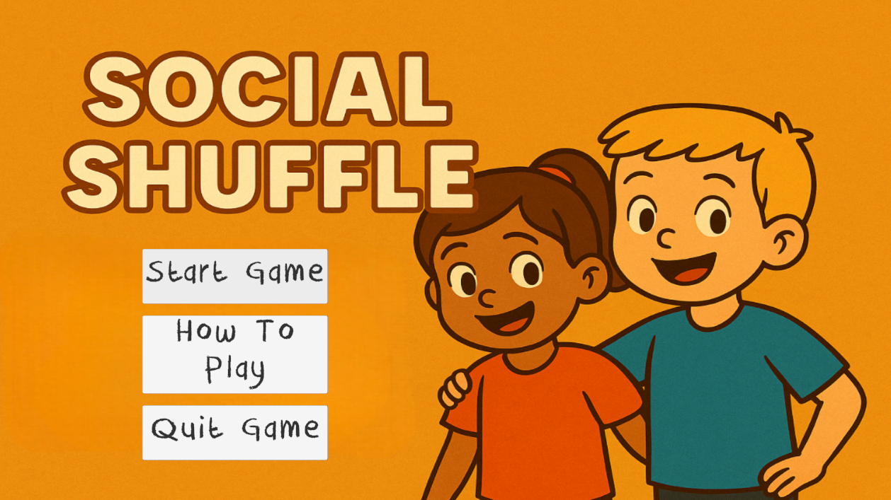
Figure 10: The main menu of the game designed called Social Shuffle.
The core gameplay centres around presenting players with a social scenario such as someone feeling left out and giving them four possible response cards. The player must then drag one card into an answer zone before confirming their choice. The selected response is then evaluated using a feedback system that reinforces or gently corrects behaviour, supported by an engaging scoring mechanic.
As the game progresses, new scenarios are introduced to the player along with some surprising modifiers that increase difficulty and encourage deeper thinking. These features are designed to mirror real-life emotional challenges while maintaining an age-appropriate level of complexity and engagement. The game promotes active learning through reflection, helping children build confidence in their social decision-making skills.

4.2 Early Game Designs
Before development began in Unity, early design efforts focused on testing and refining the core concept of Social Shuffle through non-digital means. This process began with the creation of a physical prototype using paper cards and handwritten scenarios (Figure 11). Designing the game in a physical format helped to solidify the intended structure and allowed for early testing of features such as the modifiers, assessing which ones were effective within the card game format and which were not.
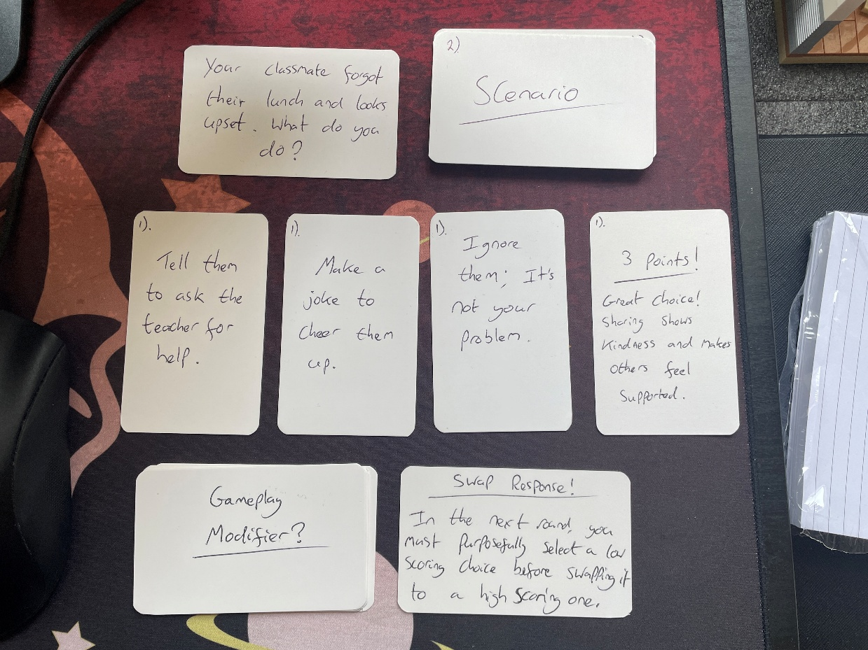
Figure 11: The original paper-based version of Social Shuffle, used to test gameplay mechanics and features.
After validating the core idea using the physical version, early wireframes were created to help plan out the game’s user interface and overall design, based on the intended visual and structural layout. Creating these wireframes (Figure 12) helped ensure the game’s structure would remain simple, accessible and intuitive, especially for the target audience of 6–9-year-olds.
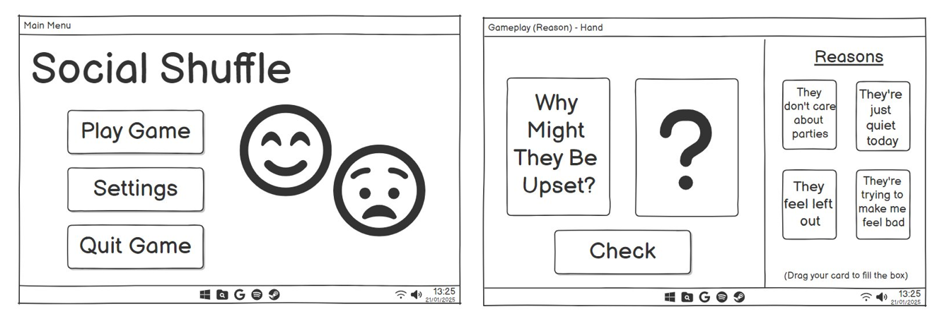
Figure 12: Early wireframe mock-ups of the main menu and gameplay scene for Social Shuffle.

4.3 Game Mechanics and Flow
Social Shuffle follows a simple but structured flow. Each round begins by presenting the player with a social scenario where the player would need to think empathetically. Below the scenario are four response cards, each representing a possible reaction to the scenario (Figure 13).
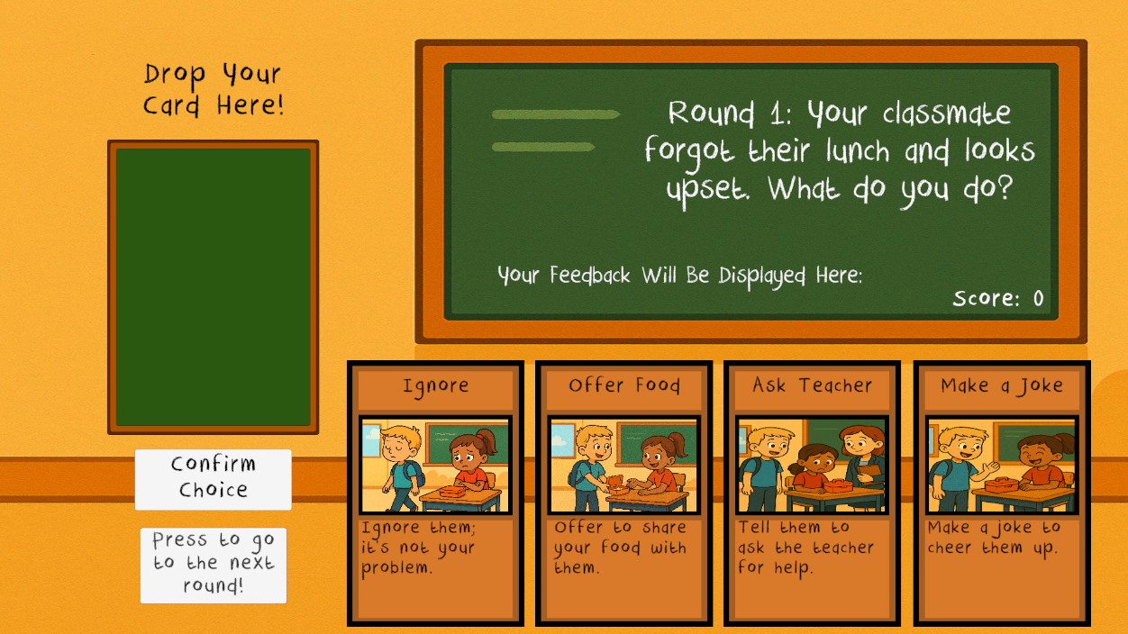
Figure 13: A sample social scenario with the four response cards displayed.
The player interacts with the game by dragging one of the cards into the answer zone and clicking a confirm button. Each card has a points value based on how empathetic or appropriate the response is. After clicking confirm, the game delivers written feedback that either affirms or encourages reflection depending on what card was selected (Figure 14).
As the player progresses, the game tracks their score. New scenarios and card sets are introduced in each round ensuring that a variety of SEL topics are covered. To add variety and challenge, some rounds introduce modifiers that change how the game is played, such as hiding cards or limiting time for making those decisions. This structure keeps the experience dynamic while reinforcing key learning objectives.
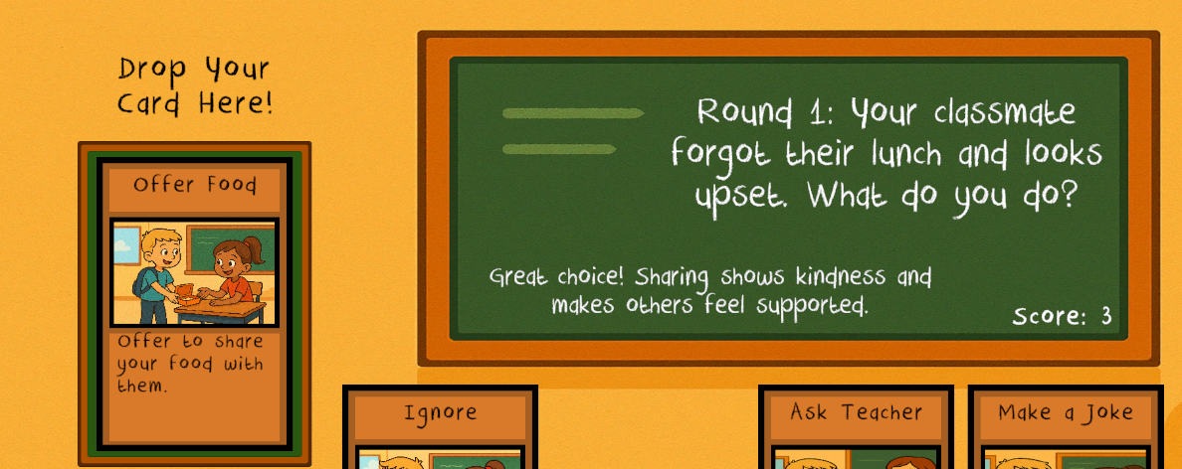
Figure 14: Example of the feedback shown after the card has been confirmed.
After all the rounds have been played, the game ends with an end screen (Figure 15) that displays the user’s final score and assigns the player a grade, offering both a sense of completion and positive reinforcement for effort and learning.
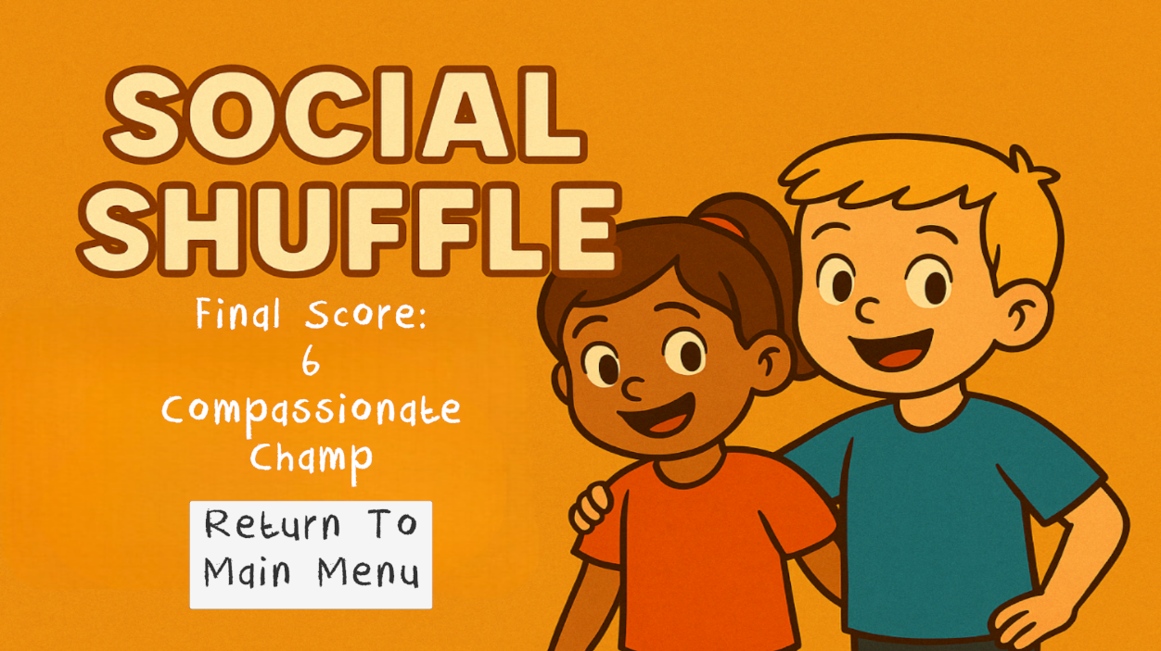
Figure 15: The end screen of the game, showing the player their score and grade.

4.4 Software Development and Tools
The development of Social Shuffle followed an iterative design methodology where each stage of production was built upon continuous feedback and observation. This approach allowed flexibility in adapting the game’s mechanics, visuals and structure to better meet the needs of the desired target audience.
The game was created in Unity 2022.3.4f1 [72], a game engine known for its flexibility in 2D UI-based design and its compatibility with C# scripting. The game also makes use of Scriptable Objects [73] to manage all the scenario and card data which replaced earlier plans for the game that made use of JSON files. This shift allowed more direct control and visibility of game content with the Unity editor, simplifying testing and updating.
However, during development, a key issue emerged due to limitations of the Unity version the game was made with. Unity 2022.3.4f1 does not support multi-scene editing, a feature that would have allowed the End Screen to be built as a separate scene for cleaner structure and logic. This limitation presented a dilemma: either upgrade Unity to a newer version, risking compatibility issues and project instability or find a workaround within the current setup. To avoid jeopardising the project’s stability, the decision to keep the existing version and instead placed the End Screen directly into the Game scene was made. This was done by converting the initial End Screen scene into a game object and inserting it into the Game scene, initially keeping it inactive. Then using scripts, it was enabled at the end of the final round and shown to the user. This approach maintained the project’s integrity while achieving the intended functionality.
Another key design decision was the shift to a data-driven structure for the game’s content. Initially, the game’s development began by hard coding each scenario and response card directly into the game logic. However, early on in development, it was recognised that this approach was inefficient and inflexible, restricting how easy it would be to add more cards and scenarios in future. As a result of this, the idea to use Scriptable Objects to create a reusable system that functioned like a lightweight, in-editor database was implemented. This allowed the game to dynamically populate UI elements with the correct scenario text, card content, feedback and images based on the current round. The change significantly improved scalability, reduced repetition in code and made testing and future updates much more manageable.
Core gameplay systems such as drag-and-drop interaction, score tracking and feedback delivery were implemented using Unity’s UI Toolkit. Additional components were developed to support modifiers, audio control and end screen logic, ensuring a complete gameplay loop from start to finish.
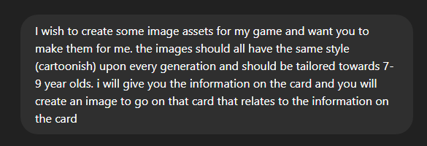
Figure 16: An example prompt used to create the image assets using ChatGPT's image generation tool.
All visual assets (including characters, backgrounds and card images) were generated using ChatGPT’s image generation tool, ensuring a consistent style while allowing for quick iteration. The background music was sourced from a royalty-free music library called “freepd.com” [61] to avoid copyright issues and ensure the game remained accessible and sharable for educational use.

4.5 Accessibility and Age Appropriateness
Ensuring that Social Shuffle was both accessible and developmentally appropriate was central to its design. Originally, the game was aimed at being developed for children ages 3-6, aiming to introduce early basic emotional understanding through visual gameplay. However, following feedback received during the interim viva and further research into developmental psychology and reading ability, this age range was reconsidered.
As mentioned in 1.4.3 of this paper, Cervantes [5] found that children ages 6-9, including those with ASD and ADHD, show greater consistency in recognising social cues and responding to structured activities. This suggests that this age group is better suited for educational games that require players to interact with the themes present in Social Shuffle. Additionally, children within this age group are much more likely to have developed a suitable foundation of reading skills, making them more capable of understand the game’s written elements. As a result, the target age group for Social Shuffle was shifted to 6-9 years old, ensuring that the gameplay and educational content aligned more closely with typical cognitive and emotional development and that stage.
This change then influenced many design decisions. The game’s language, scenarios and pacing were tailored to suit early primary school-aged children, ensuring that the content reflected real-life situations that a child at that age could relate to. All the text within the game is presented in a clear, simple language to support children at that age that might still be developing those foundational literacy skills.
From an accessibility standpoint, the game uses a clean visual layout with large fonts, minimal distractions and intuitive UI components. Buttons are clearly labelled and spaced for ease of interaction and core mechanics such as drag-and-drop were chosen for their simplicity. These features were designed not only for neurotypical children but also with neurodivergent players in mind, including those with ADHD or ASD. High-contrast visuals, non-distracting colours and consistent navigation patterns help create a calm and usable interface.

4.6 Database Design
Although this project does not use a traditional relational or JSON-based database, a database-like structure was implemented using Unity’s Scriptable Objects system. This system provides a flexible, lightweight solution for storing structured data within the Unity Editor, allowing for scalable content management without the complexity of external database integration.
Each scenario in the game was represented by a custom Scriptable Object containing the scenario text, related response cards and feedback messages. Similarly, each card was defined using its own Scriptable Object which included the response text, point value, visual asset reference and feedback string. These were group and linked to their corresponding scenario to ensure consistent and dynamic data loading during gameplay.
This approach allowed the game to:
- Dynamically populate UI elements based on the selected scenario.
- Simplify content updates by enabling non-programmatic edits directly in the Unity Editor.
- Reduce code redundancy and hardcoding.
- Improve testing and content scaling by treating each data object as a modular component.
The use of Scriptable Objects also ensured that content could be cleanly separated from logic, improving maintainability and reducing the likelihood of logic-related errors when modifying game data.

4.7 Modifiers and Progressive Challenge
To maintain engagement and encourage deeper reflection, Social Shuffle introduces a set of gameplay modifiers that are activated on the last scenario. These modifiers add light difficulty adjustments to help develop decision-making under pressure as well as to simulate the unpredictability of real-life social situations, an aspect that individuals with ASD often find challenging due to common preference for routine and difficulty adapting to unexpected change [5].
Before the third round has begun, one of three modifiers are randomly selected and then applied to the upcoming round. The three modifiers are:
- Limited Choices – two random response cards are removed from the player’s hand and they have to choose which card out of the two they think would be the most empathetic, even if both of them are low-scoring cards, encouraging players to evaluate their choice more carefully.
- Swap Response – the player must first choose what they think is a low scoring card (less empathetic) and the replace it with a high scoring card (more empathetic) and they then earn the difference; otherwise, they receive no points. This modifier encourages self-correction and reflection as well as encouraging players to understand what a less empathetic choice would be.
- Quick Thinking – A 30-second timer is introduced. If the player does not confirm their card selection in time, they receive 0 points along with a “Time’s Up” message. This simulates real-world pressure and reinforces fast, emotionally intelligent decision-making.
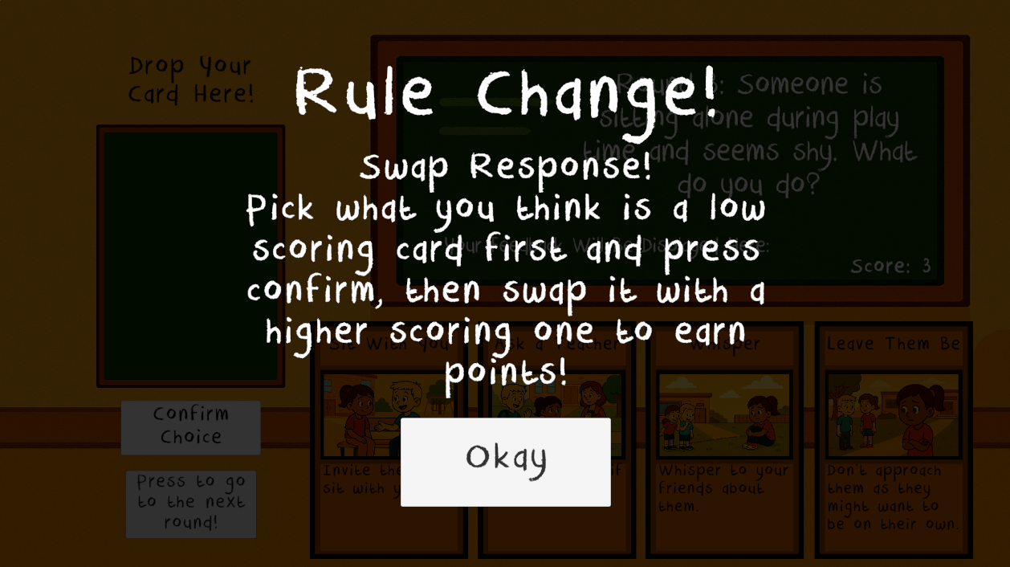
Figure 17: Modifier pop-up showing the player what modifier has been applied, in this case it is Swap Response.
Each modifier was carefully tested to ensure it added challenge without overwhelming players, especially those at the targeted age range. They were designed not to interfere with core learning goals but rather support emotional adaptability.

4.8 Audio and User Feedback Systems
Audio in Social Shuffle plays an important role in enhancing engagement without overwhelming the player. A continuous background music track is used through the Main Menu, How To Play screen and the Gameplay scene to provide consistency and a calm atmosphere. Care was taken to ensure that the music chosen was subtle and non-distracting, aligning with the needs of the target audience and neurodivergent users. As mentioned earlier, the track was sourced from a royalty-free music website [61], ensuring legal use and accessibility for public release.
To avoid abrupt changes between scenes, the music system was designed using a persistent audio object that carries over across scenes via “DontDestroyOnLoad()”. The only exception is when the player returns to the Main Menu from the End Screen, at which point the music resets to prevent overlap or looping glitches.
Beyond audio, Social Shuffle uses visual feedback after each round to reinforce learning. Once a card is confirmed, the game displays a short message indicating whether the choice was appropriate, accompanied by the number of points you’ve earned. This system supports positive reinforcement, helping children understand emotional outcomes without fear of failure. The End Screen further build on this by showing the final score and an encouraging grade, such as “Kindness Cadet” or “Feel-good Friend”, giving the player a sense of accomplishment.
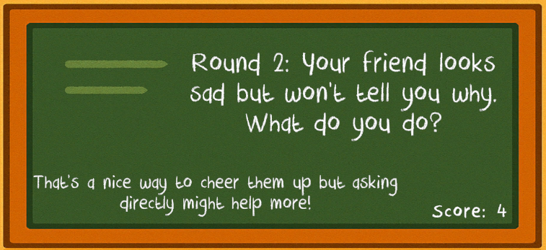
Figure 18: The feedback system showing the player their score and feedback from the card they just played.
Together, these feedback systems contribute to a more immersive and emotionally supportive gameplay experience, helping children feel guided and motivated to improve.

4.9 Development Overview and Progress Reflection
While much of the development journey has been discussed throughout this section, this project has ultimately been a valuable learning experience in combining educational theory with practical game design. Working through challenges such as Unity’s version limitations, balancing SEL goals with engaging mechanics and adapting the game for real-world use has strengthened my skills in both planning and problem-solving. Above all, Social Shuffle reinforced the importance of designing with empathy—both for the player and throughout the creative process.
The project followed a structured and iterative approach, beginning with early concept validation through a physical prototype. This hands-on stage informed many of the mechanics that would later be implemented digitally. Early Unity development began with hard-coded content, but this was quickly replaced by a dynamic, database-driven system using Scriptable Objects to simplify scalability and testing. As development progressed, new features were added, including gameplay modifiers, an end screen system and audio feedback, each one contributing to a more complete and accessible experience.
A full breakdown of the development stages, including key milestones and technical decisions, is provided in the Appendix.

5. Evaluation
This section evaluates the effectiveness and educational impact of Social Shuffle by examining the testing process, analysing user feedback and reflecting on the game’s intended outcomes. The evaluation focuses on how well the game achieved goals in promoting SEL, as well as the accessibility and usability of the final product. Insights gathered from playtesting are used to assess the game’s strengths and potential areas for improvement.

5.1 Playtesting Approach
To evaluate the effectiveness, clarity and educational impact of Social Shuffle, a structured playtesting process was carried out. Since the target audience could not be directly involved due to ethical considerations and time constraints, adult participants were invited to take part in a simulated playtest experience. They were asked to play the game while imagining themselves as a 6-9-year-old, helping to simulate the emotional and cognitive perspective of the intended players.
To guide participants, a testing document was distributed that introduced the game, outlined its purpose and provided context for the mindset simulation. This document included examples of typical behaviours and though processes for children in the target age group such as struggling with inclusion, navigating friendships and recognising emotions. It also included detailed instructions on how to download, play and replay the game multiple times in order to experience all three gameplay modifiers. The full testing document that was handed out to participants can be found in the Appendix.
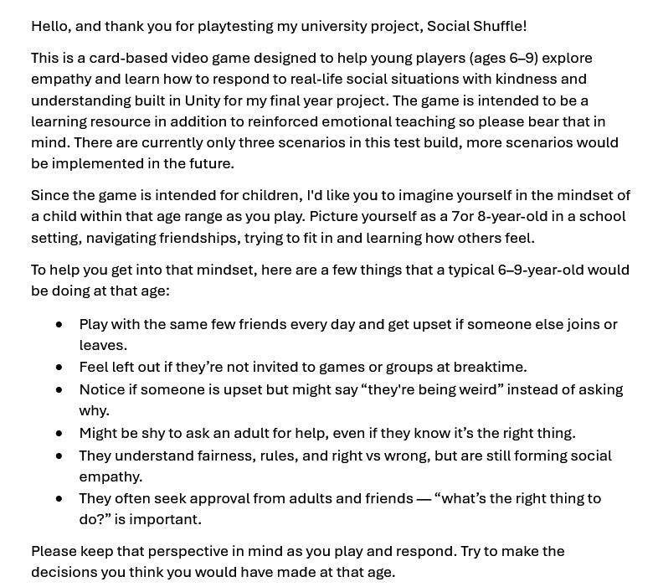
Figure 19: Excerpt from the instruction document given to playtesters, guiding them through the testing process and mindset simulation.
After playing the game, participants were asked to complete a Google Form containing a mix of Likert-scale and open-ended questions. These questions (Table 6) assessed various aspects of the game including UI clarity, emotional content, modifier understanding, accessibility and overall engagement.
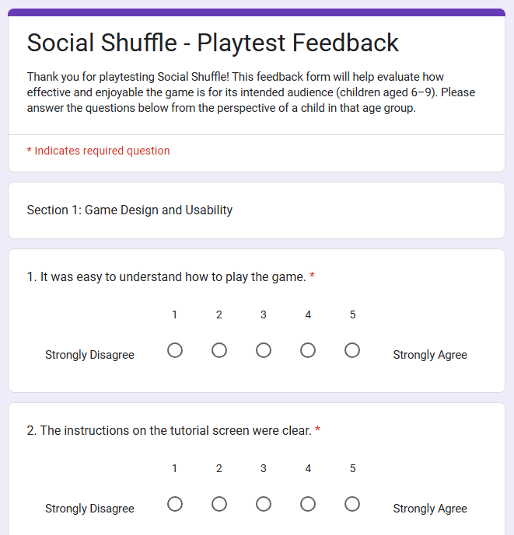
Figure 20: Sample questions from the Google Form used to collect structured feedback.
A total of eight responses were collected. This feedback informed the evaluation process that follows, with both quantitative summaries and selected quotes used to reflect tester perspectives.

No. | Question | Question Type
1 | It was easy to understand how to play the game. | Likert scale
2 | The instructions on the tutorial screen were clear. | Likert scale
3 | The buttons and interactions felt responsive. | Likert scale
4 | The visuals and layout were easy to navigate. | Likert scale
5 | The game had an element of fun as well as educational. | Likert scale
6 | I understood what each scenario was asking me to do. | Likert scale
7 | I was able to tell which card was the most empathetic. | Likert scale
8 | The feedback after selecting a card helped me understand the outcome. | Likert scale
9 | The game made me think how others might feel. | Likert scale
10 | The game would be a helpful tool for children to learn about empathy. | Likert scale
11 | The modifiers made the game more interesting. | Likert scale
12 | The Limited Choices modifier was easy to understand. | Likert scale
13 | The Swap Responses modifier made you try and understand what a “bad” response would be. | Likert scale
14 | The Quick Thinking modifier encouraged players to think “with their gut” or instinct. | Likert scale
15 | Which modifier did you enjoy the most and why? | Open-ended
16 | Did the game feel like it was aimed at children aged 6-9? Why or why not? | Open-ended
17 | What would have helped you better understand what to do in the game? | Open-ended
18 | What would you change or improve about the game? | Open-ended
19 | Did you notice any bugs/issues with the game that affected your gameplay experience? | Open-ended
Table 6: The full list of questions found on the testing feedback Google Form

5.2 Feedback and Findings
The results from the playtesting feedback were generally very positive, indicating that Social Shuffle met its intended goals in terms of clarity, accessibility and emotional learning.
A summary of the most relevant findings is provided below:
Feedback Area | Summary of Responses
UI Clarity | 7/8 testers rated the UI as very clear and easy to use. With only one selecting neutral.
Scenario Comprehension | All testers felt the scenarios were age-appropriate and easy to understand.
Modifier Understanding | 6/8 found the modifiers understandable; two suggested clearer explanations or tutorials.
Visual Accessibility | Most testers praised the large text, clean layout and minimal visual distractions.
Emotional Learning | 5/8 agreed the game encouraged emotional thinking; others were neutral or unsure.
Overall Enjoyment | 7/8 reported they enjoyed the game and would recommend or play again.
Table 7: The feedback given from playtesting via the Google Form.
Participant comments further supported these findings, particularly regarding the game’s clarity and gentle approach to feedback. For example:
Question 16. Did the game feel like it was aimed at children aged 6-9? Why or why not?
“Yes, it was simple and short so it was the right length for a child that age to focus and complete.”
Question 15. Which modifier did you enjoy the most and why?
“The swap response modifier was my favourite since it encourages the player to think carefully about what a bad response would be as well as what would be a better response, I believe this helps reinforce how to be empathetic towards other children.
One area identified for improvement was the clarity of some of the modifier rules. While the majority understood the added challenges, a few participants indicated that younger players might need more on-screen guidance or visual indicators when a modifier is active.
Overall, the feedback suggests that Social Shuffle is well-designed for its intended age group. Players found the scenarios relatable, the interface intuitive and the core gameplay enjoyable. The game’s structure and scoring system were also seen as motivating particularly when paired with the encouraging End Screen and emotional reinforcement messages. However, is it important to acknowledge a key limitation: while adult testers provided valuable insights, the effectiveness of the game in teaching social-emotional skills cannot be fully validated without testing on actual children. Asking adults to simulate a child’s understanding, especially in areas like emotional recognition and development, in inherently limited and cannot fully replicate how younger users would interact with the game. As such, while testing provides a strong indication of usability and structure, further research involving child participants would be necessary to confirm the game’s educational impact.

5.3 Reflection on User Impact
Despite the constraints of adult-only testing, the results suggest that Social Shuffle has strong potential as an educational tool for promoting SEL in children. Testers reported that the game encouraged reflection, presented age-appropriate content and delivered feedback in a supportive and constructive way. These elements are essential when working with young audiences, especially in helping them understand emotions, make kind choices and think from other perspectives.
The game’s gentle reinforcement system and visual clarity were highlighted as strengths that could support neurodiverse players as well, particularly those with ADHD or ASD. While the full impact on emotional development cannot be confirmed without testing on children, the game structure aligns well with recognised SEL principles and provides a safe, low-pressure environment for practising empathy-based decision-making.
Looking forward, Social Shuffle could be refined and tested further in educational or therapeutic settings to evaluate its real-world effect on emotional growth and social awareness. The feedback gathered here forms a strong foundation for that future work.

6. Conclusions and Recommendations
This project set out to explore how digital games can be used to support social-emotional learning in children aged 6-9. Through the design, development and evaluation of Social Shuffle, it has demonstrated that video games can provide meaningful opportunities for children to practise empathy, reflect on emotional choices and build social understanding in a safe and engaging environment.
The game successfully met its original aim by integrating realistic social scenarios with interactive, feedback-driven gameplay. Players are encouraged to consider the emotional outcomes of their choices and reflect on the impact of their behaviour, key components of SEL. The game’s design was informed by literature in developmental psychology, game-based learning and accessibility, resulting in an interface and mechanic set that was approachable, inclusive and suitable for the target age group.
Evaluation results, gathered through structured playtesting with simulated players, indicated high levels of clarity, accessibility and enjoyment. Most participants found the scenarios east to understand, the feedback meaningful and the UI intuitive. The addition of gameplay modifiers introduced variation and challenge without overwhelming the player and taking away from the aim of the game. However, some feedback pointed to the need for improved clarity around how the modifiers worked, suggesting room for further refinement in tutorial design and in-game explanation systems.
Recommendations for future development:
- Expand testing to include actual children aged 6-9 to gather more authentic data on emotional engagement and comprehension.
- Improve tutorial guidance with clearer visual or interactive examples of how each modifier functions before gameplay starts.
- Introduce more diverse scenarios, including themes of cooperation, disagreement and inclusion to broaden emotional coverage.
- Delve deeper into additional accessibility options such as voiceovers to further support non-readers or children with emerging literacy skills.
- Track progression and reflection over time by implementing a system that shows improvement or patterns across multiple play sessions.
- Collaborate with educators or child psychologists to further validate the game’s structure and learning outcomes.

6.1 Final Summary
Social Shuffle demonstrates that with thoughtful design, digital games can offer more than entertainment, they can foster meaningful emotional growth. This project not only contributes a working prototype to the field of educational game design but also sets the groundwork for future exploration into how play can teach empathy and social skills in a developmentally appropriate and engaging way.

7. Personal Reflection
Working on Social Shuffle has been more than just a technical project; it has been an exploration of how games can serve a meaningful educational purpose. Throughout development, I’ve gained valuable insight into designing not just for usability but for emotional impact, something that is often overlooked in mainstream game design. Balancing fun with learning, simplicity with challenge and empathy with engagement required constant adjustment and consideration. While there is still more to explore in terms of measuring long-term impact, this project has laid the foundation for creating accessible, emotionally intelligent games that can support young learners in understanding both themselves and others.
One of the most rewarding aspects was the challenge of designing for a younger audience. It forced me to think critically about how players between the ages of 6 and 9 perceive information, interact with game mechanics and emotionally engage with content. I learned how important it is to present information clearly and consider diverse accessibility needs, including those of neurodivergent users, right from the initial design stages.
From a development perspective, this project deepened my confidence in using Unity and helped me build more advanced skills in game logic structuring, UI design and working with Scriptable Objects. Choosing to abandon JSON-based system in favour of a more modular, editor-driven approach also gave me a better understanding of scalability and clean data management. These lessons I will carry forward into future projects.
Time management and scope control were also major learning points. There were features I originally planned to include that I later had to scale back in order to meet deadlines and keep the project focused. Learning how to prioritise what was essential to the user experience, and when to let go of more experimental ideas, was a difficult but essential part of the process.
Finally, this project has reaffirmed my passion for creating games that are not only entertaining but also socially and emotionally enriching. Social Shuffle taught me that games can have a real-world impact when designed thoughtfully and ethically. In the future, I hope to continue working on projects that blend gameplay with purpose and to further explore the space where education, empathy and interactivity meet.

References
[1] Rashid, T. “Development of Social Skills among Children at Elementary Level”, Bulletin of Education and Research, June 2010, Vol 32.
[2] Anonymous. “Bronfenbrenner's Ecological Systems Theory”, Simply Psychology, 2024.
[3] Polanczyk, G., de Lima, M. S., Horta, B. L., Biederman, J., & Rohde, L. A. "The Worldwide Prevalence of ADHD: A Systematic Review and Metaregression Analysis," American Journal of Psychiatry, vol. 164, no. 6
[4] Harris, J. “Leo Kanner and Autism: A 75-Year Perspective”, International Review of Psychiatry, 2018, Vol 30(1), pp. 3–17.
[5] Cervantes, P. E., Matson, J. L., Adams, H. L., Williams, L. W., Goldin, R. L., & Jang, J. "Comparing social skill profiles of children with autism spectrum disorders versus children with attention deficit hyperactivity disorder: Where the deficits lie," Research in Autism Spectrum Disorders, vol. 7, no. 8.
[6] O’Keeffe, C., & McNally, S. “A Systematic Review of Play-Based Interventions Targeting the Social Communication Skills of Children with Autism Spectrum Disorder in Educational Contexts”, Review Journal of Autism and Developmental Disorders, 2023, Vol 10(1), pp. 51–81.
[7] Scassellati, B., Boccanfuso, L., Huang, C., Mademtzl, M., Qin, M., Salomons, N., Ventola, P., & Shic, F. “Improving Social Skills in Children with ASD Using a Long-Term, In-Home Social Robot”, Science Robotics, 2018.
[8] Shute, V., Ventura, M., & Ke, F. “The Power of Play: The Effects of Portal 2 and Lumosity on Cognitive and Noncognitive Skills”, Computers & Education, August 2015, Vol 80.
[9] Barr, M. "Video games can develop graduate skills in higher education students: A randomised trial," Computers & Education, vol. 113, pp. 86–97, 2017.
[10] Shin, E., & Kim, J. H. "The Metaverse and Video Games: Merging Media to Improve Soft Skills Training," Journal of Internet Computing and Services, vol. 23(1).
[11] Ryan, R. M., & Deci, E. L. "Self-Determination Theory and the Facilitation of Intrinsic Motivation, Social Development, and Well-Being," American Psychologist, 2000, vol. 55(1).
[12] Gee, J. P. "What Video Games Have to Teach Us About Learning and Literacy," Palgrave Macmillan, 2003.
[13] Bauckhage, C., Drachen, A., Sifa, R., & Thurau, C. "Achievement and Friends: Key Factors of Player Retention Vary Across Player Levels in Online Multiplayer Games," arXiv, 2017.
[14] McLaren, B. M., Adams, D. M., Mayer, R. E., & Forlizzi, J. “A Computer-Based Game That Promotes Mathematics Learning More Than a Conventional Approach”, International Journal of Game-Based Learning, 2017.
[15] Baig, A. R., & Alotaibi, A. “Effect of Curriculum-Based Video Games on Students’ Performance: An Experimental Study,” International Journal of Emerging Technologies in Learning (iJET), 2020.
[16] Mayer, R.E., "Computer Games in Education," Annual Review of Psychology, 2019, Vol. 70.
[17] O. Lieberman, "Promoting Social and Emotional Learning With Games: 'It's Fun and We Learn Things,'" Journal of Applied Developmental Psychology, vol. 24, no. 6, 2003.
[18] Asadzadeh, A., Shahrokhi, H., Shalchi, B., Khamnian, Z., & Rezaei-Hachesu, P. (2024). Serious educational games for children: A comprehensive framework. Heliyon, 10, e28108.
[19] CASEL. Social and Emotional Learning (SEL) Competencies. Collaborative for Academic, Social, and Emotional Learning (CASEL), January 2017.
[20] Panorama Education, Social-Emotional Learning User Guide, November 2015.
[21] iCEV, Social-Emotional Learning (SEL) Toolkit, iCEV Multimedia, 2022.
[22] Learning Policy Institute, Evidence for Social and Emotional Learning in Schools, Learning Policy Institute, 2017.
[23] Rapini, S., Beyond Textbooks and Lectures: Digital Game-Based Learning in STEM Subjects, Center for Excellence in Education, 2012.
[24] El Mawas, N., Trúchly, P., Podhradský, P., Medvecký, M., & Muntean, C. H. (2022). Impact of game-based learning on STEM learning and motivation: Two case studies in Europe. Knowledge Management & E-Learning, 14(4).
[25] Microsoft, "Science Subject Kit – Chemistry," Minecraft Education, Available: https://education.minecraft.net/en-us/resources/science-subject-kit/chemistry.
[26] Hromek, R., & Roffey, S. (2009). "Promoting Social and Emotional Learning With Games: 'It's Fun and We Learn Things.'" Simulation & Gaming, 40(5).
[27] García-Gil, M.Á., Revuelta-Domínguez, F.-I., Pedrera-Rodríguez, M.-I., & Guerra-Antequera, J. Exploring Video Game Engagement, Social–Emotional Development, and Adolescent Well-Being for Sustainable Health and Quality Education. Sustainability, vol. 16, no. 99, 2024.
[28] Sergio Alloza, Flavio Escribano, Sergi Delgado, Ciprian Corneanu, & Sergio Escalera, "XBadges: Identifying and Training Soft Skills with Commercial Video Games," arXiv, 2017.
[29] Susan Rivers, "Harnessing Video Games to Cultivate Social and Emotional Learning," Connected Learning Alliance, 2023.
[30] R. Clark, Scenario-Based Learning: Developing Students’ Critical Thinking through Real-World Problem Solving, Wiley, 2020.
[31] J. Gee, What Video Games Have to Teach Us About Learning and Literacy, Palgrave Macmillan, 2003.
[32] R. Sawyer, The New Science of Learning: How to Learn in Harmony with Your Brain, Columbia University Press, 2019.
[33] S. E. Rivers, "Using Scenario Cards for Teaching Social and Emotional Learning," Journal of Educational Strategies, vol. 12, no. 4, pp. 45–60, 2022.
[34] B. Barab, T. Dodge, K. Thomas, & R. Carteaux, "Quest Atlantis: A Game-Based Learning Environment for Fostering Social Responsibility," Educational Technology Research and Development, vol. 57, no. 1, pp. 35–50, 2009.
[35] Read, J. C., & MacFarlane, S. J. “Using the Fun Toolkit and Other Survey Methods to Gather Opinions in Child Computer Interaction”, Proceedings of the 2006 Conference on Interaction Design and Children, June 2006
[36] Yusoff, A., Crowder, R., Gilbert, L., & Wills, G. “A Conceptual Framework for Serious Games”, Proceedings of the 9th IEEE International Conference on Advanced Learning Technologies, July 2009
[37] Norman, D. A. The Design of Everyday Things: Revised and Expanded Edition, Basic Books, 2013
[38] Malone, T. W., & Lepper, M. R. “Making Learning Fun: A Taxonomy of Intrinsic Motivations for Learning”, in Snow, R. E., & Farr, M. J. (Eds.), Aptitude, Learning, and Instruction, Volume 3: Conative and Affective Process Analyses, Lawrence Erlbaum Associates, 1987
[39] Hromek, R., & Roffey, S. “Promoting Social and Emotional Learning With Games: ‘It’s Fun and We Learn Things.’” Simulation & Gaming, Vol. 40(5), 2009
[40] Gee, J. P. What Video Games Have to Teach Us About Learning and Literacy, Palgrave Macmillan, 2003.
[41] Hromek, R., & Roffey, S. “Promoting Social and Emotional Learning With Games: ‘It’s Fun and We Learn Things.’” Simulation & Gaming, 2009.
[42] Kim, Y., & Shute, V. J. “The interplay of game elements with learning: A literature review”, Computers in Human Behavior, Vol. 46, 2015.
[43] Scrivens, A. “Elden Ring Review: Git good or die tryin’”, MobileSyrup, February 24, 2022. Available: https://mobilesyrup.com/2022/02/24/elden-ring-review/
[44] Sheffield, B. “Rewarding The Players: Valve On Portal 2”, Game Developer, November 8, 2010. Available: https://www.gamedeveloper.com/design/rewarding-the-players-valve-on-i-portal-2-i-
[45] Phillips, T. “Portal 2 is better at brain training than software designed for that, says science”, Eurogamer, April 3, 2014. Available: https://www.eurogamer.net/portal-2-is-better-at-brain-training-than-software-designed-for-that-says-science
[46] Fullerton, T. Game Design Workshop: A Playcentric Approach to Creating Innovative Games, CRC Press, 2018.
[47] Schell, J. The Art of Game Design: A Book of Lenses, CRC Press, 2019.
[48] Unity Technologies. “Unity for Education”, Unity, 2024. Available: https://unity.com/products/unity-educators
[49] Epic Games. “Blueprint Visual Scripting”, Unreal Engine Documentation, 2024. Available: https://docs.unrealengine.com/en-US/ProgrammingAndScripting/Blueprints/index.html
[50] Ryan, R. M., Rigby, C. S., & Przybylski, A. “The Motivational Pull of Video Games: A Self-Determination Theory Approach”, Motivation and Emotion, 2006.
[51] Blumberg, F. C., et al. “Serious Games: What Are They? What Do They Do? Why Should We Play Them?”, Serious Games and Edutainment Applications, Springer, 2011.
[52] Flewitt, R., & Ang, L. “Research ethics in early childhood”, International Journal of Early Years Education, 2020.
[53] British Psychological Society. “Code of Human Research Ethics”, The British Psychological Society, 2021.
[54] Ruggiero, D. “The Effectiveness of Games for Educational Purposes: A Review of Recent Research”, Games and Culture, 2015.
[55] Yuan, B., Folmer, E., & Harris, F. C. “Game Accessibility: A Survey”, Universal Access in the Information Society, 2011.
[56] CG Cookie. “Visual Scripting Quick Start Guide”, CG Cookie, 2022. Available: https://cgcookie.com/posts/visual-scripting-quick-start-guide
[57] Microsoft. “Inclusive Tech: Xbox Adaptive Controller”, Microsoft Accessibility, 2024. Available: https://www.xbox.com/en-GB/community/for-everyone/accessibility
[58] PlayStation. “Accessibility Features in The Last of Us Part II”, PlayStation Blog, June 2020. Available: https://blog.playstation.com/2020/06/09/the-last-of-us-part-ii-accessibility-features-detailed/
[59] Squire, K. “Video Games and Learning: Teaching and Participatory Culture in the Digital Age”, Teachers College Press, 2011.
[60] Cambridge University Press. “Teachers Talk Tech 4: Games in Language Teaching”, Cambridge ELT Blog, May 24, 2023. Available: https://www.cambridge.org/elt/blog/2023/05/24/teachers-talk-tech-4-games-in-language-teaching/
[61] FreePD. “Free Public Domain Music Library.” FreePD.com. Available: https://freepd.com
[62] Willcutt, E. G. “The Prevalence of DSM-IV Attention-Deficit/Hyperactivity Disorder: A Meta-Analytic Review”, Neurotherapeutics, Vol. 9, No. 3, 2012.
[63] Lord, C., Elsabbagh, M., Baird, G., & Veenstra-VanderWeele, J. “Autism Spectrum Disorder”, The Lancet, Vol. 392, No. 10146, 2018.
[64] Matson, J. L., Rotatori, A. F., & Helsel, W. J. “Development of a Rating Scale to Measure Social Skills in Children: The Matson Evaluation of Social Skills with Youngsters (MESSY)”, Behaviour Research and Therapy, Vol. 21, No. 4, 1983.
[65] Microsoft. “Minecraft Education,” Microsoft, 2024. Available: https://education.minecraft.net/en-us
[66] Squad. “Kerbal Space Program,” Private Division, 2024. Available: https://www.kerbalspaceprogram.com/
[67] Code.org. “Learn Computer Science,” Code.org, 2024. Available: https://code.org/
[68] Bandai Namco Entertainment. “Elden Ring,” Bandai Namco Europe, 2024. Available: https://en.bandainamcoent.eu/elden-ring/elden-ring
[69] Valve Corporation. “Think With Portals,” Valve, 2024. Available: https://www.thinkwithportals.com/
[70] Unity Technologies. “Unity – Real-Time Development Platform,” Unity, 2024. Available: https://unity.com/
[71] Epic Games. “Unreal Engine,” Epic Games, 2024. Available: https://www.unrealengine.com/en-US
[72] Unity Technologies. “Unity 2022.3.4 LTS – Release Notes,” Unity, 2024. Available: https://unity.com/releases/editor/whats-new/2022.3.4
[73] Unity Technologies. “ScriptableObject,” Unity Manual, 2024. Available: https://docs.unity3d.com/Manual/class-ScriptableObject.html

Appendix

Full Developmental Timeline
1. Project Initiation
Date: Project start
- Concept developed for an empathy-based card game focused on SEL.
- Target audience initially defined as children aged 3–6.
- Chose Unity for development; created 2D UI project structure.
- No issues at this stage.
2. Physical Prototype & Early Design
Date: Early design phase
- Created a physical version of the game using paper cards and hand-written scenarios.
- Tested basic gameplay structure and response logic.
- Early playtesting helped inform tone, pacing and content structure.
3. Initial Unity Build & Hard-Coding Attempt
Date: Beginning of digital development
- Started coding the first response card and game logic manually (hard-coded).
- Quickly realised this approach would limit flexibility and make updates difficult.
4. Age Group Adjustment & Refinement
Date: Early development
- Based on viva feedback and research, revised target audience from 3–6 to 6–9 years.
- Adjusted content, scenarios and reading level to suit developmental needs.
5. Transition to a Data-Driven Structure
Date: Early development
- Switched from hard coding to using Scriptable Objects as a lightweight database.
- Created systems to dynamically load card text, scenarios, images and feedback based on current round.
- This change improved scalability, simplified testing and laid the foundation for modifiers and future content.
6. Core Gameplay Development
Date: Following structural setup
- Built drag-and-drop interaction system.
- Implemented confirm button and feedback display.
- Added basic score tracking.
7. UI Structuring and Scene Logic
Date: Mid-development
- Designed clean UI layout for clarity and accessibility.
- Developed End Screen but encountered issues due to Unity 2022.3.4f1 not supporting multi-scene editing.
- Chose to embed the End Screen directly in the Game Scene and activate it via script.
8. Modifier System Implementation
Date: Post-core mechanics
- Introduced three gameplay modifiers: Limited Choices, Swap Response and Quick Thinking.
- Created pop-up screens to explain each modifier to the player.
- Debugged modifier triggers and ensured fairness for target age group.
9. Audio Integration
Date: Late development
- Added background music using a royalty-free track [61].
- Implemented a persistent music object with DontDestroyOnLoad() across scenes.
- Music resets only when returning to the Main Menu from the End Screen.
10. Game Export and Playtesting
Date: Final weeks
- Built executable version and uploaded to itch.io.
- Designed a feedback form for play testers, including questions tailored for the simulated target age group.

Social Shuffle Playtesting Document


