LCLM5003 Project Management

Project Title: Project Management Plan on Reopening of Highway project

Student ID: 2412985
Student Name: Maria Diana Iubis

Table of Contents
Part A: Project proposal poster 2
Part B: Reflections from the feedback received from tutor and peers 8
Part C: Project management plan 11
1. Introduction 11
2. Project description 12
3. Scope 12
4. Work breakdown structure 13
5. Quad Chart 13
6. Gantt Chart 15
7. Stakeholders' involvement 17
8. Allocation of resources 19
9. Risk Analysis 21
10. Conclusion 24
11. Reference List 25

Part A: Project proposal poster
3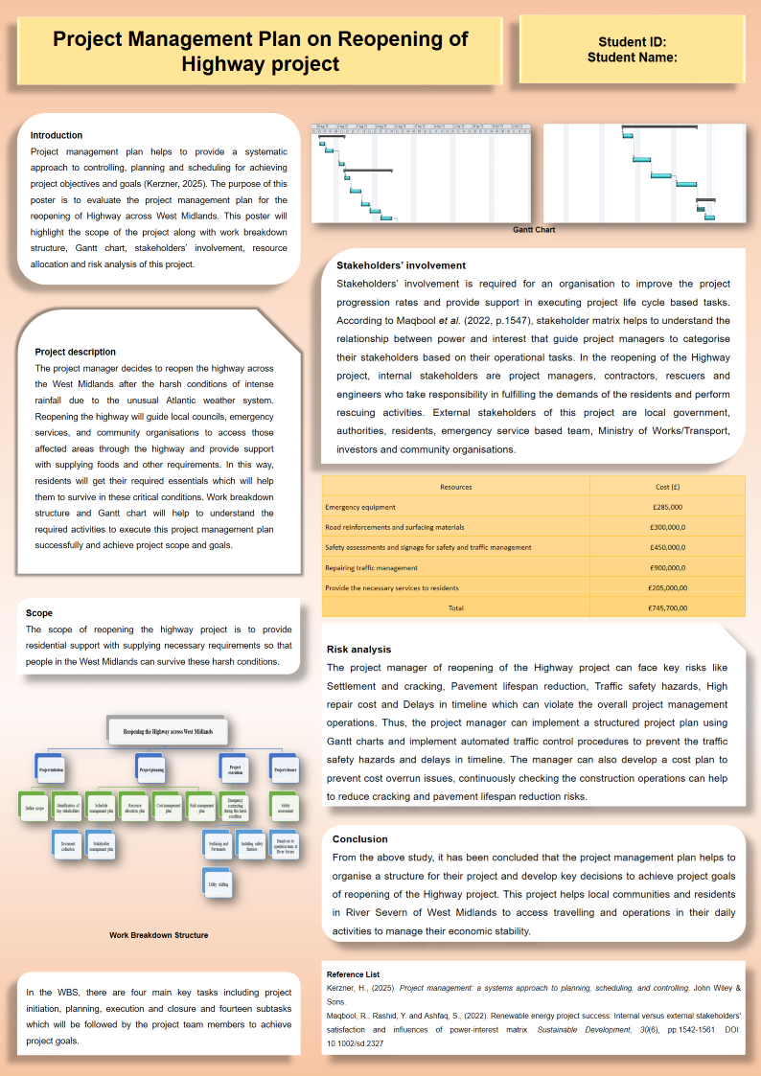

Introduction
Project management plan helps to provide a systematic approach to controlling, planning and scheduling for achieving project objectives and goals (Kerzner, 2025). The purpose of this poster is to evaluate the project management plan for the reopening of Highway across West Midlands. This poster will highlight the scope of the project along with work breakdown structure, Gantt chart, stakeholders’ involvement, resource allocation and risk analysis of this project.
Project description
The project manager decides to reopen the highway across the West Midlands after the harsh conditions of intense rainfall due to the unusual Atlantic weather system. Reopening the highway will guide local councils, emergency services, and community organisations to access those affected areas through the highway and provide support with supplying foods and other requirements. In this way, residents will get their required essentials which will help them to survive in these critical conditions. Work breakdown structure and Gantt chart will help to understand the required activities to execute this project management plan successfully and achieve project scope and goals.
Scope
The scope of reopening the highway project is to provide residential support with supplying necessary requirements so that people in the West Midlands can survive these harsh conditions.
Work breakdown structure
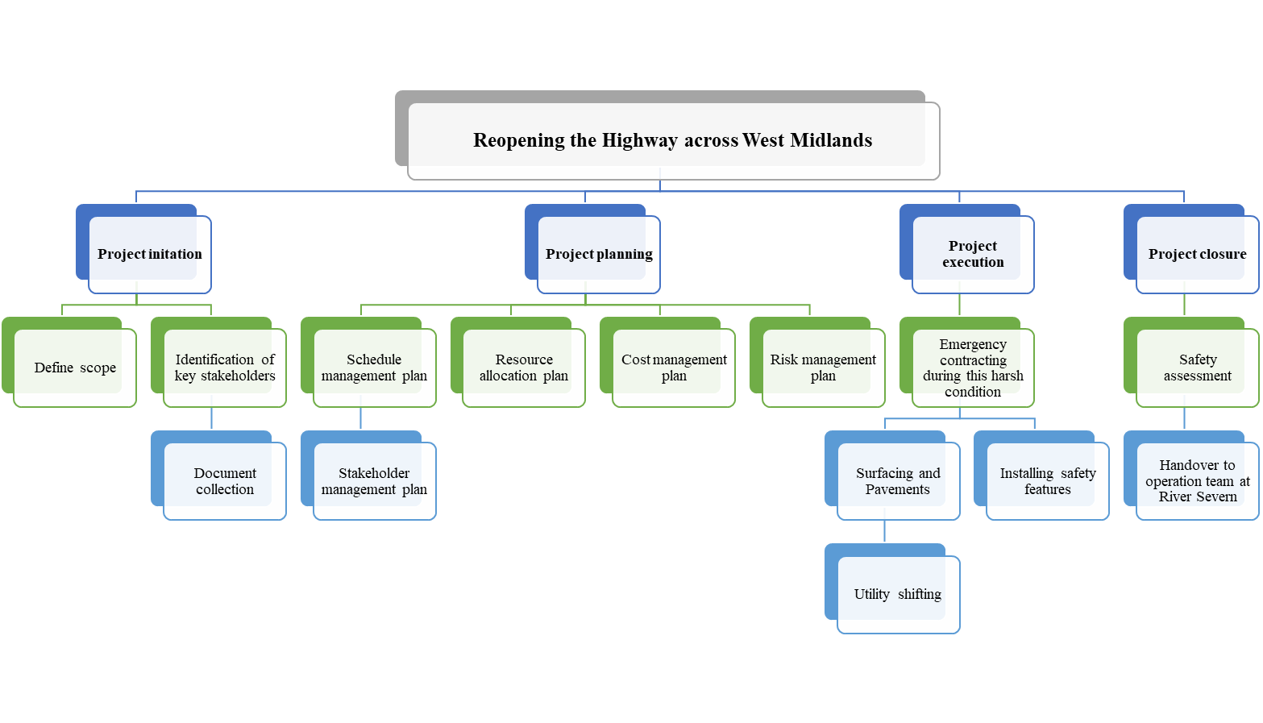
Figure 1: Work Breakdown Structure
In the WBS, there are four main key tasks including project initiation, planning, execution and closure and fourteen subtasks which will be followed by the project team members to achieve project goals.
Gantt chart
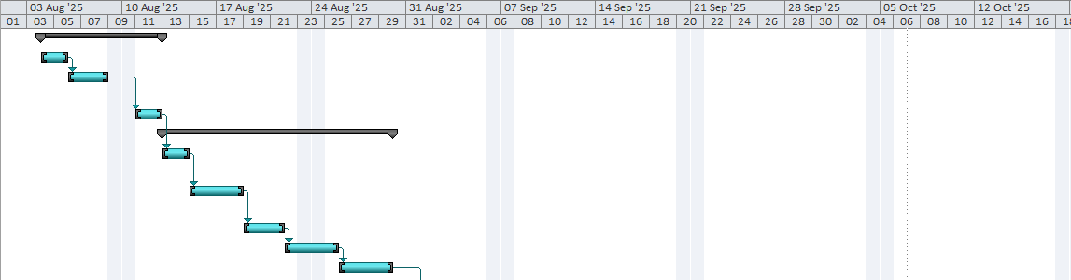
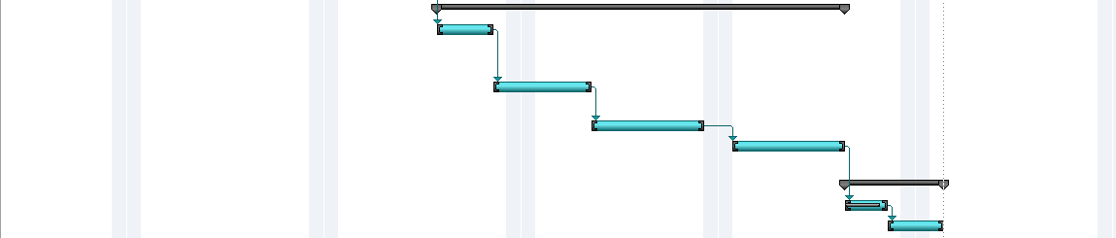
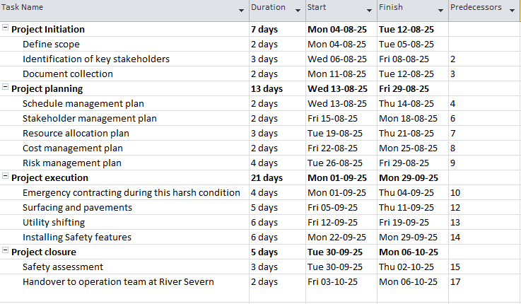
Figure 2: Gantt chart

Stakeholders’ involvement
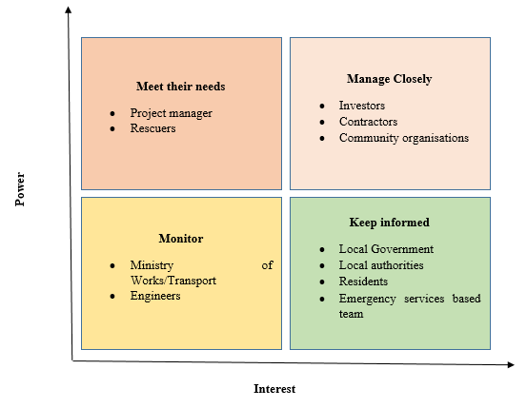
Figure 3: Stakeholder matrix
Stakeholders’ involvement is required for an organisation to improve the project progression rates and provide support in executing project life cycle based tasks. According to Maqbool et al. (2022, p.1547), stakeholder matrix helps to understand the relationship between power and interest that guide project managers to categorise their stakeholders based on their operational tasks. In the reopening of the Highway project, internal stakeholders are project managers, contractors, rescuers and engineers who take responsibility in fulfilling the demands of the residents and perform rescuing activities. External stakeholders of this project are local government, authorities, residents, emergency service based team, Ministry of Works/Transport, investors and community organisations.

Resource allocation
Resources | Cost (£)
Emergency equipment | £285,000
Road reinforcements and surfacing materials | £300,000,0
Safety assessments and signage for safety and traffic management | £450,000,0
Repairing traffic management | £900,000,0
Provide the necessary services to residents | £205,000,00
Total | £745,700,00

Risk analysis
The project manager of reopening of the Highway project can face key risks like Settlement and cracking, Pavement lifespan reduction, Traffic safety hazards, High repair cost and Delays in timeline, which can violate the overall project management operations. Thus, the project manager can implement a structured project plan using Gantt charts and implement automated traffic control procedures to prevent the traffic safety hazards and delays in timeline. The manager can also develop a cost plan to prevent cost overrun issues, continuously checking the construction operations can help to reduce cracking and pavement lifespan reduction risks.

Conclusion
From the above study, it has been concluded that the project management plan helps to organise a structure for their project and develop key decisions to achieve project goals of reopening of the Highway project. This project helps local communities and residents in River Severn of West Midlands to access travelling and operations in their daily activities to manage their economic stability.

Part B: Reflections from the feedback received from tutor and peers
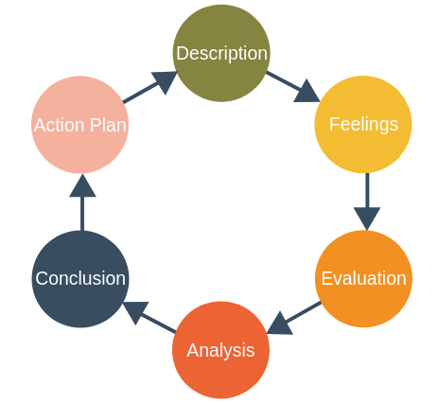
Figure 4: Gibb’s reflective model
Description
I have selected the reopening of the Highway project during my learning session, in terms of providing informative insights about the mitigation of residential as well as commercial issues. The key purpose behind the selection of this project is to provide necessary guidelines to both local communities and government to support local communities by the fulfilment of necessary needs such as foods, beverages alongside other commercial supports. During the project process, I have provided detailed information about the project scope alongside employing Work Breakdown Structure (WBS) for simplifying projects by breaking into different subtasks. The utilisation of this framework has not only supported me to organise project activities, but also helped to develop a proper resource allocation plan. I have created a Gantt chart, helping to identify critical paths and ensuring the completion of individual tasks in a timely manner, in terms of developing a proper project timeline.

Feelings
In the initial phase, I have felt both excited and nervous due to the completion of tasks in a timely manner. Peer feedback has provided me with significant support to not only measure my strengths but also identify different areas that need further improvement. The creation of WBS in a structured manner has supported me to display my strengths in providing a sense of clarity. WBS utilisation can support individuals to break project activities into different subtasks and help to simplify complex project processes (Odedairo, 2024). Even after the creation of WBS, I have managed different project activities in a structured manner, however, during the creation of Gantt chart, I felt nervous about task dependencies, reflecting my inability to distribute tasks. This bottleneck has made me feel to focus more on the development of task delegation capability with the support of team cooperation.
Evaluation
During the project process, I have gained positive feedback from my peers about the breakdown of project activities in a systematic manner. This approach has helped to organise tasks in a proper way and ensured the management of project complexities successfully. Apart from that, by creating Gantt chart, I have selected deadlines of individual project tasks in a proper way that has also helped me in the management of diverse stakeholder expectations successfully. In spite of positive feedback, I have also gained feedback about some areas that need improvement, specifically in the budget plan. Initially, I selected a project cost of around £180,000, which has been reflected as too low according to peer feedback. In a project process, a proper budget plan is considered as an important approach for managing continuous resource flow and meeting targeted objectives successfully (Nguyen, 2024). Based on my budget plan, I also have feedback about the lack of focus on details, which has limited the reliability of the budget plan.
Analysis
According to tutor and peer feedback, I have come to know that strong organisational skills have helped me to make a detailed WBS and organise individual tasks in a simple way. A proper plan can help to manage a project lifecycle successfully (Gbadegesin et al., 2025). My attention to detail and clarity has reflected strong task delegation skills. However, due to lack of decision-making skill, I have struggled to set deadlines during the creation of Gantt chart. In addition, my inaccurate financial skill has led to concerns during the development of a clear budget plan properly.

Conclusion
During the project process, I have learned about the effectiveness of WBS to maintain flexibility throughout a project process and simplify project complexities successfully. In addition, I have gained information about the necessity of financial analysis skills for making proficiency in budgeting to ensure a project continuation.
Action Plan
Areas of improvement | Required actions | Required resources | Timeline
Decision-making skill | Join mentorship session about decision-making capabilities for getting necessary tips | Learning materials, YouTube video | 5 months
Financial analysis skill | Enrol on training session about budgeting for improving knowledge about financial analysis | Lecture material | 3 months
Technical proficiency | Join online training session about gaining knowledge of different tools such as Excel, Microsoft Project and other project management tools for better budgeting | Tutor feedback, learning materials | 6 months

Part C: Project management plan

1. Introduction
A Project Management Plan (PMP) defines the scope and objectives of the project, which provides a comprehensive roadmap to ensure stakeholder alignment, facilitates clear communication, manages risk, and prevents scope creep. The scope of this assignment is to develop a project management plan for the reopening of Highways across the West Midlands.
A PMP acts as a central guide to keep teams are focused, efficient and aligned with organisational goals (Veza, and Hananto, 2025). The structure of the assignment is an emphasis on project description, scope, work breakdown structure, quadrant chart, Gantt chart, stakeholder involvement, allocation of resources, risk analysis and more.

2. Project description
The aim of the current project is to handle the harsh conditions of the Highway Project at West Midland by reopening it with the inclusion of other factors, like management of unusual weather systems. This project focuses on developing interaction with different stakeholders such as local communities as well as government in terms of measuring local needs and providing necessary guidelines on the management of emergency services in a structured manner. It ensures to break down project activities in a simple way and focuses on the completion of individual activities in a proper way for executing the project successfully. As reflected by Kerzner (2025), the development of a project plan with the alignment of targeted objectives might be helpful for a project management team to not only manage resources but also achieve targeted goals and scope easily. In this project, the plan has developed to not only manage resources but also improve collaboration with stakeholders in terms of fulfilling their needs properly.
This project ensures to handle previous risks that developed in the previous project process and focuses on providing necessary guidelines to community organisations and local councils to fulfil basic needs of local communities. In response to this, the development of Work Breakdown Structure as well as Gantt chart will help to manage individual activities systematically, and maintain deadlines throughout the project process.

3. Scope
In a project management plan, project scope is an important component that helps to determine goals, necessary resources, deliverables, and different tasks that are required to the completion of a project. The scope of the current project is to provide residential support to communities living in the West Midlands for surviving harsh situations. This project will focus on providing necessary responses for emergency conditions in the region by reopening the Highway Project for further reconstruction.

4. Work breakdown structure
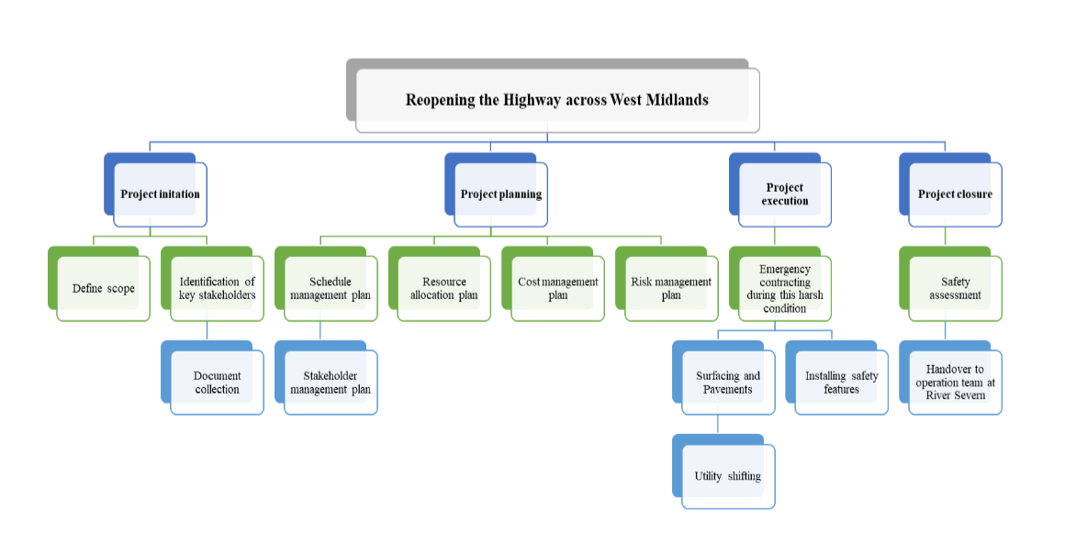
Figure 5: Work Breakdown Structure
In a project process, Work Breakdown Structure (WBS) supports enhancing productivity levels by simplifying activities. The development of a WBS can help a project manager to not only improve project planning but also to control resource allocation costs easily (Siringoringo and Machfudiyanto, 2025). Based on the current project, the above WBS has categorised tasks into four stages such as project initiation, planning, execution, as well as closure. The overall project has been divided into fourteen subtasks, aiming to handle individual tasks easily and in a structured manner. From the initial phase to closure phase, the above figure has represented different tasks in a proper structure that might be beneficial for the management of project complexities and handle cost overruns issues easily.

5. Quad Chart
The Quad Chart for a construction project is a one-page summary, divides key information into four distinct in equal sections and is laid out in a landscape format. It is used to quickly communicate project status, objectives, and technical details to stakeholders, project managers, or potential clients.
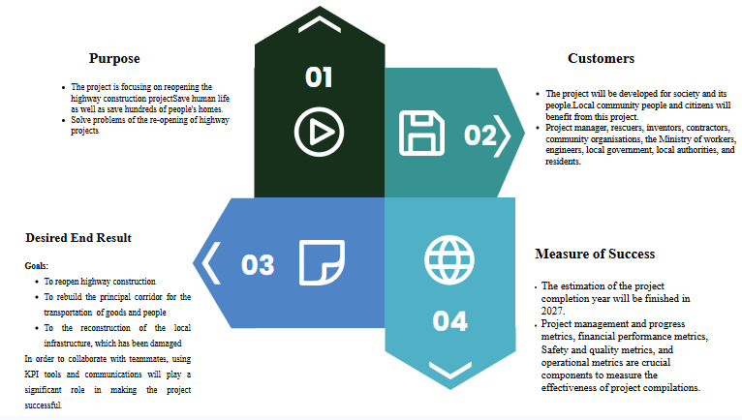
Figure 6: Quad Chart of Project Management Plan on Reopening of Highway Project
Purpose
The project is focusing on reopening the highway construction project with rebuilding the principal corridor for transportation and reconstruction of the local infrastructure that supports securing people's lives from extreme weather conditions.
The reopened highway project is made to save human life as well as save hundreds of people's homes by providing an effective network. The reconstruction of local infrastructure also needs to improve, for that reason of this project.
The result of this project is to solve problems of re-opening of highway projects, develop principal coordinators, and reconstruct local infrastructure.
Customers
The project will be developed for society and its people.
Local community people and citizens will benefit from this project.
Project manager, rescuers, inventors, contractors, community organisations, the Ministry of workers, engineers, local government, local authorities, residents, and the emergency service-based team will be involved in this project to ensure the standard quality of the project.
Desired Result
Goals:
- To reopen highway construction
- To rebuild the principal corridor for the transportation of goods and people
- To the reconstruction of the local infrastructure, which has been damaged
In order to collaborate with teammates, using KPI tools and communications will play a significant role in making the project successful. Moreover, the effective budget planning as well as the evaluation of risk among employees during the work also becomes one of the crucial reasons for the project's success rate.
Measure of Success
The estimation of the project completion year will be finished in 2027.
Project management and progress metrics, financial performance metrics, Safety and quality metrics, and operational metrics are crucial components to measure the effectiveness of project compilations. These metrics must support budget variances, low rework percentages, high safety incidents, and enhance high user satisfaction to complete the process. The effective cash flow management, such as Days Sales Outstanding (DSO), will also play an effective role in measuring the success rate in project completion.

6. Gantt Chart

Figure 7: Gantt chart on Reopening of Highway Project
The above figure highlights the specific timeline in the case of a complete highway-reopening project. The timeline has been divided into four phases, including project initiation, project planning, project execution, and project closure. The project initiation is divided into three parts, including defining the scope (take 2 days), identification of key stakeholders (take 3 days), and document collection (take 2 days). Project planning will be divided into five segments, like schedule management plan, stakeholder management plan, resource allocation plan, cost management plan and risk management, which takes 13 days to complete the cycle. The project execution is divided into four aspects, such as emergency during harsh conditions, surfacing and pavements, utility shifting and installing safety features, which takes 21 days. The project closure is divided into two areas: safety assessment and handover to the operation team. Handover to the operation team at River Severn, which takes 5 days

7. Stakeholders' involvement
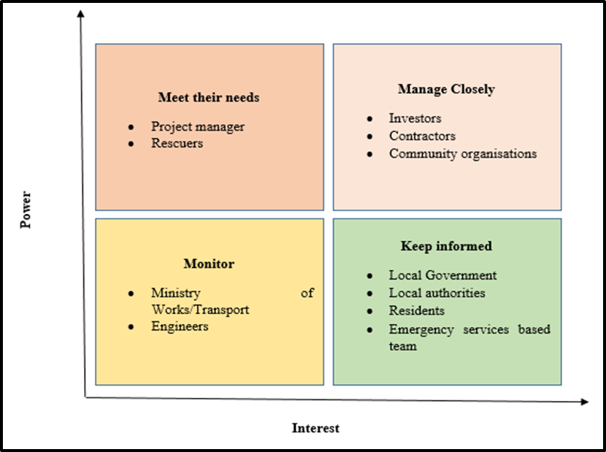
Figure 8: Stakeholder matrix
A stakeholder Matrix is a tool that is used in project management to assess and review the different project stakeholders to decide the best way to coordinate with the project (Ominde et al., 2023). Each stakeholder or group also emphasises a different strategy and matrix that helps to evaluate the best way to reach the business outcome.
High Power, High Interest (Manage Closely)
Investors, contractors, and community organisations fall into the High Power and High Interest quadrant because they have the ability to either pressure project success or cause significant project delays in reopening the highway. Investors, contractors, and community organisations are closely managed in case of highway reopening. These stakeholders have the ability to significantly influence our products and deeply invest in project success and failure. They are key players in making decisions based on the reopening of the highway project, which relies on their high power and high interest in the construction project.

High Power, Low Interest (Meet Their Needs)
Internal stakeholders such as project managers and rescuers have high power and low interest in meeting project outcomes. They focus on the standard project management framework that supports the case of daily operation for reopening highways (Harake, 2025). Project managers and rescuers have direct control over resource allocation, legal compliance, and ensure safety in the workplace in case of rebuilding principal corridors. They have an interest in smooth operation in reopening the highway project, while they have less interest in daily-based activities of employees. Their primary goal is to ensure project success without unnecessary, time-consuming involvement in every managerial decision.
Low Power, High Interest (Keep Informed)
Local government, local authorities, residents and emergency services in the project are classified as ‘Low Power, High Interest’ (keep informed stakeholders) in the project due to their possession of a deep stake in the outcome (High interest level). They have lacked direct control over the project’s daily management, scope and effective financial decision making to complete the project (Ongesa et al., 2025). Local government, local authorities, residents, and emergency service bases are kept informed and provided with guidelines in terms of enabling quality of work to reach the project outcomes. The local government and local authorities' permission must be obtained before these activities.
Low Power, Low Interest (Monitor)
The Ministry of Workers/Transport and Engineering are classified as low power because they focus on policies, regulations, budget approvals, and risk management rather than daily supervision for construction management (Leonardi, 2024). They also have less interest in skill development and workers plan-related activities in construction areas. The Ministry of Workers/ Transport and Engineers have low power and low interest in reopening high-profile projects because they have limited ability to influence the project directly and low concerns regarding its day-to-day operational activities in the workplace.
The overall finding highlighted that investors, contractors, and community organisations have high power in case of project delays and growth-related decisions for completing the project. Moreover, the project manager and Rescuer also have high power and low interest in promoting safety in the construction workplace.

8. Allocation of resources
Resources | Cost (£)
Emergency equipment | £285,000
Fire Suppression System | £250,00
Emergency lighting Towers | £100,00
Site Emergency Management System | £250,000
Road reinforcements and surfacing materials | £300,000,0
Surface Dressing | £2,000,000
Concrete Paving and Geogrids | £1,000,000
Safety assessments and signage for safety and traffic management | £450,000,0
PPE Clothing | £450,000,0
Repairing traffic management | £900,000,0
Provide the necessary services to residents | £205,000,00
Land Acquisition | £150,000,00
Community Mitigation | £500,000,0
Stakeholder Communication | £500,000,0
Total | £745,700,00

The emergency equipment cost nearly £285,000 (£0.285 million), including fire Suppression Systems, emergency lighting towers, and site management systems’ individual costs. This equipment is important to manage construction activities alongside traffic or in tunnel environments. The road reinforcement and surface materials' total cost is £300,000,0 (£0.3 million) by aligning with Surface Dressing, Concrete Paving and Geogrids’ individual costs. Surface dressing provides a cost-effective, affordable, waterproof, and non-skid seal, while concrete paving offers long-term durability under heavy traffic. The geogrids also provide reinforcement, stabilise, and reduce reflective cracking upon the project’s completion. The PPE clothing and repairing traffic management individually costs approximately £450,000,0 (£0.45 million) and £900,000,0 (£9 million). Therefore, the total amount of safety assessment and signage for safety and traffic management is approximately £135,000,00 (£135 million). The necessary services of resident cost have been merged with land acquisition, community mitigation and stakeholder communication cost, which is nearly £205,000,00 (£2.5 million). Therefore, the total cost of the budget plan is nearly £745,700,00 (£745.7 million). Therefore, the budget of 745 million will be necessary in case of completing the projects.

9. Risk Analysis
In a project process, a proper risk analysis is defined as an important part that can help to not only identify potential risks and challenges, but also to generate ideas for addressing those risks in the initial phase. During a project, different types of risks may develop such as budget overruns, legal complexities, technical issues, labour shortage, as well as scope creep that may not only hamper project flow, but also lead to concerns about timely project completion (Rud, 2022). In the context of the current project process, regarding the reopening of the Highway project, possible risks can be the reduction of pavement lifespan, traffic safety hazards, settlement and cracking, delays in timeline and higher repairing cost, that may lead to complexion on the completion of the project on time. In the context of the current project process, a risk matrix has been created in the below section for organising risks in a systematic manner.
SL No. | Potential risks | Probability | Severity | Impact  (Probability ✕ Severity) | Mitigation strategies
R001 | Reduction of pavement lifespan | 3 | 4 | 12 | Proper drainage design is necessary alongside accurate quality control of individual materials for expanding pavement lifespan properly
R002 | Traffic safety hazards | 3 | 4 | 12 | A proper traffic diversion plan needs to be developed and with this providing proper training to workers regarding the management of internal traffic control
R003 | Settlement and cracking | 4 | 4 | 16 | A proper soil testing process needs to be conducted and with this detailed geotechnical, investigation is important.
R004 | Delays in timeline | 5 | 3 | 15 | Better project planning and accurate resource allocation on a continuous basis are necessary for ensuring the completion of project on time
R005 | Higher repairing cost | 4 | 3 | 12 | Initial cost estimation is necessary and proper training sessions need to be arranged for workers about the reduction of error rate during the project process.

This project aims to provide guidance to both government and local communities to mitigate residential issues and with this support local communities by fulfilling their basic needs such as foods, beverages alongside different commercial supports. In response to this, it is necessary to develop a proper risk matrix to not only identify risks, understand impact and take necessary action for resolution. The key reason behind the reduction of Pavement Lifespan is inaccurate material quality, poor subgrade preparation, and inaccurate compaction that may not only develop potholes, but also lead to several pavement cracks, leading to several accidents. The implementation of proper quality control measures might be beneficial to address this risk.
The other possible risk is traffic safety hazard that is mainly posed by construction workers due to poor site management or unfinished works. The improper signage and unstructured traffic management plan can lead to accident rates and vehicle damage during the project process (Sagan and Mach, 2025). Knowledge improvement among workers about site management can be beneficial to address this risk successfully. On one hand, improper handling of heavy loads can lead to settlement and cracking issues, on the other hand, lack of alignment between project plan and objective may cause delay in the project completion process (Giri, 2025). In response to this, better soil testing is necessary alongside with the development of a proper project plan; it might be significant to handle those risks successfully in the initial phase. Apart from that, an accurate budget plan is also necessary with the inclusion of necessary resources in a systematic way for handling total project costs.

10. Conclusion
The project plan is based on reopening highway construction across the West Midlands, engaging with local councils, emergency services, and community organisations to overcome the issues of “Severe Flood Warning” for people. The findings of the assignment indicate that proper management of resource allocation and developing project management teams to reach organisational goals and scope. The findings of the assignment also portrayed that the work breakdown structure is divided into four stages: project initiation, planning, execution, and closure to tackle project hurdles and cost overrun issues. The stakeholder involvement found that investors, contractors, and community organisations have high power and interest in the construction project. The overall budget cost for the project is estimated at £745.7 million. The Settlement and cracking, and Delays in the timeline are the main risk factors in project completions.

11. Reference List
Part A
Kerzner, H., (2025). Project management: a systems approach to planning, scheduling, and controlling. John Wiley & Sons.
Maqbool, R., Rashid, Y. and Ashfaq, S., (2022). Renewable energy project success: Internal versus external stakeholders' satisfaction and influences of power‐interest matrix. Sustainable Development, 30(6), pp.1542-1561. DOI: 10.1002/sd.2327
Part B
Gbadegesin, A.A., Omigbodun, O.T., Moshood, A.I. and Adeniran, A.O., (2025). Effective Project Governance in a Full Project Lifecycle. Systemic Analytics, 3(3), pp.214-221. http://sa-journal.org/index.php/systemic/article/download/55/67
Nguyen, T.T.T., (2024). Toward financial optimization: assessing the influence of budget process on effective accounting management. Management dynamics in the knowledge economy, 12(2), pp.116-132. https://sciendo.com/2/v2/download/article/10.2478/mdke-2024-0008.pdf
Odedairo, B.O., (2024). Assessing the influence of various work breakdown structures on project completion time. Engineering, Technology & Applied Science Research, 14(2), pp.13773-13779. https://mail.etasr.com/index.php/ETASR/article/download/7023/3582
Part C
Giri, O.P., (2025). Assessment of key risk factors impacting construction project performance. Int. J. Constr. Manage, 25(4), pp.1231-1241. https://www.researchgate.net/profile/Om-Giri-3/publication/388560600_Assessment_of_Key_Risk_Factors_Impacting_Construction_Project_Performance/links/67a0d82796e7fb48b9b1090c/Assessment-of-Key-Risk-Factors-Impacting-Construction-Project-Performance.pdf

Harake, M.F., (2025). Strategic Project Management in Crisis Response: A Comprehensive Analysis of Rescue Agencies' Operations During Emergencies. PM World Journal. https://pmworldlibrary.net/wp-content/uploads/2025/03/pmwj150-Mar2025-Harake-Strategic-Project-Management-in-Crisis-Response.pdf
Kerzner, H., (2025). Project management: a systems approach to planning, scheduling, and controlling. John Wiley & Sons.
Leonardi, S., (2024). Discretion and (de) centralization in wage bargaining in the construction, hospitality, urban transport and waste management sectors: A study on Italy. BARWAGE Project Report, 7. https://perspectives.cc/wp-content/uploads/2023/10/Urban_market_approaches_under_Article_6_of_the_Paris_agreement_-_recommendations_for_practical_implementations.pdf
Ominde, D., Ochieng, E.G. and Omwenga, V.O., (2023). An assessment tool for stakeholder integration excellence and project delivery optimisation. International Journal of Productivity and Performance Management, 72(7), pp.2155-2182. https://www.emerald.com/ijppm/article-pdf/72/7/2155/1114250/ijppm-02-2021-0115.pdf
Ongesa, T.N., Ugwu, O.P.C., Ugwu, C.N., Alum, E.U., Eze, V.H.U., Basajja, M., Ugwu, J.N., Ogenyi, F.C., Okon, M.B. and Ejemot-Nwadiaro, R.I., (2025). Optimizing emergency response systems in urban health crises: A project management approach to public health preparedness and response. Medicine, 104(3), p.e41279. https://www.mdpi.com/2624-6511/7/4/64
Rud, N., (2022). Use of risk matrix in innovation project management. In Economic Forum (Vol. 3, No. 12, pp. 79-88). https://e-forum.com.ua/web/uploads/pdf/Economic_Forum_Vol_12_No_3-79-88.pdf
Sagan, J. and Mach, A., (2025). Construction waste management: Impact on society and strategies for reduction. Journal of Cleaner Production, 486, p.144363. https://www.sciencedirect.com/science/article/pii/S0959652624038125
Siringoringo, Y.S. and Machfudiyanto, R.A., (2025). Analysis of the Cost Structure of the Construction Safety Management System for School Infrastructure Projects Based on Work Breakdown Structure. Journal of Project Management Research, 1(2), pp.31-46. https://journalpmresearch.com/jpmr/article/download/37/9
Veza, I. and Hananto, A.L., (2025). 50 Project Management Professional (PMP) Exam Key Principles: Clear and Practical Insights to Help You Pass the PMP Exam Using 50 Proven Strategies (Project Management Series). CV Eureka Media Aksara.

