

The Nexus of ESG Commitment, Student Internship Opportunities, and Industry Competitiveness

Subject Code: LCMB7020
Lecturer: Dr Hoan Dang Nguyen
Course: MBA
Term: 3
Student Name: Shabaaz Ali Syed
Student Number: 2128679

Acknowledgements
I wish to extend my heartfelt appreciation to my dissertation advisor, Dr. Hoang Dang Nguyen, for his steadfast encouragement, direction, and invaluable counsel during the entirety of the project. His erudition and commitment were crucial in influencing the trajectory of the research and enhancing its scholarly merits.
I would also like to express my gratitude to the fellow professors who served on my dissertation committee for their insightful critiques and scholarly input, which significantly enhanced the calibre of this investigation. Each of them has significantly contributed to the development of the dissertation's intellectual rigour.
I also extend my sincere gratitude to my friends and colleagues who have supported me throughout the arduous stages of this academic journey by providing encouragement, sharing their insights, and extending assistance. Their companionship has served as a wellspring of motivation and inspiration.
I express profound gratitude towards my parents for their steadfast encouragement, support, and comprehension. Their faith in my capabilities has served as an impetus, and I express my gratitude for the concessions they have rendered in order to support my scholastic endeavours.
In addition, I would like to extend my sincere appreciation to every participant who dedicated their time and expertise to the research, thereby enhancing the quality and scope of this dissertation and providing a more comprehensive examination of the subject.

E-Declaration Form


Master’s Degrees by Examination and Dissertation
Declaration Form.
1. This work has not previously been accepted in substance for any degree and is not being concurrently submitted in candidature for any degree.
Signed: Shabaaz Ali Syed
Date: 10/02/2024

2. This dissertation is being submitted in partial fulfilment of the requirements for the degree of Master in Business Administration.
Signed: Shabaaz Ali Syed
Date: 10/02/2024
3. This dissertation is the result of my own independent work/investigation, except where otherwise stated.
Other sources are acknowledged by footnotes giving explicit references.
A bibliography is appended.
Signed candidate: Shabaaz Ali Syed
Date: 10/02/2024

4. I hereby give consent for my dissertation, if accepted, to be available for photocopying, inter- library loan, and for deposit in the University’s digital repository
Signed (candidate): Shabaaz Ali Syed
Date: 10/02/2024
Supervisor’s Declaration.
I am satisfied that this work is the result of the student’s own efforts.
Signed: Hoang Dang Nguyen
Date: 10/02/2024

Abstract
The incorporation of Environmental, Social, and Governance (ESG) principles has evolved from a mere corporate choice to a strategic imperative in the current global economic environment. Increasing recognition of ESG factors as critical determinants of long-term organisational success is propelling this transformation, which is reshaping industry dynamics and stakeholder relations. Good governance, environmental sustainability, and social responsibility have become essential elements of business operations, in accordance with the demands of regulators, investors, and customers. The present dissertation delves into the complex interconnections among ESG commitment, organisational success, student apprenticeships, and competitiveness of organisations.
The results of the study demonstrate a range of viewpoints regarding the impact of ESG practices, suggesting a multifaceted environment in which a considerable portion recognises the favourable association with the success of organisations, despite the persistence of scepticism. In a similar vein, the overall sentiment of students towards ESG-focused internships is favourable; however, subtleties and differing viewpoints highlight the necessity for customised communication approaches. The examination of the correlation between environmental, social, and governance (ESG) orientation and the competitiveness of organisations reveals a widespread conviction that ESG-oriented organisations enjoy a competitive edge; however, opposing viewpoints introduce diversity. The study's findings underscore the ever-changing and subjective character of these perceptions, underscoring the need for ongoing investigation, education, and communication in order to effectively navigate the complex dynamics of environmental, social, and governance (ESG) factors in the contemporary business landscape.

Table of Contents
Acknowledgements 1
E-Declaration Form 2
Abstract 3
1. Introduction 6
1.1 Background and Context 6
1.2 Research Questions 7
1.3 Research Objectives 7
1.4 Hypothesis 7
1.5 Significance of the Study 7
1.4 Dissertation Structure 8
2. Literature Review 9
2.1 Definitions 10
2.1.1. Environmental, Social, and Governance Commitment 10
2.1.2. Student Internships 11
2.1.3. Organisational Competitiveness 13
2.1.4 Organisational Success 16
2.2 Correlation between ESG Orientation and Number of Student Internship Opportunities 17
2.3 ESG-Orientation is Correlated to Organizational Success 19
2.4 Students are Correlated to ESG-Oriented Organisations' Internship Programmes 21
2.5 ESG-Orientation is Correlated to Organizational Competitiveness 23
2.6 Research Gap 24
2.7 Conclusion 26
3. Methodology 28
3.1 Research Onion Framework 28
3.1.1 Research Philosophy 28
3.1.2 Research Strategy 29
3.1.3 Time Horizon 30
3.1.4 Data Collection Methods 31
3.1.5 Data Analysis Techniques 32
3.2 Ethical Considerations 32
4. Data Analysis 34
4.1 Hypothesis 1 34
4.2 Hypothesis 2 39
4.3 Hypothesis 3 45
4.4 Summary 48
5. Findings and Discussion 50
5.1 Hypothesis 1 50
5.2 Hypothesis 2 53
5.3 Hypothesis 3 55
6. Conclusion 58
6.1 Summary of Findings 58
6.2 Recommendations 59
6.3 Limitations 60
6.3 Final Conclusion 61
References 62
Appendices 75
Ethics Form 75
Survey Questions 83

1. Introduction

1.1 Background and Context
In today's global economic state, the adoption of Environmental, Social, and Governance (ESG) concepts has moved from a mere corporate decision to a strategic need. This shift is the outcome of an increasing recognition of ESG factors as significant determinants of long-term firm success, which is changing industry dynamics and impacting corporate strategy as well as stakeholder relations. Environmental sustainability, social responsibility, and good governance are all examples of ESG principles. Organisations that embrace these principles as fundamental pillars of their operations not only respond to the growing expectations of various stakeholders such as investors, customers, and regulatory bodies, but they also position themselves as socially responsible entities in an era when ethical capitalism is gaining traction (Karwowski and Raulinajtys-Grzybek, 2021; Doni and Jóhannsdóttir, 2019).
Student internships have emerged as an important link between higher education and the professional world at the same time. These internships give students with outstanding experiential learning experiences that will have a significant impact on their future paths. In recent years, student internships have expanded beyond traditional duties to include a diverse range of professions and enterprises, making them a vital component of the academic experience. They create immersive environments in which students can apply theoretical knowledge, gain practical insights, and discover critical connections in their chosen subjects (Ruhanen, Robinson and Breakey, 2013). This path highlights the significance of internships in preparing students for future careers, fostering professional growth, and providing them with the skills and knowledge required to excel in the corporate world.
The intersection of ESG commitment within industries and opportunities for students provided by internships has gotten little attention in the literature. This research gap provides the foundation for this dissertation. As ESG principles become more ingrained in business objectives, it is vital to investigate how this commitment affects the character and impact of student internships. The goal of this study is to provide light on the varied ways in which students' perceptions, decision-making, and career goals are influenced by sustainability-focused experiential learning. Furthermore, this in-depth investigation looks not only at the practical implications of ESG integration within sectors, but also at the important educational and developmental factors for students entering the workforce. Furthermore, the rising role of educational institutions in fostering ESG education and preparing students for internships in the sustainable and responsible corporate landscape demands a closer examination.

1.2 Research Questions
- How ESG orientation positively affect organizational success?
- How students are positively benefitted from ESG oriented internships?
- How ESG oriented internship increases organizational competitiveness?

1.3 Research Objectives
- To analyse how ESG orientation positively affect organizational success.
- To investigate how students are positively benefitted from ESG oriented internships.
- To identify how ESG oriented internship increases organizational competitiveness.

1.4 Hypothesis
- Hypothesis 1: ESG-orientation is correlated to organizational success
- Hypothesis 2: Students are Correlated to ESG-oriented organisations' internship programmes.
- Hypothesis 3: ESG-orientation is correlated to organizational competitiveness.

1.5 Significance of the Study
First and foremost, by exploring the dynamic relationship between ESG commitment within sectors and internship options for students, this study fills a critical gap in the existing literature. It highlights the significance of understanding the relationships between ESG practices, student internships, and industry competitiveness (Wersun et al., 2019). As a result, it contributes significantly to scholarly discourse in a wide range of fields, including corporate sustainability, education, and career development.
The significance of this study in the business sector is also evident, especially for businesses committed to ESG principles (Shapsugova, 2023). Understanding how ESG internships affect a company's approach to sustainability and corporate responsibility can aid in strategic decision-making. It provides important insights into hiring and retaining talent who adheres to ESG standards. Furthermore, by identifying the features that contribute to the success of ESG-focused internship programmes, as well as the associated challenges, this study can assist organisations in optimising their internship initiatives in order to maximise their impact and return on investment.
This study is also important for students and educational institutions since it sheds light on the possible career-shaping impact of ESG-focused internships (Jin and Kim, 2022). Internships with ESG-driven organisations can help students gain a deeper grasp of the opportunities and challenges that exist. Educational institutions, on the other hand, can use the findings to improve their curricula, better prepare students for the changing corporate environment, and adapt their methodologies to meet the needs of the business, resulting in a more knowledgeable, ethical, and capable workforce.
On a societal level, this study is significant since it analyses the applicability of ESG principles in establishing responsible business conduct and sustainability (Torres et al., 2023). The findings could be part of a larger societal movement towards ethical capitalism, in which businesses increasingly balance profit with social and environmental responsibility. By shedding light on the potential impact of ESG-oriented internships on industry competitiveness and long-term sustainability, the study supports to global efforts to promote ethical business practices and responsible corporate citizenship.

1.4 Dissertation Structure
- Chapter 2: Conducts a thorough examination and synthesis of existing ESG commitment and student internship models and frameworks. It delves into the historical context of ESG principles, the transformative power of student internships, and the contemporary research landscape. Furthermore, it delves deeply into the Triple Bottom Line (TBL) Framework, Stakeholder Theory, Institutional Theory, Resource-Based View (RBV) Model, and Corporate Social Responsibility (CSR) Framework, giving a thorough investigation to inform future research.
- Chapter 3: Covers the research plan, which is guided by the Research Onion structure. It delves deeper into the research philosophy, approach, strategy, time horizon, and data collection methodologies. It explains the utilisation of both qualitative and quantitative data collection approaches, so providing a systematic framework for the empirical inquiry.
- Chapter 4: Describes data analysis approaches in detail. It demonstrates how to use thematic analysis to analyse qualitative data, including data familiarisation, code development, and theme extraction. It also covers quantitative data statistical analysis, highlighting the use of software such as SPSS and the approaches employed, such as descriptive and inferential statistics.
- Chapter 5: Summaries the research findings and engages in a detailed discussion. It investigates the influence of ESG commitment on student internships, as well as the success factors and issues associated with ESG-oriented internships, student perspectives, and the potential for ESG-oriented internships to drive industrial innovation.
- Chapter 6: Conclusion is the dissertation's concluding chapter, summarising the research path. It synthesises the various interactions investigated during the investigation, providing a thorough understanding of the research topic. It revisits the research objectives, assesses the study's outcomes, acknowledges its limits, and gives recommendations for future research.

2. Literature Review
In this literature review, we will look at the Environmental, Social, and Governance (ESG) issues, student internships, sustainable development goals, and institutional entrepreneurship. Our goal is to untangle the complex relationship that exists at the intersection between ESG commitment, student internship possibilities, and organisational competitiveness. Through a detailed investigation of these elements, we want to identify synergies and consequences at the confluence of environmental responsibility, social impact, governance practices, student experiential learning, and the achievement of sustainable development goals. This investigation will provide light on how these elements interact to shape an organization's competitiveness in today's dynamic and socially conscious landscape.

2.1 Definitions

2.1.1. Environmental, Social, and Governance Commitment
ESG commitment, an acronym for Environmental, Social, and Governance, refers to a complete strategy taken by businesses to adopt sustainable and ethical business practices. It represents an understanding of corporations' interrelated impact on the environment, society, and internal governance frameworks. ESG, refers to a set of criteria used to evaluate a company's commitment to sustainable and ethical business practices (Syed, 2017). The Environmental (E) component investigates a company's environmental impact, including carbon footprint, energy efficiency, and climate change mitigation strategies (Sanfiz et al., 2023). For example, a company that uses renewable energy or employs environmentally friendly manufacturing practices indicates a dedication to environmental responsibility.
On the social (S) front, ESG assesses a company's impact on society by looking at its relationships with employees, customers, communities, and bigger societal concerns (Hazen, 2021). Diversity and inclusion, labour practices, and community involvement are all important social factors. A corporation that actively promotes fair employment practices, maintains a diverse and inclusive workplace, and positively engages with the communities in which it operates is one example.
The Governance (G) component looks at a company's internal structures and procedures, evaluating decision-making, ethical behaviour, transparency, and managerial performance (Hoang, 2018). Companies with clear and open policies, a balanced board structure, and effective risk management methods exhibit competent governance.
In summary, ESG commitment encompasses a holistic strategy that organisations implement in order to incorporate ethical and sustainable practices into their daily activities. The assessment of this dedication is conducted using the Environmental, Social, and Governance (ESG) framework. Within this framework, the Environmental aspect examines the ecological footprint of the organisation, the Social aspect evaluates its contributions to society, and the Governance aspect scrutinises internal mechanisms and decision-making procedures. Organisations demonstrate their commitment to ethical business conduct and contribute to a more sustainable and socially aware business environment through their adoption of renewable energy, support for diversity and inclusion initiatives, and implementation of transparent governance systems.
Measuring ESG Commitment
Measuring ESG commitment is a comprehensive process that involves both quantitative and qualitative assessments. Several frameworks, such the Global Reporting Initiative (GRI) and the Sustainability Accounting Standards Board (SASB), offer recommendations for comprehensive ESG reporting (Petera and Wagner, 2015; García-Torea, 2022). Quantifiable measurements, such as greenhouse gas emissions and diversity ratios, provide tangible indicators, whereas qualitative assessments include the effectiveness of governance systems and the level of community engagement (Al-Qahtani and Elgharbawy, 2020).
Measurable indicators, such as levels of greenhouse gas emissions and ratios of diversity, provide concrete standards, while subjective assessments examine the efficiency of governance systems and the extent of community involvement. External validation, achieved through third-party audits, rating agencies, and inclusion in ESG indexes, offers a wider viewpoint that allows for a thorough understanding of a company's commitment to sustainable and ethical practices. As the ESG landscape progresses, its influence on corporate conduct becomes more crucial, aiding in the development of a more accountable and robust global business climate.
For the purpose of this study, we will measure the ESG commitment of organisations, through the perceptions of our survey respondents. We will ask the respondents how aware they are about ESG commitment of organizations and how do they measure or analyse it. This is done by asking them whether they have come across ESG organizations, do the respondents specifically search for ESG oriented internships, and so forth.

2.1.2. Student Internships
Student internships can be defined as work experiences provided by organisations to students, usually in a hands-on learning setting relevant to their subject of study (Alfeld et al., 2013). Internships allow students to obtain practical experience in their chosen career, apply classroom information to real-world situations, and build valuable skills. These experiences are frequently carried out during academic breaks or as part of a formal curriculum, and they serve an important role in preparing students for future careers.
Student internships are critical components of academic and professional growth, providing students with hands-on experiences that bridge the gap between theoretical knowledge and practical application (Kapareliotis, Voutsina and Patsiotis, 2019). Internships are highly valued in many academic subjects because they allow students to apply classroom concepts in real-world settings. This research study investigates the diverse nature of student internship opportunities, with a focus on skill development, career preparedness, and general educational enrichment.
In conclusion, student internships are crucial in helping students move from academics to the professional world by providing temporary work experiences that are closely related to their areas of study. These experiential learning activities, frequently pursued during academic recesses or as components of a structured curriculum, give students with tangible understanding and the opportunity to employ theoretical information in practical, real-life situations.
Measuring Student Internships
Our study employs a set of meticulously formulated questions to measure student internships. These questions aim to gather information about different facets of the intern's experience, their perceptions, and the impact of ESG-focused organisations on internship prospects. The purpose of these questions is to gain a thorough comprehension of how ESG principles intersect with and influence the accessibility, excellence, and overall importance of student internship programmes. Questions 1 and 2 inquire about respondents' assessment of how organisations dedicated to Environmental, Social, and Governance (ESG) principles contribute to the availability of student internship opportunities. These questions aim to assess the perceived influence of an organization's ESG approach on the availability of student internships by offering respondents a range of agreement levels, from "Strongly disagree" to "Strongly agree."
Similalrly, Questions 11 and 16 explore the firsthand experiences of the respondents by asking about their involvement in internship programmes with organisations that actively incorporate ESG principles. This analysis not only quantifies the frequency of ESG-focused internship opportunities but also offers insights on the active participation of respondents in these programmes, enabling a more detailed comprehension of the connection between ESG and student internships. In order to delve deeper into these experiences, questions 12, 13, 14, and 15 evaluate the perceived influence of ESG-focused internships on students' skill enhancement, understanding of ethical decision-making and environmental concerns, commitment and motivation towards work, and readiness for responsible and ethical career paths. The answers to these inquiries provide a qualitative aspect to the assessment, illuminating the perceived educational and developmental results of internships that prioritise environmental, social, and governance (ESG) considerations.
Our survey measures student internships by using assessments which capture the perceived influence of ESG-oriented organisations on the availability of opportunities, as well as which gauge the direct experiences and perceived impact of ESG-focused internships on students' skills, awareness, and overall professional development. This dual methodology guarantees a thorough examination of the overlap between ESG principles and student internships, yielding useful perspectives on the possible advantages and difficulties linked to ESG-focused internship programmes.
In conclusion, assessing student internships is crucial for comprehending their overall influence on multiple aspects, such as the enhancement of skills, readiness for future careers, and alignment with educational objectives. Research continually emphasises the importance of evaluating these factors in order to measure the efficacy of internships. The primary emphasis is on enhancing skill development, which includes both technical and soft abilities. This is achieved through a comprehensive evaluation process that includes pre- and post-internship exams, feedback from supervisors, and self-reflection.

2.1.3. Organisational Competitiveness
Organisational competitiveness has been a hot topic in current business literature, reflecting the complex dynamics of the global marketplace. The foundational literature frequently sparks conversations by delving into conceptual frameworks and models that shed light on the complexity of maintaining a competitive advantage. The Resource-Based View (RBV), Porter's Diamond Model, and the Dynamic Capabilities Framework are three well-known theories that shed light on the interactions of internal and external elements that influence organisational competitiveness (Barney, 1991; Porter, 1990; Teece, Pisano and Shuen, 1997). Within the terrain of organisational competitiveness, the Resource-Based View emerges as a theoretical lens. According to the RBV, a company's distinct resources and core skills are critical to gaining and maintaining a competitive edge (Barney, 1991). This viewpoint emphasises the idea that organisations can distinguish themselves by using unique talents that competitors find difficult to reproduce.
Several studies like Kindström and Kowalkowski (2014) highlights the importance of innovation in increasing organisational competitiveness. Whether technological, process-oriented, or product-based, innovations are recognised as important drivers of long-term competitive advantage. This shows how organisations nurture an innovative culture, invest in R&D, and strategically manage technical improvements to maintain a competitive position in dynamic markets. Strategic management literature adds greatly to our understanding of organisational competitiveness by examining how organisations develop and implement strategies to acquire a competitive advantage. Scholars like Michael Porter emphasise the importance of strategic positioning, differentiation, and cost leadership in creating and maintaining competitiveness (Porter, 1985).
Globalisation adds another layer to the discussion, with research looking into how organisations expand internationally, navigate diverse cultural landscapes, and strategically position themselves to increase competitiveness in the global marketplace (Steers, Nardon and Sánchez‐Runde, 2013). This globalisation lens emphasises the necessity for organisations to adapt to the complexities of an interconnected world. Human capital's significance in organisational competitiveness is a growing field of study. Studies have also investigated how elements such as talent management, and organisational culture contribute to the development of a flexible and inventive workforce, influencing the organization's overall competitiveness (Barney, 1991).
In conclusion, the discussion on organisational competitiveness in contemporary business literature accurately portrays the complex dynamics of the global economy. The Resource-Based View (RBV), Porter's Diamond Model, and the Dynamic Capabilities Framework are fundamental ideas that provide valuable insights into how internal and external factors interact to influence competitiveness. Innovation is identified as a crucial factor, with research highlighting its contribution to enhancing long-term competitiveness through innovations in technology, processes, and products.
Measuring Organizational Competitiveness
Measuring organisational competitiveness is a broad and crucial part of strategic management research. Scholars have investigated many approaches, indices, and frameworks to provide a more nuanced knowledge of how organisations might evaluate and improve their competitive positions. Financial measurements have been the key focus in determining organisational competitiveness. For instance, Jacobson (2016) suggests that Return on investment (ROI), profit margins, and revenue growth are real financial performance indicators. These quantitative measures provide a glimpse of an organization's competitiveness and are critical in determining its competitive position. However, it is well known that focusing solely on financial measures may fail to reflect the whole range of factors driving competitiveness.
The prominent Balanced Scorecard framework developed by Kaplan and Norton (1996) emphasises implementation, which has been a recurrent theme in the field. This framework smoothly blends strategic objectives and key performance indicators, giving businesses a comprehensive tool for monitoring and evaluating performance. Leadership commitment, organisational culture, and strategic human resource alignment have been recognised as significant factors determining the success of plan implementation.
For this study, we analyse the competitiveness of organisations, particularly with regard to the availability of student internship opportunities. We aim to understand the influence of ESG commitments on the availability and promotion of internship programmes, and also explore the potential correlation between an organization's ESG focus and its overall performance. Furthermore, we will analyse the impact of ESG-focused practices on crucial aspects such as trust, stakeholder preferences, and the development of ethical decision-making skills among interns.
In conclusion, organisational competitiveness measurement is a vital component of strategic management research. Financial metrics, such as Return on Investment (ROI), profit margins, and revenue growth, serve as crucial indicators of economic performance and competitiveness, offering a quantitative viewpoint. Nevertheless, while acknowledging the constraints of relying just on financial measurements, incorporating market-based indicators such as market share, penetration, and customer satisfaction provides a comprehensive perspective on an organization's competitive standing, taking into account elements that go beyond financial performance.

2.1.4 Organisational Success
Our study defines organisational success as a term that includes financial prosperity, healthy stakeholder relationships, efficient personnel management, and a reputation for ethical and responsible business practices (Taghian, D’Souza and Polonsky, 2015). The multidimensional viewpoint emphasises the wider influence that an organisation has on its stakeholders, the environment, and society.
Measuring Organizational Success
In order to assess the achievement of an organisation, we have established a set of survey inquiries that explore financial metrics, stakeholder perspectives, and the dedication of organisations to Environmental, Social, and Governance (ESG) principles. The survey contains questions specifically designed to assess the financial consequences of ESG-focused initiatives. Questions 7, 9, 10, and 16 inquire about respondents' views on how ESG practices positively impact organisational success, resilience, competitiveness, and overall financial performance. Greater consensus in answers to these inquiries signifies a favourable assessment of economic prosperity associated with ESG principles.
Stakeholder trust and perception are also vital elements for achieving organisational success (Greenwood and Van Buren, 2010). Questions 8, 17, 18, and 19 seek to examine how an organization's dedication to ESG principles impacts consumer trust, loyalty, and its capacity to attract socially conscious partners, customers, and investors. Concurring with these assertions demonstrates a favourable influence on relationships with stakeholders, which is crucial for the achievement of organisational goals.
Likewise, questions 2, 5, 11, 12, 13, 14, and 15 are used to evaluate the importance of attracting and retaining talented individuals, which is crucial for long-term success. These questions examine the relationship between an organization's ESG focus and the quantity of student internship opportunities, the promotion of internship programmes, and the perceived beneficial impact of ESG-oriented internship programmes on skill enhancement, ethical decision-making, environmental consciousness, and commitment to work. Endorsing these assertions indicates a favourable influence on the recruitment and growth of skilled individuals, hence enhancing the overall achievement of the organisation.
To summarise, the survey questions have been carefully designed to thoroughly evaluate the various aspects of organisational success within the framework of ESG principles. The results will offer significant insights into the complex correlation between ESG orientation and the overall success of organisations.

2.2 Correlation between ESG Orientation and Number of Student Internship Opportunities
The incorporation of environmental, social, and governance (ESG) principles into student internship opportunities is a diverse and expanding phenomenon that connects with corporate social responsibility (CSR), experiential education, and the changing desires of today's workforce. Beginning with CSR, a cornerstone in organisational studies, experts such as Carroll (1991) argue that organisations that prioritise sustainability and ethical practices acquire a competitive advantage. This advantage extends beyond market dynamics and into talent recruiting, as organisations with strong CSR procedures attract a more varied and socially conscientious pool of potential interns. The integration of a company's beliefs with ESG principles makes it an appealing destination for students looking for internships that not only match their professional goals but also reflect their ethical considerations.
Similarly, Ali (2020) provided additional insight into the long-term benefits of incorporating ESG factors into corporate strategies. Beyond the financial ramifications, organisations that carefully include ESG concerns into their decision-making processes build a corporate culture that appeals to socially concerned individuals. This favourable cultural feature may increase the attraction of internships provided by ESG-focused organisations. As students scrutinise potential employers' ethical attitudes, conformity with ESG values may become an important element in determining internship decisions. Moreover, the concept of employer branding emerges as an important factor in shaping the attitudes of prospective interns. Roscoe et al. (2019) found that organisations that prioritise sustainability and ethical business practices are evaluated more positively by prospective employees. Effective communication of ESG activities helps to shape a positive employer brand, which makes organisations more appealing to students looking for internships. In a competitive internship scene, where students frequently have several options, an organization's ethical reputation becomes a critical component. Thus, a company's dedication to ESG values, when conveyed openly, might work as a magnet for attracting a larger number of students interested in internships.
Experiential education, including internships, is widely recognised as another important part of the learning process. Kolb (2014) experiential learning theory emphasises the importance of hands-on experiences in closing the gap between academic knowledge and practical application. ESG-oriented internships, by definition, present a unique opportunity for students to participate in socially responsible projects, benefiting not only their academic development but also their personal and professional progress. The potential of participating in important initiatives that match with their values increases the appeal of internships offered by socially responsible organisations. This inherent incentive to contribute to positive social and environmental results has the potential to considerably raise demand for ESG internships.
Additionally, understanding the changing tastes of the current generation of students is critical for conducting a thorough review of internship opportunities. According to Gasiorowski (2023), millennials and Generation Z are more likely to choose purposeful work that aligns with their values. This attitude shift means that internships with ESG-focused organisations will be more appealing to these cohorts. As the workforce evolves, the desire for internships that provide a sense of purpose and contribute to societal well-being is expected to increase, making ESG-oriented internships more desirable among students. Furthermore, the link between ESG integration and improved employer branding raises questions about the communication tactics used by organisations to demonstrate their commitment to ESG principles. Beyond simply embracing these values, organisations must effectively communicate their efforts to potential interns. Examining communication channels, message strategies, and general transparency about ESG activities may provide significant insights into how businesses can maximise the impact of their ethical practices in attracting a wide pool of internship applications.
In conclusion, looking into environmental, social, and governance (ESG) principles in student internship opportunities uncovers a complex landscape that includes corporate social responsibility, experiential education, and altering labour preferences. Aligning organisational values with ESG principles emerges as a compelling aspect that not only boosts an organization's appeal but also helps it stand out in the competitive internship market. The positive correlation between ESG-oriented internships and their attraction to a diverse and socially conscious students demonstrates the potential for such opportunities to address both professional and ethical issues.

2.3 ESG-Orientation is Correlated to Organizational Success
According to considerable researches, ESG principles include several components such as environmental sustainability, social responsibility, and strong governance standards, all of which play a transformative role in the development of firm strategies and practices. This demonstrates that ESG commitment is no longer a secondary concern, but rather a fundamental motivator of responsible business action. For instance, Beckmann, Hielscher and Pies (2012) highlighted ESG commitment as a differentiating feature of modern firm strategy. This is a dramatic shift away from compliance-driven techniques and towards a genuine commitment to long-term and ethical practices. Also, according to Pellegrini (2021), the shift corresponds to the emerging pattern of conscious capitalism, in which firms strive to strike a balance between profitability and societal well-being. This paradigm shift reflects a broader cultural movement, highlighting the importance of ESG principles in driving corporate activity.
According to Arquint and Berger (2022), companies that fully embrace ESG principles are adept not only at responding to shifting stakeholder expectations, but also at nurturing and safeguarding their long-term reputation. Studies like Zumente and Bistrova (2021) and Henisz, Koller and Nuttall (2019) also showed that, strong ESG commitment is a strategic advantage that enables firms to build and maintain trust and credibility with customers, investors, and the public. Because it is built on the cultivation of trust and goodwill, ESG-driven reputation management emerges as a powerful tool for boosting industrial competitiveness.
Moreover, numerous research has also discovered a high association between ESG performance and financial consequences. Wu, Zhou and Zhang (2023) found that firms with a strong ESG focus beat their peers. These companies are typically better positioned to deal with environmental and social issues. As a result, they are attractive to socially responsible investors that recognise the long-term benefit of ethical and sustainable practices. The financial implications of ESG commitment provide a compelling reason for firms to adopt these concepts into their business plans.
ESG principles have also evolved from being optional or discretionary practices to being considered essential for organisations trying to thrive in today's global business market. This trend is consistent with the emerging concept of conscious capitalism, which proposes that corporations seek to balance profitability and societal well-being (Paro, 2023). Companies that employ ESG principles aren't just reacting to societal and governmental pressures; they're actively changing their strategies to incorporate sustainability, ethics, and governance into their core operations. As a result, ESG is no longer merely a strategic choice; it is a need for organisations hoping to thrive in a world that values sustainability and ethical practices.
Additionally, as Lydenberg (2013) and Sciarelli et al. (2021) demonstrated, ESG commitment draws socially responsible investors who recognise the long-term benefits of ethical and sustainable practices. Investors are increasingly incorporating ESG considerations into their investment decisions, acknowledging the potential for long-term value creation linked with companies that comply to ESG norms. In essence, ESG commitment has obvious and visible financial repercussions, making it a critical driver of company success. Companies that prioritise ESG are better positioned not merely to solve today's business challenges, but also to survive and thrive in the long run.
Furthermore, according to Broadstock et al. (2020), ESG principles usually support innovation by fostering sustainable technologies, ethical supply chain practices, and responsible governance structures. These practices not only solidify their position as industry leaders, but also contribute to the sector's overall competitiveness and sustainability. Also, several studies, including one by Mooij (2018), back up the premise that ESG commitment acts as a catalyst for innovation within sectors, influencing their long-term market competitiveness.
In conclusion, the ESG paradigm is fundamentally based on the convergence of social responsibility and financial performance. Companies that prioritise ESG principles are not only helping to improve social and environmental results, but they are also strategically positioned themselves for long-term success. The verifiable impact on financial performance, along with the attraction of socially conscious investors, cements ESG commitment as a transformative force that extends beyond ethical considerations to become an essential component of a resilient and prosperous corporate strategy.

2.4 Students are Correlated to ESG-Oriented Organisations' Internship Programmes
The intersection of Environmental, Social, and Governance (ESG) commitment with student internships is a growing field of study that has gained traction in recent years. This study shed light on the intricate interplay that exists between organisations that are fully devoted to ESG values and the opportunities that internships provide to students. According to Takimoto and Srisuphaolarn (2021), ESG commitment within industries has a significant impact on the nature and impact of student internships. Students who intern in businesses with a strong ESG focus are exposed to a work environment that values sustainability and responsibility. This exposure is critical in shaping students' perspectives of corporate responsibility, as they begin to see it as an integral component of business operations
Furthermore, Hoffman (2022) discovered that students who take part in ESG-focused internships make more ethical and socially responsible decisions. They become more conscious of the ethical implications of corporate activity, and their actions are influenced by ESG principles. This finding supports the idea that ESG-focused internships not only provide practical experience but also change the ethical compass of rising professionals. This effect lasts beyond the internship period, as students are more likely to choose professional paths that align with their newly acquired ethical principles.
In addition, studies by Sobczak, Debucquet and Havard (2006) and Wang and Juslin (2012) investigated the educational and developmental components of ESG-focused internships. Students have a better awareness of the effects of corporate activities on society and the environment. This educational component supports their academic learning by exposing them to real-world context and ethical concerns. These internships' developmental aspect extends to students' long-term career objectives, as they become more likely to seek positions in organisations that share their ethical convictions. ESG-oriented internships, according to recent research findings, work as a catalyst for personal and professional growth, transforming students into socially responsible and ethically conscious professionals.
Additionally, study by Gover, Loukkola and Sursock (2015) have showed the educational institutions' growing role in supporting ESG education and preparing students for responsible business internships. ESG principles are fast being incorporated into school curricula. Educational institutions play a vital role in developing students' attitudes and equipping them with the knowledge and skills required for ESG-focused internships. This link between educational institutions and company ESG goals not only prepares students for the workforce, but also leads to a more conscientious and ethical corporate environment.
In conclusion, ESG-focused internship programmes provide students with tremendous possibilities for advancement, exposing them to corporate cultures that value sustainability and responsibility. Students in these programmes not only learn industry-specific skills, but also get a broader grasp of ethics and sustainability, increasing their awareness of societal and environmental consequences. The transformative effect lasts beyond the internship time, transforming students into morally conscious professionals who connect their career trajectories with their newfound beliefs.

2.5 ESG-Orientation is Correlated to Organizational Competitiveness
Jackson, Shan and Meek (2022) state that industries that provide these programmes usually generate a sense of responsibility and attention to the professional development of young talent. By improving the link between academia and industry, the industry's reputation as a socially responsible employer is enhanced. Moreover, according to Galván, Casman and Fisher (2022), interns bring new perspectives, innovative ideas, and digital skills to their host organisations. These contributions foster continuous improvement and adaptation, helping industries to respond more effectively to changing market dynamics and emerging trends. Interns also provide industries with up-to-date consumer behaviour data, giving them a competitive advantage in an ever-changing market.
Moreover, according to Zavala-Pérez, Jiménez-Rivero and García-Navarro (2021), interns who are exposed to ESG practices learn essential skills including ethical decision-making and environmental awareness. The hands-on experience in managing the complexities of ESG concerns improves employee engagement and fosters a sense of purpose and dedication in interns. This combination benefit of skill development and increased engagement gives organisations with ESG-focused internship programmes a competitive advantage in attracting and nurturing talent. Also, ESG-oriented internships have an impact on organisational competitiveness by influencing stakeholder interactions and reputation management. Székely and Knirsch (2005) emphasise that organisations that implement sustainable practices through internship programmes improve their reputation as socially responsible enterprises. This great reputation attracts not just socially conscious partners, customers, and investors, but it also helps to build positive stakeholder relationships. Recognising the organization's commitment to ESG principles promotes trust and collaboration, increasing its competitiveness in the larger business ecosystem.
Furthermore, ESG-focused internship programmes influence talent acquisition and retention. Story, Castanheira and Hartig (2016) emphasise that organisations that demonstrate a commitment to sustainability through internship opportunities are more likely to attract candidates who value ethical and socially responsible employment. Aligning organisational values with those of prospective workers not only increases talent appeal, but also helps to build a talent pool with a stronger feeling of organisational loyalty. As a result, the organisation is better positioned to retain top-tier personnel in the long run. Organisations frequently use a variety of indicators to assess the impact of ESG internships, such as employee happiness, innovation metrics, and stakeholder feedback. Similarly, Rey‐García and Mato-Santiso (2020) emphasise the significance of clear communication and reporting on ESG activities, such as incorporating sustainability into education and internship programmes. Organisations that publicly communicate their commitment to ESG principles gain competitive advantage through favourable recognition and benchmarking against industry norms.
In conclusion, the research findings demonstrate the significant and diverse influence of ESG-focused internship programmes on organisational competitiveness. These programmes, as evidenced by a variety of studies, play a critical role in bridging academia-industry divides, improving company reputations as socially responsible employers, and stimulating ongoing innovation through the introduction of new viewpoints and digital skills. ESG-focused internships considerably improve skill development and employee engagement, giving organisations a competitive advantage in talent acquisition and retention.

2.6 Research Gap
Understanding the decision-making process within organisations regarding their commitment to ESG principles, as well as the extent to which this commitment influences their willingness to offer student internship opportunities (Pataraia, 2010), is an important component of bridging this research gap. Existing work usually views ESG commitment and student internships as distinct issues, failing to disclose the subtle connections that may occur. It is necessary to have a deeper understanding of the reasons, factors, and reasoning driving ESG-driven organisations that provide student internships. This understanding will not only provide insights into the strategic considerations of these organisations, but it will also provide academic institutions and students with a clearer picture of the industries actively engaged in sustainability efforts.
Another noteworthy research gap is a lack of research on the success factors and issues associated with ESG-oriented student internship programmes. It is vital to explore the unique characteristics, requirements, and constraints of such programmes, which differ from regular internships in non-ESG-oriented organisations. As businesses adapt their business models to incorporate ESG principles, it is vital to understand the unique problems and opportunities that student internships present (Wersun et al., 2019). Recognising these issues can pave the way for more successful, responsive, and impactful ESG-focused internship programmes, furthering sustainable practices and responsible business behaviour.
Students' perspectives and experiences in ESG-focused internships are also important components of the research gap. There has been minimal research into how these internships effect students' perceptions, career aspirations, and skill development. These findings are critical not only for academic institutions, but also for businesses that want to attract, nurture, and retain the finest people who share ESG principles. A greater understanding of how ESG-focused internships influence students' ethical orientations, career choices, and skill sets should aid educational institutions and businesses in revising their approaches and curricula (Yu et al, 2022).
Furthermore, educational institutions' role in promoting ESG education and preparing students for internships in an increasingly sustainable and responsible business landscape is underutilised. It is vital to study academic institutions' strategies for equipping students with the knowledge and skills required to excel in ESG-focused internships (Wersun et al., 2019). Understanding developing educational paradigms and practices in this context is crucial for both educational institutions and businesses looking to collaborate effectively in the training of future professionals.
In conclusion, it is crucial to address the recognised deficiencies in our knowledge of the complex relationship between ESG commitment, student internships, and educational institutions in order to enhance our comprehension of sustainable and responsible business practices. Through an exploration of organisational decision-making processes concerning environmental, social, and governance (ESG) principles and their impact on the provision of student internships, researchers can reveal intricate relationships that have frequently been disregarded. Gaining an understanding of the motives and factors that motivate ESG-focused organisations to offer internships not only provides valuable insights into their long-term goals, but also helps academic institutions and students who are interested in engaging with companies that are actively committed to sustainability efforts.

2.7 Conclusion
The literature study offers a detailed comprehension of the complex connections between Environmental, Social, and Governance (ESG) orientation, student internships, and organisational success. The correlation between the culture of an organisation, tactics for acquiring talented individuals, and educational activities highlights the intricate relationship between ESG-focused organisations and student internships. Understanding ESG considerations is crucial for developing internship experiences that contribute to a sustainable and responsible business environment, as the corporate landscape adjusts to their increasing importance.
The incorporation of ESG concepts into student internship opportunities is closely linked with corporate social responsibility, experiential education, and the changing desires of the workforce. The strong association between ESG-focused internships and their appeal to diverse and socially conscious students highlights the potential of these programmes to address both professional and ethical dimensions. Furthermore, the dedication to environmental, social, and governance (ESG) principles has progressed from a strategic decision to a vital element for achieving organisational prosperity. The profound influence of ESG principles on reputation management, financial performance, and innovation establishes it as a crucial catalyst for resilient and prosperous company strategy.
Furthermore, the convergence of ESG dedication with student internships offers students tremendous prospects for progress, influencing their moral outlooks and professional paths. Internships with a focus on environmental, social, and governance (ESG) not only improve skills particular to the business, but also help students develop a broader comprehension of ethics and sustainability. This in turn cultivates professionals who are socially responsible.ESG-focused internship programmes improve organisations' competitiveness by enhancing their reputation as socially responsible employers, stimulating innovation, and shaping stakeholder relations. These programmes enhance the recruitment and retention of skilled individuals, resulting in a competitive edge by cultivating a talent pool that shares the same values as the organisation.
Ultimately, incorporating ESG concepts into student internships and organisational procedures provides a diverse and complex framework that includes ethical considerations, talent development, reputation management, and competitiveness. Understanding the interconnectedness between ESG dedication, internships, and organisational achievement is crucial for fostering a future in which sustainability and ethical practices are fundamental to both academic and professional domains. The results emphasise the importance of further investigation and comprehension of these connections in order to navigate a business environment where ethical considerations are of utmost importance.

3. Methodology

3.1 Research Onion Framework
This dissertation is built using the Research Onion Framework, as defined by Saunders, Lewis and Thornhill (2009). It is divided into layers, each of which plays a vital role in directing the research process. The philosophical assumptions that underpin the research are central to it, adopting an interpretivist position that acknowledges the subjective nature of social processes. This approach informs the choice of a qualitative research technique deemed most appropriate for studying the complicated relationships between ESG commitment, student internships, and industrial competitiveness. The following diagram illustrates the framework:

Source: https://www.researchgate.net/figure/Saunders-et-als-Research-Onion-30_fig2_349316382

3.1.1 Research Philosophy
Various paradigms in research philosophy provide distinct logical and cognitive perspectives, each of which influences the study technique and methodologies employed. The positivist paradigm is selected as the most appropriate approach for this research due to its focus on quantitative methods. Positivism offers a rational and cognitive framework that is congruent with the research's aim of scrutinising student internships within industries and environmental, social, and governance (ESG) commitment. By adopting this methodology, data can be systematically gathered and subjected to statistical analysis, with the ultimate goal of revealing measurable and objective patterns and relationships (Park, Konge and Artino, 2020). The study's objective, which is to acquire empirical evidence and numerical insights into the intricacies of sustainable and responsible corporate apprenticeships, aligns with the emphasis placed on quantitative research methods.

3.1.2 Research Strategy
In order to acquire a thorough understanding of the research concerns, this study employs a quantitative technique. This approach is justified by the research's complete focus on ESG commitment, student internships, and industrial competitiveness. To collect data, structured surveys with multiple-choice questions (MCQs) are used (Palmer and Devitt, 2006). These multiple-choice questions (MCQs) have been carefully designed to extract standardised and quantitative data from survey participants. The benefit of gathering quantitative data is that it provides organised insights into a variety of aspects of ESG commitment, student internship experiences, and industry competitiveness (Oldford, Willcott and Kennie, 2021). MCQs make data collecting for statistical analysis easier by allowing the detection of patterns, trends, and correlations in the data.
Using MCQs to collect quantitative data produces organised data that can be statistically evaluated to detect trends and relationships. This quantitative component ensures a quantitative understanding of the research issue, which is required in several parts of the study. This method allows for a more in-depth investigation of the complicated and context-specific connections between ESG commitment, student internships, and industrial competitiveness.

3.1.3 Time Horizon
In research design, choosing a time horizon is a critical decision that has a substantial impact on the study's ability to appropriately answer its research questions. In this context, three main time horizons—cross-sectional, longitudinal, and retrospective—provide diverse approaches to data collection and analysis, each with their own set of advantages and disadvantages. Moreover, the timescale of our research is provided in the following Gantt chart:
Task | Week 1-2 | Week 3-4 | Week 5-6 | Week 7-8 | Week 9-10 | Week 11-12 | Week 13-14 | Week 15-16
Project Planning and Proposal Refinement
Literature Review on the relationship between ESG and student internships
Methodology
Data Collection with MS Forms
In-Depth Quantitative Data Analysis
In-Depth Quantitative Data Analysis
Discussion and Conclusion
Finalize and Review
Source: Author’s creation
This study's cross-sectional time horizon is differentiated by data collection from a sample or population at a certain point in time (Zangirolami-Raimundo, De Oliveira Echeimberg and Leone, 2018). This method provides an overview of participants' perspectives, experiences, and the present state of the topic under investigation. It is particularly well-suited to research aimed at gaining insights into the current dynamics and relationships in a specific area. The usage of a cross-sectional time horizon nicely fits the nature of this investigation. The analysis of the delicate relationship between ESG commitment within sectors and internship possibilities for students is the study's main focus. The primary purpose of this research is to understand the current state of these connections and their consequences for student experiences and industry competitiveness. As a result, given its ability to collect data from a diverse population of individuals in a very short amount of time, a cross-sectional design is the ideal option. Furthermore, the cross-sectional temporal perspective is important for this research since it allows for the collection of quantitative and qualitative data at the same time. This coherence ensures that the research may effectively address its various aims. It also guarantees that the information acquired is up to date and representative of the current environment of ESG-focused internships and industry practices.

3.1.4 Data Collection Methods
For this study, the data is collected through survey. The survey comprises a sequence of multiple-choice questions that have been specifically crafted to elicit the viewpoints and experiences of the participants. The collected data consists of responses to questions regarding the correlation between student internship opportunities and an organization's environmental, social, and governance (ESG) orientation, the influence of ESG on the organization's success, and the perceived benefits of ESG-oriented internship programmes.
The data collection procedure is executed via a user-friendly and secure online platform housing surveys. The survey stipulates that responses should be submitted electronically, which will expedite and streamline the data collection process. The survey is distributed to a diverse group of respondents, including professionals, students, and individuals with specialised knowledge in organisational practices. Microsoft Forms were selected as the primary data gathering method in this study, and this section explains why. Microsoft Forms surveys offer a user-friendly and accessible data collection platform. The study's target group, university students in the United Kingdom, are likely to be familiar with and have easy access to online survey tools. Respondents find it simple to participate in the survey because of their familiarity and accessibility. The user-friendly design of Microsoft Forms makes it easier to complete the survey, potentially increasing response rates and the overall effectiveness of the data collection process.

3.1.5 Data Analysis Techniques
The data collected via multiple-choice questions (MCQs) in Microsoft Forms surveys will be examined using graphical representations such as bar charts and pie charts. These visual aids are excellent for summarising and presenting quantitative data. Bar charts are a good way to compare and present the frequency or distribution of responses to specific questions. They illustrate data patterns, trends, and fluctuations visually. In contrast, pie charts can be used to depict the proportionate distribution of responses within a single category. They are very handy for displaying data that can be divided into several segments or groupings. Bar and pie charts are effective for offering a visual summary of participants' perspectives on numerous topics such as ESG commitment, student internships, and industry competitiveness, allowing for a more intuitive understanding of quantitative data.
We will also use hypothesis testing (Toledo, Flikkema and Toledo‐Pereyra, 2011) to test our responses based on the hypotheses we created in the introduction chapter. We will check whether our hypotheses hold true, with response to the survey questions. For the purpose of this dissertation, we have created three hypothesises. Each of them tests our concepts regrading ESG, Organizational concepts and student internships. The data we will be collected through surveys will be divided into sections in such a way that responses which are directly linked to a hypothesis are grouped together. Then we will analyse each of the responses individually. Then we will test it against the respective hypothesis. If the responses we collected supports the hypothesis, then we can say our hypothesis is true and vice versa.

3.2 Ethical Considerations
- Anonymity: Participants' privacy and anonymity will be securely protected. To maintain confidentiality, any potentially sensitive data, such as demographic information and responses to open-ended questions, will be carefully anonymized. This criterion is crucial in creating a safe and open environment in which participants may express themselves candidly and honestly.
- Volunteer Participation: All research participants will be unpaid. Potential participants will be informed that their participation is entirely voluntary and that they are free to leave the study at any time.
- Informed Consent: In accordance with established ethical principles, each participant will be provided clear and comprehensive information about the research. This information will cover the study's purpose, the kind of volunteer involvement, and the methodologies used. Each participant's informed consent, confirming their willingness to engage in the research, will be rigorously sought. Participants will be properly told that participating in or withdrawing from the study will have no negative effects.
- Secure Data Storage: Strict data security procedures will be applied to prevent unauthorised access to the obtained data. Data will be securely maintained and protected throughout the research process. It will be stored for the duration of the study, and any information that is no longer required will be securely destroyed or disposed of in compliance with data protection legislation.
- Ethics Form: As part of this research, the research supervisor must complete and sign an ethics form. This document, which will be included in the dissertation's appendices section, will detail the ethical principles and practices employed in the research. This form acts as a formal commitment to ethical research conduct and underlines the research's commitment to respecting all participants' rights and dignity.

4. Data Analysis
By applying the visions from the literature review section, we shall formulate four hypotheses. These hypotheses shall explore the intricate connections that exist between an organization's Environmental, Social, and Governance (ESG) commitment and a multitude of organisational characteristics. The formulation of hypotheses serves as a scientific inquiry into these intricate relationships.

4.1 Hypothesis 1
ESG-Orientation is Correlated to Organizational Success
To check if this hypothesis is valid, we will analyse the responses for the following questions of our survey:
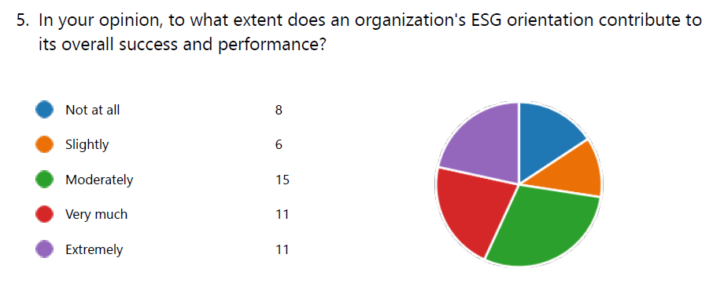
A discernible pattern becomes apparent upon examination of the survey responses pertaining to the extent to which an organization's Environmental, Social, and Governance (ESG) orientation impacts its overall performance and success. A moderate impact is perceived by the majority of participants, as 15 respondents fell into the "Moderately" category. Furthermore, a considerable proportion of the respondents ascribe a considerable impact to ESG practices, as indicated by the sum of 22 responses containing the words "Very much" and "Extremely." Conversely, a lesser proportion, denoted by the "Not at all" and "Slightly" classifications, consists of fourteen participants who hold the perception that there is a restricted correlation between ESG orientation and the achievement of an organisation. The wide array of viewpoints indicates that although a substantial proportion of participants recognise the importance of ESG practices, there is still a subset that may not entirely appreciate or comprehend the influence that such an approach has on overall achievement.
In short, the relationship between ESG orientation and organisational performance is viewed in a nuanced manner, emphasising the need for ongoing education and awareness regarding the potential benefits of implementing robust ESG practices.
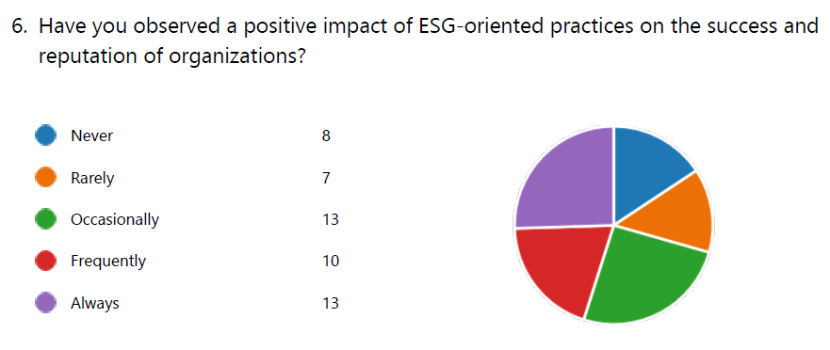
The aggregate count of 36 respondents, representing the options "Occasionally," "Frequently," and "Always," suggests that a prevailing favourable perception is held. This finding indicates that a considerable proportion of the participants have observed, to different extents, an advantageous impact of ESG practices on the reputation and profitability of businesses. It is worth noting that the 15 respondents who selected "Never" and "Rarely" represent a subset of the total sample size. This subset likely has limited or no experience with the beneficial effects of ESG-oriented practices. The existence of such a range of viewpoints highlights the necessity for increased consciousness and comprehension regarding the prospective advantages linked to ESG initiatives.
In summary, the survey findings reveal a varied yet overwhelmingly favourable perspective regarding the influence of environmental, social, and governance (ESG) practices on the achievements and standing of organisations. This underscores the criticality of ongoing endeavours to incorporate and convey the significance of ESG principles into corporate strategies.
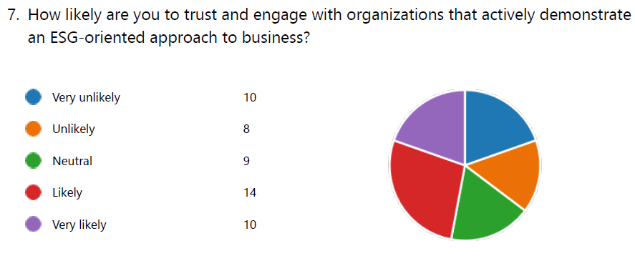
Twenty-four respondents, represented by the responses of "Likely" and "Very likely," suggest that a significant proportion of the sample demonstrates a favourable inclination towards organisations that place an emphasis on environmental, social, and governance (ESG) practices. In contrast, the 18 respondents who selected "Unlikely" and "Very unlikely" collectively constitute a smaller but significant group that harbours apprehensions regarding involvement with organisations focused on environmental, social, and governance concerns." The "Neutral" responses, which were given by nine participants, indicate a moderate stance, potentially indicating a degree of uncertainty or a dearth of firm belief concerning the influence of ESG practices on trust and engagement.
In summary, the findings of the survey indicate that respondents have a generally positive attitude towards companies that actively exhibit an environmental, social, and governance (ESG) orientation. This underscores the possibility of gaining favourable perceptions and greater confidence when ESG principles are conspicuously integrated into business strategies.
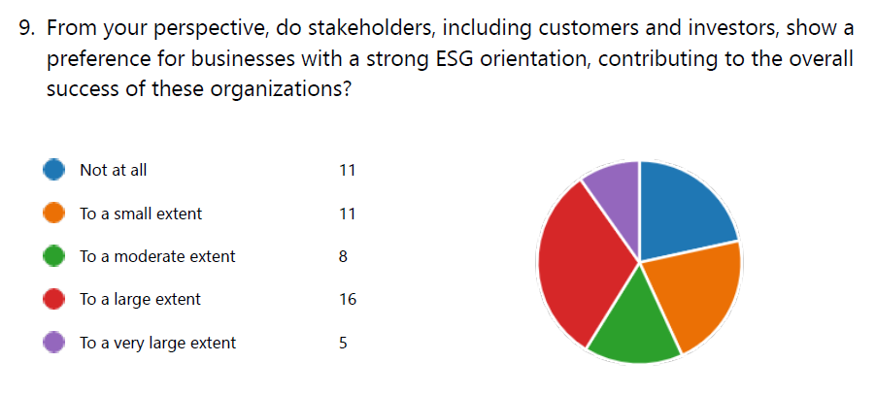
The prevailing viewpoint among participants, as indicated by the combined percentages of 21 respondents who selected "To a very large extent" and "To a large extent," is that stakeholders, such as investors and customers, strongly favour companies that possess a strong environmental, social, and governance (ESG) orientation. This suggests that there is a widely held belief that ESG factors have a substantial impact on the way in which stakeholders interact with organisations. On the other hand, the 22 participants who selected "Not at all" and "To a limited extent" as their response category indicate that a portion of the surveyed populace holds the view that ESG-oriented businesses have little influence or appeal among stakeholders. The responses "To a moderate extent" provided by eight participants suggest a position of moderate stance.
In summary, although a considerable portion of the stakeholder community acknowledges a considerable preference for ESG-focused enterprises, the existence of dissenting opinions underscores the need for continuous dialogues and education to promote a more cohesive comprehension of the ways in which ESG practices contribute to the overall success of organisations.
Testing the Hypothesis
Although a considerable proportion of respondents hold the view that ESG practices is correlated with overall performance and success, a noteworthy subset considers the correlation between ESG orientation and organisational success to be minimal or nonexistent. The existence of this variation in viewpoints implies that the hypothesis might not be universally valid among all participants, thereby revealing a nuanced understanding of the connection between ESG practices and the success of organisations.
Furthermore, although a significant proportion of participants acknowledge that stakeholders favour companies that have a robust environmental, social, and governance (ESG) focus, a minority perceives little influence or preference from stakeholders. The existence of such divergent viewpoints underscores the necessity for a more comprehensive comprehension of the ways in which stakeholders perceive the importance of ESG practices. Based on the survey results, the contradictory nature of the responses suggests that the hypothesis that ESG-orientation invariably results in favourable organisational outcomes may not be wholly valid.
In summary, the survey findings offer valuable perspectives on the intricate nature of the relationship between ESG practices and the success of organisations, suggesting that the hypothesis may not be consistently valid for every respondent. Diverse stakeholder groups' varying perspectives underscore the significance of ongoing dialogue, education, and research in order to gain a deeper understanding of the connection between ESG orientation and organisational success.

4.2 Hypothesis 2
Students are Correlated to ESG-Oriented Organisations' Internship Programmes
To check if this hypothesis is valid, we will analyse the responses for the following questions of our survey:
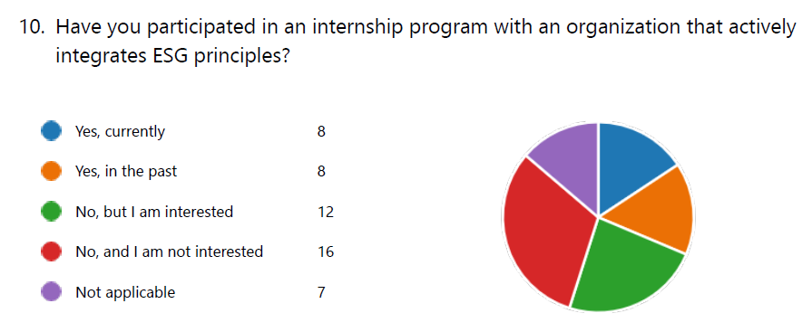
The opinions of the eight respondents who are presently enrolled in internship programmes of this nature and the eight respondents who have previously participated in such programmes indicate that organisations that integrate ESG principles into their internship frameworks generally provide a favourable experience. The responses of twelve respondents who indicated an interest in future participation, on the other hand, indicate a latent demand for internships that are in line with ESG values. Nevertheless, it is important to highlight that a considerable proportion of the participants, comprising 16 respondents, express disinterest in internships that incorporate ESG factors or have no prior experience with such opportunities. The seven participants who selected "Not applicable" suggest that the query may not be pertinent to them at this time, potentially as a result of their present situation.
In summary, although interest and engagement in ESG-focused internship programmes are apparent, the variety of responses indicates that academic institutions and organisations would be better served by promoting and conveying the significance of these endeavours to a wider demographic. By narrowing this divide in knowledge, it is possible that engagement will increase and a broader incorporation of ESG principles into internship prospects will be prompted.
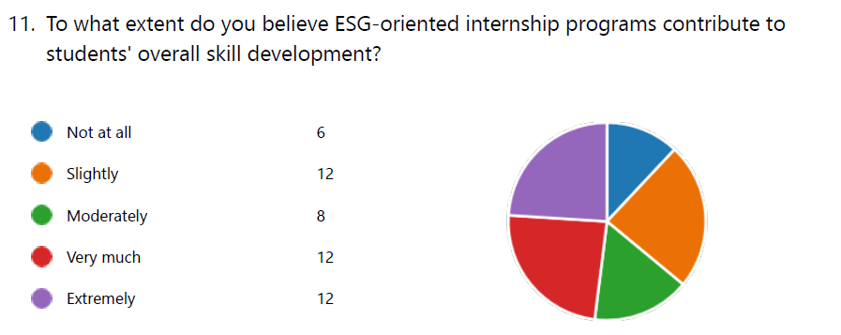
A considerable proportion of the participants, comprising 24 individuals who selected "Extremely much" and "Very much," hold a firm conviction regarding the substantial influence that internship programmes focused on environmental, social, and governance (ESG) have on the development of students' skills. This implies that these programmes are widely regarded as exceedingly advantageous in fostering a wide range of abilities in students. In contrast, among the 26 participants who rated the statements "Moderately," "Not at all," and "Slightly," there exists a subset that may harbour differing levels of doubt or scepticism regarding the practical application of ESG-focused internship programmes in terms of skill enhancement.
In summary, although a significant proportion of respondents recognise the substantial value of ESG-focused internship programmes in terms of enhancing skills, the variety of responses underscores the necessity for additional investigation and dissemination of the precise proficiencies gained via these programmes. By acknowledging and refuting these perceptions while substantiating the outcomes of skill development, it is possible to foster a broader acknowledgment of the educational benefits that ESG-focused internship programmes impart to students as a whole.
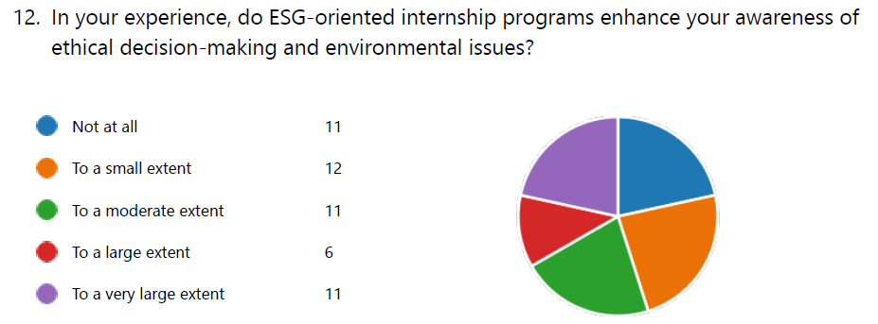
A considerable proportion of the participants, as indicated by the combined ratings of "To a very large extent" and "To a largely extent" (17 individuals), suggest that engagement in internship programmes that prioritise environmental, social, and governance (ESG) factors is positively associated with increased consciousness regarding environmental issues and ethical decision-making. This implies that these programmes significantly contribute to the development of a more profound comprehension of ethical implications and environmental issues. On the other hand, the group of 34 participants who selected "Not at all," "To a small extent," and "To a moderate extent" as their collective responses suggests that these individuals may not perceive ESG-oriented internship programmes as having a significant influence on their understanding of environmental issues and ethical decision-making. The wide range of responses underscores the necessity for organisations to communicate and incorporate components of environmental consciousness and ethical decision-making into their internship programmes.
In summary, although there is some evidence to support the notion that ESG-focused internship programmes have increased the awareness of some participants, a closer examination of the diverse responses indicates that these programmes still have the capacity to foster a more comprehensive understanding of environmental concerns and ethical considerations among all participants.
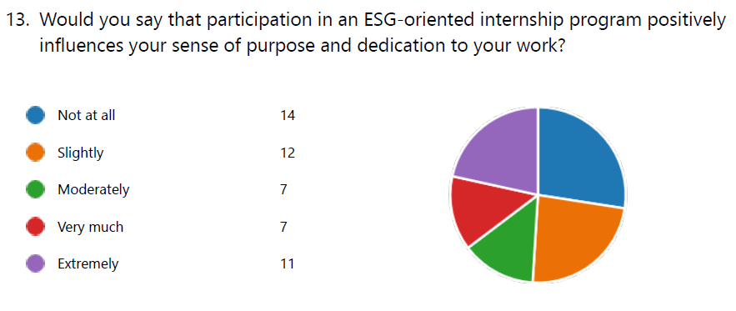
A significant proportion of the participants, as indicated by the combined ratings of "Very much," "Extremely," and "Moderately" (18 individuals), consider the influence to be positive in nature. However, a more varied or subdued effect is suggested by the combined ratings of "Not at all," "Slightly," and "Moderately" (33 individuals). According to the responses, participation in ESG-focused internship programmes is significantly associated with a sense of purpose and commitment to work for a subset of the participants. Nevertheless, a sizeable proportion of participants might not perceive this correlation to the same extent, indicating possible divergence in perspectives regarding the correlation between environmental, social, and governance (ESG) principles and individual drive.
In summary, although there is evidence suggesting that internship programmes affected a substantial proportion of participants positively, the wide range of responses highlights the need for internship programmes to strengthen and clarify the link between ESG principles and individual motivation. By confronting these perceptions, one can foster a more pervasive positive impact on the commitment to one's profession and sense of mission of individuals.
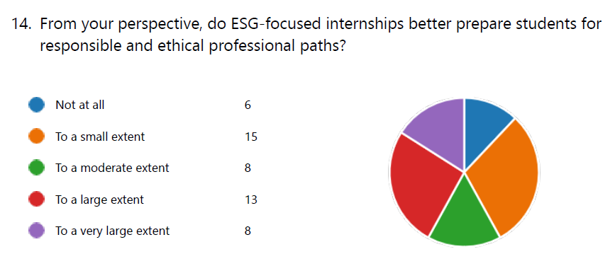
A considerable proportion of respondents (21 individuals), as indicated by the combined responses of "To a very large extent," believe that ESG-focused internships significantly prepare students for ethical and responsible careers. However, an additional segment (29 individuals), comprising the combined responses of "Not at all," "To a small extent," and "To a moderate extent," demonstrates a more varied range of viewpoints. The responses indicate that although a considerable proportion of respondents acknowledge the positive impact that ESG-focused internships have on preparing students for ethical and responsible careers, a sizeable portion of respondents may not consider these internships to have a significant effect in this regard. The divergence in perspectives underscores the necessity of enhancing and disseminating precise methods by which internships with an ESG focus foster the growth of conscientious and ethical conduct among professionals.
In conclusion, although the potential impact is duly recognised, improvements can be made to the efficacy of ESG-focused internships in consistently equipping students for ethical and responsible professional trajectories by addressing the diverse range of responses.
Testing the Hypothesis
The hypothesis is largely supported by the data for this investigation. A considerable proportion of survey respondents affirm their conviction regarding the importance of ESG practices, with a considerable number recognising a moderate to substantial influence on the success and performance of organisations. Furthermore, it is worth noting that the majority of observed effects of ESG-focused practices on the reputation and success of organisations have been positive, suggesting that ESG initiatives are generally regarded in a positive light.
A notable proportion of respondents exhibit a favourable inclination towards trust and involvement with organisations that demonstrate an ESG-oriented approach, providing additional support for the hypothesis. Furthermore, the substantial preference of stakeholders for companies that possess a robust environmental, social, and governance (ESG) orientation contributes to the recognition that ESG practices have a positive influence on the success of organisations as a whole.
Although there are divergent viewpoints, specifically some participants voicing concerns or perceiving a restricted influence, the general pattern observed in the survey responses is consistent with the proposed hypothesis. The findings of the research indicate that ESG-orientation is of paramount importance in positively impacting the success of the organisations whose members were surveyed. Nonetheless, it may be beneficial to continue dialogues, promote education, and implement awareness campaigns in order to rectify divergent viewpoints and enhance comprehension regarding the advantages linked to sustainable environmental, social, and governance (ESG) practices.

4.3 Hypothesis 3
ESG-Orientation is Correlated to Organizational Competitiveness
To check if this hypothesis is valid, we will analyse the responses for the following questions of our survey:
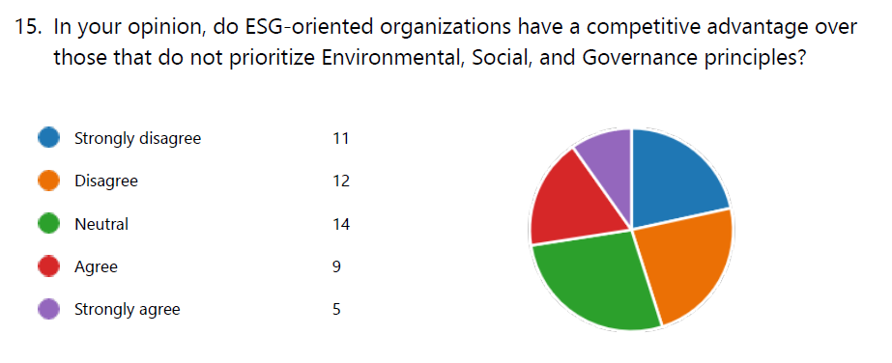
As indicated by the combined percentages of "Neutral," "Agree," and "Strongly agree" (28 respondents), the prevailing opinion is that organisations with a focus on environmental, social, and governance (ESG) factors have a competitive edge over those that fail to prioritise these factors. This suggests that a considerable proportion of the participants acknowledge that the incorporation of ESG principles has the potential to bolster the competitive standing of an organisation.
On the other hand, the cohort of participants comprising those who "Strongly disagree" and "Disagree" (23 responses) signifies a portion of the total that may hold the view that ESG-focused organisations do not possess an inherent competitive advantage. The existence of such a range of viewpoints highlights the intricate nature of understanding the strategic implications of ESG principles on the competitive position of an organisation.
In summary, although a significant proportion of respondents perceive ESG-oriented organisations as having a competitive edge, the presence of opposing perspectives indicates that further dialogues and public awareness initiatives are required to clarify the precise benefits linked to incorporating ESG principles into corporate strategies. By acknowledging and rectifying these perceptions, one can foster a more cohesive comprehension of the prospective advantages and strategic benefits that organisations can derive from adopting an ESG orientation.
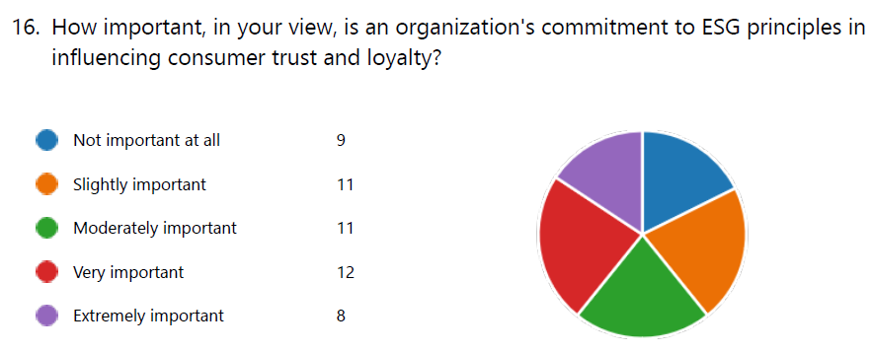
A considerable proportion of the participants, comprising 20 individuals who selected "Very important" and "Extremely important" collectively, indicate that they acknowledge the substantial impact that ESG principles have on consumer loyalty and trust. This finding indicates that a significant proportion of the participants perceive a robust correlation between an organization's assertion of ESG principles and its capacity to establish and sustain consumer confidence. Conversely, the aggregated ratings of "Not at all important," "Slightly important," and "Moderately important" (31 respondents) suggest that a subset of respondents may not place a significant emphasis on the manner in which an organization's adherence to ESG principles influences consumer loyalty and trust. The existence of such a range of viewpoints highlights the criticality for businesses to communicate and illustrate the connection between environmental, social, and governance (ESG) initiatives and fostering consumer trust and loyalty.
As a result, organisations have the opportunity to bridge communication gaps and emphasise the potential positive impact of ESG commitments on consumer relationships by addressing the perspectives of those who may not consider ESG principles to be of the utmost importance.
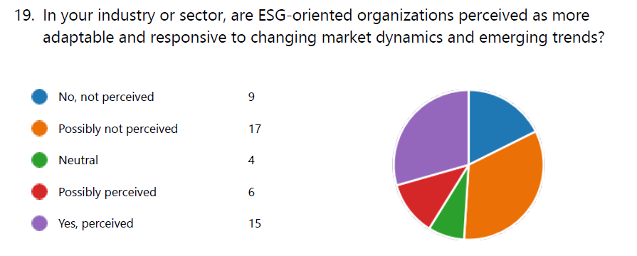
Based on the combined responses of "Possibly perceived" and "Yes, perceived" (21 respondents), the majority of participants indicate that a prevailing perception exists that organisations focused on environmental, social, and governance (ESG) factors are flexible and responsive to emerging trends and shifting market dynamics. On the other hand, the combined responses of "No, not perceived," and "Possibly not perceived" (26 respondents) suggest that a considerable proportion of the participants are either unaware of the perceived adaptability of ESG-oriented organisations in their industry or are doubtful of their status. The four participants who provided "Neutral" responses constitute a minority with an indecisive position regarding this perception.
In summary, although a subset of respondents acknowledges the flexibility of ESG-focused organisations, the presence of a substantial group holding dissenting opinions indicates that the sector as a whole requires greater understanding and dialogue concerning the ways in which ESG principles facilitate organisational responsiveness to evolving market conditions and emerging trends. By confronting these perceptions, one can foster a more cohesive comprehension of the strategic benefits linked to ESG orientation as it pertains to manoeuvring through a dynamic business environment.
Testing the Hypothesis
According to the combined responses of "Neutral," "Agree," and "Strongly agree" (28 participants), a substantial majority of respondents support the notion that organisations with an environmental, social, and governance focus have a competitive edge. This indicates that there is a general agreement among the participants that the competitive position of an organisation can be improved through the incorporation of Environmental, Social, and Governance principles. Nevertheless, the inclusion of dissenting opinions, as evidenced by the sum of "Strongly disagree" and "Disagree" responses (23 participants), introduces an element of variability and suggests that the hypothesis is not universally accepted by all participants. The existence of a wide range of viewpoints highlights the intricate nature of understanding the strategic implications of ESG principles on the competitive position of an organisation.
In summary, although a considerable proportion of respondents perceive ESG-oriented organisations to have a competitive edge, the presence of opposing perspectives indicates the necessity for continuous dialogues and educational initiatives to clarify the precise benefits linked to the incorporation of ESG principles into corporate strategies.

4.4 Summary
Hypothesis 1
The survey results demonstrate a sophisticated correlation between ESG practices and organisational success among the participants. While a significant minority recognises the positive influence of ESG practices on overall performance and achievement, a notable subgroup believes that the connection is minimal or non-existent. The presence of contrasting perspectives implies that the theory may not hold true for all individuals uniformly. While a considerable portion of individuals acknowledge that stakeholders prefer corporations that prioritise environmental, social, and governance (ESG) factors, a smaller group believes that stakeholders have little influence or preference in this regard. The conflicting responses suggest that the premise claiming that an ESG-focused approach always leads to positive organisational results may not be entirely accurate, particularly among specific categories of respondents. Hence, from the perspective of our survey, we have to reject the hypothesis.
Hypothesis 2
The survey reveals a significant consensus among respondents on the hypothesis “Students are Correlated to ESG-Oriented Organisations' Internship Programmes”. Most participants view ESG activities as having a favourable influence on the reputation and prosperity of organisations. Furthermore, the participants exhibit a positive predisposition towards placing trust and engaging with organisations that exhibit a strategy focused on environmental, social, and governance (ESG) factors. Although there are differing opinions, the survey responses generally support the idea that students derive good benefits from participating in internship programmes offered by ESG-oriented organisations. Hence, from the responses to our survey, we accept the hypothesis.
Hypothesis 3
The survey findings reveal a significant majority of participants endorsing the idea that companies prioritising environmental, social, and governance (ESG) factors enjoy a competitive advantage. The collective responses of "Neutral," "Agree," and "Strongly agree" indicate a consensus among participants that integrating ESG principles can enhance the competitive standing of an organisation. Nevertheless, the inclusion of dissident perspectives, which are shown by the combined number of "Strongly disagree" and "Disagree" replies, introduces a level of variability, suggesting that the hypothesis is not uniformly embraced by all participants. The presence of many perspectives underscores the complex nature of comprehending the strategic ramifications of ESG principles on an organization's competitive status. Hence, we will accept the hypothesis. The following table summarises our findings:
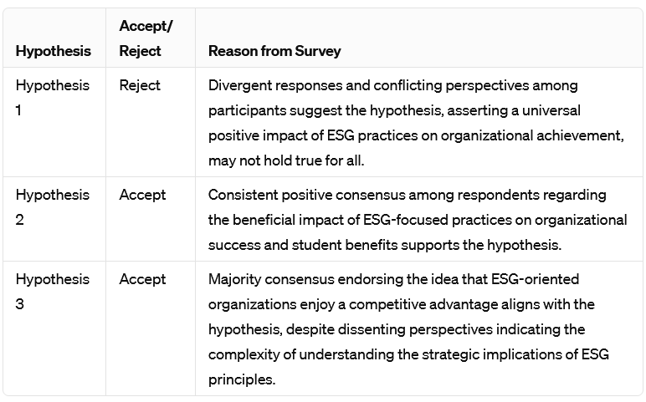

5. Findings and Discussion

5.1 Hypothesis 1
The initial hypothesis examines the diverse viewpoints revealed by respondents concerning the impact of Environmental, Social, and Governance (ESG) practices on organisations' overall performance. A considerable percentage of participants recognised and supported the notion that ESG orientation and organisational success are positively correlated, which is consistent with findings in the literature review. ESG commitment is described by Beckmann, Hielscher, and Pies (2012) as a crucial differentiating factor in contemporary firm strategy. Pellegrini (2021) emphasises the radical impact that ESG principles have in guiding business operations towards conscious capitalism. This convergence serves to strengthen the idea that, within a considerable portion of the population, ESG practices are considered crucial for attaining success for an organisation in an era characterised by social awareness and environmental accountability.
Nevertheless, a significant subset of the participants in the survey expressed doubt or perceived a tenuous correlation between ESG orientation and the achievement of an organisation. This variation in viewpoints is frequently observed, as Carroll (1991), who established the foundation for comprehending corporate social responsibility (CSR) as a catalyst for competitive advantage, notes in the literature. Divergent viewpoints on the concrete advantages of ESG practices are acknowledged in the literature as existing in the business domain. The variety of responses highlights the dynamic nature of attitudes towards environmental, social, and governance (ESG) factors and emphasises the necessity for ongoing discussions and educational efforts, as Gasiorowski (2023) notes in the literature review. The findings of the survey indicate that although an increasing number of respondents acknowledge the favourable impact that ESG principles have on the success of organisations, a significant segment continues to hold the view that this relationship is not universally acknowledged. This highlights the fluidity of perspectives regarding ESG practices and underscores the need for continuous investigation and education in this field.
Upon conducting a more comprehensive analysis of our literature review, it becomes apparent that the subtle perspectives revealed by the survey are consistent with more extensive dialogues concerning the strategic importance of ESG principles. Carroll's (1991) seminal work in the field of corporate social responsibility (CSR), which underscores the competitive edge gained by placing sustainability and ethical practices first, serves as a theoretical foundation. The contradictory viewpoints expressed in the survey results reflect the consensus in the literature that the extent to which the positive relationship between ESG orientation and organisational success can be comprehended may depend on organisational and individual circumstances. The transformative capacity of ESG principles in influencing corporate strategies is emphasised in the literature review. Furthermore, the survey results provide practical insights by uncovering the range of beliefs held by the individuals surveyed. In other words, Hypothesis 1 demonstrates that perspectives regarding the influence of ESG-orientation on the success of organisations are varied and complex. The correspondence with prior scholarly works establishes a conceptual framework; however, the inconsistency observed in the responses to the survey indicates that further investigation and instruction are required in this dynamic domain. Hence, for the purpose of this study, we will reject the hypothesis
This rejection does not imply that ESG practices are unimportant, but rather recognises that organisational success is complex and requires a more nuanced understanding of how ESG principles interact with different organisational situations. The survey results, by encompassing a wide range of viewpoints, enhance the ongoing discussion regarding the significance of Environmental, Social, and Governance (ESG) factors in achieving organisational success. The intricate nature of views regarding ESG practices necessitates a thorough examination of the factors that shape persons' perspectives. Gasiorowski (2023) highlights the importance of continuous talks and educational initiatives to improve understanding in the field of business. This is consistent with the results of the poll, where the diverse perspectives of participants indicate the fluid and changing nature of views towards ESG aspects. It becomes clear that a universal approach to assessing the influence of ESG practices on organisational success may not be suitable, and a more customised, situation-specific analysis is necessary.

Our literature review supports the notion that the correlation between ESG approach and organisational success depends on several aspects, such as industry dynamics, organisational culture, and individual values. Carroll's (1991) viewpoint on CSR as a competitive advantage emphasises the importance of harmonising organisational processes with environmental and ethical considerations. The research also recognises the presence of contrasting perspectives regarding the advantages of ESG practices, suggesting that perceptions may change among various organisational and human circumstances. The rejection of Hypothesis 1 necessitates a reassessment of the commonly held assumptions on the universally beneficial effects of ESG practices on organisational success. This statement motivates researchers and practitioners to explore the complexities of organisational dynamics and the way stakeholders perceive them. The denial does not lessen the significance of ESG practices but highlights the necessity for a more nuanced comprehension of how these practices are demonstrated in various organisational contexts. The significance of this study rests in its capacity to encompass the intricacy and variety of viewpoints about ESG procedures. The survey results offer a concise overview of present beliefs and attitudes, enabling a more knowledgeable examination of the intricacies linked to Hypothesis 1. The rejection of the hypothesis paves the way for future research to explore the precise circumstances in which ESG practices have the greatest impact on organisational success.
To conclude, although the rejection of Hypothesis 1 may appear to contradict the widely accepted belief that ESG practices universally contribute to organisational success, it actually prompts a more detailed and situation-dependent comprehension. The survey results, when analysed alongside the literature analysis, emphasise the complex interaction of factors that affect opinions of ESG practices. This rejection necessitates a transition from a general approach to a more focused analysis of how ESG principles correspond with the distinct attributes of various organisations. This study provides useful insights that add to the ongoing discussion on ESG, facilitating future research and enhancing our understanding of the complex relationship between ESG practices and organisational success.

5.2 Hypothesis 2
The second hypothesis examines the survey findings, providing insight into the nuanced but mostly positive perception of the influence of Environmental, Social, and Governance (ESG) focus on student internship experiences. The varied responses demonstrate a range of viewpoints, with a significant number of participants acknowledging and supporting the positive results linked to engagement in internship programmes that prioritise Environmental, Social, and Governance (ESG) factors. The congruence with earlier research findings, as demonstrated by Hoffman (2022) and Takimoto and Srisuphaolarn (2021), highlights the significant influence of ESG commitment on the characteristics and outcomes of student internships in different industries.
Most participants hold a favourable perception of internships that prioritise environmental, social, and governance (ESG) factors, suggesting a direct association between these programmes and beneficial results for students. Nevertheless, a notable portion of individuals voiced doubt or observed a weak connection between ESG focus and the achievement of organisational success. This introduces intricacy to the examination, reflecting contrasting perspectives reported in the literature, as highlighted by Carroll (1991), who established the basis for comprehending corporate social responsibility (CSR) as a catalyst for gaining a competitive edge. The corporate sector recognises the existence of differing opinions regarding the tangible benefits of ESG practices, highlighting the ever-changing perspectives on environmental, social, and governance (ESG) factors. This requires continuous dialogues and educational initiatives, as emphasised by Gasiorowski (2023) in the literature review.
The survey results suggest that although there is an increasing recognition of the beneficial effects of ESG principles on the success of organisations, a significant portion still believes that this connection is not commonly accepted. The constant change in attitudes highlights the importance of ongoing research and learning in the area of ESG practices, in line with the literature's demand for better communication to effectively engage a wider audience about the advantages of ESG-focused activities.

Moreover, the study uncovers various viewpoints regarding the benefits provided by internship programmes that concentrate on environmental, social, and governance (ESG) issues. This heterogeneity corresponds to the findings of Gasiorowski's (2023) literature study, which highlights the changing preferences of the present generation of learners, who tend to choose meaningful pursuits that are in line with their personal values. Although a notable majority recognises the beneficial impact of internships that focus on environmental, social, and governance (ESG) issues on students, not all respondents agree with this association. The literature emphasises the need for improved communication and promotional strategies to effectively communicate the advantages of ESG-focused internship programmes. This point is further supported by the diverse findings noticed in the survey results.
Upon further analysis of the literature review, it becomes evident that there is a correlation between the findings of surveys and Kolb's (2014) focus on experiential education. This connection serves to connect the divide between theoretical academic knowledge and its practical application. The relationship between internships that give priority to environmental, social, and governance (ESG) aspects and their attractiveness to a varied and socially conscious student population corresponds with the overall trend seen by Gasiorowski (2023) regarding the changing tastes of today's workforce. Previous research suggests that students, particularly those belonging to the millennial and Generation Z cohorts, are more likely to actively participate in meaningful work that aligns with their personal values. As a result, internships that give priority on environmental, social, and governance (ESG) factors are more appealing to this particular group of people. The survey results provide empirical evidence that supports the theoretical principles discussed in the literature, by drawing on the real-life experiences of students who have taken part in ESG-focused internship programmes.
To conclude, Hypothesis 2 demonstrates a diverse but generally positive viewpoint regarding the anticipated benefits of internship programmes provided by ESG-focused organisations for students. The correlation with academic literature underscores the significant potential of these programmes to transform students' perception of corporate responsibility. Thus, in the context of this study, we shall acknowledge and adopt the hypothesis.

5.3 Hypothesis 3
Hypothesis 3 investigates the possible influence of organisations giving priority to Environmental, Social, and Governance (ESG) principles on their overall competitiveness. This seeks to offer a thorough comprehension of respondents' viewpoints on the potential relationship between ESG orientation and organisational competitiveness, based on the insights obtained from survey data. The survey results reveal that participants strongly believe that organisations that prioritise ESG principles naturally have a clear advantage over others in terms of competition. This viewpoint aligns with the current academic research, particularly the publications of Jackson, Shan, and Meek (2022) and Zavala-Pérez, Jiménez-Rivero, and García-Navarro (2021). These studies highlight the favourable impacts of ESG practices on industry reputation, continuous advancement, and flexibility. The complete consensus among survey participants regarding the strategic importance of ESG orientation for organisational competitiveness provides compelling evidence that ESG principles not only strengthen a company's position within its industry but also contribute to continuous improvement and adaptation, thereby enhancing overall competitiveness.
Nevertheless, it is imperative to recognise the multitude of perspectives present in the survey findings, which introduces a level of ambiguity to the participants' viewpoints. The variety of viewpoints reflects the ongoing discussions in academic literature, recognising the significant impact of ESG principles but without reaching a unanimous agreement. The existence of conflicting perspectives highlights the intrinsic subjectivity of evaluations pertaining to competitiveness and ESG orientation, emphasising the necessity for ongoing discussion, instruction, and open distribution of ESG practices. Further analysis of our literature review supports the survey findings' focus on the connection between ESG practices, stakeholder engagements, and reputation management, as expressed by Székely and Knirsch (2005). The survey results, which demonstrate a direct relationship between internship programmes that prioritise environmental, social, and governance (ESG) factors and their influence on the recruitment and retention of skilled individuals, are consistent with the observations made by Story, Castanheira, and Hartig (2016). This highlights the importance of demonstrating a strong commitment to environmental, social, and governance (ESG) principles in order to recruit individuals who prioritise social and ethical responsibility. This commitment also has a direct impact on the competitiveness of organisations.
Although there is a general agreement on the positive views towards ESG orientation, the existence of conflicting opinions in the survey data highlights the subjective nature of assessments about competitiveness and ESG orientation. The fluctuation highlights the significance of ongoing communication, instruction, and clear distribution of ESG practices to promote a more thorough comprehension of the strategic advantages linked to an ESG approach. The survey results align with the literature's focus on clear communication and reporting of ESG initiatives, as described by Rey‐García and Mato-Santiso (2020). Both authors emphasise the importance of transparent communication in enhancing competitiveness by recognising achievements and benchmarking against industry norms. Also, Hypothesis 3 indicates that most survey participants believe that an ESG focus has a beneficial impact on the competitiveness of organisations. The survey's agreement with previous research provides strong support for adopting the hypothesis, as it demonstrates the strategic benefits associated with ESG practices. The favourable influence of ESG practices on organisational reputation, continuous growth, flexibility, talent recruitment, and employee retention highlight the complex connection between ESG orientation and competitiveness.
Nevertheless, the presence of various viewpoints in the survey data highlights the importance of continuous discussion and learning to traverse the inherent subjectivity in evaluating the strategic consequences of ESG principles on organisational competitiveness. Continuing discussions are crucial for organisations to create thorough ESG plans that align with their unique circumstances and meet the expectations of stakeholders, therefore assuring long-term competitiveness in ever-changing business settings Furthermore, the observed direct relationship between ESG-focused internship programmes and the recruitment and retention of skilled individuals brings a practical aspect to the conversation. Story, Castanheira, and Hartig (2016) emphasise the importance of ESG commitment in attracting individuals who value socially and ethically responsible work. This not only emphasises the potential advantages of ESG practices in talent management but also strengthens the notion that organisational competitiveness is closely connected to its capacity to attract and retain exceptional people, particularly in a progressively socially aware business environment.
The presence of subjectivity and diverse perspectives in the survey data highlights the intricate nature of evaluating competitiveness and ESG orientation. Although most respondents maintain a favourable opinion, it is important to acknowledge that attitudes might differ among stakeholders. This variation highlights the significance of ongoing conversation, instruction, and clear communication to bridge the gap in understanding and tackle the varied viewpoints within the organisational environment. Furthermore, the literature's focus on clear and open communication and reporting regarding environmental, social, and governance (ESG) initiatives aligns with the results of the survey. Rey-García and Mato-Santiso (2020) emphasise the importance of open communication in enhancing competitiveness by positively recognising and comparing to industry benchmarks. This highlights the notion that organisations must not only adopt ESG practices but also openly convey their endeavours to stakeholders, hence strengthening the favourable influence on competitiveness.
To summarise, Hypothesis 3 provides insight into the complex correlation between ESG approach and organisational competitiveness. The concurrence with established literature, along with the recognition of various viewpoints within the survey results, yields a nuanced comprehension of the intricate character of this association. Organisations should utilise this comprehension to navigate the inherent subjectivity involved in evaluating the strategic consequences of ESG principles on competitiveness.

6. Conclusion

6.1 Summary of Findings
For the first hypothesis, the survey findings indicate that the participants held a wide range of viewpoints. A considerable proportion of individuals recognise the beneficial impact that ESG practices have on the achievement of organisations, whereas a substantial group harbour doubt or perceives a restricted correlation. This divergence of viewpoints is consistent with the body of literature, which acknowledges that the business environment encompasses various perspectives regarding the tangible advantages of ESG practices. Hence, with the surveyed participants' partial agreement regarding the existence of a positive correlation between ESG orientation and organisational performance, the hypothesis is rejected.
Transitioning to the second hypothesis, the results reveal an overall optimistic yet intricate picture. A Considerable proportion of respondents acknowledge the favourable consequences associated with internship programmes that prioritise environmental, social, and governance (ESG) factors. This sentiment is consistent with the existing body of literature, which provides support for the idea that students can obtain favourable outcomes by participating in internship programmes that prioritise ESG. As a result, the hypothesis is accepted.
For the third hypothesis, the findings of the survey reveal a widespread agreement that organisations with an ESG focus have a competitive edge. The congruence observed in the literature lends credence to the notion that ESG principles have a beneficial impact on the repute of an industry, facilitate ongoing progress and adjustment, and ultimately bolster competitiveness. Nevertheless, the presence of opposing perspectives introduces an element of variability, underscoring the subjective character of evaluations concerning ESG orientation and competitiveness. In general, the hypothesis is partially supported, as it acknowledges the dominant belief regarding the favourable influence of ESG orientation on competitiveness while also recognising the existence of diverse viewpoints among the surveyed population Hence, we will accept the hypothesis.

6.2 Recommendations
The survey results provide significant insights into the perceptions and intricacies associated with ESG practices within organisations, as evidenced by the discussions and findings. Expanding upon these observations, the subsequent suggestions are put forth:
- Encourage Dialogue and Education Regarding ESG Practices: In light of the varied viewpoints revealed concerning the influence of ESG practices on the achievement of organisations (Hypothesis 1), ongoing dialogue and education are imperative within businesses. The implementation of platforms that facilitate continuous dialogues, educational initiatives, and public awareness campaigns can significantly enhance the breadth of knowledge regarding the advantages linked to ESG orientation.
- Strengthening Communication Approaches for ESG Internships: The intricate terrain unveiled in Hypothesis 2, wherein pupils exhibit an overall optimistic perspective albeit with divergent perceptions, necessitates the implementation of more effective communication tactics. There is a need for organisations that provide internship programmes with an environmental, social, and governance (ESG) focus to communicate the program’s benefits and value more effectively.
- Promote Greater Transparency in ESG Reporting: To assist organisations in capitalising on ESG practices to enhance their competitive edge (as suggested in Hypothesis 3), it is advisable to fortify transparent reporting mechanisms. Effective and thorough communication regarding environmental, social, and governance (ESG) initiatives can mitigate dissenting opinions and enhance an organization's standing in the industry. Transparent reporting is an effective mechanism for fostering confidence, credibility, and favourable relationships with stakeholders.
- Incorporate ESG into Leadership: In order to effectively navigate the intricacies associated with environmental, social, and governance (ESG) practices, it is advisable for organisations to incorporate ESG principles into their leadership and overarching organisational strategy. This entails integrating environmental, social, and governance (ESG) factors into the decision-making procedures, corporate culture, and strategic foresight. A commitment to ESG practices by leadership can amplify the favourable effects on the success and competitiveness of an organisation.

6.3 Limitations
One primary limitation arises from the inherent subjectivity and wide range of perceptions reflected in the responses of the participants. Although a significant percentage of respondents acknowledged the existence of a positive relationship between ESG orientation and the success of organisations, a notable subset exhibited scepticism or perceived a restricted correlation. The very nature of subjectivity poses difficulties when attempting to extrapolate results beyond the surveyed populace. Furthermore, the broader applicability of the study's conclusions may be constrained by its cross-sectional design and sample composition, which may impede the development of a comprehensive comprehension of the temporal dynamics and diverse perspectives present in various organisational contexts. Moreover, the possible existence of social desirability bias necessitates a cautious approach when attempting to interpret the complete congruence of perspectives with ESG practices.
Communication difficulties emerge as an additional notable limitation, considering the wide range of perspectives regarding the favourable aspects of internship programmes focused on environmental, social, and governance (ESG). The variability in participants' perceptions of positive outcomes underscores the importance of customised communication strategies. Recognising the dynamic nature of student preferences, the study presents a constraint in its ability to capture long-term trends. Ongoing educational endeavours become crucial in order to confront divergent perspectives among the student body. Furthermore, the research's narrow scope towards a particular demographic gives rise to apprehensions regarding the applicability of literature alignment to heterogeneous educational environments or student populations.
Subjectivity in perceptions of competitiveness is an additional limitation, given that dissenting opinions accompany the prevalent belief in the positive effects of ESG orientation. Recognising the strategic benefits associated with ESG practices is difficult due to the difficulty in establishing a universally accepted understanding of competitiveness, which is influenced by subjective perceptions. An additional constraint is the variable viewpoints of stakeholders, which impedes the development of a comprehensive comprehension of competitiveness. Additionally, the research may have overlooked industry-specific intricacies, which would restrict its capacity to offer nuanced evaluations customised to the viewpoints of a wide range of audiences.

6.3 Final Conclusion
In conclusion, it becomes apparent that Environmental, Social, and Governance (ESG) practices are inherently complex and necessitate nuanced deliberation. The analysis of three separate hypotheses revealed a range of viewpoints among the surveyed populace, which is indicative of the changing terrain of attitudes concerning ESG principles. Investigating the positive influence of ESG-orientation on the success of organisations, Hypothesis 1 unveiled a multifaceted interaction of perspectives, underscoring the imperative for continuous research and education in this dynamic domain. Hypothesis 2, which examined the advantages of ESG-focused internship programmes for students, emphasised the need for customised communication approaches to effectively communicate the program's value in the face of divergent opinions. Concerning the competitiveness of ESG-oriented organisations, Hypothesis 3 revealed a predominant conviction regarding their strategic benefits, which was moderated by opposing viewpoints, highlighting the subjectivity of perceptions of competitiveness.
In light of the complex relationship between environmental, social, and governance (ESG) practices, organisational performance, and competitive edge, it is evident that organisations must cultivate a holistic comprehension and advocate for open and honest communication. Further investigation is warranted to examine methodological improvements, enhance the representativeness of the sample, and investigate industry-specific dynamics and effective communication strategies. This research establishes a fundamental basis, encouraging academics, professionals, and decision-makers to further explore the developing intricacies of environmental, social, and governance (ESG) practices. It acknowledges the profound impact that these practices have the capacity to have on organisations that are competitive, environmentally sustainable, and socially responsible.

References
Alayón, C., Säfsten, K. and Johansson, G. (2017) 'Conceptual sustainable production principles in practice: Do they reflect what companies do?,' Journal of Cleaner Production, 141, pp. 693–701. https://doi.org/10.1016/j.jclepro.2016.09.079.
Alfeld, C. et al. (2013) 'Work-Based Learning Opportunities for High School Students.,' National Research Center for Career and Technical Education [Preprint]. http://files.eric.ed.gov/fulltext/ED574519.pdf.
Ali, H.M. (2020) 'Why corporate social responsibility matters & how it impacts business,' Proceedings of the International Conference on Law, Economics and Health (ICLEH 2020) [Preprint]. https://doi.org/10.2991/aebmr.k.200513.127.
Al-Qahtani, M. and Elgharbawy, A. (2020) 'The effect of board diversity on disclosure and management of greenhouse gas information: evidence from the United Kingdom,' Journal of Enterprise Information Management, 33(6), pp. 1557–1579. https://doi.org/10.1108/jeim-08-2019-0247.
Arquint, N. and Berger, A. (2022) 'Mitigating the risks and nurturing the opportunities,' in Routledge eBooks, pp. 119–140. https://doi.org/10.4324/9781003262039-9.
Arvidsson, S. and Dumay, J. (2021) 'Corporate ESG reporting quantity, quality and performance: Where to now for environmental policy and practice?,' Business Strategy and the Environment, 31(3), pp. 1091–1110. https://doi.org/10.1002/bse.2937.
Assensoh-Kodua, A. (2019) 'The resource-based view: a tool of key competency for competitive advantage,' Problems and Perspectives in Management, 17(3), pp. 143–152. https://doi.org/10.21511/ppm.17(3).2019.12.
Awaysheh, A. et al. (2020) 'On the relation between corporate social responsibility and financial performance,' Strategic Management Journal, 41(6), pp. 965–987. https://doi.org/10.1002/smj.3122.
Banker, R.D., Chang, H. and Pizzini, M. (2011) 'The judgmental effects of strategy maps in balanced scorecard performance evaluations,' International Journal of Accounting Information Systems, 12(4), pp. 259–279. https://doi.org/10.1016/j.accinf.2011.08.001.
Barney, J.B. (1991) 'Firm resources and sustained competitive advantage,' Journal of Management, 17(1), pp. 99–120. https://doi.org/10.1177/014920639101700108.
Battilana, J., Léca, B. and Boxenbaum, E. (2009) 'How Actors Change Institutions: Towards a Theory of Institutional Entrepreneurship,' The Academy of Management Annals, 3(1), pp. 65–107. https://doi.org/10.5465/19416520903053598.
Bebbington, J. and Unerman, J. (2018) 'Achieving the United Nations Sustainable Development goals,' Accounting, Auditing & Accountability, 31(1), pp. 2–24. https://doi.org/10.1108/aaaj-05-2017-2929.
Beckmann, M., Hielscher, S. and Pies, I. (2012) 'Commitment Strategies for Sustainability: How business Firms Can Transform Trade‐Offs into Win–Win Outcomes,' Business Strategy and the Environment, 23(1), pp. 18–37. https://doi.org/10.1002/bse.1758.
Bhattacharya, S. and Neelam, N. (2018) 'Perceived value of internship experience: a try before you leap,' Higher Education, Skills and Work-based Learning, 8(4), pp. 376–394. https://doi.org/10.1108/heswbl-07-2017-0044.
Brammer, S., Jackson, G. and Matten, D. (2011) 'Corporate Social Responsibility and institutional theory: new perspectives on private governance,' Socio-Economic Review, 10(1), pp. 3–28. https://doi.org/10.1093/ser/mwr030.
Broadstock, D.C. et al. (2020) 'Does corporate social responsibility impact firms’ innovation capacity? The indirect link between environmental & social governance implementation and innovation performance,' Journal of Business Research, 119, pp. 99–110. https://doi.org/10.1016/j.jbusres.2019.07.014.
Brown, H.S., De Jong, M. and Lessidrenska, T. (2009) 'The rise of the Global Reporting Initiative: a case of institutional entrepreneurship,' Environmental Politics, 18(2), pp. 182–200. https://doi.org/10.1080/09644010802682551.
Carlsen, L. and Brüggemann, R. (2021) 'The 17 United Nations’ sustainable development goals: a status by 2020,' International Journal of Sustainable Development and World Ecology, 29(3), pp. 219–229. https://doi.org/10.1080/13504509.2021.1948456.
Carroll, A.B. (1991) 'The pyramid of corporate social responsibility: Toward the moral management of organizational stakeholders,' Business Horizons, 34(4), pp. 39–48. https://doi.org/10.1016/0007-6813(91)90005-g.
Chousa, J.P., Castro, N.R. and Vizcaíno-González, M. (2019) 'Inclusions in and Exclusions from the S&P 500 Environmental and Socially Responsible Index: A Fuzzy-Set Qualitative Comparative Analysis,' Sustainability, 11(4), p. 1211. https://doi.org/10.3390/su11041211.
Çitilci, T. and Akbalık, M. (2020) 'The importance of PESTEL analysis for environmental scanning process,' in Advances in marketing, customer relationship management, and e-services book series, pp. 336–357. https://doi.org/10.4018/978-1-7998-2559-3.ch016.
Cornell, B. and Damodaran, A. (2020) 'Valuing ESG: doing good or sounding good?,' Social Science Research Network [Preprint]. https://doi.org/10.2139/ssrn.3557432.
Doni, F. and Jóhannsdóttir, L. (2019) 'Environmental Social and Governance (ESG) ratings,' in Encyclopedia of the UN sustainable development goals, pp. 435–449. https://doi.org/10.1007/978-3-319-95885-9_36.
Dorado, S. (2005) 'Institutional entrepreneurship, partaking, and convening,' Organization Studies, 26(3), pp. 385–414. https://doi.org/10.1177/0170840605050873.
Elkington, J. (1999) 'Cannibals with forks: the triple bottom line of 21st century business,' Choice Reviews Online, 36(07), pp. 36–3997. https://doi.org/10.5860/choice.36-3997.
Galván, J.-A., Casman, E.A. and Fisher, E. (2022) 'What skills predict an intern’s ability to innovate new products? A quantitative study of innovation capability of Mexican college interns,' International Journal on Interactive Design and Manufacturing (IJIDeM), 16(4), pp. 1301–1320. https://doi.org/10.1007/s12008-022-01005-w.
García-Torea, N. (2022) 'Sustainability Accounting Standards Board (SASB),' in Springer eBooks, pp. 1–3. https://doi.org/10.1007/978-3-030-02006-4_841-1.
Gasiorowski, M. (2023) Millennial and Generation Z Views on Meaningful Work and Intention to Stay Through the Great Resignation (Doctoral dissertation, Adler University).
Gbejewoh, O., Keesstra, S. and Blancquaert, E. (2021) 'The 3Ps (Profit, Planet, and People) of Sustainability amidst Climate Change: A South African Grape and Wine Perspective,' Sustainability, 13(5), p. 2910. https://doi.org/10.3390/su13052910.
Gennari, F. (2019) 'ETHICS COMMITTEES FOR CORPORATE CULTURE OF SUSTAINABILITY,' LIMEN - International Scientific-Business Conference - Leadership, Innovation, Management and Economics: Integrated Politics of Research [Preprint]. https://doi.org/10.31410/limen.s.p.2019.25.
Gill, A. et al. (2023) 'The Power of Culture: How passion, trust, and ethical leadership impact environmental, Social, and Governance (ESG) outcomes,' Social Science Research Network [Preprint]. https://doi.org/10.2139/ssrn.4322720.
Gond, J. et al. (2018) 'How ESG Engagement Creates Value for Investors and Companies,' University of Groningen [Preprint]. https://pure.rug.nl/ws/files/87066187/How_ESG_Engagement_Creates_Value_for_investors_and_companies.pdf.
Gover, A., Loukkola, T. and Sursock, A. (2015) 'ESG Part 1: Are Universities Ready?,' European University Association [Preprint]. https://eua.eu/resources/publications/678:esg-part-1-are-universities-ready.html.
Greenwood, M. and Van Buren, H.J. (2010) 'Trust and Stakeholder Theory: Trustworthiness in the Organisation–Stakeholder relationship,' Journal of Business Ethics, 95(3), pp. 425–438. https://doi.org/10.1007/s10551-010-0414-4.
Greenwood, R. and Suddaby, R. (2006) 'Institutional entrepreneurship in mature fields: The Big five accounting firms,' Academy of Management Journal, 49(1), pp. 27–48. https://doi.org/10.5465/amj.2006.20785498.
Harter, J.K., Schmidt, F.L. and Keyes, C.L.M. (2003) 'Well-being in the workplace and its relationship to business outcomes: A review of the Gallup studies.,' in American Psychological Association eBooks, pp. 205–224. https://doi.org/10.1037/10594-009.
Hazen, T.L. (2021) 'Social issues in the spotlight: the increasing need to improve Publicly-Held Companies’ CSR and ESG disclosures,' University of Pennsylvania Journal of Business Law, 23(3), p. 740. https://scholarship.law.upenn.edu/cgi/viewcontent.cgi?article=1645&context=jbl.
Henisz, W., Koller, T. and Nuttall, R. (2019) Five ways that ESG creates value.
Hoang, T.G. (2018) 'The role of the Integrated Reporting in raising awareness of Environmental, Social and Corporate Governance (ESG) performance,' in Developments in corporate governance and responsibility, pp. 47–69. https://doi.org/10.1108/s2043-052320180000014003.
Hoffman, A. (2022) Preparing Business Students to be Sustainable Business Leaders in the 21st Century. https://deepblue.lib.umich.edu/handle/2027.42/172874.
Iamandi, I.-E. et al. (2019) 'Mapping the ESG behavior of European Companies. A Holistic Kohonen approach,' Sustainability, 11(12), p. 3276. https://doi.org/10.3390/su11123276.
Jackson, D., Shan, H. and Meek, S. (2022) 'Employer development of professional capabilities among early career workers and implications for the design of work-based learning,' The International Journal of Management Education, 20(3), p. 100692. https://doi.org/10.1016/j.ijme.2022.100692.
Jacobson, R. (2016) 'The validity of ROI as a measure of business performance,' The American Economic Review, 77(3), pp. 470–478. https://www.jstor.org/stable/pdfplus/1804112.pdf.
Jamali, D. (2007) 'A Stakeholder Approach to Corporate Social Responsibility: A Fresh Perspective into Theory and Practice,' Journal of Business Ethics, 82(1), pp. 213–231. https://doi.org/10.1007/s10551-007-9572-4.
Jin, M. and Kim, B. (2022) 'Effects of ESG activity recognition factors on innovative organization culture, job crafting, and job performance,' Administrative Sciences, 12(4), p. 127. https://doi.org/10.3390/admsci12040127.
Johnson, J.L. et al. (2003) 'Market-Focused Strategic Flexibility: conceptual advances and an integrative model,' Journal of the Academy of Marketing Science, 31(1), pp. 74–89. https://doi.org/10.1177/0092070302238603.
Kapareliotis, I., Voutsina, K. and Patsiotis, A. (2019) 'Internship and employability prospects: assessing student’s work readiness,' Higher Education, Skills and Work-based Learning, 9(4), pp. 538–549. https://doi.org/10.1108/heswbl-08-2018-0086.
Kaplan, R.S. and Norton, D.P. (1996) 'strategic learning & the balanced scorecard,' Strategy & Leadership, 24(5), pp. 18–24. https://doi.org/10.1108/eb054566.
Karwowski, M. and Raulinajtys-Grzybek, M. (2021) 'The application of corporate social responsibility (CSR) actions for mitigation of environmental, social, corporate governance (ESG) and reputational risk in integrated reports,' Corporate Social Responsibility and Environmental Management, 28(4), pp. 1270–1284. https://doi.org/10.1002/csr.2137.
Khalil, M.A. (2021) In the race for sustainability and financial excellence: advancing firms' investment in knowledge assets and innovations. NIDA Wisdom Repository. https://repository.nida.ac.th/handle/662723737/6157
Kindström, D. and Kowalkowski, C. (2014) 'Service innovation in product-centric firms: a multidimensional business model perspective,' Journal of Business & Industrial Marketing, 29(2), pp. 96–111. https://doi.org/10.1108/jbim-08-2013-0165.
Kolb, D.A. (2014) Experiential learning: Experience as the Source of Learning and Development. FT Press.
Kraus, S. et al. (2018) 'Sustainable Entrepreneurship Orientation: A reflection on Status-Quo Research on Factors Facilitating Responsible Managerial Practices,' Sustainability, 10(2), p. 444. https://doi.org/10.3390/su10020444.
Kujala, J., Lämsä, A. and Riivari, E. (2017) 'Company stakeholder responsibility,' Baltic Journal of Management, 12(2), pp. 114–138. https://doi.org/10.1108/bjm-07-2016-0148.
Liang, T. and Tanniru, M. (2006) 'Special Section: Customer-Centric Information Systems,' Journal of Management Information Systems, 23(3), pp. 9–15. https://doi.org/10.2753/mis0742-1222230301.
Liu, L. and Nemoto, N. (2021) 'Environmental, Social and Governance (ESG) evaluation and organizational attractiveness to prospective employees: Evidence from Japan,' Journal of Accounting and Finance, 21(4). https://doi.org/10.33423/jaf.v21i4.4522.
Lydenberg, S. (2013) 'Responsible investors: who they are, what they want,' Journal of Applied Corporate Finance, 25(3), pp. 44–49. https://doi.org/10.1111/jacf.12027.
Matos, P. (2020) 'ESG and Responsible Institutional Investing Around the World: A Critical Review,' Social Science Research Network [Preprint]. https://doi.org/10.2139/ssrn.3668998.
Mintzberg, H. (1994) 'The fall and rise of strategic planning,' Harvard Business Review, 72(1), pp. 107–114. http://movingtheneedle.grow.co.nz/files/2014/09/Auckland_The-Fall-and-Rise-of-Strategic-Planning.pdf.
Mooij, S. (2018) 'Company’s ESG efforts; Catalysts and inhibitors,' Social Science Research Network [Preprint]. https://doi.org/10.2139/ssrn.3562205.
Oldford, E., Willcott, N. and Kennie, T. (2021) 'Can student managed investment funds (SMIFs) narrow the environmental, social and governance (ESG) skills gap?,' Managerial Finance, 48(1), pp. 57–77. https://doi.org/10.1108/mf-07-2021-0317.
Palermo, T. (2018) 'Accounts of the future: a multiple-case study of scenarios in planning and management control processes,' RePEc: Research Papers in Economics [Preprint]. https://econpapers.repec.org/RePEc:ehl:lserod:86648.
Palmer, E. and Devitt, P.G. (2006) 'Constructing multiple choice questions as a method for learning,' Annals Academy of Medicine Singapore, 35(9), pp. 604–608. https://doi.org/10.47102/annals-acadmedsg.v35n9p604.
Park, Y.S., Konge, L. and Artino, A.R. (2020) 'The positivism paradigm of research,' Academic Medicine, 95(5), pp. 690–694. https://doi.org/10.1097/acm.0000000000003093.
Paro, P.E.P. (2023) Towards a Conscious Business future: proposal and application of a multidimensional framework and its effects on stakeholders\’ engagement, financial performance and ESG metrics. https://doi.org/10.11606/t.18.2023.tde-12092023-142150.
Pataraia, N. (2010) The ESG and students’ involvement in European quality assurance of higher education. https://www.duo.uio.no/handle/10852/30463.
Pellegrini, M. (2021) Striking a balance between profit, people welfare, and ecosystem health in the transition towards a sustainable financial system. https://ssrn.com/abstract=4078278.
Petera, P. and Wagner, J. (2015) 'Global Reporting Initiative (GRI) and its Reflections in the Literature,' European Financial and Accounting Journal, 10(2), pp. 13–32. https://doi.org/10.18267/j.efaj.139.
Pinheiro, A.B. et al. (2023) 'What drives environmental, social and governance (ESG) performance? The role of institutional quality,' Management of Environmental Quality: An International Journal [Preprint]. https://doi.org/10.1108/meq-03-2023-0091.
Porter, M.E. (1985) Competitive advantage: creating and sustaining superior performance. http://ci.nii.ac.jp/ncid/BA00852365.
Porter, M.E. (1990) The competitive advantage of nations, Palgrave Macmillan UK eBooks. https://doi.org/10.1007/978-1-349-11336-1.
Prakash, B. (2020) Environment, Social and Governance (ESG) reporting : shift from compliance to commitment. https://essay.utwente.nl/82899/.
Rasche, A. and Esser, D.E. (2006) 'From stakeholder management to stakeholder accountability,' Journal of Business Ethics, 65(3), pp. 251–267. https://doi.org/10.1007/s10551-005-5355-y.
Rey‐García, M. and Mato-Santiso, V. (2020) 'Enhancing the effects of university education for sustainable development on social sustainability: the role of social capital and real-world learning,' International Journal of Sustainability in Higher Education, 21(7), pp. 1451–1476. https://doi.org/10.1108/ijshe-02-2020-0063.
Roscoe, S. et al. (2019) 'Green human resource management and the enablers of green organisational culture: Enhancing a firm’s environmental performance for sustainable development,' Business Strategy and the Environment, 28(5), pp. 737–749. https://doi.org/10.1002/bse.2277.
Rubera, G., Chandrasekaran, D. and Ordanini, A. (2015) 'Open innovation, product portfolio innovativeness and firm performance: the dual role of new product development capabilities,' Journal of the Academy of Marketing Science, 44(2), pp. 166–184. https://doi.org/10.1007/s11747-014-0423-4.
Ruhanen, L., Robinson, R. and Breakey, N. (2013) 'A tourism immersion internship: Student expectations, experiences and satisfaction,' Journal of Hospitality, Leisure, Sport & Tourism Education, 13, pp. 60–69. https://doi.org/10.1016/j.jhlste.2013.02.001.
Sachs, J.D. et al. (2019) 'Six Transformations to achieve the Sustainable Development Goals,' Nature Sustainability, 2(9), pp. 805–814. https://doi.org/10.1038/s41893-019-0352-9.
Sanfiz, J.M.M. et al. (2023) 'Does corporate social performance improve environmentally adjusted efficiency? Evidence from the energy sector,' Corporate Social Responsibility and Environmental Management [Preprint]. https://doi.org/10.1002/csr.2650.
Saunders, M., Lewis, P. and Thornhill, A. (2009) Research methods for business students. Pearson Education.
Sciarelli, M. et al. (2021) 'Socially responsible investment strategies for the transition towards sustainable development: the importance of integrating and communicating ESG,' The Tqm Journal, 33(7), pp. 39–56. https://doi.org/10.1108/tqm-08-2020-0180.
Shapsugova, M. (2023). ESG principles and social responsibility. In E3S Web of Conferences (Vol. 420, p. 06040). EDP Sciences.
Sheehan, N.T. et al. (2022) 'Threshold concepts and ESG performance: teaching accounting students reconceptualized fundamentals to drive future ESG advocacy,' Accounting Education, pp. 1–25. https://doi.org/10.1080/09639284.2022.2122727.
Sheehan, N.T. et al. (2023) 'Making the invisible, visible: Overcoming barriers to ESG performance with an ESG mindset,' Business Horizons, 66(2), pp. 265–276. https://doi.org/10.1016/j.bushor.2022.07.003.
Sobczak, A., Debucquet, G. and Havard, C. (2006) 'The impact of higher education on students’ and young managers’ perception of companies and CSR: an exploratory analysis,' Corporate Governance, 6(4), pp. 463–474. https://doi.org/10.1108/14720700610689577.
Steers, R.M., Nardon, L. and Sánchez‐Runde, C.J. (2013) Management across Cultures: Developing global competencies.
Stoddard, J.E., Pollard, C. and Evans, M.R. (2012) 'The triple bottom line: a framework for sustainable tourism development,' International Journal of Hospitality & Tourism Administration, 13(3), pp. 233–258. https://doi.org/10.1080/15256480.2012.698173.
Story, J., Castanheira, F. and Hartig, S. (2016) 'Corporate social responsibility and organizational attractiveness: implications for talent management,' Social Responsibility Journal, 12(3), pp. 484–505. https://doi.org/10.1108/srj-07-2015-0095.
Swaim, J.A. et al. (2013) 'Influences on student intention and behavior toward environmental sustainability,' Journal of Business Ethics, 124(3), pp. 465–484. https://doi.org/10.1007/s10551-013-1883-z.
Syed, A.M. (2017) 'Environment, social, and governance (ESG) criteria and preference of managers,' Cogent Business & Management, 4(1), p. 1340820. https://doi.org/10.1080/23311975.2017.1340820.
Székely, F. and Knirsch, M. (2005) 'Responsible leadership and corporate social responsibility:,' European Management Journal, 23(6), pp. 628–647. https://doi.org/10.1016/j.emj.2005.10.009.
Taghian, M., D’Souza, C. and Polonsky, M.J. (2015) 'A stakeholder approach to corporate social responsibility, reputation and business performance,' Social Responsibility Journal, 11(2), pp. 340–363. https://doi.org/10.1108/srj-06-2012-0068.
Takimoto, M.Y. and Srisuphaolarn, P. (2021) The influence of ESG on generation Z: a review of preference for workplace. (Doctoral dissertation, Thammasat University).
Tavanti, M. (2023) 'The future of sustainability management,' in Sustainable development goals series, pp. 325–337. https://doi.org/10.1007/978-3-031-36907-0_10.
Teece, D.J., Pisano, G.P. and Shuen, A. (1997) 'Dynamic capabilities and strategic management,' Strategic Management Journal, 18(7), pp. 509–533. https://doi.org/10.1002/(sici)1097-0266(199708)18:7.
Toledo, A.H., Flikkema, R.M. and Toledo‐Pereyra, L.H. (2011) 'Developing the research hypothesis,' Journal of Investigative Surgery, 24(5), pp. 191–194. https://doi.org/10.3109/08941939.2011.609449.
Torres, L. et al. (2023) 'The potential of responsible business to promote sustainable work – An analysis of CSR/ESG instruments,' Safety Science, 164, p. 106151. https://doi.org/10.1016/j.ssci.2023.106151.
Veenstra, E.M. and Ellemers, N. (2020) 'ESG indicators as Organizational Performance goals: Do rating agencies encourage a holistic approach?,' Sustainability, 12(24), p. 10228. https://doi.org/10.3390/su122410228.
Walgenbach, P. and Meyer, R.E. (2008) 'Institutional entrepreneurship and the structuring of organizations and markets,' in Oxford University Press eBooks, pp. 180–201. https://doi.org/10.1093/acprof:oso/9780199231423.003.0009.
Walsham, G. (2006) 'Doing interpretive research,' European Journal of Information Systems, 15(3), pp. 320–330. https://doi.org/10.1057/palgrave.ejis.3000589.
Wang, L. and Juslin, H. (2012) 'Values and corporate social responsibility perceptions of Chinese university students,' Journal of Academic Ethics, 10(1), pp. 57–82. https://doi.org/10.1007/s10805-012-9148-5.
Weihrich, H. (1982) 'The TOWS matrix—A tool for situational analysis,' Long Range Planning, 15(2), pp. 54–66. https://doi.org/10.1016/0024-6301(82)90120-0.
Wersun, A. et al. (2019) 'An exploration of student learning for sustainability through the WikiRate student engagement project,' The International Journal of Management Education, 17(3), p. 100313. https://doi.org/10.1016/j.ijme.2019.100313.
Wong, W.P., Teh, B.T. and Tan, S. (2023) 'The Influence of External Stakeholders on Environmental, Social, and Governance (ESG) Reporting: Toward a Conceptual Framework for ESG Disclosure,' Форсайт, 17(2), pp. 9–20. https://doi.org/10.17323/2500-2597.2023.2.9.20.
Wood, D.А., Thornley, B. and Grace, K. (2013) 'Institutional impact investing: practice and policy,' Journal of Sustainable Finance & Investment, 3(2), pp. 75–94. https://doi.org/10.1080/20430795.2013.776256.
Wu, Y., Zhou, R. and Zhang, C. (2023) 'Does Good ESG Performance Help Beat Peers?,' Cience and Technology Support for Social Governance and Intelligent Society [Preprint]. https://doi.org/10.2139/ssrn.4593099.
Yao, T. (2022) 'ESG Education and Job Choice,' HEC Paris [Preprint].
Youssef, A.B., Boubaker, S. and Omri, A. (2018) 'Entrepreneurship and sustainability: The need for innovative and institutional solutions,' Technological Forecasting and Social Change, 129, pp. 232–241. https://doi.org/10.1016/j.techfore.2017.11.003.
Yu, H. et al (2022). Application of an Environmental, Social and Governance (ESG) Course to Enhance the Knowledge of Sustainable Finance of International Chinese College Students in Thailand. Journal of Higher Education Theory and Practice, 22(11), 45-56.
Zahay, D. and Griffin, A. (2010) 'Marketing strategy selection, marketing metrics, and firm performance,' Journal of Business & Industrial Marketing, 25(2), pp. 84–93. https://doi.org/10.1108/08858621011017714.
Zangirolami-Raimundo, J., De Oliveira Echeimberg, J. and Leone, C. (2018) 'Research methodology topics: Cross-sectional studies,' Journal of Human Growth and Development, 28(3), pp. 356–360. https://doi.org/10.7322/jhgd.152198.
Zavala-Pérez, J.M., Jiménez-Rivero, A. and García-Navarro, J. (2021) 'Strategies and challenges for the promotion of a responsibility mindset in technical career students during internships,' Advances in Building Education =, 5(3), p. 86. https://doi.org/10.20868/abe.2021.3.4735.
Zheng, Y., & Bluestein, S. (2021). Motivating Students to Do Internships: A Case Study of Undergraduate Students' Internship Experiences, Problems, and Solutions. Teaching Journalism & Mass Communication, 11(1), 49-60.
Zumente, I. and Bistrova, J. (2021) 'ESG Importance for Long-Term Shareholder Value Creation: Literature vs. Practice,' Journal of Open Innovation: Technology, Market, and Complexity, 7(2), p. 127. https://doi.org/10.3390/joitmc7020127.

Appendices

Ethics Form
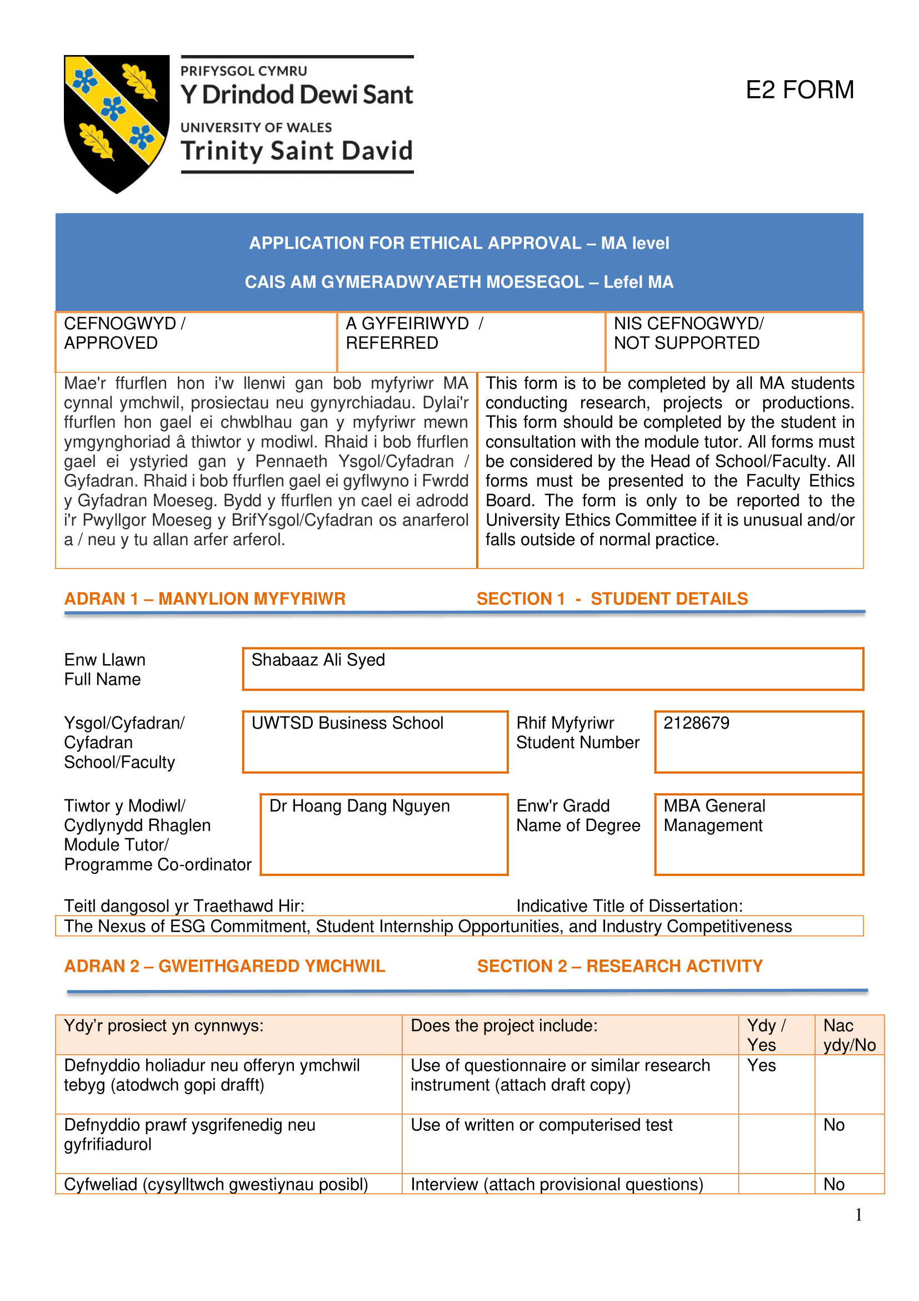
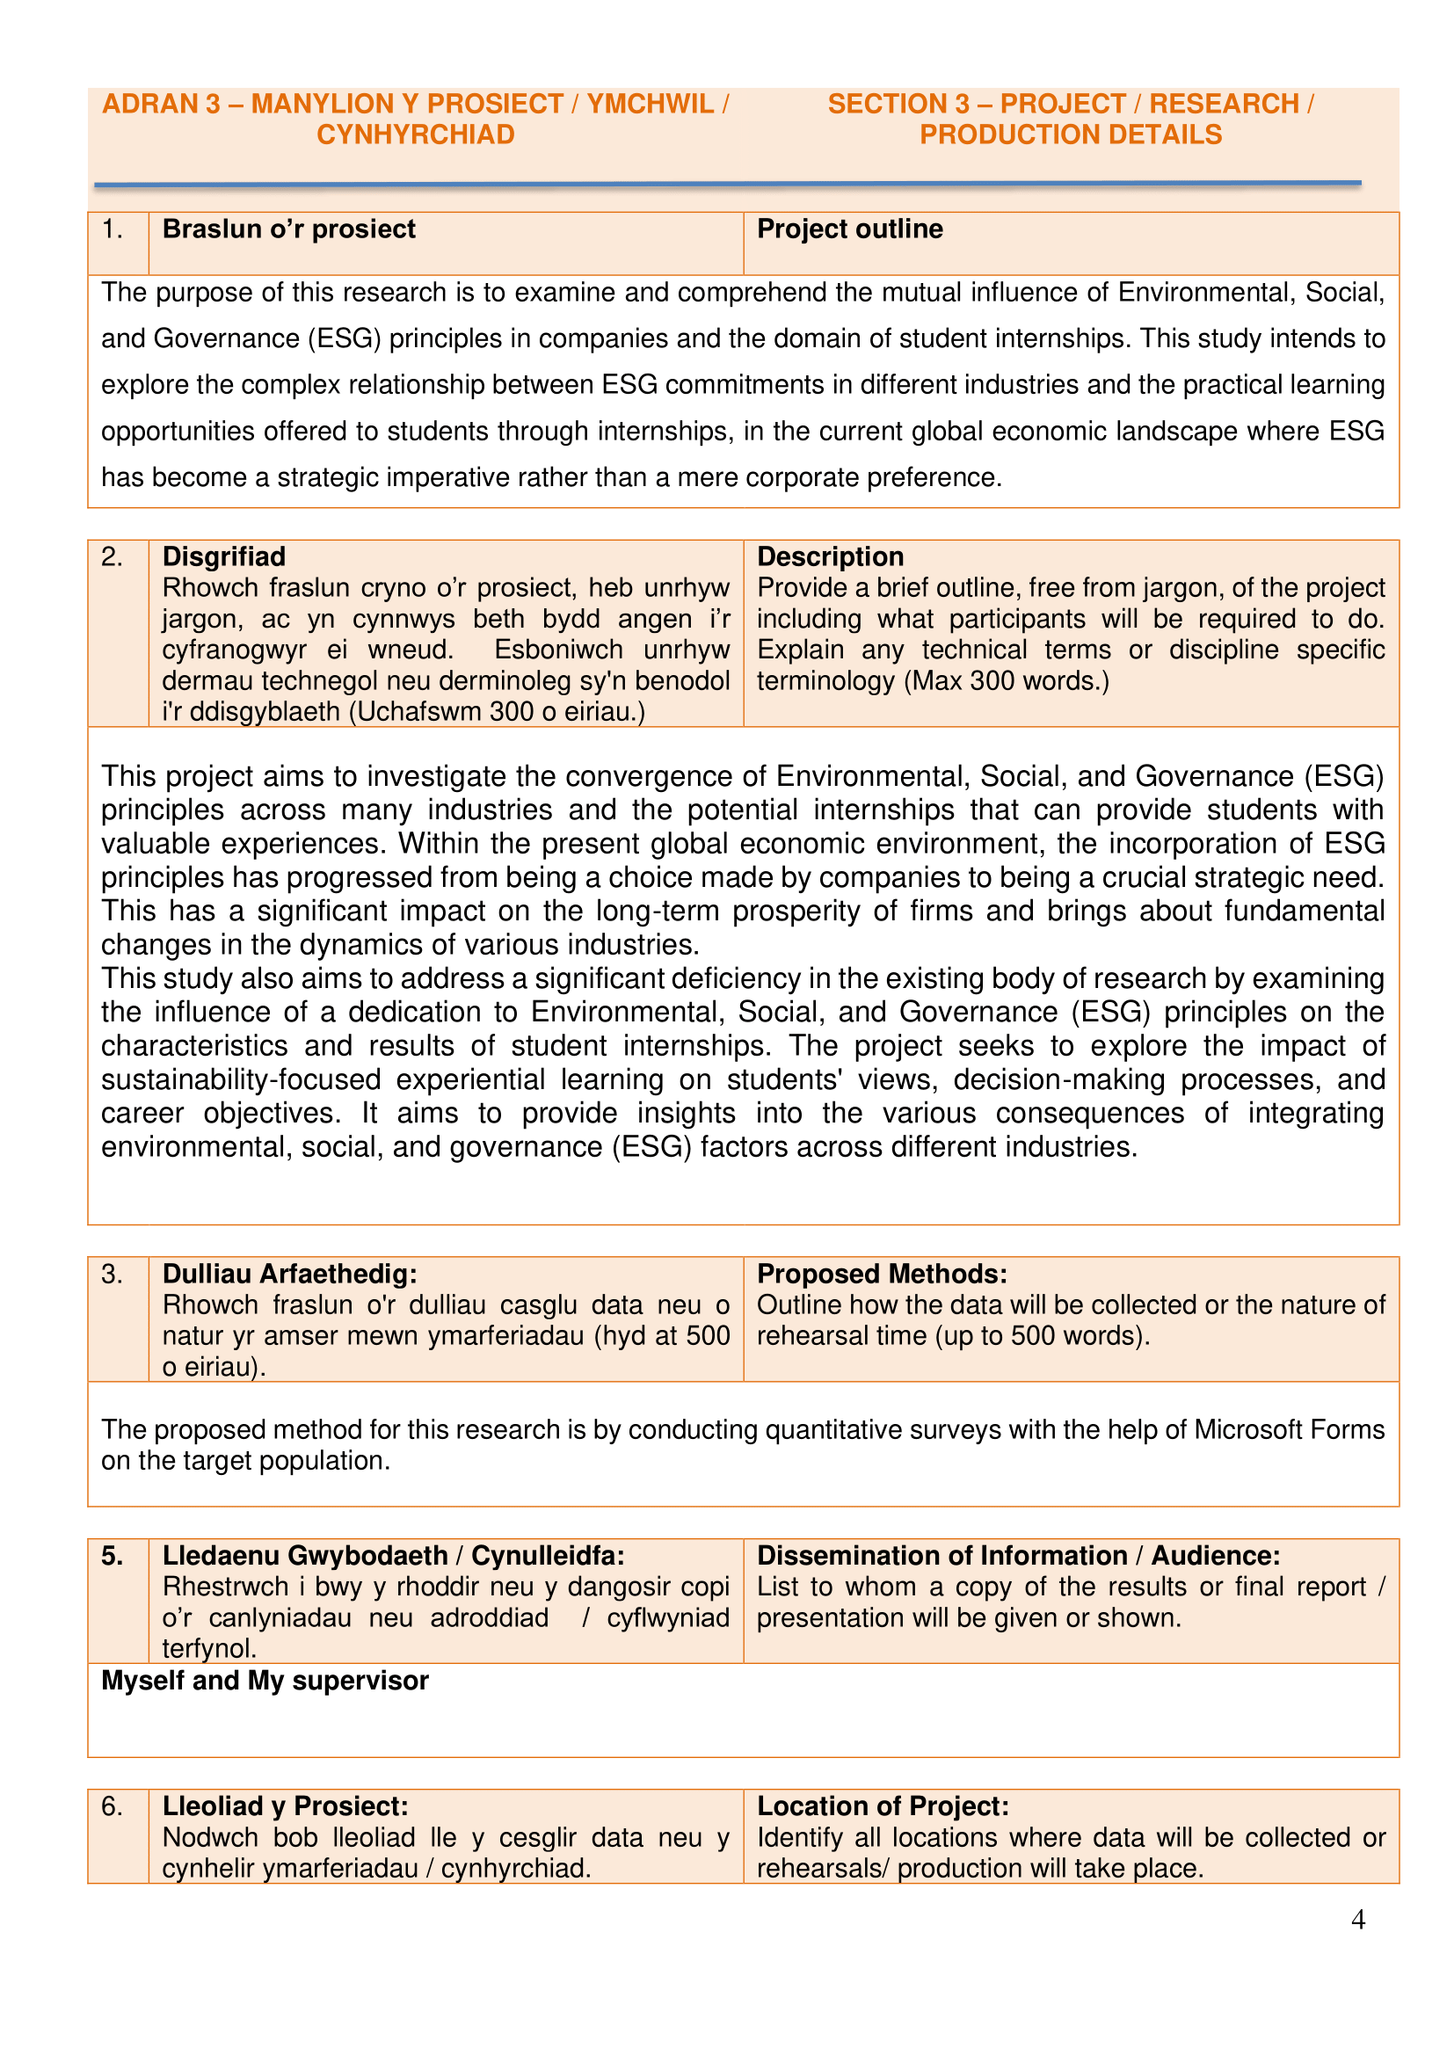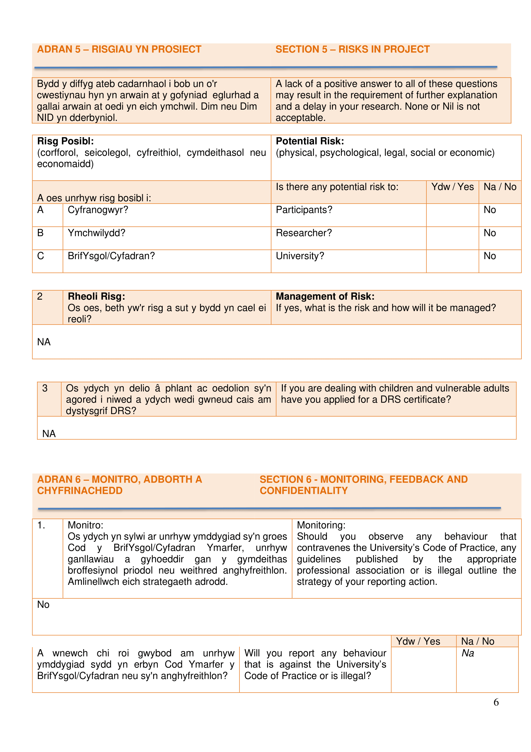

Survey Questions


