3/24/2025
University of Wales Trinity Saint David
London campus
E-Portfolio Link:
Module Name: Learning In the Digital Era
Module Code: ACCA 4025

Student Name:KOFI DENNIS ADORSOO
Student ID:2540934
Group: 3

Lecturer’s Name: ANEES BAQIR

LDE Assignment 1
E-Portfolio
Table of Contents
Introduction 2
Main Body 3
Task 1: Essential Academic and Employment Skills for the future career Path 3
Task 1 (a): Report on Essential Academic and Employment Skills 3
Task 1 (b): Evaluation of Task 1 (a) based on Similarity report 3
Task 2: Collaborative Mind Map and Individual Poster 4
Mind Map (Collaborative) 4
Poster (Individual) 4
Task 3: Virtual Collaboration and RefWorks 4
Report on Virtual Collaboration 4
Step-by-step process of using RefWorks with visuals 4
Task 4: E-Portfolio Creation and Evaluation 4
Task 4 (a): E-Portfolio Creation 4
Task 4 (b): Illustrative Review of E-Portfolio tool Selection 4
Conclusion 4
References 4
Task 1 References: 4
Task 3 References: 5

Introduction
This e-portfolio is brings the four task completed

Main Body

Task 1(a): Report on Essential Academic and Employment Skills

1. Foundations of Digital Competence in Modern Industry
While fundamental literacy skills—reading and writing—remain essential, contemporary professional environments demand higher-level digital fluency. Given the complete integration of web technologies into corporate operations, competencies such as web design and e-portfolio management are vital assets for career progression. Efficient web navigation, multi-window multitasking, and real-time information retrieval streamline operational workflows [1]. Furthermore, online educational tools offer flexible, cost-conscious avenues for continuous professional development, ensuring workforce skills align with current industry standards.

2. Administrative Automation and Team Efficiency
Serving as an Advance Team Member (ATM) requires converting core computer literacy into tangible productivity. Mastering fundamental system commands—such as mass selection (Ctrl + A), content transfer (Ctrl + C and Ctrl + V), and action reversal (Ctrl + Z)—significantly reduces task completion times and builds digital confidence.
These core technical capabilities facilitate essential administrative deliverables:
- Operational Reporting: Generating structured, accurate end-of-shift summaries to track operational metrics.
- Process Documentation: Authoring Standard Operating Procedures (SOPs) using word processors, incorporating structural elements such as custom headings, formatted typography, and visual aids.
- Automated Data Processing: Transitioning from manual calculations to formula-driven data manipulation in spreadsheet software, optimizing efficiency and accuracy [2].

3. Cognitive Skills and Strategic Problem Solving
Technical software mastery must be paired with strategic cognitive abilities to ensure long-term career resilience. Critical thinking and systematic problem-solving allow team members to evaluate operational friction, diagnose root causes, and execute effective interventions [3]. Combining technical software operations with structured analytical reasoning prepares individuals to navigate complex, technology-driven career landscapes [4].

Task 1 (b): Evaluation of Task 1 (a) based on Similarity report
My similarity report came out to be 15%, due to using other tools and web site to help me completing my work, in future i will try to give myself more time and for the assessment and try and work more with my own ideas. I try to relie less on the other sites and put my critical thinking cup on above all i will try to do 90% of the work from my own memory before sicking help from sites.

Task 2: Collaborative Mind Map and Individual Poster

Task 2: Collaborative Mind Map and Individual Poster
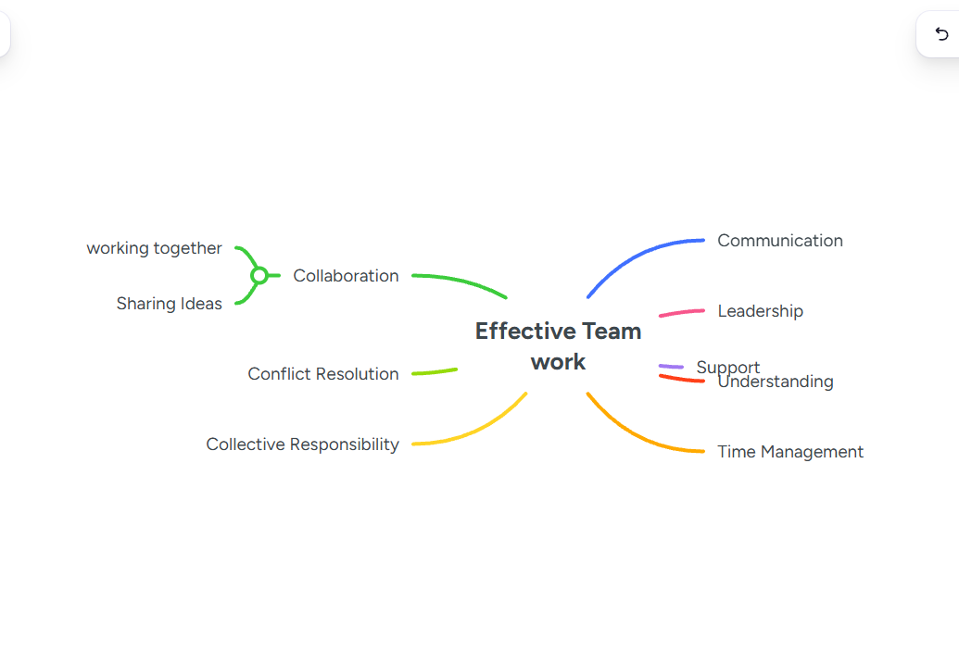
Group Member Name: KOFI DENNIS
Communication; Understanding effective communication builds good team, it prevents confusion and helps the team to Communication; Communication is very good for the teammates to know and achieve their goal. Communication is the foundation of every team; communication helps to understand what and where they are heading. Especially when it is clear and specific, boost the team's confidence.
Support; Each and everyone needs support in one way or the other. With good communications you can find where your teammates need support. Supporting comes in different ways, physically, mentally, administrative task, cheering a team mate to make him feel good. Support helps a team member feel courageous, boost their morale, they feel less stress. Support helps to achieve your goal in time not waiting for the teammate who is struggling but give him support. It helps to increase speed.
Understanding; Understanding is very good in team, it helps to identify the strength of each team member, and this can be done through paying attention to individual and keen observations. You need to know when to offer a support and when not to. is knowing the capabilities of your teammates.
Group Member Name: BEATRAM BROWN
Encouraging your teammates means supporting them with positive words and sharing ideas that helps when needed and motivating them to do their best. Encouragement strengthens confidents and improves communication.
Collaboration is working with someone or as a group by sharing ideas skills and responsibility to achieves common goals and mutual respect and support to one another to achieve their goals.
Collective Responsibility is when a group of people shares the same responsibility or make the same discissions that benefit the group rather than one individual being Soley responsible for making that decision for the group.

Poster (Individual)

Task 3: Virtual Collaboration and RefWorks

Report on Virtual Collaboration
Put your Chosen topic here

Step-by-step process of using RefWorks with visuals

First, you need to create an account for RefWorks.
Next is for you to write your synthesis. Next is to go online to check for similarities.
When you find one, you cite it, then you import it intoRefwork in a folder.The page will display last imported then you check the box next to the one you want. Then you go back to your synthesis place the cursor where you want to put then.

Task 4: E-Portfolio Creation and Evaluation

Task 4 (a): E-Portfolio Creation

Task 4 (b): Illustrative Review of E-Portfolio tool Selection

Conclusion

References

Task 1 References:

Task 3 References:

References
[1] J. P. Robinson, "What are employability skills," vol. 1, no. 3, pp.1–3, 2000,
[1] R. Vuorikari, S. Kluzer, and Y. Punie, "DigComp 2.2: The Digital Competence Framework for Citizens," Publications Office of the European Union, Luxembourg, Rep. EUR 31088 EN, 2022. doi: 10.2760/115370.
[2] T. P. Lee and S. B. Bowyer, "Spreadsheet usage, data literacy, and decision support in the digital workplace," IEEE Transactions on Professional Communication, vol. 65, no. 3, pp. 312–326, Sep. 2022.
[3] M. A. A. Agni, M. Giatman, and S. Islami, "Enhancing critical thinking and teamwork through project-based learning in technical education," IEEE Transactions on Education, vol. 67, no. 1, pp. 45–54, Feb. 2024.
[4] S. J. Tsiligiris and D. Bowyer, "Exploring the impact of digital transformation on graduate employability skills," IEEE Access, vol. 9, pp. 115200–115212, 2021. doi: 10.1109/ACCESS.2021.3105432.

