PROFESSIONAL CAREER DEVELOPMENT
STUDENT NAME: NATASHA SUSHICH
STUDENT NUMBER: 1921374
LECTURES NAME: HUSAM ALHARAHSHEH
MODULE CODE: BMSW4005
MODULE NAME: PROFESSIONAL CAREER DEVELOPMENT
LEVEL: 4

TABLE OF CONTENTS
Introduction………………………………………………2
Role play ……………………………………………….2-3
Reflection on the role play………………………………4
Gibbs reflection cycle…………………………………...4-5
Personal Development Plan…………………………….5
Swot Analysis……………………………………………5-6
Smart Objectives……………………………………….6-7
Johari Window…………………………………………. 7-8
Conclusion……………………………………………….8-9
Reference list…………………………………………….9

INTRODUCTION

To introduce myself briefly. My name is Natasha Sushich and I am a university student at University of Wales Trinity St. David. I have a limited set of professional and personal skills, which allows me to stay focused and determined to complete every single objective I set for myself throughout my life. I have various employment experiences also. My career experience began in Italy as a assistant fashion designer for the most famous fashion stylist. However, my genuine employment journey began when I did enrol at the University. I've been able to improve not just my knowledge and understanding of the professional world, but also my abilities and experiences, since beginning this course. The main theme to be discussed and analysed in this report will be role-play, was divided into two portions in which I and my classmate partner had to play the roles of interviewer and interviewee respectively.
First and foremost, my classmate partner had to interview me for the position of administrator in a car dealership company for Aros Auto Accident Repair Ltd in London. In inclusion, a self-reflection evaluation of the role play will be conducted, and a personal growth plan will be developed using a SWOT analysis. The SMART goals and the JOHARI WINDOW framework will also be explored and discussed. In addition, other references derived from in-class exercises and other valuable and reputable sources will be included in this report; all of these will be mentioned at the end of this piece.
ROLE PLAY

In the role play, I performed as a interviewee for several roles. However, in this section, I will discuss a scenario in which I was the interviewee and my classmate partner was giving me the interview for the position of administrator in a car dealership company for Aros Auto Accident Repair Ltd.
1. The first question asked me to explain why I believe I am the best candidate for this position as an administrator in their organisation. I responded to this question by stating that I am a confident, industrious, trustworthy, and conscientious individual. I operate efficiently under pressure, am hardworking, and enjoy working in teams.
2. The second inquiry was whether I could elaborate on my customer service and administrative talents and expertise. Which I mentioned were largely learned and strengthened through my previous work experiences. And my administrative duties were to manage the online system for vehicle and driver's license checks. Ordering new or replacement car parts. Providing for new vehicles to have the required documents and equipment. This is the pure communication skills that extend to persuasive speaking abilities. For example, when the customer is not sure what to buy or not to buy, I will encourage the customer by giving all the positive reasons to buy it. I said as well that I have good problem-solving experience which comes in my hand when I work in a busy environment.
3. The third question was, to explain what are my weaknesses. I said that my weaknesses are patience and Self-critical. Sometimes, Some customers can be quite chatty, oblivious to the fact that you are working and must attend other clients. This irritates me and sometimes causes me to dismiss them immediately in order to avoid the disorganisation in time management produced by some customers' protracted discussions. I can be too critical of myself too. The mark I noticed during my career is that I often feel I could do even more, even if actually, I have done very well.
4. The fourth question was, the shop is having an extremely busy day, and there is a customer who is dissatisfied with the car and wants to return it or exchange it, and would like to buy another car but it's not available this model of the car at the moment. What and how I would do and deal with this situation? I responded that returning the automobile would be dependent on the company's return rules, and that if the car that the customer wanted to buy was not available, I would apologise for the inconvenience and provide a similar model as an exchange.
5. The fifth question was, to concerned my plans for the company. I stated that my plans concerned my future career as well as my studies, and that I would acquire more experience in the car industry once I finished my studies in business and management, and that I would like to advance in my career and achieve my goals, I would like to advance my career in the car industry and achieve my goals.
REFLECTION ON THE ROLE PLAY
Reflection is the process of recognising something that is being thought in your own unique way. To make the point, that means making meaning of an opportunity and turning it into a process. Making meaning becomes learning when we employ this processing to drive our decision-making or action. In the next section, I will use the Gibbs reflective cycle to analyse my reflections on the role play.

GIBBS REFLECTIVE CYCLE
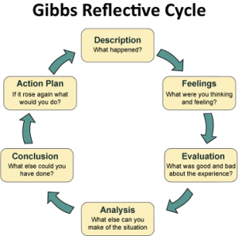
This reflection model provides a framework for assessing our experiences and has a cyclic aspect that lends itself particularly well to repeated events. Allows us to learn and plan based on objects that went well or poorly. This is divided into six stages:
Description
During the role play, my classmate partner led the interview for the position of administrator in the prestige vehicle dealership company Aros Auto Accident Repair Ltd. In the brief time which I had this interview, I was assured of all my responses. I can say that I maintained a calm demeanour during the interview, and I must say the same for my classmate partner. The interview was completed within the time frame set by our lecturer.
Feelings
I hope and believe during the interview, there weren’t too much issues throughout the interview in which I was the interviewer. I was thrilled and pleased with how I did my performance. I vividly remember this awful feeling I had when answering his question, despite the fact that we had prepared several times. I was frightened and tense, but I heard relaxation and peace in my classmate's partner's voice.
Evaluation
There were several great qualities that I saw in this role play. In spite of my terrible anxiousness, the interview went rather easily, which I believe was insufficient reason for it, and I discovered that my classmate partner's calmness was incredibly useful, composure incredibly soothing and encouraging.
Analysis
The interview circumstance taught me a lot more about what may have been done to do better of experience of the role-play performance. I believe that my classmate partner and I were fairly good and self-assured and we attentively observed the time frame that the lecturer gave us.
Conclusion
I'd like to conclude by saying that it was clear that both I and my classmate partner need a space for development in several areas.
Action Plan
Following this reflection on the role play, I feel we gained consciousness of where our weaknesses come from and to be able to change them if the situation changed. To improve and grow we will naturally rise our way to the top of any organization or company.
PERSONAL DEVELOPMENT PLAN
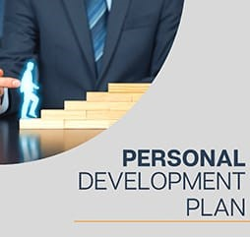
This section of the report is a thoughtful examination of the concept of PDP, which increased my self-consciousness. As the administrator is required for working with consumers in the car field who have emotional well-being and substance use, the progress of this report is to develop a hypothetical route. I need to grasp how to respond to a wide range of sophisticated, individual consumer problems, habits, and emotions. The process of intellect conduct is the way with which I am most familiar and like working. When I learn how to be more attentive to my profession, I will be able to completely relieve my stress.
In terms of self-consciousness, good customer interactions are essential for customer service and administrative abilities. Depending on the findings, I will be able to see assumptions and viewpoints and enhance my influence over my profession.
However, I did discover this information and this feeling, which are essential to being a highly successful businesswoman. One of the avenues I can take is to get advanced training in multiculturalism, which is something I deal with on a daily basis.
SWOT ANALYSIS
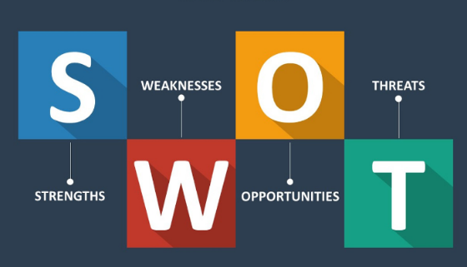
SWOT Analysis is a method that may be used in any organisation for strategic planning and management. My SWOT analysis is based on my job as an administrator for Aros Auto Accident Repair Ltd. in a car dealership.
Strengths
As I previously stated, I believe I have a decent collection of skills that I regard to be my strengths. In everything I do, I believe myself to be trustworthy, confident, dedicated, and careful. I feel I have good communication abilities as well, which I can utilise to persuade any client to buy and enjoy our automobiles and car maintenance services. I operate well under pressure and have limited problem-solving abilities.
Weaknesses
I have quite a few Weaknesses. When I get furious, I lose control of my body language, which I realize is a negative trait that I need to work on. When it comes to listening to some customers while the shop is incredibly busy, I believe I have a lot of patience. I try to pay attention to all of my customers at the same time, but it is sometimes impossible. As I previously stated, my self-criticism needs to be improved as well. I am far too harsh on myself.
Opportunities
Expanding another set of abilities would allow me to increase my opportunities to work more successfully and create more connections in the automotive industry. Furthermore, successfully completing my courses will allow me to pursue better chances in my work.
Threats
During the Pandemic, I was faced with the prospect of losing or keeping my job, which was pretty frightening. If the position is obtained, the workload may grow due to a lack of staff or shop closures. I am also conscious of the high level of competition I will have to face in the future.
SMART OBJECTIVES

The SMART method is widely regarded as the gold standard for developing effective, quantifiable goals and objectives. After thoroughly analysing and measuring my qualities and talents, I will provide my Smart goals framework, which will boost my future job chances.
Specific
My long-term objective is to expand the vehicle business, but once I finish my education, I'd like to create my own fashion line too.
Measurable
Yes, my goal can be measured.
Achievable
It is achievable. My action plan is comprehensive. Financially, I've been putting money aside to establish a fashion business. Furthermore, in addition to working in the fashion sector, I have worked with several fashion designers, which has helped me to develop my talents and awareness of the fashion industry. In addition, working in the automotive industry will allow me to pursue a more lucrative career path.
Relevant
Is the procedure that assists in preferring the major action that must be completed during the day; this will assist in achieving the main goal while doing the bare minimum and gaining and having an exceptional results.
Timely
My goal will be achieved and succeed in the time frame of 2 - 3 years.
JOHARI WINDOW
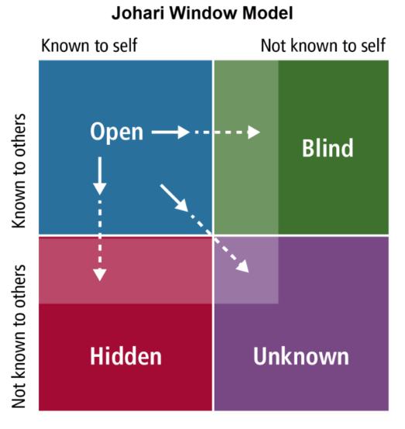
The concept of the Johari Window is one way for increasing self-awareness of yourself and others in order to better know their feelings and information.
Open Area
I believe that everyone who knows me regards me as a capable or determined person who works hard and consistently. I'd like to say that most people recognize my invincibility and worth. Also, most people know that I am both, reserved and an extrovert person.
Blind Spot
What I don't know or see about myself, but others know, is that I am an unselfish person who is always willing to help others in need, even at my own sacrifice. Some people claim I merely observe and don't talk, and I appear distracted, but I am detail-oriented.
Hidden Area
Things I know about myself that others do not know are that I am driven, prideful, and emotional, and that I do not enjoy or accept sarcasm.
Unknown
Some things I don't know about myself, and others don't know either, are that I trust too easily and that I can't forgive too quickly.
CONCLUSION

I concluded through this report that knowing yourself is important. To achieve my objectives, I must focus more on improving my talents and character. In addition, I will state that the role play that was used in class helped me learn my SWOT. I am also aware of my full potential. This examination provided a general assessment of my student life, which I considered.
REFERENCE
1. Vitae Careers Research and Advisory Centre (2023) Professional and career development, Available at: https://www.vitae.ac.uk/policy/concordat/researchers/Professional-development (Accessed: 2023).
2. UNICEF (2023) Professional and career development, Available at: https://www.unicef.org/careers/professional-and-career-development (Accessed: 2023).
3. The University of Edinburgh (2019) Gibbs' reflective cycle, Available at: https://www.ed.ac.uk/reflection/reflectors-toolkit/reflecting-on- experience/Gibbs-reflective-cycle (Accessed: 2023).
4. May Britt Bjerke and Ralph Ranger (2017) Being smart about writing SMART Objectives, Available at: https://www.sciencedirect.com/science/article/abs/pii/S0149718916302580 (Accessed: 2023).
5. Wikipedia, the free encyclopedia (20 March 2023) Johari window, Available at: https://en.wikipedia.org/wiki/Johari_window (Accessed: 2023).
6. CIPD (7 Dec 2021) SWOT analysis/Learn about the SWOT framework, the process of a SWOT analysis, and its advantages and disadvantages, Available at: https://www.cipd.co.uk/knowledge/strategy/organisational-development/swot-analysis-factsheet#gref (Accessed: 2023).

