FINANCIAL MANAGEMENT
Name of the student: Leo Kwok

Executive Summary
Surviving and thriving in the competitive business environment has become a challenge of recent uncertain economic conditions. As time goes on, investment in stocks becomes riskier. Economic uncertainties are the biggest threat of investors face when making investment decisions. This report will discuss the financial management of the healthcare section entities listed on the Hong Kong Stock exchange and the investment opportunities available to investors with reference to all assessed financial parameters.
Firstly, this report will provide an overview of the entity considered in the report namely CSPC Pharmaceutical Group Limited(hereinafter referred to as CSPC). Further, to provide an improved understanding through comparisons, two other entities from the same industry and stock exchange shall be considered Sino Biopharmaceutical Limited(hereinafter referred to as Sino)and Hansoh Pharmaceutical Group Company Limited(hereinafter referred to as Hansoh). This report will also consider the details of the operation of these entities. CSPC, Sino and Hansoh are the leading companies in the pharmaceutical industry. So their data averages are representative of the best in the pharmaceutical industry. The report will be included with all the corporate details of the entity namely CSPC. Then the Z score of CSPC and competing entities will be derived to understand the economic outcome of the entity about the industry average.
After evaluating industry competitiveness, this report will focus on the financial performance of CSPC and competing entities for fiscal years 2021, 2020, and 2019. All financial parameters of CSPC and competing entities will be tested. These test results are then compared most detailed way, allowing investors to understand investment opportunities in CSPC or the industry.
Generating and maintaining profitability within a year is becoming challenging jobs for an entity. Hence, capital expansion projects should be considered by an entity. This report will include an analysis of hypothetical investment opportunities available to the entity. This investment appraisal analysis will be based on real-time variables that CSPC will face in the expansion project. In the same conclusion, the investment evaluation results available to CSPC will be discussed in detail.

Table of Contents
1. Introduction 7
1.1 Company background 7
1.2 Operating business overview 7
1.3 Present business environment 8
1.4 Company structure 9
1.5 Research comparison company information 10
2. CSPC’s Financial analysis 11
2.1 Financial details 11
2.2 Financial structure 14
2.3 Sales growth structure 15
2.4 Profitability ratios 17
2.5 Liquidity ratios 21
2.6 Activity ratios 22
2.7 Solvency ratios 23
3. Corporate governance 24
3.1 Operational transparency 25
3.2 Minority interest 26
3.3 Board failure and credit risk 27
4. Investment appraisal 28
4.1 Net present value (NPV) 31
4.2 Accounting rate of return (ARR) & Internal rate of return (IRR) 33
4.3 Payback period (PBP) 36
4.4 Operational cash flows 40
5. Financing and capital management 41
5.1 Financing methods for analyzing 41
5.2 Bank loan financing 41
5.3 Issued share capital fund-raising 43
5.4 Sale of assets 43
5.5 Suggestion for financing method 44
6. Operational audit program 46
7. Conclusion 47
8. Appendices 56

Introduction

1.1 Company background
CSPC was established in 1938 and is headquartered in mainland China. It is a listed entity in Hong Kong with stock code 1093. Its main business is an entity engaged in the research and development, production and sales of pharmaceutical products. In fiscal 2021, CSPC's total revenue was HK$34 billion. The total issued share capital is 11,949,979,732 shares, the stock market value is HK$8.47 billion, and the total market value is about HK$100 billion. CSPC has achieved financial development and achievements in various periods.

1.2 Operating business overview
CSPC has two business segments. These business segments are finished drugs and bulk drugs. It is also engaged in the research and development of new age drugs. Its major production and R&D are carried out in Shijiazhuang City, Hebei Province, China. It is a global operating entity. The entity’s sales market is in Europe, North America and Australia. After years of development, its sales force now has about 10,000 members. It is divided into different business units by major product lines, covering institutions at all levels across the country, including graded hospitals, rural health clinic, community health clinic, clinics, and other medical institutions.
Over the years, we cultivated a group of NBP, Duomeisu, Kim Woori, Kelly. In the future, the new drug stream will continue to work hard to promote innovative sales. The sales team is strengthening the market penetration, continuously tapping market potential, and providing high-quality medicines.
With the deepening of medical reform and the rapid development of the Internet, we actively build new retail team, build an Internet medical platform, and actively explore the framework of Internet management models.
CSPC has a global presence through its innovative medicines. According to a latest survey of the world’s leading independent brand valuation consulting agency World Brand Lab, CSPC’s brand value has been ranked among the top100 most valuable brands in China and the top 500 most valuable brands in the world. Since 2004, CSPC has ranked among the leading companies in the global healthcare industryfor more than ten consecutive years(Brand Finance, 2021).

1.3 Present business environment
During the Covid-19 pandemic, the virus continues to mutate. The rapid spread of Omicron variants has brought new waves of infections that pose a constant threat to human life and health. To strengthen protection against Covid-19, CSPC has efficiently established an end-to-end nucleic acid drug development platform and has its existing nanotechnology platform to research mRNA vaccines against various strains, including Delta and Omicron. The project is currently running at full speed. New environment brings new opportunities. As the country enters a new stage of comprehensively deepening medical reform, CSCP will closely integrate its development direction with the national strategy, uphold the concept of life first, adhere to the road of innovation, and push the Group to a new height.

1.4 Company structure
CSPC is committed to improving the internal control system. There are mainly 10 centers and 6 departments. The 10 centers are Financial Centre, HR Centre, Planned Dispatching Centre, Engineering Centre, Process and Information Centre, Legal Affairs Centre, Centralised Procurement Centre, Marketing Operation Centre, Asset Management Centre, Capital Management Centre, and 6 departments are Securities Affairs Department, Cooperative Development Department, Supervision and Security Department, Public Relations Department, Party Masses Department and Group Office.
In 2021, CSPC has more than 24,000 employees and over 10 drug production sites. Its corporate structure of is comparable to the entity’s corporate requirements. It has a total of 14 board members, including 3 female board members. The entity’s board structure complies with the applicable legal requirements of the country. The board members have declared their relationship, interest in the corporate and have resolved any issues that need to be addressed in the annual financial report(CSPC, 2021).

1.5 Research comparison company information
In this report on CSPC, two other competing entities are considered, namely Sino and Hansoh. Both these entities are also incorporated in China and listed on the Hong Kong Stock exchange with the same nature of business. The necessary details of CSPC, Sino and Hansoh are shown in the table below.
Table 1.1: Research comparison company information

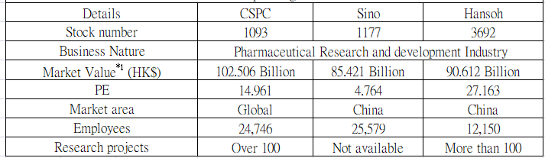
Source: Constructed by the Author
Note 1: Stock market closing date on 29 July 2022 (Source: Yahoo)

CSPC’s Financial analysis

2.1 Financial details
The table below provides a comparison of CSPC’s financial results for fiscal years 2019, 2020 and 2021 with those of competing entities, have been provided in the below table with appropriate details. CSPC’s financial performance is on par with its industry competitors in every respect.
Table 2.1: Financial details
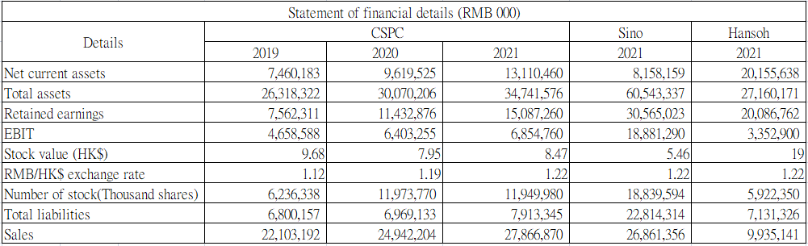
Source: Constructed by the Author
In the process of financial evaluation, the Z score of all the considered entities are determined with necessary considerations. Z score is determined to understand the competitive results of an entity(Edward, Erkki and Arto, 2016, p. 131). Further Z score of an entity is determined by the following equation:
Z = 1.2A + 1.4B + 3.3C + 0.6D + 0.999E
Where, A is determined by dividing the working capital by total assets.
B is dividing retained earnings by total assets.
C is dividing earnings before interest and tax by total assets.
D is dividing stock value by total outstanding number of shares.
E is dividing sales by total assets.
The Z score for CSPC Pharmaceutical Group Limited has been determined for 2019 to 2021. The Z score of other two entities have been determined for 2021. The details of the same is given in the below table.

Table 2.2: Financial details– Z Score analysis
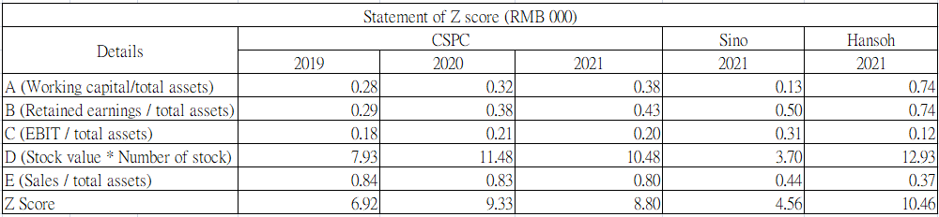
Source: Constructed by the Author
Based on table 2.2, CSPC has a Z score above 3 in all operating years. Hence, it can be said that the entity's economic performance is above average in all the operating years considered. The other two competitors are also above 3, which show that the entire pharmaceutical industry is still relatively good. Z score is classification performance in predicting bankruptcy and other types of corporate distress, the study is the first to provide such a comprehensive international analysis(Sanobar, 2012, p. 8).

2.2 Financial structure
Table 2.3: Financial structure
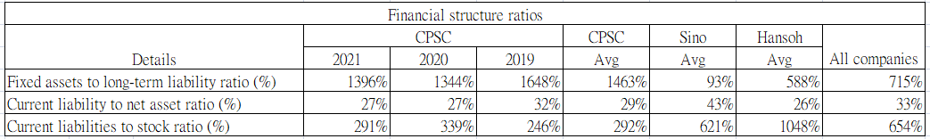
Source: Constructed by the Author
Compared to CSPC, Sino and Hansoh are relatively small entities. Hence, the competing entity’s liability position is higher than its asset position compared to its liability position. As can be seen from the above table, CSPC’s assets far exceed the company's liabilities.
CSPC is clearly well-funded and appears to have invested capital in fixed assets. Fixed assets can bring benefits to the company, but they also need to bear various costs such as repairs and maintenance. In the case of insufficient orders, too many fixed assets, such as machinery, will have idle time and need to bear the idle cost. Therefore, fixed asset investment should be carefully considered(Svetlana and Marina, 2018). If CSPC has excess funds, it should find ways to invest in other projects to increase revenue and expand its business.

2.3 Sales growth structure
Liquidity position determines an entity’s ability to pay its short- and long-term obligations with the assets in possession of the entity without raising any additional external finance(Sulayman, 2014). The CSPC Pharmaceutical Group Limited has maintained a higher asset position than liabilities in comparison to its competitive entities.
Figure 2.1: Yearly sales
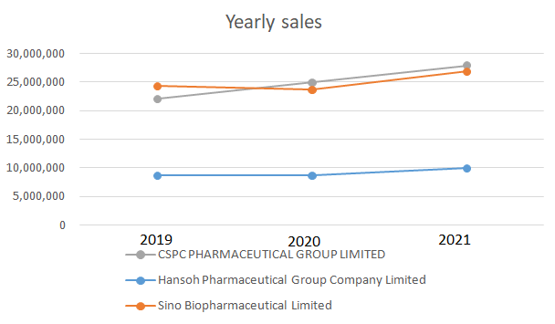
Source: Constructed by the Author
Figure 2.2: Sales growth
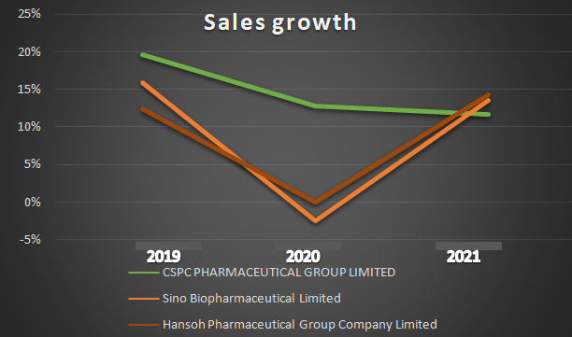
Source: Constructed by the Author
CSPC's sales are the largest among the 3 companies, and sales growth is a stable double-digit growth in every year.

2.4 Profitability ratios
The Profitability ratios show an entity’s ability to generate income and wealth(Osman, 2015). Almost all parties involved in the business use these ratios according to their analytical needs. The table below shows CSPC’s profitability compared to the other entities in the industry.
Table 2.4: Profitability ratio
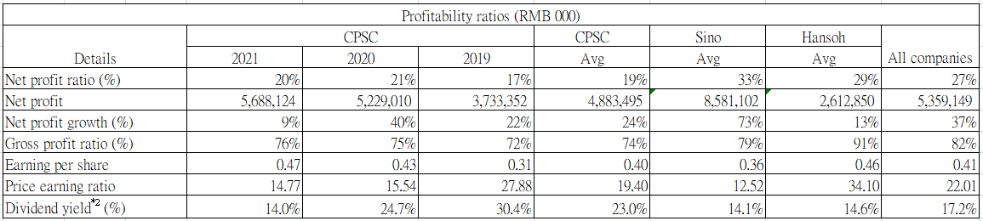
Source: Constructed by the Author
Note 2: CSPC FY2021 Final dividend and Sino FY2021 dividend are not provided
Compared with its competitors, CSPC's gross profit margin is relatively good, and it has a good performance in cost control. However, the net profit margin is lower than that of its competitors, which is due to its poor management of expenses, foreign exchange control, and fixed asset investment, which will eat into its profits. In the future due to uncertainties arising from the struggle between China, the United States, and Europe, CSPC should control foreign exchange cost fluctuations by purchasing currency futures contracts(Laurent, 1983, p. 361), and at the same time control expenditures, reduce outward expansion, and develop domestic demand.
The main goal of the company is to make a profit. Profit is a basic indicator of management's ability to manage the company. If the operating company can make profits continue to grow, investors' confidence in the company will inevitably increase, and the increase in confidence will naturally be reflected in the company's stock price(Paul and Andrew, 2001, p. 229). Companies can also use dividends to reward shareholder support.
The profitability of the three companies is similar, but Hansoh does better in cost control, and Hansoh focuses on R&D. Compared with CSPC's fixed asset investment, Hansoh's capital use is more efficient. Investors obviously have strong confidence in Hansoh, which can be fully reflected in the share price of Hansoh, so the share price of Hansoh is much higher than that of CSPC. CSCP's EPS is below the industry average because it has issued more shares than similarly profitable competitors. In this case, it raised its dividend to keep investors in support(Frank, 1984 p. 650), so the dividend yield is higher than its competitors. This strategy cannot last long.

Table 2.5: Profitability ratio
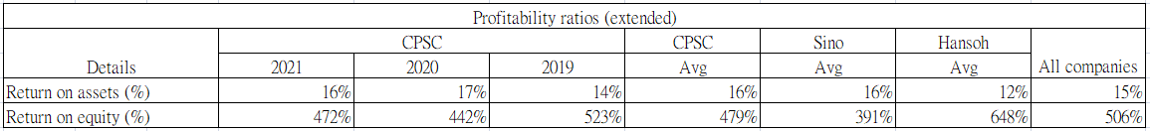
Source: Constructed by the Author
Assets in possession owned by any entity should be used most effectively to gain competitive advantages over competitors. Assets are the most financial sources for any entity. Hence, it also needs to be utilized most effectively. The table above shows the asset utilization abilities of the considered entities. The ROA and ROE held by the CSPC have reached the industry average level, which proves that its management effectively utilizes assets to generate profits. If it can manage its fixed asset investment and expenditures well, the result of ROA and ROE will shift to a higher level(Rajeswararao and Fariborz, 1991, p. 479).

Table 2.6: Operating expenses to net sales ratio
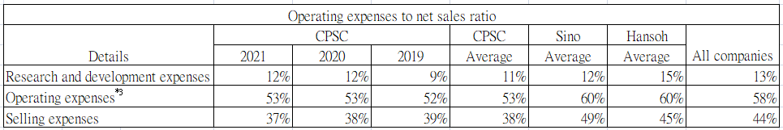
Source: Constructed by the Author
Note 3: Operating expenses is excluded other expenses.
The expenditure position matrix shows an entity’s expenditure position in comparison to the revenue or assets generated by an entity. In another word, it can be said that a lower expenditure position indicates the better economic performance of an entity(Muhammad, Mehmet and Mark, 2014, p. 59). The above table shows the expenditure position of CSPC Pharmaceutical Group Limited and the other entities regarding its revenues. As the operating expenses to net sales ratio held by the CSPC Pharmaceutical Group Limited is lower than the other two entities under consideration.
As a pharmaceutical company, CSPC should devote more resources to R&D department to develop new products, so as to bring more revenue to the company(Paul and Timothy, 1992, p. 677).

2.5 Liquidity ratios
Liquidity ratios quantitatively measure the adequacy of current and liquid assets and help evaluate the ability of a business to meet its short-term debts(Qasim and Ramiz, 2011, p. 95). The ability of a business entity to pay its short-term debts is frequently referred to as short-term solvency position or liquidity position of the entity.
Table 2.7: Liquidity ratio
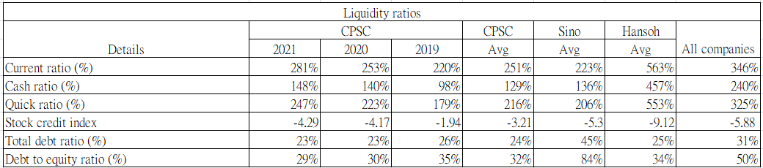
Source: Constructed by the Author
The above analysis of the financial liquidity position or working capital rotation abilities of CSPC Pharmaceutical Group Limited shows the great health of finance. Especially, current ratio, cash ratio and quick ratio are over 100%. And there are a large number of circulating funds available for turnover

2.6 Activity ratios
Activity ratios measure the efficiency of a firm or company in generating revenues by converting its production into cash or sales(Pacific Business Review International, 2014). Based on a fast conversion, generally increases both revenues and profits. Activity ratios show how frequently the assets are converted into cash or sales and are, therefore, frequently used in conjunction with liquidity ratios for a deep analysis of entities’ liquidity status.
Table 2.8: Solvency ratios
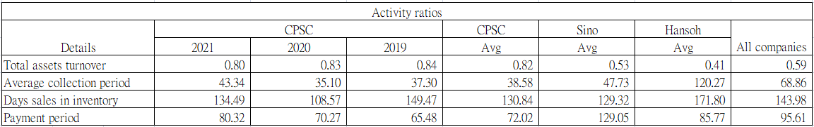
Source: Constructed by the Author
Based on the above table, compare with the average collection period and payment period, The difference between the two is almost double, which shows that CSPC Pharmaceutical Group Limited collects money much faster than it pays. Even though the average of the day sales in inventory is 131 days, according to table 2.8 average cash ratio is 129%, so the company has enough cash flow to handle any emergencies.

2.7 Solvency ratios
Solvency ratios measure the ability of a business to survive for a longer period(Abdul, 2017, p. 86). These ratios are very important to win the trust of stockholders and creditors.
Table 2.9: Solvency ratios
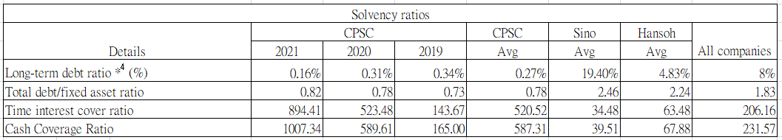
Source: Constructed by the Author
Note 4: With interest bearing
Based on the above table, obviously, CSPC Pharmaceutical Group Limited borrows less than its competitors in the industry. To improve the company's development speed and efficiency, more financing loans should be made with low interest rate.
In a financial analysis summary, the above tables show that CSPC Pharmaceutical Group Limited's resources can be more optimally utilized to expand the economic outcomes and efficiency of the entity, ultimately leading its competitors.
Also, CSPC should learn from HANSOH, how to improve the net profit ratio and gross profit ratio. And HANSOH's cost control is very good performance, their gross profit ratio can be as high as 90%.

Corporate governance
CSPC management has complied with applicable financial reporting regulatory requirements. During this process, CSPC's board of directors issued an independent corporate governance report, indicating its independent responsibility position.
In the process, CSPC management has regarded sales and business growth as the most important aspects of its long-term existence. In addition, in this process, in management reports, board members have pledged to properly track the corporate governance standards adopted by the entity, as well as maintain and adhere to those standards with reference to the CSPC’s long-term objectives.

3.1 Operational transparency
CSPC has been listed on the Hong Kong Stock Exchange since its establishment. As a result, the entity’s shareholder base is large and globally distributed. With such a large liability base, CSPC’s operation base and results should remain transparent.
Further, CSPC is an entity is engaged in the human health industry. Hence, life of people across the globe depend on the products or services provided by entities. When undertaking such obligations in operations, entities must comply with all the regulatory requirements CSPC’s stakeholder list includes domestic and foreign investors, domestic and foreign consumers of products manufactured by the entity, including the local and other governments in which the entity operates.
To serve the interest of these stakeholder’s group, CSPC has engaged independent financial and product auditors. The auditors of the CSPC are responsible for verifying CSPC’s financial and other activities in any financial year and to provide an independent report on its findings. As a listed entity, this period-based report is available from the open sources.
No discrepancy was identified and reported by the auditors for any financial period under consideration were identified and reported. Hence, it can be seen that CSPC’s business activities and effective and efficient.

3.2 Minority interest
Any company must comply with minority interests(International Journal of Economics and Finance, 2014). Same as the ethics that an entity maintains in its operations. In addition, CSPC is an entity listed on the Hong Kong Stock Exchange. CSPC has minority shareholders, and its financial statements properly indicate the value of these shareholders' equity. In the financial statements as of 2020, the total value of these shareholders is HK$3.314 million, which has been accepted by independent financial auditors without any dissenting opinions(CSPC, 2020).
Except for the financial minorities, CSPC operates under the same employee regulations that apply to the entity. No corporate regulatory actions have been taken against the entity by any regulatory authority during any financial period under consideration.
Further, the percentage of CSR activities carried out by CSPC is also on par with the industry average. Hence, CSPC has done so in terms of compliance with financial and other terms and maintaining minority interests.

3.3 Board failure and credit risk
The construction of CSPC's board of directors complies with regulatory requirements. No disciplinary action has been taken against the entity. The composition of the board of directors complies with the Company Law and the regulations of the Hong Kong Stock Exchange. Any vacancies on the Board of Directors are filled in a timely manner in accordance with regulatory requirements.
CSPC's revenue transactions occurred on credit terms. CSPC's board report contains all relevant details. CSPC offers all creditors a credit period ranging from 60 days to 180 days for all financial periods under consideration(CSPC, 2021). In addition, CSPC has established a credit risk committee to strictly control the entity's credit activities. Any overdue balances are strictly monitored by this credit committee, and if the credit committee is unable to recover the overdue balance, higher management intervenes and recovers the overdue value. CSPC has not experienced significant credit losses during any period under consideration.
In addition to this, CSPC has raised debt from the public market. In fiscal 2020, CSPC raised debt worth EUR 750 million. The debt was raised at minimum cost in 2025 through a convertible clause that converts to equity(CSPC, 2021). As such, the entity’s credit is comparable to the industry average.

Investment appraisal
The business environment always poses threats to entities operating under it. Hence, business entities require finding ways to reduce business risks. Business expansion is considered a business risk mitigation tool where additional profitability or cash inflow provides abilities to mitigate business risks(Alkaabi and Nobanee, 2019). In this process, CSPC identified two alternative business expansion projects to strengthen its business operations. Project 1 is the vitamin B group of nutritional supplements for the elderly. There are two things that the elderly need to supplement most, one is folic acid, folic acid is vitamin B9 and the other is vitamin B12. The lack of vitamin B12 is mainly because we are about 50 years old. Absorption will decrease. Symptoms of vitamin B12 deficiency are similar to folic acid. There may be severe anemia and neurological problems, and a lack of folic acid may lead to dementia(Reem, John and Almudena, 2003). Project 2 is a nutritional supplement against alopecia which is Biotin, also known as vitamin B7, is an essential vitamin that the body cannot make on its own. Its main function is to help metabolize macro nutrients such as fat, protein, and carbohydrates, thereby promoting nail and hair growth(Rachel and Charles, 2019). Both young people are at risk of hair loss. Women are prone to hair loss due to factors such as stress, pregnancy and excessive dieting, while men are at high risk of hair loss because of higher androgens in their bodies than women.

Table 4.1: Projects items basic information & sales
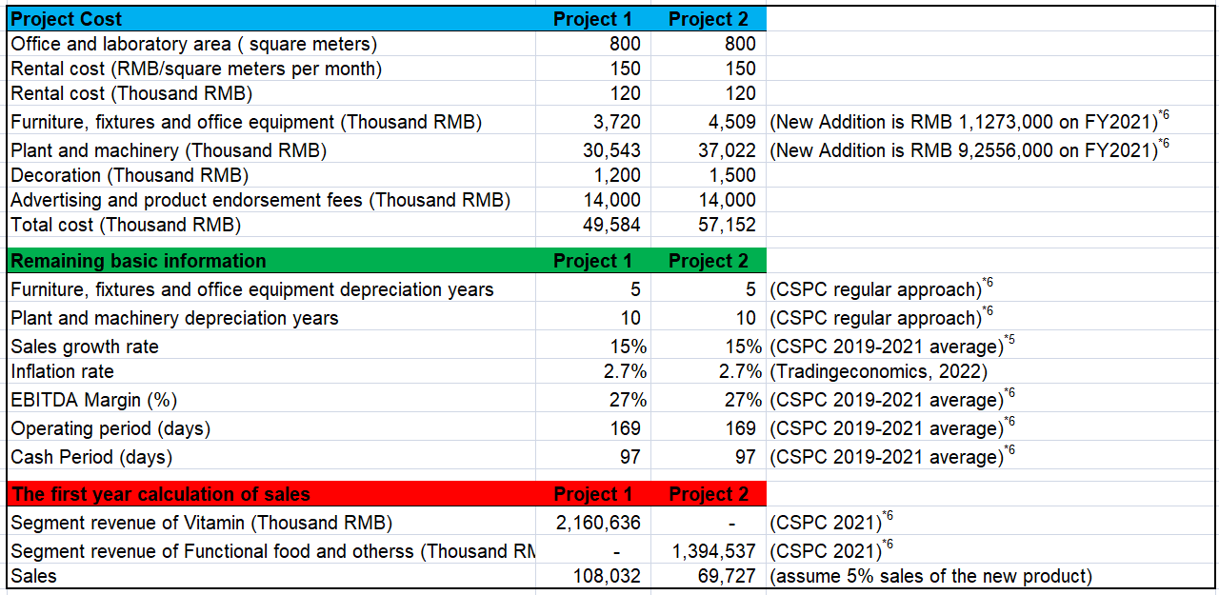
Source: Constructed by the Author
Note 5: Source from CSPC 2019 - 2021 annual report
Note 6: Source from CSPC 2021 annual report
Project 1 is a lower initial investment and higher annual operating expenses. Additionally, Project 2 will have a higher initial investment and lower annual costs. The normal corporate tax rate applicable in the country is 30%. While CSPC's developed drugs will receive a 5% tax deduction, the applicable tax rate for this project is 25%. The management of CSPC conducted a detailed financial analysis, and the average of EBITDA margin is the 27%. CSPC management has embraced a capital budgeting process to analyze alternative long-term pharmaceutical production investment projects. During this process, entities will identify better alternatives after applying capital budgeting techniques. The capital budgeting techniques that CSPC will use are:
CSPC management has embraced a capital budgeting process to analyze alternative long-term pharmaceutical production investment projects(Malenk, 2019). During this process, entities will identify better alternatives after applying capital budgeting techniques. The capital budgeting techniques that CSPC will use are:
- Net present value (NPV)
- Accounting rate of return (ARR)
- Internal rate of return (IRR)
- Payback period. (PBP)
The detailed analysis process and outcome of these capital budgeting techniques are described in the following paragraphs.

4.1 Net present value (NPV)
NPV is considered the commonly used capital budgeting tool to analyze any long-term investment project(National Research Council of Canada, 1999). The NPV considers the time value concept of money(Omid, Ali, Mohammad, Jurgita and Miroslavas, 2021). Hence, the same is considered a better tool of evaluation in comparison to the ARR and PBP Method. The numerical analysis of the net present value of the alternative projects available to CSPC is provided in below table:
Table 4.2: Net present value (Project 1)
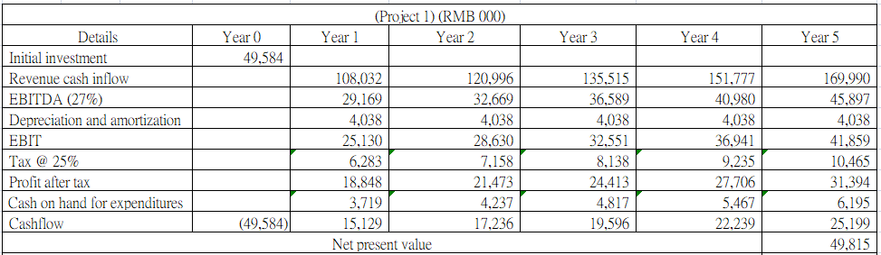
Source: Constructed by the Author

Table 4.3: Net present value (Project 2)
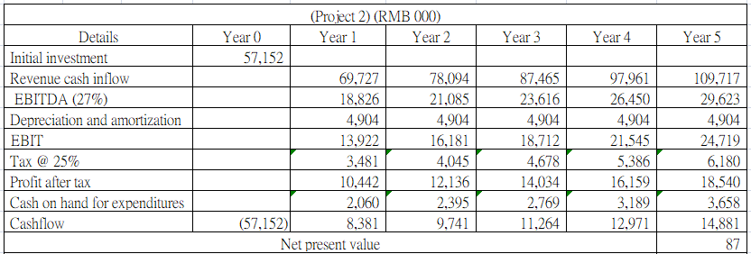
Source: Constructed by the Author
The above analysis, Table 4.2 & 4.3 shows that Project 1 will be more beneficial to CSPC. Project 1 NPV is higher than Project 2 NPV. Hence, CSPC management should proceed with Project 1. Although CSPC's management should evaluate other aspects of the project before accepting and proceeding.

4.2 Accounting rate of return (ARR) & Internal rate of return (IRR)
The ARR is the amount of return that a long-term investment project over its lifetime(Richard and Raef, 1993). The biggest criticism of the ARR is that it does not consider the time value concept of money. Though, the ARR provides an approx. understanding of the acceptability of the long-term project being assessed. The ARR is determined by dividing the total cash inflows of a long-term investment project by the initial further cash investments made in the project.
The IRR determines the actual rate of return that a long-term investment project will generate in its life(Joseph and Ingrid, 2010). Where the actual rate of return is higher than the risk adjusted cost of capital of the project, the project should get accepted. In any other case, the project should not be accepted by the entity. In the given situation of CSPC, the IRR of both the available projects has been determined in the below tables.

Table 4.4: ARR & IRR (Project 1)
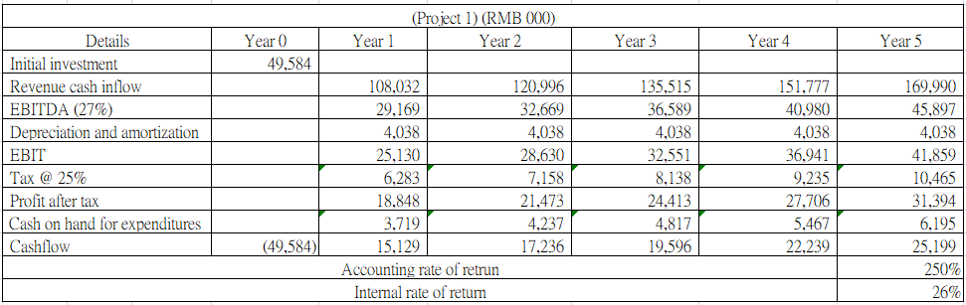
Source: Constructed by the Author

Table 4.5: ARR & IRR (Project 2)
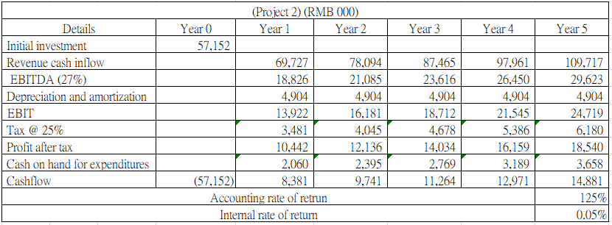
Source: Constructed by the Author
As per the evaluation made in tables 4.4 and 4.5, Project 1 is expected to be more beneficial to CSPC as the ARR of Project 1 is higher than Project 2.

4.3 Payback period (PBP)
The PBP is the expected time that a long-term project will take to recover its initial investment(Miroskaw, 2007). Where an entity is required to evaluate two alternative projects, the PBP can provide the quantification of the time that these projects will take to recover their respective time. The project with a lower payback period will recover its initial investment early and the project will generate higher profitability for the entity. The below table are providing the details of the payback period of respective projects.
Table 4.6: Payback period (Project 1)
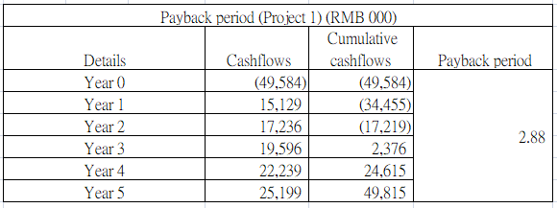
Source: Constructed by the Author

Table 4.7: Payback period (Project 2)
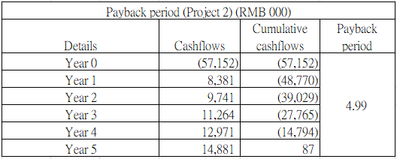
Source: Constructed by the Author
Like NPV and ARR analysis, the PBP evaluation is also providing for the early recovery of initial investments by Project 1. With a lower recovery time of investments, it can be said that Project 1 will provide higher profitability for CSPC. Though, the PBP evaluation has not considered the time value concept of money(Pamela and Frank, 2009 p. 298). The management of CSPC should consider the same and proceed accordingly.

Figure 4.1: Population size and age structure
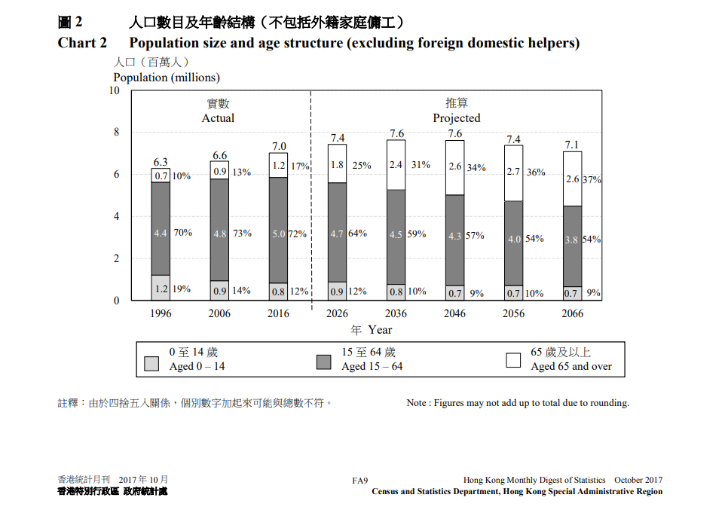
Source: (Census and Statistics Department, 2017)
Table 4.8: CIA Summary
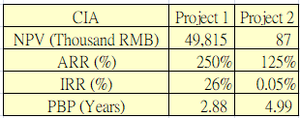
Source: Constructed by the Author
Based on table 4.9 NPV, ARR, IRR and PBP analysis, all analysis data of project 1 is better than project 2 and also greater than ROA. According to figure 4.1 the research report of the Census and Statistics Department, the population of Hong Kong will be aging in the future, and the proportion of elderly people will be higher than that of young people. Therefore, the development of products for the elderly will be more in line with the future social environment.
In conclusion, CSPC should choose project 1, and future research guidelines should develop a diverse range of pharmaceuticals and commercial supplements for the elderly.

4.4 Operational cash flows
The operating cash flow can show the cash generated by the company's operating activities, and the company has received the money in the account through its own business, which can avoid the net profit in the income statement. The problem of inventory is the glorification statement. The operating cash flow does not reflect the actual profit and loss. Based on the 2021 annual report, the net cash generated from operating activities is 4.64 billion. Therefore, the company has enough initial investment to develop new projects.

Financing and capital management
There are several options for financing long-term investment projects. These financing options include debt financing, equity financing, or own funds. Debt or equity financing requires periodic payments. However, when an entity uses its funds for capital expansion projects, its cost is still only the opportunity cost of investment. CSPC has a sufficient reserve to fund these alternative projects. Therefore, CSPC should finance the expansion project with its own funds.

5.1 Financing methods for analyzing
From the solvency ratio in Table 2.9, CSPC has strong solvency and can borrow more money. The long-term debt ratio in 2021 is only 0.16%, and the average in the past three years is 0.27%. Compared to the other two companies, the average ratio for all companies is 8%. In addition, CSPC's time interest coverage and cash coverage are 894.41 times and 1,007.34 times, respectively. Compared to the other two companies, the average ratios for three companies are 206.16 times and 231.57 times, respectively. CSPC's data has a strong advantage in the industry.

5.2 Bank loan financing
According to the 2021 annual report, CSPC's property, plant and equipment are RMB12.4 billion, of which buildings are RMB 4.14 billion and plant and machinery are RMB6.27 billion. We can take these assets to the bank as collateral to get better interest rates and higher loan amounts. First, we can apply for bank mortgage for 1% of these fixed assets. Calculated on the basis of the total value of fixed assets of this 1% of about RMB 124 million, under normal circumstances, the mortgage loan is generally 40% of the total asset value and mortgage loan an interest rate is less than 3%, so you can cash out about RMB 50 million using the collateral assets.
Table 5.1: Maximum of Mortgage percentage
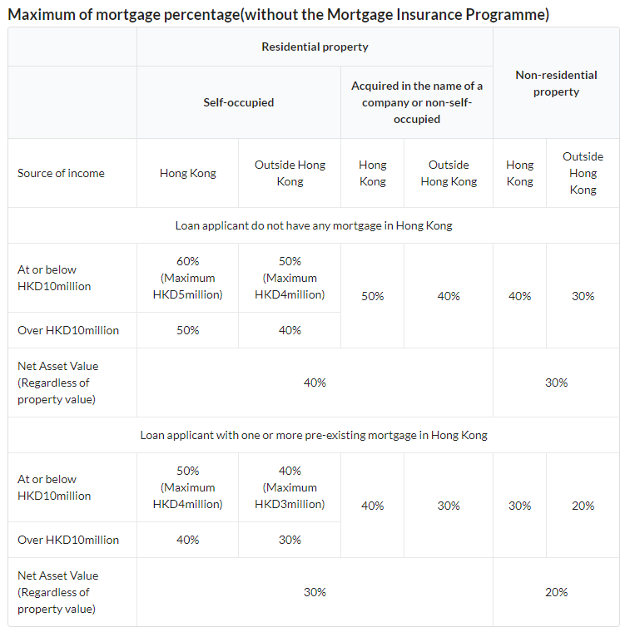
Source: Hong Kong Monetary Authority, 2020
On the other hand, Hong Kong has launched the SME Financing Guarantee Scheme(Hong Kong Monetary Authority, 2022). The Hong Kong Mortgage Corporation Limited is responsible for the implementation. The Hong Kong government provides credit guarantee commitments for small and medium sized enterprises to apply for loans from banks, aiming to assist enterprises in need to obtain financing to meet the needs of business operation and development with a maximum loan amount is HKD18 million. The loan guarantee period is up to 7 years. Therefore, CSPC can use one of its subsidiaries to apply for the SME Financing Guarantee Scheme.

5.3 Issued share capital fund-raising
The number of issued shares must correspond to the amount of share capital subscribed. The subscribed share capital and the issued share capital shall not exceed the authorized share capital. The share issued are not secured or secured by any assets. In this way, the company is funded without charging any asset fees or even asking for any guarantees.

5.4 Sale of assets
According to table 2.3 fixed assets to long term liability ratio of CSPC is 14 in year 2021, far higher the level industry average ratio is 7.2.

5.5 Suggestion for financing method
Based on the above analysis, we do not recommend issuing share capital for fund-raising. It is a disadvantageous for companies in a sound financial position, because this is bad for financially sound companies as CSPC will have to pay dividends at higher interest rates, and even if there are lower interest rate loans in the market, prudent investors are reluctant to invest in stocks, whose returns are not fixed or not guaranteed.
Although, CSPC has many assets for sale. However, based on table 2.8 total assets turnover has averaged 0.82 for past three years, and average ratios for all companies is 0.59. We can know that CSPC has a better capital turnover rate in the same industry which can be converted into cash. Therefore, we do not need to sell assets.
Finally, we should choose a mortgage loan and SME Financing Guarantee Scheme to cash out RMB 2 billion. Depend on the size and goodwill of CSPC, it is assumed that the maximum loan interest rate 2.75% and loan amount RMB 1.8 billion.

Table5.2: Cost of Mortgage loan against Project 1 profit
Source: Constructed by the Author
Table5.3: Mortgage Interest Rate
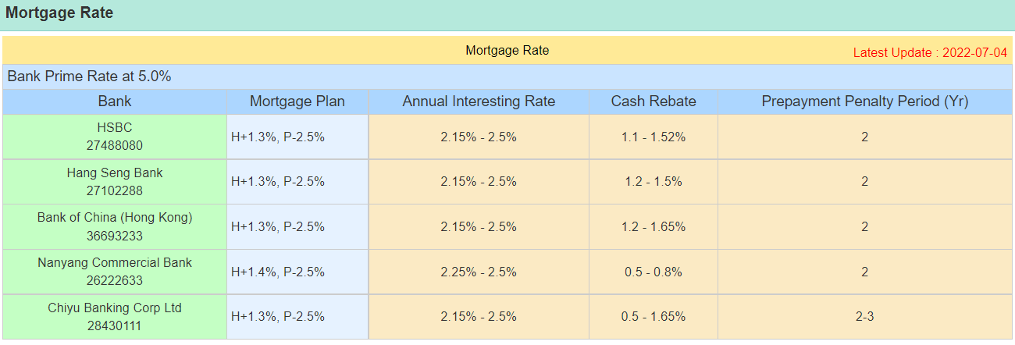
Source: Property.hk, 2022
As can be seen from the above table, the total cost of the mortgage loan is RMB 7 million based on the NPV of Project 1. Five years later, we still gain 43 million RMB.

Operational audit program
CSPC has engaged an independent audit team to verify the entity’s financial functions. This independent auditor has expressed an opinion on the entity's financial operations for each financial year under consideration(Bliss, Gul, and Majid, 2011). Further, in the audit opinion section, the independent auditors did not express dissatisfaction with the entity’s financial reporting. This shows the operational efficiency of the entity.
In addition, CSPC is a listed entity. Hence, the entries must establish audit committees to compensate for the regulatory requirements. The audit committee of CSPC is responsible for employing independent auditors and s responsible for the work of the auditors(Tsui, 2009).
In addition to the audit committee, being an entity listed on the Hong Kong Stock Exchange, a nomination committee must be established to determine remuneration paid to independent auditors. These independent committees are responsible for all aspects of the independent audit of the company.

Conclusion
In the conclusion of the financial evaluation of the CSPC and other considered entities, it can be said that the financial results of CSPC are better than the other two entities in all aspects. CSPC has higher revenues than competing entities in all financial year considered. Further, the entity’s working capital maintenance is also better than the other entities under consideration. CSCP generates a higher percentage of financial returns than its competing entities. CSPC also performed better in terms of working capital turnover. Hence, an investor intend to invest in the Hong Kong stock exchange may consider CSPC as an investment option. The global healthcare industry has delivered some of the best economic outcomes in recent years. In addition, it is expected to remain unchanged for future operating years. Therefore, the CSPC becomes a suitable choice for investment.
Based on the above analysis conclusions of CSPC's investment evaluation, it can be reasonably judged that the project has a higher financial return to the entity. However, CSPC's management should consider producing the drug at a lower cost while maintaining the same quality of the drug. Therefore, the management must effectively control the cost and expenditure, and also control the idle cost of machinery, so as to achieve the goal of low cost, less wastage with high returns(Möller, Schäffer, and Verbeeten, 2020).
References
- Alkaabi, H. and Nobanee, H., 2019. A study on financial management in promoting sustainable business practices & development. Available at SSRN 3472415.

- Abdul, A.A. (2017) The Relationship between Solvency Ratios and Profitability Ratios, pp. 86-93.

- Bliss, M.A., Gul, F.A. and Majid, A., 2011. Do political connections affect the role of independent audit committees and CEO duality? Some evidence from Malaysian audit pricing. Journal of Contemporary Accounting & Economics, 7(2), pp.82-98.

- Brand Finance (2021) 2021 China's Top 500 Brand Values. Available at: http://big5.china.com.cn/gate/big5/finance.china.com.cn/news/20210607/5587700.shtml (Accessed: 29 Augest 2022).

- CSPC PHARMACEUTICAL GROUP LIMITED, 2021. Annual Report. [online] www.cspc.com.hk. Available at: https://www1.hkexnews.hk/listedco/listconews/sehk/2022/0421/2022042101514.pdf (Accessed: 27 July 2022).

- CSPC PHARMACEUTICAL GROUP LIMITED, 2020. Annual Report. [online] www.cspc.com.hk. Available at: https://www1.hkexnews.hk/listedco/listconews/sehk/2021/0414/2021041400908.pdf (Accessed: 27 July 2022).

- CSPC PHARMACEUTICAL GROUP LIMITED, 2019. Annual Report. [online] www.cspc.com.hk. Available at: https://www1.hkexnews.hk/listedco/listconews/sehk/2020/0427/2020042701669.pdf (Accessed: 27 July 2022).

- Census and Statistics Department (2017) Population size and age structure. Available at: https://www.censtatd.gov.hk/en/data/stat_report/product/FA100061/att/B71710FA2017XXXXB0100.pdf (Accessed: 28 Augest 2022)

- Edward, I., Erkki, K. and Arto, S. (2016) classification performance of the Z-Score model, pp. 131-171.

- Frank, H. (1984) Two Agency-Cost Explanations of Dividends, pp. 650-659.

- Hong Kong Monetary Authority (2022) SME Financing Guarantee Scheme. Available at: https://www.hkma.gov.hk/eng/news-and-media/press-releases/2022/02/20220223-4/ (Accessed: 15 Augest 2022).

- Hansoh Pharmaceutical Group Company Limited, 2021. Annual Report. [online] www.hspharm.com. Available at: http://www.hspharm.com/upload/file/2021/04/27/936c5056d84441649a97c75b6a449cc0.pdf (Accessed: 27 July 2022).

- Hansoh Pharmaceutical Group Company Limited, 2020. Annual Report. [online] www.hspharm.com. Available at: https://www1.hkexnews.hk/listedco/listconews/sehk/2021/0427/2021042701377.pdf (Accessed: 27 July 2022).

- Hansoh Pharmaceutical Group Company Limited, 2019. Annual Report. [online] www.hspharm.com. Available at: https://www1.hkexnews.hk/listedco/listconews/sehk/2020/0427/2020042700627.pdf (Accessed: 27 July 2022).

- International Journal of Economics and Finance (2014) 23rd February.

- Joseph, C.H. and Ingrid, C.S (2010) THE RELEVANT INTERNAL RATE OF RETURN, pp. 139-158.

- Laurent, L. (1983) Management of foreign exchange risk, pp. 361-384.

- Malenko, A., 2019. Optimal dynamic capital budgeting. The Review of Economic Studies, 86(4), pp.1747-1778.

- Möller, K., Schäffer, U. and Verbeeten, F., 2020. Digitalization in management accounting and control: an editorial. Journal of Management Control, 31(1), pp.1-8.

- Muhammad, U.A., Mehmet, M.K. and Mark, P. (2014) Impact of operational and marketing capabilities on firm performance, pp. 59-71.

- Miroskaw, M.H. (2007) The Payback Period as a Measure of Profitability and Liquidity, pp. 177-191.

- National Research Council of Canada (1999) 10th March.

- Omid, K. Ali, H. Mohammad, K. Jurgita, A. and Miroslavas, P. (2021) Application of Three Metaheuristic Algorithms to Time-Cost-Quality Trade-Off Project Scheduling Problem for Construction Projects Considering Time Value of Money, DOI: 10.3390/sym13122402

- Paul, A. and Andrew, M. (2001) Institutional Investors and Equity Prices, pp. 229-259.

- Paul, K.C. and Timothy, M.D. (1992) New Product innovations and stock price performance, pp. 677-695.

- Pacific Business Review International (2014) 11th May.

- Pamela, P.D. and Frank, J.F. (2009) Foundations and Applications of the Time Value of Money. USA: Wiley.

- Rajeswararao, C. and Fariborz, D. (1991) Institutional ownership, capital structure, and firm performance, pp. 479-491.

- Reem, M. John, G.E. and Almudena, A.S. (2003) Folic acid with or without vitamin B12 for cognition and dementia, DOI: 10.1002/14651858.CD004514

- Rachel S.C. and Charles, T. (2019) Methods for assessment of biotin, pp. 193-217.

- Richard, P.B. and Raef, A.L. (1993) The Role of the Accounting Rate of Return in Financial Statement Analysis. 1st edn. British: Routledge.

- Sino Biopharmaceutical Limited, 2021. Annual Report. [online] www.sinobiopharm.com. Available at: http://www.sinobiopharm.com/userfiles/files/Anno-Equity/E22020430-Sino%20Bio-AR.pdf (Accessed: 27 July 2022).
- Sino Biopharmaceutical Limited, 2020. Annual Report. [online] www.sinobiopharm.com. Available at: https://www1.hkexnews.hk/listedco/listconews/sehk/2021/0422/2021042200723.pdf (Accessed: 27 July 2022).

- Sino Biopharmaceutical Limited, 2019. Annual Report. [online] www.sinobiopharm.com. Available at: https://www1.hkexnews.hk/listedco/listconews/sehk/2020/0421/2020042101098.pdf (Accessed: 27 July 2022).

- Sanobar, A. (2012) A Significant Study of the Altman’s Z-Score Model, pp. 1-8.

- Svetlana, V.S. and Marina, A.P. (2018) Modernization of the Company's Fixed Assets, Vol. 7

- Sulayman H. (2014) Liquidity Analysis Using Cash Flow Ratios as Compared to Traditional Ratios in the Pharmaceutical Sector, pp. 146-158.

- Tsui, T.C., 2009. Audit for whom? Time to review roles of independent auditors in Hong Kong. East Asia, 26(1), pp.21-39.

- Osman, I. (2015) AN EMPIRICAL STUDY OF THE RELATIONSHIP BETWEEN PROFITABILITY RATIOS AND MARKET SHARE PRICES, Vol lll, Issue 12th December.

- Qasim, S. and Ramiz, U.R. (2011) Impacts of liquidity ratios on profitability, pp. 95-98.

Appendices

All appendices and working are in excel – working_RRR.

