GLOBAL BUSINESS ENVIRONMENT
Assessment 2
MODULE CODE: LCBB4005
Lecturer: Nadeem Mirza
Student name: Alina Munteanu
Student code: 1920430

Table of Contents
1.0 Introduction 3
2.0 Overview of Company 3
3.0 Critical Evaluation of the Changes adopted at the wake of COVID 19 in Four seasons hotel 4
3.1 Lead With Care program: 4
3.2 Four Season App 4
3.3 Consulting agreement with Johns Hopkins Medicine International 5
4.0 Evaluation of the sustainability of these changes 6
4.1 Sustainability approaches behind ‘Lead With Care’ program: 6
4.2 Sustainability approaches behind 7
4.3 Sustainability approaches behind 7
4.4 Evaluation and potential recommendation 8
5.0 Conclusion 8
Reference list 9
Appendix 11

1.0 Introduction
Before the COVID 19 pandemic, the ever-expanding worldwide tourism industry was an important factor, which was driving the development of the hospitality industry. The arrivals of the international travellers had increased significantly over the last few years.
The main reasons affecting and behind the abating down of the hospitality industry after the widespread incorporation are the diminish in visits and voyages because of the cancellation of flights, the government all over the world are calling off the foreign tours and locking down most of the region and gaining the trust of the visitors. This assignment is intended to ascertain the impact of COVID-19 pandemic on Four Seasons Hotel Of London.

2.0 Overview of the Company
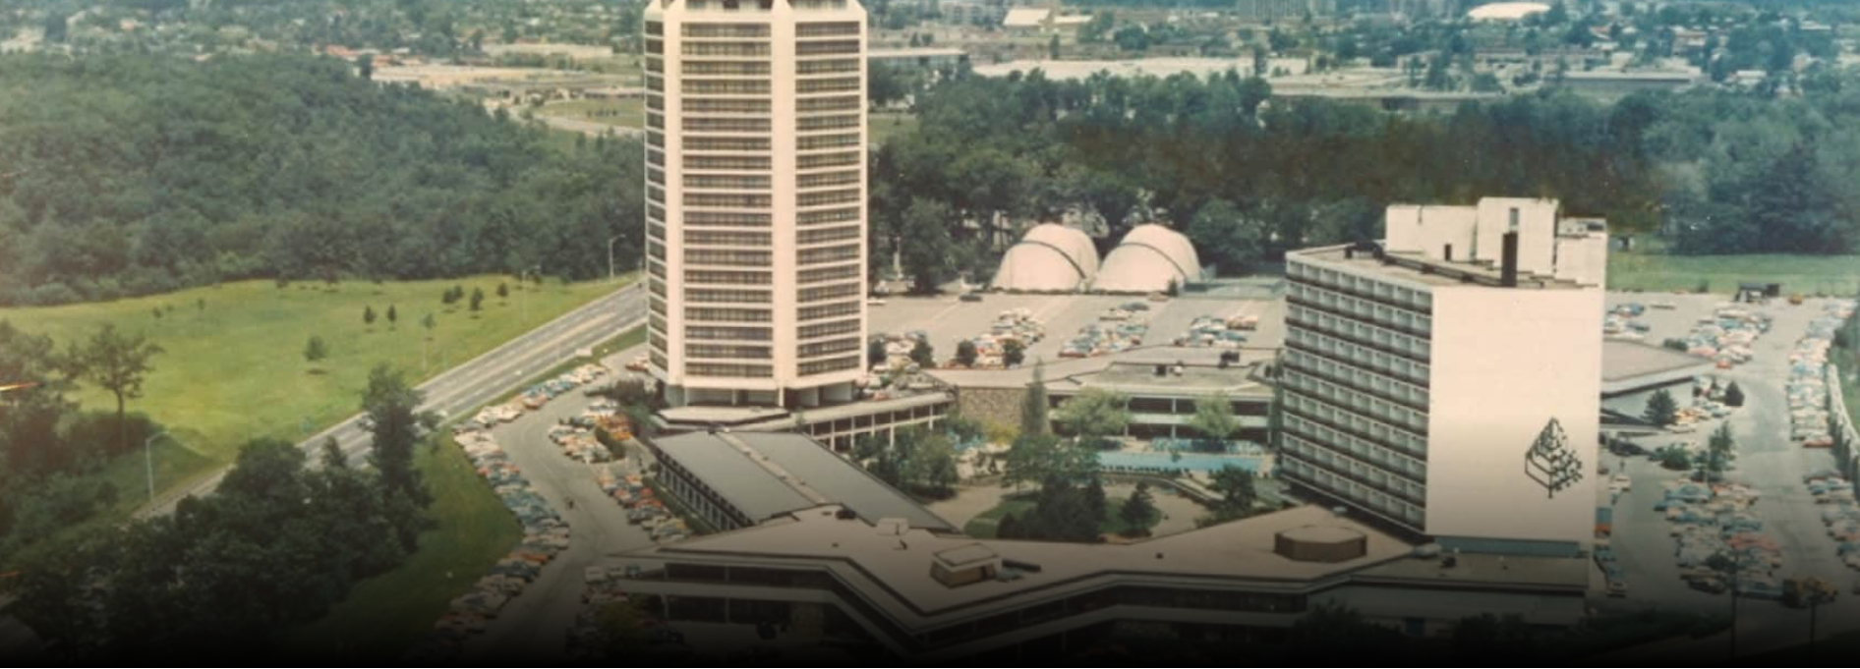
Fig 1: Four seasons Hotel
Source: Fourseasons.Com. 2020
In 1960, Max Sharp incorporated the first Four Season Hotel; later, he established two more hotels with the same name. In the year of 1970, his son Isadore Sharp incorporated the Four Seasons Hotel of London, and now it has become the world’s leading luxury hospitality company (Fourseasons.com, 2020). The focus of this company was luxury and warm reception, and it follows the principles of care, trust and service.
Due to the impact of COVID-19 19 pandemic, the company was closed for a few months, as per the Government rule. The President and Chief Executive Officer of the Four Seasons Hotels and Resorts, John Davison had announced to reopen the services in June 2020 after implementing any necessary changes for the health and safety of tourists, guests and employees.

3.0 Critical Evaluation of the Changes adopted at the wake of COVID 19 in Four seasons hotel

3.1 Lead With Care program:
The Four Seasons company has implemented a lot of up-gradation to the existing methods through the worldwide wellbeing and security program in alignment with the political decisions regarding lockdown and quarantine.
The company has also started working with Ecolab and Worldwide SOS to bring the advancement of upgraded health and safety procedures and the acquisition of supplies and technologies for Lead with Care execution.
Much upgraded Lead with Care methods, backstage measures have taken place through representative training, food dealing with conventions, and up-gradation to ventilation frameworks, social distancing to curb the person-to-person transmission and other functioning for the wellbeing of the guests as well as employees. Being anchored in the hospitality industry and empowered by the access to specialists, innovations and instruments, Lead with Care embarks clear strategies that teach and enable representatives to take care of the visitors and one another. The program emphasizes on giving care, reliance and consolation in this pandemic environment. (COVID - 19 UPDATE, 2020)
The company is making sure to provide a few additional benefits to the guests as per the rules and regulations of the UK Government, like Lead With Care tools in every room including masks, hand sanitizer, and wipes or contactless room service options for keeping a distance to decrease the spread of coronavirus (Four Seasons Press Room. 2020). The company is also ensuring that the guests and the employees cover their face with masks. These changes have been implemented by the Four-Season hotels and resorts to help the Government to control this pandemic situation.

3.2 Four Season App
The Four Seasons hotels and resorts have made a few necessary changes to their popular Four Seasons App in association with social forces to combat the COVID-19 and to give the guests quality and safe service in this pandemic situation.
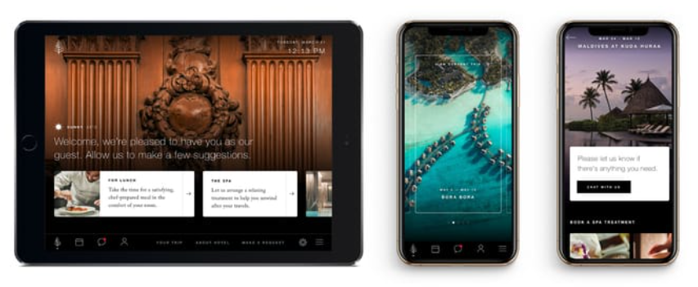
Fig 2: Four Seasons App
Source: Fourseasons.com. 2020
The company that gives the platforms backed by genuine guests, the award-winning app, has been upgraded to assist visitors to control how they lock in with the representatives restricting face-to-face communication to avoid person to person transmission whereas keeping up the most noteworthy standard of the company service that the guests find helpful (Fourseasons.com. 2020). This app is rare in the industry as it is supported by the representative and staff who are present at the hotel premises. It helps the guests to get instant service.
Due to an increase in COVID-19 cases, the company has implemented the new guidelines by the UK government, to the app. The new advancements include the capacity to make and arrange reservations, ask the representative to pick up the luggage, transport facility, room service, dine in and book a spa service, doctor on call service, isolation facility and many more services by using the app. The company made the changes, especially to provide safety against COVID-19. The app service provides a wait-free and hassle-free check-in and check-out procedure and other facilities. Moreover, the Four Seasons Chat service offers an instant interpretation of more than 100 dialects to avoid the language issue often faced by the visitors, by giving visitors the option of contactless service the company ensures the safety and social distancing.

3.3 Consulting agreement with Johns Hopkins Medicine International
The Four Seasons hotels and resorts have signed an external consultant agreement with the global division of wellbeing and research dominant, Johns Hopkins Medicine, to let people know the health and security measures and sharing their knowledge to help the company during the COVID-19 pandemic.
The Four Seasons hotels and resorts were closed till August 2020, but like many other companies, it also had losses due to the pandemic and falling GDP also affected the company adversely. The company has remained closed for several months. In the meantime, the company decided to form an advisory board keeping the COVID-19 in mind. It signed an agreement with renowned John Hopkins Medicine International and trained the representatives about the COVID-19, the transmission of the disease, social distancing standards, and utilization of individual protective equipment like PPE kit, thermal kit, sanitizers, masks (Fourseasons.com. 2020). Moreover, the company has also provided behavioural training to make sure the compassionate and individualized supervision for the visitors in the pandemic situation as the face-to-face interaction is restricted. (Baum, Mooney, Robinson, and Solnet, 2020). In association with the John Hopkins Medicine International, the company has ensured a 24/7 emergency service. It has helped the company to be more confident to ensure the safety and protection of visitors, representatives or staff. (Arain, Thalapparambath, and Al Ghamdi, 2020). The company has made it mandatory to use face covering masks for the guests as well as the employees to decrease the transmission and took the initiative to encourage the visitors to follow the guidelines and protocols during the pandemic phase.

4.0 Evaluation of the sustainability of these changes

4.1 Sustainability approaches behind ‘Lead With Care’ program:
After the hotel reopened the lead with care program will ensure that no people within the hotel boundary will get infected with any kinds of diseases along with the daily duties of employees and staff will be changed and reviewed so that they will be able to deliver the best services to their customers. All the branches of Four Seasons Hotel will be disinfected with EPA approved products and will also have backlight inspection by room attendants (Four Seasons Hotels and Resorts Announces Enhanced Health and Safety Program at Properties Worldwide, 2020). The lead with care program will also provide their staff and employees with a retraining program by which they will be able to address and fulfil all the demands and expectations of all kinds of customers. Giving the best services to their customers will help the Four Seasons Hotel to build a strong customer base and brand reputation in the market. The public areas within the hotel and nearby will also be cleaned clearly as the hotel management does not want to take any kinds of risks regarding the health and safety of their customers, staff and employees. The bars and restaurants within the hotel will also let in only a few numbers of people at a time as they will be maintaining and promoting social distancing social distance with their lead with care program. The hotel will also appoint a hygiene officer in each of their branches so that no loose ends can take place while serving the customers (Four Seasons Hotels and Resorts Announces Enhanced Health and Safety Program at Properties Worldwide, 2020)).

4.2 Sustainability approaches behind
Their mobile app will help their customers to search for their hotels all over the world, and according to their booking date, the management will make all the necessary arrangements for them. With the help of the mobile applications, customers will not have to wait in the long queues at the time of check in to fill up forms or doing all the formalities rather through the app they will submit all the legal documents beforehand, and at the time of checking in, they will be able to get access to their rooms with a contactless entry. After the COVID-19 pandemic, the app can be very much helpful as most of the people are trying to avoid any kinds of touch or contacts. With the help of their app, their customers will also be able to book tables for dinner or launch, plan their tour, book any kinds of transportations and check out activities for kids(Four Seasons Hotel 2020). This app is not only helping their customers to experience a hassle-free stay at their hotel, but this app is also helping the hotel to promote their business and the service they are proving globally (Aliperti and Cruz, 2020). Their app will also help their customers to chat with their employees in case they face any kinds of issues or want to know something. The application also provides 100 different languages, and thus the customers or the employees will not face any kinds of language issues while interacting with each other.

4.3 Sustainability approaches behind
Their third agreement which is a partnership with Johns Hopkins Medicine International is a safety measure, and just like all the other changes mentioned earlier, this change also carries a lot of sustainability. The partnership between these two companies will take care of the health of all their customers and all their staff and employees. Some of the officials from all the hospitals will always be present in the hotel. Thus, they will be able to tackle and manage any kinds of medical emergency taking place within the hotel. For example, one of their staff may not feel well, or any of their customers may have a minor accident as thus officials from the hospital will be able to start their treatment or will provide them with first aid.
This shows that the hotels are very much concerned about the health and safety of their customers and this is one of the ways by which they want to show that their employees and staff are very much valuable to them (Fix et al., 2018).

4.4 Evaluation and potential recommendation
According to Rangaswamy, Manjunatha and Kumar, (2017) high-speed internet is not available throughout the world, and many of the people don’t know how to use any kinds of smartphones or do not know how to use innovative apps. People who are not very innovative will be unable to make efficient use of these services. According to Vo and Chovancová, (2019), the changes will surely increase the price of their hotel rooms, and thus they may face a smaller number of sales than the usual part. Partnership with the hospitals will also make them increase the prices of their hotels. The following recommendations are providing
- Four Seasons Hotel can develop another version of their app which is of small size, and it will run even on low internet
- They will have to look for ways by which they will also be able to effectively offer their services to their offline customers
- They will also be able to look for ways so that they can decrease the price of their services

5.0 Conclusion
In the end, we can say that the changes which are implemented by Four Seasons Hotels are very much helpful for their customers and for their employees and staff. The changes have a lot of sustainability and do also have a few gaps. The recommended suggestions will help the Four Seasons Hotel to overcome all those issues and problems. The company will also have to develop strategies by which they will be able to manage all the negative impact of all those external factors and gain a competitive advantage in the market.

Reference list
Aliperti, G. and Cruz, A.M., 2020. Promoting built-for-disaster-purpose mobile applications: An interdisciplinary literature review to increase their penetration rate among tourists. Journal of Hospitality and Tourism Management, 44, pp.193-210. Available at: https://www.ncbi.nlm.nih.gov/pmc/articles/PMC7377806/
Arain, S., Thalapparambath, R. and Al Ghamdi, F.H., 2020. COVID-19 pandemic: Response plan by the Johns Hopkins Aramco Healthcare inpatient pharmacy department. Research in Social and Administrative Pharmacy.https://www.ncbi.nlm.nih.gov/pmc/articles/PMC7233240/
Baum, T., Mooney, S.K., Robinson, R.N. and Solnet, D., 2020. COVID-19’s impact on the hospitality workforce–new crisis or amplification of the norm?. International Journal of Contemporary Hospitality Management.https://openrepository.aut.ac.nz/bitstream/handle/10292/13568/Baum%20Mooney%20Robinson%20Solnet%202020%20IJCHM%202020%20Workforce%20Viewpoint%20accepted%20version%20(1).pdf?sequence=6
Fix, G.M., VanDeusen Lukas, C., Bolton, R.E., Hill, J.N., Mueller, N., LaVela, S.L. and Bokhour, B.G., 2018. Patient‐centred care is a way of doing things: How healthcare employees conceptualize patient‐centred care. Health Expectations, 21(1), pp.300-307. Available at: https://onlinelibrary.wiley.com/doi/pdf/10.1111/hex.12615
Four Seasons Press Room. 2020. Four Seasons Hotels And Resorts Announces Enhanced Health And Safety Program At Properties Worldwide. [online] Available at: <https://press.fourseasons.com/news-releases/2020/lead-with-care-program/> [Accessed 21 December 2020].
Fourseasons.com. 2020. COVID - 19 UPDATE. [online] Available at: <https://www.fourseasons.com/landing-pages/corporate/covid_19_update/> [Accessed 21 December 2020].
Fourseasons.com. 2020. Four Seasons App. [online] Available at: <https://www.fourseasons.com/landing-pages/corporate/mobile-app/> [Accessed 21 December 2020].
Fourseasons.Com. 2020. FOUR SEASONS HISTORY. [online] Available at: <https://www.fourseasons.com/about_four_seasons/four_seasons_history./> [Accessed 21 December 2020].
GOV.UK. 2020. Coronavirus (COVID-19): Guidance And Support. [online] Available at: <https://www.gov.uk/coronavirus> [Accessed 21 December 2020].
Markets, R., 2020. COVID-19'S Impact On Hospitality, 2020 Market Report. [online] Prnewswire.com. Available at: <https://www.prnewswire.com/news-releases/covid-19s-impact-on-hospitality-2020-market-report-301042147.html> [Accessed 21 December 2020].
Rangaswamy, R., Manjunatha, G. and Kumar, B.S., 2017. Internet as a Source of Information. Library Waves-A Biannual Peer Reviewed Journal, 3(1), pp.36-42. Available at: http://www.librarywaves.com/index.php/lw/article/download/45/39
Vo, N.T. and Chovancová, M., 2019. Customer satisfaction & engagement behaviors towards the room rate strategy of luxury hotels. Tourism and hospitality management, 25(2), pp.403-420. Available at: https://hrcak.srce.hr/file/333955

Appendix

PESTLE Analysis (Only bullets)
Political forces | - Lockdowns  - Quarantine  - Wearing a face cover  - Usages of Hand sanitizer or soap as per Government rules to decrease the COVID 19 cases and changes to restrict new cases. (Coronavirus (COVID-19): guidance and support, 2020)
Economic forces | - Fall in GDP  - Many people lost their jobs  - Companies closed.
Social forces | - Maintenance of social distancing.  - Restriction in public gatherings due to person-to-person transmission.
Technology forces | - Introduction of new technologies like thermal checking and Personal Protective Equipment.  - Online businesses increased
Environmental forces | - Worldwide sustainability drive among people
Legal forces | - Limitation in public gathering  - Compulsion in wearing masks.

Porters Five force analysis
Name of Forces | Strength of the forces | Evaluation
Threat of new entrants | Low | Four Season hotels and resorts is a world renowned company, so the threat of new entrants is low.
Rivalry among existing competitors | High | The competition is high among existing competitors like-  - London Hilton on Park lane  - JW Marriott Grosvenor House London  - Mandarin Oriental Hyde Park, London
Threat of substitutes | Moderate | The threat of substitute is moderate as there are many luxurious hotels in London.
Threat of suppliers | Moderate | Threat of suppliers is low to moderate as they have in house services.
Threat of buyers | Moderate | The company is well known to the customers and the guests who have already visited here, will surely visit again for hospitality, so the threat of buyers is low to moderate.

Product life cycle analysis
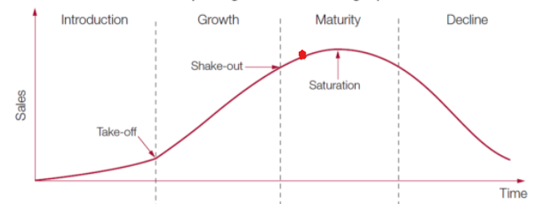
Source: https://marketing-insider.eu/characteristics-of-the-product-life-cycle-stages/

The product life cycle comprises 5 steps. The 1st one is development, 2nd one is introduction, 3rd step of the cycle is growth, 4th one is maturity and the last step is decline. From the above analysis, the Four-Season Hotels and Resorts is in the 4th stage as the company is already world renowned in the hospitality industry.

