
Problem Solving and Decision Making
BMSW4004

Ejiro Esohwode

Adrian Petrea 2020066

Table of Contents
Introduction 3
Problem Identifation 4
Imblanced work life: 4
Poor management 4
Gernerate Alternative Solutions 5
Decision Making 5
Action Plan And Implimentation 6
Interactive and effective communication: 6
Recognisiton and Refreashment: 6
Defining the Work period Clearly: 7
Stakeholder Communication Plan 9
Decision implimenting plan 10
PERT (Program evaluation and review technique) 10
Conclusion 11
References 12

Introduction
Problems are one of the integral parts of our life. In our everyday life, we are facing a number of problems and dealing with them in order to make our life a bit more smooth. As the organisation structure is getting complicated day by day the problems are also getting complicated than that of earlier. For example, before 2000, the organisation never face many issues related to information technology because of its limited uses. Nowadays every organisation try to create a strong social image and face a number of issues that are related to social media or information technology and to deal with these problem organisation need experts on these issues.
From the case given, the main problem seems to be the dissatisfaction of the employees during the covid-19 due to mental issues, poor work-life balance, lack of motivation, and many other professional issues that are totally new to the management. In this case, it was told that job satisfaction decreased 35% in the past year from a survey that had been conducted on around 2000 employee among which 64 percent was working from home. This study also finds out that 32 percent of participants don’t feel any kind of motivation in the workplace where 18 percent are dissatisfied with the quality of life in the workplace.

Problem Identification
Problem identification simply means understanding the problem and more specifically it means analysing relevant information to understand the type, causes well as impactfulness of any problem. Problem identification is the first step of the problem-solving process. It initiate the necessity of sloving a problem (Jäkel and Schreiber, 2013). A few important things need to be considered very carefully at the time of problem identification. First of all the opinion of someone needs to be different from actual facts regarding any problem because sometimes the opening makes the problem more obscure and taught to solve the problem. Secondly, all the underlying costs responsible for happening any problem need to be identified and addressed. Generally, we get to know the prime cost of occurring any problem but we don’t get the underlying causes in that much easy way but these causes are almost equally important to get a good solution for any problem.
Here, in this case, the main problem is the job dissatisfaction of employees and we will try to find out the possible cause of the problem that may help us to solve the problem in a more appropriate manner
Imbalanced work life: It can be one of the prime causes for the creation of this problem. The reason it’s an important cause is that the survey had been conducted on around 2000 employee among which 64 percent was working from home. In this case, it was told that job satisfaction decreased 35% that means this comparison refers to any specific cause for creating this problem which is the byproduct or at least crated due to allowing employees to work from home (Warren, 2021). Poor work-life balance is one of the most common issues during working from home.
Poor management: is also a crucial reason for job dissatisfaction of employees. Management of any organisation plays a vital role to balance the workloads of employees with the desired organisational performance and keep them motivated to maintain the piece with the given workloads (Greiff, Holt, and Funke, 2013). It's a fact that managing employee is easier when they're present in front of the manager rather than working from home. Because one study finds that around 70 to 80% of our communication is performed in a non-verbal manner for which personal presence is mandatory. But in the case of work from home, the non-verbal part of communication has done either very tiny portion on In any case it was totally missing. As a result, there has been created a huge communication gap between managers and employees which ultimately affects the quality of management.

Generate Alternative Solutions

Decision Making
Alike human life, an organisation faces thousands of problems that need to be dealt at a very proficient way to conduct the activities successfully. The long-term sustainability and performance of an organisation are highly dependent on the decision it makes to solve its problem. As the organisation structure is getting complicated day by day the problems are also getting compilated than that of earlier (Ferrin, 2017). For example, during the covid situation, due to the outbreak of covid-19 the new treads of “work from home” has started. Since employee, as well as organisaiton, was not familiar with it in past, therefore the problem created here are also new and challenging for organisation. Issues like mental health, differentiation between work time and family time, productivity hindrances are a few of them that are currently corner for almost the organisation that had allowed or allowed their employees to work from home.
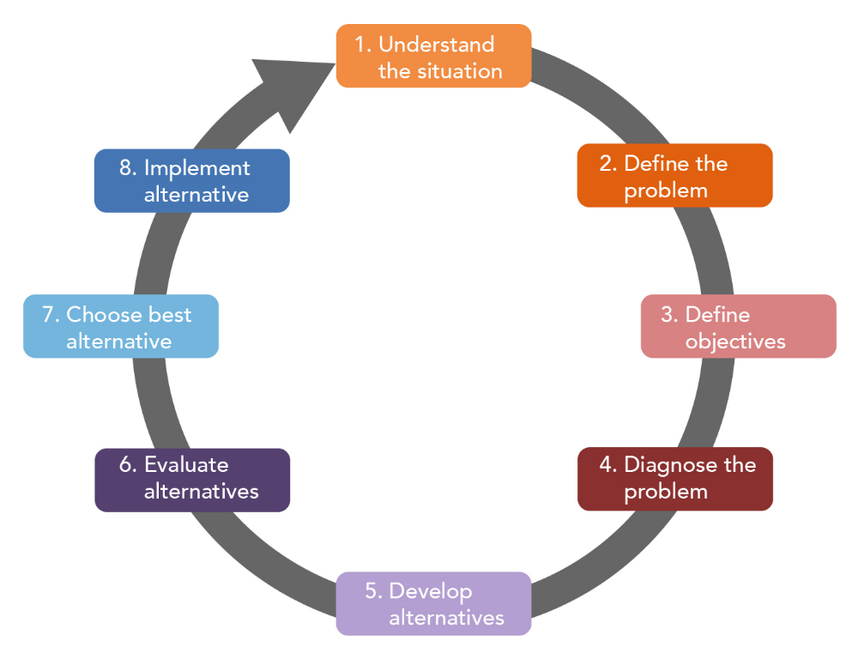
Figure 1: Decision Making Process (Bazerman, 2012)
Here is his picture, the decision-making steps are shown as the subsequent process which can be used be make any decisions (Singhvi, Dhage and Sharma, 2018). The first step of making any decisions is to understand the situation and then we have to define the problem as we have done previously we understand that the situation is abnormal due to covid-19 in our given case. Then we define the problem which is job dissatisfaction then we define our objective which is to enhance the work efficiency for employees working from home. In the next few paragrams, we will find a few alternative solutions for our problem and suggest the best one as the solution to the problem of job dissatisfaction.

Action Plan And Implementation
In the previous paragraphs, we have discussed the given problem. We also defined the problem and try to understand the abnormal situation created due to covid-19 in our given case. However, now we will discuss the possible solution and implementation plans for this.
Interactive and effective communication: in problem analysis, we have seen that 70 to 80% of our communication is performed in a non-verbal manner for which personal presence is mandatory. But in the case of work from home, the non-verbal part of communication has done either very tiny portion on In any case it was totally missing. As a result, there has been created a huge communication gap between managers and employees which ultimately affects the quality of management (Reed and Learning, 2014). This problem can be solved by ensuring more interactive and effective communication. That can be done in multiple ways. For example, one study finds that simply keeping the camera on in virtual communication can enhance the quality of the communication three times better than without keeping the camera on. Sort from that meeting adding in the more interactive platform like zoom and google meet can also increase the interactiveness (Singhvi, Dhage and Sharma, 2018). So, in order to remove the problem of poor manager and employee dissatisfaction, ensuring interactive communication can play a vital role.
PMI CHART for solution one
Plus | Minus | Interesting
- Enhance the job satisfaction  - Increase the work efficiency  - Reduce the communication gap  - Promote opennesss in organisaotnal cututre | - May incur the more operational cost  - Few misunderstandings could take place  - Employees may face status complexity | - Organisations get to learn about all the problems of employees and can solve them  - Can create a better workplace for the employee

Recognition and Refreshment: As we all know that during the covid period all of us had gone through a very taught time. Due to the outbreak of vital, life gets standstill and people get locked into their houses. So, working motivation or spread is expected to be at a low level. In this type of situation, tiny recognisation for the performance of work is a tonic for them. One study finds they for white color jobs recognition motivate them more than that of financial benefits like salary enhancement do. During the covid period, many of the large organisation has been seen to give recognition to their employees through social media pages and providing healthcare benefits. Creating a temporary heath zone, safe working environment by creating bao bubble, etc are few well-known take initiative by few large organisations for recognition of their employee's effort. One good example of reionization and refreshments by HP India is that they have brought Sidharth Malhotra for the refreshment of their employees. Therefore, for reducing job dissatisfaction recognition and refreshments also play a very crucial role.
PMI CHART for solution three
Plus | Minus | Interesting
- Enhance the job productivity  - Increase the work efficiency  - Reduce the workloads and mental entity  - Promote entritainment in organisaotnal cututre | - May incur more operational costs while arranging such refreshment opportunities for the employees | - Employees will be motivated and enhance their productivity level  - Employees may feel more attachment with the organisation.

Defining the Work period Clearly: During the covid-19 period, most of the organisation allowed their work to work from home or remote work in such cases there is not a requirement to attend office. Everyone was attending the office from their own house. Since people aren’t habituated to working from home before that most of the people and their families considered the period they spend in the home as family time and differentiating it from work time was truly difficult. For this reason, as the workers get bound to work for their organisation even after the work period, similarly they also get bound to spend time with a family member during working hours (Singhvi, Dhage and Sharma, 2018). As a result, the time boundary between working hours and family house get mixed up and there was a huge cause of diminishing working focus as well as the productivity. Therefore, in order to remove the problem and improve the quality of work.
PMI CHART for solution three
Plus | Minus | Interesting
- Increase the work efficiency  - Reduce the mental issues and promote more healthy relationships | - May get a few fewer working hours to form employees while maintaining a strict timeline for the working period. | - Employees feel more motivated to work productively during working hours.

Stakeholder Communication Plan
Stakeholders | Power | Key interest and issues | Communication method | frequency | Comments
Owners | High | Create a productive and efficient organisational environment. | Virtual or physical Meeting | Monthly | This helps the management to track the activities and lead to organisaitonal goals.
Managers | High | Make a plan to achieve the organisational goals | Virtual or physical Meeting | Daily | Make the best decision that protects and promote owners interest
Employees | Low | Work efficiently and enhance productivity to achieve the organisation's goals while maintaining good communication. | physical Meeting | Daily | It helps to diminish the information gap and expectations gap as well.
The Government | High | Protect the organisation from violations of any rules and regulations of county | Formal meeting or management | Yearly | It improves the security of the organisation

Decision implementing plan

PERT (Program evaluation and review technique)
It’s a statistical tool used in project management mostly. It helps to plan projects with customised regarding periods as well as other specifications. PERT charts are used to plan tasks of the projects to make them easier to schedule. It also makes the work coordination between different teams of a specific product much easier. For implementing our prediscussed plants PERT (Program evaluation and review technique) will be appropriate as it will help the plants schedule on time with appropriate teammates.
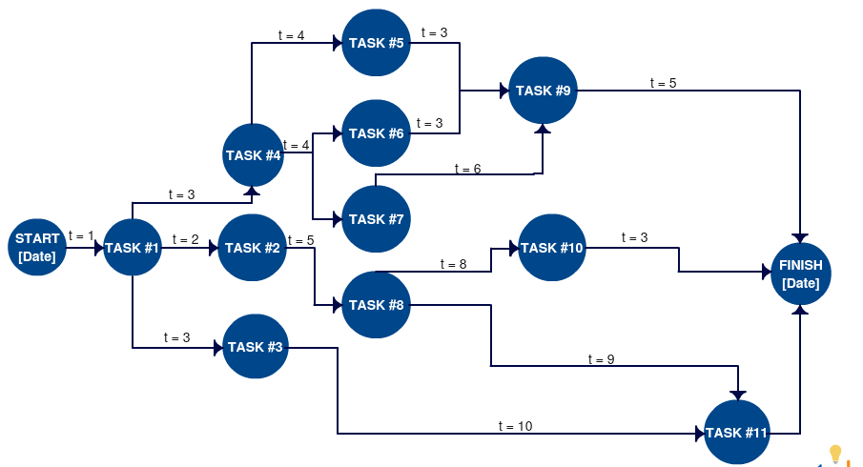
Figure 2:PERT Chart; source: (Singhvi, Dhage and Sharma, 2018)

Conclusion
In this whole report, we have discussed the main problem seems to be the dissatisfaction of the employees during the covid-19 due to mental issues, poor work-life balance, lack of motivation and many other professional issues that are totally new to the management. we define the problem which is job dissatisfaction then we define our objective which is to enhance the work efficiency for employees who works from home. We also found a few alternative solutions for our problem and suggest the best one as the solution to the problem of job dissatisfaction.

References
Bazerman, M., 2012. Judgment in Managerial Decision Making, 8th Edition. New York: John Wiley & Sons, Incorporated.
Ferrin, A., 2017. Good Moral Judgment and Decision-Making Process. The Southern Journal of Philosophy, 55(1), pp.68-95.
Greiff, S., Holt, D. and Funke, J., 2013. Perspectives on Problem Solving in Educational Assessment: Analytical, Interactive, and Collaborative Problem Solving. The Journal of Problem Solving, 5(2).
Jäkel, F. and Schreiber, C., 2013. Introspection in Problem Solving. The Journal of Problem Solving, 6(1).
Reed, C. and Learning, B., 2014. Problem Solving. Chicago: Britannica Digital Learning.
Singhvi, P., Dhage, N. and Sharma, P., 2018. Impact on Motivation Employee's Satisfaction and Employee's Performance. International Academic Journal of Organisational Behavior and Human Resource Management, 05(02), pp.1-43.
Warren, T., 2021. Work-life balance and gig work: ‘Where are we now and ‘where to next with the work-life balance agenda?. Journal of Industrial Relations, 63(4), pp.522-545.

