

Student Name: B M A RAHMAN
Student ID: 2526730

Module Name: Financial Management
Module Code: LCMB7002

Lecturer’s Name: Shengfeng Mei / Patrick Yeboah

Word Count: 5,000 (±10%)

Submission deadline: 24th April 2026 by 2PM

Table of Contents
Table of Contents 2
List of Tables 3
List of Figures 4
1. Introduction 5
2. Financial Health Check (Ratio Analysis) 6
2.1 Profitability Analysis 7
2.2 Liquidity and Efficiency Analysis 8
2.3 Gearing and Investment Ratios 10
2.4 Key Trends, Strengths and Threats 10
3. Working Capital Management Analysis 12
3.1 Cash Operating Cycle Assessment 12
3.2 Recommendations to Improve Liquidity 13
3.3 Short-term vs Long-term Financing Options 14
4. Strategic Financial Restructuring Plan 15
4.1 The Core Problem: Margin Compression 15
4.2 Restructuring Recommendations 15
4.3 Impact on Shareholders, Debt, and Operations 17
4.4 International and Ethical Considerations 17
5. Investment Appraisal and Capital Budgeting Decisions 19
5.1 Project Analysis 19
5.1.1 Payback Period (PBP) 19
5.1.2 Accounting Rate of Return (ARR) 19
5.1.3 Net Present Value (NPV) 20
5.1.4 Profitability Index (PI) and IRR 20
5.2 Recommendation: Project C 21
5.3 Capital Rationing: Best Combination Under £100m 22
6. Conclusion 24
References 25
Appendices 28
Appendix A: Key Ratio Formulas Used 28
Appendix B: Discount Factors at 10% 28

List of Tables
Table 1: Tesla Five-Year Financial Summary (FY2021–FY2025)
Table 2: Profitability Ratios (FY2021–FY2025)
Table 3: Liquidity and Efficiency Ratios (FY2024 vs FY2025)
Table 4: Gearing and Investment Ratios (FY2024 vs FY2025)
Table 5: Estimated Cash Operating Cycle (FY2024 vs FY2025)
Table 6: Comparative Summary of All Three Projects
Table 7: Capital Rationing – Comparing Project Combinations

List of Figures
Figure 1: Tesla Revenue Trend (FY2021–FY2025)
Figure 2: Profitability Margin Trends
Figure 3: Revenue Breakdown by Segment (FY2025)
Figure 4: Cash Flow Comparison (FY2024 vs FY2025)
Figure 5: NPV Comparison of Projects A, B, and C

1. Introduction
Tesla, Inc. is probably the most talked-about company in the automotive industry right now, and for reasons that extend well beyond just making electric cars. Headquartered in Austin, Texas, Tesla has positioned itself at the intersection of electric vehicles, artificial intelligence, energy storage, and increasingly, autonomous driving and robotics. With total revenues reaching $94.8 billion in FY2025 and a market capitalization that has at times exceeded the combined value of every other major automaker, the company occupies a genuinely unusual space in corporate finance (Tesla, Inc., 2026). It operates across two segments: Automotive and Energy Generation and Storage.
What makes Tesla particularly interesting for this kind of analysis is the dramatic arc of its recent financial performance. Revenues went from $53.8 billion in FY2021 to $81.5 billion in FY2022, almost doubling in a single year, and operating margins hit a remarkable 16.8%. Since then, though, things have changed quite a lot. A few factors are at play here. Tesla slashed prices to keep up sales against BYD and other Chinese rivals, R&D spending on Full Self-Driving and Optimus has ballooned, and the EV market more broadly has cooled. Put those together and you get margins squeezed down to 4.6% by FY2025. Operating income, which peaked at $13.7 billion, was down to just $4.4 billion three years later (Tesla, Inc., 2026). That is a steep drop by any standard. That kind of swing makes digging into the numbers feel especially worthwhile.
This report adopts the role of chief financial officer and works through five years of financial data from FY2021 to FY2025. What comes next is broken into a few parts. Section 2 digs into the ratios, profitability, liquidity, efficiency, and gearing, the usual suspects. Section 3 looks at working capital and how cash moves through the operating cycle. Section 4 tackles the margin compression problem and what restructuring might help. Section 5 runs three hypothetical investment projects through the standard capital budgeting tools: Payback Period, ARR, NPV, Profitability Index, and IRR. The goal throughout is to be rigorous and upfront about where the numbers look solid and where they raise questions.

2. Financial Health Check (Ratio Analysis)
Before getting lost in individual ratios, it is worth pausing to see what the raw numbers are saying. Tesla’s revenue climbed from $53.8 billion in FY2021 to $97.7 billion by FY2024, which is nearly double in just three years. But FY2025 actually saw revenue decline to $94.8 billion, which is the first year-over-year revenue drop in the company's history as a major automaker. More worrying than the top-line slowdown is what happened underneath it. Gross profit has been remarkably flat at around $17 to $18 billion for three consecutive years despite revenue fluctuations, and operating income has fallen sharply from its FY2022 peak of $13.7 billion to just $4.4 billion in FY2025 (Tesla, Inc., 2026). The reason for this gap is straightforward. R&D spending jumped from $2.6 billion to $6.4 billion over five years, and the company absorbed $494 million in restructuring charges in FY2025.
Table 1: Tesla Five-Year Financial Summary (FY2021–FY2025)
Metric ($ Bn) | FY2021 | FY2022 | FY2023 | FY2024 | FY2025
Revenue | 53.82 | 81.46 | 96.77 | 97.69 | 94.83
Gross Profit | 13.61 | 20.85 | 17.66 | 17.45 | 17.09
Op. Income | 6.52 | 13.66 | 8.89 | 7.08 | 4.36
Net Income | 5.52 | 12.56 | 15.00 | 7.09 | 3.79
Total Assets | 62.13 | 82.34 | ~106.6 | 122.07 | 137.81
Op. Cash Flow | 11.50 | 14.72 | 13.26 | 14.92 | 14.75
EPS ($) | 1.87 | 4.02 | 4.73 | 2.23 | 1.18
Source: Compiled from Tesla, Inc. (2026) Annual Report on Form 10-K and prior SEC filings.
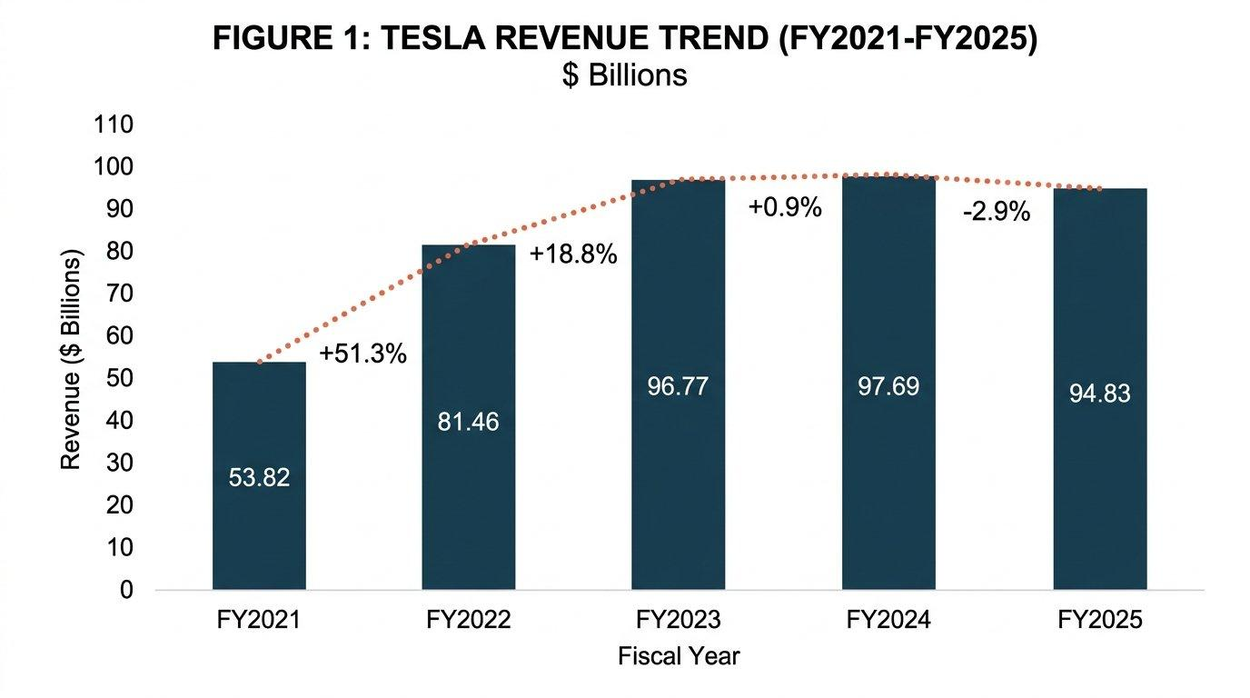
Figure 1: Tesla Revenue Trend, FY2021–FY2025 ($ Billions). Source: Author’s compilation.

2.1 Profitability Analysis
The profitability story at Tesla is, to put it bluntly, one of rapid deterioration. Gross margin peaked at 25.6% in FY2022 when Model 3 and Model Y demand far exceeded supply, with waiting lists stretching months. Fast forward to FY2025, gross margin has dropped to 18.0%. What happened? Mostly Tesla’s own doing. The company kicked off a price war in early 2023, slashing prices globally by as much as 20% in some markets to fend off BYD, Xpeng, and the rest of the Chinese challengers. It probably did protect volume to some extent, but the damage to unit economics was absolutely brutal (Li et al., 2024).
Operating margin tells an even starker story. It went from 12.1% in FY2021 to a peak of 16.8% in FY2022, then collapsed to 9.2% in FY2023, 7.2% in FY2024, and just 4.6% in FY2025. That is a 12-percentage-point decline in three years, which is the kind of margin compression that fundamentally changes how you think about a company's valuation. A significant part of the operating expense increase comes from R&D spending, which nearly tripled from $2.6 billion to $6.4 billion over the five-year period. Tesla is investing heavily in Full Self-Driving technology, the Optimus humanoid robot, and next-generation vehicle platforms, which are all expensive bets that have not yet generated meaningful revenue (Miao, 2025).
Net profit margin looks inflated in FY2023 due to a $5.9 billion one-off tax benefit. Without that, the trend is clearly downward. ROE has fallen from roughly 18.3% in FY2021 to about 4.6% in FY2025, squeezed by a growing equity base and falling profits (McLaney, 2017). EPS peaked at $4.73 in FY2023 before crashing to $1.18 by FY2025. Stock-based compensation of $2.8 billion in FY2025 adds to the real cost borne by shareholders (Arnold, 2019).
Table 2: Profitability Ratios (FY2021–FY2025)
Ratio | FY2021 | FY2022 | FY2023 | FY2024 | FY2025
Gross Margin | 25.3% | 25.6% | 18.2% | 17.9% | 18.0%
Op. Margin | 12.1% | 16.8% | 9.2% | 7.2% | 4.6%
Net Margin | 10.3% | 15.4% | 15.5% | 7.3% | 4.0%
ROE | ~18.3% | ~28.1% | ~24.0% | ~9.7% | ~4.6%
EPS ($) | 1.87 | 4.02 | 4.73 | 2.23 | 1.18
Source: Author's calculations from Tesla, Inc. (2026) Form 10-K and prior filings.
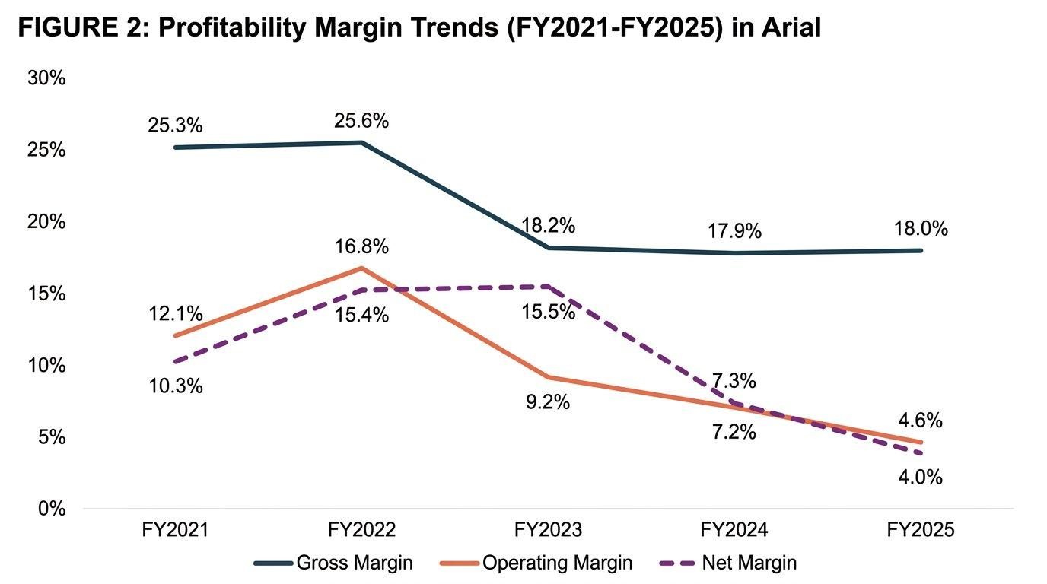
Figure 2: Profitability Margin Trends, FY2021–FY2025 (%). Source: Author’s calculations.

2.2 Liquidity and Efficiency Analysis
Liquidity is actually one of Tesla's genuine strengths. By FY2025, Tesla held $16.5 billion in cash plus $27.5 billion in short-term investments, totaling $44.1 billion in liquid assets. The current ratio of 2.17 and quick ratio of 1.77 are both strong, suggesting no near-term liquidity risk (Tesla, Inc., 2026).
The efficiency picture is more nuanced. Inventory grew from $12.0 billion to $12.4 billion year-on-year despite revenue declining by 3%, which hints at vehicles or energy products sitting on lots longer than expected. Inventory turnover slipped from 6.68 times to 6.27 times, which is not huge, but it's in the wrong direction. Accounts receivable edged up a bit from $4.4 billion to $4.6 billion, working out to about 18 days of receivables. On the payables side, accounts payable grew from $12.5 billion to $13.4 billion. That basically tells you Tesla is dragging its feet a little on paying suppliers. Now, stretching payables is a fairly standard move when margins are under pressure, nothing unusual there. But you have to be careful with it. Strain a relationship too far and you could end up with supply chain issues, which for an EV manufacturer with all those specialized components would be particularly painful (Atrill, 2020).
Table 3: Liquidity and Efficiency Ratios (FY2024 vs FY2025)
Ratio | FY2024 | FY2025
Current Ratio | 2.02 | 2.17
Quick Ratio | 1.61 | 1.77
Cash Ratio | 1.27 | 1.39
Inventory Turnover | 6.68x | 6.27x
Receivables Days | ~16 | ~18
Source: Author's calculations from Tesla, Inc. (2026) Form 10-K.
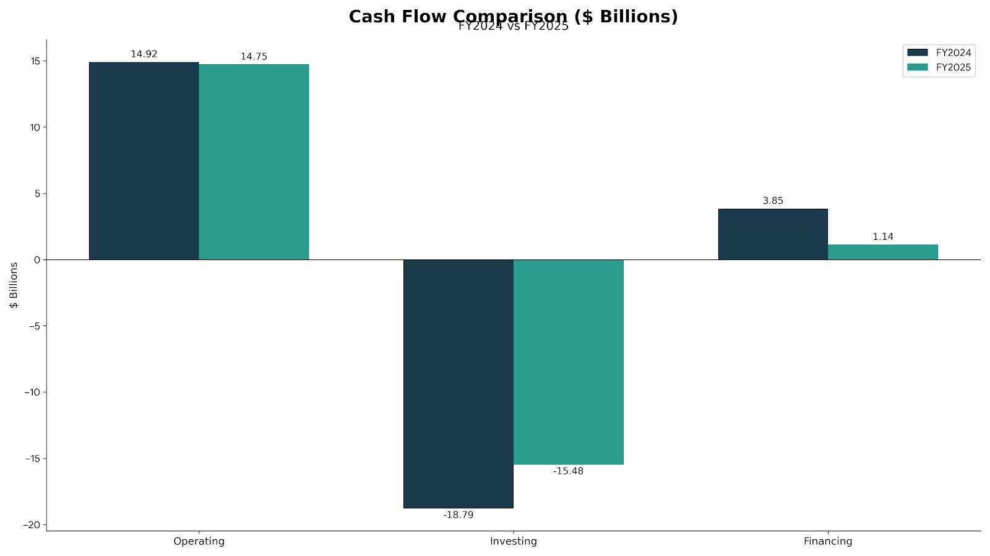
Figure 4: Cash Flow Comparison, FY2024 vs FY2025 ($ Billions). Source: Author’s calculations.

2.3 Gearing and Investment Ratios
Tesla's gearing is conservative. Debt-to-equity sits at just 0.67, lower than most traditional automakers. Long-term debt of $6.7 billion is modest against $137.8 billion in assets. Interest coverage is 12.9 times, comfortable but down sharply from FY2022's 70x+ levels (Tesla, Inc., 2026).
Stockholders' equity stands at $82.1 billion, and Tesla has never paid a dividend. The P/E ratio of roughly 340 times is extraordinarily high, reflecting market expectations for future AI, robotaxi, and Optimus revenue rather than current earnings. Whether that future growth materializes is, to be frank, uncertain (Penman, 2013).
Table 4: Gearing and Investment Ratios (FY2024 vs FY2025)
Ratio | FY2024 | FY2025
Debt-to-Equity | 0.66 | 0.67
Interest Coverage | 20.2x | 12.9x
Equity Ratio | 59.7% | 59.6%
P/E Ratio | ~178x | ~340x
Dividend Yield | 0% | 0%
Source: Author's calculations from Tesla, Inc. (2026) Form 10-K.

2.4 Key Trends, Strengths and Threats
A few things jump out when you step back and look at the whole thing. On the positive side, the Energy Generation and Storage segment has been a genuine success story, growing from $2.8 billion in FY2021 to $12.8 billion in FY2025, a 357% increase. Gross margins in this segment reached 29.8% in FY2025, which is actually higher than the automotive segment's margins. If this trajectory continues, energy could become a major profit contributor. The cash pile of $44.1 billion in liquid assets is another big plus, giving Tesla a level of strategic flexibility most of its competitors can only dream about. Operating cash flow has held steady at $13 to $15 billion annually despite falling profits (Tesla, Inc., 2026).
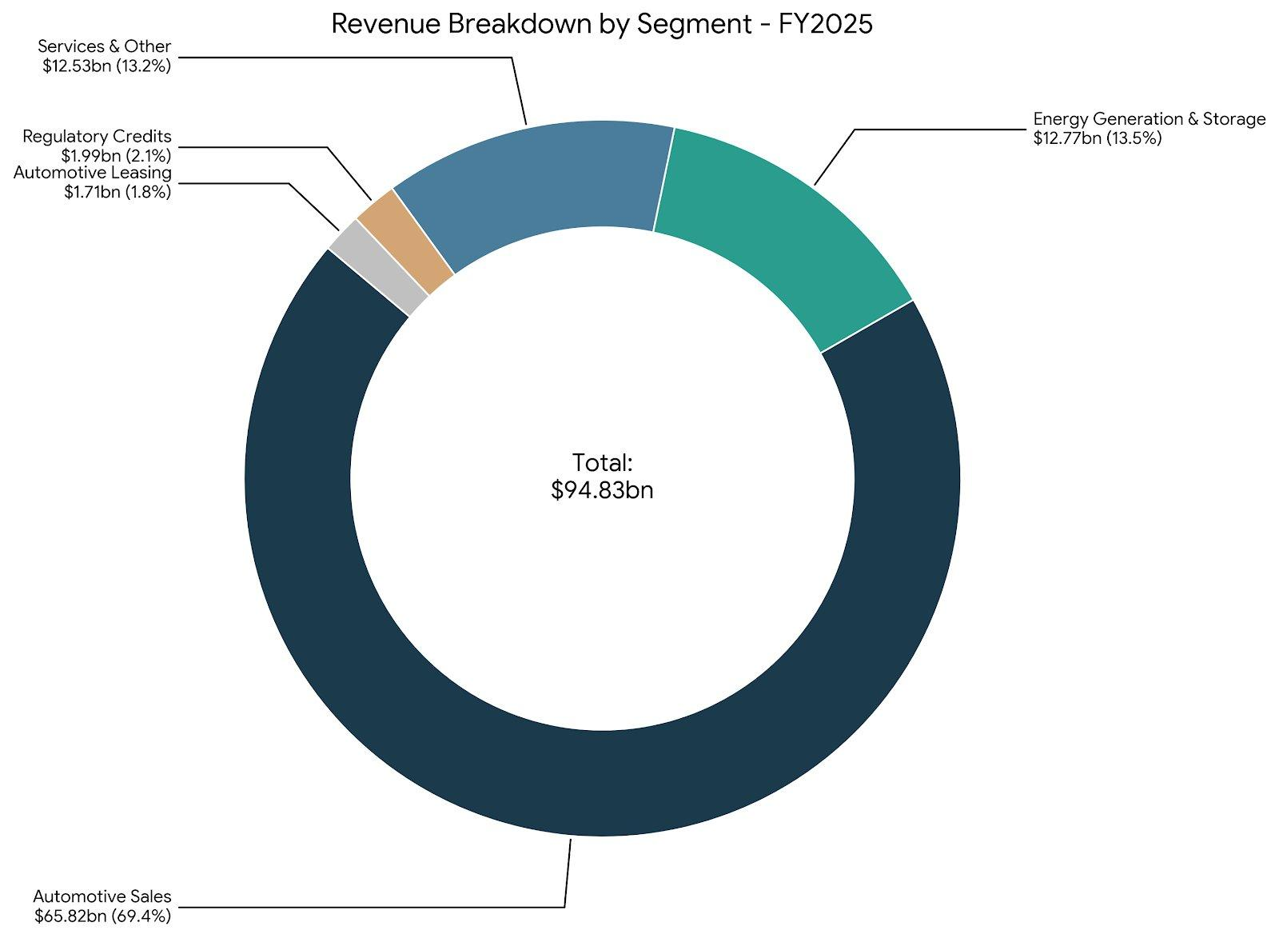
Figure 3: Revenue Breakdown by Segment, FY2025. Source: Author’s compilation.
The threats, however, are significant and getting harder to ignore. The core automotive business is shrinking in revenue terms for the first time. Automotive sales revenue fell from $78.5 billion in FY2023 to $65.8 billion in FY2025, which is a 16% drop. BYD overtook Tesla in global EV sales volume in FY2024, and the pressure from Chinese manufacturers does not look like it's going to let up anytime soon (IEA, 2025). Then there is the regulatory credits situation, which brought in $2.0 billion in FY2025. It's a bit of a double-edged sword, really. The whole thing depends on other automakers not meeting their emissions targets, so the more they electrify their own fleets, the smaller this revenue stream becomes. Not exactly a sustainable long-term strategy (Singhi, 2025). And then there is the Elon Musk factor. His involvement with the Department of Government Efficiency and the various controversies that came along with it have triggered consumer boycotts in parts of Europe. Some analysts have drawn a fairly direct line between his public activities and Tesla’s weakening brand perception (Isidore, 2025).

3. Working Capital Management Analysis

3.1 Cash Operating Cycle Assessment
Working capital management matters even for a company as cash-rich as Tesla, because it reveals something about operational discipline that the headline numbers can easily hide. The question is straightforward: how long does it take for cash to flow through the operating cycle, from paying for raw materials through to collecting payment from customers?
Inventory is the first piece of the puzzle. Tesla held $12.4 billion in inventory at FY2025 year-end against a cost of revenues of $77.7 billion, giving an inventory holding period of approximately 58 days. That is a slight deterioration from FY2024 when it was around 55 days. For an automotive manufacturer, 58 days is not terrible, but it is higher than ideal given that Tesla runs a direct-sales model without traditional dealership networks. The fact that inventory increased while revenue declined suggests that vehicles are taking longer to sell or that Tesla is building up stock of energy products like Megapack in anticipation of future orders (Tesla, Inc., 2026).
Accounts receivable of $4.6 billion against revenue of $94.8 billion translates to a receivables collection period of about 18 days. This is actually very efficient and reflects Tesla's direct-to-consumer model, where most vehicle purchases are paid at delivery or financed through third-party lenders who settle quickly. The energy segment has slightly longer collection periods due to project-based contracts with utilities, but overall, receivables management is a real strength. On the payables side, accounts payable of $13.4 billion against a cost of revenue of $77.7 billion gives a payables period of about 63 days. Tesla has been stretching its payables somewhat, which is a common and perfectly rational response to margin pressure (Brealey, Myers, and Allen, 2020).
Putting it all together: 58 + 18 - 63 = 13 days. That is an extraordinarily short cash conversion cycle. For comparison, most traditional automakers operate with cycles of 30 to 60 days or more. This means Tesla is basically getting paid by customers before it has to pay its suppliers, which generates a natural source of working capital financing. This is one of the genuinely underappreciated strengths of the business model, and it explains how Tesla can maintain strong cash generation even as reported profits decline.
Table 5: Estimated Cash Operating Cycle (FY2024 vs FY2025)
Component (Days) | FY2024 | FY2025
Inventory Holding | ~55 | ~58
Receivables Collection | ~16 | ~18
Payables Payment | ~57 | ~63
Cash Operating Cycle | ~14 | ~13
Source: Author's estimates from Tesla, Inc. (2026) Form 10-K.

3.2 Recommendations to Improve Liquidity
Given that Tesla's working capital cycle is already extremely efficient, the opportunities for improvement are more limited than you might find at a traditional manufacturer. However, there are still areas worth tightening. Inventory management is the most obvious one. The 3-day deterioration in inventory holding period may seem small, but on a cost base of $77.7 billion, each extra day of inventory ties up roughly $213 million in cash. If Tesla can bring holding days back to 55 or below through better demand forecasting and production scheduling, particularly for the energy segment where Megapack orders can be lumpy, that frees up over $600 million (Christopher, 2016).
The energy segment offers some interesting possibilities on the receivables side, particularly as it grows. Utility-scale projects tend to come with longer payment cycles, so as Tesla wins more of this business, it might be worth looking at factoring arrangements or progress billing to stop working capital getting locked up for too long. And the good news is Tesla already manages $285 million in financing receivables, so the basic infrastructure for this kind of thing already exists. Supply chain finance programs, where a bank pays suppliers early at a discount while Tesla retains its normal payment terms, could also be explored given the company's strong credit profile.
The $27.5 billion in short-term investments is also worth mentioning in this context. Yes, it earns a decent chunk of interest income, $1.7 billion in FY2025, but it is still capital sitting on the sidelines rather than being put to work in the business. A more aggressive deployment, maybe expanding manufacturing capacity, adding Megapack production lines, or going deeper into battery supply chain integration, could potentially beat what Treasury securities are returning.

3.3 Short-term vs Long-term Financing Options
Tesla’s financing setup has changed a fair bit over the years. The company carries $1.6 billion in current debt and $6.7 billion in long-term debt and finance leases. With $44.1 billion in liquid assets, Tesla could pay off all of its debt tomorrow and still have over $37 billion remaining. This gives it extraordinary financial flexibility that is rare in the automotive industry. The $5.6 billion in new debt issuances during FY2025, almost matched by $5.5 billion in repayments, tells you Tesla is refinancing rather than piling on new leverage. With interest rates where they are right now, locking in long-term fixed rates while keeping things conservative on the debt side feels like the right call. The company's consistent operating cash flows of $14 to $15 billion annually mean it does not need external financing for day-to-day operations, which is a luxury that most automakers simply do not enjoy (Watson and Head, 2019).

4. Strategic Financial Restructuring Plan

4.1 The Core Problem: Margin Compression
The fundamental challenge facing Tesla is that its core automotive business is becoming less profitable at precisely the time when it needs to fund massive R&D investments in AI, autonomous driving, and robotics. On the automotive side, gross margins have gone from 29.0% in FY2022 to roughly 17.8% in FY2025, which is quite a slide. The price war with BYD and the other Chinese manufacturers has essentially forced Tesla to give up pricing power in exchange for keeping volume, and honestly, there is no sign this pressure is easing anytime soon. BYD already outsold Tesla globally on EVs in FY2024, and it's pushing hard into Europe, Southeast Asia, and Latin America (IEA, 2025). Meanwhile, the legacy players, Volkswagen, Hyundai, and BMW, are rolling out competitive EV models at lower price points. It is getting crowded out there.
At the same time, Tesla is pouring money into projects that have not made meaningful revenue yet. FSD (Supervised) is available as a subscription but contributes only a modest amount to the top line. The Robotaxi program is still in the pilot stage. Optimus, the humanoid robot project, is pre-revenue and likely years away from commercialization. These are all interesting bets, no question. The problem is they need funding from the existing business, which is the same business that is getting squeezed on margins. So there is a real strategic tension here, and any restructuring plan has to deal with it directly rather than pretending it does not exist (Miao, 2025).

4.2 Restructuring Recommendations
One idea is to separate the energy generation and storage segment into something more standalone, maybe with its own financing and reporting structure. This segment pulled in $12.8 billion in revenue with gross margins of 29.8% in FY2025, and its growth has been genuinely impressive. Giving it more operational freedom would let Tesla attract investors and analysts who actually understand the utility-scale energy space, rather than having its performance lost inside a company that mostly gets judged on quarterly car deliveries. A partial spin-off or a tracking stock could surface real shareholder value without losing the battery tech and manufacturing synergies that make the whole thing work (Arnold, 2019).
Then there is the cost problem in automotive. The $494 million in restructuring charges for FY2025 shows that management knows something needs to change, but honestly, the scale of the challenge calls for more than just trimming around the edges. Tesla might need to think seriously about streamlining the vehicle lineup, focusing production on whichever models actually make decent money, and accelerating the move to next-generation platforms that are fundamentally cheaper to build. The rumored sub-$25,000 vehicle is critical here, but only if it can be produced at margins that do not further drag down the segment's overall profitability. Cost engineering and vertical integration of the supply chain, particularly for batteries, should be prioritized.
And then there is the $27.5 billion in short-term investments just sitting on the balance sheet. Sure, it earns interest and provides a cushion, but there is a real opportunity cost to having that much capital parked in low-risk securities while the company is dealing with what amounts to existential competitive pressure. You could make a strong argument for putting at least some of that money to work more aggressively. Allocating a portion of this capital towards aggressive Megapack manufacturing expansion, given the segment's superior margins and growth rates, would be a more value-creating use of funds. The cash hoard also opens up the possibility of strategic acquisitions, things like battery recycling companies, charging infrastructure plays, or AI software firms that could strengthen Tesla’s long-term position.
There is also the question of Tesla’s manufacturing footprint and whether it makes sense to keep building cars in China given the growing geopolitical tensions between Washington and Beijing. The Shanghai Gigafactory produces a significant share of Tesla’s global output, and any deterioration in US-China trade relations could disrupt both production and access to the Chinese consumer market, which remains one of the largest EV markets in the world. Diversifying production to India or Southeast Asia could reduce this exposure, though it would require substantial capital and time. The timing matters. Move too early and you waste capital. Move too late and you get caught by tariffs.

4.3 Impact on Shareholders, Debt, and Operations
The whole point of these restructuring ideas is to build long-term value, not to boost next quarter’s earnings. What shareholders would probably appreciate most is a clearer breakdown of where value actually sits, automotive versus energy, so they can run their own sum-of-the-parts models rather than trying to guess how much of the stock price is cars and how much is batteries. Tesla's current debt structure is already conservative, and any restructuring should maintain this low-leverage profile. The company's credit ratings and ability to access capital markets at favorable rates depend on maintaining financial discipline. Operationally, the key challenge is managing the transition from a growth-at-all-costs mindset to a more disciplined, margin-focused approach. This requires cultural change within the organization, which is never straightforward, especially at a company where Elon Musk's leadership style tends toward ambitious moonshot projects rather than incremental cost optimization (Jensen, 1986).

4.4 International and Ethical Considerations
Tesla operates in over 40 countries, with significant manufacturing facilities in the United States, China, Germany, and Mexico. Currency risk is worth worrying about too, especially the Chinese yuan and euro exposures. Tesla flagged $452 million in foreign currency transaction losses in FY2025, which is real money. Whatever restructuring happens, it needs to factor in where revenue and costs fall geographically. Natural hedging, where you match production costs with sales revenue in the same currency, is probably the most practical approach here. It will not eliminate the risk entirely, but it can take some of the edge off (Madura, 2018).
Tax planning also deserves a mention here. Tesla benefited from a $5.9 billion deferred tax asset release in FY2023, which was essentially a one-off windfall. Going forward, the company’s effective tax rate is likely to normalize, and any restructuring needs to consider the tax implications of moving operations, profits, or intellectual property between jurisdictions. The OECD’s Pillar Two global minimum tax framework, which sets a 15% floor on corporate tax rates, limits some of the traditional tax optimization strategies that multinationals have relied on (Whittington et al., 2023). Tesla’s actual tax bill will depend heavily on where it chooses to recognize revenue and where its R&D centers are located.
Ethics and governance are becoming harder to ignore for Tesla. The supply chain pulls in cobalt, lithium, and nickel from places with well-documented human rights and environmental problems, the Democratic Republic of Congo being the most obvious example for cobalt. Tesla has done some work on battery recycling and publishes Conflict Minerals Reports, but ESG-focused investors want more, and they are getting louder about it. And then there is the governance question around Musk himself. Running Tesla, SpaceX, and X (formerly Twitter) simultaneously while also being deeply involved in politics creates a concentration of risk that is, frankly, unusual for a company of this size. It is hard to put a number on the governance risk, but you definitely cannot ignore it (Eccles and Klimenko, 2019). Whether the anti-Tesla backlash in Europe is a passing thing or something more lasting is an open question, and one that will matter a lot for long-term brand strategy.

5. Investment Appraisal and Capital Budgeting Decisions
This part of the report looks at three hypothetical investment projects. Each one needs £50 million upfront and is expected to bring in cash over a five-year period. The discount rate is set at 10%, and depreciation is straight-line down to zero. Now, picking 10% as the hurdle rate is a bit arbitrary, and Tesla’s actual weighted average cost of capital is genuinely hard to pin down given how the market values the stock. But 10% works well enough as a benchmark for comparing the three options.

5.1 Project Analysis

5.1.1 Payback Period (PBP)
Project A brings in £10m in Year 1, then £12m, £14m, £10m, and finally £8m in Year 5. Cumulative cash flows reach £46m by the end of Year 4, leaving £4m to recover from Year 5's £8m inflow. The payback period works out to 4 + (4/8) = 4.5 years. Not exactly quick, but it recovers the initial investment eventually.
Project B is the simplest of the three, generating a flat £11m per year. Cumulative flows: £11m, £22m, £33m, £44m, £55m. The £50m investment is recovered during Year 5: PBP = 4 + (6/11) = 4.55 years. So basically neck-and-neck with Project A on this metric.
Project C starts slowly with cash inflows of £5m, £10m, £20m, £25m, and £5m. Cumulative flows build to £15m after Year 2, £35m after Year 3, then £60m after Year 4. The £50m is recovered in Year 4: PBP = 3 + (15/25) = 3.6 years. This is clearly the shortest payback of the three, which matters for a company like Tesla that needs flexibility to redirect capital quickly.

5.1.2 Accounting Rate of Return (ARR)
To calculate ARR, average annual profit equals average annual cash flow minus depreciation (£10m per year on a straight line). Average investment is (£50m + 0) / 2 = £25m. Project A: average cash flow £10.8m, average profit £0.8m, ARR = 3.2%. Project B: average cash flow £11m, average profit £1m, ARR = 4.0%. Project C: average cash flow £13m, average profit £3m, ARR = 12.0%. Project C dominates convincingly here, with an ARR three times higher than the next best option. This is worth noting because while ARR has well-known limitations as a metric, particularly Its failure to account for the time value of money, a 12% return is respectable by most standards (Drury, 2018).

5.1.3 Net Present Value (NPV)
Using a 10% discount rate with factors 0.909, 0.826, 0.751, 0.683, and 0.621 for years 1 through 5: Project A NPV = (10×0.909) + (12×0.826) + (14×0.751) + (10×0.683) + (8×0.621) - 50 = -£8.68 m. Project B NPV = 11 × 3.791 - 50 = -£8.30m. Project C NPV = (5×0.909) + (10×0.826) + (20×0.751) + (25×0.683) + (5×0.621) - 50 = -£1.98m. All three projects produce negative NPVs, which is not ideal. However, Project C is the least negative by a considerable margin and sits tantalizingly close to break-even. It is worth observing that a small reduction in the discount rate, say to 9%, would likely push Project C into positive territory.

5.1.4 Profitability Index (PI) and IRR
The profitability index is fairly straightforward. You take the present value of all the future cash flows and divide by the initial investment. Project A: PI = 41.32/50 = 0.826. Project B: PI = 41.70/50 = 0.834. Project C: PI = 48.02/50 = 0.960. Once again, Project C comes closest to the benchmark of 1.0. Estimating IRR through interpolation gives approximately 4.5% for Project A, about 3.6% for Project B, and around 9.2% for Project C. None of them clears the 10% hurdle, which is consistent with the negative NPVs. But Project C at 9.2% is very close indeed. Given Tesla's enormous cash reserves and its ability to access capital at rates well below 10%, there is a legitimate argument that the effective hurdle rate should be lower, which would make Project C a viable investment (Brealey, Myers, and Allen, 2020).
It is also worth thinking about how these projects compare to what Tesla could earn by deploying the same capital internally. A new Megapack production line, for instance, serves a segment with 29.8% gross margins and revenue growth exceeding 25% per year. If Tesla could build additional Megapack capacity for £50 million that generates even a fraction of the segment’s current margin profile, the internal return would almost certainly exceed what any of these three external projects offer. That is the real benchmark question, not just whether the IRR beats 10%, but whether it beats what else Tesla could do with the money. Most capital budgeting textbooks do not spend much time on this point, but in practice it is often the most important consideration.
Table 6: Comparative Summary of All Three Projects
Metric | Project A | Project B | Project C
Payback | 4.50 yrs | 4.55 yrs | 3.60 yrs
ARR | 3.2% | 4.0% | 12.0%
NPV (10%) | -£8.68m | -£8.30m | -£1.98m
PI | 0.826 | 0.834 | 0.960
IRR (est.) | ~4.5% | ~3.6% | ~9.2%
Source: Author's calculations based on project data from the assessment brief.
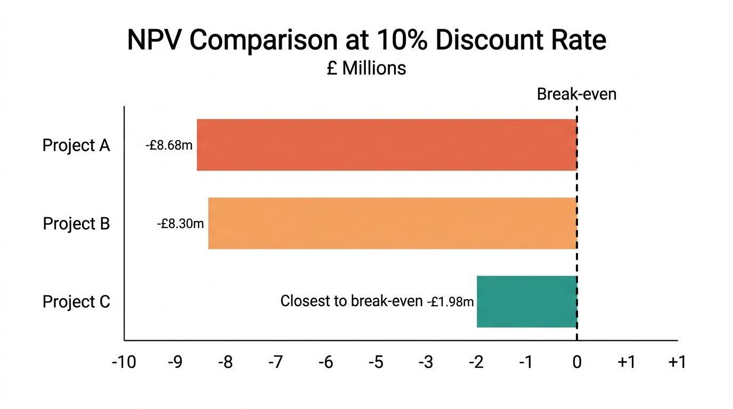
Figure 5: NPV Comparison at 10% Discount Rate (£ millions). Source: Author’s calculations.

5.2 Recommendation: Project C
If forced to choose a single project, Project C is the clear recommendation. Look at it this way: shortest payback at 3.6 years, highest ARR at 12.0%, the least negative NPV at only -£1.98m, a PI of 0.960 that nearly hits break-even, and an IRR of 9.2%, which is basically right on the doorstep of the 10% hurdle rate. The back-loaded cash flow profile, with £20m and £25m arriving in Years 3 and 4, aligns well with a company that is accustomed to investing now for future returns, which is essentially Tesla's entire corporate philosophy.
Non-financial considerations also support this choice. With $44.1 billion in liquid assets, Tesla could handle a modest NPV shortfall without breaking a sweat financially. Political risks are another consideration, things like US tariff uncertainty and potential European trade barriers on Chinese-made components. These would hit all three projects roughly equally, but they matter more for a company with Tesla’s kind of global manufacturing exposure. Customer loyalty, which is currently being tested by brand perception issues related to Elon Musk's public political activities, should also be factored in. A project that strengthens the customer proposition, perhaps through charging infrastructure expansion or service capacity investment, could generate qualitative benefits that a pure NPV calculation simply cannot capture (Pike, Neale and Linsley, 2018). Workforce impact is worth thinking about too. Tesla has over 140,000 employees spread across dozens of countries, so any capital investment decision has knock-on effects for jobs, skills, and the communities where these people live and work.
Sensitivity analysis would also strengthen the case here. If the discount rate were lowered to 8%, reflecting Tesla’s low debt costs and massive cash reserves, Project C’s NPV would move significantly closer to zero or possibly turn positive. Conversely, if the actual cash flows came in 10% below projections, even Project C would look less appealing. The numbers are estimates, not certainties, and the assumptions behind them deserve as much scrutiny as the calculations. Any experienced CFO would run multiple scenarios before committing this kind of capital.

5.3 Capital Rationing: Best Combination Under £100m
If there is a £100 million cap on the total budget, you can pair up A+B, A+C, or B+C. Each combo costs exactly £100m, so the question is which pair destroys the least value. Doing all three would require £150m, which exceeds the constraint.
Table 7: Capital Rationing – Comparing Project Combinations
Combination | Cost | Combined NPV | Avg PI
A + B | £100m | -£16.98m | 0.830
A + C | £100m | -£10.66m | 0.893
B + C | £100m | -£10.28m | 0.897
Source: Author's calculations based on project data from the assessment brief.
On the numbers, B + C comes out on top. It has the least negative combined NPV at -£10.28m and the highest average PI at 0.897. Project B provides steady, predictable cash flows of £11m per year, which is useful for planning certainty and cash flow management. Project C provides the upside through its concentrated returns in Years 3 and 4. Project B gives you that steady, predictable annual cash flow while Project C brings the big returns in Years 3 and 4. Together they make sense both intuitively and quantitatively.
But it is worth stepping back and asking the harder question: should Tesla be investing in any projects that destroy value at a 10% discount rate? When you’ve got $44 billion sitting in the bank, margins getting squeezed in automotive, and huge internal opportunities in Megapack, FSD, and Optimus, there is a real question about whether external projects are the best use of £100 million at all. Internal projects with higher expected returns could be more value-creating than external standalone investments. NPV, IRR, and payback period are genuinely useful frameworks for evaluation. They’re useful tools for thinking through decisions, absolutely. But they’re not crystal balls, and any CFO worth their salary would weigh the numbers against the wider strategic picture before signing off on anything (Brealey, Myers and Allen, 2020).

6. Conclusion
Tesla is, in many respects, a company of contradictions. Its balance sheet has never looked stronger, with $82 billion in equity and $44 billion in liquid assets providing an enormous cushion. Yet its operating profitability has deteriorated badly over just three years, with margins falling from nearly 17% to under 5%. The energy segment is a genuine bright spot with 30% gross margins and triple-digit revenue growth over the five-year period, but the automotive segment, which still accounts for the majority of revenue, is under intense and growing competitive pressure from BYD and other manufacturers.
Working capital management is actually a quiet strength, with an estimated cash conversion cycle of just 13 days, which is remarkably efficient for a manufacturer operating at this scale. The restructuring priorities are energy segment autonomy, automotive cost reduction, redeployment of excess cash, and managing Musk governance risk. Tesla's financial resources give it more room to maneuver than most competitors.
On the investment front, Project C stands out as the single best option across every metric evaluated, and pairing B with C makes the most sense under capital rationing constraints. But the broader question of whether these external projects represent the best use of Tesla's capital, compared to internal opportunities in AI, energy storage, and autonomous driving, is one that the numbers alone cannot definitively answer. The moment you start treating a spreadsheet as a substitute for strategic thinking is precisely the moment you start making poor decisions.

References
Arnold, G. (2019) Corporate Financial Management. 6th edn. Harlow: Pearson Education Limited. Available at: https://www.pearson.com/en-gb/subject-catalog/p/corporate-financial-management/P200000003754 (Accessed: 15 March 2026).
Atrill, P. (2020) Financial Management for Decision Makers. 9th edn. Harlow: Pearson Education Limited. Available at: https://www.pearson.com/en-gb/subject-catalog/p/financial-management-for-decision-makers/P200000003738 (Accessed: 15 March 2026).
Brealey, R.A., Myers, S.C. and Allen, F. (2020) Principles of Corporate Finance. 13th edn. New York: McGraw-Hill Education. Available at: https://www.mheducation.com/highered/product/principles-corporate-finance-brealey-myers/M9781260013900.html (Accessed: 15 March 2026).
Christopher, M. (2016) Logistics and Supply Chain Management. 5th edn. Harlow: Pearson Education Limited. Available at: https://www.pearson.com/en-gb/subject-catalog/p/logistics-supply-chain-management/P200000003656 (Accessed: 15 March 2026).
Drury, C. (2018) Management and Cost Accounting. 10th edn. Andover: Cengage Learning EMEA. Available at: https://www.cengage.co.uk/books/9781473748873 (Accessed: 15 March 2026).
Eccles, R.G. and Klimenko, S. (2019) 'The investor revolution', Harvard Business Review, 97(3), pp. 106-116. Available at: https://hbr.org/2019/05/the-investor-revolution (Accessed: 15 March 2026).
IEA (2025) Trends in electric car markets – Global EV Outlook 2025. [online] IEA. Available at: https://www.iea.org/reports/global-ev-outlook-2025/trends-in-electric-car-markets-2 (Accessed: 15 March 2026).
Isidore, C. (2025) 'A big problem for Tesla isn't getting much attention'. [online] CNN. Available at: https://edition.cnn.com/2025/07/22/business/tesla-regulatory-credit-sales-revenue (Accessed: 15 March 2026).
Jensen, M.C. (1986) 'Agency costs of free cash flow, corporate finance, and takeovers', American Economic Review, 76(2), pp. 323-329. Available at: https://www.jstor.org/stable/1818789 (Accessed: 15 March 2026).
Li, C., Na, J., Nan, K., Qin, J. and Wu, M. (2024) 'Tesla's product improvement strategies in the electric vehicle market', Advances in Economics, Management and Political Sciences, 92(1), pp. 177-185. doi:https://doi.org/10.54254/2754-1169/92/20231197.
Madura, J. (2018) International Financial Management. 13th edn. Boston: Cengage Learning. Available at: https://www.cengage.com/c/international-financial-management-13e-madura (Accessed: 15 March 2026).
McLaney, E. (2017) Business Finance: Theory and Practice. 11th edn. Harlow: Pearson Education Limited. Available at: https://www.pearson.com/en-gb/subject-catalog/p/business-finance/P200000003742 (Accessed: 15 March 2026).
Miao, T. (2025) 'Strategic Analysis of Tesla's Future Growth: Innovation, Expansion, and Market Trends', Advances in Economics, Management and Political Sciences, 225(1), pp. 24-29. doi:https://doi.org/10.54254/2754-1169/2025.cau27622.
Penman, S.H. (2013) Financial Statement Analysis and Security Valuation. 5th edn. New York: McGraw-Hill Education. Available at: https://www.mheducation.com/highered/product/financial-statement-analysis-security-valuation-penman/M9780078025310.html (Accessed: 15 March 2026).
Pike, R., Neale, B. and Linsley, P. (2018) Corporate Finance and Investment: Decisions and Strategies. 9th edn. Harlow: Pearson Education Limited. Available at: https://www.pearson.com/en-gb/subject-catalog/p/corporate-finance-and-investment/P200000003740 (Accessed: 15 March 2026).
Singhi, R. (2025) 'Tesla's Regulatory Credit Cash Cow Is Fading Fast: Why it Matters'. [online] Yahoo Finance. Available at: https://finance.yahoo.com/news/teslas-regulatory-credit-cash-cow-145600904.html (Accessed: 15 March 2026).
Tesla, Inc. (2026) Annual Report on Form 10-K: For the Fiscal Year Ended December 31, 2025. Austin: Tesla, Inc. Available at: https://ir.tesla.com/sec-filings/annual-reports (Accessed: 15 March 2026).
Watson, D. and Head, A. (2019) Corporate Finance: Principles and Practice. 8th edn. Harlow: Pearson Education Limited. Available at: https://www.pearson.com/en-gb/subject-catalog/p/corporate-finance-principles-and-practice/P200000003744 (Accessed: 15 March 2026).

Appendices

Appendix A: Key Ratio Formulas Used
Gross Profit Margin = (Revenue – Cost of Revenue) / Revenue × 100
Operating Margin = Operating Income / Revenue × 100
ROE = Net Income / Total Stockholders' Equity × 100
Current Ratio = Current Assets / Current Liabilities
Debt-to-Equity = Total Liabilities / Total Equity
Interest Coverage = Operating Income / Interest Expense
Inventory Days = (Inventory / Cost of Revenue) × 365
Receivables Days = (Accounts Receivable / Revenue) × 365
Payables Days = (Accounts Payable / Cost of Revenue) × 365
ARR = Average Annual Profit / Average Investment × 100
NPV = Σ [Cash Flow / (1 + r)^t] – Initial Investment
PI = PV of Future Cash Flows / Initial Investment

Appendix B: Discount Factors at 10%
Year 1 = 0.9091, Year 2 = 0.8264, Year 3 = 0.7513, Year 4 = 0.6830, Year 5 = 0.6209. Cumulative annuity factor (5 years) = 3.7908. All NPV and PI calculations in Section 5 use these factors. Small rounding differences may occur depending on how many decimal places are carried through intermediate calculations.

