Lab - Building a Switch and Router Network
Topology

Addressing Table
Device | Interface | IP Address | Subnet Mask | Default Gateway
R1 | G0/0 | 192.168.0.1 | 255.255.255.0 | N/A
R1 | G0/1 | 192.168.1.1 | 255.255.255.0 | N/A
PC-A | NIC | 192.168.1.3 | 255.255.255.0 | 192.168.1.1
PC-B | NIC | 192.168.0.3 | 255.255.255.0 | 192.168.0.1
Objectives
Part 1: Set Up the Topology and Initialize Devices
Part 2: Configure Devices and Verify Connectivity
Part 3: Display Device Information
Background / Scenario
This is a comprehensive lab to review previously covered IOS commands. In this lab, you will cable the equipment as shown in the topology diagram. You will then configure the devices to match the addressing table. After the configurations have been saved, you will verify your configurations by testing for network connectivity.
After the devices have been configured and network connectivity has been verified, you will use IOS commands to retrieve information from the devices to answer questions about your network equipment.
This lab provides minimal assistance with the actual commands necessary to configure the router. Test your knowledge by trying to configure the devices without referring to the content or previous activities.
Note: The routers used with CCNA hands-on labs are Cisco 1941 Integrated Services Routers (ISRs) with Cisco IOS Release 15.2(4)M3 (universalk9 image). The switches used are Cisco Catalyst 2960s with Cisco IOS Release 15.0(2) (lanbasek9 image). Other routers, switches, and Cisco IOS versions can be used. Depending on the model and Cisco IOS version, the commands available and output produced might vary from what is shown in the labs. Refer to the Router Interface Summary Table at the end of this lab for the correct interface identifiers.
Note: Ensure that the routers and switches have been erased and have no startup configurations. Consult with your instructor for the procedure to initialize and reload a router and switch.
Required Resources
- 1 Router (Cisco 1941 with Cisco IOS Release 15.2(4)M3 universal image or comparable)
- 1 Switch (Cisco 2960 with Cisco IOS Release 15.0(2) lanbasek9 image or comparable)
- 2 PCs (Windows 7 or 8 with terminal emulation program, such as Tera Term)
- Console cables to configure the Cisco IOS devices via the console ports
- Ethernet cables as shown in the topology
Note: The Gigabit Ethernet interfaces on Cisco 1941 routers are autosensing and an Ethernet straight-through cable may be used between the router and PC-B. If using another model Cisco router, it may be necessary to use an Ethernet crossover cable.
- Set Up Topology and Initialize Devices
  - Cable the network as shown in the topology.
    - Attach the devices shown in the topology diagram, and cable, as necessary.
    - Power on all the devices in the topology.
  - Initialize and reload the router and switch.
If configuration files were previously saved on the router and switch, initialize and reload these devices back to their basic configurations.
- Configure Devices and Verify Connectivity
In Part 2, you will set up the network topology and configure basic settings, such as the interface IP addresses, device access, and passwords. Refer to the Topology and Addressing Table at the beginning of this lab for device names and address information.
  - Assign static IP information to the PC interfaces.
    - Configure the IP address, subnet mask, and default gateway settings on PC-A.
    - Configure the IP address, subnet mask, and default gateway settings on PC-B.
    - Ping PC-B from a command prompt window on PC-A.
Why were the pings not successful?
The Routerand switch description is not configured at this time. Tracert stops at PC-A

Step 2: Configure the router.login
    - Console into the router and enable privileged EXEC mode.
    - Enter configuration mode.
    - Assign a device name to the router.
    - Disable DNS lookup to prevent the router from attempting to translate incorrectly entered commands as though they were host names.
    - Assign class as the privileged EXEC encrypted password.
    - Assign cisco as the console password and enable login.
    - Assign cisco as the VTY password and enable login.
    - Encrypt the clear text passwords.
    - Create a banner that warns anyone accessing the device that unauthorized access is prohibited.
    - Configure and activate both interfaces on the router.
    - Configure an interface description for each interface indicating which device is connected to it.
    - Save the running configuration to the startup configuration file.
    - Set the clock on the router.
Note: Use the question mark (?) to help with the correct sequence of parameters needed to execute this command.
    - Ping PC-B from a command prompt window on PC-A.
Were the pings successful? Why?
The pings were not successful because the interfaces were not manually switched on. Error was corrected by accessing the interfaces G0 and G1 and setting them to up (ON).
- Display Device Information
In Part 3, you will use show commands to retrieve information from the router and switch.
  - Retrieve hardware and software information from the network devices.
    - Use the show version command to answer the following questions about the router.
What is the name of the IOS image that the router is running?
Cisco IOS Software, C1900 Software (C1900-UNIVERSALK9-M), Version 15.1(4)M4, RELEASE SOFTWARE (fc2)
How much DRAM memory does the router have?
249856K bytes of ATA System CompactFlash 0 (Read/Write).

How much NVRAM memory does the router have?
255K bytes of non-volatile configuration memory.

How much Flash memory does the router have?
249856K bytes ATA Compact Flash.

Use the show version command to answer the following questions about the switch.
What is the name of the IOS image that the switch is running?
Cisco IOS Software, C2960 Software (C2960-LANBASE-M), Version 12.2(25)FX, RELEASE SOFTWARE (fc1

How much dynamic random access memory (DRAM) does the switch have?
Cisco WS-C2960-24TT (RC32300) processor (revision C0) with 21039K bytes of memory

How much nonvolatile random-access memory (NVRAM) does the switch have?
63488K bytes of flash-simulated non-volatile configuration memory.

What is the model number of the switch?
Model number : WS-C2960-24TT

Display the routing table on the router.
Use the show ip route command on the router to answer the following questions.

R1#show ip route
Codes: L - local, C - connected, S - static, R - RIP, M - mobile, B - BGP
D - EIGRP, EX - EIGRP external, O - OSPF, IA - OSPF inter area
N1 - OSPF NSSA external type 1, N2 - OSPF NSSA external type 2
E1 - OSPF external type 1, E2 - OSPF external type 2, E - EGP
i - IS-IS, L1 - IS-IS level-1, L2 - IS-IS level-2, ia - IS-IS inter area
* - candidate default, U - per-user static route, o - ODR
P - periodic downloaded static route

Gateway of last resort is not set

192.168.0.0/24 is variably subnetted, 2 subnets, 2 masks
C 192.168.0.0/24 is directly connected, GigabitEthernet0/0
L 192.168.0.1/32 is directly connected, GigabitEthernet0/0
192.168.1.0/24 is variably subnetted, 2 subnets, 2 masks
C 192.168.1.0/24 is directly connected, GigabitEthernet0/1
L 192.168.1.1/32 is directly connected, GigabitEthernet0/1

What code is used in the routing table to indicate a directly connected network? C

How many route entries are coded with a C code in the routing table? 2

What interface types are associated to the C coded routes? Local Interfaces

  - Display interface information on the router.
Use the show interface g0/1 to answer the following questions.
R1#show interface g0/1
GigabitEthernet0/1 is up, line protocol is up (connected)
Hardware is CN Gigabit Ethernet, address is 0030.f2eb.1c02 (bia 0030.f2eb.1c02)
Internet address is 192.168.1.1/24
MTU 1500 bytes, BW 1000000 Kbit, DLY 100 usec,
reliability 255/255, txload 1/255, rxload 1/255
Encapsulation ARPA, loopback not set
Keepalive set (10 sec)
Full-duplex, 100Mb/s, media type is RJ45
output flow-control is unsupported, input flow-control is unsupported
ARP type: ARPA, ARP Timeout 04:00:00,
Last input 00:00:08, output 00:00:05, output hang never
Last clearing of "show interface" counters never
Input queue: 0/75/0 (size/max/drops); Total output drops: 0
Queueing strategy: fifo
Output queue :0/40 (size/max)
5 minute input rate 15 bits/sec, 0 packets/sec
5 minute output rate 13 bits/sec, 0 packets/sec
10 packets input, 680 bytes, 0 no buffer
Received 0 broadcasts, 0 runts, 0 giants, 0 throttles
0 input errors, 0 CRC, 0 frame, 0 overrun, 0 ignored, 0 abort
0 watchdog, 1017 multicast, 0 pause input
0 input packets with dribble condition detected

R!#
What is the operational status of the G0/1 interface?
GigabitEthernet0/1 is up, line protocol is up (connected) _

What is the Media Access Control (MAC) address of the G0/1 interface?
0030.f2eb.1c02
How is the Internet address displayed in this command?
192.168.1.1/24 (IPV4 Notation 24bit)
  - Display a summary list of the interfaces on the router and switch.
There are several commands that can be used to verify an interface configuration. One of the most useful of these is the show ip interface brief command. The command output displays a summary list of the interfaces on the device and provides immediate feedback to the status of each interface.
    - Enter the show ip interface brief command on the router.
R!#show ip interface brief
Interface IP-Address OK? Method Status Protocol
GigabitEthernet0/0 192.168.0.1 YES manual up up
GigabitEthernet0/1 192.168.1.1 YES manual up up
Vlan1 unassigned YES NVRAM administratively down down/0/1 unassigned YES unset administratively down down
R1#
    - Enter the show ip interface brief command on the switch.
Switch# show ip interface brief
Interface IP-Address OK? Method Status Protocol
FastEthernet0/1 unassigned YES manual down down
FastEthernet0/2 unassigned YES manual down down
FastEthernet0/3 unassigned YES manual down down
FastEthernet0/4 unassigned YES manual down down
FastEthernet0/5 unassigned YES manual up up
FastEthernet0/6 unassigned YES manual up up
FastEthernet0/7 unassigned YES manual down down
FastEthernet0/8 unassigned YES manual down down
FastEthernet0/9 unassigned YES manual down down
FastEthernet0/10 unassigned YES manual down down
FastEthernet0/11 unassigned YES manual down down
FastEthernet0/12 unassigned YES manual down down
FastEthernet0/13 unassigned YES manual down down
FastEthernet0/14 unassigned YES manual down down
FastEthernet0/15 unassigned YES manual down down
FastEthernet0/16 unassigned YES manual down down
FastEthernet0/17 unassigned YES manual down down
FastEthernet0/18 unassigned YES manual down down
FastEthernet0/19 unassigned YES manual down down
FastEthernet0/20 unassigned YES manual down down
FastEthernet0/21 unassigned YES manual down down
FastEthernet0/22 unassigned YES manual down down
FastEthernet0/23 unassigned YES manual down down
FastEthernet0/24 unassigned YES manual down down
GigabitEthernet0/1 unassigned YES manual down down
GigabitEthernet0/2 unassigned YES manual down down
Vlan1 unassigned YES manual administratively down down
Switch#
Reflection
  - If the G0/1 interface showed administratively down, what interface configuration command would you use to turn the interface up?
NO SHUTDOWN

  - What would happen if you had incorrectly configured interface G0/1 on the router with an IP address of 192.168.1.2?
Any Terminal device configured with a gateway address of 192.168.1.1 would lose contact with the router. _

  - Explain the operation of a Router and a Switch.
A switch is a data communication device (DCD) that can memorize the MAC addresses of any connected Data Terminal Device (DCT) i.e. a PC, and send any received packet to the correct port. This reduces the need for repeated ARP requests flooding the network thus increasing the availability of the network for all devices. Routers operate differently. Whereas a switch is designed to operate within a defined network, a router is designed to connect different networks together. It will not only record the MAC addresses of connected devices on the internal network (LAN) but can record the addresses of connected devices on the external network which can be either another LAN or a wide area network (WAN) that is often provided by DSL providers such as Virgin or BT.

Appendices

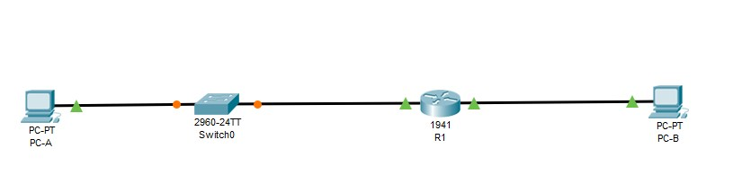
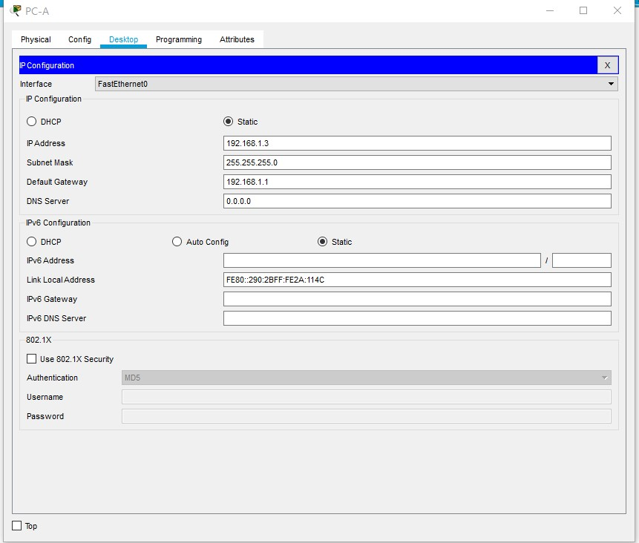
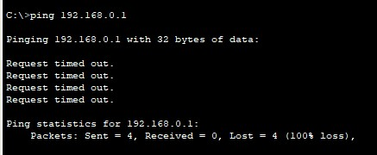

Initilising Switch

C2960 Boot Loader (C2960-HBOOT-M) Version 12.2(25r)FX, RELEASE SOFTWARE (fc4)
Cisco WS-C2960-24TT (RC32300) processor (revision C0) with 21039K bytes of memory.
2960-24TT starting...
Base ethernet MAC Address: 0002.1690.1855
Xmodem file system is available.
Initializing Flash...
flashfs[0]: 1 files, 0 directories
flashfs[0]: 0 orphaned files, 0 orphaned directories
flashfs[0]: Total bytes: 64016384
flashfs[0]: Bytes used: 4414921
flashfs[0]: Bytes available: 59601463
flashfs[0]: flashfs fsck took 1 seconds.
...done Initializing Flash.

Boot Sector Filesystem (bs:) installed, fsid: 3
Parameter Block Filesystem (pb:) installed, fsid: 4

Loading "flash:/c2960-lanbase-mz.122-25.FX.bin"...
######################### [OK]
Restricted Rights Legend

Use, duplication, or disclosure by the Government is
subject to restrictions as set forth in subparagraph
(c) of the Commercial Computer Software - Restricted
Rights clause at FAR sec. 52.227-19 and subparagraph
(c) (1) (ii) of the Rights in Technical Data and Computer
Software clause at DFARS sec. 252.227-7013.

cisco Systems, Inc.
170 West Tasman Drive
San Jose, California 95134-1706

Cisco IOS Software, C2960 Software (C2960-LANBASE-M), Version 12.2(25)FX, RELEASE SOFTWARE (fc1)
Copyright (c) 1986-2005 by Cisco Systems, Inc.
Compiled Wed 12-Oct-05 22:05 by pt_team
Image text-base: 0x80008098, data-base: 0x814129C4

Cisco WS-C2960-24TT (RC32300) processor (revision C0) with 21039K bytes of memory.

24 FastEthernet/IEEE 802.3 interface(s)
2 Gigabit Ethernet/IEEE 802.3 interface(s)

63488K bytes of flash-simulated non-volatile configuration memory.
Base ethernet MAC Address : 0002.1690.1855
Motherboard assembly number : 73-9832-06
Power supply part number : 341-0097-02
Motherboard serial number : FOC103248MJ
Power supply serial number : DCA102133JA
Model revision number : B0
Motherboard revision number : C0
Model number : WS-C2960-24TT
System serial number : FOC1033Z1EY
Top Assembly Part Number : 800-26671-02
Top Assembly Revision Number : B0
Version ID : V02
CLEI Code Number : COM3K00BRA
Hardware Board Revision Number : 0x01

Switch Ports Model SW Version SW Image
------ ----- ----- ---------- ----------
* 1 26 WS-C2960-24TT 12.2 C2960-LANBASE-M

Cisco IOS Software, C2960 Software (C2960-LANBASE-M), Version 12.2(25)FX, RELEASE SOFTWARE (fc1)
Copyright (c) 1986-2005 by Cisco Systems, Inc.
Compiled Wed 12-Oct-05 22:05 by pt_team

Press RETURN to get started!

%LINK-5-CHANGED: Interface FastEthernet0/6, changed state to up

%LINEPROTO-5-UPDOWN: Line protocol on Interface FastEthernet0/6, changed state to up

Switch>enable
Switch#write erase
Erasing the nvram filesystem will remove all configuration files! Continue? [confirm]y[OK]
Erase of nvram: complete
%SYS-7-NV_BLOCK_INIT: Initialized the geometry of nvram
Switch#reload
Proceed with reload? [confirm]yC2960 Boot Loader (C2960-HBOOT-M) Version 12.2(25r)FX, RELEASE SOFTWARE (fc4)
Cisco WS-C2960-24TT (RC32300) processor (revision C0) with 21039K bytes of memory.
2960-24TT starting...
Base ethernet MAC Address: 0002.1690.1855
Xmodem file system is available.
Initializing Flash...
flashfs[0]: 1 files, 0 directories
flashfs[0]: 0 orphaned files, 0 orphaned directories
flashfs[0]: Total bytes: 64016384
flashfs[0]: Bytes used: 4414921
flashfs[0]: Bytes available: 59601463
flashfs[0]: flashfs fsck took 1 seconds.
...done Initializing Flash.

Boot Sector Filesystem (bs:) installed, fsid: 3
Parameter Block Filesystem (pb:) installed, fsid: 4

Loading "flash:/c2960-lanbase-mz.122-25.FX.bin"...
########################################################################## [OK]
Restricted Rights Legend

Use, duplication, or disclosure by the Government is
subject to restrictions as set forth in subparagraph
(c) of the Commercial Computer Software - Restricted
Rights clause at FAR sec. 52.227-19 and subparagraph
(c) (1) (ii) of the Rights in Technical Data and Computer
Software clause at DFARS sec. 252.227-7013.

cisco Systems, Inc.
170 West Tasman Drive
San Jose, California 95134-1706

Cisco IOS Software, C2960 Software (C2960-LANBASE-M), Version 12.2(25)FX, RELEASE SOFTWARE (fc1)
Copyright (c) 1986-2005 by Cisco Systems, Inc.
Compiled Wed 12-Oct-05 22:05 by pt_team
Image text-base: 0x80008098, data-base: 0x814129C4

Cisco WS-C2960-24TT (RC32300) processor (revision C0) with 21039K bytes of memory.

24 FastEthernet/IEEE 802.3 interface(s)
2 Gigabit Ethernet/IEEE 802.3 interface(s)

63488K bytes of flash-simulated non-volatile configuration memory.
Base ethernet MAC Address : 0002.1690.1855
Motherboard assembly number : 73-9832-06
Power supply part number : 341-0097-02
Motherboard serial number : FOC103248MJ
Power supply serial number : DCA102133JA
Model revision number : B0
Motherboard revision number : C0
Model number : WS-C2960-24TT
System serial number : FOC1033Z1EY
Top Assembly Part Number : 800-26671-02
Top Assembly Revision Number : B0
Version ID : V02
CLEI Code Number : COM3K00BRA
Hardware Board Revision Number : 0x01

Switch Ports Model SW Version SW Image
------ ----- ----- ---------- ----------
* 1 26 WS-C2960-24TT 12.2 C2960-LANBASE-M

Cisco IOS Software, C2960 Software (C2960-LANBASE-M), Version 12.2(25)FX, RELEASE SOFTWARE (fc1)
Copyright (c) 1986-2005 by Cisco Systems, Inc.
Compiled Wed 12-Oct-05 22:05 by pt_team

Press RETURN to get started!

%LINK-5-CHANGED: Interface FastEthernet0/6, changed state to up

%LINEPROTO-5-UPDOWN: Line protocol on Interface FastEthernet0/6, changed state to up

Switch>

Initilising Router
System Bootstrap, Version 15.1(4)M4, RELEASE SOFTWARE (fc1)
Technical Support: http://www.cisco.com/techsupport
Copyright (c) 2010 by cisco Systems, Inc.
Total memory size = 512 MB - On-board = 512 MB, DIMM0 = 0 MB
CISCO1941/K9 platform with 524288 Kbytes of main memory
Main memory is configured to 64/-1(On-board/DIMM0) bit mode with ECC disabled

Readonly ROMMON initialized

program load complete, entry point: 0x80803000, size: 0x1b340
program load complete, entry point: 0x80803000, size: 0x1b340

IOS Image Load Test
___________________
Digitally Signed Release Software
program load complete, entry point: 0x81000000, size: 0x2bb1c58
Self decompressing the image :
######################### [OK]
Smart Init is enabled
smart init is sizing iomem
TYPE MEMORY_REQ
Onboard devices &
buffer pools 0x01E8F000
-----------------------------------------------
TOTAL: 0x01E8F000
Rounded IOMEM up to: 32Mb.
Using 6 percent iomem. [32Mb/512Mb]

Restricted Rights Legend
Use, duplication, or disclosure by the Government is
subject to restrictions as set forth in subparagraph
(c) of the Commercial Computer Software - Restricted
Rights clause at FAR sec. 52.227-19 and subparagraph
(c) (1) (ii) of the Rights in Technical Data and Computer
Software clause at DFARS sec. 252.227-7013.
cisco Systems, Inc.
170 West Tasman Drive
San Jose, California 95134-1706

Cisco IOS Software, C1900 Software (C1900-UNIVERSALK9-M), Version 15.1(4)M4, RELEASE SOFTWARE (fc2)
Technical Support: http://www.cisco.com/techsupport
Copyright (c) 1986-2012 by Cisco Systems, Inc.
Compiled Thurs 5-Jan-12 15:41 by pt_team
Image text-base: 0x2100F918, data-base: 0x24729040

This product contains cryptographic features and is subject to United
States and local country laws governing import, export, transfer and
use. Delivery of Cisco cryptographic products does not imply
third-party authority to import, export, distribute or use encryption.
Importers, exporters, distributors and users are responsible for
compliance with U.S. and local country laws. By using this product you
agree to comply with applicable laws and regulations. If you are unable
to comply with U.S. and local laws, return this product immediately.

A summary of U.S. laws governing Cisco cryptographic products may be found at:
http://www.cisco.com/wwl/export/crypto/tool/stqrg.html

If you require further assistance please contact us by sending email to
export@cisco.com.

Cisco CISCO1941/K9 (revision 1.0) with 491520K/32768K bytes of memory.
Processor board ID FTX152400KS
2 Gigabit Ethernet interfaces
DRAM configuration is 64 bits wide with parity disabled.
255K bytes of non-volatile configuration memory.
249856K bytes of ATA System CompactFlash 0 (Read/Write)

Press RETURN to get started!

Unauthorised Access is strictli prohibited. Violators will be prosecuted to the full extent of the law.

User Access Verification

Password:

R!>enable
Password:
R!#write erase
Erasing the nvram filesystem will remove all configuration files! Continue? [confirm]
[OK]
Erase of nvram: complete
%SYS-7-NV_BLOCK_INIT: Initialized the geometry of nvram
R!#reload
Proceed with reload? [confirm]
System Bootstrap, Version 15.1(4)M4, RELEASE SOFTWARE (fc1)
Technical Support: http://www.cisco.com/techsupport
Copyright (c) 2010 by cisco Systems, Inc.
Total memory size = 512 MB - On-board = 512 MB, DIMM0 = 0 MB
CISCO1941/K9 platform with 524288 Kbytes of main memory
Main memory is configured to 64/-1(On-board/DIMM0) bit mode with ECC disabled

Readonly ROMMON initialized

program load complete, entry point: 0x80803000, size: 0x1b340
program load complete, entry point: 0x80803000, size: 0x1b340

IOS Image Load Test
___________________
Digitally Signed Release Software
program load complete, entry point: 0x81000000, size: 0x2bb1c58
Self decompressing the image :
########################################################################## [OK]
Smart Init is enabled
smart init is sizing iomem
TYPE MEMORY_REQ
Onboard devices &
buffer pools 0x01E8F000
-----------------------------------------------
TOTAL: 0x01E8F000
Rounded IOMEM up to: 32Mb.
Using 6 percent iomem. [32Mb/512Mb]

Restricted Rights Legend
Use, duplication, or disclosure by the Government is
subject to restrictions as set forth in subparagraph
(c) of the Commercial Computer Software - Restricted
Rights clause at FAR sec. 52.227-19 and subparagraph
(c) (1) (ii) of the Rights in Technical Data and Computer
Software clause at DFARS sec. 252.227-7013.
cisco Systems, Inc.
170 West Tasman Drive
San Jose, California 95134-1706

Cisco IOS Software, C1900 Software (C1900-UNIVERSALK9-M), Version 15.1(4)M4, RELEASE SOFTWARE (fc2)
Technical Support: http://www.cisco.com/techsupport
Copyright (c) 1986-2012 by Cisco Systems, Inc.
Compiled Thurs 5-Jan-12 15:41 by pt_team
Image text-base: 0x2100F918, data-base: 0x24729040

This product contains cryptographic features and is subject to United
States and local country laws governing import, export, transfer and
use. Delivery of Cisco cryptographic products does not imply
third-party authority to import, export, distribute or use encryption.
Importers, exporters, distributors and users are responsible for
compliance with U.S. and local country laws. By using this product you
agree to comply with applicable laws and regulations. If you are unable
to comply with U.S. and local laws, return this product immediately.

A summary of U.S. laws governing Cisco cryptographic products may be found at:
http://www.cisco.com/wwl/export/crypto/tool/stqrg.html

If you require further assistance please contact us by sending email to
export@cisco.com.

Cisco CISCO1941/K9 (revision 1.0) with 491520K/32768K bytes of memory.
Processor board ID FTX152400KS
2 Gigabit Ethernet interfaces
DRAM configuration is 64 bits wide with parity disabled.
255K bytes of non-volatile configuration memory.
249856K bytes of ATA System CompactFlash 0 (Read/Write)

--- System Configuration Dialog ---

Would you like to enter the initial configuration dialog? [yes/no]: n

Press RETURN to get started!

Router>

Activating Router Connections
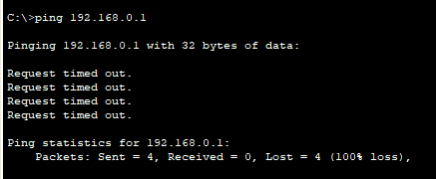

User Access Verification

Password:

R1>show configutation
^
% Invalid input detected at '^' marker.
R1>enable
Password:

R1#config term
Enter configuration commands, one per line. End with CNTL/Z.
R1(config)#interface GigabitEthernet0/0
R1(config-if)#no shutdown

R1(config-if)#
%LINK-5-CHANGED: Interface GigabitEthernet0/0, changed state to up

%LINEPROTO-5-UPDOWN: Line protocol on Interface GigabitEthernet0/0, changed state to up
exit
R1(config)#interface GigabitEthernet0/1
R1(config-if)#no shutdown

R1(config-if)#
%LINK-5-CHANGED: Interface GigabitEthernet0/1, changed state to up

%LINEPROTO-5-UPDOWN: Line protocol on Interface GigabitEthernet0/1, changed state to up
exit
R1(config)#show ip interface brief
^
% Invalid input detected at '^' marker.
R1(config)#exit
R1#
%SYS-5-CONFIG_I: Configured from console by console
show ip interface brief
Interface IP-Address OK? Method Status Protocol
GigabitEthernet0/0 192.168.0.1 YES NVRAM up up
GigabitEthernet0/1 192.168.1.1 YES NVRAM up up
Vlan1 unassigned YES NVRAM administratively down down
R1#

