Usability Engineering


Assignment 1 - Prototyping & Testing

120069 (Samuel Groves)

Contents
1. Introduction (Task 1) 3
1.1 Existing Technologies (Task 1) 3
2. Target Audience (Task 2) 4
2.1 Requirements (Task 2) 4
2.2 Task analysis Information 4
3. Prototype Design (Hand Drawn) (Task 3) 5
3.1 Initial Design (Task 3) 5
3.2 Human Factor Theories (Task 4) 18
3.3 Documented walkthrough with user (Task 5) 19
3.4 Analysis/evaluation of external Prototype (Task 6) 22
4. Prototype Design (Software) (Task 7) 23
4.1 Initial Design (Task 7) 23
4.2 Analysis of Prototype (Task 7) 43
4.3 Evaluation of Usability Techniques (task 8) 44
5. References 46
6. Bibliography (Read but not used) 46

Introduction (Task 1)
With the surge of COVID-19 and the surrounding pandemic/restrictions, new and essential technologies have had to be developed at a rapid rate. Due to the speed at which these technologies have been created, such as the NHS COVID website (Covid Pass), key usability features have not been implemented, or lack thereof.

1.1 Existing Technologies (Task 1)
There are already existing governmental covid pass technologies available. The NHS website has implemented and designed a covid pass webpage which users must navigate in order to obtain the desired information such as a covid pass or information related to their personal vaccinations (such as dates or vaccine type).
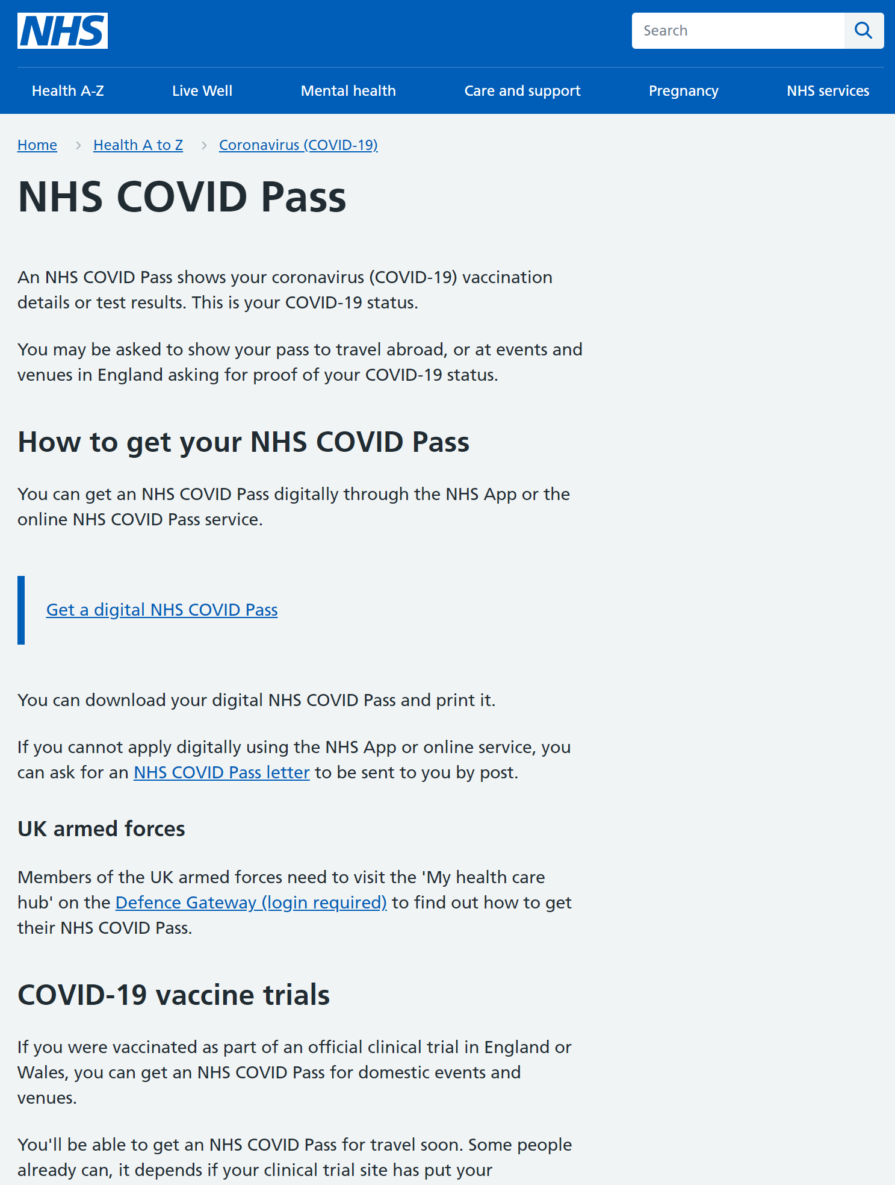
Another existing technology also designed alongside the NHS website is the NHS App [2]. This application is similar to the website in that users must navigate through the application in order to obtain the desired information. One large disadvantage of this application is that it is only available within England. Therefore, the application is unusable by other countries within the United Kingdom.
There are many other initial disadvantages and advantages of these technologies which will be further discussed within the identification of the target audience. The discussion provides a baseline for the requirements of a proposed solution and a justification as to why a new solution should be implemented.
The task at hand is to develop an application/propose a solution for a specific user task required when obtaining/managing or simply using COVID pass technologies. This is specifically related to the Welsh Government. The user task selected is the ability for one to access their COVID pass.

Target Audience (Task 2)
The selected target audience will be the 18 to 25-year-old age group. This target audience has been identified as there is a correlation between this age range and the type of reason why a COVID pass is used. For this age group, the main reason why a COVID pass is obtained is so that individuals can enter nightclubs or events.

Requirements (Task 2)
To design an effective solution, observations were conducted with end users. These users obtained a COVID pass through the current means and their responses were documented. The target audience is young adults aged 18 to 25. This target audience has been Identified due to the range of domestic events where COVID passes are required [5].
The users observed were required to go through the current application and were asked to obtain a COVID pass through these conventional means. They were told to discuss design features, issues, and any positive elements of the current application after obtaining the COVID pass and through the process where they felt necessary. Two potential users participated in a walkthrough.
The data analysed also provided important information on the requirements of the proposed solution. Specifically, what should be implemented and what should be avoided when designing the solution.

2.2 Task analysis Information
The walkthrough/observations were used as a form of task analysis. The initial thoughts of the users provided interesting information. One user described the navigation of the current system as “overly complex” and that there is either too much information within a window at any given time, or not enough. They described there being “no balance” in the use of white space and clear navigation.
Another user described the current COVID pass application as “bearable”. The user was asked to expand on this. They explained that there are clear improvements that can be made for example, the navigation felt very unfinished. They expressed frustration on parts of the application that required data to be entered. If they navigated to another window (backwards or forwards), the data entry fields would reset, and the user had to refill the information.
A noticeable observation was made at this point. This particular user shortened the data that they submitted to the data entry fields due to frustrations related to resubmitting data. Both users were asked their opinions and thoughts on the ability to access relevant information relating to a query.
One user expressed deep concern on the ability to access vital information. They described the application as using too many slides and windows. By the time they found the information that they needed, they had reopened the application due to the inability to go back to their original starting point.
Another user described the navigation as tedious and overwhelming. They found the information relating to a specific query to be overly cluttered, containing information that was not related or relevant to the query made.
Both users were asked what they think is good about the current solution; their thoughts on what they like. One user suggested that the colours were quite nice, there was a clear colour scheme. They also described the authentication of the user to be ‘streamlined’ relating to the short video requirement and also uploading of their image. They described the uploading of a short video to be quite tedious but shared understanding of the security protocols and procedures that must be followed to ensure the COVID pass is provided to the correct individual.
Another user stated that the application worked well with their current device. This was directed at the speed of the application (such as the ability to open and load web pages). They further described the aesthetics to be clunky and overwhelming on their device.
During the observations, both users were asked how they think the application could be improved. Both users suggested improvements to the navigation. One user suggested that due to the difficult navigation, this had a ‘knock-on’ effect to the difficulty of obtaining specific information.
One user suggested that the ability to obtain useful and specific information should be overhauled. A few moments occurred where the users had found the correct page they were looking for, although the information was missed within the page relating to their specific query due to the page aesthetics and layout of information.
A user suggested that a search bar could prove extremely useful for people who are searching for direct information. This might suggest that the proposed design should also follow a specific and familiar theme throughout.

Prototype Design (Hand Drawn) (Task 3)

Initial Design (Task 3)
An initial solution was designed. This solution was hand-drawn and allowed further analysis of the human theory factors found within the design, alongside a real user documented walkthrough. The paper-based design can be shown below.
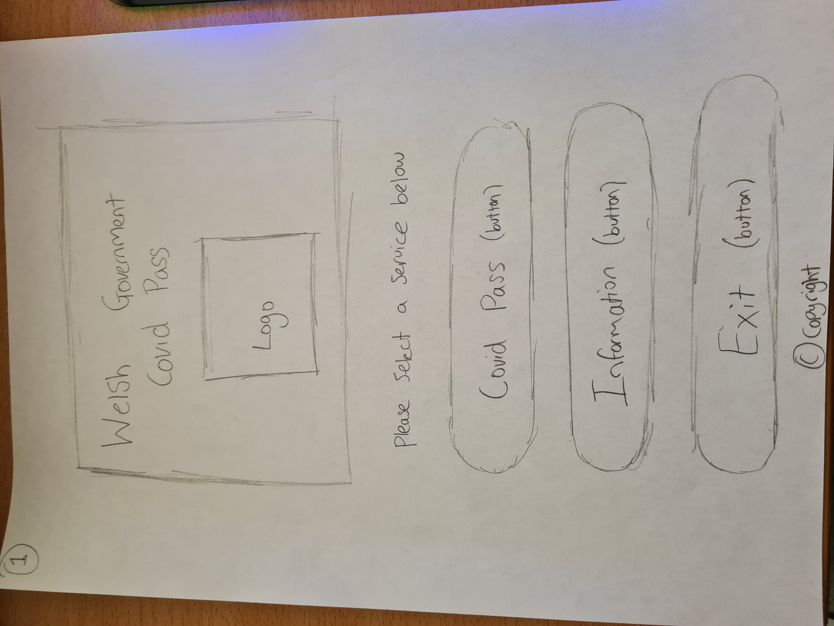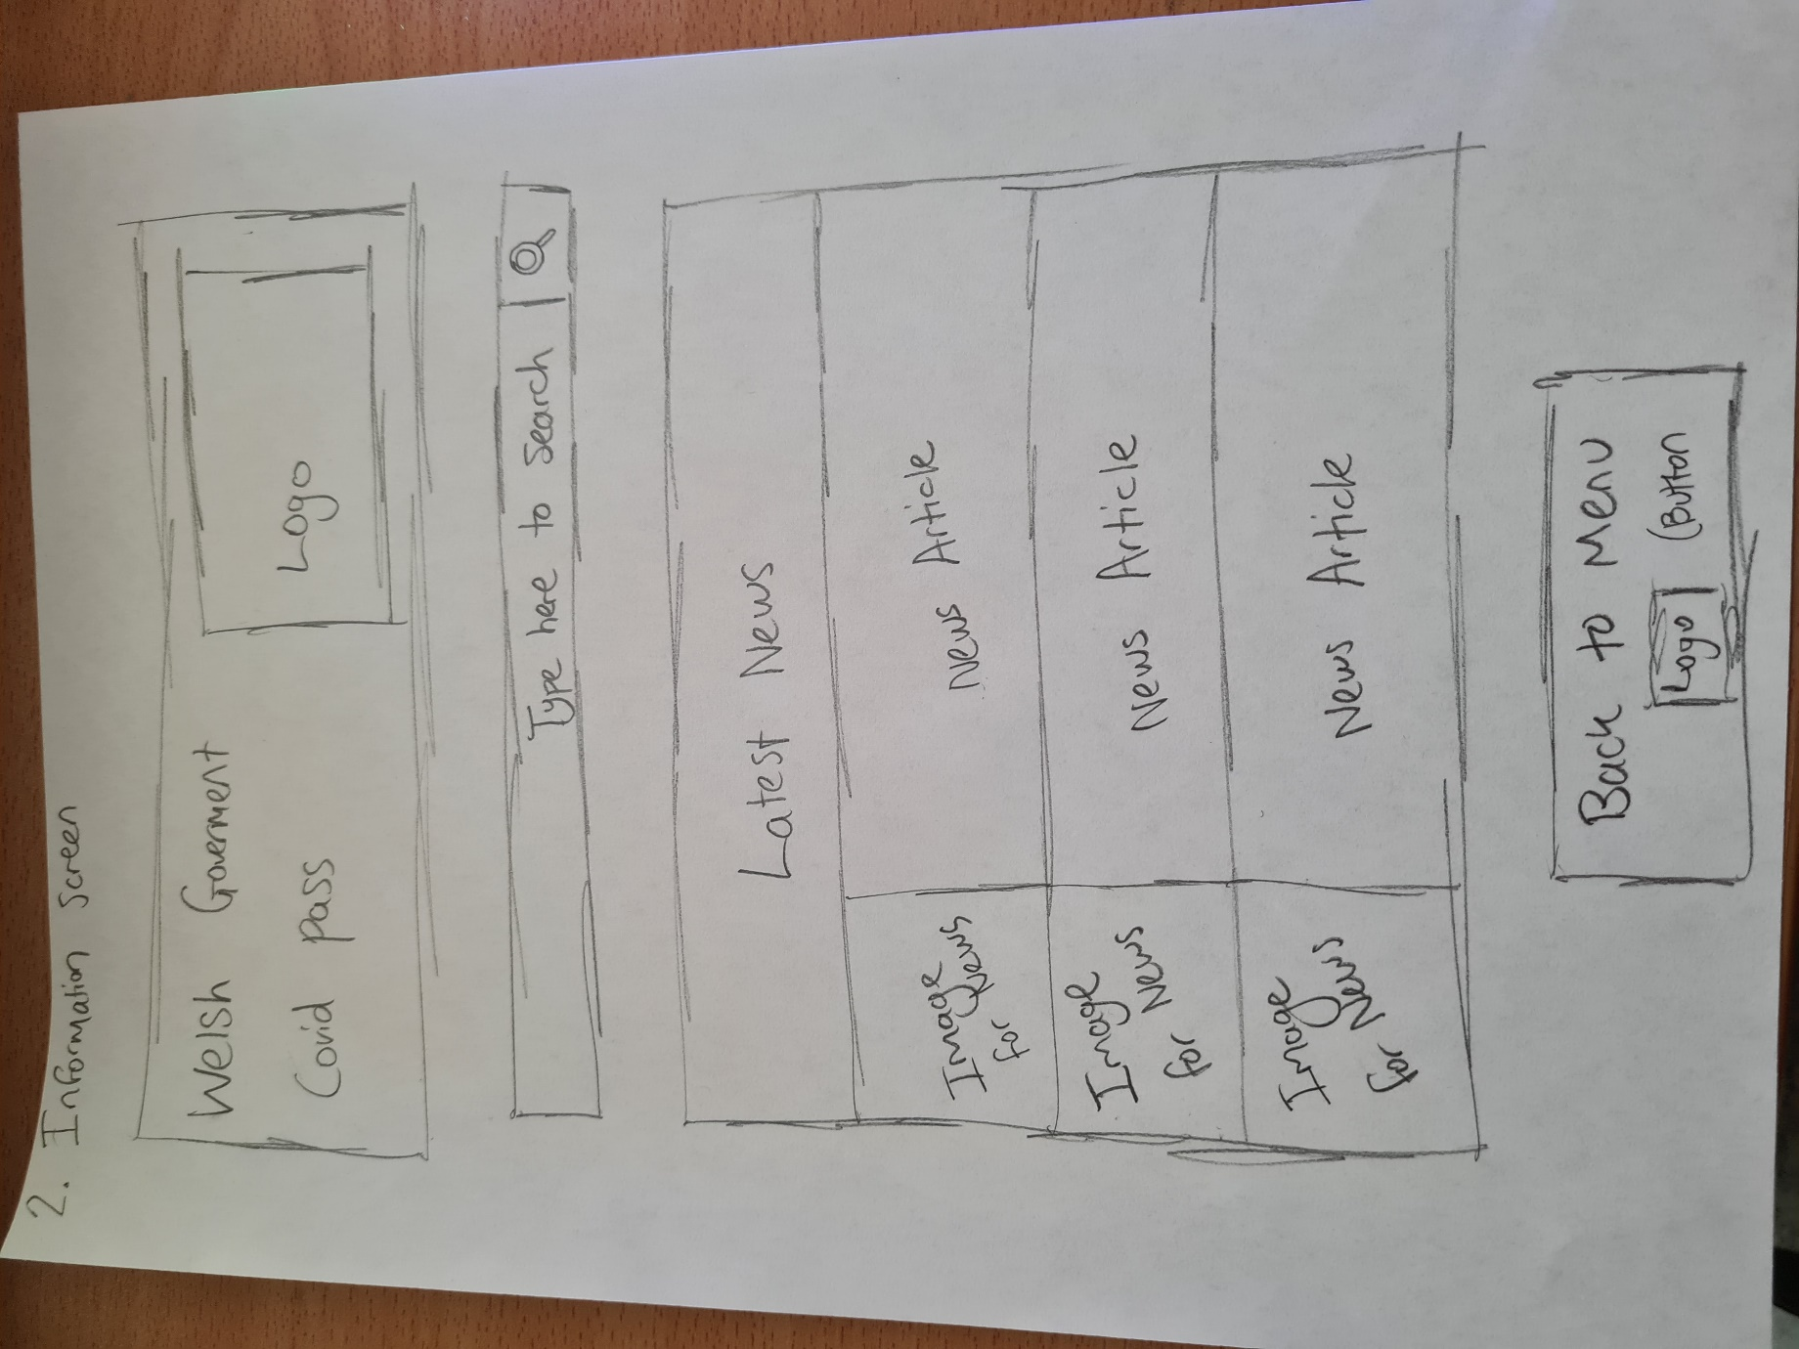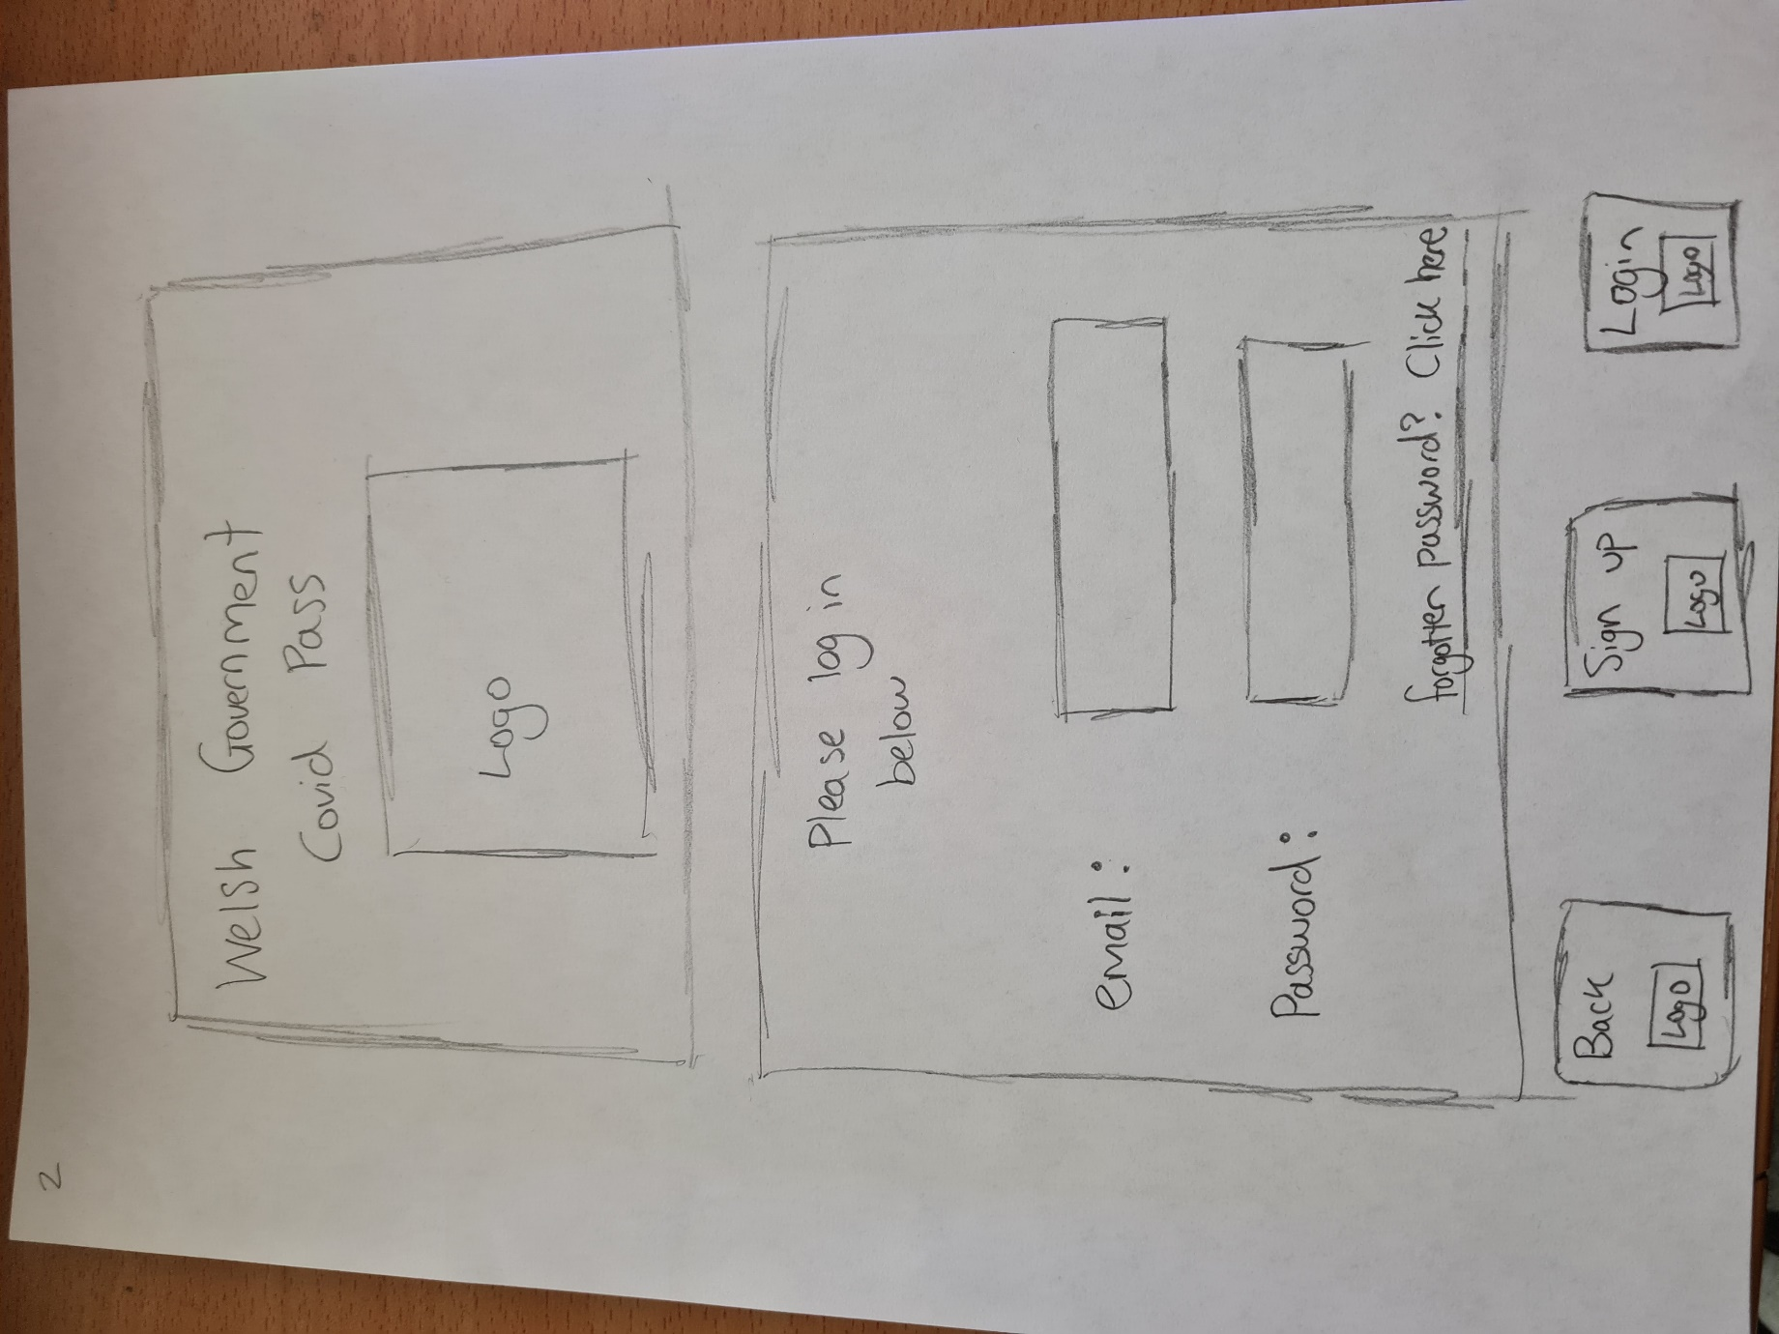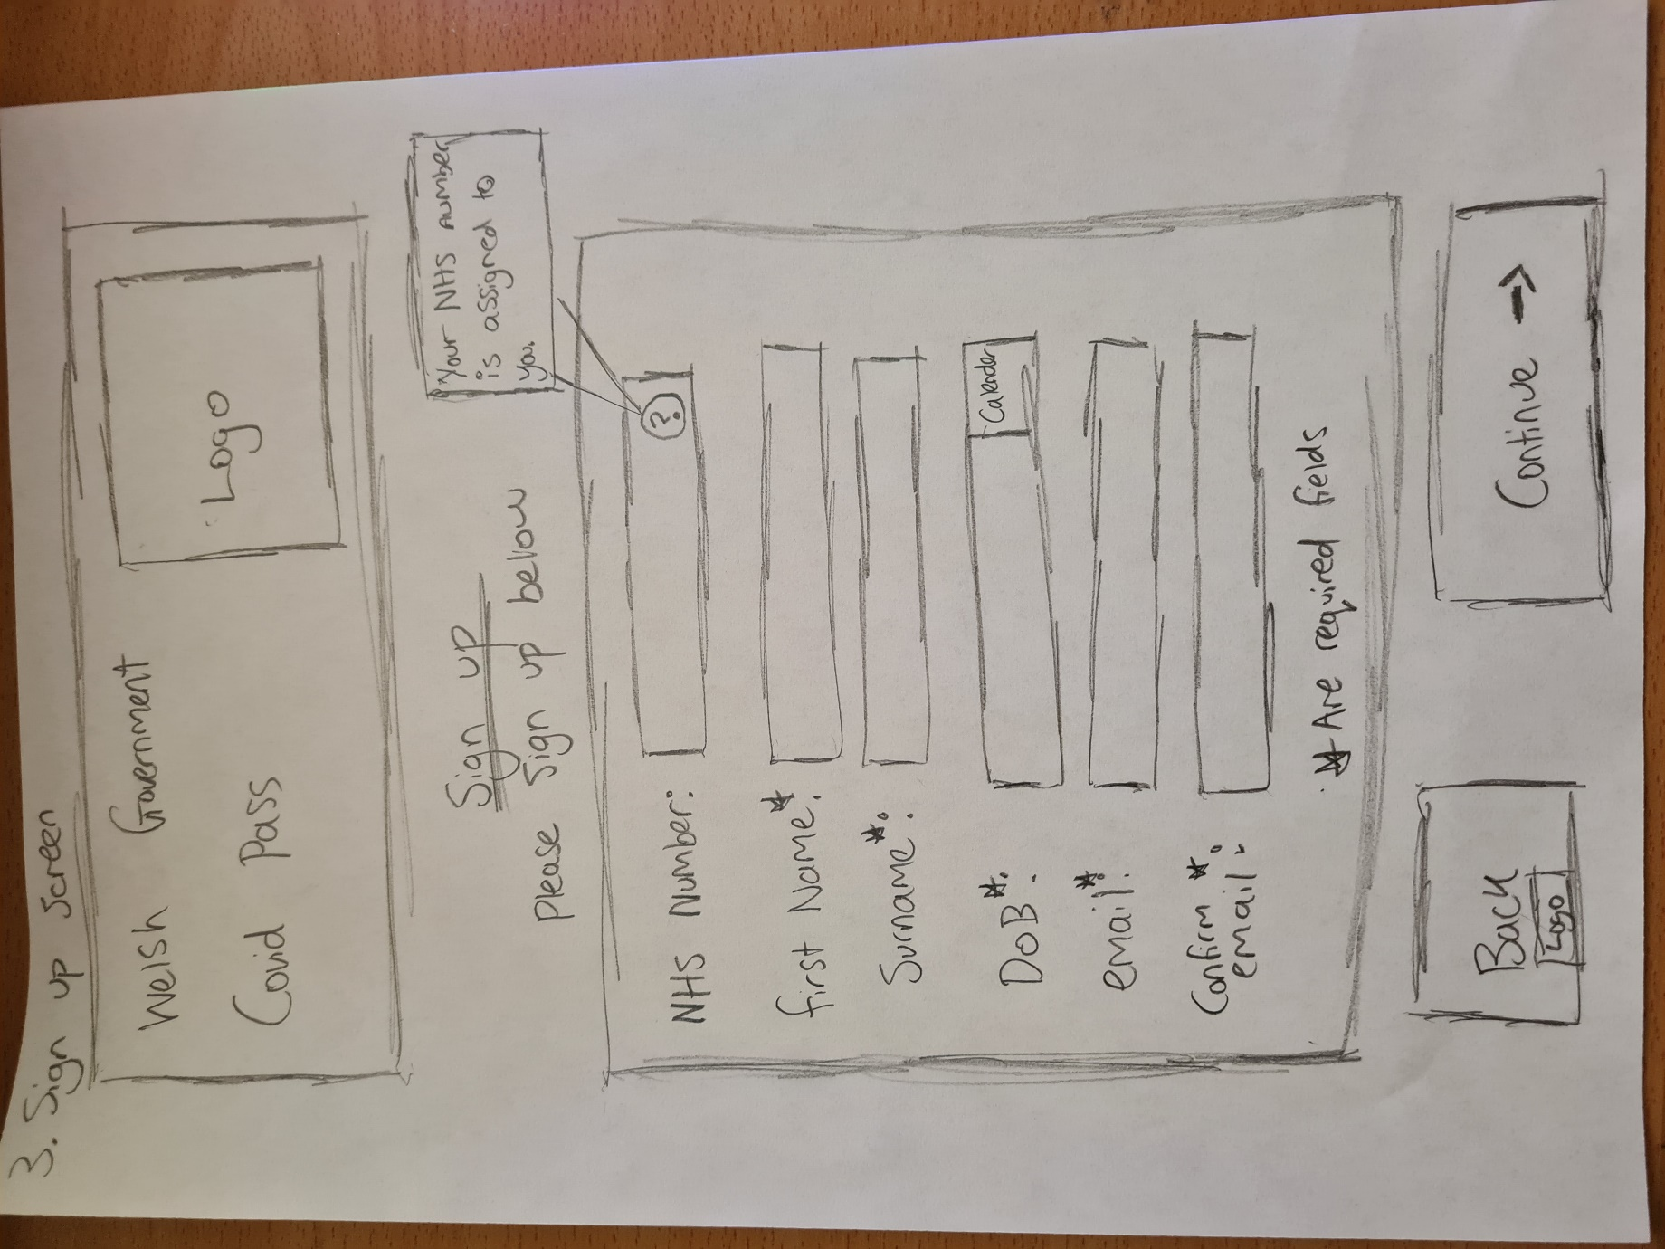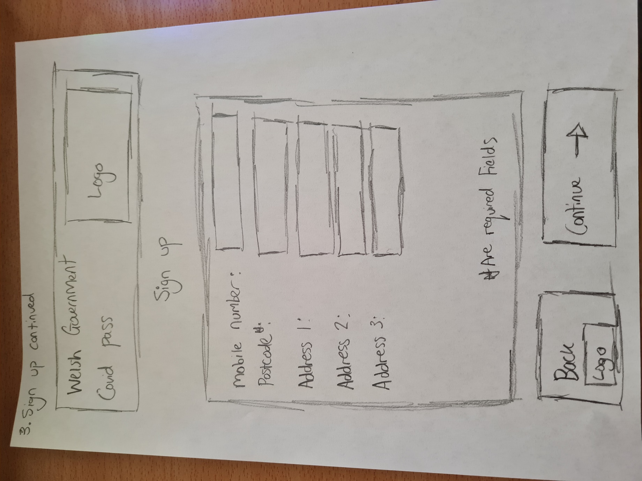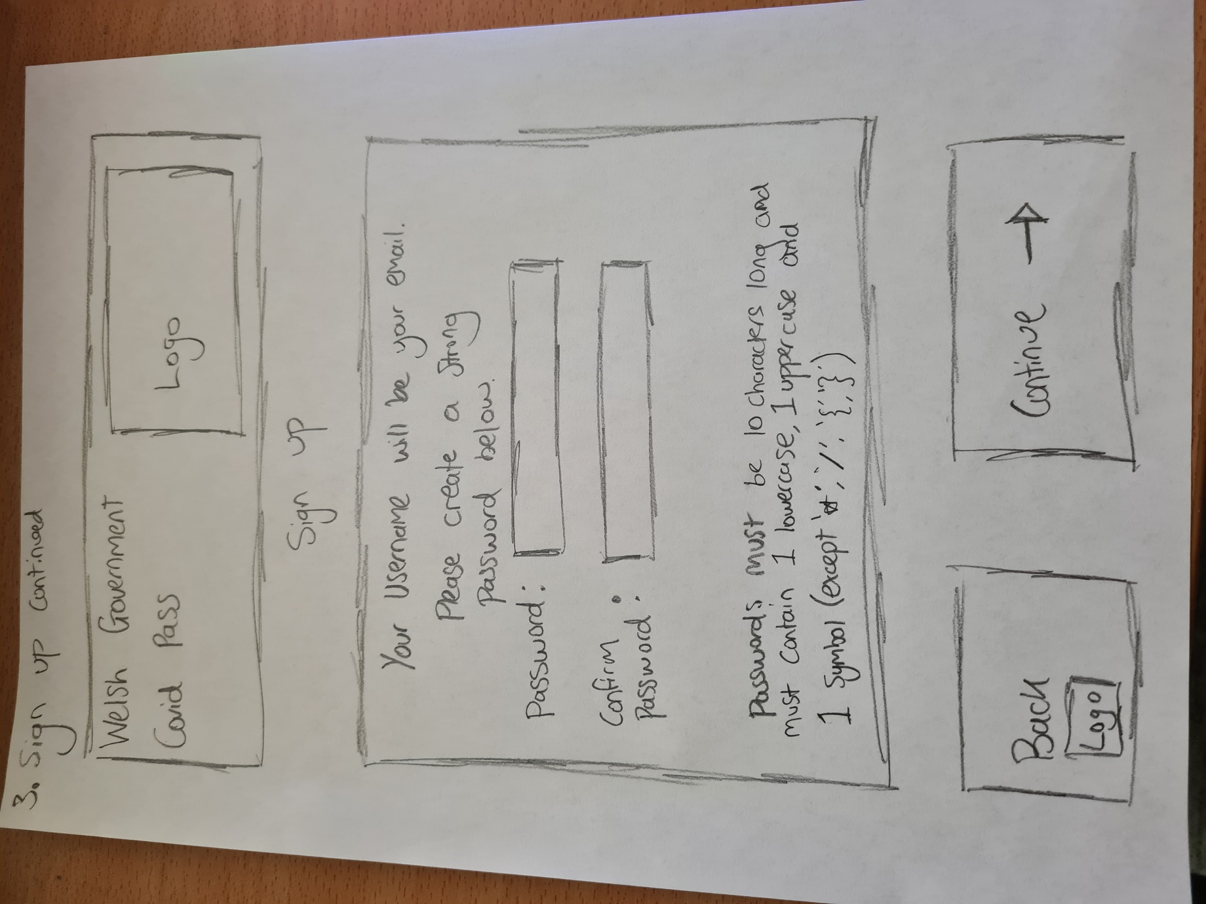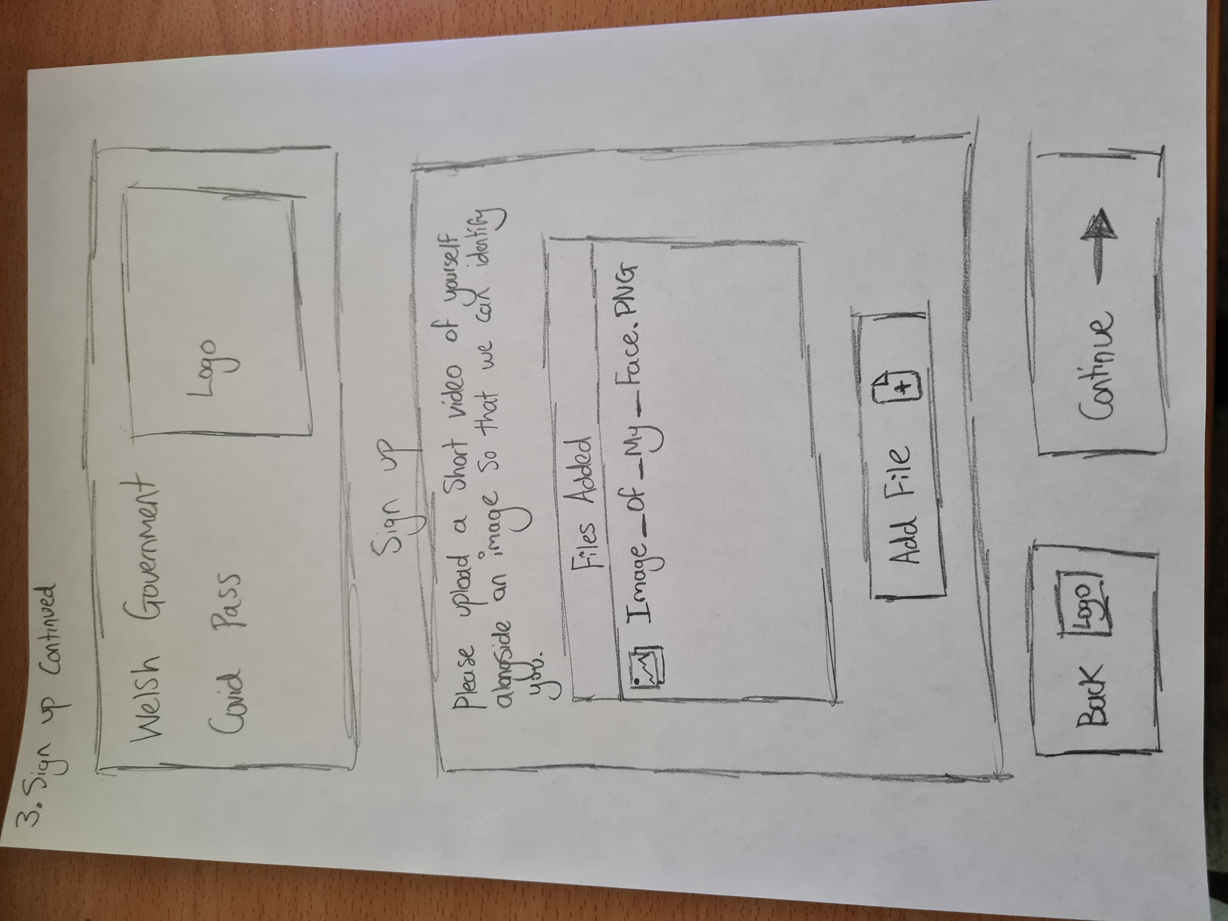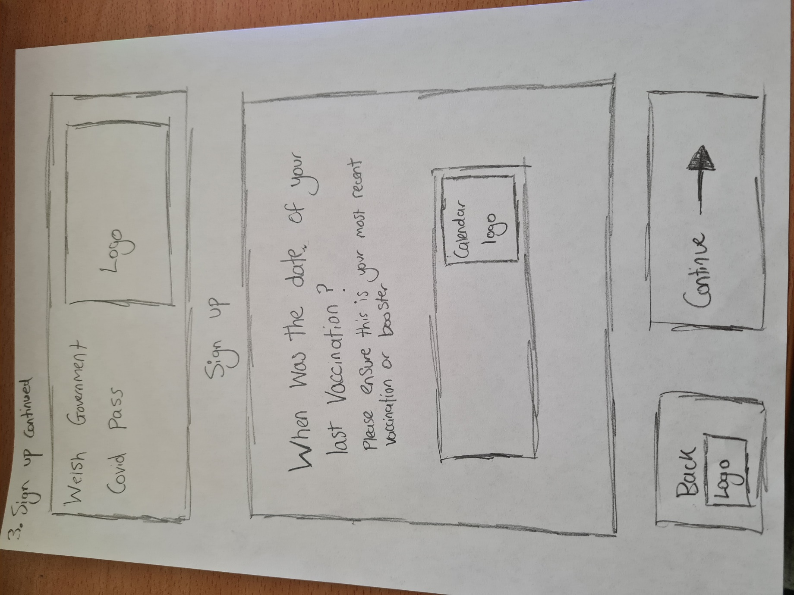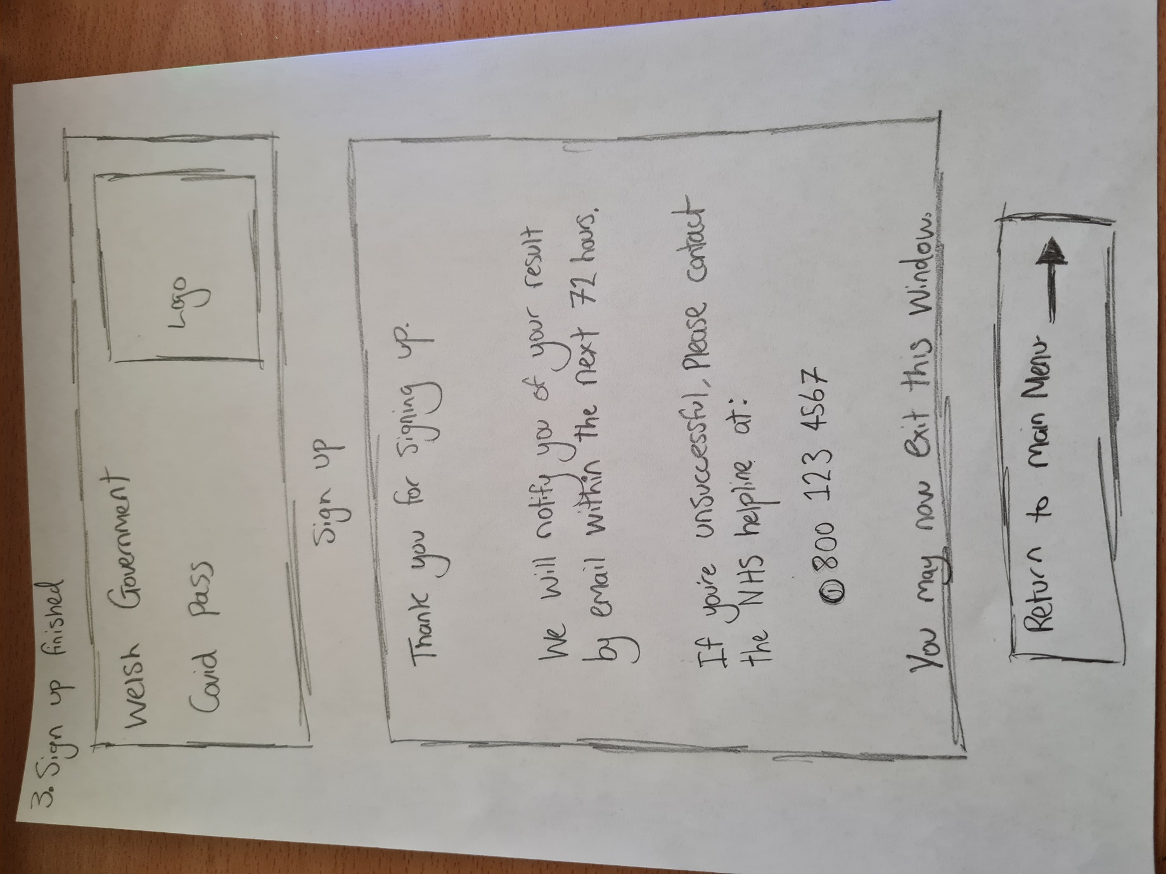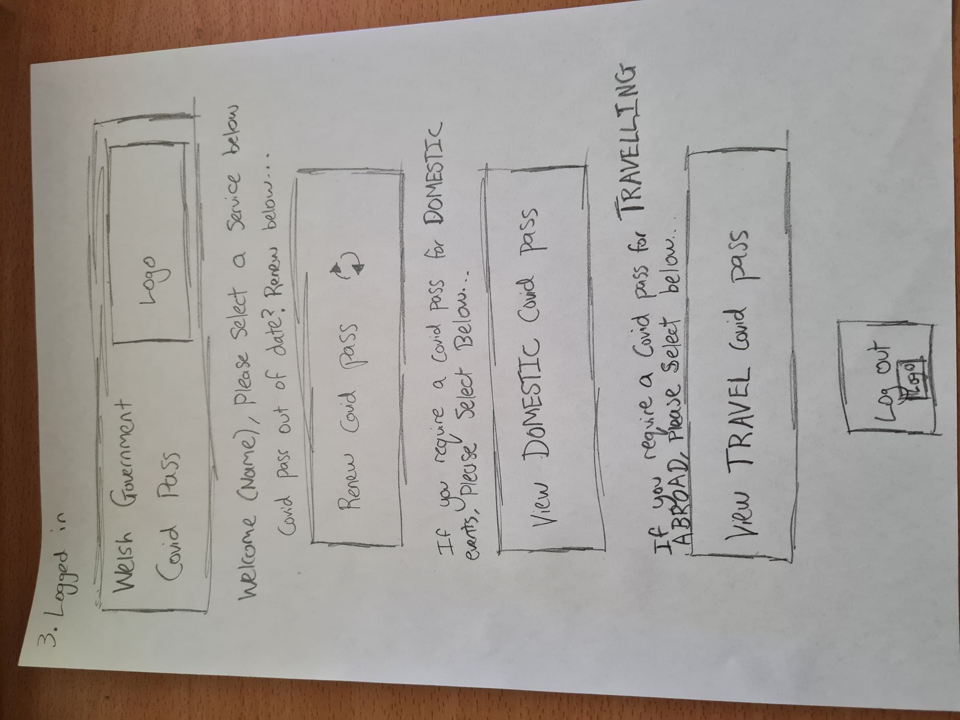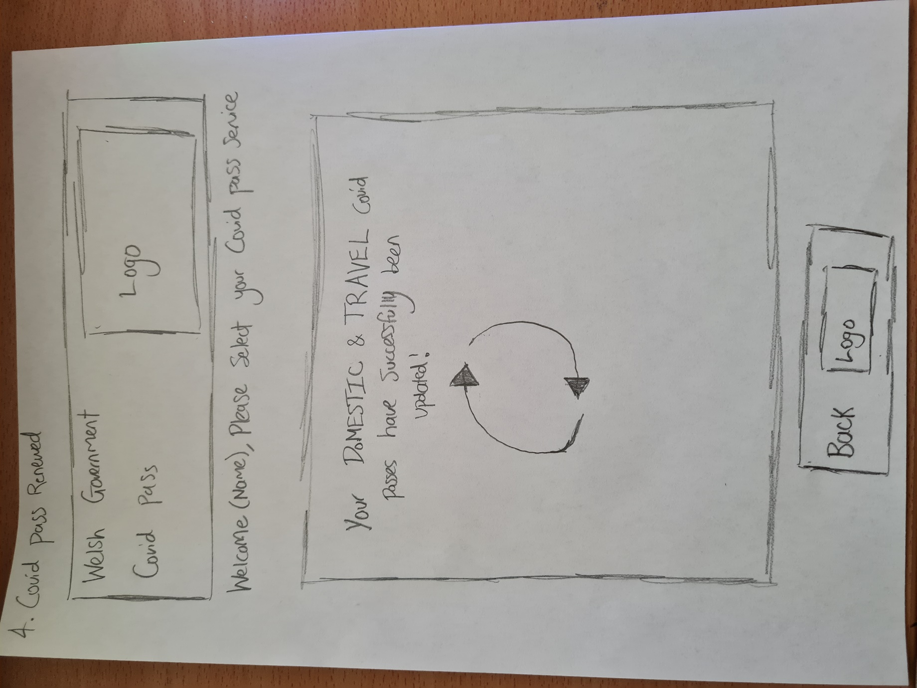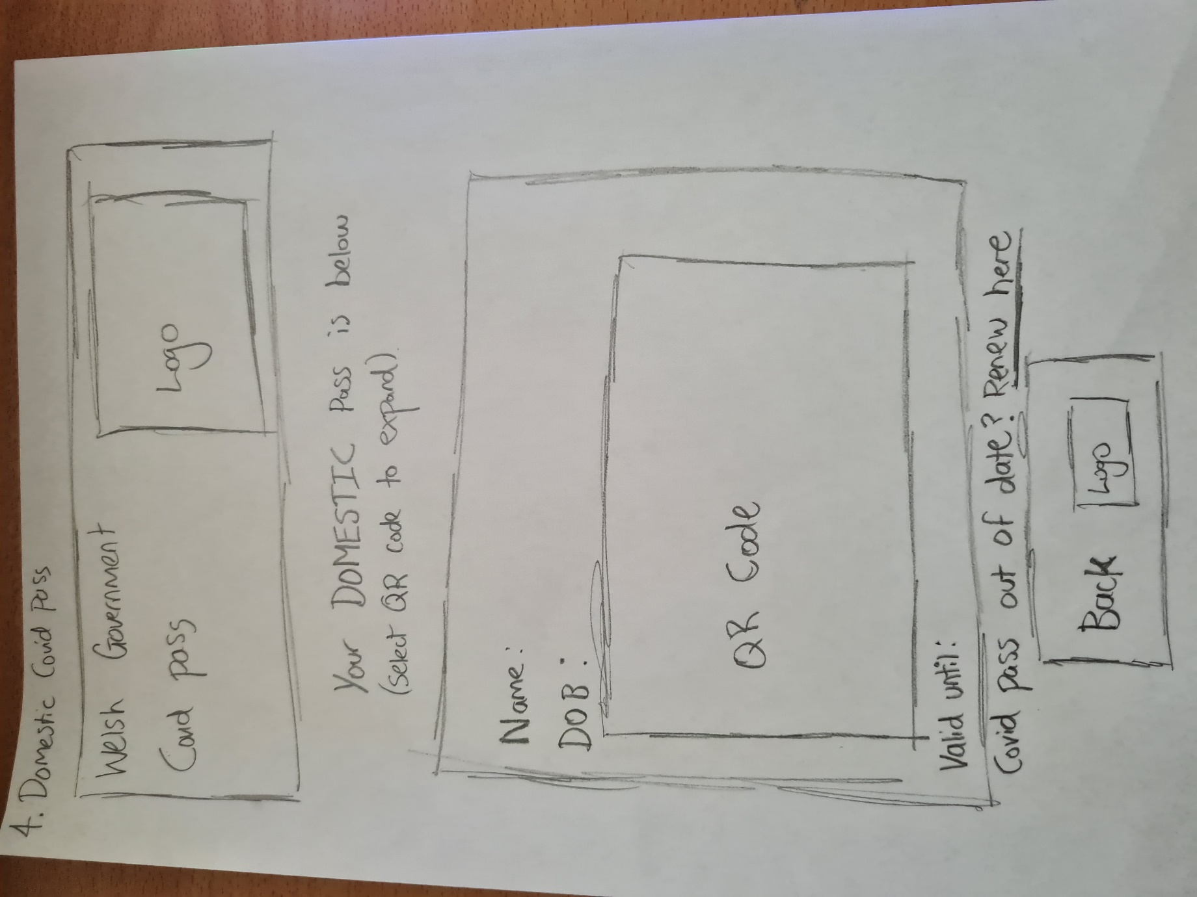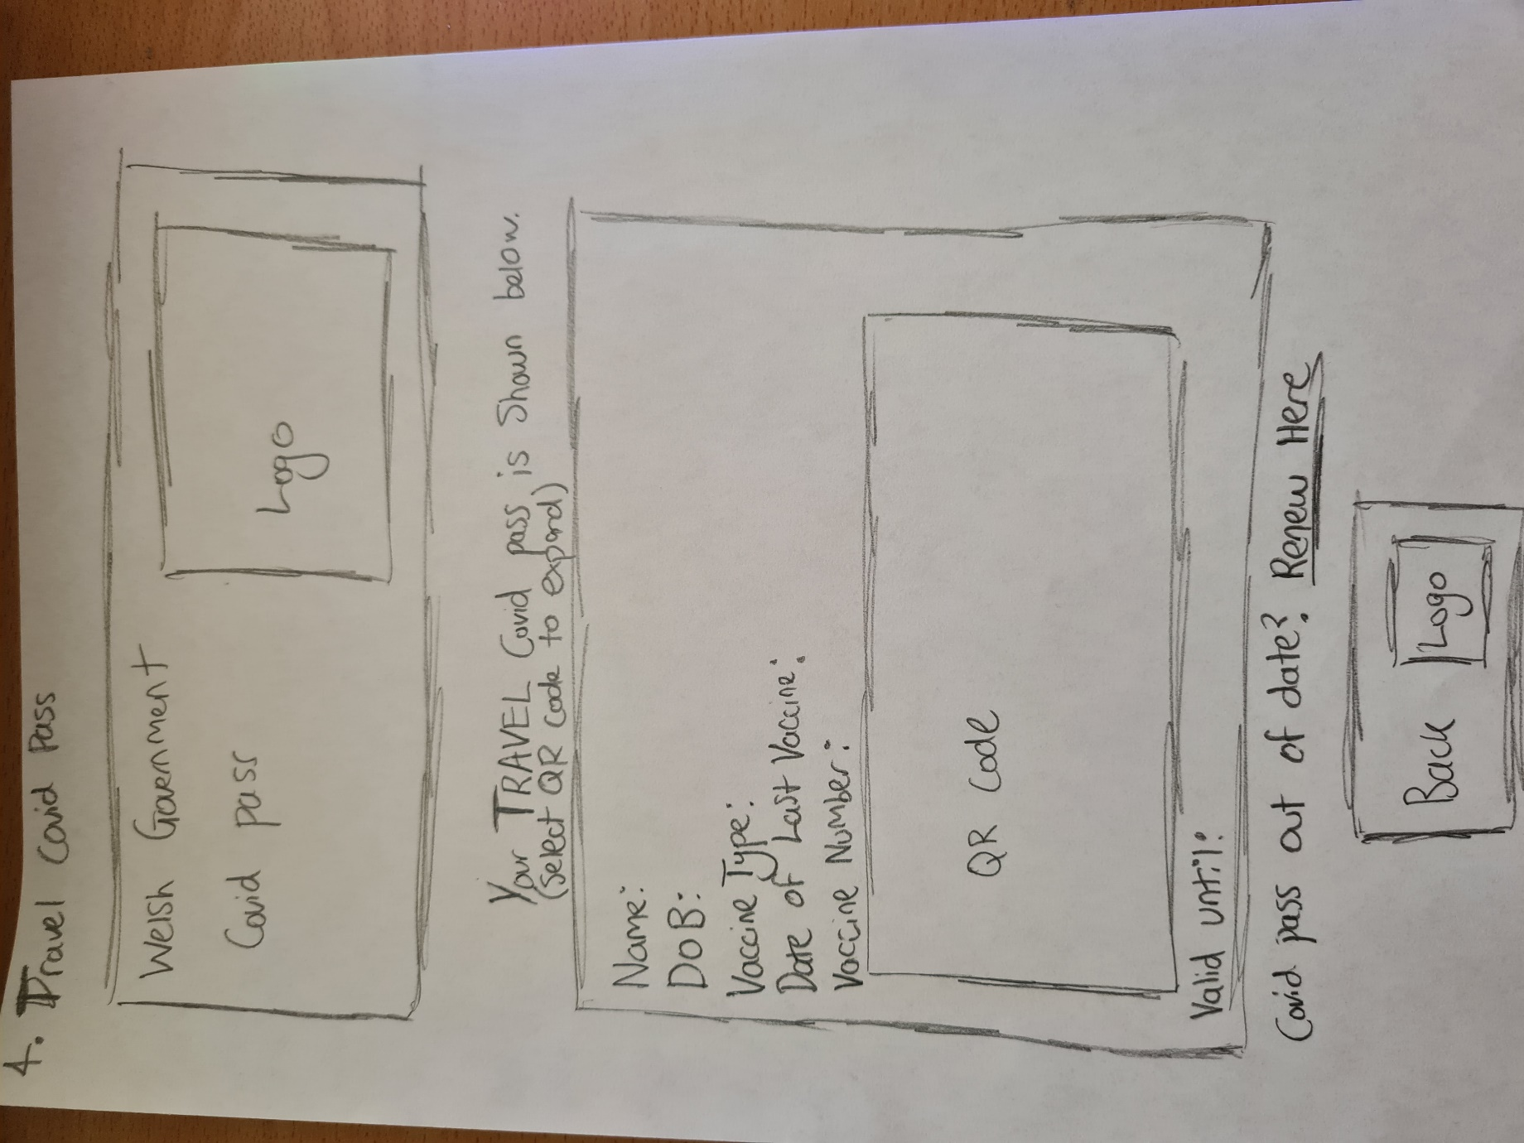

3.2 Human Factor Theories (Task 4)
In order to produce an effective solution, an analysis on the human factor theories must be considered. Applying different human factor theories to the design will allow the effectiveness of the solution to be measured. Testing of the proposed solution will also allow the effectiveness of the solution to be measured, which will provide justification for why the design, and features of the design, have been implemented.
The human factor theories alongside how they have been implemented into the design are shown below.
- Human Memory
This relates to attention span and navigation [3]. The human memory must remember or have guidance for the steps required to complete specific tasks throughout the application. Without this consideration when using the application, users could become confused. Therefore, processes and stages throughout the design (such as the sign-up system) have been concise and simple. Direct reasoning and guidance lower the chance of confusion.
- Human Reasoning
This is another form of cognitive psychology. This relates to how a user understands and reasons with the application [1]. The true logics of the application and the understanding of what is required from the user. Providing clear and concise navigation allows users to understand the reasoning behind specific design elements such as the expansion of the QR code for the covid pass. A user will understand that the ability to expand the QR code is implemented so that it can be scanned easier for the event/s that they attend, without explicitly saying.

- Visual Perception
This relates to how users see the application. Specifically, how vision works. How will users perceive the application and how will they understand the process [4]. The colour scheme for the design will ensure that visually, colours are light and ‘easy on the eye’. Providing a minimalist design alongside this so that the application looks visually appealing.
- Interface Metaphors
Interface metaphors relate to a set of user interface visuals that users already understand from previous endeavours [7]. Implementing functions and features and allowing a user to understand them by exploiting their knowledge and experiences. This is shown throughout the design by implementing logos such as the ‘arrow’ attached to the continue button. Another example is the ‘updated’ logo shown on the COVID pass updating screen. A user will perceive this

- Affordance
This describes the actions that a user can readily perceive a function or feature [6]. It is the understanding of elements provided to the user relating specifically to the interface they use. To understand this buttons are made clearly ‘clickable’ and follow the same format. This ensures consistency and will ensure the user understands a function or feature of the interface through using the application for the first time (and continued).

Documented walkthrough with user (Task 5)
A documented walkthrough with a proposed end user as suggested, will allow justifications to be made and will allow the effectiveness of the solution to be measured. Not only this, but based on the response of a user, the design may require changes which can be implemented within the software designed prototype.
A questionnaire was designed to determine the usability ratings of the overall system designed (initial paper-based solution). Vital information was obtained. The user was asked what they would rate the visibility of the system. They rated this a 3 (minor usability issue) out of 5. They stated that there is good visibility for the user as they can go back and forth using the buttons at the bottom of the page (back and continue).
They suggested that the use of arrows and logos provided better visibility. The issue that they observed was the lack of error messages or success pages. Once a user has completed the sign-up process, they are told that they will be notified in 72 hours. The user suggested that this should be an estimate as the NHS system could crash or become very busy which may take longer than expected and could “worry, frustrate, or make the user anxious”.
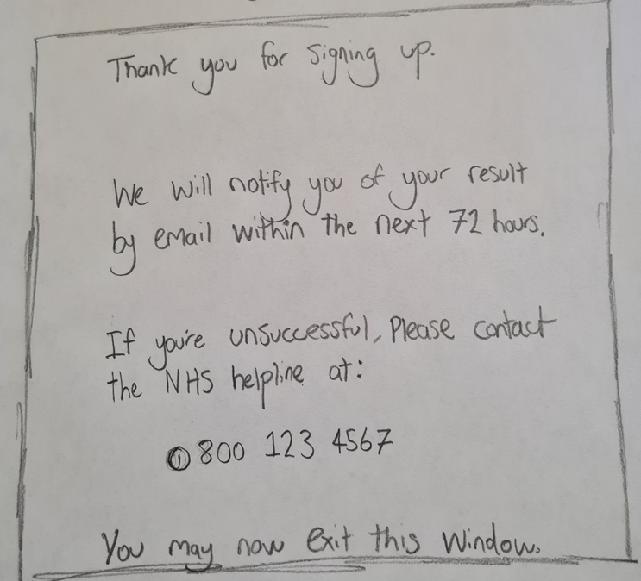
The user was asked to match the system and the real world. They rated this a usability rating of 4 (major usability issue). They found that familiar words and phrases were implemented well with no jargon to confuse the user. However slight confusion was found on the ‘update covid pass’ selection.
This is a section initially missed during the design of the process. The user stated that they are asked to select a covid pass service yet there is no available selection. This text should be removed so that the user is not confused, and they understand that once they have selected to refresh their covid passes, the page below is shown (without the ‘please select your covid pass service’ text).
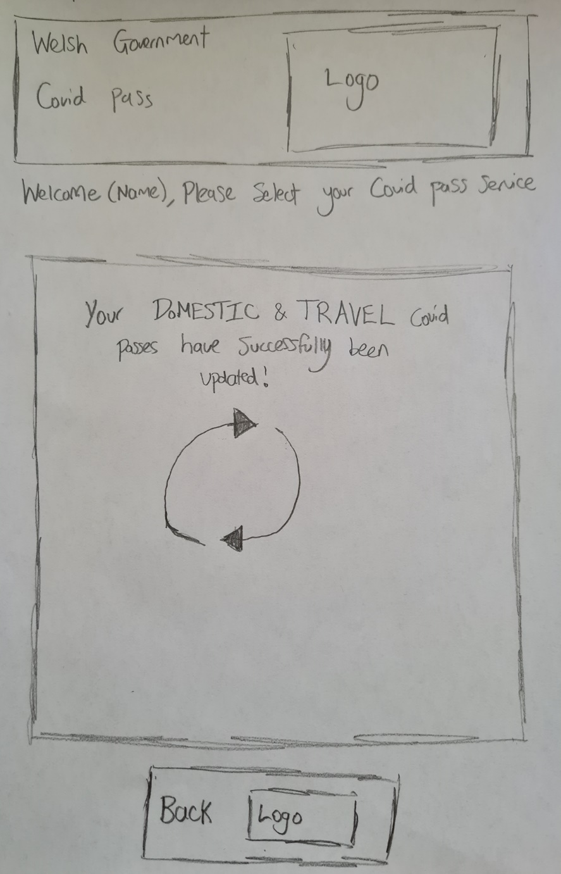
The user was asked to rate the user control and freedom. They were also asked to measure the consistency of the application and its standards. Both of these were rated 2 (cosmetic issue only). The user suggested that there is no way to go back to the homepage other than using the ‘back’ button multiple times. Part of the sign-up page was ‘inconsistent’ as the address and mobile number did not have asterisks next to them (required fields) yet the postcode did. This was an oversite initially and was implemented as the address validation fields can become very complex since some users input different information within those address fields.
Error prevention was rated a 5 (usability catastrophe) as there were no error messages shown throughout the design. The user was concerned on how they would know the video or image they added was the correct format and size. Recall/recognition was rated a 1 (no usability issue).
The user rated the flexibility and efficiency of use a 2 (cosmetic issue) and suggested again that a home page or button should be added. This was the only cosmetic issue within this factor. The overall aesthetics and minimalist design was rated a 3 (minor usability issue). They stated that the ability to renew your covid pass was irrelevant when each travel and domestic pass, you can select to renew there.
The ability to recover from errors was rated a 5 as there is no error messages shown. Help and documentation elements were rated 2 as although straight forward, a help button should be added to the screens for quick and easy assistance.
The user rated the overall system a 3 out of 5 (5 being the best rating) and provided many recommendations. Error messages should be added, alongside a home or logo button within each screen. They personally did not think that the user had to input the date of their last vaccination as this should already show for users who do remember their NHS number and have added it. They suggested that the ‘upload a video’ and ‘upload a facial image’ should be separated to minimise confusion.

Analysis/evaluation of external Prototype (Task 6)
Another solution was assessed (from the viewpoint of a user). There were few usability issues within their solution. There was one catastrophic usability error which was found within their designs. Users could obtain their domestic covid pass but had no option to obtain a travel covid pass for going abroad.
The consistency and standards present in their solution were rated a 4 (major usability issue). There was no guidance to if a user input field had to be required or not. Some people do not know their NHS number and throughout their solution, there was no evidence for users to obtain or find out how to get this. The assumption was made that the NHS number user input field was required. This would not work in a real environment due to lack of user knowledge.
The user control and freedom of their application was given a usability rating of 3 (minor issue). There was no option to go straight back to the home screen. In order to go back to the main menu, users would have to keep selecting the ‘back’ button.
A cosmetic issue found within their design was the lack of logos or useful icons to further understand what a particular function or button does. The ‘continue’ button could benefit from additional information.
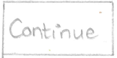
This could improve the overall projected flow of obtaining a covid pass for users, providing a better understanding of the overall system (this could also reduce confusion). Their designed solution worked well, there were some very useful features added to the design but some improvements which could be made also.
Overall, their solution works well and with the critique and analysis performed to evaluate their solution, a software prototype could be created.

Prototype Design (Software) (Task 7)

Initial Design (Task 7)
A hand-drawn solution has been designed. This design was created after the researched gathered from the initial paper-based prototype. Shown below is the general navigation of the entire application proposed alongside the actual proposed design.

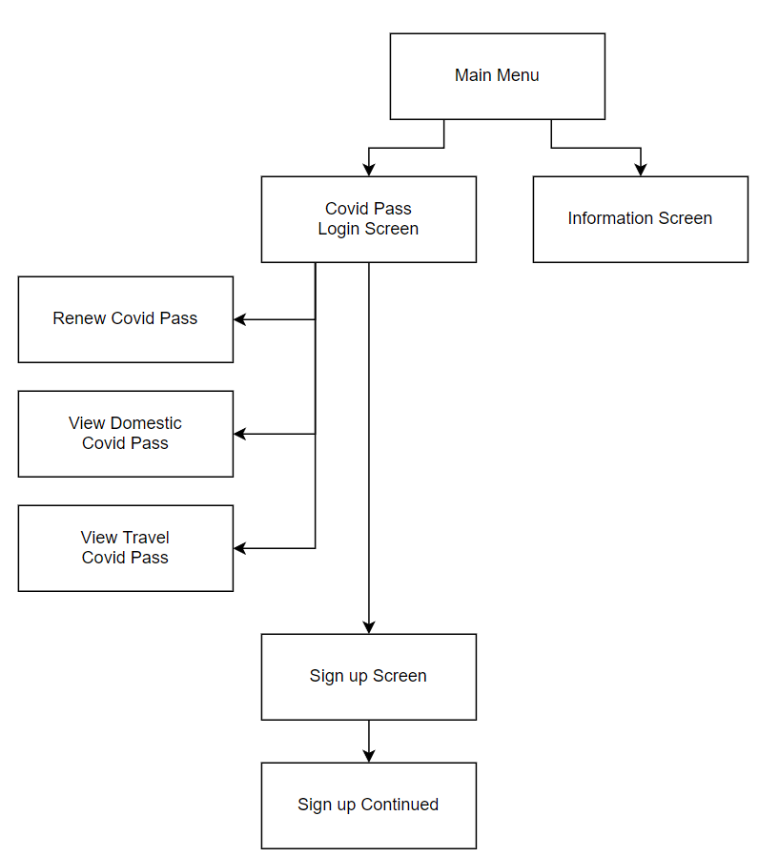

Main Menu
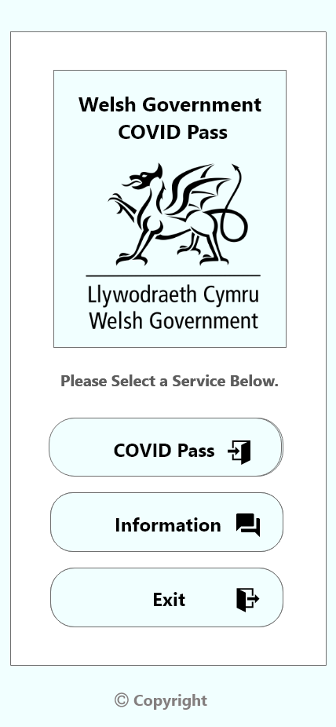
COVID Pass login screen
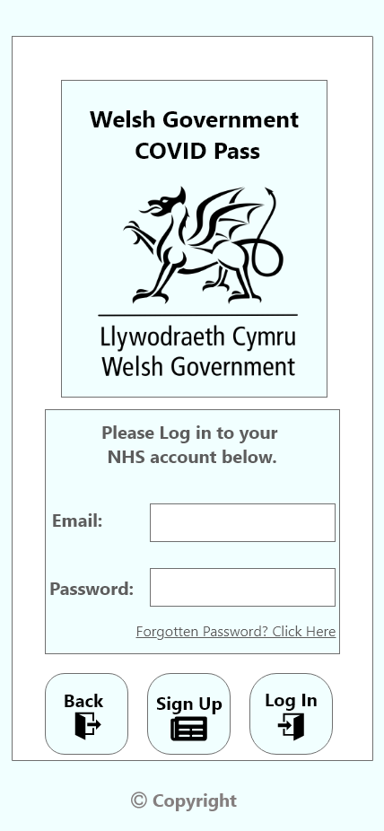
Information Screen
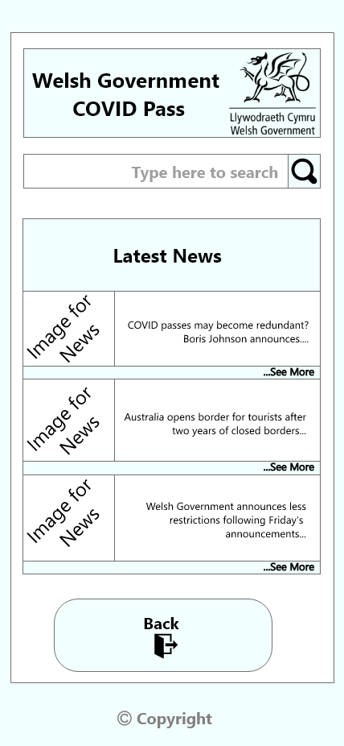
COVID Pass main screen (After Login)
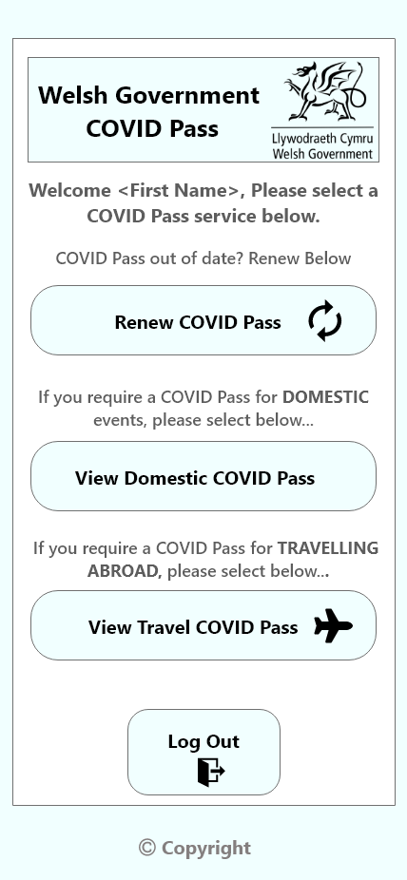

Renew COVID Pass screen
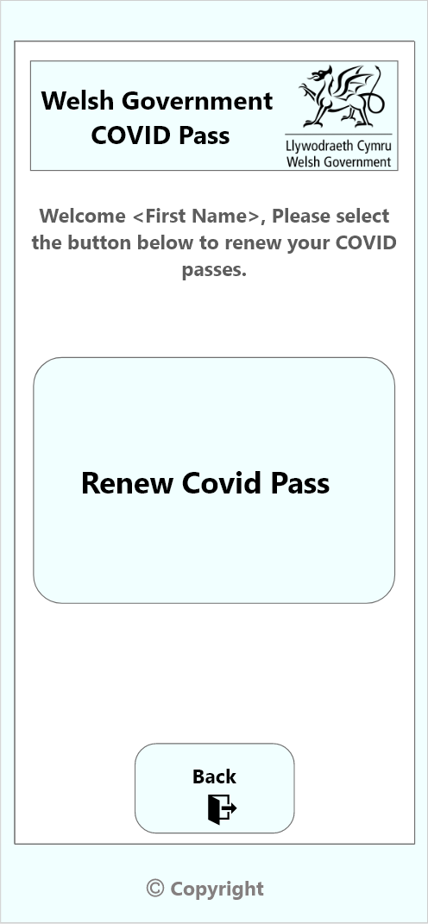

Renew COVID Pass Screen (Loading)
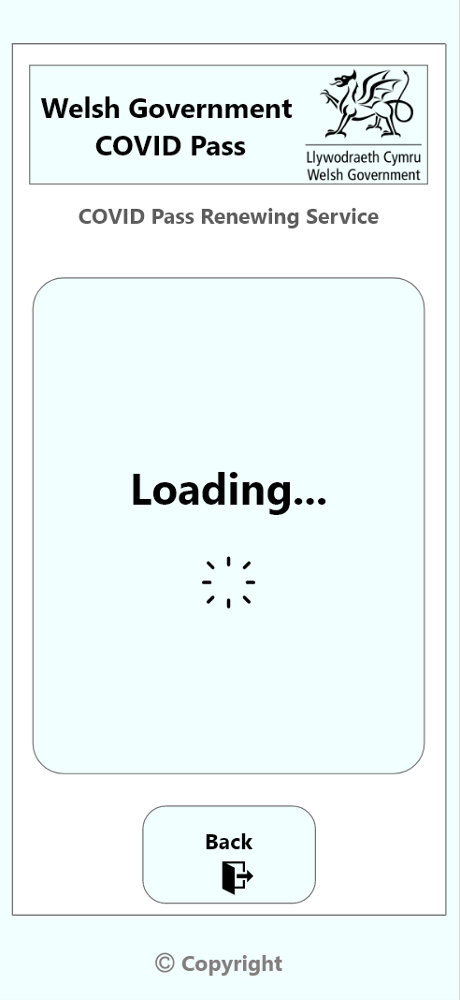
Renew COVID Pass Screen (Updated)
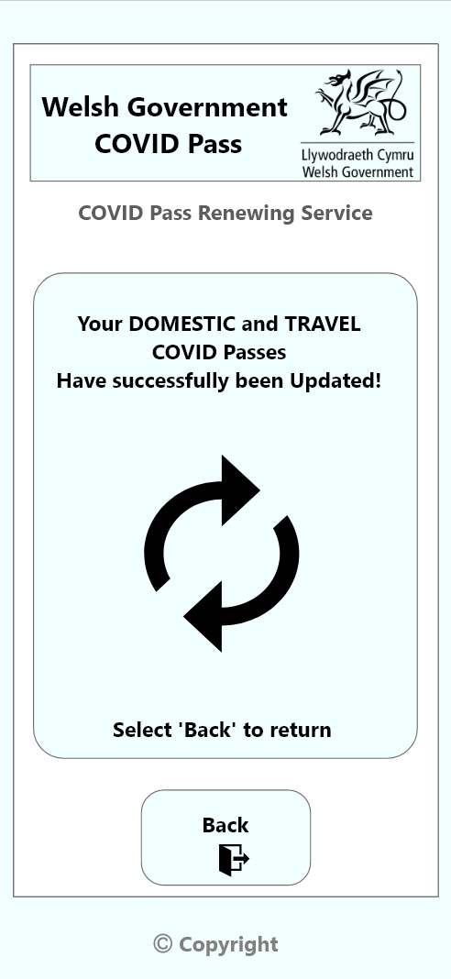
Domestic COVID Pass
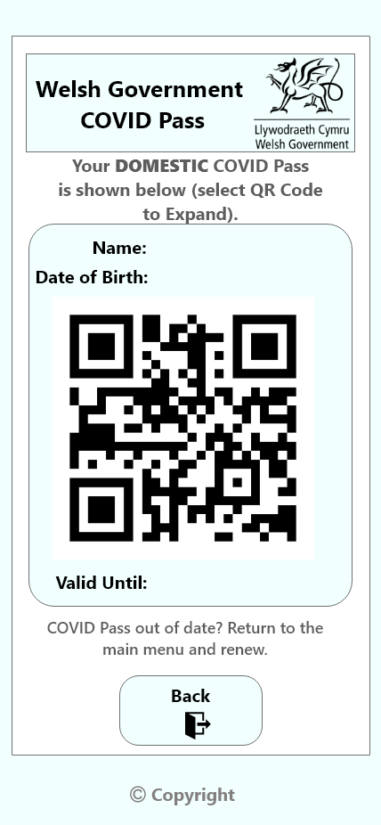
Domestic COVID Pass (Expanded)
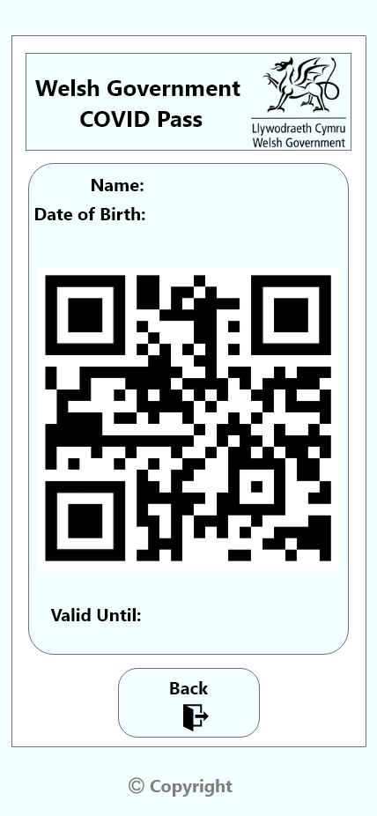
Travel COVID Pass
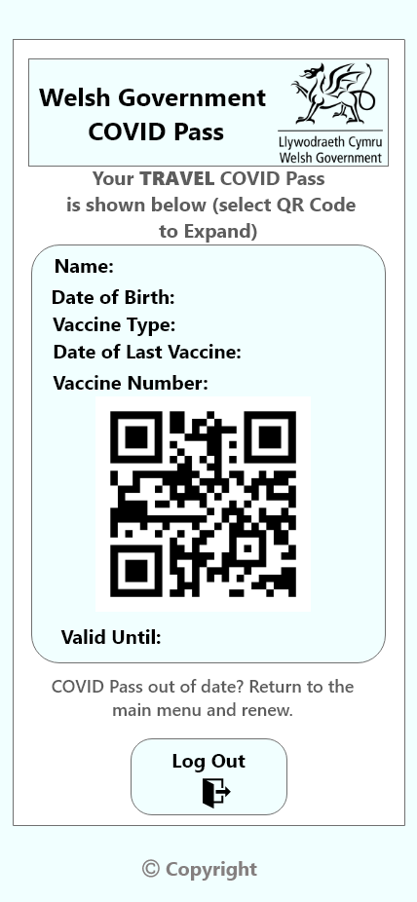

Travel COVID Pass (Expanded)
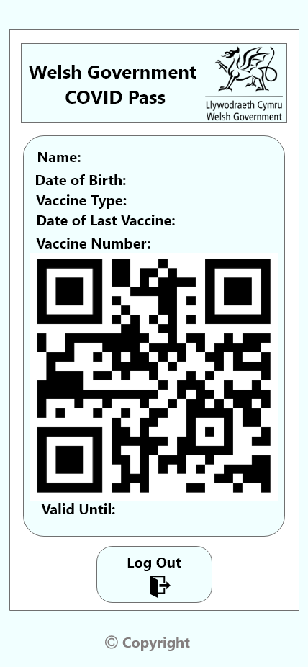
Sign up Screen - 1
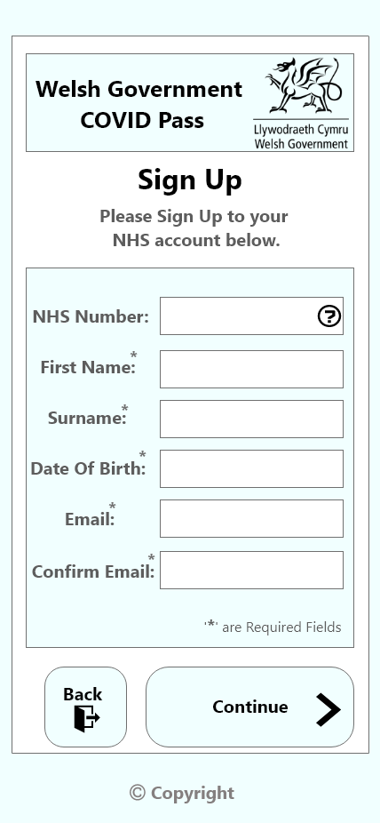
Sign up Screen – 2
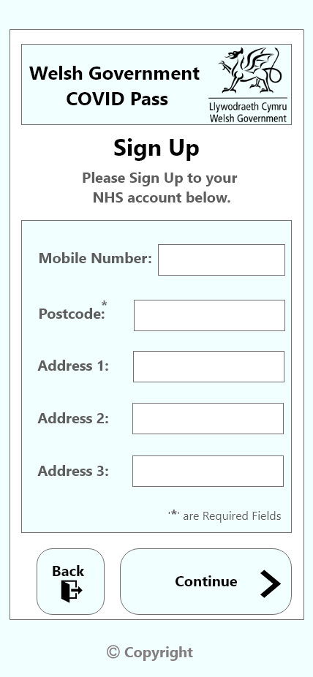

Sign up Screen – 3
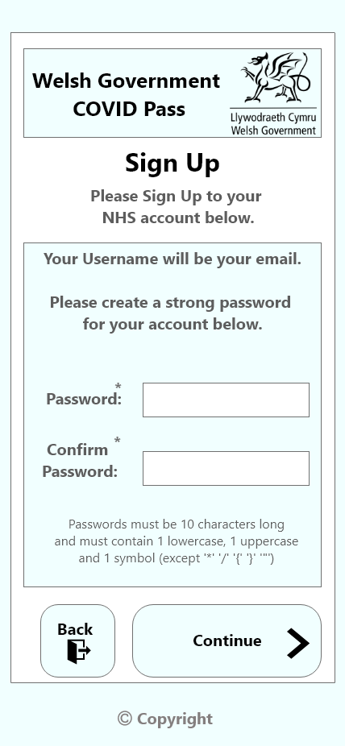
Sign up Screen – 4
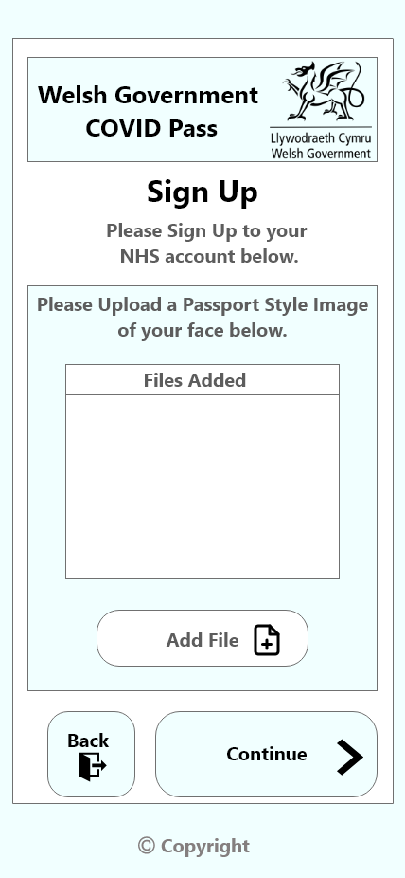

Sign up Screen – 5 (Error)
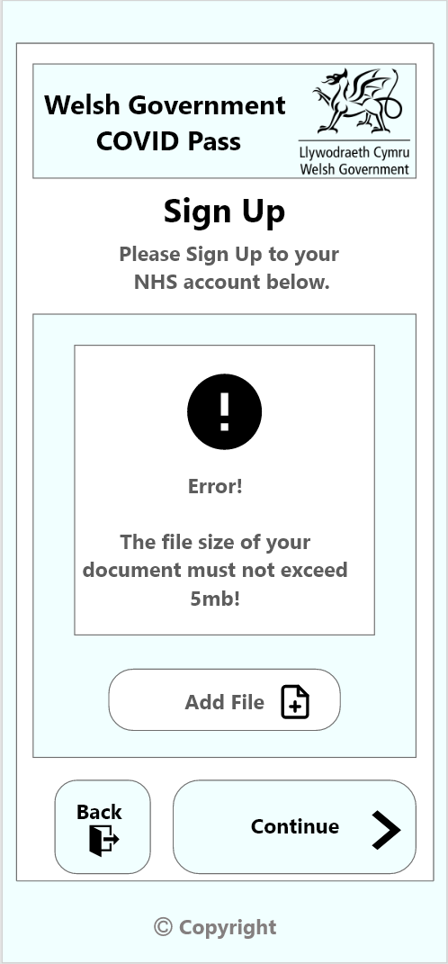
Sign up Screen – 6
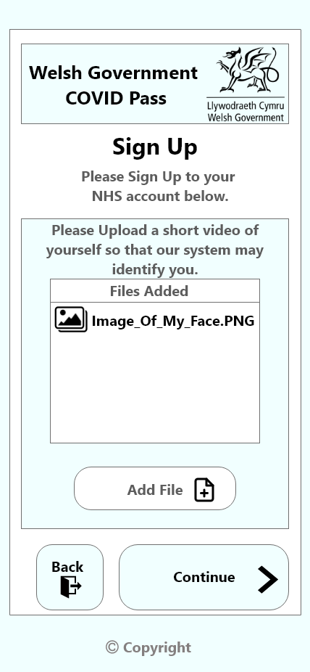
Sign up Screen – 7
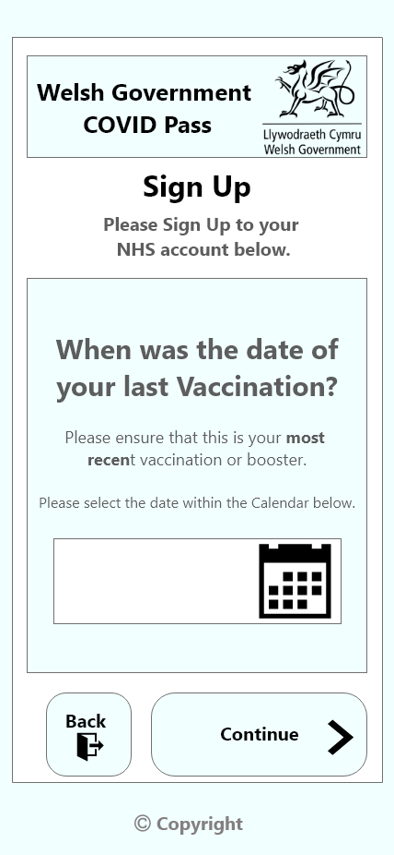

Sign up Screen - 8

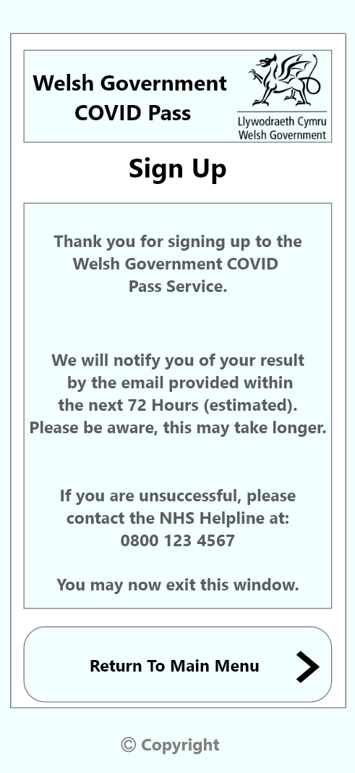

Analysis of Prototype (Task 7)
An analysis of the prototype will ensure that the proposed solution is effective, realistic, and viable. Through the task analysis performed on the current measures required to obtain a covid pass and the documented walkthrough with a potential end user on the designed solution, an analysis can be performed.
The software chosen to design the solution was Adobe XD. A large range of other suitable technologies were also assessed. Photoshop was observed as one of these technologies. Photoshop is an industry standard for designing and editing software [8]. Photoshop provides an extensive range of editing features that a lot of editing/design software simply do not have.
The largest issue with this software is the high skill ceiling [10]. The interface can prove difficult to manage. This could lead to the design taking longer than the amount of time allocated to the solution. Due to the strict time allocated to the design of the solution, this software was disregarded.
Adobe XD provides an extensive list of editing features. The largest benefit to using this application is that designs for applications can be setup on project initialisation [9].
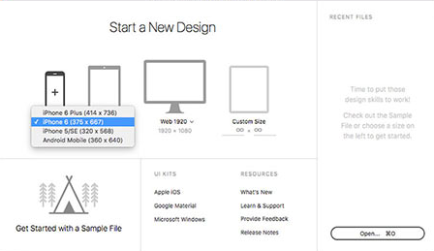
As the solution is an application (available on smartphones), this could allow the design to take considerably less time as the sizes of the application (width and height) are already discovered. The navigation and simple clean interfaces are easy to understand, even for a beginner. With the creation of each page or interface, the flow of data can be observed instantly which can allow easy understanding of not only Adobe XD, but the application/solution being designed.
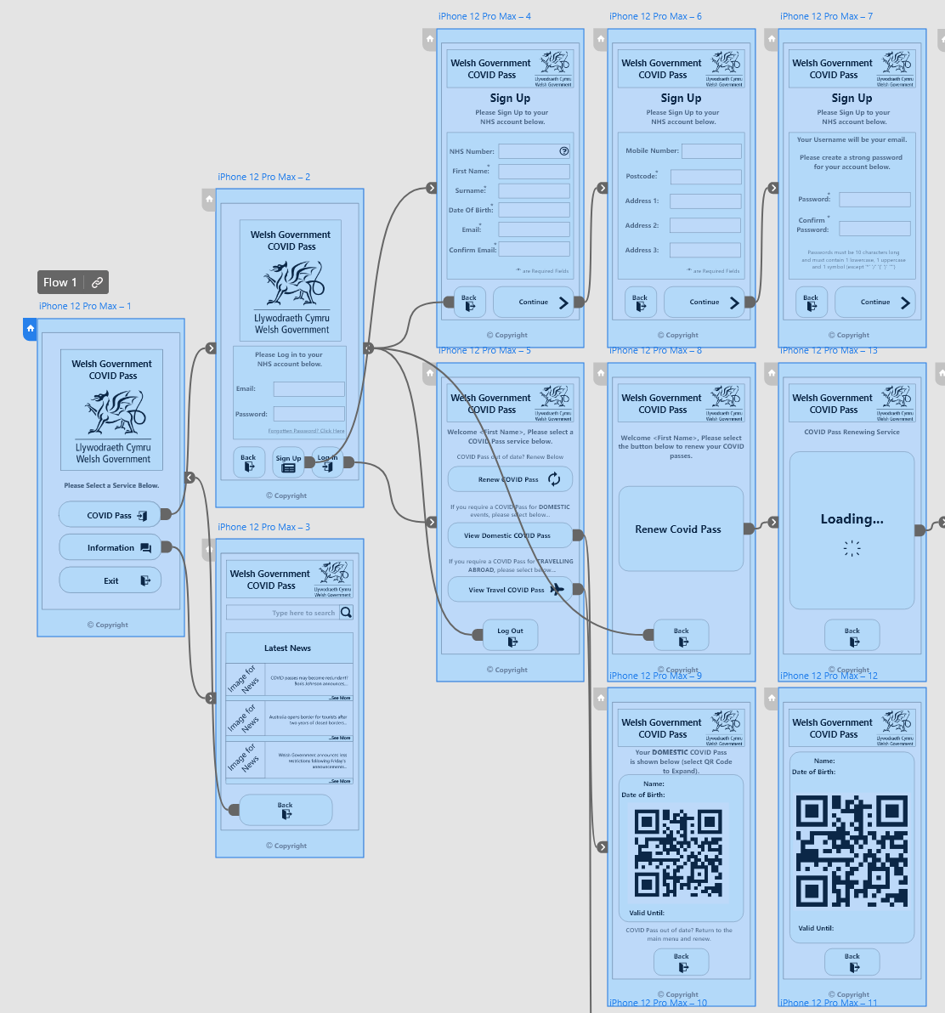
Adobe XD may not have the range of features that photoshop has, but with the skill ceiling being much lower, this was selected as the software used to design the solution.

Evaluation of Usability Techniques (task 8)
The usability techniques such as the task analysis proved vital in obtaining information on the specific target audience chosen (18 to 25). From this initial starting point, design choices were formed based on the information gathered. The choice to build an application instead of a website was one initial choice discovered from the task analysis.
Clear and concise navigation was an important discovery. Throughout the task analysis (interviews) and the user evaluation, it was clear that any type of confusion that a user might face should be controlled, solved, or prevented.
Sufficient error screens have been implemented so that users can understand if they have uploaded an incorrect document type or file size. This was suggested throughout the user walkthrough evaluation of the paper-based design. In addition to this, the logo on each screen has been made clear that it is a navigating feature used to return home. The human factors implemented allowed for design choices to be justified.
Little key navigation elements proved extremely useful such as each button using the same shape. To further expel confusion, the use of logos and icons allowed users to understand specific elements of the application faster and more conveniently than just using text.
The human factors ensured the design met specific standards set out such as the clear navigation (which was evidently extremely confusing within the task analysis of the current COVID pass methods available).
There is still some improvements to be made. The user evaluation of the paper-based prototype highlighted many issues previously not found. Although the major issues were solved, the lower rated issues (such as cosmetic issues) were not addressed. This is due to the time constraints and limitations of designing the proposed application.
The usability techniques implemented such as task analysis, applying human factors and the walkthrough of the paper prototype were time consuming. This may be true, but without implementing such key factors, large issues within the proposed solution may have gone unnoticed. The implementation of these usability techniques were worth the time spent to develop an effective solution.

References
- The application of cogntive psychology to User-Interface Design [Internet]. Medium. 2021 [cited 25 April 2022]. Available from: https://uxdesign.cc/the-application-of-cogntive-psychology-to-user-interface-design-81599ad7fb55
- NHS COVID Pass [Internet]. nhs.uk. 2022 [cited 5 February 2022]. Available from: https://www.nhs.uk/conditions/coronavirus-covid-19/covid-pass/
- Whitefield A. A framework for human factors evaluation [Internet]. Taylor & Francis. 2007 [cited 5 February 2022]. Available from: https://www.tandfonline.com/doi/abs/10.1080/01449299108924272
- Flach J, Tanabe F. An Ecological Approach to Interface Design [Internet]. SAGE Journals. 1998 [cited 15 February 2022]. Available from: https://journals.sagepub.com/doi/abs/10.1177/154193129804200324
- Getting a digital NHS Covid Pass [Internet]. Youtube.com. 2021 [cited 17 February 2022]. Available from: https://www.youtube.com/watch?v=d6WLLSd7GJE
- Tubik. UX Design Glossary: How to Use Affordances in User Interfaces [Internet]. Medium. 2018 [cited 17 February 2022]. Available from: https://uxplanet.org/ux-design-glossary-how-to-use-affordances-in-user-interfaces-393c8e9686e4#:~:text=Affordance%20is%20a%20property%20or,it%20to%20open%20the%20door.
- Interaction Metaphors [Internet]. Science Direct. 2010 [cited 25 February 2022]. Available from: https://www.sciencedirect.com/topics/computer-science/interaction-metaphor
- Official Adobe Photoshop | Photo and design software [Internet]. Adobe.com. 2022 [cited 15 March 2022]. Available from: https://www.adobe.com/uk/products/photoshop.html
- Multimedia A. Pros and Cons of Adobe XD You Might Not Know - ADMEC Multimedia Institute [Internet]. ADMEC Multimedia Institute. 2022 [cited 15 March 2022]. Available from: https://www.admecindia.co.in/graphic-design/pros-and-cons-adobe-xd-you-might-not-know/
- 32 Pros and Cons of Using Photoshop for Your Upcoming Project [Internet]. PGBS. 2022 [cited 22 March 2022]. Available from: https://www.proglobalbusinesssolutions.com/photoshop-pros-cons/

Bibliography (Read but not used)

- Reimer J. A History of the GUI [Internet]. Ars Technica. 2005 [cited 5 March 2022]. Available from: https://arstechnica.com/features/2005/05/gui/
- Creative Cloud pricing and membership plans | Adobe Creative Cloud [Internet]. Adobe.com. 2022 [cited 15 March 2022]. Available from: https://www.adobe.com/uk/creativecloud/plans.html?plan=individual&filter=all&promoid=PYPVPZQK&mv=other
- Affordances and constraints [Internet]. Scotsimcentre.blogspot.com. 2022 [cited 23 March 2022]. Available from: http://scotsimcentre.blogspot.com/2015/05/affordances-and-constraints.html#:~:text=In%20human%2Dobject%20interaction%2C%20an,how%20they%20should%20be%20used.

