
Skills for the Workplace
Module Assignment Submission
Student Name: | Liza Nassrin
Student Number: | 1818727
Module No: | BMSK6001
Module Title: | Emergent Leadership Skills for the Workplace

Statement of Confirmation of Authenticity
By the act of making this submission, the student declares that this is the work of the student named above. The work has not, in whole or in part, been knowingly presented elsewhere for assessment, or where assessment has been built on a previous assessment, this has been identified. Where materials have been used from other sources it has been properly acknowledged. If this statement is untrue, the student acknowledges that an assessment offence has been committed.
Attention is drawn to the plagiarism and unfair practice policies of UWTSD.

Table of Contents
Introduction 3
Critically assess a recognised leadership model or theory in relation to its ability to impact on individual’s workplace performance 3
Leadership- 3
Management- 3
Transformational leadership- 4
Transactional Leadership- 5
Situational leadership theory- 6
Four Situational Leadership Styles- 7
Evaluate own ability to use a range of leadership styles, in different situations and with different type of people, to fulfil the leadership role 8
The author of the report is a customer service manager at a contact centre, and she will discuss how she uses her situational leadership style to carry out her leadership responsibilities in a variety of settings and with a variety of individuals. 8
Telling: High Task/Low Relationship- 8
Selling: High Task/High Relationship- 8
Participating: Low Task/High Relationship- 9
Delegating: Low Task/Low Relationship- 9
Assess your own ability to set direction, motivate, delegate, and empower others to bring about a workplace change 11
Absence of trust- 12
Fear of conflict- 12
Lack of commitment- 12
Avoid of accountability- 12
Inattention to results- 13
Set direction- 13
Motivation- 13
Empowerment- 13
Delegation- 13
Conclusion 14
Reference 14
Appendix A 17
Appendix B 19
Appendix C 21
Appendix D 21
Appendix E 22

Introduction

It makes sense to concentrate on what leadership and management entail in the context of today's organisations. An individual may hold the title "leader." Regardless of the duties and roles he or she fulfils, it may refer to someone who practises leadership, or it may simply refer to the group's leader. In other words, the terms "leader" and "leadership" don't always mean the same thing. A person who wears the label "leader" is either in command, exercising leadership, or doing both. Position isn't always a prerequisite for leadership; it's also an activity, a phenomenon, and a relationship.
(Nirenberg, 1998).
Regardless of the leadership perspective one may have, understanding and applying leadership organisations may be done with the help of the beneficial framework provided by the concepts described below. The report's author conducted scholarly research to completely describe leadership and to provide advice on how to succeed as a leader at work and boost productivity.

Critically assess a recognised leadership model or theory in relation to its ability to impact on individual’s workplace performance

Leadership-

The development of the appropriate leadership behaviours, methods, and qualities is essential since leadership has the greatest impact on how an organization's culture is shaped. There is ample proof that there is a connection between leadership and a number of crucial outcomes in the healthcare industry, including patient happiness, patient mortality, organisational financial success, staff well-being, engagement, turnover, and overall quality of treatment.
(Bush, 2014).
According to Northouse, “A leader's role is to persuade a group of people to work toward a common objective, according to the definition of leadership”.
(Northouse, 2022).
According to Carnota, leadership is the act of organising and directing the interests and activities of a group of people who have joined together for a project or company. This is done by a person who fosters cooperation by forcing everyone to reach an agreement, more or less voluntarily, on specific goals and methods.
(Carnota, 2000).

Management-
Planning, budgeting, organising, staffing, controlling, and problem-solving are among the management activities. The following are examples of management roles: figurehead; liaison; monitor; disseminator; spokesperson; change agent; disturbance handler; resource allocator; and negotiator. The two most commonly seen and used leaderships styles are-
Mintzberg (2011).
After conducting study on management and leadership, the report's author discovered two key distinctions between the two. Management is about procedures that keep a constant state in place. The majority of the time, management requires holding a position inside an organisation and using legitimate power. Although more enigmatic, leadership involves tackling challenging issues and bringing about change. Influence from followers is necessary for leadership, and this influence entails a psychological contract. It may not always imply position. Instead, it uses the power of the Referent. Despite these key distinctions between management and leadership, both are crucial, and their influence depends on the sort of business they serve.
(Schwarzkopf, 1993).
Leadership styles relate to a particular behaviour and are impacted by the leader's objectives, personality, and contact with the team.
Many ideas have been proposed and are still being developed to explain good leadership. Transformational and transactional leadership theories are two of the most well-known theories of leadership. Theories of transformational and charismatic leadership have become more popular since the late 1980s. Several theorists, including Bass, have put forth versions of transformative leadership.
Although the majority of authors concur that transactional and transformational leadership differ in theory and practise, many authors hold that the addition of transformational leadership significantly improves the effectiveness of transactional leadership, leading to higher levels of performance for individuals, groups, and organisations.
(Bass & Avolio, 1994).
Some people think that the term "transactional leadership" refers to a subset of "transformational leadership."
(Weihrich, Cannice and Koontz, 2022).
the two most prevalent types of leadership are, Transformational and Transactional describe below-

Transformational leadership-

A transformational leader is someone who energises and transforms their followers to produce amazing results.
(Robbins and Coulter, 2007).
He or she is able to arouse, excite, and motivate followers to put out extra effort to accomplish group goals by paying attention to the concerns and developmental needs of individual followers, changing followers' awareness of issues by assisting them in looking at old problems in a new manner. According to the philosophy of transformational leadership, a leader is someone who inspires followers to act in the best interests of the group as a whole and to look out for one another's interests.
(Warrilow, 2012).
Through a number of factors, transformational leadership improves the motivation, morale, and productivity of followers. These include encouraging followers to take greater ownership of their work, challenging followers to do so, and understanding the strengths and weaknesses of followers so the leader can assign followers to tasks that will improve their performance. Connecting followers' sense of identity and self to the project and the collective identity of the organisation is another.
(Jung and Sosik, 2002).
Four elements of a transformational leadership style were highlighted by Warrilow:
- Charm and idealised power- the extent to which the leader exemplifies commendable behaviour, exhibits convictions, and takes positions that inspire followers to identify with the leader who upholds a distinct set of principles and serves as an example for them.
- Motivating inspiration-the degree to which the leader articulates a vision that is appeals to and inspires the followers with optimism about future goals and offers meaning for the current tasks in hand.
- stimulation of the mind-the extent to which the leader challenges preconceptions, stimulates, and fosters creativity in the followers. By giving followers a framework to understand how they connect [to the leader, the organisation, each other, and the goal], the followers are better equipped to creatively overcome any challenges that may stand in the way of the mission.
- Individual and individualised care-the extent to which the leader considers the requirements of each individual follower, serves as a mentor or coach, and respects and values the individual's contribution to the team. This meets and strengthens each team member's need for self-fulfilment and self-worth, and by doing so, motivates followers to continue achieving and growing.
(Warrilow, 2012).

Transactional Leadership-

Managerial leadership, commonly referred to as transactional leadership, emphasises the function of supervision, Transactional leadership is a form of leadership in which the leader emphasises organisation and group performance. uses prizes and penalties to encourage obedience from his followers. Contrary to Transformational Those in positions of authority who employ the transactional approach don't seek to alter the course of history; rather, they seek to simply maintain the status quo. These leaders scrutinise the work of their subordinates to identify flaws and deviations. In times of crisis and emergency as well as when undertaking undertakings, this kind of leadership is beneficial. must be carried out in a particular way. In the context of Maslow's hierarchy of needs, transactional leadership focuses on the lower levels of the hierarchy and works at the fundamental levels of need fulfilment. The trade approach is used by transactional leaders, and incentives are given for successful work or successful outcomes. On the other hand, those with this leadership style might punish subpar performance or unfavourable results until the issue is resolved. Transactional leadership emphasises precise task performance as one strategy to target lower-level needs.
(Hargis, 2001).
To get their followers to comply, transactional leaders utilise rewards and penalties. Extrinsic motivators, they only elicit a little amount of obedience from followers. They agree with the organization's objectives, organisational structure, and culture. Directors and doers are common characteristics of transactional leaders.
(Nye, 2013).
Contingency pay and management by exception are the two components of transactional leadership. Contingency compensation offers incentives for work and rewards excellence. Management-by-exception keeps things as they are, steps in when employees fall short of expectations, and starts remedial action to boost productivity.
(Lowe, Kroeck, & Sivasubramaniam, 1996).
By stating that transactional leaders are those who trade material goods for their followers' labour and allegiance, James Macgregor Burns distinguished between these leaders and transformative leaders. Leaders that are transformational interact with their followers, put their attention on higher order intrinsic needs, and spread awareness of the relevance of particular objectives and novel approaches to achieving those outcomes. While transformational leaders exhibit active behaviours such as fostering a sense of mission, transactional leaders frequently exhibit more passive behaviours.
(Hay, 2012).
Researchers have made brave attempts to explain the nature and impact of leadership through the ideas of transformational and transactional leadership. Both theories have various advantages and disadvantages. However, the impact of contextual factors on leadership outcomes in the context of both leadership philosophies should not be ignored.
however, although transformational leadership has received a lot of criticism, its acceptance has increased recently. After conducted research the report writer prefers Transformational Leadership
For instance, research have revealed that managers in many contexts, such as the military and business, discovered that transformational leaders were assessed as more effective, higher performers, more promotable than their transactional counterparts, and more interpersonally responsive.
(Yukl, 1999).
Additionally, empirical data demonstrates a strong correlation between transformational leadership and favourable employee work outcomes, including lower turnover rates, increased productivity, employee happiness, innovation, goal achievement, and follower well-being.
(Eisenbeiß and Boerner, 2013).

Situational leadership theory-

Additionally, empirical data demonstrates a strong correlation between transformational leadership and favourable employee work outcomes, including lower turnover rates, increased productivity, employee happiness, innovation, goal achievement, and follower well-being.
(Hersey & Blanchard, 1982).
The idea offers managers a means of learning and developing various leadership philosophies, from which they can select the most suitable one based on the maturity/readiness of a team or person to carry out the particular task or project at hand. According to Fred Fielder, who initially identified these two behavioural types, the Situational Leadership Theory is based on task behaviour and relationship behaviour. (Fred Fielder, 1967). Work-oriented managers have a propensity to concentrate on the details and require all the information related to the task before acting. In contrast, relationship-oriented managers work to build rapport with staff members and team members in order to involve them in the process of formulating an action plan. Based on the team's or employees' maturity (readiness) level for a particular job or project deliverables, the Situational Leadership Theory strikes a balance between task behaviour and relationship behaviour.
(Hersey, Blanchard, & Johnson, 2013).
A mix of competence and maturity/readiness (task-relevant knowledge and skills, as well as transferable skills). The interpersonal abilities of a project manager are typically linked to commitment, which includes motivation, self-conference, and attitude toward others. The situational leadership theory identifies four stages of development or preparation, which are as follows: Employees with low levels of maturity or readiness may be new to the position, without the knowledge, confidence, or drive needed to execute the task on their own, and/or a team may still be in the formation stage of team development. Employees or a team with a moderate level of maturity or readiness may be willing to execute the task at hand, but they may not have the necessary training or expertise for the job or project. Employees or a team with a high-moderate level of maturity/readiness may have the knowledge, education, and demonstrated skills to complete the task or project, but they might not be confident in their abilities or the mission's objectives. Teams or employees who have reached a high level of maturity or preparation can function independently. They are dedicated, self-assured, possess the necessary expertise, and assume responsibility for the task.
(Hersey, Blanchard, & Johnson, 2013).
The most effective leadership style for a manager to deploy is one that is well matched to the maturity/readiness level of the employees or team members in a given situation, according to the situational leadership theory proposed by Hersey & Blanchard (1982).

Four Situational Leadership Styles-

Instead of one single fixed leadership method being the optimal style approach for every occasion, the situational leadership theory is based on four possibilities for leadership approaches. The different types of situational leadership styles for a given situation based on an employee’s or team’s maturity include:
- Telling: High Task/Low Relationship
- Selling: High Task/High Relationship
- Participating: Low Task/High Relationship
- Delegating: Low Task/Low Relationship
The Situational Leadership Model sowed in Appendix C.
"Statistics reveal that in the U.S. roughly 543,000 new businesses get started each month, but more businesses shut down than start up each monthp.1," wrote (Nazar, 2013). In many cases, poor leadership is to blame for business closures. (Myatt, 2012). The creators of the Situational Leadership Theory, Hersey, and Blanchard (1982), assert that dynamic and effective leadership is a key characteristic that distinguishes successful organisations from those that fail.
(Hersey & Blanchard, 1974).
The author of the report chooses to employ situational leadership at her workplace since it is flexible and allows her to act as a team leader in any circumstance. According to studies, when managing a team of workforce, the majority of managers use both a primary and secondary leadership style. When seeking to persuade and lead individuals and teams, a manager will choose a major leadership style that is utilised most frequently. In other words, most managers typically have a preferred or "default" leadership style while managing teams or employees and a secondary or supporting style(s) of leadership that they will adopt, depending on the situation. It is crucial to remember that every manager has a core leadership style, meaning they typically employ one of the four fundamental leadership philosophies. They could, however, possess just one secondary leadership style or as many as three.
(Paul Hersey, 2009) recommended that the manager should make sure he or she communicates clearly regardless of whether the manager uses a primary or secondary situational leadership style to ensure the employee or team members understand the goals and objectives to successfully complete the tasking or project deliverables. The manager can determine the maturity/readiness level of the individual or team that he or she is seeking to influence for the successful completion of the tasking or project once this has been effectively conveyed and thoroughly understood by everybody, including addressing any misunderstandings.
(Blackwell and Gibson, 1999).

Evaluate own ability to use a range of leadership styles, in different situations and with different type of people, to fulfil the leadership role

The author of the report is a customer service manager at a contact centre, and she will discuss how she uses her situational leadership style to carry out her leadership responsibilities in a variety of settings and with a variety of individuals.

Telling: High Task/Low Relationship-
The leader defines the roles for others throughout this stage of leadership. communication is mainly one-way. The perspective of the leader is in explaining the why, when, what, and how. Giving clear instructions from the leaders to the employees at different stages in the leadership styles more effective in different types of individuals in different situations.
(Hersey, 1985).

Selling: High Task/High Relationship-

During this period, communication is primarily two-way. Leader continues to provide instructions. Leaders offer emotional support, and followers are persuaded to buy into the organisation. When making decisions and solving problems, executives work as a team to boost business performance.
(Hersey, 2009).

Participating: Low Task/High Relationship-

This stage manager discussed issues and made choices. Less task-specific behaviour instructions are given by the leader, who also fosters follower trust to produce successful results.
(Hersey, 1985).

Delegating: Low Task/Low Relationship-

At this level, the process is being handled by people and groups, but the stage leader is still keeping an eye on the development. If this step is followed correctly, team members will gain the knowledge necessary to finish the work either individually or collectively. At this level, the process is being handled by people and groups, but the stage leader is still keeping an eye on the development. If this step is followed correctly, team members will gain the knowledge necessary to finish the work either individually or collectively.
(Gill, 2009).
The report's author completed two distinct questionnaires to assess her capacity for leadership. which shows on her Appendix A and Appendix B.
the report's overall score for the leadership style questions was-
authoritarian leadership 18, democratic leadership 22 and laissez-faire leadership 17.
An individual who practises authoritarian leadership, often referred to as autocratic leadership, has complete decision-making authority and ultimate control over his subordinates. With little to no involvement from his or her team members or followers, an authoritarian leader decides on policies, procedures, and group goals. In businesses and organisations where decisions must be made quickly and effectively, where it is essential that specific tasks be completed in a specific manner, and where there is little room for error, such as in a catering company where the report works as a team leader, authoritarian leadership is advantageous.
(Sulpakar, Ridwan, Herdian, Sudjarwo, & Hariri, 2022).
There are many shortcomings to authoritarian leadership, however. Excessive use of this leadership style may cause the leader to be viewed as domineering and iron-fisted, which can breed resentment or aggression among group members. Furthermore, followers may grow to resent that they are not able to contribute their expertise or opinions to decision making. These factors may lead to a higher churn rate. Additionally, authoritarian leaders are typically lacking in creative problem-solving skills, which can hurt a group's operations.
(Williams, 2018).

Democracy literally translates to "governed by the people." Making room for multiple people to engage in the decision-making process is a key component of this leadership style. Democratic or participatory leadership is another term that's frequently used. In this leadership approach, the report writer scored higher. These leaders take an active role in debates while also taking the time to hear other people out. Positive, inclusive, and collaborative work environments are frequently the result of this style. A strong democratic leader can also encourage the group's imagination.
(White and Lippitt, 1960).
The concepts of democratic leadership put out by White and Lippitt (1960) place an emphasis on the leader's encouragement of group involvement, discussion, and decision-making. An authoritarian leader, on the other hand, maintains strict control over collective choices and activities. Each member's specific work assignments and co-workers are set by the autocratic leader, who also controls all policies, methods, and activity phases. Although the autocratic leader tends to be distant from active group engagement, he or she tends to be personal in his or her praise and criticism of each member's work. But the democratic leader tries to behave normally while abstaining from doing too much labour. While giving instructions is the primary function of an autocratic leader, providing information or broadening the members of his or her group's knowledge is the primary function of a democratic leader. The differences between the functions of authoritarian and democratic leaders are not very stark in practise. Every position played by authoritarian and democratic leaders remains within the typical gamut of behaviours for leaders in various contexts in a society.
(White and Lippitt, 1960).
Leaders that practise laissez-faire have a trusting and dependent attitude toward their workforce. They don't micromanage, get overly involved, or provide excessive direction or instruction. Instead, laissez-faire executives encourage their staff to use their initiative, resources, and expertise to advance their objectives. As attitudes of trust and dependence are crucial for a leader toward her employees, the report writer's low score in this leadership style is one of her flaws.
However, Democratic leaders actively participate in decision-making while involving others. They are in charge of making sure that the choices taken result in the expected results. Laissez-faire leaders rarely participate in decision-making, largely delegating it to their team. Therefore, leaders are responsible for mistakes or poor decisions rather than employees, making it crucial to make the right choices in the appropriate circumstances.
(Lewis, Williams, & Baker, 2020).
The report's author also asked her a second question to better understand her leadership style, which is shown in her Appendix B.
This questionnaire clarifies what leadership abilities are. This questionnaire clarifies what leadership The ability to identify and solve problems is also an example of conceptual skills. Conceptual management skills require the ability to make quick decisions, where required. Some types of problem-solving skills include decision-making, critical thinking, logical thinking, multitasking, and troubleshooting. abilities are.
The report's author received a higher score for administrative abilities, indicating that she has a greater by combining time-consuming administrative responsibilities into a single function, administrative talents boost workplace productivity. The most often used abilities include managing projects, planning travel, setting up meetings, and filing expense reports. This competence is crucial to her performance in the office environment.
(Carroll, Ford, and Taylor, 2015).
Social skills are under the category of interpersonal skills. You can engage, communicate, and work effectively with others when you have the necessary interpersonal skills. Empathy, active listening, and emotional intelligence are typical illustrations of interpersonal skills.
This three-skill model emphasises that effective administrators may be trained rather than necessarily being born. In an effort to offer a more beneficial perspective on the administrative process, it goes beyond the requirement to define certain features. It may be helpful in the selection, training, and promotion of executives by assisting in the identification of the abilities most required at various levels of responsibility.
(Bennis, and Thomas, 2002).
Emotional intelligence, or EI, is the cornerstone of interpersonal abilities. That is, being conscious of your ideas, behaviours, and emotions; realising how you affect others; and recognising how others are feeling and what they need. The author of the report will raise her level of emotional intelligence so that she can become more socially adept.
(Kouzes, and Posner, 2012).
A skill set that includes analytical, creative thinking, and communication abilities is referred to as conceptual skills. For managers and leaders, they are especially crucial. Conceptual skills become more crucial as one moves up the corporate ladder. Another illustration of conceptual skills is the capacity to recognise and address issues. Conceptual management abilities necessitate the capability of making snap decisions when necessary. Making decisions, exercising critical and logical thought, multitasking, and troubleshooting are some examples of problem-solving abilities.
(Kippenberger, 2002).
Analysing and assessing whether or not a corporation is accomplishing its objectives and adhering to its business plan is a crucial conceptual skill. Managers must assess how each department interacts with one another, identify any specific problems, and choose the next course of action. Employees that lack effective communication skills won't be able to discuss their solutions with the appropriate parties. A conceptual thinker can outline an issue and suggest remedies. He or she is able to communicate clearly with individuals at various organisational levels, from senior management to staff members in a particular department. Conceptual thinkers also make for good listeners. Before coming up with a strategy, they must first consider the demands of the employers.
(Alvesson, Blom, and Sveningsson, 2017).

Assess your own ability to set direction, motivate, delegate, and empower others to bring about a workplace change

After thorough investigation and comprehension, the report writer decides on her direction, motivation, delegation, and empowerment. She will also adopt any necessary changes. When the report writer considers leadership are often focus on what: external characteristics, practise, behaviour, and actions that impressive leaders demonstrate as the Although this way of thinking is a terrific place to start, focusing solely on what is visible will prevent us from becoming the leaders anyone may be. To understand how exceptional leaders lead, the report writer needs to uncover what lies beneath, and that process starts with mindsets. In fact, any endeavour to become a better leader should begin with understanding the thoughts, feelings, and emotions that drive us because of the inherent ability of a leader's mindset to guide an organisation towards good transformation.
(Barsh and Lavoie, 2014).
The report's author outlines the list of team dysfunctions that prevent success below-

Absence of trust-
Lack of trust among team members is the first dysfunction. This is primarily due to their reluctance to show vulnerability in front of the group. It is impossible to establish a basis for trust when team members are not honestly honest with one another about their flaws and shortcomings. ​
The report writer will foster strong bonds among the team members so that they may develop mutual trust. The report's author will solicit input and assign each member the duty of building a strong sense of trust among them. ​

Fear of conflict-
Because it lays the stage for the second dysfunction, conflict aversion, this failure to establish trust is detrimental. ​Teams lacking in trust are unable to have frank and impassioned discussions about their positions. Instead, they use covert conversations and circumspect remarks. ​
(Lencioni, 2012b).
The report writer will employ open communication with one another to prevent dispute. Additionally, if a disagreement arises, it will be resolved as soon as possible with a solution that has been approved by the entire team. ​

Lack of commitment-
Because it guarantees the third dysfunction of a team—lack of commitment—a lack of healthy conflict is an issue. Team members rarely, if ever, buy in and commit to decisions without having expressed their ideas in the course of impassioned and open debate, even though they may pretend to agree during meetings. ​
(Lencioni, 2012).
The report's author will regularly meet to discuss the results of any recent successes or failures. The report writer will ensure that everyone is aware of the commitment explicitly and that it never breaks. ​

​Avoid of accountability-
Team members develop an avoidance of accountability, the fourth dysfunction, as a result of this lack of genuine commitment and buy-in. Even the most motivated and dedicated individuals frequently hesitate to confront their teammates about actions and behaviours that seem to be detrimental to the success of the team unless they have agreed to a clear course of action. ​
(Lencioni, 2005).
The report writer will involve everyone on the team in the assignment in order to avoid this stage of dysfunctions. She will also ensure that everyone has a clear understanding of the task and is capable of carrying out their individual obligations. ​​

Inattention to results-
The fifth dysfunction can flourish in a culture where people fail to hold one another accountable. When team members prioritise their own demands (such as ego, career development, or recognition) over the group's objectives, it leads to inattention to results. ​​
The document to reduce the possibility of last dysfunction, writer will carefully select the appropriate person for the job. ​​
(Lencioni, 2002).
After thorough investigation and comprehension, the report writer decides her set direction, motivation, delegation, and empowerment describe below-

Set direction-
By adhering to her organisational vision and goals, the report writer established direction. Additionally, her chosen course will be chosen by pyritizing each person's values and beliefs. which will result in the members acting professionally and the organisation performing at its peak. Appendix D contains a schematic of the Layers of Human Behaviour and Performance paradigm.

Motivation-
The report's author uses the Motivating for High Performance Motivational Flow Model to keep herself and her team motivated. In this methodology, she will first identify the motivation's goal before getting a clear idea of how to inspire herself and her team. This drive will result in exceptional performance. This drive also rewards the group with accomplishment and acknowledgment. Motivating for High Performance​ Motivational Flow Model shows in Appendix E.

Empowerment-
In the context of leadership is concerned with effective delegation and team member growth. ​Giving someone instructions on what to do (the output or outcome) but not how to do so is the practical definition of empowerment. ​​
(Lencioni, 2002).

Delegation-

The standard definition of delegation is the transfer of power and accountability for particular duties, responsibilities, or choices from one person (often a leader or management) to another. For an understanding of delegation, the report's author used the Stewardship Delegation model. Stewardship delegation has five components that must all be understood for it to be effective. The following are the five levels of initiative:
Stage 1-Observe the instructions. There is no initiative at this stage. ​
Stage 2-What should I do? Here, the person starts to show initiative by posing a question. Although he or she shows interest and awareness, they are still unsure of what to do.
Stage 3-Recommend. The person starts to understand the task fully and starts to come up with solutions. ​
Stage 4-Independently acts, but report right away. Here, the person acts on his or her own initiative but reports right away to ensure that the activities taken were accurate and that everything else matched up with what was done. ​
Stage 5-Independently act and regularly report. With the knowledge that routine evaluation will be sufficient to keep things on track, we can now trust the individual to act on his or her own. ​
Independently act and regularly report. With the knowledge that routine evaluation will be sufficient to keep things on track, we can now trust the individual to act on his or her own. ​
Delegation is crucial for the report writer since she learns best by doing, and delegation is a development tool. It aids in the development of new skills, increases competency in crucial areas, and fosters a culture of "can do" in order to create an inspiring atmosphere. The use of delegation as a strategy for improvement allows for the introduction of new viewpoints and innovative techniques to stale procedures and tried-and-true methods.
(Taylor, 2016).

Conclusion

the idea that as leadership involves responsibility, it should be demanding and challenging (though certainly not without elements of personal gratification). Nelson Mandela once said that it is preferable to lead from behind and place others in the forefront, especially when you are able to rejoice when good things happen. When there is danger, you take the front line. The public will then respect your leadership. Theories and models can provide you with a framework within which to work while assisting us in examining the leadership process. They are unable to guarantee long-term leadership success on their own. Being able to follow those fundamental models of leadership styles can help you adopt your own style.
(Ortega, 2020).

Reference

Alvesson, M., Blom, M. and Sveningsson, S, (2017). Reflexive Leadership. Los Angeles: Sage
Bennis, W. and Thomas, R, (2002). Geeks & Geezers: How Era, Values, And Defining Moments Shape Leaders. Harvard Business School Press.
Bush, T. (2014). Educational leadership and leadership development in Africa. Educational Management Administration & Leadership, 42(6), 787–791.
Barsh, J., & Lavoie, J. (2019, February 22). Lead at your best. McKinsey & Company. https://www.mckinsey.com/featured-insights/leadership/lead-at-your-best
Bass, B. M., & Avolio, B. J. (1994). Improving organizational effectiveness through transformational leadership. Thousand Oaks, CA: Sage.
Blackwell, C. W., & Gibson, J. W. (1999). A Conversation with Leadership Guru, Paul Hersey. Journal of Leadership Studies, 5(2), 143–151. https://doi.org/10.1177/107179199900500212
Carnota L, O. (2000). Management without being overwhelmed. A contribution to staff efficiency. Cuba: ENSAP.
Carroll, B., Ford, J. and Taylor, S. (2015). Leadership. Los Angeles. SAGE Publications.
Eisenbeiß, S. A. and Boerner, S. (2013) A Double-edged Sword: Transformational Leadership and Individual Creativity. British Journal of Management. 24(1): 54–68.
Gill, R., 2009. Theory And Practice of Leadership. London: Sage publications.
Hargis, M. B., Wyatt, J.D., Piotrowski, C. (2001). Developing Leaders: Examining the Role of Transactional and Transformational Leadership across Contexts Business. Organization Development Journal 29 (3): 51–66
Hay, I (2012) Transformational Leadership Characteristics and Criticisms. http://www.leadingtoday.org/weleadinlearning/transformationalleadership.htm
Hersey, P. & Blanchard, K. (1982). Management of organizational behaviour. Englewood Cliffs, New Jersey: Prentice Hall, Inc.
Hersey, P., Blanchard, K., & Johnson, D. (2013). Management of organizational behaviour –Leading human resources. Pearson Prentice Hall: Upper Saddle River, NJ:
House, R. J., & Mitchell, T. (1974). Path-goal theory of leadership. Journal of Contemporary Business,3, l–97.
Hersey, P (1985). The situational leader. New York. NY: warner books.
Hersey, P. (2009). Situational leaders. Leadership Excellence, 2(6), 2.
Jung, D. I., & Sosik, J. J. (2002). Transformational Leadership in Work Groups. Small Group Research, 33(3), 313–336. https://doi.org/10.1177/10496402033003002
Kouzes, J. and Posner, B, (2012). The Leadership Challenge. San Francisco: The Leadership Challenge.
Kippenberger, T, (2002). Leadership Styles. Oxford. Capstone.
Lewis, S., Williams, M. W., & Baker, D. (2020). Another Way: Living and Leading Change on Purpose. Chalice Press.
Lencioni, P. (2002). The Five Dysfunctions of a Team: A Leadership Fable (1st ed.). Jossey-Bass.
Lencioni, P. (2005). Overcoming the Five Dysfunctions of a Team: A Field Guide for Leaders, Managers, and Facilitators (1st ed.). Jossey-Bass.
Lencioni, P. M. (2012). The Five Dysfunctions of a Team: Intact Teams Participant Workbook (2nd ed.). Pfeiffer.
Lencioni, P. M. (2012b). The Five Dysfunctions of a Team: Participant Workbook for Team Leaders (1st ed.). Pfeiffer
Lowe, K. B., Kroeck, K. G., & Sivasubramaniam, N. (1996). Effectiveness correlates of transformational and transactional leadership: A meta-analytic review. Leadership Quarterly, 7, 385-425.
Mintzberg, H. (2011). Managing (First Edition). Berrett-Koehler Publishers.
Myatt, M. (2012, January 12). Businesses don’t fail –leaders do. Forbes. https://www.forbes.com/sites/mikemyatt/2012/01/12/businesses-dont-fail-leaders-do/#70b1b0706c97iv
Mustafa, S. M. S., Elias, H., Noah, S. M., & Roslan, S. (2010). A Proposed Model of Motivational Influences on Academic Achievement with Flow as the Mediator. Procedia - Social and Behavioral Sciences, 7, 2–9. https://doi.org/10.1016/j.sbspro.2010.10.001
Nirenberg, J. (1998). Myths We Teach, Realities We Ignore: Leadership Education in Business Schools. Journal of Leadership Studies, 5(1), 82–99. https://doi.org/10.1177/107179199800500109
Northouse, P. G. (2022). Leadership: Theory and Practice (Fifth Edition). SAGE Publications, Inc. https://www.forbes.com/sites/jasonnazar/2013/09/09/16-surprising-statistics-about-small-businesses/#587701da5ec8.
Nye, J. S. (2013). Transformational and transactional presidents. Leadership, 10(1), 118–124. https://doi.org/10.1177/1742715013512049
Ortega, T. (2020). Leadership, Motivation & Mentoring – 28 Day Boot Camp for New Managers: The 63 Essential Tactics for Taking Your Team from Mediocre to Magnificent! Independently published.
Robbins, S. P. and Coulter, M. (2007) Management (9th ed.). London: Prentice- Hall
Sulpakar, S., Ridwan, R., Herdian, H., Sudjarwo, S., & Hariri, H. (2022). Exemplary Leadership Style and Other Leadership Styles Associated with Exemplary Practices. International Journal of Education and Information Technologies, 16, 81–91. https://doi.org/10.46300/9109.2022.16.9
Schwarzkopf, N. (1993). It Doesn’t Take a Hero: The Autobiography of General H. Norman Schwarzkopf (1st ed.). Bantam.
Taylor, L. L. (2016). The Art of Delegation: How to Effectively Let Go to Grow with 20–34 Employees. CreateSpace Independent Publishing Platform.
Weihrich, H., Cannice, M., & Koontz, H. (2022). Management a Global & Entrepreneurial Pe (12th ed.). Mcgraw Hill Higher Education.
Warrilow. S (2012) Transformational Leadership Theory - The 4 Key Components in Leading Change & Managing Change. http://EzineArticles.com/?expert=Stephen_Warrilow
Williams, P. (2018). Leadership Excellence: The Seven Sides of Leadership for the 21st Century (Reprint ed.). Advantage Media Group.
White, L. R. K. (1960). Autocracy and Democracy; an Experimental Inquiry (First Edition). Harper & Brothers.
Yukl, G. (2011). Leadership in organization (7thed.). Prentice Hall: Upper Saddle River, NJ.

Appendix A
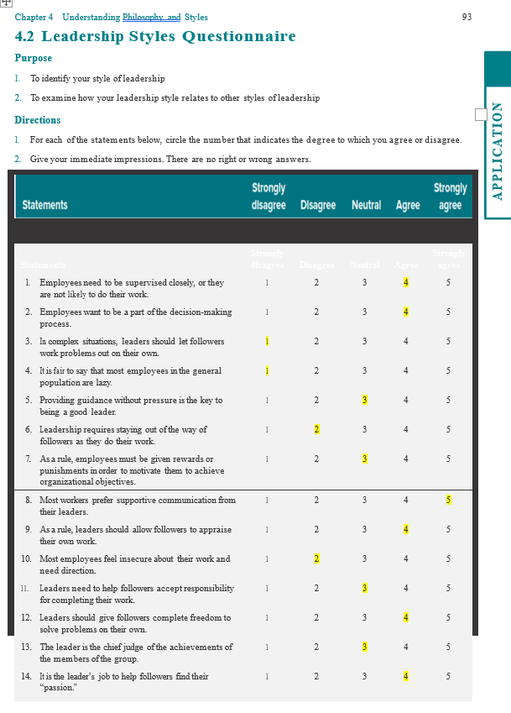

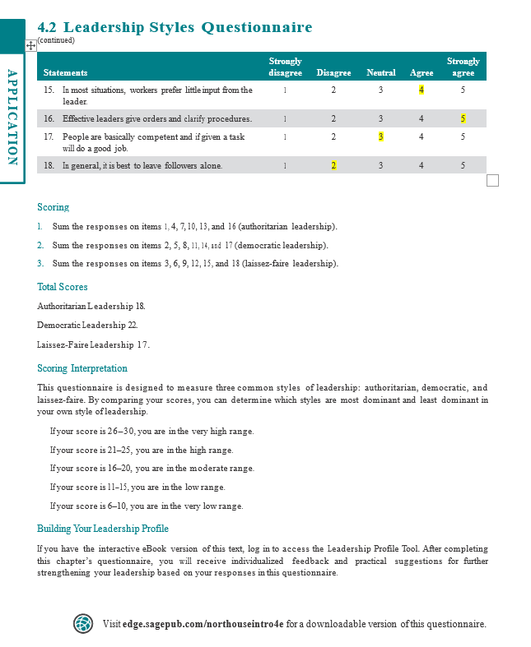

Appendix B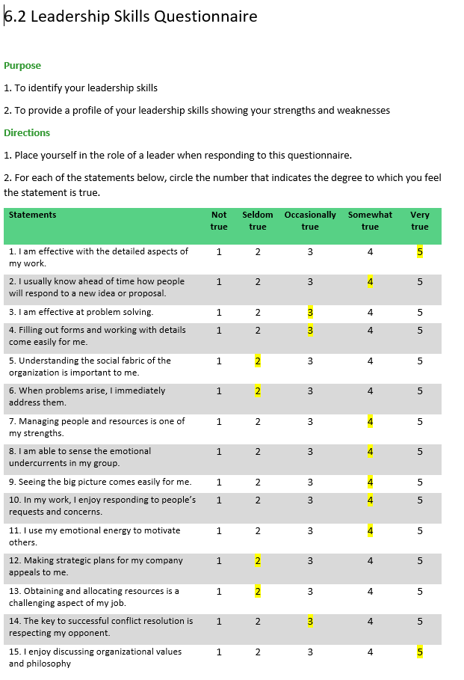

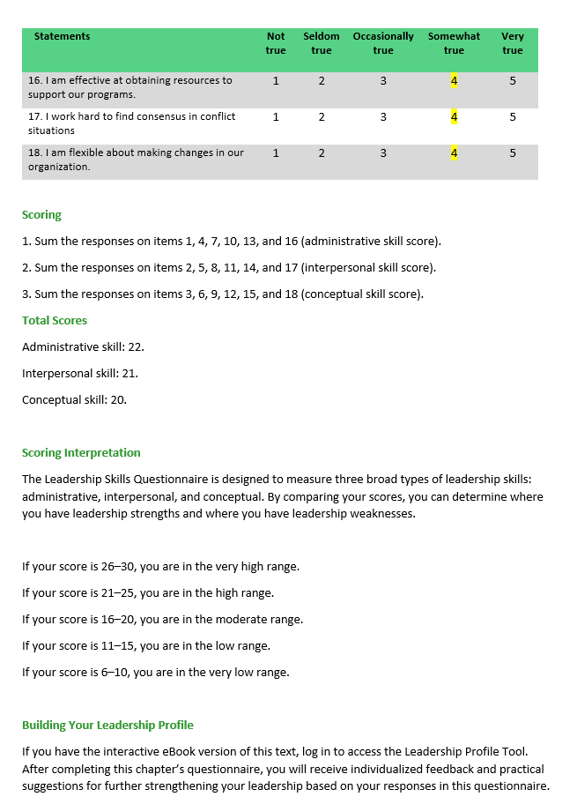

Appendix C

The Situational Leadership Model-

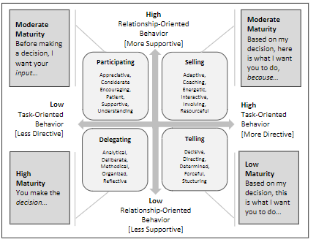
(Arora & Baronikian, 2013).

Appendix D

Layers of Human Behaviour & Performance ​
Identity-who?
Values and beliefs-why?
Capability-how?

Professional behaviour and performance

(Raymondson, 2013).

Appendix E

Motivating for High Performance​ Motivational Flow Model​
Star​
Performance​
Flow
Recognition​
&​
Achievement
Purpose
Motivation

(Mustafa, Elias, Noah, & Roslan, 2010).

