
Youth Work Interventions and Therapeutic Practice toolkit
Introduction and Rationale
Youth work is a dynamic and ever-evolving field that plays a vital role in supporting the healthy development of young people within our communities. Recognizing the unique challenges and opportunities that young people face in today’s world, this toolkit has been developed with a clear and practical purpose: to equip youth work practitioners with actionable resources, ideas, and strategies that can be immediately applied in their everyday work with young people.
The rationale behind this toolkit stems from a deep belief in the importance of youth work as a profession that not only supports the individual development of young people but also contributes to the broader health and wellbeing of our society. Through direct engagement with young people—whether in schools, community centers, outreach programs, or informal settings—youth workers have the potential to make a profound, lasting difference in the lives of those they support.

This toolkit is designed with practical application at its core. Drawing from both established theoretical frameworks and the lived experiences of practitioners, the resources provided here are intended to bridge the gap between theory and practice. Rather than presenting abstract concepts, the toolkit offers concrete tools and approaches that have been tried and tested in a range of youth work contexts. Whether you are a frontline practitioner, a team manager, or involved in training the next generation of youth workers, these resources aim to boost your confidence, provide fresh inspiration, and enhance your ability to make a positive impact.
Importantly, this toolkit acknowledges the diversity of youth work environments and the changing needs of young people. In contemporary practice, flexibility and adaptability are key. The challenges facing young people—such as mental health concerns, social exclusion, identity exploration, and the impacts of digital technology—require youth workers to be resourceful and responsive. The tools and strategies included in this toolkit are designed to be adaptable, ensuring they remain relevant in a rapidly shifting landscape.
At the heart of this work is a commitment to the values and principles of youth work: respect for young people’s autonomy, belief in their potential, and a focus on empowerment and participation. By sharing these resources, I hope to strengthen the professional community of youth workers and contribute to a culture of reflective, evidence-informed practice.

How the Toolkit Links to Module Aims and Learning Outcomes
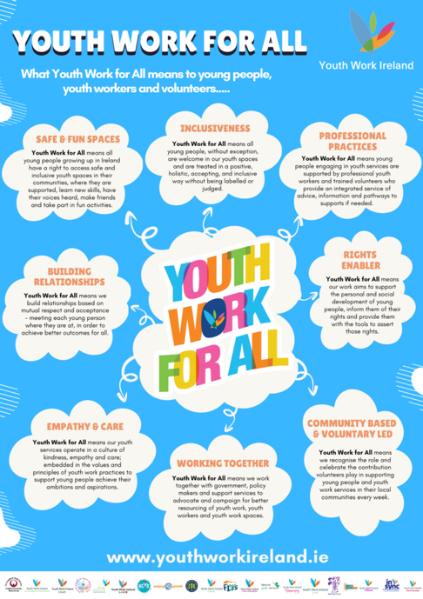
Youth work is not simply about delivering activities or providing a safe space for young people—although these are important aspects. Effective youth work is underpinned by a strong foundation of theory, evidence-based skills, and critical reflection. This toolkit is closely aligned with these aims and learning outcomes, demonstrating how theory and practice inform one another in the context of real-world youth work.
Blending Theory, Skills, and Reflection
The best youth work practice emerges when practitioners can seamlessly blend theoretical understanding with practical skills and a habit of reflective practice. Throughout this toolkit, you will find numerous examples of how theoretical concepts can inform everyday interactions and interventions with young people. By understanding the ‘why’ behind our actions, we become more intentional and effective in our practice.
Key Theories in Youth Work
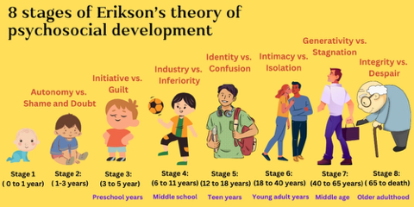
Erikson’s Stages of Development: Erik Erikson’s theory provides a valuable lens for understanding the social and emotional journeys that young people navigate. According to Erikson, adolescence is marked by the crisis of “identity vs. role confusion,” as young people seek to develop a sense of self and personal direction. By being aware of these developmental stages, youth workers can tailor their support to the particular challenges and opportunities that young people face at different ages.
Person-Centred Theory (Carl Rogers): Carl Rogers’ person-centred approach emphasizes the importance of empathy, unconditional positive regard, and authenticity in building trusting relationships. This theory underpins many youth work practices, from active listening to creating safe, non-judgmental spaces where young people feel valued and understood.
Social Learning Theory (Albert Bandura): Bandura’s social learning theory highlights the significance of observational learning—how young people learn by watching the actions and attitudes of others. By providing positive role models and fostering environments where pro-social behaviors are celebrated, youth workers can leverage this theory to encourage constructive learning and growth.
Skills in Practice
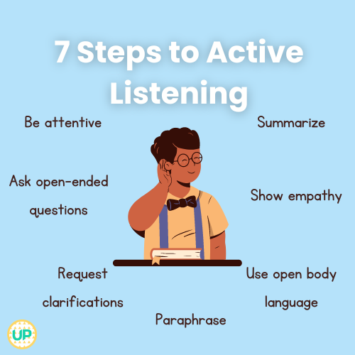
Theory only becomes meaningful when translated into practice. The following core skills are essential for youth work professionals:
- Active Listening: Deeply rooted in person-centred theory, active listening involves giving full attention to young people, reflecting back what they say, and validating their experiences. This helps young people feel genuinely heard and builds the trust necessary for effective support.
- Strengths-Based Approaches: Drawing from positive psychology and resilience theory, strengths-based practice encourages youth workers to focus on young people’s existing assets and capabilities, rather than solely on their challenges or deficits. This approach boosts self-esteem and motivation.
- Goal Setting and Action Planning: Informed by behavioral theories, supporting young people to set achievable goals and develop step-by-step plans fosters agency and a sense of accomplishment. Youth workers can use tools like SMART goals (Specific, Measurable, Achievable, Relevant, Time-bound) to guide this process.
Bringing Theory to Life: Real-World Examples
- Example 1: A young person is repeatedly engaging in risk-taking behaviors, such as substance use or skipping school. Applying social learning theory, a youth worker might identify positive influences in the young person’s life—perhaps a peer or community leader—and facilitate opportunities for them to spend more time together. By reinforcing healthy behaviors and providing consistent encouragement, the youth worker can help the young person adopt new, positive habits.

- Example 2: A youth worker notices that a young person is withdrawn and reluctant to participate in group activities. Using a person-centred approach, the worker prioritizes building a trusting relationship, demonstrating empathy, and offering unconditional support. Over time, the young person feels safer to open up and becomes more engaged in activities.
- Example 3: Supporting a young person through a major life transition, such as leaving school or entering employment, requires sensitivity to the identity exploration described by Erikson. The youth worker can acknowledge the challenges of this phase, provide relevant information, and offer guidance that respects the young person’s growing independence.
Reflecting on Practice
Regular reflection is a hallmark of effective youth work. Practitioners are encouraged to ask themselves questions such as:
- Which theories or principles informed my decisions today?
- How have my skills developed over time?
- What outcomes have I observed, and how do these relate to my interventions?
Engaging in supervision and peer discussions further strengthens the link between theory and practice, ensuring that learning is ongoing and practice is continually refined.
Summary: By combining theoretical knowledge, practical skills, and reflective habits, youth workers are better equipped to meet the diverse and evolving needs of young people. This toolkit offers a pathway for integrating these elements into everyday practice.

Building and Sustaining Relationships with Young People

At the core of successful youth work is the ability to build strong, meaningful relationships with young people. These relationships are not only the foundation for effective support and intervention, but also serve as models for healthy, respectful connections that young people can carry into other areas of their lives.
Starting Relationships
Beginning a relationship with a young person requires intentionality and sensitivity. Approaches include:
- Meeting Young People Where They Are: This means engaging with young people in environments where they feel comfortable and at ease, whether that’s a local park, community center, online platform, or school.
- Starting Conversations Naturally: Initiating dialogue at the right time and place—such as during an activity or in an informal setting—can help break the ice and establish rapport without pressure.
- Transparency and Role Clarity: Being upfront about your role, the nature of your support, and any boundaries or limitations is essential. This builds trust and sets clear expectations.
Developing and Sustaining Relationships
Sustaining relationships over time involves:
- Collaborative Goal Setting: Involving young people in decisions about their responsibilities and the direction of their engagement fosters ownership and mutual respect.
- Responsive Listening: Attending to young people’s questions, concerns, and feedback ensures that their voices are central to the process.
- Ethical Practice: Upholding integrity, confidentiality, and professional boundaries is non-negotiable. Adhering to legal and contractual guidelines protects both young people and practitioners.
- Values-Driven Practice: Youth work is guided by core values such as respect, inclusion, and empowerment. Remaining true to these principles, even in challenging situations, strengthens relationships and promotes positive outcomes.
Therapeutic Methods in Youth Work
Many youth work settings incorporate therapeutic approaches to support young people’s mental health and emotional wellbeing. While youth workers are not therapists, they often use therapeutic skills and models to create supportive environments.
- Solution-Focused Conversations: These focus on helping young people identify their strengths, resources, and possible solutions to challenges, rather than dwelling on problems.

- Cognitive-Behavioral Techniques: Youth workers may use basic CBT techniques, such as recognizing unhelpful thoughts and promoting alternative perspectives, to support young people in managing their emotions and behaviors.
- Group Work and Peer Support: Facilitating group discussions and peer-led activities provides opportunities for young people to share experiences, learn from one another, and develop social skills.
- Arts-Based and Creative Activities: Creative expression through art, music, drama, or writing can be a powerful tool for emotional processing and communication, especially for young people who find verbal expression difficult.
- Mindfulness and Relaxation: Introducing simple mindfulness exercises or relaxation techniques can help young people manage stress, anxiety, and other emotional challenges.
Case Study: Building Trust with a Reluctant Young Person
A youth worker meets Jamie, a 14-year-old who is new to the youth center and appears withdrawn. Recognizing Jamie’s reluctance to engage, the youth worker adopts a person-centred approach, offering consistent encouragement and respecting Jamie’s pace. Over several weeks, the worker uses creative activities as a non-threatening way to build rapport. Gradually, Jamie begins to open up, participates more actively, and eventually shares some personal concerns. Reflecting on this process, the youth worker realizes the importance of patience, empathy, and the power of creative interventions in building meaningful relationships.

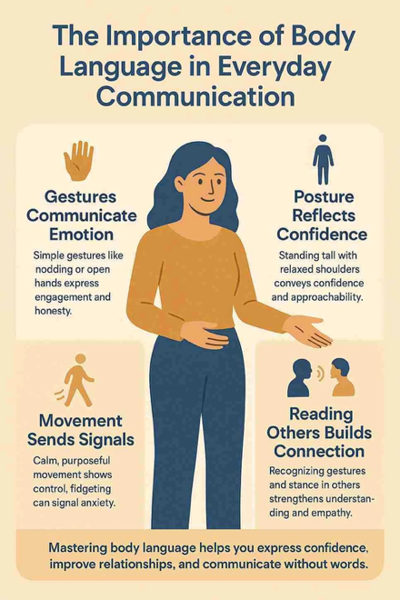
Key Skills for Effective Youth Work
To be effective, youth workers must cultivate a wide range of skills that support both group facilitation and one-to-one work. These skills are not innate—they can be developed and refined through practice, training, and reflection.
Communication Skills
Clear, respectful communication is fundamental. This includes:
- Verbal Communication: Using language that is age-appropriate, inclusive, and non-judgmental.
- Non-Verbal Communication: Being aware of body language, facial expressions, and tone of voice.
- Active Listening: Demonstrating genuine interest, reflecting back what is heard, and asking clarifying questions.
Empathy and Understanding

Empathy involves not only understanding what young people are experiencing, but also conveying that understanding in ways that foster connection and trust. This is particularly important in moments of conflict, distress, or uncertainty.
Group Facilitation
Facilitating groups requires:
- Managing Group Dynamics: Navigating the complexities of personalities, relationships, and potential conflicts within the group.
- Encouraging Participation: Creating opportunities for all voices to be heard, especially those who may be quieter or marginalized.
- Fostering a Positive Environment: Setting ground rules, modeling respectful behavior, and intervening when necessary to maintain safety and inclusivity.
Relationship-Building
Strong relationships are built on consistency, reliability, and respect. Youth workers who are approachable and trustworthy create spaces where young people feel safe to share their thoughts and experiences.
Problem-Solving and Flexibility

Youth work is unpredictable. Practitioners must be able to adapt to changing circumstances, think on their feet, and develop creative solutions to unexpected challenges.
Confidentiality and Professional Boundaries
Maintaining confidentiality is essential for building trust, but youth workers must also know when and how to share information appropriately—particularly when safeguarding concerns arise. Clear professional boundaries protect both young people and practitioners.
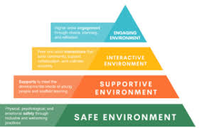
Knowledge of Youth Development
Understanding the stages and processes of youth development allows practitioners to tailor their support to the needs of individuals and groups. This includes awareness of how cultural, social, and environmental factors influence development.
Reflective Prompt: Consider a recent interaction with a young person. Which skills did you use? How did your approach affect the outcome?

Essential Knowledge for Youth Workers
A strong knowledge base enhances the quality of youth work practice. Key areas include:
Youth Development
Understanding the physical, emotional, cognitive, and social development of young people is crucial. This knowledge enables youth workers to recognize typical challenges—such as identity exploration, peer pressure, and risk-taking—as well as the influence of family, culture, and community.
Group Work and Facilitation
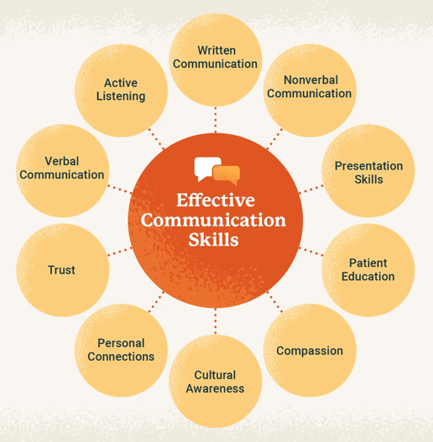
Knowledge of group processes is essential for effective group work. This includes understanding roles within groups, stages of group development (such as forming, storming, norming, performing, and adjourning), and strategies for managing conflict and promoting positive participation.
Effective Communication
Youth workers need to be skilled communicators, adept at using both spoken and non-verbal language. This involves active listening, being mindful of cultural differences, and adjusting communication styles to suit various ages, backgrounds, or individual needs.
Safeguarding and Boundaries
Keeping young people safe is a top priority. Youth workers must be familiar with safeguarding policies and procedures, understand confidentiality requirements, and know how to respond to disclosures or concerns appropriately.
Embracing Diversity
Valuing diversity means respecting differences in culture, religion, gender, sexuality, ability, and other characteristics. Inclusive practice ensures that all young people feel welcome, valued, and supported.
Local Knowledge
Familiarity with local services, programs, and opportunities allows youth workers to connect young people with additional support and resources as needed.


Association: The Heart of Youth Work
Definition and Significance
Association refers to the process of young people coming together to form groups, build friendships, and create communities of shared interest. This concept is central to youth work, reflecting the importance of belonging, participation, and collective identity.
Why Association Matters
- Learning Social Skills: Through association, young people develop communication, teamwork, and conflict resolution skills that are essential for life.
- Building a Sense of Belonging: Being part of a group provides emotional support, combats loneliness, and fosters a sense of acceptance.
- Becoming Community Members: Participation in collective activities—such as volunteering, student councils, or youth-led projects—helps young people understand their role in society and develop a sense of social responsibility.
How Youth Work Supports Association
- Providing Safe Spaces: Youth workers create environments—such as clubs, workshops, and events—where all young people feel welcome and included.
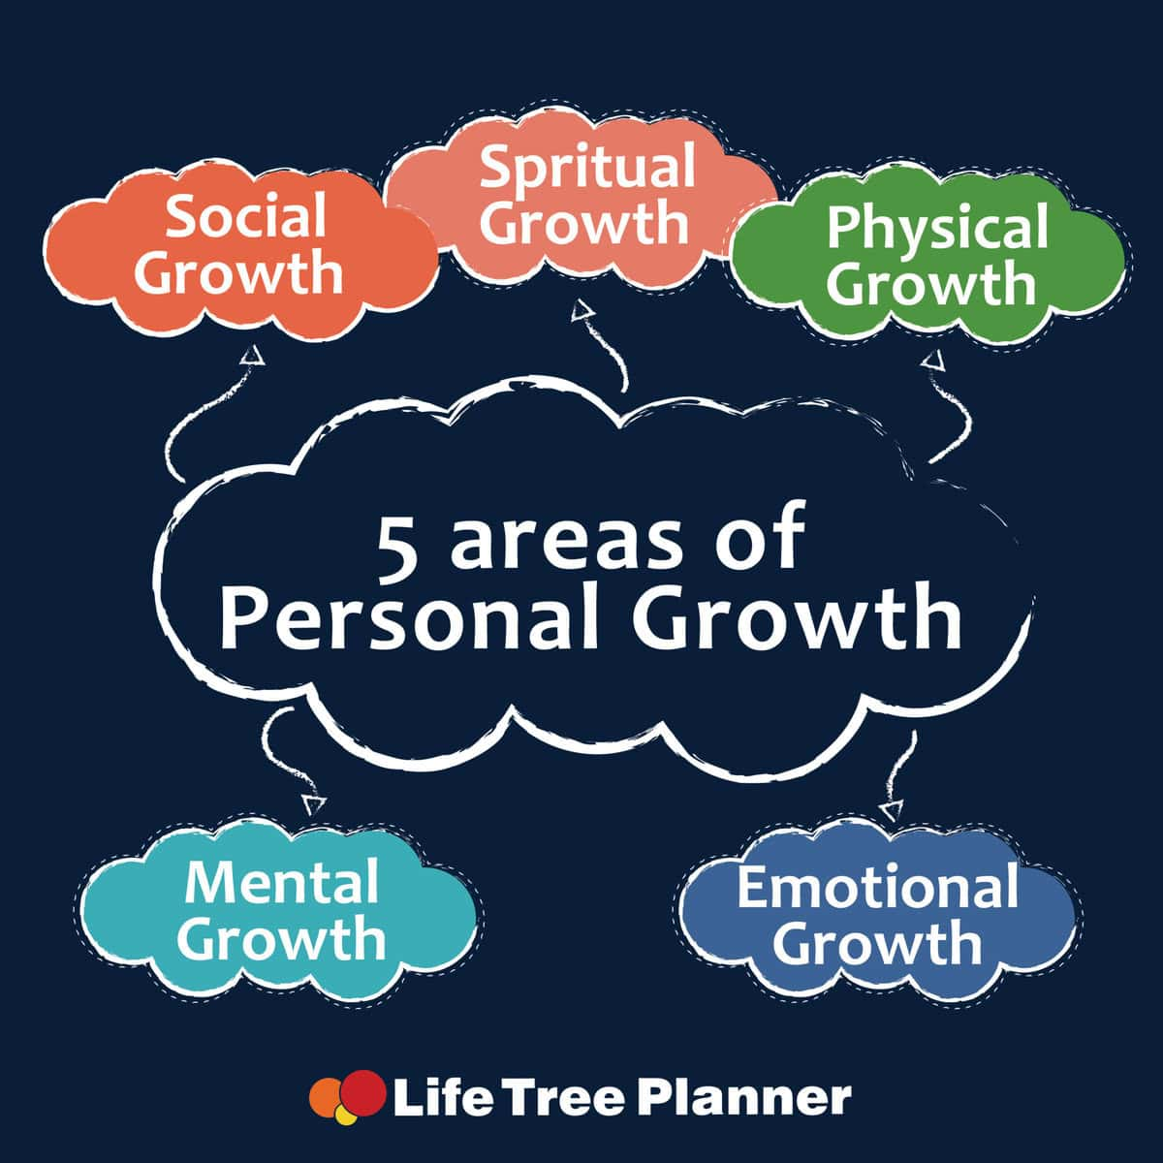
- Promoting Involvement and Leadership: By encouraging young people to plan activities, lead projects, and make decisions, youth workers foster agency and leadership skills.
- Supporting Personal and Social Growth: Through group discussions, team games, and collaborative projects, youth workers help young people build confidence, reflect on their strengths, and challenge their assumptions.
Example: A youth worker facilitates a debate on a topical issue, encouraging young people to express their views and listen to others. This not only builds communication skills but also strengthens the group’s sense of identity and cohesion.

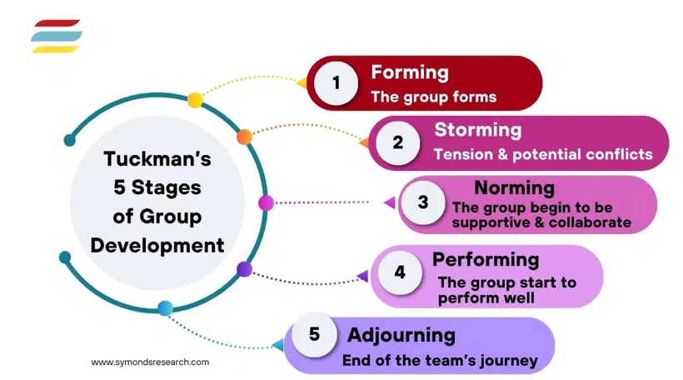
Theoretical Foundations: Group Work Theory and Informal Education
Group Work Theory in Youth Work
Group work theory posits that individuals learn and grow through participation in groups. Key components include:
- Group Dynamics: Understanding how relationships form and evolve within groups helps youth workers create inclusive environments.
- Participation: Ensuring that all members have opportunities to contribute builds confidence and belonging.
- Peer Learning: Young people often learn best from one another, sharing experiences and insights in ways that may not occur in one-to-one settings.
Informal Education in Youth Work
Informal education recognizes that much learning takes place outside formal settings. Its principles include:
- Voluntary Participation: Young people choose to engage, making learning more meaningful.
- Relationship-Building: Trusting relationships between youth workers and young people are foundational.
- Flexibility: Learning is tailored to young people’s interests and real-life concerns.
How These Theories Help Youth Workers
By using group work theory and informal education, youth workers can:
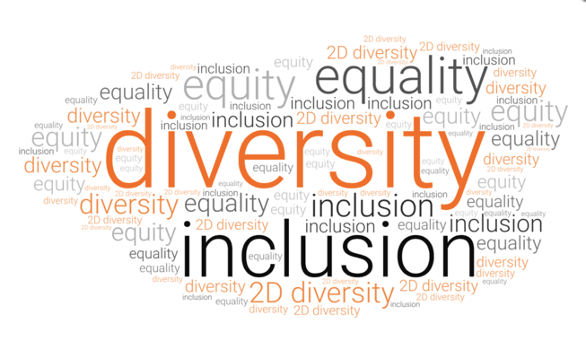
- Support Social and Emotional Growth: Activities and informal learning foster confidence and resilience.
- Encourage Inclusion and Empowerment: Participation and choice help young people feel respected and valued.
- Meet Individual and Group Needs: Flexibility allows for responsive, tailored support.
- Inspire Lifelong Learning: Informal education encourages curiosity and ongoing personal development.

Relationship-Building Strategies: Practical Tools and Interventions
Building meaningful relationships with young people requires practical strategies that are responsive to both individual and group contexts.

One-to-One Strategies
- Regular Check-Ins: Consistently making time for conversations allows young people to share their thoughts and feelings in a safe, confidential space.
- Active Listening: Paying full attention, reflecting back, and validating a young person’s experiences builds trust.
- Goal Setting: Working collaboratively to set and review goals supports agency and motivation.
Group Strategies
- Icebreakers and Energizers: Activities like “Two Truths and a Lie” or “Human Bingo” help break down barriers and foster group cohesion.
- Shared Goal Setting: Involving the group in setting collective goals or planning activities increases ownership and engagement.
- Facilitated Discussions: Structured conversations on topics that matter to the group encourage participation and respect for diverse viewpoints.

Therapeutic Models in Practice
- Person-Centered Model: Placing young people at the center, focusing on empathy and unconditional positive regard.
- Solution-Focused Brief Therapy: Emphasizing strengths and solutions rather than problems.
- Restorative Approaches: Facilitating dialogue and repair when conflicts arise.
Practical Example: A youth worker notices tension between two members of a group. Using restorative techniques, the worker facilitates a conversation where each person can express their feelings and work together to find a resolution. This not only addresses the conflict but also models healthy communication skills.

Facilitating Association: Practical Methods and Activities

Youth workers play a pivotal role in helping young people form supportive peer connections. Effective facilitation involves:
- Creating Welcoming Environments: Setting ground rules and using inclusive language to ensure all young people feel valued.
- Structured Group Activities: Team challenges, collaborative projects, and group discussions build trust and cooperation.
- Reflection and Feedback: Encouraging young people to reflect on their experiences and give feedback promotes growth and strengthens group identity.

Example Activities:
- Team Challenge: Divide the group into teams and set a collaborative task, such as building a bridge from everyday materials. This encourages teamwork and creative problem-solving.
- Open Discussion: Facilitate a conversation on a topic chosen by the group, ensuring all voices are heard and respected.

Practical Tools and Resources
Resource 1: Emoji Feelings Game
How to Use:
- Hand out cards or pieces of paper to everyone, each showing a different emoji (happy, sad, surprised, etc.).
- Ask everyone to pick the emoji that best matches how they’re feeling today and explain their choice.
- This activity works well as a check-in or icebreaker.
Ways to Adapt:
- Use stickers or let participants draw their own emojis for younger groups.
- Have participants post their emoji in the chat for online sessions.
- Use at the start of a session or as a transition activity.
Resource 2: Superpower Speed Chat
How to Use:
- Go around the group and ask: “If you could have any superpower, what would it be and why?”
- Give each person about 30 seconds to share their answer, keeping the pace lively.
- This is a fun, fast way to boost energy and help everyone learn about each other.
Ways to Adapt:
- Switch up the question (e.g., favorite animal, dream vacation).
- Use as a warm-up, to re-energize, or help the group refocus.
- Works both in-person and virtually.
Additional Resources:
- Values Card Sort: Provide cards with different values (e.g., honesty, friendship, creativity). Ask young people to choose those most important to them and discuss their choices. This helps with self-awareness and group understanding.
- Group Agreements: Collaboratively develop a set of group rules or expectations at the start of a program. This fosters ownership and accountability.

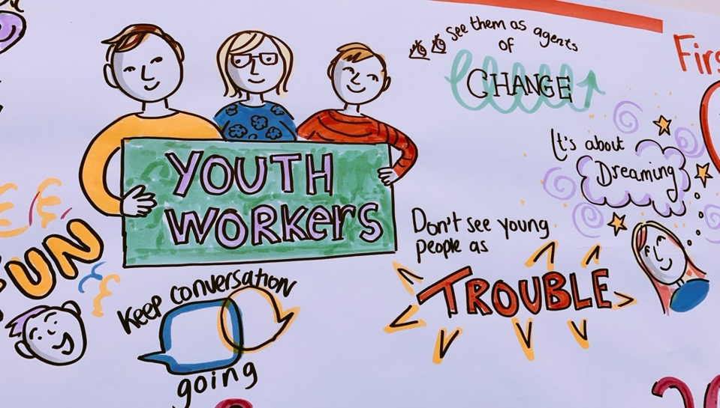
Conclusion
This toolkit reflects the best of current youth work practice, grounded in theory and lived experience. By using these tools, strategies, and resources, youth workers can build stronger relationships, foster association, and support young people to thrive—both as individuals and members of their communities. Through ongoing reflection, skill development, and a commitment to the values of youth work, practitioners can continue to make a meaningful, lasting impact.

References:
Davies, B. (2019) Austerity, youth policy and the deconstruction of the youth service in England. London: Palgrave Macmillan.

Ord, J. (2016) Youth work process, product and practice: Creating an authentic curriculum in work with young people. 2nd edn. Abingdon: Routledge

Jeffs, T. and Smith, M. K. (2010) Youth work practice. Basingstoke: Palgrave Macmillan
Erikson, E. H. (1968) Identity: Youth and crisis. New York: W. W. Norton.
Rogers, C. R. (1961) On becoming a person: A therapist’s view of psychotherapy. Boston: Houghton Mifflin.
Bandura, A. (1977) Social learning theory. Englewood Cliffs, NJ: Prentice Hall.
National Youth Agency (NYA) (2020) Youth Work Essentials: Skills and Knowledge. Available at: https://www.nya.org.uk/resource/youth-work-essentials-skills-and-knowledge/ (Accessed: 11 May 2026)
National Youth Agency (NYA) (2021) Reflective Practice in Youth Work. Available at: https://www.nya.org.uk/resource/reflective-practice-in-youth-work/ (Accessed: 11 May 2026).
National Youth Agency (NYA) (2020) Building Relationships in Youth Work. Available at: https://www.nya.org.uk/resource/building-relationships-in-youth-work/ (Accessed: 11 May 2026).
Youth Access (2022) Therapeutic Youth Work: Guidance for Practitioners. Available at: https://www.youthaccess.org.uk/resources/therapeutic-youth-work-guidance-for-practitioners (Accessed: 11 May 2026).
National Youth Agency (NYA) (2020) Youth Work Skills and Competencies Framework. Available at: https://www.nya.org.uk/resource/youth-work-skills-and-competencies-framework/ (Accessed: 11 May 2026).

National Youth Agency (NYA) (2020) Youth Work Curriculum. Available at: https://www.nya.org.uk/resource/youth-work-curriculum/ (Accessed: 11 May 2026).
National Youth Agency (NYA) (2020) The Value and Practice of Association in Youth Work. Available at: https://www.nya.org.uk/resource/value-and-practice-of-association-in-youth-work/ (Accessed: 11 May 2026).
Infed (2020) Group Work and Informal Education in Youth Work. Available at: https://infed.org/mobi/group-work-and-informal-education-in-youth-work/ (Accessed: 11 May 2026).
National Youth Agency (NYA) (2022) Building Positive Relationships in Youth Work. Available at: https://www.nya.org.uk/resource/building-positive-relationships-in-youth-work/ (Accessed: 11 May 2026).
National Youth Agency (NYA) (2020) Facilitating Groups and Peer Relationships in Youth Work. Available at: https://www.nya.org.uk/resource/facilitating-groups-and-peer-relationships-in-youth-work/ (Accessed: 11 May 2026).

