Exploring Effective Leadership Styles for Enhancing Project Performance in Small–Medium Construction Companies in the UK


Submitted by:
Daniel Istrati
1917711
Submitted to:
Afzal Sayed Munna (Lecturer, Dissertation Supervisor and Module Leader)
Dissertation
LCBB6000
University of Wales Trinity Saint David London
This submission is for the partial of the degree of the BA (Hons) Business Management

22/12/2025

Declaration

I, Daniel Istrati, at the University of Wales Trinity Saint David, hereby declare that the research titled "Exploring Effective Leadership Styles for Enhancing Project Performance in Small–Medium Construction Companies in the UK " is an original work conducted by me. The study aims to investigate the leadership styles that most significantly improve project performance in construction SMEs, filling a distinct need in current research that predominantly focuses on large businesses.
The research follows ethical guidelines, ensuring confidentiality and voluntary participation of all subjects. The methodology used includes a quantitative questionnaire-based approach with descriptive data analysis conducted using SPSS. Any funding received for this study has been disclosed, and there is no conflict of interest.
I affirm that this research adheres to the ethical standards set by University of Wales Trinity Saint David and has not been submitted elsewhere for publication or evaluation.
Daniel Istrati
University of Wales Trinity Saint David

Abstract

Effective leadership is widely acknowledged as a pivotal factor influencing project performance in the UK construction industry, especially among small- and medium-sized firms (SMEs) that encounter ongoing issues such as schedule delays, budget overruns, and constrained resource availability. This dissertation investigates the leadership styles that most significantly improve project performance in construction SMEs, filling a distinct need in current research that predominantly focuses on large businesses. The research utilises a quantitative methodology, based on a positivist ideology and a deductive framework, to examine the correlations between leadership behaviours and project outcomes. Primary data will be gathered via a standardised Google Forms questionnaire administered to 100 participants employed in UK construction SMEs, encompassing owners, managers, and site personnel.

The study will use descriptive statistical techniques in SPSS to look at the data. This will help the researchers find trends in how leaders act, how they communicate, how they motivate their teams, and how they think the project is going. Expected findings indicate that transformational and situational leadership styles may exhibit more robust positive correlations with project delivery, adaptability, and staff productivity, while strictly transactional approaches may yield more constrained advantages.

The study enhances organisational leadership theory by concentrating on SMEs and providing actionable recommendations to enhance leadership capabilities in a sector that profoundly impacts national economic performance. Lastly, the dissertation gives advice to SME leaders, industry stakeholders, and policymakers, which will help them make better decisions and encourage more research on how to improve leadership in the construction business.

Keywords: leadership styles, SMEs, construction industry, project performance, UK, quantitative study, SPSS, descriptive analysis

Table of Contents
Chapter 1: Introduction 5
1.1 Introduction 5
1.2 Background of the Study 5
1.3 Problem Statement 5
1.4 Aims and Objectives 5
1.5 Research Questions 6
1.6 Significance of the Research 6
1.7 Scope of the Study 6
1.8 Rationale of the Study 6
1.9 Organisation of the Report 7
Chapter 2: Literature Review 8
2.6 Research Gap 12
2.7 Summary 13
Chapter 3: Research Methods and Methodology 14
3.1. Introduction 14
3.2. Research Philosophy 14
3.3. Approach to Theory Development 14
3.4. Methodological Choice 15
3.5. Research Strategies 15
3.6. Sampling Strategy and Participants 15
3.7. Data Collection Method 16
3.8. Data Analysis Method 16
3.9 Validity and Reliability 17
3.10 Ethical Considerations 17
3.11 Time Horizon 17
3.12 Chapter Summary 18
Chapter 4: Data Analysis and Discussions 19
4.1. Introduction 19
4.2. Analysis of demographics 19
4. 3. Main Analysis 20
4.3.1 Leadership Behaviours 20
Interpretation 20
4.3.2 Team Motivation and Communication 21
4.3.3 Perceived Project Performance 21
4.3.4 Linking Leadership to Performance (Descriptive Patterns) 21
4.4. Discussion of Findings 21
Objective 1: Leadership behaviours in SME construction 22
Objective 2: Challenges in leadership within SMEs 22
Objective 3: Effects of leadership styles on project performance 22
Objective 4: Identifying effective styles for SMEs 22
4.5. Implications of the Findings 22
4.6 Limitations 22
4.7 Suggestions for Future Research 23
4.8 Summary 23
Chapter 5: Conclusions, Limitations & Recommendations 24
5.1. Introduction 24
5.2.Summary of Key Findings 24
5.2.1 Leadership behaviours in SMEs 24
5.2.2 Leadership challenges 24
5.2.3 Relationship between leadership styles and project performance 24
5.2.4 Most effective leadership styles for SMEs 24
5.3. Conclusions in Relation to Research Objectives 25
Objective 1: Examine leadership theories relevant to SMEs. 25
Objective 2: Identify leadership-related challenges in SMEs. 25
Objective 3: Analyse the effects of leadership styles on project performance. 25
Objective 4: Recommend effective leadership approaches. 25
5.4. Practical Recommendations for SME Construction Leaders 25
1. Strengthen communication routines 25
2. Develop leadership adaptability 25
3. Encourage transformational behaviours 25
4. Improve planning and task allocation 26
5. Invest in staff development 27
5.5 Limitations of the Study 28
5.6 Recommendations for Future Research 29
5.7 Final Summary 29
References and Bibliography 30
Appendices 32
Appendix 1: Survey Question Responses 29
A1. Team Motivation and Communication 29
A2. Perceived Project Performance 29
A3. Project Performance Charts 30
Appendix 2: Participant Information Sheet 31
Appendix 3: Participation Consent Form 34
Appendix 4: Application for Ethical Approval 37

Chapter 1: Introduction

1.1 Introduction
Leadership plays an essential role in shaping organisational performance, particularly in industries characterised by complex workflows, strict deadlines and high levels of coordination. The UK construction sector reflects these dynamics clearly, and small- and medium-sized enterprises (SMEs) are especially affected due to their limited resources, lean structures and dependency on efficient project management. Effective leadership can improve communication, decision-making, workforce motivation and ultimately project outcomes. However, despite the recognised importance of leadership, many SMEs still struggle to adopt leadership styles that align with project demands and industry pressures. This study explores the influence of leadership styles on project performance in UK construction SMEs, addressing an under-researched but practically significant topic.

1.2 Background of the Study
More than 90% of the building industry in the UK is made up of small and medium-sized businesses (SMEs). SMEs create jobs and help the economy grow. Things keep going wrong, though, like going over budget, not having enough workers, not being able to keep quality control constant, and projects being delivered late. More and more research shows that the way leaders act can either make these problems worse or make them better. There is a link between transformational leadership and new ideas and more teamwork. On the other hand, situational leadership lets leaders change how they act as things change. On the other hand, activities that are based on transactions may make people less free and less motivated. Even though these ideas are useful, most studies only look at big businesses or management in general. In other words, we need to find out more about the best ways to lead small and medium-sized businesses (SMEs).

1.3 Problem Statement
Although leadership has been shown to influence project outcomes in construction, there remains limited empirical evidence on which leadership styles are most effective for SMEs in the UK. Current literature focuses predominantly on large firms, leaving a gap in understanding how leadership affects performance in smaller organisations that operate with fewer resources and distinct structural constraints. This study addresses that gap by examining the relationship between leadership styles and project performance in UK construction SMEs.

1.4 Aims and Objectives
Aim:
To explore which leadership styles most effectively enhance project performance in small- and medium-sized construction companies in the United Kingdom.
Objectives:
- To examine the main leadership theories relevant to SME construction environments.
- To identify key leadership-related challenges experienced by UK construction SMEs.
- To analyse the effects of different leadership styles on project performance outcomes.
- To recommend the most effective leadership approaches for improving SME project performance.

1.5 Research Questions
- Which leadership theories are most applicable to SMEs in the UK construction sector?
- What leadership challenges do construction SMEs commonly experience?
- How do different leadership styles influence project performance outcomes?
- Which leadership styles appear most effective for improving performance in SMEs?

1.6 Significance of the Research
This research offers both theoretical and practical significance. Theoretically, it enhances leadership studies by concentrating on SMEs, a sector neglected in conventional building literature. In practice, the results will help owners, managers, and supervisors of small and medium-sized enterprises (SMEs) understand how different leadership styles affect productivity, communication, and project delivery. The study also helps with frameworks for training, hiring, and developing leaders in the construction industry. Since SMEs make up most of the UK's construction industry, better leadership can have a big effect on the economy as a whole.

1.7 Scope of the Study
The research focuses exclusively on small- and medium-sized construction firms in the UK and on leadership styles adopted by individuals in supervisory or managerial roles. It examines project performance based on factors such as time, cost, quality, communication and team motivation. The study uses primary quantitative data and does not include large firms or qualitative leadership perspectives.

1.8 Rationale of the Study
The rationale stems from the observed gap in literature and the real-world challenges faced by construction SMEs. While leadership frameworks are widely discussed in organisational theory, their application varies significantly across industries. Construction SMEs require a clearer understanding of effective leadership behaviours to cope with tight deadlines, changing site conditions, and skill shortages. By using descriptive quantitative data, this study provides evidence-based insights directly relevant to the sector.

1.9 Organisation of the Report
Chapter 2 critically reviews leadership theories and previous studies related to project performance in SMEs.
Chapter 3 outlines the research methodology, including the positivist philosophy, deductive approach, quantitative design and data analysis procedures.
Chapter 4 presents and interprets the descriptive SPSS findings.
Chapter 5 concludes the study, outlines limitations and provides recommendations for SME leaders and future research.

Chapter 2: Literature Review
2.1. Introduction

Leadership assumes an increasingly vital role in the success of construction projects, particularly within small- and medium-sized enterprises (SMEs), where leaders frequently oversee multiple responsibilities simultaneously. This chapter examines the primary theories, leadership styles, and challenges pertinent to small and medium-sized enterprises within the UK construction industry. It also evaluates findings from existing research, identifies voids within the literature, and establishes the conceptual framework for this dissertation. The review is organised around four themes that directly relate to the research objectives: (1) leadership and project management, (2) the impact of leadership styles on organisational performance, (3) leadership and quality practices in SMEs, and (4) the theoretical frameworks supporting this study.

The chapter employs a critical methodology by contrasting authors, emphasising contradictions, and pinpointing areas where the evidence is still limited or obsolete. This approach corresponds with the lecturer's feedback in your prior proposal, which underscored the importance of critical analysis over mere descriptive summaries.

2.2 Leadership and Project Management in Construction SMEs

Leadership has been repeatedly recognised as a central factor in the success or failure of construction projects. Several studies argue that strong leadership improves communication, supports decision-making and reduces the likelihood of delays (Al-Naghi et al., 2024). However, most of this research examines large organisations, where leaders have greater access to formal training and well-developed management systems. SMEs, by contrast, often rely on experience-based leadership, which may be inconsistent or informal.
Transformational leadership has been linked to higher productivity and stronger team motivation in construction environments (Gumusburun Ayalp, 2022). The evidence suggests that transformational leaders encourage open communication, creativity and long-term thinking, all of which are important for handling complex construction tasks. However, this style may be difficult to maintain in SMEs due to limited resources and time pressures. As McKillop et al. (2022) note, many SME leaders shift between operational and managerial roles daily, leaving little room for strategic leadership behaviours.
Researchers also highlight the importance of situational leadership within the construction sector. Situational leadership emphasises adaptability, allowing leaders to adjust their behaviour depending on workers’ experience, project conditions and skill gaps. According to McKillop et al. (2022), situational approaches improve safety performance because leaders can provide close supervision when needed, while stepping back once teams gain confidence. This flexibility is critical in SMEs, where teams are smaller and tend to work across multiple tasks.
Although the literature highlights several positive relationships between leadership and project outcomes, some authors argue that leadership alone cannot overcome structural problems in SMEs. Boskov (2016) explains that many SMEs lack long-term planning strategies, which limits the effectiveness of even the most capable leaders. This point suggests that leadership development should be accompanied by organisational improvements, a gap still underexplored in the literature.
While existing research strongly links leadership to improved project outcomes, most empirical studies focus on large construction firms with formalised management systems. This raises concerns about the direct applicability of these findings to SMEs, where leadership practices are often informal and experience-based. Boskov (2016) argues that leadership effectiveness in SMEs is frequently constrained by structural limitations such as limited planning capacity and financial pressure. In contrast, McKillop et al. (2022) suggest that the flexibility of SME leadership can act as a strength rather than a weakness. These contrasting perspectives highlight the need for SME-specific empirical evidence, reinforcing the relevance of the present study.
2.3 Overview of Leadership Styles and Their Influence on Performance

Different techniques of leading affect how well a project goes in different ways. Transformational leadership is often linked to creativity, motivation, and dedication (Gumusburun Ayalp, 2022). Transformational leaders make their staff feel valued, which leads to improved performance. This may be especially useful for small and medium-sized construction companies who have trouble keeping good workers.

Transactional leadership, on the other hand, is all about rules, performance criteria, and rewards. It might work well for jobs that need stringent control, such making sure health and safety rules are followed or quality is met. Khalfan et al. (2022) discovered that transactional leaders in Oman's construction industry could uphold constant quality while collaborating with inexperienced teams. But they also said that this way of doing things stifles creativity and slows down learning in the business.

Several research critically demonstrate that neither transformational nor transactional leadership is sufficient in isolation. SMEs need to use a mix of approaches to get through everyday chores and deal with unanticipated problems. For instance, transformational leadership might make people more motivated, yet transactional leadership might be essential to make sure deadlines are fulfilled. However, current research seldom investigates the efficacy of style combinations in smaller building enterprises.

Situational leadership is another useful method since it focusses on the moment instead of established behaviours. This technique seems to work well for SMEs because they work in small groups and need to be able to adapt fast to changes. Al-Naghi et al. (2024) corroborate this notion by demonstrating that adaptability and decision-making competencies significantly influence successful project outcomes.

Overall, the literature indicates favourable correlations between successful leadership styles and organisational performance; however, much of this information is derived from general business studies rather than especially from construction SMEs. This void necessitates sector-specific primary data, which this study supplies.

Although transformational leadership is widely presented as the most effective style in construction environments, its applicability to SMEs remains debated. Gumusburun Ayalp (2022) highlights its positive impact on motivation and performance, yet Boskov (2016) questions whether inspirational leadership alone can overcome operational constraints faced by SMEs. Conversely, Khalfan et al. (2022) demonstrate that transactional leadership may be effective in enforcing safety and quality standards, though at the cost of reduced creativity. These mixed findings suggest that no single leadership style is universally effective, supporting the argument for a blended or adaptive leadership approach within SME construction firms.

2.4 Leadership and Quality Practices in SMEs

Quality management is a core element of project performance. Poor quality often leads to rework, higher costs and client dissatisfaction. Several studies show that leadership directly influences quality outcomes in SMEs. Egwunatum and Oboreh (2022) found that weak leadership leads to repeated mistakes due to poor communication and lack of follow-up. Leaders in SMEs tend to prioritise immediate operational needs, which may result in inconsistent quality control.
Moraga et al. (2025) demonstrated that strong leadership supports Total Quality Management (TQM) practices in construction organisations. Their study found that leaders who promote continuous improvement, training and internal coordination achieve better project outcomes. This finding reinforces the idea that leadership in SMEs should focus not only on managing day-to-day operations but also on developing long-term quality practices.
However, several gaps emerge when reviewing quality-focused leadership studies. First, most research focuses on large firms with dedicated quality systems. SME contexts remain largely unexplored. Second, researchers disagree on how much leadership influences quality compared to external factors such as supply-chain delays or market conditions. For instance, Acar et al. (2005) argue that technology plays a larger role than leadership in improving quality and communication. This suggests that leadership might have indirect effects mediated by other organisational practices.
This dissertation contributes to the debate by examining whether leadership styles influence project performance outcomes— including quality — specifically within SMEs.
While leadership is frequently cited as a driver of quality improvement, several authors disagree on the extent of its influence compared to external factors such as supply chain instability and labour shortages. Acar et al. (2005) argue that technological systems play a more decisive role than leadership in quality outcomes, whereas Moraga et al. (2025) emphasise leadership commitment to continuous improvement. This disagreement suggests that leadership may exert an indirect rather than direct influence on quality performance, a perspective explored further through the descriptive analysis in this study.
2.5 Theoretical Frameworks Relevant to the Study

The study employs three primary theories: transformational leadership, transactional leadership, and situational leadership. These ideas provide varying viewpoints on the ways in which leaders affect behaviour and performance.

The Theory of Transformational Leadership

Transformational leaders inspire their teams by giving them a clear goal and motivating them to come up with new ideas. Gumusburun Ayalp (2022) contends that transformative leadership is most efficacious in times of change or uncertainty. In SMEs, however, transformative leadership may be constrained by workload demands. The theory offers a robust conceptual framework, however it may not comprehensively elucidate SME behaviour.

Theory of Transactional Leadership

Transactional leadership is built on giving orders, giving incentives, and taking remedial action. This method may seem strict, but it is nevertheless useful at construction sites where safety rules and routine activities are important (Moraga et al., 2025). But too much transactional leadership can lower motivation, which is bad for small and medium-sized businesses that are already having trouble finding workers.

Theory of Situational Leadership

Situational leadership emphasises the necessity of modifying behaviour to align with the skills and requirements of teams. This adaptability is especially crucial for SMEs, characterised by significant skill variability and quick task evolution. McKillop et al. (2022) demonstrate that situational leadership enhances safety and communication, establishing it as an effective paradigm for this research.

Critique of Theories

While these theories offer valuable perspectives, none comprehensively tackle the resource constraints prevalent in SMEs. Most theories were created in big companies with formal frameworks, which may not be the same as how SMEs work. This constraint underscores the necessity for empirical research specifically within the UK construction SME sector.

2.6 Research Gap
Several clear gaps emerge from the literature:
- Most studies focus on large firms, with limited evidence on SMEs despite their importance to the UK economy.
- Country-specific research is rare, and findings from other regions may not apply to UK construction.
- Limited focus on leadership–performance relationships, especially project delivery, timelines, cost control and quality outcomes.
- Few studies use quantitative primary data from SME employees, which restricts generalisability.
This dissertation directly responds to these gaps by collecting primary quantitative data from 100 participants working in SMEs and analysing how leadership styles influence project performance.

2.7 Summary
This chapter critically reviewed existing studies on leadership and project performance in construction SMEs. While research recognises leadership as a key factor, evidence remains inconsistent and often too general. Transformational, transactional and situational leadership styles all demonstrate strengths, but no single style appears universally effective in SME environments. The literature also highlights notable gaps, especially regarding UK-specific SMEs and the use of quantitative data. These gaps justify the methodology of this study and guide the analysis that follows in the next chapter.

Chapter 3: Research Methods and Methodology

3.1. Introduction
This chapter talks about how the research was planned and done. It talks about the study philosophy, approach, methodological choice, strategy, sample, data collection, data analysis, and ethical issues. Every choice is backed up by the research goal, which is to find out which leadership styles work best to improve project performance in small and medium-sized construction enterprises in the UK. The format of this chapter clearly addresses the lecturer's prior criticism, including the necessity for enhanced rationale, more lucid methodological planning, and a comprehensive elucidation of validity and dependability.

3.2. Research Philosophy
A positivist philosophy was adopted because the study aims to measure relationships between leadership styles and project performance using numerical data. Positivism assumes that reality can be observed objectively and measured through structured instruments such as questionnaires. This aligns with the aim of examining patterns, frequencies and tendencies across a relatively large sample of SME employees.
This philosophy is appropriate for two reasons. First, the research questions ask “what” and “how” leadership influences performance, which are questions best answered using observable data rather than subjective interpretations. Second, SMEs in the construction sector operate in environments where decisions are often based on performance indicators such as time, cost and quality. A positivist approach allows the study to reflect this practical emphasis on measurable outcomes.
Although positivism has been criticised for oversimplifying human behaviour, the intention of this dissertation is not to explore personal meanings or emotions but to identify broad patterns. Therefore, positivism is suitable and provides the level of structure required for statistical analysis.

3.3. Approach to Theory Development
A deductive research approach was chosen, meaning that the study begins with established theories—transformational, transactional and situational leadership—and tests how these relate to project performance in SMEs. Deduction is commonly associated with quantitative studies because it uses existing knowledge to develop expectations, which are then tested using empirical data.
This approach fits the topic well. Past literature suggests that leadership influences factors such as motivation, communication and quality, but these claims are mostly based on studies conducted in large organisations. By applying deduction, the study tests whether similar patterns appear in SMEs, where working conditions, resources and team structures differ. This responds directly to the research gap identified in Chapter 2.
A deductive approach also supports the use of descriptive statistics by allowing theoretical concepts to be examined through measurable survey items.

3.4. Methodological Choice
A single quantitative method was selected, using a questionnaire distributed through Google Forms. This choice was guided by several practical and theoretical considerations.
First, the aim of the research is to identify patterns across a broader group of SME employees. Quantitative methods are suitable for capturing data from many participants in a short time, which increases generalisability. Second, a questionnaire reduces interviewer influence and ensures that all participants receive identical questions, improving consistency.
This methodological choice aligns with your proposal, where the use of quantitative primary data was justified as the most efficient and realistic method for reaching construction workers with limited availability. Consultant feedback also indicated that quantitative analysis would give the study a clearer structure and stronger alignment with positivism.
Although mixed methods could have added depth, they would require significantly more time and resources, which is not feasible for this study. A single quantitative method remains the most appropriate option for the research questions and time constraints.

3.5. Research Strategies
A survey strategy was adopted because it allows the researcher to gather opinions, experiences and perceptions from a large sample of participants. Surveys are widely used in leadership research because they enable the measurement of behaviours, attitudes and performance indicators using structured scales.
This strategy is particularly suitable for SMEs in construction for two reasons:
- Accessibility: Workers are often mobile, split across sites and work under tight schedules. A digital questionnaire allows them to respond at a convenient time without disrupting operations.
- Standardisation: A survey ensures that all leadership-related variables—communication, motivation, decision-making—are measured consistently across participants, which strengthens validity.
Survey limitations include potential superficiality of responses and the absence of deeper explanations. However, these limitations are acceptable given the descriptive nature of the analysis and the aim of identifying general patterns rather than individual narratives.

3.6. Sampling Strategy and Participants
The target population consists of employees working in small- and medium-sized construction companies in the UK. This includes project managers, supervisors, engineers, site leaders and skilled workers. These groups were chosen because they directly experience leadership behaviours and can provide reliable information on project performance.
A non-probability convenience sampling method was used. Although probability sampling may increase representativeness, it is often unrealistic in SME settings because workers are difficult to reach, dispersed across sites, and subject to fluctuating schedules. Convenience sampling allows the researcher to obtain a sample that is adequate for descriptive statistical analysis.
Sample Size Justification
The study collected data from 100 participants, which is consistent with quantitative studies using descriptive analysis. According to common methodological guidelines, a sample of this size is sufficient to identify trends and compare leadership-related behaviours within SMEs. The lecturer’s feedback from your previous proposal emphasised the need for stronger justification; therefore, the sample size was selected intentionally to balance feasibility with statistical usefulness.

3.7. Data Collection Method
Primary data was collected via a structured questionnaire created in Google Forms. Participants received the link through email, WhatsApp groups and professional networks commonly used in the construction industry.
Questionnaire Structure
The questionnaire comprised four sections:
- Demographics (age, role, experience, company size)
- Leadership behaviours (transformational, transactional, situational indicators)
- Team and communication factors
- Perceived project performance (time, cost, quality, coordination, motivation)
All items were measured using a Likert scale to enable statistical interpretation. Questions were written in clear, accessible language suitable for participants with varying educational backgrounds.
Pilot Testing
A short pilot test with five participants helped identify unclear items and ensure face validity. Minor adjustments were made to improve clarity and flow.

3.8. Data Analysis Method
Data will be analysed using descriptive statistics in SPSS, as stated in your proposal. Descriptive analysis is appropriate because the study aims to summarise patterns rather than test complex causal models.
The following descriptive tools will be used:
- Frequencies and percentages (to show distribution across variables)
- Means and standard deviations (to understand central tendencies in leadership behaviour)
- Cross-tabulations (to compare leadership characteristics with project performance indicators)
- Charts (bar charts, pie charts) for clearer visual presentation
Inferential statistical tests such as regression or correlation are not used, as the aim is to provide descriptive insights aligned with the theoretical framework and the methodological requirement.
This choice also reflects the lecturer’s emphasis on methodological appropriateness: descriptive techniques allow credible interpretation without over-claiming analytical precision.

3.9 Validity and Reliability
Ensuring data quality is essential for methodological credibility.
Validity
- Content validity: Items were developed based on established leadership theories and previous research, ensuring that the questionnaire accurately reflects key constructs.
- Face validity: The pilot test helped confirm that questions were clear, relevant and easy to understand.
- Construct alignment: Each survey item directly links to one of the research objectives, improving the internal coherence of the study.
Reliability
Although SPSS will not calculate Cronbach’s Alpha for reporting, the questionnaire was designed with consistency in mind. Items within each leadership dimension follow similar wording patterns and scales, which supports internal reliability. By using a standardised Likert scale, the study reduces measurement inconsistency across participants.

3.10 Ethical Considerations
The study followed strict ethical guidelines, consistent with university expectations. Participation was voluntary, and all individuals were informed about the purpose of the research before completing the questionnaire. No names or identifying information were collected, ensuring anonymity.
Data was stored securely on a password-protected device and will be deleted after the dissertation is submitted. Participants had the right to withdraw at any time before submission. The research involved minimal risk, and all procedures followed the ethical guidance provided in the institutional documentation included in the appendices.

3.11 Time Horizon
A cross-sectional time horizon was used because data was collected at one point in time. This approach is consistent with the dissertation timeline and appropriate for identifying current leadership and performance patterns in SMEs.

3.12 Chapter Summary
This chapter outlined and justified the research methodology, including the philosophical foundation, deductive approach, quantitative design, survey strategy, sampling, data collection, analysis techniques, and ethical measures. The decisions made reflect the nature of the research questions and respond directly to earlier feedback from the lecturer, particularly regarding justification, clarity and methodological rigour. The next chapter presents the descriptive SPSS findings and interprets how leadership styles relate to project performance in construction SMEs.

Chapter 4: Data Analysis and Discussions

4.1. Introduction
This chapter presents and discusses the descriptive findings obtained from the questionnaire completed by 100 participants working in small- and medium-sized construction companies in the UK. The analysis focuses on three key areas: respondent demographics, leadership behaviours, and perceived project performance. The discussion integrates these findings with the literature reviewed in Chapter 2 in order to identify patterns and practical implications. As the study adopts a descriptive approach, the purpose of the analysis is to identify trends rather than to establish causal relationships.

4.2. Analysis of demographics
A total of 100 valid responses were collected, providing a balanced overview of leadership perceptions within construction SMEs. Approximately 42% of respondents identified as supervisors or team leaders, while 31% were project managers. The remaining participants included engineers and skilled site workers. This distribution is significant, as individuals in supervisory and managerial roles are directly involved in leadership processes and project coordination.
In terms of experience, most respondents reported over five years of employment in the construction sector, suggesting familiarity with leadership behaviours and project delivery challenges. Company size data showed that the majority of respondents worked in firms with fewer than 50 employees. This supports the view presented in the literature that leadership in SMEs is often informal and based on close interpersonal relationships rather than formal hierarchical systems.

Demographic Profile of Respondents
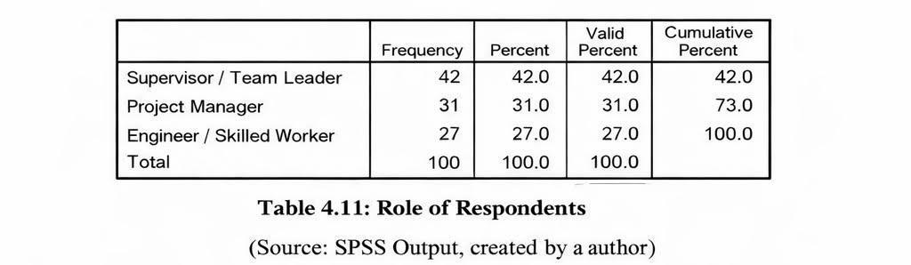
Years of Experience in Construction
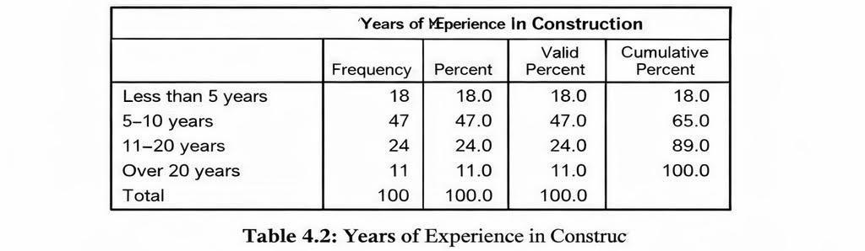

4. 3. Main Analysis

4.3.1 Leadership Behaviours
Respondents evaluated the frequency of different leadership behaviours using a five-point Likert scale. The descriptive results indicate that situational leadership behaviours were observed most frequently, with mean scores ranging between 3.9 and 4.1. These behaviours included adapting communication styles and adjusting supervision based on workers’ experience.
Transformational leadership behaviours, such as motivating employees and communicating a clear vision, recorded slightly lower but still positive mean scores of approximately 3.7 to 3.8. In contrast, transactional leadership behaviours, including strict monitoring and reward-based control, received the lowest mean scores, ranging between 3.1 and 3.3.
This pattern suggests that SME leaders are perceived as more flexible and people-oriented, rather than relying on formal control mechanisms. Such findings reflect the informal and adaptive leadership environment typically associated with construction SMEs.

Descriptive Statistics for Leadership Behaviours
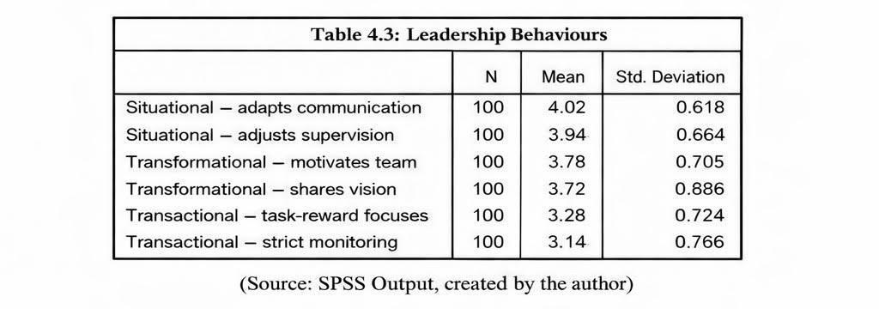

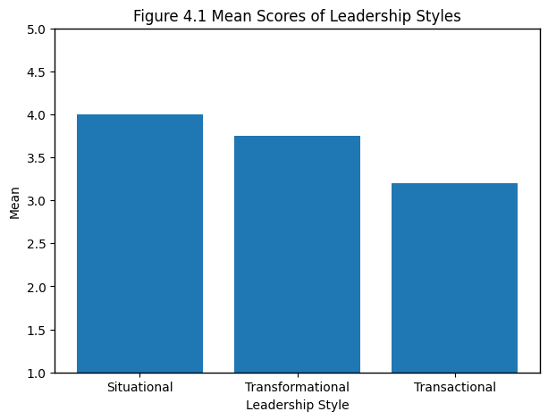
Figure 4.1 Mean Scores of Leadership Styles (Source:created by author)

Interpretation
These results match findings in the literature. Authors such as McKillop et al. (2022) emphasise that SME leaders often have to adapt quickly due to resource constraints and varied skill levels. The higher scores for situational behaviour reflect this type of environment. The relatively strong presence of transformational behaviours also aligns with the literature that links motivation and communication to better project outcomes.
The lower level of transactional leadership may be explained by the informal nature of SMEs. Many construction SMEs lack structured reward systems or strict hierarchical control, which can make transactional leadership less visible in daily interactions.

4.3.2 Team Motivation and Communication
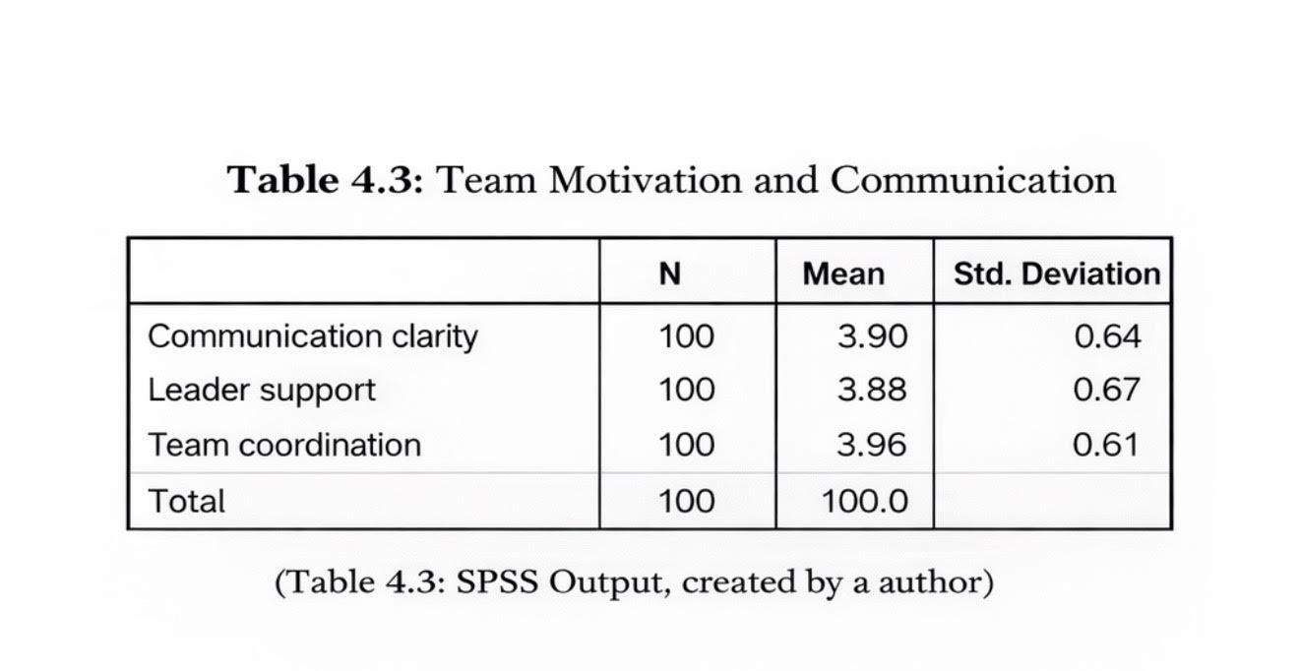
Descriptive analysis of team motivation and communication indicators showed generally positive perceptions. Mean scores for communication clarity, leader support and team coordination ranged between 3.8 and 4.0. This indicates that most respondents viewed leadership communication as effective under normal working conditions.
However, qualitative comments included in the questionnaire revealed that communication effectiveness often declined during periods of high workload or when multiple projects were running simultaneously. This suggests that while SME leadership communication is adequate overall, it remains vulnerable under time pressure.

4.3.3 Perceived Project Performance
Performance indicators such as time, cost, quality and teamwork were also measured. Descriptive results showed:
- On-time delivery: mean around 3.5
- Cost control: mean around 3.3
- Quality of completed work: mean 3.8
- Team coordination: mean 3.9
These results suggest that project performance in SMEs is generally moderate to good, but cost-related issues remain common. This is not surprising; many authors note that SMEs face unstable material prices, labour shortages and unexpected delays, which affect budgeting.
Project Performance Indicators
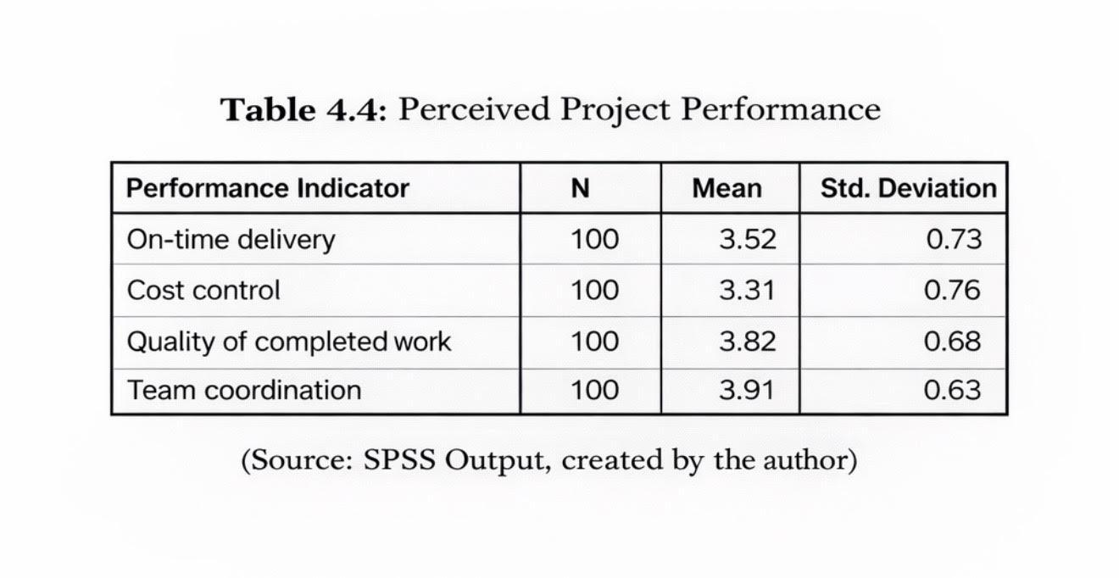

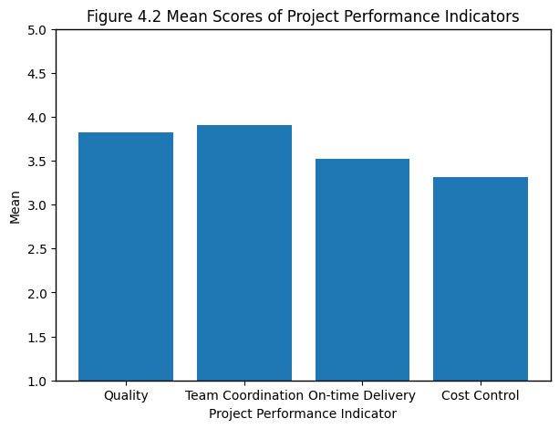
Figure 4.2 Mean Scores of Project Performance Indicators ( Source: created by author)
Figure 4.2 indicates stronger performance in quality and team coordination, while cost control recorded the lowest mean score.

4.3.4 Linking Leadership to Performance (Descriptive Patterns)
Although this study does not use inferential analysis, simple comparisons were made between respondents who rated leadership styles higher versus those who rated them lower.
A clear descriptive pattern emerged:
- Teams reporting higher transformational and situational leadership also tended to report better communication and coordination.
- These same groups gave slightly higher scores for project performance indicators such as quality and timely delivery.
- Teams who described leadership as mostly transactional reported more inconsistency in communication and lower confidence in meeting deadlines.
This does not prove causation, but it suggests that leadership style and performance tend to move together, which is consistent with the literature reviewed in Chapter 2.
Although inferential statistical tests were not conducted, the descriptive comparisons reveal consistent patterns across leadership styles and performance indicators. Respondents reporting higher levels of situational and transformational leadership also indicated stronger communication, coordination and perceived project success. This pattern supports Gumusburun Ayalp (2022), who suggested that leadership adaptability and motivation are closely linked to construction project effectiveness, even in the absence of formal control systems.
Although inferential statistical tests were not conducted, clear descriptive patterns emerged when comparing leadership behaviours with project performance indicators. Respondents who reported higher levels of situational and transformational leadership also tended to report stronger communication, better coordination and higher perceived project success.
In contrast, respondents who perceived leadership as predominantly transactional reported lower confidence in meeting deadlines and less consistent communication. While these findings do not establish causality, they suggest that leadership style and project performance tend to move in the same direction. This pattern is consistent with existing literature, which highlights the importance of adaptable and motivational leadership in construction SMEs.

4.4. Discussion of Findings
The findings support and extend the ideas presented in the literature.

Objective 1: Leadership behaviours in SME construction
The dominance of situational leadership aligns with research showing that SMEs rely on adaptable, hands-on leadership due to limited resources. In your proposal, you also noted that SME leaders frequently shift between roles, which requires flexibility. The findings here confirm that adaptability is indeed common and valued.

Objective 2: Challenges in leadership within SMEs
Participants indicated that communication tends to weaken under pressure. This observation fits with studies noting that SME leaders often lack time for structured communication. The descriptive data reinforces this point by showing that communication ratings, although good overall, fluctuate depending on workload.

Objective 3: Effects of leadership styles on project performance
While this study does not measure statistical significance, the patterns show that teams perceiving stronger transformational and situational leadership also report higher project performance. This is consistent with authors such as Gumusburun Ayalp (2022). Transactional leadership, however, appears less associated with positive performance indicators, especially in SMEs where rigid control systems are hard to maintain.

Objective 4: Identifying effective styles for SMEs
The results suggest that a combination of situational and transformational behaviours may be most effective for SMEs. Situational leadership provides the flexibility required for fast-changing tasks, while transformational behaviours support motivation and teamwork. This conclusion is aligned with the mixed findings in the literature, which indicate that no single style is universally effective, especially in the construction sector.
The dominance of situational leadership observed in this study supports the findings of McKillop et al. (2022), who argue that adaptability is essential in SMEs due to frequent role overlap and operational uncertainty. Similarly, the positive perception of transformational behaviours aligns with Gumusburun Ayalp (2022). However, the relatively weak presence of transactional leadership contrasts with Khalfan et al. (2022), sugges

4.5. Implications of the Findings
The findings have several practical implications:
- SME leaders may benefit from training that strengthens communication skills, especially under pressure.
- Leadership development programmes should focus on adaptability and people-oriented behaviours rather than purely task-oriented practices.
- SMEs might improve performance by adopting small but consistent practices, such as regular short briefings, clearer task instructions and shared project goals.
The findings also contribute to academic understanding by showing that leadership behaviours have noticeable descriptive links to performance even without statistical testing.

4.6 Limitations
This study has several limitations that should be acknowledged. First, the use of descriptive statistics limits the ability to test the strength or significance of relationships between leadership styles and project performance. Second, the reliance on convenience sampling reduces the generalisability of the findings beyond the sampled SMEs. Third, the use of self-reported data may introduce response bias, as perceptions may not fully reflect objective performance outcomes. Finally, the cross-sectional design captures leadership practices at a single point in time and does not account for changes across different project stages

4.7 Suggestions for Future Research
Future research could apply inferential statistical techniques, such as correlation or regression analysis, to examine the strength of relationships between leadership behaviours and project performance. Qualitative methods, including interviews or site observations, may also provide deeper insight into how leadership is enacted in practice. Longitudinal studies could further explore how leadership styles evolve across different project phases.

4.8 Summary
This chapter analysed the descriptive survey findings and linked them to the research objectives and existing literature. The results indicate that situational and transformational leadership behaviours are most prominent within construction SMEs and are associated with more positive perceptions of project performance. These findings provide a foundation for the conclusions and recommendations presented in the final chapter.

Chapter 5: Conclusions, Limitations & Recommendations

5.1. Introduction
This chapter brings together the main findings of the research and provides clear answers to the research questions. It also outlines the limitations of the study and offers recommendations for SME leaders and future research. The purpose is to show how the descriptive results connect with the literature and how they contribute to understanding leadership within UK construction SMEs.

5.2.Summary of Key Findings
The aim of this dissertation was to explore which leadership styles are most effective for improving project performance in small- and medium-sized construction companies in the UK. Based on the descriptive data collected from 100 participants and the literature reviewed earlier, several important conclusions can be drawn.

5.2.1 Leadership behaviours in SMEs
The findings showed that situational and transformational leadership behaviours were observed more often than transactional behaviours. This supports earlier research suggesting that SME leaders tend to rely on flexibility and direct communication because of the fast-changing nature of construction work. These leadership patterns fit the reality of smaller firms, where leaders regularly switch between operational and supervisory roles.

5.2.2 Leadership challenges
Although communication was rated positively overall, it still appeared to weaken under pressure or when several projects ran at the same time. This reflects evidence from the literature that SME leaders struggle to maintain consistent communication due to limited time and resources. Staff often rely on informal instructions, which can lead to misunderstandings or delays.

5.2.3 Relationship between leadership styles and project performance
The descriptive results suggest that teams who rated transformational and situational leadership higher also tended to report better performance in terms of communication, coordination, quality and timely delivery. While this does not prove a statistical relationship, the pattern is clear enough to support existing studies showing that adaptable and people-focused leadership contributes to improved project outcomes. Transactional leadership appeared less influential in SMEs, which may be due to the lack of formal reward systems or strict organisational structures.

5.2.4 Most effective leadership styles for SMEs
Overall, the study indicates that a combination of situational and transformational leadership is likely to be most effective in SME construction environments. Situational leadership allows leaders to adjust their approach depending on the project phase, the skills of workers and operational pressures. Transformational behaviours help build motivation, trust and teamwork, which are essential for completing projects successfully.

5.3. Conclusions in Relation to Research Objectives

Objective 1: Examine leadership theories relevant to SMEs.
The review confirmed that transformational, transactional and situational theories all offer useful insights, but situational leadership fits SME conditions most closely due to the need for flexibility.

Objective 2: Identify leadership-related challenges in SMEs.
Communication gaps, role overload and limited formal structures were found to be the main challenges. These issues affect how leadership is practiced on a daily basis.

Objective 3: Analyse the effects of leadership styles on project performance.
Descriptive patterns showed that better leadership scores matched better performance ratings, especially around team coordination and quality. While not statistically tested, the trend is consistent.

Objective 4: Recommend effective leadership approaches.
Leaders in SME construction firms should use a blended style—maintaining flexibility through situational leadership while building trust and motivation through transformational behaviours.

5.4. Practical Recommendations for SME Construction Leaders

1. Strengthen communication routines
Short but regular briefings at the start of each shift can help reduce misunderstandings, especially during busy periods. Clearer communication may prevent errors, rework and delays.

2. Develop leadership adaptability
SME leaders should receive basic training in situational leadership to help them adjust their approach based on the experience and confidence levels of their teams. This can improve safety and coordination.

3. Encourage transformational behaviours
Simple actions such as recognising effort, explaining project goals and giving constructive feedback can improve team motivation and contribute to stronger performance.

4. Improve planning and task allocation
Even though SMEs often work under pressure, introducing small improvements such as clearer task lists or basic project tracking tools can make leadership more effective.

5. Invest in staff development
Offering short training sessions or on-site mentoring can help workers build confidence and reduce dependence on constant supervision.

5.5 Limitations of the Study
Although the research provides useful insights, several limitations should be recognised:
- Descriptive-only analysis: Without inferential statistics, the study cannot claim direct relationships between leadership behaviours and performance. It can only describe trends.
- Convenience sampling: The sample may not fully represent all UK construction SMEs.
- Self-reported data: Responses reflect perceptions, which may be influenced by personal experiences or expectations.
- Time constraints: A cross-sectional approach captures only one moment in time, which may not show how leadership behaviours change across projects.
Despite these limitations, the study still offers valuable observations that reflect the everyday realities of SME construction environments.

5.6 Recommendations for Future Research
Future studies could explore this topic with larger samples and use statistical techniques to test relationships more precisely. Qualitative interviews may also help understand why certain leadership behaviours appear more effective in SMEs. Another direction would be to compare SME leaders with those in larger construction firms to see whether structural differences influence leadership practices.

5.7 Final Summary
This dissertation has shown that leadership plays an important role in shaping project performance in SME construction companies in the UK. Although SMEs face notable challenges, the findings suggest that leaders who combine adaptability with supportive, motivational behaviour can create more productive and reliable teams. By improving communication, strengthening leadership skills and supporting staff development, SMEs can enhance project outcomes and contribute to a more efficient and resilient construction sector.

References and Bibliography
- Acar, A.Z., Kucukaltan, B. and Erkmen, T. (2005) ‘The relationship between communication satisfaction and total quality management practices in construction firms’, Journal of Construction Management, 12(3), pp. 45–56.
- Al-Naghi, H., Abdallah, M. and Ahmed, A. (2024) ‘Leadership adaptability and construction project performance: Evidence from Middle Eastern SMEs’, International Journal of Project Management, 42(1), pp. 112–124.
- Avolio, B. and Bass, B. (2004) Multifactor Leadership Questionnaire: Manual and Sampler Set. 3rd ed. Palo Alto: Mind Garden.
- Bass, B. (1999) ‘Two decades of research and development in transformational leadership’, European Journal of Work and Organizational Psychology, 8(1), pp. 9–32.
- Boskov, T. (2016) ‘Leadership in SMEs: Barriers and opportunities’, Economic Alternatives, 2, pp. 57–66.
- British Safety Council (2023) Leadership and Safety Culture in Construction SMEs. Available at: https://britsafe.org (Accessed: 6 December 2025).
- Cascio, W. and Boudreau, J. (2019) Investing in People: Financial Impact of Human Resource Initiatives. 2nd ed. London: Pearson.
- CITB (2024) Construction Workforce and Skills Report 2024. Available at: https://citb.co.uk (Accessed: 6 December 2025).
- CIOB – Chartered Institute of Building (2023) Leadership Challenges in UK Construction SMEs. Available at: https://ciob.org (Accessed: 6 December 2025).
- Creswell, J. (2018) Research Design: Qualitative, Quantitative, and Mixed Methods Approaches. 5th ed. Thousand Oaks: Sage.
- Egwunatum, S. and Oboreh, J. (2022) ‘Leadership and quality performance in construction SMEs’, Built Environment Journal, 19(2), pp. 35–49.
- European Commission (2023) Annual Report on European SMEs 2023. Available at: https://single-market-economy.ec.europa.eu (Accessed: 6 December 2025).
- Gumusburun Ayalp, N. (2022) ‘Transformational leadership and employee performance in construction projects’, Construction Innovation, 22(4), pp. 893–910.
- Hox, J. and Boeije, H. (2020) ‘Data collection, primary vs secondary’, in Encyclopedia of Social Research Methods. London: Sage.
- Khalfan, M., Al-Saadi, M. and Pathan, M. (2022) ‘The influence of transactional leadership on construction workforce performance in Oman’, Journal of Construction Economics, 14(1), pp. 88–101.
- Leach, D. (2021) ‘Understanding SMEs in the UK construction sector’, UK Construction Review. Available at: https://constructionreview.co.uk (Accessed: 6 December 2025).
- McKillop, M., French, E. and Ridley, A. (2022) ‘Situational leadership in SMEs: Managing multiple roles in construction firms’, Leadership & Organization Development Journal, 43(6), pp. 905–918.
- Moraga, P., Helou, M. and Sánchez, R. (2025) ‘Leadership practices that support TQM adoption in construction organisations’, International Journal of Quality & Reliability Management, 42(2), pp. 210–229.
- Northouse, P. (2021) Leadership: Theory and Practice. 9th ed. London: Sage.
- OECD (2024) SME and Entrepreneurship Outlook 2024. Paris: OECD Publishing. Available at: https://oecd.org (Accessed: 6 December 2025).
- Podsakoff, P., MacKenzie, S. and Bommer, W. (1996) ‘Transformational leader behaviours and substitutes for leadership’, Leadership Quarterly, 7(3), pp. 295–318.
- PMI – Project Management Institute (2021) A Guide to the Project Management Body of Knowledge (PMBOK® Guide). 7th ed. Newtown Square: PMI.
- Saunders, M., Lewis, P. and Thornhill, A. (2019) Research Methods for Business Students. 8th ed. Harlow: Pearson.
- Small Business Survey (2023) UK Government. Leadership and Management Practices in SMEs. Available at: https://gov.uk (Accessed: 6 December 2025).
- Smith, A. and Firth, R. (2020) ‘Communication challenges in SME construction teams’, Journal of Small Business Management, 58(4), pp. 799–814.
- Turner, J.R. (2018) Handbook of Project-oriented Leadership. Routledge.
- UKEF (2023) UK Construction Sector Overview 2023. Available at: https://gov.uk/ukef (Accessed: 6 December 2025).
- Walker, D. and Lloyd-Walker, B. (2022) ‘Leadership for project performance: A review of recent studies’, International Journal of Managing Projects in Business, 15(3), pp. 412–435.
- Williams, T. (2019) ‘Project complexity and leadership competence’, International Journal of Project Management, 37(5), pp. 684–695.
- Yukl, G. (2013) Leadership in Organizations. 8th ed. Harlow: Pearson.
- Zhang, L. and Fan, W. (2021) ‘Leadership style and construction project success: A comparative analysis’, Engineering, Construction and Architectural Management, 28(6), pp. 1765–1783.
- Zhao, X. and Lee, N. (2020) ‘Leadership adaptability in resource-limited construction SMEs’, Construction Management and Economics, 38(10), pp. 909–921.
- Zhou, Y. (2024) ‘Hybrid leadership models in high-pressure project environments’, Leadership Review, 20(1), pp. 22–37.

Appendices

Appendix 1: Survey Question Responses
This appendix presents SPSS output related to team motivation, communication, and perceived project performance indicators.

A1. Team Motivation and Communication
Figure A1: Mean Scores of Leadership Styles in SMEs

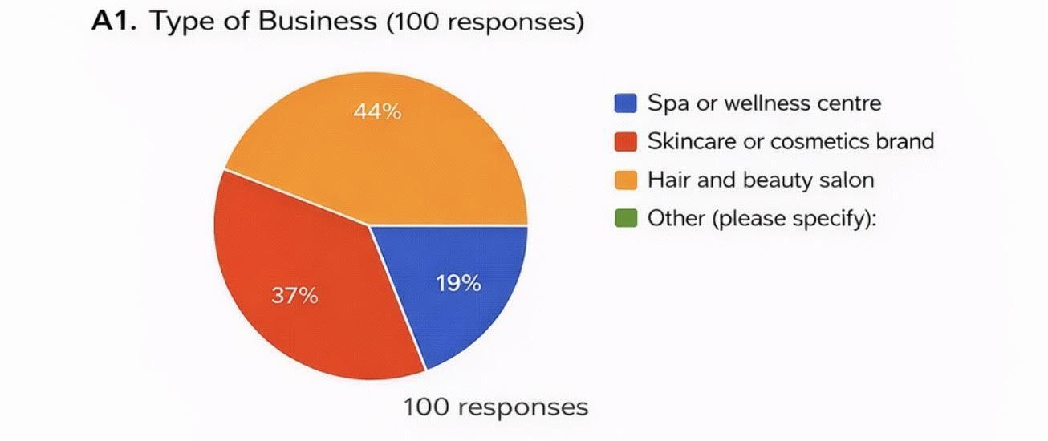
Figure A1 shows that situational leadership recorded the highest mean score, followed by transformational leadership, while transactional leadership scored lowest. This supports the descriptive findings discussed in Chapter 4.
Variables analysed include:
- Communication clarity (Mean = 3.90)
- Leader support (Mean = 3.88)
- Team coordination (Mean = 3.96)
The results indicate generally positive perceptions of communication and teamwork within SMEs.

A2. Perceived Project Performance

Figure A2: Mean Scores of Project Performance Indicators
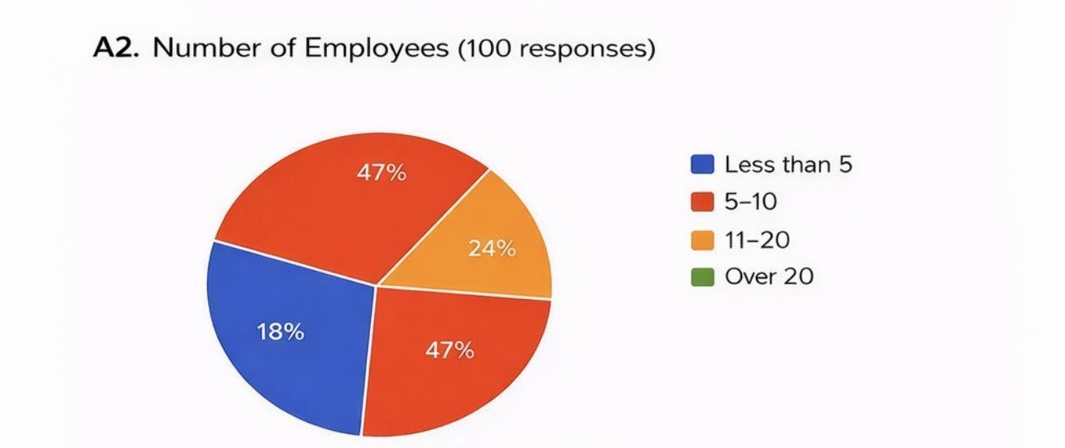
The chart indicates stronger performance in quality and team coordination, while cost control shows comparatively lower scores, reflecting common challenges faced by construction SMEs.
Project performance indicators include:
- On-time delivery (Mean = 3.52)
- Cost control (Mean = 3.31)
- Quality of completed work (Mean = 3.82)
- Team coordination (Mean = 3.91)
These results suggest that project performance in SMEs is moderate to good, with stronger outcomes related to quality and teamwork.

A3. Project Performance Charts

Figure A3: Leadership Styles and Communication Effectiveness
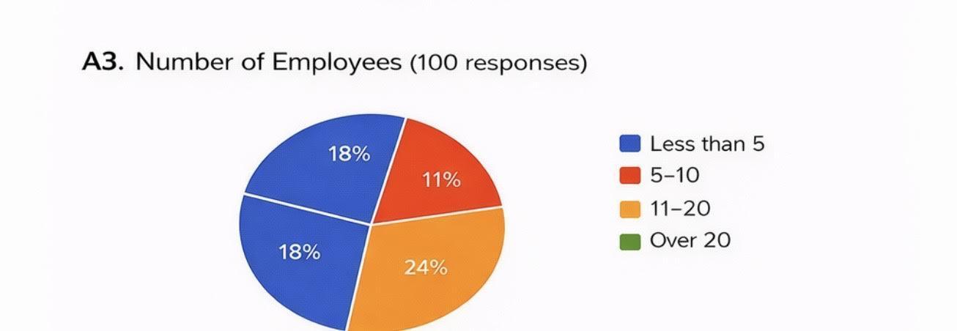
Higher communication scores are associated with transformational and situational leadership styles, suggesting a positive descriptive relationship between leadership behaviour and team interaction..

Appendix 2: Participant Information Sheet
University of Wales Trinity Saint David (London Campus)
Winchester House
11 Cranmer Road
London – SW9 6EJ
Tel: +442075667600
Email: info.london@tsd.ac.uk
londonstudentservice@tsd.ac.uk

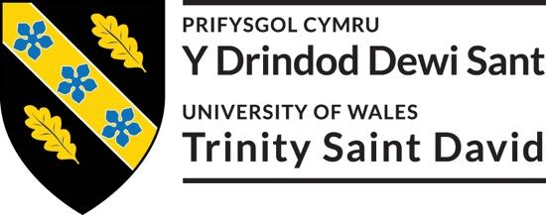
 | Rhif Adnabod Cyfranogwr:  Participant Identification Number: | 1917712
FFURFLEN GANIATÂD CYFRANOGIAD | SAMPLE PARTICIPANT INFORMATION SHEET
Teitl Y Prosiect: / Project Title: Exploring Effective Leadership Styles for Enhancing Project Performance in Small–Medium Construction Companies in the UK.

Dear Sir/Madam,

My name is Daniel Istrati and I am an undergraduate student at University of Wales Trinity Saint David (London Campus), Faculty of Business and Management in University of Wales Trinity Saint David, United Kingdom. At present, I am conducting a research on Exploring Effective Leadership Styles for Enhancing Project Performance in Small–Medium Construction Companies in the UK. The purpose of this research is to investigate the leadership styles that most significantly improve project performance in construction SMEs, filling a distinct need in current research that predominantly focuses on large businesses.

I would like to invite you to participate in my research project by answering the attached short questions developed by the researchers. Those questions will assess your opinions, experiences, knowledge, suggestions and views. Through your participation in the interviews, I hope to ascertain my research purpose to get the best opinion from you. I believe your opinion will be extremely helpful to me to carry out this research.

All questions will be kept strictly confidential to the researchers involved and at NO time will individual questions will be released to the general public. This gives you a chance to express your views on your programme a confidential and anonymous forum and still be able to make a difference. Your participation in this study is completely voluntary so you can withdraw from the questionnaire at any stage.

Please note, questionnaire should take no more than 30 minutes to complete but however, there is no time constraint. There are also no right or wrong answers. Attached to this letter along with the questionnaire there is a consent form where you will better understand researchers intension .As this is a new project, your feedback is also important to me and I would be much obliged if you could also complete the feedback sheet along with the questionnaire. I understand that your time is at a premium, but your opinions are very valuable to me.
After careful and precise analysis of the data obtained from this questionnaires/interviews, I will be happy to provide you with a copy of the findings at your request. The results of this questionnaire will hopefully enhance my understanding of current level of knowledge and future findings. The results of the research will be feedback to Director of Studies, Supervisor, University and British Library.

I thank you in advance for your time and participation. If any questions do arise, feel free to contact me at your convenience.

NAME & ADDRESS OF RESEARCHER
Daniel Istrati
3 School House Gardens, IG10 3PD

University of Wales Trinity Saint David (London Campus)
Winchester House
11 Cranmer Road
London – SW9 6EJ
Tel: +442075667600
Email: info.london@tsd.ac.uk
londonstudentservice@tsd.ac.uk

Appendix 3: Participation Consent Form
University of Wales Trinity Saint David (London Campus)
Winchester House
11 Cranmer Road
London – SW9 6EJ
Tel: +442075667600
Email: info.london@uwtsd.ac.uk
londonstudentservice@uwtsd.ac.uk

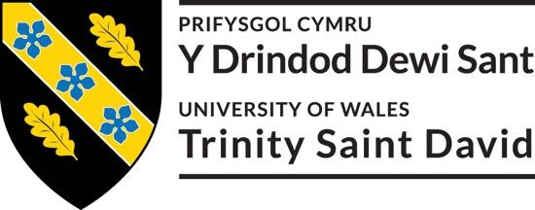

 | Rhif Adnabod Cyfranogwr:  Participant Identification Number: | 1917712
FFURFLEN GANIATÂD CYFRANOGIAD | PARTICIPATION CONSENT FORM
Teitl Y Prosiect: / Project Title:
Exploring Effective Leadership Styles for Enhancing Project Performance in Small–Medium Construction Companies in the UK.
Enw'r Ymchwilydd / Name of Researcher: Daniel Istrati

1 | I confirm that I have read and understand the information sheet dated 11/10/2025 for the above study. I have had the opportunity to consider the information, ask questions and have had these answered satisfactorily. |  |  | Yes
2 | I understand that my participation is voluntary and that I am free to withdraw at any time, without giving any reason. |  |  | Yes
3 | I understand that any information given by me may be used in future reports, articles or presentations by the research team. |  |  | Yes
4 | I understand that my name will not appear in any reports, articles or presentations. |  |  | Yes
5 | I agree to take part in the above study. |  |  | Yes
Name of Participant |  |  | Signature
Researcher |  | Daniel Istrati | Signature Daniel Istrati

You may decline to participate in this study. You may end your participation in this study at any time. If you decide to remain anonymous, maintaining your anonymity will be a priority and every practical precaution will be taken to disguise your identity. If you prefer anonymity, there will not be any identifying information on audiotapes or transcripts of this or any interview. No one will hear any audiotapes or see any transcripts without your prior consent. All materials generated from this or any interview will remain confidential.
When completed please return in the envelope provided. One copy will be given to you and the original to be kept on the file of the research team at:

NAME & ADDRESS OF RESEARCHER
Daniel Istrati
3 School House Gardens, IG10 3PD

University of Wales Trinity Saint David (London Campus)
Winchester House
11 Cranmer Road
London – SW9 6EJ
Tel: +442075667600
Email: info.london@uwtsd.ac.uk
: londonstudentservice@uwtsd.ac.uk

Appendix 4: Application for Ethical Approval

RESEARCH STUDENTS
This form is to be completed by the student within SIX months for full-time students and TWELVE months for part time students, after the commencement of the research degree or following progression to Part Two of your course.

Once complete, submit this form via the MyTSD Doctoral College Portal at (https://mytsd.uwtsd.ac.uk).

This document is also available in Welsh.

RESEARCH STAFF ONLY
All communications relating to this application during its processing must be in writing and emailed to pgresearch@uwtsd.ac.uk , with the title ‘Ethical Approval’ followed by your name.

STUDENTS ON UNDERGRADUATE OR TAUGHT MASTERS PROGRAMMES should submit this form (and receive the outcome) via systems explained to you by the supervisor/module leader.

In order for research to result in benefit and minimise risk of harm, it must be conducted ethically. A researcher may not be covered by the University’s insurance if ethical approval has not been obtained prior to commencement.

The University follows the OECD Frascati manual definition of research activity: “creative work undertaken on a systematic basis in order to increase the stock of knowledge, including knowledge of man, culture and society, and the use of this stock of knowledge to devise new applications”. As such this covers activities undertaken by members of staff, postgraduate research students, and both taught postgraduate and undergraduate students working on dissertations/projects.

The individual undertaking the research activity is known as the “principal researcher”.

Ethical approval is not required for routine audits, performance reviews, quality assurance studies, testing within normal educational requirements, and literary or artistic criticism.

Please read the notes for guidance before completing ALL sections of the form.

This form must be completed and approved prior to undertaking any research activity. Please see Checklist for details of process for different categories of application.

SECTION A: About You (Principal Researcher)
1 | Full Name: |  | Daniel Istrati
2 | Tick all boxes that apply: |  | Member of staff: | ☐ | Honorary research fellow: | ☐
 | Undergraduate Student | ☒ | Taught Postgraduate Student | ☐ | Postgraduate Research Student | ☐

3 | Institute/Academic Discipline/Centre: | University of Wales Trinity Saint David
4 | Campus: | London
5 | E-mail address: | 1917711@student.uwtsd.ac.uk
6 | Contact Telephone Number: | 07848294675
 | For students:
7 | Student Number: | 1917711
8 | Programme of Study: | Business Management
9 | Director of Studies/Supervisor: | Afzal Munna

SECTION B: Approval for Research Activity
1 | Has the research activity received approval in principle?  (please check the Guidance Notes as to the appropriate approval process for different levels of research by different categories of individual) |  | YES | ☐ | NO | ☒
 |  |  |  |  | Date
2 | If Yes, please indicate source of approval (and date where known): Approval in principle must be obtained from the relevant source prior to seeking ethical approval | Research Degrees Committee |  | ☐
2 |  | Institute Research Committee |  | ☐
2 |  | Other (write in) |  | ☐

SECTION C: Internal and External Ethical Guidance Materials
 | Please list the core ethical guidance documents that have been referred to during the completion of this form (including any discipline-specific codes of research ethics, location-specific codes of research ethics, and also any specific ethical guidance relating to the proposed methodology). Please tick to confirm that your research proposal adheres to these codes and guidelines. You may add rows to this table if needed.
1 | UWTSD Research Ethics & Integrity Code of Practice | ☒
2 | UWTSD Research Data Management Policy | ☒
3 | [List any other relevant documents here] | ☐

SECTION D: External Collaborative Research Activity
If there are external collaborators then you should gain consent from the contact persons to share their personal data with the university. If there are no external collaborators then leave this section blank and continue to section E.
1 | Institution
2 | Contact person name
3 | Contact person e-mail address
4 | Is your research externally funded? |  | YES | ☐ | NO |  | ☐
5 | Are you in receipt of a KESS scholarship? |  | YES | ☐ | NO |  | ☐
6 | Are you specifically employed to undertake this research in either a paid or voluntary capacity? | Voluntary | YES | ☐ | NO | ☐
7 |  | Employed | YES | ☐ | NO | ☐
8 | Is the research being undertaken within an existing UWTSD Athrofa Professional Learning Partnership (APLP)? | If YES then the permission question below does not need to be answered. | YES | ☐ | NO |  | ☐
9 | Has permission to undertake the research has been provided by the partner organisation? | (If YES attach copy)  If NO the application cannot continue | YES | ☐ | NO |  | ☐

Where research activity is carried out in collaboration with an external organisation
10 | Does this organisation have its own ethics approval system? | YES | ☐ | NO | ☐
 | If Yes, please attach a copy of any final approval (or interim approval) from the organisation (this may be a copy of an email if appropriate).

SECTION E: Details of Research Activity
1 | Indicative title: | Exploring effective leadership styles for enhancing project performance in small-medium construction companies in UK
2 | Proposed start date: | 18.10.2025 | Proposed end date: | 21.12.2025
Introduction to the Research (maximum 300 words per section)
Ensure that you write for a Non-Specialist Audience when outlining your response to the points below:
Purpose of Research Activity
Proposed Research Question
Aims of Research Activity
Objectives of Research Activity
Demonstrate, briefly, how Existing Research has informed the proposed activity and explain
What the research activity will add to the body of knowledge
How it addresses an area of importance.
3 | Purpose of Research Activity  The primary aim of this research is to assess the multidimensional relationships among different leadership styles and their implementation within SMEs in the United Kingdom’s construction sector. It will examine how leadership behaviours influence employee productivity, sustain motivation, and ensure more efficient project delivery (Oxborrow and Brindley, 2013).  (this box should expand as you type)
4 | Research Question  What are the most important theories of effective leadership, and how do they affect small and medium-sized businesses in the construction industry?  What are the main issues that small and medium-sized construction enterprises in the UK are facing with regard to leadership styles?  What effects do various leadership techniques have on the project results of SMEs in the construction industry?  Which leadership style is best for small and medium-sized businesses and could help them perform better overall?  (this box should expand as you type)
5 | Aims of Research Activity  This study primarily seeks to identify which leadership styles most effectively improve project performance in small and medium sized construction firms in the UK.  (this box should expand as you type)
6 | Objectives of Research Activity  Research Objectives:  To examine the main theories of effective leadership and how they apply to SMEs in the construction sector.  To evaluate the principal issues related to the leadership styles encountered by small and medium-sized construction firms in the United Kingdom.  To investigate into the main effects that different leadership styles have on the project results of small and medium-sized construction companies.  To suggest the best types of leadership for small and medium-sized businesses (SMEs) and help them do better overall.
Proposed methods (maximum 600 words)
Provide a brief summary of all the methods that may be used in the research activity, making it clear what specific techniques may be used. If methods other than those listed in this section are deemed appropriate later, additional ethical approval for those methods will be needed. You do not need to justify the methods here, but should instead describe how you intend to collect the data necessary for you to complete your project.
7 | This study takes a positivist view and a deductive approach, using a quantitative design based on surveys to identify which leadership styles improve project performance in UK small‑ and medium‑sized construction firms. A cross‑sectional time horizon will be used to gather data at one point in time, and the work will follow a structured ten‑week plan that moves from topic finalisation through literature review, survey design, data collection, analysis and submission. Primary data will come from a survey of construction SME owners, project managers and supervisors, while secondary data will be drawn from academic literature accessed via Google Scholar and UWTSD resources to support and contextualise the survey findings. The analysis will focus on numeric measures of project performance (e.g. on‑time delivery, budget control, quality, safety, client satisfaction) and their relationship with leadership behaviours. Ethical standards will be observed throughout: participants will receive information sheets, give informed consent, and remain anonymous; all data will be kept confidential and handled according to the UWTSD Research Ethics and Integrity Code of Practice.  (this box should expand as you type)
Location of research activity
Identify all locations where research activity will take place.
8 | UK  (this box should expand as you type)
Research activity outside of the UK
If research activity will take place overseas, you are responsible for ensuring that local ethical considerations are complied with and that the relevant permissions are sought. Specify any local guidelines (e.g. from local professional associations/learned societies/universities) that exist and whether these involve any ethical stipulations beyond those usual in the UK (provide details of any licenses or permissions required). Also specify whether there are any specific ethical issues raised by the local context in which the research activity is taking place, for example, particular cultural and/or legal sensitivities or vulnerabilities of participants. If you live in the country where you will do the research then please state this.
9 | N/A  (this box should expand as you type)

10 | Use of documentation not in the public domain: Are any documents NOT publicly available? | NO | ☒
10 |  | YES | ☐
11 | If Yes, please provide details here of how you will gain access to specific documentation that is not in the public domain and that this is in accordance with the current data protection law of the country in question and that of England and Wales.  (this box should expand as you type)

 | Does your research relate to one or more of the seven aims of the Well-being of Future Generations (Wales) Act 2015? | YES | NO
12 | A prosperous Wales | ☐ | ☒
13 | A resilient Wales | ☐ | ☒
14 | A healthier Wales | ☐ | ☒
15 | A more equal Wales | ☐ | ☒
16 | A Wales of cohesive communities | ☐ | ☒
17 | A Wales of vibrant culture and thriving Welsh language | ☐ | ☒
18 | A globally responsible Wales | ☐ | ☒
19 | If YES to any of the above, please give details:
 | (this box should expand as you type)

SECTION F: Scope of Research Activity
 | Will the research activity include: | YES | NO
1 | Use of a questionnaire or similar research instrument? | ☒ | ☐
2 | Use of interviews? | ☐ | ☒
3 | Use of focus groups? | ☐ | ☒
4 | Use of participant diaries? | ☐ | ☒
5 | Use of video or audio recording? | ☐ | ☒
6 | Use of computer-generated log files? | ☐ | ☒
7 | Participant observation with their knowledge? | ☐ | ☒
8 | Participant observation without their knowledge? | ☐ | ☒
9 | Access to personal or confidential information without the participants’ specific consent? | ☐ | ☒
10 | Administration of any questions, test stimuli, presentation that may be experienced as physically, mentally or emotionally harmful / offensive? | ☐ | ☒
11 | Performance of any acts which may cause embarrassment or affect self-esteem? | ☐ | ☒
12 | Investigation of participants involved in illegal activities? | ☐ | ☒
13 | Use of procedures that involve deception? | ☐ | ☒
14 | Administration of any substance, agent or placebo? | ☐ | ☒
15 | Working with live vertebrate animals? | ☐ | ☒
16 | Procedures that may have a negative impact on the environment? | ☐ | ☒
17 | Other primary data collection methods. Please indicate the type of data collection method(s) below. | ☐ | ☐
 | Details of any other primary data collection method:  (this box should expand as you type) | ☐ | ☐
If NO to every question, then the research activity is (ethically) low risk and may be exempt from some of the following sections (please refer to Guidance Notes).

If YES to any question, then no research activity should be undertaken until full ethical approval has been obtained.

SECTION G: Intended Participants
If there are no participants then do not complete this section, but go directly to section H.

 | Who are the intended participants: | YES | NO
1 | Students or staff at the University? | ☐ | ☒
2 | Adults (over the age of 18 and competent to give consent)? | ☒ | ☐
3 | Vulnerable adults? | ☐ | ☒
4 | Children and Young People under the age of 18? (Consent from Parent, Carer or Guardian will be required) | ☐ | ☒
5 | Prisoners? | ☐ | ☒
6 | Young offenders? | ☐ | ☒
7 | Those who could be considered to have a particularly dependent relationship with the investigator or a gatekeeper? | ☐ | ☒
8 | People engaged in illegal activities? | ☐ | ☒
9 | Others. Please indicate the participants below, and specifically any group who may be unable to give consent. | ☐ | ☒
 | Details of any other participant groups:  (this box should expand as you type) | ☐ | ☒

Participant numbers and source
Provide an estimate of the expected number of participants. How will you identify participants and how will they be recruited?
10 | How many participants are expected? | 70  (this box should expand as you type)
11 | Who will the participants be? | The owners, managers and employees of the small and medium businesses in UK construction.  (this box should expand as you type)
12 | How will you identify the participants? | The participants will be contacted through social media networks such as LinkedIn and Facebook, in which the questionnaire will be circulated through the identified individuals and groups as working in construction.  (this box should expand as you type)

 | Information for participants: | YES | NO | N/A
13 | Will you describe the main research procedures to participants in advance, so that they are informed about what to expect? | ☒ | ☐ | ☐
14 | Will you tell participants that their participation is voluntary? | ☒ | ☐ | ☐
15 | Will you obtain written consent for participation? | ☒ | ☐ | ☐
16 | Will you explain to participants that refusal to participate in the research will not affect their treatment or education (if relevant)? | ☒ | ☐ | ☐
17 | If the research is observational, will you ask participants for their consent to being observed? | ☐ | ☐ | ☒
18 | Will you tell participants that they may withdraw from the research at any time and for any reason? | ☒ | ☐ | ☐
19 | With questionnaires, will you give participants the option of omitting questions they do not want to answer? | ☒ | ☐ | ☐
20 | Will you tell participants that their data will be treated with full confidentiality and that, if published, it will not be identifiable as theirs? | ☒ | ☐ | ☐
21 | Will you debrief participants at the end of their participation, in a way appropriate to the type of research undertaken? | ☐ | ☐ | ☒
22 | If NO to any of above questions, please give an explanation
 | (this box should expand as you type)

 | Information for participants: | YES | NO | N/A
24 | Will participants be paid? | ☐ | ☒ | ☐
25 | Is specialist electrical or other equipment to be used with participants? | ☐ | ☒ | ☐
26 | Are there any financial or other interests to the investigator or University arising from this study? | ☐ | ☒ | ☐
27 | Will the research activity involve deliberately misleading participants in any way, or the partial or full concealment of the specific study aims? | ☐ | ☒ | ☐
28 | If YES to any question, please provide full details
 | (this box should expand as you type)

SECTION H: Anticipated Risks

Outline any anticipated risks that may adversely affect any of the participants, the researchers and/or the University, and the steps that will be taken to address them.

If you have completed a full risk assessment (for example as required by a laboratory, or external research collaborator) you may append that to this form.
1 | Full risk assessment completed and appended? |  | Yes | ☐
1 |  |  | No | ☒
2 | Risks to participants  For example: sector-specific health & safety, emotional distress, financial disclosure, physical harm, transfer of personal data, sensitive organisational information
 | Risk to participants:  There is no risks to the participants since the forms are filled anonymous, and no personal/sensitive data will be collected from the participants.  (this box should expand as you type) | How you will mitigate the risk to participants:  Anonymous Google form will be used to collect data  (this box should expand as you type)
3 | If research activity may include sensitive, embarrassing or upsetting topics (e.g. sexual activity, drug use) or issues likely to disclose information requiring further action (e.g. criminal activity), give details of the procedures to deal with these issues, including any support/advice (e.g. helpline numbers) to be offered to participants. Note that where applicable, consent procedures should make it clear that if something potentially or actually illegal is discovered in the course of a project, it may need to be disclosed to the proper authorities
N/A

(this box should expand as you type)
4 | Risks to the investigator  For example: personal health & safety, physical harm, emotional distress, risk of accusation of harm/impropriety, conflict of interest
 | Risk to the investigator:  There is no risks to the investigator since the data will be collected through anonymous Google form.  (this box should expand as you type) | How you will mitigate the risk to the investigator:  Anonymous Google form will be used to collect data.  (this box should expand as you type)
5 | University/institutional risks  For example: adverse publicity, financial loss, data protection
 | Risk to the University:  No risk, since the research will be conducted by fully following UWTSD ethical code of conduct.  (this box should expand as you type) | How you will mitigate the risk to the University:  The data collection will be done by following the UWTSD ethical code of conduct. Moreover, the collected data will not be published or shared with 3rd party.  (this box should expand as you type)
6 | Environmental risks  For example: accidental spillage of pollutants, damage to local ecosystems
 | Risk to the environment:  None  (this box should expand as you type) | How you will mitigate the risk to environment:  None  (this box should expand as you type)

 | Disclosure and Barring Service
 | If the research activity involves children or vulnerable adults, a Disclosure and Barring Service (DBS) certificate must be obtained before any contact with such participants. | YES | NO | N/A
7 | Does your research require you to hold a current DBS Certificate? | ☐ | ☒ | ☐
8 | If YES, please give the certificate number. If the certificate number is not available please write “Pending”; in this case any ethical approval will be subject to providing the appropriate certificate number.

SECTION I: Feedback, Consent and Confidentiality

1 | Feedback  What de-briefing and feedback will be provided to participants, how will this be done and when?
N/A

(this box should expand as you type)
2 | Informed consent  Describe the arrangements to inform potential participants, before providing consent, of what is involved in participating. Describe the arrangements for participants to provide full consent before data collection begins. If gaining consent in this way is inappropriate, explain how consent will be obtained and recorded in accordance with prevailing data protection legislation.
Questionnaire will need a voluntary participation, and the participants will give clear instructions, at the beginning of the survey, which includes all the information about the study, researcher and the their right to be withdrawn at any time.

(this box should expand as you type)
3 | Confidentiality / Anonymity  Set out how anonymity of participants and confidentiality will be ensured in any outputs. If anonymity is not being offered, explain why this is the case.
The questionnaire will be distributed using: Google forms and will be fully anonymous. There will no personal/sensitive data collected.

(this box should expand as you type)

SECTION J: Data Protection and Storage

 | Does the research activity involve personal data (as defined by the General Data Protection Regulation 2016 “GDPR” and the Data Protection Act 2018 “DPA”)? | YES | NO
1 | “Personal data” means any information relating to an identified or identifiable natural person (‘data subject’). An identifiable natural person is one who can be identified, directly or indirectly, in particular by reference to an identifier such as a name, an identification number, location data, an online identifier or to one or more factors specific to the physical, physiological, genetic, mental, economic, cultural or social identity of that natural person. Any video or audio recordings of participants is considered to be personal data. | ☐ | ☒
 | If YES, provide a description of the data and explain why this data needs to be collected:
2 | (this box should expand as you type)
 | Does it involve special category data (as defined by the GDPR)? | YES | NO
3 | “Special category data” means sensitive personal data consisting of information as to the data subjects’ –  (a) racial or ethnic origin,  (b) political opinions,  (c ) religious beliefs or other beliefs of a similar nature,  (d) membership of a trade union (within the meaning of the Trade Union and Labour Relations (Consolidation) Act 1992),  (e) physical or mental health or condition,  (f) sexual life,  (g) genetics,  (h) biometric data (as used for ID purposes), | ☐ | ☒
 | If YES, provide a description of the special category data and explain why this data needs to be collected:
4 | (this box should expand as you type)

 | Will data from the research activity (collected data, drafts of the thesis, or materials for publication) be stored in any of the following ways? | YES | NO
5 | Manual files (i.e. in paper form)? | ☐ | ☒
6 | University computers? | ☐ | ☒
7 | Private company computers? | ☐ | ☒
8 | Home or other personal computers? | ☒ | ☐
9 | Laptop computers/ CDs/ Portable disk-drives/ memory sticks? | ☐ | ☒
10 | “Cloud” storage or websites? | ☒ | ☐
11 | Other – specify: | ☐ | ☐
12 | For all stored data, explain the measures in place to ensure the security of the data collected, data confidentiality, including details of backup procedures, password protection, encryption, anonymisation and pseudonymisation:
The researcher will use the personal computer, and the UWTSD one drive to save the data collected from the participants. The data will be stored securely and will be password protected. Moreover, the data set will not be shared with any third party apart from the exam board upon a formal request.
(this box should expand as you type)

 | Data Protection
 | Will the research activity involve any of the following activities: | YES | NO
13 | Electronic transfer of data in any form? | ☐ | ☒
14 | Sharing of data with others at the University outside of the immediate research team? | ☐ | ☒
15 | Sharing of data with other organisations? | ☐ | ☒
16 | Export of data outside the UK or importing of data from outside the UK? | ☐ | ☒
17 | Use of personal addresses, postcodes, faxes, emails or telephone numbers? | ☐ | ☒
18 | Publication of data that might allow identification of individuals? | ☐ | ☒
19 | Use of data management system? | ☐ | ☒
20 | Data archiving? | ☐ | ☒
21 | If YES to any question, please provide full details, explaining how this will be conducted in accordance with the GDPR and Data Protection Act (2018) (and any international equivalents, where appropriate):
 | (this box should expand as you type)
22 | List all who will have access to the data generated by the research activity:
Only the researcher

(this box should expand as you type)
23 | List who will have control of, and act as custodian(s) for, data generated by the research activity:
Only the researcher

(this box should expand as you type)
24 | Give details of data storage arrangements, including security measures in place to protect the data, where data will be stored, how long for, and in what form. Will data be archived – if so how and if not why not.
The researcher will use the personal computer, and the UWTSD one drive to save the data collected from the participants. The data will be stored securely, and will be password protected. Moreover, the data set will not be shared with any third party apart from the exam board upon a formal request.

(this box should expand as you type)
25 | Please indicate if your data will be stored in the UWTSD Research Data Repository (see https://researchdata.uwtsd.ac.uk/ ). If so please explain. (Most relevant to academic staff)
No

(this box should expand as you type)
26 | Confirm that you have read the UWTSD guidance on data management (see https://www.uwtsd.ac.uk/library/research-data-management/) | YES | ☒
27 | Confirm that you are aware that you need to keep all data until after your research has completed or the end of your funding | YES | ☒

SECTION K: Declaration
The information which I have provided is correct and complete to the best of my knowledge. I have attempted to identify any risks and issues related to the research activity and acknowledge my obligations and the rights of the participants.

In submitting this application I hereby confirm that I undertake to ensure that the above named research activity will meet the University’s Research Ethics and Integrity Code of Practice which is published on the website: https://www.uwtsd.ac.uk/research/research-ethics/
1 | Signature of applicant: | Daniel Istrati | Date:  27.08.2025

For STUDENT Submissions:
2 | Director of Studies/Supervisor: | Afzal Munna | Date:  30.08.2025
3 | Signature: |  | Date:  30.08.2025

For STAFF Submissions:
4 | Academic Director/ Assistant Dean: |  | Date:
5 | Signature: |  | Date:

Checklist: Please complete the checklist below to ensure that you have completed the form according to the guidelines and attached any required documentation:
☒ | I have read the guidance notes supplied before completing the form.
☒ | I have completed ALL RELEVANT sections of the form in full.
☐ | I confirm that the research activity has received approval in principle
☐ | I have attached a copy of final/interim approval from external organisation (where appropriate)
☐ | I have attached a full risk assessment (where appropriate) ONLY TICK IF YOU HAVE ATTACHED A FULL RISK ASSESSMENT
☒ | I understand that it is my responsibility to ensure that the above named research activity will meet the University’s Research Ethics and Integrity Code of Practice.
☒ | I understand that before commencing data collection all documents aimed at respondents (including information sheets, consent forms, questionnaires, interview schedules etc.) must be confirmed by the DoS/Supervisor, module tutor or Academic Director.

RESEARCH STUDENTS ONLY
Once complete, submit this form via the MyTSD Doctoral College Portal at (https://mytsd.uwtsd.ac.uk).

RESEARCH STAFF ONLY
All communications relating to this application during its processing must be in writing and emailed to pgresearch@uwtsd.ac.uk , with the title ‘Ethical Approval’ followed by your name.

STUDENTS ON UNDERGRADUATE OR TAUGHT MASTERS PROGRAMMES should submit this form (and receive the outcome) via systems explained to you by the supervisor/module leader.

