Nino Aguilar (2305326)
2305326@STUDENT.UWTSD.AC.UK
networking operating systems & services
ACCA5023

NOS - Coursework 2
Installing Active Directory Domain Services Feature
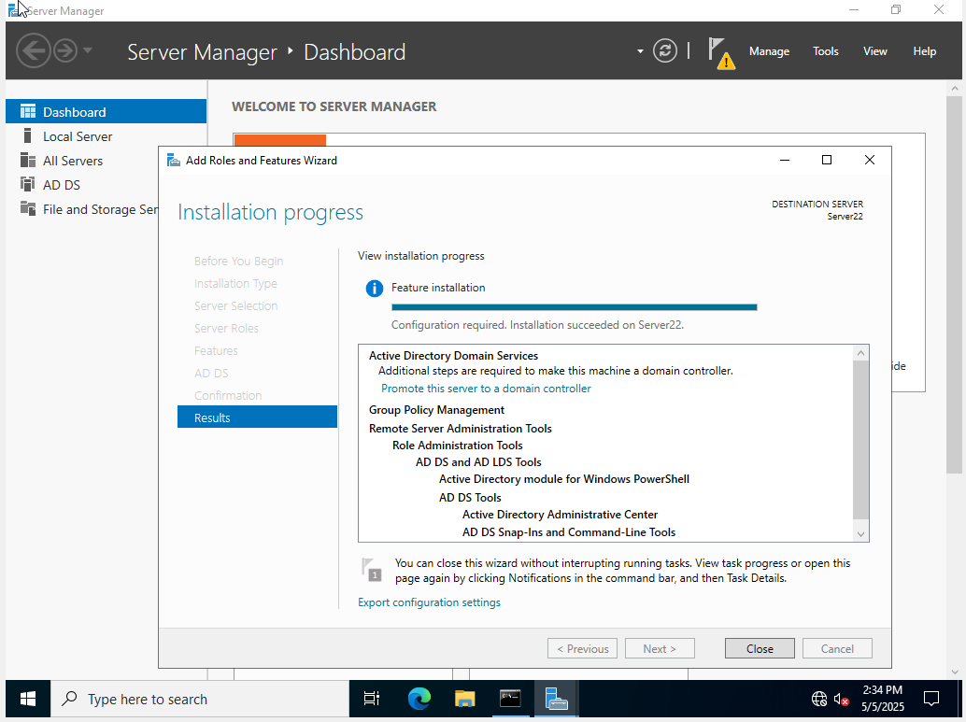

Promote Server as a Domain Controller
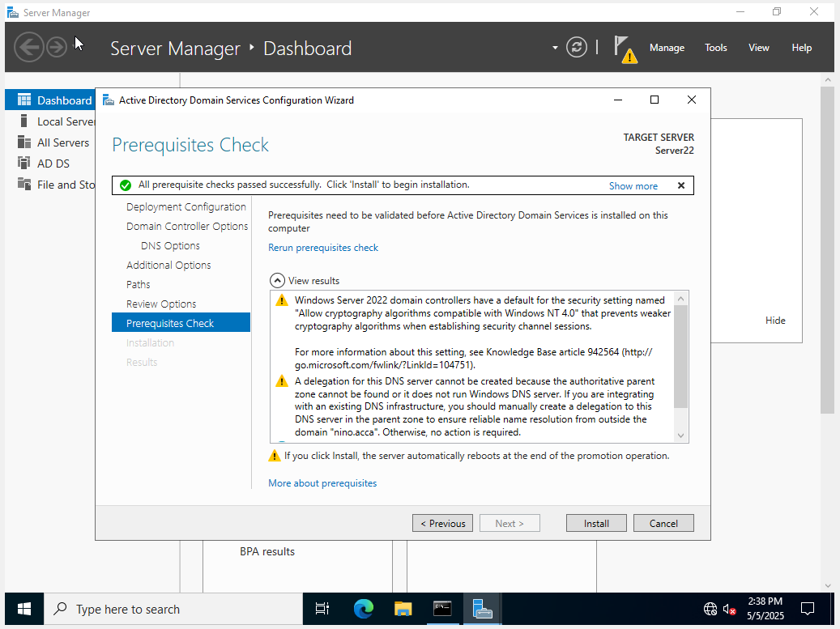

Adding Computer to Domain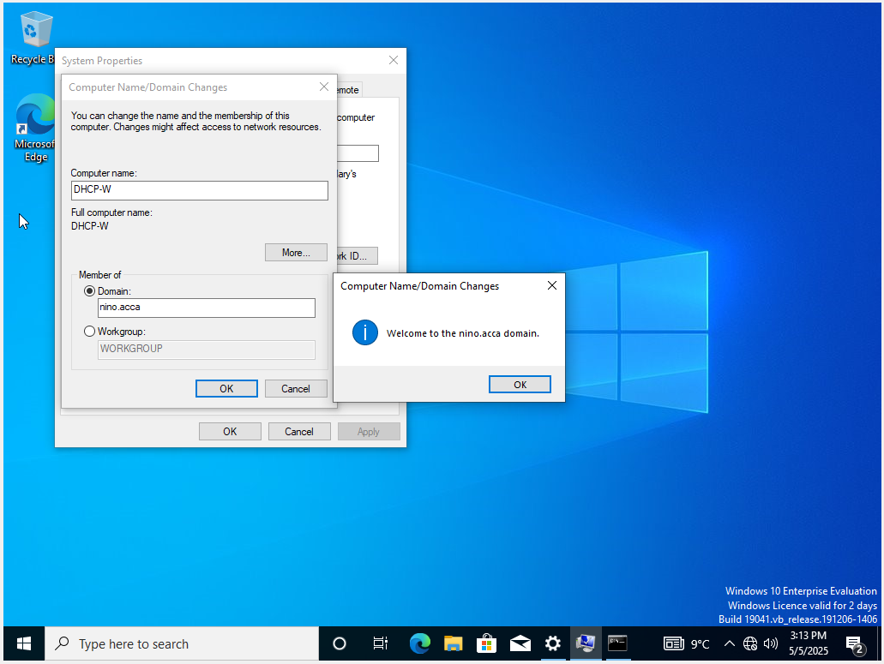
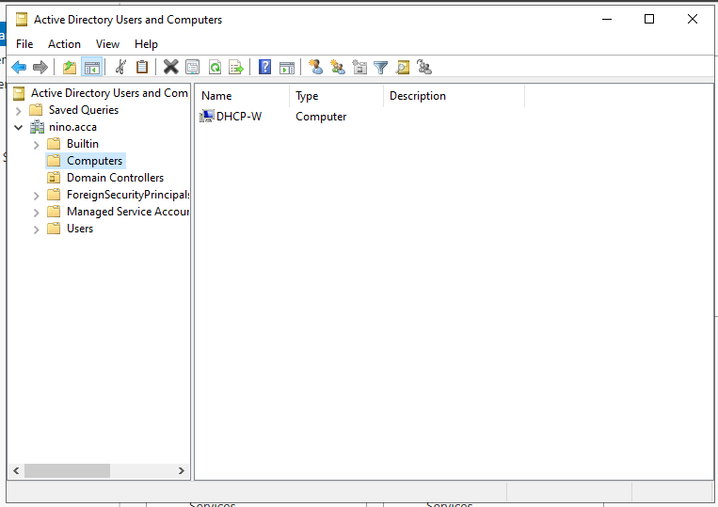

Installing Routing and Remote Access
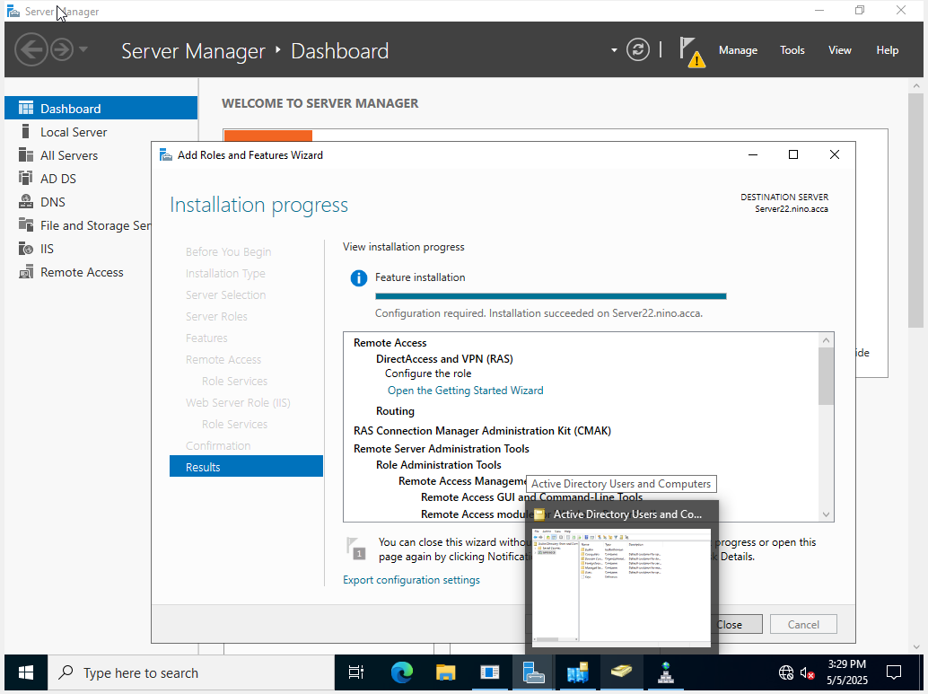

Ping Successful from Client to External Server
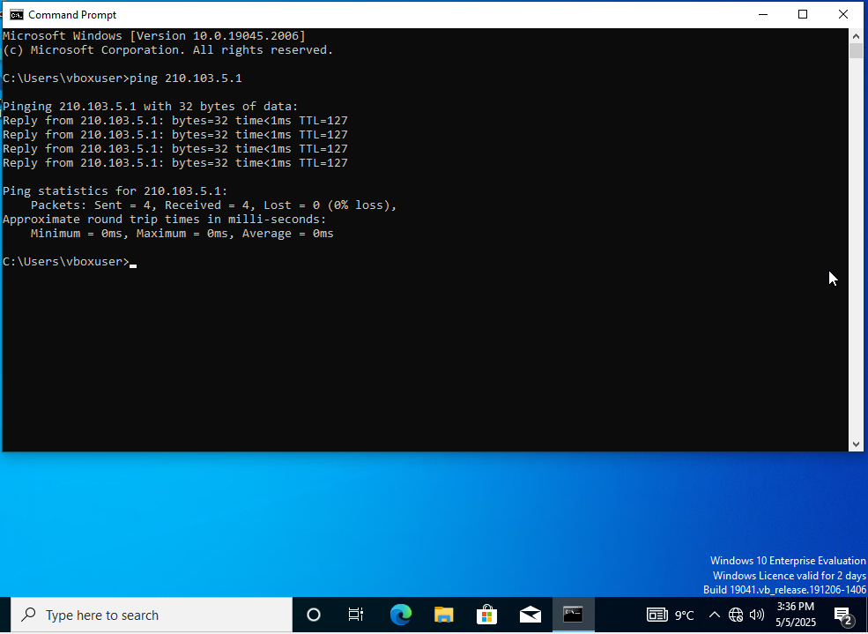

Install + Configuring PPTPD in Debian Sever
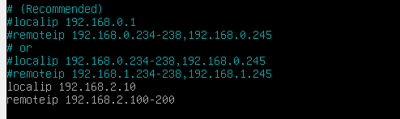
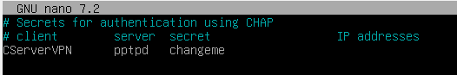
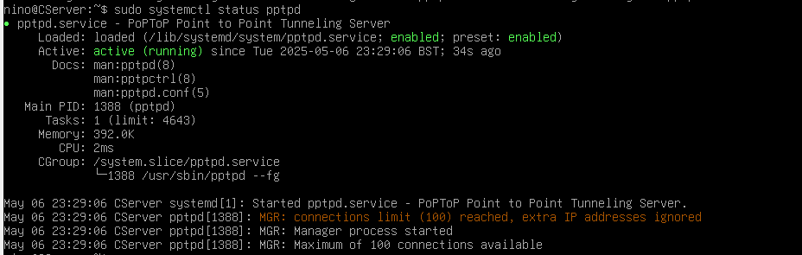

Point to Point Tunneling Protocol Configured VPN (One side)

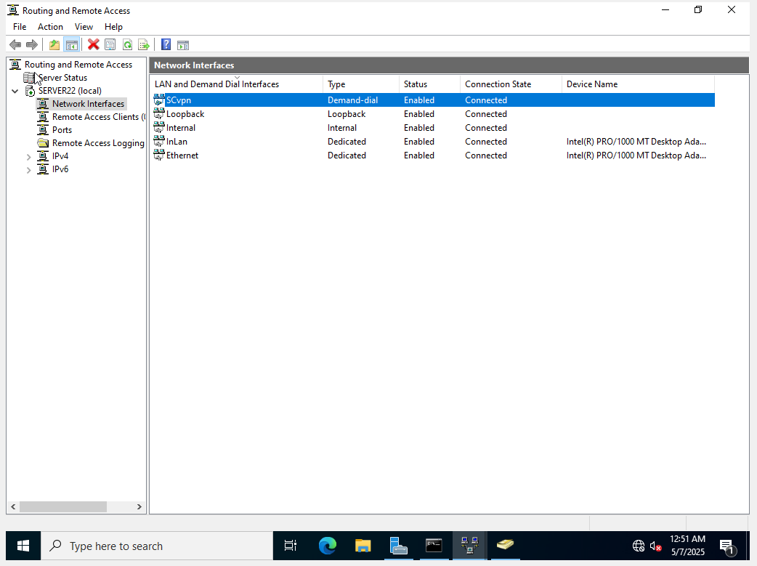

Successfully Configured DNS Servers with DNSPowershell
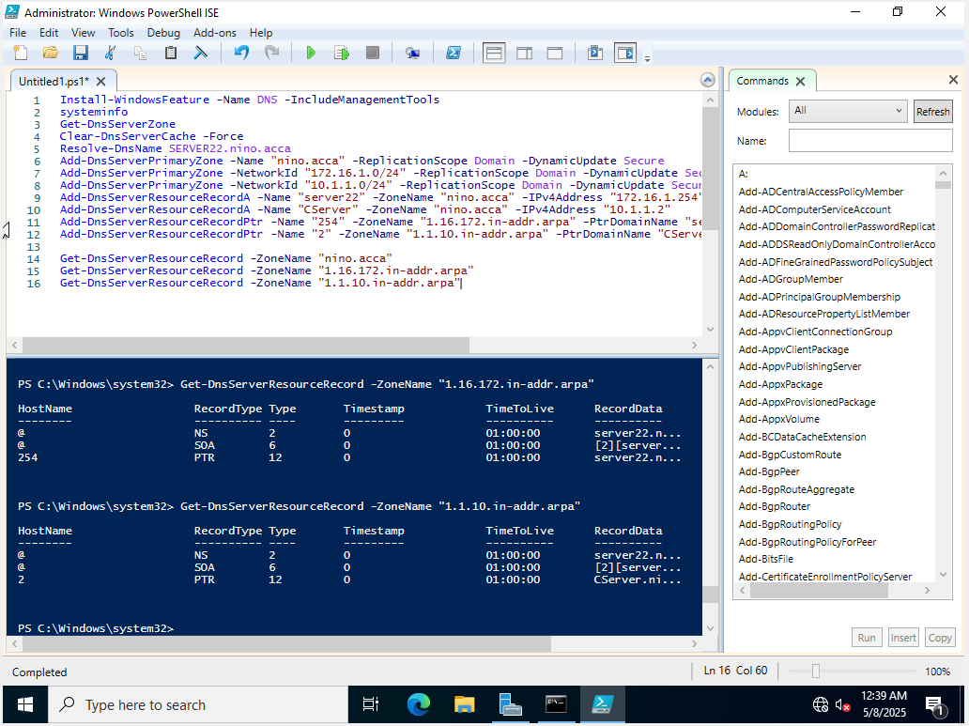
Installing DHCP with PowerShell
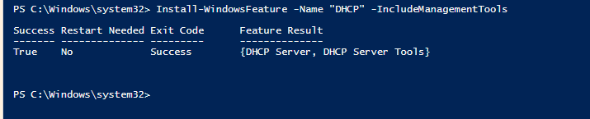

Configuring + Authorizing DHCP Windows
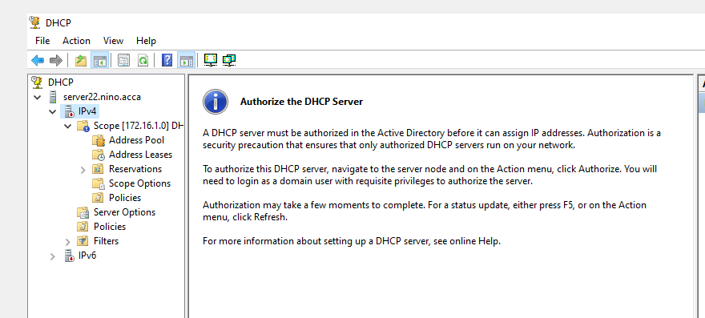
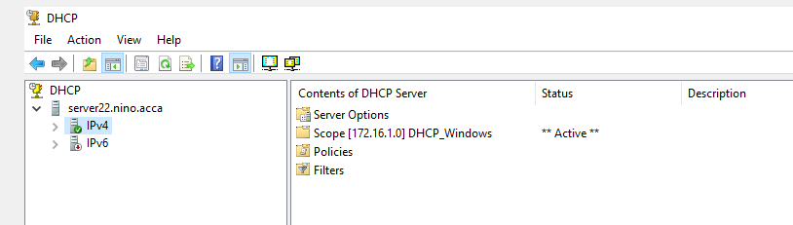
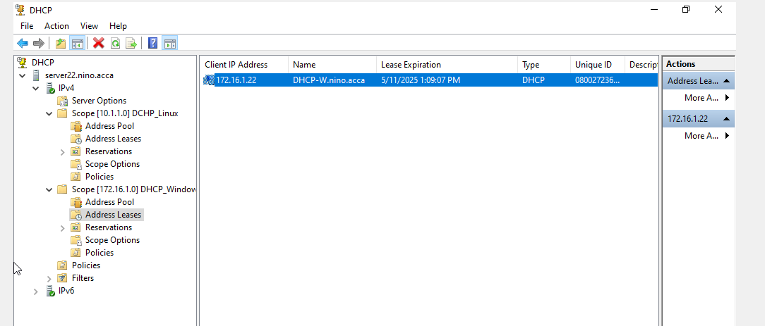

Configuring DHCP Relay – Linux
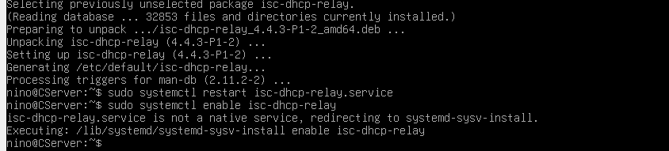

Upload CSV list to Swansea Users OU
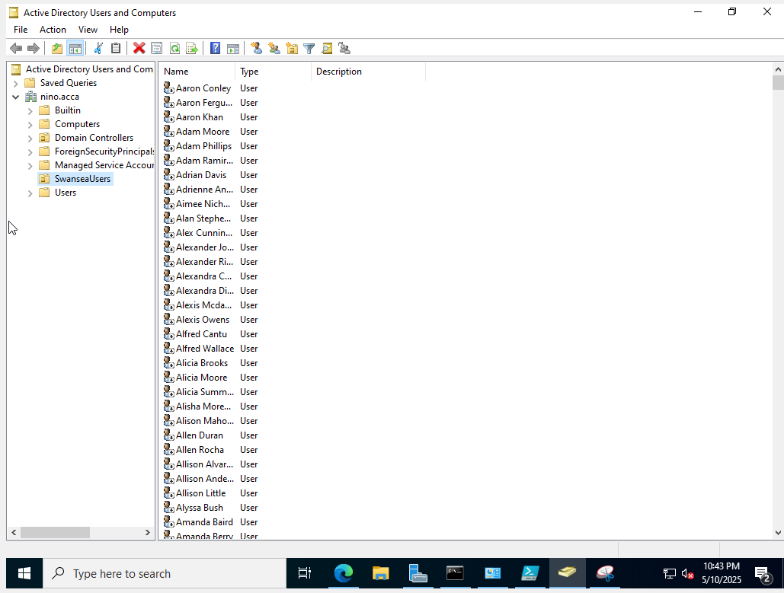

Giving Full Permission whilst Everyone else is Read Only
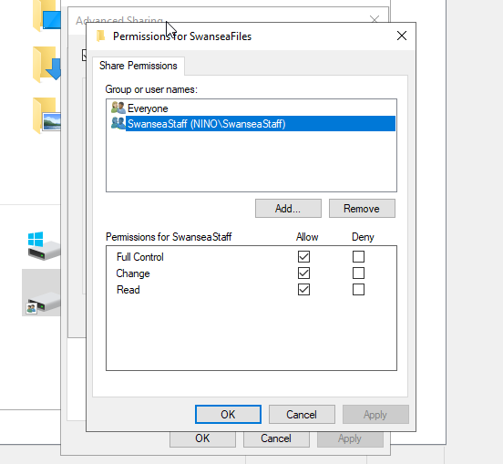

Shared Drive to Cardiff + Swansea Network
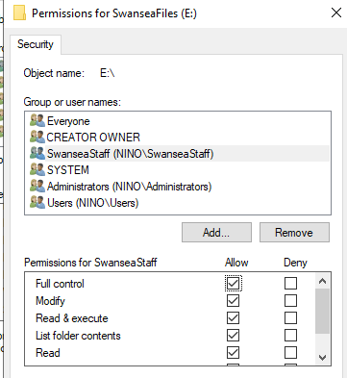

Configured IIS + Website Created – nino.acca
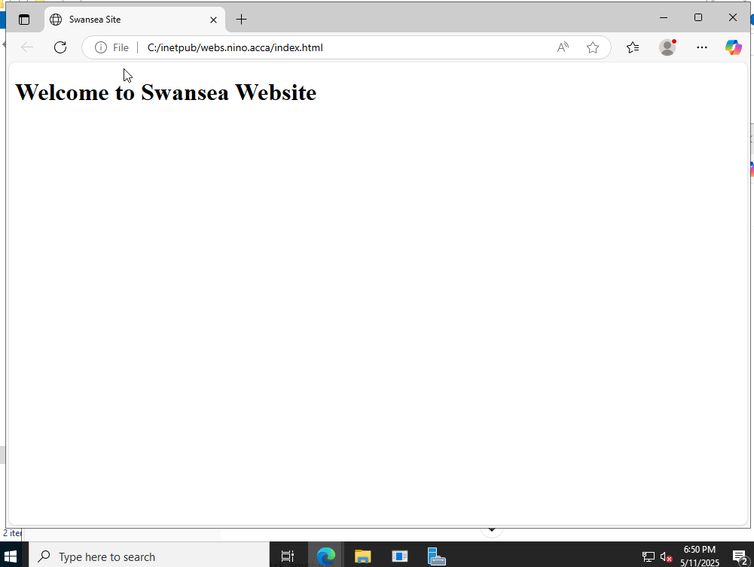
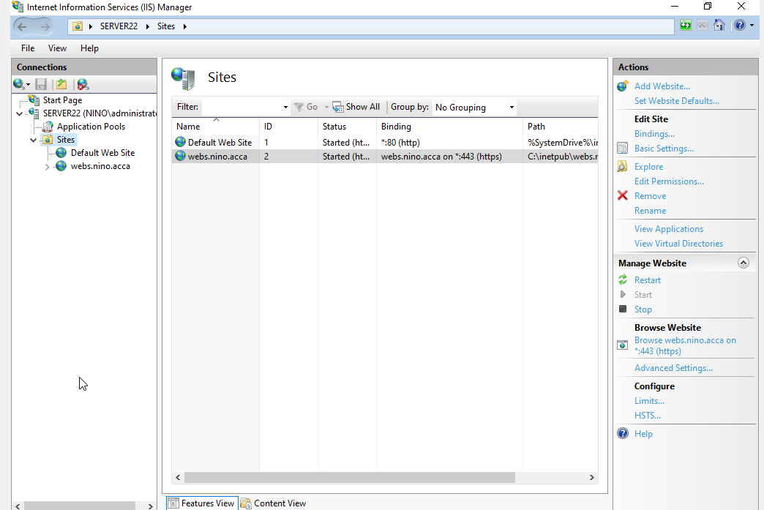

Enabling Internal Authentication
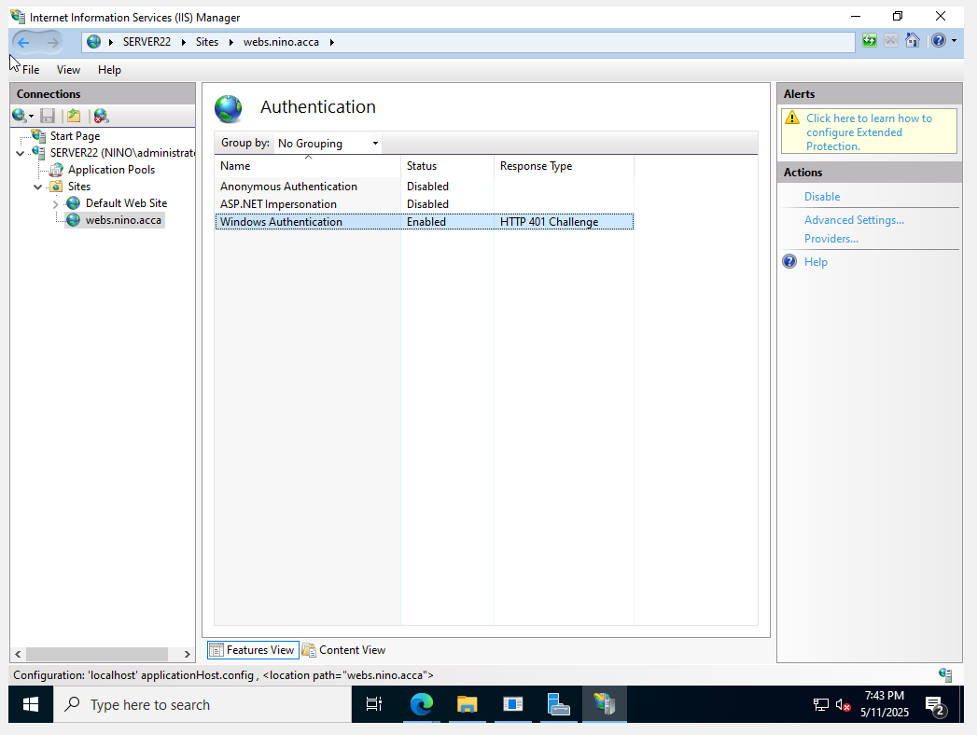

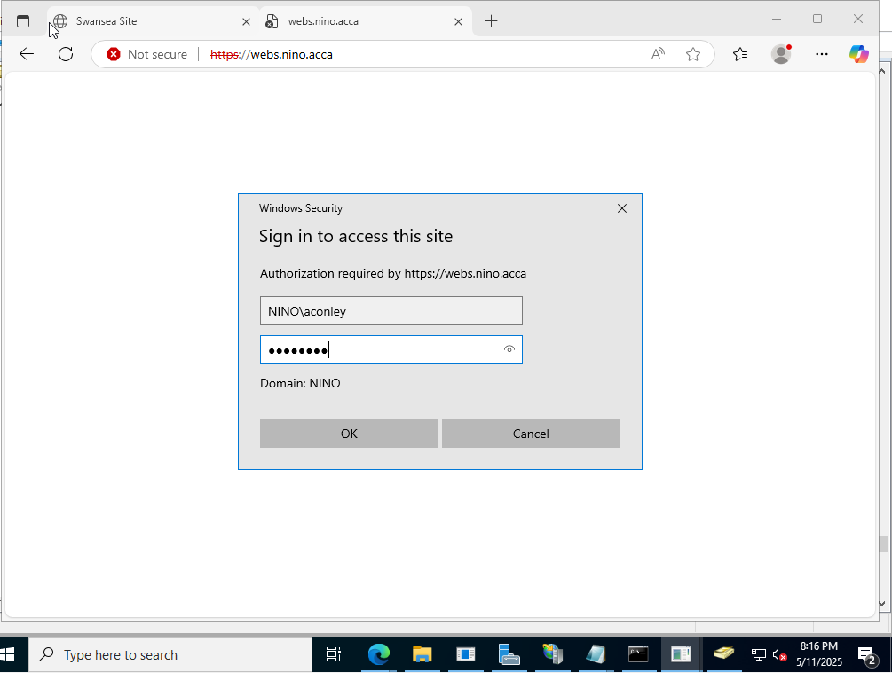

Remote Desktop Service Role Installation
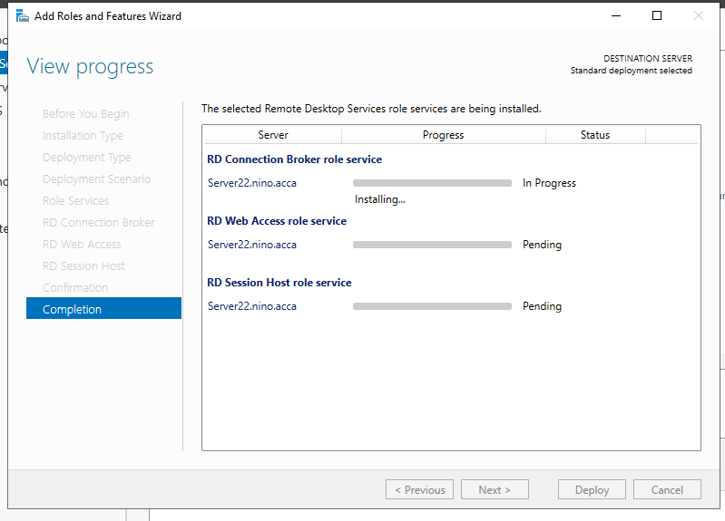

Login Page Access via https://rds.nino.acca


