Student Name: Emma Morgan
Student Number: 1701833
Course: BA Illustration
Module: Research Practices (ADAD5001)

Lecturer: Louise Burston

Word count: 2,258

In this proposal, three keywords will be explored and researched in depth, that will develop into a question for my dissertation. This proposal will be based on knowledge from my own practices and research into the keywords themselves, looking in particular at theorists such as Johannes Itten and Johann Wolfgan von Goethe. The roles of colour, symbolism and expressionism within the visual arts discipline will be explored, with the primary focus being aimed towards paintings. With this in mind, the works of Vincent Van Gogh and Edvard Munch will be included as examples of how colour, symbolism and expressionism is used within paintings to create emotion.

Keyword one: Colour Theory
Within the visual arts discipline, colour theory is described as the practical application of combining colours and is known as an important aspect within paintings as various colours can communicate emotion to an audience through a particular painting. For example, within a painting the colour red can invoke negative feelings such as anger or positive feelings such as love, this shows how there can be various interpretations of a colour within a painting.
Researching into the context of colour theory, in scientific terms colour theory was initially founded by Isaac Newton, when he discovered the visible spectrum from his experiments with light and prisms, forming his theory that colour originally came from light. The visible spectrum breaks up into 7 colours – Red, orange, yellow, green, blue, indigo and Violet, from which he represented within the first creation of the colour wheel, showing the relationships between the colours. The colour wheel forms just the basis of colour theory and after Newton’s discovery, “It was commonly thought that white light represented light in its pure form and that colors were modifications of white light” (Shevell, 2003, p. 2)

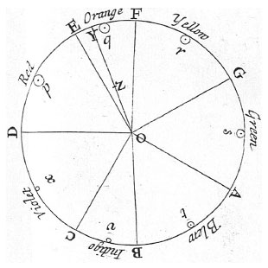

Figure 1: Isaac Newton, Colour Wheel, 1666
Although the idea of colour theory originated from Newton, “The Theory of Colours by German poet Johann Wolfgang von Goethe and The Law of Simultaneous Color Contrast by French chemist Michel Eugene Chevreul, are considered the founding documents of color theory.” (Stewart, 2018) In 1809, the German poet Goethe formed his own version of the colour wheel in pigments and unlike Newton, his idea of colour theory was explored through human perception and focused more on the psychology of colour, rather than the science of colour.
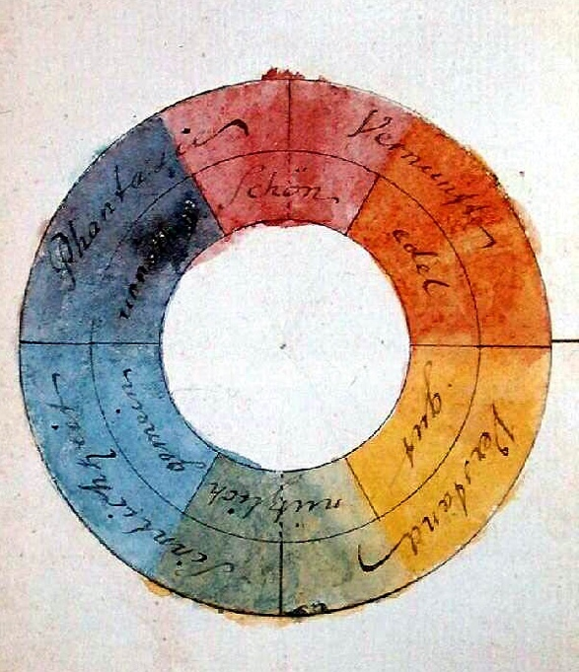

Figure 2: Colour Wheel, Johann Wolfgang von Goethe, 1809
Goethe made many explanations on the emotion of colours within his colour wheel but one example of Goethe’s psychology exploration in colour theory is his statement on the colour ‘yellow’. - “we find from experience, again, that yellow excites a warm and agreeable impression. Hence in painting it belongs to the illumined and emphatic side.” (Goethe,1840, p.307) From the above statement, Goethe uses the words ‘warm’ and ‘illumined’ portraying yellow as a happy and bright colour that would have a positive psychological effect on the audience’s emotion because of its bright uplifting nature.
Following the ideas of Goethe’s colour theory and psychology exploration, Johannes Itten, an artist and theorist developed colour theory further creating a 12- hue colour circle. The 12-hue colour circle initiated from 3 colours – Red, yellow and blue, shown in the triangular section of the colour circle. These colours are also known as the primary colours and when 2 out of the 3 colours are mixed together, these form the secondary colours, shown in isosceles triangles outside of the primary colour. In the outer circle of the wheel are the tertiary colours which form from mixing a primary and secondary colour together. Itten states that “the sequence of the colors is that of the rainbow or natural spectrum.” (Itten, 1970, p.30)
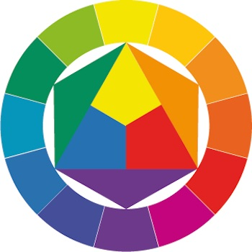

Figure 3: 12-hue colour circle, Johannes Itten,

In his book ‘The Art of Color’, Itten explores in great detail his other contributions to colour theory – The seven contrast colours:
- Hue – various hues on the colour wheel being mixed together
- Light to dark – shades of colour
- Cold to warm – colour in relation to temperature
- Complementary
- Simultaneous
- Saturation
- Extension

Combining both emotion and science into his theories, Itten explains “Colors are forces, radiant energies that affect us positively or negatively, whether we are aware of it or not.” (Itten, 1970, p.12) This statement can be applied to colour theory within paintings and the impact of emotion, in regard to positive or negative effects on the particular individual viewing the painting. Following on from the research into colour theory and psychology of colour, there are several artists that apply colour to their work as an attempt to portray or evoke emotion or feeling, this is shown widely within the paintings of Vincent Van Gogh, who draws upon the elements of expressionism and symbolism.

Keyword two: Symbolism
Symbolism initially began as a literary movement from poets and “the name “symbolist” itself was first applied by the critic Jean Moréas” (Stanska, 2016) In the late nineteenth century, symbolism developed into an art movement and came to prominence through the work of symbolist artists like Gustave and Redon. In addition to symbolists’ artists, symbolism was also widely recognised within the work of post-impressionist Paul Gauguin, who often used very symbolic aspects within his paintings through the use of emotion and bold colour, which influenced the work of Vincent Van Gogh.
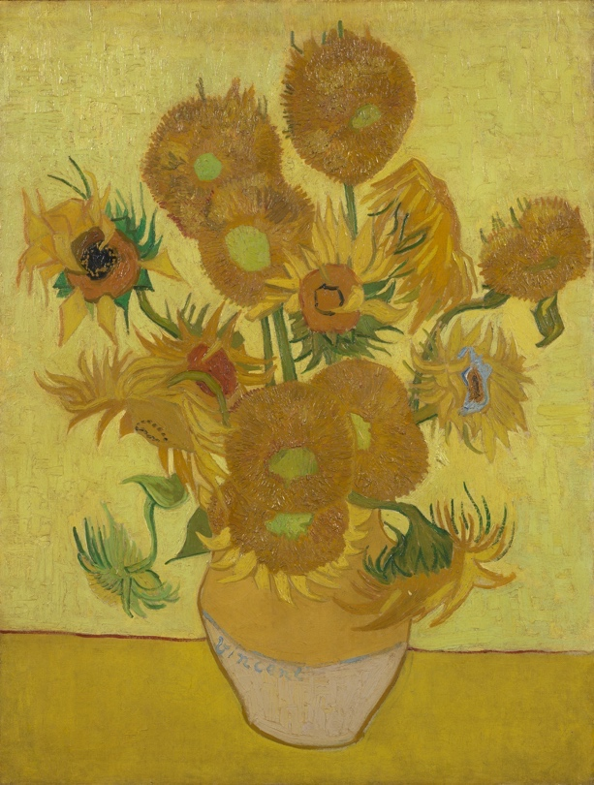
“Symbolist painters believed that art should reflect an emotion or idea.” (Myers, 2000), bringing in the idea that symbolism is the use of representation through symbols, often taking various approaches such as form, colour, shape and much more. The idea that art should reflect emotions can uncover deeper meanings hidden within some artworks, which was often shown within Vincent Van Gogh’s paintings, due to his diverse moods at the period of time in which he painted them.

Figure 4: ‘Sunflowers’ Vincent Van Gogh, 1888

This painting became one of the most well-known paintings by Gogh and was originally painted for his friend Paul Gauguin in an attempt to impress him upon his arrival. On the National Gallery website it explains that “it was painted during a rare period of excited optimism, while Van Gogh awaited the arrival of his hero, the avant-garde painter Paul Gauguin” (The National Gallery) Gogh created several versions of the famous painting ‘sunflowers’ and eventually formed a series of paintings, which reflected his own emotions and experiences through symbolic representations.
This particular version of Gogh’s sunflowers consisted of many yellow hues, which form quite a bright uplifting painting and applying Goethe’s colour theory, this painting can be seen as a symbolic representation of happiness, that expresses Gogh’s optimistic feeling into the painting. Not only can this painting communicate a positive emotion and effect from the meaning of the colour to the audience but it has personal meaning to Van Gogh, as it comes from an emotion experienced by himself which he captures within his work and although the colour in this painting is what really brings it together, the other important aspect of this painting is the meaning behind the sunflowers. “Yellow, for him, was an emblem of happiness – in Dutch literature, the sunflower was a symbol of devotion and loyalty. In their various stages of decay, these flowers also remind us of the cycle of life and death.” (The National Gallery) Sunflowers are recognised from their bright colours associated with warmth, natural beauty and the sun, which Gogh captured through the use of intense and expressive colour in the blossoming sunflowers, however the natural beauty is also captured within the decaying flowers. The vivid colours used within Van Gogh’s paintings have association to the term ‘Expressionism’ in relation to the inner feelings or ideas being represented within a painting of symbolic meaning. This further links together the idea of colour theory and the art movement symbolism to the known art movement of expressionism.
Keyword three: Expressionism
“The words “expressionism” and “expressionist” first cropped up in the art literature around 1911, initially as blanket terms for avant-garde art in Europe around the turn of the century.” (Wolf, 2004) Expressionism is a modernist art movement that initially developed in poetry and paintings and as an art term “expressionism refers to art in which the image of reality is distorted in order to make it expressive of the artist’s inner feelings or ideas” (Tate)
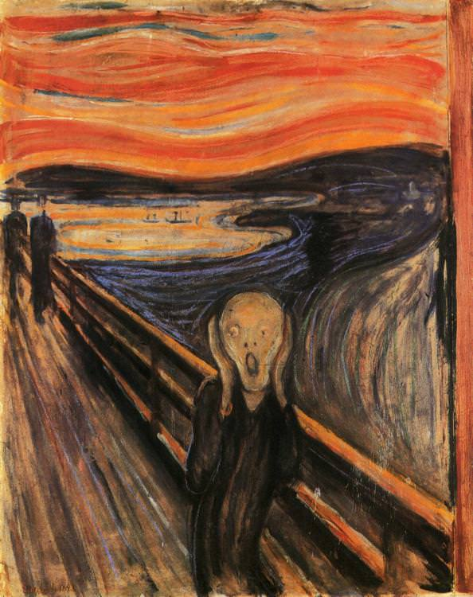
An example of the above statement is the influence of artist Edvard Munch within expressionism, who became an important figure from his well-known and iconic painting ‘The Scream’.

Figure 5: ‘The Scream’ Edvard Munch 1893

Connecting the elements of expressionism and symbolism within one painting, “The Scream by Edvard Munch seems to be the most known Symbolist work.” (Stanska, 2016). From an initial visual point of view, the painting depicts a distorted figure in the centre, who is covering their ears with their hands and shows two figures in the background walking into the distance. The painting itself is said to be based on a real-life experience, from which Munch felt the emotions of anxiety and the feeling of being scared, and like Van Gogh he captures these emotions within the painting linking in his use of elements from the art movement expressionism.
These colours bring in the example of psychological effects from colour theory and what we understand of each colours meaning, for example the sky is various shades of red and orange which could symbolise anger, frustration or even danger, especially in terms of the title name. When we hear a scream, we often think of danger, leading the audience to a possible negative effect from viewing this painting, although we do not know it’s a scream of someone being in danger. Though a section in a journal by Edvard Munch that describes his experience and what he felt during this experience has been shared in an article, by a writer in The New York Times:
''All at once the sky became blood-red . . . clouds like blood and tongues of fire hung above the blue-black fjord and the city . . . and I stood alone, trembling with anxiety . . . I felt a great unending scream piercing through nature,'' it says. (Jaroff, 2003)
The painting is an accurate representation of the above quote from Munch, which decodes the meaning of ‘The Scream’ through symbolic expression of colours and personal experience. There has been an ongoing argument that the person in the painting isn’t actually screaming, instead he is hearing a scream, which from the above quote we get an understanding that ‘The Scream’ is a depiction of a feeling, rather than a real-life event/experience. In conclusion to Munch’s painting, there is a strong communication of the feelings of fear and anxiety to the viewing audiences and applying Itten’s colour theory, it can be said that this painting can have a negative effect on the audience from the colour and expressive emotion.
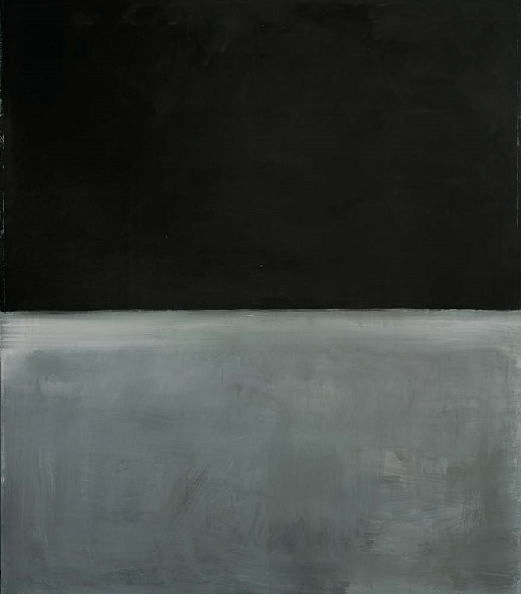
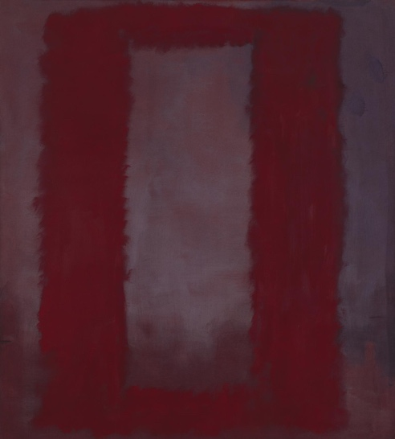

Figures 6: Red on Maroon, Mark Rothko, 1959 Figure 7: Untitled (Black on Gray), Mark Rothko 1969

Another form of expressionism that explores expressive and emotional effects is portrayed through the use of abstract art and also referred to as the art movement abstract expressionism. Abstract expressionism developed around the 1940/50s and focuses primarily on the use of mark making, developing from the works of American painters like Mark Rothko. Mark Rothko became one of the many figures of abstract expressionism and creators of colour field painting through his works consisting of only solid and flat colours in simple compositions to express the deep human emotions, which in affect link to psychological effects of colour theory. The above images are 2 paintings created by Mark Rothko, which show how he approached abstract expressionism with minimal mark making and simplicity through the compositions of vertical and horizontal geometric shapes like rectangles. These paintings are so abstract and minimal that their interpretations can vary a great deal on the viewers opinion, or the emotion taken from them. In relation to colour theory, from the second painting ‘Untitled(Black on gray)’ the interpretation of negative psychological effect can be portrayed through the idea that the colour black is dull or tragic and symbolises grief or death but in the first painting, the colours consist of deep maroons and reds which portray a completely different view of emotions, like the symbolism of the colour red can be anger, love, passion and various more emotions. The focus of Mark Rothko’s paintings is an act of representing human emotion which links directly to all 3 of the keywords explored through this proposal.

So, to summarise these 3 keywords all together - they are elements within visual arts that affect how we, as viewers interpret the emotion and meaning behind a painting. In addition to this, how we interpret emotion and meaning can also depend primarily on our own feelings and experiences and not just the inner feelings of the artist and their work. These elements within visual arts have led me to a question that will be researched and written about in depth for my upcoming dissertation, exploring the psychological effects of colour theory in paintings and bringing in the connections of the art movements symbolism and expressionism further.
The question which will be researched and written about for my upcoming dissertation is:
How do paintings within the visual arts discipline communicate to their audience?
Regarding this question, various sub questions will be explored on the use of colour, symbolism, expressionism and other elements of art that effect how the paintings communicate to their audience. The sub questions will be:
How is colour used in art to create emotion?
Can colour interpret psychological effects in paintings?

Bibliography
- Goethe, J. (1840) ‘Theory of Colors’, M.I.T. Press
- Itten, J. (1970) ‘The Elements of Color’, John Wiley & Sons
- Jaroff, L. (2003) ‘More Than a ‘scream’ ’, The New York Times, Available at: https://www.nytimes.com/2003/12/09/science/more-than-a-scream-a-blast-felt-round-the-world.html?rref=collection%2Ftimestopic%2FMunch%2C%20Edvard&action=click&contentCollection=timestopics&region=stream&module=stream_unit&version=search&contentPlacement=18&pgtype=collection (Date accessed: 24.04.19)
- Myers, Nicole (2007) ‘Symbolism’, In Heilbrunn Timeline of Art History. New York: The Metropolitan Museum of Art – Available at: https://www.metmuseum.org/toah/hd/symb/hd_symb.htm (Date accessed: 16.04.19)
- Shevell K, S. (2003) “The Science of Color’, Elsevier
- Stanska, Z (2016) ‘5 Facts That Will Help You Understand Symbolism’ Available at: http://www.dailyartmagazine.com/5-facts-that-will-help-you-understand-symbolism/ (Date accessed: 24.04.19)
- Stewart, J. (2018) ‘Learn How Color Theory Can Push Your Creativity to the Next Level’, My Modern Net, Available at: https://mymodernmet.com/basic-color-theory/ (Date Accessed: 5.05.19)
- Tate, ‘Expressionism’, Available at: https://www.tate.org.uk/art/art-terms/e/expressionism (Date Accessed: 6.05.19)
- The National Gallery, ‘Sunflowers: Symbols of happiness’ Available at: https://www.nationalgallery.org.uk/paintings/learn-about-art/paintings-in-depth/sunflowers-symbols-of-happiness?viewPage=1 (Date Accessed: 6:05.19)
- Wolf, N. (2004) ‘Expressionism’, Taschen

