7/14/2026
Matthew Hope (2509337)

Creativity and Evaluation

Abstract
In modern organisations, large amounts of customer feedback are generated through online reviews, surveys, and support interactions. Analysing this information manually can be difficult and time consuming, making it challenging for businesses to quickly understand customer satisfaction. Artificial Intelligence and Natural Language Processing provide solutions by allowing organisations to automatically analyse customer opinions and identify trends.
This project focuses on the development of a Customer Sentiment Analysis Dashboard that analyses customer reviews and classifies them as Positive, Negative, or Neutral. The system was developed using Python in Visual Studio Code, with libraries such as Pandas and TextBlob used for data processing and sentiment analysis. The results were then presented using Microsoft Power BI to create interactive visualisations that help users understand customer feedback.
The project follows an Agile development approach, allowing the system to be developed in stages with regular testing and improvements. This report explores the innovation behind sentiment analysis, the tools and methods required to implement the solution within a large organisation, and the legal and ethical considerations involved when using AI and customer data.
Overall, the project demonstrates how AI and data analytics can transform customer feedback into valuable insights that support improved decision-making and customer experiences.

Contents
Abstract 1
Task 1: Practical Development and implementation 3
Implementation and troubleshooting 4
Task 2: Enterprise and innovation 6
PEST Analysis 7
Legal and Ethical Considerations 7
Task 3: Project reflection 8
Project progress diary 8
Skills 9
Positive Social Impact (PSI) 9
Conclusion 10
Appendices 11
Task 3 dashboard feedback 11
Certified online training course using LinkedIn learning 13
References 14

Task 1: Practical Development and implementation

Feedback was collected from five individuals who reviewed the initial design and implementation of the Customer Sentiment Analysis Dashboard. Collecting user feedback during software development is an important part of the development process because it helps identify usability issues and opportunities for improvement before deployment [1]. Overall, the responses were positive, with participants agreeing that the dashboard was easy to understand and provided a clear overview of customer sentiment. They particularly liked the simple layout, clear charts and graphs, and the use of sentiment categories positive, Neutral and Negative, which made the results quick to interpret. Several participants commented that the dashboard would be useful for businesses because it could help managers identify trends in customer satisfaction and make more informed decisions based on customer feedback [2].
Although the feedback was largely positive, participants also suggested several improvements. The most common recommendation was to include interactive filters, allowing users to view sentiment results by date, product or customer category. Others suggested adding KPI cards to display key statistics, such as the total number of customer comments analysed and the overall sentiment score. Two participants recommended using a more consistent colour scheme, such as green for positive sentiment, amber for neutral sentiment and red for negative sentiment, to improve readability and create a better user experience [3]. One participant also suggested adding a search function so that specific customer comments could be located quickly when investigating complaints. Based on this feedback, the dashboard design would be updated by adding interactive filters, improving the visual layout, and including summary metrics to make the information more accessible and valuable for business users. Using feedback to refine a system is consistent with recognised software engineering practices that encourage continuous improvement throughout the software development lifecycle [4].

Implementation and troubleshooting
The aim of this project was to develop a Customer Sentiment Analysis Dashboard capable of analysing customer reviews and classifying them into three sentiment categories: Positive, Negative, and Neutral. The project was implemented using Python within Visual Studio Code for data processing and sentiment classification, while Microsoft Power BI was used to create interactive visualisations that present the analysis results.
The first stage of implementation involved preparing the development environment. Visual Studio Code was installed and configured with Python support. The required Python libraries, including Pandas and TextBlob, were installed. Pandas was used for importing, managing, and processing customer review data, while TextBlob was used to perform natural language processing and calculate sentiment scores from customer comments.
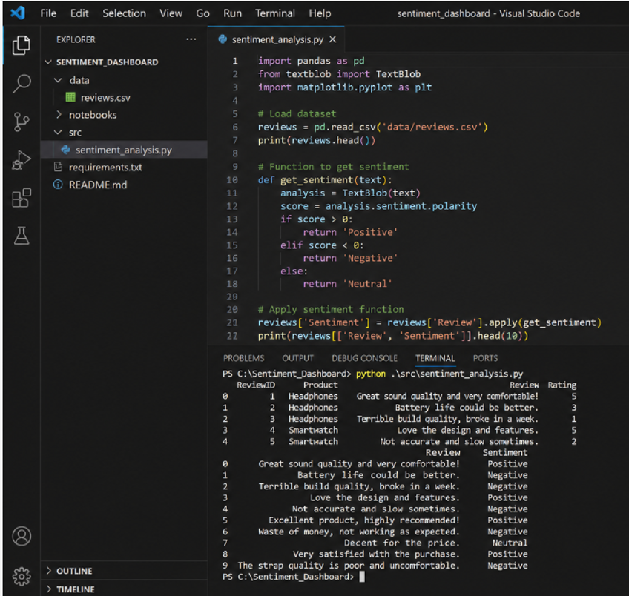
Figure 1. Sentiment analysis project created in Visual Studio Code.

After the development environment was prepared, a customer review dataset was created and stored in CSV format. The dataset contained examples of customer feedback, which acted as the input data for the sentiment analysis process. The CSV file was imported into Python using the Pandas library, allowing the reviews to be processed and analysed programmatically.
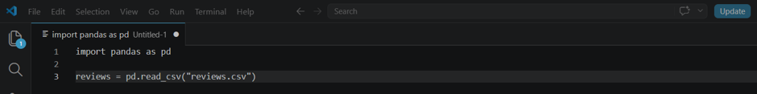
Figure 2. Customer review dataset imported into Python.
The next stage involved applying sentiment analysis to each customer review. A Python function was developed using the TextBlob library to calculate the polarity score of each review. The polarity score determines whether a review contains positive, negative, or neutral language. Based on the calculated score, each review was assigned a sentiment label. These sentiment classifications were then added as a new column within the dataset, allowing the results to be easily analysed and visualised [5].
Following completion of the sentiment analysis, the processed dataset was exported as a new CSV file and imported into Power BI. Within Power BI, multiple visualisations were created, including charts displaying the number of positive, negative, and neutral reviews. These dashboard components allow users to quickly identify customer satisfaction levels and analyse overall sentiment trends.
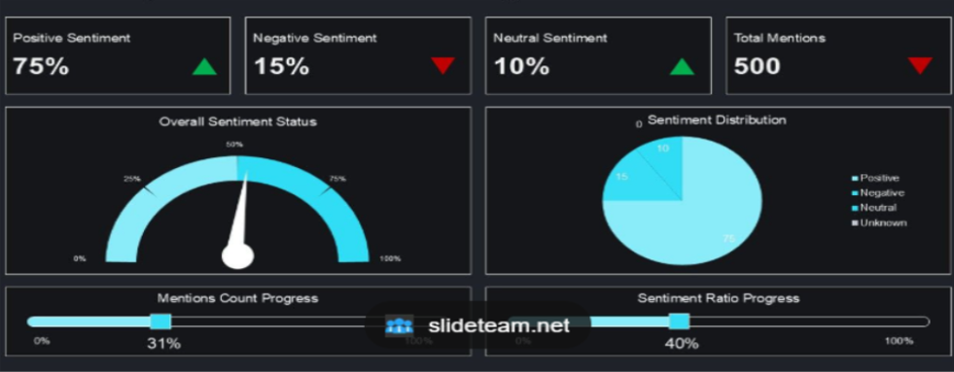Figure 3. Example Customer Sentiment Analysis Dashboard.
The completed dashboard provides an accessible method of presenting customer feedback analysis. Instead of manually reviewing individual customer comments, users can use the dashboard to identify patterns within customer opinions and gain insights into overall customer satisfaction.

Task 2: Enterprise and innovation
The proposed Customer Sentiment Analysis Dashboard could be implemented within a large technology organisation such as Microsoft to analyse customer feedback, reviews, surveys, and support interactions. The purpose of the system would be to use Natural Language Processing and data analytics techniques to identify customer opinions and provide organisations with insights that improve decision-making and customer satisfaction.
The development of the dashboard would follow an Agile software development methodology. Agile allows large organisations to develop systems through smaller development cycles known as sprints, enabling regular feedback from stakeholders and continuous improvement throughout the project lifecycle. This approach is suitable because customer requirements and technologies can change quickly, particularly within artificial intelligence projects [6].
During development, customer data would first be collected from multiple sources, including online reviews, customer surveys, social media platforms, and customer service conversations. The data would then be cleaned and prepared before being processed by an NLP model. Python would be used as the main programming language, supported by libraries such as Pandas for data processing and TextBlob or machine learning frameworks for sentiment classification. NLP techniques allow computers to analyse human language and identify patterns within large volumes of text data [7].
The practical system architecture would consist of several components. Customer feedback would be stored securely within a cloud database, such as Microsoft Azure SQL Database. Python-based sentiment analysis models would process the data and assign sentiment scores, which would then be transferred into Microsoft Power BI to create interactive dashboards. Cloud platforms provide organisations with scalability, reliability, and secure access to business intelligence systems [8]
Deployment within a large organisation would require strong cybersecurity controls. User authentication, role-based access controls, encryption, and secure data storage would be implemented to protect customer information. This is particularly important because customer reviews and support conversations may contain personal information that must be protected under data protection regulations such as the General Data Protection Regulation.
After deployment, continuous maintenance would be required to ensure the dashboard remains accurate and reliable. This would include monitoring system performance, updating software dependencies, fixing technical issues, and retraining the sentiment analysis model using new customer data. AI systems require ongoing evaluation because language patterns and customer expectations can change over time.
The project could also evolve through additional features. Future improvements could include real-time sentiment monitoring, automated customer complaint alerts, predictive analytics to identify dissatisfied customers before complaints occur, and integration with AI-powered customer service platforms. Continuous innovation would allow the organisation to gain greater value from customer data and improve customer experiences.

PEST Analysis
Factor | Analysis
Political | Microsoft operates globally and must comply with different government regulations relating to data protection, artificial intelligence, and cybersecurity. Increasing government focus on responsible AI development may influence how Microsoft designs and deploys AI-based systems.
Economic | Demand for cloud computing, AI services, and business intelligence solutions creates significant growth opportunities for Microsoft. However, economic uncertainty and reduced technology spending could affect investment in new digital solutions.
Social | Customers increasingly expect personalised and efficient digital services. AI-driven sentiment analysis can help organisations understand customer needs; however, users may have concerns regarding privacy, transparency, and how their data is analysed.
Technological | Rapid developments in artificial intelligence, machine learning, and cloud computing provide opportunities for Microsoft to improve products such as Azure and Power BI. However, competitors and fast-changing technologies require continuous research and innovation.

Legal and Ethical Considerations
A key legal consideration for implementing a Customer Sentiment Analysis Dashboard is compliance with data protection legislation. Organisations must ensure that customer information is collected, stored, and processed lawfully. GDPR requires companies to protect personal data and provide transparency regarding how information is used [9].
Ethical concerns must also be considered when developing AI-based sentiment analysis systems. AI models may contain bias if training datasets are incomplete or unbalanced, which could result in inaccurate sentiment predictions. Organisations should therefore regularly test models, monitor accuracy, and ensure decisions made using AI remain fair and explainable [10].
Overall, implementing a Customer Sentiment Analysis Dashboard within Microsoft would demonstrate how enterprise organisations can use AI, cloud computing, and data analytics to improve customer relationships. However, successful implementation requires careful consideration of technical development, cybersecurity, legal compliance, and ethical AI practices.

Task 3: Project reflection
To evaluate my sentiment dashboard, I demonstrated the completed project to five colleagues and explained its design, sentiment analysis process, and key features. After the demonstration, they completed a short questionnaire with rating-scale and open-ended questions covering usability, design, functionality, and clarity.
The overall feedback was positive. All five colleagues agreed that the dashboard was easy to navigate and that the charts clearly displayed positive, negative, and neutral sentiment. They felt the layout was professional and made the results easy to understand. However, they also suggested several improvements. Two colleagues recommended adding search and filtering options to analyse specific keywords or date ranges. Others suggested including tooltips to explain charts and sentiment scores, improving the colour scheme for accessibility, and displaying additional statistics such as the total number of comments analysed.
Based on this feedback, I would enhance the dashboard by adding filtering features, explanatory tooltips, improved visual design, and extra summary statistics to create a more informative and user-friendly experience.

Project progress diary
Throughout the project, I used project management methods and a Gantt chart to plan and organise my work. The Gantt chart helped me break the project into different stages, including research, development, testing, and evaluation, while allowing me to track deadlines and monitor my progress. I also completed weekly progress sheets to record completed tasks, challenges, and the next steps required.
Using these tools helped me stay organised and manage my time effectively throughout the development of my sentiment dashboard. One challenge I faced was that some development and testing tasks took longer than expected, especially when improving the accuracy and functionality of the dashboard.
If I were to complete the project again, I would plan additional time for testing and improvements, set smaller weekly targets, and collect feedback earlier during development. This would help me manage the project more efficiently and improve the outcome.

Skills
During this module, I developed a range of new technical and personal skills through creating my sentiment dashboard. I improved my knowledge of sentiment analysis, data processing, and data visualisation by learning how to analyse information and present results clearly through a dashboard.
I also developed project management skills by using tools such as Gantt charts to plan tasks, manage deadlines, and track progress. Completing weekly progress sheets improved my organisation and reflection skills by allowing me to review my work and identify areas for improvement.
Additionally, I improved my problem-solving skills by fixing technical issues and making decisions during the development process. I also gained experience in collecting and analysing feedback from users to improve my project. These skills will be useful for future projects, studies, and my career.

Positive Social Impact (PSI)
My sentiment dashboard can have a positive social impact by helping organisations understand opinions, feedback, and trends more effectively. By analysing sentiment from comments or reviews, businesses can identify customer needs, improve their services, and make better decisions. The dashboard could also help organisations understand public views and respond to important issues more efficiently.
The skills I developed during this project, including data analysis, dashboard development, project management, and problem-solving, can help me create useful digital solutions in the future. These skills can be applied to projects that improve decision-making, increase efficiency, and provide better user experiences. Overall, this project has shown how technology and data analysis can be used to solve real-world problems and create positive benefits for individuals, organisations, and society.

Conclusion
This project demonstrated how Artificial Intelligence, Natural Language Processing, and data visualisation can be used to analyse customer feedback and provide valuable insights. The Customer Sentiment Analysis Dashboard successfully used Python, TextBlob, Pandas, and Power BI to classify reviews and present sentiment results clearly. The project also considered enterprise implementation, Agile development, cybersecurity, and ethical issues when using customer data. Feedback helped identify possible improvements to enhance the dashboard. Overall, this project developed my technical, project management, and problem-solving skills while showing how AI solutions can support better decision-making and improve customer experiences.

Appendices

Task 3 dashboard feedback completed on Microsoft forms:
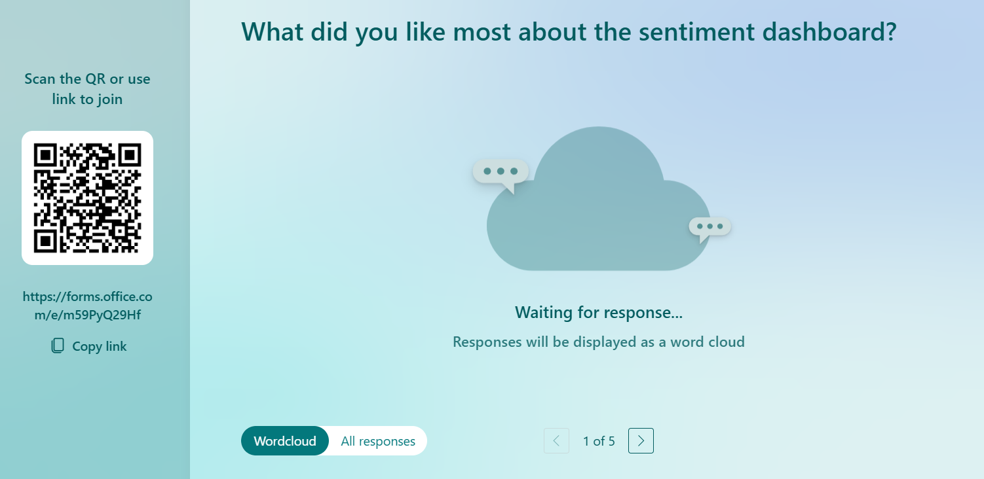
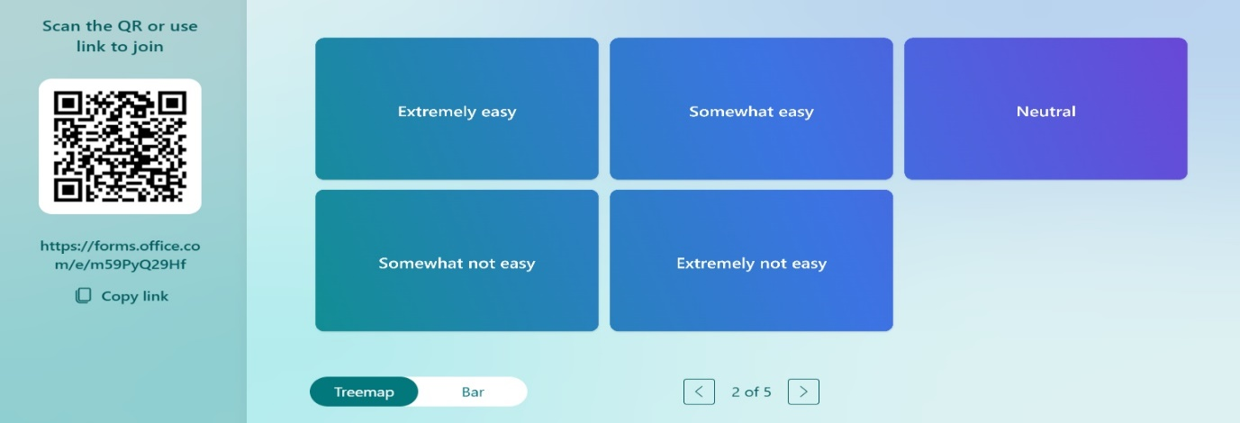
Figure 4-page 1 question
Figure 5-page 2 question
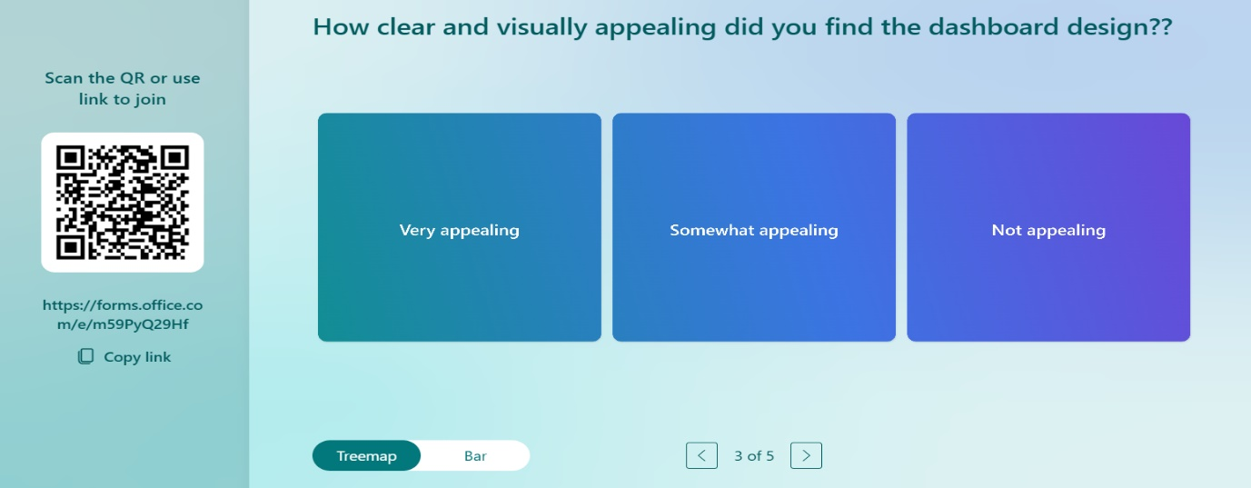
Figure 6 page 3 question
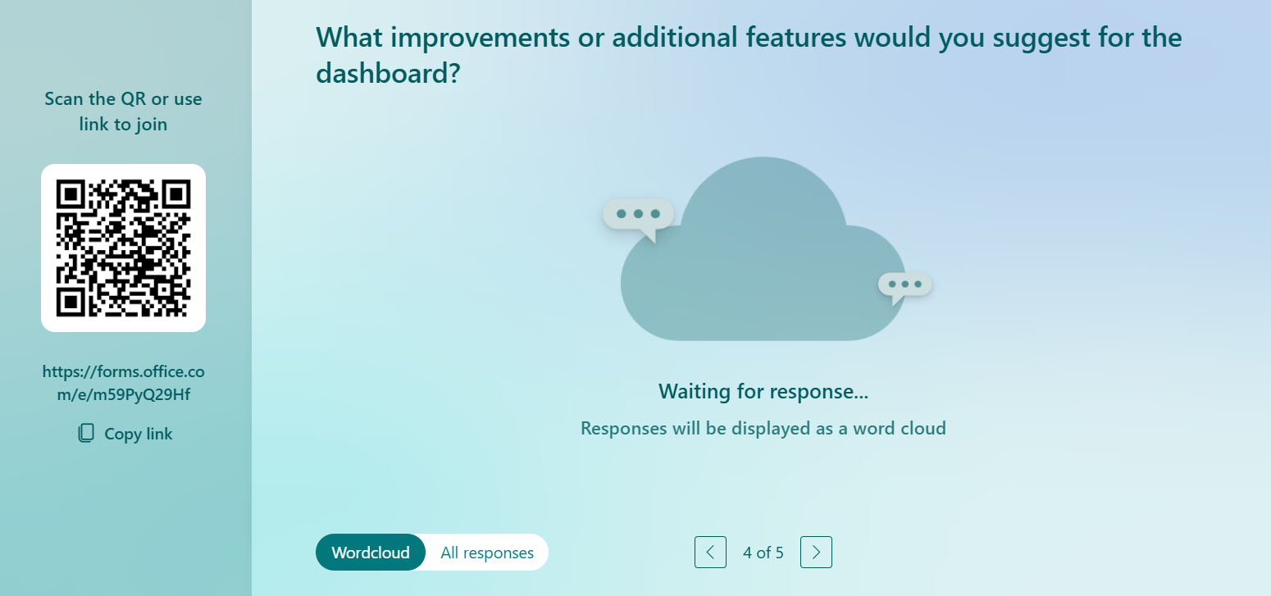
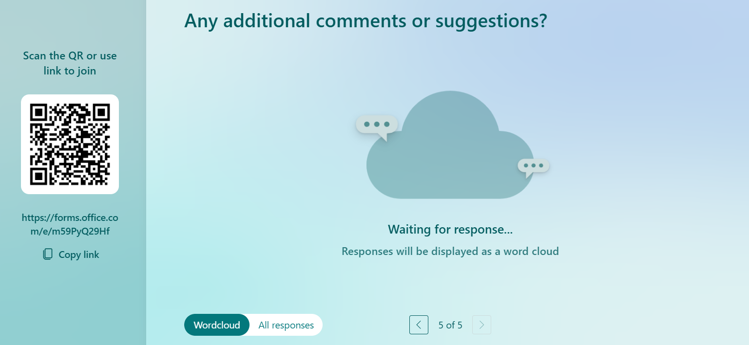
Figure 7 page 4 question
Figure 8 page 5 question

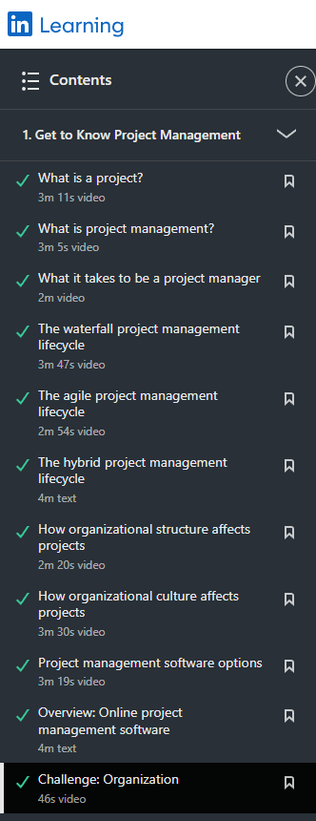
Certified online training course using LinkedIn learning:


Figure 9 Linkedin learning Figure 10 Linkedin learning

References
[1] A. Dennis, B. H. Wixom and D. Tegarden, Systems Analysis and Design: An Object-Oriented Approach with UML, 7th ed. Hoboken, NJ, USA: Wiley, 2020. [Date accessed: 14-Jul-2026].
[2] Microsoft, "Power BI documentation," Microsoft Learn. [Online]. Available: https://learn.microsoft.com/power-bi. [Date accessed: 14-Jul-2026].
[3] ISO 9241-210:2019, Ergonomics of Human-System Interaction – Human-Centred Design for Interactive Systems. Geneva, Switzerland: International Organization for Standardization, 2019. [Date accessed: 14-Jul-2026].
[4] I. Sommerville, Software Engineering, 11th ed. Harlow, UK: Pearson, 2019. [Date accessed: 14-Jul-2026].
[5] S. Loria, “TextBlob: Simplified Text Processing,” 2018. [Online]. Available: https://textblob.readthedocs.io/en/dev/. [Date accessed: 14-Jul-2026].
[6] K. Schwaber and J. Sutherland, “The Scrum Guide,” Scrum.org, 2020. [Date accessed: 14-Jul-2026].
[7] D. Jurafsky and J. H. Martin, Speech and Language Processing: An Introduction to Natural Language Processing, Computational Linguistics, and Speech Recognition, 3rd ed., Pearson, 2023. [Date accessed: 14-Jul-2026].
[8] M. Armbrust et al., “A view of cloud computing,” Communications of the ACM, vol. 53, no. 4, pp. 50–58, 2010. [Date accessed: 14-Jul-2026].
[9] European Union, “General Data Protection Regulation (GDPR),” Regulation (EU) 2016/679, 2016. [Date accessed: 14-Jul-2026].
[10] N. Mehrabi et al., “A survey on bias and fairness in machine learning,” ACM Computing Surveys, vol. 54, no. 6, pp. 1–35, 2021. [Date accessed: 14-Jul-2026].

