

Course Title: MBA - International Business
Term 1

Student Name: VISHAL BHALALA
Student ID: 2509170

Module Name: Marketing Management
Module Code: LCMB7024

Lecturer’s Name: Dr Laila Maazouz (London)
Word Count: 2288/2500
A Study on Brand Development Strategy for Microsoft Ride: Electric Personal Mobility Solution

Table of Contents
Introduction 3
1. Segmentation, Targeting, Differentiation, and Positioning Analysis 3
1.1 Company Background and New Brand Concept 3
1.2 Market Trends and Consumer Behaviour Justification 4
1.3 Market Segmentation 4
1.4 Target Audience 5
1.5 Differentiation Strategy 5
1.6 Positioning Strategy 5
2. Marketing Mix Strategy (7Ps) 6
3. Marketing Strategy 9
4. Reflection 10
Conclusion 11
References 12

Introduction
Founded in 1975, Microsoft Corporation is a technology powerhouse based in the USA and with expertise in software, cloud, and enterprise solutions. Although Microsoft has been able to venture into different fields of technology, the company has not ventured into the electric mobility market (Pfoertsch, 2024). This report summarizes a holistic brand development plan of Microsoft ride, a new brand which is an intelligent electric personal mobility solution, such as e-scooters and e-bikes to urban commuters. The new branding approach is comparable to the framework suggested by Kotler in which Microsoft develops a new brand name to launch a new product line (Pfoertsch, 2024).

1. Segmentation, Targeting, Differentiation, and Positioning Analysis

1.1 Company Background and New Brand Concept
Table 1: Brand Development Strategies - Microsoft's Portfolio
Source: (Kotler, 2023)
 | Existing Product Category | New Product Category
Existing Brand Name (Microsoft) | Line Extension: Microsoft Surface Pro 9, Surface Pro 10, Surface Laptop 5 (new versions within existing computer/tablet category) | Brand Extension: Microsoft Surface Headphones (using Surface brand to enter audio accessories category)
New Brand Name | Multibrands: Xbox and Surface (both Microsoft-owned brands competing in gaming and computing markets separately) | New Brands: Microsoft Ride (completely new brand name entering electric mobility/transportation category)
Table 1 shows the strategic position of Microsoft Ride in the brand development system by Kotler. Microsoft Ride is a new brand in the market of electric personal mobility, which would enable Microsoft to build brand name and identity outside the corporate technology image. Microsoft Ride includes two major products: Ride Flow e-scooter and Ride Cruise e-bike. The two incorporate AI-based navigation, IoT connectivity, predictive maintenance systems, and cloud integration (Kotler, 2023).

1.2 Market Trends and Consumer Behaviour Justification
The electric scooter and bike market in the world shows exponential growth, which is estimated to hit a figure of 42 billion by 2030 with the compound annual growth rate of more than 12 percent. Congestion in urban areas, increased fuel prices, and environmental consciousness are pushing consumers to greener means of transport (Grand View Research, 2023). The trend of commuting that takes place after the pandemic shows that people have shifted to the use of personal mobility options over transport. The adoption of electric vehicles by the government is encouraged through subsidies and the development of infrastructure on the global level. Consumer behaviour is becoming more concerned with convenience, integration of technologies, and environmental responsibility. Microsoft ride can cash in on these trends by providing technologically advanced greener mobility solutions (Grand View Research, 2023).

1.3 Market Segmentation
Table 2: Market Segmentation Analysis for Microsoft Ride
Source: (Straits Research, 2024)
Segmentation Type | Segment Description | Key Characteristics
Demographic | Urban professionals aged 25-45 | Middle to high income, tech-savvy, environmentally conscious
Geographic | Major metropolitan cities | High population density, developed cycling infrastructure
Psychographic | Health-conscious innovators | Value sustainability, fitness, convenience, technology integration
Behavioural | Daily commuters and micro-mobility users | Short-distance travelers, multimodal transport users, tech adopters
The following table (Table 2) is a detailed market segmentation of Microsoft Ride. The target audience is urban professionals aged between 25-45 years of age having an annual income of between 45,000 and 120,000 dollars. As geographical areas, capital cities such as London, Amsterdam, San Francisco, Tokyo, Berlin, and Singapore are the priority markets. At the psychographic level, the audience comprises of health-conscious innovators who are adopting sustainable living. Daily commuters with a distance ranging between three to fifteen kilometers exhibit the highest potential of adoption, behaviorally (Straits Research, 2024).

1.4 Target Audience
The first audience segment is the urban residents aged between 28-40 years and living within ten kilometers of their workplace in the big metropolis and have a salary of between 50,000 to 100,000 per year (Wyman et al., 2024). They are employed in technology, financial, creative and professional services. This customer base appreciates time savings, eco-friendliness, health, and technology. They are the users of smartphone applications, smart home, and wearable fitness devices. The secondary targets are university students, delivery service providers, and urban tourists (Wyman et al., 2024).

1.5 Differentiation Strategy
Microsoft Ride is differentiated by six unique pillars. To begin with, AI-powered intelligence applies machine learning in route optimization, traffic prediction, and battery management. Second, cloud-connected ecosystems will be connected to Microsoft Azure that will allow live data synchronization and remote diagnostics (Balaji et al., 2024). Third, enterprise grade security has high grade encryption, biometrics authentication and anti-theft measures such as GPS location. Fourth, sustainable manufacturing uses recycled materials and carbon neutral manufacture. Fifth, the smooth multimodal integration links to the public transportation app and navigation systems. Sixth, XYZ provides ownership options on a flexible subscription such as maintenance, insurance and replacement provisions (Wyman et al., 2024).

1.6 Positioning Strategy
Microsoft Ride also competes in the premium segment as an Intelligent mobility to sustainable urban living. The differentiation focuses on smartness based on AI-powered functionalities, sustainability based on greenery consciousness, and dependability based on corporate technology. In contrast to the competitors who concentrate on hardware specification or price competitiveness, the Microsoft Ride presents an end-to-end mobility ecosystem, which combines the quality of hardware and sophistication of the software (Balaji et al., 2024).

2. Marketing Mix Strategy (7Ps)
Product
There are two flagship products in Microsoft Ride. The Ride Flow e-scooter is aimed at commuters who need to cover a short distance, being 25 kilometers in top speed, 45 kilometers in range, with dual suspension, LED lights, and regenerative braking, folding to 18 kilograms in weight, and a smartphone mount. The Ride Cruise e-bike is designed to cover longer commutes with the 32-kilometer top speed, 80-kilometer range, seven-speed gears, hydraulic disc braking, removable battery, and 25-kilogram cargo carrying capacity. They both have 10-inch touchscreen displays that display speed, battery status, navigation, and fitness measurements (Ahmed et al., 2024).
Price
Table 3: Pricing Strategy for Microsoft Ride
Product Model | Purchase Price | Subscription Price | Value Proposition
Ride Flow (E-Scooter) | $899 | $49/month | Portable, lightweight, last-mile solution
Ride Cruise (E-Bike) | $1,799 | $89/month | Extended range, cargo capacity, comfort
Ride Pro Bundle | $2,499 | $119/month | Both models, premium accessories, priority support
Table 3 presents the pricing model between the market penetration and the premium pricing. The Ride Flow at $899 uses competitive pricing but with the focus on the best technology. Ride Cruise priced at the upper end at $1,799 competes with the high-end and the mass-market options (Precedence Research, 2025). The subscription models offer an entry level, lowering the barrier to finances and creating a recurrent revenue. The promotions are in the form of 15 per cent discounts to Microsoft 365 subscribers, corporate bulk purchase plans, 20 per cent student discounts and trade in programs that offer up to 200 credits. Finance facilities allow installments plans with no interest in twelve months (Ahmed et al., 2024).
Place
Distribution strategy uses an omnichannel strategy that is geared towards access and a unified brand experience. The main outlets will be Microsoft Experience Centers where they can get to test ride and demonstrate the products. The microsoftride.com site provides the online retailing of products through virtual showrooms and online home delivery (Precedence Research, 2025). Physical presence is increased through strategic alliances with leading electronic sellers such as Best Buy and MediaMarkt. Having specialty cycling shops as exclusive collaborators means expert consultation. Corporate sales channels are aimed at businesses who are interested in sustainable ways of commute by the employees (Ahmed et al., 2024).
Promotion
Integrated marketing communications use various promotional strategies. Some of the activities before launch would be teaser campaigns on social media, technology reviewers involving them in partnerships, and exclusive preview events (Wang, 2023). Launch campaigns include TV commercials, online advertising to professionals in cities, search engine advertising, and content advertising using blogs and podcasts. Some of the PR programs involve press releases, collaboration with environmental groups, and sponsorship of urban bicycle events. Experiential marketing will implement pop-up demonstration areas with free test rides and collaborations with coworking areas (Akroush, 2010).
People
Microsoft ride spends heavily on human capital both cashiers and operational areas. Customer service departments are thoroughly trained on the product specification, troubleshooting and customer relationship management. Mobility experts offer specialized services whereby they offer customer-specific advice on the right products. The technical support teams make sure that the issues are solved quickly via several channels (Akroush, 2010). Delivery personnel also offer white-glove delivery services, product demonstrations, and safety briefing. Since customers feedback, product development teams are always innovating. Partnership managers are the ones who ensure brand representation consistency in the channels of distribution (Wang, 2023).
Process
The customer experience is all about ease and fulfillment of the customer with the awareness till after sales services. The awareness phase applies to select digital advertising and experience events. The consideration stage will offer detailed online services such as product descriptions, compare options, and demonstration lounge (Akroush, 2010). The stage of purchase has a variety of different choices such as online ordering and store purchases. Professional set up and safety training is part of the delivery process. The support stage will involve the continuous provision of support in the form of mobile applications. The service phase guarantees convenient service maintenance by appointments at homes and warranty. The stage of loyalty compensates the participation in terms of upgrade programs and referrals (Wang, 2023).
Physical Evidence
Elements of physical evidence are physical experiences that build quality perceptions. The product design focuses on high-quality design, with smooth aluminum frames and elegant color schemes. The packaging is on sustainable material and has simple design. The Microsoft Experience Centers are designed with current layouts and test ride zones as well as interactive screens. The mobile application is designed using intuitive design that is in line with the design language of Microsoft (Elgarhy and Mohamed, 2022). Marketing collateral is visually consistent with the use of professional photography and harmonious color patterns. Customer touchpoints such as delivery vehicles and packaging contain branding. It has the product itself as the main physical evidence and the quality of its build and performance justifies the high price. The third-party validation is through sustainability certifications and safety ratings (Elgarhy and Mohamed, 2022).

3. Marketing Strategy
4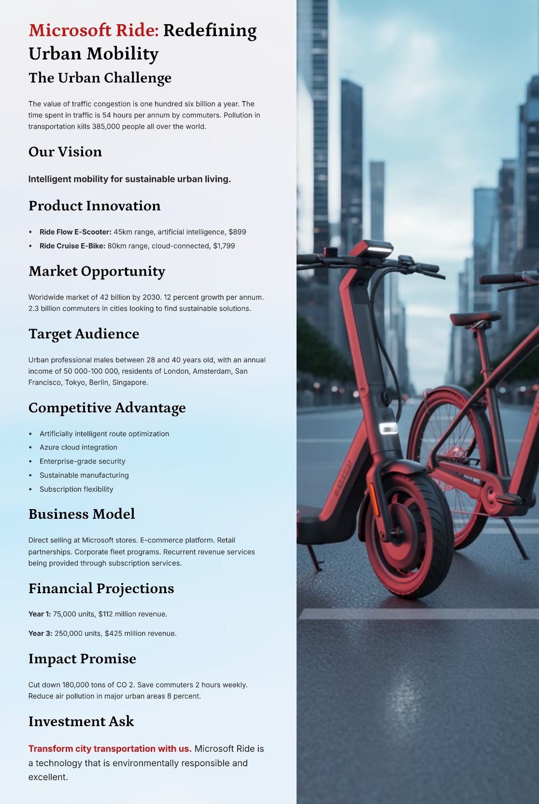

4. Reflection
The development of the Microsoft Ride brand strategy has been one of the most rewarding experiences I have had in my life that have enabled me to understand strategic marketing better (Kumar, Rajan and Garg, 2024). In the process, I was able to learn many new things regarding the difficulty of the process of entering new markets and the importance of strategic planning in such cases. In my scenario, my original judgment of what the research entailed was wrong as I began working on this project. During my exploration of the market of electric mobility, I discovered that there are various parameters including regulatory requirement, infrastructure, and consumer motivation differences (Grewal et al., 2024).
The formulation of the STDP analysis has made me a thinker in the formulation of positioning and differentiation. I also realized that marking market gap was not enough but showing how Microsoft current capabilities can generate real competitive advantages (Kumar, Rajan and Garg, 2024). The practice helped in developing my abilities in connection of organizational capabilities and market opportunities. The development of the 7ps marketing mix was particularly educative as I had an opportunity to experience the interdependence of the marketing elements to one another. I also discovered that my pricing decision affected channels of distribution, and the service support was the parameter that depended on the product features (Grewal et al., 2024).
The other problem was how to prepare the marketing pitch. To begin with, I did not find it easy to narrow my general plan to a concise persuasive speech. This has made me callous when it comes to sorting out only the serious information. I was demonstrated that good communication is comprised of the things that my audience would like to hear. This skill will be useful when I make a professional presentation. Various valuable skills were also learned in the process. My analytical skills were also developed, since I merged information that was brought forth by different sources. I have enhanced my creative skills in problem solving, and my strengths in strategic thinking (Kumar, Rajan and Garg, 2024).
This was a lesson that supplemented several lessons. Good strategies must be balanced both in terms of creativity and critical thinking. I cannot simply afford to have new ideas, but I must have justification of such ideas through research. I also learned that to develop solutions that are relevant, one should learn about the needs of the customers in an in-depth way. I am now assured that I will be able to draft elaborate marketing strategies in the future. The specified project has served as an excellent learning experience in putting theory into practice. The skills that I have gained will be applied in my marketing career later in my life (Grewal et al., 2024).

Conclusion
Microsoft ride is a strategic entry by Microsoft in the growing market of electric personal mobility under a new brand strategy. The general analysis of the STDP offers the definition of the obvious target groups, the differentiation and the positioning strategies that capitalize on the technological potential of Microsoft. The actionable structures of product development, pricing, distribution, promotion, people management, process optimization, and physical evidence creation product development, pricing, distribution, promotion, people management, process optimization and physical evidence creation are available in 7ps marketing mix products development, pricing, distribution, promotion, people management, process optimization, and physical evidence creation action structures. The brand reacts to the true needs of the market about rational, intelligent urban transportation and aligns with the modern consumer principles about environmental friendliness. An effective implementation will see Microsoft as a competitive player in the new mobility business and will result in it being a good addition to the city’s sustainability interests.

References
Ahmed, S., Saad, A.T., Chowdhury, S.R., Sobhani, F.A., Hassan, Md.S. and Islam, M.A. (2024). Impact of marketing mix elements on the brand equity of online food delivery services: an emerging economy perspective. Cogent Business & Management, 11(1). doi: https://doi.org/10.1080/23311975.2024.2380018.
Akroush, M.N. (2010). (PDF) The 7Ps Classification of the Services Marketing Mix Revisited: An Empirical Assessment of their Generalisability, Applicability and Effect on Performance - Evidence from Jordan’s Services Organisations. [online] ResearchGate. doi: https://www.researchgate.net/publication/349771276_The_7Ps_Classification_of_the_Services_Marketing_Mix_Revisited_An_Empirical_Assessment_of_their_Generalisability_Applicability_and_Effect_on_Performance_-_Evidence_from_Jordan.
Balaji, Pratyusha D, Sravanthi B and Jayakiran Reddy E (2024). Recent AI Applications in Electrical Vehicles for Sustainability. SSRG international journal of mechanical engineering, 11(3), pp.50–64. doi: https://doi.org/10.14445/23488360/ijme-v11i3p106.
Elgarhy, S.D. and Mohamed, L.M. (2022). The Influences of Services Marketing Mix (7ps) on Loyalty, Intentions, and Profitability in the Egyptian Travel Agencies: The Mediating Role of Customer Satisfaction. Journal of Quality Assurance in Hospitality & Tourism, 24(6), pp.1–24. Doi: https://www.tandfonline.com/doi/abs/10.1080/1528008X.2022.2080148
Grand View Research (2023). Electric Scooters Market Size & Share | Industry Report, 2019-2030. [online] Grandviewresearch.com. doi: https://www.grandviewresearch.com/industry-analysis/electric-scooters-market.
Grewal, D., Guha, A., Satornino, C.B. and Becker, M. (2024). The future of marketing and marketing education. Journal of Marketing Education, 47(1). doi: https://doi.org/10.1177/02734753241269838.
Kotler, P. (2023). Philip Kotler. [online] Philip Kotler. doi: https://www.pkotler.org/blog/2023/8/3/regeneration-the-future-of-community-in-a-permacrisis-world.
Kumar, V., Rajan, B. and Garg, V. (2024). Transformative Marketing Education: Drivers, Outcomes, and Research Agenda. Journal of Marketing Education. doi: https://doi.org/10.1177/02734753241266170.
Pfoertsch, W. (2024). The Genesis of Human-to-Human Marketing. Humanism in business series, pp.99–130. doi: https://doi.org/10.1007/978-3-031-67155-5_6.
Precedence Research (2025). Electric Scooters Market Size, Growth, Share Report 2021-2030. [online] www.precedenceresearch.com. doi: https://www.precedenceresearch.com/electric-scooters-market.
Straits Research (2024). Smart Mobility Market Size, Share, Trends & Growth Graph by 2033. [online] Straitsresearch.com. doi: https://straitsresearch.com/report/smart-mobility-market.
Wang, X. (2023). The Effect of Service Marketing Mix (7Ps) on Purchase Intention in the Script Killing Industry. Academic Journal of Management and Social Sciences, 4(2), pp.57–62. doi: https://doi.org/10.54097/ajmss.v4i2.12087.
Wyman, O., Nienhaus, A., Rilling, S. and Markey, D. (2024). How Urban Mobility Will Look Like in 2035. [online] Oliver Wyman Forum. doi: https://www.oliverwymanforum.com/mobility/2024/oct/what-urban-mobility-will-look-like-in-2035.html.

Appendix


