University of Walles Trinity Saint David Birmingham

ELON MUSK AND TESLA
LOOKING TO THE FUTURE

Group 5 Report

Students: Juliana Lopez - student nr. 1906785
Ionut Adrian Voinea - student nr. 2008573
Angel Ciprian Lungu - student nr. 2007934
Krzystof Wieslaw Kurowski - student nr. 2009954

Programme: Bachelor of Arts Business Management
Module: Introducing the Modern Workplace
Module code: LCBB4003
Lecturer: Uju Ugochukwu

Content:
- Introduction . . . . . . . . . . . . . . . . . . . . . . . . . . . . . . .p. 4
- LEADERSHIP
  - Introduction to leadership . . . . . . . . . . . . . . . . . . . . p. 4
  - Leadership styles . . . . . . . . . . . . . . . . . . . . . . . . . . . p. 5
  - Leadership Theories . . . . . . . . . . . . . . . . . . . . . . . . . p. 5
  - Personality traits . . . . . . . . . . . . . . . . . . . . . . . . . . .p. 6
  - Psychological theories . . . . . . . . . . . . . . . . . . . . . . . .p. 6
- ELON MUSK – THE LEADER
  - Leadership and personality trait theories . . . . . . . . p. 7
  - Elon Musk . . . . . . . . . . . . . . . . . . . . . . . . . . . . . . . . . . p. 7
  - Biography . . . . . . . . . . . . . . . . . . . . . . . . . . . . . . . . . . p. 8
  - Leadership traits and personality traits . . . . . . . . . . p. 8
- TESLA MOTORS Inc.
  - Beginnings . . . . . . . . . . . . . . . . . . . . . . . . . . . . . . . . . p. 10
  - Blue Ocean Strategy . . . . . . . . . . . . . . . . . . . . . . . . . p. 10
  - Tesla Roadster . . . . . . . . . . . . . . . . . . . . . . . . . . . . . . p. 11
  - Model S and model X . . . . . . . . . . . . . . . . . . . . . . . . .p. 11
  - Model 3 and Model Y . . . . . . . . . . . . . . . . . . . . . . . . .p. 12
  - Looking to the future . . . . . . . . . . . . . . . . . . . . . . . . . p. 12
- OTHER BUSINESS OF ELON MUSK.
  - SpaceX . . . . . . . . . . . . . .. . . .. . . . . . . . . . . . . . . . . . . .p. 13
  - PayPal . . . . . . . . . . . . . . . . . . . . . . . . . . . . .. . . . . . . . .p. 13
  - Neuralink . . . . . . . . . . . . . . . . . . . . . . . . . . . . . . . . . . . p. 14
- Conclusion . . . . . . . . . . . . . . . .. . . . . . . . . . . . . . . . . .p. 14
- REFFERENCES . . . . . . . . . . . . . . . . . . . . . . . . . . . . . . .p. 16

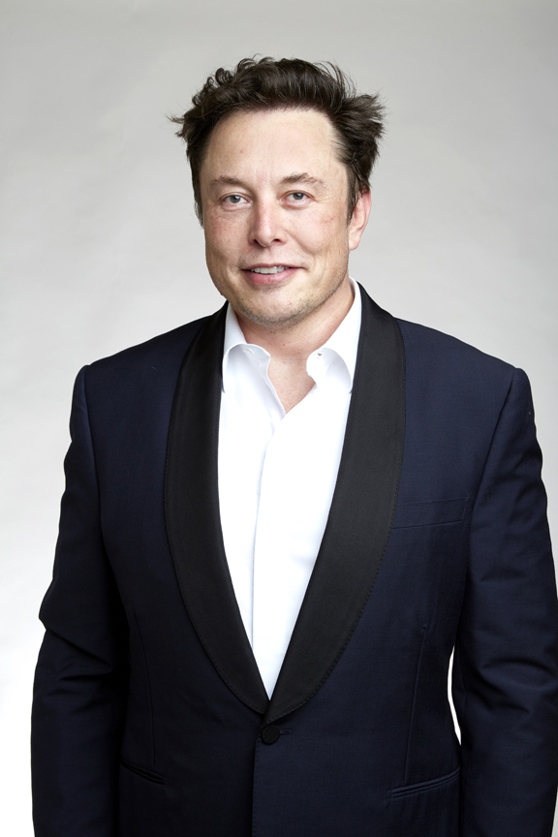  Source: (Wikipedia, 2019)  ELON MUSK  PERSONALITY TRAIT | 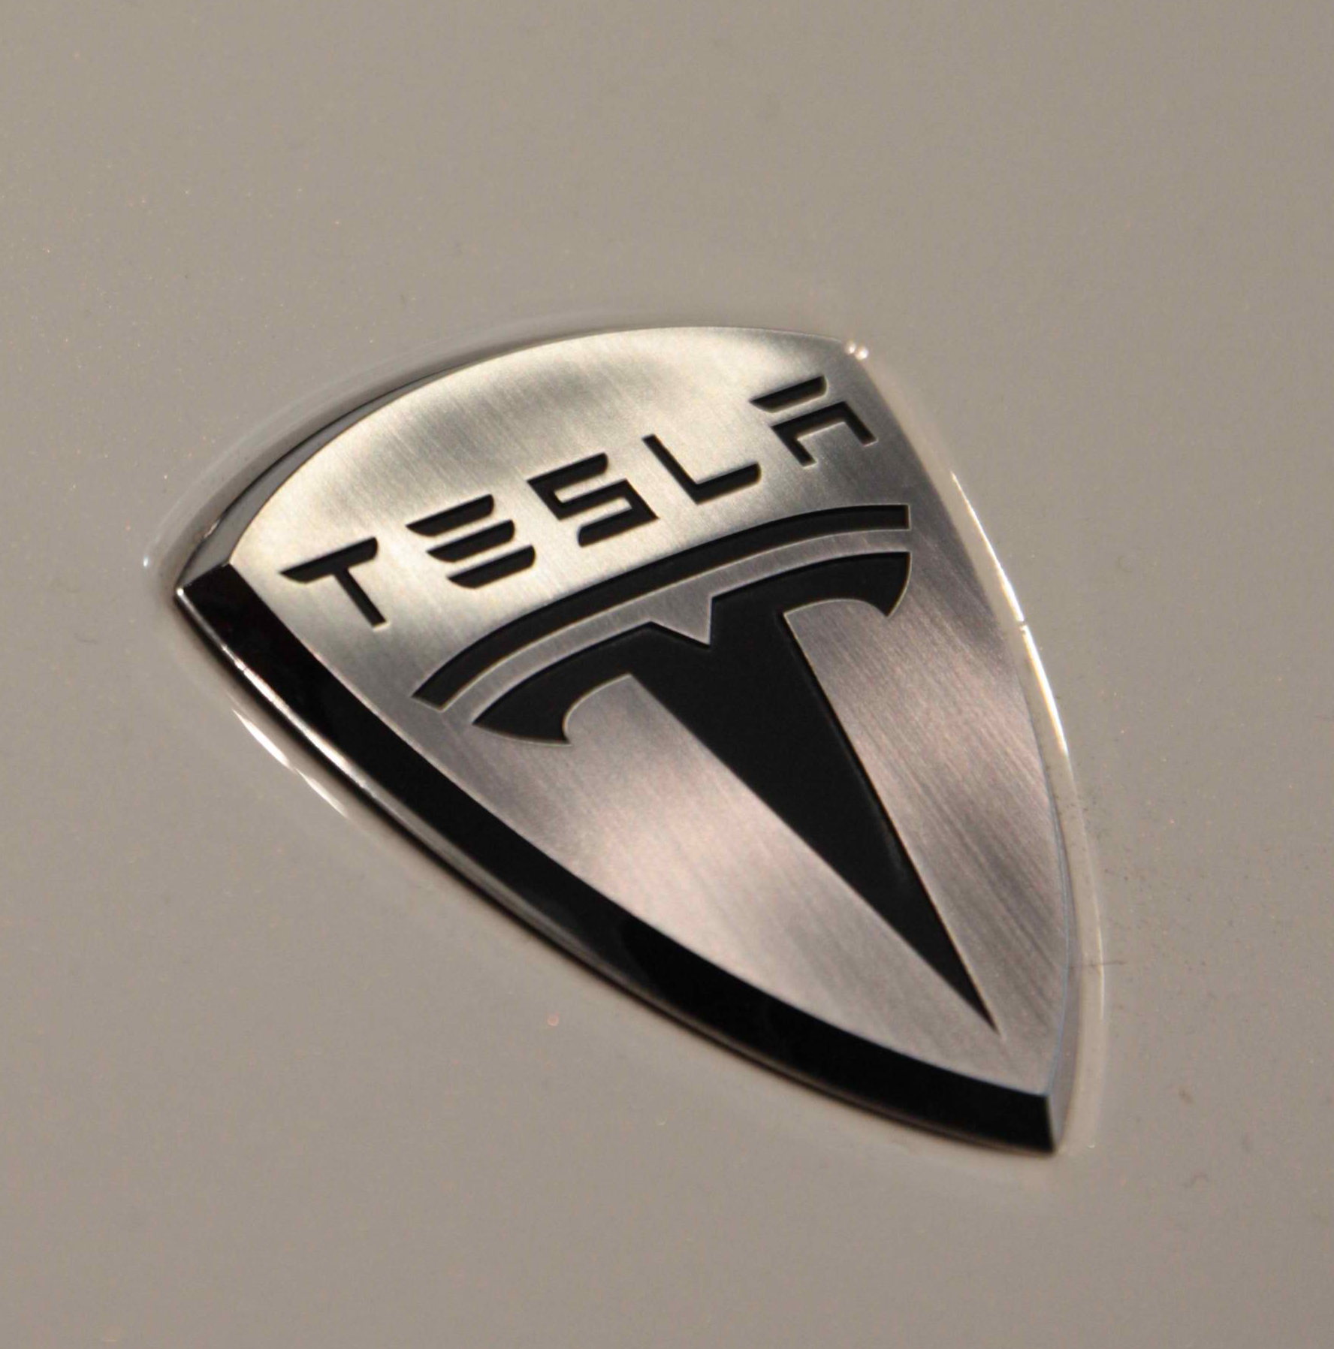  Source: (Tesla Site 2020)  Abstract  Elon Musk four key characteristics that shapes him as a leader.

“Failure is an option here. If things are not failing, you are not innovating enough.”
Elon Musk

- Introduction
Elon Reeve Musk was born on June 28th in 1971, Pretoria, South Africa. He is a successful entrepreneur co-founder of PayPal (Gregersen, 2019), he owns 20 per cent of Tesla shares and the CEO of SpaceX; considered the world’s second-richest person, his net worth in 2020 is $127.9bn according to Bloomberg Billionaires Index (Sharma, 2020). As suggested by Wong (2007) leader is someone which encourages followers to achieve a common goal and Elon Musk as shown to be an incredible and innovative leader.
The purpose of this project report is to acknowledge and point four key characteristics of the above leader, that has shown to be one of most influential people in the world and attempt to understand what makes him so unique. This section of the report will focus on a brief Elon Musk’s biography, define what is a leader, types of leadership and personality traits, also different theories examples; strategies that made him failure or succeed.
Most of the time these two concepts leadership and management which play an important role in an organisation could bring confusion, but they are different. Moreover, leadership and management require same attitude, skills, and behaviour. Leaders focus on vision to achieve a goal, also communicate with others about strategies for accomplishing the vision. Furthermore, leaders motivate people around them, negotiate for results by resolving differences and support each other to achieve common goal (Kotter,2001).
On the other hand, managers focus on structures and systems to succeed, resources to function well, they provide direction and control people by given them similar duties (Kotter,2001). Also, managers aim is to accomplish goals in a short period of time, without threats, establish roles that can make a company work successfully (Kotterman, 2006).
- Leadership
2.1 Introduction to leadership
The concept of leadership was long ago introduced this term was usually used to describe powerful and active people who were capable of leading armies, build empires and shape the fate of a nation. Moreover, great leaders of the past are still remembered today and are part of an incredible political, social, military, and religious history. As a result, this made social scientists question the determinants of leadership effectiveness? What shapes a leader?

Juliana Lopez
What traits, behaviours, and abilities they must have to make them unique? Also, how flexible are they in different situations (Yukl, 2012)?
As suggested by House et al (cited in Yukl, 2012), leadership is ‘the ability to influence, motivate, and enable others to contribute towards the effectiveness and success of the organisation.
The way in which leadership can shape an organisation performance has been a matter of great interest to researchers for over 50 years, but the answers is still vague. Within an organisation there are dyadic also known as traditional and organisational leadership, universal and situational leadership. Researchers suggested that transformational leadership is more effective in unstable environments with poor organisational performance because this style is meant to inspire others and encourages vision for a better future organisation (Gordon and Yukl, 2004).
In the same way, organisational leaders influence organisational performance by innovation, human resources, process liability and efficiency. All leaders within an organisation must be flexible to adapt their behaviour to fit the situation (Gordon and Yukl, 2004).
2.2 Leadership styles
There are many leadership styles but, in this report, it will be explored transactional, transformational, and laissez-fair leadership. According to Tracey and Hinkin (1998) transformational leadership inspires people by encourage them to work as a team, moral values about choices and behaviour of individuals, developing a vision and achieve a goal (Tucker and Russell, 2004).
On the other hand, transactional leadership followers work via exchange (reward). Meaning the leader establish a goal for the followers to receive reward which will be beneficial for both leader and followers (Chaudhry and Javed, 2012).
Likewise, laissez-fair leaders give a credit to members to do all the task and make decision by themselves. Which mean leaders trust the group to do all work by themselves, work in their own initiative, be responsible for decision-making (Chaudhry and Javed, 2012).
2.3 Leadership Theories
Moreover, leadership has numerus theories such as the Great Man theory ‘born to lead?’ – it defends that leaders has charisma with strong personality and confidence by stimulating trust to followers as well as intelligence in which they share information and communication with followers. They are also considered to be sociable (Cherry, 2019).
In addition, behavioural theory focuses on the actions to do something, not on mental qualities or internal factors. This theory says leaders learn by teaching and be observant to grow as a leader (Cherry, 2019).
Juliana Lopez
While in trait theory is suggested that leaders are born with qualities and attributes, personalities, and behaviours of a leader. They show traits such as extroversion, self-confidence, and bravery (Cherry, 2019).
Meanwhile, situational, and contingency theory focus on the environment and situation by decision-making. As suggested by White and Hodgson leaders is not just about qualities, but connection between behaviours which show performances, needs of followers and context (Cherry, 2019).
2.4 Personality traits
In addition, there is five personality traits which helps identify a leader. As defined by Cervone and Pervin personality traits refer to “psychological qualities” that individuals possess, shaping their characteristics, and shows individuals’ feeling about attitude in relation to others, thinking or sharing ideas and behaving in workplace that will improve their performing (Colbert et al., 2012).
Also, openness to change highlight creativity which is an important skill for an effective leader, so this is open-minded leader; conscientiousness individuals look for achieving goals and loyalty. On the other hand, responsible during task, organised, hardworking committed, it has perseverance to achieve something, and achievement-striving for better performing (Colbert et al., 2012).
Finally, agreeableness is trusting inspiring and by motivating others, cooperative working in group in benefit of something, caring and helping others; tolerant and understanding people behaviour around them. Neuroticism individuals are anxious about outcome result, insecure and vulnerable, and self-conscious with some situation. Extraversions are sociability friendly, with good connection with a group, and dominance and influence others (Colbert et al., 2012).
2.5 Psychological theories
Psychological theories focus on behavioural, mindset and development of individuals. If it is understood ‘how’ and ‘why’ humans’ behaviour in some type of way this make it better to understand us and others. It includes behavioural, cognitive, biological, cross-cultural and humanistic perspective. The psychodynamic perspective means that experiences from the past may reflect into you, today. The biological perspective defends that there is a direct relationship between brain activity ad cognition (Ugochukwu, 2020).

Juliana Lopez
3. ELON MUSK – THE LEADER

3.1 Leadership and personality trait theories
The trait theory of leadership emphasis to identify various personality traits and characteristics that are directly connected to a successful leadership when dealing with various circumstances (Cherry, 2019). The theory is linked to the “great man” leadership theory initiated back in mid 1800s by the historian Thomas Carlyle. According to Carlyle history shown exceptional leaders with a native ability to lead and not an ability that can be developed, stating that "The history of the world is but the biography of great men." (Spector, 2015). Among the examples provided by Carlyle worth to mention names as: alexander the Great, Julius Caesar, Abraham Lincoln, Mahatma Gandhi. Later, the sociologist Herbert Spencer introduced the idea that leaders are a product of the society they live in (Spencer, 1874). One of the contra arguments of Great Man theory of leadership mentions that not all individuals with born leadership qualities become successful leaders and further researches revealed that leadership is a most complex subject with various factors that will influence the degree of success of a certain leader (Yukl, 2012).
Personality traits theory, trying to respond to the simple question “how many personality traits exists?” evolved from the Gordon Allport’s idea (mentioning that there are 4,000 personality traits), to Raymond Cattel opinion (there are 16 personality traits and ) until Hans Eysenck idea about 3-factor theory (Cherry, 2020).
Nowadays personality phycologists argue that there are five main personality dimensions (called “Big 5”): extroversion, openness, agreeableness, conscientiousness, and neuroticism (Gans, 2017). OCEAN or CANOE are the abbreviations often used to remember these big five personality traits.
3.2 Elon Musk
“I do not have all the answers (…). Let me be clear about that. I’m trying to figure out the set of actions I can take that are more likely to result in a good future. If you have suggestions in that regard, please tell me what they are…” (Elon Musk, 2020),
The story of Elon Musk, stared in South Africa, with outrageous beginnings, is the best example of American dream, as he achieved an incredible success in the business world several times (Hanson, 2020).It is recognized as a self-made billionaire that not simply attempted to earn money. The unique characteristic that made Elon Musk so famous is the characteristic of his all initiatives and ventures: the final objective to contribute into a better word creation for humankind.

Ionut Adrian Voinea
3.3 Biography
Elon Musk was born on June 28th, 1971 in Praetoria, South Africa, his parents being: father South African and mother Canadian. During childhood Elon shown already a talent for computers and entrepreneurial behaviour, by creating a video game sold to a computer magazine (Britannica,2020). At 17th age, in 1988, Elon Musk obtained the Canadian passport and left South Africa being against apartheid and also considering that United States will offer him the right place for economic opportunities.
Musk graduated in 1997 from University of Pennsylvania, being specialized in physics and economics, and enrolled in graduate school (physics) at Stanford University (California) but after 2 days he decided to leave the university feeling that he can find more potential in business through Internet, than studying physics.
1995 was the year when Musk founded Zip2, its first company as entrepreneur, providing maps and business directories to online newspapers. After 4 years Zip2 was sold for $307 million to Compaq. Based on this transaction Musk continued his way in business, founding X.com (online financial services) that became later the famous PayPal (company specialized in online money transfers). In 2002 eBay acquired PayPal from Musk for an amount of $1.5 billion.
The inner belief of Musk is that humanity must become a multiplanet species to have a chance to survive. Based on this belief, correlated with his dissatisfaction related to high expenses of rocket launchers, Musk founded in 2002 SpaceX (Space Exploration Technologies) to launch rockets with more affordable expenses. Thus, started to launch them, Falcon 1 (2006), Falcon 9 (2010), Falcon Heavy (2018) followed by Spaceship launched in May 2020 (founded also by NASA carrying Crew Dragon). The next objective is a spacecraft aiming to provide transport from Earth cities and develop bases on Mars and Moon (Britannica,2020).
Tesla is another success story of Elon Musk, following its passion for electric cars. Therefore, in 2004 founded Tesla Motors along with 2 other entrepreneurs, following a successful and sometimes debated business during years.
3.4 Leadership traits and personality traits
The following section will detail leadership traits that allowed Elon Musk to have so many achievements in so little time.
Action oriented.
Elon Musk demonstrated extremely decisive behaviour in any circumstances, acting very quickly, due to its capacity of processing a large amount of information simultaneously. Musk used science and rational thinking to bring quick solutions, transforming this personal characteristic into a competitive advantage. Going directly into action, Musk had the chance to have an immediate reaction, feedback and decide if the decision was the optimal one or
Ionut Adrian Voinea
not, analysing immediately any issue. Once the decision is done, he put all the efforts into accomplish it, receiving immediate feedback, either is a success or failure. Thus, leaders that acts drive the employees towards clarity, while inaction generate doubts. With the feedback the action can be adjusted, if was not the optimal one, but lack of action will lead to a missed opportunity to understand what gone wrong (Vance,2015).
Ethical behaviour.
One of the key characteristics Elon Musk is known for is the ethical behaviour, considering that “if your work ethic doesn’t match the goal, you cannot achieve it” (Hanson, 2020). The ethical behaviour starts with his personal involvement, being recognized for outworking. This habit attracts some investors in Musk’s ideas, even they are not 100% convinced that the idea will have success, investing in the Musk himself and his commitment to work ethic rather than in a business.
Problem solving.
One of the successful traits of Musk as leader is related to its focus on solving the big problems, considering the technology as a tool to improve life quality. For a successful leader, focusing on solving big problems is essential, through time/resources/energy investment and not acknowledge them.
Focus on problems root causes not on the effects
Continuous learning attitude.
The continuous learning attitude was demonstrated by Musk through its programming knowledge, reading a wide variety of books that gave him the opportunity to know, understand and link various concepts.
The best attitude towards learning and developing is related to a constant reflection and things that can be improved done in better way and question themselves, look for answers.
Strong risk tolerance
According to business studies, 96% of start-ups fails after 10years in business, as developing this kind of business implies a significant uncertainty and risk. Following the first success (Zip2 sold to Compaq), Musk did not stop to accept risks and invest millions of dollars in his further companies, learning from the failures and enhancing the opportunities.

Ionut Adrian Voinea
4. TESLA MOTORS Inc.

4.1 Beginnings
Tesla Motors was founded on first of July 2003 by Martin Eberhard and Marc Tarpenning in San Carlos, California. Few months later, Ian Wright joined to build an electric car who can break the usual corelation between high performance and low consumption in automobile industry. Until then, everybody think is impossible to have both. They wanted to build a car factory, but also to be a technology company and to have all components: battery, software, and electric engine (Wikipedia, 2020).
Although he knew from the beginning about their plans to build an electric car, Elon Musk joined to the project in January 2004, with a contribution of US$ 6.5 million. Next, in February invested another US$7.5 million and became the chairman of the board.
In May 2004, the fifth member joined the team. J.B. Straubel come for an interview at Tesla headquarter and was hired at once as CTO (chief technical officer). A lawsuit settlement agreed in 2009 allows all five to call themselves cofounders.
Team was ready. Also, the goal: to build first electric car with high performance. Long strategical goal was to create affordable mass market electric vehicles. But, until then, the new company must go to the … ocean.
4.2 Blue Ocean Strategy
From the beginnings, Tesla defined the goals to not compete with other business, only to fill an open space in the market.
About the market, Kim and Mauborgne (2005) notice the differences between Red Ocean and Blue Ocean strategy to denote the market universe.
Red Ocean are all the industries in existence at day, where market is known and companies try to exploit existing demands and to perform by price or other facilities and to take a greater share of the existing market from the competitors. “Cutthroat competition turns the ocean bloody red” (Kim and Mauborgne, 2005, p3).
Blue Ocean means all the industries not in existence today. It is an unknown market, unexplored and without competition. Is vast, deep, and full of opportunities, like the ocean (blue) is. When a business is aligned to Blue Ocean Strategy, create an uncontested marketplace and the competition become irrelevant.
In 2004, when joined to Tesla concept, Elon Musk said the main goal to the company will be to produce electric cars with affordable price. But research is expensive, and the first step was to develop an electric car with speed and design similar or greater than combustion cars on the market.
Angel Ciprian Lungu
4.3 Tesla Roadster
With JB Straubel as chief technology and Elon Musk on design, Tesla Motors build first electric sport car with high mileage. First tests were made with acid batteries and borrowed powertrain, then change the batteries with lithium-ion cells, increasing the range and reduced the weight, then licensed AC Propulsion’s EV Power system design and reductive charging system. All the innovations reduce the mass, complexity, and costs.
For the design, Musk received the Global Green 2006 product design award, and he received the 2007 Index Design award for the design of the Tesla Roadster. Tesla's designers chose to construct the body panels using resin transfer moulded carbon fibre composite to minimize weight; this choice makes the Roadster one of the least expensive cars with an entirely carbon fibre skin.
For Roadster, Tesla produced several prototypes between 2005-2007. In 2006 was officially revealed to the public, and in February 2008 first Tesla Roadster was delivered to co-founder, chairman and product architect Elon Musk. Until June 2009, another 500 similar cars were produced. In July 2009 Tesla began production of 2010 model, first major product update, and the Roadster Sport model, with a patented powertrain. Each year, Tesla Roadster involved research and technologies to make their product safer, faster, and economical.
On 13 January 2010, Tesla announced the 1,000th Roadster produced. Same January, first Right-hand-drive Roadster was produced for UK and Ireland. Price was started at £86,950 and cost about 1.5p per mile.
Last version, “Roadster 2.5”, was launched in July 2010. Each version has new features and technical improvements. Until they finished 2,500 units contracted with Lotus gliders, new ways were revealed. It was time to go on and accomplish the long-term goal: affordable electric car. With US$118,000 starting price, Roadster is not affordable at all, but prepare the next generation. In 2014, Tesla announced an upgrade to “Roadster 3.0”, but is not based on Lotus gliders, instead on a shorten version of Tesla Model S.
4.4 Model S and model X
After first luxury electric car, Tesla start to develop and launched less expensive version. In 2009 launched Model S, a sedan car with 5 doors, at a cost of US$ 49.900, and first units was delivered in 2013. Same year, Tesla launched Model X design prototype at the Geneva Motor Show. Model X, a SUV with 7 seats, was available from 2015.
Tesla strategy was to cut the costs, but to maintain the luxury of their cars. Also, they implement new technologies in products. Tesla autopilot was a huge success and allow to the driver minimum of attention.
Starting from 80 employees, Tesla Motor took ownership of automobile manufacturing plant from Freemont, California and start production with 1,000 workers. In 2018, the facility ha10,000 workers and can produce 500,000 units per year.
Angel Ciprian Lungu
4.5 Model 3 and Model Y
In 2016, Tesla revealed new model of electric car, a family car with 5 seats, but with sport-car level of acceleration and 5 stars safety ranking. After a week from unveiling the Model 3, Tesla announced they have already taken 325,000 reservations. From 28 July 2017, when first Model 3 cars was delivered until 2020 Tesla build more than 525,000 units and the car become the world's best-selling plug-in electric car ever.
In March 2019 Tesla announced the production of a new electric compact crossover utility vehicle based on Model 3 sedan platform, but Model Y offer optional third row of seats for seven passengers. First car was delivered in March 2020.

4.6 Looking to the future
Since was born in 2003, Tesla motors look to the future. The aim of Elon Musk to provide an affordable electric car is nearby. Tesla announced in 2021 can build an electric car under US$ 35,000.
They invested not only in car business, but also in fast chargers to provide support, and in green technologies. In 2016 Tesla acquired SolarCity and develop a new range of solar panels. Their aim to provide cars and energy with 0 emissions of carbon is nearby.
Even across the years Tesla have some financial troubles, become the most valuable American automaker to ever exist and in 2020, with a value of 165 billion euro, surpassed all three German brands together (BMW, Daimler and Volkswagen together market value is 156 billion euro).

Angel Ciprian Lungu
5. OTHER BUSINESS OF ELON MUSK.
5.1 SpaceX
Through analysing the managerial reports of SpaceX, it was identified that the Bold leadership style had been implemented by Elon Musk on SpaceX. This leadership model does not only believe in Creative ideology, as they are acting with their innovative ideas. Consequently, the business objectives are successfully achieved boldly, and no hesitation will be there in business activities. Elon Musk has greatly expressed his thoughts, ideas, and Poland to the team members to develop future goals (Anderson and Sun, 2017). As a positive impact of this bold leadership style, SpaceX was able to launch 15 commercial missions in the current financial year. It could be regarded as the market growth of the Company, which has initiated its effective leadership model.
Based on the financial analysis, each launch of a commercial mission resulted in sales revenue amounting to $80 million. Maintaining 15 missions required an effective leadership model, another side the team members would mash up the business plans. Thus, the Bold leadership model has identified the actual project goals and the process to achieve each objective. As the leader has acted with his ideology, thus team members were not getting confused about the job requirements. Hence, it could be stated that the effective leadership model could ensure business growth.
5.2 PayPal
According to the managerial report of PayPal, Elon Musk has implemented the Transformational leadership in this organization. Under this leadership model, the leader is working with team members and participating in the work field. As an impact of this, all the existing problems will be identified by the leaders and resolved immediately. Besides that, the leaders to make a plan to mitigate future risks will also analyse future risks. It is an appropriate process to motivate the team members in achieving the business objectives. Idealized influence, intellectual stimulation, individualized consideration, and inspirational motivation are the four main aspects of transformational leadership (Choi, Kim and Kang, 2017). Through implementing these approaches, Elon Musk has improved the market position of PayPal in every accounting term.
Before implementing the leadership of Elon Musk, the sales revenue of PayPal was $172 billion and became $222 billion. It could be regarded as the financial growth for PayPal. Effective leadership implementation has been contemplated as the reason for such financial growth. Transformational leadership model improves the market position of PayPal. Based on the market analysis, the daily growth rate of PayPal is calculated as 7% to 10%. Its leadership enables them to utilize market opportunities with effective team management.

Krzystof Wieslaw Kurowski
5.3 Neuralink
It is a US neurotechnology Company and was founded by Elon Musk. Entire business activities of that Company have been operated through using the Transformational leadership model. The major reason is that Elon Musk has preferred to inspire their team members by providing rewards after each achievement. Thus, it is considered as an example of transformational leadership (Lord et al. 2017). Besides that, he has participated with team members, which also reflects the availability of a participative leadership model. Both leadership styles have improved the operational excellence of Neuralink. The mission of this organization is to develop an advanced technology that could cure any type of neurological problems across the world.
Elon Musk has decided to develop a new technology, which will enable the doctors to conduct brain surgeries at a lower cost to ensure the success rate. As per the market analysis, Neuralink has started the project of building the Brain computers with a capital fund of $27 million (Sebastian et al. 2018). Thus, it could be regarded as the big financial project of Neuralink, and Elon Musk led it. As per the market trend, a growing movement had been identified in this organization, as the revenue was enhanced by 12%. Hence, it could be stated that the effective leadership model has improved the market growth of Neuralink.
6. Conclusion
In order to manage the business activities and different project managers are required to consider any specific leadership model that is appropriate for the business organization. Leadership is a set of models and methods that guides organizational managers to provide effective directions to the team members. Different types of leadership models are available in the business environment. Based on the business characteristics, organizational management is required to select the most effective leadership model. Out of those models, the Transformational and Participative leadership model has been considered as the most effective method of leading business projects. The major reason is that transformational leadership has inspired and motivated the team members. On the other hand, the participative leadership model enables leaders to analyse workplace challenges. Consequently, top-level management could provide an immediate solution to these identified issues. Besides that, the bold leadership style is also contemplated as highly effective for developing the ideology, which ensures the business improvements.
Elon Musk is an effective leader of Tesla, Neuralink, PayPal, SpaceX, and others. All the companies operated under the leadership of Elon musk have achieved success in maintaining their market growth rate. Consequently, the financial and non-financial factors of all these organizations are found to be improved in every accounting term.

Krzystof Wieslaw Kurowski

In the case of SpaceX, Elon Musk has launched 15 missions in the current accounting year. Each launch has resulted in financial inflows of $80 million. Integrating 15 big projects in single management is considered as a complex possession, which was managed by Elon Musk through using the Bold leadership model. This specific model enables the leaders to act their ideology.
As an impact of this, the transparency of business objectives was increased to the team members. Hence, overall management processes resulted in market growth. In addition to this, the sales revenue of PayPal was also found to be increased by 7% to 10% every day. Effective leadership models have been considered as the main reason behind such economic growth.
Current managerial report of Neuralink has shown that Elon Musk has implemented a new project to develop the Brain-computer in the project budget of $27 million. Through using the Transformational leadership model, he has decided to improve project efficiency. Based on the overall analysis, it was determined that the success of business objectives is highly varied on the efficiency of leaders. Thus, leaders are required to select an appropriate leadership model to ensure the achievement of business goals.

Krzystof Wieslaw Kurowski
7. REFFERENCES:
- Britannica (2020) [online ] Available at: https://www.britannica.com/biography/Elon-Musk Accessed 16th of November 2020.
- Chaudhry, A.Q. and Javed, H. (2012). Impact of Transactional and Laissez Faire Leadership Style on Motivation. International Journal of Business and Social Science, [online] 3(7). Available at: http://www.ijbssnet.com/journals/Vol_3_No_7_April_2012/28.pdf [Accessed 9 Nov. 2020].
- Cherry, K. (2019). The Major Leadership Theories. [online] Verywell Mind. Available at: https://www.verywellmind.com/leadership-theories-2795323 [Accessed 26 Nov. 2020].
- Cherry, K. (2019). Understanding the Trait Theory of Leadership [online] Available at: https://www.verywellmind.com/what-is-the-trait-theory-of-leadership-2795322#:~:text=The%20trait%20theory%20of%20leadership%20focuses%20on%20identifying,first%20proposed%20by%20Thomas%20Carlyle%20in%20the%20mid-1800s. (Accessed: 10th of November 2020).
- Colbert, A.E., Judge, T.A., Choi, D. and Wang, G. (2012). Assessing the trait theory of leadership using self and observer ratings of personality: The mediating role of contributions to group success. The Leadership Quarterly, 23(4), pp.670–685.
- Drucker, P. (2012). The Practice of Management. Routledge.
- Educational Leadership and Administration, Kluwer Academic Publishers, Netherlands: 395-418.
- Firestone, W. A. (1996). Leadership: Roles or Functions? K. Leithvvoodvediğ. (eds.), International Flandbook.
- Gordon, A. and Yukl, G. (2004). The Future of Leadership Research: Challenges and Opportunities. German Journal of Human Resource Management: Zeitschrift für Personalforschung, [online] 18(3), pp.359–365. Available at: https://journals.sagepub.com/doi/pdf/10.1177/239700220401800307 [Accessed 20 Oct. 2019].
- Gregersen, E. (2019). Elon Musk | Biography & Facts. In: Encyclopædia Britannica. [online] Available at: https://www.britannica.com/biography/Elon-Musk [Accessed 24 Nov. 2020].
- Hanson, R. (2020) Elon Musk: A Biography of Billionaire Entrepreneur Elon Musk. Penguin Random House.
- Hirsh W (2003). Positive Career Development for Leaders and Managers. In J. Storey (ed.) Leadership in Organizations: Current issues and key trends, RoutledgeGriffin, & Ricky, W. (2003). Management. Boston: Houghton Miffi.
- Hull D. (2020) Elon VS. The shorts, Bloomberg Businessweek,(online) 27.01.2020. Available on https://www.bloomberg.com/news/features/2020-01-22/Elon-VS-the-shorts/ (Accessed in 15.11.2020).
- Kim, W.C. and Mauborgne, R. (2005) Blue ocean strategy: How to create uncontested market space and make the competition irrelevant. Boston, Mass.: Harvard business School, 2005.
- McMunn, R. (2020) Leadership vs. management! What is the difference? Available at: https://www.youtube.com/watch?v=YNGO1GWnbm4&feature=youtu.be Accessed 06th of November 2020.
- Nagelhout, R. (2016). Elon Musk: Space Entrepreneur. [online] Google Books. New York: Greenhaven Publishing LLC. Available at: https://books.google.co.uk/books?hl=en&lr=&id=rH1mDwAAQBAJ&oi=fnd&pg=PP1&dq=Elon+musk+biography+&ots=TsTgCRBqOD&sig=6BVkdhBPXZd0h57hLbE0iIqB4jQ#v=onepage&q&f=false [Accessed 20 Nov. 2020].
- Nejad, H., & Rowe, G. (2009). Strategic leadership.
- Northouse, P.G. (2010). Leadership: Theory and practice (5th edn.). London: Sage.
- Reed, E (2020) History of Tesla: Timeline and Facts (online), TheStreet, updated 05.10.2020, Available on https://www.thestreet.com/technology/history-of-tesla-15088992/ (Accessed in 21.11.2020).
- Sharma, S. (2020). Elon Musk passes Bill Gates to become world’s second-richest person. [online] The Independent. Available at: https://www.independent.co.uk/news/world/americas/elon-musk-second-richest-bill-gates-b1760788.html [Accessed 24 Nov. 2020].
- Spector, B., Carlyle,(2016) Freud, and the Great Man Theory more fully considered. Leadership. 2016;12(2). DOI: 10.1177/1742715015571392.
- Spencer, H. (1874) The Study of Sociology. Appleton.
- Stringham, E.P et all (2015) Overcoming Barriers to entry in an established industry: TESLA MOTORS, California Management Review Vol. 57, No. 4 Summer 2015 CMR.BERKELEY.EDU.
- Tucker, B.A. and Russell, R.F. (2004). The Influence of the Transformational Leader. Journal of Leadership & Organizational Studies, [online] 10(4), pp.103–111. Available at: https://journals.sagepub.com/doi/10.1177/107179190401000408 [Accessed 9 Nov. 2020].
- Vance, A. (2015). Elon Musk: How the Billionaire CEO of Spacex and Tesla is Shaping Our Future. Penguin Random House.
- Wikipedia (2020) History of Tesla (online). Available on https://en.wikipedia.org/wiki/History_of_Tesla,_Inc./ (Accessed in 15.11.2020).
- Wikipedia (2020) Tesla Ink. (online). Available on https://en.wikipedia.org/wiki/Tesla,_Inc./ (Accessed in 20.11.2020).
- Yukl G. Effective leadership behaviour: What we know and what questions need more attention. Acad Manag Perspect. 2012;26(4):66-85. doi:10.5465/amp.2012.008.

