ECAD 6007 Assessment: Critical Incident, observation and evaluation: 7/11/22 deadline (5000 words)

Introduction

Motivation is a keen interest of mine, through it we can achieve more than initially thought. I observed a classroom, focusing on motivation within the class, detailing critical incidents that struck me. The purpose of my observation was to help me self-reflect on how I could utilise what I saw to my advantage in future teaching, becoming a better teacher.
This assignment will go into detail on my main observation, followed by an in-depth look into literature that speaks of motivation with a final reflection that tells of what I learned and what comes next. I will note that for professional reasons, I will be keeping the school, teacher and students’ names secret; following conduct and out of respect, when speaking, I will refer to different students as letters. Examples of which are student X and student Y.

Role of Critical Reflection

The critical reflection is the grand focus of this assignment. ‘Critical reflection’ was a term popularised by David Tripp in 1993, and has been developed more over the years. Tripp defined critical incidents as a deeper analysis of an observed event that allows you to gain understanding of your own or other teachers’ development and pedagogy; Jack Richard and Thomas Farwell also would have the same idea. Now this ‘critical incident’ is not serious, rather just a normal classroom moment, teacher talking to students, how they interact and the techniques used. Following the observation, you can see what worked well and vice versa; able to substitute techniques that are not adequate and improve on techniques you are utilising well.
I plan on discussing this as a means of self improvement. Without critical reflection, I am blind to my faults and damaging my teaching. As a teacher it is my role to nurture eager and capable learners, following the Welsh curriculum targets, so like students; teachers need to constantly improve to become our best selves.
The teacher also needs to be welcoming to students, without that sense of belonging, students feel isolated and are less engaged, hurting their future. A critical incident could involve a one to one discussion between teacher and student, helping them to adjust to the classroom, where you can detail what techniques are used and what can be improved upon to give the students their best future. How the students feel is as important as how we teach, the twin aspects of mentor and carer must be at peak performance for both teachers and students to succeed. Humans are social creatures, needing a sense of success following a challenge through positive feedback for example; providing that feeling is what teachers do best. For the mind becomes more active when you are in a good mood, preventing or delaying negativity alongside mind blocks; helping develop students.
My own desire to become a teacher is to change how people see education. Many people can achieve greatness if given the opportunity and drive to do so. Through critical reflection, I can see how teachers motivate their students, improving themselves via assimilating their techniques, and consistently improving over time. For this assignment however, I will only be covering one critical incident in grand detail and discuss how it has influenced me.

Observation: School and Class Content

I conducted my critical reflection in a primary school located in the Pembrokeshire province, specifically a years 1-2 classroom. The school is massive, with 50+ staff members, numerous classrooms for each year, having various methods of ALN support and serves as the head network school for my PGCE. It also bears plenty of playgrounds that accommodate the children. During my observation of a primary class, there was a role play area that engaged their artistic side, an example being how to build a tower correctly with plastic blocks. The classroom I observed is an open area with a carpet that allows the class to sit with each other, and three main tables where each group enacts specific work assigned to them. For example in the front there is the teachers table where the class works alongside the teacher while another group sits with the LSA, as the other children try maths and English games on Ipads and sheets respectively.
I noticed specifically the art across the class with characters that encourage the children with English for example, helping them remember to use punctuation and sentences correctly. This is fantastic as it helps a child become independent, learning to work without assistance from others, using their environment as a reminder to see if they are on the right track; allowing staff to aid the rest of the class so all can flourish.

Critical incident linked to Donaldson’s Four Purposes

My highlighted critical incident occurred during a multi-staged lesson where children in Welsh colour groups did various tasks, I focused on an English writing task specifically. The children were with the teacher, writing sentences based on what career they desired, utilising AFL the teacher asked questions to her children that got them to think in greater depth; for example, how does this job make the child feel? This greater scope of thinking, got the students to write more about their idea which was met by praise as they worked, motivating them to push on and complete their task with eagerness. Continuing from this interaction, the teacher would mark work with a highlighter, green meaning great work but requires improvement; whilst pink meant excellent work. Highlighting in this manner gives the students agency to improve their work, checking punctuation, and spelling amongst other factors until both teacher and student are satisfied. This is a method of conditioning that appears to be working quite well, the students desire to reach the pink marker and will go through additional work if needed to reach that. In the students’ futures, they will naturally with the help of this conditioning, become self-motivated to achieve and thus capable which appeals to the ambitious, capable learners aspect of Donaldson’s 4 purposes. A growth mindset is being built up throughout this incident, students are encouraged to take interest in their work, examine it and strengthen themselves. Through this self-reflection can the student motivate themselves to perform even better in the future, further linking this incident to the four purposes.

Furthermore I noted the use of a character called ‘Mr Marker’, a poster that notes great writing skills like finger spacing, correct use of capitals and fullstops. With the writing skills being listed to make a character that appears like a gnome, acting as a child friendly image. The placement of the poster is important as well, right by the teacher’s desk and in front of the students which is on purpose to remind them on how to conduct themselves. I believe that the use of characters is of great importance with younger students, for it creates a dopamine effect in their minds. Desiring to be like ‘Mr Marker’ for example, doing their best to fulfil his criteria, improving themselves while having fun. Similar to prior mentioning of conditioning, ‘Mr Marker’ fits as imagery in their mind, associating their writing with him, picking up language terms with ease as they see this poster across their time in class.
One last aspect I wish to discuss about this critical incident is the confidence given to students, to work by themselves through self questioning, thinking of a future job, writing without the assistance of their teacher, looking at their surroundings for aid if needed as shown with ‘Mr Marker’. Only interacting with the teacher when AFL was used or finishing work, which grants students’ ownership of their work, motivating themselves to excel; catering to their ambition and confidence, one additional aspect of the 4 purposes. This incident is interesting to me because there is a link between motivation and growth mindset. The teacher stretches students through questioning and AFL which challenges her class to think in further depth and create fine pieces of work that they are proud of.

Literature review
I have taken time to delve into research discussing the use of motivation within the classroom. To begin, I will discuss the importance of positivity mentioned by Adriane Bethune, an experienced teacher specialising in the health of both mind and body, which is key to the Welsh curriculum and motivation. The book covers various ways to craft a positive environment and nature that translated into better learning, for it helps broaden minds. This outlook is apparent in everyday life, you perform better with any task if good feelings are in place; for during my observations, those feeling positive would act with greater haste compared to neutral to slightly negative students. Positivity is an important theme for improving the neuroplasticity of students. It is key to teaching, always lengthening the stretch zone as new ideas are proposed and learned over time. Like a caretaker, teachers must act as staple support to the student, aiding them overtime with positive encouragement, and allowing them to take action by themselves while preventing overlap with the panic zone, destroying motivation. One interesting detail is arguing about the use of praise which could potentially create a fixed mindset, students are less likely to attempt or face challenges due to a fear of making mistakes that conflict with their personal view of greatness, encouraged by their parents and teacher. This intrigues me and gets further development by comparing two different scholarly views, with praise being in use when challenges are overcome but overuse of it reinforces a rat race mentality in the school and stunts emotional development. Use of praise is a strong part of motivation and correct use of it will create the strong individuals desired by the curriculum, this text only strengthens my view on this.
Last theory proposed by Bethune, is the flow theory that is argued to be occurring when operating at your highest level and reaching the full potential, related to the stretch zone; unachievable when bored or anxious. The text made me aware of this theory, interesting for its use in motivation allowing students to learn more when having fun. Challenges must reach the level of student skills, having obvious goals and immediate feedback further on related to prior knowledge. There is also an identification of issues within the school system when discussing flow theory; dull teaching blocks learning. Bethune argues creating a classroom culture of identifying strengths, bettering weaker skills and praise with accomplishments, through this could a class motivate themselves and aid each other; embodying the Welsh curriculum’s desire of self motivated students. Bethune’s work is intriguing and inspiring for my desire of motivation, providing various ideas alongside resources which will help in future teaching, though I have not identified any way of behavioural management inside the text nor a way of motivating a student that cannot truly self-regulate motivation.

This is where I introduce Rob Pelvin to cover this aspect of the unmotivated, another experienced teacher who runs training courses for teachers and the owner of the ‘Needs Focused teaching’ website and brand. Pelvin handles various parts of motivation, including group work, misconceptions and how to overcome a lack of motivation. Pelvin mentions various ways of overcoming issues but mainly he concludes that there is always a reason for a problem, placing responsibility in the teacher’s hand to discuss with their student, seeking and plucking the issue. Much lack of motivation in everyday life comes from the corresponding lack of interest, likewise in schools; solving this requires building up a student's esteem, through strategic praise which raises the student until they are at the level of their friends. Furthermore, everyone desires success no matter the topic, similar to modelling ideals used in the curriculum and workplaces; the teacher pairs up students with a friend to reduce pressure and leave them with a higher feeling by trying the task again by themselves. This is a great idea in terms of motivation, great for classes lacking in a distinct visual environment, allowing groups to work together alongside propping up struggling students with relative ease, effectively using AFL strategies such as Think - Pair - Share while fulfilling children’s desire to socialise. A compelling idea that can be used in place of character posters or co-exist, enhancing one another. Further detail is within the text about the types of students for whom everyone learns differently, noting that if every lesson is taught in the same manner, it will produce an alienated class that is disruptive and disinterested. This is importance because a small disruption can escalate to a classroom run amok, appealing to Gardener’s theory, a teacher needs a lesson to appeal to various learners; for example, a kinesthetic student needs a practical activity while an interpersonal student requires co-operation. Differing the forms of learning will be of importance in future teaching; providing a means of motivation for all students, gaining awareness of this is beneficial. Comparing the idea to what I observed, students appeared engaged but in terms of how the lesson was planned to accommodate learning types, I lack awareness of this, potentially it is part of the subtext of its lesson plan that my own future lessons will incorporate.

Beyond the use of Pelvin and Bethune, I have also used electronic journals to advance my perspective on motivation within the classroom. Motivation can be heavily influenced by an environment, affecting both intrinsic and extrinsic learners who work for different reasons but would feel the same if they felt isolated for example. This text is a segment from a scientific journal co-authored by a trio, analysing the relationship between schools and students, highlighting a specific quote that describes the effects of a faulty school environment. “Whatever the causes of a low or absent sense of psychological membership in the school, the result of a failure to attain a full and legitimate sense of membership in the school as a social system may be, for many students, lowered motivation, less active engagement, and ultimately diminished academic achievement.” Motivation cannot be created from isolation; it is a teacher’s and schools’ duty to accommodate students and raise them to their full potential, lacking this will diminish what a student is capable of but will not reach due to isolation. This links to Pelvin’s work about the unmotivated but to a smaller scope, bearing only a few pages so naturally it will not be as grand in scope; it does however send a message that classrooms must be welcoming for motivation to fully activate inside the student. Teachers must do all they can to have this atmosphere and do everything possible to support if isolation is truly felt.

I also researched a further co-authored scientific journal to establish more information about motivation; specifically the mindset behind it and how to apply the psychology behind it in a classroom. Linking back to Pelvin’s unmotivated students, those who avoid work or appear ‘helpless’, supposedly have this behaviour from how they conceptualised the goals of a lesson; using a fixed mindset that fears challenge and failure, quite difficult for them to recover from initial defeat and poor grades. The idea of the ‘helpless’ student comes from a lack of self-belief, their performance goals and strategies used by the teacher. This cross-linked information is useful for illustrating that the ‘unmotivated’ children who do not fulfil their work due to lack of interest may come from how a lesson is taught rather than the student themself. The student needs the right support to improve themselves to a point they are self-confident enough to be driven for their greatness, overcoming their ‘fixed mindset’. The ‘growth mindset’ theory is a key part of this resource, for it explores how teachers that are open to change appear to perform better compared to a fixed mindset, similar to students themselves. Many prior insights into the ‘growth mindset’ are referenced within the text, allowing further research to take place if a desire to Specifically, the text bares its focus on the STEM (Science, Tech, Engineering, Maths) teachers, exploring results that state students taught by these teachers have upgraded performance and achievements, improving their motivation as a response, reacting well to that teacher. These teachers also set goals for themselves, similar to their students, seeking to perform better over time, similar to how student teachers act. Teachers unable to go beyond their ‘fixed mindset’ saw less motivation in the classroom, with the findings done by the authors, discussing that the difference in mindsets and teaching practices affect the motivation levels of students.
This crosslinks with ‘self-determination’ an idea brought to my attention by Idit Katz and Bat-Hen Shahar; both a part of the Ben-Gurion University of the Negev, in Israel. The duo discussed similar aspects to this science journal but noted further that students respond greatly to characteristics they expect of a teacher, becoming more engaged as they placed a higher value on learning and self-regulation; acting as the master of their learning. But to conflict this, controlling teachers experience a higher sense of coercion but poor self-autonomy and engagement, resulting in self-doubting students which must be avoided. Bringing a positive attitude to the class and being the role model needed in students’ lives will always make the difference, realising they could achieve the same success by taking control of their learning; aspiring for personal greatness, and fulfilling their ambition as focused upon in the Welsh curriculum. Self-ambition for students is the same for teachers; both desire success and provide motivation to one another, through various tasks and feedback; which is the main reason I inserted this short article to complement the scientific journal. Both discuss the student and teacher relationship which needs to be strong to produce self-motivated learners that strive for personal greatness; while Katz and Shahar fulfil a short expansion of the scientific journal their collaboration has only expanded my thoughts on what can be done to increase motivation.
I believe the scientific journal is quite informative, for an open and forward-looking outlook is necessary for motivating others, lacking this will affect the classroom on an unconscious level for people to sense each others’ emotions, intentional or not. To adapt this into my teaching, to have great students, I must be the best version of myself; behaviour and outlook must be pristine to influence others to give it their best also, making a ‘growth mindset’ a natural occurrence on the sub consequence level. One critique I do have of this text to mention is the use of data within the text that can be seen as a barrier to readers; only taking onboard the text without actually analysing the meaning of these results, themselves. Applying such advice without proper understanding can lead to mistakes and misinterpretation, damaging good intentions.

The last area of motivation I want to cover with literature is the incentives of rewards which in my personal opinion is a double-sided affair. Rewards are a way of encouragement but also can instil a sense of privilege, too much can lead to students linking work with reward as an expectation and when there is a lack of it, there is backlash from that student. The most important aspect of the origin of this paper is its publication date of 1996. Teaching has changed since then and thus it can be seen as outdated but it remains relevant for its credible research that helps me understand flaws in some methods of education, specifically the use of rewards.
The idea of rewards is great for students, a nice way to incentivize students to take their work with more pride, however, this sets work in the mind of children as more of a process to be played for prizes rather than to express creativity and improve their skills. The rewards can hurt learning, drawing away focus from improving skills, only working to reach incentives like stickers for example; which would appeal to extrinsically motivated students. Furthermore, the timing of rewards can be decisive, for example, presenting the awards before the lesson’s end, could encourage students to rush through their work to get prizes with haste. One key quote I will highlight here comes with perceptions of motivation. “The authors found that students consistently chose easier problems when the teacher would be grading the problems, but chose the harder problems when evaluating themselves.” I highlighted this in particular considering it ties into the main focus of rewards for students who prefer to resolve problems with ease as any person would. Their main goal is to receive a reward quickly; affirming their self-belief, refusing to challenge it through difficult work while being observed by those they idolise. The student would approach a challenge when they are not watched by others, showing that there needs to be strong encouragement of students alongside a friendly atmosphere to encourage mistakes; for it helps growth, and give the courage needed to go beyond perceived skills. Rewards themselves are not a plight to learning, they can be used correctly, I believe its use can get the most disinterested student into taking part, if it is used once every few weeks makes said reward more incentivising, preventing issues that would arise from frequent use. Furthermore, a lack of a visible reward can potentially encourage the student to take a further interest in their work, seeing positive caretaker and school staff feedback as an encouragement to strive forward. This invokes both intrinsic and extrinsic motivation to their best effect, working for your betterment and making others pleased. The idea is supported by the article also, with research done in the past, which found that the subjects who received no award or an unexpected reward spent significantly more time drawing than subjects with the expected award; proposed during the lesson.

Reflection/Evaluation & next steps

The critical reflection is in use, to improve myself using the observation as a benchmark; imaging if I was teaching it and what I can take on. Positive relationships was used within the class, as the teacher inspected each student’s, giving encouragement, as they focused on the work. This to me is a great use of AFL, for it places the focus on the students, who can focus on their work and motivate themselves to see it fulfilled; installing intrinsic motivation which is a key point to take away from this observation. Students I believe in future lessons similar to this, could be encouraged to share their work, inspiring friends and allow use of Think, Pair, Share to improve each other by taking on advice and visualising one another’s work. The use of a learning environment also is a key feature that I took away from the lesson, using encouraging images such as characters to give reminders of what skills to use. Relating to my main interest of motivation, using posters amongst other items, can invigorate students without constant teacher assistance, allowing the teacher to focus on a broader range of children while a struggling student can assist themselves through using the classroom to their advantage. With the research conducted during the literature review, I have taken away means of maintaining motivation in the classroom without drawbacks such as an over-reliance on rewards or disinterest; trialling these approaches will be key to truly fulfil my desire of creating self driven students. The approach of the previous; Think, Pair, Share being one such approach.
A suggestion, I would make to the lesson would involve doing a short overview of what the task entails before allowing students to write, presenting AOLAs and making sure students understand before moving on, though it might consume time, I believe its effect would be worth it for any struggling students. It is merely a little addition that can be swapped out depending on student knowledge, presenting how I see the lesson in a positive light, needing little to no improvements and a great idea to branch my own off from.
Naturally I will be using Kolb’s reflective theory, seeing that I will trial what I learned from the critical incident by using the classroom environment to my advantage and allow students to take charge of their learning following conditioning. To link what I have already experienced within schools, the encouragement of students, providing a sense of team-work alongside a welcoming atmosphere will enhance lessons learned from the observation. However this will have to be tested to see its true validity within a classroom environment and not simple idealism by myself; if there is success, these previously discussed ideas will continue alongside efforts into improvement. Whilst if the testing proves a failure, the ideas will need to either be reworked for another attempt in a future lesson or scrapped. Another method of reflection that I could potentially use is Gibbs which accounts more steps taken to take observations, using and evaluating it; either reflection model I will use shall assist me in creating a great lesson from my ‘critical incident’.

Overall the critical incident played out as desired, the learning environment was controlled, students were encouraged and took their work as their responsibility, wanting to better themselves and feel quite proud of it. I desire to reflect this in my own lessons in the future, having lessons that allow students to be responsible for their own growth, engaging well when allowed to be creative, while also raising students that do not believe in themselves or find a task disinteresting. In the future, this observation will be reenacted and will see myself come back to look at this and depth deeper into what went right with the ‘critical incident’, how I learned from it and if what was learned was truly taken on board. For teaching is an ever ongoing process, and forgetting prior knowledge only leads to negligence.

Conclusion

The experience of the critical incident was great, for it allows a subtitle approach towards some specific lessons, allowing students to take charge of their learning while asking for an adult's assistance when desiring feedback and marking. My approach during the critical incident was a distant oversight of the lesson; but for upcoming lessons, I will be inspecting students as they write, moving around to keep a teaching presence across the classroom. Following aspects of the Professional standards for Teaching and Leadership, the influence was used by the teacher I observed and I will do the same, allowing students to reflect on their learning, listen to their feedback and naturally learners leading learning. These aspects will allow the lesson to reach its full potential and provide confidence for students which is needed for their future years. The installation of confidence will not only help students but also myself, with efforts being realised, it displays that skills taught are now realised and shows students’ capability to perform even harder tasks in the future. Furthermore, with the prospect of the highlights used to mark improvement, it gives students personal ownership of their work, desiring to improve it to a level that is satisfying and reaches their potential. Utilising all these aspects selected within a lesson will produce another step for ‘growth mindset’ students, building up their drive for their learning, and becoming individuals desired by the Welsh curriculum.
To conclude this assessment, I will be linking my motivation research to the ‘critical incident’, becoming aware of the many ways people are driven, how to capitalise on it and what to avoid; creating self-driven students that performed well during the lesson for both personal reasons as well as the adoration of adults.

Bibliography

- Code of professional conduct and practice - ewc.wales (2019) Code of professional conduct and practice (ewc.wales)

- Ferreira Manuela,Cardoso Paula Ana, Luís Abrantes José, Motivation and Relationship of the Student with the School as Factors Involved in the Perceived Learning - ScienceDirect, P 1 -2 ; published as part of Procedia - Social and Behavioral Sciences Volume 29, (2011)

- Bethune, A (2018) Wellbeing in the Primary Classroom: A practical guide to teaching happiness, (London: Bloomsbury Publishing)

- Pelvin, R (2017) Motivate the Unmotivated: : A Step by Step System You Can Use To Raise Motivation In Your Classroom Tomorrow

- Richardson South Deborah, Bledsoe S. Robert , and Cortez Zaraly Kimberly Tanner (ed), Mindset, Motivation, and Teaching Practice: Psychology Applied to Understanding Teaching and Learning in STEM Disciplines (2020) https://doi.org/10.1187/cbe.19-11-0238 accessed September 2022

- Katz Idit,Sharar Hen - Bat, Teachers’ motivation and beliefs as predictors of their autonomy-supportive style, P.2; published as part of School Psychology International 2015, Vol. 36(6) 575–588. (Accessed October 2022) (selfdeterminationtheory.org)

- Baranek Kay Lori, The Effect of Rewards and Motivation on Student Achievement, (Grand Valley State University) (1996), The Effect of Rewards and Motivation on Student Achievement (gvsu.edu) (Accessed October 2022)

Appendix


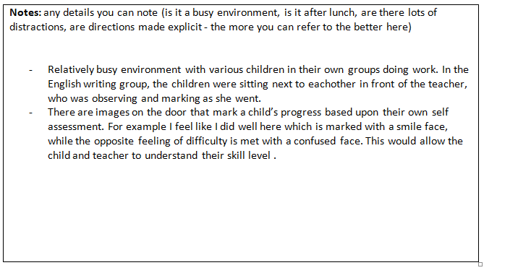

Figure 1: My highlighted critical incident that is the assessment’s main focus.

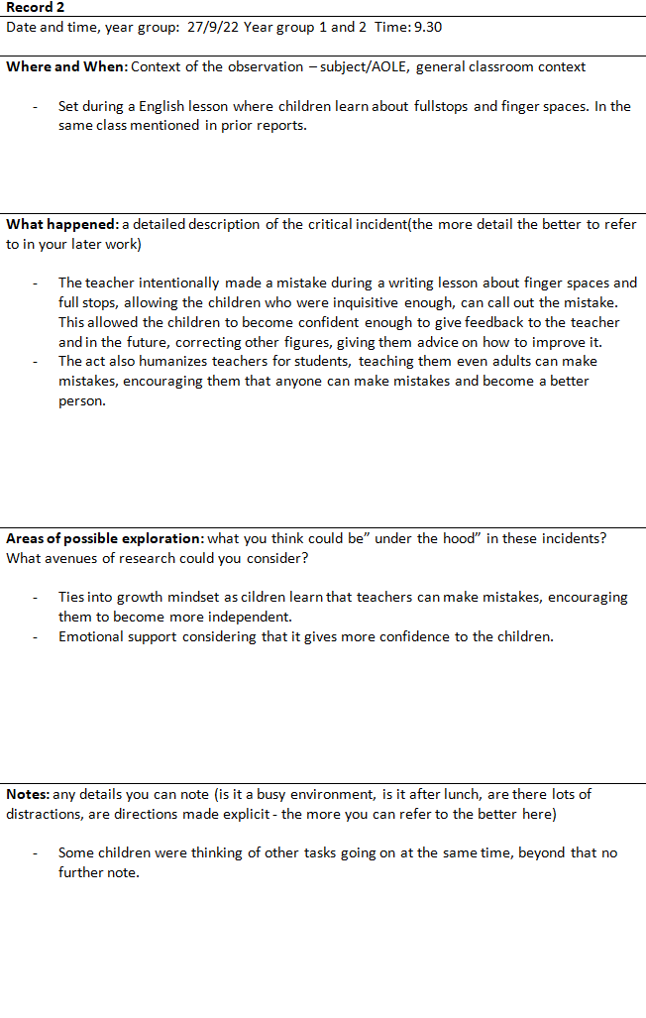
Figure 2: Second critical Incident

This continues with a focus on writing and English skills, focused upon during the assessment. The teacher intentionally made a mistake in the lesson to raise students’ spirits by making herself relatable to them, though mistakes are a natural occurrence and presenting that even adults make them, reassures students. The reassured students will be able to take on the task with more confidence, willing to take on difficult tasks and welcome mistakes. I highlighted this for it can work great for lessons that may appear difficult to students, and ground it to allow more accessibility, furthermore connecting with a teacher style of firm but fair; where teachers act in a friendly manner but stern enough to be relatable and strict enough to play the duel role of mentor and caretaker to its prime. Considering its use in improving my own way of teaching, it suggests to me ways of developing ways to encourage students such as making a mistake and offering a chance for students to tell what needs to be correct. Studying and developing methods of encouragement will no doubt help both my teaching and students, improving the student-teacher relationship and work efficiency, now confident enough to undertake challenging work.

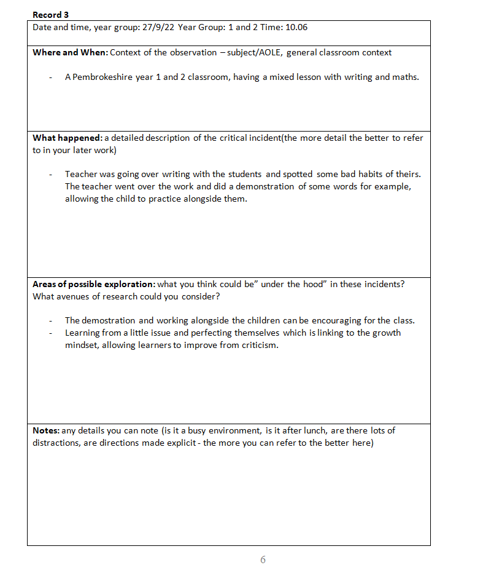
The third and last ‘critical incident’ covers the use of AFL but with a grander detail in the teacher’s involvement, rather than a one to one conversation, it was a demonstration for a seated group. The teacher went over recurring mistakes in many students’ work, and offered to help them overcome these hurdles, providing an example and choosing one student to mimic, raising confidence and conditioning to allow repetition. Repetition will allow students to continue use of a ‘growth mindset’, developing a small weakness to a strength, improving from criticism, by attempting corrections, again and again. I did not note any distractions for the class, for the group I observed was paying direct attention to their teacher; which was done through a discussion with a small group. Directed learning such as this, appears to be quite effective, and will be adapted for lessons in the future.

Ferreira Manuela,Cardoso Paula Ana, Luís Abrantes José Motivation and Relationship of the Student with the School as Factors Involved in the Perceived Learning - ScienceDirect, P 1 -2 ; published as part of Procedia - Social and Behavioral Sciences Volume 29, (2011), Pages 1707-1714.
Bethune, Adrian (2018) Wellbeing in the Primary Classroom: A practical guide to teaching happiness, (London: Bloomsbury Publishing), P.48
Pelvin, Rob (2017) Motivate the Unmotivated: : A Step by Step System You Can Use To Raise Motivation In Your Classroom Tomorrow, P.91
Bethune (2018), P.48
Bethune (2018), P.101.
Pelvin, (2017), pp.141-142
Pelvin, (2017) pp.123-124
Ferreira, Cardoso, Luís (2011), p.2
Richardson South Deborah, Bledsoe S. Robert , and Cortez Zaraly Kimberly Tanner (ed), Mindset, Motivation, and Teaching Practice: Psychology Applied to Understanding Teaching and Learning in STEM Disciplines (2020) https://doi.org/10.1187/cbe.19-11-0238 (Accessed September 2022)
Katz Idit,Sharar Hen - Bat, Teachers’ motivation and beliefs as predictors of their autonomy-supportive style, P.2; published as part of School Psychology International 2015, Vol. 36(6) 575–588. Accessed October 2022, untitled (selfdeterminationtheory.org)
Baranek Kay Lori, The Effect of Rewards and Motivation on Student Achievement, published by Grand Valley State University (1996), P.16 The Effect of Rewards and Motivation on Student Achievement (gvsu.edu) (accessed October 2022)
Baranek. L, (1996), P.14.
Code of professional conduct and practice - ewc.wales (2019)
Bethune (2018), pp.82 - 84

