ECYW7001 5000 Word Journal Component – Placement/Project One – Pontlliw Primary School
Order of contents:
- Coronavirus – The impact
- An information sheet of the work placement
- A critical examination of my roles and responsibilities as a trainee youth worker
- A community profile – A Mini Village in a Major Town
- A SWOT analysis of the primary school
- A summary of my own learning and development
- Appendices

The role that I carried out whilst I was on placement at Pontlliw Primary School changed at the start of 2021 as the Coronavirus pandemic took over and the school closed as a school setting and opened as ‘emergency childcare’ for the children of key workers. My job role as a teaching assistant became a role which resembled the role of a youth worker as I continued to work with the young people from Year 6 however, there were no strictly set hours, no work deadlines to meet and the role of the teacher, teaching assistant and youth worker rolled into one role. Even though the young people and children were in the ‘childcare’ because their parents were carrying out key worker roles, the young people and especially the younger children did not see the school environment as school. The environment became one where there was no uniform, no set timings; “if you’re hungry, eat now” was one of the most spoken sentences from the adults, and there were a range of activities for the young people to keep themselves busy throughout the day, board games, online quizzes, Minecraft and craft took over from mathematics, literacy and topic work.

All of the work that follows was written during the 2020/2021 Coronavirus pandemic. However, most of the work in the assignment was written while I was still able to carry out my role as a trainee youth worker and implement the project with the young people.

I hope that when the school welcomes back the young people who I worked with on the project, I will be able to take time out of my role as a Teaching Assistant to finish the project with the young people who were committed to creating a space that would benefit them and the rest of the school.


Placement Information Sheet – Pontlliw Primary School

Pontlliw Primary School is a small village school with just under 200 pupils. The school caters for children aged 3, in a morning nursery class, to 11 years old. The junior’s side of the school is set in an old building and the infants can be found in the new build attached. The school can be seen to put the children at the heart of everything that they do, from creating pupil voice groups to carrying out termly questionnaires to ensure all of the needs of the children are being met or catered for. The school website informs us that the school is a busy, caring and friendly environment to be part of and having worked there for 6 years and being a pupil there, I couldn’t agree more.
The school, like other schools in Wales, are working hard to create an environment where the children receive the best quality of learning from the New Curriculum for Wales, a curriculum that has integrated itself nicely into the way Pontlliw teaches and learns.
The majority of the children in Pontlliw speak English as a first language and a report by Estyn in 2014 states that only 3% of the school children speak Welsh at home. Estyn reported the school as an overall ‘good’ writing that the school is an inclusive community with a passionate and caring ethos. More recently in 2020, according to Wightwick Pontlliw was awarded the ‘Green’ annual school code colour by The Welsh Government deeming them a “very effective” primary school.

Reference List
Estyn. (2014) ‘A report on Pontlliw Primary School’ https://www.estyn.gov.wales/system/files/2020-08/Inspection%2520report%2520Pontlliw%2520Primary%2520School%25202014%2520%2528English%2520only%2529_0.pdf.pdf.pdf.pdf.pdf.pdf.pdf.pdf.pdf.pdf [Accessed: January 14th 2021].
Pontlliw Primary School. (2019) ‘Pontlliw Primary School’ http://www.pontlliwprimary.co.uk/ [Accessed: January 14th 2021].
Wightwick, A. (2019) ‘Wales school colour codes 2020: These are the schools ranked green’ https://www.walesonline.co.uk/news/education/colour-codes-schools-green-2020-17664013
Critical Examination of a Trainee Youth Worker

In this critical examination of my role as a trainee youth worker, I will compare my responsibilities and the implementing of my activity on placement to what Prospects (2021) states a youth worker would be responsible for and the role that they would carry out. I have chosen to compare my role to the one stated on Prospects.ac.uk as in my placement there was not a trained youth worker due to my placement being carried out within a small primary school.
Before starting the project with the young people in the school I carried out some research to find out what the school was missing in terms of a club or project. There were different after-school clubs for cooking, P.E, craft and IT but there was nothing where the young people could experience the outdoors in a new light. Nature Scot, (2020) writes that young people between the ages of 11 and 17 years old enjoy taking part in new activities and are keen to get outdoors to learn. The website, Prospects.co.uk (2021) states that and assessment of the young people’s needs should be carried out and planning should be made to suit the interests or needs of the young people. This is something I wanted to bear in mind when the project started. Once I started, the aim was to create somewhere where the young people could use the outdoors to benefit their learning and over all development. As well as those two factors, I wanted somewhere where we could invite in the community and create a welcoming space. I believe that an area where young people can develop and learn was created and used, however, because of the pandemic and a local lockdown, the project did not reach the stage of inviting in the local businesses and community.
Prospects (2021) also states that a youth worker should develop the relationship with the young people through building trust, respect and ensuring that the space used was a space where young people can develop their identity and place in society. In the group sessions, I would remind the group that they were free to talk about whatever they wished, and that it was not formal education. There were discussions on topics such as gender, what role some of the young people wished to play within our community and the topic of the transition to comprehensive school cropped up more than once in each session. Youth Affairs Council of Victoria (2013) writes that when a youth worker is talking with young people, it is important to be yourself and talk openly as you would to anyone. Even though I was being myself around the young people, I was very careful about the choice of wording and language that I used when we were discussing different topics.
Next, Prospects (2021) writes that is the role of the youth worker is to set boundaries and deal with any challenging or inappropriate behaviour. During one session, two boys from the group started being inappropriate while another member of the group was trying to discuss how she thought we should lay out the garden. It was off-putting for her so I called the boys to one side and explained that even though is not formal education we still have to respect others in the group, as you would in the ‘outside world’, one of the boys tried to challenge what I had said until I asked if he wanted to express his views for the garden in front of the group and have others talk over him. He realised how he was in the wrong and how he would not have wanted others to do to him what he was doing. When I am faced with confrontation, I remain calm as I believe over reacting can often lead to not resolving the initial problem.
Prospects (2021) continues to state that it is often the role of the youth worker to work with key people in a young person’s life. These people may include family members or professionals from outside agencies such as health, education or young offending. The only encounter that I had with someone who would be classed as an outside agency was one of the teachers. During a discussion one of the group members told me how she was really struggling to access online homework from home due to not having access to a computer or tablet. After making the teacher aware of this, the girl was provided with a school laptop to take home. As I stated, I did not have any other encounters during my time on the project however due to my good communication skills I believe that I would have no real issues in working with or alongside families or other professionals. HM Government (2018) writes that everyone who has any contact with children, young people or their families has a role to play in their safety, well-being and safeguarding.
Another role of a youth worker is to attend multi-agency meetings and use different practitioners and sectors to form a ‘Team Around the Family’ approach. Part of my Teaching Assistant role is within the school’s TAF team, however, as a trainee youth worker I did not encounter any part of TAF or multi-agency working.
Some youth workers will be responsible for recruiting, training and managing staff according to Prospects. During the project I was the only adult working with the young people when whether we were out on the yard, in the garden and in the classroom so I did not need to provide any further training. I did however ensure that I was up to date on safeguarding and first aid training. As I was the only adult, all queries from parents and young people came to me. It was also my responsibility to ensure that we had a fire register on us at all times and the class teacher and headteacher knew how many young people I had with me outdoors, in case of an emergency.
Prospects (2021) goes on to write that most youth work projects and services are dependent on government funding, fundraising and sponsorship. When I set the project up, I was offered some money from the school’s Eco pupil voice group which I used to purchase some tools. Part of the project involved the young people writing to the local garden centre which is how we received the free seeds. I was also given a few donations by parents as they really wanted the project to work. The money donated by parents was used to supply the young people with gardening gloves and to buy extra soil. The last couple of pounds were spent on buying squash and a small snack for the group each week. Without the generosity of the parents the project would have been limited and we would not have been able to meet our goals in time.
There is not much that I would have done differently with the project, especially given the time that we had. Due to lockdown, we were unable to welcome the parents and community into the garden however it is something that is still in the school diary for when the school re-opens to full classes. I could have possibly spent more time outside at the start of the project instead of using the indoor hall to carry out research with the group however, again we did not know that the project would be cut so short.
There were a few situations/altercations between the young people which arose, but I dealt with them as best as I could. Nothing left the session unsettled. As I have stated in the ‘My Own Learning and Development’ I do think that I was too comfortable with the young people that I was working with as I have known them all for the last 6 years and due to the village being so small, I am quite friendly with some of the parents. I hope that for my next project I am in a setting which challenges me and where I am faced with new experiences.

Reference List
HM Government. (2018) ‘Working Together to Safeguard Children’ https://assets.publishing.service.gov.uk/government/uploads/system/uploads/attachment_data/file/942454/Working_together_to_safeguard_children_inter_agency_guidance.pdf [Accessed: January 13th 2021].
Nature Scot. (2020) ‘Young People and the Outdoors’ https://www.nature.scot/professional-advice/land-and-sea-management/managing-access-and-recreation/increasing-participation/young-people-and-outdoors [Accessed: January 13th 2021].
Prospects. (2021) ‘Youth Worker’ https://www.prospects.ac.uk/job-profiles/youth-worker [Accessed: January 13th 2021].
Youth Affairs Council of Victoria. (2013) ‘Communicating With Young People’ https://yerp.yacvic.org.au/build-relationships/involve-young-people/communicating-with-young-people [Accessed: January 13th 2021].

‘A Community Profile’

A Mini Village in a Major Town

Aimee Mathias

2020/2021
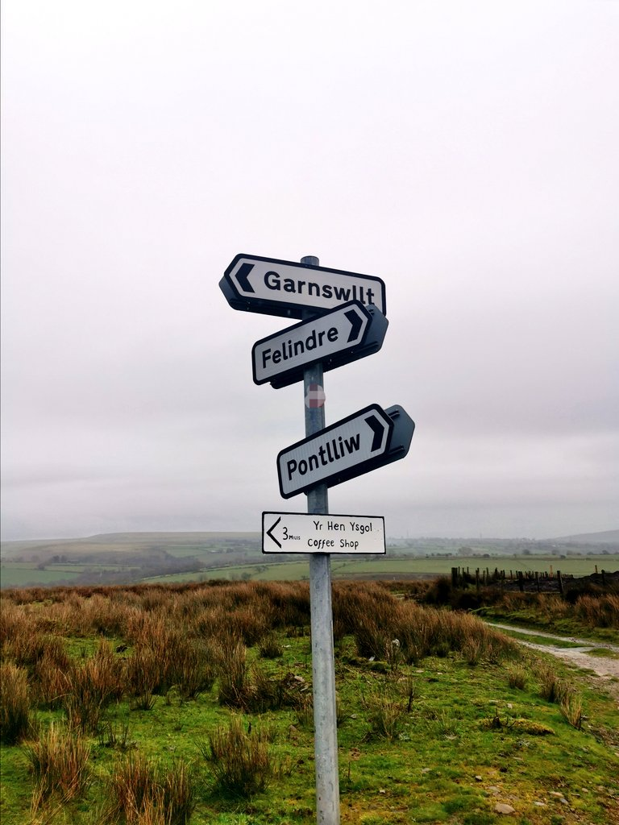

Introduction

The aim of this profile is to look at the resources and opportunities available to the young people in this small village of Pontlliw. The profile will offer statistical information on the village and the surrounding areas and bring to light the requirements and social needs of the young people in this community. The profile will be focused on young people aged mainly 11 years old and in Year 6. “Children, after all, are not just adults-in-the-making. They are people whose current needs and rights and experiences must be taken seriously.” (Kohn, 1993, no page)

History of the Village
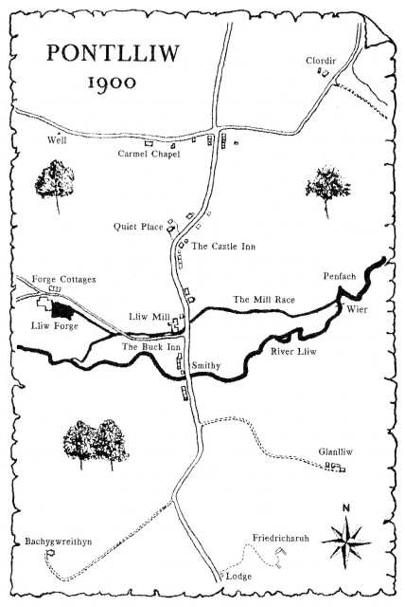
According to Smith (1993-2009, no page) in the 1900s the village of Pontlliw was known locally as a mining village due to the local colliery being the main employer in the village. Pontlliw, at that time, had its own mini-industry consisting of its own Forge employing over 60 men where metal and machinery parts were shipped all over the world. There was no village school and the children of Pontlliw would walk the 2 mile trip to the next village of Penllergaer. The image to the left shows how bare Pontlliw was in the early 1900’s.
Fast forward just over 100 years and Pontlliw is now known locally as the “Pontlliw and Tircoed Community”. Brinkoff (no date) states that Pontlliw holds a population of 1,659 however the community now boasts a combined population of over 2,619.
(Source: Smith, 1993)

Geography and Physical Environment
Located 8 miles from the built-up Swansea City Centre, it is fair to say that Pontlliw is on the outskirts of Swansea. The village itself is very much a smaller village squeezed between two much bigger villages, Penllergaer (population of 2,868) and Pontarddulais (population of 6,281). Pontlliw has a fair-sized park and the backdrop of the Pontarddulais Mountains where locals are known to walk, off road mountain bike or battle the tarmacked inclines on their road bikes. Pontlliw is just one mile long so some may find it surprising that there are four ways into (and out of) Pontlliw from the surrounding villages and the four roads come together to create the crossroad situated at the heart of the village. The crossroad is where you will find the Post Office, Primary School, Village Hall, Church Hall and Church. The only village facilities that aren’t at the crossroad are The Buck Inn and Bella’s Bar and Café, both public houses on the main road through Pontlliw. Albeit a small village, there is quite a lot of land surrounding the village. Most residents take pride in the appearance of the homes and especially their gardens, creating a colourful display as you pass through the village.

Education
Pontlliw has quite a small primary school compared to neighbouring villages. In both Pontarddulais and Penllergaer Primary School two form entry can be seen for most school years and some classes have three form entry. Pontlliw has a single form entry for all years. The school sees children from outside of Pontlliw applying and appealing to secure a place in the Primary School. The school has built up somewhat of a reputation for accepting and welcoming children with additional learning needs and this has attracted families with ALN children from as far afield as Llanelli and Port Talbot as the children are welcomed into the mainstream classes.
Pontlliw Primary School, along with four other primary schools feed Pontarddulais Comprehensive School, locally known as ‘Bont Comp’. Bont Comp was voted number 1 Comprehensive School in Wales in 2017 and keeps up an impressive 95% overall yearly attendance rate.
The attitude towards education in Pontlliw is outstanding. Each child can be seen actively trying to improve their skills and knowledge and most children will complete homework within the given time or choose to stay in at lunch time to complete it. That is not the case just one mile away in Pontarddulais. Senior staff at Pontarddulais Comprehensive School say that as the children transition into young people, they notice that the young people who are growing up within Pontarddulais have a much more negative outlook on education compared to those from the surrounding areas. Could that be because research carried out by Swansea Council in February 2020 show that over 30% of 4,449 people aged between 16 and 74 over 1,390 people in Pontarddulais are unemployed? Ilivehere.co.uk (2020) states from the information taken in the UK Census 2011, the people living in Pontlliw have higher levels of education qualifications, more than the average UK citizen therefore signifying that the village is better educated than the average village in Wales.

Facilities and Resources
As previously mentioned, the village has a village hall, church hall, two small shops, a Post Office and two pubs which both serve meals. These facilities are not overly welcoming to young people. Neither of the halls provide a youth club, or any other club for young people or children. There used to be a small Brownies, Cubs, Scouts and Girl Guides group however they have now all finished. There are also no sports groups within Pontlliw except from the football team, who are open to over 16 years old. The park is where you will find the bulk of the young people from Pontlliw, especially on a Friday evening. In some villages or cities, it can be daunting or intimidating to find a group of young people in a village park as reported in Dorset Echo (2019) here in Pontlliw, it is not like that. The village actively encourages young people to use the park and its facilities. Within the park grounds there is an all-weather tennis court which includes markings for football, netball, tennis and hockey, this is also used by the primary school. Next to that is the park with swings, baby swings, a lay down swing; purposely designed for someone with a disability which may restrict them from sitting up unaided, slides and climbing frames. There is also a BMX and skate park within the park. This is used a lot by young people and children as the jumps are small enough for beginners and fun enough for intermediates. Lastly, the park has a small outdoor gym with monkey bars and pull up bars, etc. In the summer months the park really is the place to be as a young person, however, as the days get shorter there is nowhere for these young people to meet indoors.
As I walk through the main park area in November 2020, I find myself thinking of how the Corona Virus pandemic has changed the lives of these young people in Pontlliw. If there was a small community youth club in place, organised/scheduled weekly Skype calls could provide the young people with a chance to see each other and check in virtually. No doubt that in 2020 the young people have taken it upon themselves to create these calls, however, I do worry that those one or two people who are not quite in a group may be missing out.
Here in Pontlliw there are a lot of main facilities missing. These missing facilities can be found in the surrounding villages but would require a mode of transport to access them. There is no library, supermarket, doctor’s surgery or bank in Pontlliw. They can all be found in Pontarddulais just two miles away. The bus route, X13 travels from Pontlliw and through the main road of Pontarddulais where all of these resources can be found. The village is also missing a community centre and leisure centre. Neither of these can be found within the nearby villages. The closest leisure centre can be found almost four miles away and the closest community centre even further at almost 6 miles away. These are two facilities which would most definitely be used by the young people from the village if they were within a safe walking distance.

Conclusion
To conclude, I believe that even though Pontlliw is a very welcoming, inclusive and inviting village for young people to live and grow up in, there are quite a few additions that could be added to create an environment where the young people are free to express themselves. Their options of activities are limited to ‘going to the park’, of course, that is a weather permitting activity.
The village will benefit from a small community centre or using the Village Hall to create an evening youth club where young people would benefit from informal education, information, and support maybe more than once a week. This is something that the community council could look into and support.
The village could be considered an affluent and well-educated area with a high number of successful young people. To continue this, the success of these young people should be celebrated to inspire others who follow.

Reference List
Brinkhoff, T. (2019) ‘PONTLLIW AND TIRCOED’ https://www.citypopulation.de/en/uk/wales/admin/swansea/W04000976__pontlliw_and_tircoed/ [Accessed: 27th October 2020].
Dorset Echo. (2019) ‘Call for action after teens 'intimidate' parents and children with anti-social behaviour’ https://www.dorsetecho.co.uk/news/17545513.call-action-teens-intimidate-parents-children-anti-social-behaviour/ [Accessed: 28th October 2020].
ILiveHere UK. (2020) ‘Socio-economic statistics for Pontlliw, Swansea’ https://www.ilivehere.co.uk/statistics-pontlliw-swansea-30890.html [Accessed: 28th November 2020].
Kappan, P. D. (1993) ‘Choices for Children: Why and How to Let Students Decide (*)’ https://www.alfiekohn.org/article/choices-children/?print=print [Accessed: 27th October 2020].
Smith, N. (1993) ‘Pontlliw Village Hall (The Story of a Dream Come True)’ https://pvh-online.org.uk/historych1.html [Accessed: 26th October 2020].
South Wales Police Swansea. (2020) 22 December. Available at: https://twitter.com/SWPSwansea/status/1341391657955192835/photo/2 [Accessed: 23rd December 2020].
Swansea Council Information, Research & GIS. (2020) ‘PONTARDDULAIS WARD PROFILE’. Swansea: Swansea Council.
Swansea Council. (2019) ‘Pontlliw Park’ https://www.swansea.gov.uk/pontlliwpark [Accessed: 23rd December 2020].

SWOT Analysis: Pontlliw Primary School 2020/21

Frue (2017) states that a SWOT analysis is a guideline that can be used by any business or organisation to recognise their strengths, weaknesses, opportunities and threats. By creating a SWOT analysis, the (in this case) organisation can focus on certain areas of interest such as:
- Areas that need improving
- Areas that are excelling
- Areas which have hit a stop
- Areas which could cause damage if left

S  Strengths | W  Weaknesses | O  Opportunities | T  Threats
- Ranked ‘Green’ therefore in Welsh Governments top tier  - Strong community bonds  - Great communication with parents and carers  - Small class sizes  - Highly trained teachers and teaching assistants  - Welsh speaking teaching staff  - Helpful PTA and volunteers  - Passionate staff  - Approachable governors  - Continuous high attendance  - Inclusive environment  - Open door policy for parents and carers  - Excellent IT resources and knowledge within school  - Approachable staff  - Excellent understanding of children with additional learning needs  - Accessible school – wheelchair friendly corridors and doors  - A flow of new ideas for the school/approaches to learning  - Well operating transition programmes  - Using the community resources – village hall, church and park  - Interaction from children in new projects and daily work  - Links to schools throughout Europe – Erasmus  - Breakfast and after school club | - Financial challenges  - Parents parking  - Parents involvement  - Limited time to plan new lessons  - Limited time to implement new ideas  - Outdoor junior yard development  - Lack of general space around school – guitar teacher, violin lessons, extra curriculum support | - Afternoon nursery  - Increase local business links  - Communicating with parents via social media platforms  - Supporting low-income families through home learning – providing laptops for children’s learning/work  - Use money from new housing development to create another classroom/space | - New housing development – more pupils and not enough space  - Lack of funding  - Social media – negative status’  - Admission through appeal process – class size increases  - Reduction of support from outside agencies – councillors, play therapists, etc.  - Dropping from ‘Green’ to ‘Yellow’ in WG tier system

Reference List
Frue, K. (2017) ‘How to Do a SWOT Analysis of Your School’ https://pestleanalysis.com/how-to-do-swot-analysis-of-your-school/ [Accessed: January 10th 2021].

Summary of My Own Learning and Development

To summarise my own learning and development whilst on placement, I am going to refer to the Youth Work National Occupational Standards. Within the document created by NOS; National Occupational Standards, there is a diagram outlining The Values of Youth Work. The diagram can be seen below.
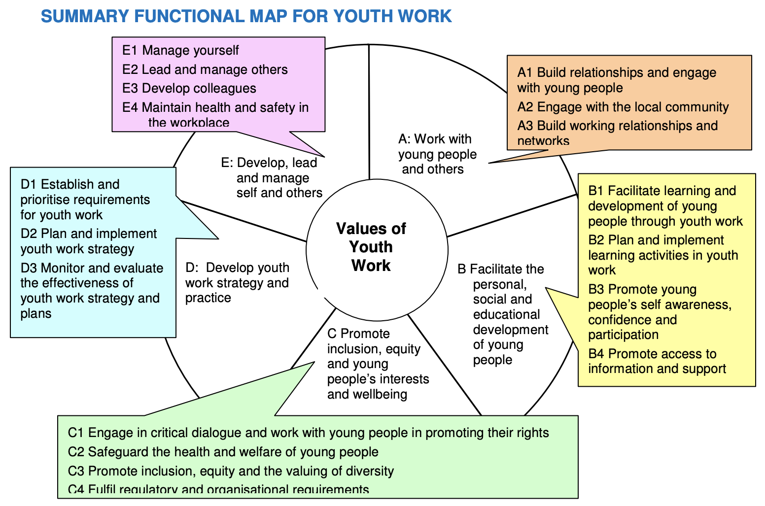
(Source: NOS, 2014. p.6)
The aim of The Youth Work National Occupational Standards (NOS) is to outline the skillset needed to work with young people, in all settings. The summary map above identifies some of the key functions and principles that should be applied while carrying out activities of any kind with young people. It can sometimes be unlikely that the youth worker will carry out all of the outcomes in each area within one activity but when there is a team of youth workers these areas may all be met. I will be basing my outcomes on the work carried out over four sessions with young people so the outcomes achieved may seem a lot for just one activity.

A: Work with young people and others
Due to Coronavirus restrictions, I carried out my placement project in the local primary school where I have worked for over six years. I was very fortunate to start the role of the trainee youth worker with groups of young people from the Year 6 class. Even though I have a very open and understanding role as a TA already, to change my role from teaching assistant to trainee youth worker, I encouraged the young people to call me ‘Aimee’ instead of ‘Miss Mathias’. By doing this it symbolised a difference of roles and the children knew that it was a much more informal group than the ones they are used to being in in school.
At the start of each session with the groups we would make use of the outdoor classroom, a sturdy wooden shelter, by carrying out a short check in session. The young people would use one word to describe how their week was going and they could then expand on that if they wished. Often, they would come back to their word during the day where they would start discussing what was going well or not so well for them at that time.
There were a couple of times throughout the project where a young person felt they could not play a good enough role within the group. At this point, I would remove them from the group and discuss with them these feelings. We would then talk about their strengths and reintroduce them to the group with their strengths being at the front of their mind and the realisation that they can achieve the goals that had been set that day.
At the start of the project, I involved the parents and local businesses in the project by asking for donations of money, tools and seeds and in return they would be welcomed into the garden in spring when we have an open morning to proudly display the young people’s work. I am glad that I was able to involve the community within the project as in 2019 after evaluating a short-term P.E group that I had implemented, I had regretted not involving the local community and parents. Bristol University (2017) writes that communicating with and the use of the local community can bring new knowledge, skills and experience.

B: Facilitate the personal, social and educational development of young people
Although the groups were informal, I wanted to create an environment where everyone felt safe and free to express their own ideas and thoughts. As I knew the group of young people before starting the project, therefore I strategically chose the groups. I ensured that there was a mix of young people in each group as I thought it was important for them to understand that some people have different views, ideas and beliefs. This worked really well and surprisingly there was a strong group feel each week.
The project started with research from the young people to find out what flowers or seeds would work best for that time of year. A few of them were bored with looking online so I encouraged them to broaden their horizon and use different research methods. Some of the young people then ‘interviewed’ family
Each young person would also set a personal goal for that session/day. Some set personal goals, and some set more academic goals. For example, some of the goals included:
- Using the shovel,
- Paying someone a complement,
- Not shouting at someone who got in their way,
- Identifying five different leaves.
From this, I learnt that each young person wanted to take a different lesson/achievement from each session.
After the group had checked in, we discussed the risks and challenges that the session would involve. To activate the young people’s prior knowledge, I encouraged them to all think of or find a risk or challenge in the garden area and then we talked about them. From doing this, I learnt that it is important to support young people who are finding risks in new places for the first time as well as the importance of enabling young people to be actively involved with all parts of activities.
Not only were the young people assessing their environment, but they were also managing the tools and equipment that we had to use that day. Each group had a job each week which they were responsible for completing. I would plan the activity each week and then leave it to the young people to implement within their group, I would be involved in the group. Towards the end of the day, we would come together and discuss what had been achieved. I would then use a checkout strategy where each young person would highlight something that another had done well. This is something that I found worked brilliantly as everyone took a compliment away each time. Eaude (2009) writes that often children, young people and adults may find it difficult to find their own happiness so by having others point out where you are doing well enables you to see what they are seeing.

C: Promote inclusion, equity and young people’s interests and welfare
Within the overall group there is one young person who is on the Autistic Spectrum and there are some boys who struggle with anger and behaviour issues. This is obviously something that I needed to remember at all times, especially while they were using or had access to the gardening tools or equipment.
One of the sessions included creating ‘bird feed balls’. There were six young people that week and one of those was a young person who will be referred to as ‘W’ for this piece of work. W is on the Autistic Spectrum, although highly functioning. W was excited to create the feed balls however when it came to mixing the seeds, lard and bread W did not want to use his hands due to the different texture and sensation that he would have experienced. The other young people are aware that W has Autism but that does not change their approach to him at all. While some of the young people suggested W used gloves to create the mixture it came to me that W could use a small hand-held shovel to mix. By doing this I showed that W could still be included as I knew how eager he was to be involved. I learnt that it doesn’t always have to be something that is normal to fix the problem, sometimes something that is practical that works just as good. Friedlander (2010) writes that often those who are undertrained or misinformed can find it difficult to work with or teach young people or children with autism. I did not find this as one of my first roles as a Teaching Assistant was working with a Year 6 autistic child. I learnt so much from my time with him, lessons that will stay with me throughout my life inside and outside of work.

D: Develop youth work strategy and practice
Before starting the project, I looked into what the school was missing. There are lots of after-school groups which cover P.E, cookery, art, etc. but there was nothing that enabled the young people to work outside and experience gardening. I realised that a gardening project would also work well alongside the Year 6 class topic of WW2.
To create the opportunities for each member of the class to be involved with the project, I worked alongside the Year 6 teacher to create a timetable of when would suit around the school day. Every Wednesday was decided and the young people in the classroom would be outdoors all day. Education Minister for Wales, Kirsty Williams (2019) writes that one of the aims of youth work is for young people to develop holistically. I believe that this project has done just that. The young people have learnt skills to be independent, to work as part of a team and to communicate effectively all whilst doing something completely different for all of them.

E: Develop, lead and manage self and others
After each session I kept small journal entries that I was able to reflect in and act upon in the following week. I believe that my skills continued to grow each week, especially my confidence in managing a small group of young people and the ability to use my initiative when needed. Each week before taking the young people into the garden I carried out a quick risk assessment of the area to check for any changes or risks to the area for example, ice, fallen acorns, broken equipment (wood, seating, etc.) or animal faeces. A small first aid kit was taken out with us each for each session, and we were close enough to the window of another classroom in case of any serious accidents.

Overall, I believe that I have learnt a lot from this experience. I know I will be able to take the newly developed skills into the next placement setting. The skills of strong communication, encouraging young people to better themselves and believe in themselves and the skill of promoting the rights of young people is something that I hope to take into my current role as a Teaching Assistant. To develop further, I would gain more experience working with groups of young people who I am not familiar with as I believe that I was too comfortable with the young people in the groups due to knowing them for so long prior to the project, however, the use of a new organisation was not possible due to Coronavirus.

Reference List
Bristol University. (2017) ‘Working with Local Communities’ https://www.publicengagement.ac.uk/sites/default/files/publication/working_with_local_communities.pdf [Accessed: January 8th 2021].
Eaude, T. (2009) ‘Happiness, emotional well‐being and mental health – what has children’s spirituality to offer?’ https://www.tandfonline.com/doi/full/10.1080/13644360903086455 [Accessed: January 8th 2021].
Friedlander, D (2009) ‘Sam Comes to School: Including Students with Autism in Your Classroom’, The Clearing House: A Journal of Educational Strategies, Issues and Ideas, vol.82:3, pp141-144.
National Occupational Standards. (2014) ‘LSI YW00 Youth Work National Occupational Standards Introduction’ https://www.nya.org.uk/wp-content/uploads/2014/06/National-Occupation-Standards-for-Youth-Work.pdf [Accessed: January 8th 2021].
The Welsh Government. (2019) ‘Youth Work Strategy for Wales’ https://gov.wales/sites/default/files/publications/2019-06/youth-work-strategy-for-wales.pdf [Accessed: January 8th 2021].

Appendices

- Risk Assessment – Pontlliw Primary School Pond Area
- Placement Report from Pontlliw Primary School
- Supervision Report from Cath Wilson
- Dated journal entries
- Email sent to parents informing them of the activity and giving them the opportunity to stop photos of their child or children from being used in this essay
- Pictures from the project:
Minecraft project work
Work produced by the young people during the project
Letter sent to the local garden centre
Outdoor project starting

- Risk Assessment - the following risk assessment was created by Pontlliw Primary School in 2010 and the last review was 2019  ‘Plannu hadau i dyfu am oes’ ‘Planting the seeds for a lifetime of growth’  RISK ASSESSMENT – POND AREA  Hazard / Risk | Who is at risk | Normal Control Measures  (Brief description and/or reference to source of information). | Additional Control Measures  (To take account of local/individual circumstances). | Risk Rating H/M/L
Drowning | Staff  Pupils  Visitors | Design:  - Edges of the pond clearly visible.  - Deeper zone positioned away from the edges.  - The depth should be kept as shallow as possible.  - Pond regularly maintained to ensure that the perimeter does not become obscured and that the area around the pond does not deteriorate.  - Slip / tripping hazards eliminated from the surrounding area. |  | L
 | Staff  Pupils  Visitors | - Edges that are open for access for pond dipping should be gently sloping, or flat and well defined.  - Appropriate level of supervision in place taking into account age of pupils and any special needs  - Pond area fenced to (1.1m high min) with gate to deter unsupervised entry |  | L
Hygiene  Infection Weils disease  Poisoning (blue-green algae) | Staff  Pupils  Visitors | - Adequate provision for hand washing is readily available.  - Provide hand dryers rather than communal hand towels.  - Do not allow children to touch any part of their face with their hands before hands are washed.  - All wounds on exposed skin are suitably covered;  - No eating in the pond area  - Prevent access to the area by cats/dogs, checks always made of the area to remove (hygienically) any faeces before children enter the area.  - Any algal scum should be removed, avoiding skin contact. Pupils should be supervised carefully so that they have no opportunity to eat any parts of the plants growing in or around the pond. |  | L

2. Feedback from Leanne Evans/Pontlliw Primary School

Aimee has settled extremely well into her placement with the young people of our school. She is a natural in this field, has instantly built relationships, and has a strong ability to engage with young people. In the project, which she has begun at our placement, the young people are excited to take part. They are fully engaged, as the project has a meaningful purpose. Not only does the project benefit the young people and school but it also benefits our local community; thus building a working relationships and networks within our school and local business. With Aimee’s support, guidance and enthusiasm, young people have been motivated to learn and see a purpose to achieve their attended goals. Parents have also supported the project by donating money, tools and resources to making our school a better place.
Aimee has provided learning opportunities to facilitate the learning and development of our young people.
She listens their needs, ideas and goals. She takes on board their opinions and puts this into practice; this is why the young people remain engaged whist she works with them in groups on a variety of different tasks.
The tasks that Aimee has led range from
- Learning about how people grew their own food in WW2
- Research into what plants grow best this time of year.
- Writing letters to local companies and parents asking for donations of plants/ gardening tools.
- Writing the correct format of a letter and posting – providing life skills opportunities.
- Digging out the vegetable patch in preparation for the vegetables to be planted.
- Weeding and laying soil.
- Making birdhouses, painting and making feeders for the birds to make the school a brighter place.
All of these have provided the young people with an empowerment through their active involvement in the project to also have a voice at our school. Through this Aimee has also provided learning opportunities to consolidate and provide real life opportunities to develop young people awareness of their rights and responsibilities.
Our 3 areas of focus this year as a school are Respect, Care and Community. Aimee’s project with our young people allows opportunities for them to achieve the end goal.
It a pleasure to accommodate Aimee for her placement. The bond that Aimee has developed with the young people in a short space of time, and under current circumstances, is to commend. The young people trust Aimee and are confident to speak openly when in her company. Aimee deals with all situations with a great deal of professionalism.
She has not only built a strong relationship with the young people but is also highly thought of by other members if staff.
Signed:
L. Evans (Senior Leadership Team) Pontlliw Primary School
14/01/2021

3. Supervision Report from Cath Wilson
Aimee is carrying out her placement in a local primary school, facilitating the personal, social, and educational development of young people in year 6.
During her placement Aimee has organised a gardening project with the pupils. As Aimee already knew most of the pupils, she looked at ways she could promote learning and social interaction with the pupils using an informal setting rather than the formality of the classroom.
Through supervision, Aimee discussed the reason behind the idea as well as any issues she came across.
Aimee recognised that by offering this project to the young people they would take ownership of their own learning. Aimee witnessed how the young people organised themselves, who became natural leaders and those that preferred to follow instruction. During supervision Aimee was able to relate this to Tuckman’s theory of group development.
When planning the project Aimee considered all the young peoples need and learning styles. Aimee discussed how she worked to promote inclusion and equality. Aimee gave an example of how she initially had concerns about a young person who had Autism and how he would interact with the other pupils. However, by allowing the group to develop organically Aimee was able to witness how the easily young people ensured that the young lad was included in all activities. Aimee noted how this inclusion by peers created a growth in confidence of the young lad as well as the positive impact the project was having on the wellbeing of all the young people involved.
During supervision we discussed issues that arose. Aimee discussed her thoughts and concerns that she initially faced with one young person, (a son of one of teachers), The young person pushed the boundaries and the rules. To overcome this Aimee encouraged the group to set their own rules and boundaries, again giving voice and control to the young people.
Throughout the life of the project Aimee was able to monitor the effectiveness of the project and the impact it was having on the young people’s wellbeing. Aimee measured this through group discussion as well as one to one support. Aimee recognised how the group grew in confidence and tasks were fairly distributed throughout the team. Aimee was able to take a step back from delegating roles as the young people took ownership of the project.
During the project Aimee was able to demonstrate how she can develop, lead, and manage others. Once the project was confirmed with the Head Teacher, Aimee independently created and developed in collaboration with the young people.
During supervision Aimee talks passionately about the young people she has worked with and the pleasure she has gained from this project is apparent. Aimee has been able to relate her theory to practice and has shown to be a good reflective practitioner.
Aimee is now looking forward to working in a new setting and has expressed her interest in working in a residential project with young people who face the additional challenges of growing up without or with limited family support network.

Cath Wilson
07/03/21

4. Journal accounts – Pontlliw Primary School – Garden Project

November 4th 2020 – Online research
The aim of this afternoon’s session was to work with a partner, or small group, to research the different seeds that we would need to purchase in readiness to plant once we have completed the work outdoors and feed that information back to the bigger group. There were a couple of complications with the laptops not being charged so we used the school iPads instead. Looking back on this initial complication, I am grateful that I work in the school, so I am aware of the different equipment that is available for us to use and where to locate it at such short notice.
As a big group we decided on a range of tasks to carry out throughout the week (as I work in their classroom, I was there if support was required) that would relate to the classroom-based topic of WW2 and our Grow Your Own task. We decided to create Grow Your Own posters, write and post letters to local businesses including the local garden centre and individually the young people wanted use the new Minecraft Education software to ‘build’ their own virtual WW2 vegetable garden or bunker. Some of the group went a step further after they had created their Minecraft garden and incorporated their mathematics skills and worked out their digital area and perimeter.

November 11th 2020 – The Bugs!
Today was the first outdoor session that I held in Pontlliw Primary School. The aim of the day was to remove as much of the over-grown grass as possible. A group of 7 young people were in the garden with me, they were all dressed appropriately for the weather and the wet grass. To start the session, we discussed some basic health and safety rules; to keep warm, to stay out/away from the pond and it was at this point that one of the young people jokingly said, “leave any bugs well alone”. The group laughed, as did I. When we approached the planter’s areas of the garden the bugs started appearing! It started as a joke, “watch out for that worm” or “watch out for that beetle/spider” and so on. After about an hour of dodging the bugs, the young people became more interested than afraid of them. I quickly downloaded a bug identifier app, and the young people took it in turns to identify the bugs.
To reflect on this session, I had organised for two men from the community with strong links to the school to help out by cutting the grass the week before the first session however, thanks to the Welsh Weather that we experienced in early November they were unable to do so. It did not stop too much of the session though as we spent some time just walking a path from the outdoor classroom/shelter to the planters to beat down the grass. I will definitely purchase a few pairs of gloves, so that each young person has a pair for the session as the cold air really got to some of them especially when they had been pulling on wet grass or weeds.

November 18th 2020 – Confronting Their Behaviour
Today was a wet drizzly day where no one really wanted to be outside. The original plan for the session had been to loosen the earth that was already in the planters, so it was ready for seed planting next week. After a short time of loosening the earth, three of the boys started to get bored and started to wind each other up and distract the rest of the group. I decided to implement the ‘dry’ activity that I had as a back-up that we could do in the outdoor classroom. We started to create bird feeder balls, two of the boys in particular were very wound up and due to their language, created an uneasy feel amongst the group. After talking with the two boys in private they agreed to return to the group sensibly and try their best to not distract anyone any further.
This session had some confrontation however as I remained calm, I was able to resolve the situation and regain some kind of control over the activity as a whole and achieve a good outcome from the day.

November 18th 2020 – Quick thinking, Initiative
When I decided to change the session and use the birdseed balls plan, it completely slipped my mind that in this group I had a young person on the Autistic Spectrum. The boy who will be called ‘W’ for this entry can sometimes surprise us and handle last minute change really well. Today was not really one of the times. I think that over all because of the different area, the rain and the cold all of W’s senses were heightened. The birdfeeders were created using seeds, bread and lard – the easier the better. The group used their hands to mix/crush the ingredients together and it was a lot more successful than I originally thought it would be. W tried, but really did not like the feeling of the mixture on his hands. Others in the group suggested that he used latex gloves so the mix was not directly on his hands however I quickly grabbed a small shovel and W was able to mix the ingredients and his partner could mould the mix around the string.

November 25th – ‘Just Keep Spreading, Spreading, Spreading’
Last night we had a trailer full of soil delivered to the school for us to use in our planters. One of the girls in the group, a keen swimmer, started singing the song from Finding Nemo which simply says, “just keep swimming, swimming, swimming”. Another girl joined in the song and changed ‘swimming’ to ‘spreading’. That became the tune of the day. Without being directed or asked to do so, the group of 6 split into two groups of three girls and three boys. Each group worked on a planter each. To start with everyone was really productive and the spreading of soil was going really well. Then, the boys started flicking smaller lumps of soil at the girls. Something totally harmless but something the girls did not like. There was no big fuss made over this and everyone continued to plod on.
A really good session today, we are now ready to plant our seeds.

December 2nd 2020 – Who Dropped the Seeds?!
After a dry couple of days, the soil was perfect to plant the seeds that the young people had decided on. We had a variety of bean seeds in different little bags ready to plant. We walked from the school up to the garden and that’s when it happened… someone dropped the bean seeds and mixed them. The young person who dropped the seeds was quite upset as they had spent some time creating little tags to place with each type of seed. I explained that it was not the end of the world and we would be able to have a mixed garden of beans when they grow. I demonstrated how to plant the seeds deep enough in the soil and give the young people a few seeds each to get on with. Once most of the seeds were planted, we decided to keep some back and plant some indoors to see the difference.
I am glad that I was able to keep some seeds back as with a proposed lockdown coming, the young people who will remain in school will be able to take pictures of the beans growing in class and share the pictures with the rest of the groups.

December 9th 2020 – Jack and The Beanstalk
When I arrived at lunch time today, lots of the members of the group came running over to tell me that we had mini stalks growing in class. It was so nice to see their enthusiasm and to watch the groups mix as they discussed the growth and the differences between being planted indoors and out.
The project was cut short due to the Coronavirus pandemic closing schools in Wales in January 2021.

5. Email sent to parents/carers
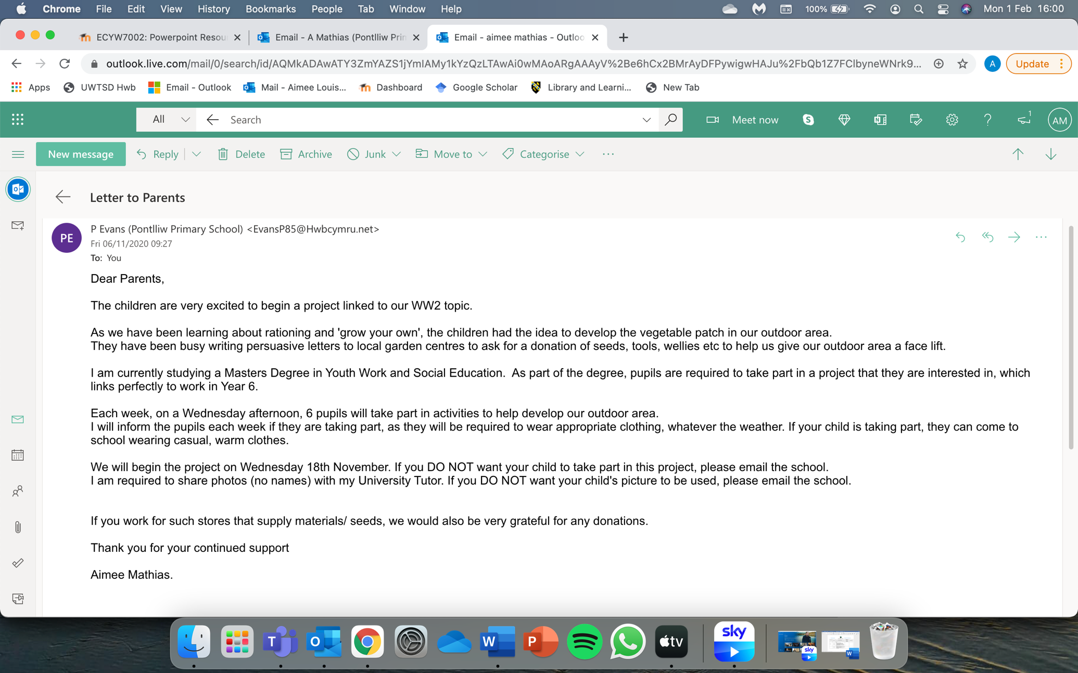
6. Project pictures



