Computational Thinking
Term 1
Andrei-Daniel Mihai
Student no. 1912494

PART 2.

Question 1. Using turtle I designed the following shapes.

- Circle

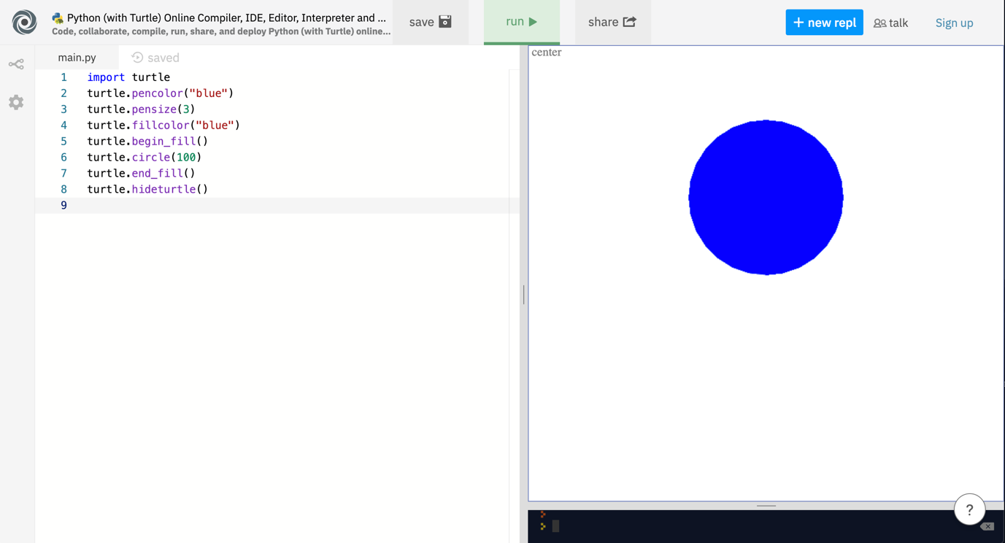

- Square
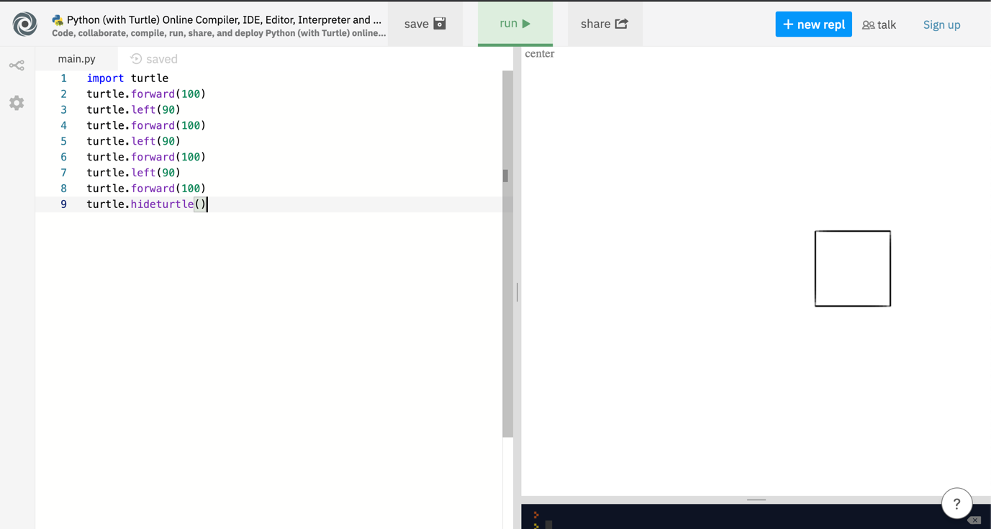

Question 2
Write a program to check whether the given number is odd or even.
Code program is :
n=int(input(“enter a number”))
if n%2==0:

print(n, ”is a even number”)
else:
print(n, “is a odd number”)
Image for even number

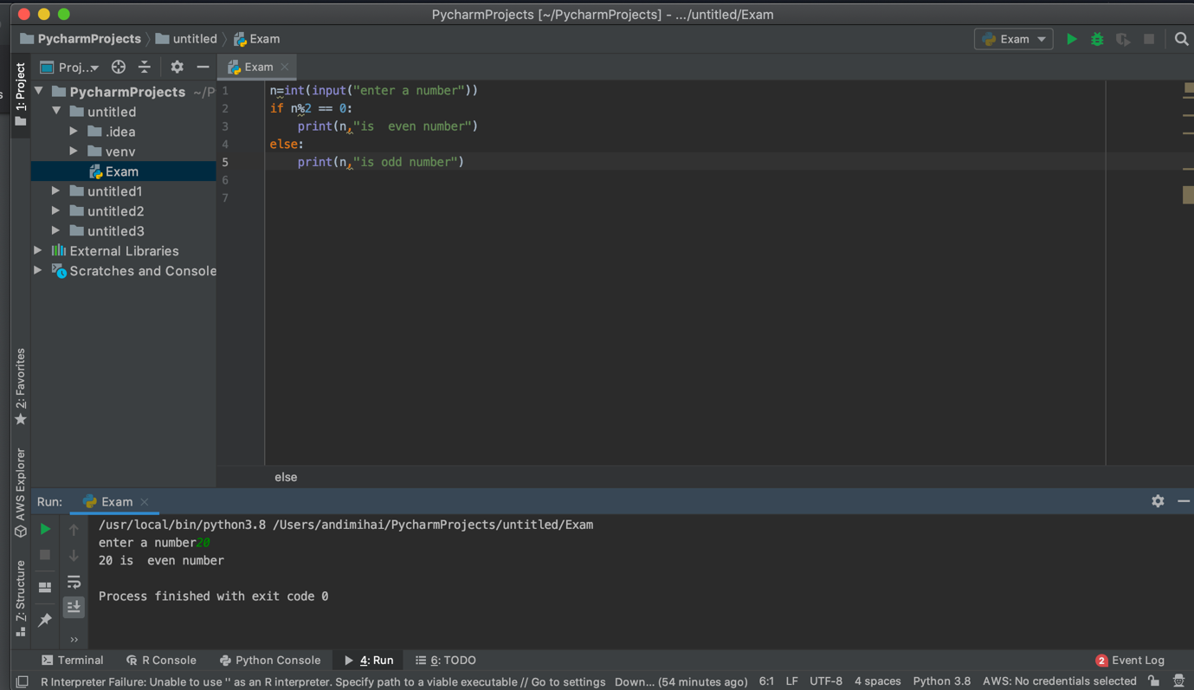

Image for odd number
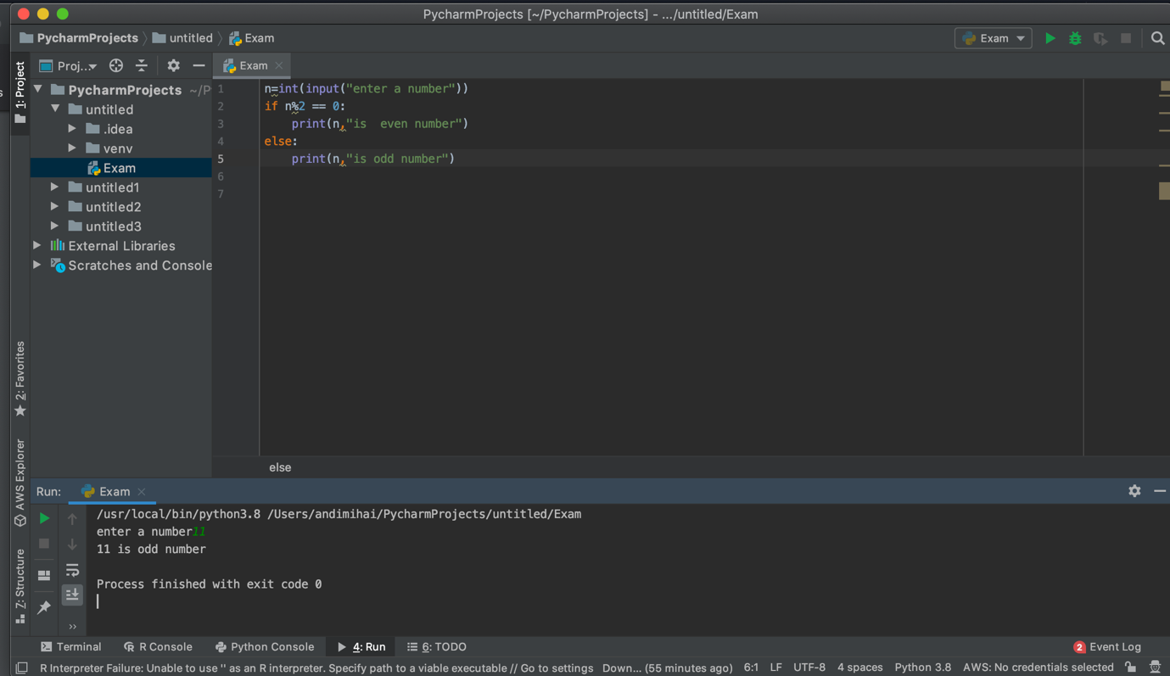

Question no.3
Product of N numbers

a = int(input("Enter number:"))
p = 1
for i in range (1, a+1):
p=p*i
print(p)

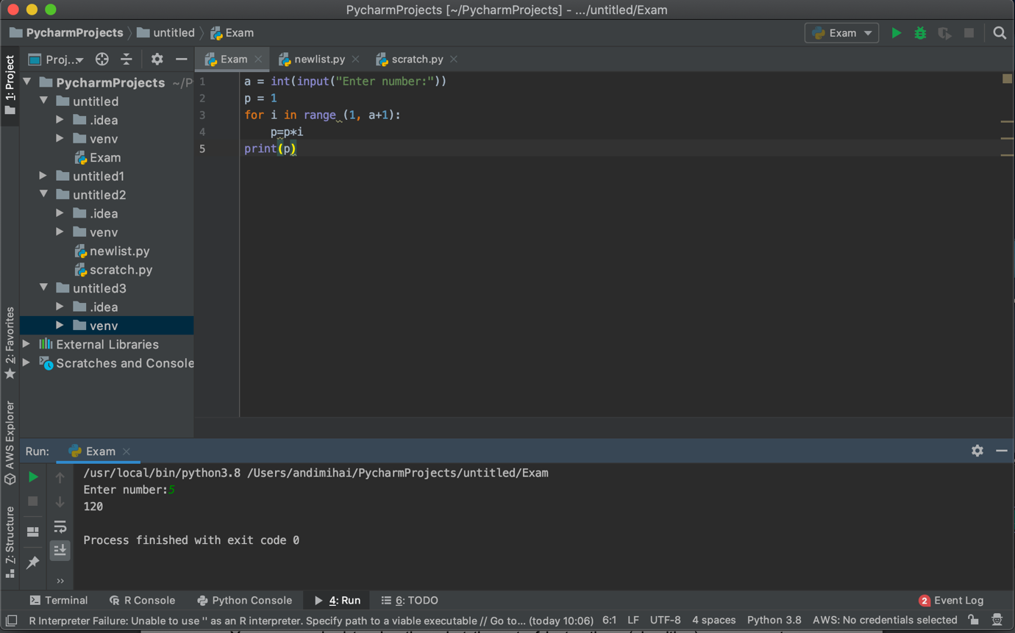

Question 4.

Height=[122, 145, 163, 122, 121, 141, 170, 180]
Print(height, “height list”)
Height.append(190)
Print(“the list after append [190]”, height)
Length=len(height)
Print(“the total number of elemets is:”, height)
Height.sort()
Print(“the list after sorting is:”, height)
Height.reverse()
Print(“the list after reverse is :”, height)

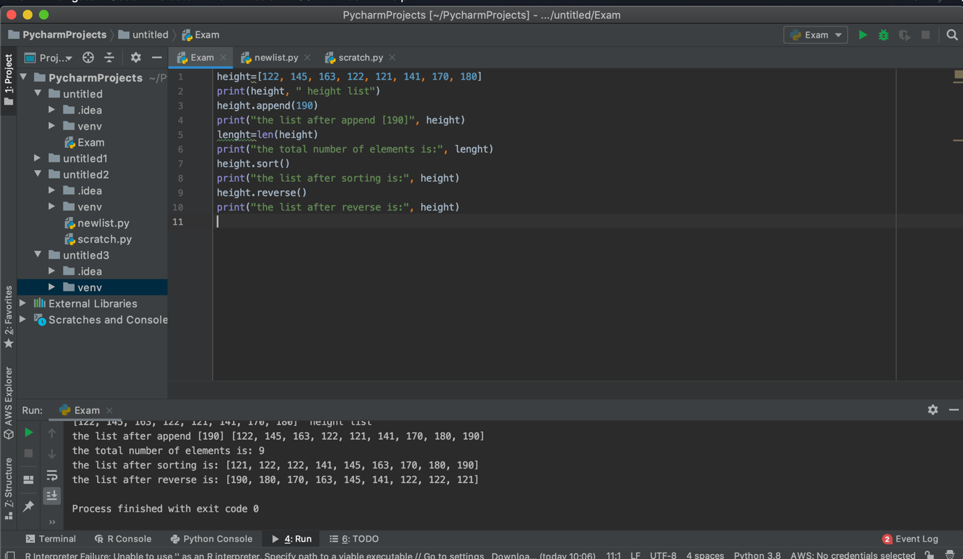

Part 1.

Question no 2

Draw a flow chart to find which number is greatest among two number
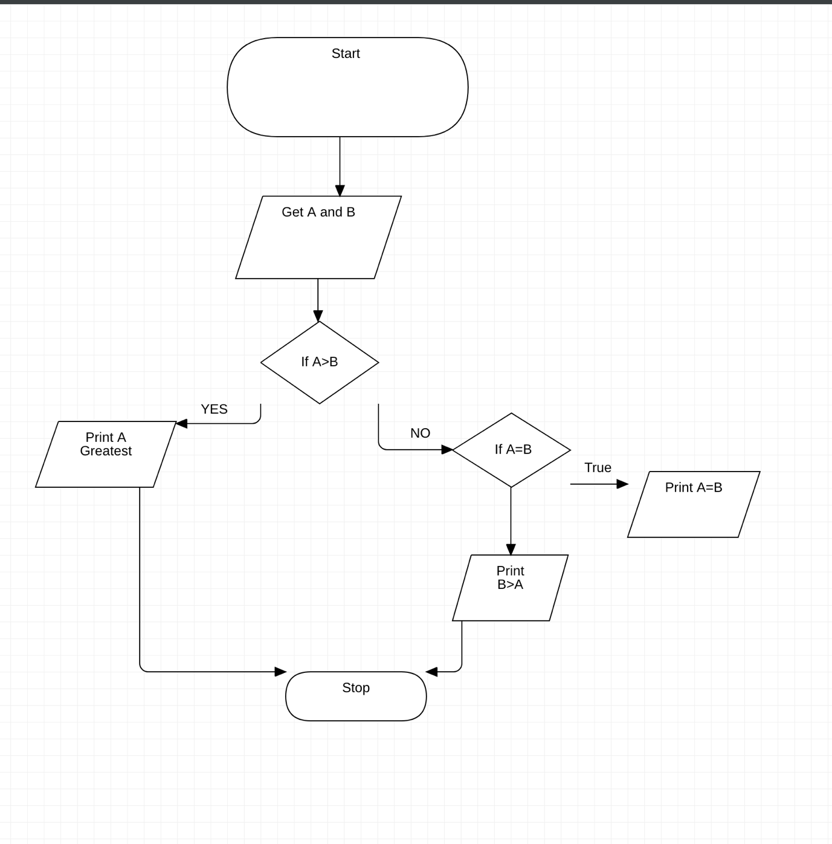

Question no.1
1.Start
2.Pick up Kettle
3.Run the tap (for water)
4.Open Kettle Lid
5.Fill the Kettle up
6.Close the kettle lid
7.Plug the kettle on
8.Turn on the kettle
9.Grab a mug.
10.Put inside the mug 2 metal tea spoons of coffee
11.Add 1metal tea spoon of sugar
12.After water is boiled
13.Stop the kettle
14.Add the boiling water from the kettle in the mug on top of the coffee and sugar half of a big mug
15.Stir the whole component
16.Get the carton of milk
17.Open the carton of milk
18.Pour the milk to fill up the other half form the mug
19.Stirr the rest of the composition
20.Serve the mug with milky coffee
21.Stop

