Component 2 – Written Assignment (Report)
Student Name: Nazema Bibi
Student Number:2333305
Lecturer Name: Olufemi Oluranti
Submission Date: 19th July 2026
Module: Building Your Personal Brand (BMHP5015)

Contents
- Introduction ……. 3
- Overview of the Job Role ….. 3
- Job Description and Person Specification…. 4
- Analysis of Employability Skills….. 7
- Evaluation of My Current Skills….. 9
- Building My Personal Brand….. 12
- Promoting My Professional Identity…..12
- Professional Networking…. 13
- My Unique Selling Point….. 13
- Five-Year Action Plan…. 13
- Resources Required….. 14
- Communicating My Skills to Employers….. 15
- Conclusion…. 16
- References…. 23
- Appendix….. 5/6

Employability Skills and Professional Development for a Career as a Mental Health Support Worker in the UK

Introduction
The health and social care sector relies on skilled professionals who are compassionate, adaptable and committed to delivering person-centred care. Employability is not simply about obtaining academic qualifications but also involves developing professional behaviours, transferable skills and lifelong learning that enable individuals to perform effectively within complex healthcare environments (CIPD, 2024). As demand for mental health services continues to increase across the United Kingdom, Mental Health Support Workers play an essential role in supporting individuals experiencing mental illness, promoting recovery and improving wellbeing (NHS England, 2024).
This report explores the role of a Mental Health Support Worker, a career that aligns with my future aspirations following completion of my BSc Health and Social Care degree.. The report also discusses how I can build a strong personal brand, develop my professional identity and expand my professional network to enhance future employment opportunities. Finally, a five-year action plan is presented to demonstrate how I intend to achieve my career goals through continuous professional development and reflective practice.

2. Overview of the Job Role
For this report, I have chosen the role of Mental Health Support Worker because I am interested in pursuing a career in mental health after completing my BSc Health and Social Care degree. The job vacancy selected for this report was advertised by Cygnet Health Care on the NHS Jobs website. The position is based at Cygnet Hospital Oldbury in the West Midlands. The vacancy was posted on 3 July 2026 and closes on 2 August 2026 (NHS Jobs, 2026).
The role involves supporting adults receiving inpatient mental health care within a Psychiatric Intensive Care Unit (PICU) and Acute Ward. According to the job advertisement, successful applicants will work 42 hours per week, including days, nights and weekends, providing high-quality, person-centred care to individuals experiencing acute mental health conditions. Mental Health Support Workers are responsible for supporting service users with their daily activities, monitoring their physical and emotional wellbeing, maintaining accurate records, promoting recovery and independence, and working closely with nurses, psychiatrists, psychologists and other members of the multidisciplinary team (NHS Jobs, 2026).
The vacancy also highlights that Cygnet Health Care values staff development by offering training opportunities and career progression. This demonstrates that employers expect applicants to be committed to lifelong learning and continuous professional development. As someone who enjoys helping others and wants to build a career within mental health services, I believe this role closely matches my future career aspirations.
(See Appendix 1, Figures 1 and 2 for screenshots of the vacancy
3. Job Description and Person Specification
The NHS Jobs advertisement outlines several key responsibilities and essential qualities required for the role of a Mental Health Support Worker.

Job Description
The successful applicant will be expected to:
- Deliver compassionate and person-centred care to adults receiving mental health treatment.
- Support service users with daily living activities while promoting independence and recovery.
- Observe, monitor and report changes in patients' physical and mental health.
- Maintain accurate patient records and documentation.
- Work collaboratively within a multidisciplinary team to deliver high-quality care.
- Promote dignity, respect and equality when supporting service users.
- Follow safeguarding procedures and maintain confidentiality.
- Contribute to maintaining a safe, therapeutic environment for patients and staff (NHS Jobs, 2026).

Person Specification
The advertisement states that applicants should demonstrate:
- Excellent communication and interpersonal skills.
- Compassion, empathy and patience.
- The ability to work effectively as part of a multidisciplinary team.
- Emotional resilience when supporting individuals experiencing mental illness.
- Good organisational and time-management skills.
- Professional behaviour and respect for confidentiality.
- A commitment to safeguarding vulnerable adults.
- Willingness to undertake further training and Continuous Professional Development (CPD) (NHS Jobs, 2026).

These requirements demonstrate that employers are looking for candidates who not only possess appropriate qualifications but also display professional values, emotional intelligence and strong interpersonal skills. This reflects the NHS Constitution, which emphasises compassion, respect, teamwork and commitment to providing high-quality patient care (Department of Health and Social Care, 2021).

Appendix 1
Figure 1. NHS Jobs Advertisement – Mental Health Support Worker
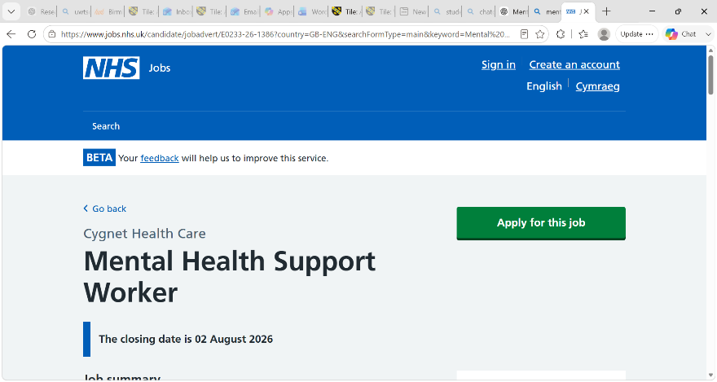
Source: NHS Jobs (2026). Mental Health Support Worker – Cygnet Health Care, Cygnet Hospital Oldbury.

Figure 2. NHS Jobs Advertisement – Job Summary and Main Duties
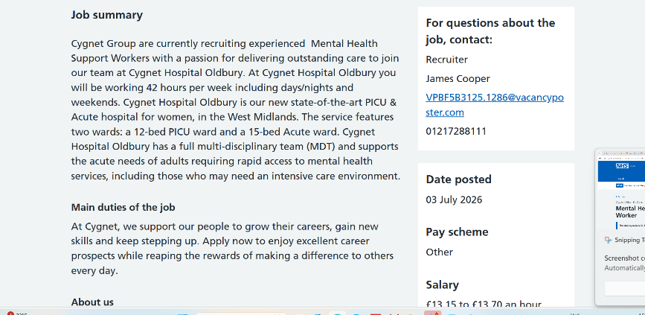
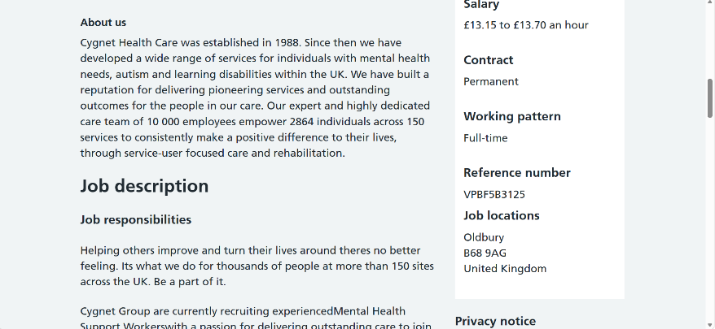
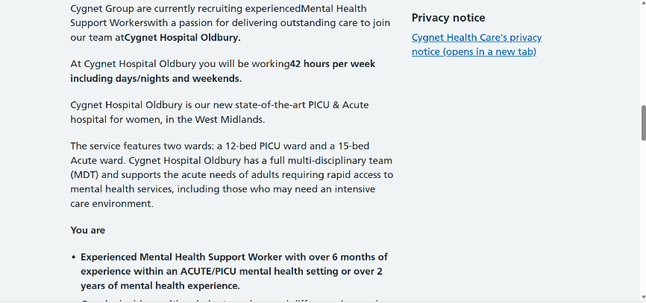
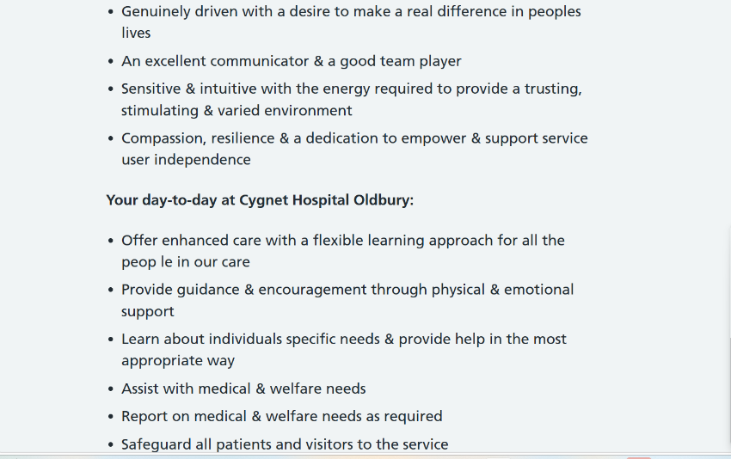
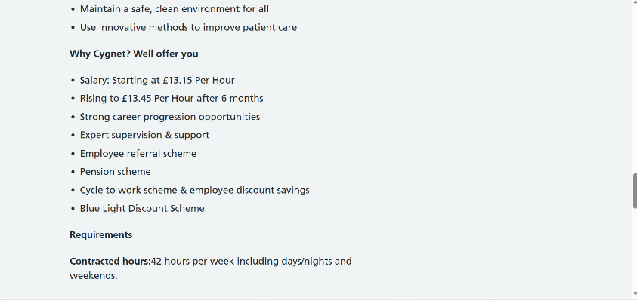
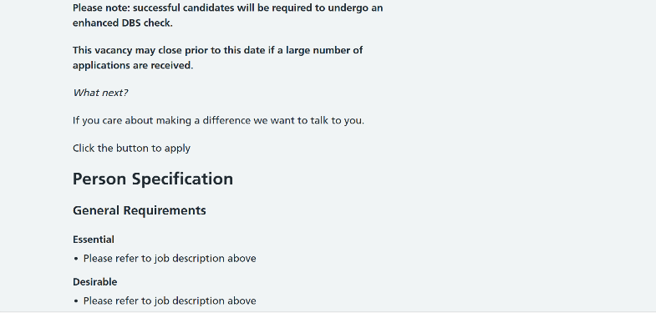
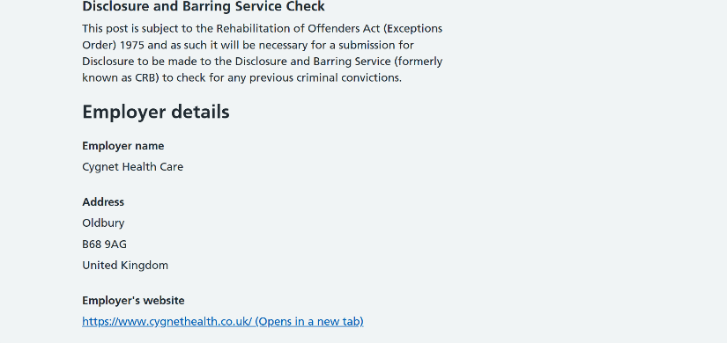
Source: NHS Jobs (2026). Mental Health Support Worker – Cygnet Health Care, Cygnet Hospital Oldbury.

Analysis of Employability Skills Required for the Role
Employability skills refer to the combination of knowledge, behaviours, personal qualities and transferable skills that enable individuals to obtain and sustain employment while performing effectively within their chosen profession (CIPD, 2024). Within mental health services, these skills are particularly important because professionals work with individuals experiencing psychological distress, vulnerability and complex social needs.

Communication Skills
Communication is one of the most important employability skills identified within the NHS job advertisement because Mental Health Support Workers interact with service users, families and multidisciplinary teams on a daily basis. Effective communication involves more than simply exchanging information; it requires active listening, empathy, emotional intelligence and the ability to adapt communication styles to meet individual needs. Many people experiencing mental illness may struggle to communicate their thoughts or emotions, meaning professionals must communicate clearly, respectfully and without judgement.
Effective communication contributes to person-centred care by encouraging individuals to participate in decisions about their treatment while promoting dignity and trust. In contrast, poor communication can result in misunderstandings, reduced patient engagement and risks to patient safety (Care Quality Commission, 2024). Consequently, communication is not only an employability skill but also a professional responsibility that directly influences recovery and quality of care.

Empathy and Compassion
Mental health professionals regularly support individuals experiencing depression, anxiety, psychosis, trauma and other psychological conditions. Compassion enables practitioners to understand service users' experiences without judgement while maintaining professional boundaries.
Empathy improves therapeutic relationships and contributes to positive recovery outcomes because service users are more likely to engage with professionals who demonstrate genuine understanding and respect. Skills for Care (2024) identifies compassion as one of the core values required across health and social care professions.

Teamwork
Teamwork is another essential employability skill because mental health services are delivered through multidisciplinary collaboration involving psychiatrists, nurses, psychologists, occupational therapists, social workers and support workers. Every professional contributes different expertise towards achieving positive outcomes for service users.
Effective teamwork requires open communication, mutual respect and shared decision-making. It also reduces the risk of fragmented care by ensuring that information is communicated accurately between professionals. Employers therefore seek candidates who demonstrate flexibility, cooperation and the ability to contribute positively within diverse healthcare teams. Developing these skills will enable me to provide coordinated, person-centred care while supporting colleagues effectively.

Safeguarding Knowledge
Mental Health Support Workers frequently work with vulnerable adults who may be at risk of abuse, neglect or exploitation. Therefore, knowledge of safeguarding legislation and reporting procedures is fundamental.
Professionals must understand responsibilities under the Care Act 2014, Mental Capacity Act 2005 and safeguarding policies to ensure service users remain protected. Failure to recognise safeguarding concerns may result in significant harm to vulnerable individuals.

Emotional Resilience
Working within mental health services can be emotionally demanding due to exposure to distressing situations, challenging behaviours and complex clinical needs. Emotional resilience enables practitioners to manage workplace pressures while maintaining professionalism and providing safe care.
Developing resilience also reduces the likelihood of burnout, stress and compassion fatigue. Employers increasingly value applicants who demonstrate self-awareness, reflective practice and healthy coping strategies.

Professionalism and Ethical Practice
Professionalism involves accountability, integrity, confidentiality and adherence to organisational policies. Mental Health Support Workers are expected to respect confidentiality under the Data Protection Act 2018 and maintain professional boundaries when supporting service users.
Professional behaviour also includes punctuality, reliability and commitment to lifelong learning. Continuous Professional Development (CPD) ensures practitioners remain competent as healthcare practice evolves.

Digital Skills
Digital literacy has become increasingly important across healthcare. Mental Health Support Workers use electronic patient records, digital appointment systems and online communication platforms. NHS England continues to expand digital healthcare services, making technological competence an essential employability skill (NHS England, 2024).
Individuals who demonstrate confidence using healthcare technologies are likely to contribute more effectively within modern healthcare environments.

Problem-Solving and Adaptability
Mental health settings are often unpredictable. Support workers must make appropriate decisions while responding calmly to changing patient needs. Critical thinking enables practitioners to identify problems, seek support when necessary and contribute to effective care planning.
Adaptability has become increasingly valuable due to changing NHS policies, workforce pressures and evolving patient needs. Employers therefore seek candidates who remain flexible while maintaining high standards of care.

5. Evaluation of My Current Skills Against the Job Requirements
To evaluate my readiness for the role of a Mental Health Support Worker, I have reflected upon my current knowledge, transferable skills and personal qualities against the person specification contained within the NHS Jobs advertisement. Self-reflection is an important aspect of professional development because it enables healthcare professionals to recognise their strengths, identify areas requiring improvement and develop realistic career goals (Cottrell, 2021). Reflective practice also supports lifelong learning and continuous improvement, which are essential within modern health and social care practice.
One method I have used to evaluate my employability is a SWOT analysis, which identifies personal strengths, weaknesses, opportunities and threats. This framework encourages reflective practice and supports the development of realistic career goals.

SWOT Analysis
Table 1. Personal SWOT Analysis
Strengths | Weaknesses
Strong communication and listening skills | Limited practical experience in mental health settings
Compassionate and empathetic towards others | Confidence when managing challenging situations needs improvement
Reliable and committed to learning | Public speaking can sometimes make me nervous
Able to work effectively within a team | Need greater knowledge of NHS electronic record systems
Good organisational and time-management skills developed through university study | Limited experience leading teams

Opportunities | Threats
Completing my BSc Health and Social Care degree | High competition for NHS vacancies
Volunteering within community mental health services | Emotional demands associated with mental health work
NHS training programmes and Continuing Professional Development (CPD) | Changes in NHS recruitment requirements
Networking through LinkedIn and university placement opportunities | Balancing future employment with continued professional education

The SWOT analysis demonstrates that I already possess several qualities expected of Mental Health Support Workers, particularly communication, empathy and teamwork. However, it also highlights areas that require further development before applying for employment.
One of my greatest strengths is my ability to communicate effectively with others. Throughout my university studies, group presentations, discussions and written assignments have strengthened my verbal and written communication skills. Good communication is essential within mental health care because professionals must build trusting relationships with service users while working collaboratively with multidisciplinary teams (Skills for Care, 2024). I believe my approachable manner and willingness to listen carefully enable me to support people respectfully and without judgement.
Another important strength is empathy. Health and social care professionals must understand the emotional experiences of service users while maintaining professional boundaries. During my studies I have explored person-centred care, equality, safeguarding and ethical practice, which have reinforced the importance of treating every individual with dignity and compassion. These values align closely with the NHS Constitution, which emphasises compassion, respect and commitment to quality care (Department of Health and Social Care, 2021).
Despite these strengths, I recognise that I have limited direct experience supporting individuals with complex mental health conditions. Although my academic learning has provided theoretical knowledge, practical experience remains essential for developing confidence when responding to challenging behaviour or crisis situations. This represents one of my main development needs before entering employment.
I also recognise that confidence is an area requiring improvement. While I communicate effectively in most situations, I can sometimes feel anxious when speaking in unfamiliar professional environments. Developing greater confidence through volunteering, placement opportunities and practical experience will improve my ability to communicate assertively with colleagues and service users.
Another area for development involves digital healthcare systems. NHS organisations increasingly rely upon electronic patient records, digital documentation and online communication systems. Although I am confident using Microsoft Office applications and university learning platforms, gaining experience with NHS digital systems would increase my employability and enable me to adapt more quickly within healthcare settings.
Overall, this self-evaluation demonstrates that I possess many of the personal qualities expected by employers, while also recognising the importance of continuous learning and professional development.

6. Health and Social Care Qualifications and Experience
My current qualification is the BSc Health and Social Care, which has enabled me to develop a broad understanding of health promotion, safeguarding, person-centred care, communication, equality, diversity and professional practice. The programme has strengthened both my academic knowledge and transferable employability skills.
Throughout the course I have completed a variety of assignments requiring independent research, report writing, presentations and reflective practice. These activities have improved my critical thinking, organisation, problem-solving and evidence-based decision-making skills.
In addition to academic study, I have developed important interpersonal skills through collaborative learning and group activities. Working with classmates has strengthened my ability to cooperate with others, manage different opinions and contribute effectively within teams. These experiences reflect the multidisciplinary collaboration expected within NHS mental health services.
As I continue progressing through my degree, I intend to gain practical experience through volunteering within mental health charities and community organisations. Practical experience will enable me to apply theoretical knowledge while increasing confidence when supporting vulnerable individuals.
Undertaking additional CPD courses, including Mental Health First Aid, Suicide Awareness and Safeguarding Adults training, will further strengthen my knowledge and demonstrate commitment to lifelong learning.

7. Building My Personal Brand
Personal branding refers to the way an individual presents their professional knowledge, values and abilities to employers and colleagues (Montoya and Vandehey, 2008). Within health and social care, a positive personal brand should demonstrate compassion, professionalism, integrity and commitment to providing person-centred care.
Developing a professional personal brand will increase my employability by demonstrating that I possess both the technical knowledge and professional behaviours expected within the NHS. Peters (1997) argues that individuals should consider themselves as professional brands whose reputation influences career opportunities. Therefore, maintaining a professional image both online and offline is essential.
To strengthen my personal brand I will maintain an up-to-date LinkedIn profile, regularly update my CV, complete additional CPD courses, attend healthcare careers events and seek constructive feedback from lecturers, mentors and future supervisors. I will also ensure that my online activity reflects NHS values by communicating respectfully, maintaining confidentiality and demonstrating professionalism. These activities will help employers recognise me as a motivated, trustworthy and compassionate healthcare professional committed to lifelong learning.

8. Promoting My Professional Identity
Professional identity develops through education, experience and reflective practice. It represents how individuals perceive themselves as professionals and how they are recognised by others within their chosen career (Adams et al., 2006).
Professional identity is also shaped by accountability, ethical practice and adherence to professional standards. Although Mental Health Support Workers are not registered healthcare professionals, employers still expect them to demonstrate honesty, confidentiality, respect and professionalism in every aspect of their work. Developing these qualities throughout my career will strengthen my reputation as a reliable and compassionate healthcare practitioner.
My professional identity is centred upon providing compassionate, respectful and person-centred care. I believe every individual deserves to be treated with dignity regardless of their background, culture or mental health condition. Throughout my degree I have developed a deeper understanding of equality, diversity, safeguarding and ethical practice, which continue to shape my professional values.
Maintaining professionalism requires continuous learning and self-reflection. Reflective practice enables healthcare professionals to evaluate their performance, recognise areas requiring improvement and enhance future practice (Schon, 1983). I therefore intend to continue reflecting on my experiences throughout my career to support ongoing professional development.

9. Building Professional Networks
Networking plays an important role in career development because it enables individuals to access employment opportunities, share knowledge and develop professional relationships (CIPD, 2024).
To strengthen my professional network I intend to engage with a range of organisations and resources, including:
- LinkedIn to connect with healthcare professionals and recruiters.
- NHS Jobs to monitor employment opportunities.
- University Careers Service for interview preparation and career advice.
- Skills for Care for professional guidance and workforce development.
- Mental health charities such as Mind and Rethink Mental Illness to gain volunteering experience.
- Healthcare conferences and professional networking events.
Developing professional relationships may increase access to mentorship, career advice and future employment opportunities. Networking also encourages lifelong learning through sharing experiences and best practice with other professionals.

10. My Unique Selling Point (USP)
My unique selling point is my compassion, resilience and commitment to continuous professional development. Throughout my studies I have demonstrated determination to improve my academic knowledge while developing transferable skills including communication, teamwork and organisation. I understand that effective mental health care requires emotional intelligence as well as technical knowledge, and I believe my ability to listen carefully, treat individuals with dignity and remain committed to lifelong learning would enable me to make a valuable contribution within the NHS. My willingness to continually improve through education, reflection and practical experience distinguishes me from other applicants.

11. Five-Year Action Plan
To become a successful Mental Health Support Worker, it is important to set realistic and achievable goals that support continuous professional development. An action plan provides a structured approach to developing the knowledge, skills and experience required for the role. Continuous Professional Development (CPD) is essential in health and social care because it helps professionals maintain competence, improve practice and respond to changes in healthcare services (Skills for Care, 2024).
Table 2. Five- Year SMART Action Plan
Timeframe | Development Goal | Action Required | Expected Outcome
Year 1 (2026–2027) | Complete my BSc Health and Social Care degree | Successfully complete all modules and graduate | Achieve the qualification required for entry-level healthcare roles
Year 1 | Improve mental health knowledge | Complete Mental Health First Aid, Safeguarding Adults and Suicide Prevention training | Gain recognised certificates and increase professional knowledge
Year 2 (2027–2028) | Gain practical experience | Apply for NHS Mental Health Support Worker roles or volunteer with mental health charities | Develop confidence and practical skills when supporting service users
Year 3 (2028–2029) | Continue CPD | Attend NHS training, workshops and online learning | Improve professional competence and maintain current knowledge
Year 4 (2029–2030) | Strengthen leadership skills | Take on additional responsibilities within the workplace and seek mentoring | Increase confidence and prepare for career progression
Year 5 (2030–2031) | Progress within mental health services | Apply for senior support worker or assistant practitioner opportunities | Develop a long-term career pathway within the NHS

This action plan demonstrates that achieving a career within mental health services requires ongoing learning rather than relying solely on academic qualifications. Setting measurable goals also enables progress to be reviewed regularly and supports lifelong professional development.

12. Resources Required to Achieve My Career Goals
Achieving the role of a Mental Health Support Worker will require access to a variety of educational, professional and personal resources. These resources will enable me to strengthen my employability and prepare for the responsibilities of working within the NHS.
Firstly, I will continue to access learning opportunities through my university by using academic journals, online learning platforms and careers guidance services. These resources will help me develop evidence-based knowledge and improve my academic and professional skills.
Secondly, I intend to complete additional CPD courses, including Mental Health First Aid, Safeguarding Adults, Basic Life Support, Infection Prevention and Control, Equality and Diversity, and Suicide Prevention. These training programmes will strengthen my knowledge while demonstrating my commitment to professional development.
Volunteering will also be an important resource for developing practical experience. Organisations such as Mind, Rethink Mental Illness and local community mental health services provide opportunities to work alongside experienced professionals while developing confidence in supporting individuals experiencing mental health difficulties.
Professional networking resources, including LinkedIn, NHS Jobs and the university careers service, will assist me in identifying employment opportunities, preparing applications and building relationships with healthcare professionals. Regular attendance at careers fairs and NHS recruitment events will further increase my understanding of employer expectations.
Finally, reflective practice will remain an important personal resource throughout my career. By regularly evaluating my performance and seeking constructive feedback from tutors, mentors and colleagues, I will continue to improve my professional competence and confidence.

13. Communicating My Skills to Potential Employers
One of my greatest strengths is communication. Throughout my BSc Health and Social Care degree I have regularly developed this skill through presentations, group discussions, written reports and collaborative learning activities. These experiences have improved my confidence when presenting evidence-based information, listening to the opinions of others and working effectively within teams. I believe these experiences have prepared me to communicate respectfully with service users, families and colleagues while contributing positively to multidisciplinary care.
I intend to maintain a professional and up-to-date CV that clearly demonstrates my education, transferable skills, training courses and any voluntary or paid experience. My CV will be tailored to each job application to reflect the requirements outlined within the person specification.
A well-written cover letter will enable me to explain why I am interested in the position and demonstrate how my skills align with the NHS values of compassion, respect, teamwork and commitment to quality care. Providing examples from my university studies and any practical experience will strengthen my application.
In addition, I will maintain a professional LinkedIn profile to showcase my qualifications, CPD activities, achievements and career aspirations. LinkedIn also provides opportunities to connect with healthcare professionals, recruiters and organisations, increasing my visibility within the sector.
During interviews, I will communicate my skills by using examples from academic assignments, group work and any volunteering or work experience. I will use the STAR (Situation, Task, Action and Result) technique to provide structured responses to competency-based interview questions. Demonstrating effective communication, professionalism and enthusiasm will help create a positive impression on employers.
Finally, I will develop a professional portfolio containing certificates, examples of reflective practice, training records and evidence of CPD. A portfolio demonstrates commitment to lifelong learning and provides evidence of continuous professional development.

14.Conclusion
This report has critically analysed the employability skills required for the role of a Mental Health Support Worker and evaluated my current knowledge, experience and professional qualities against the expectations outlined within a current NHS job advertisement. The analysis demonstrates that successful healthcare professionals require a combination of communication, teamwork, professionalism, resilience and a commitment to lifelong learning.
Reflecting upon my own skills has enabled me to recognise both my strengths and the areas requiring further development. Although I possess many of the personal qualities expected by employers, gaining practical mental health experience and continuing my professional development will further strengthen my employability. Building a strong personal brand, developing professional networks and maintaining a commitment to reflective practice will also support my future career progression.
Overall, the five-year action plan provides a realistic pathway towards achieving my career ambitions. By continuing to develop my knowledge, practical experience and professional behaviours, I aim to become a compassionate and effective Mental Health Support Worker who contributes positively to person-centred care and the wider NHS workforce.

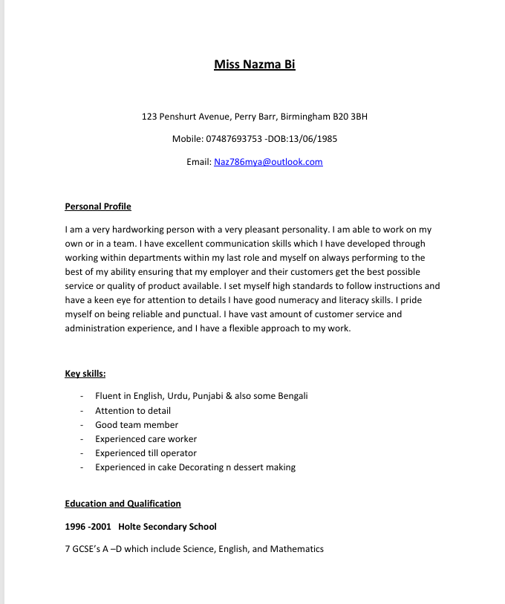
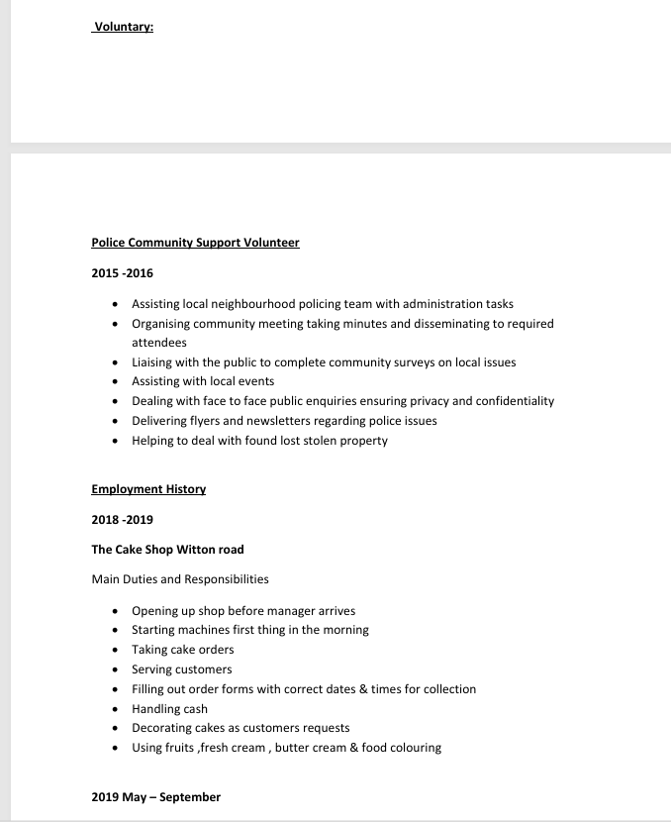
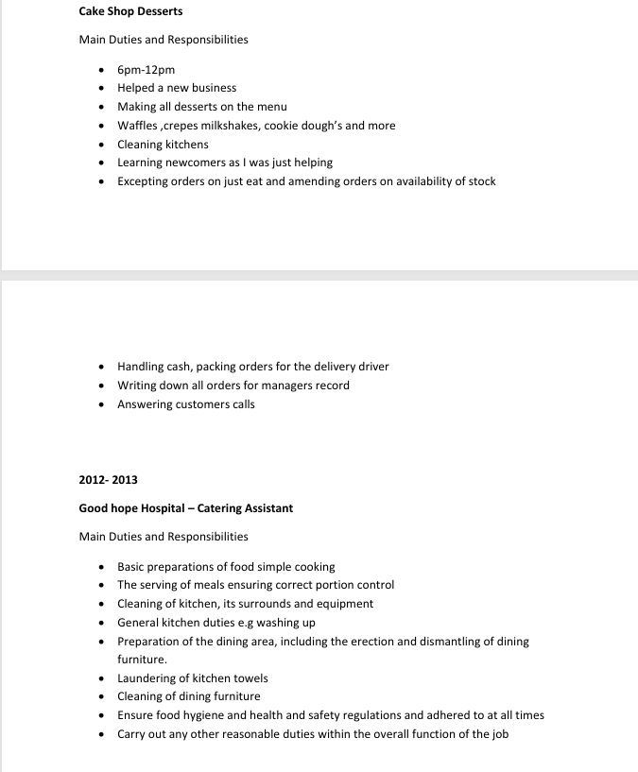
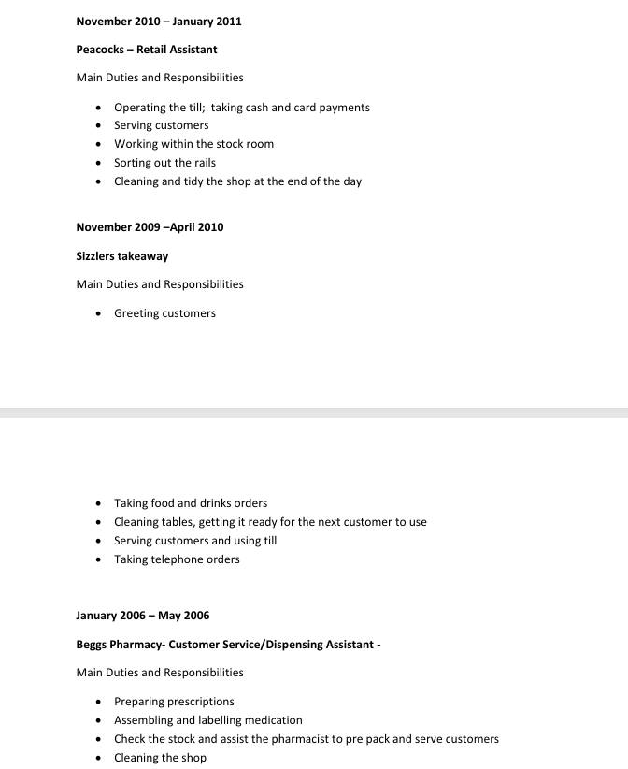

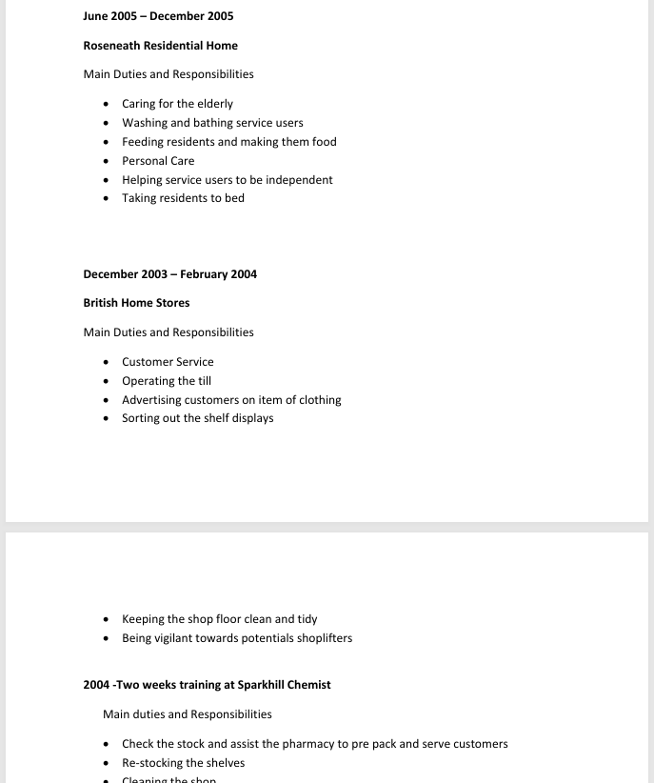
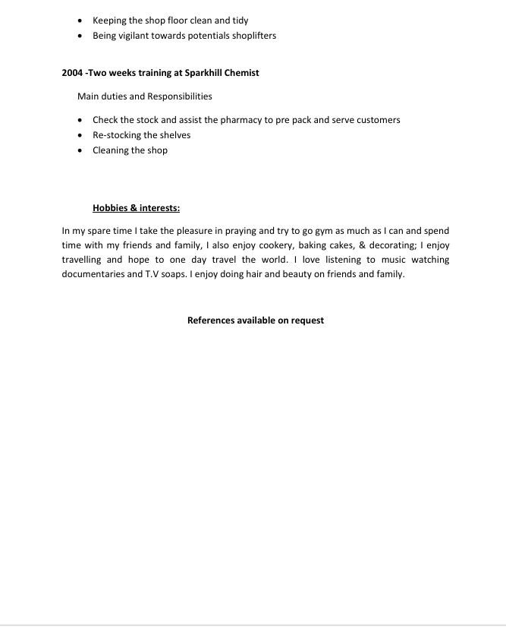

Reference List
Adams, K., Hean, S., Sturgis, P. and Clark, J. (2006) ‘Investigating the factors influencing professional identity of first-year health and social care students’, Learning in Health and Social Care, 5(2), pp. 55–68.
Care Act 2014. (2014) London: The Stationery Office.
Care Quality Commission (2024) Guidance for providers on meeting the regulations. Available at: https://www.cqc.org.uk (Accessed: 22 July 2026).
Chartered Institute of Personnel and Development (CIPD) (2024) Employability factsheet. Available at: https://www.cipd.org (Accessed: 22 July 2026).
Cottrell, S. (2021) Skills for Success: Personal Development and Employability. 5th edn. London: Red Globe Press.
Data Protection Act 2018. (2018) London: The Stationery Office.
Department of Health and Social Care (2021) The NHS Constitution for England. London: Department of Health and Social Care.
Mental Capacity Act 2005. (2005) London: The Stationery Office.
Montoya, P. and Vandehey, T. (2008) The Brand Called You: Make Your Business Stand Out in a Crowded Marketplace. New York: McGraw-Hill.
NHS England (2024) Working in mental health. Available at: https://www.england.nhs.uk (Accessed: 22 July 2026).
NHS Jobs (2026) Mental Health Support Worker – Cygnet Health Care, Cygnet Hospital Oldbury. Available at: https://www.jobs.nhs.uk/candidate/jobadvert/E0233-26-1386 (Accessed: 22 July 2026).
Peters, T. (1997) ‘The Brand Called You’, Fast Company, 10, pp. 83–90.
Schön, D.A. (1983) The Reflective Practitioner: How Professionals Think in Action. New York: Basic Books.
Skills for Care (2024) Core Skills for Health and Social Care. Available at: https://www.skillsforcare.org.uk (Accessed: 22 July 2026).

