Module Code: BMSW4002

Effective Team working for team success.

Student Name : Ana Maria Dogaru Teacher Name : Akash Puranik
Student Number: 2111954

Executive Summary
This study is looked at the importance of good collaboration, as well as how a lack of it may contribute to failure. Vodafone UK's Abdul is in charge of a brand-new initiative. The purpose of this research is to investigate a model to create a successful group, a well-balanced team that provides excellent results, discuss the importance of collaboration in achieving success and analyze the reasons behind Vodafone UK's new project inadequate collaboration. Due to poor performance and a lack of communication among team members, Abdul realized that his team was not functioning correctly. Team building can include using Tuckman's model of team development for Abdul's benefit. If Abdul's team can work together effectively, they will be more productive and focused. This decreases their tension and speeds up their work. To strengthen a team's capacity to communicate successfully, it is important to develop tight professional ties. Team members' inability to communicate effectively is the biggest issue

Table of Contents
Introduction 4
Aim of this study 4
A theoretical model for developing effective team 4
Tuckman’s Team Development Model 4
Types of roles needed to create an effective team 6
Balanced roles: The Belbin model 6
Impact of effective teamworking on team success 7
Barriers to effective teamworking identified in this scenario 8
Conclusion 11
References 12

Introduction
This study has been focused on effective teamwork and how the absence of it leads to failure along with how effective team working can generate success. Abdul is the manager for a new project of Vodafone's UK. But due to the covid-19 situation, they cannot meet yet which has increased the communication gap for the team (Newman and Ford, 2021). Along with that, the team members are not responsive to each other. The ultimate result is the failure of the planned goals and complaints from the customers.

Aim of this study
The aim of this study includes the followings
- Analyzing a model to develop an effective team
- Focusing on the type of roles needed to have a balanced team that effectively produces good outcomes
- Discussing the impact of effective teamwork
- Entailing the reasons behind the ineffective team working for the Vodafone UK's new project.

A theoretical model for developing effective team
Team effectiveness models provide managers with a framework for evaluating their groups. Leaders may use team effectiveness models to better understand how their teams are functioning and what can be done to make them better. The use of the team effectiveness model may assist Abdul since they give an objective way of analyzing the performance of his team. Below the way of building an effective team for Abdul is given below:

Tuckman’s Team Development Model
Abdul the manager of Vodafone UK noticed that his team is not functioning well as there are complaints regarding the performance of the team and team members are also not responsive to each other. So, to develop an effective team, he can apply Tuckman’s Team Development Model (Kur, 2016).
Forming: At the start point, team members of Abdul don’t know each other. As a result, miscommunication happened because the team is only beginning to form at this point, everyone on the team is still figuring things out; they don't know where they fit in, how the team will operate, or how the manager will manage them, or whether they'll succeed (Largent, 2016). This obscure situation lead to the ineffective team which has already been happened in the case Abdul team though already the team has passed some time. Abdul may face some difficulties in the next phase- the "storming stage"
Storming: This is a time when the team of Abdul is still getting to know one another, which is called storming. Power battles may arise as they get to know one other. Some team members may attempt to set the tone for the rest of the team regarding how to work or how the team should operate, which might lead to conflict (Kur, 2016). Members of Abdul’s team may potentially criticize or doubt his leadership authority at this point. But nothing to be tensed here. It's a natural phase in which Abdul can recover through the next stage-norming.

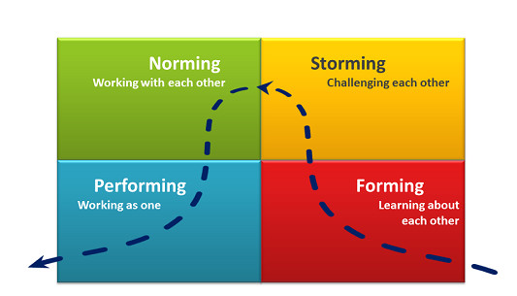
Figure 01: Tuckman’s Team Development Model (Largent, 2016)
Norming: At this stage, Abdul can settle the team into routine work during this phase. A deeper knowledge of the way the team functions is completed in this phase. When Abdul will input the deeper knowledge of work to the team members which need to be done routine wise, good results will come. Additionally, then team members will feel more confident in their ability to collaborate with other team members, receive criticism from others, navigate their tasks, and seek assistance or support. The problem that is a notice in Abdul's team of not being responsive to other team members will be resolved here.
Performing: This is when the real fun begins. At this point, everyone on Abdul’s team has earned the respect and trust of one another. Understanding the team's structure and processes, as well as their roles within the team, will happen here. As a result of Abdul’s leadership, the team is motivated and enthusiastic, which results in high levels of productivity.
Each level progresses as the team gets to know and trust each other better—and becomes stronger and more successful as a result. Building high-performing teams require time and effort, as the Tuckman Team Development Model illustrate (Largent, 2016)s.

Types of roles needed to create an effective team
To identify the types of roles to create an effective team, The Belbin model will be used here. Meredith Belbin, a professor at Henley Management College, is credited with developing one of the most well-recognized models (Broucek and Randell, 2016). Based on his original concept and extensive research, he identified nine roles that are critical to effective team functioning.
Balanced roles: The Belbin model
Plant: Here the role is to create innovative ideas. This role must think outside the box and come up with imaginative solutions to challenges. As this role possesses a wide range of creative, inventive, and problem-solving skills, it can make the team highly unique and productive.
Resource Investigator: Uses their natural curiosity to come up with new ideas for the team. These people are enthusiastic and outgoing. They explore opportunities and establish connections with others which are highly needed for Abdul’s team.

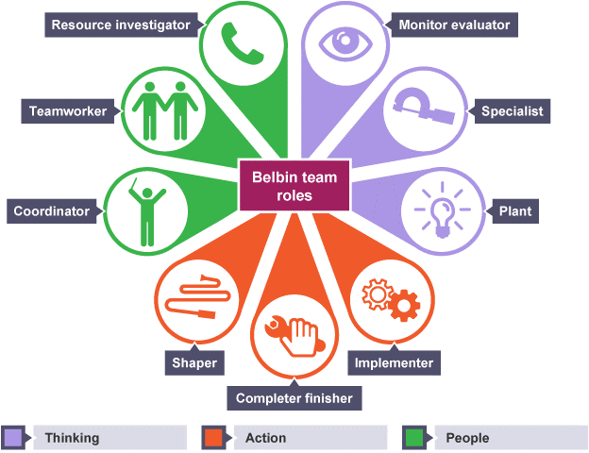
Figure 02: Belbin’s model (Batenburg and van Walbeek, 2013)

Co-ordinator: This group needed a clear focus on its goals, a way to mobilize and distribute its members' responsibilities (Aritzeta et al., 2017). The problem is that they may be seen as manipulative and may try to shift the burden of responsibility onto others which will be challenging for Abdul to mitigate. So Abdul needs to oversee their activity closely.
Shaper: By giving the necessary motivation, he ensures that the team's attention and momentum are not compromised. He is dynamic, demanding, and thrives in a high-pressure workplace. He or she has the ambition and the courage to take on difficult situations.
Teamwork: This role contributes to the cohesiveness of the group by identifying and completing tasks on behalf of the group using their wide range of skills and experience. Strong points include being cooperative, insightful, and diplomatic (Broucek and Randell, 2016).
Evaluator: This role observes the situation objectively, weighing the team's alternatives objectively, and providing a logical perspective. Sober, strategic, and thoughtful are some of my greatest assets. Considers all possibilities and makes well-informed decisions.
Implementer: It was imperative that a practical strategy is devised and that it be implemented as quickly as possible. Among its virtues are its reliability and efficiency. This role organizes and executes plans of action, transforming ideas into actionable plans which will mitigate the deviation of Abdul’s planned goal (Aritzeta et al., 2017).
Completer: After a project, it's best to utilize this tool to ensure that the work is error-free and polished to the greatest levels of quality. This role assures Abdul about his competition of target. This role needs to be energetic.
Specialist: This role can Bring a wealth of expertise to the team Abdul in a certain area. They are Focused, self-starting, and devoted to the task at hand As a result, clients of the Abdul team benefit from their in-depth expertise.

Impact of effective teamworking on team success
It's impossible to establish something as strong as a team without the contributions of all of the members, each of whom brings their unique abilities, skills, and ideas (Doyle, 2008). Effective team working will bring success for Abdul’s team in the following manner:
- Increasing productivity: It is easy when everyone in Abdul’s team is doing their fair part of the work and responsibilities are distributed for Vodafone UK’s new project based on the talents and expertise of the members of the team.
- Innovation and satisfaction: The ability to collaborate with others in a group fosters the development of new, creative approaches to solving challenges for Vodafone UK’s new project by exchanging and building on each other's ideas. Team members of Abdul tend to be more self-assured and generate more original ideas while brainstorming as part of a group. This results in a sense of belonging, which contributes to work satisfaction (Stewart, 2019).
- Focusing on the objective through effective communication: Team members will aid and depend on one other for support and direction through the difficult times that confront every firm. Currently, the team members of Abdul are now doing well communication with each other which hampers the activity. Effective team working will Abdul's team to concentrate on the objective minimize stress, and allow them to accomplish jobs more quickly. The ability to communicate within a team openly and efficiently is greatly enhanced by the development of close working connections. Members will support and inspire one another to use and develop their qualities and abilities (Fraser and Hvolby, 2010).
- Weaknesses minimized through collaboration: For the new project for Vodafone UK, collaborative teams can cover for each other's weaknesses and talents, allowing them to be more flexible in their work. Work-life harmony is facilitated by allowing employees to be more adaptable in their schedules and schedule their work around their personal lives even in the covid-19 situation. Skills and knowledge are improved as a result of the exchange of information among members of the team throughout their job (Fraser and Hvolby, 2010). All members of the team will be encouraged to strengthen and deploy their leadership characteristics from time to time.
- Enhancing Customer Service: Teamwork has several advantages outside of the workplace, including an improvement in the quality of customer service which is currently absent in Vodafone UK's new project (Stewart, 2019)

Barriers to effective teamworking identified in this scenario
Some challenges make it difficult for teams of Abdul to work together and accomplish their goals. To work together effectively, it is common for members of a team to have good working relationships, agree on objectives, assume personal responsibility for their job, and come up with creative solutions to problems that arise.
Communication gap: Here the main barrier is the communication gap in Vodafone UK’s new project due to the covid-19 situation. Team members cannot meet which do not allow them to arise empathy for other team members. That’s why one doesn’t help another and as Abdul cannot direct them physically, they have a low consistency to work routinely. Teams now operate remotely as a result of technological advancements and mainly due to Covid-19 (Newman and Ford, 2021). Because professionals aren't near one another, working as a team might be more difficult when this kind of physical barrier exists (Wilson and Pirrie, 2010). Digital technologies that make it easier to collaborate remotely and frequent face-to-face meetings may help teams overcome the barrier of physical distance. Creating a common objective for the team to strive toward is frequently the first step in a successful partnership. If teams don't properly comprehend or agree on the goals of their job, they may face difficulties. Setting objectives, assessing them, and detailing the process to accomplish them may alleviate goal confusion by establishing a uniform methodology (Doyle, 2008).A lack of communication leaves team members of Abdul unsure about their roles and duties. To close these communication gaps and improve teamwork, groups should work consciously to improve their communication abilities (Wilson and Pirrie, 2010).
Lack of leadership ability: Abdul doesn't check the work routinely which is a sign of inefficient leadership. He started to oversee the work when there is complaints but it should be his duty to oversee the work at his routine so that everything is going according to plan. For groups to successfully work together, they need leaders who can guide them, share their expertise, and consistently promote cooperation. Since the poor leadership of Abdul lead to team members feeling detached and uninspired, this can have a significant influence on their capacity to collaborate. Leadership may take control of these circumstances by providing more teaming chances, helping team members improve their abilities, and developing methods to promote effective collaboration (Batenburg and van Walbeek, 2013).
Several members on the team: In Abdul's group there are 18 members which are difficult to manage in the absence of physical communication. Collaboration is generally more effective when small teams—between three and six professionals—are involved. The reason for this is that smaller groups are more likely to communicate with one another, form good connections, and distribute their workloads equitably (Broucek and Randell, 2016). Members of a big team like the Vodafone UK project may have difficulty distributing responsibilities and figuring out what their function should be.
Issues of accountability: Here in the Vodafone project, employees are not put into an accountable situation yet which is an indicator of weak monitoring and inefficient team management work which leads to deviation of the planned objective. Team members' viewpoints may be more recognized, and they may be more understanding of one another's problems to achieve standards if there is more responsibility (Wilson and Pirrie, 2010). As a result, Abdul should devise procedures for monitoring workflow and holding all team members responsible for their responsibilities to get through this roadblock.

Conclusion
Abdul noticed that his team was not working properly since there were complaints about the team's performance and team members were not responsive to each other. Abdul might use Tuckman's Team Development Model to build a strong team. Their determination and willpower are also essential attributes for dealing with difficult situations. Working together, the Abdul team at Vodafone UK has greater feelings of accomplishment and fulfillment. Abdul's team will be more productive and more focused if they can work together well. This reduces stress and allows them to complete tasks faster. Establishing close professional relationships improves a team's ability to communicate effectively.

References
Aritzeta, A., Swailes, S. and Senior, B., 2017. Belbin's team role model: Development, validity and applications for team building. Journal of Management Studies, 44(1), pp.96-118.
Batenburg, R. and van Walbeek, W., 2013. Belbin role diversity and team performance: is there a relationship?. Journal of Management Development.
Broucek, W.G. and Randell, G., 2016. An assessment of the construct validity of the Belbin Self‐Perception Inventory and Observer's Assessment from the perspective of the five‐factor model. Journal of Occupational and Organizational Psychology, 69(4), pp.389-405.
Doyle, J., 2008. Barriers and facilitators of multidisciplinary team working: a review. Nursing Children and Young People, 20(2).
Fisher, S.G., Hunter, T.A. and Macrosson, W.D.K., 2010. The distribution of Belbin team roles among UK managers. Personnel Review.
Fraser, K. and Hvolby, H.H., 2010. Effective teamworking: can functional flexibility act as an enhancing factor? An Australian case study. Team Performance Management: An International Journal.
Kur, E., 2016. The faces model of high performing team development. Leadership & organization development journal.
Largent, D.L., 2016. Measuring and understanding team development by capturing self-assessed enthusiasm and skill levels. ACM Transactions on Computing Education (TOCE), 16(2), pp.1-27.
Newman, S.A. and Ford, R.C., 2021. Five steps to leading your team in the virtual COVID-19 workplace. Organizational Dynamics, 50(1), p.100802
Stewart, G.L., 2019. Teamwork and group dynamics (No. 658.4036 S8).
Wilson, V. and Pirrie, A., 2010. Multidisciplinary Teamworking: Beyond the Barriers? A Review of the Issues. Research Report Series. The Scottish Council for Research in Education, 15 St. John Street, Edinburgh EH8 8JR (6 British pounds). For full text: http://www. score. ac. UK/resreport/rr96.

