Charitable setting
  - Neath
Date: 02/12/2019

Introduction
This charitable setting is based in Neath, that works with children to Action for children (2020) ‘protect and support children and young people providing practical and emotional care and support’. This portfolio of evidence will be looking at my placement over ten days. Whilst looking at this setting, it will be providing evidence in what activities I have completed over these days. There will be information relating to activities, meetings, training and outings with the children. Each day will have a different group therefore the activities that are repeated are with different groups.



Day 1
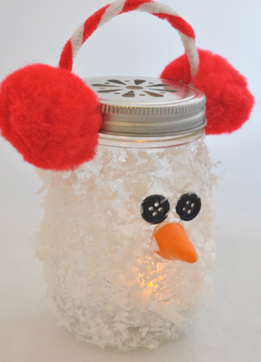
Date: 11/12/2019. Crafts
On this day we were making tea light candles, as snowmen as it is Christmas time. We got the glue, eyes, glitter, Pom poms, pipe cleaners and scissors to make the candles. The children were making the candles to go home with. We used this activity as a sensory activity as the children were able to explore different materials and especially the glitter snow which the children annoyed putting their jars in to decorate them.
This activity was successful and the children were pleased on what they had done, their parents and carers were proud of what they had made to go home with, for next time to improve this activity I would use different glue due to pva not being suitable to stick Pom poms on glass.

Day 2
Date: 12/12/2019 winter wonderland
On this day we went to winter wonderland, it was very cold but the children enjoyed going on the different rides to experience different types of motion. The children enjoyed going this group is smaller than the rest due to the needs of the children. Whilst looking at this activity it was beneficial for the children as they went on the train, the snow slide and other rides, and this is important for the children as they are engaging with each other and building friendships. This activity was very successful and the children were very pleased to have gone to winter wonderland. On the other hand one of the children are afraid of heights and this become an issue when going on rides with the other children.
There was one ride that was very loud and if found that the children were less likely to go on the ride due to being sensitive to noise and this did cause some difficulty with the children. After going to winter wonderland we went for food to the café in Sainsbury’s, the children are not very keen on going to sociable places and become very anxious due to the nature of the environment the children did eat their food in the café and we did leave and go home after.

Day 3
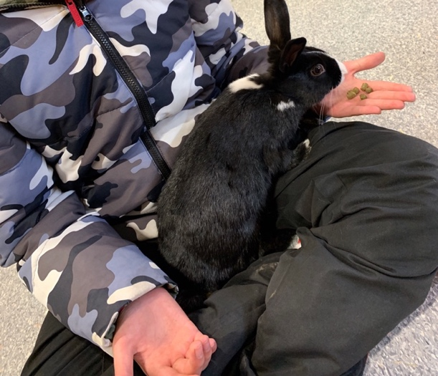
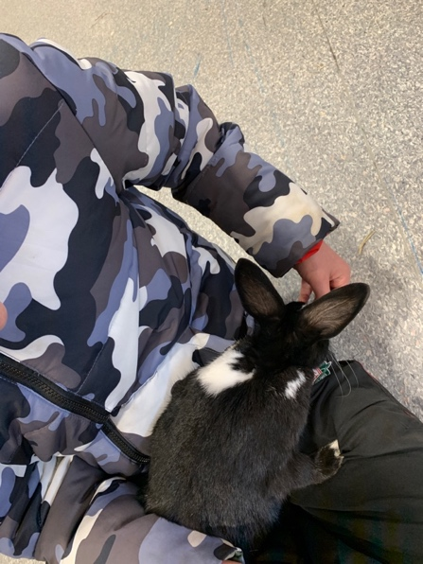
Date: 13/12/2019 arcades
On this day, it is my 1-1 child and we went to the arcades, the child suffers from ADHD, with support and constant reassurance from myself the child felt comfortable going to the arcades and playing the 2p machines. This was allowing the child to use many different skills such as concentration, fine motor skills, listening skills whilst playing different games it was clear to see the child was enjoying playing different games.
After the arcades we went for food to McDonalds, the child was able to choose what they wanted for food and therefore allowing the child choice. Due to the child’s circumstances providing choice was an important part, due to no choice given at home. By providing choice the child felt as if they were able to choose what they wanted and not what they had to have. After going to McDonald’s we went to pets at home and the child was able to hold the animals and feed them, therefore the child learnt about the care and feeding requirements of the different animals. This made the child feel valued due to the staff allowing the child to feed the animals and to provide care for those animals.

Day 4
Date: 14/12/2019 Christmas cooking
On this day we done Christmas cooking and we were making fruit kebabs that looked like the grinch or reindeers. The children wanted to do both therefore we allowed the children to explore the different types of fruit that was available such as strawberries, grapes, oranges, apples, bananas, kiwi, plum and others, and therefore the children were able to taste different fruit and to see if they liked them. This activity was carefully planned due to the allergies of the children and some children are not allowed certain fruit. This activity was very hands on for the children and they felt as if it was their own work, and used their own imagination to make their own grinch or reindeer.
Overall, I felt this activity was successful and the children asked to do this activity again to try different types fo fruit, this showed that the children did enjoy and enjoyed tasting the different fruit that is available.



Day 5
Date: 16/12/2019 bowling
On this day, it is my 1-1 child and we went bowling, the child was able to communicate with me and the child was able to have fun. The child was nervous at the start but the child did come round when we started to play. With this child being in busy environments can be challenging but the child managed it well, and when asked after the activity would they like to go back again the child replied yes as they really enjoyed.
This was allowing the child to overcome their barriers of being anxious in busy environment whilst having fun with the support off myself. Providing the child with the support was improving the child’s mental health and wellbeing, as the child does not get this support at home, and therefore the child was able to overcome the barrier of being in a busy environment where there are a lot of children and people around. I found after this activity the child felt more comfortable in the community, and had slightly overcome their anxiety of being in big crowds or areas. The child wanted to go back to bowling when I was with them next.

Day 6
Date: 17/12/2019 limitless
On this day, it is my 1-1 child and we went to limitless, this was a fun activity for the child to burn some energy. The child enjoyed jumping around on inflatables and trampolines, and got the chance to meet other children of their age. This is good for this child as it helps the child overcome their anxiety, and therefore they felt comfortable playing with others in limitless.
With doing activities in the community it can be difficult to judge wether the activity is suitable for the child, and wether or not there will be children there who may impact on their development, whilst trampolining the child felt uncomfortable as there was children staring at them, and this may have had an impact on their mental health, and also the child felt a little anxious, to overcome this barrier I went trampolining with them to reassure them that everything was ok. The child then felt comfortable that they had reassurance from my self and was able to play freely.

Day 7
Date: 18/12/2019 winter wonderland
On this day, we went to Winter Wonderland with another group this group has different needs therefore it can be difficult when some children want to go on the rides and others do not. Whilst doing this activity it can be expensive as the rides do cost a lot and when there is a few children going on it adds up. Within the company there is a set budget for the children to use, on the other hand when doing activities that are expensive than others it can become an issue and may go over the budget. Whilst doing this activity there was an activity where wheelchair users were not able to access the ride, this can be very challenging for children to process due to the other children being able to go on and not the child in the wheelchair. There is only 2 rides in Winter Wonderland that is appropriate for wheelchair users. This may have an impact on the child’s mental health as they may feel excluded from activities.
I feel to improve this activity careful preparation needs to be conserved for this child, to ensure that the child will be able to access all rides with no issue. The child did feel a bit upset after being told that they were not able to go on and others were, but instead we took them on a different ride.

Day 8
Date: 19/12/2019 christmas crafts
On this day, we done Christmas crafts, and we painted reindeer hands and made Christmas cards. This group is the smallest group therefore a lot of attention is required for the children. The children enjoyed making their own Christmas cards and using paint on their hands.
On the other hand, some of the children did not like putting the paint on their hands as it was very sensory for them. It can be difficult for children to process having paint on their hands as some children do not like having things on their hands or the sense of being dirty. With this activity to meet the needs of the children it was important to look at what was beneficial for them, allowing the child to explore paint in a tough tray so that they had the opportunity to use their senses and to discover the paint. This was the most beneficial way for the children to use paint as they had the experience to use the paint to do Christmas reindeers and Christmas cards. I feel this activity was beneficial for the children as they were able to explore their senses in different ways therefore they may have ha an opportunity to overcome their fears.

Day 9
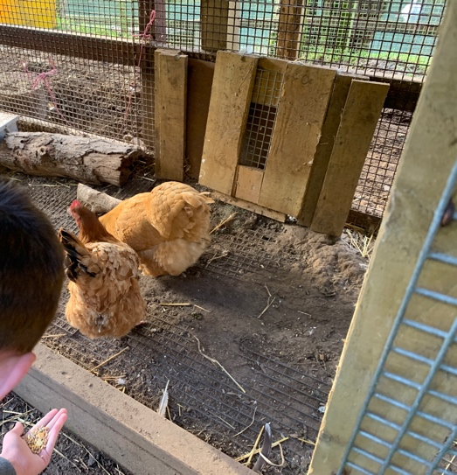
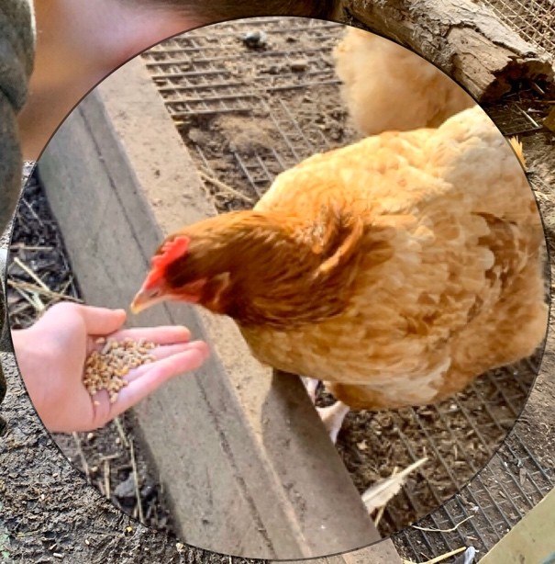
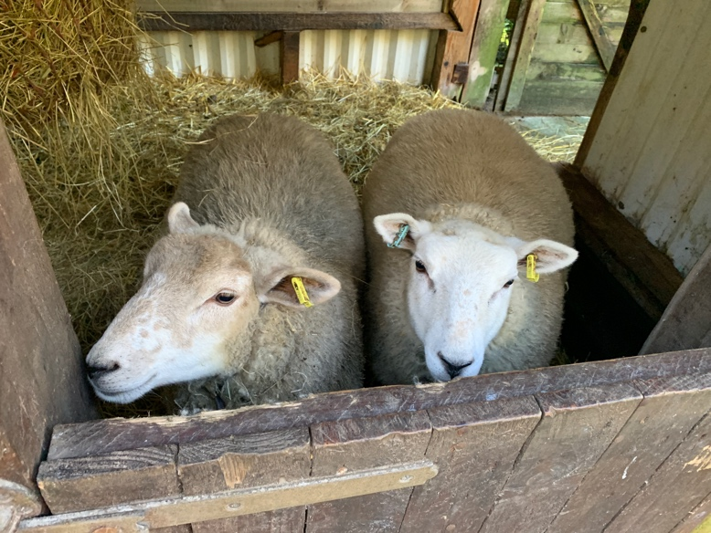
Date: 20/12/2019 santa gower heritage
On this day, this child is my 1-1 and we went to see Santa in the Gower heritage Centre, the child really enjoyed seeing Santa followed by seeing the animals. This was one of my favourite experiences with this child, as it was nice to see how caring and gentle the child was with the animals. The child enjoyed stroking the animals and feeding the chickens and ducks. This provided the child with a unique experience that does not happen very often. This activity was not expensive and therefore the budget was not an issue for this day. After seeing Santa and feeding the animals we went for food, the child enjoys going for food where they want to go as this provides the child with an option of choice.
I found that since going to the centre the child wants to go see more animals in different places and picks up on their health requirements and their needs very easily. This child focuses well on their health and provides good care to them.

Day 10
Date: 21/12/2019 cinema
On this day, we went to the cinema and we watched Frozen 2, the children sat quietly in the cinema with pop corn and sweets. It was a nice trip for the children just before Christmas as they were exited, it was nice for them to go somewhere of their choice and watch the film of their choice. The children are involved with the planning and choice fo activities to ensure that we do activities that the children want to do. We focus on the children’s needs when planning activities, some children are only able to access the disabled toilet so it is important when planning that there is a disabled toilet near so that the children are able to access.
Whilst choosing the appropriate film for the children it is important to take into consideration the children’s circumstances at home, as there may be a film where it may trigger an emotional part in the children therefore can cause upset ness or for the child to feel frustrated. It is important when we gave the children sweets and pop corn that they did not have any allergies or any additives that may trigger their behaviour.

