Digital Surveying and Highway Design
Digital Building Survey: A Practical Application of 3D Laser Scanning, Point Cloud Analysis and Traditional Measurement Methods
Emily Aston

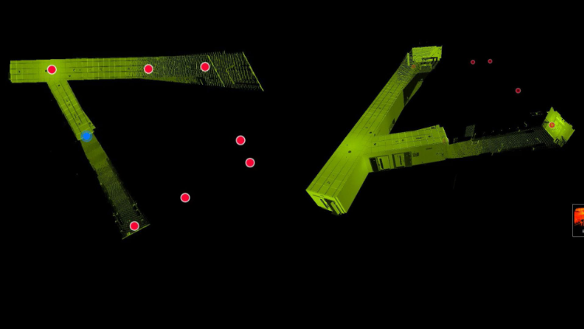

Contents

Introduction 3
Part 1: Planning the Survey 3
Part 2: Practical Survey 6
Part 3: Measurement and Analysis 8
Appendices 10

Introduction
This report presents a digital building survey of a communal area within the IQ Building at the university. The project aims to develop practical experience in planning and undertaking a measured building survey while exploring the application of both traditional and modern digital surveying techniques. The survey will initially be planned using conventional measurement methods, including a measuring tape and Electronic Distance Measurement (EDM) equipment, before proposing the use of a terrestrial laser scanner to capture the surveyed environment as three-dimensional point cloud data. The report is structured into three parts, beginning with the survey planning process, followed by the practical execution of the survey and concluding with an analysis of the measurements obtained and a comparison between traditional and digital surveying methods.

Part 1: Planning the Survey
1.1 Purpose of the survey:
The purpose of this survey is to obtain an accurate record of the dimensions and spatial layout of a communal area within the IQ Building. The information collected will be used to produce measured drawings that accurately represent the existing building layout and could support future alterations, improvements or extensions if required.
A further objective of the survey is to compare traditional surveying techniques with modern digital surveying technology. The survey will initially be completed using a measuring tape and Electronic Distance Measurement (EDM) equipment before being repeated using a terrestrial laser scanner. This approach will allow the effectiveness of each method to be evaluated in terms of efficiency, accuracy and the level of detail captured.
1.2 Survey Area Definition:
The proposed survey area comprises a communal space within the IQ Building together with the adjoining corridors. This location has been selected because it contains a range of permanent architectural features that provide an appropriate environment for undertaking both traditional and digital building surveying techniques.
The survey will include the internal walls, door openings, windows, a structural column and connecting corridors to ensure that the overall geometry and layout of the space are accurately recorded. Prior to commencing the survey, the survey boundary will be established to ensure that all relevant building features are captured while avoiding the collection of unnecessary information from surrounding areas.
The level of detail required will be sufficient to produce accurate measured drawings and to enable a comparison between traditional measurement techniques and terrestrial laser scanning. Particular attention will be given to recording the overall room dimensions together with the size and position of significant architectural features. Temporary objects and building users will not form part of the survey unless they restrict access or influence the proposed survey methodology.
The proposed survey extent is illustrated in Appendix A, while the processed laser scan outputs obtained following completion of the survey are presented in Appendix B.
1.3 Survey Equipment and Methods
The survey will initially be undertaken using traditional measurement techniques consisting of a measuring tape and an Electronic Distance Measurement (EDM) device. The measuring tape will be used to obtain short-distance measurements and verify dimensions between fixed building features, while the EDM will provide accurate measurements over longer distances by using laser technology to determine the distance between the instrument and a target.
The combination of these instruments will enable the principal dimensions of the communal area, together with architectural features such as doors, windows, corridors and the structural column, to be measured and recorded manually. These measurements will subsequently be used to produce accurate measured drawings of the survey area.
Following completion of the traditional survey, the communal area will be surveyed using a terrestrial laser scanner (RTC360). This ground-based LiDAR device emits rapid laser pulses that measure the distance to surrounding objects, producing a highly accurate three-dimensional point cloud representing the surveyed environment.
To achieve complete coverage, multiple scan positions will be planned throughout the communal area and adjoining corridors. At each location, software installed on an iPad will be used to register and stitch the scans together, ensuring sufficient overlap between adjacent scans and allowing any missing areas to be identified before the survey is completed.
Once processed, the point cloud will provide a comprehensive digital representation of the surveyed area from which accurate dimensions can be extracted. This method is expected to provide a more complete record of the building than traditional measurement techniques while reducing the likelihood of omitted information.

1.4 Site Assessment and Survey Planning
Prior to commencing the survey, a scan strategy will be developed to ensure complete coverage of the communal area while maintaining the accuracy and efficiency of the data collection process. The survey will be planned to capture all permanent architectural features, including internal walls, doors, windows, the structural column and adjoining corridors, with sufficient overlap between scan positions to enable successful registration of the point cloud.
The terrestrial laser scanner will be positioned at multiple locations throughout the survey area to minimise areas hidden from the scanner's line of sight. Scan positions will be selected to provide clear visibility of the surrounding environment while avoiding obstructions such as furniture or other fixed objects where possible. Particular consideration will be given to areas surrounding the structural column and corridor junctions, as these locations may create shadowed areas if insufficient scan positions are used. The communal area benefitted from consistent internal lighting conditions, which were considered suitable for undertaking the proposed survey.
To ensure continuity between individual scans, each scan location will be planned to overlap with the previous position. This overlap will enable the iPad registration software to accurately stitch the scans together during data capture, reducing the likelihood of registration errors and improving the overall quality of the final point cloud. The registration process will also allow the survey team to identify any areas that have not been sufficiently captured before leaving the site.
Before each scan is undertaken, the scanner will be positioned on a stable surface and checked to ensure it is level and free from potential movement during operation. The survey will progress systematically through the communal area and adjoining corridors to ensure all planned scan positions are completed efficiently while minimising disruption to building users.
The completed scan locations and processed point cloud presented later in Appendix B.
1.5 Risk Assessment
Prior to undertaking the survey, a risk assessment will be completed to identify any hazards that could affect the safety of the survey team, building occupants or the survey equipment. As the survey will be carried out within an occupied university building, particular consideration will be given to pedestrian movement, equipment placement and maintaining a safe working environment. Appropriate control measures will be implemented to minimise risks while ensuring the survey can be completed efficiently and without unnecessary disruption.

Hazard | Potential Risk | Control Measures
Trip hazards from equipment | Students or staff could trip over tripods, measuring tapes or equipment. | Position equipment away from main walkways where possible, maintain awareness of pedestrian movement, and remove equipment immediately after use.
Pedestrian traffic | Building users may interfere with the survey or accidentally move through scan areas. | Carry out the survey during the quieter periods where possible and communicate with building users when necessary.
Manual handling of equipment | Risk of strains or injury when transporting survey equipment. | Use correct lifting techniques and transport equipment safely between survey locations.
Obstructions | Furniture, doors or fixed objects may restrict access or create incomplete measurements or scan shadows. | Plan survey and scan positions in advance and reposition equipment where necessary to improve coverage.
Damage to survey equipment | Accidental knocks or collisions could damage expensive equipment. | Ensure equipment is supervised at all times and securely positioned on stable ground.
Slips and trips | Uneven surfaces, trailing equipment or clutter could cause injury. | Keep the work area tidy and avoid leaving equipment or cables in pedestrian routes.
Fire evacuation | Emergency procedures may interrupt the survey. | Familiarise the survey team with fire exits and follow university emergency procedures if required.

Part 2: Practical Survey
2.1 Survey Evidence:
The practical survey was undertaken within the communal area of the IQ Building in accordance with the survey plan developed in Part 1. Evidence of the survey environment and the selected scan positions is provided in Appendix C, demonstrating the areas from which the terrestrial laser scanner was intended to capture the building. The processed scan outputs are presented in Appendix D.
2.2 Survey Execution:
The practical survey was completed largely in accordance with the survey plan developed in Part 1. The survey commenced with the collection of manual measurements using a measuring tape and Electronic Distance Measurement (EDM) device to record the principal dimensions of the communal area and its key architectural features. Once the manual survey had been completed, the area was surveyed using a terrestrial laser scanner.
A total of seven scan positions were used to capture the communal area and adjoining corridors. The scan positions had been carefully planned before the survey and provided sufficient coverage of the space, meaning no additional scanner locations or significant repositioning of the equipment were required during data collection. The registration software on the iPad was used throughout the survey to stitch the individual scans together, allowing the survey team to confirm that adequate overlap had been achieved between each scan position.
The survey progressed smoothly for the majority of the exercise. During one scan, two students walked through the survey area; however, this caused only a minor interruption and did not significantly affect the overall survey. Once the area was clear, scanning continued as planned, and the remaining scan positions were completed without issue.
Overall, the survey was successfully completed in accordance with the proposed methodology, resulting in both manually recorded measurements and a registered three-dimensional point cloud that provided a comprehensive digital representation of the communal area for further analysis.
2.3 Problems encountered:
During the practical survey, very few problems were encountered due to the effective planning of the survey and the selection of appropriate scan positions. The proposed survey methodology allowed the communal area to be captured efficiently, and the seven planned scan positions provided sufficient coverage without the need for additional scans or major adjustments.
The only minor interruption occurred when two students passed through the survey area while one of the laser scans was being undertaken. As the communal area remained accessible to building users throughout the survey, this was an anticipated possibility. To prevent the moving individuals from affecting the scan data, the survey team briefly paused the scanning process until the area was clear before continuing. This resulted in only a minimal delay and had no significant impact on the overall survey programme or the quality of the completed point cloud.
No equipment faults or software issues were experienced during the survey. The registration software successfully stitched the seven scans together, confirming that sufficient overlap had been achieved between each scan position. The manual survey was also completed without difficulty, allowing the dimensions collected using the measuring tape and Electronic Distance Measurement (EDM) device to be compared with those extracted from the processed laser scan data.
Overall, the practical survey demonstrated that careful planning, appropriate equipment selection and consideration of the survey environment contributed to the successful completion of both the traditional and digital surveying methods.

Part 3: Measurement and Analysis
3.1 Measurements Extracted from the Point Cloud:
Following completion of the laser scanning survey, the registered point cloud was processed to produce an accurate three-dimensional representation of the communal area within the IQ Building. The processed scan enabled dimensions to be extracted directly from the digital model, including the overall room dimensions, corridor widths, door and window openings, and the dimensions of the structural column.
The measurements obtained from the point cloud were compared with those collected during the manual survey using the measuring tape and Electronic Distance Measurement (EDM) device. The comparison demonstrated that both methods produced consistent results; however, the digital survey provided the additional benefit of allowing further measurements to be extracted following completion of the survey without requiring a return visit to site.
The processed laser scan outputs and annotated measurements are presented in Appendix D, while the manually produced survey drawings are provided in Appendix A. These appendices demonstrate the measurements obtained and form the basis of the comparison discussed in the following section.

3.2 Comparison of Traditional and Digital Survey Methods

Criteria | Traditional Survey (Tape & EDM) | Terrestrial Laser Scanner
Time | Required individual measurements to be recorded manually, making the survey more time-consuming. | Captured large amounts of information quickly from each scan position, reducing the time required on site.
Accuracy | Dependent on careful measurement, recording and human accuracy. | Produced highly accurate point cloud data from which measurements could be extracted digitally.
Completeness | Only measurements intentionally recorded were available afterwards. | Captured the entire surveyed environment, allowing additional measurements to be obtained later without revisiting the site.

Overall, the terrestrial laser scanner provided a more comprehensive digital record of the surveyed area than the traditional survey. Although the manual survey produced accurate measurements of selected features, the point cloud allowed further dimensions to be extracted following the survey without the need for additional site visits. However, the traditional survey remained valuable for understanding measurement techniques and verifying dimensions collected using digital methods.
3.3 Evaluation
The comparison demonstrated that both surveying methods were capable of producing accurate building measurements; however, they differed significantly in the amount of information captured and the efficiency of the survey process. The manual survey required individual measurements to be taken and recorded, whereas the terrestrial laser scanner created a comprehensive three-dimensional point cloud of the communal area. This enabled measurements to be extracted during post-processing and reduced the likelihood of missing important features. The practical survey highlighted the advantages of integrating digital surveying technologies within modern building surveying practice while reinforcing the importance of understanding traditional measurement techniques.

Appendices
Appendix A - Measured Survey Drawing (Manual measurements)
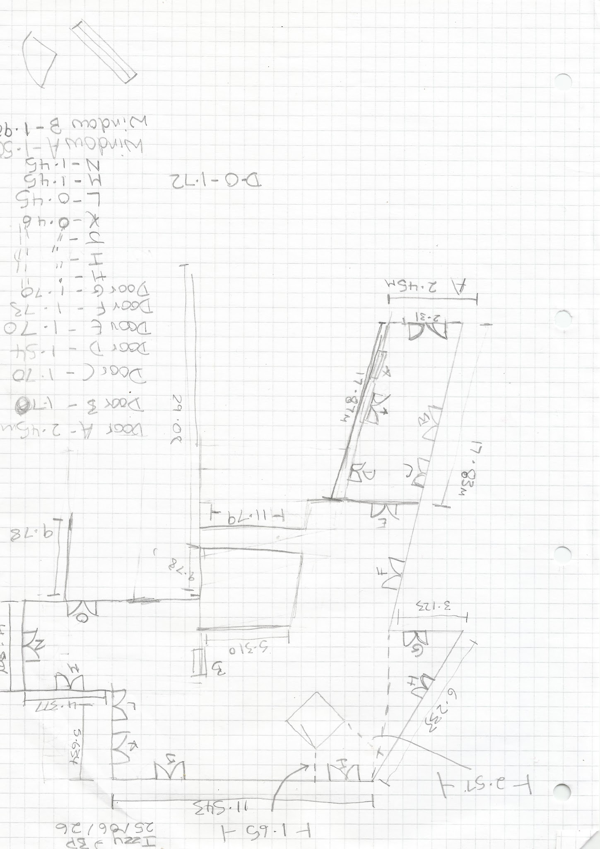
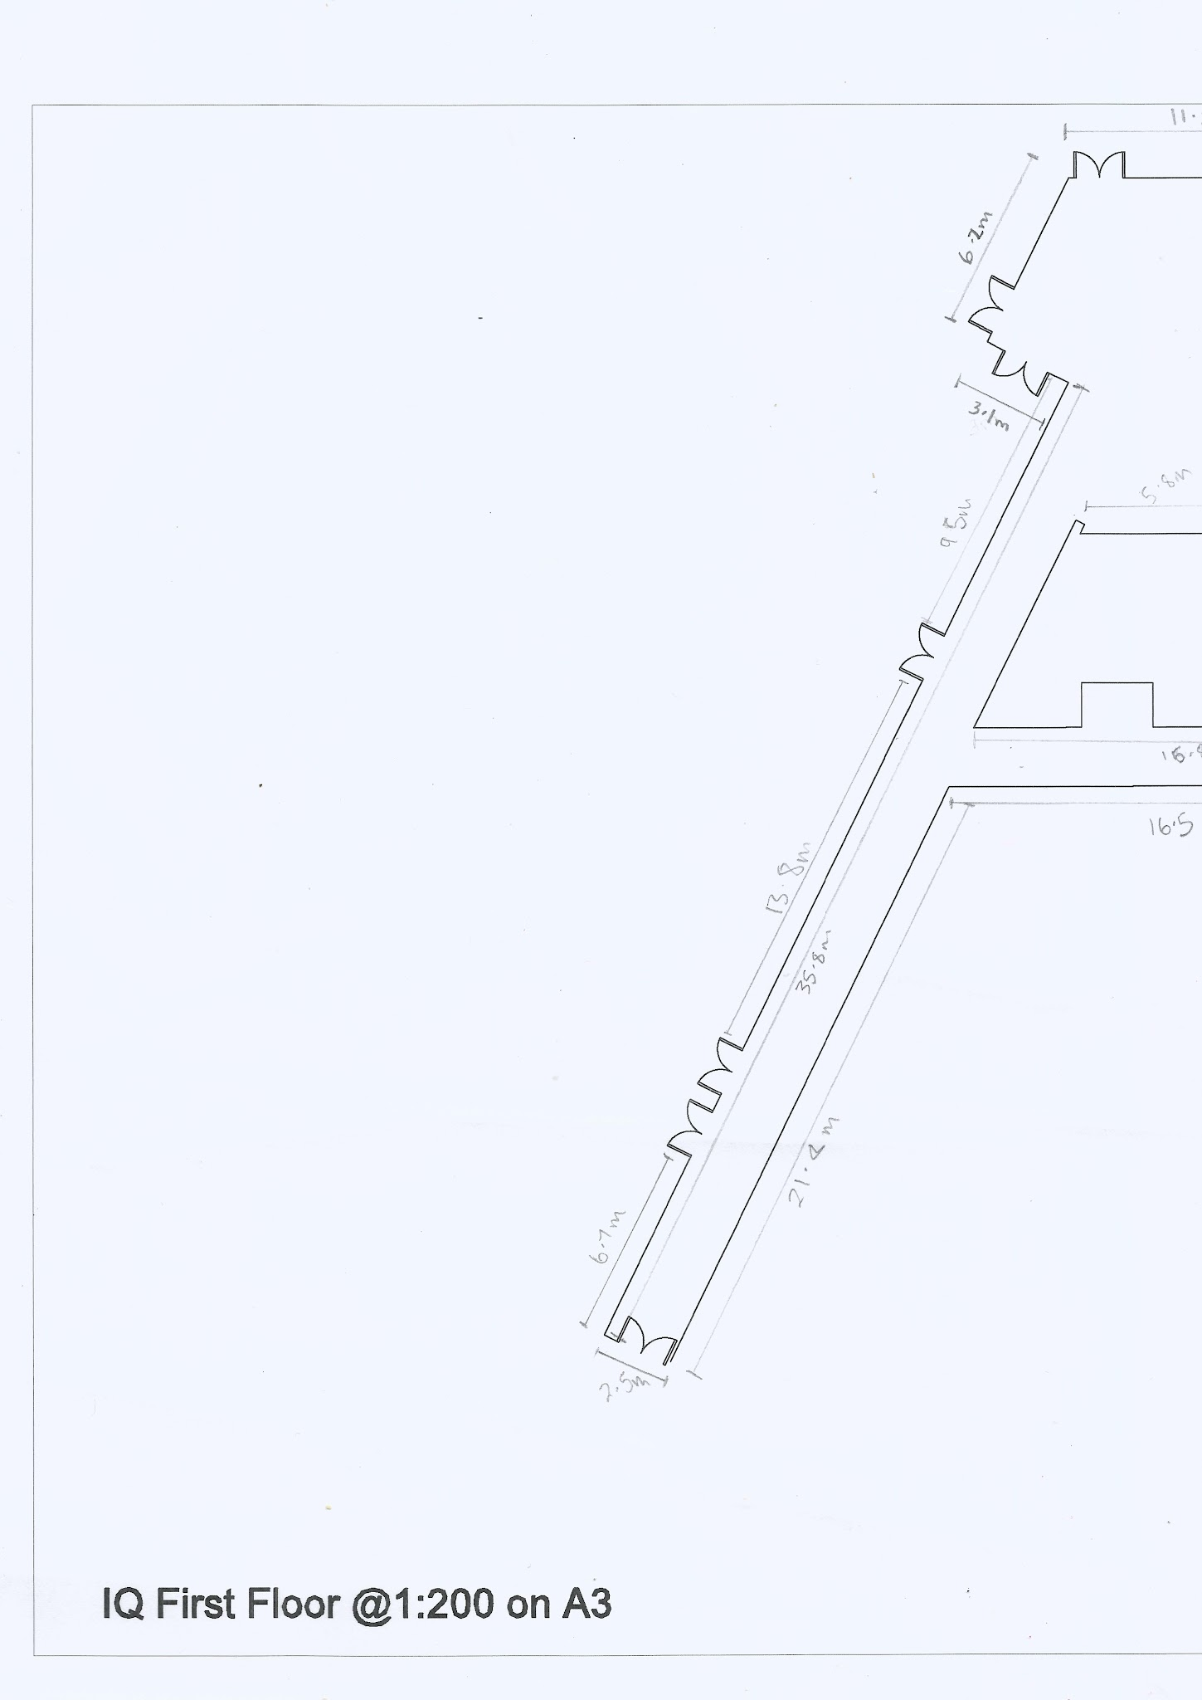
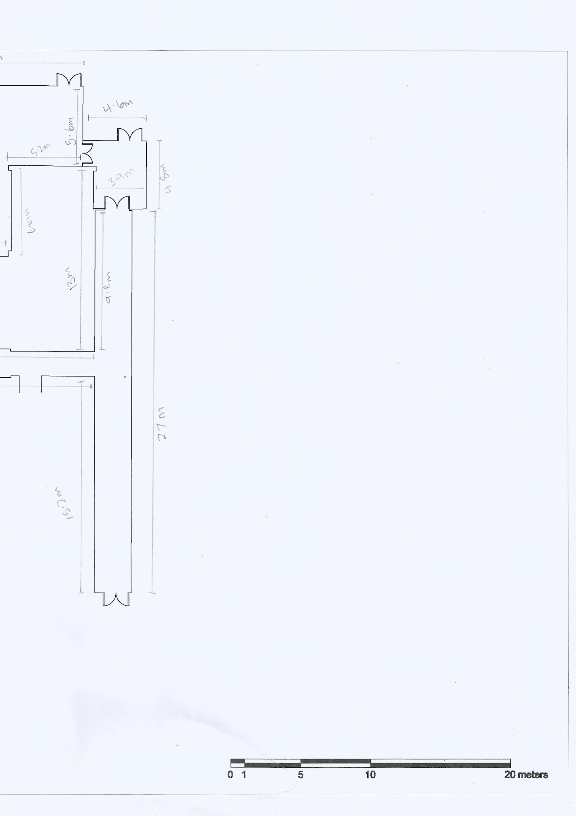
Appendix B - Proposed Survey Plan (Scan positions)

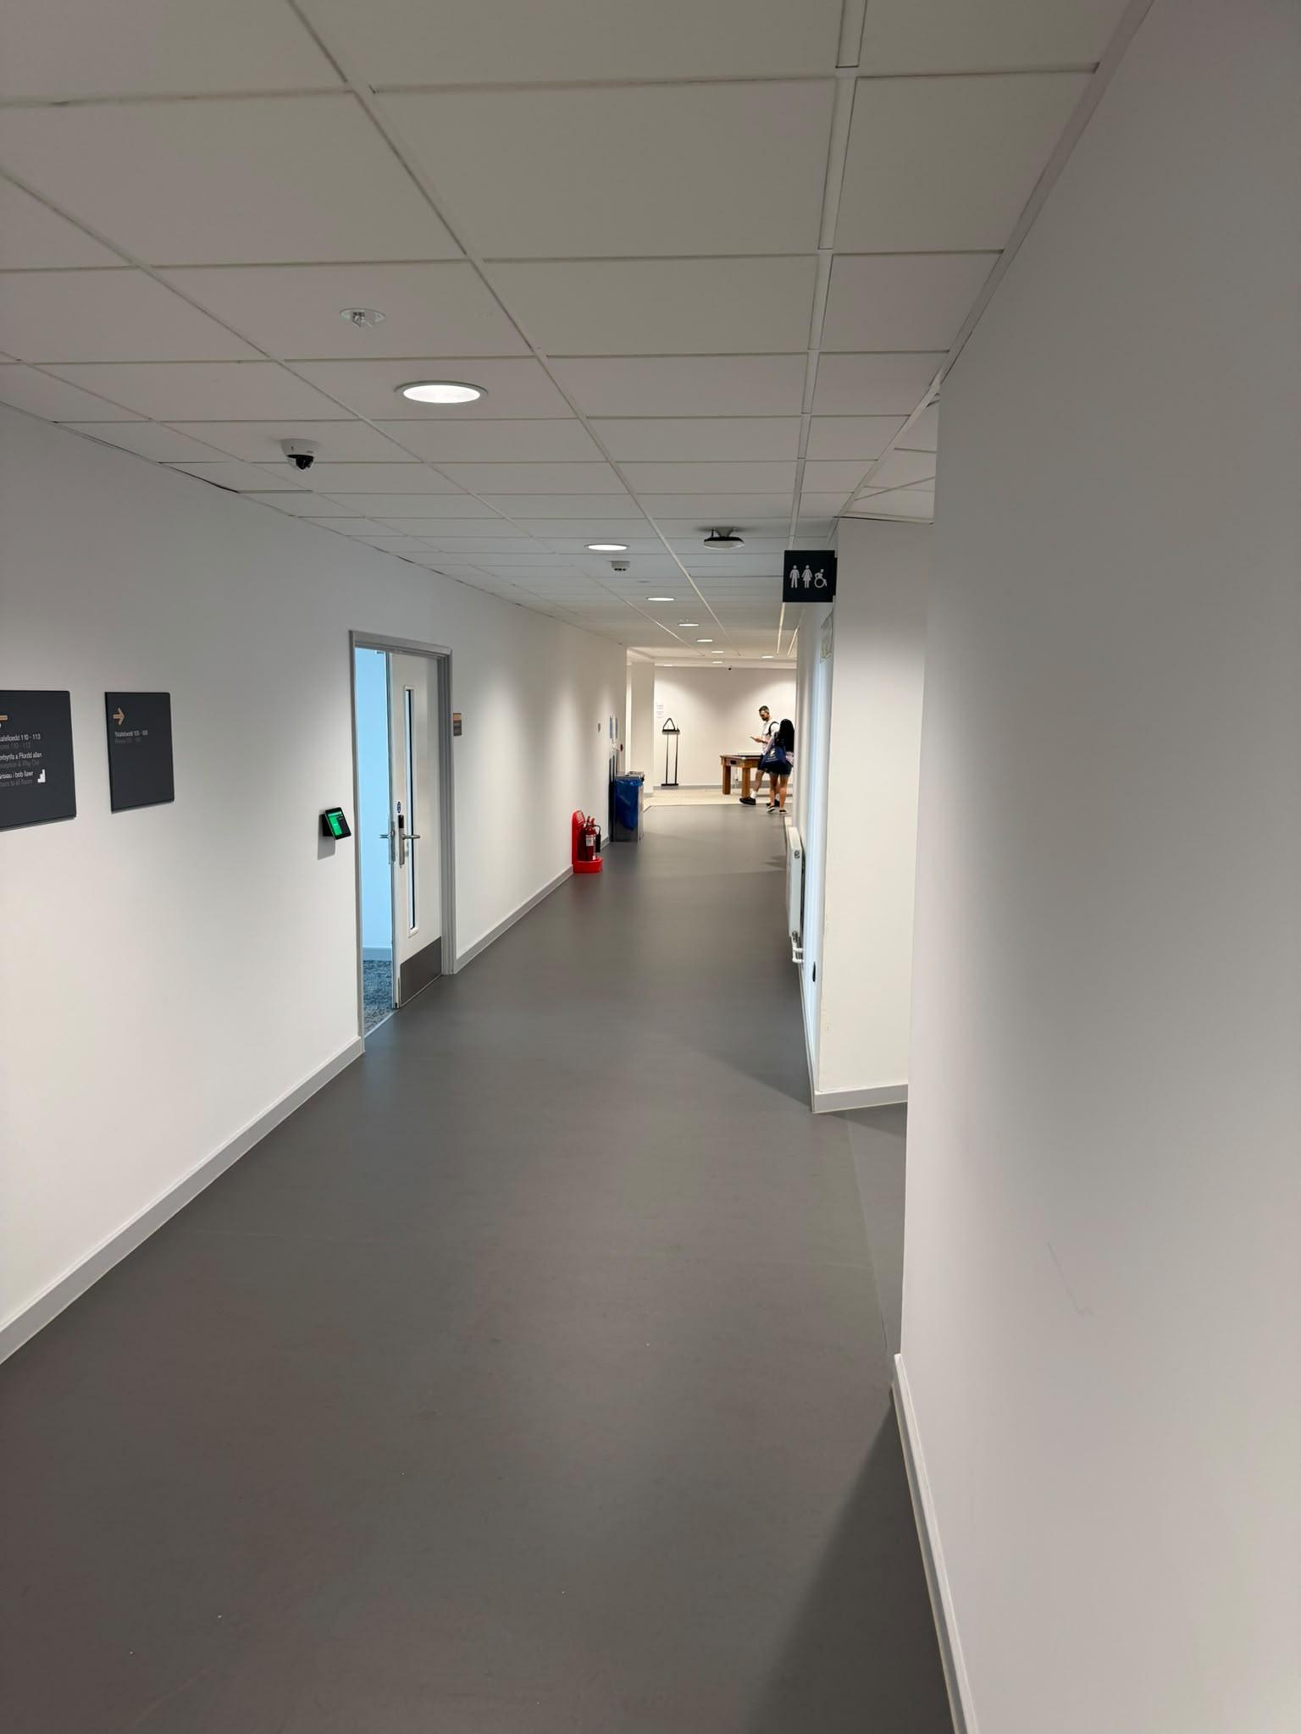
Appendix C - Survey Environment (Photographs of the area)
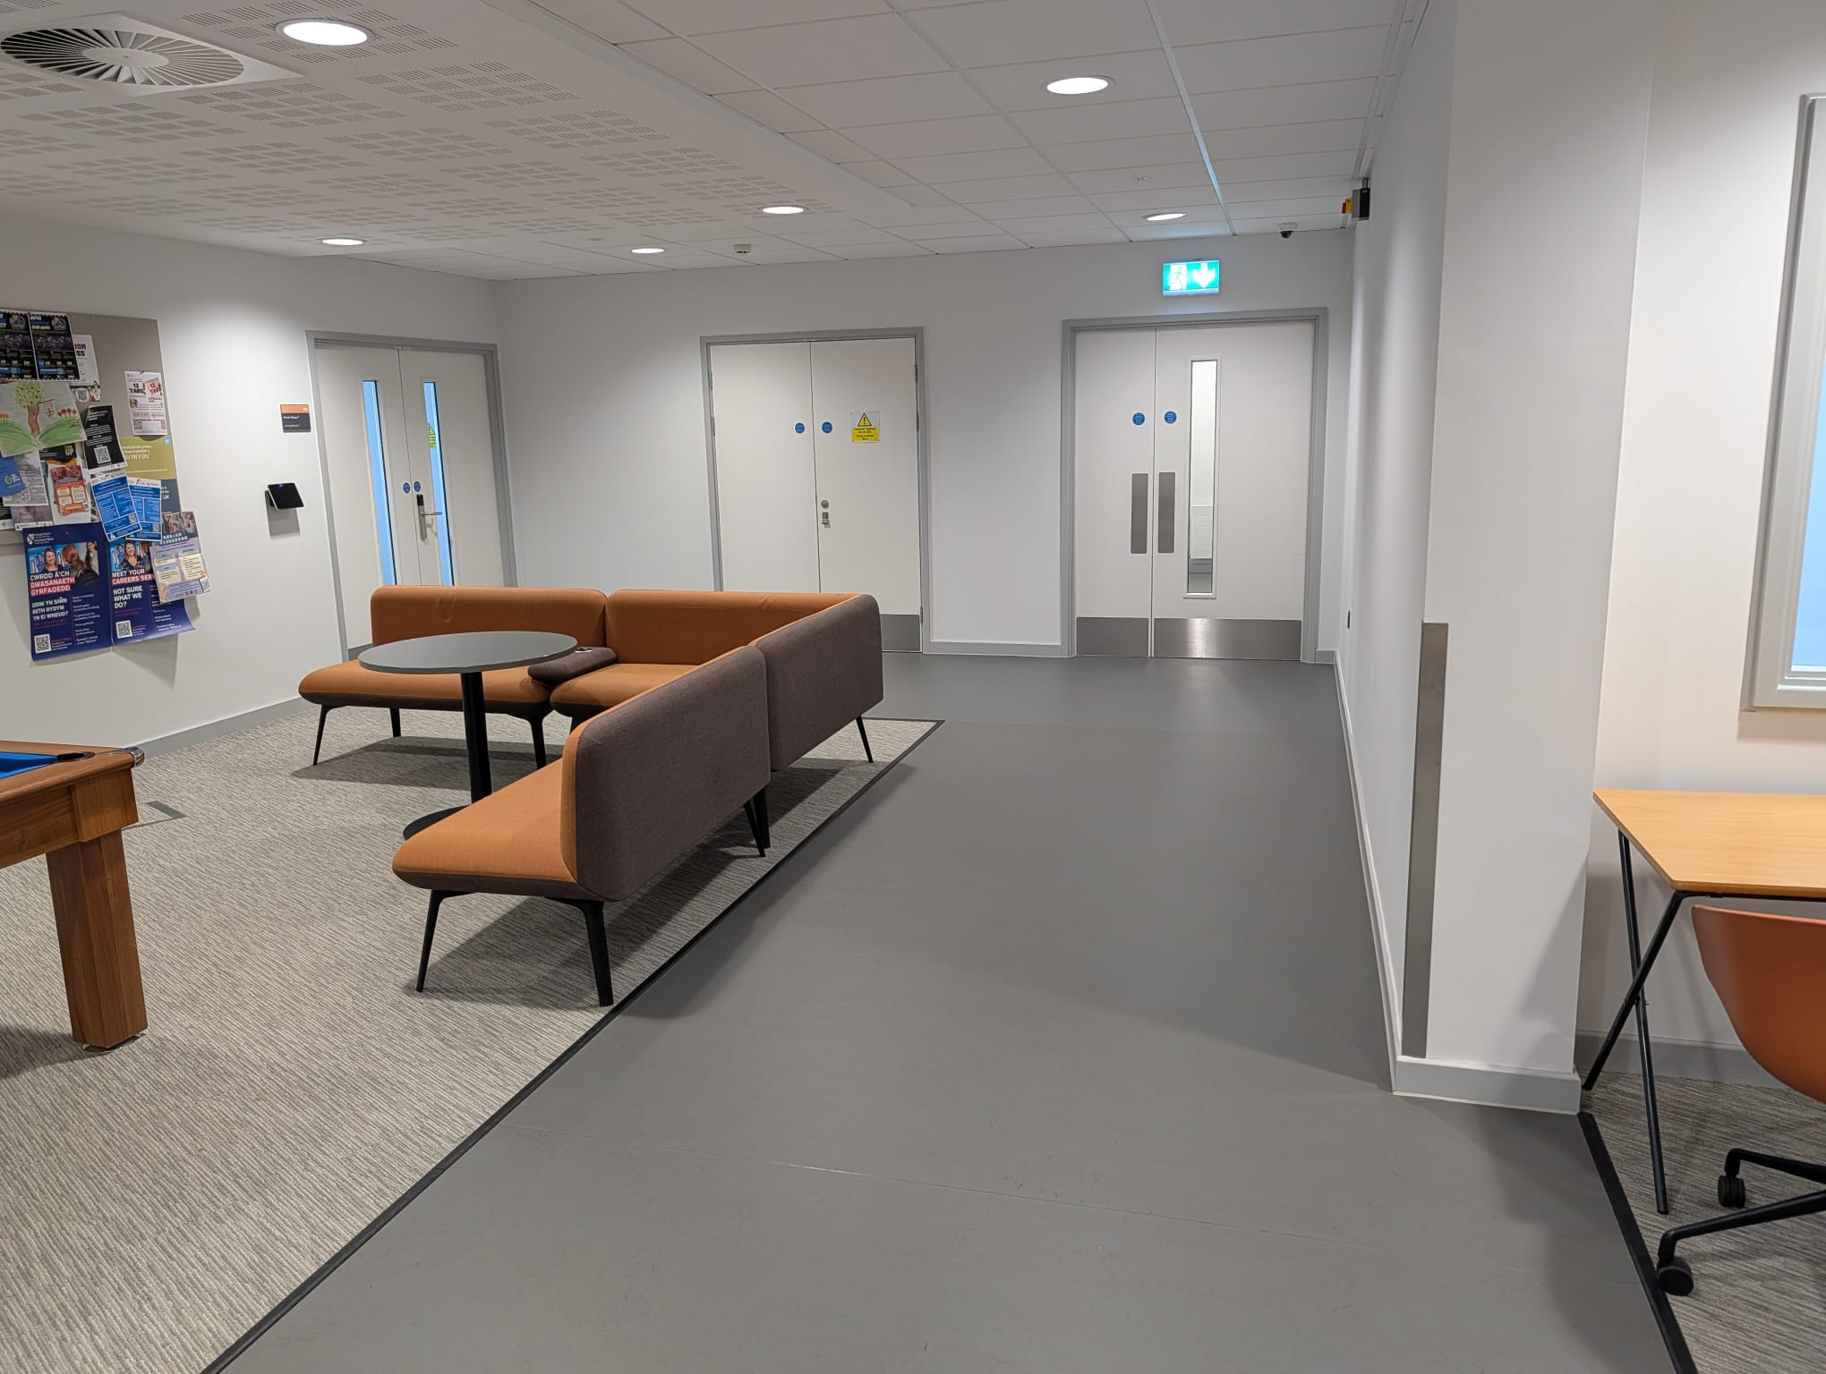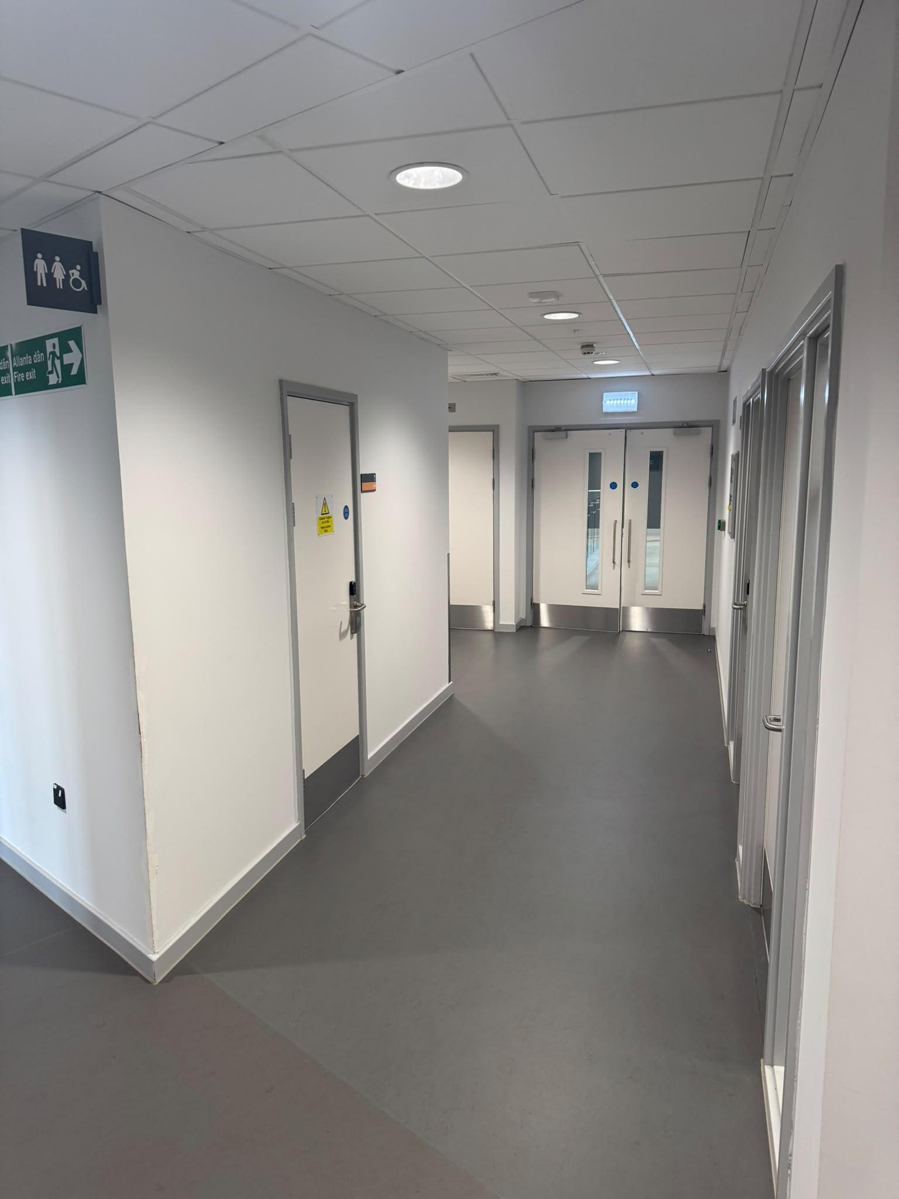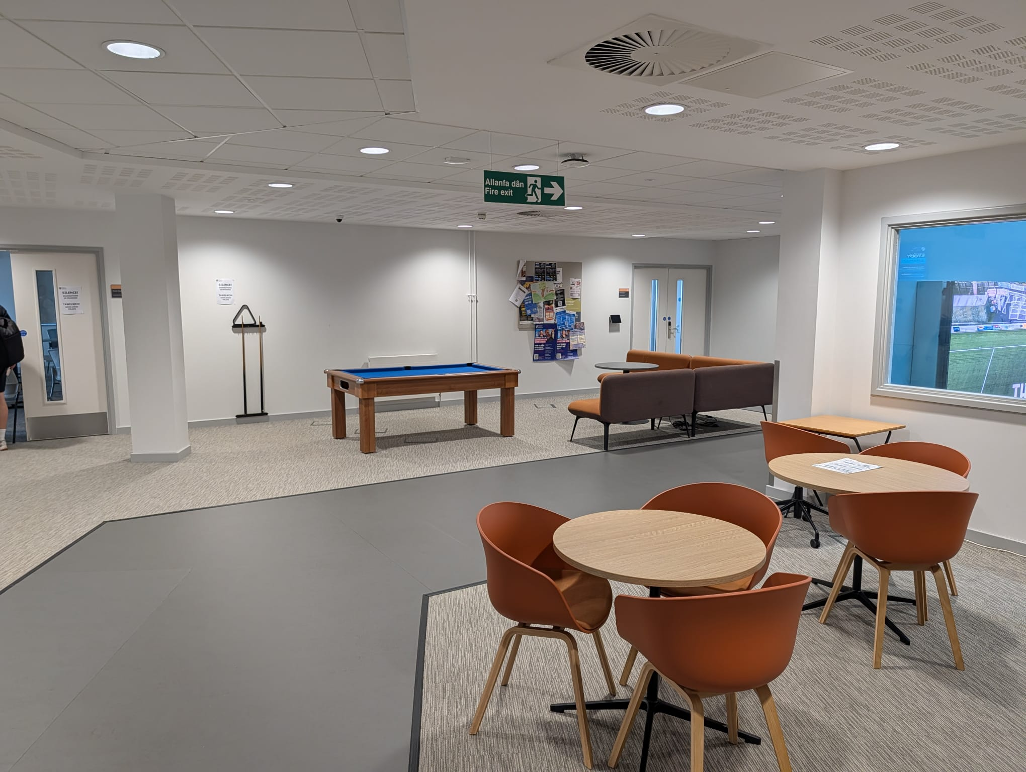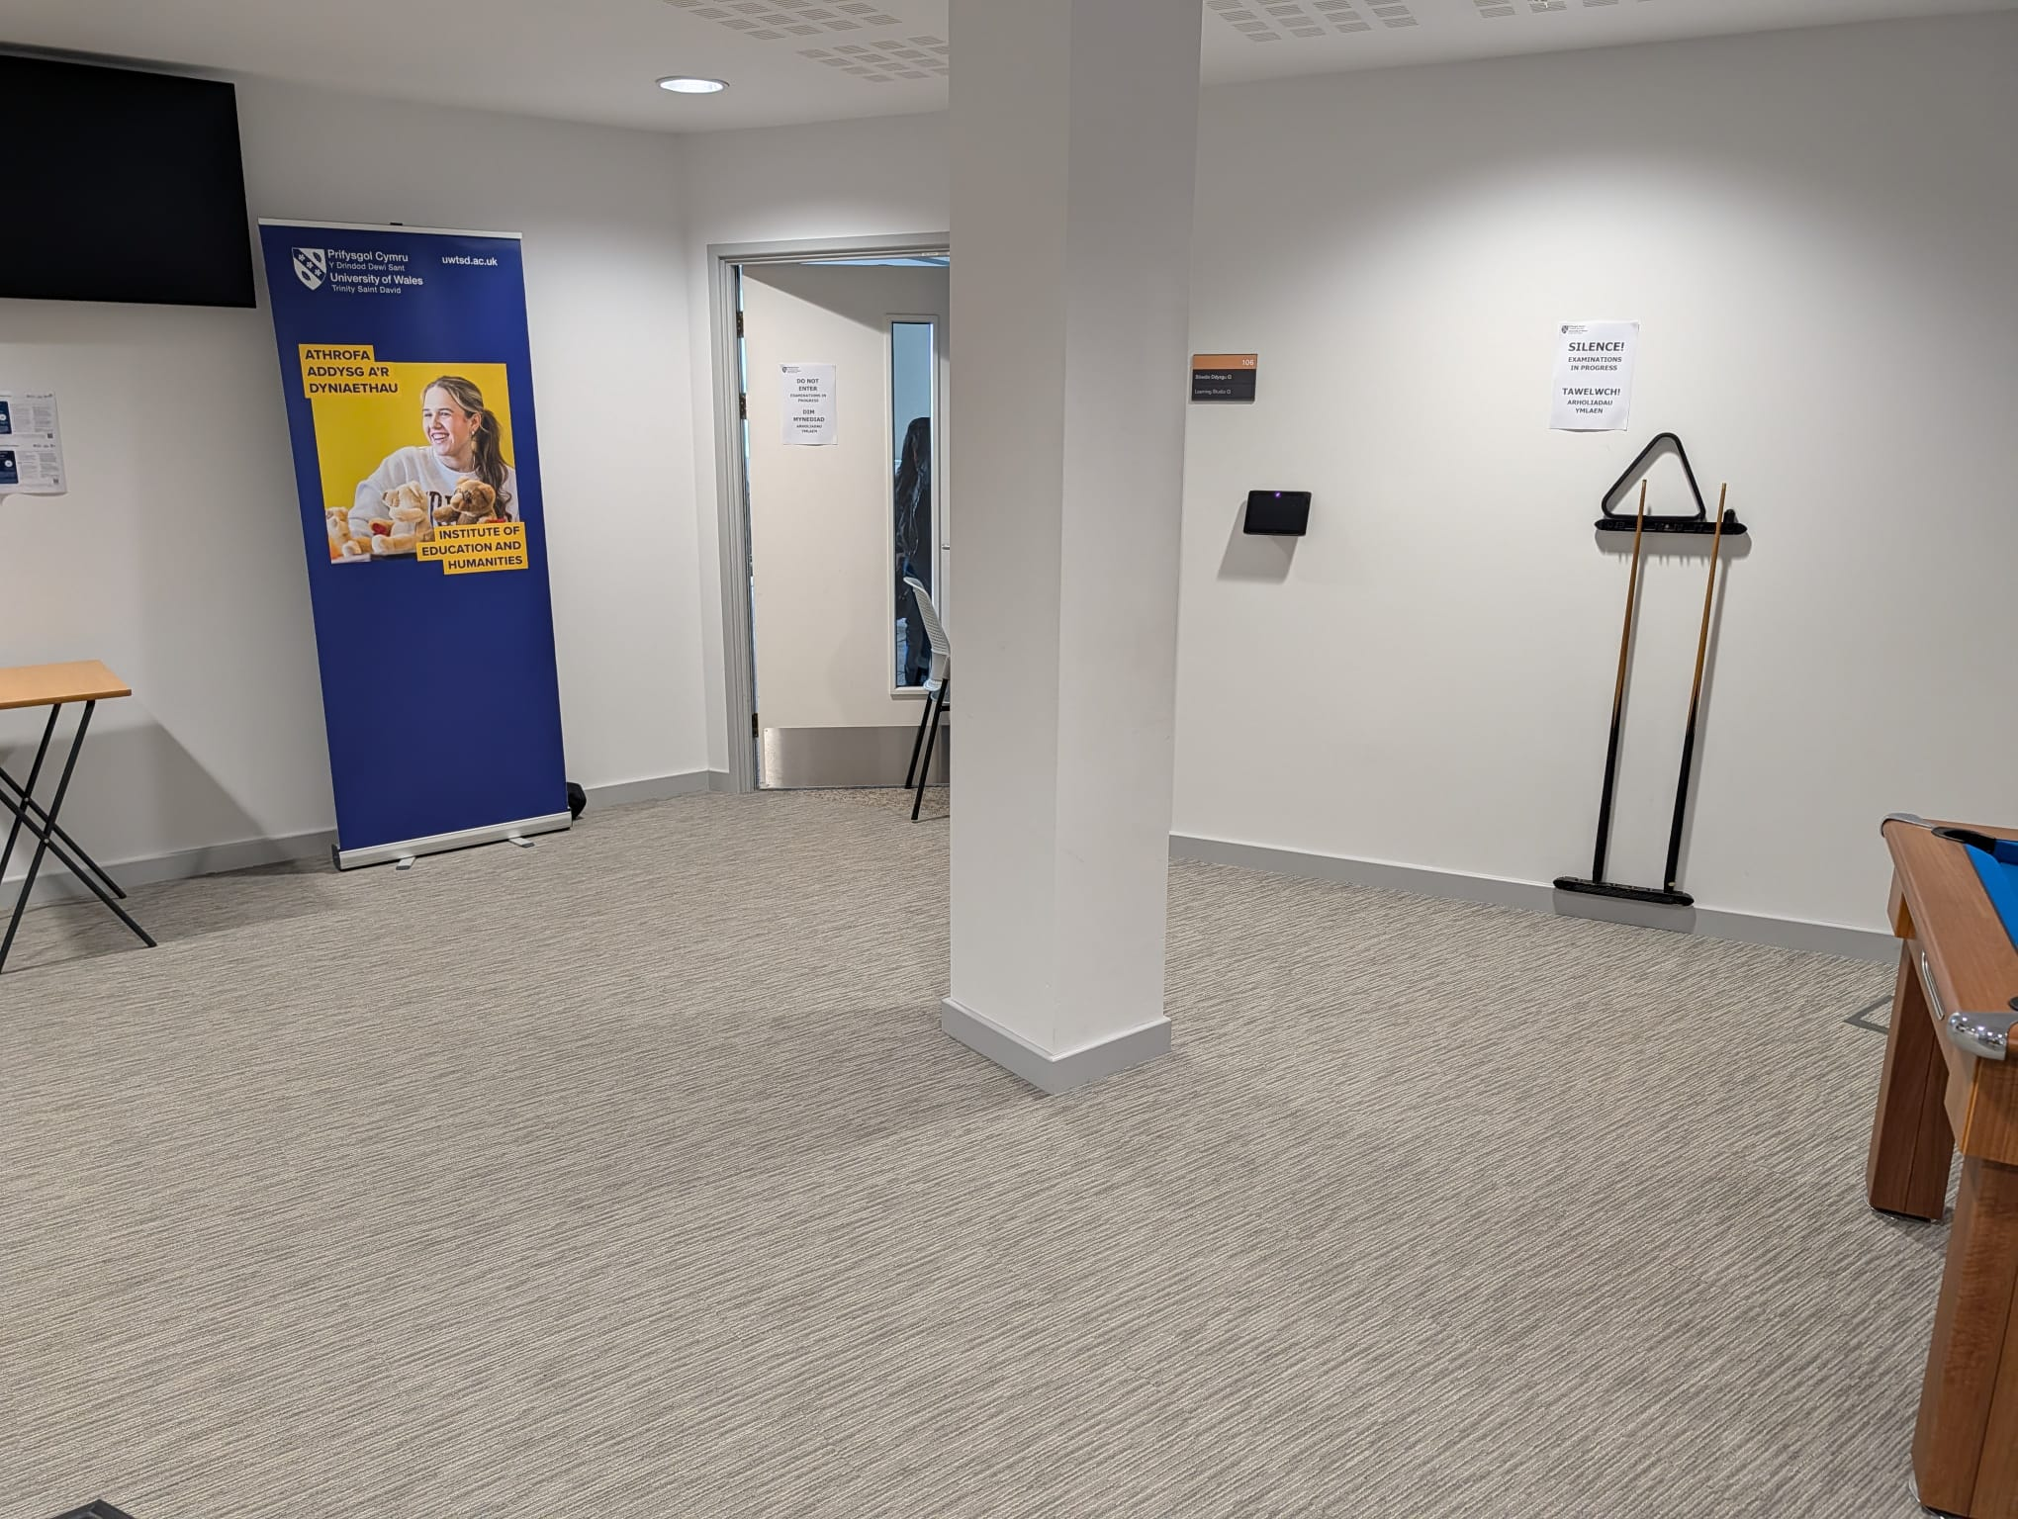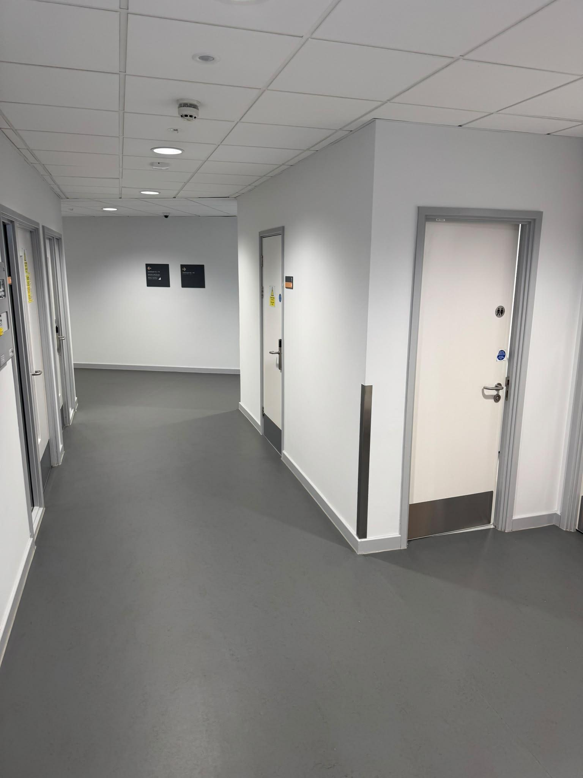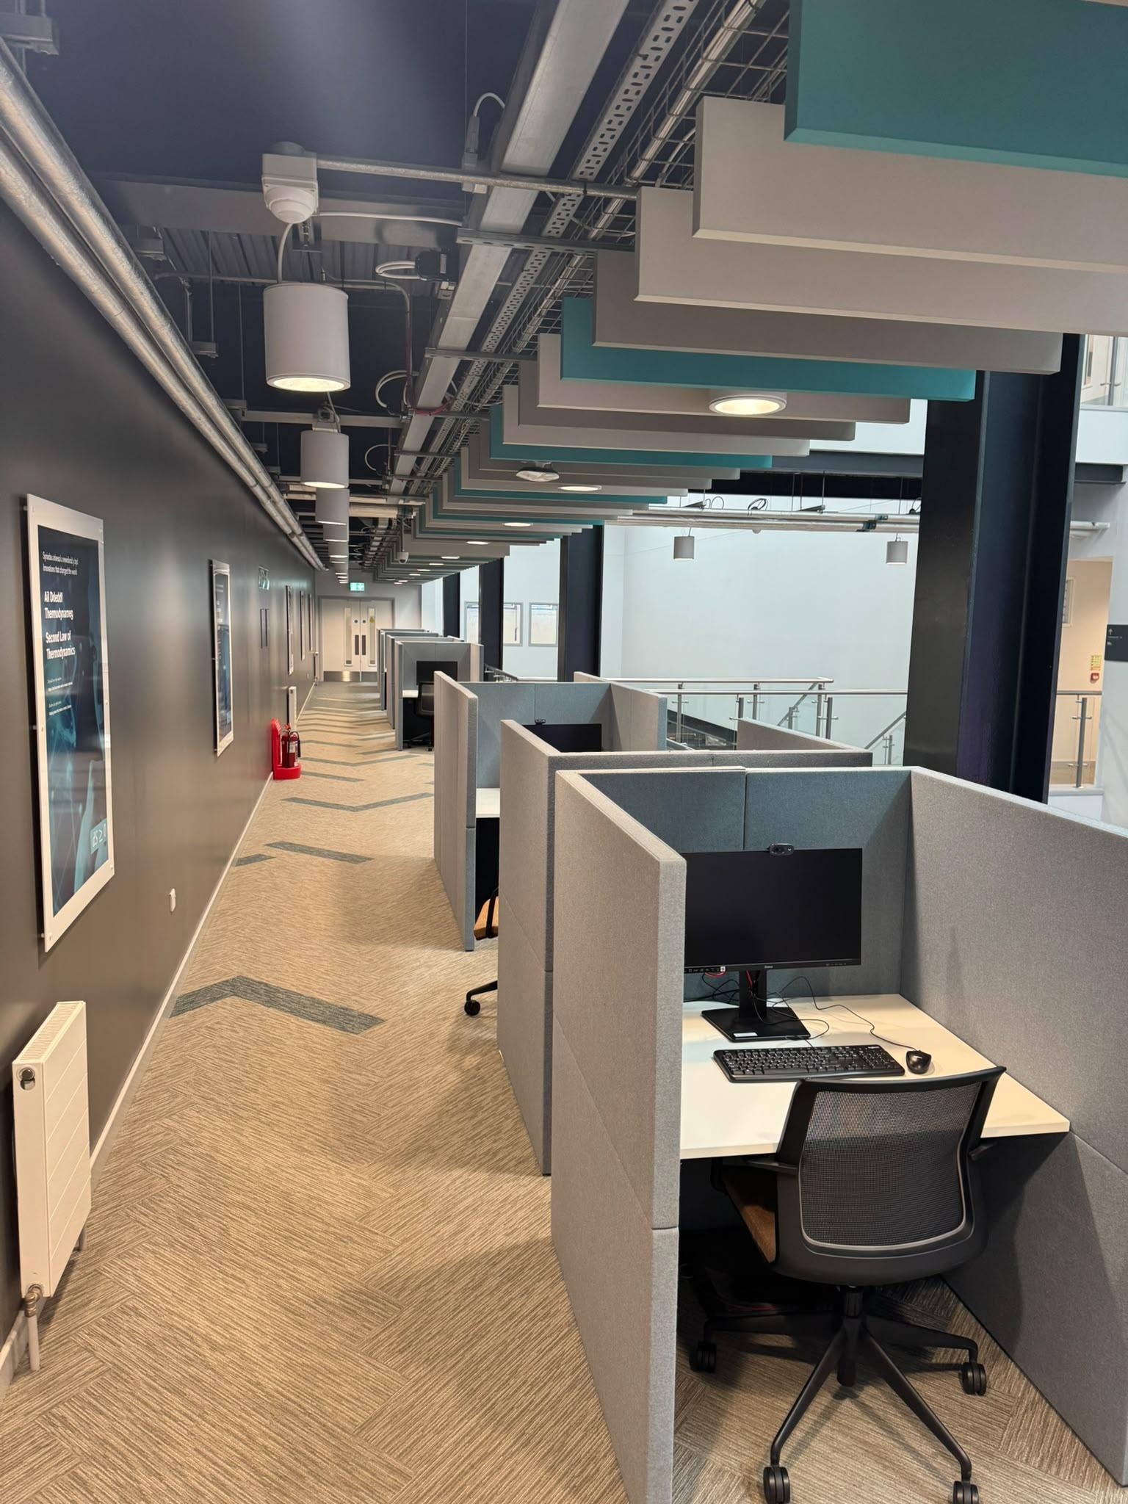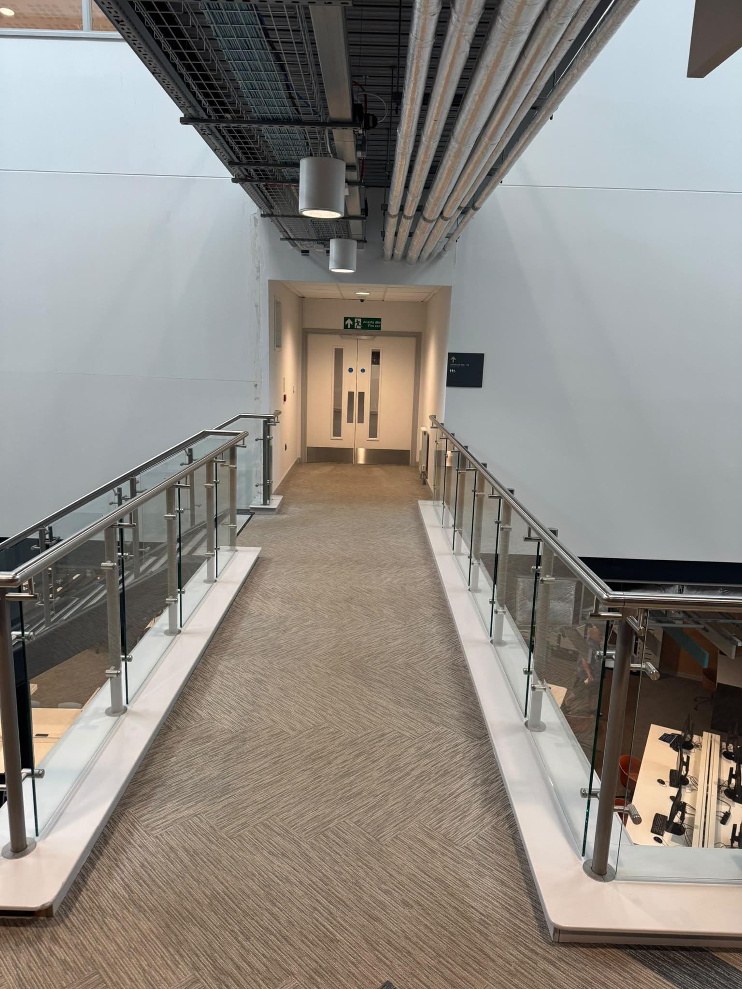

Appendix D - Processed Laser Scan Results (To scale floor plan)

