ECYW7001 5000 Word Journal Component
Order of Contents:
- Information Sheet
- Critical Examination of My Role
- Community Profile
- SWOT Analysis
- Summary of My Own Learning and Development
- Appendices

Throughout this academic journal, I will refer to several young people. Some I have grouped as ‘young people’ and for others I have typed just the first or the first and second initial. I have done this as some of the young people asked to remain anonymous when I first discussed the essay with them, therefore I decided to keep to initials for all the young people. For example, K or CA.
A further list of references can be found at the start of the diary entries in the appendix.

Please see Appendix 6 where I explain how the Corona Virus pandemic has affected my placement at The Wallich and Appendix 7 where I have broken down the total word count.

Information Sheet
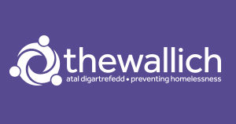

‘Doing something about homelessness in Wales’ (The Wallich, 2021)

The Wallich was set up in the 1970’s by a man who wanted to give back after he’d experienced homelessness and help as a young person. The daughter of the founder told Wales Online The Wallich started as a warehouse where just over 35 people could stay and it quickly grew as new properties were donated, sponsored by businesses, or bought (McCarthy, 2017). A report published by The Wallich (2020) stated that in 2019/20 it owned or managed 188 properties and had 500 bed spaces to provide to young people and adults who were experiencing homelessness or were at risk of sleeping on the Welsh streets.
The Wallich website provides information about the charity, the support that they offer and the projects that are running. When I carried out the research in July 2021 for this journal, The Wallich were carrying out over 60 projects in local authorities throughout Wales. The projects run by The Wallich mainly support people who are at risk of becoming, or who are homeless however, there are some other projects run through the charity. These projects include support for those abusing alcohol or drugs, prisoner empowering projects, floating support for young people and temporary accommodation for individuals or families. The Wallich states that in 2018/19 there were 71 projects run over 18 Welsh local authorities.
The projects I was part of were, the Floating Support and the Training Flats provided by The Wallich for young people. Carmarthenshire Floating Support Services provides both young people and adults with the support required to keep a tenancy. During the placement I shadowed in two houses in Llanelli. Both areas were central to shops, train stations and bus stops. After talking so some of the young people within the Training Flats, they identified that being close to public transport was an essential for them as they relied on these modes of transport to reach friends, family and jobs. According to The Wallich (2021) the service users can use the Floating Support Service for guidance and support on:
• Financial management
• Substance or alcohol misuse
• Physical or mental health issues
• Homelessness support or advice
According to The Wallich (2021) the Floating Support Service has 15 Senior Support Workers within Carmarthenshire. Each of those Seniors have their own team of three to four Support Workers who work with a range of agencies to support the needs of the service users. There are several ways that the Floating Support Service can be accessed. The Wallich (2021) declares that the service can be accessed by a self-referral form, a referral from housing departments or partner agencies. “The Wallich operate with three main obvectives: getting people off the streets; keeping people off the streets; and creating opportunities for people” (The Wallich, 2019).
The Wallich is constantly growing, developing, and creating new projects as a charity to accommodate the needs of at-risk young people and adults within the Wales. According to the yearly report published by The Wallich (2021) 9,664 people were offered support in the 2019/20 year. This support ranges from upskilling, finding temporary accommodation or supported living. The Wallich (2021) also reports that their Rough Sleepers Intervention Teams supported just over 10% less people than the year before, however, it is noted that since the last report in 2018 the reporting systems have changed, and a discrepancy was expected.

Reference List:
McCarthy, J. (2017) Jess Turtle grew up surrounded by homeless people - now she's opening a museum all about homelessness. Available at: https://www.walesonline.co.uk/news/wales-news/jess-turtle-grew-up-surrounded-12830783 (Accessed on: July 20th 2021).
The Wallich (2019) Our Mission. Available at: https://thewallich.com/app/uploads/2020/12/Business-Plan-2020.pdf (Accessed on: July 20th 2021).
The Wallich (2019) Time for transformation. Available at: https://thewallich.com/app/uploads/2020/12/Business-Plan-2020.pdf (Accessed on: July 20th 2021).
The Wallich (2021) About Us. Available at: https://thewallich.com/about-us/ (Accessed on: July 20th 2021).
The Wallich (2021) Carmarthenshire Floating Support Service. Available at: https://thewallich.com/services/carmarthenshire-homelessness-floating-support-service/ (Accessed on: July 20th 2021).

Critical Examination of a Trainee Youth Worker
This part of the academic journal will focus on critically examining the role of the Trainee Youth Worker in comparison to the work that I carried out while on placement. This placement was completely different to my first placement which was in a small primary school with much younger young people. At The Wallich, my role mirrored the role of a Support Worker, therefore, I have chosen to compare and critique the two roles for this part of the essay. The information for the role of the Youth Worker will be taken from the job Prospects, a website created to advertise jobs and courses as well as provide information on careers. I have used Prospects again for the role of the Support Worker, however the career online titles the page ‘Family Support Worker’ as the role often has different titles.
At The Wallich, I started by visiting the young people in their homes weekly. From the start it became apparent that the young people did not want to be involved in a project that would be spread over weeks as they had their own commitments, and I did not want them to see the project as an obligation. As a group we then discussed smaller projects, focusing on what the young people hoped to achieve. We chose a small cooking project, creating an office space and clearing the garden to create a better outdoor area. According to Davies (2008) youth work should always be about starting where the young people are at. This is exactly what I did when we carried out the cooking project as they would not have engaged if I had used a complicated recipe to create the first meal. Instead, we started with a ham, cheese, and pepper omelette. This enabled the young people to practice their chopping skills and use a frying pan, something that one of them had never used. It is important to remember that some of the young people had come from homes where they were adequately cared for and did not need to make their own meals, wash their clothes, or even hoover their bedroom so creating a small meal like this for themselves is a huge step.
Lifeways (2021) suggests that the teaching of life skills, for example, cooking, paying bills and shopping, is one of the roles carried out by Support Workers. Prospects (2021) also write that Youth Workers should assess the needs of the young people to create and implement programmes which relate to their areas of needs therefore, creating the small cookery project entwined the role of the Youth Worker and Support Worker into one to enable the best outcome for the young people at this house. Prospects (2021) provides examples of the programmes that young people may take part in with their Youth Worker. These programmes included, smoking, bullying and health. I believe that the small cooking project fits in with the health example as the young people are now able to create a healthier snack rather than purchasing fast food or binge eating.
Both Lifeways (2021) and Prospects (2021) state that both Support, and Youth Workers should build a trusting relationship with young people to support and empower them. As seen in the appendix, diary entry 6, I saw how important it was to gain the trust of the young man (C) we were supporting when he was in a vulnerable state. In this case, C had only just got to know us and trusted us to speak on his behalf to other agencies to find and provide accommodation for the night and to support his mental health needs. A critique to this is that as the process happened so quickly, the young person could have been falsifying the information that he provided us with to be provided with accommodation as he had seen what his friend had been provided with, however, at that point our main concern was his welfare.
In 2007, Fraser and Blishen (2007) wrote that in the 25 years prior, the amount of young people, aged 11-25years old, reporting mental health problems including anxiety and depression had increased by 70% in and the amount of young people reporting incidence of self-harm had also risen to the point where one in 15 young people had been affected. More recently, Baker (2020) wrote that the results of a survey taken in 2017 by NHS England conclude that over 12% of young people aged 5-19 years old displayed and were being treated for at least one mental health disorder. From the information C gave us upon meeting him it was apparent that C fell into the low-income household category which NHS England (2018) states puts young people at a risk twice as high to suffer one or more mental disorders.
Although not a critique on the work that I carried out, another critique I have for this area is that after building a professional, trusting relationship with C, he was left alone over night at a hotel after declaring this mental health issues. There should be an agency between Youth Workers and Support Workers where young people are watched over via frequent welfare checks throughout the night which would reduce the risk of self-harm. This is something that I have added to the SWOT analysis as an opportunity as I believe it is a project that could be set up by the Wallich for their service users – both young people and adults, however I do understand that cases like this do not occur every day.
Another important aspect of youth work that matches with the description of support work is the necessity of multi-agency working. During the time I spent at The Wallich, I saw the great impact that good multi-agency working could have however, on the contrary, I saw the effect of poor multi-agency work.
Harris and Allen (2011) conclude that young people who received support from a range of professionals believed that their educational outcomes and general aspects of well-being were positively impacted upon due to the support that they had. Two of the young people at the third house were attending college with the hope of getting a place at university. Upon meeting them for the first time, they said that their success was due to the support that they had when they moved out of their previous home, and moved into the Training Flat (TF). One of them said that the support they received, especially from their Support Worker and Youth Worker, gave them the confidence to return to college as a mature student and gain the qualifications they needed to attend university.
Some of the young people discussed with Kerry and myself at their tenants meeting the fact that they knew the multi-agencies were working well together as they did not have to repeat themselves to the different agencies. It was important when we built a support network around C (diary entry 6) that we acted quickly as we knew that he needed emergency accommodation. Most young people prefer agencies to speak on their behalf so they are not repeating themselves, however that was not the case with young person 3, CA – see appendix diary entry 9. CA was overwhelmed by the number of adults who were supporting him as he had looked after himself throughout his teenage years. In this case, the critique is that everyone who was working with CA should have discussed with him how he wanted them to work. As well as other issues, when CA made a suicide attempt, he stated that one of the main feelings he felt was ‘overwhelmed’. In response to this, Kerry made the decision to withdraw the support work as CA was receiving enough support from his Youth Worker, Crisis Team Worker, and family.
It is at this point that I’d say Support Workers and Youth Workers can carry out roles that are too similar which risks repetition for the young person. Harris and Allen (2011) state that in some cases, especially when young people are still in education, multi-agency working is viewed as reactive, short-term, and disjointed by the young people. Harris and Allen (2011) continue to write that whereas most young people value of agencies working together, there are some cases where the young people do not feel involved in the shaping of their support. From my experience, I believe that most agencies work together to support and improve the lives of the young people however, in some cases, too many agencies can provide too many options and/or opinions.
In conclusion, there are many areas where youth work and support work meet and cross. Starting where the young people are at, building a trusting relationship, understanding mental health issues and multi-agency working are all skills that both a Support Worker and a Youth Worker require and during this placement, these are the main skills that I have achieved and improved upon as a Trainee Youth Worker. From being on placement with a Support Worker, both Support Workers and Youth Workers carry out a role that puts the young person at the centre of their work. There are far too many roles that are carried out by both agencies that match each other; however, when carried out correctly, the young person receives the best possible support and guidance. I plan to take the patience, understanding and resilience that I have witnessed into all roles throughout my future career.

Reference list:
Baker, C., 2020. Mental health statistics for England: prevalence, services and funding. Number: 6988th [PDF] London: House Of Commons, p.11. Available at: https://dera.ioe.ac.uk/34934/1/SN06988%20%28redacted%29.pdf [Accessed 1 August 2021].
Davies, B., (2008) Youth Work: A Manifesto For Our Times. [Online] Youth & Policy 88 p5. Available at https://indefenceofyouthwork.files.wordpress.com/2009/03/youth-work-a-manifesto-for-our-times-bernard-davies.pdf [Accessed on 1st August 2021].
Fraser, M. and Blishen, S., 2007. Supporting Young People’s Mental Health. [PDF] London: The Mental Health Foundation, p.1. Available at: <http://ISBN 978-1-906162-06-1> [Accessed 1 August 2021].
Harris, A. and Allen, T., 2011. Young people’s views of multi‐agency working. British Educational Research Journal, [online] 37(3), pp.412-414. Available at: https://bera-journals-onlinelibrary-wiley-com.ezproxy.uwtsd.ac.uk/doi/pdfdirect/10.1080/01411921003692876 [Accessed 2 August 2021].
https://dera.ioe.ac.uk/34934/1/SN06988%20%28redacted%29.pdf
Lifeways. (2021) The Role of a Support Worker. Available at: https://www.lifeways.co.uk/resources/the-role-of-a-support-worker [Accessed on 1st August 2021].
NHS England. (2018) Mental Health of Children and Young People in England, 2017. Available at: https://digital.nhs.uk/data-and-information/publications/statistical/mental-health-of-children-and-young-people-in-england/2017/2017 [Accessed: January 13th 2021].
Prospects. (2021) Family Support Worker. Available at: https://www.prospects.ac.uk/job-profiles/family-support-worker [Accessed on 1st August 2021].
Prospects. (2021) Youth Worker. Available at: https://www.prospects.ac.uk/job-profiles/youth-worker#:~:text=As%20a%20youth%20worker%2C%20you,a%20successful%20transition%20to%20adulthood [Accessed on 1st August 2021].

A Community Profile
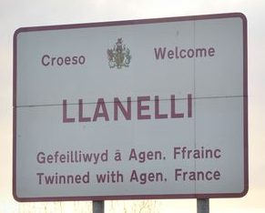
(MacCarthy, 2017)

The aim of this profile is to look at the resources and opportunities available to the young people using the Training Flats in Llanelli. The service is run by Support Officers who support young people in their transition from different backgrounds into a shared property. Often the young people who are using the Training Flats have come from backgrounds where they’ve had no experience of living alone, paying bills, making meals, or running a home. There is a short process that the tenants go through to be placed in one of the houses.
Although the project is called ‘Training Flats’, the buildings are actually houses which have a communal kitchen, living room, and bathroom; their bedrooms have a lock system in place if they feel the need to lock it. Once a bedroom becomes available in one of the houses, a Support Worker will interview any potential candidates to ensure they are a good match to those already living in the house; after all, it is already their home, and it is important to ensure their views are heard. Once a candidate is successful, they view the house, meet the other tenants, and move in. Some young people have left their home with nothing, if this is case, the Support Worker will supply an emergency kit which will include easy to cook food, toothpaste, shampoo, body wash and all other daily essentials. The house is already equipped with bedroom furniture so the tenants can move into a clean room.
This community profile will focus on Llanelli as a town, but it will also provide information on The Wallich’s involvement in the lives of the young people as for most people receiving support, their community is the support provided by The Wallich. Due to this, this community profile will look at the following subheadings:
• Town Statistics
• Geography and Physical Environment
• The Community of Support
• The Training Received.
These will allow a more in-depth look at the community around the young people as for most of the service users they have come from over villages or cities in Wales and therefore the education and resources are not as relevant to them as the support and training.

Town Statistics
According to Thomas (2019) Llanelli is currently the largest, and most populous, town in Carmarthenshire. However, this has not always been the case. Davies on behalf of Coflein (2009) stated that historically Llanelli was a small town which saw an increase of residents and business across the 18th century and into 19th as the mining for coal became more popular and in the later years the steel and tinplate industries took over. According to CityPopulation (2021) in 2019 the town, had an estimated population of 26,225 a small increase from the recorded 25,168 in 2011. It is estimated that 6,294 of the 26,225 people in Llanelli are aged 0-19 years old and therefore considered young people. According to McCarthy (2017), The Wallich was created in the late 1970s with a base in Cardiff and over the following years more bases were created. Although the main office is still in Cardiff, there are now offices all over Wales (The Wallich, 2021).

Geography and Physical Environment
This part is going to be split into three smaller parts as I will discuss the geography of each location and the physical environment that the young people are living in.
Location 1 – The first house is located within the town of Llanelli with access to the bus station, train station and supermarkets. There is a large indoor market as well as a range of clothing shops, budget shops and fast-food restaurants. The house is within walking distance from all of these and there is a small village hall near the house. One of the young people joined a college course and another started a job after attending an education and employment open day at the village hall.
Location 2 – The location of this house is on the outskirts of Llanelli and further from a main town, however it is within walking distance to the bus stop. The young person uses the small village shop daily to buy his daily goods and catches the bus into town once a week for a bigger food shop. Unlike the first house, this house is on the bus route for the local college, therefore the young person uses that to get into college three days per week.
The Houses – Both houses are officially called ‘Training Flats’ by The Wallich, however both are five-bedroom houses. Each house has a communal living room, kitchen, and bathroom and each young person has their own locked bedroom. Chiodelli and Baglione (2014) write that living in a communal environment could possibly be the answer to the breakdown of communities in larger towns and cities. In this case, young people living together definitely creates their own community as some of the young people who move into the Training Flats have a misunderstanding of what a positive community can look like due to their past experiences.
The house at the first location has a large outdoor space at the back of the property which consists of a small garden and large patio. The young people use this space to entertain friends and hang out washing. The second house has three floors. Although it does not have a garden as it is above a fast-food restaurant, it does have a large park opposite which the young person uses as a ‘make do’ garden on sunny days. Bakerink (2018) states that it is often forgotten that young people, especially teenagers should be spending time outdoors. Spending time outside can increase levels of fitness and reduce stress levels and the symptoms of ADHD, something that some of the young people in the Training Flats struggle with.

Support
The young people who live in the Training Flats have access to 24-hour support. It is important to note that the Training Flats are not sheltered accommodation and support staff only go to the property to carry out support, training, or guidance with the young people. The support that the young people receive from different organisations can be considered their community as, although outdated however still relevant, McMillan and Chavis (1986) define a community as a feeling rather than a place. The feeling of belonging and of mattering to someone or a group is how McMillan and Chavis describe a community. Both go on to propose that a community can be made up of the following elements: membership, influence, integration and fulfilment of needs and a shared emotional connection.
In the Training Flats, each young person has a Youth Worker, a Support Worker, an On-Call Support Worker and the whole house has a Housing Officer. Once a month, all these professionals will meet with the young person together to discuss any issues or just for a catch-up session. Each week, the young person will meet with their Support Worker to carry out a form of training. The training can vary from each week. Often, we discussed how to fill in forms or approach the bank/doctor’s surgery for the first time and other times we would cook a meal together or do some gardening. The small projects that I carried out included cooking, gardening, and building flat pack office furniture for one of the young people to help with her college studies. According to MentalHealth.org (2021) over 55% of young people become overwhelmed, stressed, or are unable to cope because of the fear of making a mistake. After reading this statistic before starting the placement I wanted to ensure that each young person understood that they had the time and freedom to make mistakes when we were carrying out the small projects as I am a firm believer in learning from mistakes. During one of the projects, a young person put the wrong parts of the flat pack desk together and became quite annoyed with himself which resulted in him saying he couldn’t do it and “couldn’t be bothered to finish it” (see journal entry 10). After working together and going back a step to work out where we had gone wrong, we were able to fit the correct parts together. At that point I think it was important for me to use positive language such as “let’s see where we went wrong” or “lets both go through the instructions” to show that we were still working as a team.

Conclusion
The young people in these settings have a personalised support community working around them and each young person has that feeling of belonging somewhere, for some, this is the first time. Careful consideration is used to ensure the house is right for each applicant and it is in the best possible location to suit to needs of the young people. The Training Flats are providing the support and training that young people need to enable them to, one day, run a home with a family or by themselves. Youth clubs or youth-based facilities have not been mentioned in this community profile as for these young people, youth clubs are not the right setting as most of the young people living at the Training Flats are quite mature e.g., working or in college as mature students. The next step would be to celebrate the achievements of the young people in their training both in and out of the flats and continue to provide further support and training as they develop and their needs change, e.g., managing their tenancies.

Reference List:
Bakerink, J. T., (2018) Importance of outdoor time for child and teen well-being. Available at: https://www.summerlinhospital.com/resources/caring-for-kids-online-fall-2018/importance-outdoor-time-child-teen-wellbeing#:~:text=Time%20spent%20active%20outside%20can,with%20others%20in%20social%20settings [Accessed on: July 30th 2021].
Chitewere, T, Taylor, DE (2010) Sustainable living and community building in Ecovillage at Ithaca: The challenges of incorporating social justice concerns into the practices of an ecological cohousing community. Research in Social Problems & Public Policy 18: 141–176. https://www.emerald.com/insight/content/doi/10.1108/S0196-1152%282010%290000018007/full/html
City Population (2021) Llanelli. Available at: https://www.citypopulation.de/en/uk/wales/admin/carmarthenshire/W04000519__llanelli/ [Accessed on: July 29th 2021].
Lloyd Davies, M., (2009) Llanelli. Available at: https://coflein.gov.uk/en/site/33068/#:~:text=Historically%20a%20minor%20town%2C%20Llanelli,Railway%20which%20opened%20in%201803 [Accessed on: July 29th 2021].
McCarthy, J. (2017) Heroin and Llanelli: Inside a town's drug problem. [Online] Wales Online. Available at: https://www.walesonline.co.uk/news/wales-news/heroin-llanelli-inside-towns-drug-12751242 [Accessed on: July 30th 2021].
McCarthy, J. (2017) Jess Turtle grew up surrounded by homeless people - now she's opening a museum all about homelessness. [Online] Wales Online. Available at: https://www.walesonline.co.uk/news/wales-news/jess-turtle-grew-up-surrounded-12830783 [Accessed on: July 29th 2021].
McMillan, D. W., & Chavis, D. M. (1986). Sense of community: A definition and theory. Journal of Community Psychology, 14(1), 6–23. https://doi.org/10.1002/1520-6629(198601)14:1<6::AID-JCOP2290140103>3.0.CO;2-i
Mental Health Foundation. (2018) 60% of young people unable to cope due to pressure to succeed. Available at: https://www.mentalhealth.org.uk/news/60-young-people-unable-cope-due-pressure-succeed Accessed on: July 30th 2021].
The Wallich (2021) Our Impact. Available at: https://thewallich.com/about-us/ [Accessed on: July 29th 2021].
Thomas, R. (2019) A Brief History Of Llanelli. [Online] West Wales Chronicle. Available at: https://www.westwaleschronicle.co.uk/blog/2019/10/01/a-brief-history-of-llanelli/ [Accessed on: July 29th 2021].

SWOT Analysis

The following SWOT Analysis investigates the Strengths, Weaknesses, Opportunities and Threats that The Wallich face. I chose to look at both the Wallich as a whole and The Floating Support Service which takes into consideration the young people or service users in their training or in their homes.
Green font – Floating Support Service
Blue font – Floating Support Service and The Wallich
S  Strengths | W  Weaknesses | O  Opportunities | T  Threats
Each young person has a key worker. | Not spending enough time with each person due to demand to see other service users. | Re-open drop-in centre for young people. Closed initially due to Covid pandemic. | The rise of homeless young people.
Good communication between Support Worker and young person. | Too many adults with one young person. E.g. Housing Officer, Youth Services, Key Worker, Support Worker and Training Officer - carrying out the same or similar work. | Increase communication with other young people by using social media platforms for announcements. | Poor engagement with the programme can jeopardise the young person’s position at the accommodation.
24-hour support for the young people. | Funding due to a drop in fundraising events – Covid related. | Fundraising events as lockdown measures ease. | Too many service users and not enough accommodation.
A steady flow of new and upcoming projects being implemented across Wales. | Young people not engaging with the support offered to them | Increase local business awareness and links to provide sponsor opportunities | Service users mistreating the house/flat and causing disruption.
Ample staff training opportunities. |  | Create open evenings exampling the projects that are on offer for local businesses to support. | Low attendance to young people training jeopardises young person’s position in the flat/on the program.
Passionate staff who always put the needs of the young people or service user first.
Small group sizes when working as a group.
Providing an inclusive environment for staff and service users.

The Wallich (2021) Our Impact. Available at: https://thewallich.com/app/uploads/2020/08/at-a-glance-2020.pdf (Accessed: July 20th 2021).

Summary of my Learning and Development
I am going to refer to the Youth Work National Occupational Standards (NOS) to summarise my learning and development during this placement. NOS have created a diagram which summarises the main values of youth work. I am going to give examples of how my role linked to each value. The NOS diagram can be seen below.
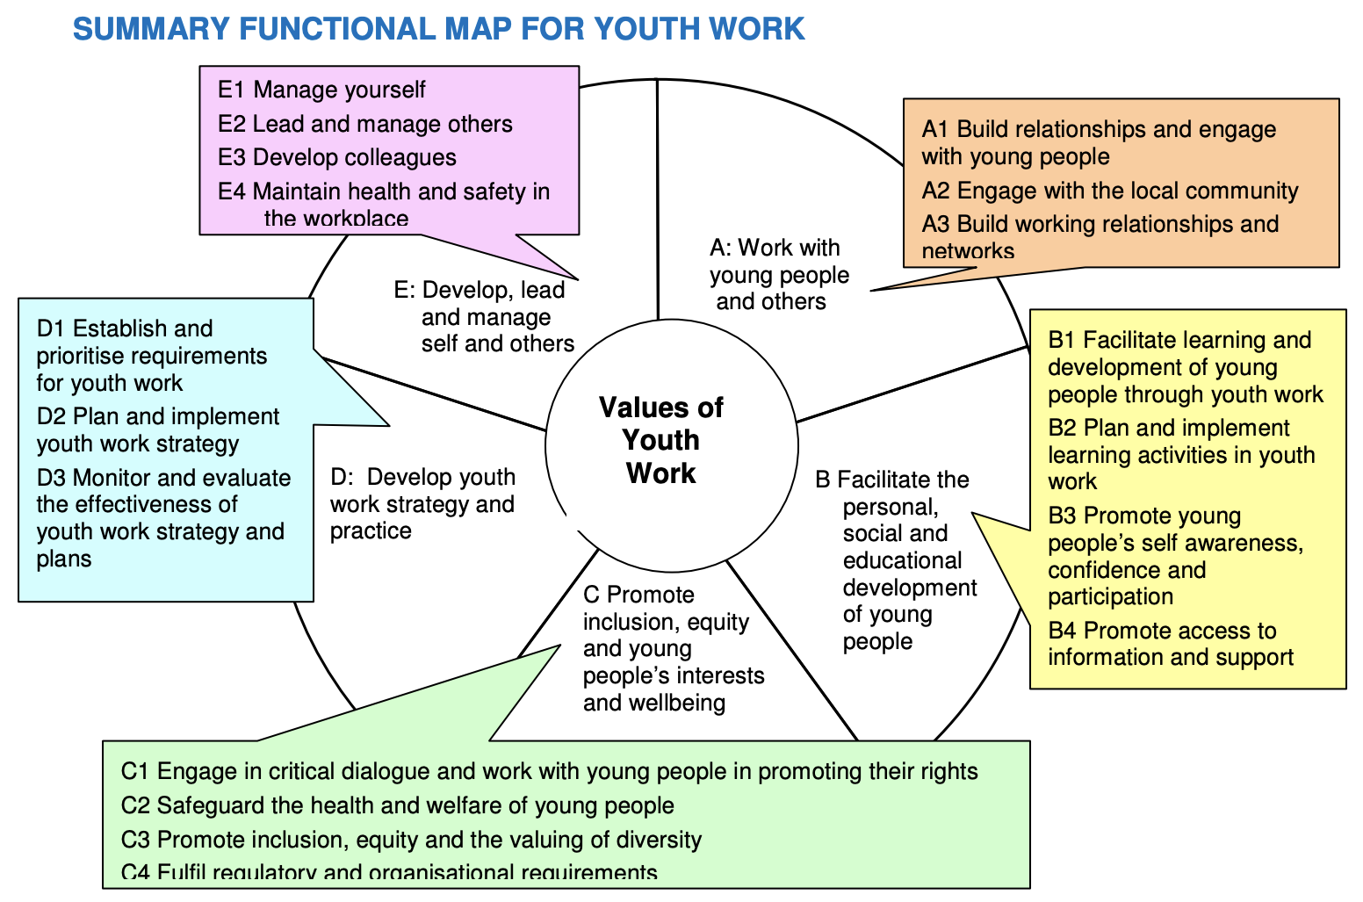
(Source: NOS, 2014. p.6)
According to NOS, they provide an outline of the skillset that Youth Workers should show when working with young people. The summary map provides some of the key principles that should be applied when providing young people with opportunities or activities. NOS writes that it is unlikely that all the outcomes will be achieved in one activity, therefore I will be basing the outcomes on my overall placement experience.

Work with young people and others
At the start of this project, I was mindful that a lot of the young people I would be meeting through The Wallich will have had rocky relationships with adults in the past therefore, to start with I took a step back and observed as Kerry took the lead. As the young people became more familiar with me being there, I started to build a professional relationship with them. The Open University (2020) write that you can almost measure how comfortable a young person is around a professional adult by how much they engage and respond to the help offered. In appendix diary entry 6, K knew that he was in a position where he could tell me about his friend C and that he needed our help. This showed that K trusted me and knew that C would have the support, just like he had.
I also worked with different agencies and family members while I was on placement at The Wallich. I have always worked with whole families; however I am not used to working with different agencies on one case. As discussed in the Examination of My Role, working with different agencies can be beneficial when we all want the same outcome for the young person. As seen in diary entry 8, multi-agency work does not always go to plan as sometimes there can be a clash of opinions or views. It was good to see how different agencies communicate and progress together, however it was also clear to see how they can disagree at times.
Unfortunately, unlike my first placement which was fully community based, we did not have the opportunity to set up a full-scale project, therefore opportunities to work with the community were missed.

Facilitate the personal, social, and educational development of the young people
The mini projects were decided upon as they were needed to enhance the young people’s personal, social, or educational development. The educational development of the young people was developed when they took part in the cooking project as it involved measuring, reading and research as described in appendix diary entry 7. The social development of the young people was enhanced as two young people who would not normally talk or work together build the flat pack furniture. This also developed their participation and confidence. It was a huge step for them as they were both new to the house and their teamwork helped to develop their social skills with each other.
Other than the projects, with Kerry’s guidance I provided a lot of information and support to the young people. For example, I used Google to find the latest information on college courses for one young man, I gathered information about the vaccination process at a local doctor’s surgery for one young woman and with the support of Kerry we accessed the Mental Health Crisis Team for another young man, C (appendix diary entry 6). Sapin (2012) writes when a Youth Worker supports the development of a young person, they are also supporting their own professional development. Most of the cases were completely new experiences for me and therefore there were plenty of opportunities for me to learn and develop my skills as a trainee Youth Worker.

Promote inclusion, equity, and young people’s interests and wellbeing
As a Trainee Youth Worker, the young people’s wellbeing and interests are two of my main values. There was some conflict in appendix diary entry 8 as the views of myself and Kerry crossed with those of the housing officer as we interviewed a potential new tenant. It was important to both Kerry and I that we safeguarded the tenants who were already settled at the house as we knew there would be a potentially dangerous clash with the new tenant however, the housing officer was looking to fill the room without considering the consequences.
In another case, a young person moved into one of the Training Flats and Kerry and I decided it was important and appropriate to promote inclusion and the importance of valuing diversity with the young people already living at the house. We done so by allowing the young people to ask each other open questions and researching the answer to any questions that we, or they, were unsure of. Sapin (2012) p9. states that Youth Workers who limit themselves to specific activities and targets with young people may find their perspective and activities to be limited. If we had had a limited target and approach to this subject, the young people in this home may have felt refrained throughout their time there.

Develop youth work strategy and practice
“Youth work is about seizing the unplanned opportunities while also planning opportunities that lie outside formal systems of education” The Youth Work Strategy for Wales, 2019.
The above quote is how I would summarise placement two. Often, I would turn up with a plan of what we would do that week, sometimes I would allow them to lead the session and other times I would encourage the input of all of us. The placement was not one that could be measured with specific outcomes, and neither could the young people. Their measurable outcome is when they can leave the Training Flat to buy/rent their own accommodation.
Each young person completed a self-risk assessment form (Appendix 3) with me (with Kerry’s supervision) when they joined the Training Flats and once, they have settled within their new home (after no specific time) they will carry out an ‘Outcome Review’ (Appendix 4) which allows them and us to create goals of what they have achieved and their next step of what they want to achieve/manage while they are at the Training Flats.

Develop, lead and manage self and others
The first placement was in an environment where I was comfortable, I knew everyone, and I knew what I was doing. This placement has been a completely new environment with new people, opportunities, and challenges – It has allowed me to develop my youth work skills to a new level and I have managed myself and young people in a way that I had not expected to. Kerry allowed me to take lead and manage the young people while adding what I could improve on for next time. Due to Covid restrictions I was unable to interact with other colleagues at The Wallich, but I was able to develop working colleagues within other agencies.

My time at The Wallich has been incredibly influential on my views, opinions and values as a Youth Worker and I have developed skills that will be transferable into any career with young people. I have faced challenges head on, and I have been able to adapt to meet the requirements of both a Trainee Youth Worker and Support Worker at the same time. My confidence has grown weekly and the opportunity to work with a range of agencies has only enhanced that. I am looking forward to pursuing a career in the youth work field and developing further to reach my full potential.

Reference List:
National Occupational Standards. (2014) ‘LSI YW00 Youth Work National Occupational Standards Introduction’ https://www.nya.org.uk/wp-content/uploads/2014/06/National-Occupation-Standards-for-Youth-Work.pdf [Accessed: August 3rd 2021].
Open Learn University. (2020) Professional Relationships with Young People. Available at: https://www.open.edu/openlearn/health-sports-psychology/professional-relationships-young-people/content-section-0?active-tab=description-tab [Accessed: August 3rd 2021].
Sapin, K., 2012. Essential Skills for Youth Work Practice. 2nd ed. [PDF] London: Sage, pp.3-19. Available at: https://in.sagepub.com/sites/default/files/upm-binaries/66923_Sapin___Essential_Skills_for_Youth_Work_Practice.pdf [Accessed 3 August 2021].
Welsh Government. (2020) Youth Work Strategy for Wales. [PDF} Cardiff: Welsh Government. Available at: https://gov.wales/sites/default/files/publications/2019-06/youth-work-strategy-for-wales.pdf [Accessed 3 August 2021].

Appendices

- Placement Report from Kerry Edwards
- Supervision Report from Cath Wilson – Still to come
- Dated Journal Entries
- Young Person Self-Risk Assessment
- Young Person Outcome Target Review
- Corona Virus Impact

1 – Placement report from Learning Mentor - Kerry Edwards
LEARNING MENTOR’S FINAL REPORT
Work in accordance with the pillars of Youth Work in Wales: Principles and Purposes
A Exceptional  70%+ | B Effective  60-69% |  | C Satisfactory  50-59% |  |  | D Rather weak  40-49% |  | E Weak  0-39%
Aimee confidently worked in accordance with the pillars of Youth Work in Wales.

Work with young people and others
A Exceptional  70%+ | B Effective  60-69% |  | C Satisfactory  50-59% |  |  | D Rather weak  40-49% |  | E Weak  0-39%
Aimee confidently worked with young people that have been referred to The Wallich. Aimee engaged with their support plans and supported their individual needs.

Facilitate learning and development of young people through planning and implementing learning activities in youth work
A Exceptional  70%+ | B Effective  60-69% |  | C Satisfactory  50-59% |  |  | D Rather weak  40-49% |  | E Weak  0-39%
Aimee worked well to provide activities and opportunities for the young people within their homes and community.

Actively demonstrate commitment to inclusion, equity and young people’s interests and health and wellbeing
A Exceptional  70%+ | B Effective  60-69% |  | C Satisfactory  50-59% |  |  | D Rather weak  40-49% |  | E Weak  0-39%
Aimee confidently worked with all young people and worked on their health and well-being. Aimee was aware of the young people’s interests and supported their needs based on these.

Plan and implement strategy and youth work activities for young people
A Exceptional  70%+ | B Effective  60-69% |  | C Satisfactory  50-59% |  |  | D Rather weak  40-49% |  | E Weak  0-39%
Aimee worked well to provide activities and opportunities for the young people within their homes and community based on their interests and needs.

Develop, lead and manage self and others
A Exceptional  70%+ | B Effective  60-69% |  | C Satisfactory  50-59% |  |  | D Rather weak  40-49% |  | E Weak  0-39%
Aimee was able to manage herself during placement and showed good initiative with the young people. Aimee worked with a range of different agencies and managed the young people independently when needed.

Work with communities
A Exceptional  70%+ |  | B Effective  60-69% |  | C Satisfactory  50-59% | D Rather weak  40-49% |  | E Weak  0-39%
Aimee worked confidently with the community and worked in partnership with housing officer to support the young people in creating new opportunities.

LEARNING MENTOR’S FINAL REPORT (continued)
How has the student developed during the placement?
Aimee has gained confidence during placement and was able to independently work with the young people.

What is your feedback on observing the student’s planned piece of practice?
Aimee worked well with the young people and got down on their level. She planned things thoroughly and provided lovely activities based on the needs and interests of the young people at The Wallich.

What are your suggestions for further professional development?
Aimee would be fantastic working with vulnerable people, both young people and adults, and has a natural caring nature.
Has the student passed the placement? Please take into account your view of the student’s performance in each of the Key Aspects of Youth Work (Please circle clearly).
Yes, Pass | No, Fail
Please provide a grade and % mark reflecting your experience of the student
Grade: A % Mark: 90%

Signed Learning Mentor | Kerry Edwards
Signed Student | Aimee Mathias
Date | 02.08.21

2 – Supervision report from Cath Wilson
How did the student use supervision and respond to feedback?
Aimee discussed the cases that she was shadowing with Senior Worker. She discussed both positive and negative aspects of young people moving into shared accommodation. Aimee recognises the challenges and barriers faced by young people who are looking to live independently. Aimee responded well to feedback and asked for advice and acted upon this. Aimee used supervision well and will in time and experience take a more proactive role in guiding the supervision to meet her own learning needs. It was a pleasure holding supervision with Aimee

To what extent did the student seek challenging situations, and how were these worked with?
Aimee has worked closely with 6 vulnerable young people each with their own individual challenges. Aimee has embraced the work and not shied away from any challenging situations; however she has worked thoughtfully and used her mentor and supervision for support.

To what extent did the student show enthusiasm, commitment, creativity and innovation?
Aimee has shown utmost enthusiasm and total commitment. Aimee is passionate about her role and has thought creatively in her approach to supporting the young people. Aimee has looked at different ways the young people can work together in the house and share responsibility.

How well was the student able to relate theory to practice and reflect on her/his own practice and that of others?
Aimee was able to relate theory to practice and this was demonstrated in Supervision

How did the student articulate her/his own beliefs and values and relate them to the work?
Aimee put the young people at the heart of her work. She shows understanding and empathy and her listening and conversational skills are excellent.

How pro-active was the student in demonstrating anti oppressive beliefs, language, and behaviour?
Aimee uses the tools of discussion and activities to demonstrate anti oppressive beliefs and behaviours. Aimee encourages yet challenges anti oppressive language beliefs and behaviours.

In your professional opinion has the student achieved the necessary standards to function as a professionally qualified Youth and Community Worker? (Please circle)
Yes No

Please provide a grade and % mark reflecting your experience of the student
Grade: A % Mark: 75%+

Signed Supervisor | Cath Wilson
Signed Student | Aimee Mathias
Date | 17/08/2021

3 – Dated Journal Entries
House 1 – Location 1 A Street
House 2 – Location 2 BP
House 3 – Location 3 N Road (settled house)

Young Person 1 – Male, K, 18 years old
Young Person 2 – Male, C, 18 years old
Young Person 3 – Male, CA, 17 years old
Young Person 4 – Female, A, 17 years old

1 – April 28th – The First Day
As I drove towards Station Road, I was overcome with an unfamiliar feeling of nervousness. I am not a nervous person, especially when it comes to meeting new people or experiencing something new however, I realised that this was something that I was hoping to make a career out of, and I knew that it was going to set me on the right path. After finding myself lost on three streets of Llanelli and asking a young lady for directions, I finally found the purple door to The Wallich. I met Kerry for the first time in a small office. Due to Covid restrictions we were wearing masks and kept a good distance from each other. After a quick chat with Kerry, she told me that we were going to meet one of the young people today! I was dressed in black trousers and a smart blouse, I thought I looked far too ‘officey’ to meet a young person for the first time so as we walked past my car, I put on my sports jacket to cover the blouse – even though Kerry insisted I didn’t. I met K for the first time and realised straight away that there was an ease to talking to a young person when you’re there to help or support them. K was settling into the home as it was only his second day there.
On reflection, 1 – I don’t need to dress like I’m going to work at an office. 2 – the young people are probably just as nervous to meet someone new as I was.

2 – May 10th 2021 – Coming Out of my Shell
Today I was the third day on placement. I was a lot more confident when I arrived at the office to meet Kerry. We walked to K’s house (location 1) and completed some paperwork with him. We discussed the possibility of him joining a college course or starting an apprenticeship. I felt that I contributed a lot more to the conversations today compared to the first time I met K as I feel that K is used to me being there when Kerry is. After all, on the first day it was his first morning at the house and my first day, so it was bound to take some time to get to know one and other.

3 – May 17th 2021 – A New Location
This afternoon we travelled to location 2 to meet CA. I was nowhere near how nervous I was when I first met K but I think the nervousness was due to the whole new experience and not due to the fact I was meeting a new person. When we arrived at location 2 CA was quite agitated and frustrated about something that he did not initially want to discuss. After being at the property for around 20 minutes he disclosed that he had lent a friend’s friend £200 but had no joy when he asked for it back. CA started to punch one hand into another as he became more and more frustrated. Kerry and I calmed him down by discussing other methods to ask for his money back which did not involve violence. We then discussed the importance of not lending money to people he does not really know.

4 – May 19th 2021 – Starting a New Case
This week we met C who was a good friend of K. C was at K’s house as he was experiencing some trouble at his own home. Kerry talked through C’s options and a case was opened for him. C had had his phone, wallet and ID taken from him by his parents and insisted that he did not want any other authorities involved as he had younger brothers and did not want his parents being investigated in anyway. We agreed that no further investigations would be carried out and we could help C apply for a new ID and work towards finding a low-cost phone for him. C was grateful for the help. I reminded K that his tenancy agreement states that he is not to have any over-night guests and he insisted that C was not staying. C was entered into The Wallich system and Kerry was assigned as his Support Worker as she knew she was likely to meet him at K’s house anyway.
I filled out the ‘new service user’ forms with C with Kerry’s supervision. It was a new process for me and I appreciated being showed the form and allowed to fill it out.

5 – May 26th 2021 – Mental Health Crisis Team
Today started with checking in with K first as he is the closest resident. I entered the property first as Kerry was taking a phone call from another service user – the back door was left open, so Kerry was still in ear shot. When we arrived at K’s house a friend of his was already there with C. We’d met C last week however, K insisted that we supported C as he had stated that he was homeless and suicidal. As I was alone with the two young people, I assured them that we would do as much as we could, and we would need to wait for Kerry to enter as she knew the exact route to take. Kerry then initiated the discussion with C and I got involved as he opened up further. I thought it was best for him to open up a little before we both started talking as he may have felt as though he was being interviewed about his currant living conditions. C was very open and both Kerry and I took it in turns to discuss different options and his feelings with him. It was important to gain his trust before we tried to help him further as we knew that the next step would involve multi-agency communication and we would need to know everything about him in order to talk to other agencies on his behalf, as he had wished.
We spent the morning arranging temporary accommodation for C and then focused on the mental health side to his case. As this was my first look at the mental health service, I couldn’t help but be shocked, angry and frustrated at the fact that no one was able to help C until the morning when he was able to go to A&E as the Crisis Team would be available then. That meant that C was alone and without support for 19 hours after stating that he felt suicidal. I did not show my emotions to C or Kerry during the afternoon however when Kerry and I were alone back at the office we discussed how poor it was that a young man had nowhere to turn to for support for that long. We took C to a nearby temporary accommodation where he stayed until we picked him up the next morning to go to A&E.
7 – June 2nd – Cooking Project
Today we met two young people at house 1. In previous weeks we had discussed cooking an easy omelette as it was a dish that included dicing, chopping, and frying – aspects of cooking that the young people had not tried before. The young people had already bought the ingredients and they had decided to follow an app-based recipe on one of their phones. Kerry and I supervised, and they talked themselves through the app and I listened to their instructions to make my own omelette once they had finished. I thought that if they were able to relay the instructions to me, they would be able to follow them again for themselves.
It was a great mini project that enhanced the social and educational development of the young people. I was pleased to see how a simple activity could be so helpful to the young people.

8 – June 7th – Multi-agency working – Interviews – Conflict
As there is a spare bedroom at one of the houses, today we carried out interviews with a handful of young people to find one to suit the house’s aesthetics. Interviewing was a housing officer, Kerry, and me. Although they are called interviews, they are more of an informal chat to gather some information on the young person to see whether they were right for this house. As the interviews started it became obvious that the housing officer had the view of getting anybody into the house whereas Kerry and I knew that they had to suit the young people who were already settled in the house. In the house there were three young men who were either in college or working full time. It is fair to call the house a settled house as there is very little work that Kerry carries out with the young people. After each young person left the housing officer said “they should move in” when there were some clear indicators as to why each young person would not fit into the house. In some of the cases the house would not suit the young person and in other cases the young person would not suit the house. Finally, we agreed on the last young person to be interviewed as he was in quite a stable financial position in temporary accommodation and looking for the next step.
I was surprised to see how the views changed between the different agencies. Afterwards Kerry and I agreed that the young people should always be a priority in a decision that is going to affect them.

9 – June 21st – Low Self Esteem
Today was a tough day. CA was very emotional today as he had been rejected from a few local jobs and his application to the Royal Navy had also been declined because of a previous mental health illness. CA has trained physically so hard to be able to pass his fitness tests that he did not think there was any point to anything now. I talked through the different options he had as I knew how much he enjoyed the gym and helping others to train. We discussed the possibility of training as a fitness instructor, but I think it was all just too overwhelming for CA at that point as he was not open to any other ideas. As the catch-up session went on, CA spoke about how badly he believed he was treated by the police, doctors, and mental health team when he’d approached the doctor for mental health help previously. Due to this, I asked if we should be concerned about his mental health now and Kerry informed CA of the route that she would take if he disclosed any concerns to us and insisted that the police would not be involved. CA insisted that he was not having any suicidal thoughts and that he was just frustrated about the way his application for the Navy was handled.
One week later, Kerry read on Facebook about a missing young man and the police were fearing for his safety. It later turned out to be CA who had made an attempt to take his own life. His reason being that although he felt so alone, he also felt that organisational support was overwhelming him. Kerry decided to withdraw her/our role as Support Workers as CA was still having the support of the Youth Worker and Housing Officer. The role of the Youth Worker and Support Worker provide very similar support to the young people in the Training Flats therefore Kerry knew that CA would still be having the support, hopefully without the feeling of being overwhelmed.

10 –July 19th 2021 – Flat Pack
Today Kerry and I drove a flat pack office set to house 1 as when we spoke about creating a project two of the young people asked for office equipment as one was starting a college course and one was working from home every morning. After being granted some money from The Wallich we researched which equipment they wanted and purchased it. We arrived at the house and the two young people were both eager to help, however they were both new to the house and had not had much of a chance to get to know each other or work together. K had some tools in the garage so gathered them for us to use. He was eager to get involved and A was happy to read the instructions and pass us the parts, and it was obvious that both the young people were grateful for the equipment and our help. Towards the end, K put together two of the wrong parts. Instantly he became annoyed with himself, started swearing and left the room. After two minutes I went out to find him in the garden where he told me he wasn’t finishing it and he’d had enough. We spoke through what had gone wrong and returned inside to finish putting the equipment together. It was important that I used words such as “we” and “both of us” as it showed that we were working as a team to build something that we’d worked together to receive. A welcomed K back to the group and we finished setting up the desk and chair as a team.

4 – Young Person Self-Risk Assessment

With Kerry’s supervision I completed the initial self-risk assessment form with A on her first day at the house. I have copied this form and removed names, numbers, and some incident details.

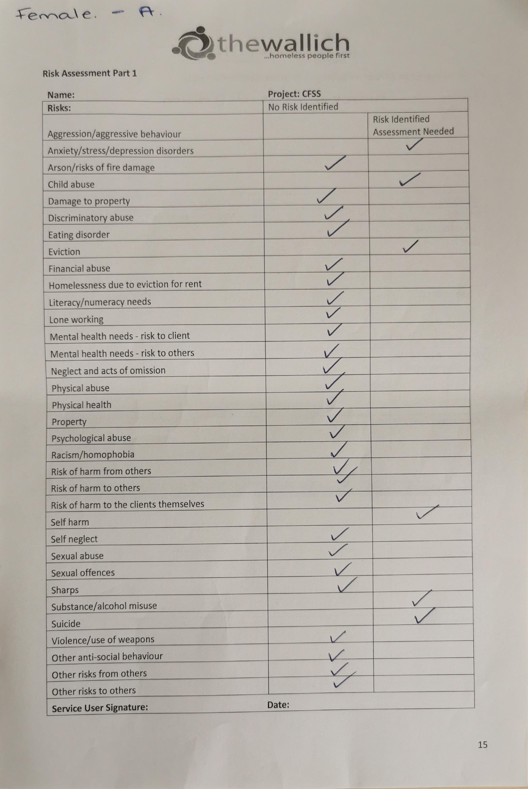
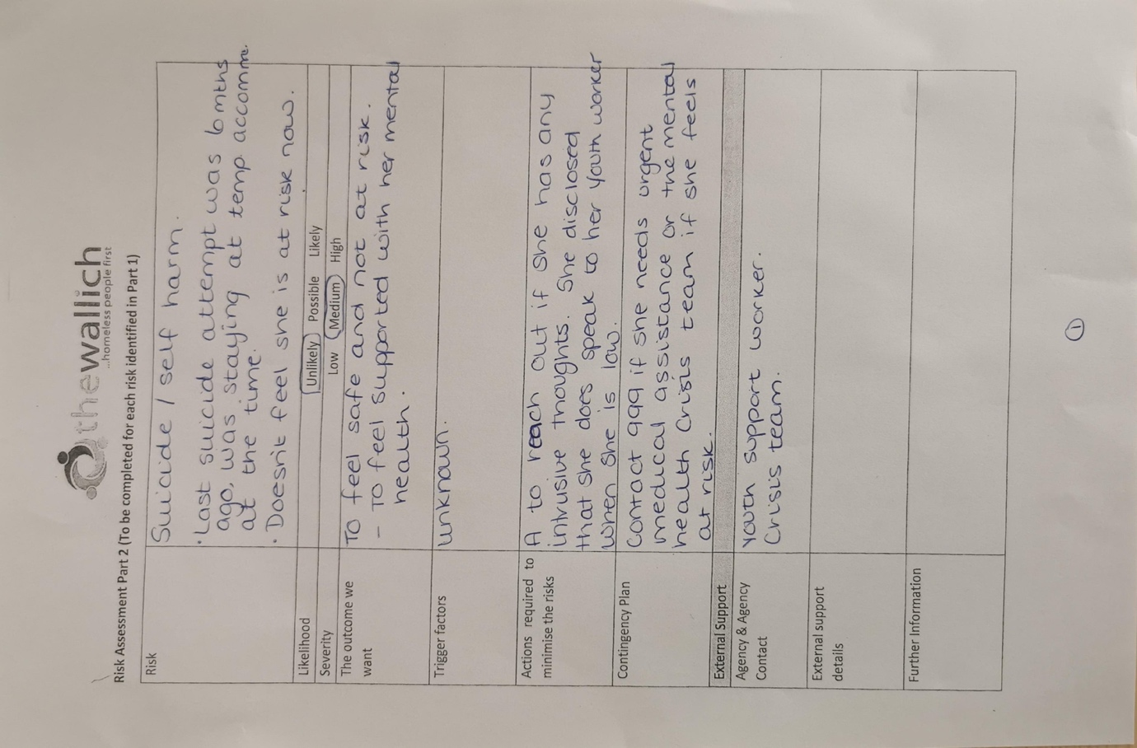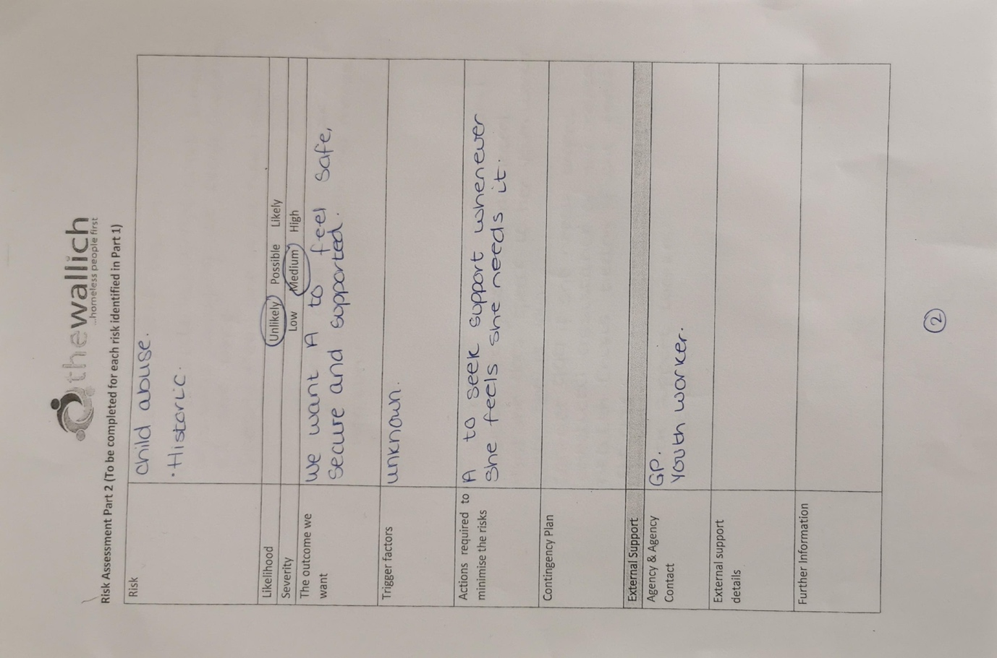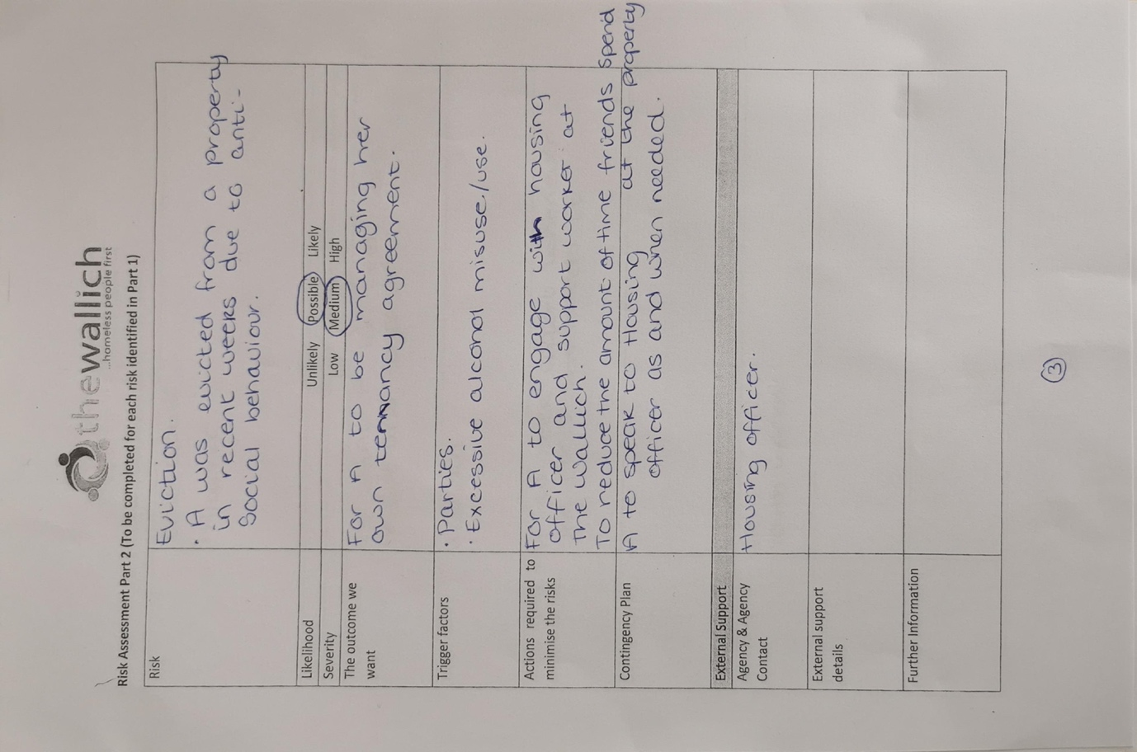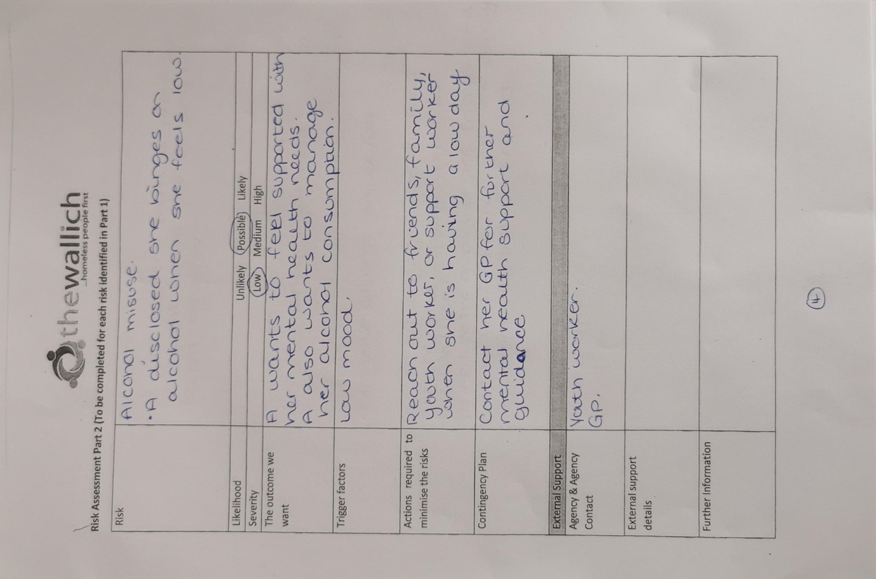

5 – Young Person Outcome Target Review

After some time at their new Training Flat, each young person discusses their outcomes with their Support Worker. I did not complete one of these, however Kerry did discuss the process with me.

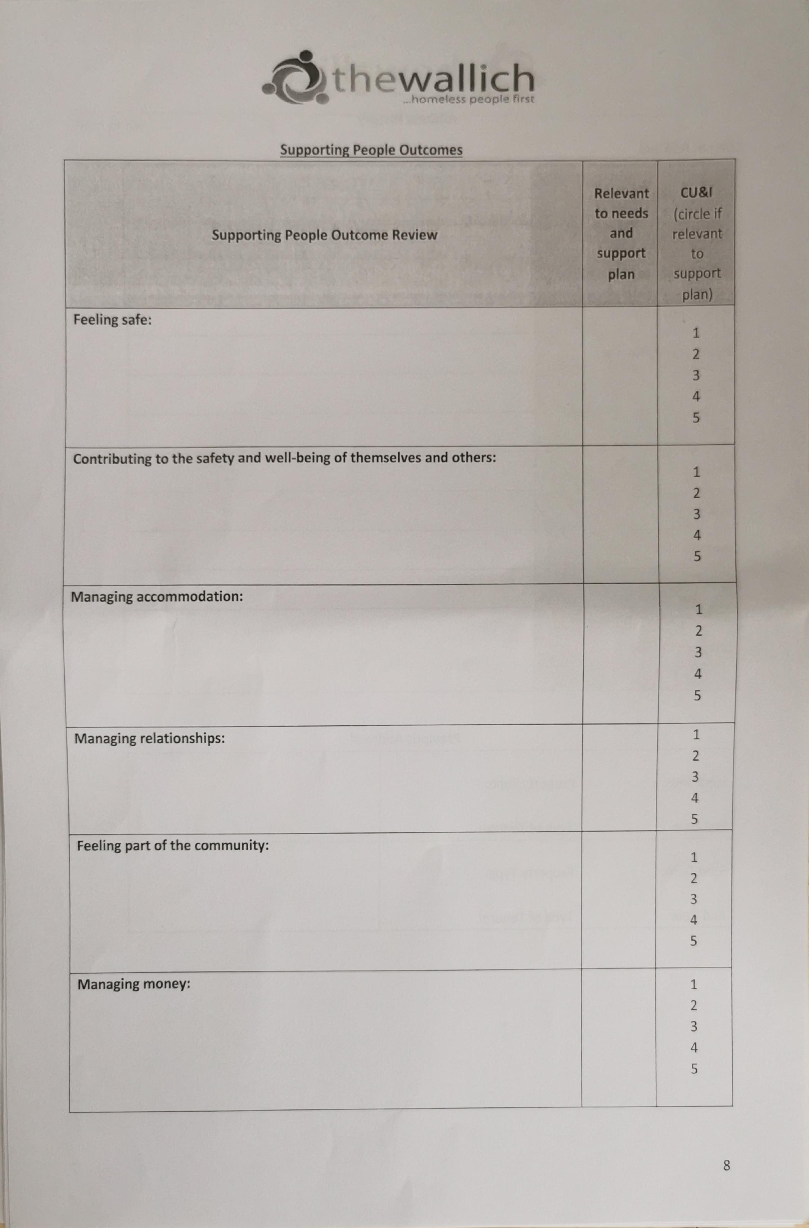
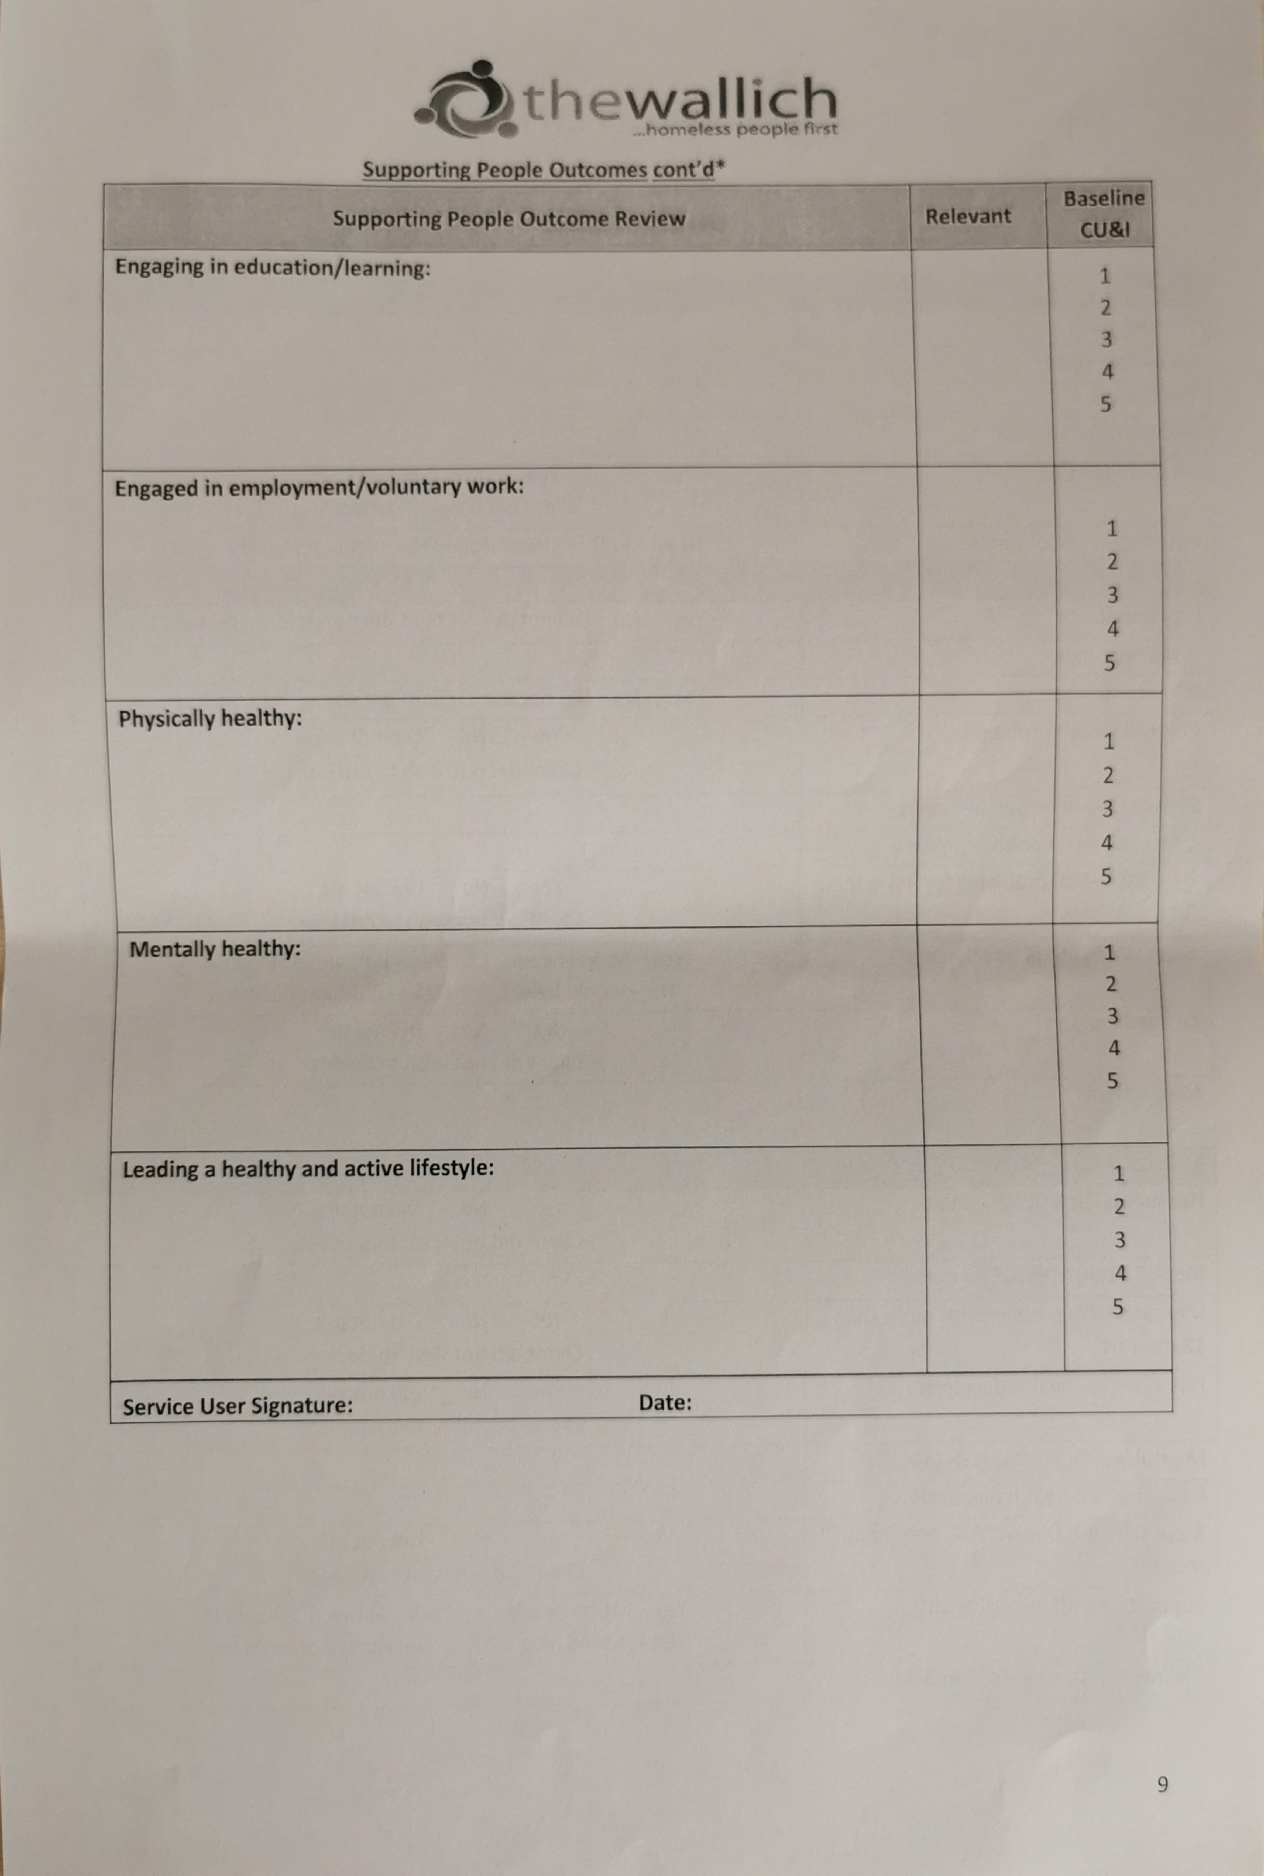

6 – Corona Virus Impact
The Wallich I shadowed a Floating Support Key Worker, Kerry. The experience was hugely affected by the global pandemic, Corona Virus. Although restrictions had been lifted slightly, it was still obvious that there was a pandemic. Whereas normally I would have been in the office shadowing Kerry, she now worked mainly from home therefore I was unable to see a lot of the daily work. Throughout the pandemic, a lot of the support that the young people had had to change from in-person meetings to virtual/online calls. I was fortunate to start the placement as restrictions eased and by wearing face masks, we were allowed access into the Training Flats where we could spend time, in person, with the young people.
When we visited the young people in the Training Flats, we kept our face masks on and when possible, we would sit in the kitchen/communal area where we were able to keep the door open ensuring a flow of fresh air. At times, this was frustrating as the masks acted as a barrier for the young people and it could be hard to see their real facial expressions. The young people were required to wear a mask even though we were entering their home.
Kerry did book some office time to show me referral forms, profiles, and other paperwork which I found valuable when we were working with different agencies discussing these forms. Due to not being able to spend a lot of time in the office, we were limited to how many hours we could accumulate in the week. For that reason, I have continued to volunteer in this setting into the summer months.

7 – Word Breakdown
Academic Journal excluding references – 5,500
References word total – 561
Academic Journal including references – 6,061
Academic Journal including references and appendices – 9,643

TurnItIn similarity with no references or appendices – 2%

