

MODULE CODE: ECPT6007

ASSESSMENT COMPONENT: A1 Curriculum Development Project

STUDENT NAME: Jac Thomas

STUDENT NUMBER: 2204038

AI Acknowledgement
I confirm that I have not used any AI tools in the research and creation of this assignment.
I confirm that I have not presented any AI generated materials as my own work.
I confirm that I have copies of my drafts, notes, and other resources I used, which I may be asked to provide in evidence.

Contents
1.0 Intro 4
2.0 Justification/Rationale 5
3.0 Aims and Objectives 7
3.1 Module Aims: 7
3.2 Module Objectives: 8
4.0 Professional Standards 9
5.0 Timetable/Scheme of work 10
6.0 Reading List 17
7.0 Module Assessment 18
7.1 Assessment Types 18
7.2 Assessment Question 18
8.0 Subject Specific Knowledge and Skills and Transferable Skills 20
References 21
Appendix 23
Lesson Plan 1 – Business Planning 23
Powerpoint for Business Planning 27
Business Planning Activity 37
Lesson Plan 2 – Business Types 39
Business Startup PowerPoint 43

1.0 Intro
This assignment is a curriculum designed to fill a gap in the Business and Management Course at UWTSD, the curriculum is all about developing skills in students to start their own businesses, the lessons that will help meet this goal are detailed within the scheme of work. This assignment will also detail why the existence of this curriculum is justified, The main aims and objectives, What professional standards the curriculum will be aligned with, a list of suggested reading and an overview of the assessment models used within the curriculum.

2.0 Justification/Rationale

For my Curriculum, I want to design a module for level 5 learners studying on the Business and Management Course at University of Wales Trinity St David, I have chosen to design a curriculum that focuses on preparing business students for actually starting up their own businesses. The reason I have chosen to deliver the curriculum to level 5, is because they will have had some development of analysis and evaluation within level 4, which I know from my own experience, Expecting Level 4s to have to handle this much analysis and evaluation could be unfair.
I found that when I myself was studying the course I learnt a variety of skills I could apply if I were to start my own business, I knew what marketing tactics were realistic for me to use, I knew the importance of accounting and I could employ strategy for certain business decisions, but I remain none the wiser on how to actually start a business and I think this a sizeable gap that the current business and management course has and it needs to be addressed. For example, even though there were Human Resources Modules, there is little to no instruction on the processes of hiring people, how training will be designed and little coverage in employment rights, this is something I feel would fit into the curriculum naturally.

An article by Bremner (2025) helps to highlight some of the shortcomings of the business programme at the university, Bremner’s (2025) article talks about the steps of setting up a business, they explain the steps of a business plan, including the financial planning element, choosing the correct business structure, securing the funds to establish a business, for example loans and crowdfunding and registering your business with the HMRC. Some of these elements I had learnt about during my time in Secondary education and Further Education, But during my time in Higher Education at UWTSD, I do not feel these elements were covered in any depth.
Again, when talking about employment, little of the process was ever talked about to me, The Small Business Academy (2026) outlines some processes that are needed when becoming an employer such as registering with HMRC, The legal requirements that need to be followed by a business and what procedures are followed in paying someone. Again, these elements are not covered on the course. Even if students do not run their own business they may find themselves within a position where they are expected to lead, the business course at UWTSD does look at leadership from a business point of view but it does not give any attention to how people would be hired, which is strange, as pointed out by The Institute of Directors (2026) a good leader will have a vision of the company’s future, a vision that may need the involvement of new individuals, not knowing how to find these individuals could hinder that vision.
A university statement about the business and management programme is as follows: “We bridge the gap between theory and practice, ensuring you understand the real world of work” (University of Wales Trinity Saint David, 2026), Part of this statement is fulfilled, provided that the student is going to work for someone else, as I found that this course gave me a great deal of employability, but I would argue that understanding the real world of work would entails being prepared to run your own business just as well as working for someone else. An article by Pardes (2026) details the poor US job market and how as a result of a lack of jobs many new graduates are deciding to create their own jobs, An article by Knowles (2026) highlights that the job market in the UK is also seeing a lack of demand for hiring, Students should then be prepared to create their own work as it could be a reality that without this curriculum they may only be prepared to work jobs in the UK that they cannot currently attain.

3.0 Aims and Objectives

3.1 Module Aims:
The overall aim for this module is to equip students with the skills to start and run a business effectively and legally. This will be achieved with the scheme of work, which will follow the overall module objectives outlined below, as well as the specific lesson objectives laid out for each lesson.
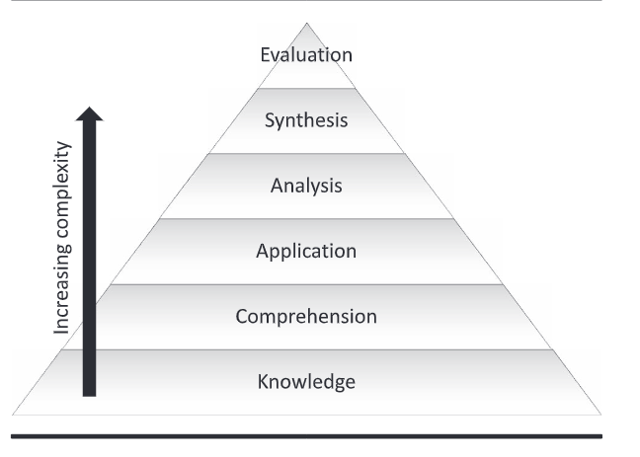
Figure 1: Blooms Taxonomy of Learning (Adams, 2015)

The Module and Scheme of Work Objectives of this curriculum are modelled off of Blooms Taxonomy of Learning. Adams (2015) explain each stage, these stages increase in complexity as students go through the levels of the hierarchy:
Knowledge – the retention of information
Comprehension – Demonstrate correct knowledge e.g. Paraphrasing, Peer teaching, etc.
Application - Applying knowledge to a new scenario
Analysis – Critical thinking, e.g. being able to determine whether something is fact or opinion
Synthesis – “creating a novel product in a specific situation”
Evaluation - Using information in critical thinking to way up the effectiveness of certain elements e.g. Using Feedback and Assessment results in determining the effectiveness of a lesson

3.2 Module Objectives:

By the end of the Module, Students should be able to:
- Demonstrate the correct knowledge of all the theories covered within the scheme of work
- Be able to use the theory they have used in practical scenarios
- Justify any decisions they make with critical and balance arguments

4.0 Professional Standards

This course will be in line with the professional standards for further education, laid out by the Welsh Government (N.D.), throughout the entire scheme of work professional standards will be met. To be more specific: The atmosphere in the class will see a commitment to the safety and welfare of students, supporting them for all their time studying on the curriculum, by extension there will be a value on equality and diversity by ensuring there is no discrimination of any kind within the classes. There will be a great volume of discussions and group interactions on this scheme of work, so it is important to ensure that all voices will be heard, and dignity and respect will be demonstrated by myself and learners to each other. The interactive elements of this scheme of work are designed to ensure an element of positive and collaborative relationship between myself and students. This curriculum will see a strong focus on independent learning which shows a commitment to enabling learners in being responsible for their own learning. The scheme of work is designed with a variety of different activity styles; this range of media is designed to be in line with the standard of planning and delivering effective teaching.

5.0 Timetable/Scheme of work

Programme Title: The Essentials of Running a Business | Venue: UWTSD IQ Building | Lecturer: n/a
Hours per week: 4 (Running from 11/1/27 to 15/3/27) | Day/Time:  Monday 9:00 – 13:00 | Number of weeks: 10
Module Aim: to equip students with the skills to start and run a business effectively and legally | Module Objectives:  - Demonstrate the correct knowledge of all the theories covered within the scheme of work  - Be able to use the theory they have used in practical scenarios  - Justify any decisions they make with critical and balance arguments | Assessment: 2000-word essay
Week Number | Topic | Aims and Objectives | Teaching and Learning Activities | Resources Required | Assessment
1 - 11/1/27 | Business Types | The aim of this lesson is to provide students with a detailed overview of the different types of business types that can be established  By the end of the session students should be able to:  - Recognise the different types of business types including sole traders, partnerships, public and private limited companies  - Explain the advantages and disadvantages of each of the startup types  - Apply the knowledge gained in a class discussion | The lesson will start with a plenary asking students what they know about business startups, to gauge entry level knowledge. There will be a lecture, with opportunities for engagement, designed to convey the basic information about business startups to students to students, I will ask students to carry out a research activity in groups for the advantages/disadvantages section, after which they will feed their answers back. The discussion at the end will be done as individuals, to see how well the students can use the information they have attained within the lesson to discuss which business startup they would choose and why. | Laptop/Phone needed for research – can be provided if students do not have them | The group activity is student led learning, but when answers are fed back, I can address knowledge gaps if need be. The end activity is for me to see how well students can apply the knowledge they have gained
2 -18/1/27 | Business Planning | The Aim of this lesson is to equip students with the skills and knowledge needed to develop a good business plan  By the end of the session students should be able to:  - Outline the steps of a business plan  - Explain each stage of a business plan in depth  - Apply their knowledge by assessing the quality of various business plans | The lesson will start with an opening plenary designed to engage students; they will be asked what they think is involved in a business plan. There will be a lecture that will cover the elements of a business plan in little detail, the students will be asked to gather the rest of the knowledge in a research activity (should be done in groups), knowledge gaps (if any) will be addressed afterwards with the following slides. The students will then be given examples of business plans that have strengths and weaknesses, and it is hoped they will be able to find said strengths and weaknesses with their knowledge. | Laptop/Phone needed for research – can be provided if students do not have them | The research activity at the start should get students to demonstrate how well they can explain each aspect of business planning. The latter activity will help me to see how critical they can be off business plans based off of what they have learnt.
3 - 25/1/27 | Funding | This lesson builds on the funding section of the lesson plan but will go into more necessary detail  By the end of the session, students should be able to:  - Outline and explain the different methods of funding available to them  - Explain the advantages and disadvantages of different methods of funding  - Apply knowledge in a class discussion | The lesson will start with a call back to the previous lesson on business planning where students will be asked to recall what they can about funding methods. The advantages and disadvantages can be done as a lecture but ensure there are plenty of opportunities for engagement. An end discussion on the topic of which funding method is best for a business will conclude the lesson. | None are necessarily required but note taking aids are highly recommended. | The discussion will see how well students can use the information they have learnt in the lesson to defend their opinions. ar
4 – 1/2/27 | Employment | The aim of this lesson is to teach students about the process of hiring someone:  By the end of the lessons students should be able to:  - Outline what is meant by employment  - Explain what employment registration looks like based on what type of business is being run (e.g. Sole Trader)  - Explain the procedures followed when employing someone (contract, payroll etc.) | The lesson will start with an opening plenary to gauge learner knowledge about employment, After a brief lecture on the basics of employment, a research activity will be set to students to see what they can find out about employment in different types of business, any knowledge gaps will be addressed during the feedback, a lecture will be given then on the procedures of hiring someone, it will be followed with an activity where students will be given a scenario in one of the several business types and they must lay out how they would employ a person within that business. | Laptop/Phone for research activity – a device can be provided if need be. Paper/Laptop for completing the last activity – this is down to student preference, and both can be provided. | Assessment of knowledge will take place for the most part in the final activity, which will measure not only if the knowledge is correct but also if it is being applied in the correct way.
5 – 8/2/27 | Hiring Process | The aim of this lesson is to enable students to develop knowledge on how they can hire people, what interviews would like and how the decision process may proceed  By the end of the lesson students should be able to:  - Outline and explain several methods of advertising jobs/seeking potential employees  - Outline and explain the methods in which applications can be filtered  - Demonstrate a knowledge of how the interview and decision-making process would be carried out and apply that knowledge | The lesson will be started with an activity, getting the students simply to list as many different ways as possible of advertising a job role they can think of, engaging them before giving a lecture that will cover several different methods of doing so. The next section of the lesson will focus on how applications can be sorted through, An activity could be set before the lecture getting students to research several different methods and tools of filtering applications. The final segment of this lecture will then look at the interview and decision process getting students to design their own | Laptop/Phone will be needed for research – can be provided if need be. Laptop/Paper for last activity (up to student preference) – Can be provided if the students do not have their own. | Knowledge will be assessed during the ending activity, gauging not only if the correct knowledge has been retained but measuring how well students can apply this knowledge.
6 – 15/2/27 | Training Employees | The aim of this lesson is to show students methods of training employees.  By the end of the lesson, students should be able to:  - Outline and explain several different methods of training employees  - Apply the knowledge gained towards by evaluating the options at hand | A starter activity where students think of different ways of training employees and feedback afterwards, could be a good way to engage them at the start of the lecture. After looking over some of the methods of training employees in an interactive lecture, students will be asked to justify which method/methods they would use and why and then feedback to the class. | Paper/Laptop (which can be provided if students should need it) – This will be needed for the final activity | The last activity of the session will show if the students have a deep knowledge of the training methods that have been covered by weighing them up against each other.
7 – 22/2/27 | Tax for Business | The aim of this session is to gives students an overview of what it is like for businesses to pay tax  Students should be able to:  - Outline what taxes a business should have to pay to HMRC  - Explain some of the tax laws business have to follow  - Apply the knowledge they have by completing an in-task activity | An Opening plenary will be a good way to gauge learner knowledge. A research activity where students feedback their answer on different tax types and what taxes must pay can help to ease learners into the topic. Knowledge gaps can be covered within the lesson plan. The ending activity can take the form of an interactive quiz. | A device for the research tasks and interactive quiz – which can be provided if the students do not have their own. | The quiz at the end of the lesson should cover all that is involved in the lesson, it gives students a chance to demonstrate that they have attained the knowledge that is hoped they achieve but also knowledge gaps can be addressed with a quiz
8 – 1/3/27 | Establishing Supplier Relations | The aim of this session is to leave students with adequate knowledge on how suppliers can be secured when starting out as a business and what processes are invovled  By the end of the session students should be able to:  - Outline the purpose of and need for supplier relations as a business  - Explain what processes would be involved in finding the right supplier and maintaining a relationship  - Create a plan for a new business on how they can access suppliers and maintain a good relationship with them. | An opening plenary asking students what suppliers do for businesses and why they think it is important to maintain a relationship with them is a great way to start the lecture. A lecture can be provided on the processes of finding a supplier and maintaining a good relationship with them but there can be many questions throughout, to help engage students. The end activity will see students given a prompt in which they must create a response proposal, where there must be justification for choices, which they can share with the class once the activity is concluded. | Laptop/Paper required for last activity | The last activity is designed to see how well students can use their newfound knowledge to synthesise a response and justify decisions, which will show application of knowledge, analysis and synthesis skills.
9 – 8/3/27 | Legal Compliance | The aim of this lesson is to leave students with knowledge of what laws they will have to comply with as a business and as an employer  By the end of the session students should be able to:  - Outline what laws must be followed when running a business (e.g. Health and safety, employment rights, Trade laws, etc.)  - Explain the impact of these laws on operating a business  - Apply the knowledge to a series of case studies | A starter activity where students are asked to list what laws businesses have to follow will be a good way to gauge what knowledge they already possess or need to develop, either way it should help to engage them within the lesson. When going through the slides students should be asked what impact they think these laws have on businesses and should be encouraged to explain their answers. The last activity of the lesson should see learners look through a series of case studies and be able to explain what laws the businesses are following and how and also what laws they are not following and what consequences they could face. | A laptop to access and edit the case studies on Moodle or alternatively pen and paper if students prefer to write things out. | The case study activity will allow students to not only apply their knowledge but show analysis of the situations at hand, allowing them to demonstrate the depth of their knowledge, if there any knowledge gaps they can be addressed
10 – 15/3/27 | Tutorial/Assignment Workshop | The aim of this session is to provide students with a chance to ask any questions they may have about the assignment, be it about how they should structure their essay or if they have a knowledge gap they wish to address | There will not be any set activities, There can be a Q and A of sorts if students are happy to ask questions in front of others, but they may wish to have one to ones where they discuss their work on an individual level | Students should have a device to bring up their work – there are devices at the university that they can use should they have no access to the tech. | There will be no assessment - this session is designed as a progress review and opportunity for students to get help should they need it.

6.0 Reading List

There will be a suggested reading list for students that undertake this curriculum, these sources can be of use to them when trying to further subject knowledge and when completing the assignment.
Item | Resource Type | Available at:
Business planning and market strategy by E. K. Valentin (2015) | Book | UWTSD Online Library
Job Interviewing -- Keeping Employees All In the Family -- How to hire someone whose core values agree with yours by David Myron (1999) | Magazine Article | UWTSD Library
Understanding Business Taxes by The UK Government (2026) | Website | https://www.business.gov.uk/support/business-tax-and-reporting/understanding-business-taxes/
Comparing Business Structures by the UK Government (2026) | Website | https://www.business.gov.uk/support/business-structures-governance-and-ethics/comparing-business-structures/

7.0 Module Assessment

7.1 Assessment Types

This Curriculum will feature Initial, Formative and Summative Assessment.
Capes (2024) describes initial assessment as gauging entry level knowledge as well as communicating what learners will need educators to focus on, this will happen before the lesson commences. In the context of this curriculum, initial assessment will take place in a majority of lessons in the form of a starter activity, be that an opening plenary, a simple listing activity or a research activity. I will be using this to see if there are particular areas to focus on when delivering a lesson but also, I feel these activities are great ways to engage students.
Blundell and O’Brien (2019) explain that formative assessment is more focused on how students can improve or maintain a good performance based on activities such as Quizzes, Reflective activities and Group discussions. They also note that these activities lead to qualitative feedback for students and not a score. In this curriculum, formative assessment will be carried out within the lesson to assess that students are attaining the correct knowledge and can apply this knowledge to different scenarios, for example the lesson on business planning will have a research activity with a feedback session to follow which will show how well students are able to explain the information they find and highlight any knowledge gaps that need to be filled.
Summative Assessment on the other hand is defined by Taras (2005 ) as an encapsulation of evidence up to a given point and is the final stage of a judgement, in relation to the curriculum I am teaching, this will be a final grade that is awarded to students based on the score they attain In a final project. The summative assessment in this curriculum will be an essay. Race (2020) discusses many of the advantages of essay writing, they note that essays demonstrate the depth of the knowledge attained by students, it allows for students to express their own opinion on a matter, they note that this can make it hard to mark fairly, but this is why arguments need to be justified and the same marking criteria is applied to all learners and they note that essays are typically a form of assessment that students will be familiar with, which on the business and management courses at UWTSD they will have had some experience with. .

7.2 Assessment Question

“What elements of starting and running a business do you consider most important – Justify your choices and provide balanced arguments” – 2000 words

The Due date for this essay is due 22/3/2027, the reason it is set for this date is so that students have enough time to expand on their subject knowledge through attending lessons rather than set the assignment deadline during the middle of their studies, setting it on this date also means that students will have a week after the assignment workshop to make any changes.

8.0 Subject Specific Knowledge and Skills and Transferable Skills

The whole curriculum is focussed on developing subject specific knowledge and skills, through these lessons students will be able to not only have the employability skills to work for someone else but they will have the necessary knowledge and skills to be their own boss and run their own business if that is the path they choose to pursue. In regards to the development of transferable skills many of the formative assessments seen within the scheme of work, such as the class discussions, business plan analysis and quiz will not only enable us to measure knowledge but develop how well business can apply and analyse the knowledge they attain within the course and it will work on how they balance their arguments, all of these skills will also be assessed within the final assessment.

References

Adams, N.E. (2015) “Bloom’s taxonomy of cognitive learning objectives,” Journal of the Medical Library Association, 103(3), pp. 152–153. Available at: https://doi.org/10.3163/1536-5050.103.3.010.
Blundell L. and O’Brien R. (2019) ‘A spotlight on... Formative Assessment’ Centre for Innovation in Education Available at: https://www.liverpool.ac.uk/media/livacuk/centre-for-innovation-in-education/staff-guides/formative-assessment/formative-assessment.pdf Accessed: 23rd April 2026
Bremner M. (2025) “How to start a business in 10 steps: a guide for UK entrepreneurs” Available at: https://www.sumup.com/en-gb/starting-business/how-to-start-a-business/ Accessed: 24th April 2026
Capes K. (2024) “What Is Initial Assessment? A Complete Guide” Available at: https://brooksandkirk.co.uk/the-importance-of-initial-assessment-in-education/ Accessed: 30th April 2026
Institute of Directors (2026) “Leadership in the workplace” Available at: https://www.iod.com/resources/business-advice/leadership-in-the-workplace/ Accessed: 5th May 2026
Knowles T. (2026) “Britain’s job market ‘floundering’ as companies remain cautious about hiring” Available at: https://www.theguardian.com/business/2026/mar/09/britain-job-market-floundering-companies-cautious-hiring Accessed: 5th May 2026
Pardes A. (2026) “How AI’s threat to entry-level jobs is turning gen Z into ‘Generation Entrepreneur’” Available at: https://www.theguardian.com/technology/ng-interactive/2026/apr/25/gen-z-entrepreneurs-business-ai Accessed: 5th May 2026
Race P. (2020) ‘The lecturer's toolkit : a practical guide to assessment, learning and teaching’ Fifth Edition, Routledge
Taras, M. (2005) “ASSESSMENT - SUMMATIVE AND FORMATIVE - SOME THEORETICAL REFLECTIONS,” British journal of educational studies, 53(4), pp. 466–478. Available at: https://doi.org/10.1111/j.1467-8527.2005.00307.x.
The Small Business Academy (2026) “Employing someone for the first time – A useful guide” Available at: https://thesmallbusinessacademy.co.uk/employing-someone-for-the-first-time-a-useful-guide/ Accessed: 25th April 2026
University of Wales Trinity St David (2026) “Business and Management” Available at: https://www.uwtsd.ac.uk/subjects/business-and-management Accessed: 25th April 2026
Welsh Government (N.D.) “Professional standards for further education teachers, work-based learning practitioners and adult learning practitioners in Wales” Available at: https://educators.wales/sites/default/files/2023-07/Professional%20standards%20for%20FE%20%20WBL%20and%20ACL%20Practitioners%20-%20June%202023.pdf Accessed: 29th April 2026

Appendix

Lesson Plan 1 – Business Planning


Topic: Business Planning |  | Class: Level 5 Business
Date: 18/2/27 | Length of lesson: 4hrs |  | Number of students: n/a
Resources required:
Laptop/Phone for the research activity – which can be provided if students do not have their own.
Pen, Paper and Printouts of resources as backups for technological failure and as backups for students

Aim of Lesson:

The Aim of this lesson is to equip students with the skills and knowledge needed to develop a good business plan

Learning Outcomes – The Learners Should Be Able To:

- Outline the steps of a business plan
- Explain each stage of a business plan in depth
- Apply their knowledge by assessing the quality of various business plans

Previous student knowledge required for the session:

None required

Anticipated difficulties (if applicable):

Technological issues which would affect the research activity and PowerPoint. However, the lesson can be delivered without a slideshow and the research activity and substituted with an interactive lecture, the last activity can be done by giving printouts and providing pen and paper for the students to complete the activity

Conflict within group activity – be aware of any conflict that may arise within the group – know the cohort and avoid pairing together individuals that may be more likely to argue

Professional Standards (where are these being met within the session)

The session focuses on learners being responsible for their own learning by means of finding information themselves in the research activity.

The Groupwork element of the lesson should enable learners to build positive relationships with one another

The session will demonstrate effective delivery of teaching by using a variety of different activities within the lesson with an aim to enhance the learning experience.

Lesson Detail:

Stage | Focus | Strategy | Time
Opening | What is involved in a business plan | Discussion | 10 mins
Main Body | Brief Coverage of the sections of a Business plan and why it is important | Lecture with opportunity for student engagement | 20 mins
Main Body | Find information on each of the stages | Research Activity - In groups | 30 mins
Break | - | - | 20 mins
Main Body | Feedback information from Research Activity | Feedback | 20 mins
Main Body | Cover the slides following the activity, just to recap what has been covered and pass on information that may not have been passed on | Lecture with opportunity for engagement | 30 mins
Main Body | Final Activity – Business Plan Review | Activity | 1 hr
Break | - | - | 20 mins
Main Body | Feedback from Review Activity | Discussion | 25 mins
Conclusion | Any Questions | Q and A | 5 mins

Assessment Strategies: when and how are they included within the lesson?

Research activity – where students will find out information on the different aspects of a business plan – which will assess how well they can explain the information they find and if knowledge gaps need to be addressed.

Review Activity – Students will be assessed on how they apply their knowledge to these examples, it should also build on evaluative abilities and again it is an opportunity to address knowledge gaps should they appear.

Powerpoint for Business Planning

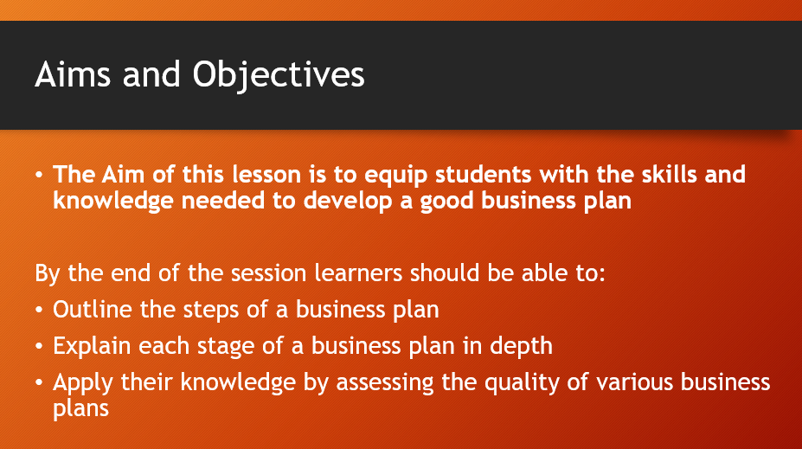
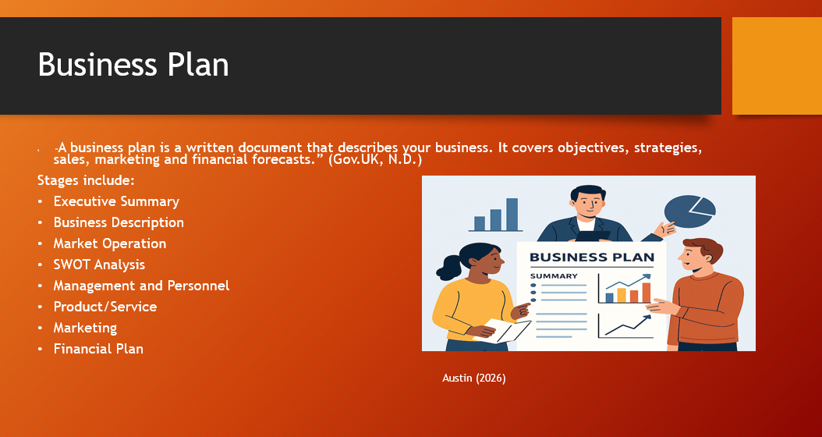

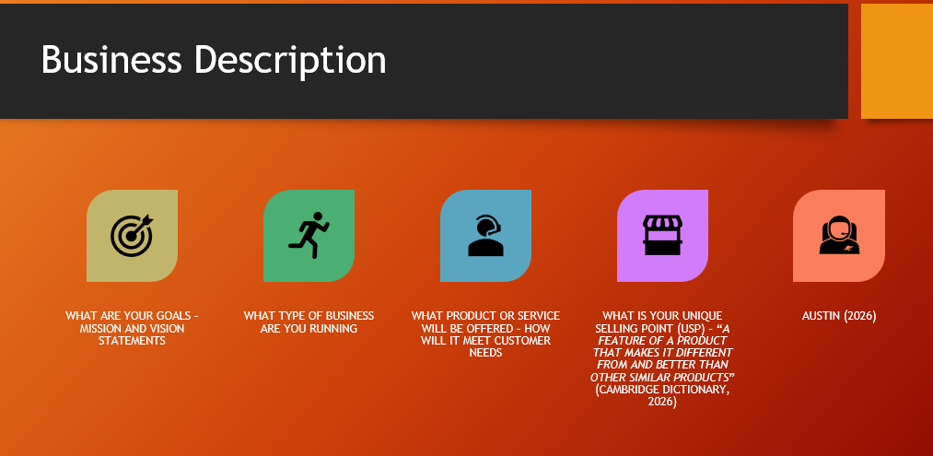
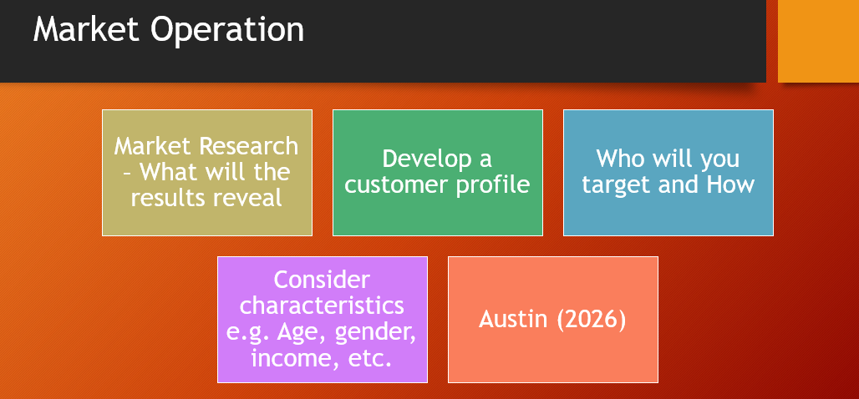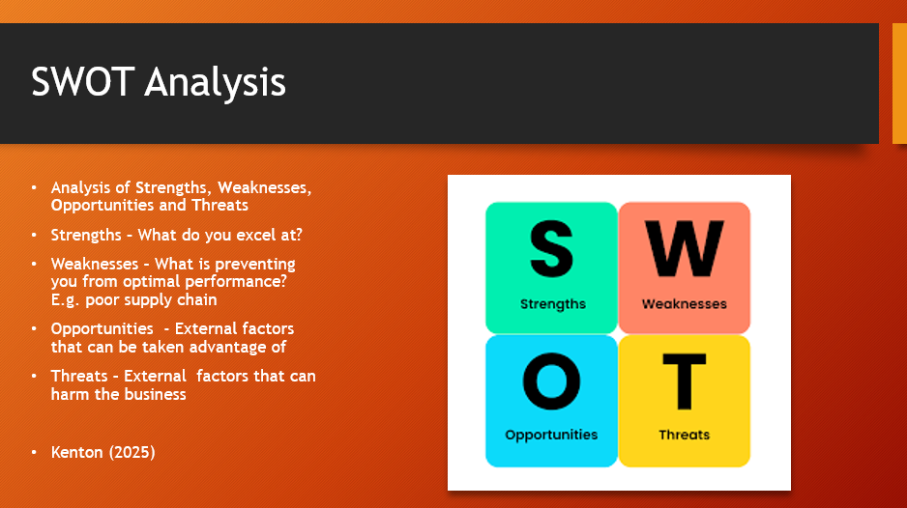
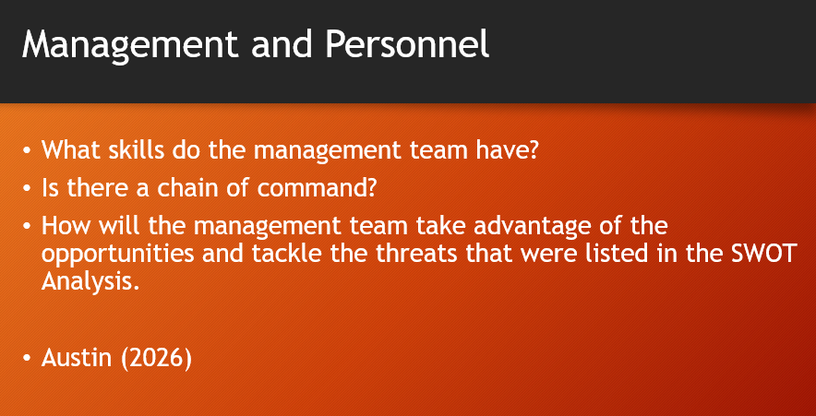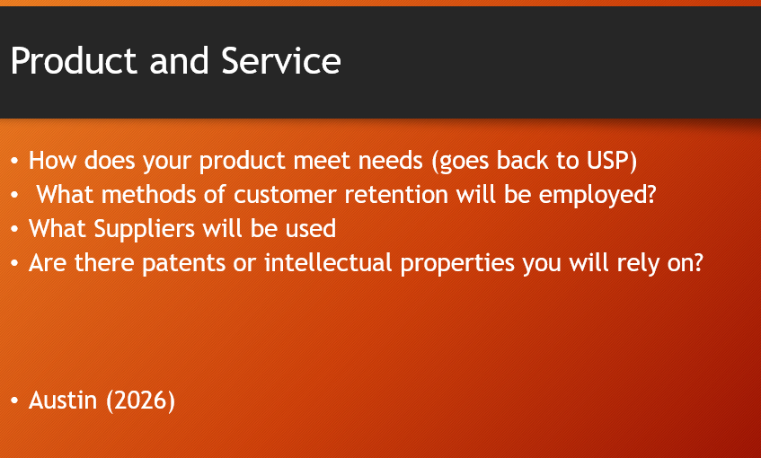
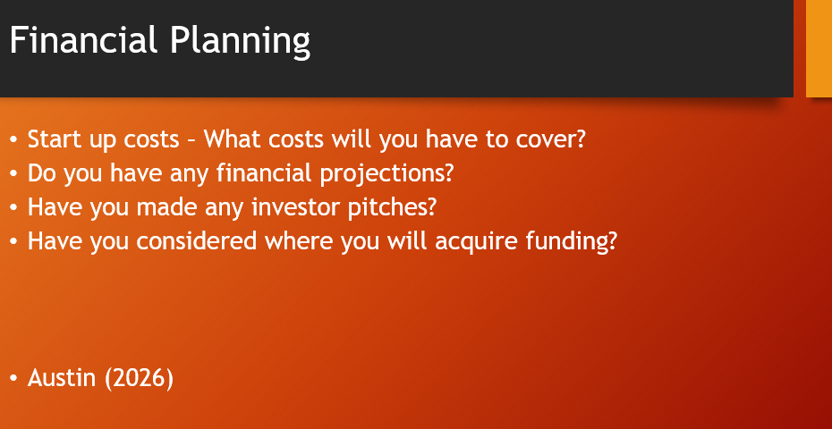
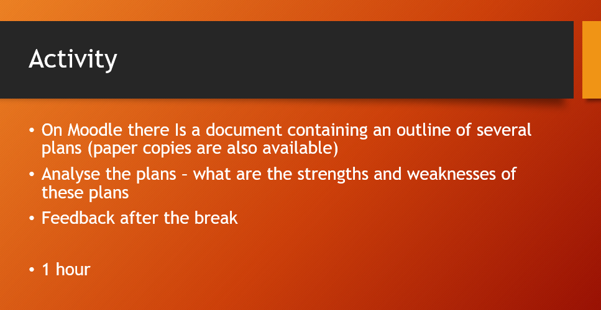

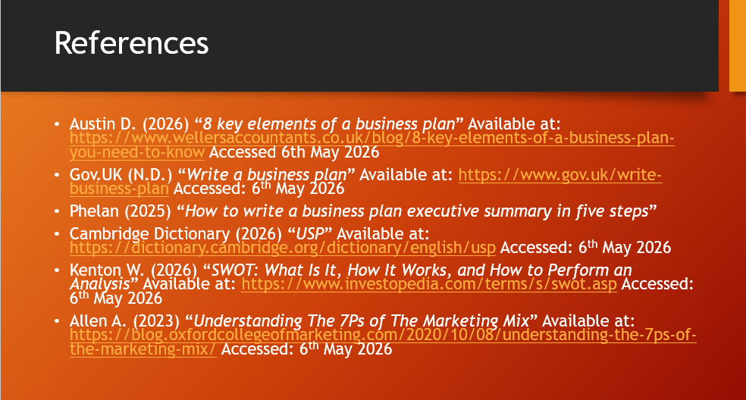

Business Planning Activity

Take a look at the following Business Plan outlines, What are some of the strengths and weaknesses you see in these plans

Person 1

Person 1
Person 1 wants to start their own gym that is easily accessible and affordable within their local area, they have concluded from market research that this is a want for many people in the area.
They have not devised a mission or vision statement
They want to raise awareness through social media advertising as they have found it is a low cost, but they have not considered that many people in the area are in an age bracket where social media is not commonly used
Person 1 has secured investment for the startup of the gym and has mapped out the costs for the foreseeable future as well as determining how many members will be needed to meet costs and make a profit
There is no SWOT Analysis conducted, so they remain unaware of what their biggest strengths and opportunities are, and they do not know how to address the weaknesses and threats they could face
Person 1 has developed a management team but has yet to decide what strategies they shall use.

Person 2
Person 2 wants to create their own sports drink line, they want it to appeal to those on a budget and offer unique flavours in contrast to other brands such as Lucozade, however they have not checked if such a market exists. They have not put together a mission or vision statement
They have accumulated zero funding, nor have they planned to get it, have no idea where they are going to procure their ingredients from or how much they cost. They want to launch the campaign with a tv advert but have not researched any costs nor do they know how long it would air for. No SWOT Analysis has been created, nor do they have any personnel to support them.

Person 3

Person 3’s business plan features an executive summary that succinctly breaks down what is involved within the plan. Their mission and vision goals are very clear
Person 3 has conducted extensive market research to find that people want a cheap music streaming service that provides high quality audio. They found their main demographic are people aged 18-24 and that the best way to target them is through social media.
Person 3 has made a detailed financial plan that looks into how costs will be covered, how many members they will need to attain and by what time so that costs can be covered and hopefully a profit made.
Person 3 is currently in the middle of trying to secure the rights to use certain bands and artists on their platform. They intend to offer a reward catered to users based on their favourite artist as a means of customer retention.
Person 3 has made a detailed SWOT Analysis that helps them take advantage of strengths and opportunities and devise ways to address weaknesses and threats.
In regard to funding, Person 3 has secured a loan that will help them start the service

Person 4

Person 4 wants to start selling a chocolate bar that is low in calories and comes in a variety of unique flavours, they believe this will sell well for those trying to lose weight but do not have any market research to back this up.
Their mission and vision statements are very clear

They have worked out how much it will cost to produce these bars and where they can get the raw materials supplied from. Person 4 has had investments offered for when the product begins to sell

Person 4 has looked at TV adverts as a form of advertising believing that most people that wish to lose weight are in the age bracket that prefer to watch television, but they have not checked if this is true.

They have completed a SWOT analysis that should help them make some decisions based on what they expect to encounter externally (Opportunities and Threats) and how they intend to deal with internal issues.

Lesson Plan 2 – Business Types

Topic: Business Startups |  | Class: Level 5 Business
Date: 11/1/27 | Length of lesson: 4 hours |  | Number of students: n/a
Resources required:
Laptop/Phone needed for research – can be provided if students do not have them

Aim of Lesson

The aim of this lesson is to provide students with a comprehensive overview of the different types of business types that can be established

Learning Outcomes – The Learners Should Be Able To:

- Recognise the different types of business startups including sole traders, partnerships, public and private limited companies
- Explain the advantages and disadvantages of each of the startup types
- Apply the knowledge gained in a class activity and discussion

Previous student knowledge required for the session:

None required

Anticipated difficulties (if applicable):

Technology does not work, in which case the lesson can be delivered without slides, and the research activity can be substituted for an interactive lecture segment. The discussion activity can be carried out regardless.

Conflict within group activity – be aware of any conflict that may arise within the group – know the cohort and avoid pairing together individuals that may be more likely to argue

Professional Standards (where are these being met within the session)

During the class discussion there will be respect from myself and between the students when people voice their opinions, everyone will be given equal opportunities to speak.

Students will be responsible for their own learning with the research activity which is designed to empower and engage them.

Lesson Detail:

Stage | Focus | Strategy | Time
Introduction | Guage entry level knowledge | Plenary | 5 mins
Main Body | Cover the different types of business startups | Lecture with different types of engagement | 1 hour
Break | - | - | 20 mins
Main Body | Research the Advantages and Disadvantages of business startups | Research Activity in Groups | 40 mins
Break | - | - | 20 mins
Main Body | Feedback from Research Activity | Feedback | 30 mins
Main Body | Cover slides that can help in addressing potential knowledge gaps | Lecture with opportunities for questions | 30 mins
Main Body | Discuss which business startup style is best Is optimal | Discussion | 30 mins
Conclusion | Opportunity for Questions | Closing Plenary | 5 mins

Assessment Strategies: when and how are they included within the lesson?

The group activity will allow me to assess how students convey the information they have found and if there are any knowledge gaps I should need to address.

The latter activity will see how students can use the knowledge to justify their decision on which business startup method they think is more optimal.

Business Startup PowerPoint



