
Starters
- Welsh Cawl (This traditional thick soup of Welsh contains turnips, carrots, leeks, seasonal vegetables and potatoes. Also, you can add bacon chunks, lamb, beef, shredded chicken and ham hocks as per your choice) £12.25
- Souvlaki salad (The dish comes with a bed of ice lettuce with black olives, tomatoes, red onion, feta cheese and topped with grilled chicken, bacon strips and butter tossed shrimps) £13
- Battered mushroom with your favourite stuffing (It contains fried button mushrooms with beer batter and you can choose any stuffing for mushroom among shredded chicken with blue cheese, bacon cubes, grilled cottage cheese or mozzarella) £11
Entrée menu
- Grilled pork chops (marinated pork with Dijon mustard, parsley, soy sauce, lemon zest and brown sugar. Then grilled with olive oil. It serves with sauteed French beans, green peas and carrots and garlic toast) £14.5
- Spaghetti with meatballs (it contains beef or pork meatballs marinated with Worcestershire sauce, cheese, garlic, pepper and salt and placed on semi-thick spicy gravy. The dish comes with a bed of sauteed spaghetti and topped with meatballs with spicy red gravy) £14.5
- Broccoli and Chicken Alfredo (it comes with sauteed broccoli and chicken in chef's special rich Alfredo sauce and is also served with freshly cooked penne pasta. Also, if you want, you can opt-out chicken and can add mushroom or cottage cheese instead of that) £12
- Roasted beef with multigrain bread and spicy vegetable gravy (it comes with spicy roasted beef slab along with fresh multigrain bread. You can add French fries and mashed potatoes tossed in butter) £16
- Brit seafood pie (it contains chunks of smoked haddock, cod, grilled tuna and salmon. also it includes juicy cockles as a cherry on top of this dish. It comes along with cheese sauce with laverbread) £13
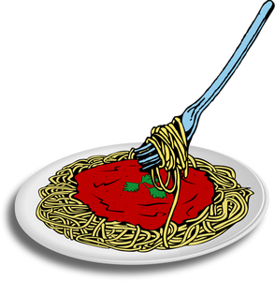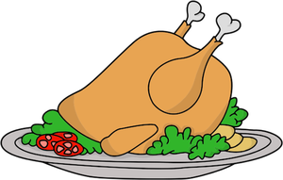
HOTEL TRINITY



Special note: if you have any food allergies and a preference for vegetarian dishes, please speak to our floor staff about your meal ingredients before placing the order.
DUE TO COVID SITUATION, YOU CAN ALSO TAKE AWAY YOUR ORDER. WE ACCEPTED BOTH CASH AND ONLINE PAYMENTS TRANSACTIONS.
Beverage menu
WINE
White house wines (100 ml) £7
Sparkling blush (100 ml) £8.5
Wine with spark (100 ml) £9

COCKTAILS
Blueberry margarita (it comes with a Mexican twist along with that muddled blueberries, Cointreau, gin and lime juice) £11
The cherry on top (it contains cranberry juice, Maraschino cherry liqueur, Welsh cream and apple juice) £11
Gin afternoon tea (contains gin, lime juice, cardamom tea, cranberry juice and served cold in a nicely curated traditional teapot) £9
Citrus and caramel cocktail (contains lime juice, salted gin, liquid caramelized hazelnut) £7

SOFT BEVERAGES
Coca cola (classic and diet) 330 ml £7
Hot chocolate with whipped cream, £10
Vanilla milkshakes with crushed strawberry and blueberry £8

Desserts
- Bara birth (traditional Welsh fruit cake contains rich dry fruits, brown sugar and cold black tea. It served with cinnamon tea and one vanilla wafer) £10
- Homemade pies (it comes with cinnamon tea and vanilla wafers) £7
- Sundaes (ask our waiter or waitress for today’s selected flavours) £6
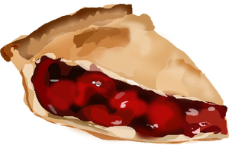

COMBOS
● Mozzarella sticks with Welsh Cawl and Sparkling blush £9
● Souvlaki salad with French fries £8
● Baked potatoes and sparkling blush £17


