
Student Name: Kuldip Kishorbhai Bhuva
Student ID: 2517333
Company: Tesla
Product: Model 3 Electric Vehicle
Country: United States
Module Name: Strategic Management (LCMB7003)
Lecturer Name: Hoang Nguyen
Word Count: 5079
Submission Deadline: 12th August 2026

Table of Contents
Section 1: Strategic Analysis 4
1. Organisational Context and Overview 4
1.1 Introduction to Tesla 4
1.2 Historical Development 4
1.3 Mission and Vision 4
1.4 Business Model 5
1.5 Industry Overview 6
1.6 Key Competitors 6
2. External and Internal Environment Analysis 7
2.1 External Environment Analysis (PESTEL Framework) 7
2.2 Critical Success Factors 10
2.3 Strategic Challenges in External Environment 12
2.4 Internal Environment Analysis 13
2.5 VRIO Framework Analysis 14
2.6 Internal Strengths and Competitive Advantage 15
3. Comprehensive and holistic view of the organisation 17
3.1 CSR and Sustainability Objectives 17
3.1.1 Overview of Tesla's CSR Strategy 17
3.1.2 Alignment with Business Objectives 18
3.1.3 Critical Evaluation 19
3.2 Balanced Scorecard 20
3.2.1 Introduction to Balanced Scorecard 20
3.2.2 Financial Perspective 20
3.2.3 Customer Perspective 20
3.2.4 Internal Business Processes 21
3.2.5 Learning and Growth 21
4. Strategic Choices and Implementation 23
4.1 Business-Level Strategies 23
4.2 Most appropriate strategy for the organisation. 24
4.2.1 Strategic Choice 24
4.2.2 Ansoff Matrix 25
4.2.3 SAFe Framework Analysis 25
4.3 Delivering Optimum Performance and Sustained Competitive Advantage 27
4.4 Challenges on Strategic Implementation 28
4.5 Ways of Mitigation 29
Section 2: Reflective Account 30
Reflection Using Gibbs Reflective Cycle 30
Introduction to the Framework 30
Application of the Framework 31
Reference List 33

Section 1: Strategic Analysis

1. Organisational Context and Overview

1.1 Introduction to Tesla
Tesla, Inc. is a multinational company based in the US and headquartered in Austin, Texas, that deals with the battery-powered electric cars (EVs), energy storage, and solar power systems. The report narrows down to the Tesla Model 3 sedan in the United States market since it is the model with the most complete market data, and the strategic importance of the Model 3 since it is a mass-market model in an increasingly competitive EV market (Liu, Boothman and Graham, 2025).

1.2 Historical Development
Tesla was co-founded by Martin Eberhard and Marc Tarpenning, but was later influenced by Elon Musk, who had invested a total of 6.5 million dollars in Tesla in 2004 and was appointed to the position of chairman in 2008 as well as CEO in 2008. It was the Model 3, costing between 38, 630 in 2026, which was meant to democratize electric mobility and it is the highest selling electric sedan in America ( Biscontini and Tyler, 2025).

1.3 Mission and Vision
The objective of Tesla is to hasten the world to sustainable energy. Its vision is centred around creating an ecosystem of clean energy that includes vehicles, battery storage, and solar generation and having a net-zero amount of emissions in its value chain by 2040.

1.4 Business Model
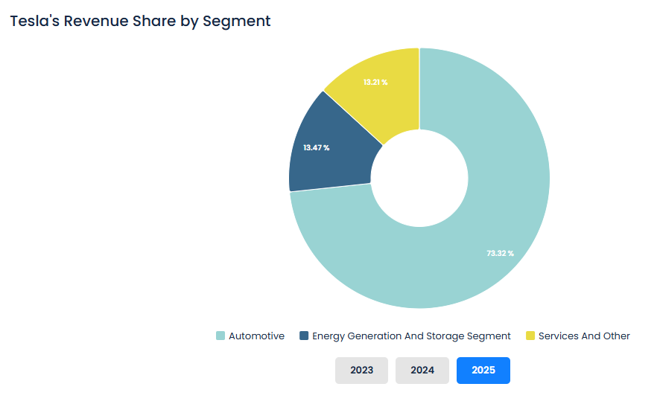
Figure 1: Tesla's Revenue Share by Segment
(Source: Bullfincher, 2025)
Tesla has a vertically structured direct to consumer business, which does not rely on dealerships. The sources of revenues are automotive sales, regulatory credits, energy generation and services. In 2025, Tesla made a revenue of $94.83 billion annually and in the automotive category, the revenue was$ 69.53 billion (Bullfincher, 2025).

1.5 Industry Overview
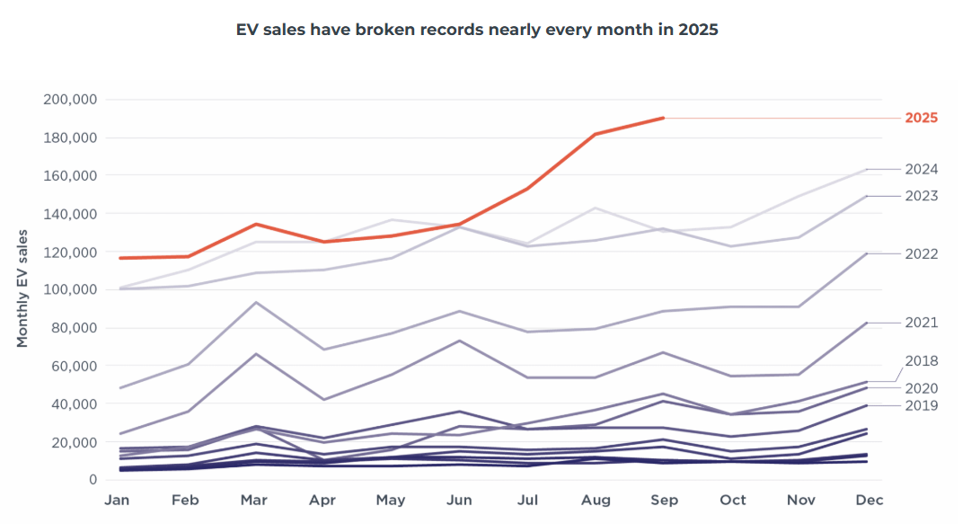
Figure 2: EV sales have broken records nearly every month in 2025
(Source: Scott, 2025)
The US EV market had at the time(2025) attained around 1.2 million battery electric vehicle sales. In Q4 2025 with the lapse of the federal $7,500 EV tax credit following passage of the One Big Beautiful Bill Act the market share declined to 5.7% of all new car sales, however (Scott, 2025).

1.6 Key Competitors
In the United States, Tesla supplied a good figure of 192,440 units of Model 3 at the end of 2025, a figure that controlled 15.9% of the total EV sales in 2025. By Q2 2026, the Model 3 will remain the second most sold EV in America, having sold 34,944 a quarter, and the total Tesla US EV market share is 50.5% (Alvarez, 2026).

2. External and Internal Environment Analysis

2.1 External Environment Analysis (PESTEL Framework)
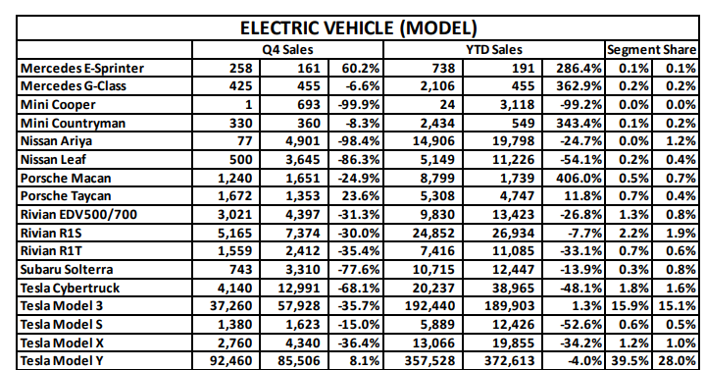
Figure 3: ELECTRIC VEHICLE (MODEL)
(Source: Cox AUTOMOTIVE, 2026)
Political Factors: The political climate works both to the advantage of Tesla. On 4 July 2025, The One Big Beautiful Bill Act repealed the $7,500 federal EV tax credit (Section 30D) and the $4,000 used EV credit (Section 25E) as of 1 October 2025, seven years earlier than they were planned to be in the Inflation Reduction Act. This increased the virtual price to purchase the Model 3, and the market share of EVs in the US dropped to 5.7% of new car purchases in Q4 2025, compared to 10.5% in Q3 2025 (Cox AUTOMOTIVE, 2026). Independently, the name of mass media celebrity CEO, Elon Musk, with his high profile participation with the Trump administration through the Department of Government Efficiency (DOGE), brand-polarized the brand. A Yale University study estimated that Musk's political activities cost Tesla between 1 million and 1.26 million US vehicle sales since October 2022, whilst Q1 2025 deliveries fell 13% year-over-year. A Morgan Stanley survey found 85% of investors believed Musk's political ties were damaging Tesla (Gillingham and Kotchen, 2025). State-level rebates of $1,000 to $7,500 in California, Colorado, and New York provide partial offset.
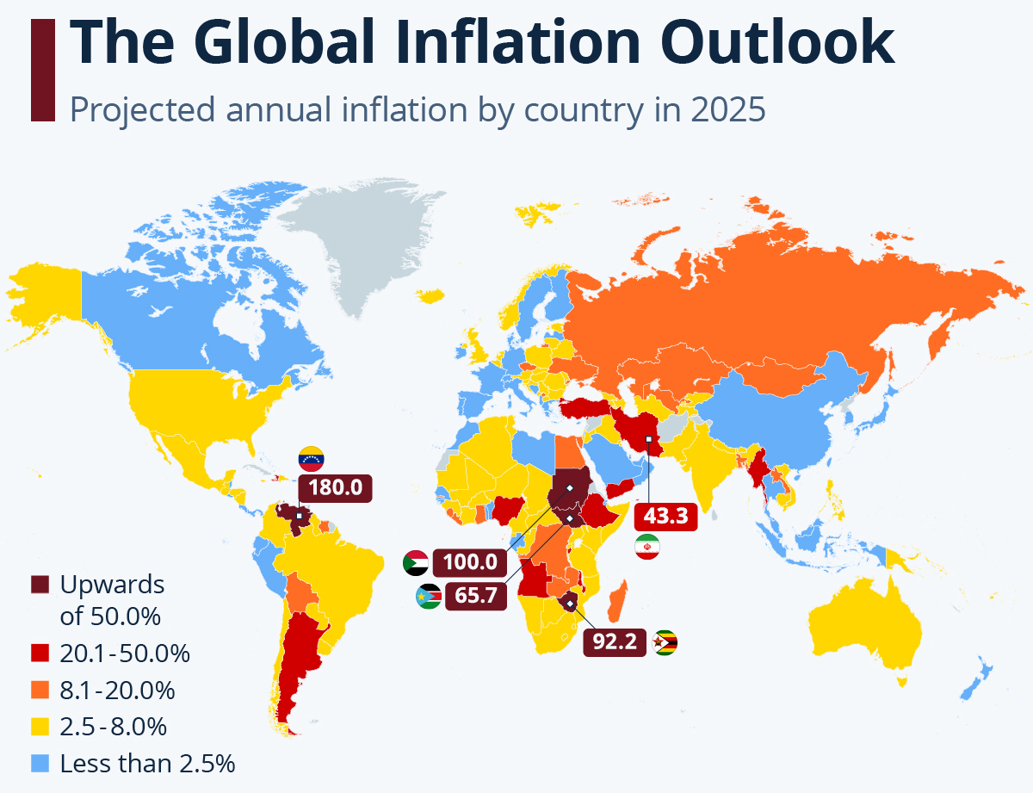
Figure 4: Global Inflation
(Source: Buchholz, 2026)
Economic Factors: The inflation of the costs of raw materials in lithium, cobalt and nickel is still stretching battery prices, but the attitude of Tesla to use lithium iron phosphate (LFP) cells has mitigated the effects (Co, 2025). Direct repricing applies to a subsidy-free market with the launch of the $36,990 Model 3 Standard trim in 2026. In 2025, Tesla saw a decrease in its annual revenue by 2.93% to reach $94.83 billion, and automotive revenue by 10% to reach $69.53 billion. The operating margin was squeezed to 2.1% in Q1 2025 and then go up to 5.8% in Q3 2025. In Q2 2026, trailing twelve-month revenue increased by 25.52% to reach $103.62 billion with a quarterly revenue of $28.24 billion increasing by 25.52 year-over-year (Siddiq, 2026).
Social Factors: The attitude of consumers has changed drastically. The brand reputation of Tesla dropped to 95th in the 2025 Axios Harris 100 poll, after dropping 8th in the 2021 poll, as Professor Scott Galloway termed it as one of the biggest brand destruction in company history. Owners have taken down brand insignia, Tesla dealerships have protested. Wider social patterns remain positive towards the EV adoption, but the Model 3 with a start at 38,630 and some destinations helps it appeal to first-time EV adopters (Turnnidge, 2025).
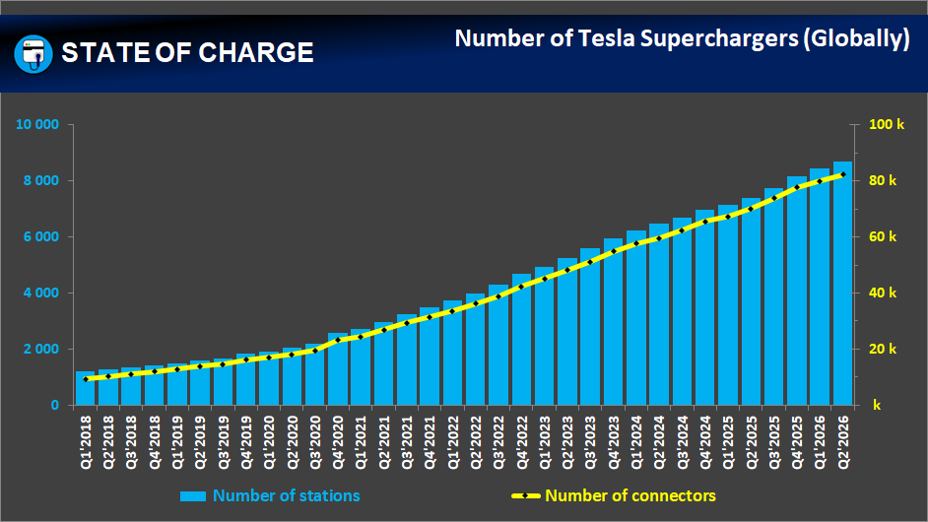
Figure 5: Number of Tesla Supercharger
(Source: Kane, 2026)
Technological Factors: The best differentiator of Tesla is technology. Full Self-Driving (FSD), which is based on vision-based neural networks and developed under the over-the-air fleet updates, advances. In 2023, Tesla filed most patent applications in the areas of AI hardware and software. The business proprietary Supercharger network had surpassed 82,000 connectors worldwide as of Q2 2026, and had over 42,000 stalls spread among approximately 3,200 stations in North America (Kane, 2026). The network throughput was 2.0 TWh, year-over-year increased by 30% with reliability confirmed by J.D. Power as 96% and self-reported uptime at over 99.9%. There are V4 Superchargers, which are being rolled out with up to 500kW (Gene, 2026).
Environmental Factors: In 2025, Tesla reaffirmed a net-zero greenhouse gas target of the value chain by 2040 in its 2025 Impact Report. The lifecycle emissions of the Model 3 are still within the lowest circles in the sector, with battery recycling programmes reclaiming increasing amounts of precious minerals. Previously, scrutiny of supply chains was increasing, but legal exposure of mineral sourcing with the August 2025 DRC lawsuit on cobalt, and the implementation of new legislation on supply chains (EU Supply Chain Act) increased legal risk (European Critical Raw Materials Act, 2025).
Legal Factors: The California Senate Bill 261 costs new climate disclosure. Recall efforts by NHTSA of software on rearview cameras and central display behaviour on 2024-25-Model 3 vehicles have raised some eyebrows, with the majority of the issues being addressed through OTA updates (Persefoni, 2025). The welcome to regulatory scrutiny of network access and pricing through the adoption of Tesla North American Charging Standard (NACS) by Ford, GM and Rivian has cemented a moat in Tesla infrastructure and has invited regulation of network access and pricing.

2.2 Critical Success Factors
There are five competitive factors of the Model 3 within the US.
- Firstly, the affordability of a price is more important than premium positioning, and this is directly addressed by a $36,990 Standard trim. Second, the infrastructure that charges is conclusive (Shelton, 2026).
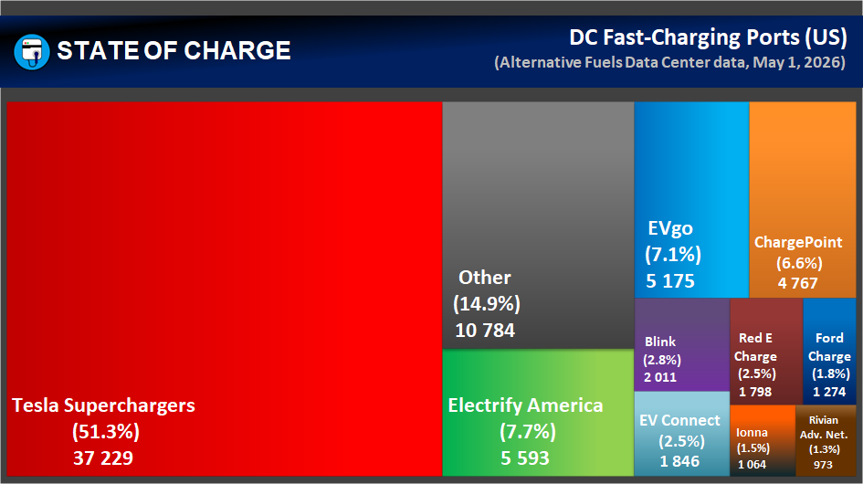
Figure 6: Largest DC Fast-Charging Networks by Ports
(Source: Kane, 2026a)
- In mid-2026, Tesla had a Supercharger network, holding 52% of all US DC fast- chargers and leaving a convenient gap that Electrify America and other 3rd party networks are incapable of filling (Kane, 2026a).
- Third, stickiness of software ecosystems via OTA updates, FSD and in-car entertainment entails switching costs that competitors find difficult to follow.
- Fourth, brand recovery is necessary as it has lost the confidence of the already progressive Tesla customers.
- Fifth, it is as important to supply chain resilience as it is about cost. A direct shift towards localised supply chain and un dependency on China is the battery joint venture with local LG Energy Solution in Lansing, Michigan, which is set to produce $4.3 billion in 2027 (Singh, 2026).

2.3 Strategic Challenges in External Environment
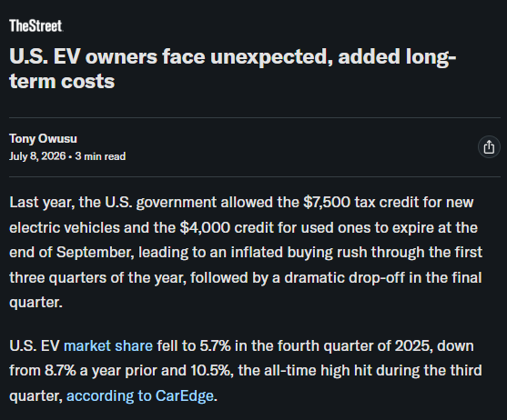
Figure 7: Increase in Cost of Vehicles
(Source: Owusu, 2026)
With the elimination of the $7,500 tax credit, the total cost of ownership of Model 3 has increased, and the 5.7% EV sales in the US market in the fourth quarter of the 2025 (as compared to 10.5% in the third) indicate the price sensitivity of the segment (Owusu, 2026). At approximately $42,000 and 800-volt charging, the Hyundai Ioniq 6 gives 361 miles of EPA range, and is able to openly compete with Model 3 range leadership (Porter, 2008). BMW i4, priced around 53,000, appeals to people looking to purchase high quality of interior, which the minimalist cabin of the EV Tesla does not match. The deliveries of Tesla fell by the first worldwide in 2025, decreasing by 8.5 percent on an annual basis, the first decrease in the company in 10 years, and Hyundai, Kia, and GM reported growing gains of 17-22 percent on EVs (Sriram, 2025). The Model 3 also does not have Apple carplay and Android auto, which is provided by all competitors. Additional compliance costs are tariff uncertainty and critical mineral traceability rules (Forget, 2026).

2.4 Internal Environment Analysis
An assessment of Tesla's internal environment reveals distinctive resources, capabilities, and core competencies that underpin its competitive position.
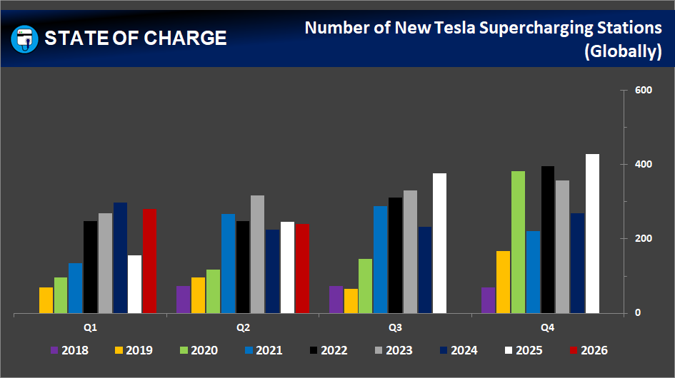
Figure 8: Tesla Number of Superchargers
(Source: Kane, 2026a)
Key resources: The Main Resources are six active Gigafactories in four continents (Fremont, Shanghai, Berlin, Texas, Nevada, and New York) having an annual capacity of over 2.3 million motor vehicles. The Supercharger network consisting of 82,357 connectors around the globe is a physical resource that is unprecedented in the EV industry (Kane, 2026a). Currently, the numbers of autonomous systems used on fleets worldwide open up loads of valuable Autopilot miles that can be reported as an effective training source at a level of 35 billion miles autonomously in 2025. By mid-2025, the company will maintain ongoing R&D as it will have cash reserves of over $30 billion (Faisal et al., 2026).
Capabilities: Among the key Capabilities are vertically integrated manufacturing with battery cells, assembling of vehicles and software. OTA updates also allow ongoing product enhancement, without service calls, and the direct-to-consumer sales system of operation maintains control of prices and margins impermissible to competitors using dealer-networks.
Core competencies: According to Satpathy et al. (2025), the most important Core Competencies is to integrate battery technology, autonomous software, and charging infrastructure into one ecosystem. All the elements strengthen each other to create a customer experience that is difficult to be repeated element by element by the competitors.

2.5 VRIO Framework Analysis
The VRIO framework (Barney, 1991) tests whether Tesla's resources deliver sustained competitive advantage.
Resource/Capability | V | R | I | O | Competitive Implication
Supercharger Network (82,000+ connectors, 52% US DC fast-charging) | Yes | Yes | Yes | Yes | Sustained Competitive Advantage
Brand Recognition and Direct Sales Model | Yes | Yes | Partially | Yes | Temporary Competitive Advantage
FSD Software and AI Data | Yes | Yes | Yes | Partially | Unrealised Competitive Advantage
Vertical Integration (Battery to Vehicle) | Yes | Yes | Yes | Yes | Sustained Competitive Advantage
Over-the-Air Software Updates | Yes | Partially | Partially | Yes | Temporary Competitive Advantage
Gigafactory Manufacturing Scale (2.3M+ capacity) | Yes | Yes | Yes | Yes | Sustained Competitive Advantage (MacKenzie, 2026)
Fleet Driving Data (35 billion+ Autopilot miles) | Yes | Yes | Yes | Partially | Unrealised Competitive Advantage
Table 1: VRIO Analysis
(Source: Self Created)
The Gigafactory scale, vertical integration and Supercharger network all pass all four VRIO tests providing sustained advantage. FSD and F fleet are prized, scarce and expensive to reproduce, yet Tesla has not properly structured its business to make money on them - unsupervised FSD cannot be sold commercially at all and HW3 vehicles cannot run the latest output (MacKenzie, 2026). Once a long-term competitive edge, brand recognition has since been reduced to a short-lived one, indicating the decline between 8th and 95th in the Axios Harris survey of 2021-2025.

2.6 Internal Strengths and Competitive Advantage
Internal Strengths: The greatest strength Tesla has in terms of moats is its network of Superchargers in 3,200 stations, 99.9% uptime, 52% domestic DC fast-charging. The more there are chargers, the more people will buy them, and their usage will support further growth (Chaudhary, 2025). The network effect will reinvent itself. Merging battery cells manufactured in Gigafactory Nevada to Fremont vehicle production allows cost advantages rivals provided by dealers could not achieve, and enabled the production of the $36,990 Model 3 Standard. Projected capital expenditure of more than $25 billion in 2026 - almost three times the expenditure in 2025 of $8.5 billion - indicates aggressive cash re-investment in production, AI infrastructure, and robotics (Sriram and Roy, 2026).
Competitive Advantage: The flaws are also quite evident. The Model 3 interior has a consistent level of criticism regarding the single 15-inch touchscreen and physical controls that are missing against those of the BMW i4 and Hyundai Ioniq 6 (CAR Magazine, 2026). The Tesla R&D interest has changed significantly to AI, robotics and Optimus and the concern is that the core business of the vehicle is not sufficiently investment. The lack of a collective bargaining agreement and lack of a commitment to a living wage (the only one among the large Western automakers) also is found in Tesla, which has earned negative ESG ratings, which is a weakness of governance that can limit institutional investor behavior.

3. Comprehensive and holistic view of the organisation

3.1 CSR and Sustainability Objectives

3.1.1 Overview of Tesla's CSR Strategy
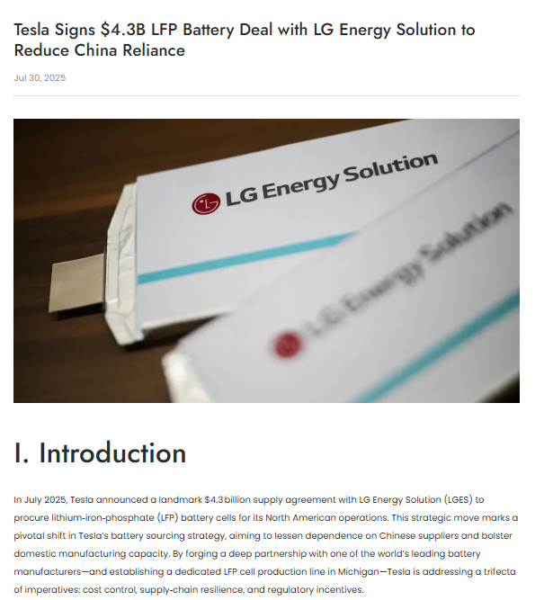
Figure 9: Tesla Signs $4.3B LFP Battery Deal
(Source: TESMAG, 2025)
The corporate social responsibility strategy of Tesla is pegged on its mission of making the world shift to sustainable energy. By the year 2025, a report entitled Impact Report, confirmed the company aims at achieving its objective of a net-zero greenhouse gas emissions across the entire value chain in the year 2040. In the case of the Model 3, the CSRs can be seen in battery recycling programmes, the adoption of lithium iron phosphate (LFP) chemistry to minimize reliance on cobalt, and through the establishment of a domestic supply chain, with the 4.3 billion LG Energy Solution joint venture announced in March 2026, production is planned to commence in Lansing, Michigan in 2027 (TESMAG, 2025).

3.1.2 Alignment with Business Objectives
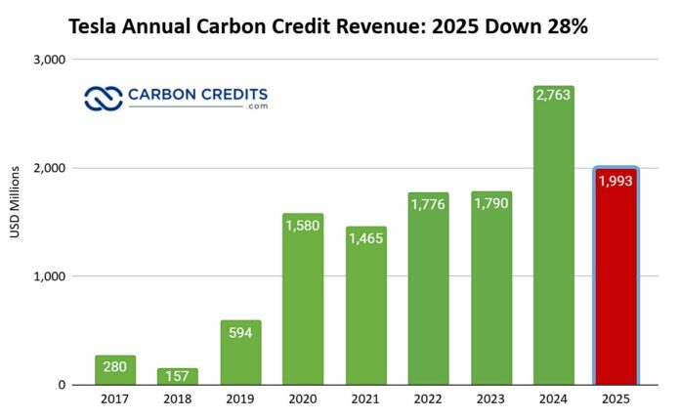
Figure 10: Tesla Annual Carbon Credit Revenue
(Source: Jennifer, 2026)
The Tesla CSR approach is intrinsic to the commercial model and not an appendage. Zero-emission positioning of the Model 3 leads customers to purchase the vehicle in large numbers, as long-term customers are building an environmental performance profile, and the sales of environmental performance in the form of regulatory credits reached a half-billion figure in Q1 2025 alone (Jennifer, 2026). More importantly, though, this alignment creates a means of vulnerability: credit revenues are on competitor under-performance and US federal policy, which are wearing thin. The cancellation of the 7,500-powell EV tax credit on 30 September 2025 indicates that regulatory tailwinds are turning, and the weakness of trying to monetise sustainability without more strategy would benefit from deeper anchoring.

3.1.3 Critical Evaluation
According to Adaghe (2025), although Tesla is a leader in environmental matters, its overall CSR implementation is a point of criticism. Tesla is the only large Western car company to lack a collective bargaining agreement in the world, and the August 2025 DRC cobalt lawsuit revealed the frailty inside the crucial metals sourcing. Lack of Science Based Targets initiative (SBTi)-approved emissions targets also undermine net-zero commitments. As a result, thus environmental CSR is strategically aligned, social and governance aspects have to be strengthened to a considerable degree in order to provide holistic responsibility.

3.2 Balanced Scorecard

3.2.1 Introduction to Balanced Scorecard
The Balanced Scorecard, devised by Kaplan and Norton (1992) is a strategy that transforms the strategic vision into quantifiable performance in 4 interdependent perspectives beyond the financial ones. In the case of the Tesla Model 3 in the US market, the framework is applied to give a comprehensive outlook on the interplay of strategic implementation and competitive performance (Madsen, 2025).

3.2.2 Financial Perspective
Objective: Return automotive profitability, as automotive revenues were reduced by 10% and margin narrowed to 2.1 percentage points in 2025 and Q1 2025.
KPIs: Model 3 gross per unit unit, US automotive segment income and amount of cash flow created.
Targets: Sustain Model 3 US to make more than 190,000 unit deliveries and increase operating margin to over 8 percent by 2027 (GuruFocus News, 2026).
Initiatives: The introduction of the $36,990 of Standard trim, manufacturing cost-saving through domestic production of LFP batteries starting 2027.

3.2.3 Customer Perspective
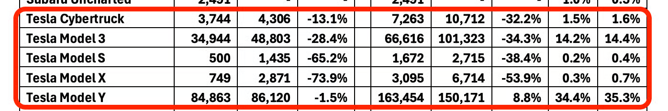
Figure 11: Tesla Model 3 sales
(Source: Alvarez, 2026b)
Objective: Rescue the negative brand reputation that has manifested as a drop in Tesla, previously ranking 8th (2021) to 95th (2025) in the Axios Harris 100 poll and restore trust among formerly more progressive Model 3 owners.
KPIs: Net promoter score, retention rate of Model 3 among new customers, and electric sedan share of the US market.
Targets: Continue to be the leading electric sedan from the USA with 34,944 US deliveries in a quarter (Q2 2026) as the Model 3 (Alvarez, 2026b).
Initiatives: Depoliticalised marketing messages, more referral schemes, and the physical control reintroduction of the indicator stalk in the 2026 Model 3 update, in direct response to consumer comments.

3.2.4 Internal Business Processes
Objective: Head the operational effectiveness which supports Model 3 competitiveness with Hyundai Ioniq 6 and BMW i4.
KPIs: Vehicle output at Fremont plant, uptime of Supercharger network , and rate of success on OTA software updates.
Targets: Expand the Supercharger network to more than 42,000 stalls in North America, deploy V4 500kW, and lessen the number of warranty claims associated with the 20242025 model year recalls (Malik, 2026).
Initiatives: Change in over 25 billion of capital should be spent in 2026, which is almost three times as much as in 2025, allocated to the creation of automation of manufacturing, AI infrastructure, and the expansion of the charging networks (Walz, 2026).

3.2.5 Learning and Growth
Objective: Develop human, informational and organisational potentials to protect the competitiveness of Model 3 in the long run.
KPIs: Engineering workforce employed in the Model 3 refinement, the rate of FSD software adoption, and the amount of data on the fleet driving that is considered in autonomous system training.
Targets: Ongoing releases of FSD version and continuous growth of AI training computational infrastructure.
Initiatives: Patent development in vision-based neural networks - most of Tesla patent claims since 2023 are in AI hardware and software - and rebalancing the delivery of R&D in the Optimus robotics programme versus the traditional Model 3 engineering to avoid product ageing (Ungria, 2026).
The Balanced Scorecard encapsulates the Tesla Model 3 strategy in four interconnected perspectives in the form of measurable objectives. Financial objectives restore margins using the Standard trim at 36,990; customer objectives recover brand trust and maintain a segment lead; operational process objectives increase the moat of Supercharger; and learning and growth objectives rebalances the R&Ds between AI aspirations and core Model 3 development.

4. Strategic Choices and Implementation

4.1 Business-Level Strategies
Cost Leadership
Complete cost leadership cannot be applied to the case of Tesla when this company faces the challenge of competition with other Chinese producers such as BYD. The re-introduction of the $35,990 Standard trim Model 3 in 2026 however indicates that the company will make a strategic change to cost competitiveness especially with the $7,500 federal EV tax credit expiring on 30 September 2025 (Iliff, 2026). This is a combined pricing-differentiation strategy, and Tesla can still take a position in the market after the subsidies in the US without losing brand recognition.
Differentiation
Keeping the framework based on the generic strategies made by Porter (1985), the key strategy of the Model 3 is the broad differentiation with the help of high technology, strong brand, and integration of ecosystems. At the corporate scale, Tesla is diversified in energy storage, solar generation, AI, and robotics, with non-automotive revenue rising by 44% on an annual basis in Q3 2025, to 3.4 billion dollars (Peterson, 2026). This differentiation ambition is further highlighted by the $1 trillion CEO pay package, which is pegged on the targets such as 20 million vehicles and 1 million robots being released (Kolodny, 2025).

4.2 Most appropriate strategy for the organisation.

4.2.1 Strategic Choice
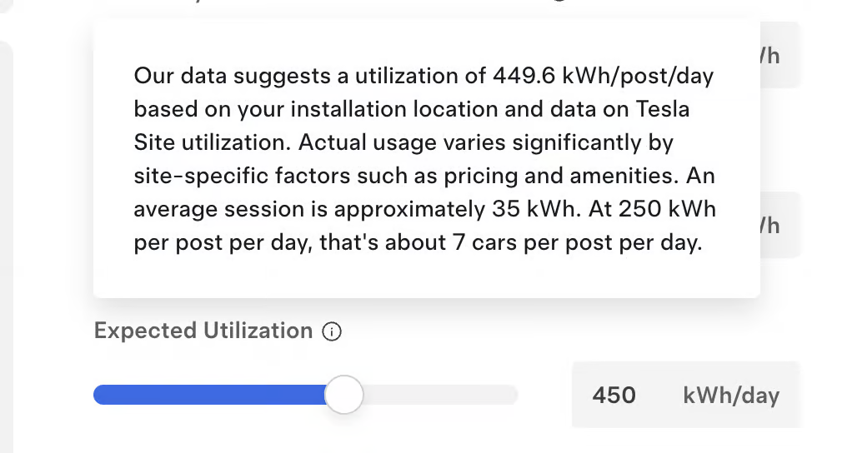
Figure 12: Tesla Supercharger Setup Cost
(Alvarez and Juurikas, 2026)
The suggested model of the Model 3 in the US involves an integrated cost-differentiation assisted by market penetration. Tesla ought to step-up investment into Supercharger networks (82,357 worldwide connections currently in place) as a competitive edge that cannot be matched by rivals, and capitalize on the Standard trim to acquire price-sensitive customers who are currently depending on the federal tax credit. At the same time, Tesla ought to minimise Model 3 reliance on FSD as a unique selling point since Full Self-Driving has not been successfully tested commercially and alternatively focus on certain proven qualities including 321-363 miles of EPA range, 96 percent of Supercharger reliability and total cost of ownership benefits (Alvarez and Juurikas, 2026).

4.2.2 Ansoff Matrix
 | Existing Products | New Products
Existing Markets | Market Penetration (Recommended Primary Focus):  Market penetration by taking advantage of price-sensitive US consumers after expiration of tax-credit. Referral programmes to protect 15.9% US EV share (Gore, 2024). | Product Development:  Pieced-together quality improvements, Car Play/Android Auto, and 2027 Highland refresh to overcome Ioniq 6 and BMW i4.
New Markets | Market Development:  Expand Model 3 leasing and fleet sales into the corporate and rideshare markets that are underserved in the retail channel. | Diversification:  Cybercab robotaxi platform. Risk increased in case of unexplored unsupervised FSD; second-tier in comparison to Model 3 defence (Guzmán, 2026).

4.2.3 SAFe Framework Analysis
The suggested integrated cost-differentiation strategy of the Model 3 is evaluated according to the SAFe framework, three criteria are considered.
Suitability: The strategies will address the strategic issues that Tesla will be facing beyond 2025. The federal EV tax credit of 7,500 has expired on 30 September 2025 and the Hyundai Ioniq 6 is providing 361 miles at approximately 42,000 (Eckert and Roy, 2025) which alone does not allow differentiation. The moat of 82,357 global connectors Standard of 36,990 and Supercharger, directly answers these external demands (Roy, 2025).
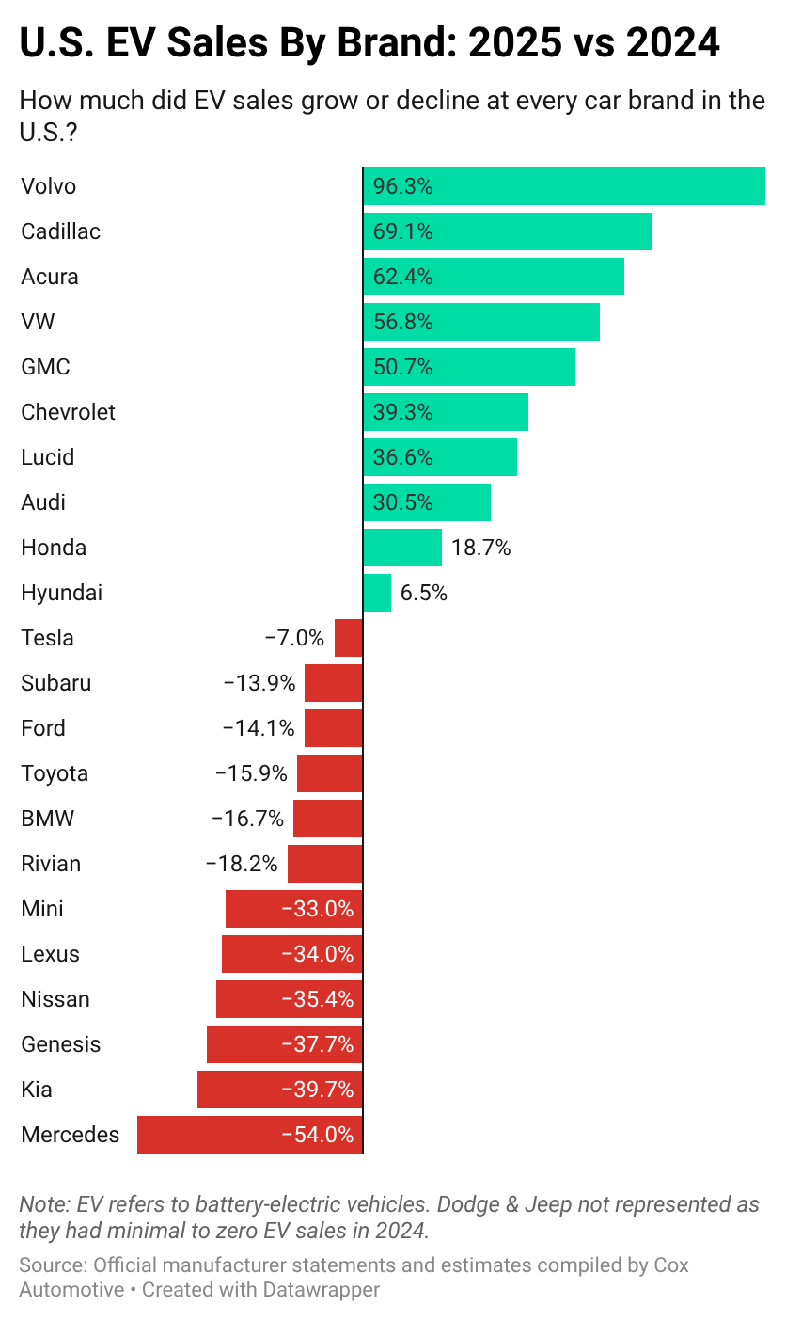
Figure 13: US Ev Sales
(Source: Hogan, 2026)
Acceptability: As the U.S. EV market share recovered by 50.5% in Q2 2026 and 34,944 Model 3 deliveries, and the energy revenue increased by $3.4 billion in Q3 2025, 44% year-over-year, returns to shareholders are acceptable (Shahan, 2026). There is diversification of revenue, with the exposure to politics stemming from CEO comments still being an issue for institutional investors.
Feasibility: Tesla has a $25 billion capital expenditure programme in 2026, which will contribute to its bolstering of feasibility, but cash reserves of 30 billion dollars, and the LG Energy JV of 4.3 billion which will enable production of LFP in 2027, within the country. The size of the Gigafactory and vertical integration are also indicators that required resources, capabilities and infrastructure are available to implement the strategy.

4.3 Delivering Optimum Performance and Sustained Competitive Advantage
Differentiation Through Ecosystem Lock-in
Based on the logic of differentiation identified by Porter (1985), the 2027 Model 3 update (Apple CarPlay, physical controls reinstated, more luxurious interiors) meets the areas of vulnerability in relation to the BMW i4, with the Supercharger rollout of 82,357 connectors and V4 500kW delivering what delivers a deeper ecosystem lock-in. The optimal real life analogy that Apple uses toward iPhone-App Store integration can be seen as hardware differentiation through proprietary infrastructure that can not be replicated by competitors (Find My Electric, 2026).
Restore trust to build for the long-term.
Brand rehabilitation can restore the trust of progressive buyers. Tesla Model 3 lost a great portion of the US sales when they quit via inappropriate brand communication. This restoration of trust can be achieved using the stakeholder theory as theorized by Freeman (1984). This group as a combination produces the best synergies to increase the current moats, gaps, and rebuild the goodwill upon which the future competitiveness of the Model 3 will be based (Hetzner, 2025).

4.4 Challenges on Strategic Implementation
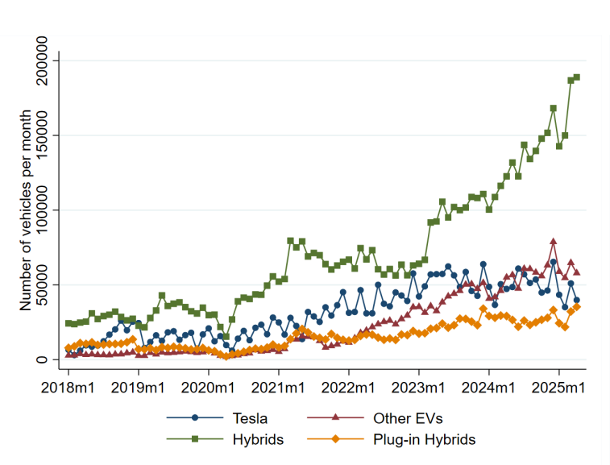
Figure 14: Sales of Teslas, other EVs, hybrids, and plug-in hybrids over time
(Source: Gillingham et al., 2025)
The key to successful implementation will lie in decolonization of the Model 3 product story and the political scandal of the CEO, which the Yale study estimated cost Tesla 1 million to 1.26 US sales since October 2022 (Gillingham et al., 2025). A downstream reallocation in the capital expenditure budget included in the 2026 budget of 25 billion would fill the competitive gaps determined with the Hyundai Ioniq 6 and BMW i4 potentially being the most effective approach to closing the identified competitive gap areas. Among the risks are that the organisation will not be keen to accept changes of their products not only due to long term resistance that leadership might have embraced but also due to possible shareholder resistance since the compensation package that was just approved was such a huge package (Werner Hyundai, 2025).

4.5 Ways of Mitigation
There are three recommendations for the mitigation. One, first, seek market penetration by carrying on with the low end Standard trim priced at above standard, state level incentive marketing, and leasing to attract customers scared by the loss of tax credit. Second, focus on the 2027 product refresh, aiming at the Apple CarPlay, reinstatement of physical controls and interior improvements to narrow down the difference with the BMW i4. Third, seek to invest in image mending by de-politicalising advertising and creating greater distinction between corporate messages and CEO opinions (Find My Electric, 2026).

Section 2: Reflective Account

Reflection Using Gibbs Reflective Cycle

Introduction to the Framework
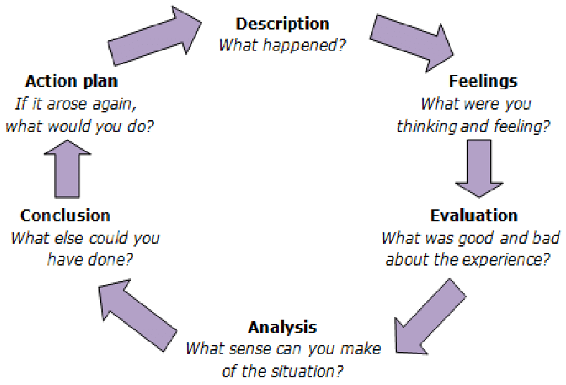
Figure 15: Gibbs Reflective Cycle
(Source: Akhter, 2015)
Gibbs (1988) reflection cycle is a systematic means of thinking about experience in six steps namely: description, feeling, evaluation, analysis, conclusion and action plan. I selected it among the cycles of Kolb since Gibbs provides the place to the emotional part of the work which was relevant in this case. Discussing a company as polarising as Tesla and a CEO as contentious as Elon Musk was destined to be never a strictly analytical endeavour.

Application of the Framework
Description: I was instructed to compose a strategic management report on the Tesla, which concerned the Model 3 in the US market. The assignment involved applying concepts I had learned, namely PESTEL, VRIO and SWOT and the generic strategies of Porter, Ansoff, and the Balanced Scorecard to an actual company with actual issues (Imanova, 2025). During approximately two weeks, I had read Tesla 10-K filings, quarterly earnings updates, sustainability reports, pieces of scholarly articles, and much automotive journalism. I created the report section bit by bit, verifying figures with original sources, and polished it extensively in the process.
Feelings: I was sure at the beginning. Tesla is a company that I have heard of numerous times, and I thought I was aware of the story. That hope could not stand the test of the research. The more I read the more I knew how up-to-date my so-called knowledge was up-to-date. The EV tax credit at the Federal level, which I had figured was still front and center in the case of the Model 3 pricing, had been scrapped (Qadir et al., 2024). Subsequently, when I discovered more recent information and began to identify the picture, the frustration became rather more of a curiosity. Later on I was actually interested in the problem, which was unexpected of me (Zedelius, Gross and Schooler, 2022).
Evaluation: The Balanced Scorecard made me think outside the box of financial performance, where most of the Tesla commentary resides, and reevaluated the customer perception and internal potential more thoughtfully. Relating all the statistics to reliable sources provided the report with a certain degree of rigour that I would not have attained by writing in my memory (Benková et al., 2020). I too took excessive time on PESTEL and I needed to be ruthless in removing sections to make space to fit the VRIO and swot. The first CSR section was written in the form of a Tesla press release, and the re-write took place after I had read the critical academic literature (Pereira, 2025).
Analysis: In retrospect, the greatest lesson is one on the variation between being aware of a business and comprehending its strategic location. I was aware that Tesla produces electric automobiles. Only by the work did I realise how bound to macro-political changes, the behaviour of CEOs, and the decisions of infrastructure investment established years before are the future of the Model 3 stitched up. Such frameworks as PESTEL and VRIO are not simply scholarly activities. They compelled me to see parts of the picture I otherwise should not have seen, and to balance them in a net-work of each other, instead of considering them in isolation (Rašticová et al., 2024).
I also came to know about the boundaries of structures. VRIO informs me of whether the resource offers you a competitive edge. But never informs you what to do when a valuable, rare, expensive to duplicate resource which in the case of Tesla is its brand, is being undermined due to decisions the framework can never record. Consultancy judgement resides in that gap, and is not very pleasant to sit (The Strategy Institute, 2024).
Conclusion: There are three things that I completed the report in a better way than when I began. First, I am more responsible in checking facts prior to writing down. Second, I find it easier to have conflicting evidence before me without falling before my time into a single story. Third, I now understand more about the order in which to stitch structures into which every one builds off the previous one, as opposed to boxes to be checked.
Action Plan: In further strategic analysis undertakings, I will undertake three things differently. My own sc source log will commence at day one, because I will have all of the numbers in the final version linked to a referral, and will not have to recreate it at the end. I shall not compose the SWOT initially but at the end because it is more effective as a summary of the other models than a point of departure. And I shall put still more time on the reflective part itself, as it was in the discipline of pausing and inquiring what it was that I in reality learned, that the greatest part of the real value of this exercise was discovered to be (Daff, Tame and Sands, 2024).

Reference List
Adaghe, W. (2025) “Evaluating Tesla’s corporate social responsibility practices and reflecting on the process.” Available at: https://doi.org/10.13140/rg.2.2.29063.05281.
Akhter, N. (2015) “Development of a Semi-Standardized Achievement Test of Education for Intermediate Level,” ResearchGate [Preprint]. Available at: https://www.researchgate.net/publication/315498140_Development_of_a_Semi_Standardized_Achievement_Test_of_Education_for_Intermediate_Level
Alvarez, S. (2026a) Tesla Model 3 and Model Y Dominates U.S. EV Market in 2025, TESLARATI. Available at: https://www.teslarati.com/tesla-model-3-model-y-dominates-us-ev-market-2025/
Alvarez, S. (2026b) Tesla Still Commands Half of U.S. EV Market, Model Y and Model 3 Remain America’s Best Sellers, EVwire. Available at: https://evwire.com/p/tesla-us-ev-market-q2-2026-results-cox-automotive
Alvarez, S. and Juurikas, J. (2026) Tesla now Helps You Calculate How Much Launching Your Own Supercharger Site Would Cost, EVwire. Available at: https://evwire.com/p/tesla-reveals-how-much-it-costs-for-you-to-buy-a-supercharger-calculator
Benková, E., Gallo, P., Balogová, B. and Nemec, J. (2020) “Factors Affecting the Use of Balanced Scorecard in Measuring Company Performance,” Sustainability, 12(3), p. 1178. Available at: https://www.mdpi.com/2071-1050/12/3/1178
Biscontini and Tyler (2025) Tesla Inc | EBSCO, EBSCO Information Services, Inc. | www.ebsco.com. Available at: https://www.ebsco.com/research-starters/business-and-management/tesla-inc
Buchholz, K. (2026) The Global Inflation Outlook, Statista Daily Data. Statista. Available at: https://www.statista.com/chart/27480/projected-annual-inflation-by-country/?srsltid=AfmBOoqtXO8HCspfMBpIBs7mmWjklq7f0JhBYzapBE-mMH26E9kkeopl
Bullfincher (2025) Tesla Revenue Breakdown by Segment, Tesla Revenue Breakdown By Segment | Bullfincher. Available at: https://bullfincher.io/companies/tesla/revenue-by-segment
CAR Magazine (2026) Hyundai Ioniq 6 vs Tesla Model 3 vs BMW i4 (2023) Group Test Review, CAR Magazine. Available at: https://www.carmagazine.co.uk/car-reviews/comparison/2023/hyundai-ioniq-6-vs-tesla-model-3-vs-bmw-i4/
Chaudhary, N. (2025) Tesla Superchargers - All You Need to Know, Expwithevs.in. ExperiencesWithEVs. Available at: https://www.expwithevs.in/p/tesla-superchargers
Co, J.J.P.S.T. (2025) Lithium-ion Battery Pack Prices Increase Due to Rising Costs of Materials and Components, Jiangxi JingJiu Power Science& Technology Co.,LTD. Available at: https://www.kijo-battery.com/lithium-ion-battery-pack-prices-increase-due-to-rising-costs-of-materials-and-components.html
Cox AUTOMOTIVE (2026) Electric Vehicle Sales Report Q4 2025. Available at: https://www.coxautoinc.com/wp-content/uploads/2026/01/Q4-2025-Kelley-Blue-Book-EV-Sales-Report.pdf
Daff, L., Tame, C. and Sands, J. (2024) “A course design approach that encourages reflective practice habits,” The International Journal of Management Education, 22(2), p. 100990. Available at: https://doi.org/10.1016/j.ijme.2024.100990.
Eckert, N. and Roy, A. (2025) “Automakers Push EV Sales as $7,500 US Tax Credit Is Set to End,” Reuters, 9 July. Available at: https://www.reuters.com/business/autos-transportation/automakers-push-ev-sales-7500-us-tax-credit-is-set-end-2025-07-09/
European Critical Raw Materials Act (2025) European Commission. Available at: https://commission.europa.eu/topics/competitiveness/green-deal-industrial-plan/european-critical-raw-materials-act_en
Faisal, K., Yan, W.Y., Fan, W., Kwan, M.H., Alamoudi, M., Sindi, A. and Qaffas, Y. (2026) “Strategic Imperatives for High-Definition Map Development in the Emerging Autonomous Vehicle Market of Saudi Arabia,” Future Transportation, 6(3), p. 131. Available at: https://doi.org/10.3390/futuretransp6030131.
Find My Electric (2026) Tesla Depreciation - Model S-3-X-Y (and How to Avoid It), Find My Electric. Available at: https://www.findmyelectric.com/blog/tesla-depreciation-explained/
Fool, M. (2026) Automotive sales driven by growth in hybrids in the second quarter of 2026, The Globe and Mail. Available at: https://www.theglobeandmail.com/investing/markets/stocks/TSLA/pressreleases/3525239/automotive-sales-driven-by-growth-in-hybrids-in-the-second-quarter-of-2026/
Forget, M.-P. (2026) Does the Tesla Model 3 Have Apple CarPlay?, Ingenext. Available at: https://ingenext.ca/blogs/news/does-the-tesla-model-3-have-apple-carplay?srsltid=AfmBOoq-E4uXO7n0NRkx8_UAXmolkwcL7xAq8fDCuJ55DV-Fhq5vR1bV
Gene (2026) Tesla’s newest “Folding V4 Superchargers” are key to its most aggressive expansion yet, TESLARATI. Available at: https://www.teslarati.com/tesla-folding-supercharger-v4/
Gibbs, G. (1988) Learning by Doing: A Guide to Teaching and Learning Methods. Oxford Brookes University.
Gillingham, K. and Kotchen, M. (2025) Elon Musk’s Partisan Political Activities Resulted in Over 1 Million Fewer Tesla Sales, Yale School of the Environment. Available at: https://environment.yale.edu/news/article/elon-musks-partisan-political-activities-resulted-over-1-million-fewer-tesla-sales
Gillingham, K., Kotchen, M., Levinsohn, J. and Nalebuff, B. (2025) “The Musk partisan effect on Tesla sales,” SSRN Electronic Journal [Preprint]. Available at: https://doi.org/10.2139/ssrn.5665427.
Gore, C. (2024) “Consumer Perspectives on Battery Electric Vehicles: A Literature Review.” Available at: https://doi.org/10.6028/nist.tn.2306.
GuruFocus News (2026) Tesla (TSLA) sets ambitious vehicle delivery targets for future years, gurufocus. GuruFocus. Available at: https://www.gurufocus.com/news/8747421/tesla-tsla-sets-ambitious-vehicle-delivery-targets-for-future-years?mobile=true%3Fmobile%3Dtrue&mobile=true%3Fmobile%3Dtrue%3Fmobile%3Dtrue&mobile=true&mobile=true#google_vignette
Guzmán, A. (2026) Tesla’s Full Self-Driving Tech Is at the Center of Two Texas Suits, Austin American-Statesman. Available at: https://www.statesman.com/business/article/tesla-robotaxi-fsd-texas-legal-challenges-22365346.php
Hetzner, C. (2025) Tesla brand damage revealed: consumers rank its ethics and character near the very bottom of a new Axios Harris poll, Fortune. Available at: https://fortune.com/2025/05/22/elon-musk-axios-harris-poll-tesla-brand-damage/
Hogan, M. (2026) The EV market was pure chaos in 2025. Here’s who won out (and who lost big), InsideEVs. Available at: https://insideevs.com/features/784561/ev-winners-and-losers-2025/
Iliff, L. (2026) Tesla, Hyundai, Toyota Help May EV Registrations Hit 8-Month High, Autonews.com. Available at: https://www.autonews.com/ev/ev-registrations-may-show-continued-rebound-0717/
Imanova, M. (2025) “Application of Strategic Management Tools in Business Growth,” Ancient Land, 7(8), pp. 65–76. Available at: https://doi.org/10.36719/2706-6185/50/65-76.
Jennifer (2026) Tesla reports first-ever annual revenue drop in 2025, carbon credit sales also dip 28%, Carbon Credits. Available at: https://carboncredits.com/tesla-reports-first-ever-annual-revenue-drop-in-2025-carbon-credit-sales-also-dip-28/
Kane, M. (2026a) Largest DC Fast-Charging Networks in the US: May 2026, EV Charging Stations With Tom Moloughney. Available at: https://evchargingstations.com/chargingnews/dc-fast-charging-may-2026/
Kane, M. (2026b) Tesla Supercharging Network Added 241 Sites: Q2 2026 Report, EV Charging Stations With Tom Moloughney. Available at: https://evchargingstations.com/chargingnews/tesla-supercharging-q2-2026-2/
Kolodny, L. (2025) Tesla says shareholders approve Musk’s $1 trillion pay plan with over 75% voting in favor, CNBC. Available at: https://www.cnbc.com/2025/11/06/tesla-shareholders-musk-pay.html
Liu, C.C., Boothman, S.G. and Graham, J. D (2025) “The Rise and Recent Decline of Tesla’s Share of the U.S. Electric Vehicle Market,” World Electric Vehicle Journal, 16(2), pp. 90–90. Available at: https://doi.org/https://doi.org/10.3390/wevj16020090.
MacKenzie, A. (2026) When It Comes to Tesla’s Unsupervised Full Self-Driving, Here’s Why Reality Bites, MotorTrend. Available at: https://www.motortrend.com/features/the-problem-with-tesla-unsupervised-full-self-driving-why-its-not-coming-on-hardware-3-vehicles
Madsen, D.O. (2025) “Balanced Scorecard: History, Implementation, and Impact,” Encyclopedia, 5(1), p. 39. Available at: https://doi.org/10.3390/encyclopedia5010039.
Malik, N. (2026) Tesla opens more 500 kW V4 Superchargers in U.S., Not a Tesla App. Available at: https://www.notateslaapp.com/news/3828/tesla-opens-more-500-kw-v4-superchargers-in-us
Owusu, T. (2026) U.S. EV owners face unexpected, added long-term costs, Yahoo Finance. Yahoo! Finance. Available at: https://finance.yahoo.com/energy/articles/u-ev-owners-face-unexpected-191300548.html
Pereira, D. (2025) Tesla PESTLE Analysis (2025), Business Model Analyst. Available at: https://businessmodelanalyst.com/tesla-pestle-analysis/
Persefoni (2025) California SB 253 and SB 261: What Businesses Need to Know - Persefoni, www.persefoni.com. Available at: https://www.persefoni.com/blog/california-sb253-sb261
Peterson, B. (2026) Tesla Profit Plunges as Musk Turns Focus to ‘Robot Army’ . Available at: https://www.wsj.com/business/autos/tesla-tsla-q3-earnings-report-2025-653ea365.
Qadir, S.A., Ahmad, F., Al-Wahedi, A.M.A.B., Iqbal, A. and Ali, A. (2024) “Navigating the complex realities of electric vehicle adoption: A comprehensive study of government strategies, policies, and incentives,” Energy Strategy Reviews, 53(53), pp. 101379–101379. Available at: https://www.sciencedirect.com/science/article/pii/S2211467X24000865
Rašticová, M., Sitalaksmi, S., Jaya Addin Linando and Šerá, E. (2024) Sustainable Leadership. Available at: https://www.researchgate.net/publication/391018890_Sustainable_Leadership
Roy, A. (2025) “Tesla expected to unveil lower-cost Model Y in push to reignite sales,” Reuters, 7 October. Available at: https://www.reuters.com/business/autos-transportation/tesla-expected-unveil-lower-cost-model-y-push-reignite-sales-2025-10-07/
Satpathy, P.R., Ramachandaramurthy, V.K., Radha Krishnan, T.R. and Padmanaban, S. (2025) “Technological innovations and sustainable strategies for advancing electric vehicle performance and market integration,” Energy Strategy Reviews, 60, p. 101790. Available at: https://doi.org/10.1016/j.esr.2025.101790.
Scott, D.E. (2025) Record Electric Vehicle Sales Show American Demand – Will U.S. Automakers Deliver or Retreat? - International Council on Clean Transportation, International Council on Clean Transportation. Available at: https://theicct.org/record-electric-vehicle-sales-show-american-demand-will-us-automakers-deliver-or-retreat-nov25/
Shahan, Z. (2026) Tesla Climbs Back Above 50% Share of US EV Market — Who’s in 2nd, 3rd, 4th?, CleanTechnica. Available at: https://cleantechnica.com/2026/07/22/tesla-climbs-back-above-50-share-of-us-ev-market-whos-in-2nd-3rd-4th/
Shelton, S. (2026) Tesla Model 3 | U.S. News & World Report, Usnews.com. U.S. News & World Report. Available at: https://cars.usnews.com/cars-trucks/tesla/model-3
Siddiq, S. (2026) Tesla’s (TSLA) Margins Broke in a Way Deliveries Can’t Fix, Yahoo Finance. Yahoo! Finance. Available at: https://finance.yahoo.com/markets/stocks/articles/tesla-tsla-margins-broke-way-173223992.html
Singh, K. (2026) “US government confirms Tesla and LG Energy Solution&#x27;s $4.3 billion battery deal,” Reuters, 17 March. Available at: https://www.reuters.com/business/energy/us-government-confirms-tesla-lg-energy-solutions-43-billion-battery-deal-2026-03-17/
Sriram, A. (2025) “Tesla Annual Deliveries Fall for First Time as Competition Hurts Demand,” Reuters, 2 January. Available at: https://www.reuters.com/business/autos-transportation/tesla-posts-first-fall-annual-deliveries-demand-slows-2025-01-02/
Sriram, A. and Roy, A. (2026) “Tesla&#x27;s $25 billion spending plan tests investor faith in unproven AI bets,” Reuters, 23 April. Available at: https://www.reuters.com/business/autos-transportation/teslas-25-billion-spending-plan-tests-investor-faith-unproven-ai-bets-2026-04-23/
TESMAG (2025) Tesla Signs $4.3B LFP Battery Deal with LG Energy Solution to Reduce China Reliance, TESMAG. Available at: https://www.teslaacessories.com/blogs/news/tesla-signs-
The Strategy Institute (2024) Video Framework: Unlocking Competitive Edge for Your Business, Thestrategyinstitute.org. Available at: https://www.thestrategyinstitute.org/insights/vrio-framework-unlocking-competitive-edge-for-your-business
Turnnidge, S. (2025) “‘Tesla takedown’ protesters urge boycott of Elon Musk’s cars,” BBC, 29 March. Available at: https://www.bbc.com/news/articles/ckgnglpzy90o
Ungria, G. De (2026) Patent Snapshot: Tesla’s Vision-Based Autonomous Driving - Parola Analytics, Parola Analytics. Available at: https://parolaanalytics.com/parolanews/tesla-vision-based-autonomous-driving-patents/
Walz, E. (2026) Tesla plans over $25B in capital spend for robotics, chips and AI, Yahoo Finance. Available at: https://finance.yahoo.com/sectors/technology/articles/tesla-plans-over-25b-capital-110000335.html
Werner Hyundai (2025) 2025 Hyundai Ioniq 6 vs. BMW i4, Werner Hyundai. Available at: https://www.wernerhyundai.com/2025-hyundai-ioniq6-vs-2025-bmw-i4/
Zedelius, C.M., Gross, M.E. and Schooler, J.W. (2022) “Inquisitive but not discerning: Deprivation curiosity is associated with excessive openness to inaccurate information,” Journal of Research in Personality, 98, p. 104227. Available at: https://doi.org/10.1016/j.jrp.2022.104227.

