Marketing plan written for

__________________Heritage Madrid Hotel__________________

Student Name

_________________________Lăcătuș Mirela Elena_________________________

Student ID number
__________230098419_________

Marketing Essentials BMIH4005

Lecturer

________________Huw Thomas________________

Introduction

This marketing plan will identify the most promising opportunities business for the hotel in order to gain new customers while exiting the lockdown. The hotel chosen to create this marketing plan for is a Relais&Chateaux component, specifically Heritage Hotel Madrid.

Heritage Madrid is a 5-star accommodation located in Madrid, the capital city of Spain, close to Paseo de la Castellana. It is housed in a 20th-century listed building, beautifully decorated in a belle-époque style.The hotel has modern décor, with an urban and cosmopolitan air, combined with modern facilities. All rooms have a private bathroom with high-quality toiletries, a bathrobe and slippers.

- Marketing Mix

Product –
The optimal operation of a modern hotel is impossible without a series of services to satisfy the needs of the guests. The Heritage Hotel’s services include accommodation, food, information, daily housekeeping, cleaning services, concierge service, luggage storage, tour desk, 24-hour front desk, etc.

Price -
Characteristic of prices in the tourism industry is their differentiation depending on certain factors, For the Heritage Hotel, the price range is between €335 and €621, depending on the type of room, the time of booking and payment, but also the length of stay.

Place –
The tourist product is distributed in 3 ways, respectively directly to the consumer, through online intermediaries and through travel agencies.

Promotion –
The main channel of promotion for Heritage Hotel is through the Relais & Chateaux brand and by cultivating personal relationships, partnerships and association with famous brands. Another significant promotion may be the architecture and décor of the building which is unique for a hotel and that is attracting many tourists. As well, the location of the hotel can be considered a promotion channel by itself. Many tourists are attracted by this hotel because it is located in the center of Madrid, near all main points of interest.

- The Marketing Environment (Micro-SWOT

Strenghts:
- location in the center of Madrid
- short distances to many important objectives
- the value for money is very good
- panoramic view over the city from the rooms
- employees are attentive to the smallest details;
- Located near all main points of interest
- the service offer of the hotel falls within the norms of category 4 * and operates according to these norms
- the hotel is located in the capital of Spain, in the commercial, financial and cultural center
- Architecture, comfort and decor
- general cleaning is very high which satisfies the customers creates a very good image of the hotel
- The comfort and facilities of the rooms

Weaknesses
- no parking available which may cause dissatisfaction with customers who have used the personal car as transportation
- Wi-fi in public places
- High prices
- Located in busy area

Opportunities
- activity throughout the year ensures a good and continuous functioning of the hotel activity and of the technical equipments, helping to increase the degree of occupancy and the turnover
- location suitable for business people, less than 10km from the airport
Threats
- entry of new competitors on the market
- changes in consumer preferences
- economic crisis because if the pandemic

- The Marketing environment (Macro) PESTEL
Politics - these refer to government policies that may affect the hotel
- increased hotel tax of 10% (was 8% until 2013)
- every hotel has to have a license from Regional Tourism Authorities
- competitive regulations
- current government stability is favorable for foreign investors
- the social welfare policy in Spain protects employees and should stimulate the growth of the hotel business by recruiting new personnel.

Economy
- the purchasing power of tourists
- the price level
- the income level
- A decrease of the inflation started in 2012 but currently( starting last year) it experiences a period of growth (5,6)
- Spain’s currency is euro (€)

Social
- adaptating to different cultures
- promoting a genuine local culture
- the current population of Spain is 46,7 million people and it is has been declining since 2006 with small fluctuations
- 80.3 % of the population is urban, that is equivalent to 38 million people
- The spaniard’s median age is rising, currently is 44,9

Technological
New technologies are constantly changing and those who do not keep up with them are quickly overtaken by those who manage to adapt, and this happens often "on the go".

- accelerating technical progress
- continuous innovation
- currently, Spain occupies the 11th place in the global rankings

Environment
These represent accelerating climate changes, which is affecting tourism, agriculture and transport the most (hybrid cars have zero pollution taxes). This is also where the growing desire to protect the environment comes in.

Laws
This category of factors also includes legislation on consumer protection, competition or occupational safety and health. Changes in the minimum wage are a good example taking in consideration that the wages of the population are directly impacting the incomes of the hotel industry.
- The employees have 21 business days of paid vacation
- Maternity leave is paid and is 4 months
- 40 hours working per week

- Creating Customer Value & Engagement
The methods used to find out exactly what customers expect from Heritage Madrid Hotel are the following: surveys, feedbacks, reviews and an analysis of the market place.
The hotels can create customer value through different ways, methods and channels. In the Heritage Hotel case, it will be considered the following methods:

- Quality services
Every customer wants to obtain high quality services and products in exchange of their funds.
Hotel management must ensure quality consistency, as dissatisfied guests will happily spread negative impressions to friends, colleagues and relatives. Hotel staff must be properly trained to ensure that the service is provided in a friendly and business manner.

- Facilities
Customer value and engagement can be fabricated by offering special facilities, for instance: pet friendly stay, airport transport, free parking, free WI-FI, tourist information, free luggage storage, early check-in, free service to wake up guests at a certain time, information service that will help the customer navigate in an unknown city, use of a medical kit, delivery of correspondence to the room upon receiving.

- Providing authentic experiences
The Hotel, being situated in a very large known cultural and historical city, can increase customer engagement by cultivating personal relationships with them and by providing help for their customers to discover the beauty and rich history of the city of Madrid.

- Effective Use of digital Marketing

The Digital Media holds an important place in advertising the hotel.

The Digital Media channels that will be used are the following:
Email marketing
Email marketing is a form of marketing that can make the customers on the hotel’s email list aware of discounts, and other services. It can also be a softer sell keep them engaged.
SEO
SEO will help drive traffic to the hotel’s website and it will help build customer engagement as well as an increased conversion rate.

Social media marketing
The hotel should have accounts on all social networks that focus on visuals, such as Pinterest, which is becoming increasingly popular.
The post on the social media should not only resume to promoting the hotel and the hotel’s services. Examples of posts that should be found on the hotel’s social media accounts include boards with places to visit and restaurants recommendations, pictures of food and drinks that guests can find in the hotel’s restaurant, events and pictures of the rooms and hotel.

Pay per click
Placing online ads in strategic places that the hotel will only pay for when a visitor clicks on the ad.

Viral Marketing
Creating content that will encourages readers to distribute it, so that it can be viewed by a large number of people.
Website strategy
Improving the website of the hotel in order for it to be more accessible even for people that are not tech friendly.

Conclusion –

The marketing plan was created was created based on the particularities of the Heritage Hotel, a component of the Relais &Chateaux association that is located in Spain.
In order to analyse the microenvironment of the hotel, the scanning of the strengths, weaknesses, opportunities and threats of the location. Following the analysis, there were recorded more strengths than weaknesses which means that the hotel does very well.
Following the analysis of the macroenvironment, it was discovered that exists many factors that are influencing the activity of the studied hotel.
It was concluded that the digital marketing channels that are going to be used are email marketing, SEO, viral marketing, social media, ads and website strategy.

References – Credible sources (a minimum of 15)

- Worldometer (2019). Spain Population (2019) - Worldometers. [online] Worldometers.info. Available at: https://www.worldometers.info/world-population/spain-population/.
- Ramón Rodrı́guezA. (2002). Determining factors in entry choice for international expansion. The case of the Spanish hotel industry. Tourism Management, 23(6), pp.597–607.
- Garrett, D. (n.d.). PESTEL and Trend Analysis for the Hotel Industry in Spain - 2780 Words | Report Example. [online] Free Essays. Available at: https://ivypanda.com/essays/pestel-and-trend-analysis-for-the-hotel-industry-in-spain/.
- icmab (n.d.). The Nature Index 2019 is out. [online] ICMAB. Available at: https://icmab.es/nature-index-2019-icmab-csic-and-spain [Accessed 25 Nov 2021].
- ‌tradingeconomics.com. (n.d.). Spain Inflation Rate | 1955-2020 Data | 2021-2022 Forecast | Calendar | Historical. [online] Available at: https://tradingeconomics.com/spain/inflation-cpi#:~:text=Inflation%20Rate%20in%20Spain%20averaged.
- Mailchimp. (n.d.). What is Email Marketing? Definition and Advantages. [online] Available at: https://mailchimp.com/marketing-glossary/email-marketing/#:~:text=Email%20marketing%20is%20a%20form.
- ResearchGate. (n.d.). (PDF) Digital marketing in hotel industry. [online] Available at: https://www.researchgate.net/publication/325117493_Digital_marketing_in_hotel_industry.
‌
- www.cvent.com. (n.d.). Hotel Digital Marketing: The Complete Guide | Cvent Blog. [online] Available at: https://www.cvent.com/en/blog/hospitality/hotel-digital-marketing.
‌
- Customer Engagement Management in Tourism. (n.d.). Customer Engagement in the Hotel industry. [online] Available at: https://customerengagementmanagementintourism.wordpress.com/category/customer-engagement-in-the-hotel-industry/.
‌
- Wu, J. (Snow), Law, R. and Liu, J. (2018). Co-creating value with customers: a study of mobile hotel bookings in China. International Journal of Contemporary Hospitality Management, 30(4), pp.2056–2074.
‌
- www.relaischateaux.com. (n.d.). Heritage Madrid, Boutique Hotel and Gourmet restaurant in town Madrid – Relais & Châteaux. [online] Available at: https://www.relaischateaux.com/us/spain/heritagemadrid-madrid [Accessed 25 nov. 2021].
- ‌ Relais & Chateaux Hotel Heritage in Brugge. (n.d.). Official Website. [online] Available at: https://www.hotel-heritage.com/# [Accessed 26 Nov 2021].
‌

‌

‌

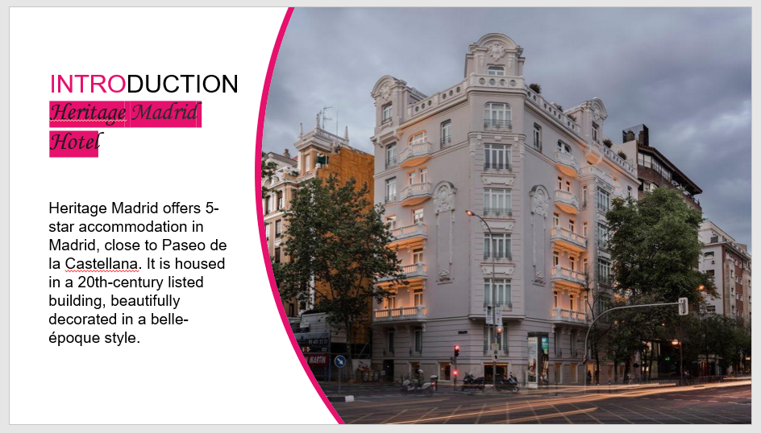
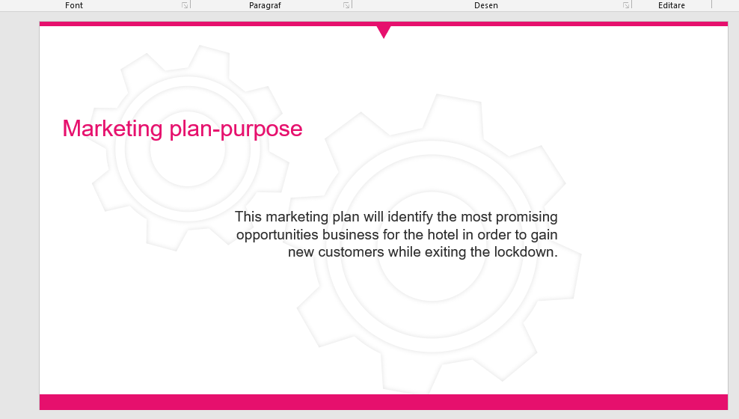
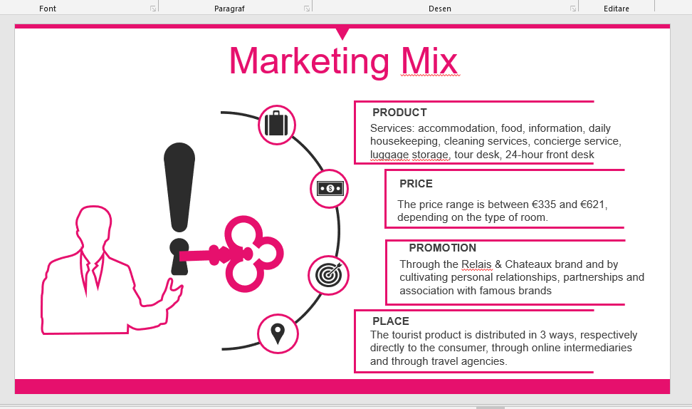
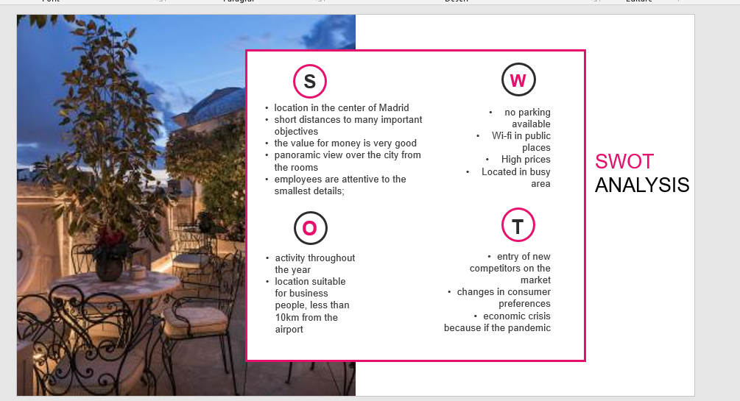
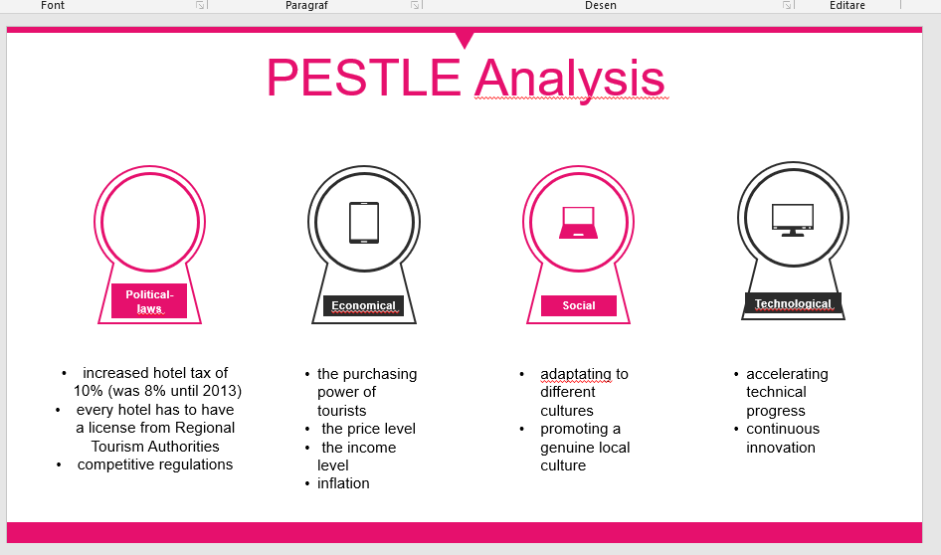
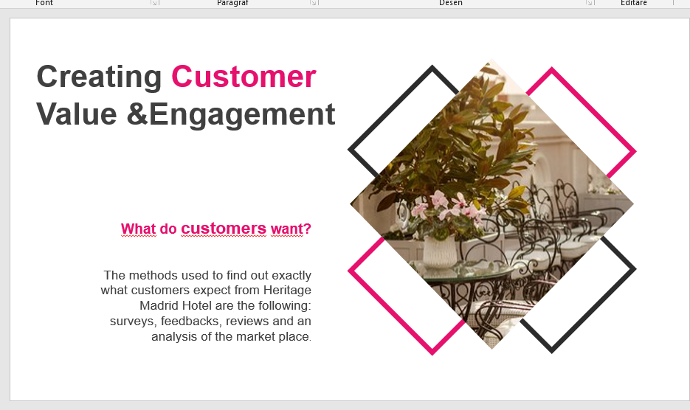

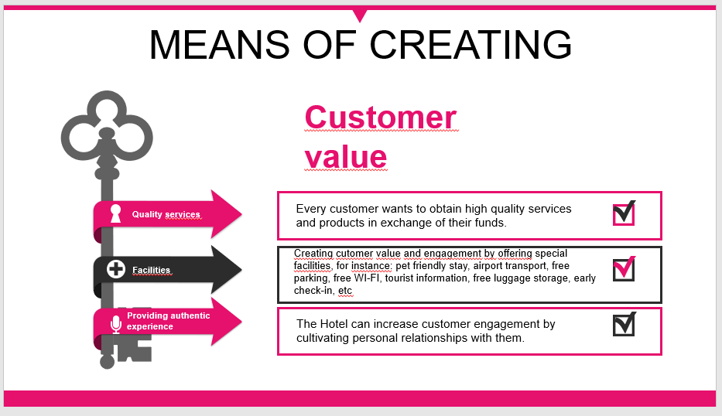
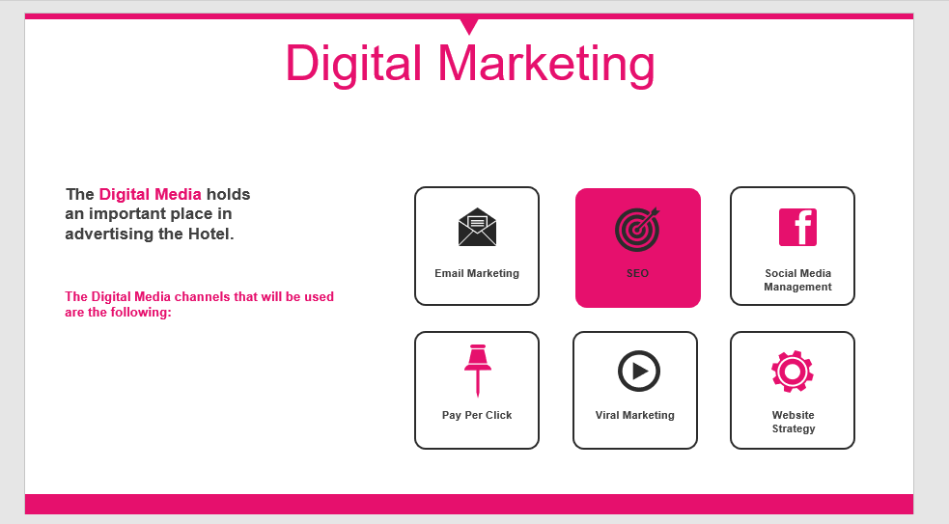

Worldometers.info, Population of Spain, 2020.
Mailchimp. (n.d.). What is Email Marketing? Definition and Advantages. 2020

