ACE Week 3 Oct 12th 2026
Botanical Beauty

OBSERVE
Gestural loose brush marks – full, rich canvas of paint
Matisse Blue Flower Vase on Table Cloth
Raoul Dufy. Bouquet of Flowers, 1951
Lucila Zentner
Canvas & Ivy – Maracuya Grove Wallpaper
Emma Gale Still Life

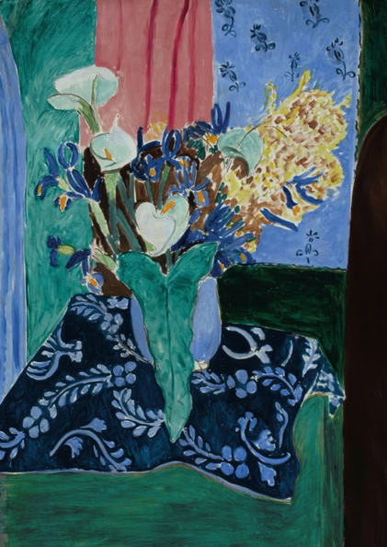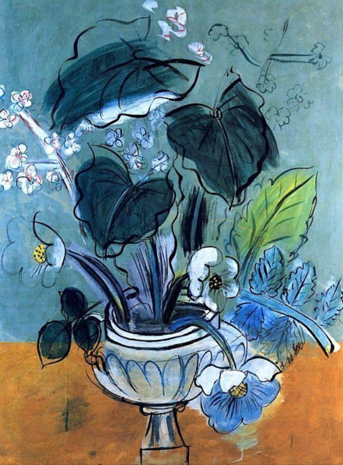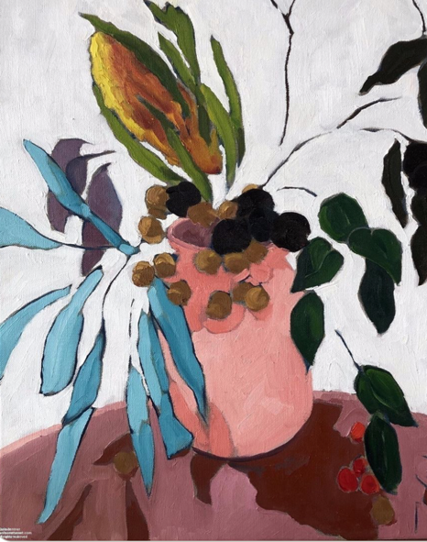

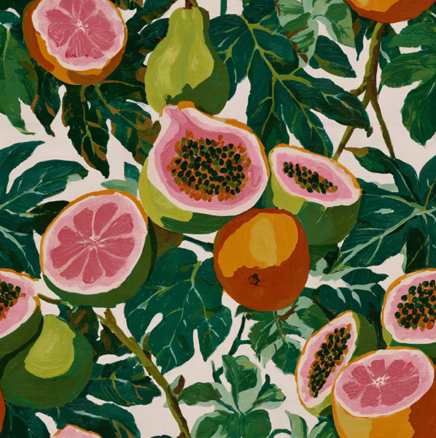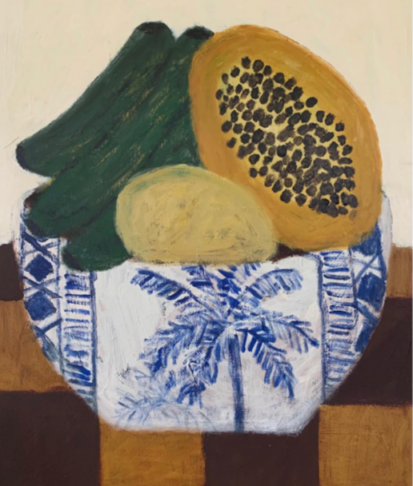

STYLISE
Stylised and subverted colour palettes
Rebel Walls
Amazonia - Tres Tintas
Happy Wall – Arty Monstera Wallpaper
Katherine Herrell

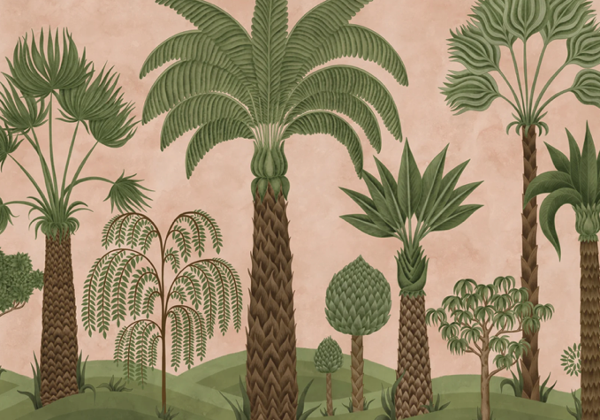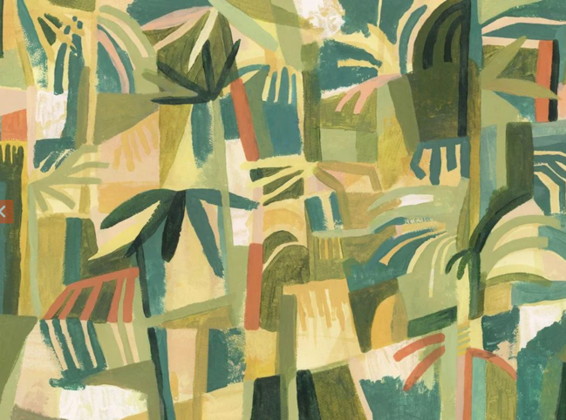

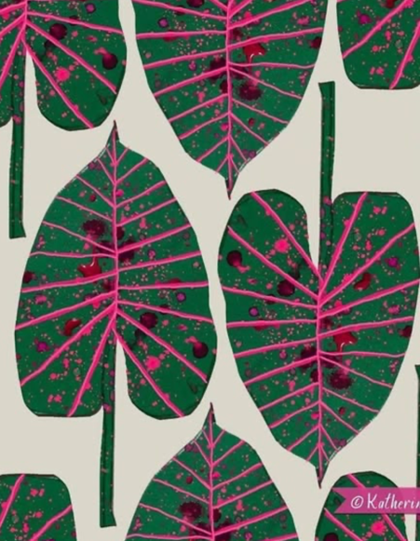
DISRUPT
Deconstruct Paint, Cut ,Collage
Tropicalia Wallpaper by Tres Tintas
Collage – unknown

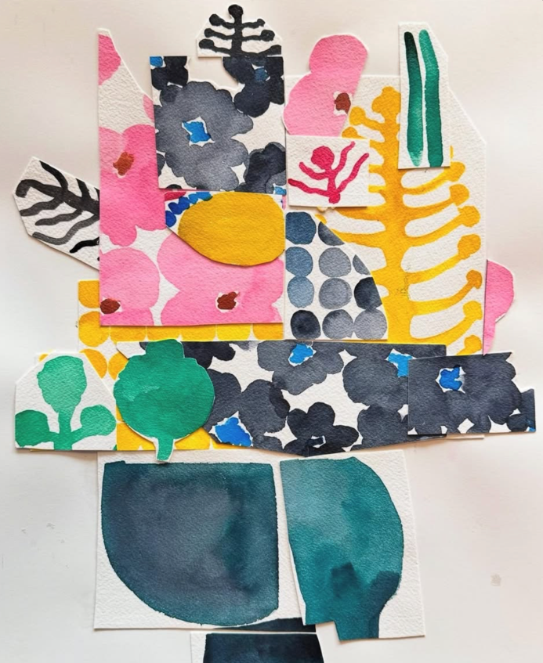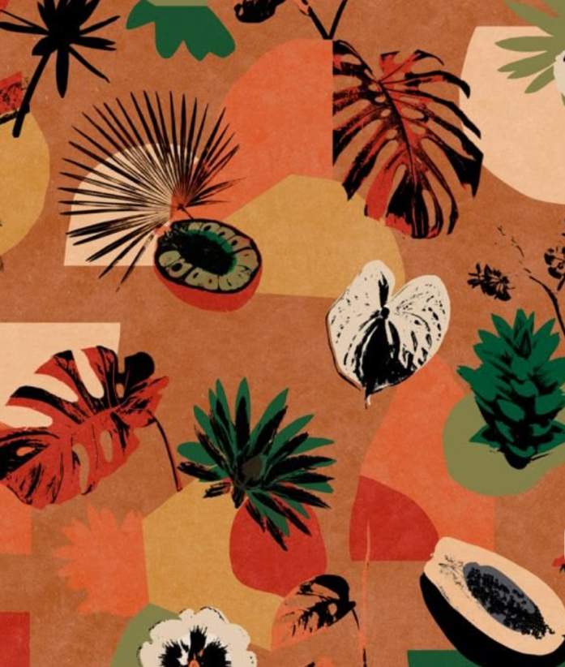

FRAMED



