Addressing the problem of staff shortage in Proper Care, UK

In this report what I will be doing is addressing and elaborating on the issues which were mentioned in task 1. I will also implement a decision and on top what I will do is discuss success indicators to measure of the effectiveness of my decision.
A research-informed discussion on the nature and impact of the complex problem on employees and their organisations
A problem which is faced by many different employees within their organisations is a lack of self discipline. “Self-discipline could be seen as an art of self-control, self-reliance, self-determination and self-sufficiency, which stimulates an individual to sustain his/her decisions and drives the individual towards achieving the set goals.” Adeyeye, J., Adeniji, A.A., Osinbanjo, A.O. and Oludayo, O., (2015). Staff shortage has a link with self-discipline as some staff members may not be discipline enough to carry out the tougher jobs and instead leave for jobs that are a lot easier. The self-discipline is caused as well when theirs lack of motivation from staff members and everything around them. When the staff receive little to no support what this will then do is make life harder for them as they may have personal issues ongoing and they may need some support internally as they’re not receiving that support that will make life a lot more difficult.
“NHS employees who are dedicated to patient care and ‘going the extra mile’ simply can’t be stretched any further, says Cary Cooper, professor of organisational psychology and health at Alliance Manchester Business School. “Workloads are too high, and people are working longer hours and not feeling valued and cared for.” (Gyton, G. 2017). This is many of the reasons as to the complex problem as most staff are being overworked and underpaid. Facing abuse from patients and being made to do all the hard work and being appreciated little.
“The key problem in the public health sector, which is not necessarily an issue for many other sectors with high numbers of EU workers, is that the NHS was already finding it difficult to retain staff before the 2016 referendum. The NHS relies quite heavily on foreign workers to make up for the shortfall in staff.” (Dalingwater, L., 2019). What this shows is the complex problem can have many different factors and one of those factors are likely the fact of Brexit which means a number of workers within the EU have left the UK. Which makes it harder to get staff as most healthcare rely on foreign workers that come in from other countries and get the job done. This also makes recruiting harder as bringing someone in from a foreign country might seem less complex than bringing someone in who doesn’t match the specifications of an employee.
“The coronavirus pandemic has significantly increased the strain on frontline nurses. The RCN are concerned that the extra responsibility and pressure placed on nurses could increase the change of staff “burnout”. This comes amid a rising second wave of Covid patients, the annual pressures that accompany the winter and the inevitable struggle to clear the growing backlog of cancelled appointments from 2020.” (Fund Our NHS. 2020). sWith Covid-19 still running about frontline nurses within healthcare have been strained and they are struggling with the burnout that they are facing this is due to been given extra responsibilities and tasks it makes things for staff a lot harder and as this is extra pressure. Staff are slowly cracking from the burnout.
PESTLE
Political factor
Political factors effecting social care and the NHS; Change of government and Brexit why this is a factor is because due to Brexit many staff within the NHS. The change of Government and potentially prime minister is an effect within social care this is due to the uncertainties that come within. Are the NHS going to be given enough funding to what’s required? Due to Brexit with staff from other originalities it would be a problem. If the NHS are huge and detrimental to the UK. Why are the government making it collapse? It should be funded and supported.
Economical Factor
Economical factors that are effecting the NHS are budget cuts and potentially funding from the government which would reduce and meaning the NHS would have to cut jobs in order to save money and from going bankrupt. A Financial crisis is another issue of the 5000 nurses vacancies and what this leads to having issues with recruiting the right staff. If the NHS don’t receive the right funding they could collapse and we could be a country where our health will too expensive to look after.
Social Factor
A Social factor effecting the NHS and staff shortage within Proper Care is the life expectancy in the UK increasing, as people are living longer they are using the NHS more often than your average adult. Another social factor effecting the NHS. Another social factor effecting the staff shortage is lifestyle factors some staff may have children and to work around where they can spend time with their loved ones and their children. If staff are working more than spending time with their family this could lead to career changes for staff within healthcare which will then further lead to more staff joining on leaving health care for another career.
Technological Factors
With new technologies being developed left, right, and centre, health care is slowly being improved. Scanning tools are more affordable than ever, making them a staple of hospitals and clinics. Various pumps and tools for treating or managing conditions are being developed, decreasing morbidity. Overall, these technological improvements in the healthcare space are a positive for all parties involved. Not only do patients receive a higher standard of care, but government organizations like the NHS are able to speed up and automate more clinical tasks. What this can lead to is treatment and spotting potentially issues to be seen earlier and then later and prevent any illnesses from escalating.
Legal Factors
Patients who are unhappy with the level of care by the NHS are now taking their grievances on legal platforms. In many cases, it is the patient’s family member who takes the legal recourse as they believe the medical system has been unjust towards the patient. The NHS has also faced many such litigation cases from unhappy patients. Also with potential new rules being implement that should a patient miss a GP/Hospital appointment they’ll be fined £10 coming into play very soon. This will spark outrage and chaos.
Environmental
The toxic waste from medication that has been used which leads to protests from activists groups worldwide. What this could be caused by is the testing that is done on the medicine and activists group who are concerned about saving the planet will want to step in and get things sorted out. They wouldn’t want that mess in the world to continue at any costs.
Cause and Effect analysis

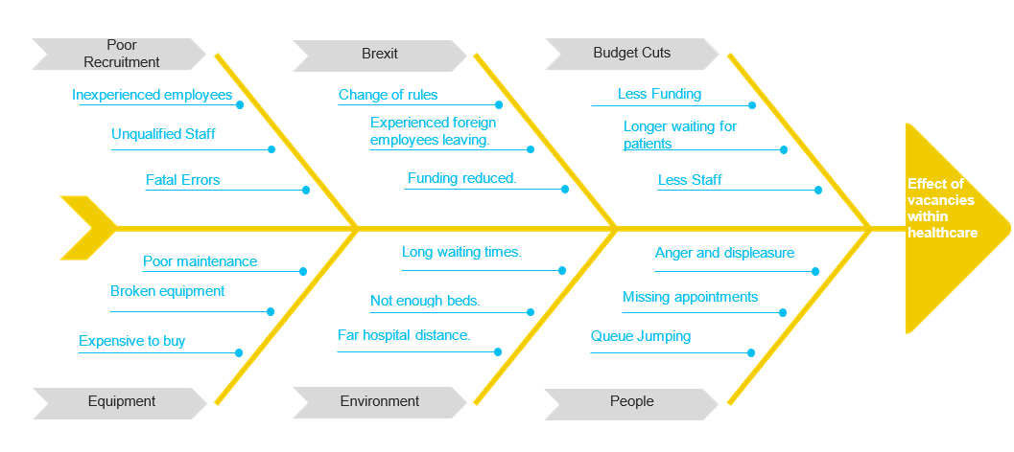

What would be a cause of the vacancies within the healthcare is the lack of respect for the workers and more focus on the patients as there is a clear imbalance between the two.
With the patients its all about them being crammed in and the government not investing enough into hospitals and places for where patients will stay and get stuff done.
For workers its harder for them as they tend to face a lot of abuse from patients not realising the staff are underpaid and overworked most of the time and therefore not being able to do the normal activities as they are always stuck in a role where they are never able to do the things that they want rather the things they wouldn’t want to do.

Evaluation of alternative solutions.

Better recruitment;
Advantages: An advantage of better recruitment would be to end up hiring better staff which means you end up hiring top quality staff. Which leads to the fact of getting the right experience and skillset within the workplace and making sure it all matches and one way or another we have position filled and there are less skill gaps which means there are less issues within the workplace.
Disadvantages: However finding the right person maybe time consuming as its still about looking into may different CV’s and the risk which ends up being attached to this is potentially hiring the wrong member of staff who could end up making the wrong decisions and end up impacting the workplace in a negative environment. Also what could as be an issue when hiring better staff is that not everybody would have the qualities that are being looked for as that will then lead to further issues along the line.
KPI: Would be to set expectations and targets and have benchmarks. Where the staff have to turn up on time and ensure every patient is delivered good service what this also means and leads to is having a meeting every 6 months regarding their performance.
Create a union
Advantages: An advantage of creating a union is that if staff are not happy, they can strike together meaning that they will end up looking out for one another and potentially stop any issues from working being delayed. The pay can be disputed which will mean that the government will have to respond and do something in order to stop and prevent issues from getting a lot worse than they already are.
Disadvantages: A disadvantage of that is that it drives up costs and prevents individuality some staff may be happy with current decisions that are being made but then what that could then further lead to is decision going incorrectly which would mean they no longer are supported or a benefit gets cut.
Use staffing/recruitment agencies
Advantages: Helps fill the role quicker and it helps with staffing issues. Disadvantages: It costs a lot to use agencies and they could hire anybody who might not be experienced/qualified. They’re the middle man and they are not directly from a Proper Care/NHS itself.
Work on communication skills
Advantages: Improves communication, improves ways of connected and improves ways to work. Disadvantage: Not everyone knows how to communicate effectively and most people are limited on how they communicate.
Offer more hours to current employees
Advantages: Employees likely to stay and Employees will feel they are part of something. Disadvantages: Some people may not want to work extra hours or need it.
Include more benefits with the job role: Advantages: More people will apply for the roles, more people will view it as an incentive. Disadvantages: Some staff may work the bare minimum and not everyone will view it as a benefit or an incentive.
Conclusion
In Conclusion to this the best way in order to prevent a staff shortages would be to create a Union as it’s a way where everything is discussed and if there are unhappy staff it will lead to a strike. What that strike will then cause the bosses and the government to hear the sadness of staff and why there are shortages as it will increase changes being implemented and staff to then have more benefits and feel supported within Proper Care UK.

References:

Adeyeye, J., A. A. Adeniji, A. O. Osinbanjo, and O. Oludayo. "Effects of workplace ethics on employees and organisational productivity in Nigeria." In International Conference on African Development Issues (págs. 267-273). Tokyo: OSAA. 2015.
Bush, T. 2019. PESTLE Analysis of NHS. 29 October. PESTLE ANALYSIS. [Online]. [10 July 2022]. Available from: https://pestleanalysis.com/nhs-pestle-analysis/

Charlesworth, A. 2021. The Health Foundation. 13th May. What action is required to make NHS workforce shortages a thing of the past?. [Online]. [8 July 2022]. Available from: https://www.health.org.uk/news-and-comment/blogs/what-action-is-required-to-make-nhs-workforce-shortages-a-thing-of-the-past
Cleanlink. 2022. 10 Solutions To Staff Shortages. [Online]. [10 July 2022]. Available from: https://www.cleanlink.com/news/article/10-Solutions-To-Staff-Shortages--28045

Dalingwater, L., 2019. NHS staffing shortages and the Brexit effect. Observatoire de la société britannique, (24), pp.67-86.
Fund our nhs. 2020. Staff shortages. [Online]. [1 August 2022]. Available from: https://nhsfunding.info/symptoms/10-effects-of-underfunding/staff-shortages/
Gyton, G. 2017. NHS ‘struggling with staff shortages and high workloads’. [Online]. [1 August 2022]. Available from: https://www.peoplemanagement.co.uk/article/1744871/nhs-struggling-with-staff-shortages-and-high-workloads

