PREPARED FOR DEBORAH HUGHES
Work Based Project - ACBA 5009
Jon Phillip Langstone (2006738)
Literature Review
2022
Contents
1. Research Title 1
2. Abstract 1
3. Introduction and Background 1
4. Literature Review 2
4.1 The UK Housing Crisis 2
4.2 Modern methods of construction (MMC) 4
4.3 Focusing on Cross-laminated Timber 6
4.4 Case study 1 – Isle of Mull Community Housing 10
4.5 Case study 2 - Dalston Lane Housing 11
4.6 The Sustainability of CLT Construction 12
4.7The Future of CLT implementation in the UK 13
5. References 16

List of Figures
Figure 1 Savills – MMC (Selsey, 2020) 5
Figure 2 Conventional assembly layup of cross-laminated timber (Buck, 2016) 7
Figure 3 CLT Masonry Cladding System (Dollard, 2018). 8
Figure 4 Charring of Timber (Structural Timber Association, 2015) 9
Figure 5 USCA Community Housing (back) (Thorne Wyness Architects, 2018) 10
Figure 6 USCA Community Housing (front) (Thorne Wyness Architects, 2018) 10
Figure 7 Timber is Carbon Negative (APPG, 2019) 12

Table 1 Applications of CLT (Structural Timber Association, 2015) 5

Research Title

Is off-site cross-laminated timber construction a forward-thinking solution to the housing crisis in the UK?

Abstract

This research will seek to answer the question, whether off-site cross-laminated timber construction methods are a forward-thinking solution to the increasing demand for newly constructed homes in the UK. With a focus on the development of modern methods of construction.

Introduction and Background

The researcher has been heavily involved in various types of construction in the United Kingdom and Western Canada. After many years of witnessing first-hand, the increasing demand and popularity of the use of off-site construction, specifically cross-laminated timber, the researcher felt it would be beneficial to further understand how cross-laminated timber has developed, and whether it is a forward-thinking solution to the developing housing crisis in the UK.

Literature Review

The UK Housing Crisis

To begin with, it is important to understand that the United Kingdom has a housing crisis, and it has been steadily worsening since the 1970s: So how was it caused and where did the problems initially come from?

From the evidence researched, four main causes have emerged and are outlined below:

- The green belt zones

- The green belt zones are areas of protected land that surround cities and towns in which housing development is prohibited (CPRW, 2022). Unsurprisingly green belts make housing more expensive because they restrict the supply of housing. Therefore, countries like Canada, New Zealand, and Australia have seen steep rises in the price of houses. Approximately there are nearly two million hectares of green belt land inside the United Kingdom.

- The UK planning system

- A single homeowner can put a planning application together to then send to the local planning authority (Government, 2015). These applications are looked at through a ‘case by case’ system and are assessed accordingly. This means the local planning authorities must look through thousands of individual applications. This is unlike other countries as they mostly use a zonal planning system. This ‘case by case’ system ultimately slows down the development and restricts the supply of newly built homes.

- The collapse of social housing

- After the end of World War two, the UK government built around 100,000 social housing units annually. These homes were designated for people who could not afford housing with their capital alone. Ever since the 1950s, the development of social housing has steadily come to a halt.

- Population boom

- In the last 40 years, the UK has experienced a population explosion. Most estimates have suggested that around 65 million people currently live in the UK. Some put it down to years of open borders with the European union. But regardless, there just aren't enough homes for those who need them. Until recently, there has been a distinct lack of political will to deal with the problem.

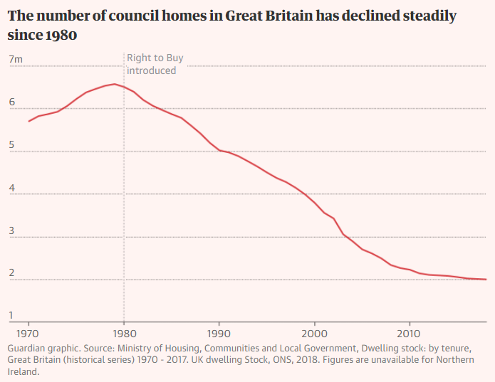
the table below shows the steady decline of council housing in the UK since the 1980s to present day:

Table 1 the decline in number of council homes in the UK (Guardian, 2021)

Quite recently Kenzie Zimmer, an editor for inews quotes that the current government has set a target for the number of homes to be built in the next few years, even though it falls short of the numbers currently estimated (345,000) to be needed:

“Boris Johnson has sought to remedy this problem by setting a target to build 300,000 homes a year by the mid-2020s, but the question of where these houses will be built looms large”
(Zimmer, 2021).

This shows that the current government is aware that the construction industry in the UK is not yet fit to produce the given number of homes needed to keep up with the demand.

Here are some additional causes which have influenced the housing crisis in the UK:

- Lack of affordable homes.
- Difficulties for mortgages for first-time buyers.
- Supply and demand disruption.
- London property price imbalances.
- Lack of new home construction.
- Lack of available land on offer to small and medium-sized developers.
- Buy-to-let markets have grown.
With these specific causes mentioned above in mind, the crisis boils down to the main cause; that not enough new homes are being built in the UK, to keep up with the demand: “The demands on the residential construction sector are substantial” (Davies, 2018).

A quote from Horn also outlines the severity of the demand further:

“With England alone needing up to 345,000 new homes annually, it’s clear that fresh, innovative solutions that disrupt the market are required to bridge that significant gap.”
(Horn, 2020)

With these annual demands outlined, the government has been looking toward the construction industry, to try and increase its productivity. A major factor of the crisis is that the UK is now facing a skilled labour shortage (which will be covered in the next chapter), an emerging energy crisis, and a climate crisis which certainly does not help the construction industry in its efforts to build and develop more homes (Farmer, 2016).

Alongside the demand for housing, the UK government has set a goal to meet zero carbon emissions by 2050. The homes that are going to be built between now and 2050, should be built using a large percentage of renewable materials, just to meet target set for 2050.

Modern methods of construction (MMC)

Modern Methods of Construction MMC

As discussed in the prior chapter, in 2017 the UK government set an ambitious target to build around 300,000 homes annually by the mid-2020s. but there are constraints such as Brexit, the pandemic and a shortage of skilled trades people that mean it cannot meet the target using traditional methods of construction alone. This is where modern methods of construction (MMC) come in.

MMC can be described as embracing a range of off-site manufacturing and on-site building methods that provide different techniques to traditional house building. MMC can range from having entire homes being produced from factory-built volumetric systems. This is done using an array of different materials and new innovative techniques using cutting edge 3D modelling (This will be covered further on) and new frameworks for building onsite.

MMC can create better quality homes in a much shorter time than most traditional methods of construction. MMC was initially created to meet the urgent demand for residential buildings after World War two. It then became popular again when the housing crisis started, post 2005. (Go-Construct, 2021).

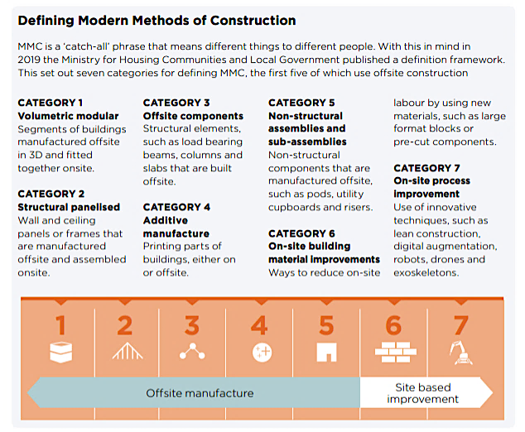
MMC is correctly defined and correctly categorized in figure 1 below, taken from the Savills research division:
Figure 1 Savills – MMC (Selsey, 2020)

Modern Methods of construction consist of many variations, here are the major aspects:

- Pre-assembly off-site manufacturing.
- Panelised construction.
- Volumetric construction.
- Modular integrated Construction (MIC).

The benefits that come with MMC, compared to traditional methods of construction are (Rahimian, 2020):
- Greater predictability of cost
- Efficiency Savings
- Environmental Savings
- Improved construction quality
- Increased speed of construction
- Improved health and safety

Off-Site Manufacturing/Construction

Off-site manufacturing of building elements, rooms, or whole buildings is becoming more and more attractive each year, as traditional construction methods are becoming more expensive the demand is outstripping the demand.
There are three off-site construction types used in the UK construction industry:

- Elemental or component – elements manufactured in a factory and delivered for assembly and installation on site.

- Panelised construction – closed or open panels that can be made up of steel, timber, or precast concrete systems. With additional insulation

- Volumetric - units assembled volumetrically inside a factor. Typically, these units are transported by lorry, with set dimensions for ease of delivery. They are then installed together on-site.

For some years, offsite construction has been seen as the solution to the UK’s housing crisis. This is due to a quick and efficient way of building residential homes, that meet the ever-increasing demand (Davies, 2018).

A quote from Savill’s describes the UK government’s response to Offsite manufacturing in 2018:

“In 2018, the House of Lords Science Committee was told that the use of offsite manufacture was the only way to achieve the government target of 300,000
homes per annum.”
(Savills, 2020)

4.3 Focusing on Cross-laminated Timber

Basic principles:

Timber frame is the second most popular construction method for homes in the UK. England and use 15% of UK housing output. But Scotland has a larger 75% of the market share. Around 85% of new homes in Scotland are built using timber, with thanks to the natural abundance of forests in the country (Construction Index, 2021).

Cross-laminated timber (CLT) is an engineered timber product and a system of manufacturing building elements from mass timber panels which can be whole components of a building envelope and primarily act as a structural frame. CLT panels are pre-cut to size in a factory through the use of computer-aided CNC machines. Experts predict that CLT will eventually threaten to upset the popular use of the two main structural materials, which are famously concrete and steel. Over the past ten years, the use of CLT in off-site UK construction techniques has risen dramatically. CLT has been used in the UK since the mid-90s. It originally came from Europe, as Germany and Austria were the biggest manufacturers of CLT at the time (Davies, 2018).

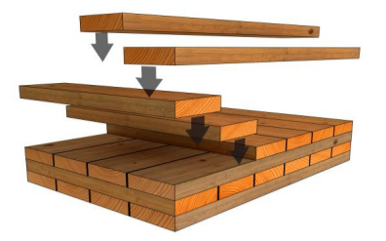
CLT is developed from the process of using glue to bond strips of laminated timber together to create structural beams. But in recent years, the technology has developed further to produce structural floors, walls, and roofing systems. The first structural beams of this type are known as glue-laminated or glulam beams. CLT uses the same method to engineer whole-wall panels that are both strong and beautiful in design. It is also a relatively new form off MMC in the field of timber construction. (Brinkley, 2021). CLT will also often have windows and door openings pre-cut during the manufacturing stage. CLT presents no limitations to architecture. CLT resists high racking and compressive forces, so it can be especially cost-effective for multi-storey and long-span applications (Storaenso, n.d.). Fig2 below clearly indicates which pattern the timber is orientated in the production of CLT:
Figure 2 Conventional assembly layup of cross-laminated timber (Buck, 2016)
What materials make up CLT?
CLT in the UK is made from the use of timber lamellae. Spruce is the popular choice of timber found in the UK. Although other trees such as Scot’s pine, larch, and Douglas fir can be used. Formaldehyde is the adhesive used to form the large-format structural bond for the panels. The layers of timber used to build up the structure of CLT are alternate to the adjacent layers and will have grains running in the same direction. This will provide strength and rigidity reduces the possibility of any warping. Table 2 Applications of CLT (Structural Timber Association, 2015)
Table 2 shows the broad types of applications that CLT construction can offer on any given project.

Most building types that are built using CLT around the world are:

- Schools
- Highrise buildings (up to 10 storeys)
- Warehouses
- Theatres
- Houses
- Industrial complexes

Good Practice
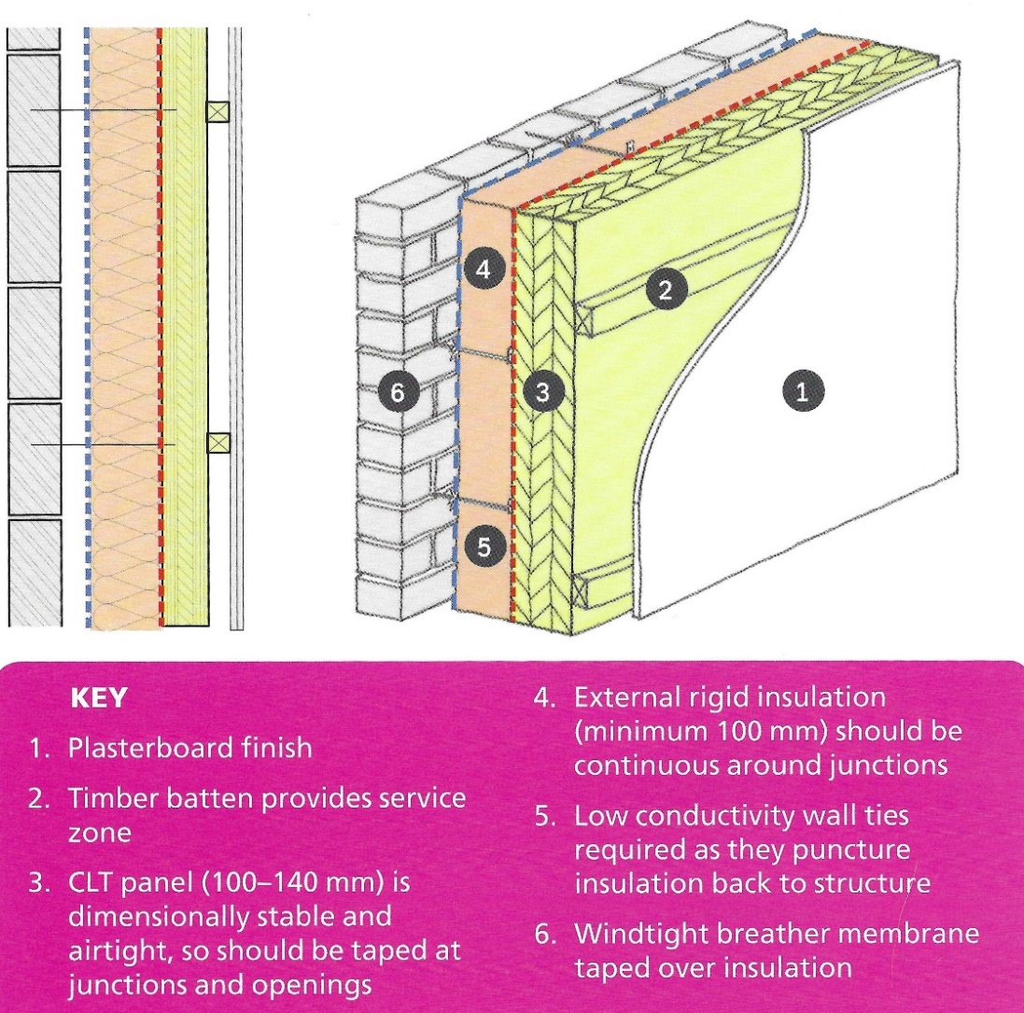
CLT is primarily used as a structural frame in the UK, due to the climate, Timber frames are typically clad with materials that can withstand the damp weather conditions frequently seen throughout the year. Fig3 below illustrates a section and a concise example of good practice when cladding CLT with external insulation and Masonry:
Figure 3 CLT Masonry Cladding System (Dollard, 2018).

Fire Protection
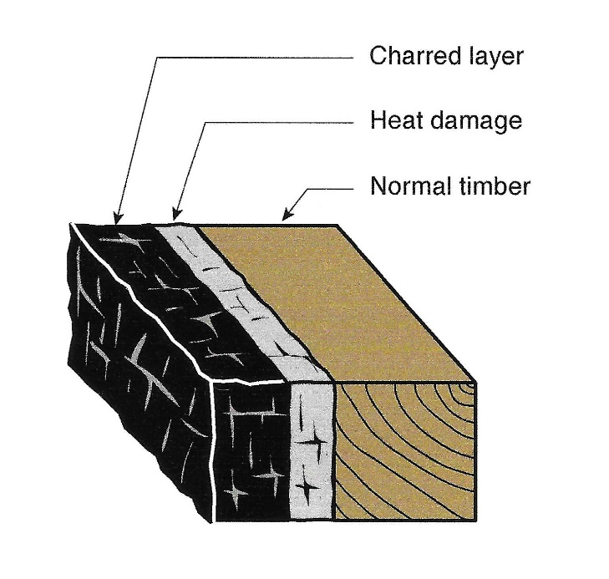
There is an assumption that because wood burns, timber buildings are at a higher risk of fire. Modern timber construction has demonstrated that this assumption is incorrect. Timber structures can be fitted with sacrificial layers, where an outer section takes the brunt of the damage and chars at a predictable rate of less than 1mm per minute, which will then protect the inner segments and allow time for the evacuation of the building, also depicted in fig3. (Storaenso, 2013). Many CLT Components are now treated with fire retardants, giving them an edge over other commonly used building materials such as steel, which will bend far more than timber, and concrete will spall. CLT outperforms steel and concrete in tests performed all over the globe
Figure 4 Charring of Timber (Structural Timber Association, 2015)

Air Tightness
Very tightly packed CLT panels can trap up to 90% of the heat that would escape from a home. CLT has a high thermal mass, which means that temperatures will be kept stable and comfortable.
Durability
CLT panels are often covered in a cladding system or an exterior finish, this means it is unlikely to be exposed to any wetting from the outside environment. Cross-laminated timber and glulam can offer high strength to weight ratios that in many cases equal those of steel and reinforced concrete.
CLT is also kiln dried to bring moisture content down to around 12%, which is enough to prevent fungal attack, and kill off any bacteria or bugs that might be lurking inside.
Disadvantages of using CLT

4.4 Case study 1 – Isle of Mull Community Housing
This case study is a great example of UK architects taking advantage of new CLT technology as an experimental project to showcase the benefits of using CLT in areas of the UK that experience challenging weather, fluctuating temperatures, and extreme levels of dampness:
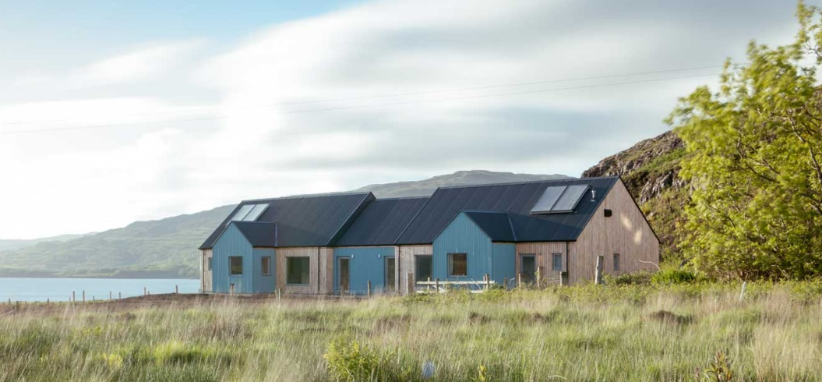
Thorn Wyness Architects: Social housing, Isle of Mull, Scotland
Figure 5 USCA Community Housing (back) (Thorne Wyness Architects, 2018)
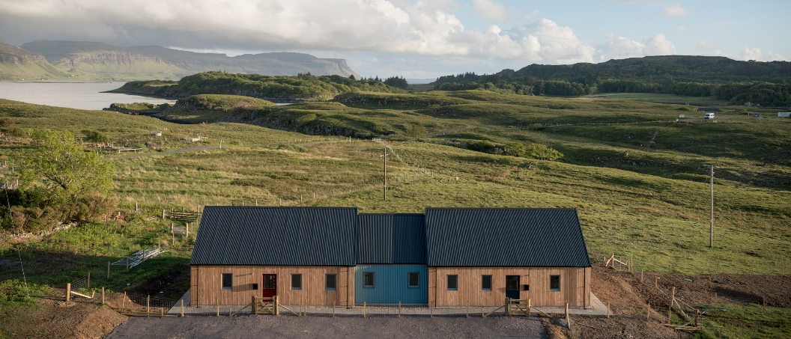
On the isle of Mull, Scotland in 2010, the local community was under threat of losing its Primary School and Community Centre due to population decline caused by a lack of affordable housing. Thorn Wyness Architects were tasked with building two, two-bedroom rental homes, built with CLT, which would provide rental homes for the young families living on the island (Thorne Wyness Architects, 2018). The houses are designed using Fabric First, Passive House principles. A CLT structure allowed them to create generous internal volumes inside a more reserved exterior. CLT helped to achieve great levels of airtightness and continuous insulation resulting in negative thermal bridging values.
Figure 6 USCA Community Housing (front) (Thorne Wyness Architects, 2018)
Thorne Wyness architects comment on why they used CLT for this build:
“We were familiar with Cross Laminated Timber through studying timber construction methods and felt that using CLT would allow us to achieve a very high standard of build quickly, easily and economically. Both houses achieved final airtightness results of 0.39l/s despite our contractors working under difficult conditions”
(Thorne Wyness Architects, 2018).

4.5 Case study 2 - Dalston Lane Housing
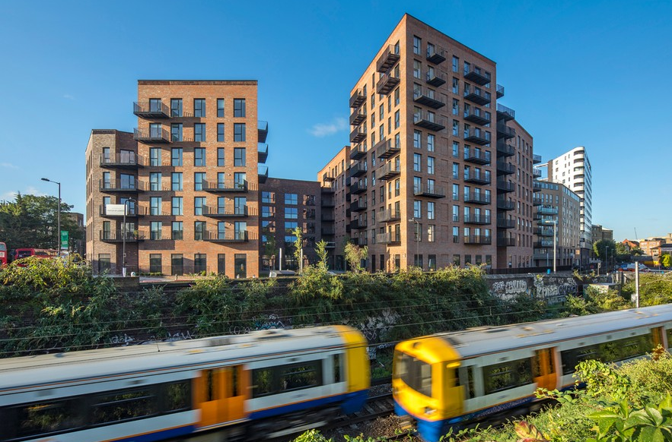
Designer: Waugh Thistleton Architects
Figure 7 Dalston Lane Completed (waughthistleton, 2018)
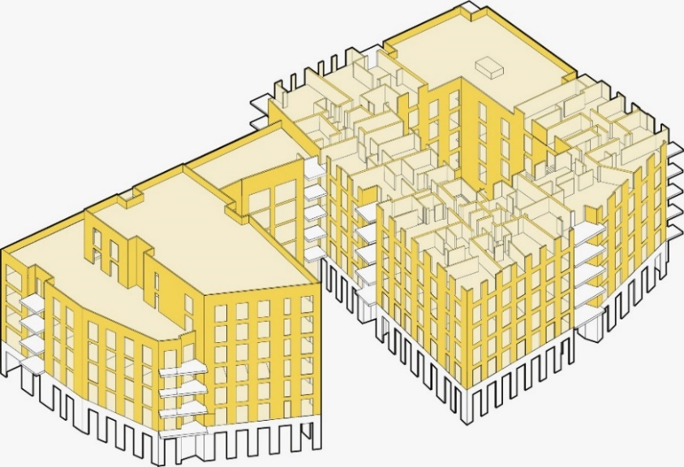
In London in 2018, Dalston works was the world’s largest CLT building on the planet, at the time of completion. It was hailed as a landmark project in the UK which helped roll out the use of CLT in high density urban housing. The building is a ten-storey, 121-unit development and is built entirely with CLT, this includes the stairs, core walls, floors. The total weight of all the CLT used in this build would equate to a fifth of concrete building built to the same size. This in turn reduced the large number of site deliveries made to the site over the entire construction phase of the building by roughly 80% (waughthistleton, 2018).

Although the building has been cladded with Brick, Fig.8 clearly shows the extent of CLT being utilized on this large building, which is highlighted in yellow. Each internal space is orientated to maximise daylight to the apartments’ balconies and communal open spaces.

Figure 8 Dalston Lane CLT Frame (waughthistleton, 2018)
The CLT panels were sourced from outside the UK and are produced using certified timber from sustainably managed forests in Germany and Austria. Approximately 2500 trees were used to build Dalston Lane. Andrew Waugh, director of Waugh Thistelton, says: “This is a great example of how we can generate the housing we desperately need across London and the UK and how we can build this from solid timber” (Wood Knowledge Wales, 2018).

4.6 The Sustainability of CLT Construction

Over the past 20 years, there has been much international discussion on the imminent global climate crisis. With the most recent conference on climate change at the COP26 in Glasgow, there has been a lot of discussion regarding Modern methods of construction, and how they may be able to help reduce the construction industries’ carbon footprint using more sustainable materials, such as Timber. With the housing crisis in mind, the option of timber as a preferred material of choice for the newly built homes of Britain may well help CLT develop much further, to become the favoured material, method and solution of the future. Fig.9 illustrates the amount of CO2 absorbed and stored in timber when put into the construction process. Timber stands alone as a renewable construction resource that actively sequesters carbon as it grows, as shown in the figure below:
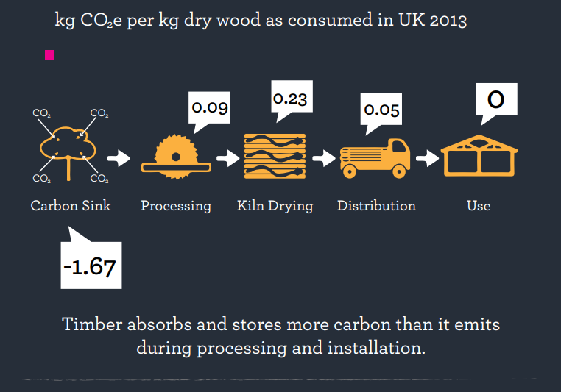
Figure 8 Timber is Carbon Negative (APPG, 2019)

A quote taken from the structural timber association suggests that CLT is a good match to meet sustainable requirements and aesthetic specifications:

“Large-volume timber structures, such as CLT, are a natural choice of
construction where low-embodied-carbon materials are required for where the aesthetic requirements for a dimensionally stable exposed timber finish are required”
(Structural Timber Association, 2015).

Timber frame construction and off-site timber manufacturing have many advantages compared to the use of steel and concrete frame construction. They are as follows:

- Less wasteful
- Increased recyclability
- Increased Durability
- Easily demolished
- Environmentally friendly
- Less time to build
- Increase fire safety properties
- Increased airtightness
- Fewer dust hazards in the construction phase

The UK construction industry still uses far too many non-renewable resources that bring a total carbon emissions percentage of 40% of the country’s total emissions. CLT should be treated as one of the many solutions to the current climate crisis and act as a sustainable form of construction that the UK government needs, to meet the net-zero target by 2050 (Ideal Modular Homes, 2020).

A quote taken from the environment analyst UK also states the true environmental benefits of using CLT:

"Cross laminated timber reduces freshwater consumption. It enhances indoor environment quality, which helps in the sustainability of the environment. It also helps in keeping the environment clean by generating zero waste during its production"
(Environment Analyst, 2018).

Healthy environment for the end-user

Trees provide us with an abundant, replenishable source of material. When
used in buildings, timber offers unsurpassed benefits to the health and
wellbeing of those involved in the construction, those living nearby and
those that live or work inside the completed building.

4.7The Future of CLT implementation in the UK

As humanity reassesses its relationship with the planet from one of
exploitation to one of investing and protecting our natural assets, so do people transition from using materials that are extracted from the ground and
pollute the atmosphere, to prioritizing the use of that which is naturally
grown.

Since the introduction of CLT from Europe in the 1990s, it has grown in popularity due to a range of attributes. CLT stands out for its strength, appearance, versatility, and sustainability, reduced construction times and greater quality control. The drawbacks of using CLT are far and few between.

To be continued further

How is the CLT industry responding to the combustibles ban? (BUILDING magazine. Great reference!

GRENFELL cladding combustible

Methodology

Research aims

5. References
APPG. (2019). How the timber industry can help solve the housing crisis. The All-Party Parliamentary Group for the Timber Industries (APPG).
Brinkley, A. C. (2021, June 17). Cross Laminated Timber: How to Build With CLT. Retrieved from homebuilding.co.uk: https://www.homebuilding.co.uk/advice/cross-laminated-timber
Buck, D. &. (2016). Further Development of Cross-Laminated Timber (CLT): Mechanical Tests on 45° Alternating Layers.
Construction Index. (2021). Grow Your Own. The Construction Index Magazine, 32-35.
CPRW. (2022). The Campaign for the Protection of Rural Wales. Retrieved from cprw.org.uk: https://cprw.org.uk/
Davies, A. (2018). Modern Methods of Construction. RICS.
Dollard, T. (2018). Designed to Perform. London: RIBA Publishing.
Environment Analyst. (2018, September 21). Cross laminated timber market to grow 15% by 2025, says report. Retrieved from environment-analyst.com/uk: https://environment-analyst.com/uk/70377/cross-laminated-timber-market-to-grow-15-by-2025-says-report
Farmer, M. (2016). The Farmer Review of the UK Construction Model. ©COPYRIGHT Mark Farmer 2016.
Go-Construct. (2021). Modern Methods of Construction. Retrieved from goconstruct.org: https://www.goconstruct.org/educational-resources/learn-about-construction/modern-methods-of-construction/#:~:text=Modern%20methods%20of%20construction%20is,as%20alternatives%20to%20traditional%20building.&text=Creating%20paneled%20units%20in%20factories,
Government, D. f. (2015). Plain English guide to the Planning System. London: Department for Communities and Local Government.
Guardian, T. (2021, March 31). UK housing crisis: how did owning a home become unaffordable? Retrieved from theguardian.com: https://www.theguardian.com/business/ng-interactive/2021/mar/31/uk-housing-crisis-how-did-owning-a-home-become-unaffordable
Horn, S. (2020, April 23). How timber frame and offsite construction meet housing demand. Retrieved from pbctoday: https://www.pbctoday.co.uk/news/mmc-news/timber-frame-housing-demand/75242/
Ideal Modular Homes. (2020, July 31). Sustainable Construction: Using CLT. Retrieved from idmh.co.uk: https://idmh.co.uk/blog-news-events/sustainable-construction-using-clt
Isherwood, K. (2020, July 8). Delivery of new-builds hits highest figure in over 20 years, despite COVID. Retrieved from buyassociation.co.uk: https://www.buyassociation.co.uk/2021/07/08/delivery-of-new-builds-hits-highest-figure-in-over-20-years-despite-covid/
Rahimian, J. S. (2020). Offsite production and manufacturing for innovative construction. Abingdon: Routledge.
Savills, R. (2020). Modern Methods. Retrieved from euro.savills.co.uk: https://pdf.euro.savills.co.uk/uk/spotlight-on/spotlight-modern-methods-of-construction-spring-2020.pdf
Selsey, R. V. (2020). Modern Methods of Construction. Retrieved from pdf.euro.savills.co.uk: https://pdf.euro.savills.co.uk/uk/spotlight-on/spotlight-modern-methods-of-construction-spring-2020.pdf
Storaenso. (2013). CLT - Cross Laminated Timber Fire Protection. Storaenso.
Storaenso. (n.d.). Cross-laminated timber (CLT). Retrieved from storaenso.com: https://www.storaenso.com/en/products/wood-products/massive-wood-construction/clt
Structural Timber Association. (2015). Cross-laminated timber construction. Structural Timber Association.
Taylor, R. L. (n.d.). Cross-laminated Timber. In TRADA, Timber Frame Construction (p. 216). TRADA.
Thorne Wyness Architects. (2018). USCA Community Housing. Retrieved from thornewyness.co.uk: https://www.thornewyness.co.uk/architecture/isle-of-mull/2017/05/26/USCA-community-housing.html
waughthistleton. (2018). DALSTON WORKS. Retrieved from waughthistleton.com: https://.com/dalston-works/
Wilson, W. (2020, February 11). Stimulating housing Supply. Retrieved from researchbriefings.files.parliament.uk: https://researchbriefings.files.parliament.uk/documents/SN06416/SN06416.pdf
Wood Knowledge Wales. (2018, June 04). Just 3 hours to grow equivalent trees for world’s largest CLT Building. Retrieved from woodknowledge.wales: https://woodknowledge.wales/special-feature/just-3-hours-to-grow-equivalent-trees-for-worlds-largest-clt-building
Zimmer, K. (2021, October 26). Building on greenbelt land is still politically toxic, despite the severity of the housing crisis. Retrieved from inews.co.uk: https://inews.co.uk/opinion/greenbelt-land-building-politically-toxic-uk-housing-crisis-1268477

