How individuals’ beliefs, attitudes and values impact on workplace behavior.

BMSW5101_BIRM
COSTEL ANDONE (2027240)
LECTURER: OBINNA NKWOCHA

Table of Contents
CHAPTER 1 2
Introduction 2
Description of workplace beliefs and origins 2
The Source of Values 3
Types of beliefs in workplace 3
Honesty 4
Punctuality 5
Respect 5
Positivity 6
Reducing negativity at the workplace 7
Conclusion 8
References 8
CHAPTER 2 11
Critical reflect on my critical thinking skills 11
Introduction 11
What? 11
So what? 11
Now what?.............................................................................................................................12
Developing arguments 13
Theories of management 14
How will I implement critical thinking in the future? 14
References 15

CHAPTER 1

Introduction
The first part of this essay is about the analysis of the impact of individual beliefs and values at the workplace, their origins and some types of beliefs; honesty, punctuality, respect and positivity, and the impact it has as behaviour at the workplace. It is also about reducing the negative impact of beliefs in the workplace followed by a conclusion that underlines all the arguments and research in this essay. In the second part, it is about a reflective critique on the development of my skills learned in this module using one of the two reflective models: Kolb’s reflective model (1984) or Driscoll reflective model (1994).

Description of workplace beliefs and origins
Values are vital to companies. Both decision-making and behaviour at work, these are called key determinants and considered in organizations as values and are listed as a subject of interest in the company class. By meaning what is appropriate or desired, values direct the choice of action. However, they do not give us standardized or precise prescriptions for actions. There are some organizations that focus on work values, in order to improve the quality of services. The fusion of daily practices results from the work of values for the purpose of effective organization at the workplace (Askeland et all, 2020).
According to Meglino and Ravlin (1998), values gain an appreciated place in the public and scientific discourse at several levels. They are "among the very few social psychological concepts that have been successfully employed across all social science disciplines"(Rokeach & Ball-Rokeach, 1989, p. 775).
A belief is something related to an inner feeling that something specific is true even if that belief can be unproven or irrational. e.g., I think that if you have a ladder above your head and you pass under it, this brings bad luck, or the existence of life after death (Anderson & De Silva, 2009).
Values have a major influence on the behaviour of individuals and are regarded as an important pawn of organizational culture. At the same time, values are recognized as needs, motivations, attitudes, goals and even personality types (Rokeach, 1979).
Shokef and Erez (2006) talk about work values (e.g., openness to cultural diversity, customer guidance, the orientation towards a competitive performance) and transpires in an almost global atmosphere. Values refer to desirables goals and beliefs that transcend specific actions and have the role of standards to direct the evaluation of the behaviour of events and people (Schwartz, 1992, p. 4).

The Source of Values
Boudon (2017) notes that there are two sets of values - instrumental and terminal. They are consolidated and developed in the environment in which they develop on the one hand, and through the culture on the other. Socialization with friends, education, culture, religious institutions, family, society and personal experiences, all these helps to build values in people (FIGURE 1). Social and belief systems, and to some extent the socio-economic affects individual values.
FIGURE 1.
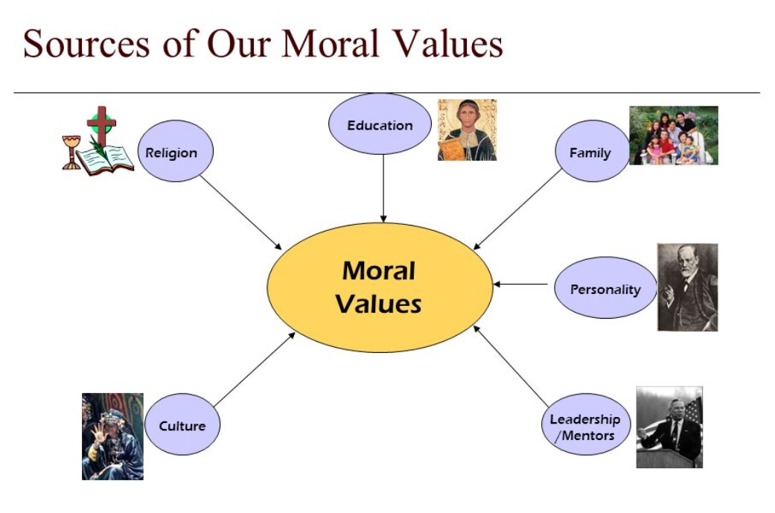
Source: https://slideplayer.com/slide/10016033/.

Types of beliefs in workplace
Work values are principles or beliefs related to the workplace or career. These values describe the individual's beliefs regarding his career. For example, some people think that gaining a sense of achievement through their effort is a basic advantage in their profession (Finegan,1994).
It is vital for great efficiency at work understanding beliefs and values. These beliefs are of several types at the workplace, including:
-Honesty
-Punctuality
-Respect
-Positivity

Honesty
Honesty is primarily a quality and refers to an individual being honest and fair. It refers to the work well done even in the most difficult and difficult conditions. The best workplace policy is honesty when it comes to the skills or qualities of any individual. Truth and transparency at work defines an individual as being honest (Veage et all, 2014). At the workplace, honesty encourages a feeling of trust between the company, employees and the community. The management style at the workplace and the environment in which an individual carries out his activity sometimes affect the employee's exposure to integrity. Changes brought to a company regarding its management can contribute to the encouragement and presentation of honesty on the part of a company's employees.
For example, a leader in a business company sometimes must make tougher calls. What results is that the action takes place in a harsh environment. And if the leader is concerned about his employees or the team he leads and their results, then honesty will be the one that unites the team, being an example given by both the leader and the other members of the organization (Jocelyn et all, 2013).
According to Finegan (1994), honesty is superior more in theory and less in practice. For example, some members of a company's team sometimes avoid talking about disappointments, opinions, or general ideas that could help the correct and profitable operation of the company. Unfortunately, these opinions reach the leaders' ears due to conversations with other team members in the form of frustration or gossip. By encouraging integrity, an atmosphere of responsibility is created, which leads to the promotion of honesty, which results in solving the problems the company faces, as well as much higher results and profits for the company.

Punctuality
Punctuality is and is part of the responsibilities of every individual who works in a company, being the assurance while he will successfully fulfil his tasks in that organization. Regardless of the position of any individual at work, constant punctuality is and remains very important.
The development of respectful and professional habits is due to the awareness of the basic elements of the individual's presence and punctuality at the workplace (Chamberlain, 1982).
Mikkola and Väisänen (2013), notes that the ability of an individual to be on time at the workplace and to complete tasks within the terms given by superiors is called punctuality. Punctuality at the workplace denotes professionalism, where the necessary arrangements and planning in time ensure the fulfilment of obligations at the workplace. E.g., Coordinating the commute to the workplace, creating a timetable or starting the shift at the time set by the company shows and proves that the employee fulfils his duties at the workplace.
At work, people rely on each other, and punctuality is the common point between them, without which working in a team and finishing tasks on time would not be possible. For example, the team of a company, due to the punctuality of the whole team, improves the efficiency of meetings and arrangements, all members start their tasks on time, and no one must wait for the other person because he has not yet arrived at the workplace. Another example of how beneficial the punctuality of employees can be is the development of the company's reputation due to this ability (Back at all, 2006).

Respect
According to Dillon (1992), respect is defined as taking seriously as well as offering attention to another individual. Ignorance, negligence is the lack of respect that people experience at work. In organizational theory, respect is identified as a value, and the analysis related to respect in organizations are limited (Sheridan, 1992).
Mishra and Spreitzer (1998), says that respect is the basis for trusting one another in a company. It goes without saying that employees will have more trust in management and will carry out their activities at the highest standards of professionalism if they are treated correctly and with respect by those who lead them. For example, a leader will listen to anyone in his team practicing transparency, recognizing the strengths and values ​​of each employee in his team. By doing all the above, the employees at the workplace will react and respond in the same way, from here it follows that if a company wants respect to be at the highest standards, it is good for the management to set a first example.
It is vital for both employees and employers to respect each other. Any employed individual must respect managers and colleagues, speaking gently to everyone and giving them due attention. Productivity and collaboration create satisfied employees and at the same time create a pleasant workplace. Employees are satisfied with their job and will leave satisfied with their performance at work. And this brings great benefits to both employers and employees in the long term (Ellingsen and Johannesson, 2007).

Positivity
This ability involves supporting a positive behaviour, especially in the face of challenges.
Positive thinking at work it is due to this ability called positivity. In workplaces where there is cooperation, trust and safety are entirely due to those with a positive mindset.
Regarding the competitive environment of today's organizations, it is necessary for the survival mentality to extend to workplaces for greater performance (Luthans & Youssef, 2007).
Organizations in order to pursue optimal performance change their purpose from a fixation on the weaknesses of the company to hasten the conditions that advance the flourishing of people (Cameron, 2010).
Task performance in work teams includes both quality and quantity, the results of the team, as well as the rest of the performance and objectives of the employees at work (FIGURE 2). This state of the team requires that members interact positively with each other, where performance and the pursuit of the desired objectives require the support of positive relationships between team members at work.
(FIGURE 2).

Source: https://info.totalwellnesshealth.com/blog/7-tips-for-promoting-positivity-in-your-workplace.

This positive and emotional connection between employees is vital in the achievement of objectives, it promotes positivism and high-quality energetic bonds between employees and team members, very valuable resources for achieving objectives in the company (Cameron, 2010).
A positive tone in the organization is increased by large interactions with the support of the entire team and which subsequently increase its efficiency (MA West & Richter, 2011).
For example, a team in an organization will have a positive tone maintained, both on the part of the leader and on the part of the chain members, all their actions will be crowned with success and the efficiency of the actions will be at the highest levels.

Reducing negativity at the workplace
Most people at some points have had a less than pleasant experience at work. It is possible that a member of a company's team spread rumours such as that a member did not behave nicely towards another colleague. Team leaders or company managers have the role and responsibility to address and discuss these problems with those involved before they get worse. All these problems lead to poor collaboration, stress, and reduced productivity both person in question, and sometimes of the entire group at work (Yao et all, 2020).
Facebook, Google, Microsoft and other successful companies focus on creating positive environments in their organizations.
For example, Microsoft encourages employees to face certain responsibilities, to learn from mistakes made and to accept failure.
In order to reduce negativity at the workplace, the management of the company should offer employees the freedom of expression, to present their ideas, opinions and even criticism.
The promotion of collaboration and communication are the ones that will substantially reduce the negativity of beliefs at the workplace, and the recognition of the achievement of the team's objectives in the organization will only strengthen a constant well-being at the workplace.

Conclusion
As a conclusion of workplace beliefs, promoting healthy relationships in the company is vital for a positive and healthy workplace. The development of respect and trust both on the part of the employees and the management department, will lead to the creation of a positive work environment in which everyone will benefit. Spreading positivity will make a stronger mentality for all those who work in such a work environment.

References
Askeland, H., Espedal, G., Jelstad Løvaas, B., & Sirris, S. (2020). Understanding Values Work Institutional Perspectives in Organizations and Leadership (1st ed. 2020.; H. Askeland, G. Espedal, B. Jelstad Løvaas, & S.
Back, M.D., Schmukle, S.C. and Egloff, B., 2006. Who is late and who is early? Big Five personality factors and punctuality in attending psychological experiments. Journal of Research in Personality, 40(5), pp.841-848.
Boudon, R., 2017. The origin of values: Sociology and philosophy of beliefs. Routledge.
Cameron, K. S. (2010). Five keys to flourishing in trying times. Leader to Leader, 2010(55), 45-51.
Chamberlain, P.J., 1982. Careers lessons and career awareness of fifth-form students. British Journal of Guidance and Counselling, 10(1), pp.74-82.
Dillon, R.S., 1992. Respect And Care: Toward Moral Integration1. Canadian journal of philosophy, 22(1), pp.105-131.
Ellingsen, T. and Johannesson, M., 2007. Paying respect. Journal of Economic Perspectives, 21(4), pp.135-150.
Finegan, J., 1994. The impact of personal values on judgments of ethical behaviour in the workplace. Journal of Business Ethics, 13(9), pp.747-755.
Geue, P.E., 2018. Positive practices in the workplace: Impact on team climate, work engagement, and task performance. The Journal of Applied Behavioral Science, 54(3), pp.272-301.
Laschinger, H.K.S. and Finegan, J., 2005. Using empowerment to build trust and respect in the workplace: A strategy for addressing the nursing shortage. Nursing economics, 23(1), p.6.
Luthans, F., Youssef, C. M. (2007). Emerging positive organizational behavior. Journal of Management, 33(3), 321-349.
McDonald, P. and Gandz, J., 1992. Getting value from shared values. Organizational dynamics, 20(3), pp.64-77.
Meglino, B.M. and Ravlin, E.C., 1998. Individual values in organizations: Concepts, controversies, and research. Journal of management, 24(3), pp.351-389.
Mikkola, M. and Väisänen, O., 2013. Values in the workplace: The effects of national values on Indian and Finnish business cooperation.
Sarah, S., Prasetyo, Z.K. and Wilujeng, I., 2019. Development of Living Values (Honesty) Assessment Instrument in Learning Process. International journal of instruction, 12(4), pp.443-458.
Schwartz, S.H., 1992. Universals in the content and structure of values: Theoretical advances and empirical tests in 20 countries. In Advances in experimental social psychology (Vol. 25, pp. 1-65). Academic Press.
Shokef, E. and Erez, M. (2006), “Global work culture and global identity, as a platform for a shared understanding in multicultural teams”, in Chen, Y.-R. (Ed.), National Culture and Groups: Research on Managing Groups and Teams, Elsevier, Amsterdam, Vol. 9, pp. 325-52.
Veage, S., Ciarrochi, J., Deane, F.P., Andresen, R., Oades, L.G. and Crowe, T.P., 2014. Value congruence, importance and success and in the workplace: Links with well-being and burnout amongst mental health practitioners. Journal of Contextual Behavioral Science, 3(4), pp.258-264.
West, M.A. and Richter, A.W., 2011. Team climate and effectiveness outcomes. Handbook of organizational culture and climate, pp.249-270.
Yao, Z., Luo, J. and Zhang, X., 2020. Gossip is a fearful thing: The impact of negative workplace gossip on knowledge hiding. Journal of Knowledge Management.

CHAPTER 2

Critical reflect on my critical thinking skills

Introduction
In this critical reflection I will apply the very used and well-known Driscoll's reflection model (Driscoll, 2007).

What?
Most of the day we think and perform our tasks automatically, being even a routine, and people with critical and sharp thinking are essential at the workplace (Ash and Clayton, 2004).
In my opinion, this module is one of the most interesting modules, because just its name makes you think of something new, and which both I and my colleagues think I have not met.
Just from the name of this module I realized that it will be about a development from a mental point of view, and that will help me in the decisions that I will make in the future at work and beyond.
From the first hour of this module, a confusion was created in me because my way of thinking was totally different from what was presented to me and to my colleagues.
The lecturer presented us with a different approach to thinking, critical I could say, based on some established theoretical models.
Or presented theories and analyses related to values, differences between beliefs and attitudes at the workplace and to understand the system of values ​​at the workplace, and what impact they will have followed their application.

So what?
Hour after hour, the lecturer presented us with different topics of this module, more and more interesting among them:
- Logical reasoning
- Beliefs, values ​​and attitudes,
- Developing arguments
-Validating evidence
- Causal reasoning and
- Theories of management.
All these topics made me really understand what the art of critical thinking means, I could say, and it doesn't refer to a change in human nature or to proceed completely rationally as I initially tended to believe.
This module is about our own and others' way of knowing, and the limitations we have.
Critical thinking is born from two academic disciplines: Psychology and Philosophy (Lewis & Smith, 1993).
I liked this philosophical approach because it made me think critically, to be able to see the attributes and qualities of a person, for example, then the actions and behaviours that a critical thinker can achieve (Thayer-Bacon, 2000).
Sternberg (1986) reports that this type of thinking treats the critical thinker as a perfect type, based on people's abilities under the best circumstances (FIGURE 3).

(FIGURE 3).

Source: https://www.uopeople.edu/blog/why-is-critical-thinking-important/.

Another very important topic that I really liked is about beliefs, values ​​and attitudes.
About faith I understood the fact that it refers to people's internal feelings, to something that can be true even if what I think about that faith can be irrational or unproven.
A very eloquent example is the one referring to the fact that if we pass under a ladder sooner or later it will bring us bad luck.
Regarding the value, I understood the importance we give, and these values ​​often reflect the way we live our lives. E.g., I value my family and I respect free expression.
And finally, the attitude, through which I express my opinions and convictions either through my behaviour or through words. E.g., I get upset when I hear about a person being sick, or the physical abuse of people (Anderson & De Silva, 2009).
Now what?
Due to the reflection on these beliefs, values ​​and attitudes, I realized that any person has the right to express his feelings and to accept the fact that people can have beliefs, attitudes or values ​​different from mine.
I realized that I have no right to try to make people change their beliefs and attitudes just by the simple fact that they are different from my values ​​and beliefs.

Developing arguments
The statement is the conclusion of a paragraph, and the writer wants you to accept it (Dyer, 2011).
The statement is in the arguments - the primary idea that we want to demonstrate.
A quality statement must be captivating, daring, and the fact that it should be argued is the most important thing.
The next topic is about the validation of evidence. I really liked it because of Pearson's RED Critical Thinking Model, and it is considered as a key to critical thinking.
R - recognize assumptions
E - valued arguments
D - draw conclusion.
This model encourages students to use it, being easy to use, helping with memory.
The next topic learned in this module is Causal reasoning.
I understood that a causal statement is described as a relationship between two events, from here results the effect on the other.

Theories of management
These management theories are united with organizational difficulties, such as leadership and change, motivation, and their use in practical problems and situations.
The last topic in this module is Theories of management.
These are defined as concepts that are part of the recommended management strategies and can include tools such as guidelines and frameworks that can be applied in modern companies.

How will I implement critical thinking in the future?
I think that first I will implement critical thinking both in the professional and social environment. Implementing critical thinking is the only chance by which I will make conscious and correct choices.
I will start practicing critical thinking from now on, because there is no questioning about the choices made by critical thinkers. It will help me to think independently and trust my own feelings, and the result will be better decision-making.
I have already started to implement critical thinking starting with the most mundane decisions made every day, which makes me understand myself, avoid negative beliefs and put more emphasis on my strengths, and thus makes me feel happy.
In the future, I will improve my relationships with those around me by applying critical thinking, which will later lead to a more open understanding towards my peers and will help me to be open to other opinions towards my peers.
I will start to apply critical thinking even at the workplace by showing that now I understand that the company appreciates employees who ask questions, think critically and at the same time offer creative plans, which will make a very good impression. In the future, I will apply critical thinking in my personal life as well, it will help me define my goals and I will know what I should and should not do.
A particularly well-known critical thinking quote is said by former US President Thomas Jefferson: "An educated citizenry is a vital requirement for our survival as a free people " (FIGURE 4).

(FIGURE 4).
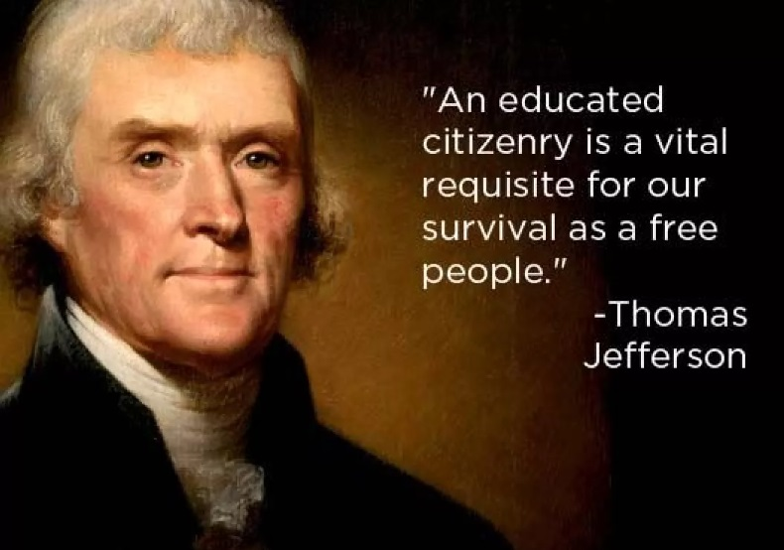
Source: https://www.edweek.org/teaching-learning/opinion-updating-mr-jefferson-an-education-for-todays-democracy/2015/12.

References

Ash, S.L. and Clayton, P.H., 2004. The articulated learning: An approach to guided reflection and assessment. Innovative Higher Education, 29(2), pp.137-154.
Brookfield. S. (2012) Teaching for critical thinking: tools and techniques to help students question their assumptions. (Online) San Francisco: Jossey-Bass.
Chatfield, T. (2017). Critical thinking: Your guide to effective argument, successful analysis and independent study. Sage.
Driscoll, J., 2007. Adventures in facilitating group clinical supervision in practice. Practising Clinical Supervision–A Reflective Approach for Healthcare Professionals, pp.53-71.
Lewis, A. and Smith, D., 1993. Defining higher order thinking. Theory into practice, 32(3), pp.131-137.
Thayer-Bacon, B.J., 2000. Transforming critical thinking: Thinking constructively. Teachers College Press.

