Appendices.

Appendix 1 | Page 3
Learner interview – outline of questions.

Appendix 2 | Page 4
Research day- interview schedule.

Appendix 3 | Page 6
Learner interview – transcription.

Appendix 4 | Page 9
Email to staff.

Appendix 5 | Page 10
Questionnaire.

Appendix 6 | Page 13
Questionnaire – findings.

Appendix 7 | Page 18
Observation.

Appendix 8 | Page 20
Intervention

Appendix 9 | Page 22
Ethics form.
Appendix 10 |  | Page 38
Consent form.

Appendix 11 | Page 41
Right to withdraw – learner flashcards

Appendix 12 | Page 42
Research study – findings.

Appendix 13 | Page 50
Draft email.

Appendix 1

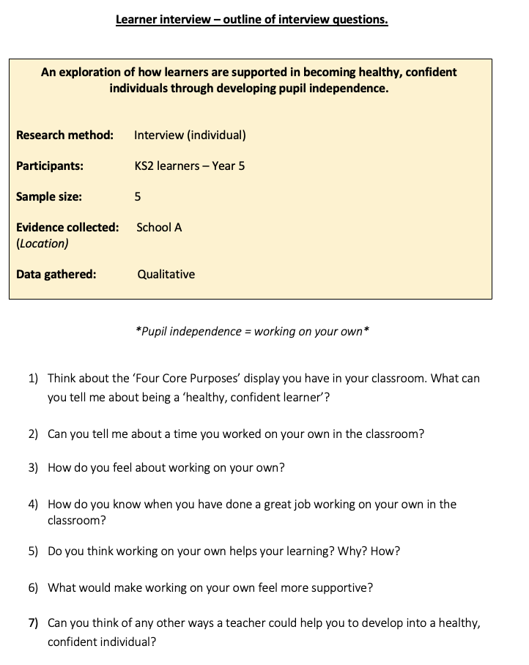

Appendix 2

Research day – interview schedule
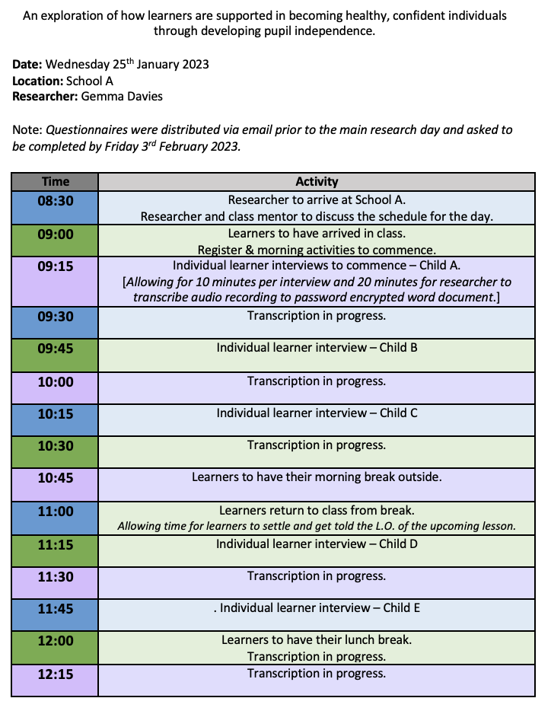

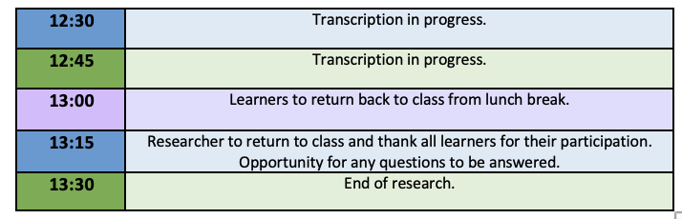

Appendix 3
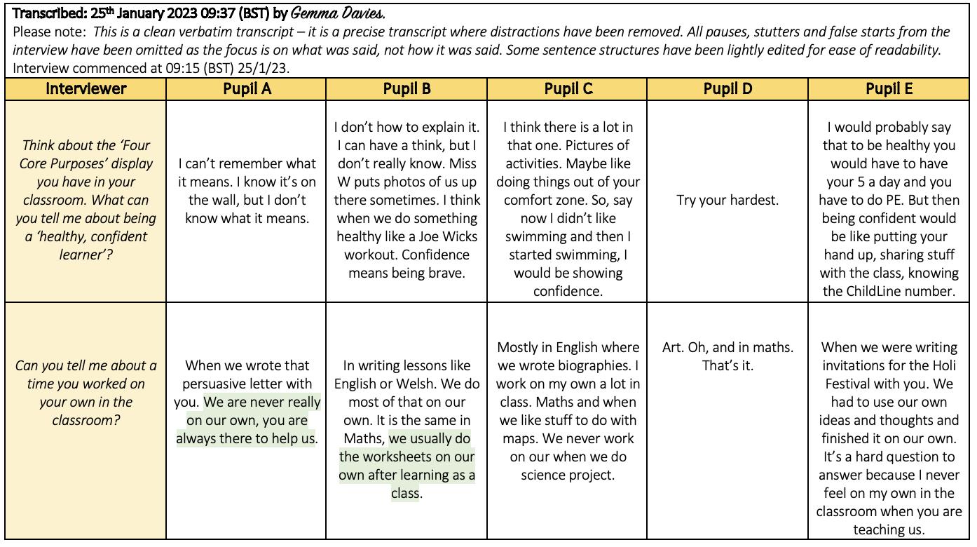
Learner interview – transcription

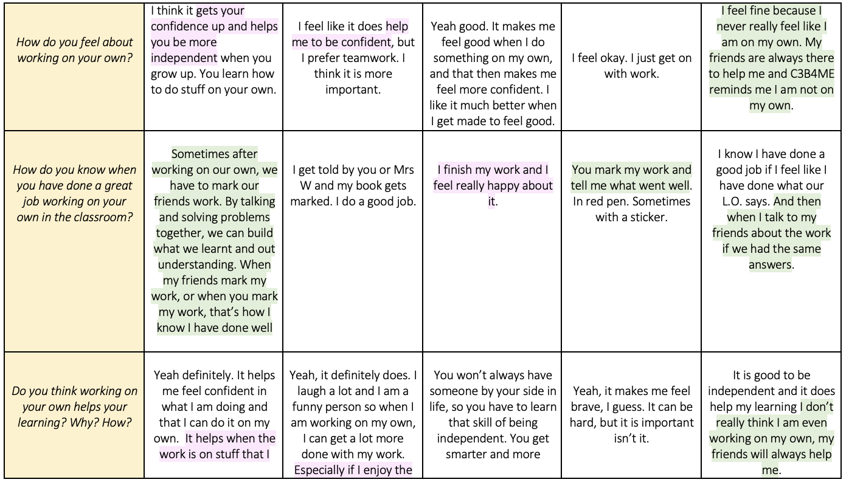

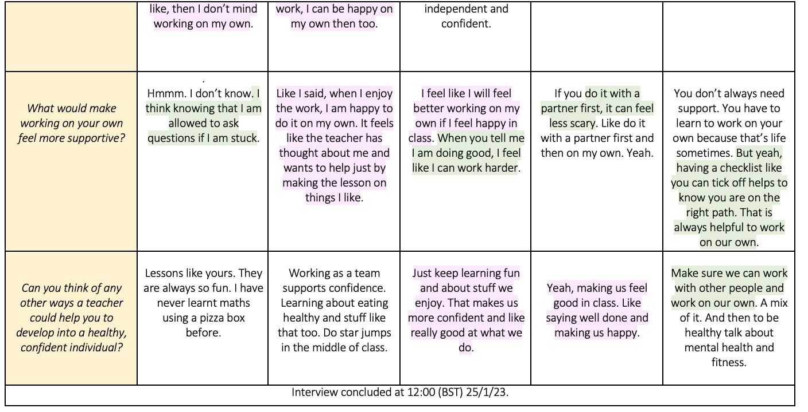

Appendix 4

Email to staff

Dear ………………….,

I hope you are well!

My name is Gemma Davies, and I am final year student on the BA Primary Education with QTS course at the University of Wales Trinity St David. I have thoroughly enjoyed my time at Richmond Park Primary School in the Talie. sin Year 5 class these past two weeks.

I am currently exploring how pupil independence is developed for my final research project. I need to have gathered data by Friday 3rd February 2023 and I would be grateful if you could complete the questionnaire to assist with my research. It should take no more than 15 minutes, and you have the right to withdraw from the research at any time. You can find the questionnaire through clicking the link below:

https://forms.office.com/Pages/ResponsePage.aspx?id=-REPTm4EBUWcuNshUjEeIcKgAPILiAxMv-ffXAE4nvJUMk1IRlBVU0ZCMFczWUhZMEMxTlRXOUu

Should you wish to withdraw after the questionnaire has been submitted, please contact me with your memorable code, and your data will be destroyed and discarded from the results. All data provided will be kept secure in a password protected file and kept anonymous, solely to be used for the purpose of my research assignment.

I would like to thank you for your time and assistance, it is greatly appreciated. If you have any questions, please do not hesitate to contact me.

Thank you.
Kind regards,
Gemma Davies.

Appendix 5

Questionnaire
An exploration of how learners are supported in becoming healthy, confident individuals through developing pupil independence.

Research method: Questionnaire
Participants: KS2 Staff
Sample size: 3
Evidence collected: School A
(Location)
Data gathered: Mixed method – Quantitative & qualitative.

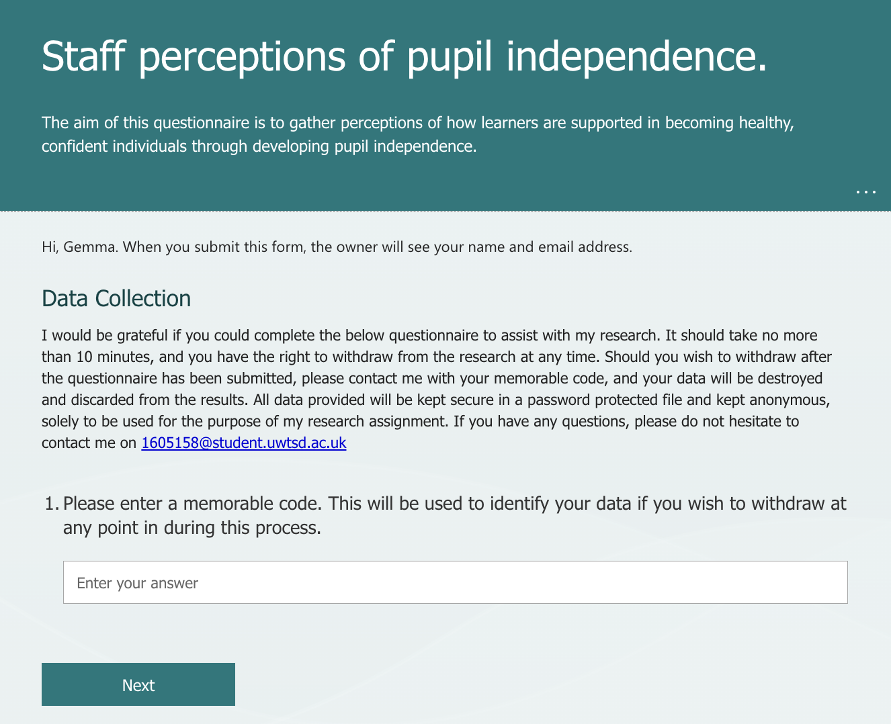

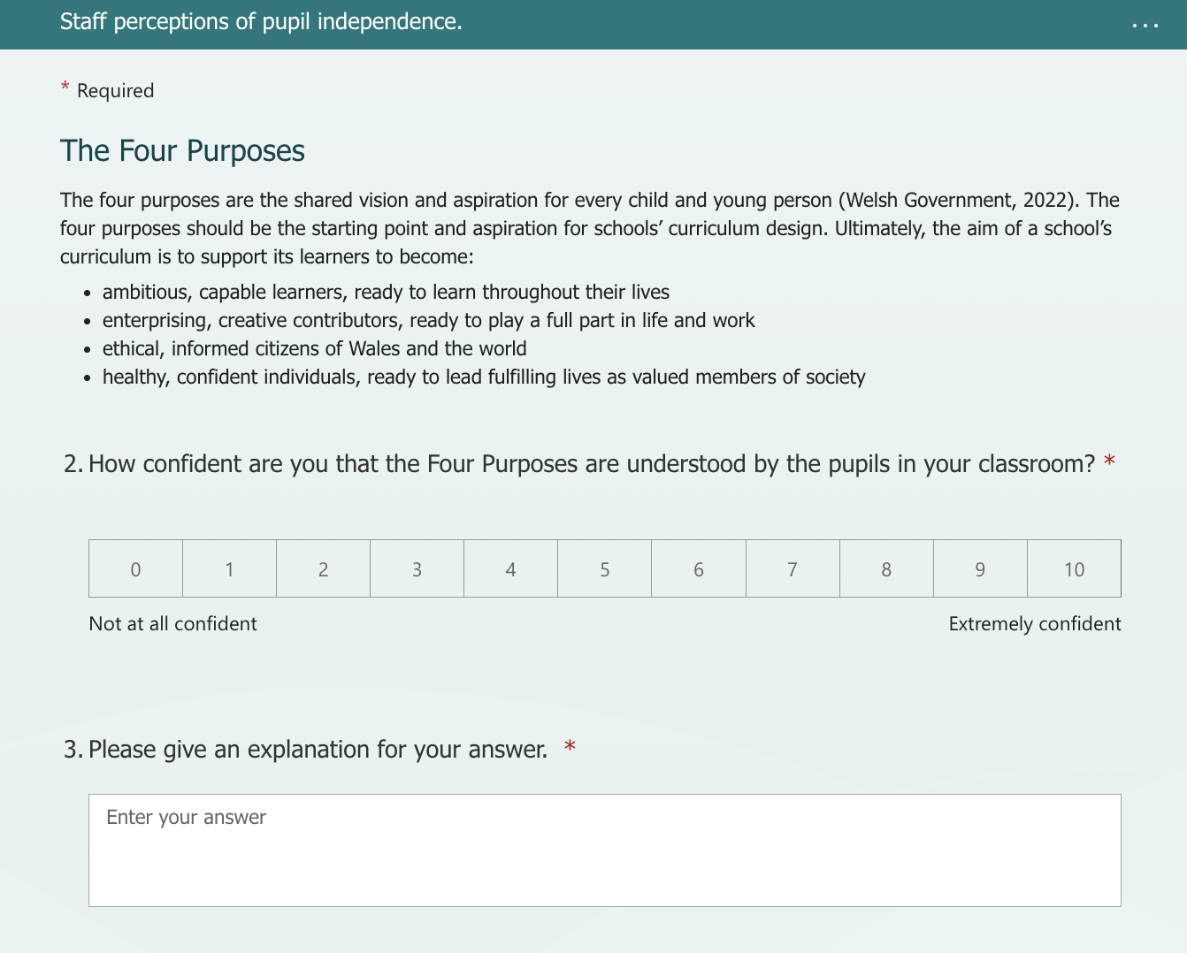
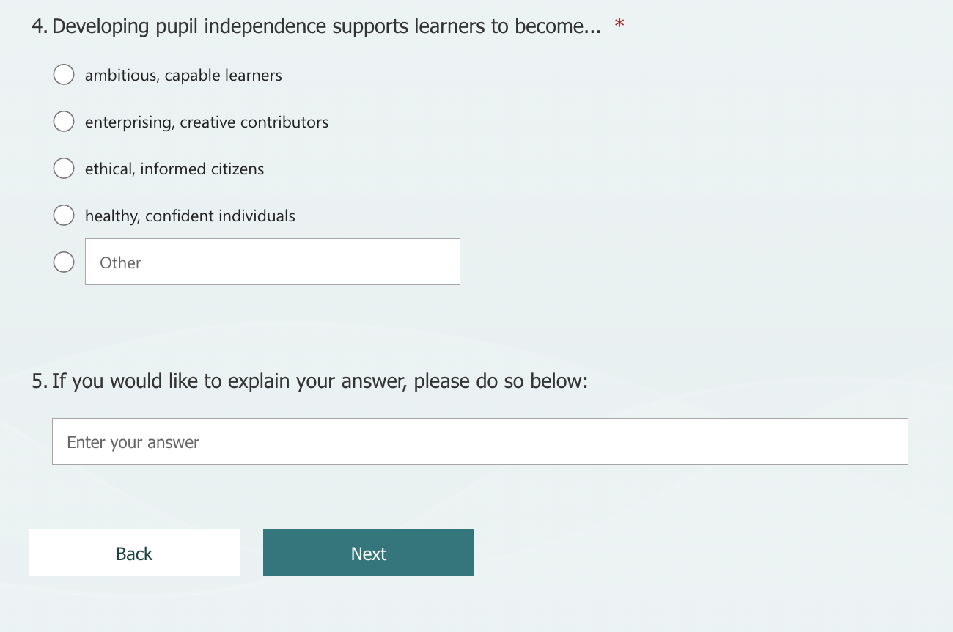
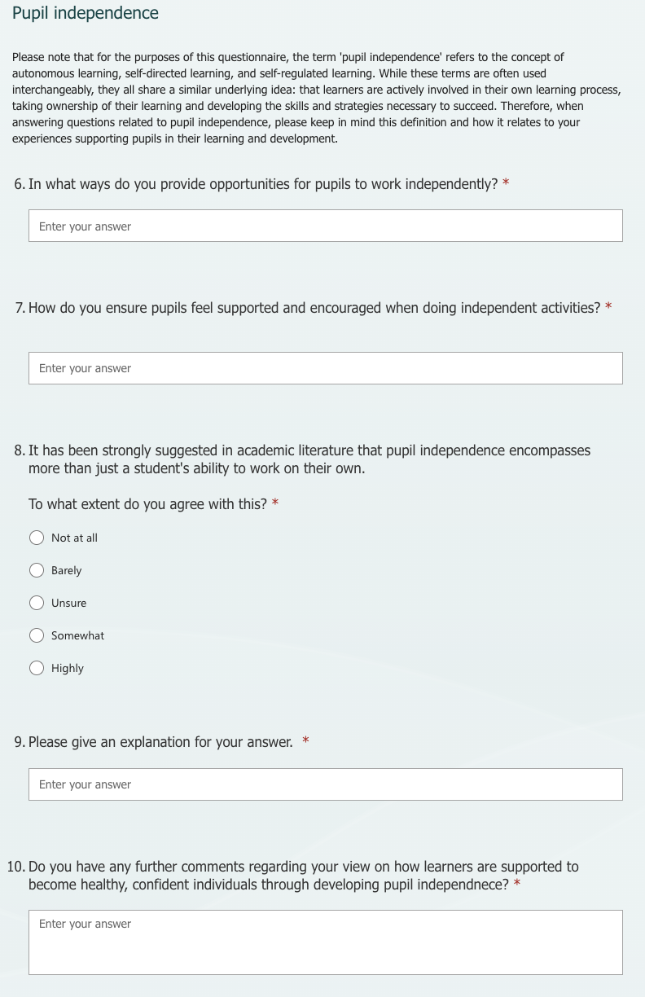

Appendix 6

Questionnaire - findings
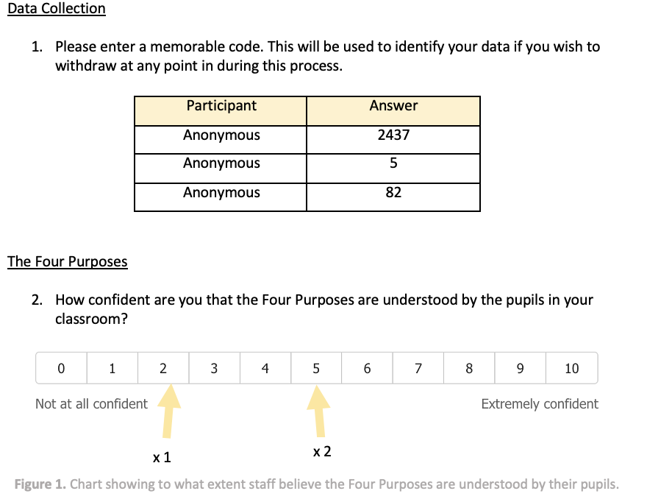

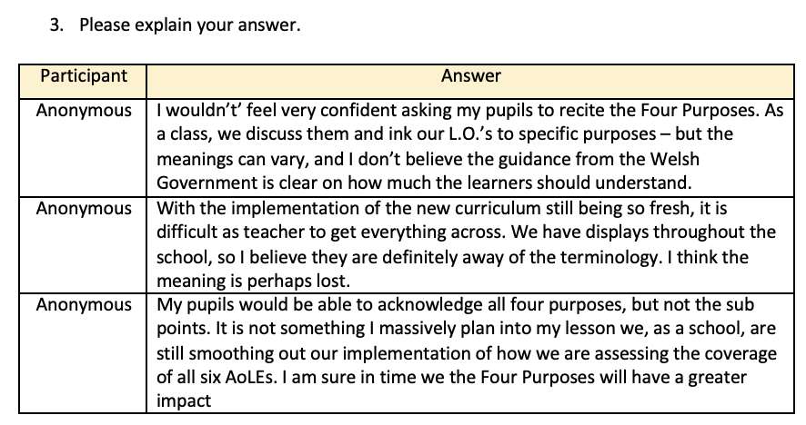

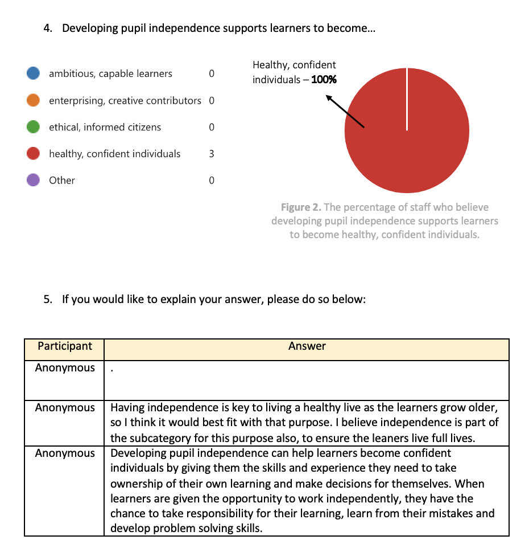

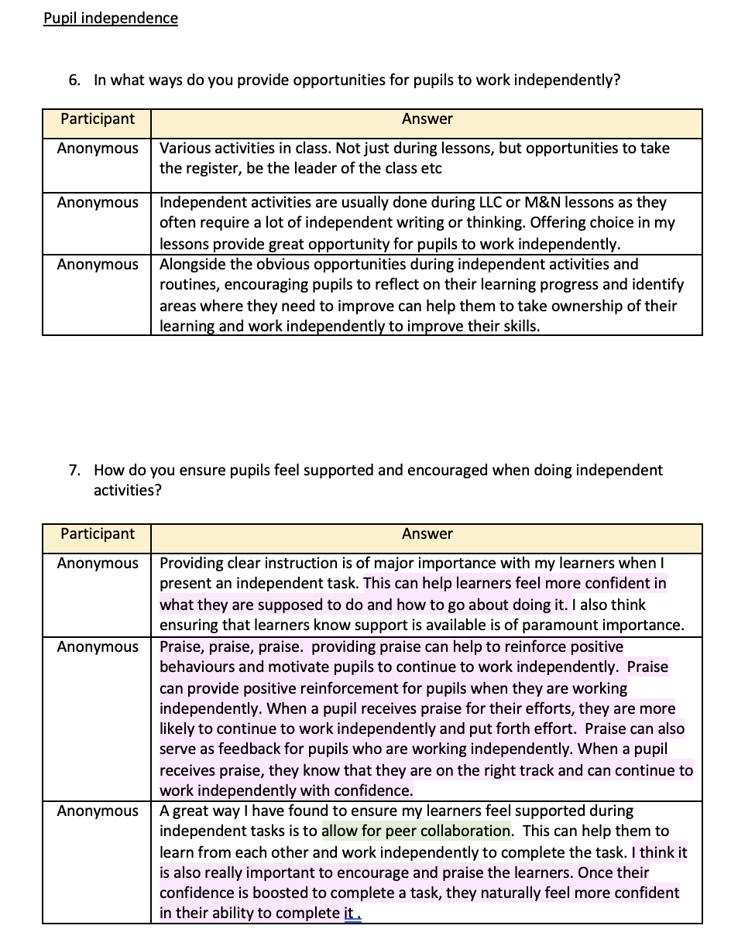

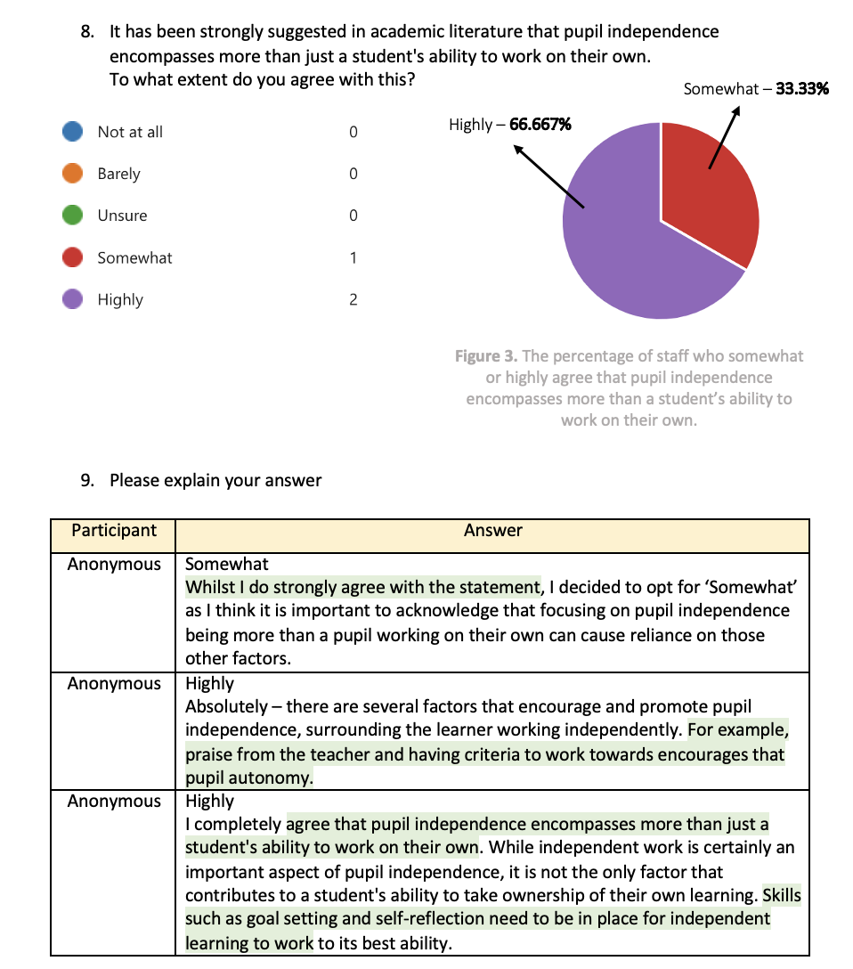

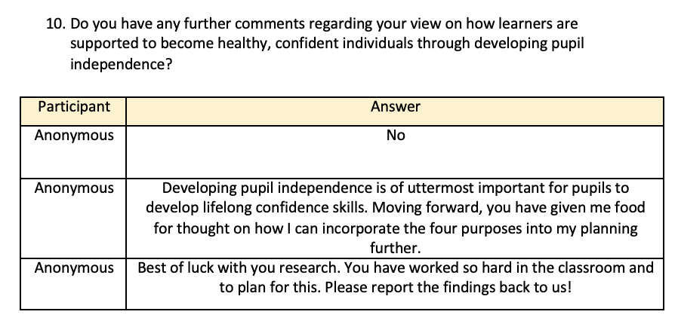

Appendix 7

Observation
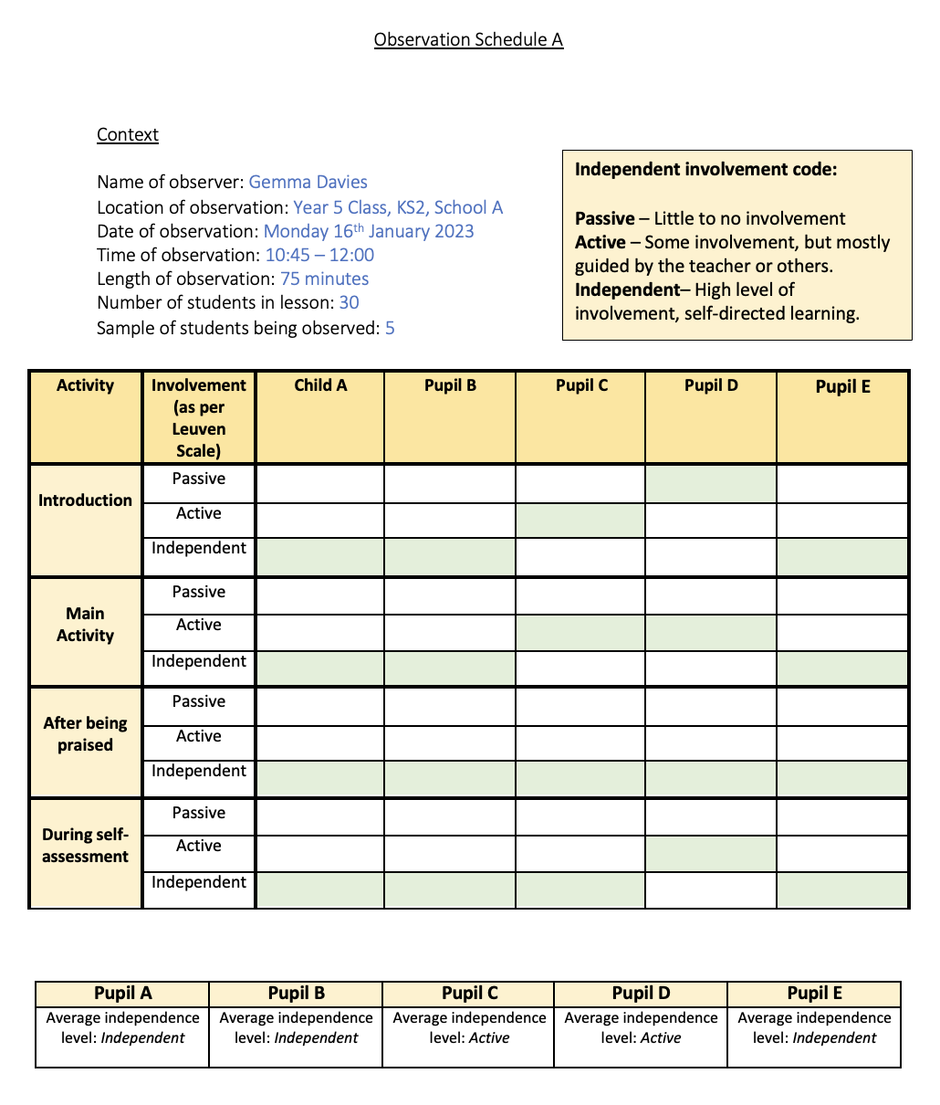
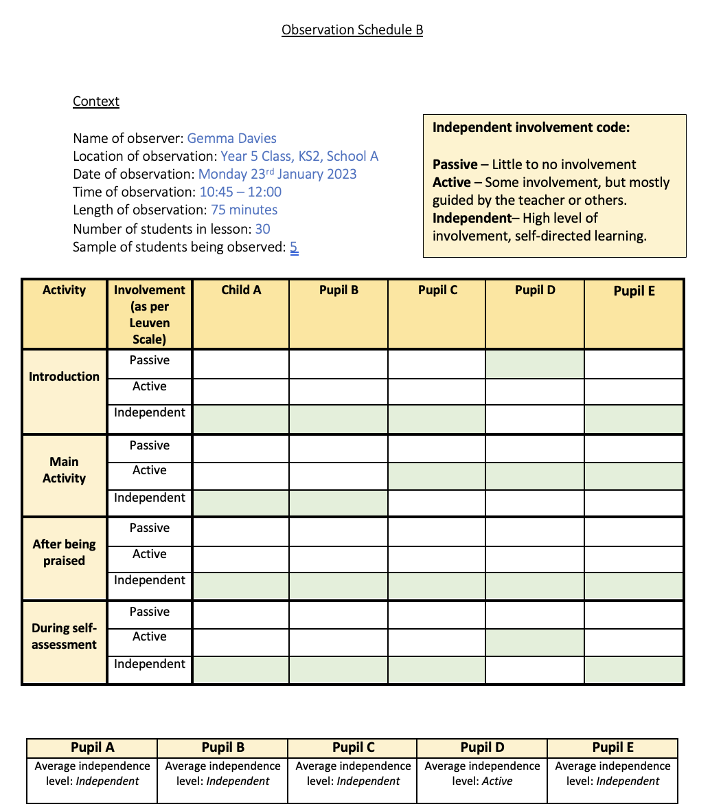

Appendix 8

Intervention
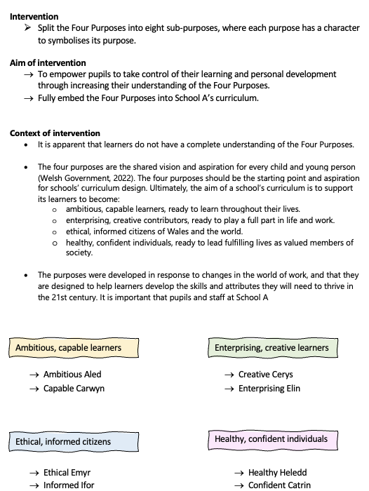

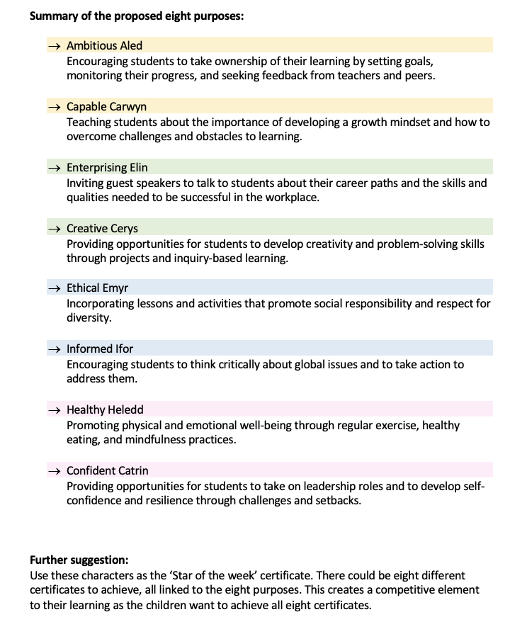

Appendix 9

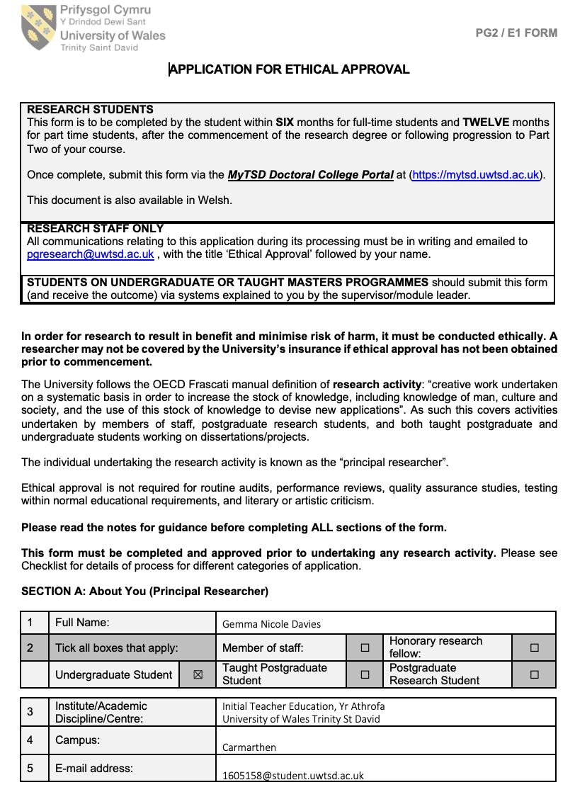
Ethics Form

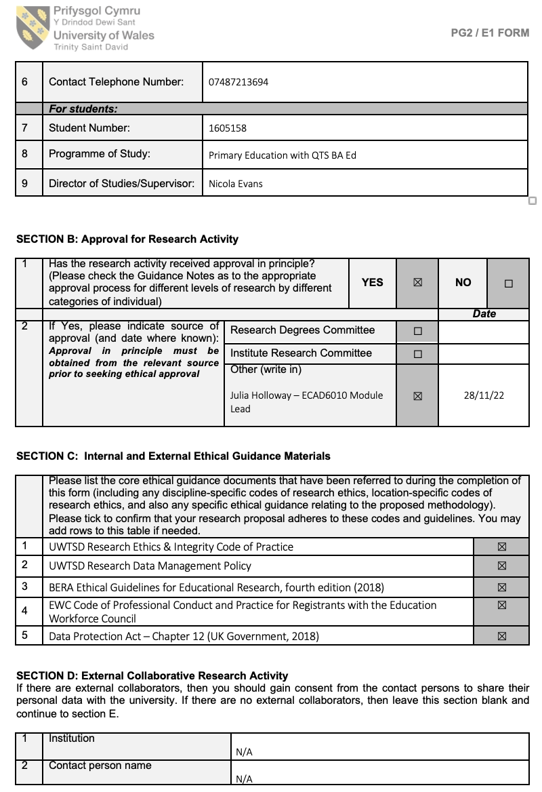

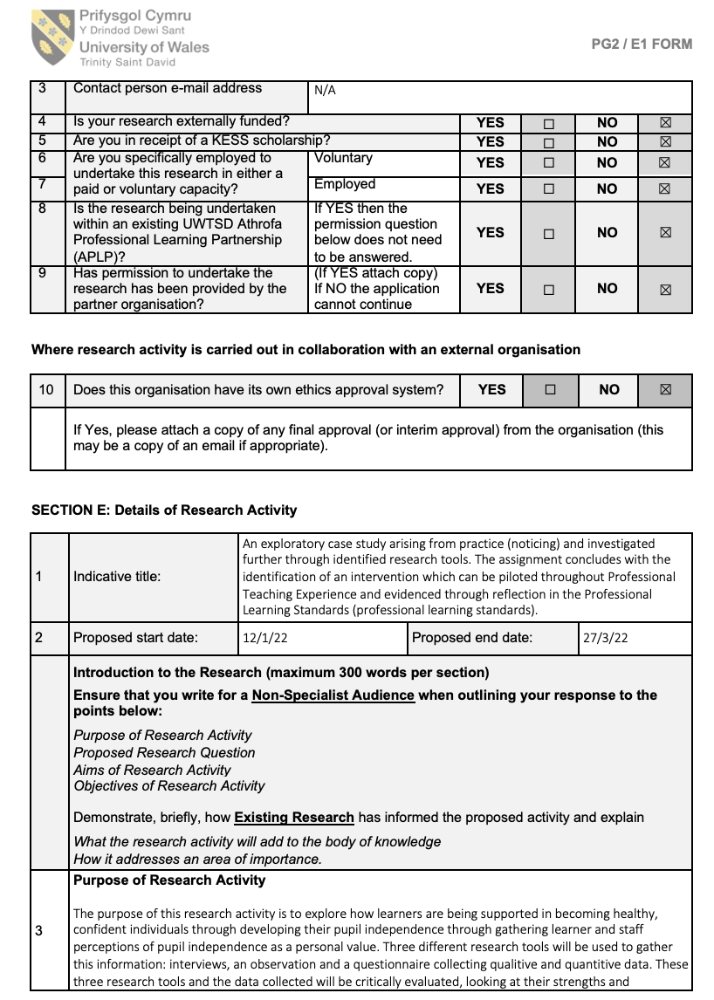

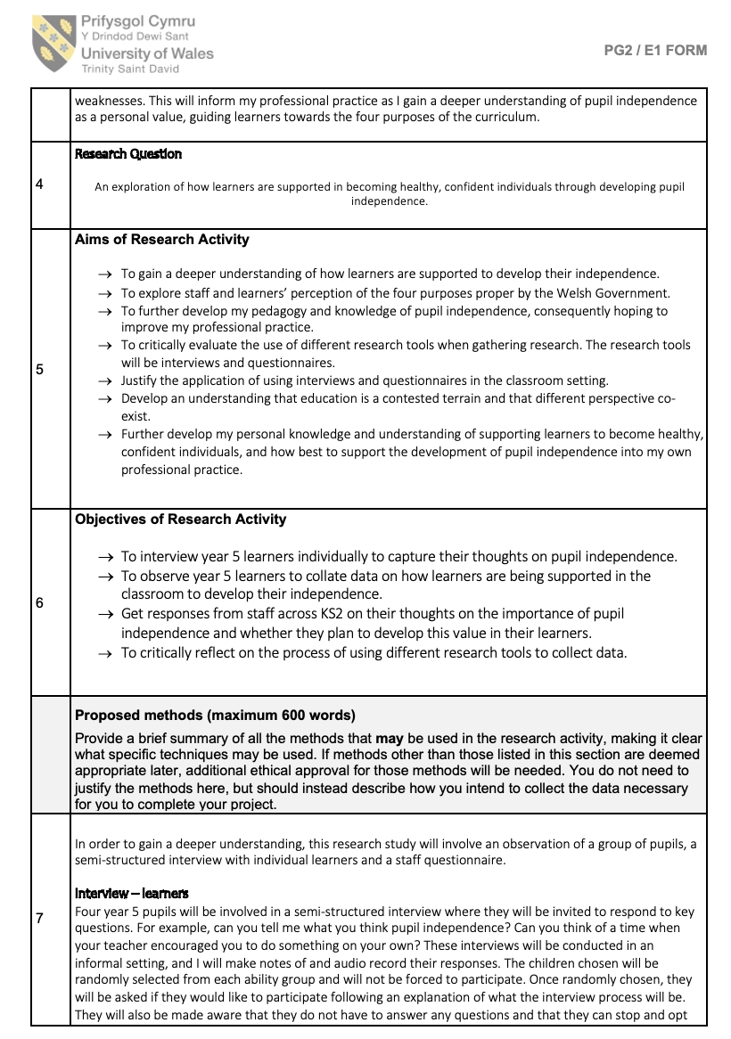

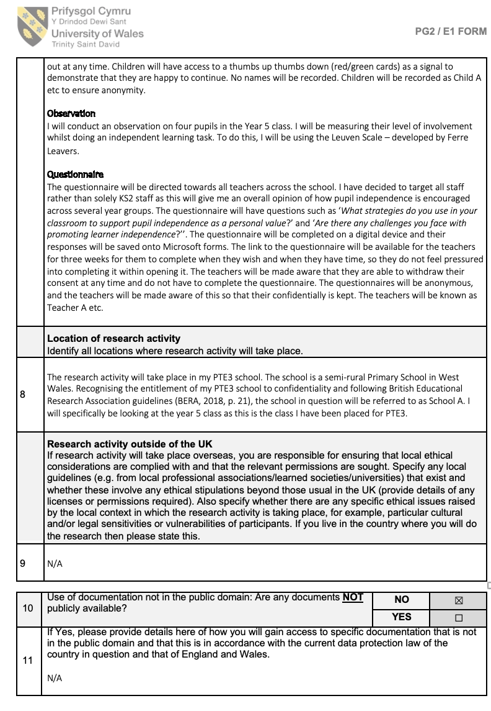

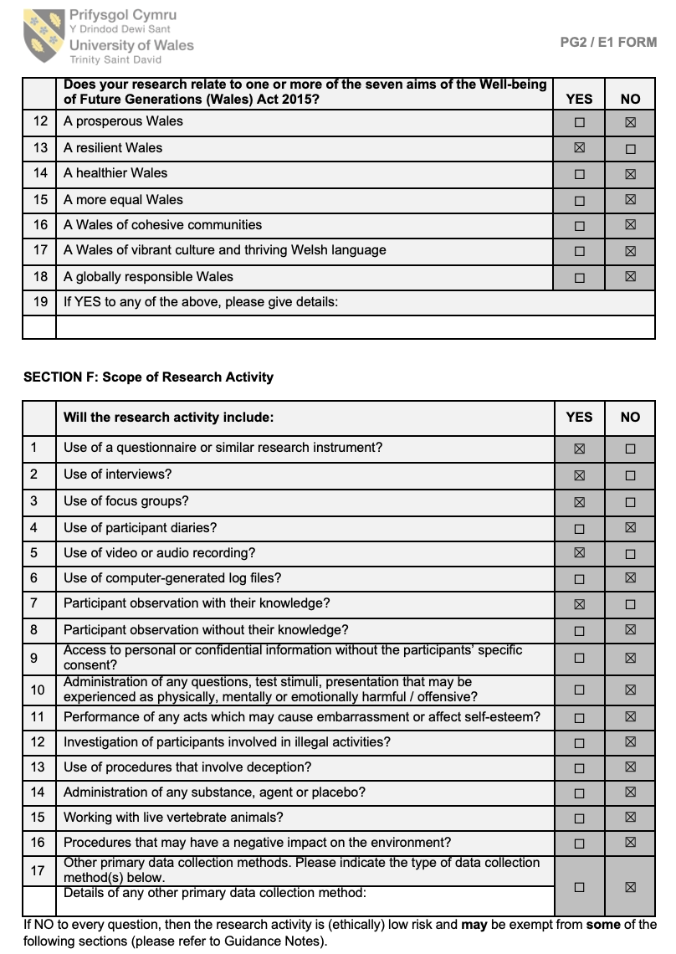

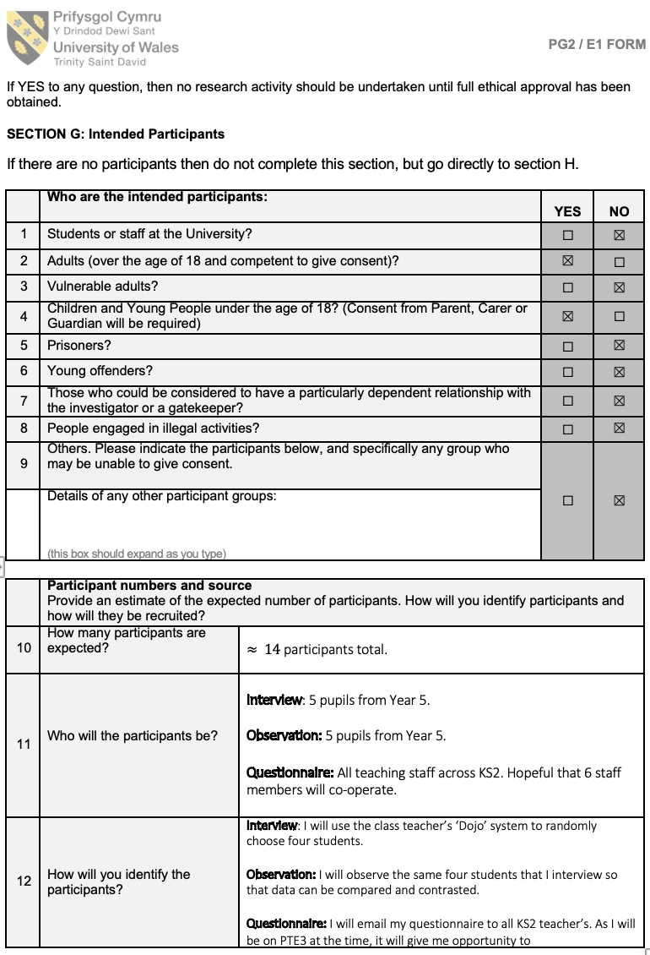

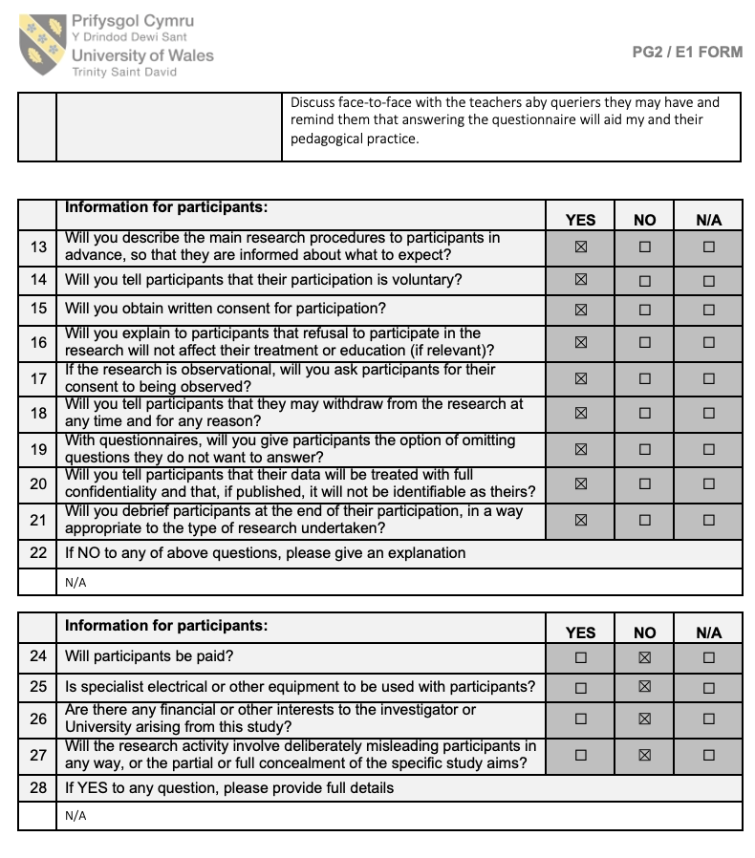
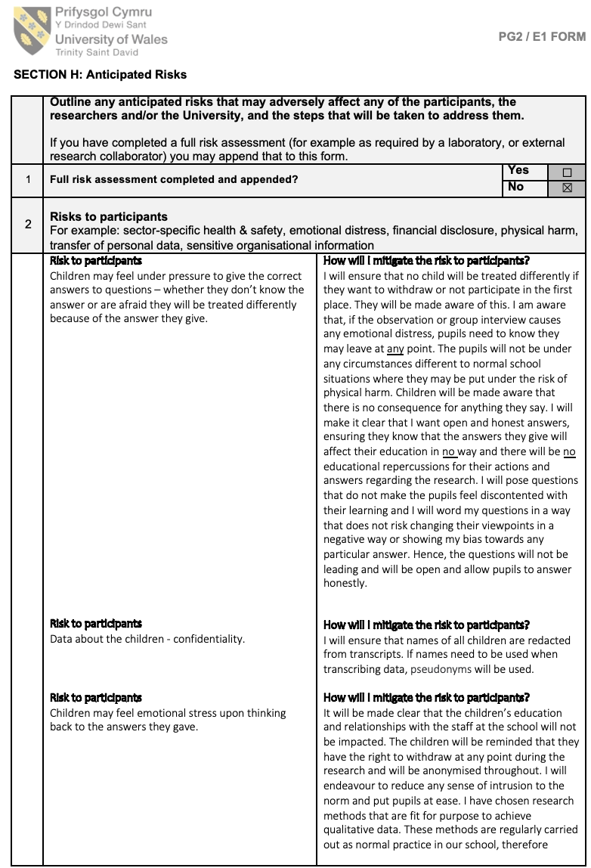

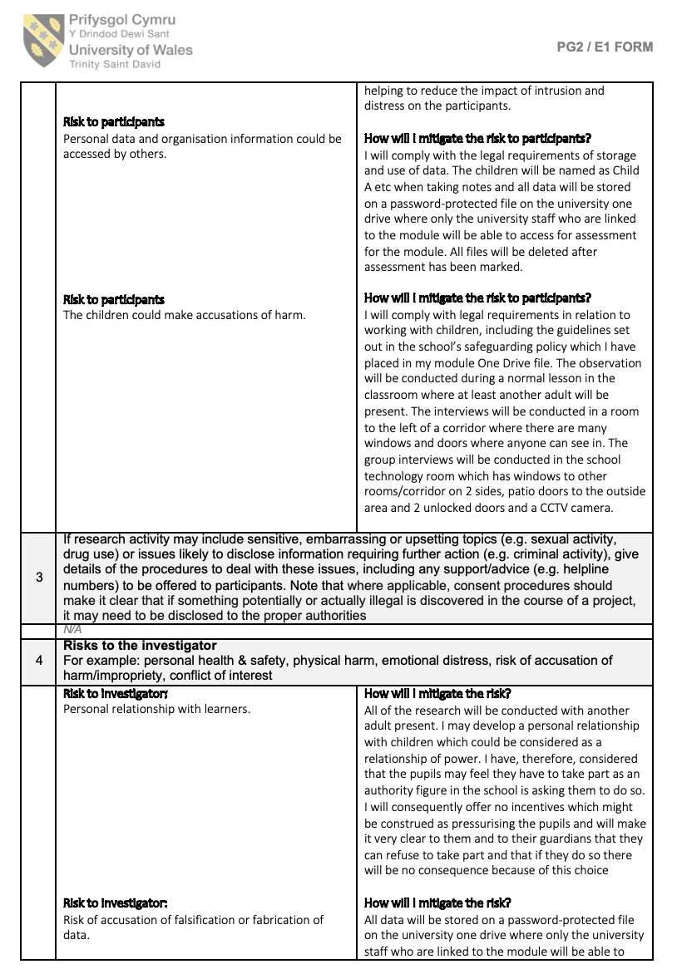

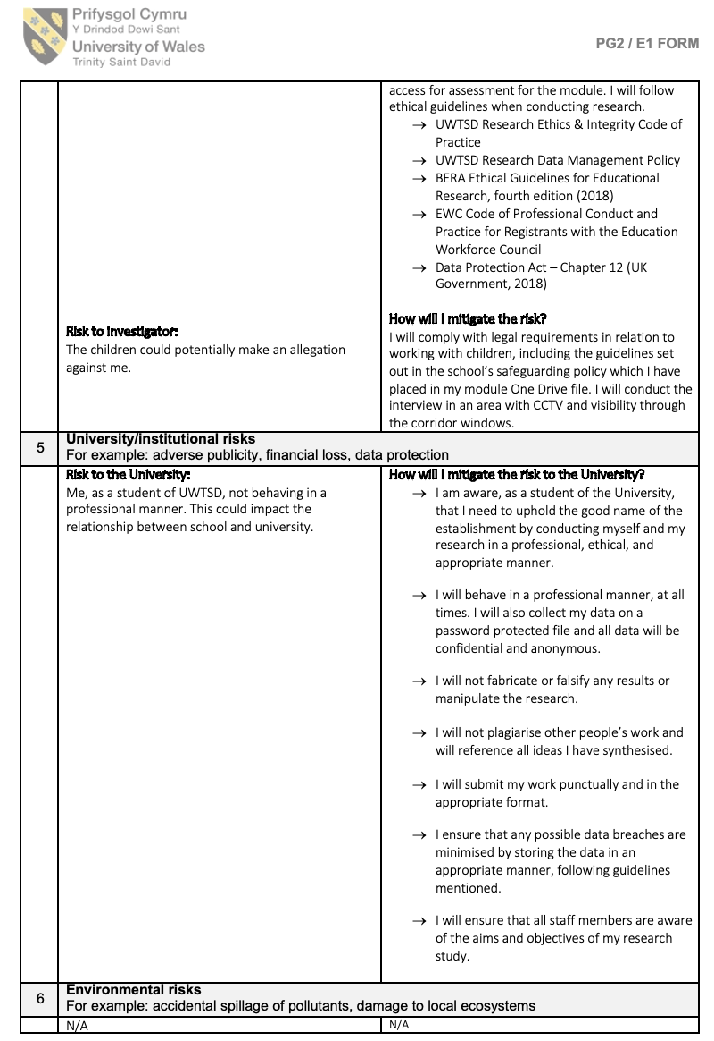
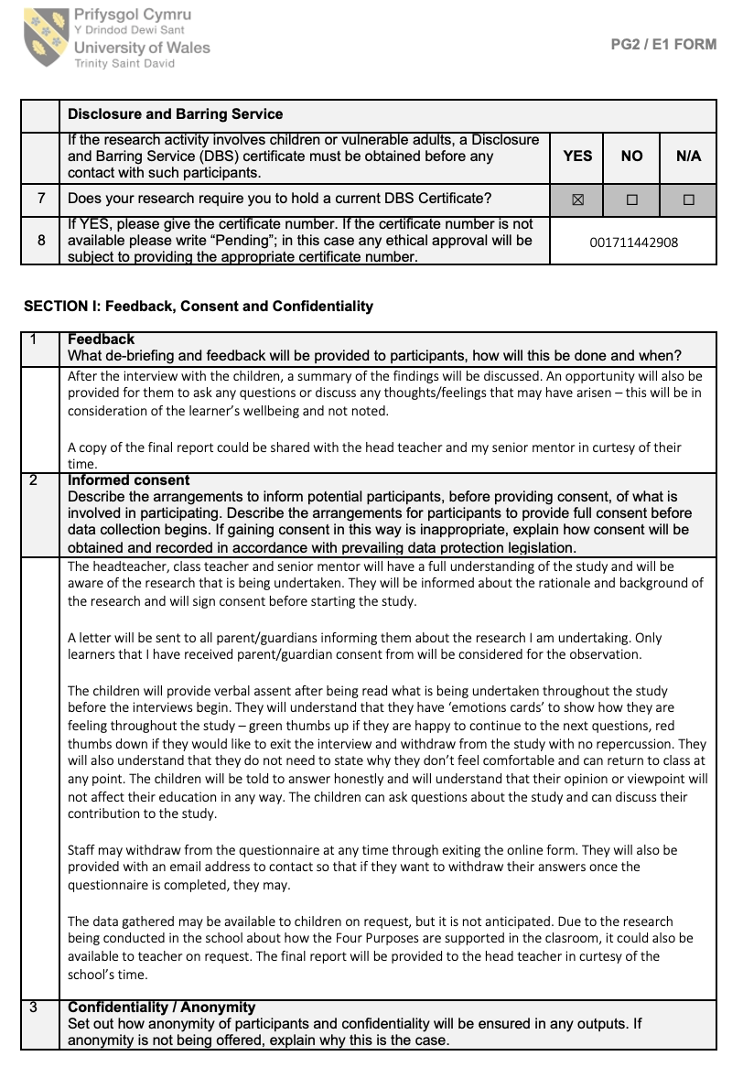

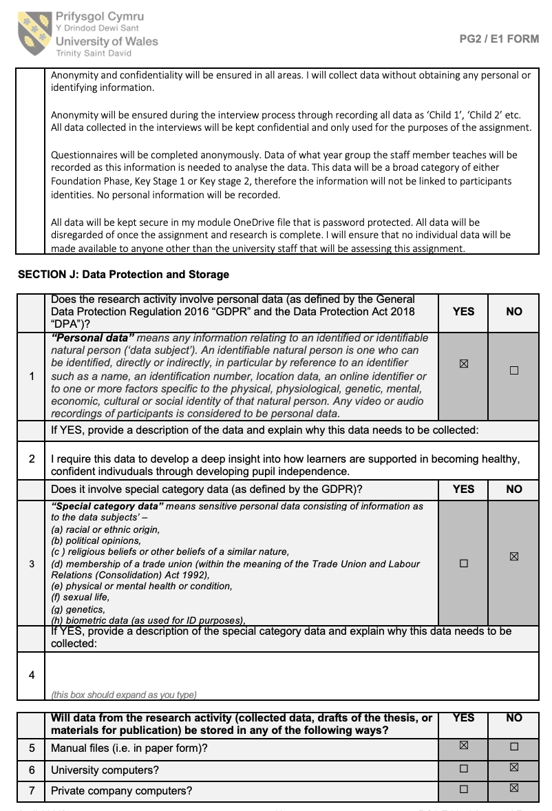

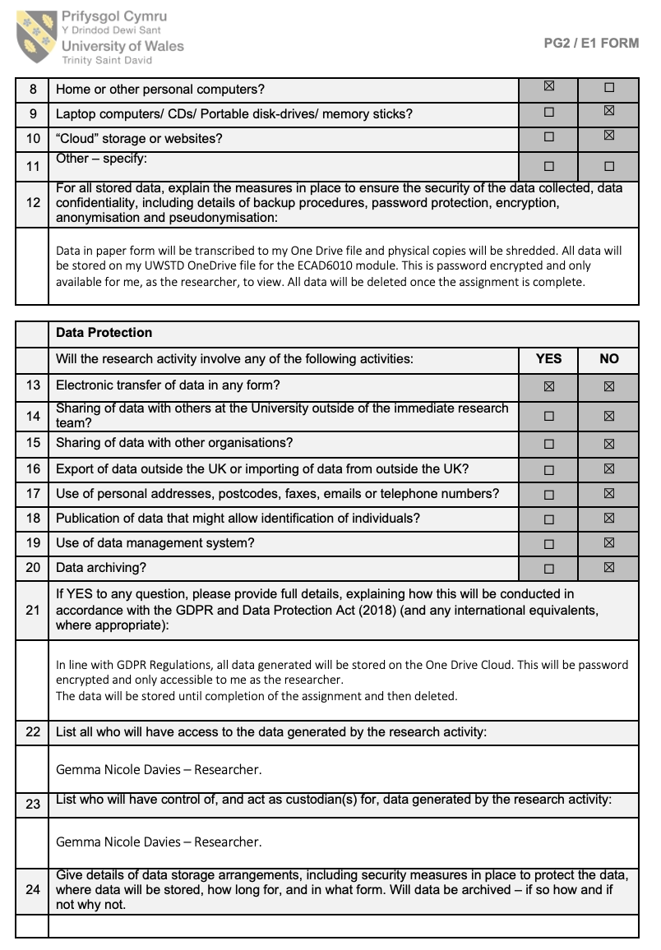

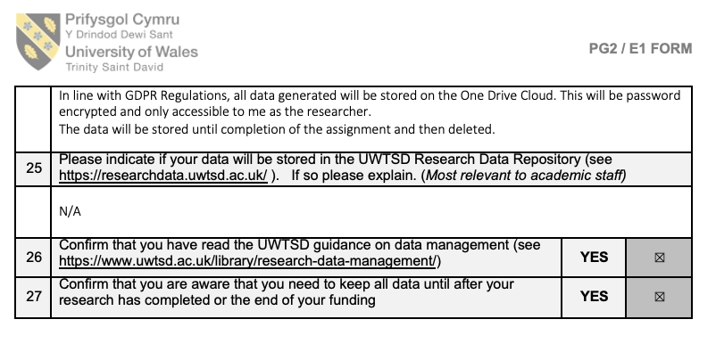

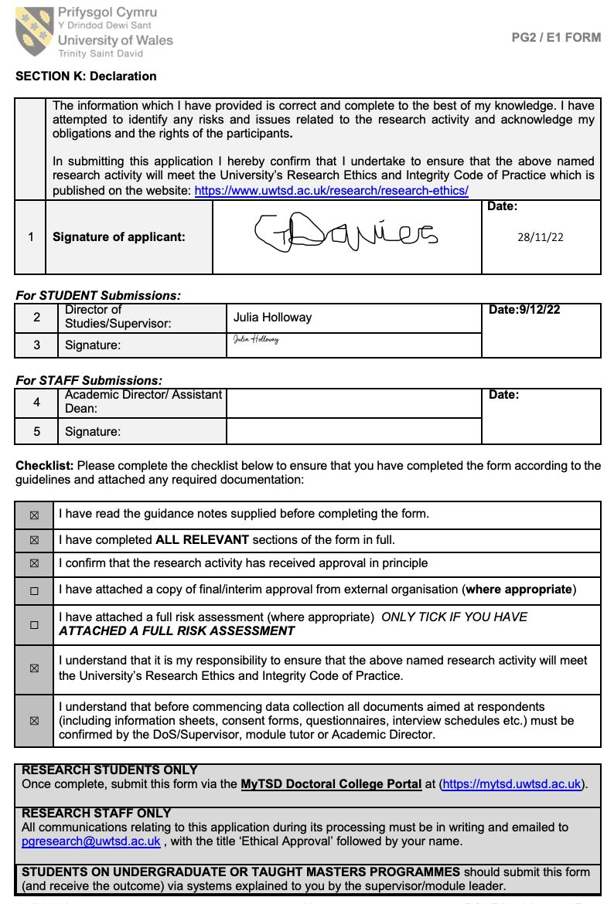

Appendix 10

Consent form
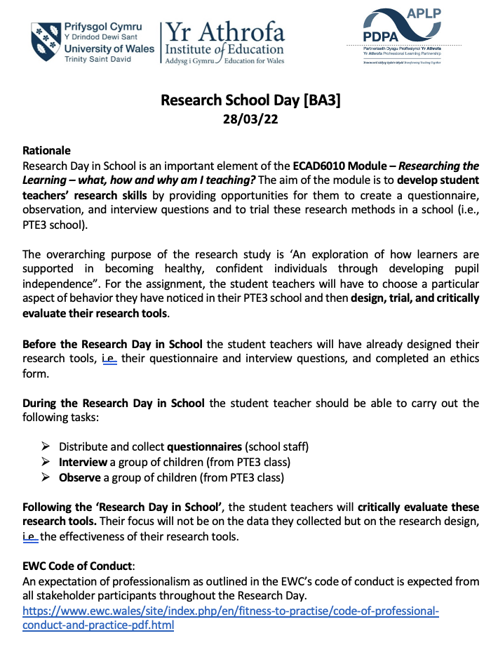

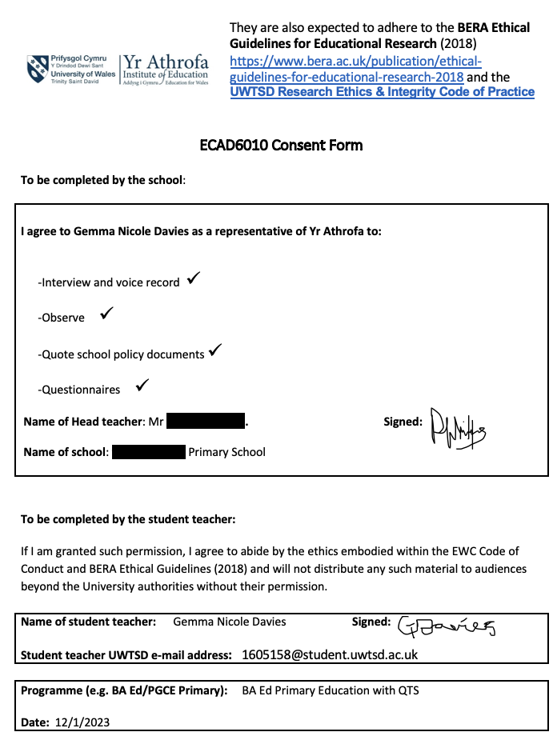

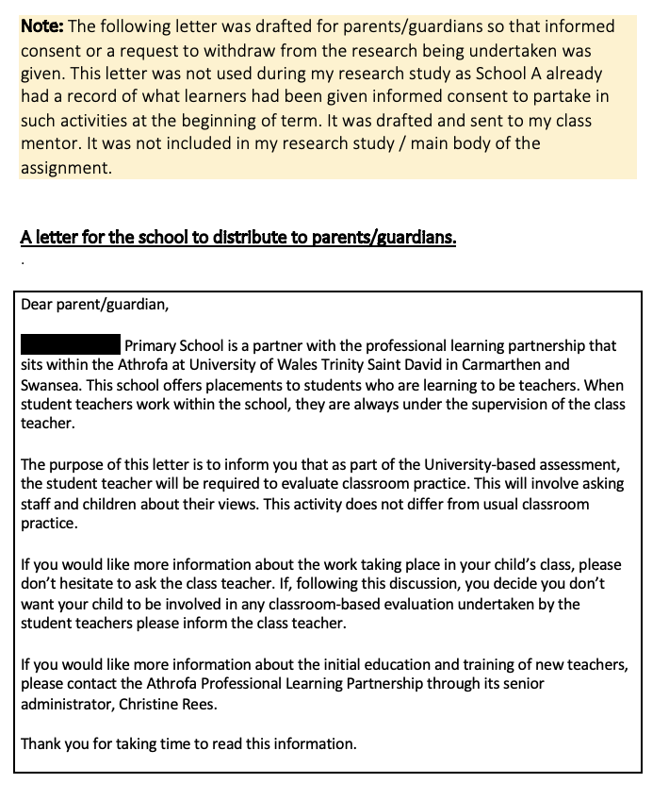

Appendix 11

Right to withdraw – learner flashcards

Appendix 12

Research study – findings.
Table 1
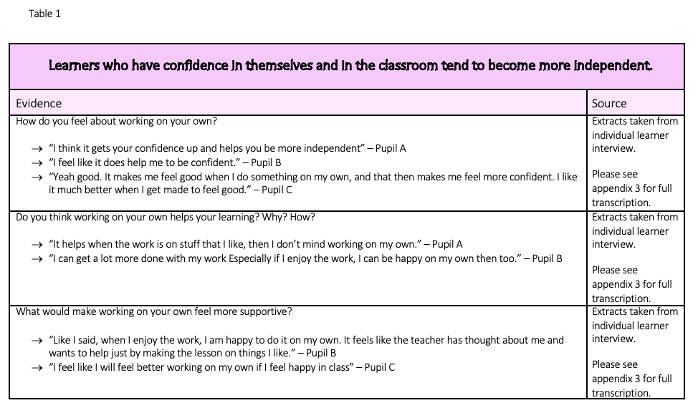

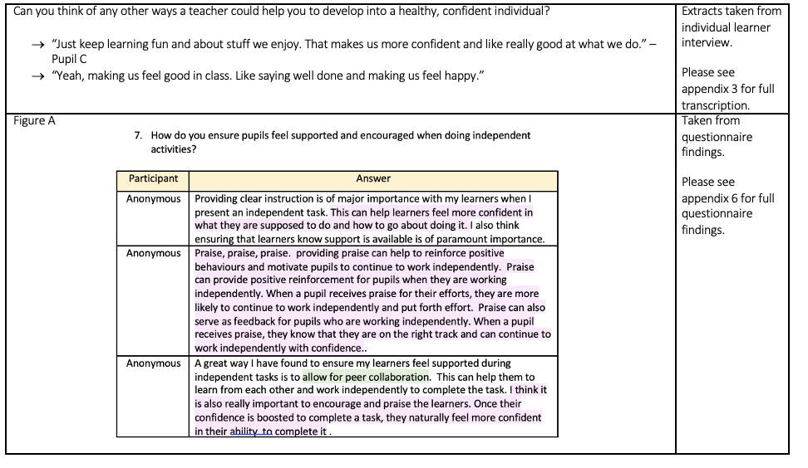

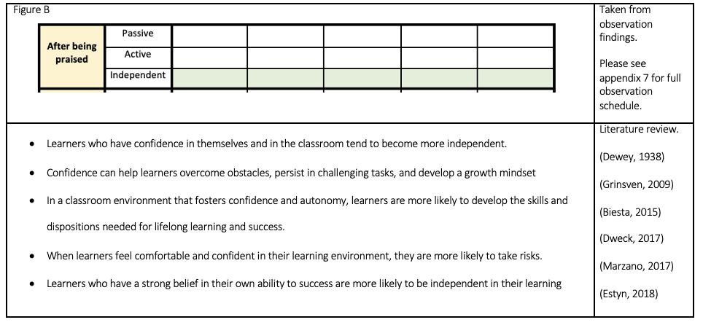

Table 2
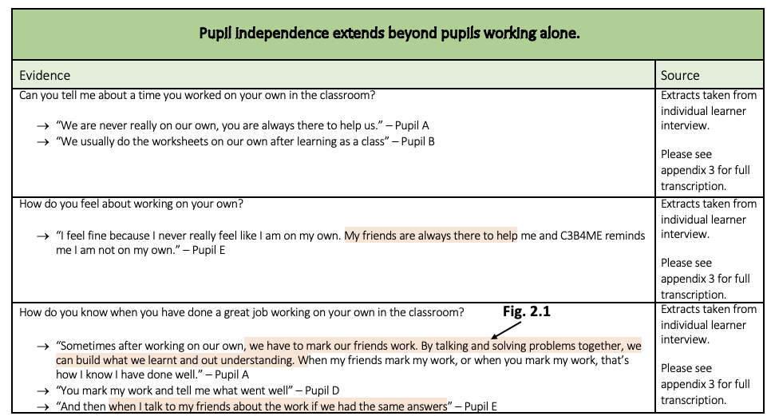
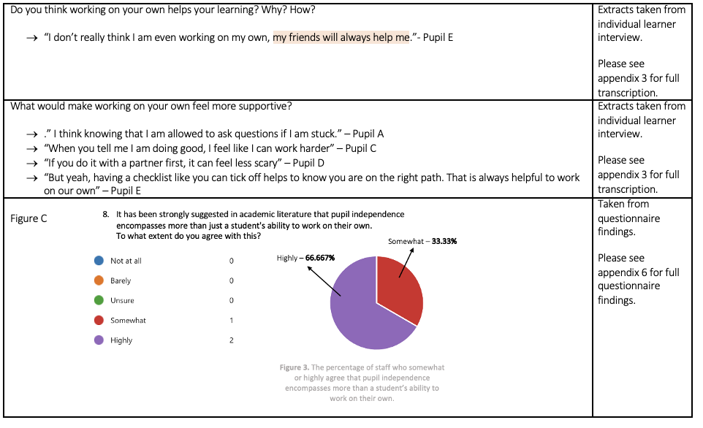

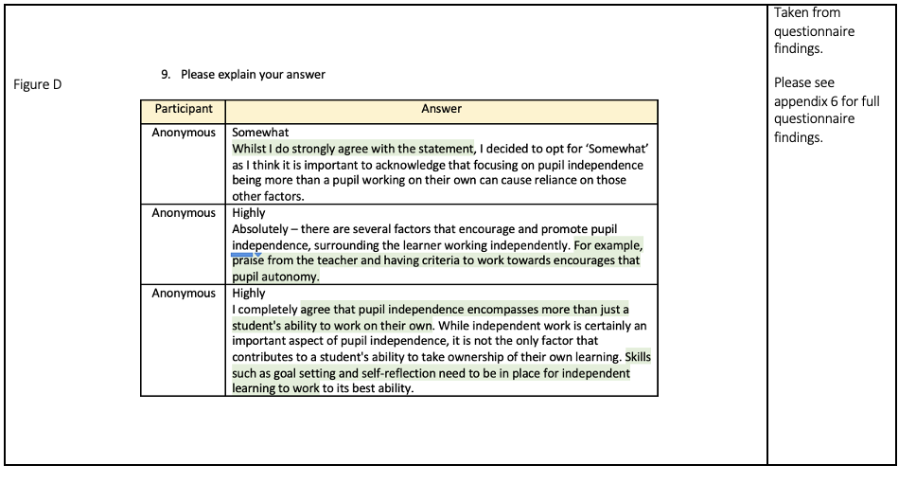

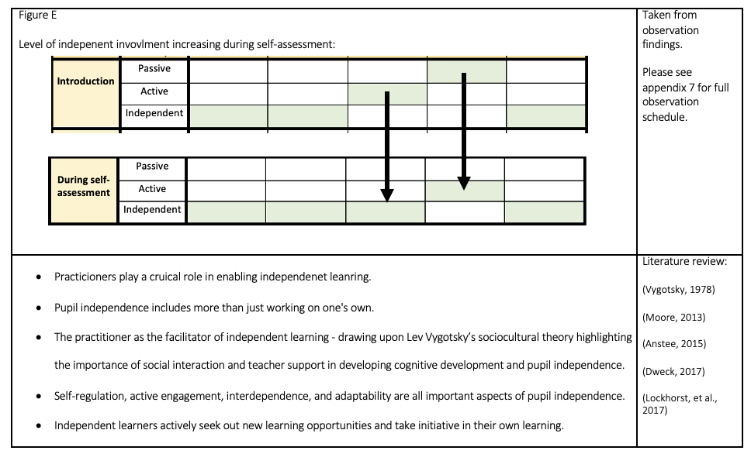

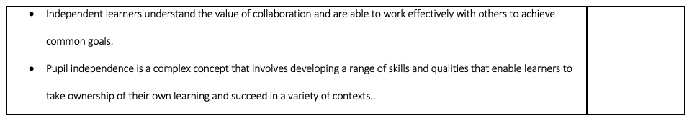

Appendix 13

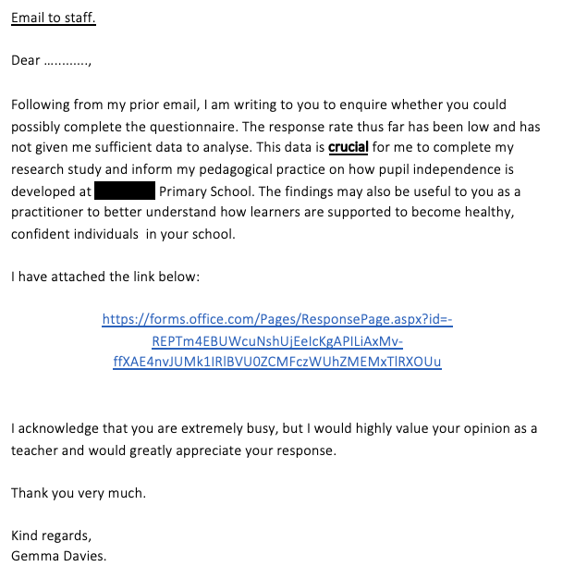
Draft email

