Business Issues & the Context of HR
Report Title: You have been asked by your CIPD Branch to lead a discussion at one of its events on ‘The evolving role of HR in the contemporary business world’. You have been asked to produce a paper for inclusion in the delegate pack.

Name: Suzanne Lewis

CIPD Membership Number: 48800860

Date: 5 JANUARY 2018

I declare that this assignment is my own work and that any information obtained from books and other sources have been appropriately referenced.

Signed: Date: 05/01/2018
Introduction
This paper will accompany a discussion at a CIPD Branch event addressing the evolving role of HR in the contemporary business world, as part of a delegate pack.
The Coleg Cymraeg Cenedlaethol
The organisation that will be used throughout this paper as a case study to demonstrate the models and theories in practice will be the Coleg Cymraeg Cenedlaethol (the Coleg). The Coleg is a third sector organisation, currently funded by Welsh Government to work nationally with the universities and colleges across Wales to enhance Welsh medium provision across these sectors. It currently employs 24 members of staff across three offices and has a Board of Directors representing the sectors.
The Coleg’s management structure
The Coleg’s management structures has a Chief Executive and three senior managers. One of the senior managers is responsible for HR, which demonstrates a recognition of the importance of HR having a voice at the highest level of the organisation’s management. CIPD (2017f) refer to types of strategies such as those that are deliberate ensuring vertical alignment of policies and activities across all departments and functions in achieving the main goals. The emergent strategies are not as planned as the deliberate strategies. With a more flexible nature, more often than not they adapt to the changing markets needs such as the technology sector (CIPD, 2017f). The Coleg’s strategy is a deliberate strategy that also aligns itself with the policy direction of the Welsh Government.

Contents
Strategy  Strategy formulation  Strategy implementation  Corporate responsibility  Business ethics and accountability  The HR Function  Tools for analysing the business environment  Factors impacting on an organisation and a HR function  Business performance  HR and the change management agenda  Data for planning  Conclusion | 4  4  5  6  7  7  8  13  15  15  17  20

Strategy
Strategy has been defined by numerous academics and while Tyson (1995) defines strategy simply as a set of ideas, practices and policies adopted by management to achieve the people management objective, Quinn (1980) defines it as a pattern or a plan integrating the organisations main goals, actions and policies coherently. Both definitions imply the need to have an end (organisational goals) to be achieved by the using resources to achieve the actions leading to the organisational goals. Strategy includes the formulation, implementation and evaluation processes (David, 2011).
Strategy formulation
While the formulation process sets out what is to be achieved, the implementation phase is the process of actioning the resources to complete the numerous tasks and goals. Delery and Dory (1996) refer to three HRM perspectives in strategy formulation, these are (1) Universalistic – best practice; (2) Contingency – best fit; and (3) Configurational – holistic approach. The figure below demonstrates a strategic HRM model where both the strategic HRM and the strategic choice both feed into HR strategies and strategic management for a holistic approach.
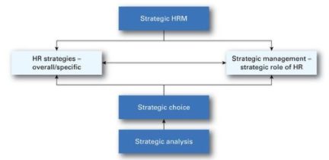
Figure X: Strategic HRM Model in Armstrong (2012:17)
Organisations approach strategy formulation depending on the markets or service areas that they operate within. The Coleg’s strategy is linked tightly to the Welsh Government’s policies as it is funded by the Welsh Government and therefore its objectives are aligned and the Coleg also contributes significantly to the goals set out in the Welsh Governments’ Cymraeg 2050: Welsh language strategy.
Strategy implementation
Alexander (1985) identified five features appearing in successful strategy implementation, these are (1) communicating; (2) starting with a good idea; (3) gaining employee commitment and involvement (4) providing sufficient resources; and (5) developing an implementation plan. It can be argued that features (1), (4) and (5) are all planning elements while (1) and (3) are communication and engagement features of such a plan.
HR works with the people aspect of the business and similarly when it comes to implementing a strategy HR’s role is to ensure that there are relevant HR strategies, activities and solutions in ensuring that the recruitment, selection, deployment and appraising of the people within the workforce are implemented to a satisfactory standard. HR therefore has to understand the business fully and the external context that affect the business. It is essential that HR communicated these insights to the Management Team as part of influencing strategy.
Porter’s (1985) generic strategies model is a best-fit model and addresses the source of competitive advantage and scope. It looks at the cost and the differentiation, for example a business in the bottom left square of the figure below would be demonstrating a cost-minimisation in a focused market. The cost leadership aspect of the model looks to minimise cost to the business in delivering its service or product, rather than the price paid by the customer. Cost leadership is about ensuring value for money and differentiation addresses what is achieved through quality enhancement or innovation. The focus feature of the figure uses cost leadership or differentiation in a niche market. The kinds of HR policies and practices that need to be in place in order to effectively to support the three of these will differ.

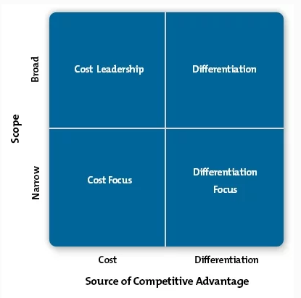
Figure X: Porter’s Model 1985 (Source: Mindtools.com)
A strategy will layout the incremental processes rather than provide a detailed account of how these will be achieved. It is a high level document that sets out the business’ vision. The HR strategy must align with the business strategy and the business’ main objectives. (CIPD, 2017f)
Corporate responsibility
Kaptein and Wempe (2002) discuss the idea that organisations are responsible for their decisions. The role of HR often lead to decisions that pose ethical questions in dealing with people and workforce issues. Despite some corporate responsibility stemming from legal requirements such as the Health and Safety at Work Act 1974, Employment Law and the General Data Protection Regulation some organisations take on corporate responsibility by only sourcing their products ethically.
Winstanley’s (1996) ethical framework refers to elements such as (i) basic human, civil and employment rights; (ii) social and organisational justice; (iii) universalism by treating individuals as ends in themselves; and (iv) community of purpose, thus treating employees as stakeholders.
The CIPD Code of Conduct demonstrates that as a HR Professional there is a requirement to behave ethically and observe the high standards of conduct while maintaining integrity. Furthermore CIPD (2017g) notes that ethical cultures are essential in allowing businesses to move their focus from short-term profits to long-term sustainability with the aim of ensuring that work benefits all, from employees to the shareholders.
Business ethics and accountability
CIPD (2015b) published a research review on ethical decision-making and refer to eight perspectives on workplace dimlemas. These persepectives are offered as lenses to aid ethical decision-making by describing possible ways of thinking about work from a philosophical angle. Eight lenses are defined and it is emphasised that neither one is correct or incorrect, but simply a tool offering different perspectives on work dilemmas. THese eight lenses are (1) fairness; (2) merit; (3) markets; (4) democracy; (5) wellbeing; (6) rights and duties; (7) character; (8) handing down.
The HR Function
The HR function can be structured in a variety of ways for numerous reasons. The centralised approach allows the support from HR by a central team, while a decentralised approach sees HR carried out by individual departments. The Coleg has a centralised HR team but also outsources specific services such as occupational health and provides a self-service function for tasks such as updating personal details and holiday requests through HR software.
Ulrich’s three-legged stool model demonstrates another type of HR function – the shared service approach (CIPD, 2017h) which combines a variety of the above functions. This approach has a HR business partner providing support to departments and are then supported by a centralised entity handling the more routine HR services such as administration, payroll and absences. The centre of excellence seen in the figure below tends to be a small team of individuals that have specialist knowledge. The strategic business partner is a senior HR professional that would influence, steer and implement strategy through working with line managers. Together, these three aspects hold up the HR function in an organisation.

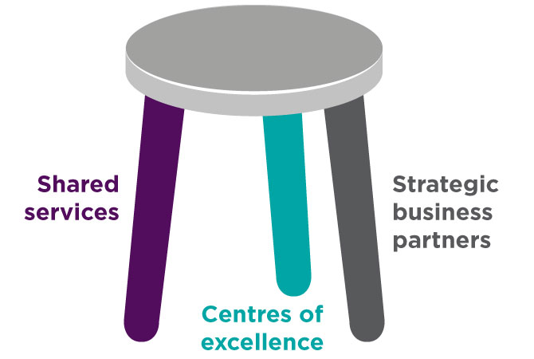
Figure X: Ulrich’s three-legged stool model
– where HR is split between three areas of expertise
(Source: CIPD 2017h)
HR professionals understand how the business operates and ensures that the values are maintain to achieve the organisational goals. Using data and evidence to gain insights, the HR professional is able to support strategies and business cases. The HR professional will often ask the right questions and connect the purpose with the impact to create the most value. A HR professional will always have integrity and by abiding to the CIPD Code of Conduct, it will challenge when necessary using evidence and its relationships to influence appropriately. (CIPD, 2017h)
Tools for analysing the business environment
- SWOT
A SWOT analysis originated by Humphrey in the 1960s, is a way in which a business is able to analyse the internal environment by gathering its strengths, weaknesses, opportunities and threats. It often includes aspects such as the organisation’s financial situation, reputation and the organisation’s performance. It is essential to only accept precise and verifiable statements in a SWOT analysis and the lists should be prioritised to ensure that energy is allocated effectively (Mindtools, 2017d). The SWOT tool is often used as part of a planning process in both business and strategy and is insightful in understanding an organisation and decision-making for all types of situations.
Strengths | Experience and knowledge of the HE sector  Knowledge of Welsh medium provision in Wales  Strong relationships with HE sector  Quality and competence in the HE sector  Reputation
Weaknesses | Experience and knowledge of the FE sector  Market awareness (FE)
Opportunities | New sector  Develop relationships and networks with FE sector  Developing Welsh medium provision in a new sector  Reputation  New trends (PESTLE)
Threats | Reputation  Financial situation of universities – impacting on financial situations of universities and staff cuts resulting in networking contacts being lost.
Table X: SWOT Analysis of the Coleg Cymraeg Cenedlaethol
The advantages of the SWOT tool is that it is a simple framework that helps identify strengths and weaknesses and allows the organisation to identify opportunities that it can build upon and weaknesses that need strengthening. It also allows for the examination of both internal and external factors. However, disadvantages of this tool include it being too simplistic and key factors may be missed. In order to get the best from it, it needs to be undertaken regularly and include a variety of different perspectives.
- PRIMO – F
PRIMO-F is a development of the SWOT tool and created as part of research at Durham University Business School (DUBS), into what makes an organization and its management effective and demonstrated by the equation below (Morrison, 2010).
Organisational Growth Effectiveness = Performance to date * Potential for the future
The PRIMO-F framework stands for (1) people; (2) resources; (3) innovation; (4) marketing; (5) operations and (6) finance and it measures the internal factors or to benchmark against other organisations.
People | Networking with universities to develop Welsh medium provision in the HE sector.  Link with employers to develop Welsh medium work-experiences for students.  Strategically lead Welsh medium-provision effectively across Wales.
Resources | Knowledgeable workforce  3 office locations to cover Wales  Strong leadership.
Innovation | Developments in Welsh medium provision including the use of video-conferencing to reach a wider audience  Continuous improvement ethic for all processes.
Marketing | Regular contact with schools to raise awareness of Welsh medium provision in the HE sector  Board of Directors across the HE sector  Academic Board to ensure information and developments are addressed and communicated.
Operations | Strong management structure  Board of Directors  Academic Board  Regular monitoring meetings with Welsh Government and universities.
Finance | Welsh Government funded body.  Scholarships for students  Formulated subject grants as per the Academic Plan.
Table X: PRIMO-F tool based on the Coleg Cymraeg
The advantages of the PRIMO-F tool it is far more detailed and structured than the SWOT analysis. While maintaining an element of simplicity it allows a business to address specific areas such as resources and finance. It is a culmination of the main elements in understanding the business’ situation at present and towards the future. However, disadvantages of this tool include it being as open as the SWOT tool and the need to have numerous individuals to take part in the analysis to get a fuller understanding of the business and its direction.
- PESTLE
PESTLE is a useful tool to analyse the external influences of an organisation and stands for the following elements – Political; Economic; Social; Technological; Legal; and Environmental. It allows an organisation to identify key issues that may affect the business and analyse the potential impact it may have on the organisation (Mindtools, 2017c). It therefore allows an organisation to respond to these impacts foreseen on a local, national and global level. A PESTLE analysis should be done collaboratively and not in isolation to obtain the most effective results and can be incorporated into an ongoing process to monitor any changes in the business environment (CIPD, 2017e).
Political | Economic | Social | Technological | Legal | Environmental
Welsh Government Welsh Language Strategy with the aim to reach 1 million Welsh Speakers by 2050 aligned with the Coleg’s role.  Minister for Education accepting the recommendations of a Task and Finish Group to expand the Coleg’s remit to FE.  Brexit – Potential cuts to universities that could lead to staff cuts and a breakdown of the HE network with the Coleg.  Consultation on amended the Welsh Language Measure (2011) could impact on the Coleg’s business and remit.  Political change at UK level. | Increasing inflation rate leading to an increase in the cost of living for students.  University fees.  A downturn in the economy may negatively affect the number of students studying. | Cultural trends.  Social pressures.  Expectations of stakeholders. | Developments in online learning allows students to study at home rather than attend a university.  E-learning developments.  Cost of implementing new technologies  Technological infrastructure | GDPR changes in data regulations affecting data sharing with universities and colleges.  Welsh Language Measure (Wales) 2011 under consultation.  New legislation  Brexit and the changes following the UK’s exit from Europe.  Compliance with regulations.  Accountability | Sustainable development  Location of the offices  Travel by staff and environmental factors due to this.
Table X: PESTLE analysis of the Coleg.
The advantages of the PESTLE is that it is a simplistic tool that allows a better understanding of the wider environment of the business and pushes towards strategic thinking. While it can assist an business to anticipate threats and spot opportunities, the data used may be based on assumptions that are later discovered to be unfounded. The disadvantages include the data used that can on one side be simplistic and or alternatively there may be too much data. Once again, this would need to be undertaken regularly to ensure the most current data and information.
- Porter’s five forces
Porter’s five forces model was created by Porter of Harvard Business School in 1979 with the aim to analyse the attractiveness and the likely profitability of an organisation (Mindtools, 2017e). The figure below outlines the 5 forces that are (1) competitive rivalry; (2) supplier power; (3) buyer power; (4) threat of substitution; and (5) threat of new entry.
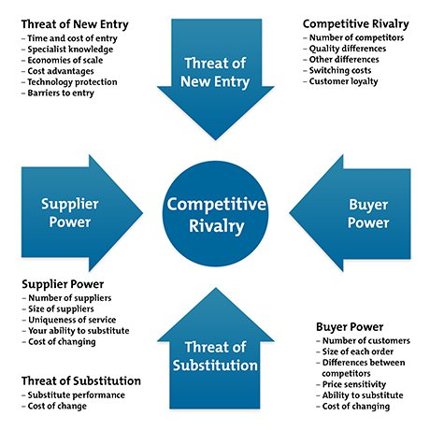
Figure X: Porter’s five forces (Source: Mindtools, 2017e)
As this model concentrates mainly on rivalries it is not as relevant for the Coleg as the other tools. Despite this, it’s important to acknowledge it usefulness in understanding the external factors that may impact the business environment of the organisation. The table below outlines Porter’s five forces in the context of the Coleg. Advantages of this model is that it provides a fuller image of the business environment surrounding the organisation that allows for the business to better understand the competition and profitability and can be seen to be extremely beneficial in the private sector. Disadvantages include that it only provides a snapshot of the market or industry and that it is not suitable for all sectors, for example the third sector and that it examines the external factors only.
Competitive rivalry | Currently no rivalry as the Coleg is the only organisation currently leading Welsh medium provision of HE in Wales through Partnerships with the university and funding by Welsh Government.
Supplier power | From a supplier point of view, the funding comes directly fro Welsh Government. However the impact of student numbers and fees affects what courses the university can run. This thas a secondary impact on the Coleg and the Coleg’s work.
Buyer power | Though the Coleg doesn’t have ‘buyers’ as such, the universities have students paying fees, which impacts on their Financial situation as does funding from other sources such as the European Union. This has a secondary impact on the Coleg.
Threat of substitution | A recent task and finish group set up by Welsh Government provided a set of recommendations to enahnce the remit of the Coleg from HE only to HE and FE. This demonstrates the lack of threat of substitution for the Coleg’s work.
Threat of new entry | As with all organisations the threat of new entry wil always be apparent. In the case of the Coleg the funding would have to be allocated to a new entity which is unlikely at present.
Table X: Porter’s five forces and the Coleg.
Factors impacting on an organisation and a HR function
Following on from the researching the above models based on the Coleg, two internal factors and 2 external factors have been addressed in more detail below.
- Stakeholder (Workforce)
Stakeholders are both internal and external. This section concentrate sont he internal workforce. Communication has a vital role in sharing information and listening to stakeholders and while HR often takes care of the workforce communication.
- Management structure
The HR Senior Manager within the Coleg is also Secretary to the Board of Directors. This provides consistency and awareness across stakeholder engagement. HR can benefit from this type of management structure by enabling conversation between the right people at the right time. When issues or development are raised the HR professional is in a position to manage the situation, gather the relevant evidence and communicate with those required.
- Political
Political factors are referred to in PESTLE and this has a significant impact on the Coleg. On a local level, the Coleg is currently funded by Welsh and if the political direction of support for Welsh medium provision in the HE and FE sectors were to change the impact would be significant to the Coleg. On a larger national level any political changes to fees or English university funding could have a great impact on the Coleg’s work. If fees are lower in England, less students may study in Wales and vice-verca. On a global level, Brexit impacts greatly on the Coleg as universities are heavily funded for their research through European funding. With less funding, universities will not be able to provide the current provision. On the other hand, it may be an opportunity and universities will look for more innovative ways of plugging the funding gap.
- Globalisation
Globalisation has allowed for interconnectivity throughout the world with freer movement of capital, goods and services (BBC Bitesize, 2014). With technological developments alongside globalisation it has allowed the HE sector to develop e-learning further. However the impact of the Brexit vote has been accused of causing a sharp dip in the number of foreign students for long-term study at UK universities (The Independent, 2017). The 41,000 drop in student numbers demonstrates how significant factors, such as a political vote, can affect a sector as a whole.
Business performance
HR has a vital role to play in business planning in ensuring that the employees are seen as a valuable resource for the organisation. Finnis (2010) refers to the limitations of the more traditional HR metrics such as quantifying the impact of HR processes and the success or failure of HR initiatives. Despite this, many HR metrics such as absence rate are HR data metrics that are still collected by the Office for National Statistics (2017). A modern approach to HR metrics is HR analytics which is the use of data about people in an analytical process in order to solve a business problem in order to ensure that the organisation is gaining value by using relevant data and evidence (CIPD, 2017i). Despite there being three levels of HR analytics capability, most organisations only tend to reach the first level of descriptive analytics. Similarly to project management, the HR analytics process needs to be structured that beings with a plan, followed by design, data collection and analysing a report of the findings and an evaluation (CIPD, 2017i).
HR and the change management agenda
Organisations are constantly evolving today and this can be driven by a specific factor such as a technological change in the market or it can be a subtle development such as more efficiency within a process. HR has an important role in change management to ensure that “organisation (re)design, due process, employee voice and clear communication” are addressed appropriately and efficiently (CIPD, 2017j). There are many models of change to aid effective change management concerns with what is controllable (business processes) and uncontrollable where people and the meanings people attach to processes.
Lewin’s model of change has three stages, these are (1) unfreezing; (2) movement; and (3) refreezing. A required change can be implemented by addressing these stages. The process begins with creating a motivation to change (unfreezing) and then goes on to using techniques, such as effective communication to embrace the change (movement). It ends when the organisation return to stability before begining the cycle once again (Mindtools, 2017b). There is often a resistance to change and the figure below demonstrates Lewin’s 1940s model of the force field analysis. It demonstrates the need for the forces of change to be greater than the forces of resistance (Mindtools, 2017j).
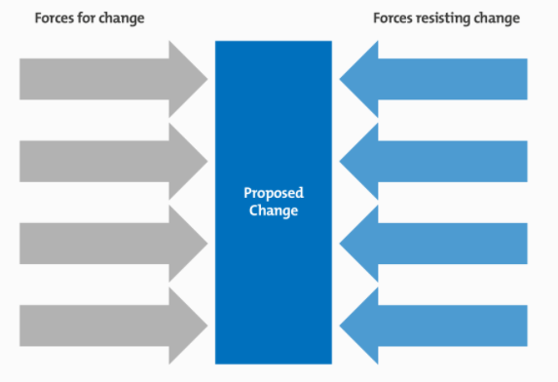
Figure X: Force field analysis (Source: Mindtools, 2017f)
Another change management model is Beer’s 1990 model that demonstrates six stages, these are (1) Mobilise commitment to change; (2) Develop a shared vision; (3) Foster consensus; (4) Spread revitalisation; (5) Institutionalise revitalisation; and (6) Monitor and adjust strategies (Armstrong, 2012). These six steps require effective communication and lead to a processes of task and finish through the stages. Individuals deal with change differently. The DREC model below demonstrates how individual move from one stage to the next in dealing with change.
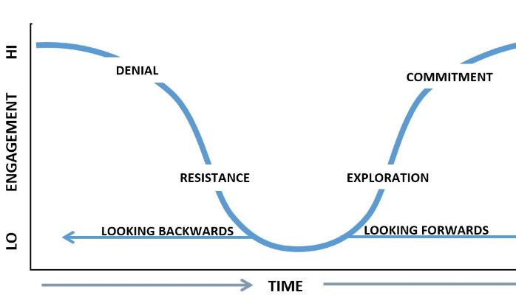
Figure X: DREC Model (Source: Linkedin, 2015)
The DREC model derived from the Kübler-Ross change cycle and the similarities can be seen from that model, (1) denial; (2) anger (3) bargaining; (4) depression; (5) acceptance. Known as the grief and bereavement cycle (strategiesformanagingchange.com, 2009). The resistance to change means that it takes time for an individual to work through the DREC cycle.
It is essential that HR professionals communicate effectively and this can be done from a top down approach where the senior managers provide information to employees. It can also be achieved through a bottom up approach where employees attend workshops and participate in a consultation. Alternatively it can be a two-way discussion where one-to-one meetings are held with line managers and employees or with HR (Armstrong, 2012). HR professionals have a role in ensuring honesty, thoroughness and patience with the ability to listen and provide empathy. The role of HR is to assist, engage the workforce and support the process.
Data for planning
In order to gain an insight into the workforce, HR analytics are used to allow the HR to better understand and ensure there is a focus on the human element of the workforce. This people-data in conjunction with analytical processes leads to
- HR data
HR data includes both quantitative (numbers) and qualitative data (subjective) and can be gained from inside or outside of the organisation. This data can be used to inform planning for the organisation such as HR statistics, KPIs, balanced scorecard, government data and benchmarking, as addressed below. In addition to this data, each organisation holds a vast amount of data themselves on their workforce. This data can be analysed and new processes and directions can be created from this analysation.
- Key Performance Indicators (KPIs)
An organisation’s performance may be measured in numerous ways and it is important for the measurement to be relevant to the sector. For example the private sector may use KPIs as a data point for financial results, profitability or productivity. While the public will have financial targets sets and may not use KPIs in the same context as the private sector. Their KPIs may be targeted to achieve greater efficiency or efficiency savings.
Miyake (2015) refers to KPIs in specific categories such as employment KPIs that include absenteeism rate, number of full-time employees and average time to fill a job vacancy. The KPIs provide valuable information, for example the absenteeism KPI provides the organisation with a perspective on the amount of labour lost due to unpredicted leave. KPIs are an aspects of HR performance that are most critical for the achievement of business objectives and whether the HR objectives are being achieved.
- Balanced Scorecard
A strategic performance measurement framework known as the balanced scorecard was developed by Kaplan and Norton with the aim of translating an organisation’s vision into actions through strategic planning. The four perspectives shown in the framework are (1) customer; (2) financial; (3) processes; (4) learning and growth. Kaplan and Norton (1995) demonstrate, in the figure below, how the balanced scorecard is used. As seen below, it is not only information that is collected, specific data is required in the ‘learning and growth’ perspective of this scorecard. Using this scorecard side-by-side to an organisation’s objectives reveals areas of strength and weaknesses and the type of implementation required to achieve the organisational goals. The HR professional in an organisation may be best placed to address the ‘processes’ of the scorecard.
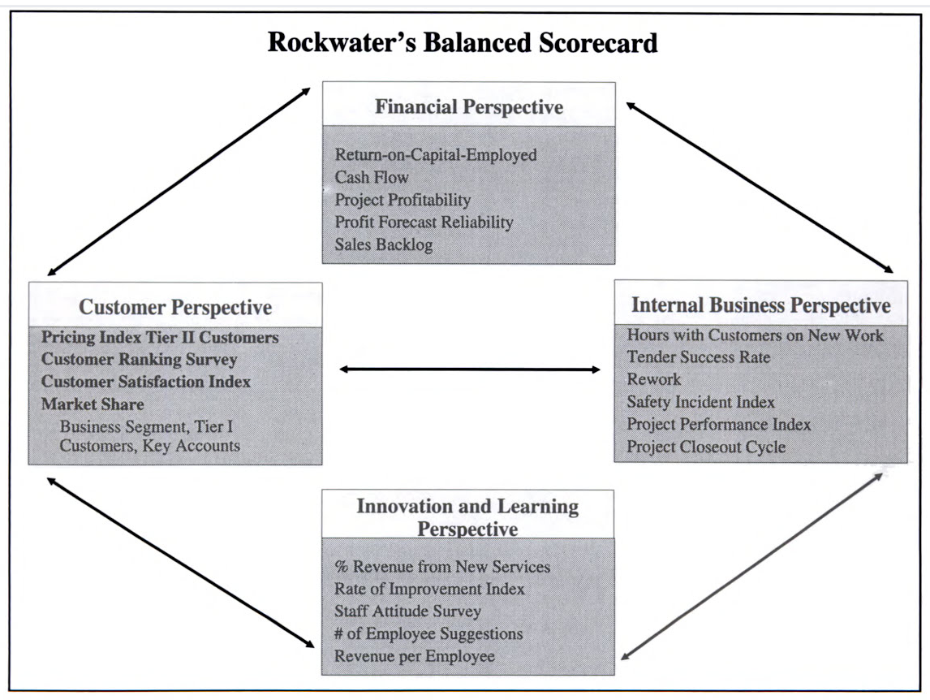
Figure X: Rockwater’s Balanced Scorecard (Source: Performance Measurement, Management & Appraisal)
- Benchmarking
External data can provide information on the trends in HR. Data gathered by HR may include the number of job applications and absence figures which can be used to benchmark internally by comparing to previous years or externally against competitors or similar businesses.
- Government data
The government collect data across all sectors and often publish this data to demonstrate success of their various strategies, policies or legislative developments. In November last year, BBC News (2017) reported that though wages are falling behind the cost of living, “unemployment remains at a 42 year low.” The exact figures can be seen in the news article and refer to the Office of National Statistics as the source for the data provided. Hr professionals in organisations use data collected by the Office for National Statistics to benchmark against, or if they are part of a new business the data may be used to understand the sector or market such as salary paid for an administrative officer in the NHS.
Conclusion
This paper concludes with the insight that HR is an ever evolving profession. It concentrates on the people element to ensure that the workforce are heard, are appropriate and continually develop their skills in order to achieve the organisational objectives. Sectors work differently to each other and though there are numerous models for strategy, managing change, understanding the organisation in its current and future context – it is essential for each organisation to choose the most appropriate tools. Ethics and accountability continue to have a place in a 21st century organisation that should be led, managed and actioned through integrity while also maintain standards. HR has a role in each stage of strategy formulation and implementation and the HR strategy must be aligned vertically with the business strategy, while horizontally aligned with HR practices. The HR data available to organisations both internally and externally are vast and once again, in order to be efficient with that data and organisation must seek the most appropriate data for their evidence base.

Bibliography
Alexander, L.D. 1985. Successfully Implementing Strategic Decisions. Long Range Planning, 18(3): 91–97 .
Armstrong, M., 2012. Armstrong's Handbook of Human Resource Management Practice. 12th Ed. Kogan Page Publishers.
BBC Bitesize. 2014. Globalisation. [ONLINE] Available at: http://www.bbc.co.uk/schools/gcsebitesize/geography/globalisation/globalisation_rev1.shtml. [Accessed 3 January 2018].
BBC News. 2017. UK pay squeeze tightens but unemployment dips. [ONLINE] Available at: http://www.bbc.co.uk/news/business-41996505. [Accessed 3 January 2018].
CIPD. 2015a. Changing HR operating models. [ONLINE] Available at: https://www.cipd.co.uk/knowledge/strategy/hr/operating-models. [Accessed 2 January 2018].
CIPD. 2015b. Ethical decision-making: Eight perspectives on workplace dilemmas. [ONLINE] Available at: https://www.cipd.co.uk/knowledge/culture/ethics/workplace-decisions-report. [Accessed 2 January 2018].
CIPD. 2016a. Sustainable organisation performance. [ONLINE] Available at: https://www.cipd.co.uk/knowledge/strategy/sustainable-performance/factsheet. [Accessed 2 January 2018].
CIPD. 2016b. Workforce planning. [ONLINE] Available at: https://www.cipd.co.uk/knowledge/strategy/organisational-development/workforce-planning-factsheet. [Accessed 2 January 2018].
CIPD. 2017a. Business ethics and the role of HR. [ONLINE] Available at: https://www.cipd.co.uk/knowledge/culture/ethics/role-hr-factsheet. [Accessed 2 January 2018].
CIPD. 2017b. Corporate governance: an introduction. [ONLINE] Available at: https://www.cipd.co.uk/knowledge/strategy/governance/factsheet. [Accessed 2 January 2018].
CIPD. 2017c. Corporate responsibility: an introduction. [ONLINE] Available at: https://www.cipd.co.uk/knowledge/strategy/corporate-responsibility/factsheet. [Accessed 2 January 2018].
CIPD. 2017d. HR analytics. [ONLINE] Available at: https://www.cipd.co.uk/knowledge/strategy/analytics/factsheet. [Accessed 2 January 2018].
CIPD. 2017e. PESTLE analysis. [ONLINE] Available at: https://www.cipd.co.uk/knowledge/strategy/organisational-development/pestle-analysis-factsheet. [Accessed 2 January 2018].
CIPD. 2017f. Strategic human resource management. [ONLINE] Available at: https://www.cipd.co.uk/knowledge/strategy/hr/strategic-hrm-factsheet. [Accessed 2 January 2018].
CIPD. 2017g. Business ethics and the role of HR. [ONLINE] Available at: https://www.cipd.co.uk/knowledge/culture/ethics/role-hr-factsheet. [Accessed 2 January 2018].
CIPD. 2017h. HR business partnering. [ONLINE] Available at: https://www.cipd.co.uk/knowledge/fundamentals/people/hr/business-partnering-factsheet. [Accessed 2 January 2018].
CIPD. 2017i. HR Analytics. [ONLINE] Available at: https://www.cipd.co.uk/knowledge/strategy/analytics/factsheet. [Accessed 3 January 2018].
CIPD. 2017j. Change Management. [ONLINE] Available at: https://www.cipd.co.uk/knowledge/strategy/change/management-factsheet. [Accessed 3 January 2018].
CIPD. CIPD Code of Conduct. [ONLINE] Available at: https://www.cipd.co.uk/Images/code-of-professional-conduct_tcm18-14510.pdf. [Accessed 2 January 2018].
David, F., 2011. Strategic Management Concept and cases. 13th ed. New Jersey: Prentice Hall.
Delery, J.E. and Doty, D.H. 1996. Modes of Theorizing in Strategic Human Resource Management: Test of Universalistic, Contingency, and Configurational Performance Predictions. Academy of Management Journal, 39, 802-835.
Finnis, R..= 2010. HR metrics: why they need to be used now. [ONLINE] Available at: http://www.hrmagazine.co.uk/article-details/hr-metrics-why-they-need-to-be-used-now. [Accessed 3 January 2018].
Kaplan, R.S., and Norton, D.P. 1996. The Balanced Scorecard: Translating Strategy into Action. Boston: Harvard Business School Press,
Kaplan, R.S., and Norton, D.P., Putting the balanced scorecard to work. In Schneier, C., Shaw, D., Beatty, R., and Baird. L.,1995. Performance Measurement, Management, and Appraisal Sourcebook. Massachusetts. Human Resource Development Press.
Kaptein, M. & Wempe, J. 2002. The Balanced Company: A corporate integrity approach. Oxford: Oxford University Press.
Linkedin. 2015. 'Why' Should We Manage Change?. [ONLINE] Available at: https://www.linkedin.com/pulse/why-should-we-manage-change-garry-platt/. [Accessed 2 January 2018].
Mindtools.com. 2017a. Porter's Generic Strategies. [ONLINE] Available at: https://www.mindtools.com/pages/article/newSTR_82.htm. [Accessed 2 January 2018].
Midtools.com. 2017b. Lewin's Change Management Model. [ONLINE] Available at: https://www.mindtools.com/pages/article/newPPM_94.htm. [Accessed 2 January 2018].
Mindtools.com. 2017c. PEST Analysis. [ONLINE] Available at: https://www.mindtools.com/pages/article/newTMC_09.htm. [Accessed 2 January 2018].
Mindtools.com. 2017d. SWOT Analysis. [ONLINE] Available at: https://www.mindtools.com/pages/article/newTMC_05.htm. [Accessed 3 January 2018].
Mindtools.com. 2017e. Porter's five forces. [ONLINE] Available at: https://www.mindtools.com/pages/article/newTMC_08.htm. [Accessed 3 January 2018].
Mindtools.com. 2017f. Force Field Analysis. [ONLINE] Available at: https://www.mindtools.com/pages/article/newTED_06.htm. [Accessed 3 January 2018].
Miyake, D. 2015. 48 Human Capital KPIs & Scorecard Measures. [ONLINE] Available at: https://www.clearpointstrategy.com/human-capital-kpis-scorecard-measures/. [Accessed 3 January 2018]
Morrison, M. 2010. PRIMO-F Model for Business Development. [ONLINE] Available at: https://rapidbi.com/primo-f-model-for-business-development/. [Accessed 3 January 2018].
Office for National Statistics. 2017. Sickness absence in the labour market: 2016. [ONLINE] Available at: https://www.ons.gov.uk/employmentandlabourmarket/peopleinwork/labourproductivity/articles/sicknessabsenceinthelabourmarket/2016. [Accessed 3 January 2018].
Quinn, J. B. 1980. Strategies for Change: Logical incrementalism, Irwin, Georgetown, Ontario
Strategies for managing change. 2009. Kubler-Ross grief cycle. [ONLINE] Available at: http://www.strategies-for-managing-change.com/kubler-ross.html. [Accessed 3 January 2018].
Taylor, S. & Woodhams. C. 2016. Studying Human Resource Management. London: Chartered Institute of Personnel and Development.
The Independent. 2017. Foreign student numbers plummeting in wake of Brexit. [ONLINE] Available at: http://www.independent.co.uk/news/uk/politics/foreign-student-numbers-plummeting-in-wake-of-brexit-a7596186.html. [Accessed 3 January 2018].
Tyson, S., 1995. Human resource strategy. Pitman Pub.
Welsh Government. 2018. Cymraeg 2050: A million Welsh speakers. [ONLINE] Available at: http://gov.wales/docs/dcells/publications/170711-welsh-language-strategy-eng.pdf. [Accessed 2 January 2018].
Winstanley, D., Woodall, J., and Heery, E. 1996. Business ethics and human resource management: Themes and issues, Personnel Review, Vol. 25 Issue: 6, pp.5-12.

Higher Education
Further Education

