Student: Cristian serban (1921412)
Lecturer: Peter allen
University of wales trinity saint david
term 2 assignment
Academic and employability skills (BMSW4001_LON)
[Company name] | [Company address]
[Year]
Table of contents

- Introduction
- Time management
- CV writing
- Public speaking and giving presentation
- Cover letter writing
- Conclusion
- References

Introduction

In June 2020 I started studying at the University of Wales Trinity Saint David. This university offers people the chance to study for a level 4 diploma. After studying for the certificate of higher education in skills for the work place the students are able to continue on a 3 years course in business and management or cloud computing. This is a great opportunity for people who did not have the chance or possibility to study in their early age and now want to improve their working skills or learn how to manage their company better. In the first year I started to learn 6 different modules. One of them is called academic and employability skills. In this module I learned a lot about employability skills, report writing, cover letter writing, time management, paraphrasing, academic writing, referencing, giving presentations, cv writing and more... This module really helped me understand how important it is to know my skills, the thinks I am good at and the things that I can improve to be better in the field I want to progress. I learned something new every day with our lecturer Peter Allen and I discovered many new things. I will talk about some topics that helped me and made me improve my skills using a reflection model learned in the class.

I will be using Gibbs reflective cycle. In his 1988 book "Learning by Doing." Professor Graham Gibbs published his Reflective Cycle. It is particularly useful for helping people learn from circumstances they frequently encounter, especially when they don't go well.

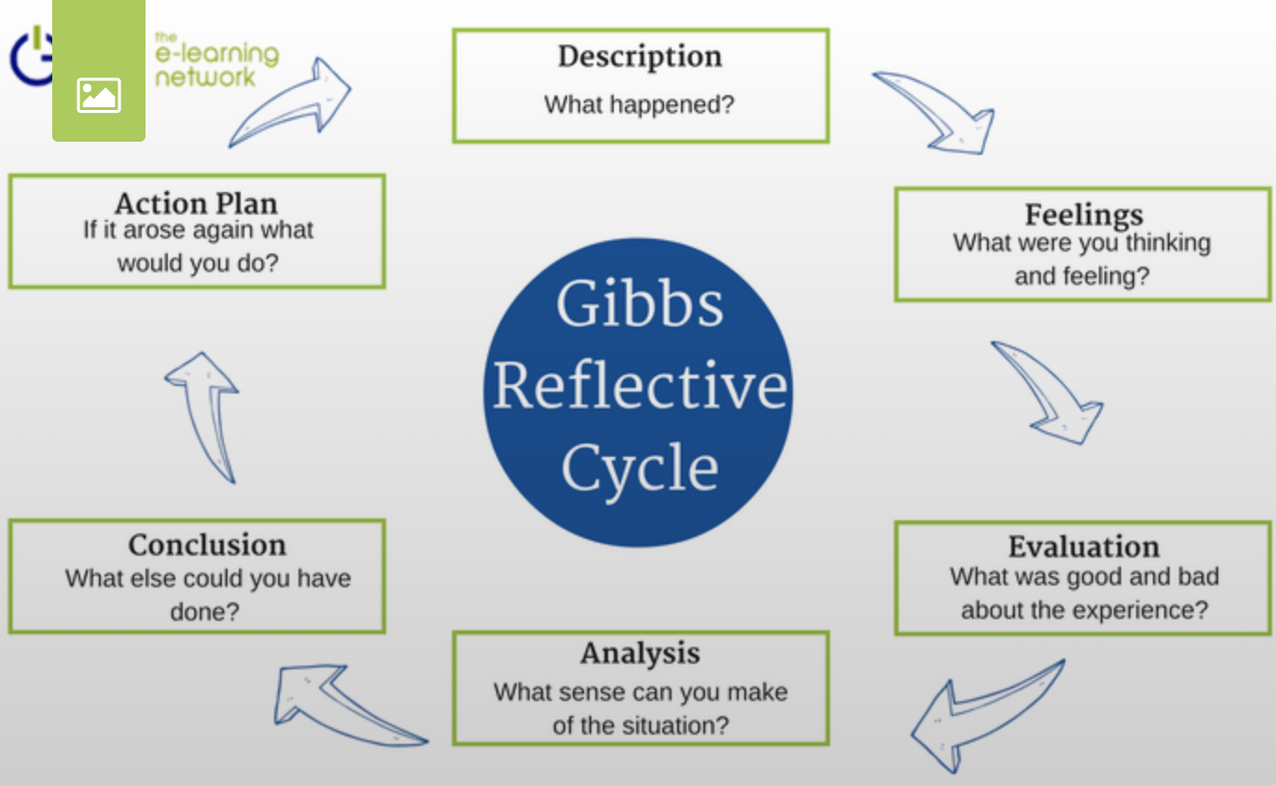

Time management

Time management was one on the first topics we talked about with Mr. Peter Allen. At first I did not think it was going to be so interesting and helpful but it turned out it was.
We learned that time management is the way toward getting sorted out and arranging how to separate your time between explicit exercises. Good time management empowers you to work more brilliant, not harder, so you complete more in less time, in any event, even when time is tight and pressures are high. Neglecting to deal with your time harms your adequacy and causes pressure. (Works, 2018)
The lecturer explained to us how we can use time management in our everyday life and how it will help us. We talked about weekly time management and each student made a time schedule. When completing the time schedule I realized how important it is to know what I have to do in the future and put it in order. Before this I was not using any calendar to manage my time. Now I do it every week and it is changing my life in a better way.
My initial reaction was surprise. This was something I did not think I was going to use in the future. And It was really easy to do as well.
Time management is one of the most important skills we have. It can help us be more productive, reduce our everyday stress, be more efficient and it increases our opportunity for advancement. But we also learned that a bad time management can bring a poor quality of work because when doing things in the last minute we risk reducing the quality of our work for speed. A bad time management can easily make us miss our deadlines and create poor working relationships.
I am very happy I was able to learn about time management. It really helped me change my lifestyle and made things easier. After this class I was able to manage my work activities and my studies in a better way. I am less stressed now, I have more time to study and I am less tiered with the work. I have more time for my family and other personal activities. This class brought a lot of good things that made my life better.
CV Writing

Another very useful topic to learn about was the Curriculum Vitae (CV). A CV is an important part of any job search, not to mention a perfect way to bring in one position all your expertise, experience, and credentials. In reality, the difference between having an interview and not being considered for the job may be a well written CV. (Rolfe, 2018). I learned that there are some essential things that I must cover in my CV. Things like my personal details, a personal statement, my skills, my past work experience, my education and qualifications and hobbies. A CV must be easy to read and not very long. The slides and tutorial videos that I saw in class really helped me understand how I should write my CV to make it look good and to make the recruiter read it. Before this class I was not sure how to write a CV or what information to put in. Now I know a CV must be logical and not too long. I always check for grammar and spelling errors and use bullet points.
I also did some practice in class which helped me understand better how my CV should look like. In the class practice I was able to write my CV following some steps that the teacher showed us. It was really simple to understand and very helpful.
I really needed this information for my future development and the teacher did a great job explaining all these things. Before this class I had a lot of CVs send to different companies but very few of them called me for an interview. I learned a lot about the CV writing in this class. Now I am confident that I can write a good CV for the job I want and the recruiter will consider me.

Public speaking and giving presentations

For certain fields of academic research, for example, business studies and
languages, the ability to create and produce an effective presentation is essential.
In the workplace, however, this skill is also very important. (university, 2020).
Public speaking and giving presentations is a very important skill. At the University of Wales Trinity Saint David this is one of the first subjects you will learn about. At the beginning of the year I knew I was going to give some presentations during the school period but I didn’t know anything abut it. I never gave a presentation or speak to a large group of people. I had so many things to learn about this. The teacher did a great job showing us different slides about how to give a presentation and how to create it. We also saw different videos of people giving presentations. I learned that the slides of the presentation must be clear and showing the bullet points of the idea. Too much text is not good in the presentation slides because the public must pay attention to you not the text.
During this class I understood how to approach the overall task of creating a presentation, how to prepare my script and how to practice my presentation. For live presentations, the most significant thing is to communicate clearly and make yourself heard. Do your best to plan properly if you encounter stage fright. In order to help you deal with your nerves, healthy, strong planning will go a long way.
This class really helped me build up my self confidence. After the practice and the presentations given at the end of the terms now I am very confident and I know I can produce slides and give presentations much easier. This will really help me in the future. Public speaking is a very important skill and can always help you. This has helped me become a better student and understand more about working with large groups of people. I am really glad I could learn this from the beginning of the school, it will help me a lot during all the studying period and after.

Cover letter writing

Writing a cover letter is an integral part of almost any work application.
Not only do you have to ensure that it sells your expertise and abilities to recruiters, you also need to do it in a straightforward and succinct way that eventually convinces the reader to want to meet you. (Rolfe, 2018). Before writing a cover letter we must do some research about the company and the role we are applying for. We must know what is the company doing, who are the competitors, what does the role involve and what are the skills we need to have.
The cover letter must come with a CV. In this class we saw different slides and the teacher showed us how a cover letter should look like. Three points should be short in your opening paragraph: why you're writing the letter, the role you're applying for, how you've found out about the position. In the second paragraph we must describe why we are suitable for this job. In the third paragraph we must show what can we do for the company and outline our career goals. In the fourth paragraph We reiterate our interest in the role and why we are the right choice for the job. It's also a good time to say that for an interview we would like to meet with the boss. At the end we must close the letter with 'Sincerely yours' (if you know the hiring manager's name),
or 'faithfully yours' (if you don't), accompanied by your name.
I can say that this was all new for me. I never sent a cover letter with my CV to anyone because I did not think this was necessary. Now I know how important the cover letter is. It can make a big difference to the employer and the chances of getting the job I want increase very much with the right cover letter. Now every CV I make will have a cover letter.

Conclusion

I had a lot to learn from this module. I think this was the most interesting module we had this year. The teacher was very communicative and he explained things in a very pleasant way. I never got bored in this class and I liked how the teacher used slides and videos to make us understand better the lessons.
I am sure in the future the skills learned here will help me develop a better career but will also help me become a better person and student. The things I learned here definitely changed me in better. Now I am more prepared for the future and I am more confident in me.

References
Rolfe, A., 2018. How to: write a cover letter. [Online]
Available at: https://www.reed.co.uk/career-advice/how-to-write-a-cover-letter/
[Accessed 12 12 2020].
Rolfe, A., 2018. What is a CV. [Online]
Available at: https://www.reed.co.uk/career-advice/what-is-a-cv/
[Accessed 12 12 2020].
university, T. o., 2020. Giving presentations. [Online]
Available at: https://help.open.ac.uk/giving-presentations
[Accessed 12 12 2020].
Works, E., 2018. mindtools. [Online]
Available at: https://www.mindtools.com/pages/article/newHTE_00.htm#:~:text=Time%20Management%20Definition,tight%20and%20pressures%20are%20high.
[Accessed 17 11 2020].

