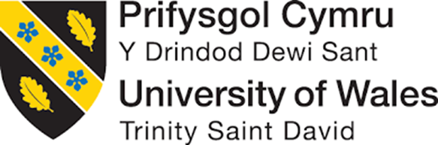

REPORT

BMSW4002

Effective Teamwork and Communication
Student Name: Biser Emilov Kolev
Student ID: 2022842
Lecturer’s name: Timothy Hopkins

Table of contents
Introduction to importance of team working and communication within organizations 3
Discussion 4
Strategies for effective team working within organizations 4
Range of communication skills integral to success within the workplace 4
Definition, importance and theories relating to group/ team dynamics, along with your own workplace examples 5
Evaluation of models of communication applicable to the workplace, with case study examples regarding their applicability within the workplace 6
Evaluation of the communication skills, with case study examples regarding their applicability within the workplace 8
Examples of poor communication in your workplace 8
Recommendations for improving workplace communication and communication skills, with reference to the existing literature 9
Conclusion 10
References 11

Introduction to importance of team working and communication within organizations
Teamwork and communication play one of the most significant roles in terms of the enhancement of organizational position in this highly competitive business market. As per the viewpoint of Martin et al., (2019, p. 350), elective communication and sustainable teamwork can enrich the organizational environment that can enhance employee retention factors within an organization. Moreover, the present study is going to reveal the strategies, models and theories of effective communication and sustainable teamwork aspects. Along with this, the present assessment is also going to elaborate on the communication and teamwork factors from the example of several organizational contexts and provide potential recommendations to enhance these factors by mitigating obstacles.

Discussion

Strategies for effective team working within organizations
As per the viewpoint of Gharaveis et al., (2018, p. 40), effective teamwork ventures include several segments such as collaborative nature, conflict management factors, encouragement behaviour, self-estimation, outlining the goal and others. Stressing on rewarding team performances can be one of the most efficient strategies for encouraging good teamwork. As per the viewpoint of Dirks, (2019, p. 45), avoiding the occurrence of conflicts, through maintaining proper communication channels can help to enhance the collaborative nature that enhances team-working within organizations, and it also leaves a positive impact on the performance management factors of the organization. For example, within multinational companies like Unilever, a common portal for interaction has been developed for the management-level employees, wherein they can interact with one another and know about the company proceedings, to maintain collaboration between different branches.
The same is also done for maintaining efficient inter-and intradepartmental communication, fostering teamwork. It can be clarified that the appropriate leadership method and arranging individuals according to their expertise levels, knowledge and experience in different sectors can help the organizational management to enhance the team-engagement factors. For instance, Tesco provides a voice to each employee to get notified about the thinking arrangement of the employees and the teams are formed based on the subject-level expertise of individuals, their experience and knowledge (Tesco.com.my., 2021). Exchange of views amongst departments is encouraged during the team and board meetings to enhance the innovation quotient of the organization besides helping the employees to work as a team towards the realization of organizational objectives.

Range of communication skills integral to success within the workplace
As stated by Spencer et al., (2018, p. 18), effective communication encompasses the aspects of maintaining several behavioural aspects such as friendliness, confidence, empathy, respect, clarity, and others. In addition, listening is one of the most important communication skills to be implemented within the workplace. For instance, the management group of Sainsbury maintains effective communication with the employees through listening out to their views patiently, either through group meetings organized by team leaders or board meetings by the management. This helps the management, team leaders and employees to be on the same page, understand the problems and work together to mitigate the same.
Sainsbury's maintains both verbal and non-verbal aspects of communication through direct and indirect modes like meetings, emails, phone calls, written mobile messages as well as printed documents. Besides, strong emotional control and empathy, along with the straightforward nature of talking and appropriate body language are adopted by team leaders and managers, as skills, to avoid miscommunication. While the letters, direct messages, emails are used to convey information to the employees, direct verbal communication like meetings and phone calls are used to know about the problems of the employees and empathize with them, to help them feel associated with the organization.
The body language, time of talking and gestures convey the concern of the management as well as their level of respect towards their employees, which enhances their motivation levels and encourages them to work for the development of the organization as well as share their woes, thus, leading to efficient problem-solving (Sainsbury's Careers., 2021). The straightforward and empathetic skills of communication are also depicted through the publication of newsletters and annual reports targeting the customers and stakeholders, to communicate the development and decisions of the company and keep them well-informed, which helps in maintaining strong stakeholder-satisfaction and engagement.

Definition, importance, and theories relating to group/ team dynamics, along with your own workplace examples
As per the opinion of Donald and Carter (2020, p. 17), Tuckmans’s Group Dynamics theory can be considered as one of the most effective and sustainable theories for describing the appropriate features of teamwork and group development.it has been evidenced that group dynamics can help the organizational management to incorporate job satisfaction and clarity reading the organizational decisions. Tuckman’s Group Dynamic theory encompasses several stages such as forming, storming, norming, performing, and adjourning. The organization Argos is a part of Sainsbury. It has been evidenced that the concerned organization neglected several aspects of teamwork and effective communication that sometimes became a reason for the organizational degradation in the past.
As per the viewpoint of Loewenstein et al., (2019, p. 345), the respective theory can be considered the most helpful for the organization as this theory can provide the organization with comprehensive and sustainable ideas to enhance the maturity and efficiency of the organizational employees and the management groups. The concerned organization always pays attention to the terms of the individual performance equity that reduces the effectiveness of the teamwork venture, creating conflicts and discrimination besides affecting organizational activities, vide this theory. As stated by Lucas (2017, p. 260), it can be clarified that Tuckman’s Group Dynamics theory can help an organization to measure the primary aspects of teamwork that can help the organizational management to maintain the teamwork venture within the organization. As a result, it also helps to enhance the collaborative nature of the employees that can enhance the engagement factor switch the organization.
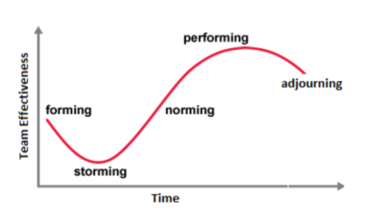
Figure 1: Stages of Tuckman's Theory
Source (Kiweewa et al., 2018, p. 280)

Evaluation of models of communication applicable to the workplace, with case study examples regarding their applicability within the workplace
It has been evidenced that most of the organizations incorporated effective communication ventures to enhance the employee retention factor to enhance the performance of the organization. Hence, Berlo's model of communication can be considered one of the most effective and significant models of communication that can increase organizational performance based on the effective communication venture. It has been evidenced that this model encompasses the elements such as sender, message, channel, and receiver. This model maintains the SCMR approach which helps the organizational management to maintain the simplest form of effective communication. It has been evidenced that Tesco incorporated this model which helped the organization to maintain effective communication channels between management, leaders, and employees (Spencer et al., 2018, p. 15).
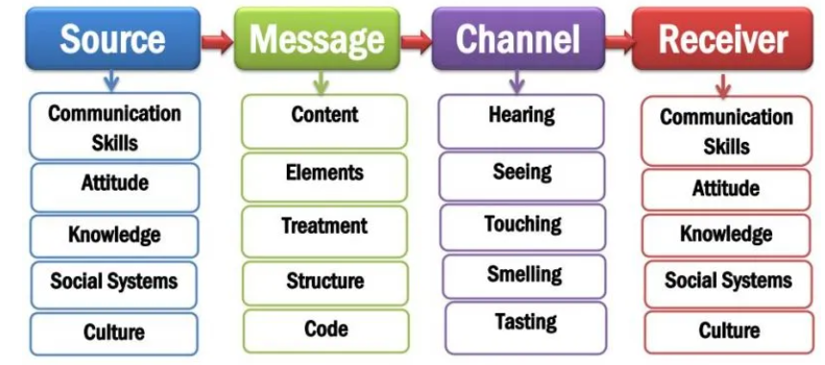
Fig 2: Berlo’s Model of Communication
Source: (Spencer et al., 2018, p. 15)
Moreover, the application of Berlo's communication model also helps the organizational management to get notified regarding the mindset of customers and employees as well, through the actions of the marketing and the HR teams respectively. It provides a clarified idea to the organizational management to frame their upcoming activities and strategies, and this has a role to play in the competitive advantage attained by the company on the market (Attaran et al., 2019, p. 20). It has been evidenced that Berlo's communication model help the organizational management to generate clarified communication that helps to mitigate any chances of confusion. Along with this, it also helps to maintain transparency among the employees and organizational management. In addition, it also helps organizational management groups to maintain employee motivational factors that enhance the aspects of employee retention (Lucas, 2017, p. 258).
On the other hand, the transactional communication model plays a crucial role to enhance an organizational effective communication venture that enhances the organizational environment and organizational activities. As per the viewpoint of Wang et al., (2018, p. 111115), the transactional communication model encompasses several characteristics such as the content on time, existing moment, relation with the past. Another retail giant, Sainsbury, applies this transactional communication model within the organizational context to enhance the effective communication factor amongst the employees.
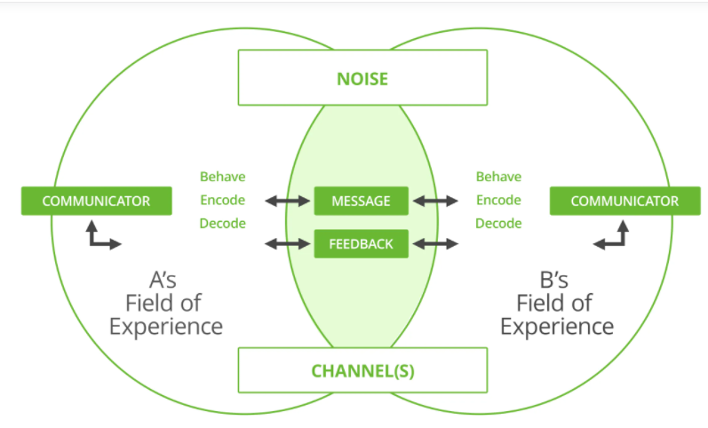
Fig 3: Transactional model of communication
Source: (Wang et al., 2018, p. 111115)
Under this model, the interaction between the sender and the receiver is facilitated in real-time and thus, the organization mainly focuses on face-to-face communication or virtual meetings through Skype rather than written communication. Sometimes, a mixed venture consisting of both linear and transactional models is implemented within the company, especially during training sessions as well as board meetings, wherein first, the management speaks up about the conditions of the company or the basics of the training, followed by interaction sessions, wherein the employees or the candidates, as per the case, are allowed to exchange their views. This interaction again proceeds in a linear and transactional fashion, till the end of the session. As per the viewpoint of Attaran et al., (2019, p. 19), the model helps in reducing chances of miscommunication as well as makes the process more interactive rather than being monotonous. However, this model is very complicated for the sender. Hence, improper implementation also can degrade organizational communications.

Evaluation of the communication skills, with case study examples regarding their applicability within the workplace
As stated by Barratt, (2019), effective communication also can enhance sustainable teamwork ventures within the organization. Thus, it can be clarified that effective communication enhances the employee retain factor along with the customer engagement factors. It has been evidenced in this assessment that the organization Tesco maintained Berlo's communication model that helps the organization management to maintain effective communication ventures related to getting notified about the mindset of the employees and the customers. The organization maintain effective communication skills such as empathy, straightforwardness, confidence, proper interaction, and others that help the organizational management to represent their thinking properly in front of employees and customers (Barratt, 2019).
Along with this, transactional communication ventures are also beneficial to maintain past records that can influence the upcoming decisions of the organization. It has been evidenced that the organization Sainsbury implemented verbal and nonverbal communications. Hence, in this implementation, it is required to keep the records that can help the organizational management to maintain trustability factors. Hence, maintain clarity in terms of verbal communication is one of the most important skills of effective communication. More to the context, the organizational management group of the respective organization keeps the documents, clips, and others to get notified about the past declarations which help the organizational agent group to restructure their new declarations.

Examples of poor communication in your workplace
As per the viewpoint of Rajhans, (2018, p. 50), poor communication factors can affect the organizational position within the preferred list of the customers. However, it has been evidenced that the organization Argos has become the fastest delivery organization in this COVID-19 pandemic situation, in terms of online shopping. Yet, this organization does not maintain appropriate communication and teamwork ventures within an organizational context. In this pandemic situation, most of the employees were not eager to conduct this home delivery venture based on their personal health and safety aspects. On the other hand, the organizational management did not conduct the appropriate meetings with the employees to become aware of the demand of the employees that also affected the employee retention factors. On a contradictory note, the concerned organization maintained effective communicative ventures with the customers that helped the organization to acquire the position of the fastest delivery organization. On the other hand, the organizational management prefers individualism that discourages the teamwork ventures of the organization. Hence, it also created discrimination among the employees. As a result, of these implementations, effective communication and collaboration factors are also reduced within organizational management that drives the workplace environment towards degradation.

Recommendations for improving workplace communication and communication skills, with reference to the existing literature
It is highly recommended to the organization Argos to incorporate the procedures of the implementation of effective communication and sustainable teamwork to enhance organizational position in this competitive business market. The conceded organization also can incorporate a transactional communication model which is entirely followed by the organization Sainsbury. It can help the organizational management to keep the record of the past data that can help the organization management to ensure the trustability factors. Along with this, the concerned organization also can implement Berlo's communication model that is used by the organization Tesco. Hence, it can help Argos to generate an appropriate meeting with the employees to maintain the well-being factor of the employees that can help to enhance employee retention factors within the organization. Moreover, the concerned organization also incorporate appropriate leadership strategies to implement teamwork venture within the organization to boost organizational development.

Conclusion
To conclude, it has been clarified from the discussion that effective communication and a suitable teamwork approach and enhance the trustability factor that can enhance the customer engagement and employee retention aspects.

References
Attaran, M., Attaran, S. and Kirkland, D., 2019. The need for digital workplace: increasing workforce productivity in the information age. International Journal of Enterprise Information Systems (IJEIS), 15(1), pp.1-23.
Barratt, J., 2019. Developing clinical reasoning and effective communication skills in advanced practice. Nursing Standard, 34(2).
Dirks, J.L., 2019. Effective strategies for teaching teamwork. Critical care nurse, 39(4), pp.40-47.
Donald, E.J. and Carter, A., 2020. Overview of Common Group Theories. Group Development and Group Leadership in Student Affairs, p.17.
Gharaveis, A., Hamilton, D.K., Pati, D. and Shepley, M., 2018. The impact of visibility on teamwork, collaborative communication, and security in emergency departments: An exploratory study. HERD: Health Environments Research & Design Journal, 11(4), pp.37-49.
Kiweewa, J.M., Gilbride, D., Luke, M. and Clingerman, T., 2018. Tracking growth factors in experiential training groups through Tuckman’s conceptual model. The Journal for Specialists in Group Work, 43(3), pp.274-296.
Liu, D., Zhu, G., Zhang, J. and Huang, K., 2020. Data-importance aware user scheduling for communication-efficient edge machine learning. IEEE Transactions on Cognitive Communications and Networking, 7(1), pp.265-278.
Loewenstein, K., Barroso, J. and Phillips, S., 2019. The experiences of parents in the neonatal intensive care unit: an integrative review of qualitative studies within the Transactional model of stress and coping. The Journal of perinatal & neonatal nursing, 33(4), pp.340-349.
Lucas, P.R., 2017. Positioning critical reflection within cooperative education: A transactional model. Asia-Pacific Journal of Cooperative Education, (3), pp.257-268.
Martin, G., Khajuria, A., Arora, S., King, D., Ashrafian, H. and Darzi, A., 2019. The impact of mobile technology on teamwork and communication in hospitals: a systematic review. Journal of the American Medical Informatics Association, 26(4), pp.339-355.
Rajhans, K., 2018. Effective communication management: A key to stakeholder relationship management in project-based organizations. IUP Journal of Soft Skills, 12(4), pp.47-66.
Sainsbury's Careers. 2021. Marketing and Communication Jobs | Sainsbury's Jobs. [online] Available at: <https://sainsburys.jobs/roles/corporate-functions/marketing/> [Accessed 22 July 2021].
Spencer, L.J., Marschark, M., Machmer, E., Durkin, A., Borgna, G. and Convertino, C., 2018. Communication skills of deaf and hard-of-hearing college students: Objective measures and self-assessment. Journal of communication disorders, 75, pp.13-24.
Tesco.com.my. 2021. IT & Communication. [online] Available at: <https://www.tesco.com.my/html/default.aspx?ID=472&PID=1055> [Accessed 22 July 2021].
Wang, Z., Chu, R., Wu, W., Li, Q., Cai, Z., Cao, N. and Gu, M., 2018. Identification and optimization models for a freight-integrated transportation corridor with line importance and freight communication capability. Ieee Access, 7, pp.11114-11126.

