

IRAJ AALINEJADIAN

Student ID number: 1808658

Programme: Civil Engineering

Module: Geology and Soil Mechanics

Module code: ACBA5004

Lecturer: Dr Allan Nantel

Assignment Title: Soil Mechanics PRACTICAL

Contents

Atterberg Limits 3
Introduction: 3
Methodology for Atterberg Limits: 3
Analysis and Discussion 7
Conclusion: 8
Constant Head Permeameter 8
Introduction 8
Methodology: 9
Analysis and Discussion 10
Conclusion: 13

Atterberg Limits

Introduction:
Atterberg limits is a measuring system for the water content in a fine grained soil - it can measure the limits of shrinkage, plastic and liquid. Normally it is used for the classification of soil, classing together soils with similar limits and indices.
Attenberg is used to define properties of index in fine grained soils, marking the boundaries of both liquid and plastic states and plastic and semi solid states and includes liquid limit (LL) and plastic limit (PL), plasticity index (PI) and shrinkage limit (SL).
Of all these, liquid limit and plastic limit are essential elements when predicting the strength of soil. When clay makes a gradual change from liquid to plastic it is defined as the liquid limit of the soil. Conversely, plastic limit in clay means the water content when there is a sudden change from ductile to brittle.
The most part of the limits is both the liquid limit and the plastic limit as they are essential for the classification of soils in the unified soil classification system (USCS)
In this case, the group undertook standard practice when deciding the liquid limit, plastic limit and an index of the plasticity of a soil sample in accordance to BS EN ISO 17892-12:2018 (British Standards Institute, 2018)
Objectives:
- To work out liquid limit, plastic limit and plasticity index of sample of soil.
- To create data inside acceptable error range as requested by the lab tutor.
- To make analysis of the sample working from the results of the experiments and decide its type, as per the Unified Soil Classification System.

Methodology for Atterberg Limits:

Materials require:
• Casagrande Cup or Liquid Limit Device
• Flat Grooving Tool
• Gauge
• Water in Content Container
• Mixing and Storage Container
• Moisture cans
• Spatula
• Balance
• Sieves (Number 40, ISO 3310-1)
• Glass Plate
• Drying Oven
• Containers with Lid
We start by weighing and numbering four containers, writing the weights in the test result table. We then sieve (using size 04 mm) a piece of soil sample so that we remove any larger pieces of soil. We place 250 g of the sieved sample in a container and mix in water. We need to stir it, chop it and knead it to a smooth clay consistency and this will need 30-35 drops on the Casagrande equipment so that the 12 mm grooved gap closes. We then place a portion of this clay in the cup bowl of the Casagrande (It is important that the cup we use is both clean and dry before we start each test.), pressing it and spreading it down flat with spatula, and take care we do not to add air bubbles. We need it to be 10 mm deep. We return any unused sample back to the mixing bowl.
Then, with gauging groove tool, we make groove in the centre of the sample and work front to back. With a clay soil, we must achieve it in one action (three swipes in the case of a silt soil). We must take care not to split the sides of the sample. as it must not crack up or slip over the cup and must not go through the sample to the cup surface.
We must then set the counter on the cup to zero and turn the crank handle on the cup at 2 revs per second so that cup is raised up and down until the groove in the soil sample closes over 12 mm. We then make a note of how many drops are required to shut soil sample over 12 mm.
With a spatula we take out a soil sample which should be the same width as the spatula. Working side to side, we must slice across the groove. We put this sample in a container and weigh both soil and container then make a note of the weight.
We then repeat the above, so we have four samples. We then place all four samples to dry in an oven for 24 hours at 110° C. Afterwards, we must weigh the dried sample plus its container so that we can work out the moisture content.

In order to work out the plastic limit (PL) we must roll out a thread of 20g of soil passing number 40-micron sieve. The working surface must be both flat and non-porous. If the soil is sufficiently moist it will be plastic enough to roll to a tiny diameter and will keep its shape. Such a sample can be remoulded and retested from scratch. As the moisture within evaporates, the thread will break up earlier at a bigger diameter. When this diameter is 3mm, due to the moisture content, the plastic limit is achieved. If a thread cannot be rolled into a 3mm diameter with any amount of moisture, the soil is described as non-plastic. The lower limit of the plastic state is the plastic limit. This means that even the smallest additional amount of moisture over and above the plastic limit will destroy the soil's cohesion.

 | 1 | 2 | 3 | 4 | 5 | 6 | 7
Type of test | LL | LL | LL | LL | PL | PL | PL
Container number | LL 1 | LL 2 | LL 3 | LL 4 | PL 1 | PL 2 | PL 3
Weight of wet soil + container | 9.43 g | 13.35 g | 13.39 g | 12.89 g | 8.01 g | 9.04 g | 8.18 g
Weight of dry soil + container | 8.02 g | 10.66 g | 10.86 g | 10.24 g | 7.24 g | 8.31 g | 7.39 g
Weight of container | 4.72 g | 4.69 g | 4.69 g | 4.72 g | 4.73 g | 4.73 g | 4.81 g
Weight of moisture | 1.41 g | 2.69 g | 2.71 g | 2.65 g | 0.77 g | 1.09 g | 0.79 g
Weight of dry soil | 3.3 g | 5.97 g | 5.99 g | 5.52 g | 2.51 g | 3.58 g | 2.58 g
Moisture content | 42.72% | 45.06% | 45.24% | 48.01% | 30.68% | 30.45% | 30.62 %
Number of blows | 32 | 22 | 19 | 15
Table 1. Data for the liquid limit test and plastic limits of soils

Weight of moisture = [Weight of wet soil + Weight of container] – [Weight of dry soil + Weight of container] (Equation 1)
Weight of moisture (LL 1) = 9.43g - 8.02g =1.41g
Weight of moisture (LL 2) = 13.35 g - 10.66 g = 2.69 g
Weight of moisture (LL 3) = 13.39 g - 10.86 g = 4.69 g
Weight of moisture (LL 4) = 12.89 g - 10.24 g = 2.65 g
Weight of moisture (PL 1) = 8.01 g - 7.24 g = 0.77 g
Weight of moisture (PL 2) = 9.04 g - 8.31 g = 1.09 g
Weight of moisture (PL 3) = 8.18 g - 7.39 g = 0.79 g

Weight of dry soil = [Weight of dry soil + Weight of container] – [Weight of container]
(Equation 2)
Weight of dry soil (LL 1) = 8.02 g - 4.72 g = 3.3 g
Weight of dry soil (LL 2) = 10.66 g - 4.69 g = 5.97 g
Weight of dry soil (LL 3) = 10.86 g - 4.69 g = 5.99 g
Weight of dry soil (LL 4) = 10.24 g - 4.72 g = 5.52 g
Weight of dry soil (PL 1) = 7.24 g - 4.73 g = 2.51 g
Weight of dry soil (PL 2) = 8.31 g - 4.73 g = 3.58 g
Weight of dry soil (PL 3) = 7.39 g - 4.81 g = 2.58 g

Moisture content is calculated using the equation:
W (%) = (M ω / M ʂ) * 100 (Equation 3)
where W stands for the moisture content in percentage, M ω is the mass of the wet soil sample, M ʂ and is the mass of the wet sample.
Moisture content (LL 1) = (1.41 g / 3.3 g) * 100 = 42.72%
Moisture content (LL 2) = (2.69 g / 5.97 g) * 100 = 45.06%
Moisture content (LL 3) = (2.71 g / 5.99 g) * 100 = 45.24%
Moisture content (LL 4) = (2.65 g / 5.52 g) * 100 = 48.01%
Moisture content (PL 1) = (0.77 g / 2.51 g) * 100 = 30.68%
Moisture content (PL 2) = (1.09 g / 3.58 g) * 100 = 30.45%
Moisture content (PL 3) = (0.79 g / 2.58 g) * 100 = 30.62%

Graph 1

Analysis and Discussion
The Atterberg limits are normally used to differentiate silts and clays and the different grades of silts and clays. Just like the liquid limit, plastic limit and the placidity index, Atterberg limits are extensively used, both individually or jointly, with other properties of soil to tie in with engineering behaviour -compressibility, permeability, shrink swell, shear strength and compaction.
In fine grained or cohesive soil, liquid limit is an essential property as its value is used for its soil classification. On site, it can provide data for the state of the consistency of the soil. The activity of clays and toughness index of soil can be calculated by its liquid value.

Another important framework for the classification of soil is the plasticity index. Clay soils are considered to have a high plasticity index. Abnormally large and recurring slope failures can be caused by the addition of just moderate amounts of water. In the lower range value, the soil is liable to silt. If the soil has little or no clay and silt, as in case of zero value, it is described as non-plastic soil.
Liquid limit = 44%
Plastic limit = 30.58%
Plasticity Index = Liquid limit - Plastic limit (Equation 4)
Plasticity Index = 44% - 30.58% = 13.42%
Graph 2 shows the plasticity chart for USCS, in which will be used to classify the type of soil sample in the experiment.
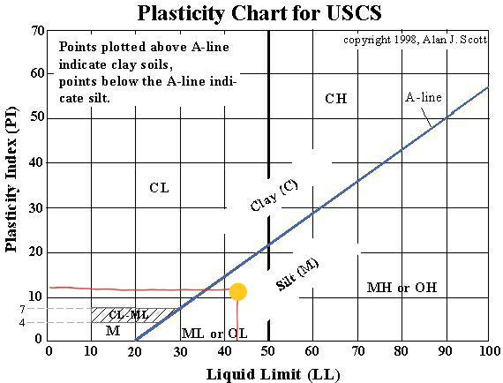
Graph 2

Conclusion:
After thorough analysis of the Atterberg limits of the soil sample, it is concluded that the soil is classified as silt with intermediate plasticity.

Constant Head Permeameter

Introduction
Permeability records the rate of the soil’s ability to allow water to flow through its voids and pores. Sand and gravels are both suitable soils for this test, but any soil with silt cannot be used. Granular soils, reconstituted or disturbed, can be tested. This test is used to ascertain the coefficient of permeability in soil. The constant-head method is used for disturbed granular soils that contain no more than 10% passing through the No200 sieve. it is made on remolded samples only. Only materials with a coefficient of permeability of approximately 300 mm per day or greater can be used for this test. For samples where materials will be used as - backfill for abutments, permeable material for underdrains, sand drains, sand blanket for sand drain areas and other similar materials - the 'Constant Head' method of test is used. The Constant Head Permeability Tests are to be carried out according to BS EN ISO 17892-11:2019 (British Standards Institute, 2019)

Methodology:

APPARATUS
a. ‘Hobart’ soil mixer.
b. Top-loading scale, 15 kg capacity.
c. Scoop.
d. Stop watch or timer.
e. Depth gauge.
f. Moisture pans.
g. Drying oven.
h. Domestic water supply.

1.The outlet level of the 305 mm diameter reservoir should be filled with water. Put the perforated plate on top of the specimen and then put the mold and specimen on the “U” shaped hanger so that it has a head of water of approximately 200 mm. Make sure the mold is level using the nuts on the three vertical studs, and fill with water up to the top of the specimen. If there is a very high rate of flow, “K” of 60 or 90 m/day, (0.07- 0.1 cm/sec), or if there is any indication of piping or of passing of fines from the sample during the test, it might be necessary to use less head of water.

2. Let it percolate for some time to achieve a high degree of saturation and uniformity of test results.

3. Water should run into the intake reservoir at a rate quicker than the rate of flow through the specimen with the excess going through the intake overflow tube into the sink. The outlet reservoir must be full to overflow before starting the test. Any surplus water from the outlet reservoir will equal the amount that has passed through the specimen.
4. Calculate the quantity of flow (Q) with a graduated measurer or by weight and calculate elapsed time (t) for the amount of flow. Keep a record of these amounts.
5. Repeat test runs so that you can determine an average result. If you have much increased permeability than subsequent recordings, ignore the first one. The subsequent readings are normally closer. Further readings after a longer period of time will record a much lower rate of flow. This could well be due to entrapped air or migrations of fines to the lower level of the test specimen.
6. Keep record of the water temperature in degrees Celsius (°C), head of water (H) and height of sample (L).

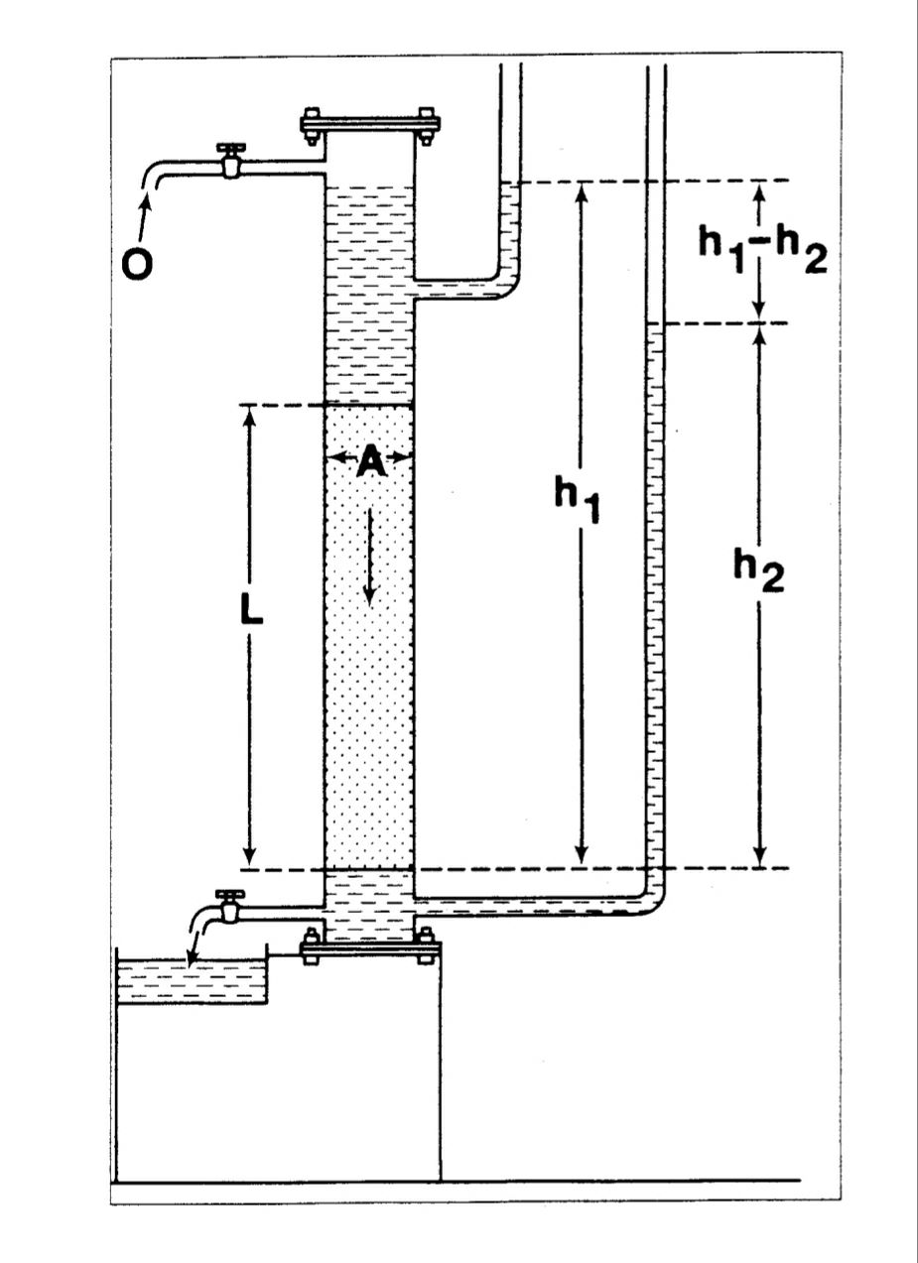
K = Q x L (Equation 5)
A x h x t

h= h1 – h2

Analysis and Discussion

In the Constant Head Permeameter test, the following results were obtained:
- Water collected was 920 x 10⁻⁷ m³ in 2 minutes and 45 seconds.
- Water collected was 185 x 10⁻⁶ m³ in 5 minutes and 30 seconds.
- Water collected was 36.8 x 10⁻⁵ m³ in 11 minutes.
The sample was 0.1m in diameter.
The head difference of 0.068m was measured between points 0.2m apart.
Determine the Coefficient of Permeability in m/s. to three decimal places for each of the three tests.
Averaged the three test values to find the Coefficient for the sample under test:

Test (a)
Q = 920 x 10⁻⁷ m3
2 minutes and 45 seconds = 2(60) + 45 = 165s
Area= π (0.1 / 2) ² = 0.00785m²
h = 0.068m; L = 0.2m
K = Q x L = ( 920 x 10⁻⁷ m³ * 0.2m ) / (0.00785m² * 0.068m * 165s)
A x h x t

= (184 *10⁻⁷ m4) / (0.088077‬ m³/s) = 2089.0811 * 10⁻⁷ m/s = 2.089 *10⁻⁴ m/s
………………………………………………………………………………………………
Test (b)
Q = 185 x 10⁻⁶ m³
5 minutes and 30 seconds = 5(60) + 30 = 330s
Area= π (0.1 / 2) ² = 0.00785m²
h = 0.068m; L = 0.2m
K = Q x L = ( 185 x 10⁻⁶ m³ * 0.2m ) / (0.00785m² * 0.068m * 330s)
A x h x t

= (37 *10⁻⁶ m4) / (0.16014‬ m³/s) = 231.04783 * 10⁻⁶ m/s = 2.310 *10⁻⁴ m/s
………………………………………………………………………………………………….
Test (c)
Q = 36.8 x 10⁻⁵ m3
11 minutes = 11(60) = 660s
Area= π (0.1 / 2) ² = 0.00785m²
h = 0.068m; L = 0.2m
K = Q x L = ( 36.8 x 10⁻⁵ m³ * 0.2m ) / (0.00785m² * 0.068m * 660s)
A x h x t

= (7.36 x 10⁻⁵ m4) / (0.352308‬ m³/s) = 20.890811 * 10⁻⁵ m/s = 2.089 *10⁻⁴ m/s
Coefficient for the sample under test:

K (average) = (2.089 *10⁻⁴ +2.310 *10⁻⁴ +2.089 *10⁻⁴) / (3)
K (average) = 2.163*10⁻⁴ m/s

………………………………………………………………………………………………………………………………………………

Associate this value with Darcy’s table of Coefficients to classify the sample type by coefficient of permeability Value: K (average) = 2.163*10⁻⁴ m/s
The rate of water flow associated with this class
q (flow rate) = V x A (Equation 6) or
q = A x K x I (Equation 8)
Velocity v = k x I (Equation 7)
Hydraulic Gradient: I = Δh = 0.068m / 0.2m = 0.34 (Equation 9)
L
So Velocity is v = k x I= 0.34 * 2.163*10⁻⁴ m/s = 0.735*10⁻⁴ m/s
And the flow rate for this clean sand is:
q (flow rate) = V x A = 0.735*10⁻⁴ m/s * 0.00785m² = 0.005773*10⁻⁴ m³/s

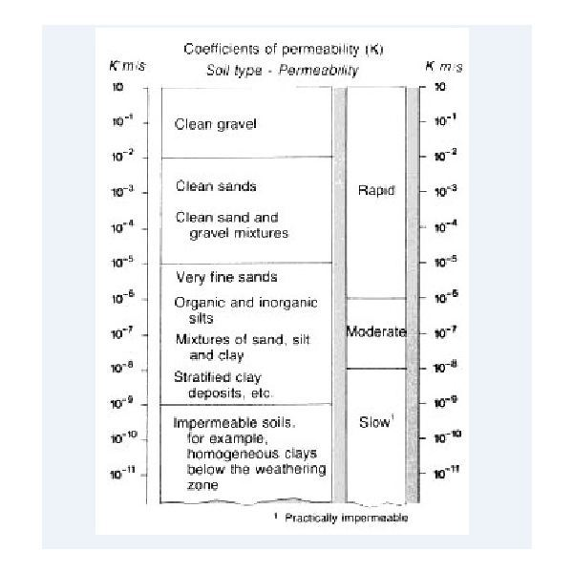
Darcy’s Law & Coefficient of Permeability
When I compare my calculations of average Coefficient of Permeability (K = 2.163*10⁻⁴ m/s) with Darcy’s Law table above, the resulting sample is clean and find sand. Therefore, the water can flow rapidly through it.

Conclusion:
We want to know what the purpose and value of this analysis method is?
Permeability impacts on the settlement of saturated soil when it is under load. It is crucial in the design of earth dams and for calculating the strength of slopes and any retaining structures. It is also important when designing any filters made up of soil. it is necessary to understand the permeability and its properties of the soil in order to roughly calculate the amount of soil seepage underground and subsequently to resolve the best way of pumping this out of the excavation. Also in the case of any earth structures or retaining walls which are subject to seepage. In soil permeability classes, the clean sand is permeable.
clean sand can be used to filter water; it could work like an abrasive. We can use this clean sand as a road base that is a protective layer underneath in most roads. On the other hand, clean sand impacts landslides. It proved that land on the side of a hill could possibly be prone to a landslide if it was saturated by a large amount rain or water.

Bibliography
British Standards Institute. (2018). Geotechnical investigation and testing - Laboratory testing of soil, Part 12: Determination of liquid and plastic limits. London: British Standards Institute.
British Standards Institute. (2019). BS EN ISO 17892-11:2019. London: British Standards Institute.

