

Name: Shazad Hussain Shah
Student number: 2311387
Module code and title: LCBB5013/Entrepreneurship
Lecturer name: Fouziya Farheen
Assignment title: Portfolio

Table of Contents
Element 1: Business idea, products/services, objectives & USP 3
Business idea and overview 3
Products and services 3
Objectives 4
Unique Selling Point (USP) 5
Element 2: Business environment & competitor analysis 5
What PESTEL is and how it helps 5
Competitor analysis 7
SWOT analysis 7
Element 3: 4Ps, market segmentation & marketing strategies 8
Market segmentation and target customers 8
4Ps applied to Elegance Imitations Ltd 9
Online marketing strategies 10
Element 4: Legal, management and financial planning 11
Legal structure and justification 11
Organisational Structure and Chart 11
Start-up funding requirements and sources 13
Cash Flow 15
References 16

Element 1: Business idea, products/services, objectives & USP

Business idea and overview
Elegance Imitations Ltd will be a specialist Asian imitation jewellery retailer operating from Alum Rock Road, serving customers in Birmingham and beyond. The core proposition is a visually strong, service-led store focused on artificial jewellery that complements South Asian outfits and event dressing. The shop will be organised into three clear shopping zones: Bridal, Occasion, and Everyday, because customers commonly shop by event need (“I need a complete bridal set”, “I need something for Eid”, “I need everyday earrings”) rather than by technical jewellery categories (Kotler and Armstrong, 2021). Clear zoning also improves merchandising discipline and makes it easier to guide customers towards bundles and upgrades (Johnson et al., 2017).
The Bridal section will provide premium-looking statement sets designed for wedding photography and formal ceremonies. This includes coordinated necklace and earring sets, heavier bangles, and headpiece items used in South Asian bridal styling. The Occasion section will target events such as engagement parties, mehndi nights, formal receptions and Eid gatherings. Ranges will be built around seasonal colour palettes and finishes that match popular fabrics and embroidery tones. The Everyday section will focus on lighter items with frequent repeat purchase potential (e.g., studs, hoops, simple bangles, rings), supporting regular footfall and stabilising revenue when wedding demand is quieter (Kotler and Armstrong, 2021).
The location is commercially sensible because Alum Rock is a high-footfall retail corridor with local communities that frequently purchase culturally specific fashion goods, particularly around religious and wedding seasons (Birmingham City Council, n.d.). This demand profile supports a specialist retailer that offers a deeper and more tailored assortment than general accessory shops.

Products and services
The business will generate revenue primarily from curated jewellery collections sold as individual items and as co-ordinated sets. Instead of trying to stock “everything”, the business will manage ranges by collection logic (finish + colour family + occasion). This reduces dead stock risk and improves buying decisions, since retail profitability depends heavily on stock turn and working capital discipline (Johnson et al., 2017).
To strengthen differentiation and raise perceived value, Elegance Imitations Ltd will offer service elements that support assisted selling:
- Bridal appointment slots (timed, guided selection)
- Styling and colour-matching advice (building a full look)
- Gift-ready packaging and wrapping
- After-sales guidance (storage/care, avoiding tangling and damage)
Because jewellery is a category where customers worry about irritation and quality, the business will implement supplier controls and keep traceable purchase records aligned to product safety expectations (OPSS, 2019; Trading Standards, 2024). In year 1, stock will be sourced mainly from UK wholesalers for speed and reliability; as the business matures, it can explore controlled overseas sourcing to improve margins, while managing VAT/import requirements (GOV.UK, n.d.).

Objectives
The objectives of Elegance Imitations Ltd will be set in stages so progress can be measured clearly. In the first 0-3 months, the business will focus on setting up legally and operationally by registering as a limited company, securing the Alum Rock Road shop, completing the fit-out, buying initial stock, and launching social media and a basic website. Success in this stage will be measured by whether the business is fully registered, the shop is ready to trade, most of the opening stock is displayed, and the online platforms are live.
In the 3-6 month period, the goal is to build awareness, attract customers and generate regular sales. This will be measured through sales revenue, customer footfall, bridal appointments, repeat visits and customer reviews.
In the 6-12 month period, the business will aim to improve efficiency and move towards break-even by identifying best-selling products, reducing slow-moving stock, and increasing online sales. Progress will be measured through stock turnover, profit margins and whether monthly income begins to cover monthly costs.
In the 1-3 year period, the focus will be on growth through expanding the customer base, introducing exclusive collections, and building partnerships with bridal and event-related businesses. Success will be measured through sales growth, online orders, repeat customers and improved profitability.

Unique Selling Point (USP)
The USP is “occasion-zoned Asian imitation jewellery with appointment-led styling and visible trust controls.” This means:
- deeper “matchability” because ranges are built by colour family/finish,
- higher conversion through guided bridal appointments and bundling, and
- stronger reassurance through clear returns policies, product safety diligence and transparent online information (BIS, 2013; Trading Standards, 2024; OPSS, 2019).
Limitations (honest reflection): demand can be seasonal and stock-heavy; therefore the business will rely on tighter reorder rules, evergreen everyday lines, and a working capital buffer (Johnson et al., 2017).

Element 2: Business environment & competitor analysis

What PESTEL is and how it helps
PESTEL is a framework used to analyse the macro-environment: Political, Economic, Social, Technological, Environmental and Legal factors. It is useful because it helps businesses anticipate external drivers (such as regulation or shifts in spending power) that can materially affect demand and costs, enabling better strategic planning and risk management (ICAEW, n.d.).
PESTEL analysis
Political:
If products are sourced internationally, changing customs processes and documentation requirements can affect lead times and landed costs. Even when buying via UK wholesalers, those wholesalers may face upstream import delays. Planning for peak seasons therefore requires early ordering and contingency suppliers (GOV.UK, n.d.). Political/regulatory “friction” matters most when customers need items quickly for fixed event dates (Johnson et al., 2017).
Economic:
Imitation jewellery can benefit when customers reduce spending on precious metals during cost-of-living pressure, but the same environment increases price sensitivity and encourages discount shopping. This creates a tension: volume may rise while margins fall. A sustainable response is value-based pricing through bundles, tiered ranges, and selective exclusives rather than constant discounting (Porter, 1980; Kotler and Armstrong, 2021). Mintel’s reporting on UK jewellery retailing highlights that consumer confidence and discretionary income strongly influence jewellery purchasing behaviour (Mintel, 2025).
Social:
Birmingham’s local customer base includes communities where jewellery is culturally significant for weddings and celebrations, creating recurring demand across life events and religious festivals (Birmingham City Council, n.d.). Social trends also support the popularity of premium imitation sets as “photo-impact” alternatives, particularly when customers want multiple looks across wedding functions without the cost and security risks associated with high-value gold.
Technological:
Customers increasingly discover products through visual content and social commerce. For jewellery, short-form video and try-on style content reduce perceived risk because customers can assess sparkle, scale and movement (Chaffey and Ellis-Chadwick, 2022). Technology also shapes operations: an integrated EPOS, inventory tracking and an e-commerce platform reduce overselling and support click-and-collect.
Environmental:
Fast fashion criticism can extend to low-cost accessories if products are poor quality and quickly discarded. The business can respond by selecting more durable finishes, encouraging re-wear styling (“one set, multiple outfits”), and using recyclable packaging, actions that protect both reputation and repeat purchasing (Johnson et al., 2017).
Legal:
Legal compliance is a high-risk area. UK guidance highlights restrictions and expectations around nickel release and restricted substances such as lead and cadmium in jewellery, particularly for products in prolonged skin contact (Trading Standards, 2024). Online selling must comply with consumer contracts rules and clear cancellation/returns processes (BIS, 2013). In addition, any customer data captured via online orders, appointment booking or marketing lists must be handled in line with UK GDPR; the ICO stresses that privacy notices must clearly explain how and why personal data is used (ICO, n.d.).
The PESTEL analysis shows that Elegance Imitations Ltd has good potential, but it also faces external risks. Social and economic factors create opportunity because customers still want stylish jewellery for weddings and events, while rising living costs may make imitation jewellery a more affordable option than real gold. However, customers may also become more price-sensitive, which could reduce profit margins if the business relies too much on low pricing (Mintel, 2025).
The analysis also highlights the importance of technology and legal compliance. Social media and online selling will help attract customers, but the business must also follow rules on product safety, returns and data protection. Overall, the PESTEL analysis suggests the business idea is promising, but success will depend on strong marketing, careful planning and legal compliance (ICAEW, n.d.; OPSS, n.d.; ICO, n.d.).

Competitor analysis
Competitor analysis means examining other businesses that sell similar or related products to understand their prices, strengths and market position (Porter, 1980). This helps a business identify how it can compete and stand out.
For Elegance Imitations Ltd, there will be both direct and indirect competition. Direct competitors are local shops that sell similar Asian artificial jewellery for bridal and occasion wear. Indirect competitors include real jewellery shops, supermarkets, and fashion retailers that may sell small ranges such as bangles or earrings. However, these businesses usually do not specialise in Asian styles or offer the same level of variety and matching services. This gives Elegance Imitations Ltd a clear opportunity to stand out through specialist products and personalised service (Kotler and Armstrong, 2021).

SWOT analysis
A SWOT analysis looks at a business’s strengths, weaknesses, opportunities and threats. Its purpose is to help the owner understand the business idea more clearly and make better decisions (Johnson et al., 2017).
Strengths: specialist focus; strong merchandising clarity; service-led experience; high visual appeal for content marketing (Kotler and Armstrong, 2021).
Weaknesses: seasonality; stock ties up cash; new brand lacks reviews; reliance on supplier quality consistency (Johnson et al., 2017).
Opportunities: growth in imitation jewellery market and social commerce reach beyond Birmingham; partnerships with bridal vendors (GM Insights, 2025; Chaffey and Ellis-Chadwick, 2022).
Threats: compliance failures could damage trust; price competition online; rising operating costs; algorithm changes affecting reach (OPSS, 2019; Porter, 1980).
In this case, the SWOT analysis shows that the business has strengths such as a clear niche and a specialist product range. However, weaknesses include seasonal demand, stock risk and being a new business without an established reputation. Overall, it suggests the business has strong potential, but careful stock control and customer trust will be important.

Element 3: 4Ps, market segmentation & marketing strategies

Market segmentation and target customers
Segmentation will be built around need-state and behaviour, not just demographics, because jewellery purchasing is strongly driven by event urgency and desired look (Kotler and Armstrong, 2021). The key segments are:
- Bridal buyers (high value, low frequency): brides and close family members shopping for complete sets for multiple ceremonies. They value coordination, “photo impact”, and reassurance. This segment justifies appointment-led service because it reduces decision stress and increases the likelihood of bundled purchases (Johnson et al., 2017).
- Occasion buyers (mid-high value, seasonal): customers purchasing for Eid, engagement functions, receptions and parties. They are trend responsive and buy in colour waves; this segment can deliver repeat sales through seasonal capsule collections (Chaffey and Ellis-Chadwick, 2022).
- Everyday refresh buyers (lower value, high frequency): customers buying lightweight pieces for work, casual wear or frequent outfit changes. This segment is essential for smoothing seasonal peaks and building a dependable baseline revenue stream (Kotler and Armstrong, 2021).
- Gift buyers (problem-solving segment): shoppers seeking an appropriate present at short notice. They value convenience, guidance and packaging more than maximum choice (Johnson et al., 2017).
Targeting: Primary focus will be bridal + occasion due to margin potential and bundle economics, with a secondary focus on everyday refresh customers to stabilise cashflow (Kotler and Armstrong, 2021).
Positioning: “Bridal-ready glamour and everyday elegance, Asian inspired imitation jewellery with expert matching, strong variety, and trustworthy quality.”

4Ps applied to Elegance Imitations Ltd
Product
The product strategy is “curated completeness”. Rather than carrying fragmented stock, the business will develop ranges as coordinated collections: finish (gold/antique/rose/silver), colour family, and occasion. This supports upselling and reduces customer uncertainty (Kotler and Armstrong, 2021). Product safety diligence will be embedded into buying decisions, reflecting UK guidance on metal content and restricted substances (Trading Standards, 2024; OPSS, 2019).
Operationally, product success depends on supply reliability. The business will start with UK wholesalers for speed and consistent replenishment, then consider controlled overseas sourcing later to improve margins while managing VAT/import responsibilities (GOV.UK, n.d.). Stock will be managed by weekly review of fast movers, strict reorder points for everyday items, and early seasonal buys for bridal/occasion capsules (Johnson et al., 2017).
Price
Pricing will follow a good–better–best architecture: entry price everyday items, mid-tier occasion sets, and premium bridal bundles. This supports different budgets while steering customers towards higher-margin bundles. Strategically, it avoids dependence on discounting, which Porter warns can trigger destructive price rivalry when competitors can easily match promotions (Porter, 1980). Promotions will be seasonal and value-added (e.g., gift boxing, free bangle pairing) rather than deep price cuts, protecting brand perception (Kotler and Armstrong, 2021).
Place
The business will be omnichannel: a physical shop on Alum Rock Road plus an online store for convenience and national reach. The physical store enables try-on confidence and immediate purchase, while the online channel supports repeat orders and broader discovery (Chaffey and Ellis-Chadwick, 2022). Click-and-collect encourages store visits and add-on purchases. Online transactions will comply with consumer contract requirements around cancellation and returns, improving trust and reducing complaints (BIS, 2013).
Promotion
Promotion will combine local community visibility with digital performance marketing. In-store promotion will focus on seasonal themes (wedding season/Eid edits) and window merchandising that signals the three zones clearly. Digitally, promotion will emphasise “try-on proof”, bundling and customer stories (with consent). This approach aligns with digital marketing best practice for visually led products (Chaffey and Ellis-Chadwick, 2019).

Online marketing strategies
- Short-form video content (core engine): weekly reels/TikToks showing outfit matching, bridal bundles and styling transformations. This reduces perceived risk and improves conversion for jewellery because customers can see scale and movement (Chaffey and Ellis-Chadwick, 2022).
- Live selling and seasonal drops: timed launches before peak periods create urgency without permanent discounting. The weakness is platform dependency; therefore, drops will be backed by owned channels (email/WhatsApp opt-in lists) so sales don’t collapse if reach changes (Chaffey and Ellis-Chadwick, 2022).
- Local SEO and Google presence: optimised Google Business Profile and location landing pages for high-intent searches (e.g., “bridal jewellery Birmingham”). This supports both in-store visits and click-and-collect (Kotler and Armstrong, 2021).
- Paid social + retargeting: small-budget ads aimed at video viewers, website visitors and basket abandoners can deliver efficient acquisition. The risk is rising ad costs; mitigation is creative testing and improving organic content quality to support lower cost-per-click performance (Chaffey and Ellis-Chadwick, 2022).
- Trust-building website design: clear policies, transparent returns, and compliant data handling reduce friction and protect reputation. ICO guidance emphasises that privacy notices must clearly explain data use and rights, which also strengthens customer confidence (ICO, n.d.).
- Retention system: loyalty points, personalised recommendations (“complete the look”), and VIP previews of new drops. This is important because it is cheaper to retain customers than to repeatedly acquire new ones, and repeat purchasing is vital to offset seasonality (Kotler and Armstrong, 2021; Johnson et al., 2017).
Key limitation: seasonality and trend risk can create uneven sales and excess stock. The response is tight buying controls, evergreen everyday lines, seasonal capsules, and weekly stock reviews to protect cashflow (Johnson et al., 2017).

Element 4: Legal, management and financial planning
In the UK, a business can operate as a sole trader, partnership, or limited company. A sole trader is owned by one person who is personally responsible for the business. A partnership is owned by two or more people who share profits and responsibilities. A limited company is legally separate from its owners, which means the business is responsible for its own debts. Other types include franchises and social enterprises (GOV.UK, n.d.; bfa, n.d.).

Legal structure and justification
For Elegance Imitations Ltd, the best option is a limited company because it keeps the owner’s personal finances separate from the business. This gives the owner more protection if the business faces debt or legal problems, and it also creates a more professional image.
Legal requirements and controls
- Insurance: Employers’ liability insurance is required if employing staff; other covers such as public liability and stock insurance are sensible for retail risk management (HSE, 2023).
- Product safety: jewellery must comply with UK expectations on restricted substances (e.g., limits and controls relating to nickel release and other metals). The business will keep supplier documentation, purchase records and (where possible) evidence supporting compliance (Trading Standards, 2024; OPSS, 2019).
- Online consumer rights: clear cancellation and refund processes, written in plain English, reduce disputes and build trust (BIS, 2013).
- Data protection: appointment booking, online accounts and opt-in marketing must follow UK GDPR principles. The ICO stresses transparency and clear privacy information (ICO, n.d.).

Organisational Structure and Chart
Bootstrapping in a start-up means building and running the business using the owner’s own money and resources, rather than relying heavily on outside funding. It usually involves keeping costs as low as possible, taking on multiple roles personally, and growing gradually from the income the business generates. This approach helps the owner keep more control over the business, although it can also increase workload and limit how quickly the business can expand.

In the early stages, Elegance Imitations Ltd will use a bootstrapping approach, meaning I will carry out several key roles to keep costs low. Initially, I will act as the Managing Director, Store Manager, and E-commerce and Marketing Co-ordinator. This means I will be responsible for overall strategy, supplier management, finance oversight, daily shop operations, stock control, customer service, website management, social media content, and online promotion. Taking on these multiple roles at the start will reduce wage costs and help the business operate more efficiently while it is still building sales.
As the business grows, additional staff can be introduced to reduce workload and improve efficiency. At that stage, part-time Sales and Styling Advisors can support customers in-store, while an outsourced bookkeeper or accountant can assist with payroll, tax and financial records. This lean structure is practical for a start-up because it allows the business to control costs in the early months while still covering all essential functions.
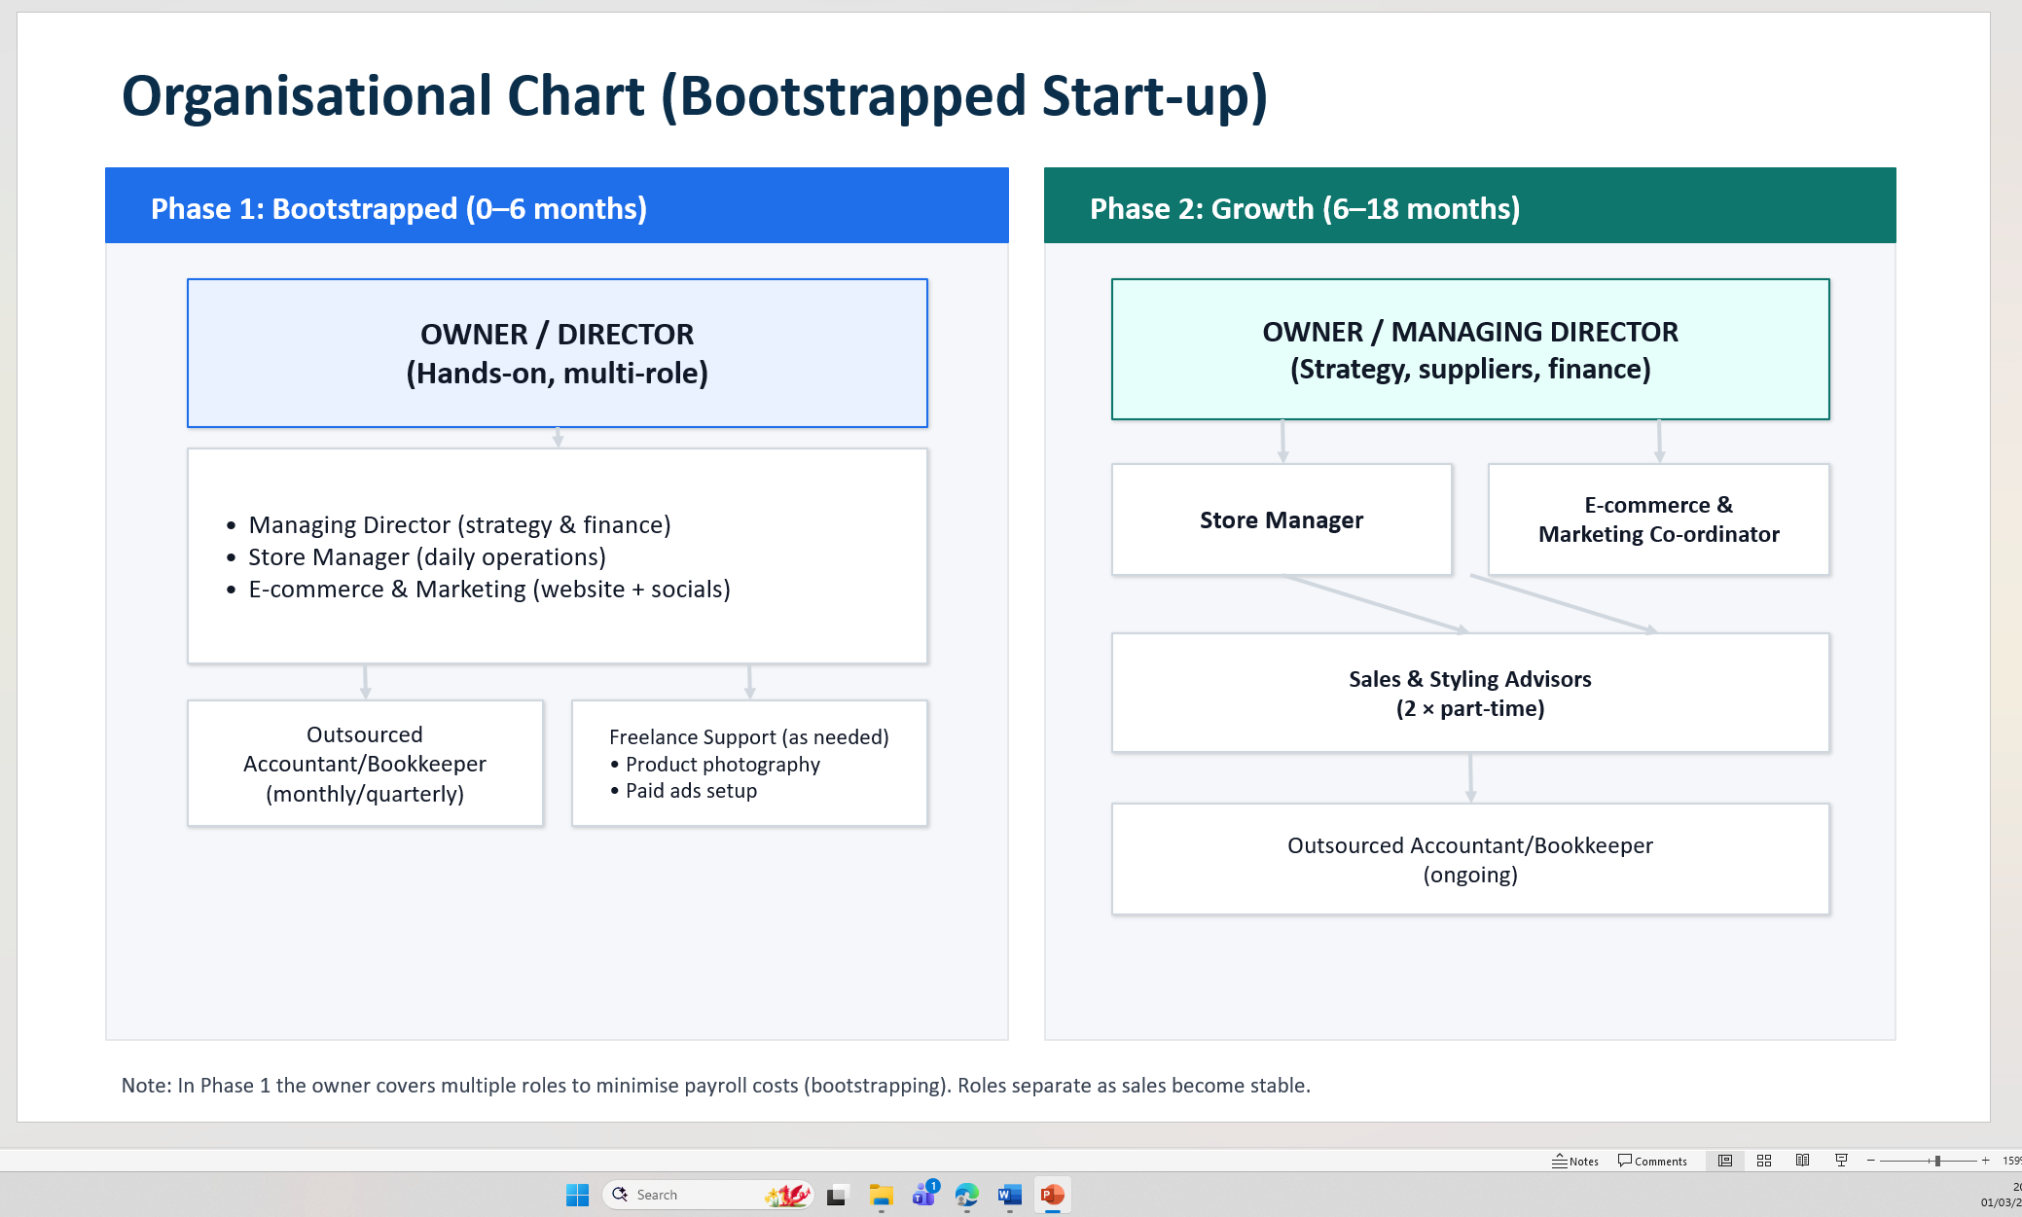

Start-up funding requirements and sources
Indicative costs (range):
- Deposit + initial rent: £4,500–£9,000
- Fit-out, signage, lighting, security: £6,000–£12,000
- Initial inventory: £15,000–£30,000
- Website + photography: £1,500–£4,000
- EPOS, packaging, consumables: £1,000–£2,500
- Launch marketing + working capital buffer: £6,000–£13,000
Estimated total: £30,000–£70,000, depending on unit size and inventory depth (Johnson et al., 2017; Mintel, 2025).

Funding sources
The business will be funded through a mixture of personal savings and external finance, as the estimated start-up costs are likely to fall between £30,000 and £70,000. This includes approximately £4,500-£9,000 for deposit and initial rent, £6,000-£12,000 for shop fit-out, signage and security, £15,000-£30,000 for opening stock, £1,500-£4,000 for the website and photography, £1,000-£2,500 for EPOS, packaging and supplies, and around £6,000-£13,000 for launch marketing and working capital. My own savings would be the most practical starting point, as this avoids immediate repayment pressure and allows me to keep full control of the business. However, because the total set-up cost is significant, additional funding such as a Start Up Loan may also be needed to cover early expenses and support cash flow in the first year. Family investment could also be considered, provided that it is formally agreed and recorded. Once the business becomes established, supplier credit may help further by allowing stock to be purchased on agreed payment terms instead of being paid for upfront. Overall, using a combination of funding sources would help the business cover its initial costs while maintaining enough working capital to trade effectively

Supplementary data to keep on file
Supplier declarations, invoices and batch information; any available test/certification evidence relevant to compliance; staff training notes on refunds/complaints; trade mark certificate (if registered); and website copyright statements for brand assets (Trading Standards, 2024; OPSS, 2019)

Cash Flow

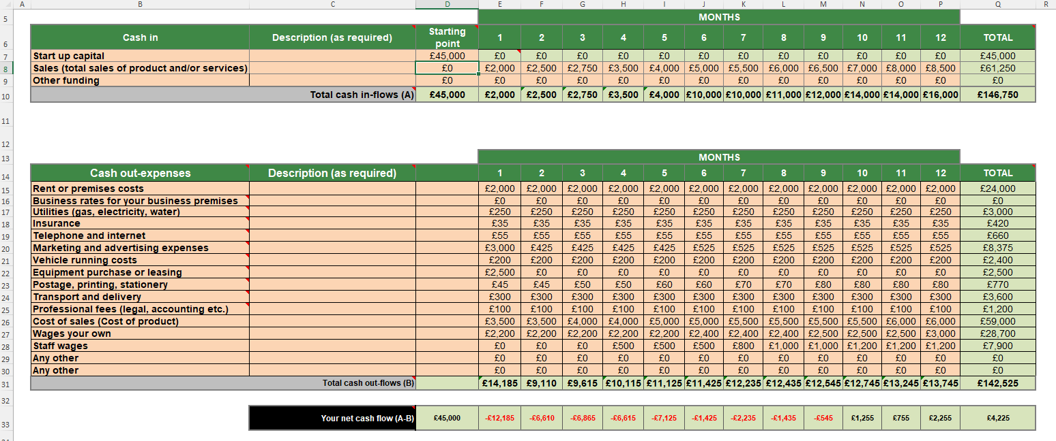

References
Birmingham City Council (n.d.) Alum Rock Ward factsheet. Available at: https://www.birmingham.gov.uk/download/downloads/id/15450/alum_rock_factsheet.pdf (Accessed: 15 February 2026).
BIS (2013) Consumer Contracts (Information, Cancellation and Additional Charges) Regulations: Guidance. Available at: https://assets.publishing.service.gov.uk/media/5a817b92ed915d74e33fe73a/bis-13-1368-consumer-contracts-information-cancellation-and-additional-payments-regulations-guidance.pdf London: Department for Business, Innovation & Skills (Accessed: 15 February 2026).
British Business Bank (2026) Business guidance on Start Up Loans. Available at: https://www.british-business-bank.co.uk/ (Accessed: 15 February 2026).
Chaffey, D. and Ellis-Chadwick, F. (2022). Digital Marketing: strategy, implementation and practice. 8th ed. Harlow: Pearson Education Limited
Chohans Fashion (n.d.) Website and store information. Available at: https://chohansfashion.com/ (Accessed: 15 February 2026).
GM Insights (2025) Imitation Jewelry Market Size & Outlook 2025–2034. Available at: https://www.gminsights.com/industry-analysis/imitation-jewelry-market (Accessed: 15 February 2026).
GOV.UK (n.d.) Set up a private limited company; trade mark registration; VAT on imports; sole trader/partnership guidance; social enterprise guidance. Available at: https://www.gov.uk/limited-company-formation (Accessed: 15 February 2026).
HSE (2023) Employers’ liability compulsory insurance (HSE40). Available at: https://www.hse.gov.uk/pubns/hse40.htm (Accessed: 15 February 2026).
ICAEW (n.d.) PESTEL – what is it and how to apply it. Available at: https://www.icaew.com/technical/business/strategy-risk-and-innovation/strategy/pestel (Accessed: 15 February 2026).
ICO (n.d.) How to write a privacy notice and what goes in it. Available at: https://ico.org.uk/for-organisations/advice-for-small-organisations/privacy-notices-and-cookies/how-to-write-a-privacy-notice-and-what-goes-in-it/ (Accessed: 15 February 2026).
Johnson, G., Whittington, R., Scholes, K., Angwin, D. and Regnér, P. (2017) Exploring Strategy. 11th edn. Harlow: Pearson.
Kotler, P. and Armstrong, G. (2021) Principles of Marketing. 18th edn. Harlow: Pearson.
Mintel (2025) UK Jewellery & Watches Retailing Market Report. London: Mintel.
ONS (2013) E-commerce QMI. Office for National Statistics. Last revised 31 October 2013. Available at: https://www.ons.gov.uk/businessindustryandtrade/itandinternetindustry/methodologies/ecommerceqmi (Accessed: 15 February 2026).
OPSS (2019) Product safety advice for businesses. Available at: https://www.gov.uk/guidance/product-safety-advice-for-businesses (Accessed: 15 February 2026).
Porter, M.E. (1980) Competitive Strategy: Techniques for Analysing Industries and Competitors. New York: Free Press.
Trading Standards (Business Companion) (2024) Jewellery safety: metal content. Last reviewed/updated April 2024. Available at: https://www.businesscompanion.info/en/quick-guides/product-safety/jewellery-safety-metal-content (Accessed: 15 February 2026).
bfa (2024) What is franchising? Available at: https://www.thebfa.org/what-is-franchising/ (Accessed: 15 February 2026).

