There are several ways in which the terms place and space have been defined and studied. Although the two words interact in a dynamic relationship and tend to be used interchangeably, they each represent separate concepts. Referring to key thinkers; Eric O. Jacobsen, Yi Fu Tuan, Doreen Massey, Michel De Certeau and Brian O’ Doherty, this essay will delve into various theories of space and place, exploring how the two terms interact with each other. Discussion will focus on how space, place and environment have been utilised throughout multiple Art disciplines, such as, Installation, Photographic and Conceptual Art. Discourse will begin with an Investigation into the ways in which contemporary artists such as Pipilotti Rist, Sophie Calle, Marcel Duchamp and William Anastasi have amalgamated or challenged notions of space, place and their environment within their Art practice. Evaluating how these artists have created innovative, engaging environments that blur perceptual boundaries, and confronted conventional ideas of what we understand a space or place to be.

Eric O. Jacobsen, when discussing realms of space and place, Describes place as a “context-specific, meaning-rich concept”. In other words, place is a context that occupies personal experiences, associations and memories of the things within it. (Jacobsen, 2012) An example of this is your childhood home. It could never be entered without acknowledging your familiarity with it. Equally, when using place as a verb “to place”, the same applies. By placing something in a space we create an association or relationship between that object and its surroundings (Jen Jack Gieseking, 2014). Space, however, is an intangible concept, a physical location or blank slate, devoid of personal experience. (Johnson, 2019) For example, a new house, consisting of the same bricks and interior, is purely a “space” we inhabit. Attaching experiences and memories to it, until It becomes our home, a “place” we value. We place our personal belongings into the house and become emotionally attached to the space, placing sentimental importance on it (Jen Jack Gieseking, 2014). While places are perpetually constructing and moulding our characteristics, spaces permit us to assess the identities which have been produced. “as a person lives life, one’s narrative begins to etch meaning on a particular space, causing it to become a place” (Jacobsen, 2012). Space is therefore something abstract, without any considerable meaning. While, a place is a space that has a meaning.

Like Jacobsen, Yi Fu Tuan explains how the distinctions between space and place can be described in the degree to which people give meaning to a particular area. (Tuan, 1977) Tuan considers how Significance can be derived or given to an area in two different ways; the first being in a direct and intimate way, through senses such as smell, hearing and vision. And the second; in an indirect and conceptual way mediated by symbols and the arts (Tuan, 1977, pp. 6-7). He describes space as a site which has no social connections to an individual. No value has been added to this space (Tuan, 1977, pp. 164-165). According to Tuan, it does not invite or encourage people to fill the space by being creative. No meaning has been described to it. (Tuan, 1977, p. 6)
Pipilotti Rist explores the relationship between place and space with her energetic, extensive installations. Her consumption of space combines the spiritual and the physical. Rists abundant visual conversation of psychedelic, sensual experiences juxtapose the bizarre with the familiar. The artist completely changes the spectators experience of a once mundane space, by creating an entirely new atmosphere through what she places within it. Rist transforms spaces using a variation of visual elements, such as; lighting, moving image, sound, sculpture and furniture. Each component is strategically placed to create a unique sensory experience. (The Solomon R. Guggenheim Foundation, 2019) She utilises every aspect of the space, creating an embodiment of her subject matter through her environment, rather than merely using it as an area of display. By doing so, Rist attempts to break down the barriers between public and private space. Her artworks, concepts and personality become inimitably entwined within the space. Transforming it into an invented or artificial place for the public to enter and submerge themselves (Hauser & Wirth, 2019). Pixel Forest (Fig 1), is created using 3,000 LEDs hung on threads, resembling a movie screen that has shattered into the space. Ultimately, Rist is Inviting viewers to take an immersive stroll through a 3-dimensional video (Lütgenau, 2016).

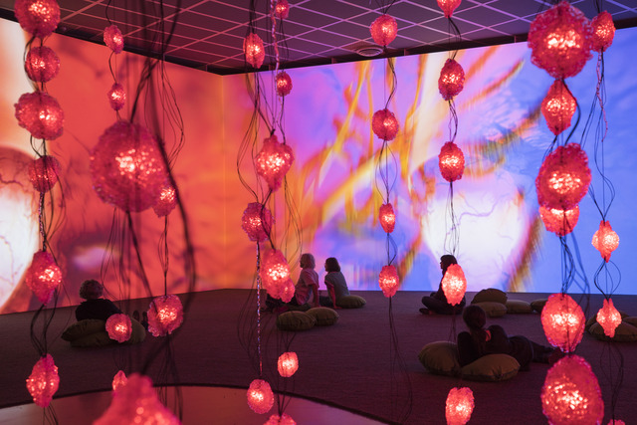

Figure 1: Pipilotti Rist, Pixel Forest (2016) Installation view: “Pipilotti Rist: Dein Speichel ist mein Taucheranzug im Ozean des Schmerzes” [Your Saliva is my Diving Suit in the Ocean of Pain]
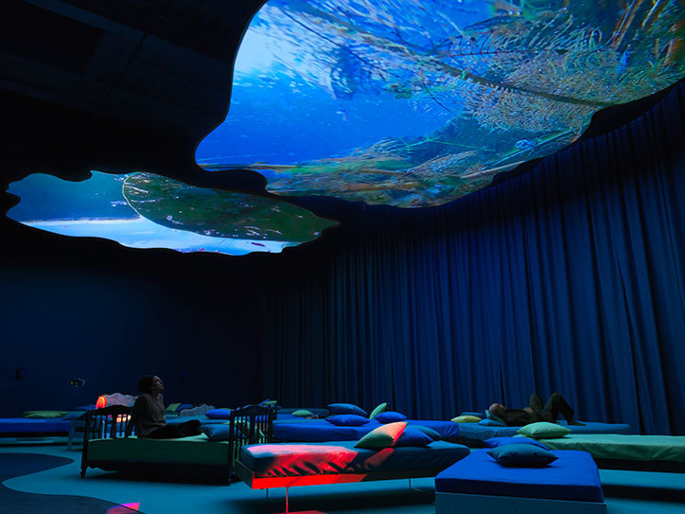

Figure 2: Pipilotti Rist, 4th Floor to Mildness from the Mildness Family, 2016, installation view, Pipilotti Rist: Pixel Forest, New Museum, New York.

The materials placed within the space forge a relationship with each other and the spectator. Referring to (Fig 2), beds are placed around the space to consume the walkway, while the video projection placed on the ceiling informs the audience of how to view the moving image. The placement of each object dictates how we experience this environment and all the other objects within it (Hauser & Wirth, 2019). By introducing the bed- a private object, into the space, the audience develops a connection to it through the association with their own homes. Therefore, composition and the act of “placing” objects, become a key concept (The Solomon R. Guggenheim Foundation, 2019). “Place exists of ‘space’ that is filled with meanings and objectives by human experiences” (Taun, 1977, p. 4).

Doreen Massey in for space, similarly, challenges us to reconsider many of our assumptions about space, including the belief that it is merely something we pass through. Massey “believes that an analysis of spatial relations between, for example, people, cities, jobs, is key to an understanding of politics and power” (Warburton, 2015). She see’s space not as an empty stage, but infused with all kinds of myriad stories, memories and events. Investigating the idea that space is not something stagnant and neutral, a static entity, but is something interwoven with time, thus ever changing (Massey, 2005). These ideologies are studied throughout many Art disciplines, not just installation. Michel De Certeau defines Art as a "way of making", by which he means a way of imagining that is transmitted into a process of acting; one which manipulates methods of consumption (Certeau, 2011).
Sophie Calle makes use of several methods presented in De Certeau’s notions of 'making do'. Her Art renovates our experience of urban spaces, in the operation of ordinary routines, the privileging of time over space, and the reclaim of memory through the agencies that make possible mundane routines (Certeau, 2011). Instead of attempting to disturb the structures that control urban Spaces and paradigms, Calles emphasis on the daily practices of living, highlight the power of "making do" in her environment.

Place and space play a central role in the daily struggles between the bureaucratic powers that dominate society and those who exist within its formations. While the management of conduct is reliant upon the allocation of leisure and work within specific designated spaces, such as a home or an office. Transverse tactics do not obey these laws as they are not defined or characterised by it. These approaches can challenge the dominant arrangement of spatial relationships: "they attempt to reduce temporal relations to spatial ones through the analytical attribution of a proper place to each particular element and through the combinatory organization of the movements specific to units or groups of units." (Certeau, 2011). Therefore, particular methods of operating within a space become the weapon for diverting, using and manipulating spaces. Certeau uses the comparison of a North African living in Paris who integrates into the structure enforced upon him, by the constraints of low-income housing and the French language by constructing a way of living that is recognisable to that of his native home. He "creates for himself a space in which he can find ways of using the constraining order of the place or of the language...By an art of being in between, he draws unexpected results from his situation" (Certeau, 2011, p. 30).

This tactic is utilised in Calle’s, phone booth from Gotham Handbook (Fig 3), produced in collaboration with Paul Auster. Auster urges Calle to turn her attention to spaces and objects that are overlooked, "the small barely noticeable things standing right in front of our eyes". (Sophie Calle, 2013) Calle's understanding of this instruction is to develop a mundane public space. Deciding upon a phone booth situated at the corner of Greenwich and Harrison streets, Calle adopts the public space designed for communal use and makes it personal.

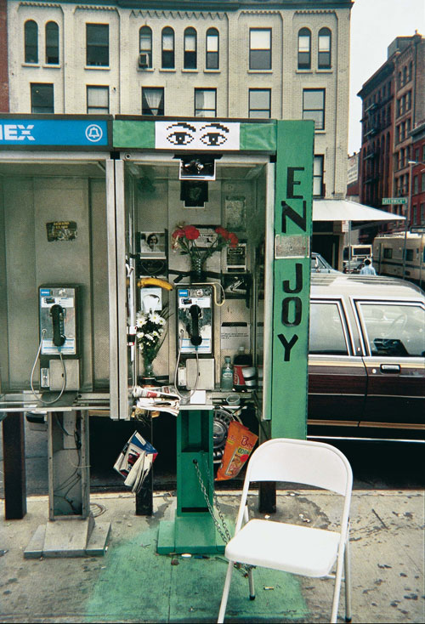

Figure 3: Sophie Calle. Detail, Gotham handbook, 1994/2000. Collage with gelatin silver print, text, cibachrome print on plexiglas frame. Courtesy Galerie Emmanuel Perrotin, Paris & Miami.

Calle decorates the booth with green paper, pictures and bouquets of flowers, filling the space with writing pads, pencils, an ashtray, a folding chair and an issue of glamour magazine. By filling the space with things found in the home she occupies the same approach as the north African in his Parisian apartment. In adopting an object of public amenity that belongs to no-one and everyone, Calle is exposing the systems of framing that exist in daily experiences, which appoint specific spaces for certain tasks, to be used by specific people. Through the method of manipulation and occupation, Calle repossesses these spaces, not by threatening them but in making them noticeable and in interposing the “individual” into spaces assigned for the “multiple” anonymous public (Sophie Calle, 2013). Imposing the question of how the phonebooth should be perceived. Is it now a space or a place? Does her exploitation of the space change its value and meaning from that of an insignificant functional space to a distinguished place? This confronts the predetermined definitions of space and place and establishes a level of innovation in the contrived normative order.
“individuals derive or give meaning to the earths geography and use this to shape and organise the world around themselves” (Paul Cloke, 1991). It is our perception of the world that influences our comprehension of what “place” is. The failure to cultivate space as a place, has risen exponentially with the increase of information and the accessibility of quicker transportation. Jacobsen postulates that our culture suffers from the increase of “placelessness”. There is a disengagement from the idea of place, as it is now harder to identify ourselves by our places. This ensues a struggle to extricate space from place. We require a healthy quantity of the remoteness and privacy space offers. Without space, we may become devoured by our places. However, without place, we are perceptible to feeling a disillusion that emanates from a disproportionate extent of space. (Jacobsen, 2012)

In addition to altering the experience of a space by transforming its framework, certain spaces can impact the perception of the objects placed within it. It has been the virtuosity of our era to examine things in relation to their environment, to come to see the context as seminal on the thing. To see the environment as a thing itself. There are several discourses implanted in the curation of different spaces. Brian O'Doherty reconnoitres what the exceedingly controlled environment of the contemporary gallery does to the Art object, what it does to the viewing subject, and, how the context consumes the object, becoming it. The most apparent and key concern when exhibiting is the notion of dirty space. This space is not truly dirty, but it is loaded with pre-formed thoughts on how it should be, and what should be in it (O'Doherty, 2000). O’Doherty delves into the significance of the gallery space throughout the history of modernism, foreseeing the white cube as a paradigm for 20th-century art. "The outside world must not come in, so windows are usually sealed off. Walls are painted white. The ceiling becomes the source of light… The art is free, as the saying used to go, to take on its own life”. (O'Doherty, 2000, p. 15) Similar to that of a holy space, the artworks, like religious verities, are to appear unaffected by time and its vagaries. The white cube removes the artwork from any historic or visual context. O'Doherty describes the modern gallery space as "constructed along laws as rigorous as those for building a medieval church." (O'Doherty, 2000, p. 15). As the artwork becomes revered due to this environment, it’s the environment that enhances the work in late modernism. “Art exists in a kind of eternity of display” (O'Doherty, 2000, p. 15). “This eternity gives the gallery a limbolike status; one has to have died already to be there." (O'Doherty, 2000, p. 15)

“Designed to accommodate the prejudices and enhance the self-image of the upper middle classes” (O'Doherty, 2000, p. 76) the white cube appears as a consequence of a commercial, capitalist approach to art. It is the gallery space that enhances some of the most profound artistic actions in the 1970s (O'Doherty, 2000). O’Doherty analyses Marcel Duchamp’s notorious works, noting that Duchamp was the first to make the gallery space the primary material to be altered by art. (O'Doherty, 2000) With Duchamp’s Fountain (Fig 4), the context and critical thought is needed to see the exhibition space as something other than neutral. By exploiting a mundane urinal, an object designed for function, Duchamp, like Calle, utilises “the everyday”. However, rather than introducing objects into a space to modify how we value that space, Duchamp takes an object out of its original environment and places it within an entirely new formal context. Changing how we value the object. The urinal is modified by its new environment but also fundamentally impacts how we view the gallery space (Kaye, 2000).

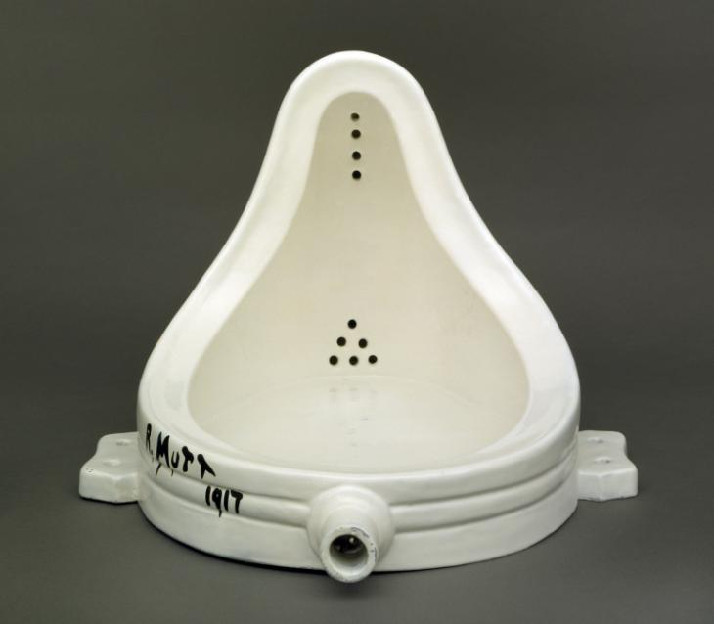

Figure 4: Marcel Duchamp, Fountain 1917, replica 1964, Succession Marcel Duchamp/ADAGP, Paris and DACS, London 2019

William Anastasi’s 1967 exhibition Six Sites (Fig 5), also challenges predetermined concepts of space, place and the gallery environment. Anastasi notably photographed the walls of the New York Dwan Gallery and presented his images on the same walls, defying the conventional purpose of a photograph (Artnet Worldwide, 2019). Photographs are a way of documenting and capturing moments within multiple spaces and places. They allow an individual to transport that place into an entirely new space, becoming a visual record or story. Anastasi, however, presents what you are already observing, the spatial narrative you are already stood within. He introduces no new place or story. Instead, the Spectator discovers the aesthetic beauty of the bare white walls that surround them, noticing nuances they once disregarded. The space alters how we value the photographs and the photographs alter how we value the space.
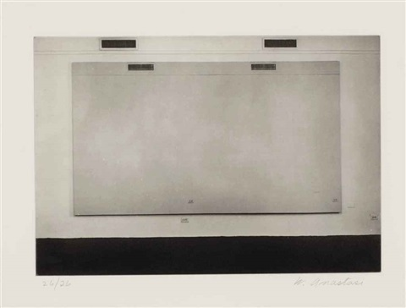

Figure 5: William Anastasi (American, born 1933), Untitled (Six sites), 1966, Photography, 21.1 x 30.8 cm. (8.3 x 12.1 in.), Dwan Gallery, New York

a place does not exist of measurable constraints and is alongside an apparent manifestation of a specific time period. Monuments, architecture and arts is a good example of this. (Tuan, 1977)

Relph seeks to maintain the connection between space and place and not present them as separated concepts. This is due to the connotation of place being that it has the power to requisition and to focus human experiences, actions and intentions spatially (Sowers, 2008, pp. 43-51). "So space and place are dialectically structured in human environmental experience, since our understanding of space is related to the places we inhabit, which in turn derive meaning from their spatial context" (Relph, 2008)

Works Cited

Artnet Worldwide, 2019. william-anastasi. [Online]
Available at: http://www.artnet.com/artists/william-anastasi/
[Accessed 20 10 2019].

Certeau, M. D., 2011. The Practice of Everyday Life. 3rd Edition ed. s.l.:University of California Press.

Hauser & Wirth, 2019. Exhibitions: Pipilotti-Rist. [Online]
Available at: https://www.hauserwirth.com/hauser-wirth-exhibitions/3175-pipilotti-rist-2
[Accessed 20 11 2019].

Jacobsen, E. O., 2012. Space Between: A Christian Engagement with the Built Environment (Cultural Exegesis). s.l.:Baker Academic.

Jen Jack Gieseking, W. M. C. K. S. L. &. S. S., 2014. The people, place, and space reader. [Online]
Available at: https://peopleplacespace.org/toc/section-2/
[Accessed 11 10 2019].

Johnson, H. F., 2019. Space-constructing-intangible. [Online]
Available at: https://museum.cornell.edu/exhibitions/space-constructing-intangible
[Accessed 02 11 2019].

Kaye, N., 2000. In: 1st, ed. Site-Specific Art: Performance, Place and Documentation. s.l.:Routledge, p. 184.

Lütgenau, P., 2016. pipilotti-rist-pixel-forest. [Online]
Available at: https://www.artrabbit.com/events/pipilotti-rist-pixel-forest
[Accessed 05 10 2019].

Massey, D., 2005. For Space. s.l.:SAGE Publications Ltd; 1 edition.

O'Doherty, B., 2000. Inside the White Cube: The Ideology of the Gallery Space, Expanded Edition. Expanded Edition ed. s.l.:University of California Press.

Paul Cloke, C. P. a. D. S., 1991. Approaching Human Geography: An Introduction To Contemporary Theoretical Debates. 1st ed. s.l.:SAGE Publications Ltd.

Relph, E., 2008. Place and PLacelessnes. s.l.:Pion.

Sophie Calle, P. A., 2013. Sophie Calle: Double Game. 1st edition ed. s.l.:Violette Editions.

Sowers, D. S. a. J., 2008. Place and Placelessness, Edward Relph. In: R. K. G. V. Phil Hubbard, ed. Key Texts in Human Geography. London: SAGE, pp. 43-51.

Taun, Y. F., 1977. In: Space And Place: The Perspective of Experience. Minneapolis: University Of Minnesota Press, p. 4.

The Solomon R. Guggenheim Foundation, 2019. Pipilotti Rist - Sip my ocean. [Online]
Available at: https://www.guggenheim.org/artwork/5208
[Accessed 21 11 2019].

Tuan, Y. F., 1977. In: Space And Place: The Perspective of Experience. Minneapolis: University Of Minnesota Press, pp. 164-165.

Tuan, Y. F., 1977. In: Space And Place: The Perspective of Experience. Minneapolis: University of Minnesota Press, p. 6.

Tuan, Y. F., 1977. Space and Place: The Perspective of Experience. Minneapolis: University of Minnesota Press.

Bibliography

Bachelard, Gaston. 1994. The Poetics of Space. Boston, MA: Beacon Press.

Cooper Marcus, Clare. 1992. “Environmental Memories.” In Place Attachment, edited by Irwin Altman and Setha M. Low, pp. 87–112. New York: Springer.

Ferguson, S. C. a. R., 2000. Uta Barth in Between Places. s.l.:Henry Art Gallery,U.S.

Garage publishing program in collaboration with Ad Marginem press, 2019. Inside the White Cube: The Ideology of the Gallery Space. [Online]
Available at: https://garagemca.org/en/publishing/brian-o-doherty-inside-the-white-cube-the-ideology-of-the-gallery-space
[Accessed 12 11 2019].

Gioni, M., 2016. Pipilotti Rist: Pixel Forest. s.l.:Phaidon Press.

Heider, Fritz. 1967. On Perception, Event Structure, and Psychological Environment: Selected Papers. Madison, CT: International Universities Press.

Interartive, 2016. The-art-of-tactics-sophie-calle. [Online]
Available at: https://cultureurbanspace.interartive.org/the-art-of-tactics-sophie-calle
[Accessed 21 10 2019].

Janet Hand, Sophie Calles Art of Following and Seduction, Cultural Geographies 12 (Sage Publications, 2005), 470

Kitchin, P. h. a. R., 2010. Key Thinkers on Space and Place. 2nd ed. s.l.:SAGE .

Kitty Zijlmans, T. C. B. H. C. v. E. &. H. W., 2010. Take Place: Photography and Place from Multiple Perspectives. s.l.:Valiz.

massey, D., 1994. Space, Place and Gender. s.l.:Polity.

Papastergiadis, "everything that surrounds," The Everyday, 70.

Society of Control, n.d. INSIDE THE WHITE CUBE. [Online]
Available at: http://www.societyofcontrol.com/whitecube/insidewc.htm
[Accessed 30 10 2019].

Sophie Calle, quoted in Bice Curiger "In Conversation with Sophie Calle," in Sophie Calle: The Reader (London: Whitechapel, 2009), 50.

Simin Davoudi, I. S., 2008. Conceptions of Space and Place in Strategic Spatial Planning (RTPI Library Series). s.l.:Routledge.

