Merleen Garvey: 2129226
BMSK 4001
WHAT IS THE MOST EFFECTIVE WAY TO MOTIVATE STAFF?
Lecture: Doreen


This Photo by Unknown Author is licensed under CC BY-SA
What is the most effective way to motivate staff?

INTRODUCTION
For any given organisation to work well productively a contributing factor that is key to succeed well in staff performance is how to effectively promote staff motivation. According to Chris Pearce (2007) is one of an extensive line of researchers who show and state the same parody of information and results. However, there is no clear-cut solution that whatever principal managers use it forms the guidelines as outlined in his article Ten Steps to staff motivation. By examining closely four of the ten ways in motivating staff effectively but also explaining the pitfalls that managers can so too often do.

INTERVIEW OR INDUCTION
A good manager in a professional setting who values his or her staff will be determined by the results in performance outcome. But to ensure its consistency knowing your staff will be detriment if overlooked. From interviewing and induction will form part of background knowledge of the employee through recruitment. The manager will then have an idea of what kind of person they are employing. But to ensure of its upkeep one to one, appraisal and feedbacks will form the relationship between ‘boss and worker.’ The manager would have an open-door policy, confidentiality, approachable, this is a sure sign of respect on both parties making employee feel that they are part of a team. Managers must put in the work to get the best from their employee showing interest of your co workers will prove how efficient and professional in getting to know its staff forming a picture of who they are their interest even in some unusual circumstances outside influences could impact in the working environment but if the manager is aware of such problems a need to know basis would be in their interest to accommodate them. Communication between manager and staff is a key element to motivation.

SKILL REQUIREMENT
Recognising staff’s abilities in any workplace formulates counter productivity thus recognising their capabilities in the workplace. Participants may be quick in picking up the work expected of them to the point they exceed, however those who are happy enjoying the role at a steady pace and not hungry for promotion by means of other benefits that keeps them happy. The offer of training schemes will promote a happy environment. Not all organisations would not get the best from their employee if recognising their potential or how bored or in few cases struggling to perform well due to either the role requires complex procedures or become repetitive. Identifying the potentiality of an individual’s ability earmarks that either the manager would see that provisional training materials or classroom teaching are available. Not only will it boost their confidence and the willingness to learn but increase productivity within the organisation, staff retention but importantly building up a good reputation no one wants to work in an environment where none of these things are on offer. It would be irresponsible of the manager if advertising for someone to work in their organisation listing no requirement of skills to match the criteria of the role.

APPRAISALS AND TRAINING
A continuous relationship between manager and staff is imperative for effective staff motivation. From the interview and or induction stage this will form a background of the employee. Regular reviews on their progression on a three-monthly basis for example shows you are prepared to invest in them It not only encourages them no matter how mundane the work may be but gain their respect. An action plan for instance with provisional training to boost confidence and self-esteem, one-to-one meeting with the manager reviewing staff of reaching their goals and achievements. An employee who is not reaching their potential does not necessarily mean they are lazy or lack interest may implicate reasons why the employee is not doing so well or display lack of interest. The manager if a good one would be able to have a formal chat to identify outlining the problems. Home life, divorce and health could be a contributing factor. Putting in place feedbacks with your staff discussing what is expected of them by setting objectives to potentially reach their goals with confidence successfully. Effective communication between manager and worker is too often ignored resulting in demotivation of staff absence or worse resignation in any given organisation.

BONUSES PROMOTION
“Most workers rate job satisfaction, getting on with colleagues and decent treatment by their managers ahead of receiving a bonus, says research” (“Bonuses not the best way to motivate staff - The Telegraph”)
According to The Telegraph (2013) article a report showed one plausible reason workers who are satisfied in their job, collaborating well with colleagues, and having a good manager simply outweighs receiving a bonus. It further suggests bonuses may not be a solution to motivating staff. However, according to Holton, V (2013) argues that money can also be a contributing factor in motivating staff. In detail employees may be content with incentives or a one-off payment. Recognition of staff continued performance in the working environment would not necessarily mean that the quality of work that productively meets the requirement but would only enhance it. Therefore, the manager would look to other areas of rewards as simply a promotion. In comparison should the working environment not meet the standards i.e., poor working conditions, unappreciated, devalued and overworked the demotivation of staff would be not overlooked by payment in the wage packet. Additionally, an employee who is allowed to participate in the running of the workplace, this will provide a balance of an alternative way for staff being beneficial to the business providing innovative ideas all too well show the willingness and deliverance of how appreciative a cooperative manager motivates staff (see graph below).

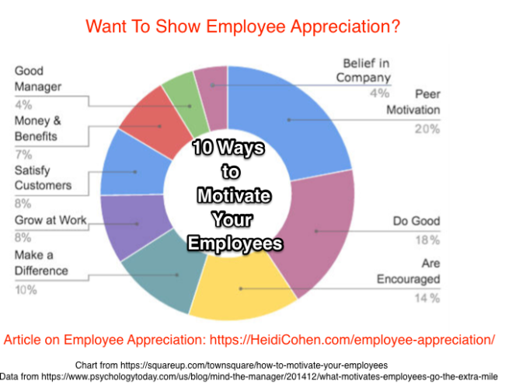
This Photo by Unknown Author is licensed under CC BY-SA-NC

CONCLUSION
The author further suggests that individual’s behaviour or act providing specific goals and tasks will only be partially set by the foundation it is targeting. But only will it be achievable if the participant is willing it also constitutes the fact that the participant will only do it for themselves and no other reason. Conclusively in effect a manger who collaboratively treats their staff well promoting good working conditions and benefits will in return have a productive working force that consequently shows effective motivation within any given organisation is strategically imperative for it to be successful.

Pearce, Chris (2007) Ten steps to staff motivation, nursing management vol 13 No 9 February 2007
Telegraph.co.uk (2013) ‘Bonuses not the best way to motivate staff’.
Tovey, A. (2013). Bonuses not the best way to motivate staff. Retrieved from http://www.telegraph.co.uk/finance/jobs/10392115/Bonuses-not-the-best-way tomotivate-staff.html
Holton, Viki. (April 4th, 2013) Employee Benefits; London
Article on Employee Appreciation: https://Hedi Choen.com/employee-appreciation?

