

A Report on
Innovative Service Plan for The Body Shop

Module Name: Developing Innovation and Creativity for Business Advantage
Module Code: BMSW6102
Student Name: Asen Chipilov
ID: 2128091
Lecturer: Dr. Iniobong Enang
Table of Contents
Introduction 3
Products and Services of The Body Shop 4
The Ways Innovation Have Influenced “The Body Shop” 7
Positive Influences of Innovation 7
Challenges and Negative Impacts of Innovation 7
Application of SCAMPER model 9
Recommendation 13
Conclusion 14
References 15

Introduction
This paper focuses on The Body Shop which is one of the most famous brands promoting ethical and sustainable beauty, and discusses how the company can follow the strategy of the SCAMPER model in the modern world. The Body Shop founded by Anita Roddick in 1976 upgraded a significant market position by using the principles such as using natural and high-quality ingredients, avoiding animal testing, and the promotion of environmental issues. It may, therefore, be concluded that the company features a highly ethical tone in its work; however, it has to deal with significant competition and new trends in the beauty market. Applying the concepts of the SCAMPER model, which includes Substitute, Combine, Adapt, Modify, Put to another use, Eliminate, and Reverse in this report, the possible ideas to initiate change at The Body Shop are the following. Concerning the future it discusses improving the sustainability, extending the ethical procurement, digitalisation, diversification of products, deepening the cooperation with the communities, and changing the marketing strategies. When following these suggestions, The Body Shop will be able to consolidate its market leadership, build on its values, and to drive the industry towards the responsible future to which it is committed.

Products and Services of The Body Shop
The Body Shop is a global beauty brand established in 1976 by Anita Roddick and specializes in skincare, cosmetics, and personal care products, and is famous for its ethical approaches of production.
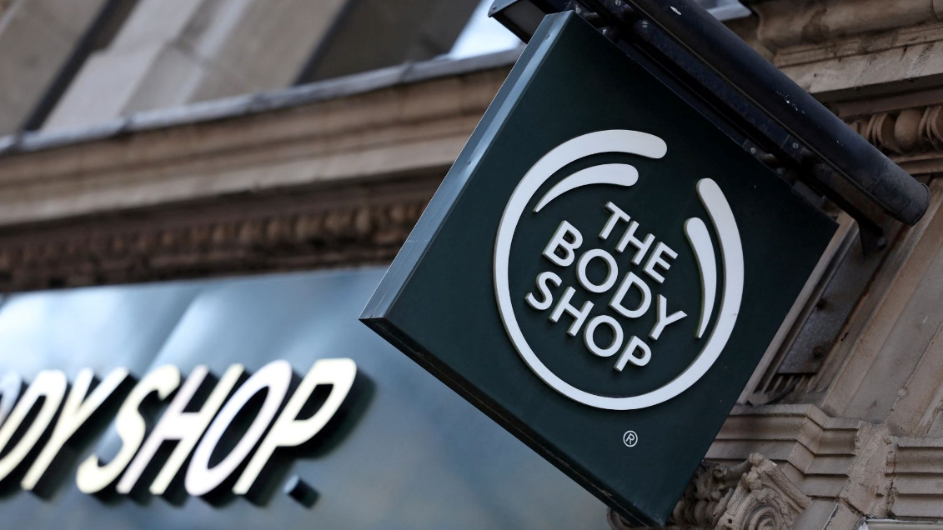
Figure-1: The Body Shop (GlobalData, 2023)
Its product range is diverse and includes cosmetics, skin care, jewelry, fragrances, gifts, toys, and greeting cards and catering service, all of which boast several principles that are core to the company’s values: focusing on quality natural ingredients, not testing on animals or using animal products, and conducting business in an environmentally sustainable manner.

Figure-2: Product range of The Body Shop (The Body Shop, 2024)

Skincare
The Body Shop has a body and skincare range for the face, and the products include cleansers, toners, moisturizers, serums, and masks that are developed to address specific skin problems. Some of the popular ‘routines’ include the ‘Tea Tree’ range for skin that is prone to pimples, whose active ingredients have the capacity to remove toxins while sooth the skin, and the ‘Vitamin E’ range which is ideal for dry sensitive skin as it replenishes the skin with oils that are rich in vitamin E thus acting as an antioxidant (Kotler, 2020). The luxury skincare “Drops of Youth” and “Oils of Life” target anti-ageing, helping to restore and renew skin using plant stem cell technology and skin-nutrient oils.
Body Care
Cosmetics are pivotal for The Body Shop that offers such product categories as body butters, scrubs, shower gels, and lotions. Of course, the famous “Body Butter” can also be found among the main offerings as a product with different fragrances and types that will make the skin soft and smooth. Some of these components include shea butter, coconut oil, and almond milk and as illustrated by the Gold Reservation campaign, Beasley’s is committed to the sustainable procuring of these ingredients.
Haircare
Another Subsection of products that The Body Shop also provides is hair care products such as shampoos, conditioners and treatments (McEachern, 2012). The “Banana” haircare line which is even used the real banana purees as ingredients for adding moisture or shine to the hair. Moreover, the “Ginger” series is considered to be created to eliminate problems such as dandruff and dryness since the hair is subjected to constant scratching.
Makeup
The makeup products that are available from The Body Shop are currently foundations, concealers, lipsticks, and eyeshadows and these among others are more that is cruelty free and most alternatives to be vegan. Another aspect of this brand’s message is the organic and sustaining nature of many ingredients used in products that improve appearance while also benefiting the skin.

Fragrance
The Body Shop’s fragrance line consists of eau de toilettes, body mists, and fragrances in easily recognizable and different scents. One product is a White Musk; the scent is a well-known line that offers facial minks that are not tested on animals; the scent is described as light and floral with hints of musk, elegant and fresh (Mintel, 2023). Other scents are also based on the concepts of nature, giving out the smell that could be of fruits, flowers, or the trees, and others of being rich and luxurious.

The Ways Innovation Have Influenced “The Body Shop”

Positive Influences of Innovation
Ethical Sourcing and Community Trade
While the author classified Ethical sourcing and community trade as one model of sources, it comprehensively covers four different models of sources. One of the more significant accomplishments implemented at The Body Shop is the Community Trade program, which started in 1987. It holds the responsibility of being among the pioneers of ethical sourcing through developing fair-trade relationships with suppliers based in the third world countries (Roddick, 2021). Most of its raw materials like shea butter from Ghana, tea tree oil from Kenya hence, not only qualifies their products with natural and socially responsible ingredients but also contributes towards the growth of Global economy. Thus, this innovative approach of procurement has positively impacted the establishment of the brand image and consumer loyalty in matters concerning the company ethics and sustainable procurement practices.
Cruelty-Free and Vegan Products
The Body Shop was among the pioneers in anti-animal testing in cosmetics as a major company of that industry. This was evident in the “Forever Against Animal Testing” campaign rolling out in 1989 and becoming part of its visual identity. This approach has been helpful in changing the outlooks of the particular market and thus resulted into the widening acceptance of no cruelty solutions (Porter, 2015). It also became the brand that positions itself as a vegan brand, which helped it to gain a larger customer base due to increased demand for cruelty-free and plant-based foods.

Challenges and Negative Impacts of Innovation
Balancing Innovation with Tradition
Innovatively, though innovative The Body Shop has largely gained on the overall top-line, it also has incurred certain problems. It is not uncommon to hear executives debate the need to maintain the successful products that they have been selling while at the same time, invest in new products that have the potential to become the next big sale (Kumar, 2019). Innovations have to fit the brand’s values, and they need to be achingly relevant to the customer base; that means often appealing to the base of dedicated users that can be quite resistant to change. For example, altering the composition of readily known products, embracing new ingredients, or even altering their packaging methods in the name of environmental conservation risks losing the old clients.
Competitive Market
The beauty industry is fairly saturated, and today’s competition reveals that many brands have followed suit in ethical and sustainable practices. This has made it difficult for The Body Shop to sustain its innovativeness, which it had for so long prided itself on (Natura, 2023). This means that one has to keep on innovating in order to be competitive, but this on the other hand calls for more resource investment in Research and development water.
Corbel Structure and Trade Mark
The recent management change owes to The Body Shop’s sale to L’Oréal in 2006 and to Natura &Co in 2017. While such acquisitions created prospects for development and diversification, they also troubled those desiring the brand to adhere to the same ethics of its inception. In order to maintain the core essence of the company, maintaining connection with the core values of the company has been the key success factor being; The Body Shop decided that hit innovative strategies had to conform to its initial values before the L’Oreal took over.

Application of SCAMPER model
The SCAMPER model is a creative thinking tool used to spark innovation and overcome challenges by exploring seven different dimensions: He identified the seven-management problem solving techniques as: Substitute, Combine, Adapt, Modify, Put to another use, Eliminate and Reverse. Using the heuristic tool of SCAMPER to analyse The Body Shop situation provides an excellent way to identify new ways of overcoming all the market threats and risks while staying loyal to the company’s core values of ethical and sustainable business.
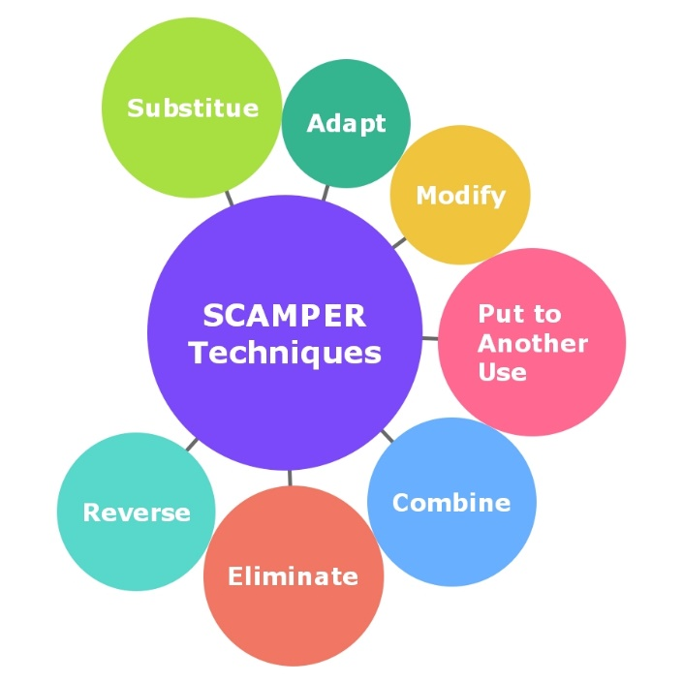
Figure-3: SCAMPER model (Smith, 2023)
Substitute
- Ingredients: Substituting synthetic ingredients with natural and locally-sourced alternatives. This can work towards improving the attractiveness of products by bringing a focus on the fact that the food chain is sustainable along with helping local economies. For instance, the use of extracts which are locally produced instead of using chemicals such as synthesized perfumes.
- Packaging: Replacing traditional plastic packaging with biodegradable or compostable materials (Peattie, 2010). This innovation would further meet the needs of the consumers by offering biodegradable packaging and also will help in cutting down on the effect on the environment.
- Retail Formats: Substituting physical store expansions with digital and virtual reality (VR) experiences: By implementation of e-commerce and offering the virtual store experience it is possible to make shopping appeal like physical stores without that negative impact.
Combine
- Product Lines: Combining skincare with wellness products (The Body Shop, 2024). Those with aromatherapy or wellness components like anti-aging creams that reap the bonus of lavender or night creams that have lavender and then serums with chamomile for stress can fit the bill clearly.
- Collaborations: Partnering with eco-friendly fashion brands: Collaborations with other sustainable fashion brands for designs that are produced in a limited edition or jointly produced items might expand the design’s audience among the consumers and strengthen the focus on sustainable values.
- Technologies: Integrating AI and machine learning with customer service: The integration of AI in customer service, especially in coming up with skincare prescription and consultations can benefit the customers and build loyalty with them.
Adapt
- Community Trade Program: Adapting the Community Trade program to include more urban farming initiatives (Mintel, 2023). This could perhaps entail procuring the materials from urban gardens, which would also mean supporting the local farming industry and cutting the length through which food has to travel to reach consumers.
- Sustainability Practices: Adopting a circular economy approach: One possible suggestion is to set up a take- back program for customers to return the packaging for recycling or for such other purposes that can help to make good company’s expressed environmental policies and the customer would definitely get something out of it.
- Marketing Strategies: Adapting marketing to emphasize inclusivity and diversity: Having numerous models and promoting the products that are designed for different skin types and colors may appeal to the diverse customer base that follows the trends of global diversity.
Modify
- Product Formulas: Modifying existing product formulas to enhance sustainability: In some cases, altering the composition of products to incorporate upcycled ingredients or to use less water attracts the green consumer whiles at the same time cutting costs (Kotler, 2020).
- Retail Experience: Redesigning stores to serve as community hubs: These changes will help to develop a proper relationship with the customer and to show that The Body Shop is ready to be the leader in the community.
- Loyalty Programs: Revamping the loyalty program to reward sustainable behaviors: It is possible to encourage customers through rewards and loyalty programs acting as refill stations or supporting various environmental programs.
Put to Another Use
- Excess Inventory: Utilising excess inventory for charitable initiatives (Natura, 2023). Often donating the goods that are left unsold to the shelters and other communities helps and leave a positive impact on the company as well as on the community.
- Stores as Recycling Centers: Transforming retail locations into recycling drop-off points: There are benefits of using repeated for customers and its beauty product containers to get them recycled at The Body Shop stores can contribute to increased traffic and increased brand commitment.
- Educational Platforms: Leveraging the brand’s platform to educate on sustainability: Presenting information about the environment and changes that every person can make on social networks or the company’s website may help to make The Body Shop a reference point for such a theme.
Eliminate
- Single-Use Packaging: Reducing the usage patterns of new raw material by shifting from single use of plastic product such as straws that can be replaced with refillable/reusable or biodegradable and compostable product packing can go a long way in lessening the effect on the environment.
- Harmful Ingredients: Eliminating parabens, sulfates and any other chemical that is in some way regarded as controversial will help attract the normally conscious health-conscious clientele and also reduces risks (McEachern, 2012).
- Redundant Processes: Increased efficiency in the use of the available supply chain resources as well as the integration of environmentally friendly logistics practices helps to decrease costs and their harm to the natural environment.

Reverse
- Reverse Traditional Advertising: Shift from traditional advertising to user-generated content: Making customers post what they use and their own opinions about products from The Body Shop can help in creating the customer-generated content which is more effective and interesting to the customers.
- Customer Feedback Mechanism: Flip the feedback process to be proactive rather than reactive: Consider customer feedback in the development of new products and corporate sustainability measures by using polls and focus groups to determine that innovations meet main client’s expectations.
- Product Life Cycle: Implement a cradle-to-cradle approach (Kotler, 2020). Taking as much care as possible to design a product to have its lifecycle included its end part where all the physical components can be recycled or reused then it will be possible to develop products that are environmentally friendly and could be embraced by customers with ecological conscience.

Recommendations
- Enhancing Sustainability: Using biodegradable and compostable packaging, increase numbers of refilling facilities and launch a returnable system to recycle the empty packet.
- Broadening Ethical Sourcing: Expanding the Community Trade program to cover urban farming undertaking to source its products and services from the local markets thus cutting down on the transportation pollution.
- Embracing Digital Transformation: Covid 19 has shown the growing trend in online shopping; thus, invest in e-commerce and virtual reality shopping experiences(Mintel, 2023).
- Innovating Product Lines: Creating skincare products with focus on the aspects of wellness and use natural and up-cycled materials in the formulation of the products.
- Strengthening Community Engagement: Transforming the stores into the centres of gravity for running workshops and sustainability talks to form better relationships with consumers.
- Revamping Marketing: Taking a note of the user-generated content and Diversity when it comes to models and the products provided for the clients’ skincare needs.
- Leading in Sustainability Education: Developing an extensive number of educational materials on sustainability to establish the company as a knowledge hub, The Body Shop.

Conclusion
Applying the suggested SCAMPER model, the Body Shop can diminish the impact of market threats and continue its ethical and sustainable development. Sustainability improvement, ethical materials’ enlargement, digital transition, novelty product development, and community influence are some of the ways that the firm can remain relevant. The above strategies will build on The Body Shop’s understanding of better-quality products, animal test-free products and environmentalism to make sure that it remains to be at the forefront of steering the cosmetic industry into change. Incorporating these progressive strategies will not only counter current concerns but also enhance the company’s future outcome that directly result at The Body Shop’s progress.

References
GlobalData. (2023). Ethical Consumerism in the Beauty Industry: Trends and Insights. GlobalData PLC.
Kotler, P., & Armstrong, G. (2020). Principles of Marketing. Pearson.
Kumar, V., & Rajan, B. (2019). Socially responsible innovations: Model and applications. Journal of Product Innovation Management, 29(6), 883-897.
McEachern, M. G., & Carrigan, M. (2012). Revisiting contemporary issues in green/ethical marketing: An introduction to the special issue. Journal of Marketing Management, 28(3-4), 189-194.
Mintel. (2023). Global Beauty and Personal Care Trends. Mintel Group Ltd.
Natura &Co. (2023). Annual Report. Retrieved from Natura &Co Investor Relations.
Peattie, K., & Belz, F. M. (2010). Sustainability marketing—An innovative conception of marketing. Marketing Review St. Gallen, 27(5), 8-15.
Porter, M. E. (2015). Competitive Advantage: Creating and Sustaining Superior Performance. Free Press.
Roddick, A. (2021). Business as Unusual: The Journey of Anita Roddick and The Body Shop. HarperCollins.
Smith, N. C. (2023). Corporate social responsibility: Whether or how?. California Management Review, 45(4), 52-76.
The Body Shop. (2024). Forever Against Animal Testing Campaign. Retrieved from The Body Shop Official Website.
The Body Shop. (2024). Sustainability Report. Retrieved from The Body Shop Official Website.

