Oxygen Balance – Level 4 Explainer
Table of Contents
Introduction 1
Calculating Oxygen Balance for Mixtures 2
The Kistiakowsky-Wilson Rules 3
Calculating the Volume of Gaseous Products Produced (V) 5
Calculating the Heat of Explosion (Q) 6
Calculating the Power Index and TNT Equivalence of an Explosive based on Q and V 7
Example Questions 9
TNT 9
RDX 10
Adding Aluminium 11

Figure 1: Oxygen Balance Curve for Primary and Secondary Explosives 3

Table 1: The Kistiakowsky-Wilson Rules 4
Table 2: The Modified Kistiakowsky-Wilson Rules 4
Table 3: Examples of Products of Detonation 4
Table 4: Examples of Volume of Gases from Detonation 5
Table 5: Examples of Heat of Explosion 6
Table 6: The Power Index of Certain Explosives (gauged against Picric Acid as Standard) 8

Equation 1: Typical formula for an explosive 2
Equation 2: Oxygen Balance Equation (CHNO Explosive) 2
Equation 3: Oxygen Balance for Mixtures of Ideal Explosive 3
Equation 4: Calculating Volume of Detonation Gases (dm³mol⁻¹) 5
Equation 5: Determining the heat of explosion using Hess' Law 6
Equation 6: Power Index 7
Equation 7:Equation for TNTe (based on Q and V) 8

Introduction

The performance of an ideal explosive (i.e. a homogeneous explosive where oxygen is bonded at the molecular level) can often be determined from its oxygen balance. It is a complex subject, but simple determination of explosive power or TNT equivalence can be calculated from knowing oxygen balance (Ω), heat of explosion (Q) and the volume of gaseous products of detonation produced (V). The simple equation for an ideal explosive decomposition (depending on oxygen balance) is shown in Equation 1:

$$C_{a}H_{b}N_{c}O_{d(s/l)}→aCO_{2(g)}+bH_{2}O_{(g)}+cN_{2(g)}……..$$

Equation 1: Typical formula for an explosive
In the above equation the CHNO denote carbon, hydrogen, nitrogen and oxygen atoms, and a, b, c, and d denote the number of those atoms in the explosive molecule. For example, TNT (C₇H₅N₃O₆) has 7 carbon atoms, 5 hydrogen atoms, 3 nitrogen atoms and 6 oxygen atoms in one molecule.

Oxygen balance (OB, OB%, or Ω) is an expression that is used to indicate the degree to which an explosive can be oxidized, to determine if an explosive molecule contains enough oxygen to fully oxidize the other atoms in the explosive. For example, fully oxidized carbon forms carbon dioxide, hydrogen forms water, sulphur forms sulphur dioxide, and metals form metal oxides. A molecule is said to have a positive oxygen balance if it contains more oxygen than is needed and a negative oxygen balance if it contains less oxygen than is needed.

An explosive with a negative oxygen balance will lead to incomplete combustion, which commonly produces carbon monoxide, which is a toxic gas. Explosives with negative or positive oxygen balance are commonly mixed with other energetic materials that are either oxygen positive or negative, respectively, to increase the explosive's power. For example, TNT is an oxygen negative explosive and is commonly mixed with oxygen positive energetic materials or fuels to increase its power. To determine the oxygen balance of an explosive in the form $C_{a}H_{b}N_{c}O_{d(s/l)}$, the following formula is used based on Equation 1 (see Equation 2).

$$Ω=\frac{\left(d-2a-\frac{b}{2}\right)}{MW}×15.99 ×100\%$$

Equation 2: Oxygen Balance Equation (CHNO Explosive)
Notes:

Equation 2 does not apply to heterogeneous explosives (containing additives such as Al, B, Mg, Zn etc) where the fuel and oxidiser a mixed separately.

a, b, c and d are the number of atoms of carbon, hydrogen, nitrogen and oxygen in the molecule.

MW is the molecular weight of the explosive (i.e. TNT molecular weight is 227g).

Calculating Oxygen Balance for Mixtures

Calculating oxygen balance for mixtures of ideal explosives such as RDX and TNT is no black art. You simply calculate the oxygen balance for each explosive and then multiply the values by the percentage composition. For example, Figure 1 shows the typical oxygen balance curve for some secondary explosives and their values. The representation has been described in lectures, with primary explosives following no fixed pattern.

Figure 1: Oxygen Balance Curve for Primary and Secondary Explosives

Therefore, if we were to calculate the oxygen balance for RDX/TNT 50/50, then we would follow Equation 3.

$$Ω_{mixture}=\sum{Ω_{RDX}\%_{RDX}+Ω_{TNT}\%_{TNT}}$$

Equation 3: Oxygen Balance for Mixtures of Ideal Explosive

$Ω_{mixture}=0.5 \left(-21.6\right)+0.5 \left(-73.9\right)=-47.8$%

Explainer: As we improve the oxygen balance (i.e. move towards zero), we are moving away from creating C(s) (enthalpy of formation value 0 kJ mol⁻¹), CO(g) (enthalpy value -110), and H₂O(g) (enthalpy of formation -241.8) towards CO₂(g) (enthalpy -393.5). As such, more and more energy is being produced as we tend towards zero oxygen balance (EGDN being the utopia). Once we have a surplus of oxygen (such as NG), energy values start to drop again as O₂(g), like N₂(g), has an enthalpy of formation value of 0.

The Kistiakowsky-Wilson Rules

Once we know the oxygen balance of an explosive (it will be positive, zero, or negative), we can then begin to consider what the products of detonation may be (working towards the explainer in the paragraph above). These are determined by the Kistiakowsky-Wilson (see Table 1) and modified Kistiakowsky-Wilson rules (see Table 2). Dependent upon the oxygen balance value, you MUST use the appropriate table. For oxygen balance values less negative than -40 (i.e. -30 etc), us the Kistiakowsky-Wilson rules. For oxygen balance values more negative than -40 (i.e. -45 etc), use the modified rules.

Table 1: The Kistiakowsky-Wilson Rules
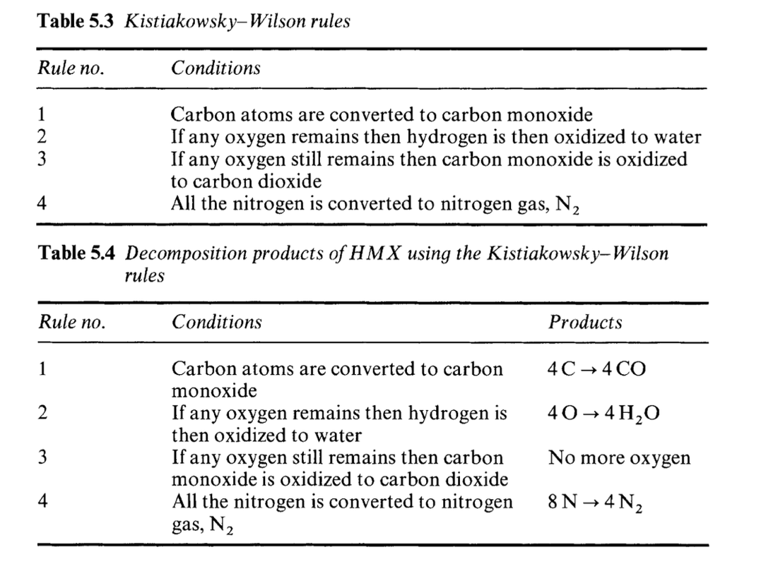

Table 2: The Modified Kistiakowsky-Wilson Rules
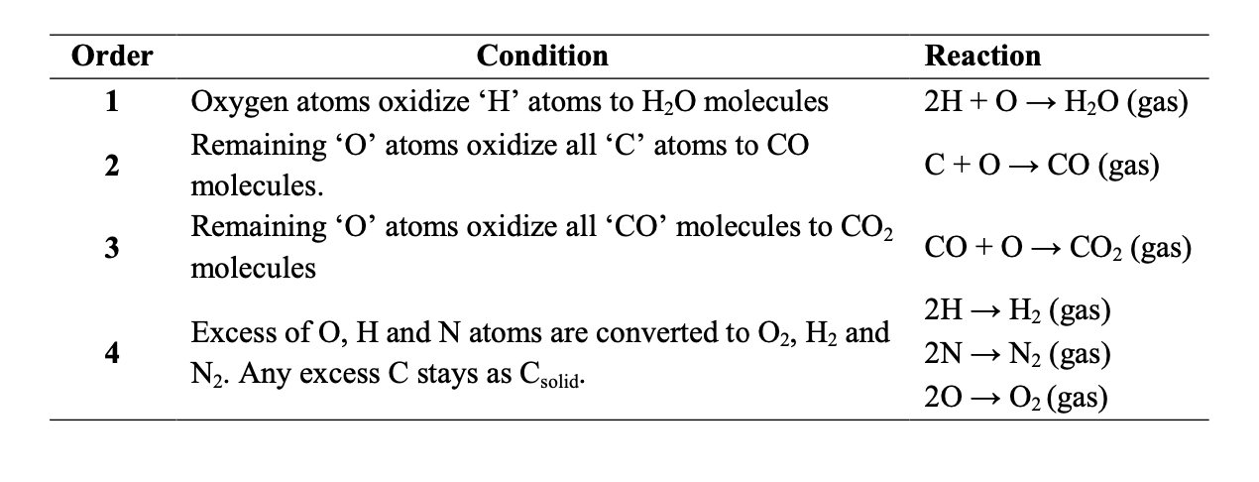
Examples of products of detonation can be seen in Table 3 (overleaf) using these rules:

Table 3: Examples of Products of Detonation
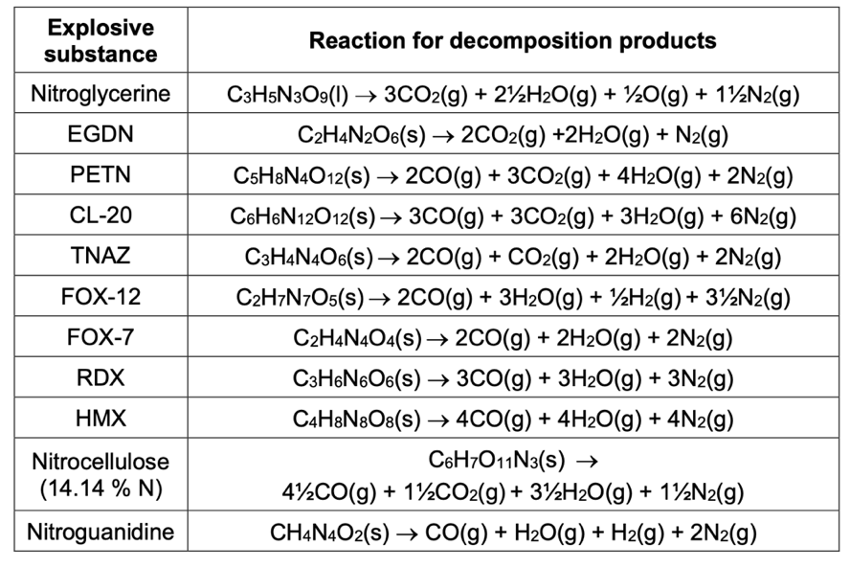

When we use these tables, the products of detonation can be determined, which allows us to calculate heat of explosion (Q, in kJ mol⁻¹ or kJ kg⁻¹) and volume of gases produced (V in dm³ mol⁻¹ or dm³ g⁻¹).

Calculating the Volume of Gaseous Products Produced (V)

V is simple to determine from the equation below (see Equation 3) and values for some explosives are shown in Table 4:

$V=\left(n{CO}_{2}+nH_{2}O+nCO+nN_{2}…..\right)×22.4$ (for dm³ mol⁻¹)

Equation 4: Calculating Volume of Detonation Gases (dm³mol⁻¹)

Table 4: Examples of Volume of Gases from Detonation
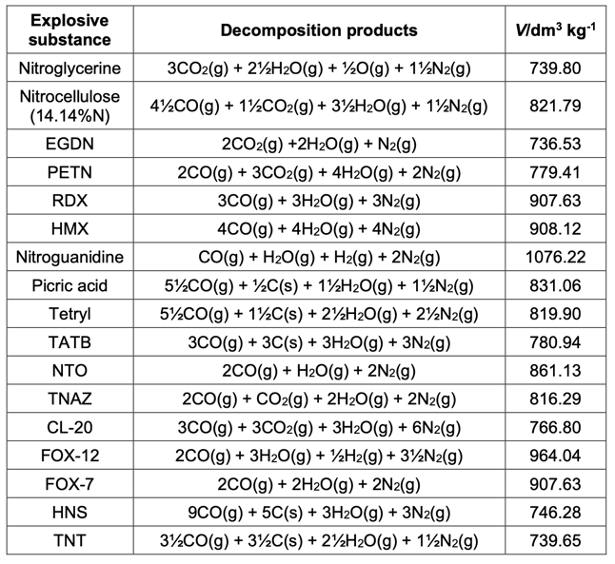

Calculating the Heat of Explosion (Q)

Hess’ Law is then used to calculate the heat of explosion (Q) (see Equation 4)

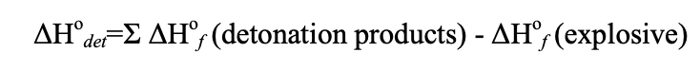
Equation 5: Determining the heat of explosion using Hess' Law

Examples of heat of explosion using Hess’ Law can be seen in Table 5:

Table 5: Examples of Heat of Explosion
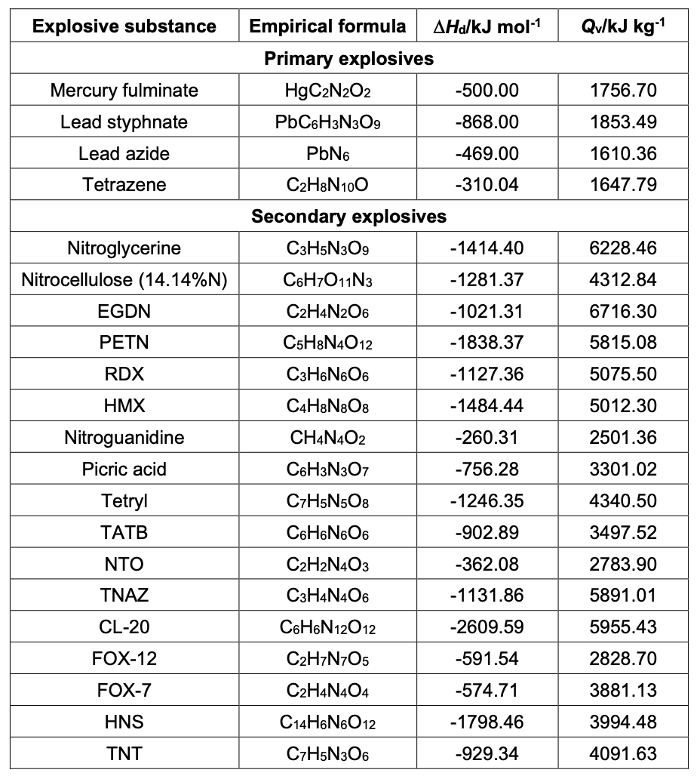

Calculating the Power Index and TNT Equivalence of an Explosive based on Q and V

Power Index (PI) of an explosive calculated using Equation 5.

Power Index = $\frac{Q_{e}V_{e}}{Q_{picric acid }Vpicric acid}×100\%$

Equation 6: Power Index
Where Q_{e} and V_{e} are the values calculated for the explosion under consideration.

The TNT equivalence (TNTe) of an explosive (based on the values of Q and V) can be determined using Equation 6

TNT Equivalence = $\frac{Q_{e}V_{e}}{Q_{tnt}V_{tnt}}$

Equation 7:Equation for TNTe (based on Q and V)

Table 6 shows the values of PI and TNTe for certain primary and secondary explosives.

Table 6: The Power Index of Certain Explosives (gauged against Picric Acid as Standard)
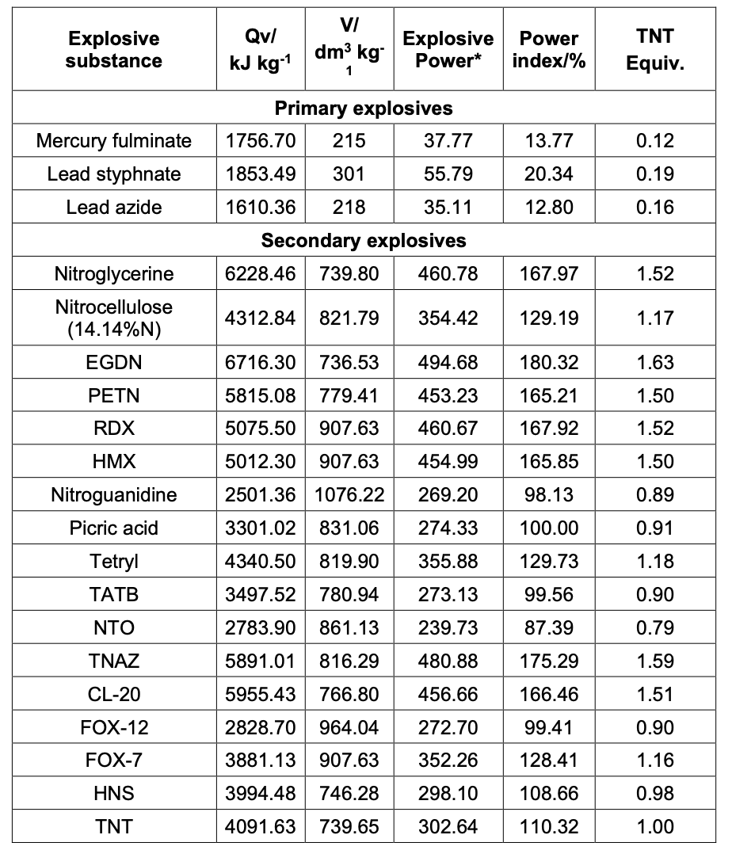

As this is a lot of theory, let’s just get on and do it!

Example Questions

What is the oxygen balance, likely products of detonation, heat of explosion, volume of gases and power index for:

- TNT – C₇H₅N₃O₆
- RDX – C₃H₆N₆O₆

Things we need to know up front:

- Use K-W rules when the oxygen balance is more positive than -40 (i.e. tending towards 0).
- Use the modified rules when the oxygen balance is more negative than -40 (tending towards -100 for example).

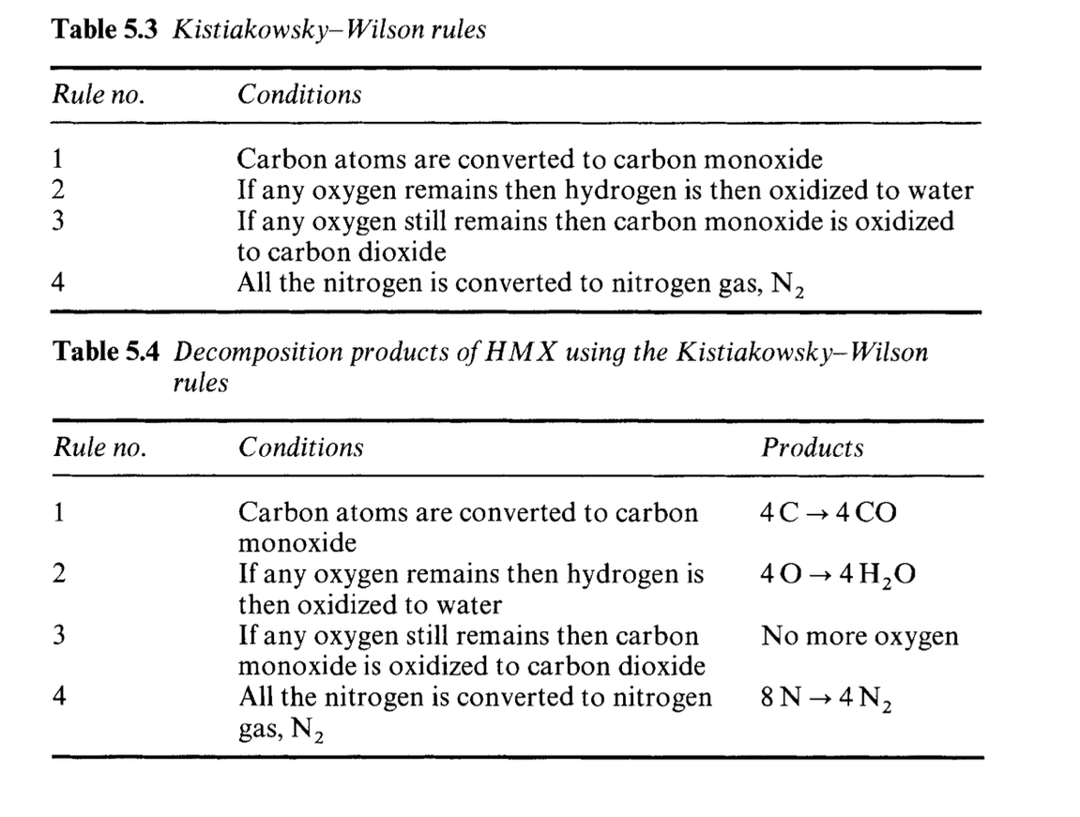

Compound | △H_{f} (kJ/mol)
TNT _{(s)} | -26.10
RDX _{(s)} | +62.00
C _{(s)} | 00.00
CO_{2 (g)} | -393.50
CO _{(g)} | -110.50
H₂O _{(g)} | -241.80
N_{2 (g)} | 00.00
O₂ _{(g)} | 00.00

TNT

$$Ω=\frac{d-2a-\frac{b}{2}}{MW}×1600$$

$$∴Ω=\frac{6-14-\frac{5}{2}}{227}×1600=-74\%$$

Therefore, this is more negative than -40 so we use the modified K-W rules:

$$C_{7}H_{5}N_{3}O_{6(s)}→{2.5 H}_{2}O_{(g)}{+ 3.5 CO}_{(g)}+{3.5 C}_{(s)}+{1.5 N}_{2(g)}$$

$$∴Q=\left[\left({∆H}_{f}Products\right)-\left({∆H}_{f}Reactants\right)\right]$$

$$∴Q=\left[\left({∆H}_{f}H_{2}O+{∆H}_{f}CO\right)-\left({∆H}_{f}TNT\right)\right]$$

$$∴Q=\left[\left(2.5×(-241.8)+3.5×(-110.5\right)-\left(-62.10\right)\right]$$

$$∴Q=\left[\left(-991.25\right)-\left(-26.10\right)\right]=-965.15{kJmol}^{-1}$$

$∴Q=\frac{{∆Hf}_{d}×1000}{MW}=\frac{\left(-965.15×1000\right)}{227}=-4091 {kJkg}^{-1}$ [literature value = -4091]

$$V=\left(n{CO}_{2}+nH_{2}O+nCO+nN_{2}…..\right)×22.4$$

$$∴V=\left(2.5 H_{2}O+3.5 CO+1.5 N_{2}…..\right)×22.4=168{dm}^{3}{mol}^{-1}=168×\frac{1000}{227}=740{dm}^{3}{kg}^{-1}$$

Therefore, Power Index = $\frac{QVexplosive}{QVpicric acid}×100\%=\frac{4091×740}{3301×831}=110\%$

TNT Equivalence $\frac{Q_{e}V_{e}}{Q_{tnt}V_{tnt}}=1$

RDX

$$Ω=\frac{d-2a-\frac{b}{2}}{MW}×1600$$

$$∴Ω=\frac{6-6-\frac{6}{2}}{222}×1600=-21.6\%$$

Therefore, this is less negative than -40 so we use the K-W rules:

$$C_{3}H_{6}N_{6}O_{6(s)}→{{3 CO}_{(g)}+3 H}_{2}O_{(g)}+{3 N}_{2(g)}$$

$$∴Q=\left[\left({∆H}_{f}Products\right)-\left({∆H}_{f}Reactants\right)\right]$$

$$∴Q=\left[\left({∆H}_{f}H_{2}O+{∆H}_{f}CO\right)-\left({∆H}_{f}RDX\right)\right]$$

$$∴Q=\left[\left(3×(-241.8)+3×(-110.5\right)-\left(+62\right)\right]$$

$$∴Q=\left[\left(-1056.9\right)-\left(62.0\right)\right]=-1118.9 {kJmol}^{-1}$$

$∴Q=\frac{{∆Hf}_{d}×1000}{MW}=\frac{\left(-1118.9×1000\right)}{222}=-5040 {kJkg}^{-1}$ [literature value = -5036]

$$∴V=907{dm}^{3}{kg}^{-1}$$

Therefore, Power Index = $\frac{QVexplosive}{QVpicric acid}×100\%=\frac{5040×907}{3301×831}=167\%$

TNT Equivalence $\frac{Q_{e}V_{e}}{Q_{tnt}V_{tnt}}=\frac{5040×907}{4091×740}=1.52$

Adding Aluminium

When we add aluminium to an ideal explosive, the composition becomes heterogeneous. As explained in the class, Al particles can be too large to react in the reaction zone and have an endothermic response – they absorb heat to get up to their ignition temperature. As such, they do not generate heat until the detonation products have formed. Depending upon the amount of aluminium added, energy is released upon reaction with the detonation products (anaerobic combustion) and then subsequently if excess aluminium reacts with atmospheric oxygen (aerobic combustion). When aluminium reacts with the oxygen provided by the detonation products (or atmospheric oxygen), Al₂O_{3(s)} is formed. This has an enthalpy of formation of -1669 kJ mol⁻¹, thereby significantly increasing the heat of explosion. For aerobic combustion, Al will only react for so long as the heat generated by the explosion can raise its temperature above its ignition temperature.

The effect of metal additives such as Al, Zn, Mg and Ti is to reduce peak overpressure, reduce gas volume, and extend reaction zone thereby increasing heat of explosion and impulse duration, which makes their application in enhanced blast munitions invaluable.

