
assESSMENT 2
HTML & CSS Web Development – 19/12/25

University of wales trinity saint david
London Campus
Module Name: Introduction to Web and Database Concepts
Module Code: ACCA4023
Student Name: Elena Mihail
Student ID: 2437664
Group: 1
Lecturer’s Name: Rajeev Nath
Table of Contents
1. Introduction 2
1.1 Abstract 3
2. Requirements 3
3. Implementation 4
3.1 Website Design 4
3.2 Page Screenshots 5
3.3 HTML Validation 9
3.4 CSS Validation 10
4. Evaluation 11
4.1 Usability, Accessibility & SEO- Research Background 11
4.2 Usability & Utility 12
4.3 Search Engine Optimisation (SEO) 12
4.4 Accessibility 13
4.5 Comparison of Two Live Websites 14
5. References 15
6. Appendices 15
Appendix A – HTML Code 15
Appendix B – CSS Code 30

1. Introduction
This report explains how I designed, built, and tested a multi-page website about the artist The Weeknd. The project was created for the "Introduction to Web and Database Concepts" module and was entirely hand-coded using HTML5 and CSS3. I used Visual Studio Code as my primary editor because it facilitates file management, real-time previewing, and clear folder organization.
The report includes the project requirements, the layout of each page, screenshots of the final website, HTML and CSS code validation, and an evaluation of usability, accessibility, and search engine optimization (SEO). My goal was to create a simple yet modern website that worked well on different devices, was easy to navigate, and adhered to basic web standards.

1.1 Abstract
This report presents the design, development, and evaluation of a responsive website inspired by The Weeknd. The project follows a structured approach, starting with requirements gathering and progressing to implementation using HTML, CSS, and responsive techniques. The website was evaluated using industry standard methods, including usability testing, accessibility analysis against WCAG 2.1, HTML/CSS validation with W3C tools, and basic SEO analysis.
Additional research studies were analysed to support the evaluation, highlighting best practices and common challenges in web design. The results show that the implemented website is functional, visually consistent, and accessible, with only minor areas for improvement, such as colour contrast and metadata optimization.
Overall, the report demonstrates the application of modern web development principles and evaluation techniques.

2. Requirements
The goal of this project was to design a responsive and well-structured website entirely by hand, using only HTML5 and CSS3. The theme I chose was "The Weeknd," a popular modern artist with a wealth of available content, such as a biography, albums, and songs. This theme allowed the website to include different types of information and showcase various page layouts.
The website had to have at least five pages. My final structure included a homepage, a biography page, an albums page, a songs page, and a contact page. Each page had a clear purpose: to introduce the artist, display information about their life, showcase their album artwork, list songs, and provide a simple contact form for fans. All files were written manually in Visual Studio Code without using website builders or generators. This helped me practice layout design, navigation structures, and responsive styling.
Another requirement was to use good web standards. I used semantic HTML elements such as `<header>`, `<nav>`, `<section>`, and `<footer>` to make the structure clear and easy for search engines and screen readers to use. The website uses external CSS for styling, which makes the code cleaner and easier to update. I used relative paths for all files, images and links, so the website works even when opened offline from the ZIP folder.
Target Audience
The website is designed for people interested in The Weeknd and modern music:
Fans who want quick access to albums and songs
Students or researchers looking for basic information
Casual visitors who want a simple overview
Beginner web developers who want to see an example of a clean HTML/CSS structure
This audience needs simple navigation, readable text and a clear visual hierarchy.
Project Requirements Met
The project meets all the requested requirements:
Minimum 5 pages
Manually coded HTML and CSS
Responsive design with flexible units and media queries
Consistent design and navigation
Correct use of relative paths
HTML and CSS validated with W3C validators
Website exported in a functional ZIP folder

3. Implementation

3.1 Website Design
The final website consists of five carefully structured pages: index.html, bio.html, albums.html, songs.html and contact.html. Each page has a specific purpose, maintaining a consistent aesthetic and navigation system so users can navigate the site smoothly. The homepage serves as a visual introduction to the site, with a main section featuring a background zoom animation designed to create an immediate impact. It includes a brief welcome message and a call-to-action button that encourages users to explore further.
The biography page presents a chronological summary of The Weeknd's life, including his early influences, career highlights, and major achievements. This content-focused page uses structured paragraphs and subtle spacing for easy reading.
The albums page displays a list of albums, each with its release year and cover art. The design prioritizes clarity and visual balance so users can easily view the entire discography.
The songs page expands on this functionality by listing songs grouped by album, making it easy to navigate to specific eras or releases.
The contact page includes an intuitive form with fields for name, email, and message, showcasing the form management structure in pure HTML.
Design Decisions
Several design decisions were made to improve usability and visual consistency. Animation was added to the homepage to modernize the interface and capture the user's attention. The typography uses a clean, easy-to-read sans-serif font to ensure text readability across different devices. The website is based on a colour palette inspired by The Weeknd's brand (primarily black, red, and white) to reinforce thematic coherence. Responsiveness was achieved using percentage widths, flexible units such as oars, and mobile-optimized design considerations. Interactive elements, such as buttons and navigation links, include hover effects to provide immediate feedback and enhance user engagement. Overall, the design seeks to balance aesthetics with accessibility and legibility, providing a professional and visually consistent user experience.

3.2 Page Screenshots
Home Page:
The homepage is the first page that users see when they open the website this includes a full-screen main section with a background image of The Weeknd, a zoom animation, and a short welcome message. The button in the main area takes users directly to the biography page.
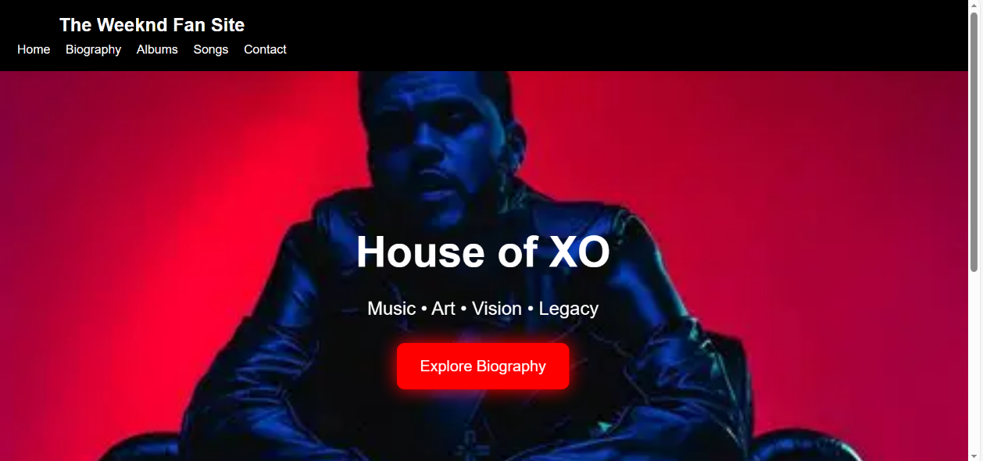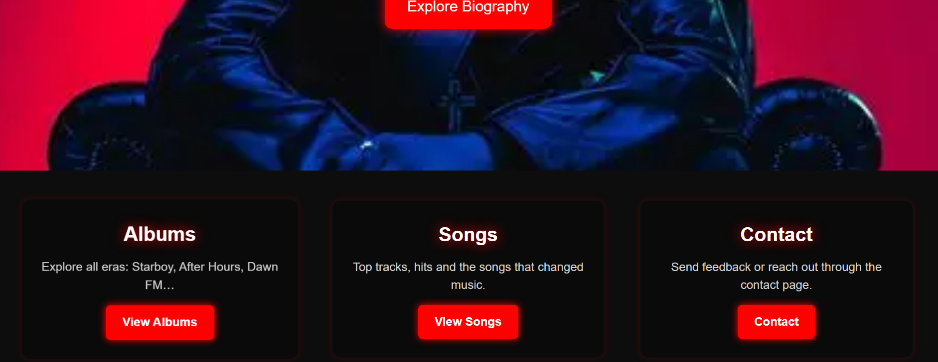
Figure 1: Home page screenshot (index.html)
Below the main section, there are three prominent boxes for Albums, Songs and Contact. Each box has scrolling effects, drop shadows, and animations to make the interface more attractive. This design helps users quickly understand the structure of the website and easily navigate between the main sections.
Biography Page:
The biography page presents information about The Weeknd’s early life and career in a clean, easy-to-read design. The page uses a two-column style: an image on the left and text on the right. The image includes a subtle red glow effect that matches the website’s colour theme.
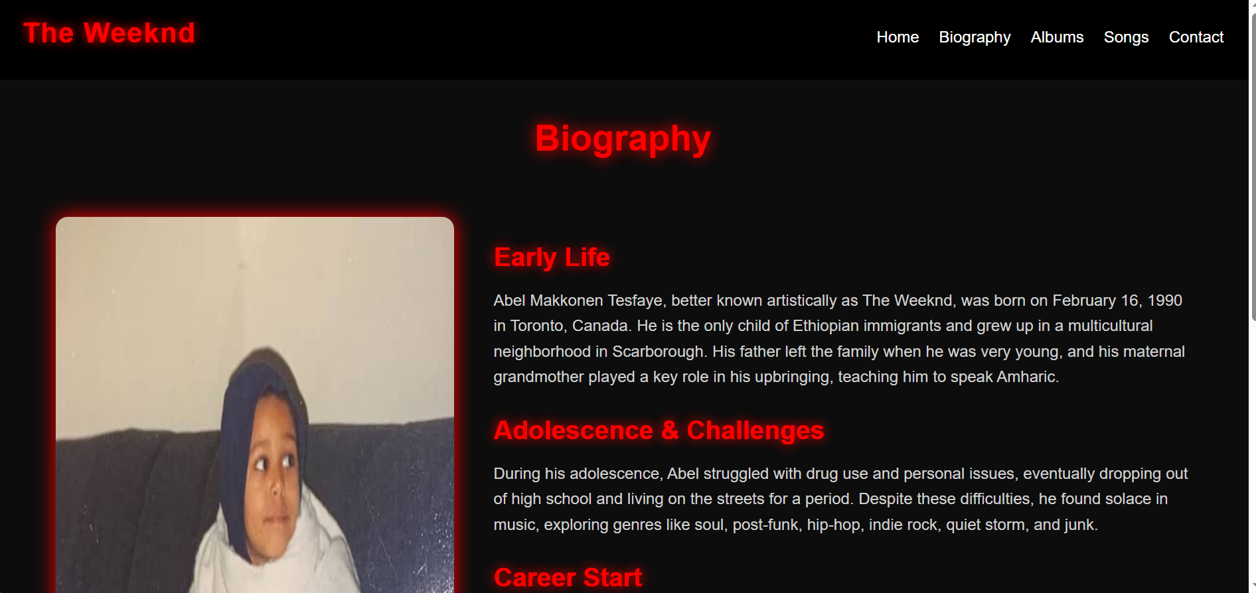
Figure 2: Biography page screenshot (bio.html)
The text is divided into clear sections, such as early life, early career, and rise to fame. This helps users understand the content without feeling overwhelmed. Animations are also used to make the text appear smoothly as the page loads, improving the reading experience.
Albums Page:
The albums page displays a collection of The Weeknd album covers. Each album is placed on a card with a drop shadow effect and a tapping animation that makes the card move slightly upwards.
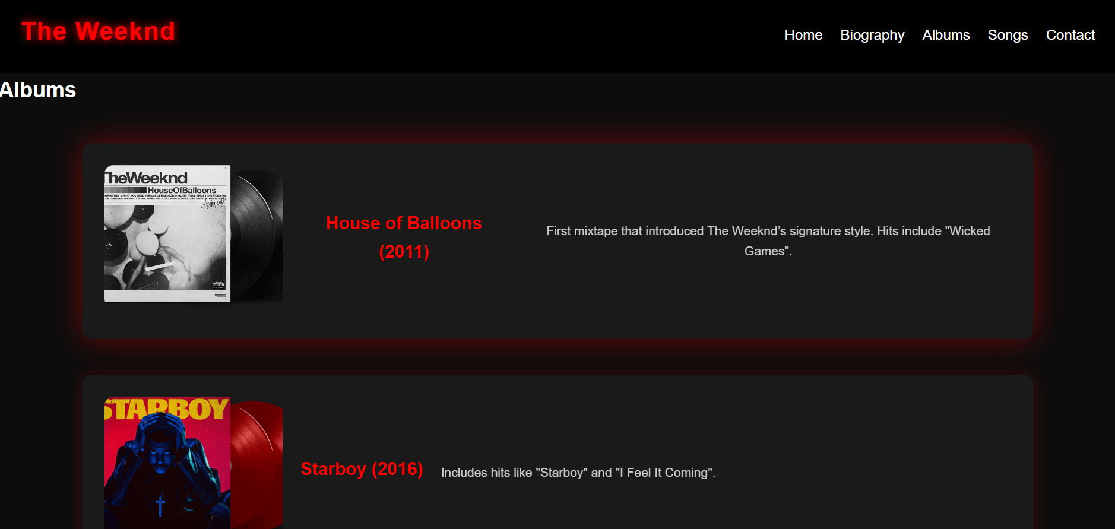
Figure 3: Albums page screenshot (albums.html)
This page uses a responsive grid layout, which means the layout automatically changes based on the screen size. This ensures that the page looks good on phones, tablets and laptops.
Each card also includes a short description, which allows users to understand the theme or style of each album briefly.
Songs Page:
The Songs page displays The Weeknd's songs grouped by album. Instead of showing everything in one long list, the page uses separate sections for each album.
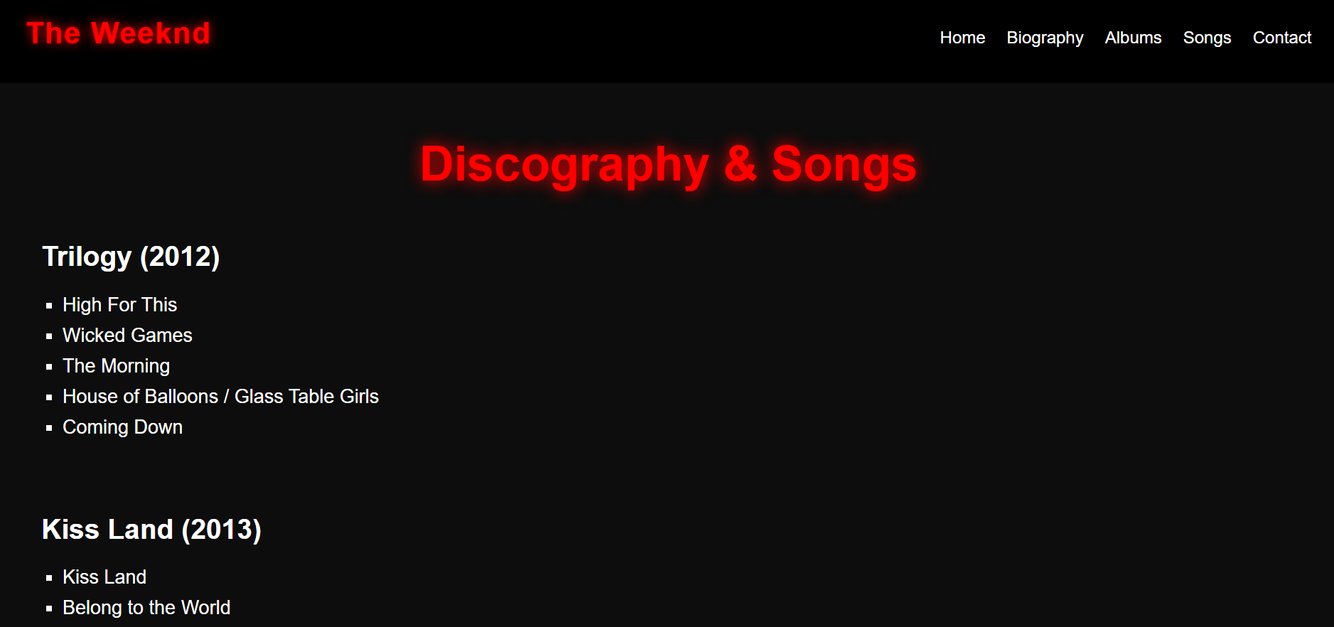
Figure 4: Songs page screenshot (songs.html)
Each section has a short title and a list of songs below it. This structure makes the page clear and easy to navigate. The design also includes bright animations and complements the website's dark theme. This allows users to easily find songs from a specific album without feeling lost.
Contact Page:
The contact page includes a simple form that allows users to write and submit a message as a fan. The form includes fields for the user's name and message, as well as a submit button with scrolling effects.
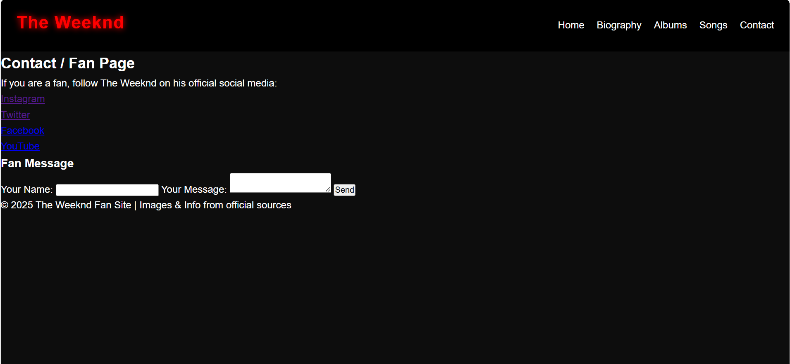
Figure 5: Contact page screenshot (contact.html)
The contact page includes a simple form that allows users to write and submit a message as a fan. The form includes fields for the user's name and message, as well as a submit button with scrolling effects. The page also provides links to The Weeknd's official social media accounts for those who want more information.
The design is minimalist and intuitive, following usability principles so that users can interact with the form without difficulty.

3.3 HTML Validation
The homepage (index.html) has been tested with the official W3C HTML validator. This tool checks whether the page structure complies with international web standards. It analyses elements such as headings, links, images, attributes and overlapping HTML tags.
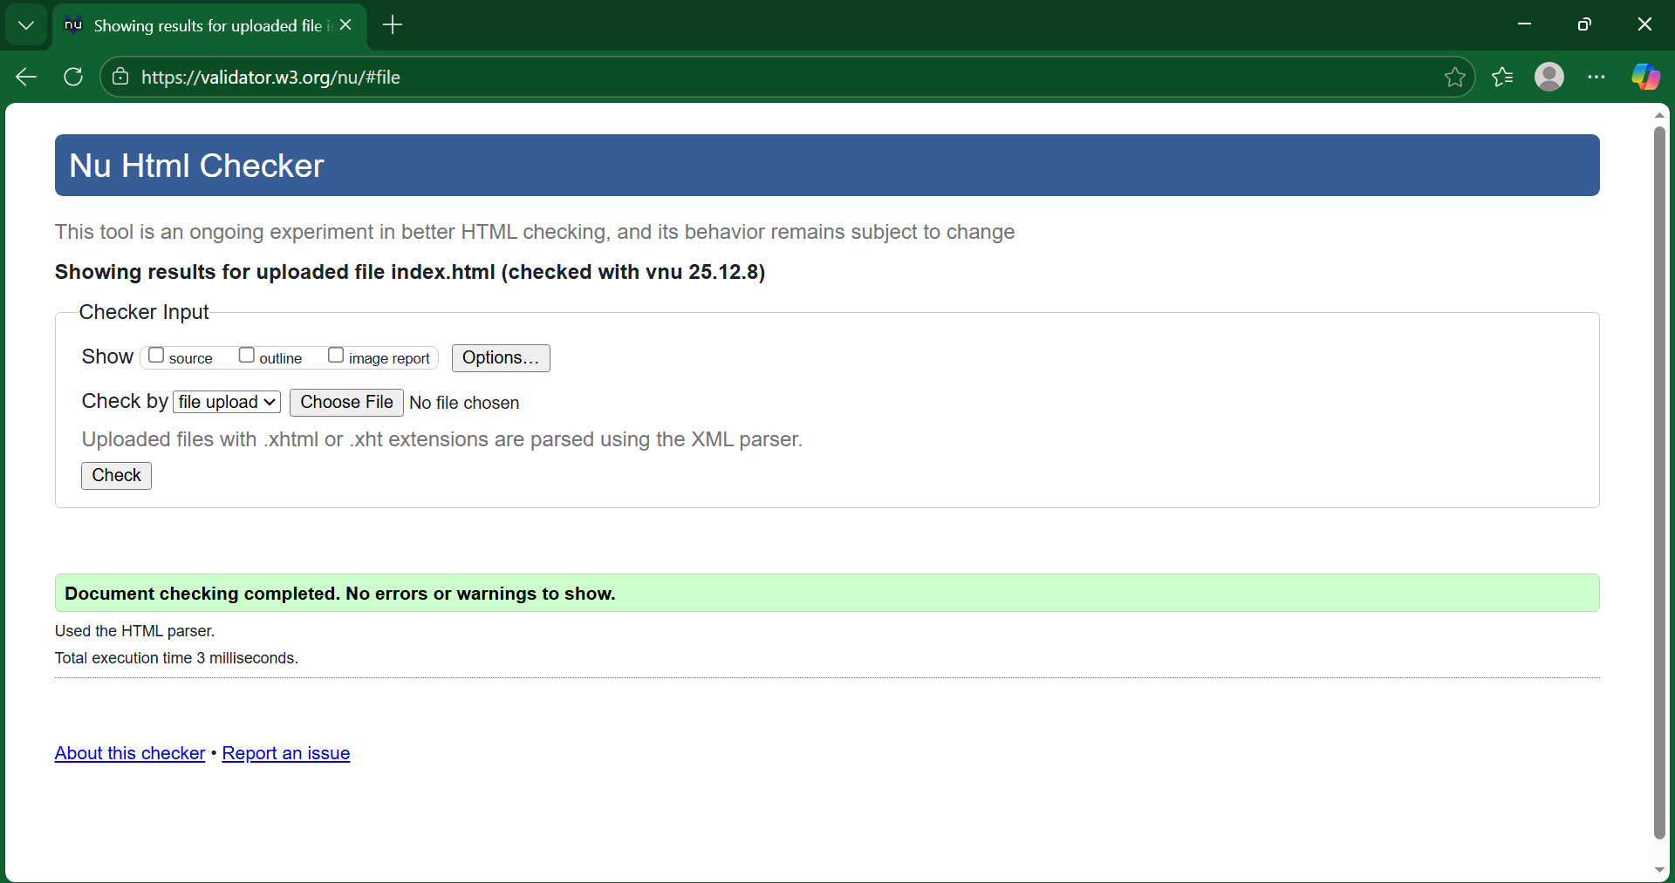
Figure 6: HTML Validator screenshot (index.html)
HTML Validation using: The W3C Markup Validation Service
The homepage validation was successful and passed without errors this means that the page uses correct HTML syntax and that all elements open and close properly. Good validation ensures that the page displays correctly on all browsers and devices, improving long-term compatibility.

3.4 CSS Validation
The stylesheet (style.css) has been tested with the W3C CSS Validator. This tool checks the syntax of CSS rules and ensures that all properties and values ​​comply with official CSS standards.
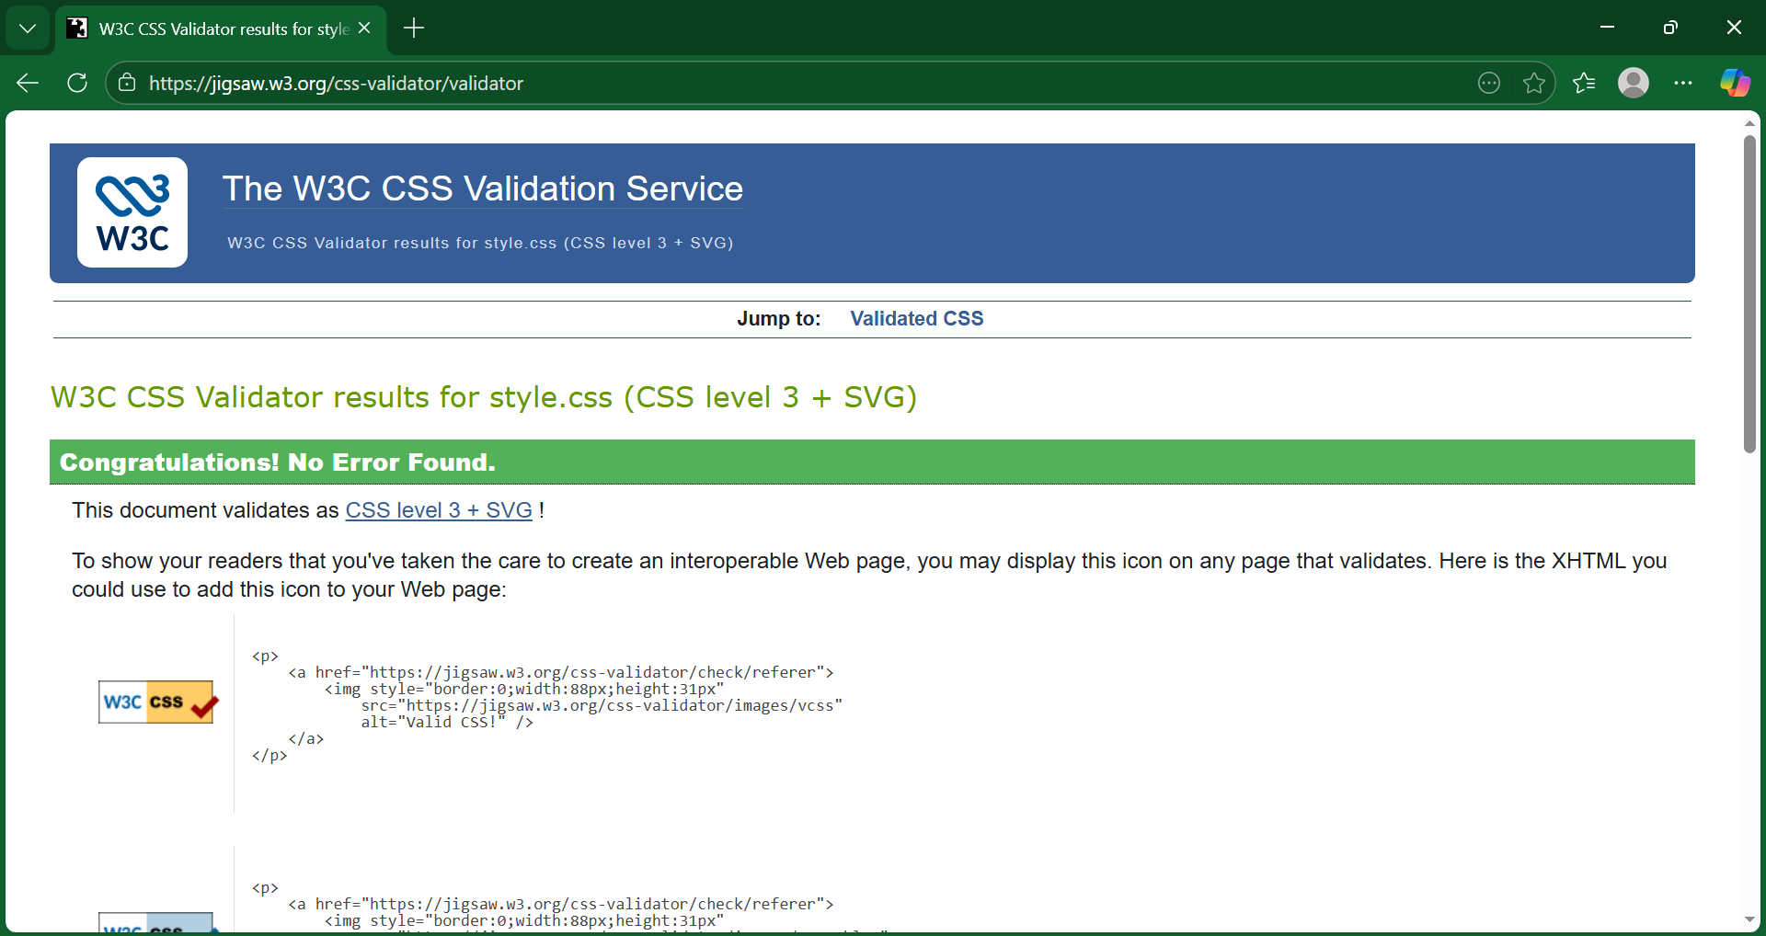
Figure 7: CSS Validator screenshot (css.style)
CSS Validation using: The W3C CSS Validation Service
The CSS file passed validation without errors this confirms that the styles used (such as animations, transitions, background images and layout rules) comply with standard CSS specifications.

4. Evaluation

4.1 Usability, Accessibility & SEO- Research Background
Usability
Usability refers to the ease with which users can interact with a website and achieve their goals effectively and satisfactorily. Good usability reduces cognitive load, improves the user experience, and increases the likelihood of returning to the site. Elements such as clear navigation, logical organization of information, and readability are essential [1].
For example, a study by Nielsen and Budiu showed that users abandon websites more quickly if the navigation is confusing or the content is difficult to read, especially on mobile devices. This highlights the importance of intuitive and consistent design [2].

Accessibility
Web accessibility ensures that all people, including those with visual, hearing, motor, or cognitive disabilities, can use a website. The WCAG 2.1 guideline defines four fundamental principles: Perceptible, Operable, Understandable, and Robust (POUR). Accessible design not only helps users with disabilities but also improves the experience for all visitors [3].
For example, Lazar et al. have shown that accessible design increases user satisfaction and reduces navigation errors, benefiting both users with disabilities and the public [4].
Search Engine Optimization (SEO)
SEO is the process of optimizing a website to improve its visibility in search engines such as Google. This includes optimizing titles, descriptions, semantic structure, keyword usage, and alt tags in images. Effective SEO increases web traffic and improves the user experience by making it easier to find the information they want.
A study by Zeng et al. found that pages with a clear hierarchy of titles, descriptive text, and appropriate use of keywords rank higher in search results, increasing the likelihood that users will find relevant content [5].
Abstract
Usability, accessibility, and SEO are fundamental components of modern web development. Each contributes to improving the user experience and effectiveness of the website: usability facilitates interaction, accessibility ensures inclusion and fairness, and SEO ensures that users can find information effectively. This theoretical knowledge serves as the basis for evaluating and improving the project's website design.

4.2 Usability & Utility
Usability
Usability refers to the ease with which users can interact with a website and achieve their goals. Aspects such as clear navigation, visual consistency, and content structure are essential for reducing cognitive load and improving the user experience.
On the project website:
The navigation bar is clear and consistent across all pages (Home, Biography, Albums, Songs, Contact).
The home page features main sections and call-to-action buttons that guide the user to relevant content.
The content structure, using headings (H1, H2, H3) and sections, improves readability and allows for quick retrieval of information.
The visual design, with appropriate contrast between text and background and subtle animations, facilitates interaction without distracting the user.
Usability
Usability refers to the practical functionality of the site. In this case, the site allows users to intuitively explore The Weeknd’s biography, discography, and songs.
Recommended improvements:
Add a search function for songs or albums.
Improve the contact form by including confirmation messages after submission.

4.3 Search Engine Optimisation (SEO)
SEO ensures that search engines can correctly interpret a website's content and improve its visibility.
Techniques applied on the project website:
Each page has a unique and descriptive title.
Appropriate use of hierarchical headings (H1 > H2 > H3).
Images with descriptive alt attributes (e.g., "The Weeknd album cover").
Semantic navigation using nav tags and structured content with sections and articles.
Keywords naturally integrated into the text, such as "The Weeknd biography" and "The Weeknd albums."
Suggested improvements:
Add manual meta descriptions for each page.
Compress images to improve loading speed.
Include internal links between related pages (e.g., songs linked to albums).

4.4 Accessibility
Web accessibility aims to ensure that a website can be used by everyone, including people with disabilities. The WCAG 2.1 guideline is based on four principles (POUR):
Perceptible:
Adequate contrast between text and background.
Images with alternative text describing the content.

Operable:
Keyboard navigation.
Interactive elements large enough and visible.
Understandable:
Use of plain language.
Consistent design and predictable navigation across pages.
Robust:
Valid HTML and CSS, compatible with browsers and assistive technologies.
Tools used:
WAVE and contrast checkers. No critical accessibility issues were detected.

4.5 Comparison of Two Live Websites
To assess best practice, the bbc.co.uk and gov.uk websites are compared in terms of usability, accessibility, SEO and mobile compatibility.
Usability:
BBC: Attractive visual design, multiple navigation menus and abundant information on the homepage.
GOV.UK: Minimalist design, very clear and straightforward navigation, without distractions.
Conclusion: GOV.UK offers simpler and more straightforward navigation, while the BBC stands out for its visual experience.
Accessibility:
Assessment carried out using the WAVE tool.
BBC: Some accessibility caveats, such as insufficient contrast in some elements and the absence of alternative labels.
GOV.UK: Strictly adheres to WCAG 2.1; accessible design for keyboards and screen readers.
Conclusion: GOV.UK has better overall accessibility.
SEO:
BBC: Use of hierarchical titles, meta tags and descriptions; large amount of multimedia content which can affect loading times.
GOV.UK: Effective use of titles and descriptive text, lightweight, keyword-driven content.
Conclusion: Both sites apply SEO best practices, but GOV.UK stands out with its lightweight, search-optimized content.
Mobile Compatibility:
BBC: Responsive, but more complex and can slow down on low-end devices.
GOV.UK: Fully responsive and lightweight design, adapts better to all types of devices.
Conclusion:
GOV.UK excels in accessibility, usability and mobile compatibility, being easier to use and faster to load. The BBC offers a richer visual experience with more multimedia content but can be more complex to navigate and less accessible. The project website combines both approaches: a clear structure and simple navigation inspired by GOV.UK, along with an attractive visual design like that of the BBC.

5. References

[1] | J. Nielsen, “How Users Read on the Web,” Nielsen Norman Group, 1997. [Online]. Available: https://www.nngroup.com/articles/how-users-read-on-the-web/. [Accessed 11 12 2025].
[2] | J. Nielsen and R. Budiu, Mobile Usability, New Riders, 2013.
[3] | W3C, “Web Content Accessibility Guidelines (WCAG) 2.1,” June 2018. [Online]. Available: https://www.w3.org/TR/WCAG21/. [Accessed 12 12 2025].
[4] | D. F. G. a. A. T. Jonathan Lazar, “Ensuring Digital Accessibility through Process and Policy, Edition 1,” 5 June 2015. [Online]. Available: https://www.educate.elsevier.com/book/details/9780128006467. [Accessed 12 12 2025].
[5] | Moz, “The Begginer's Guide to SEO,” 2015. [Online]. Available: https://moz.com/beginners-guide-to-seo. [Accessed 12 12 2025].

6. Appendices

Appendix A – HTML Code
Index.html code:
<!DOCTYPE html>
<html lang="en">
<head>
<meta charset="UTF-8">
<meta name="viewport" content="width=device-width, initial-scale=1.0">
<title>The Weeknd - Home</title>
<link rel="stylesheet" href="css/style.css">
</head>
<body>

<header>
<nav>
<h2 class="logo">The Weeknd Fan Site</h2>
<ul>
<li><a href="index.html" class="active">Home</a></li>
<li><a href="bio.html">Biography</a></li>
<li><a href="albums.html">Albums</a></li>
<li><a href="songs.html">Songs</a></li>
<li><a href="contact.html">Contact</a></li>
</ul>
</nav>
</header>
<!-- MAIN HERO -->
<section class="hero">
<div class="hero-text">
<h1>House of XO</h1>
<p>Music • Art • Vision • Legacy</p>
<a href="bio.html" class="hero-btn">Explore Biography</a>
</div>
</section>

<!-- HIGHLIGHTS SECTION -->
<section class="highlights">
<div class="highlight-box">
<h3>Albums</h3>
<p>Explore all eras: Starboy, After Hours, Dawn FM…</p>
<a href="albums.html" class="small-btn">View Albums</a>
</div>

<div class="highlight-box">
<h3>Songs</h3>
<p>Top tracks, hits and the songs that changed music.</p>
<a href="songs.html" class="small-btn">View Songs</a>
</div>

<div class="highlight-box">
<h3>Contact</h3>
<p>Send feedback or reach out through the contact page.</p>
<a href="contact.html" class="small-btn">Contact</a>
</div>
</section>

<footer>
<p>© 2025 The Weeknd Fan Site | Images & Info from official sources</p>
</footer>

</body>
</html>
Bio.html code:
<!DOCTYPE html>
<html lang="en">
<head>
<meta charset="UTF-8">
<meta name="viewport" content="width=device-width, initial-scale=1.0">
<title>The Weeknd - Biography</title>
<link rel="stylesheet" href="css/style.css">
</head>
<body>
<header>
<h1>The Weeknd</h1>
<nav>
<ul>
<li><a href="index.html">Home</a></li>
<li><a href="bio.html">Biography</a></li>
<li><a href="albums.html">Albums</a></li>
<li><a href="songs.html">Songs</a></li>
<li><a href="contact.html">Contact</a></li>
</ul>
</nav>
</header>

<h1 class="bio-title">Biography</h1>

<section class="bio-section">
<img src="images/TheWeekndchildhood.jpg" alt="The Weeknd">

<div class="bio-text">
<h2>Early Life</h2>
<p>
Abel Makkonen Tesfaye, better known artistically as The Weeknd, was born on February 16, 1990 in Toronto, Canada.
He is the only child of Ethiopian immigrants and grew up in a multicultural neighborhood in Scarborough.
His father left the family when he was very young, and his maternal grandmother played a key role in his upbringing,
teaching him to speak Amharic.
</p>

<h2>Adolescence & Challenges</h2>
<p>
During his adolescence, Abel struggled with drug use and personal issues, eventually dropping out of high school and
living on the streets for a period. Despite these difficulties, he found solace in music, exploring genres like soul,
post-funk, hip-hop, indie rock, quiet storm, and junk.
</p>

<h2>Career Start</h2>
<p>
In 2009, he began uploading original songs to YouTube under the name "The Weeknd," removing the "e" from "weekend"
to give it a personal touch. His first mixtape, <em>House of Balloons</em>, launched his career and became a fan favorite.
</p>

<h2>Rise to Fame</h2>
<p>
In 2012, he co-founded XO, a record label that represents his work team and close friends. Throughout his career,
he has won multiple awards, including several Grammys, and has been nominated for an Oscar.
The Weeknd's lyrics explore themes of relationships and personal experiences, connecting deeply with his audience.
</p>

<h2>Why I Like Him</h2>
<p>
What stands out most about The Weeknd is his unique sound, smooth voice, and innovative production.
Songs like "Call Out My Name" or "After Hours" create a deep emotional connection, allowing me to understand
my own feelings through his music. Even after facing difficult circumstances, he found his escape in music,
which inspires me greatly.
</p>
</div>
</section>

<footer>
<p>© 2025 The Weeknd Fan Site | Images & Info from official sources</p>
</footer>

</body>
</html>
Albums.html code:
<!DOCTYPE html>
<html lang="en">
<head>
<meta charset="UTF-8">
<meta name="viewport" content="width=device-width, initial-scale=1.0">
<title>The Weeknd - Albums</title>
<link rel="stylesheet" href="css/style.css">
</head>
<body>
<header>
<h1>The Weeknd</h1>
<nav>
<ul>
<li><a href="index.html">Home</a></li>
<li><a href="bio.html">Biography</a></li>
<li><a href="albums.html">Albums</a></li>
<li><a href="songs.html">Songs</a></li>
<li><a href="contact.html">Contact</a></li>
</ul>
</nav>
</header>

<main>
<h2>Albums</h2>

<div class="album">
<img src="images/houseofballoonsalbum.jpg" alt="House of Balloons Album" style="width:200px;">
<h3>House of Balloons (2011)</h3>
<p>First mixtape that introduced The Weeknd’s signature style. Hits include "Wicked Games".</p>
</div>

<div class="album">
<img src="images/starboyalbum.jpg" alt="Starboy Album" style="width:200px;">
<h3>Starboy (2016)</h3>
<p>Includes hits like "Starboy" and "I Feel It Coming".</p>
</div>

<div class="album">
<img src="images/afterhoursalbum.jpg" alt="After Hours Album" style="width:200px;">
<h3>After Hours (2020)</h3>
<p>Includes hits like "Blinding Lights" and "Save Your Tears".</p>
</div>

<div class="album">
<img src="images/dawnfmalbum.jpg" alt="Dawn FM Album" style="width:200px;">
<h3>Dawn FM (2022)</h3>
<p>Latest studio album with a futuristic and synth-driven sound.</p>
</div>

</main>

<footer>
<p>© 2025 The Weeknd Fan Site | Images & Info from official sources</p>
</footer>
</body>
</html>
Songs.html code:
<!DOCTYPE html>
<html lang="en">
<head>
<meta charset="UTF-8">
<meta name="viewport" content="width=device-width, initial-scale=1.0">
<title>The Weeknd — Songs</title>
<link rel="stylesheet" href="css/style.css">
</head>
<body>

<header>
<h1>The Weeknd</h1>
<nav>
<ul>
<li><a href="index.html">Home</a></li>
<li><a href="bio.html">Biography</a></li>
<li><a href="albums.html">Albums</a></li>
<li><a href="songs.html" class="active">Songs</a></li>
<li><a href="contact.html">Contact</a></li>
</ul>
</nav>
</header>

<main>

<h1 class="songs-title">Discography & Songs</h1>

<!-- TRILOGY / early mixtapes -->
<section class="song-section">
<h2>Trilogy (2012)</h2>
<ul>
<li>High For This</li>
<li>Wicked Games</li>
<li>The Morning</li>
<li>House of Balloons / Glass Table Girls</li>
<li>Coming Down</li>
</ul>
</section>

<!-- Kiss Land -->
<section class="song-section">
<h2>Kiss Land (2013)</h2>
<ul>
<li>Kiss Land</li>
<li>Belong to the World</li>
<li>Live For (feat. Drake)</li>
<li>Pretty</li>
<li>Wanderlust</li>
</ul>
</section>

<!-- Beauty Behind the Madness -->
<section class="song-section">
<h2>Beauty Behind the Madness (2015)</h2>
<ul>
<li>Often</li>
<li>The Hills</li>
<li>Can't Feel My Face</li>
<li>Shameless</li>
<li>In the Night</li>
</ul>
</section>

<!-- Starboy -->
<section class="song-section">
<h2>Starboy (2016)</h2>
<ul>
<li>Starboy (feat. Daft Punk)</li>
<li>Party Monster</li>
<li>I Feel It Coming (feat. Daft Punk)</li>
<li>Reminder</li>
<li>Die For You</li>
</ul>
</section>

<!-- After Hours -->
<section class="song-section">
<h2>After Hours (2020)</h2>
<ul>
<li>Alone Again</li>
<li>Blinding Lights</li>
<li>Heartless</li>
<li>In Your Eyes</li>
<li>Save Your Tears</li>
</ul>
</section>

<!-- Dawn FM -->
<section class="song-section">
<h2>Dawn FM (2022)</h2>
<ul>
<li>Gasoline</li>
<li>How Do I Make You Love Me?</li>
<li>Take My Breath</li>
<li>Less Than Zero</li>
<li>Out of Time</li>
<li><strong>Hurry Up Tomorrow</strong></li>
<li>Is There Someone Else?</li>
</ul>
</section>

<!-- Rare (2020) — songs extra / deluxe -->
<section class="song-section">
<h2>Rare / Deluxe Tracks</h2>
<ul>
<li>Snowchild</li>
<li>Escape From LA</li>
<li>Faith</li>
<li>Blinding Lights (remix)</li>
</ul>
</section>

</main>

<footer>
<p>© 2025 The Weeknd Fan Site | Images & Info from official sources</p>
</footer>

</body>
Contact.html code:
<!DOCTYPE html>
<html lang="en">
<head>
<meta charset="UTF-8">
<meta name="viewport" content="width=device-width, initial-scale=1.0">
<title>The Weeknd - Contact</title>
<link rel="stylesheet" href="css/style.css">
</head>
<body>
<header>
<h1>The Weeknd</h1>
<nav>
<ul>
<li><a href="index.html">Home</a></li>
<li><a href="bio.html">Biography</a></li>
<li><a href="albums.html">Albums</a></li>
<li><a href="songs.html">Songs</a></li>
<li><a href="contact.html">Contact</a></li>
</ul>
</nav>
</header>

<main>
<h2>Contact / Fan Page</h2>
<p>If you are a fan, follow The Weeknd on his official social media:</p>
<ul>
<li><a href="https://www.instagram.com/theweeknd" target="_blank">Instagram</a></li>
<li><a href="https://twitter.com/theweeknd" target="_blank">Twitter</a></li>
<li><a href="https://www.facebook.com/theweeknd" target="_blank">Facebook</a></li>
<li><a href="https://www.youtube.com/theweeknd" target="_blank">YouTube</a></li>
</ul>

<h3>Fan Message</h3>
<form action="thanks.html" method="post">

<label for="name">Your Name:</label>
<input type="text" id="name" name="name" placeholder="Enter your name" required>

<label for="message">Your Message:</label>
<textarea id="message" name="message" placeholder="Write your message here..." required></textarea>

<input type="submit" value="Send">

</form>
</main>

<footer>
<p>© 2025 The Weeknd Fan Site | Images & Info from official sources</p>
</footer>
</body>
</html>
Thanks.html code:
<!DOCTYPE html>
<html lang="en">
<head>
<meta charset="UTF-8">
<meta name="viewport" content="width=device-width, initial-scale=1.0">
<title>Thank You - The Weeknd</title>
<link rel="stylesheet" href="css/style.css">
</head>
<body>

<header>
<h1>The Weeknd</h1>
<nav>
<ul>
<li><a href="index.html">Home</a></li>
<li><a href="bio.html">Biography</a></li>
<li><a href="albums.html">Albums</a></li>
<li><a href="songs.html">Songs</a></li>
<li><a href="contact.html">Contact</a></li>
</ul>
</nav>
</header>

<main>
<h1>🎉 Thank You!</h1>
<p>Your message has been successfully sent. I will get back to you soon.</p>

<a href="index.html" class="btn">Return to Home</a>
</main>

<footer>
<p>© 2025 The Weeknd Fan Site | Images & Info from official sources</p>
</footer>

</body>

Appendix B – CSS Code
Style.css code
/* ---------------------------------------------------------
Basic Reset + Default Page Settings
--------------------------------------------------------- */
* {
margin: 0;
padding: 0;
box-sizing: border-box;
}

body {
font-family: 'Arial', sans-serif;
background-color: #0a0a0a;
color: #fff;
line-height: 1.6;
}

/* ---------------------------------------------------------
Header + Navigation Bar
--------------------------------------------------------- */
header {
background-color: #111;
padding: 20px;
text-align: center;
}

header h1 {
font-size: 36px;
color: red;
text-shadow: 0 0 10px red;
margin-bottom: 10px;
}

nav ul {
list-style: none;
display: flex;
justify-content: center;
gap: 25px;
}

nav ul li a {
color: white;
text-decoration: none;
transition: 0.3s;
}

nav ul li a:hover {
color: red;
text-shadow: 0 0 8px red;
}

/* ---------------------------------------------------------
Home Page Hero Section (big intro banner)
--------------------------------------------------------- */
.hero {
height: 100vh;
background: url("../images/theweeknd-background.jpg") no-repeat center center/cover;
display: flex;
align-items: center;
justify-content: center;
text-align: center;
color: white;
padding: 0 20px;
animation: bgZoom 12s ease-in-out infinite alternate;
}

@keyframes bgZoom {
0% { background-size: 100%; }
100% { background-size: 110%; }
}

.hero-text {
animation: fadeUp 1.5s ease forwards;
opacity: 0;
}

@keyframes fadeUp {
0% { opacity: 0; transform: translateY(40px); }
100% { opacity: 1; transform: translateY(0); }
}

.hero-text h1 {
font-size: 55px;
margin-bottom: 10px;
animation-delay: 0.2s;
}

.hero-text p {
font-size: 24px;
margin-bottom: 25px;
animation-delay: 0.5s;
}

.hero-btn {
background: red;
color: white;
padding: 14px 30px;
border-radius: 10px;
font-size: 20px;
text-decoration: none;
transition: 0.3s;
display: inline-block;
animation: glow 2s infinite ease-in-out;
}

.hero-btn:hover {
background: #ff4d4d;
transform: scale(1.1);
}

@keyframes glow {
0% { box-shadow: 0 0 10px red; }
50% { box-shadow: 0 0 25px red; }
100% { box-shadow: 0 0 10px red; }
}

/* ---------------------------------------------------------
Highlight Cards on Home Page
--------------------------------------------------------- */
.highlights {
display: flex;
justify-content: space-around;
padding: 40px 20px;
gap: 20px;
flex-wrap: wrap;
}

.highlight-box {
background: #0a0a0a;
padding: 25px;
border-radius: 12px;
text-align: center;
width: 30%;
color: white;
transition: transform 0.4s ease, box-shadow 0.4s ease;
border: 1px solid #111;
box-shadow: 0 0 10px #ff000030;
}

.highlight-box:hover {
transform: scale(1.07);
box-shadow: 0 0 25px red, 0 0 50px red;
border-color: red;
animation: pulse 1.5s infinite alternate;
}

@keyframes pulse {
0% { box-shadow: 0 0 10px red; }
50% { box-shadow: 0 0 25px red; }
100% { box-shadow: 0 0 10px red; }
}

.highlight-box h3 {
margin-bottom: 10px;
font-size: 26px;
animation: glowTitle 2.5s infinite ease-in-out;
}

.highlight-box p {
color: #cfcfcf;
font-size: 16px;
line-height: 1.5;
}

.small-btn {
display: inline-block;
margin-top: 15px;
background: red;
color: white;
padding: 10px 22px;
border-radius: 6px;
text-decoration: none;
transition: 0.3s;
font-weight: bold;
box-shadow: 0 0 10px red;
}

.small-btn:hover {
background: #ff3b3b;
box-shadow: 0 0 20px red, 0 0 35px red;
transform: scale(1.05);
}

@keyframes glowTitle {
0% { text-shadow: 0 0 5px red; }
50% { text-shadow: 0 0 20px red; }
100% { text-shadow: 0 0 5px red; }
}

/* ---------------------------------------------------------
Biography Page Layout
--------------------------------------------------------- */
.bio-title {
text-align: center;
font-size: 36px;
margin: 30px 0;
color: red;
text-shadow: 0 0 15px red;
}

.bio-section {
display: flex;
flex-wrap: wrap;
justify-content: center;
gap: 40px;
padding: 20px;
max-width: 1200px;
margin: auto;
}

.bio-section img {
max-width: 400px;
width: 100%;
border-radius: 12px;
box-shadow: 0 0 20px red;
transition: transform 0.3s, box-shadow 0.3s;
}

.bio-section img:hover {
transform: scale(1.05);
box-shadow: 0 0 35px red;
}

.bio-text {
max-width: 700px;
}

.bio-text h2 {
margin-top: 20px;
margin-bottom: 10px;
font-size: 26px;
color: red;
animation: glowTitle 2.5s infinite alternate;
}

.bio-text p {
margin-bottom: 15px;
color: #cfcfcf;
font-size: 16px;
}

/* ---------------------------------------------------------
Albums Grid
--------------------------------------------------------- */
.album {
display: inline-block;
background-color: #111;
padding: 20px;
margin: 20px;
border-radius: 12px;
width: 220px;
text-align: center;
transition: transform 0.3s, box-shadow 0.3s;
box-shadow: 0 0 15px #ff000050;
}

.album img {
width: 200px;
border-radius: 10px;
margin-bottom: 10px;
}

.album h3 {
color: red;
margin-bottom: 8px;
font-size: 20px;
}

.album p {
color: #cfcfcf;
font-size: 14px;
}

.album:hover {
transform: scale(1.05);
box-shadow: 0 0 25px red, 0 0 45px red;
}

/* ---------------------------------------------------------
Songs Page Styles
--------------------------------------------------------- */
.songs-title {
text-align: center;
margin-top: 40px;
font-size: 36px;
color: red;
text-shadow: 0 0 15px red;
}

.song-section {
padding: 30px 40px;
}

.song-section h2 {
font-size: 26px;
margin-bottom: 10px;
}

.song-section ul {
padding-left: 20px;
list-style: square;
font-size: 18px;
}

/* ---------------------------------------------------------
Responsive Adjustments (mobile/tablet)
--------------------------------------------------------- */
@media screen and (max-width: 900px) {
.bio-section,
.highlights {
flex-direction: column;
align-items: center;
}

.bio-text {
max-width: 90%;
}

.highlight-box,
.album {
width: 80%;
max-width: 300px;
margin: 15px auto;
}

nav ul {
flex-direction: column;
align-items: center;
}

.album img {
width: 100%;
}
}

/* ---------------------------------------------------------
General Layout (base styles)
--------------------------------------------------------- */
body {
margin: 0;
font-family: Arial, Helvetica, sans-serif;
background: #0d0d0d;
color: white;
}

h1, h2 {
margin: 0;
}

ul {
list-style: none;
padding: 0;
}

/* ---------------------------------------------------------
Top Navigation (sticky header)
--------------------------------------------------------- */
header {
background: black;
padding: 15px 25px;
display: flex;
justify-content: space-between;
align-items: center;
position: sticky;
top: 0;
z-index: 100;
}

header h1 {
color: red;
font-size: 28px;
letter-spacing: 1px;
}

nav ul {
display: flex;
gap: 20px;
}

nav a {
color: white;
text-decoration: none;
transition: 0.3s;
}

nav a:hover {
color: red;
}

/* ---------------------------------------------------------
Songs Page Main Title Animation
--------------------------------------------------------- */
.songs-title {
text-align: center;
margin-top: 40px;
font-size: 45px;
animation: fadeIn 1s ease-in-out;
}

/* ---------------------------------------------------------
Album Preview Boxes (songs.html)
--------------------------------------------------------- */
.album {
width: 85%;
margin: 40px auto;
background: #1a1a1a;
padding: 25px;
border-radius: 12px;
box-shadow: 0 0 20px rgba(255, 0, 0, 0.2);
display: flex;
gap: 20px;
align-items: center;
transition: transform 0.3s, box-shadow 0.3s;
animation: fadeUp 0.8s ease forwards;
}

.album:hover {
transform: translateY(-5px);
box-shadow: 0 0 35px rgba(255, 0, 0, 0.4);
}

.album img {
width: 160px;
height: 160px;
border-radius: 10px;
object-fit: cover;
}

.album h2 {
margin-bottom: 10px;
color: red;
font-size: 26px;
}

.album ul li {
padding: 5px 0;
font-size: 18px;
}

/* ---------------------------------------------------------
Animations Used Across Pages
--------------------------------------------------------- */
@keyframes fadeIn {
from { opacity: 0; }
to { opacity: 1; }
}

@keyframes fadeUp {
from { opacity: 0; transform: translateY(20px); }
to { opacity: 1; transform: translateY(0); }
}

/* ---------------------------------------------------------
Responsive Fixes for Smaller Screens
--------------------------------------------------------- */
@media (max-width: 768px) {
.album {
flex-direction: column;
text-align: center;
}

.album img {
width: 200px;
height: 200px;
}
}

