


Faro Arm Mobility Rectification
REFLECTIVE PROJECT REPORT (2023)
Dylan Payne
Renishaw QUALITY CONTROL TECHNICIAN

Richard Sutton
LECTURER
Revision 1
Contents

1. Introduction 3
1.1 Aims and Objectives 3
1.1.1 Report Aims 3
1.1.2 Report Objectives 3
1.1.3 Project Aims 3
1.1.4 Project Objectives 3
1.2 Project Background 4
2. Faro Arm Mobility Rectification Project 5
2.1 Problem Identification 5
2.1.1 Feasibility Matrix 5
2.1.2 Justification 5
2.2 Development 6
2.2.1 Matrix Analysis 6
2.2.2 Final Design 6
2.2.3 3D Design 7
2.2.4 Prototype 7
2.2.5 Final Product 7
2.3 Compliance, Safety and Risk Management Issues 8
2.3.1 Faro Arm Overview 8
2.3.2 Detailed Risk Assessment 8
3. Project Management Techniques 9
3.1 Gantt Charts 9
3.2 Critical Path Analysis (CPA) 9
3.3 Work Breakdown Structure (WBS) 10
3.4 Program Evaluation and Review Technique (PERT) 10
3.5 KanBan 11
4. Leadership Styles 11
4.1 Transformational Leadership 11
4.2 Delegative Leadership 11
4.3 Authoritative Leadership 11
4.4 Transactional Leadership 12
4.5 Participative Leadership 12
5. Project Evaluation Methodologies and Techniques. 13
5.1 What is Project Evaluation? 13
5.2 Surveys 13
5.3 Document Reviews 13
5.4 Quantitative Analysis 13
5.5 Case Studies 13
6. Project Analysis 14
6.1 Techniques Used 14
7. Conclusion 15
7.1 Improvements 15
8. Bibliography 16
8.1 Appendicies 17
8.1.1 Fixtures 17
8.1.2 Tables 18
8.1.3 Gantt Chart 19

1. Introduction

1.1 Aims and Objectives

1.1.1 Report Aims

This report aims to write a reflective piece of work to analyse a past project. This analysis will be presented in the form of a written report. This report was commissioned to review and analyse a previous project carried out in which the author had full involvement, concentrating on planning methods, academic structure, and problem-solving techniques.

1.1.2 Report Objectives

The objectives of this report are to review and analyse the success of this project, as well as review the management styles used and consider where improvements could have been implemented. Finally, it will review the success of the project and propose improvements where necessary.

1.1.3 Project Aims

The project aimed to identify three areas of concern that could potentially jeopardise the safety of the operators, as well as to save the systems or locations from downtime and any incidents/issues. The three concerns were to be attained through the use of a risk assessment and then evaluated before the best course of action was decided. A feasibility analysis was required to be carried out to determine the restrictions and create an outline specification, at which point a project plan, brief and Product Design Specification (PDS) would be determined. The project progress was required to be monitored against the agreed-upon project plan and adjusted as needed, keeping track of expenses and timeliness.

1.1.4 Project Objectives

The objectives of the project were to determine a safety concern within the Quality area that required immediate rectification and to produce a solution to minimise the risk to both the operators and the equipment. The resulting design was required to show that it improves the area's or machine's overall safety with objective evidence of the improvement or removal of risk.

1.2 Project Background

The safety of the Faro Arm was a concern for the Quality department, which uses the device for various measuring activities. This project was commissioned to address this concern and develop a solution that would minimize risks to both the operators and the equipment.
The project's main goals were to pinpoint specific safety issues connected to the Faro Arm's mobility, come up with a solution that enhances overall safety, and offer unbiased proof of risk reduction. The initiative required the cooperation of stakeholders from the Quality department to accomplish these goals. A detailed study was conducted, taking into account any limits or limitations that might emerge during the rectification process, to decide whether it would be feasible to implement a solution. The specifications that will direct the ensuing design and development phases were developed using this analysis as a foundation.
A thorough project plan, brief, and Product Design Specification (PDS) were produced to manage the project efficiently. These documents established a clear path to success and acted as recommendations for the project team. To ensure the project stayed on track and accomplished its goals within the allotted timeframe, constant progress monitoring, expense tracking, and timely changes were carried out throughout the project duration.
To verify the efficacy of the adopted solution, unbiased proof of risk reduction was required, such as a decline in occurrences and increased operator safety. The project's goal was to improve the safety measures inside the Quality department by addressing the mobility issues related to the Faro Arm. This correction would reduce the dangers caused by the device's tendency to topple over and swing around while in motion, protecting both the Faro Arm and the workers nearby.

2. Faro Arm Mobility Rectification Project

The Gantt chart used for this project can be located in the appendices.

2.1 Problem Identification

2.1.1 Feasibility Matrix
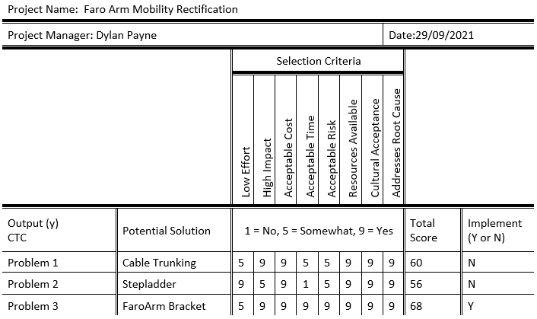

Table 1 - Problem Selection Matrix

2.1.2 Justification

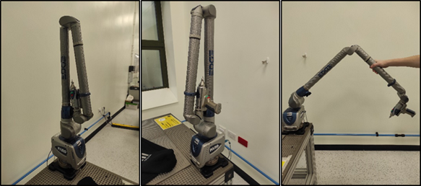
The Faro Arm could not be moved across the factory due to a risk to the operator's safety during transportation, so the Quality department needed this solution. This project didn't cost much because all the parts were made in-house utilising stock materials thanks to Renishaw's production capabilities and workshops. This project was finished in a reasonable amount of time due to prior experience with 3D modelling, hand tools, and 3D manufacturing. Once this problem was fixed, precise measurements could once more be made throughout the entire site. This issue was chosen to be addressed for these reasons.
Figure 1 - Faro Arm

2.2 Development
Figure 2 - Design 1
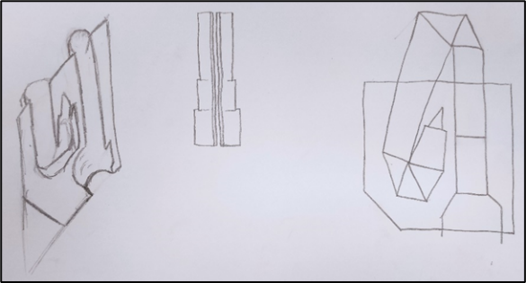
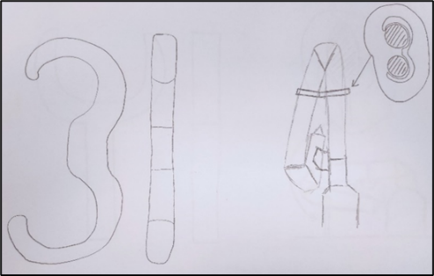
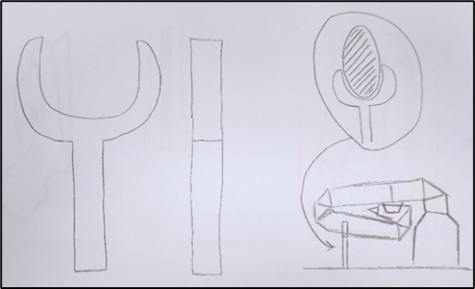
Figure 3 - Design 2

2.2.1 Matrix Analysis
Figure 4 - Design 3
 | Design 1 | Design 2 | Design 3
Cost | 3 | 3 | 2
Ease of attachment | 2 | 3 | 2
Maintenance/Replacements | 3 | 3 | 2
Weight | 3 | 3 | 2
Fit for purpose | 2 | 3 | 3
Size | 3 | 3 | 2
Ease of Manufacturing | 3 | 2 | 1
Score Totals | 19 | 20 | 14
Rankings | 2 | 1 | 3
Table 2 - Matrix Analysis

= RAG Status (Red = Negative, Green = Positive)
1 | 2 | 3
Poor | Average | Good
Table 3 – RAG

2.2.2 Final Design

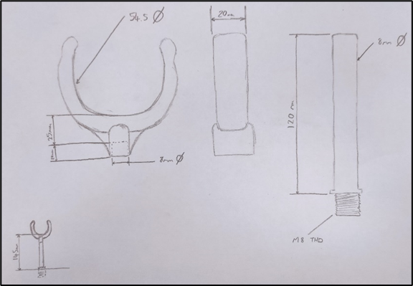
The decision was made to proceed with Design three as the final design. This variation consists of two distinct components that would be connected by a "transition fit." The top sits on a rod that screws into the table and has the same diameter as the arm on the Faro Arm. With this design, the bracket can be situated anywhere on the table. Since these two components are not fixed to one another, the Faro Arm's orientation when the rod is put into the table will not matter, allowing the bracket to freely rotate when it is attached to the rod. The top section is 3D printed with 100% infill for rigidity, with a slightly closed opening to allow for a gripped style bracket rather than a U-shaped bracket that the Faro Arm would simply rest in.
Figure 5 - Final Design

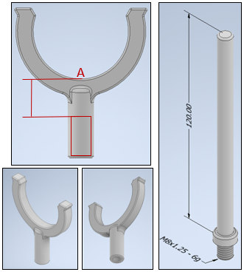
2.2.3 3D Design

The bracket has a diameter of 54.5mm with a slightly closed opening as previously stated. The opening at the bottom of the bracket has a diameter of 8mm and a depth of 20mm. The distance between the depth of this hole and the base of the bracket is 25mm. The rod has a length of 120mm from above the M8 thread. Once these two parts are mated together, they give a combined distance of 145mm from the table to point A, which is the distance the Faro Arm is from the table when in its 90° laying down position.

2.2.4 Prototype
Figure 6 - 3D Model

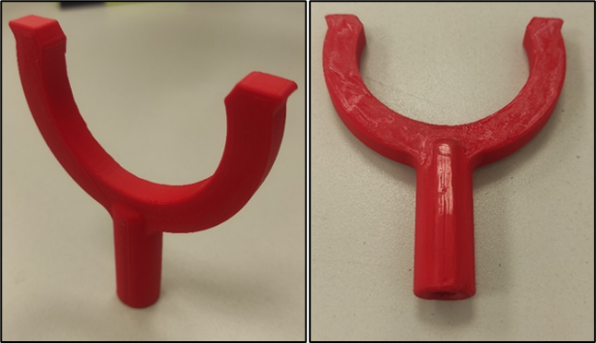
The next stage in the manufacturing process was to produce a prototype to ensure that the calculations and measurements were correct. The trial fit of this bracket onto the housing of the Faro Arm was perfect. The bracket smoothly attached and detached from the housing without causing any cosmetic damage. The grip is secure enough to hold onto the Faro Arm but also loose enough for an easy release for the operator. Fortunately, for the rod of this part, there was an 8mm diameter stainless steel rod in the scrap bins. This meant that the only requirement remaining was to cut it to length and form an M8 external thread on one end.
Figure 7 - Prototype

2.2.5 Final Product
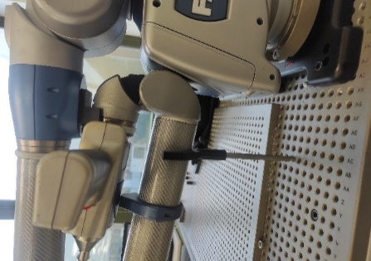
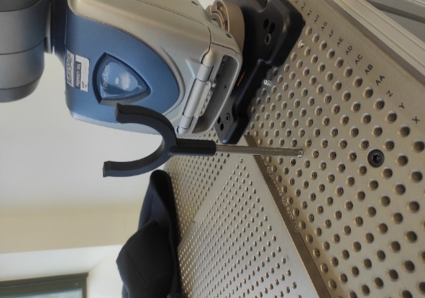
For the final design, black PLA plastic was used for the main bracket head. This was also printed standing up which produced a better surface finish all around. The final part is slotted onto the rod and the final product is shown in Figure 8.
Figure 8 - Final Assembly

2.3 Compliance, Safety and Risk Management Issues

The final product does not have any safety or risk hazards associated with its condition or operation. The product is a standalone bracket and would not cause an operator any harm on its own.
The only compliance that this part needed to conform to is the Restriction of Hazardous Substances (RoHS) to ensure that it can be used on-site within the Renishaw workplace.

2.3.1 Faro Arm Overview

The Faro Arm is covered by the Provision and Use of Work Equipment Regulations as a piece of equipment for use in a workplace. As a starting point for making the equipment safe to use, the Regulations demand that all potential risks be recognised and handled.
The Faro Arm is an electrically powered, manually operated machine for precision measurement. Electrical power is obtained by a normal three-pin plug and is drawn from the main supply for both the Faro Arm and the workstation PC. When the Faro Arm is in use, the operator is in continual physical touch with it.

2.3.2 Detailed Risk Assessment
Table 4 - Risk Assessment & Key
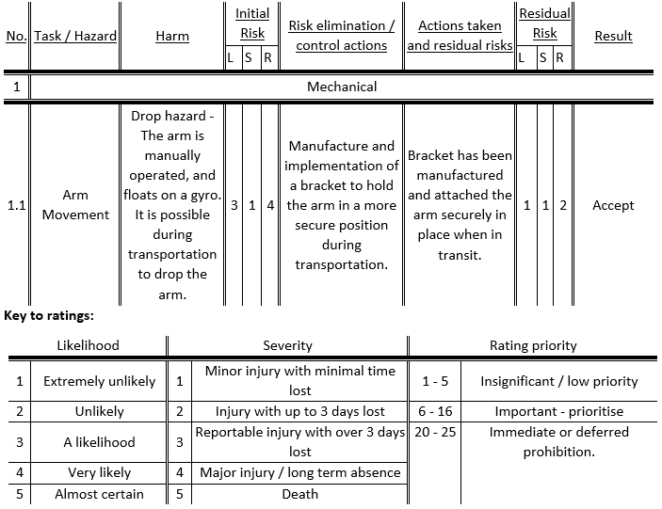
If S (severity) equals 4 or 5 the hazard must be eliminated, if possible, if not its likelihood must be as low as is reasonably practicable. If S equals 0 or L (likelihood) equals 0 the hazard is acceptable. If R (rating priority) equals 7 or higher the project cannot proceed (without explicit board approval). It may not be possible to reduce the risk rating if the initial risk rating is 6 or less this may be acceptable.

Once a risk assessment was carried out, the Faro Arm was transported to three different locations around the factory. Each excursion resulted in a safe and stable execution and an overall successful outcome.

3. Project Management Techniques

3.1 Gantt Charts

A planning tool frequently used when working on a project is the Gantt chart. They can help with scheduling and planning for projects of any size, but they are especially useful for larger, more complicated tasks. It is employed to list tasks with anticipated completion dates and deadlines. The tasks are typically stated on the chart's left side, and the time scale is shown along the top. Then, for each period, a bar or an area with start and end times for each task to be done is used to depict it. (Duke, 2023). A Gantt chart can also show the dependencies between tasks, how much of a task has been accomplished, and who is responsible for it on the project team. This is especially useful when a big project team with lots of stakeholders use it to keep everyone informed and on track when the project scope changes.
The Gantt chart format makes it very straightforward to quickly scan the chart and understand the status of the project as well as any impending deadlines that team members should be aware of (Meardon, 2023).
The limitations of Gantt charts are that they are less capable of adjusting to changes in the scope or schedule of a project. A more flexible approach to project management, such as Kanban or Scrum, would enable improved flexibility and response to evolving requirements. They may also not help team members collaborate and communicate effectively as they frequently place more emphasis on task dependencies and timetables while placing less emphasis on fostering direct collaboration and communication among team members. Methodologies like Agile or Lean would be more suited to these situations as these techniques emphasize cooperation and ongoing improvement (Geraldi & Lechter, 2012).

3.2 Critical Path Analysis (CPA)

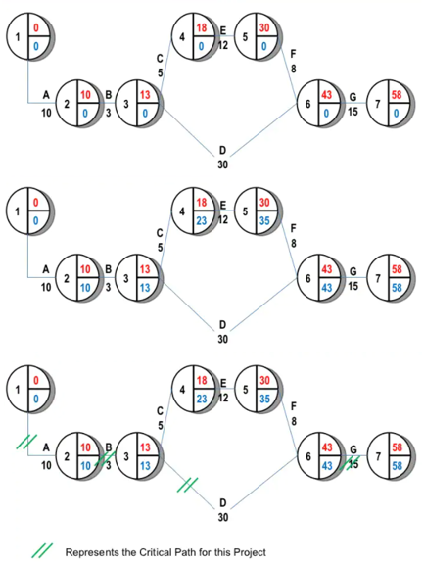
CPA is a planning method used to calculate the shortest possible completion time for the project. It is used to estimate and minimise the project completion time, prioritise tasks and plan/organise resources. CPA is achieved by identifying the most crucial tasks to find out the most efficient way of completing the project. This type of planning method pairs well with the Gantt chart due to its requirements (Tutor2u (a), 2012).
The CPA is used to calculate:
- The longest path of planned tasks to completion of the project.
- The earliest time and latest finish that each task can start and finish without impacting the length of the project.
- Which of the tasks are critical and which have total float. Critical tasks are the tasks on the longest path and the total float tasks are the ones that can be delayed without impacting the finish time of the overall project.
Figure 9 – CPA (Tutor2u (a), 2012)
Any delay of a task on the critical path will directly impact the planned project completion date. This means there are no float tasks on the critical path (MindTools, 2023). CPA concentrates on managing project dependencies and identifying critical pathways. It might not, however, offer thorough explanations of resource allocation and optimisation (Tutor2u (b), 2021). Better resource allocation and utilisation might have been achieved by using methods like Resource Levelling or the Critical Chain Method (Kashyap, 2019).

3.3 Work Breakdown Structure (WBS)

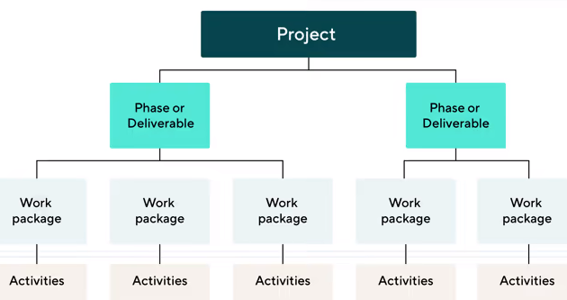
A work breakdown structure is designed to divide the project's overall burden into more manageable chunks. Every task in the project is represented graphically by the WBS. The completed project is displayed at the top of the page, with a line leading to a box (or boxes) representing the larger tasks that led up to it. Then, lines that pass beneath each of these boxes tie it to lesser jobs. The breakdown schedule can also be used to compute budgets and identify concerns when a branch is not properly handled (Organ, 2022). The divide and conquer strategy is another name for this technique. By using a WBS, you may separate the project's final scope into manageable chunks for the project team. This makes it possible to distribute the workload among the project team's members evenly. Until the task can be finished, this procedure can be repeated several times down the task chain (Landau, 2022). The main goal of WBS is to divide labour into manageable parts. It might not offer enough visibility into dependencies, deadlines, or resource allocation, though. Better visibility into these elements could be provided by methods like PERT or the Critical Chain Method, allowing for better planning and collaboration (Lock, 2013).
Figure 10 - WBS Example (Wrike, 2023)

3.4 Program Evaluation and Review Technique (PERT)

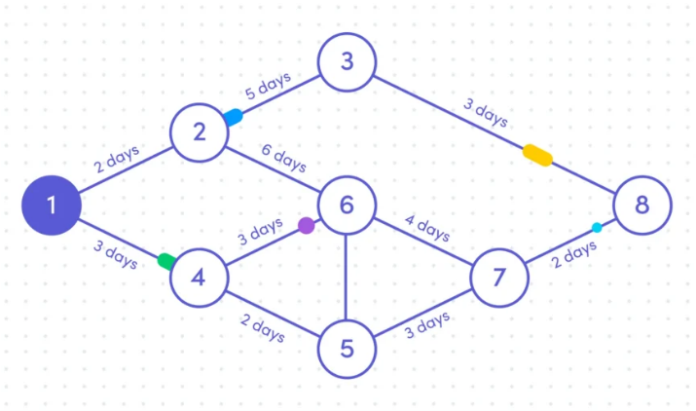
Time estimations are aided by this planning strategy. Both finishing a project on schedule and staying within the allocated budget are crucial. PERT is a tool for managing probability using straightforward statistical techniques. PERT divides the project's tasks into specific activities and then adds these projects to a Gantt chart to determine whether tasks are interdependent. This allows for the creation of a network map of the activities and the visual illustration of their interdependencies (Waldow, 2021). A node in Figure 3 represents an event, and the activities are shown as arrows connecting the nodes. The earliest time and latest time for each activity, as well as how much spare time there is for each activity, may be calculated from this example (Landau, 2022). PERT places a lot of focus on time estimates and critical routes, but it might not effectively take other project constraints, including resource or budget limits, into account. The use of methods like Earned Value Management or the Critical Chain Method might have given a more complete picture of the project's performance, taking into account costs and resource constraints (Roos, 2021).
Figure 11 - PERT Example (Waldow, 2021)

3.5 KanBan

The Kanban Method is a technique for creating, overseeing, and enhancing workflow systems. Additionally, the approach enables organisations to promote evolutionary change by beginning with their current workflow. This can be achieved by stop starting and start finishing, limiting work in progress, and visualising their workflow, which can be managed at the individual, team, and even organisational levels. Any knowledge work environment can benefit from using kanban, but it works best when work arrives unpredictably or when you want to start deploying work right away rather than waiting for other work items to finish (AgileAllaince, 2017). Kanban may not be as useful for projects needing meticulous long-term planning as it is for continuous, iterative labour. By giving a more comprehensive project picture and aiding long-term planning, methods like Gantt charts or Agile project management frameworks may be more beneficial (Anderson, 2010).

4. Leadership Styles

The various methods and demeanours that leaders use to direct and sway their teams or organisations are referred to as leadership styles. These leadership philosophies are founded on a leader's attitudes, convictions, and values, and they have a big effect on how a group functions and behaves as a whole (Kippenberger, 2002).

4.1 Transformational Leadership

The followers of transformational leaders are inspired and motivated to perform above and beyond their expectations. They inspire their team members to embrace change and personal development by articulating a compelling vision and fostering a feeling of purpose. To increase employee dedication and satisfaction, transformational leaders also offer assistance, mentoring, and recognition. High levels of staff involvement and innovation may result from this management approach (IMD, 2023).

4.2 Delegative Leadership

Little interference or direct leadership is used in this method. Delegative leaders provide their team members with the freedom to operate independently and make decisions by delegating authority and decision-making to others. When dealing with seasoned and self-driven people that need little supervision, this strategy can be beneficial. Delegative leadership, on the other hand, could lead to a lack of coordination and direction in circumstances where direction and structure are required (IMD, 2023).

4.3 Authoritative Leadership

A clear vision is established by authoritative leaders, who also provide their team members with specific instructions and expectations. They make judgements on their own, but they also take advice from others into account. These managers actively convey their expectations and are bold and confident in their course of action. Although authoritative leaders offer direction, if they don't allow for enough team discussion or feedback, they could be seen as stiff or dominating (IMD, 2023).

4.4 Transactional Leadership

To ensure that activities are accomplished by predetermined expectations, transactional leaders concentrate on developing clear structures and methods. To encourage their team members and set performance targets and KPIs, they offer incentives and awards. When efficiency and precise execution are required, transactional leadership excels. Given that it largely relies on the exchange of incentives and punishments based on performance, it might not be as effective at creating long-term employee growth and intrinsic motivation (IMD, 2023).

4.5 Participative Leadership

By soliciting the thoughts, recommendations, and input of their team members, participatory leaders include them in decision-making processes. They promote involvement, respect many viewpoints, and aim towards agreement. A collaborative and inclusive work environment fostered by participatory leadership encourages teamwork and employee engagement. It may result in improved problem-solving abilities and more job satisfaction. However, compared to more autocratic leadership styles, it could take longer to achieve choices (IMD, 2023).

5. Project Evaluation Methodologies and Techniques.

5.1 What is Project Evaluation?

A project's success, efficacy, and efficiency are all determined through the methodical process of project evaluation. It entails assessing the project's performance about its goals, as well as its results and impacts. The goal of project assessment is to shed light on the project's advantages and disadvantages, point out areas that could use improvement, and help with future project decision-making (Edis, 2022). As part of the assessment process, pertinent data and information about the project are often gathered and analysed, including project plans, budgets, timeframes, deliverables, and stakeholder comments. It is possible to employ a variety of evaluation techniques and methodologies, such as surveys, document reviews, quantitative analysis, and case studies. (Landau, 2022).

5.2 Surveys

Through a series of structured questions, surveys include gathering information from a sample of people or organisations. You can conduct surveys online, over the phone, via mail, or in person. They offer quantifiable information and make it possible to get standardised data from lots of responders. Surveys can be used to gather opinions, gauge levels of satisfaction, gauge levels of knowledge or awareness, and gather demographic data (Brad Rose Consulting, 2017).

5.3 Document Reviews

Analysing project-related documents, such as project plans, progress reports, financial accounts, and other pertinent information, is known as a document review. This approach aids in evaluating the project's compliance with rules, adherence to plans, and documenting of successes and obstacles. It may offer useful details regarding the project's planning, resource allocation, and decision-making procedures (Shinde, 2023).

5.4 Quantitative Analysis

In quantitative analysis, numerical data gathered for the project is analysed using statistical methods. It consists of evaluations including statistical significance testing, cost-benefit analysis, return on investment (ROI), cost-effectiveness analysis, and ROI. The systematic examination of data to find patterns, trends, and relationships is made possible through quantitative analysis. It offers unbiased and quantifiable insights and aids in evaluating project outcomes, impacts, and efficiency (Ibbs, et al., 2003).

5.5 Case Studies

In-depth research and analysis of certain projects or project components are included in case studies. To comprehend the project's context, procedures, and results, they entail collecting thorough data, conducting interviews, and analysing documentation. Case studies give a thorough and nuanced insight into the dynamics, difficulties, and success aspects of projects (Linkedin, 2023).

6. Project Analysis

6.1 Techniques Used

The Gantt chart was selected as the desired planning technique throughout the project as the author has previous experience using Gantt charts. They are easy to use because they visually illustrate the tasks needed to be carried out as well as the time constraints that are required. This method was paired with CPA to better manage the tasks and prioritise tasks to ensure the project was completed on time.
If this project was to be conducted again, it would be beneficial to explore other management techniques such as WBS or PERT, especially when a team is involved. For the original project, there was a slight inclusion of a project team, but 90% of tasks fell to one individual. Using a management technique such as WBS would have benefited this situation by distributing the workload among the project team's members evenly. Kanban would not be beneficial for this project as the main goals of Kanban are to manage tasks in an ongoing flow and to visualise the workflow. While it can aid in managing ongoing projects and tracking progress, it would not offer enough assistance in the early planning and prioritisation of this project. The Gantt chart and CPA project management techniques used were more beneficial when it came to the comprehensive planning, defining of project scope, setting of milestones, and establishment of design goals.
The methodology used when evaluating the project was primarily based on document reviews combined with post-project sectional critical analysis. This technique was the preferred method of evaluation as there was no data to review, just a product that met the requirements stated throughout the project. Using this evaluation technique, the project was kept on track with the requirements and plans set in place from the beginning. If this was to be conducted again it would be beneficial to conduct a survey with the operators of the Faro Arm, in which they could provide feedback and possible input for future improvements. It would also be beneficial to the stakeholders to know the added benefit the project has made within the department.
The project was carried out with a delegative leadership approach from the stakeholders as the project leader was left to operate with full freedom of the project scope and had the capabilities to delegate tasks throughout the team. From the project leader themselves, an authoritative leadership style was adapted, where minimum tasks were delegated to other team members and tasks were primarily carried out by the project leader. In a team orientated project this was not an optimal leadership style. After reviewing the various styles available it has been concluded that the most beneficial leadership style to utilise would be transformational leadership. This is due to the increased motivation, employee engagement and team performance that this style provides, where a dominant or stiff leadership style is perceived as authoritative.

7. Conclusion

This project itself was produced to identify a feasible safety concern within the workplace and produce a rectifying solution. The problem identified was that the Faro Arm was too unstable to transport around the site without disassembling it from the table mount and transporting it in a carry case. This was due to the weight of the Faro Arm and the fact it operated on a gyro, which could lead to it falling and potentially causing an operator injury. A solution was required to return the Faro Arm to its optimum mobile state. The main constraints of this project were the size, time, maintenance, and cost of the product. The size was a deciding factor when analysing and determining a design variation, which ultimately led to the small and simple design demonstrated in the final product. This design is small but efficient. This product was completed on schedule and within the allocated time stated on the Gantt chart in the appendices. The final product developed does not require any form of maintenance, and if any replacement parts are required then they can be manufactured within the Renishaw facilities. The cost of this project was kept to a minimum, and due to this, the main expenditure of this project came down to the time of the project team members. The part itself did not cost the company any money, as the materials were taken from spare stock and scrap. Given this evidence, and the success of the safety tests and risk assessment, this concludes that this project was a success, and the desired outcome was achieved.

This project report was commissioned to review and analyse the success of this project, in which it has been successful. Various planning, leadership and evaluation techniques have been researched and discovered through the process of this project review, including an analysis of the techniques used within the project itself. Better techniques could have been utilised to improve team collaboration and productivity, as previously discussed in the report.

7.1 Improvements

The project was overall a success, but improvements could be implemented if the project were to be carried out again.
The first improvement would be to spend more time on the designing phase of the project, utilising prototypes and spending more time on discovering the best option and variation of parts to use for the most desired outcome. This process could have been implemented with the use of a second bracket on the Faro Arm to hold the end of the arm from having too much sway during transportation.
Secondly, more research and utilisation could have gone into the operation of the Microsoft Projects software for constructing the Gantt chart. Inexperienced was a factor in not using this software to its most optimum standard, to which time was lost in incorrect operations and learning the new software from scratch.
Finally, this report has highlighted key methodologies that would better utilise members of a team to produce a more effective and productive project outcome. Management techniques would be researched prior to the undergoing of the project to select the most optimal technique for that specific project. A suitable leadership style/ styles should be used to not only benefit the productivity of the team, but better distribute workloads through the various members. And finally various evaluation techniques can be used to analyse and report on the success of the project.

Dylan Payne
Renishaw Quality Control Technician

8. Bibliography

AgileAllaince, 2017. What is Kanban?. [Online]
Available at: https://www.agilealliance.org/glossary/kanban/#q=~(infinite~false~filters~(postType~(~'page~'post~'aa_book~'aa_event_session~'aa_experience_report~'aa_glossary~'aa_research_paper~'aa_video)~tags~(~'kanban))~searchTerm~'~sort~false~sortDirection~'asc~page~
[Accessed 02 04 2023].

Anderson, D. J., 2010. Kanban: Successful Evolutionary Change for Your Technology Business. United States of America: BlueHolePress.
Brad Rose Consulting, 2017. The Use of Surveys in Evaluation. [Online]
Available at: https://bradroseconsulting.com/the-use-of-surveys-in-evaluation/#:~:text=Surveys%20can%20be%20an%20efficient,portion)%20of%20a%20broader%20population.
[Accessed 09 04 2023].

Duke, R., 2023. Gantt.com. [Online]
Available at: https://www.gantt.com/
[Accessed 19 03 2023].

Edis, N., 2022. Day.IO. [Online]
Available at: https://day.io/blog/project-evaluation-definition-methods-steps-how-to-do-it/
[Accessed 09 04 2023].

Geraldi, J. & Lechter, T., 2012. Gantt charts revisited. International Journal of Managing Projects in Business, 5(4), pp. 578-594.
Ibbs, C. W., Kwak, Y. H., Ng, T. & Odabasi, A. M., 2003. Project Delivery Systems and Project Change: Quantitative Analysis. Journal of Construction Engineering and Management, 129(4), pp. 382 - 387.
IMD, 2023. The 6 most common leadership styles & how to find yours. [Online]
Available at: https://www.imd.org/reflections/leadership-styles/
[Accessed 07 05 2023].

Kashyap, S., 2019. Critical Chain Management in Project Management. [Online]
Available at: https://www.proofhub.com/articles/critical-chain-management
[Accessed 26 03 2023].

Kippenberger, T., 2002. Leadership styles. 1 ed. Oxford: Capstone.
Landau, P., 2022. ProjectManager. [Online]
Available at: https://www.projectmanager.com/blog/project-management-techniques-for-every-pm
[Accessed 20 03 2023].

Linkedin, 2023. What are the advantages and disadvantages of using case studies?. [Online]
Available at: https://www.linkedin.com/advice/0/what-advantages-disadvantages-using-case-studies#:~:text=Case%20studies%20can%20explore%20multiple,and%20respond%20to%20the%20phenomenon.
[Accessed 30 04 2023].

Lock, D., 2013. Project Management. 10 ed. London: Routledge.
Meardon, E., 2023. Atlassian. [Online]
Available at: https://www.atlassian.com/agile/project-management/gantt-chart
[Accessed 19 03 2023].

MindTools, 2023. MindTools.com. [Online]
Available at: https://www.mindtools.com/atzj5xr/critical-path-analysis-and-pert-charts
[Accessed 20 03 2023].

Organ, C., 2022. ForbesAdvisor. [Online]
Available at: https://www.forbes.com/advisor/business/what-is-work-breakdown-structure/
[Accessed 20 03 2023].

RoHSGuide, 2022. RoHS Compliance FAQ. [Online]
Available at: https://www.rohsguide.com/rohs-faq.htm
Roos, E., 2021. A distributionally robust analysis of the program evaluation and review technique. European Journal of Operational Research, 291(3), pp. 918-928.
Shinde, S., 2023. Is Project Documentation Really Important? How Does it Help?. [Online]
Available at: https://emeritus.org/blog/project-management-project-documentation-for-success/
[Accessed 10 04 2023].

Tutor2u (a), 2012. Slideshare.net. [Online]
Available at: https://www.slideshare.net/tutor2u/critical-path-analysis-10762045
[Accessed 19 03 2023].

Tutor2u (b), 2021. Tutor2u.net. [Online]
Available at: https://www.tutor2u.net/business/reference/critical-path-analysis
[Accessed 26 03 2023].

Waldow, D., 2021. Monday Blog. [Online]
Available at: https://monday.com/blog/project-management/pert-charts-an-answer-to-your-project-organization-challenges/
[Accessed 26 03 2023].

Waldow, D., 2021. PERT charts: an answer to your project organization challenges. [Online]
Available at: https://monday.com/blog/project-management/pert-charts-an-answer-to-your-project-organization-challenges/

Wrike, 2023. Wrike. [Online]
Available at: https://www.wrike.com/project-management-guide/faq/what-is-work-breakdown-structure-in-project-management/
[Accessed 20 03 2023].

8.1 Appendicies

8.1.1 Fixtures

Figure 1 - Faro Arm 5
Figure 2 - Design 1 6
Figure 3 - Design 2 6
Figure 4 - Design 3 6
Figure 5 - Final Design 6
Figure 6 - 3D Model 7
Figure 7 - Prototype 7
Figure 8 - Final Assembly 7
Figure 9 – CPA (Tutor2u (a), 2012) 9
Figure 10 - WBS Example (Wrike, 2023) 10
Figure 11 - PERT Example (Waldow, 2021) 10

8.1.2 Tables

Table 1 - Problem Selection Matrix 5
Table 2 - Matrix Analysis 6
Table 3 – RAG 6
Table 4 - Risk Assessment & Key 8

8.1.3 Gantt Chart



