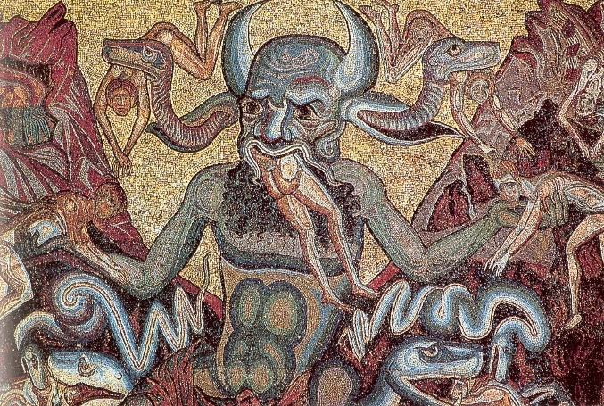

TO WHAT EXTENT WAS THE ICONOGRAPHY OF THE CHRISTIAN DEVIL BASED UPON THE EGYPTIAN GOD BES AND THE GREEK GOD PAN?

Andrew Lock

Written for Dr Ros Coard & Dr Martin Bates as submission for Advanced Archaeological Analysis (AHAC6010)

Table of contents

1 Introduction
1a Summary
1b Background
1c Scope
2 Aims and methodology
2a Aims
2b Methodology
3 Findings
3a Iconography
3c Influence of Bes
3d Influence of Pan
4 Discussion
4a The Devil outside religion
4b Did Bes and Pan have the most influence on the iconography of the devil?
4c Conclusion
5 References

Introduction
Summary
The Devil of the Christian bible is, to the Western world, a figure of pure evil who tempts humans into sin so that they can be tormented in hell for the rest of eternity. Iconography depicting the Devil has evolved over the centuries, and this report will make the case that the Egyptian god Bes and Greek god Pan influenced iconography to the extent that one can still find their influences in modern depictions of the Devil.
Background
The devil is a figure that represents pure evil in the bible, he is credited with convincing Eve to eat the forbidden fruit from the tree of knowledge, thus causing the downfall of man. He is considered the great tempter, with his goal being to lead humanity astray from God. He has been depicted in many different forms, as a serpent, a half man half goat, or with horns and a tail, among others. The stories associated with the devil can be found in ancient religions, and when examined, features that were common in the depiction of ancient deities can be seen in the iconography of the devil. This becomes most noticeable in the medieval period, where iconography depicting the devil shares clear similarities with ancient deities. One of the most well-known examples of this is the iconography of the devil in the Florence Baptistery, which was constructed between 1059-1128. The devil did not simply appear out of nowhere, his story and iconography was influenced by those that preceded Christianity, and this report will attempt to uncover the basis on which the devil was established. By determining how ancient deities inspired the image of the devil it may be possible to judge exactly how the history of the devil emerged, as well as how Christianity was able to become a dominant religion in a time when the so called pagan religions were widespread and popular.
Scope
This report will be looking at depictions of the devil through history, from early Christianity to the late medieval period. This scope allows one to see the evolution of the devil from the earliest days of Christianity to how he is commonly depicted today, since many modern depictions draw their inspiration from these earlier pieces. Since this report is focusing on the influence Ancient Egyptian and Greek deities had on iconography of the devil, by default this report will also widen its scope to include the Ancient period. While this scope may appear quite wide, it is important to cast the net wide in order to capture the details of the ancient deities and see how they have been integrated into the story and iconography of the devil.

Aims and methodology
Aims
The aims of this report are: To examine a relief of Bes from Dendera
To examine a statue of Pan
To examine the image of the devil in the Florence Baptistery
To examine the story of the devil and the evolution of early Christianity

The objectives of this report are: To examine the iconography of the devil and determine any features that were taken from ancient deities
To establish the extent to which the Egyptian deity Bes and Greek deity Pan influenced the iconography of the devil
To determine why certain deities had features attributed to the devil
Methodology
In order to examine how Bes and Pan influenced the Christian devil this report will look at various books and reports that have explored the history of the devil and Christianity, in order to gain a better grasp on how this monotheistic religion became more dominant than the older polytheistic religions it had to contend with. As well as examining written literature, iconography of the devil is of course an important source of material to this report. The Florence Baptistery is an excellent example of the devil in artwork and one can clearly see where inspiration has been drawn from the depiction of other deities. This report will also examine other depictions of the devil, as well as reliefs of ancient deities to compare them to, in an effort to pinpoint similarities between them where it can be ascertained that features were taken from the ancient deities and given to these depictions of the devil. Depictions of Bes and Pan will be used more heavily, since the focus of this report is to argue that Bes and Pan influenced the devil’s iconography more than other ancient deities.
Findings
Iconography
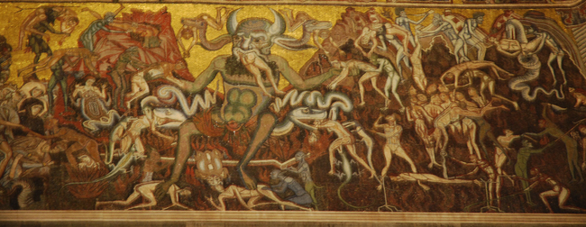
The iconography of the devil varies widely depending on the time period and where in the world it was created. This is due to the fact that every culture has its own distinct art style and ways of seeing the devil or evil. Early medieval iconography from Western Europe for example, depicts the devil as a monster, with grotesque features and often causing harm to humans. This can be seen in the Florence Baptistery, which is an Italian basilica built in the 11th-12th centuries. The iconography depicts the devil punishing the wicked in his capacity as the lord of hell.
In this scene, the devil has serpents in his ears, as well as horns, both of which were associated with the Egyptian deity Bes. “Bes, who was associated with drinking, sex and revelry, sported a beard, horns and a forked tail, and may have served as the inspiration for depictions of the devil in Western art” (Kieger. P. 2016). In this instance, it is the physical attributes of Bes that have been appropriated for use with the devil. In this image from the Florence Baptistery, one can also see that the devil is in the process of devouring the damned. This is arguably a trait that was taken from the Egyptian deity Ammit, also known as the Devourer, whose role was to prevent the unworthy from reaching the afterlife. In a sense, this is similar to the role of the devil, who tempts humans to stray from God, and then torments them in hell after they die.
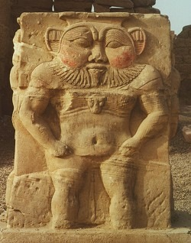
The Egyptian deity Bes was a god of drinking, sex, and revelry, and was a popular deity among the Egyptians, many of whom adopted him as a protector. He is depicted as a short figure, with a squashed face and red cheeks. When comparing this relief of Bes one can see similarities with the depiction of the devil in the Florence Baptistery. The wide face and even body shape bear a strong resemblance to each other, as there is an emphasis on the stomach that can be seen on both. The relief that can be seen here was at the temple complex of Dendera, which contained within it a number of shrines to various deities. Bes, as a patron of childbirth, had numerous depictions along the walls of birth houses. As there are “remains of a Coptic Christian basilica dated to the fifth century AD” (Ancient Egypt Online) near the temple complex, it is highly likely that early Christians would have seen this deity, and incorporated aspects of his features into the story and depiction of the devil.
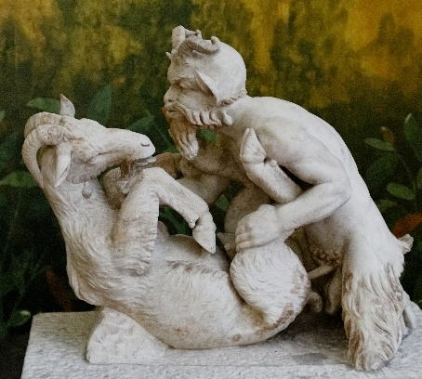
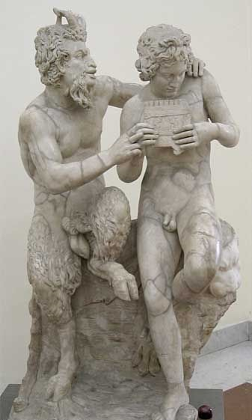
The Greek deity Pan is another figure who likely heavily influenced the iconography of the devil. Pan was sometimes depicted as a half man half goat figure, a common depiction of the devil. It is therefore likely that at some point in the early days of Christianity, Pan was selected to have his more defining features incorporated into the depiction of the devil, likely in an effort to demonise the deity. Pan was a popular god amongst both Greeks and Romans with the image on the left showing a Roman replica of a Greek statue that was found in Pompeii. The fact that Pan was such a widespread deity suggests that he was purposely targeted by early Christians to be demonised in an effort to spread their own religion. Pan has been depicted with several different features, sometimes with a goat’s head instead of a man’s, and can often be found in iconography depicting sexual scenes, including bestiality, as can be seen on the right. “Pan was one of the first 'party animals.' The horns and lustful nature of Pan would make him an obvious choice for Christianity’s Satan, especially taking Christianity's conservative outlook into consideration.” (Murray. A. 2016).

Influence of Bes
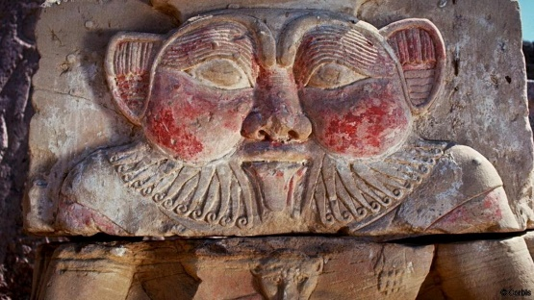
Bes appears to have had a large impact on the iconography of the devil. As mentioned earlier, Bes likely inspired the appearance of the devil with the horns, forked tail, and association with serpents. The horns, one of the most recognisable symbols of the devil, may have been taken from Bes, since they would have been a recognisable element of Bes and thus enabled his demonization. Early Christianity had a lot of competition in setting itself up as a dominant religion, as there were many popular polytheistic cults around, with dozens if not hundreds of deities that could be worshipped, which is why employing demonization of deities from other religions as a tactic was undertaken by early Christians, since they would promote their own monotheistic faith as a better alternative to religions where more than one deity could be associated with evil.
Serpents were sometimes depicting emerging from Bes’ body, and this can also be seen in the Florence Baptistery. (Sooke. A. 2014). This is clearly Christianity appropriating aspects of a god from an older culture and twisting their purpose to serve the Christian narrative that the devil was attempting to lead people astray by worshipping false idols. The fact is that Christians had no other choice in the early days of the church but to associate other deities with evil, as they were attempting to gain followers from some very well loved religions. Bes may have been selected to be demonized as he was associated with sex, drinking and revelry, something the conservative Christianity did not agree with, as in their eyes, such things were sinful and would lead to eternal damnation.
Influence of Pan
“The Church did to Pan what Stalin did to Trotsky," the art critic Robert Hughes writes in Heaven and Hell in Western Art. "The attributes of Pan were given, in art, to the Christian Satan." This quote arguably perfectly sums up what happened to the Greek deity Pan, a god who was incredibly popular before Christianity were able to demonise the half goat god as a figure that was wholly evil. Pan was a deity who represented nature, fertility and lust, and by association, sexuality. This would not have sat well with early Christians who, as mentioned earlier, were incredibly conservative and did not approve of sex and sexuality being openly explored and celebrated. Indeed, “The Greek deity Pan was one of the more popular gods of the Greeks, and was therefore a powerful competitor to the fledging Christianity for the hearts of the people” (Hearne. K. 1998). This, coupled with the fact that Pan essentially represented freedom to express sex, likely made the deity a prime target for Christianity to demonise, as their conservative nature and changing social attitudes meant that the openness represented by Pan was no longer acceptable.
Pan’s beard, goat legs and hooves were appropriated by Christianity and used to depict and describe the devil early on, as was mentioned earlier about Pan’s iconography. These features are still used to depict the devil today, so one could argue that Pan definitely had a heavy influence on the iconography of the devil. It is unfortunate that early Christianity felt the need to actively demonise other deities like Pan since “the appropriation of his image is only one of many examples where an organized religious group has gone against its core values of kindness and acceptance to villainize an existing culture that was perceived as subordinate due to their own ambitious desires.” (Murray. A. 2016). The fact that Christianity actively sought to demonise deities from other religions does fly in the face of the values the Church claims to champion, though the early Church is very different to the Church today. Pan and other deities clearly suffered a besmirching of their reputations, and it is likely one of the reasons why the polytheistic religions fell out of favour.
Discussion
The devil outside religion
As propaganda
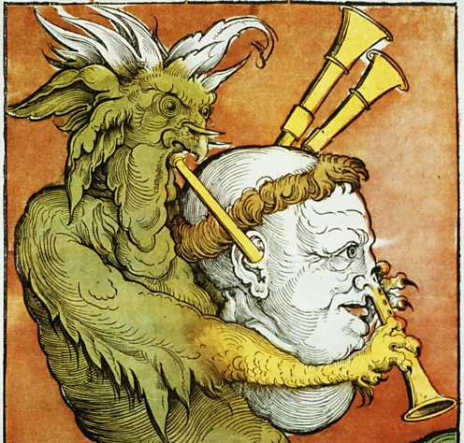
The devil has been used as propaganda since at least the medieval period. Since in the first few centuries Christianity merely used other deities as stand-ins for the devil, many of the earliest images of the devil show these deities features with the devil, which proved rather successful in promoting Christianity as a dominant religion. However, “when the church split during the Reformation, both Catholics and Protestants accused each other of being influenced by the devil. Propaganda used playful and grotesque imagery to show this corruption at work.” (BBC news). This can be seen in the image of the devil playing a monk’s head, right, suggesting the Catholic Church was an instrument of the devil. What should be noted here is that the image of the devil has evolved from merely incorporating aspects of other deities to having a more distinct identity, perhaps due to the fact that the original purpose of demonising other deities had largely been accomplished by the time of the Reformation.
Outside of propaganda between rival factions, the devil has been used when people attempt to vilify those such as political leaders. One such example of this is the caricature that appeared in The Sun on 17th April 1998. It shows the devil rejecting the Cambodian dictator Pol Pot from hell. This is an interesting take on using the devil as propaganda since it inverts the normally gleeful evil associated with the devil and suggests that there are some people even worse than the Prince of darkness. The caricature can be seen below. It should be noted that the even at the end of the 20th century, the devil is still depicted with horns that were originally attributed to Pan before being appropriated.
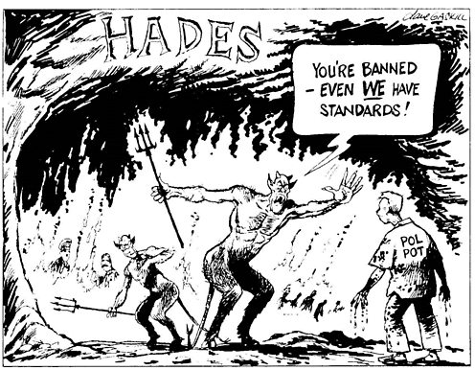

The devil outside religion
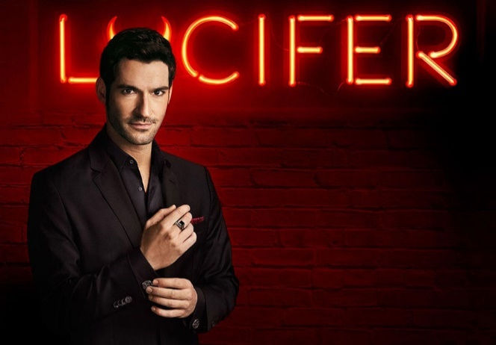
Of course when determining whether ancient deities impacted the iconography of the devil one must also look into how the devil is portrayed in literature. The devil has appeared in many instances outside of the bible, either in moral tales designed to teach people not to fall prey to one of the deadly sins, or even in modern television and films. An example of this would be the television programme Lucifer, an American show that twists the standard narrative of the devil into one of a misunderstood and not inherently evil figure. In the case of Lucifer, every evil and devil figure throughout human history has been the same individual, having simply adopted or been called different names. To an extent, the show does still use some stereotypes, as the actor portraying the devil is a well-dressed, well-spoken and well-mannered British man, which has been a common way of portraying the devil, particularly in American media. This is merely one depiction of the devil in media however, most other media depictions tend to stick with the original description of the devil, a fallen angel who is now bent on getting revenge by deceiving humanity into committing sin and thus depriving themselves of heaven.
Television is only one form of media entertainment. The devil also appears often in literature. Often the devil is a source of evil and suffering in works of fiction, but in a rare few cases the devil is portrayed in a more sympathetic light. An example of this would be John Milton’s Paradise Lost, in which while the devil is still responsible for the downfall of humanity, he is a complex character who uttered the line “Better to reign in hell, than serve in heaven.” This portrayal of the devil matched the rebellious sentiments being expressed in the 17th century by republicans. “Milton’s fierce sense of the need to champion the right of every man to his own opinion, and his dislike of anything that savoured despotism in government led him, perhaps even without realising it, to make God, the omnipotent and omniscient ruler of the world, into an autocrat, ready to crush any sign of independent revolt. And so the rebellious one, who dared to defy the all-powerful, almost inevitably became a tragic hero, whose persistent refusal to submit evokes admiration for his courage and sympathy for the terrible punishment inflicted upon him.” (O’Grady. J. 1989, p130).
This type of depiction of the devil makes one think about how a being who is supposedly evil can be related to and even understood to an extent. This type of imagery is arguably just as important as physical iconography, since the devil has still been depicted, just in a different medium that relies on imagination rather than a physical piece of art. Milton’s Paradise Lost has since had artists depict scenes from the poem, further allowing one to see a different way of presenting the devil. An example of artwork linked to Paradise Lost can be seen below.

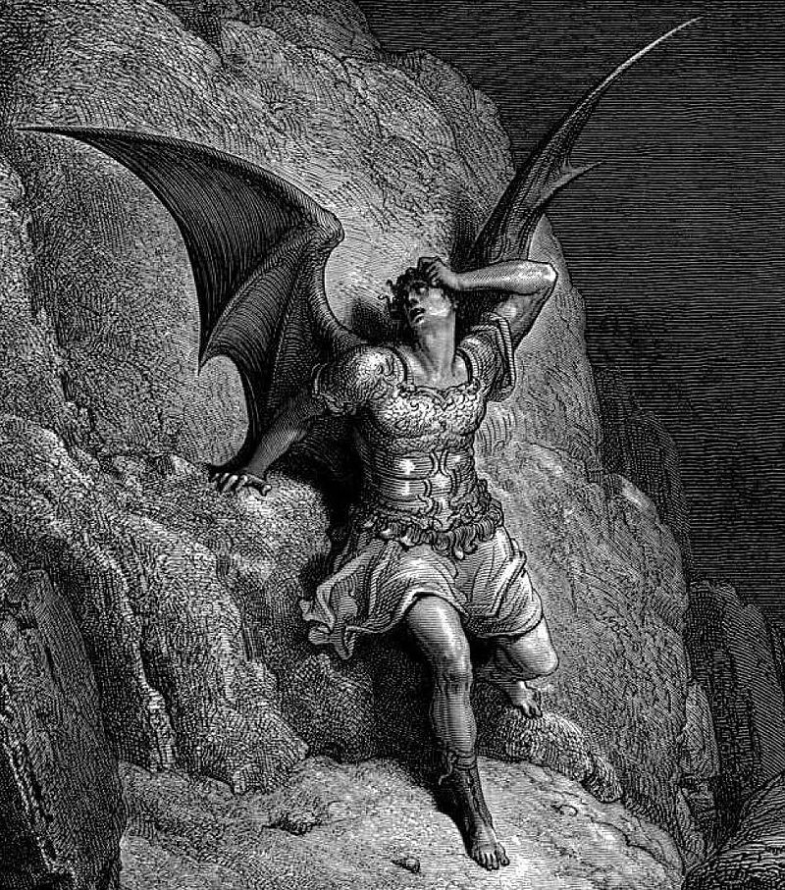
As one can clearly see, this devil is vastly different to most religious depictions of the devil. Aside from the dark, ominous wings, the devil appears like any other heavenly being. This type of iconography is interesting in that one can see how others perceive a being that has been associated with destruction and death when the religious implications are removed or depicted in a different manner.

Did Bes and Pan have the most influence on the iconography of the devil?
Having taken into account the origins of the devil’s features, as well as how the devil is portrayed today, this report would argue that Bes and Pan did have the most influence on the iconography of the devil. Considering that the features that defined Bes, serpents, horns, and a forked tail, and the features that defined Pan, the horns, the beard, and the goat legs are the features that most people think of when they think of the devil, it is clear that the demonization of these figures by the early church was a success. Particularly until the Enlightenment period, these features became associated more with the devil than any other figure after Christianity was established. In early Christianity those who worshipped Bes and Pan would have eventually been vilified by the growing number of Christians for worshipping false idols and aspects of the devil, the source of all evil in Christianity. In this respect, the early Church achieved it aims, as well as successfully establishing itself as a prominent religion within Europe and parts of the Middle East and Africa.
However one must take into account the fact these deities were selected out of dozens of others to be demonised for a reason. That reason is that they were popular. They were two widespread deities that had outgrown their basis as cultural gods and had become worshipped by many people of many different cultures. In a sense they had been elevated above being simply symbols of sex and revelry, they had become symbols of freedom of expression. This threatened the conservative church, as it can be assumed that people would prefer to be free to make their own choices rather than be governed by a doctrine that restricted what many may have grown up with. So for the church to successfully ‘bring down’ these deities is an impressive feat.
Conclusion
To conclude this report, one should consider that while the Egyptian deity Bes and Greek god Pan had the most influence in depicting the iconography of the devil, changing opinions and the move towards atheism in modern society likely means that the devil will evolve too, as the figure has done for hundreds of years. Bes and Pan were simply popular figures that the church was able to demonise and use to show that their god was the only god at the time, now that neo-paganism is on the rise, combined with record numbers of people describing themselves as atheists, the church and devil must undergo a change as well, if Christianity is to survive.
One should also take into account how the devil has already changed in some respects. Aside from the deeply religious, most people now picture the devil as a man or resembling a man, and this can be seen in modern literature and media. Consider how the devil has been depicted as a misunderstood or tragic figure, and the ramifications this has for organised religion, as a figure that is central to their belief system, one who is the source of all evil and must be avoided at all costs in order to gain entry to paradise, has now become a figure that people relate to and even sympathise with. In this respect, for the modern period Bes and Pan no longer impact the iconography of the devil as they once did in the days of early Christianity, as they are no longer popular deities that undercut Christianity.
References
Kieger. P. 2016: The devil: understanding the root of evil. National Geographic
http://www.ancientegyptonline.co.uk/denderatemplecomplex.html
https://www.theodysseyonline.com/demonization-pan-art-business-control
Sooke. A. 2014: How Egyptian god Bes gave the Christian Devil his looks. BBC
Hearne. K. 1998: The demonization of Pan.
http://www.bbc.co.uk/timelines/zwsfg82#zp4kqty
Plates
Title page image: Devil of the Florence Baptistery Available at: https://eurotravhist.wordpress.com/2010/01/26/metz-cath/
Fig 1: Florence Baptistery Available at: http://www.worldofdante.org/pop_up_query.php?dbid=I470&show=more
Fig 2: Relief of Bes Available at: http://www.globalegyptianmuseum.org/glossary.aspx?id=89
Fig 3: Statue of Pan Available at: http://www.theoi.com/Gallery/S22.2.html

Fig 4: Statue of Pan Available at: https://en.wikipedia.org/wiki/Pan_(god)
Fig 5: Relief of Bes Available at: http://www.bbc.com/culture/story/20130619-how-the-devil-got-his-looks
Fig 6: Protestant Propaganda Available at: http://www.bbc.co.uk/timelines/zwsfg82#zp4kqty
Fig 7: Devil as a political cartoon Available at: http://www.bbc.co.uk/timelines/zwsfg82#zp4kqty
Fig 8: Image of Lucifer TV show Available at: https://www.amazon.com/dp/B01AMXSQE6
Fig 9: Lucifer from Paradise Lost Available at: https://en.wikipedia.org/wiki/Paradise_Lost

