

LEVEL 7 ASSESSMENT SPECIFICATION

Student name: | Chan Shuk Yan | Student ID number: | 1921901
Programme: | MBA
Module: | Strategic Management
Module code: | HKBM7013 | Contribution to Overall Module Assessment (%): | 100%
Lecturer: | Dr Terence Li | Internal Verifier: | Dr Leo Ho
Assignment Title: | Assignment 1 | Word count (or equivalent): | 5,000 words  +/- 10%
Submission deadline: | 5 October 2020 | Return date of provisional marks & written feedback: | Within 20 days after submission
Submission method: | All written assessments, where practical and possible, must be submitted via Turnitin unless otherwise instructed by the Lecturer. (Please DO NOT put this assessment specification into Turnitin or it will match many similarities with other students’ submissions.)  Alternative submission method (if applicable):  Late submission of the assessment will result in a late penalty mark. Penalties for late submission: Up to one week late, maximum mark of 50%. Over one week late, 0%. Only the Extenuating Circumstances Panel may approve a change to submission dates.
Academic honesty / referencing: | Academic honesty is required. In the main body of your submission you must give credit to authors on whose research and ideas your work is based. Append to your submission a reference list that indicates the books, articles, etc. that you have used, cited or quoted in order to complete this assessment.

UNIQLO Strategic Management
Chan Shuk Yan Gloria

5 October 2020

Table of Contents
- Relationship between “Strategic Direction” and “Vision, Mission, and Values (VMV) of a company using Fast Retailing 5
1.1. Definition of VMV and its effects on business, corporate and functional strategies 5
1.2. Vision 5
1.3. Mission 6
1.4. Values 6
1.5. Relationship between strategic direction and VMV 7

- Macro-environmental analysis for Hong Kong casual wear industry and determine the opportunities and threats of the industry 7
2.1. Economic analysis 7
Figure 1. HK Economic declining trend 9
Figure 2. HK economic growth rate 9
Graph 1. Global Economic Growth Trend 10
2.2. Social factors 11
Figure 3. HK Economic declining trend 11
  - Technological factors 11
2.4. Political analysis 12
Figure 4. Decrease in HK retail sale 12
2.5. Environmental factors 13
2.6. Legal factors 13
2.7. Opportunities and threats 13
- Identity the corporate strategy and business strategy proposed by Fast Retailing recently. Evaluate the effectiveness of these strategies based on Balance Scorecard.
14
3.1. Corporate strategy 14
Figure 5. Vertical integration 16
3.2. Business strategy 16
Table 1. Manufacturing Scorecard 19
Figure 6: Overall business performance of UNIQLO 20
Figure 7: fast retailing group performance 20
  - Financial perspective 19
3.4. Customer perspective 19
Figure 8. Customer Satisfaction levels 19
3.5. Internal process perspective 20
3.6. Learning perspective 21

- What are your recommended corporate and business level strategies to Fast Retailing? Critically discuss how you can effectively implement the above strategies.
22
Chart 1. Gannt Chart Recommended market activities of Fast Retailing 23
Chart 2. Recommended market activities of Fast Retailing 23

- References 26

- Relationship between “Strategic Direction” and “Vision, Mission, and Values (VMV) of a company using Fast Retailing
1.1. Definition of VMV and its effects on business, corporate and functional strategies
Developing a mission, vision, and values are crucial for the strategic direction of a company (Tallant, 2011). A VMV can be identified as the philosophy that guides a business activity, the future long-term goals, and businesses practices of a firm as well as the reasons for the firm’s existence. It also differentiates a firm from others in relation to the market and goods within the industry it operates (Taiwo, Lawal, and Agwu, 2016). The VMV of a business guides in implementation of the four elements under corporate strategy. In the allocation of resources, the long-term goals are put in perspective and guided by definite principles while organizational design communicates the beliefs of the company. In the fourth element of the corporate strategy of risk management, the VMV ensures that a holistic short term and long-term perspective is provided (Pettinger, 1996). A business strategy cannot also be executed efficiently without presence of VMV. With the business strategy including the actions and the decisions of an organization, it is essential that they always follow the principle and philosophies of a business, be in line with the long term and short term goals of the organization (Courtney,1998). VMV also comes in handy in the execution of functional strategy. A company’s functional strategy focuses on the abilities and skills of individual employees and the departments they operate in (Gutterman, 2011). A VMV hence ensures that there is unison and cooperation among the employees and the departments since they work under a common standard and towards a common goal. The absence of strong values dictated by the vision and developed via mission interrupts a company's overall success.
1.2. Vision
A vision is considered as a credible, attractive, and realistic future of a company (Nanus, 1992). A realistic and attractive vision motivates, inspires, and ensures commitment to the management as well as workers. In that context, a well-strategized vision provides a clear picture of the future, and it is based on logical reasoning of the company's plans (Papulova, 2014). The fast retailing vision statement is, "Changing clothes. Changing conventional wisdom. Change the world." Fast retailing vision is a great summary of the company's purpose for functionality and existence. Of course, creating quality clothes and transforming peoples' lives and knowledge around clothing all over the world is not a one-day job. Rather, it reveals the route Fast retailing is taking in strengthening LifeWear.
1.3. Mission
While a company vision is embedded in determining a company's destination, a mission statement is concerned with the present business purpose and scope. It points out what, why, and who of a business (Thompson et al. 2013). A mission statement identifies the target group a company seeks to serve, satisfy, and deploy products and services to achieve its goal. The fast retailing mission is "to create great clothing that offers new and unique value, and delivers experiences of joy, happiness, and satisfaction to people all over the world." The mission reveals the business's usefulness, which is to enrich people's lives with joy, happiness, and satisfaction through unique and quality clothing. According to (Papulova, 2014), the mission is a source of direction for employees and helps customers and the public understand the fundamental principles a business operates in. To some extent, the mission may explain the values and beliefs of a company.
1.4. Values
Company values are critical in guiding a company's vision. Vision is often related to the mission and values of a company. Values are considered as the beliefs, practices, and principles that guide the decision-making process, pursuit of the strategic vision, and the behavior of organization personnel (Thompson et al. 2013). Therefore, the values are a guiding principle on how a company treats its customers, service quality, ethics, integrity, workforce, innovations, and social responsibility to achieve the ultimate goal (Tallant, 2011). A company with strong guiding principles links their values and vision to enhance relevance in the market place. Fast retailing values are "approaching issues from a customer perspective. Embracing innovation and challenge, respect and support individuals and committing to correctness and ethical standards." The values are deeply rooted in sustainable growth through innovation.\

1.5. Relationship between strategic direction and VMV
Based on the explanations above, it is evident that an organization cannot succeed without values, dispensed by the vision, and implemented by the mission. Thus, vision, mission, and values are vital for an organization while developing a strategy. Fast retailing values such as commitment to the correctness, innovation, and producing products that satisfy customers are combined to develop a mission statement," create great clothes that provide unique value and delivers clothing joy, happiness and satisfaction to individuals all over the world." Through this mission, it is easy to note that Fast Retailing is on a journey to continuously improve the quality of their products to reach the goal of enriching people's lives worldwide.
A fast retailing mission statement helps customers and employees understand the company is all about creating unique value through clothing. As employees understand and implement the company's values and mission, they engage in a path that leads to the vision. Thus, understanding the interaction between values, mission, and vision helps in devising a strategic direction. Strategic direction is the means, activities, and policies pursued by an organization to achieve the desired values, mission, and vision. The vision creates a bridge between values, mission, and strategic direction. For example, Fast retailing vision is "changing clothing, conventional wisdom and the world" insist on continuous innovation of clothing that provides new value and satisfaction to customers around the world (Carpenter, Bauber and Erdogan, 2012). Therefore, a company cannot develop a strategic direction in the absence of values dictated by a vision and acted upon by mission.
- Macro-environmental analysis for Hong Kong casual wear industry and determine the opportunities and threats of the industry.
Understanding macro-environmental factors inform a company on future actions, which enhances the achievement of desired competitive advantage (Baker, 2012). Thus, the macro-environmental analysis illustrates the external influences that may affect a company's decision making and business processes. The macro-environment, in this case, will be analyzed using the PESTEL model (Posner, 2015).

2.1 Economic analysis
This is the first most important factor in the macro-environment of the Hong Kong wear industry since it determines the consumer’s ability to purchase, the cost of factors of production and the price of goods in the market. Given the political unrest in 2019 and the prevailing global pandemic, the Hong Kong economy is on a downward trend. However, the Hong Kong economy is on a downward trend as it recorded a GDP of -1.2% in 2019 as compared to 2.9% in 2018. The slowdown is a result of trade tensions between China and the USA, declining the Chinese economy and the tight credit conditions pushing Hong Kong Monetary Authority (HKMA) to increase their rates. Besides, following the spread of COVID-19, economic growth was expected at -4.8% in 2020. However, considering the decrease of 9.1% in the first half of 2020 and the massive social distancing measures, Hong Kong GDP growth is projected at -6% to -8% in the next half.
COVID-19 is the primary threat to the global economy. According to Aguiar et al (2019), the global pandemic has reduced production elasticity to almost zero to cover the dort-term inability to import products and production materials from other countries. Another way COVID-19 has impacted the economy is through reduction in employment opportunities which points back to low production, imports and exports since households income has shrinked significantly (Wyman, 2020). Also, the pandemic has increased trade costs where the price of exports and imports have risen and reduced the competitiveness of Chinese businesses. Lower income and competitiveness has resulted to a decline in esports and imports as well as tourism activities which is a big blow to the economy (Maliszewska, Mattoo and Mensbrugghe, 2020; Maryla and Aaditya, 2020). The following graphs are a representation of how political unrests and virus outbreak are affecting Hong Kong economy.
Figure 1: HK economic declining trend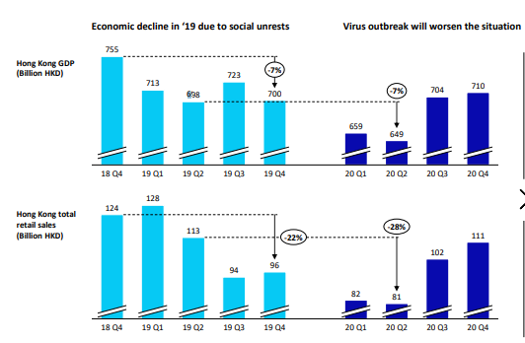
Figure 2: HK economic growth rate
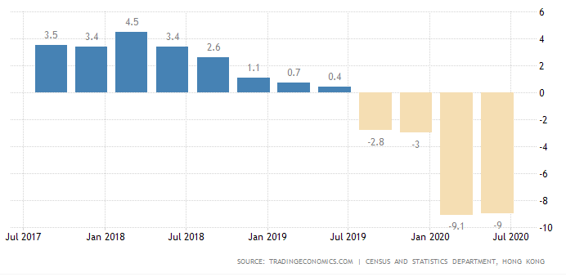
The disposable income and employment were at 670, 596 HKD in March 2020, a decrease from 791, 804 HKD in 2019. It means that there is less money available for consumers to spend on casual wear, which reduces the overall sales of the casual wear industry in Hong Kong significantly. Households are spending mostly on basic needs such as food since their income has reduced (OECD, 2020).
In terms of growth in the global economy, McKinsey report (2020) indicated that the global economy is under pressure due to the increasing geopolitical and political instabilities across the world. Brexit and trade tensions continue to impact global economic growth significantly. The US-China trade war has led to billions of dollars’ worth tariffs being imposed on imports between the two nations, which is a huge implication to the global economy (Fernandes, 2020). According to OECD (2020), the Chinese growth rate fell by 6% in the third quarter of 2019 financial year, and exports were 3.2% lower than the previous year. Besides, political upheavals in Latin America and Asia are continuously increasing uncertainty and pessimism among consumers and business owners. The long-running political protest in Hong Kong has seen retail sales decrease drastically.
Nonetheless, the McKinsey report indicates that the fashion industry could tackle the existing challenges by adopting new business models. (Remy, Schmidt, Werner, and Lu, 2013). It means the COVID-19 pandemic is a severe threat to the global economy and well-being (Walker et al., 2020). The graph below is an illustration of the global economic growth trend.
Graph 1: Global Economic Growth Trend.
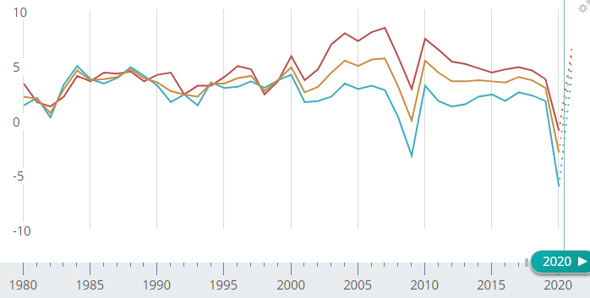
Raw materials and labor have also been impacted by the coronavirus outbreak. Although the Hong Kong textile industry has partnered with other companies in other nations to recycle fibre and provide quality products, the global pandemic has caused a delay in the production of raw materials as well as imports (McKinsey report 2020).
2.2 Social factors
Social factors are linked to cultural beliefs, population growth, career choices, age, and health consciousness, among others. These factors are of particular interest as they directly influence how the casual wear industry interacts with consumers. (Curtis, Watson, and Saphton, 2007) argued that social-cultural trends have a significant impact on the fashion industry. Kinoshima (2018) argues that social structures play a significant role in business actions and is identified as a mutual conditioning process between economic actions and society. Consumers are critical and interest in products and the store whether virtual or real (Tamura, 2001). According to the McKinsey report, fashion consumers in the present decade are self-proclaimed and driven by beliefs and can choose or boycotting a brand based on societal issues.
Furthermore, Chinese people pay attention to health and life quality (Walters and Mead, 2012), which has increased the demand for functional casual wear and prompted the manufacturing sector to enhance research and development as well as innovativeness. It means that the casual wear industry may have to focus on simple designs made of quality material to increase competitiveness (O’Cass and Siahtiri, 2020).
Nonetheless, casual wear brands such as UNIQLO have felt the change in consumer preference and business environment, and are continuously producing affordable and quality clothing. Consumers make decisions based on information researched thoroughly from online sites (Rinnebach and Richter, 2014).
  - Technological factors
Technology is a vital aspect influencing the growth of the casual wear industry in Hong Kong and across the world. A huge part of the 21st-century growth in the clothing industry is due to the sprout and use of IT, increasing the use of smartphones, globalization, and the internet to shop, which has affected consumer choice, marketing, and sales. Internet developments and improved communication technologies allow customers to make decisions based on research, shop online, and enable clothing brands to respond fast to emerging market impulses (Nenni, Giustiniano and Pirolo, 2013). According to a Go-Globe report in 2018, more than 88% of people in Hong Kong had purchased products online at least once making the technology the third most important factor. In the clothing and accessories category, Hong Kong leads in online shopping at 41.7%, which can be attributed to the customized experiences and customer services. However, the more the internet advances, the more consumer demands increases since the internet provides the latest information on fashion new trends and styles. Thus, technology innovations have made consumer decision making and purchase of casual wear easy and convenient (Stout, 2013).
2.4 Political analysis
Hong Kong experienced prolonged political demonstrations in 2019 after elections in September has increased tensions and uncertainty in the casual wear industry. The anti-government protest was as a result of a proposition to change laws. The unresolved political issues and increasing uncertainty have affected consumers' confidence and led to a significant decline in sales in the retail sector. Following the 2019 protests, uncertainty and volatility have proceeded in 2020, leading to cautiousness among consumers while spending. According to the Hong Kong Census and Statistics Department, retail sales declined by 35.5% in the casual wear industry following the protest amidst other causes such as the coronavirus pandemic. It should therefore be considered as the fourth most important factor within the clothing retail industry.
Figure 4: Decrease in HK retail sale
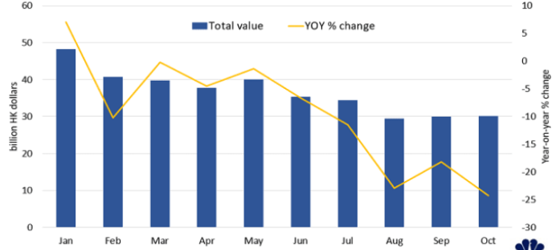
  - Environmental factors
Environmental sustainability has become a huge term in the casual wear industry in the present times. The increasing trends of pollution, carbon footprint regulation, and health hazards have led to increased social responsibility and ethical consideration in the clothing industry (Choi et al, 2012). Clothing brands are becoming more careful about carbon footprint as they seek to be more sustainable. For instance, fast retailing aims to invest in environmental sustainability through close monitoring of their manufacturing processes and environmentally friendly raw materials, operations, and packaging. Based on the McKinsey report in 2019, fashion companies prioritize sustainability by transforming their product manufacturing and design. The report proceeds to illustrate that 65% of consumers in developing markets are seeking sustainable clothing, and 32% of consumers in the developed markets prioritize sustainability. This is the fifth factor since it is among the least factors that consumer considers in the buying decision. Therefore, environmental sustainability is a major factor in influencing the purchasing power of consumers.
  - Legal factors
Laws and regulations are present in all businesses, and the casual wear industry is no exemption. Compliance with the set rules and observing business ethics is a major focus of the casual wear industry. Other than the common laws and labor laws, environmental regulations have increased in severity, and businesses must comply, which is beneficial for the clothing industry in Hong Kong (Shen, Dong and Perry, 2017). Overall, pollution regulations are more likely to impact manufacturing processes in the industry. Legal factors should be the sixth most important in the fashion industry since it does not affect consumer to a great extent.
2.7 Opportunities and threats
Based on the macro-environmental analysis, the industry has different opportunity areas. The first opportunity is embedded in political unrest and China-US trade. Brands in the casual wear industry have the opportunity to observe the unfolding of the trade wars and identify new sources of sustainable fabrics, among other raw materials. For example, it has not been easy for China to supply labor or materials in the past. Still, given the trade tensions, it is possible that the commercial restrictions could loosen and enable Hong Kong casualwear brands to source raw materials and cheap labor. Another opportunity is the rapid growth of technology and internet usage. Clothing companies can adopt the latest technology to increase production and distribution. Besides, increased online shopping provides an opportunity to launch online stores and increase sales. The growth of the aged population also presents a chance for the industry to develop clothes in consideration of demographic factors. Consumers' needs vary with age, which offers the industry an opportunity to diversify their products.
In regard to threats, prolonged political instabilities in Hong Kong is a major challenge to the industry. Trade bans and geopolitical instability can affect the supply of raw materials and result to slow economic growth, which in turn restricts the spending rate of consumers.
- Identity the corporate strategy and business strategy proposed by Fast Retailing recently. Evaluate the effectiveness of these strategies based on Balance Scorecard.
Fast retailing is a globally recognized brand and specializes in multiple fashions that involve GU, UNIQLO, and Theory. As a leading retailer and manufacturer of casual wear, fast retailing strives to provide high-quality and reasonably priced apparel through managing the production, design, procurement, and retail sales. UNIQLO annual sales in FY2019 were at 1.9 trillion yen and is persistent in providing unique products that are of high-quality and produced from high-end materials (Fastretailing.com, 2020). Fast retailing is currently pursuing the following strategies to achieve its goal.
  - Corporate strategy
One of the main corporate strategies is for the company to continue developing superior quality products that enhance customer satisfaction amid the ongoing COVID-19 pandemic. As more customers embrace the Lifewear concept, the CEO insists on ensuring that the simple and quality LifeWear clothing impacts people's daily lives all around the world. According to Tadashi Yanai, the CEO of fast-retailing, cheap and poor-quality clothing negatively influences consumer perception regarding a brand. In that order, the company strategy is product positioning, which is continue creating affordable, innovative, and high-quality clothing that is universal in comfort and design. In addition, Fast Retiling is committed to the Ariake project development aiming to achieve the Lifewear vision of "ultimate everyday wear.” The Ariake project focuses on changing how employees work, transform supply chain processes from design, production, planning, production, retail, and distribution. This can be identified as the sustainable competitive advantage of Lifewear.
The project also involves various initiatives such as analyzing digital information to accurately predict demand, communicate closely with partner factories to enhance flexibility in manufacturing, and enable efficient distribution strategies. Another initiative of the project is making use of technological forces such as the internet of things and artificial intelligence through which it conducts digital marketing hence able communicate with customers as well as increase online services directly. Overall, the Ariake project's main objective is enhancing technology to understand the needs of customers at the real stores (Fastretailing.com, 2020).
Sustainability is also a vital strategy pursued by fast retailing. According to the CEO message, LifeWear's ultimate value is intrinsically associated with the value the company brings to society. In its vision of changing clothes, conventional wisdom, and the world, fast retailing illustrates its desire to change society and enhance the environment and lives of all stakeholders. The company therefore strives to achieve a distinctive competency by creating value in the products and services through producing high-quality clothing that remains sustainable even when they are no longer worn. Fast retailing also recognizes that consumers in the present times are keen on whether the methods to procure materials and manufacture clothes contribute to a sustainable society. In that context, the company observes the Code of Conduct in the production areas avoid infringement of human rights and secure working conditions hence ensure that they are able to counter the legal forces of employment laws that may interfere with the business activities . Fast retailing is also a commitment to product research development reducing waste in its supply chain strategy by reducing the emission of greenhouse gases and water usage.

Figure 5: Vertical integration
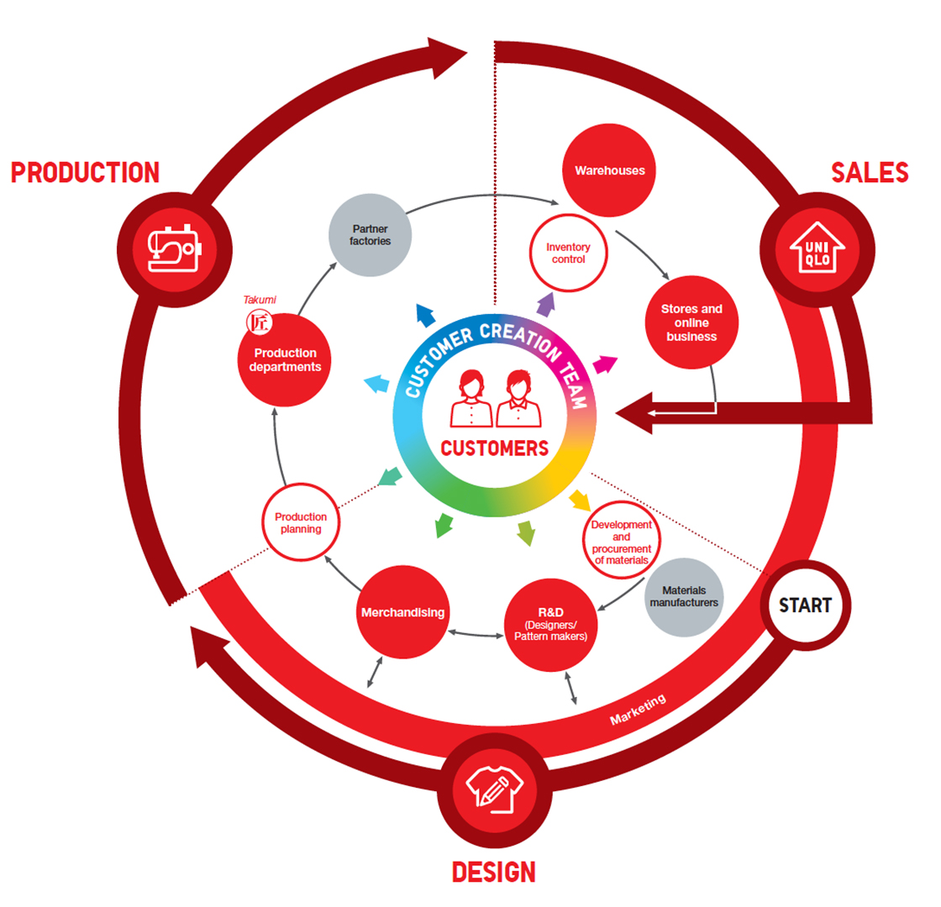
3.2 Business strategy
Fast retailing is a major brand in Hong Kong, Mainland China, and Taiwan that recorded a revenue of about $4.79 billion (¥502.5 billion), which was 14.3% more than in the 2018 financial year. Operating profit improved by 20.8% while operating profit margin increased by 17.7% in 2019. The revenue and profit margin, however, declined significantly in 2020 due to coronavirus. Nonetheless, the increasing revenues in the 2019 financial year can be attributed to the UNIQLO business strategy of strengthening brand positioning. Lifewear ultimate clothing is recognized and consumed largely in greater china (Hong Kong, Taiwan, and Mainland China). Fast retailing continuously conducts campaigns to promote Lifewear as simple, quality, and reliable clothing. The goal of LifeWear is to develop great clothes that provide unique value and delivers high satisfaction (Fastretailing.com, 2020). Positioning UNIQLO as a leading clothing brand has made LifeWear popular and embraced by consumers.
Table 1: Manufacturing Scorecard
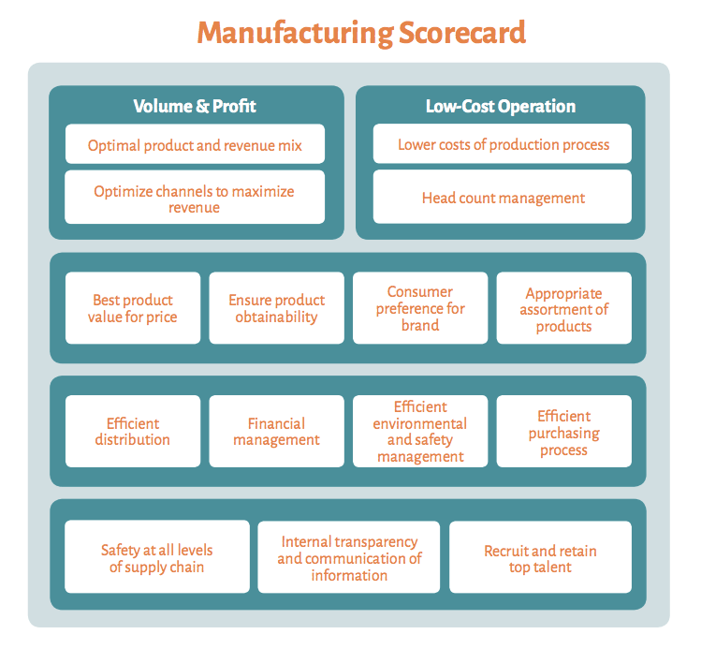Figure 6: Overall business performance of UNIQLO
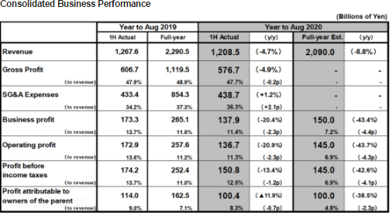
Figure 7: fast retailing group performance
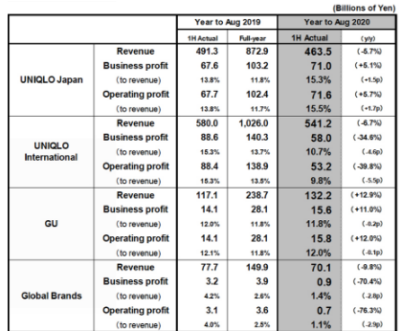
Digital marketing is also among the major business strategies employed by UNIQLO in Hong Kong, Mainland China, and Taiwan. UNIQLO uses the internet market their products by posting information regarding their events and products on social media. Thus, the virtual marketing operation is aimed at developing brand awareness. The strategy is consumer and brand focused as it improves customers’ experience offline and online. Furthermore, fast retailing use of the internet hopes to increase online sales. For instance, greater China region online sales increased by approximately 30% in 2019, which makes up 20% of the total sales. Most brands make between 15% and 20% sales through their website which proves that UNIQLO is at the forefront of utilizing technology. Although the company approximately large declines in profit and revenue and the overall performance dur to COVID-19, E-commerce sales started strengthening because of extensive digital marketing and free delivery services. As it leads to internet technology, fast fashion hopes to increase their sales through online-to-offline services, such as establishing a pick-up store for online purchases to enhance customers' ultimate convenience.
In addition, the company also has a new store strategy where it is focusing on opening new stores across Greater China. With these business strategies, UNIQLO's main objective is to achieve and surpass the one trillion Japanese yen mark, as it creates joy, satisfaction, and happiness through their unique and superior functional clothing.
Evaluation of UNIQLO strategies based on Balance Scorecard
  - Financial perspective
Based on UNIQLO financial statements, it is evident that the revenues and profit increased significantly in the 2019 financial year and have realized a downward trend in the 2020 financial year. For example, the company realized a revenue of 2.29 million in Japanese yen in fy2019, which reduced by 13.1% in 2020—similarly, operating profits reduced by 49.5% in 2020 (Fastretailing.com, 2020). However, the number of stores has increased from 3589 to 3657. Although the revenue and profits are depreciating, The UNIQLO business strategy to increase online sales and establish pick-up stores has a high likelihood of increasing sales during the pandemic. E-commerce UNIQLO sales started strengthening in May 2020 because of extensive digital marketing and free delivery services. Thus, the said strategies are vital in effecting financial rations and profits.
3.4 Customer perspective
Consumer perspective focuses on discovering, understanding, and stressing the needs of consumers. Common measures under this perspective include customer loyalty, satisfaction, and retention (Isoraite, 2008). Fast retailing depends on customer feedback to determine the satisfaction levels of their products and services. Besides, the company retrieve feedback through their e-commerce website and use the information to develop better products that meet consumer demands. Based on a satisfaction survey conducted in 2019, gathered more than 5.7 million feedback from consumers that indicated that consumers were 97% satisfied (UNIQLO, fiscal 2019).
Figure 8: Customer Satisfaction Levels
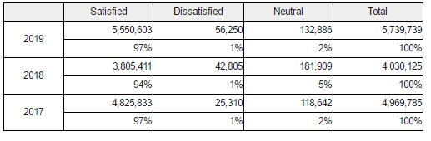
The data gathered via social e-commerce sites, brisk and mortar stores, online stores, email, chat support, among other channels, is used to improve the quality and functionality of UNIQLO products and services. The changes made based on customer feedback are then posted on the UNIQLO website on what and why they were made. In that knowledge, the strategy to communicate with customers online is effective as it has increased customer satisfaction by more than 95%.
  - Internal process perspective
As stated earlier, UNIQLO LifeWear insists on optimizing the quality of clothing. Ultimate LifeWear is committed to developing a sustainable society. Fast retailing implemented new processes to wash jeans to minimize water usage by 99 while ensuring quality and sustainable design. Besides, the company has engaged in collecting used UNIQLO items from consumers for recycling purposes and use in clothing distributed for charity globally. Fast retailing also improves sustainability through importing cotton from sustainable sources. The company also declines to use cotton harvested by children or through forced labor. Most of the sustainable processes at the fast retailing group are focused on reducing the number of chemicals, water, and energy used in processing and production. The company ensures its production and operation processes are safe for employees and the surrounding environment. Sourcing good materials and monitoring supply chain processes are crucial in developing a sustainable society and increasing the quality of LifeWear.

  - Learning perspective
Fast retailing engages education and development programs to assist employees in fostering personal and corporate growth. The company offers skill development programs to facilitate self-actualization and develop a problem-solving workforce driven by the passion for serving customers in real situations concerning products, facts, and existing marketplace. Young and new employees are also encouraged to develop a business model that supports the company's goals. The company also strives to develop a working environment that enhances equal opportunities for each worker to utilize their abilities and reach their potential.
Fast retailing also has approximately 60 health physicians that ensure safe and healthy working areas. Fast retailing wellness centers encourage employees to undergo checkups that involve mental health training and preventive measures against accidents or outbreaks. The effort to increase employees' safety and wellness is a journey towards reaching their goal of sustainability through the creation of new, functional, and quality clothing. These strategies are, therefore, effective for UNIQLO products and fast retailing in meeting their financial targets, customer base, and enhancing innovativeness.

- What are your recommended corporate and business level strategies to Fast Retailing? Critically discuss how you can effectively implement the above strategies.
After analyzing the activities of fast retailing in the market, it was depicted that there are several adjustments that should be made to ensure that the business continues to succeed.
Chart 1: Gantt Chart Recommended market activities of Fast Retailing
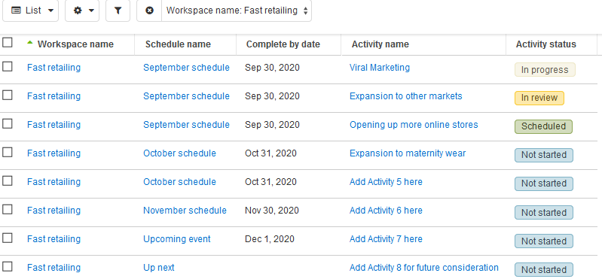

Figure 1:Duties and responsibilities of different UNIQLO departments
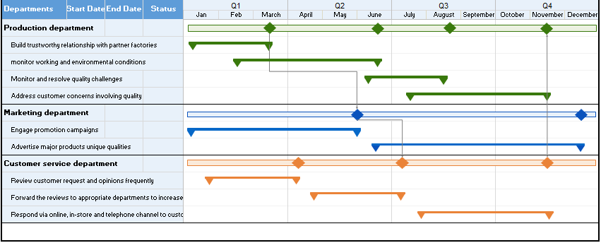
There are recommendations that were brought forward and included the following:
Focus on viral marketing.
- Expansion to other markets
- Opening up more online stores.
- Extension to maternity wear.
It is imperative for Fast retailing and UNIQLO to focus on viral marketing in order to continue boosting their sales in the market. It is a tactic that helps companies to market their products concurrently to different customers in the market. It is the best mechanism that will help to ensure that the brand is able to create awareness ensuring that all the potential customers are reached. It is an approach that helps to boost the sales of a company in the market. The business should also offer discounts to its customers in order to foster loyalty (Retailing report, 2014, np). The other recommendation is that the business should focus on venturing into new markets. This is a strategy that will help the business to expand its customer base and ensure that it does not fail in the future. This is because, with a large customer base, it is possible for a business to deal with the level of competition that prevails in the market. An example is that UNIQLO should expand to China, which has become its essential overseas market. Sales in China are expected to rise over the years and will surpass those in Japan. This is due to many people present in China as compared to Japan. Expanding its physical presence is a step that will help the business operations of the firm, hence maximizing profits.

Opening up more online stores is another recommendation that will help boost the operations of UNIQLO. This is because it will be able to reach a wide customer base, hence maximizing profits. A large market share helps a business to grow as it is able to boost its sales in the market as compared to other existing competitors (Chen, 2017, np). This is a strategy that may help to pave the way for the development of the firm for it to become a market leader. Extension to maternity is another step that will help boost the sales of the entity in the market. This is a stratagem that will help that business to acquire a new segment in the marketplace. An increase in the level of sales will help to boost sales revenue hence promoting sustainable business in the market. It is a segment that will attract new customers, ' especially pregnant women who will purchase such clothes and also for their babies. Such tactics will boost the operations of the firm in the market, enabling it to emerge as a market leader (Chen, 2017, np). The management should focus on these recommendations to boost growth and sustainability in the market. In order to fulfill these strategies, the company should adhere to its mission, vision, and values. It is essential for an entrepreneur to understand that the mission of a firm should be informational in such a way that it is able to guide the leaders, employers, and also the targeted customers. It is a statement that majorly talks about the direction that has been taken by a particular company in the market, the reason why it exists, and its ideal in the bazaar. In most cases, the mission is always future-oriented, helping the business to expand from time to time. This is an aspect that guides the entire company towards the realization of the strategic direction that has been developed. The mission of a company helps it to develop a brand that is in line with the demands of the customers in the market.

The mission, values, and vision play a vital role in the whole process of developing an organizational strategy. They act as the building blocks for the development of key values such as respect, professionalism, integrity, and honesty. The mission helps to define the organization and how it conducts its operations in the market. Values, on the other hand, help to provide guidance on how the firm will be able to reach its goals and vision in the marketplace. Whenever a firm fails to define the appropriate values, mission, and vision, it is bound to fail (Hyde, 2007, np). This is because it is difficult for it to deal with high levels of competition that prevail in the marketplace. UNIQLO is an example of a company that has established itself well in the market. This is after formulating a proper mission, vision, and appropriate values that are in line with the demands in the market. There are several brands that have failed to penetrate in the market due to their inability to formulate a proper mission statement. UNIQLO is a brand that has managed to take over the market in Hong Kong and has capitalized on all the available opportunities. This is a factor that has enabled the company to exploit the available resources hence maximizing profits (Hyde, 2007, np). It is through its mission, values, and vision that UNIQLO has managed to outline all its performance standards and metrics hence meeting the demands of the customers in the market. All the employees have been provided with certain goals and objectives that they are expected to meet in the market. These statements have provided a focal point for the firm enabling it to align with the demands of the customers in the market. Each person in such an organization works towards a single purpose. This is a factor that has helped to promote efficiency and consistency in terms of productivity. The purpose of the company has been defined in the market, ensuring that the future position of the company is listed in the market. All the values of the organization have been defined hence propelling commitment and focus among the task force.

References
Carpenter, M., Bauer, T. and Erdogan, B., 2012. Management principles
Chan, G., Chen, G., Xin, J., So, K. and Vu, T., Group Case Synopsis for: Uniqlo.
Chavan, R.B., 2018. Analysis of fashion industry business environment. Trends in Textile & Fashion Designing, 2(4), pp.212-219.
Choi, T.M., Lo, C.K., Wong, C.W., Yee, R.W. and Chan, T.Y., 2012. The consumption side of sustainable fashion supply chain. Journal of Fashion Marketing and Management: An International Journal.
Courtney, H., 1998. What is Business Strategy?. WORLD.
Curtis E, Watson H, and Sephton L, 2007. Fashion retail. John Wiley and Sons, New York, US.
Fastretailing, CEO message. (2020). CEO message. FAST RETAILING CO., LTD. https://www.fastretailing.com/eng/about/message/
Fastretailing.com business strategy. (2020). UNIQLO business strategy. FAST RETAILING CO., LTD. https://www.fastretailing.com/eng/group/strategy/tactics.html
Fastretailing.com financial summary. (2020). Results summary. FAST RETAILING CO., LTD. https://www.fastretailing.com/eng/ir/financial/summary.html
Fastretailing.com. (2020). Consolidated sales and profit forecast. FAST RETAILING CO., LTD. https://www.fastretailing.com/eng/ir/financial/estimate.html
Fernandes, N., 2020. Economic effects of coronavirus outbreak (COVID-19) on the world economy. Available at SSRN 3557504.
Go-globe. (2019, March 28). Online consumer shopping behavior in Hong Kong – Statistics and trends [Infographic]. GO-Globe Hong Kong. https://www.go-globe.hk/online-consumer-hong-kong/
Gutterman, A.S., 2011. Funtional-Level Strategy.
Hyde, K. (2007, April 26). UNIQLO: From Tokyo to New York to the global brand. Japan Society. Retrieved from http://www.japansociety.org/page/multimedia/articles/uniqlo_from_tokyo_to_new_york_to_global_brand
Isoraite, M., 2008. The balanced scorecard method: From theory to practice. Intelektine ekonomika,
KINOSHITA, A., 2018. How is a Retail Business Brand Embedded in Social Structures, Networks, and Territories? A Historical Case of Uniqlo. 流通, 2018(41), pp.1-18.
Lee, Y. N. (2020, August 14). Hong Kong cuts GDP forecast for 2020 after economy contracts 9% on-year in the second quarter. CNBC. https://www.cnbc.com/2020/08/14/hong-kong-releases-second-quarter-2020-gdp-data-economic-updates.html
Maliszewska, M., Mattoo, A. and Van Der Mensbrugghe, D., 2020. The potential impact of COVID-19 on GDP and trade: A preliminary assessment.
Maryla, V.M. and Aaditya, M., 2020. The potential impact of covid-19 on gdp and trade: A preliminary assessment. The World Bank, report.
McKinsey Report. (2020). The State of Fashion 2020. McKinsey & company. https://www.mckinsey.com/~/media/mckinsey/industries/retail/our%20insights/the%20state%20of%20fashion%202020%20navigating%20uncertainty/the-state-of-fashion-2020-final.ashx
Nanus, B., 1992. Visionary leadership: how to re-vision the future. The Futurist, 26(5), p.20
Nenni, M.E., Giustiniano, L. and Pirolo, L., 2013. Demand forecasting in the fashion industry: a review. International Journal of Engineering Business Management, 5, p.37.
O’Cass, A. and Siahtiri, V., 2014. Are young adult Chinese status and fashion clothing brand conscious. Journal of Fashion Marketing and Management.
OECD. (2020). OECD economic outlook, June 2020. https://www.oecd.org/economic-outlook/
Papulova, Z., 2014. The significance of vision and mission development for enterprises in Slovak Republic. Journal of Economics, Business and management, 2(1), pp.12-16.
Pettinger, R., 1996. Introduction to corporate strategy. Macmillan International Higher Education.
Posner, H., 2015. Marketing fashion: strategy, branding and promotion. Laurence King Publishing. Remy, N., Schmidt, J., Werner, C. and Lu, M., 2013. Unleashing Fashion, Growth City by City. McKinsey & Company.
Reboux, B., 2014. UNIQLO: A stitch in time. In Case studies in Asian management (pp. 87-102).
Rinnebach, P. and Richter, S.N., 2014. Redefining fashion business models: today’s challenges, tomorrow’s competitive edge.
Sarker, T.R. and Al Saeed, L.S.L.A., 2020. Benchmarking Marketing and Business Strategy of UNIQLO to Start-up a Retail Shop in Bangladesh. Benchmarking, 12(2).
Shen, B., Li, Q., Dong, C. and Perry, P., 2017. Sustainability issues in textile and apparel supply chains.
Stout, H., 2013. For shoppers, next level of instant gratification. New York Times, 8.
Taiwo, A.A., Lawal, F.A. and Agwu, P.E., 2016. Vision and Mission in Organization: Myth or Heuristic Device?. The International Journal of Business & Management, 4(3).
Tallant, J., 2011. Importance of Vision, Mission, and Values in Strategic Direction. GRIN Verlag.
Tamura M. 2001. Principles of distribution, Chikura Syobo, Tokyo
Thompson Jr, A., AL.(2005): Crafting and Executing Strategy. The quest for competitive Advantage. Concept and Cases Mcgraw-Hil International Edition NY.
Walker, P.G., Whittaker, C., Watson, O.J., Baguelin, M., Winskill, P., Hamlet, A., Djafaara, B.A., Cucunubá, Z., Mesa, D.O., Green, W. and Thompson, H., 2020. The impact of COVID-19 and strategies for mitigation and suppression in low-and middle-income countries. Science.
Welters, L. and Mead, A.C., 2012. The future of Chinese fashion. Fashion Practice, 4(1), pp.13-40.

